

Bachelor of Science: Professional Policing Practice Dissertation 2022

A critical evaluation into the understanding if response policing is becoming more demanding and analysing the pressures of being on the front line.

1920839
Jamie Ieauan Gough
08/01/2023

Declaration/Statements Page

DECLARTION

This work has not previously been accepted in substance for any degree and is not being concurrently submitted in candidature for any degree.

Signed - J.Gough (Candidate)
Date – 08/01/2023

STATEMENT 1

This work is the result of my own investigations, expect where otherwise stated.
Other sources are acknowledged by footnotes giving explicit references. A bibliography is appended.

Signed – J.Gough (Candidate)
Date - 08/01/2023

STATEMENT 2

I hereby give consent for my work, if accepted, to be available for photocopying and for inter-library loan, and for the title and summary to be made available outside organisations.

Signed – J.Gough (Candidate)
Date – 08/01/2023

Candidate’s signature - J.Gough Date 08/01/2023

Contents Page

Contents | Page
Declaration | 2
List of figures | 5
Acknowledgements | 6
Chapter One – Introduction | 7
Introduction | 7
Summary of research objectives | 7
Literature review | 8
Survey method | 8
Summary of sampling framework | 9
Ethical issues | 9
Timescale | 9
Chapter Two – Literature Review | 10
Introduction | 10
Chapter Three – Methodology | 16
Introduction | 16
Research strategy | 16
Data collection | 17
Limitations and potential problems | 17
Ethical considerations | 17
Conclusion | 17
Chapter Four – Analysis of results | 18
Introduction | 18
Themes | 25
Conclusion | 25
Chapter Five – Findings and Conclusion | 26
Introduction | 26
Summary | 28
Further research | 28
Recommendations | 29
Limitations | 29
Bibliography | 30-33
Appendices | 34
Appendix 1 – Ethics form | 34-53
Appendix 2 – Questionnaire – Police | 54-56
Appendix 3 – Questionnaire – Survey Monkey - Public | 57-58

List of Figures

Figures | Page
Figure 1: Spending on Police – 2009/2018 | 7
Figure 2: March 2016 to March 2022 Police government funding | 11
Figure 3: Incident statistics from Lancashire Constabulary control room 2013 | 12
Figure 4: Incident types broken down into specified categories | 13
Figure 5: Statistics flagged as being mental health in thousands from 36 of 46 UK Police forces | 14
Figure 6: Questionnaire: Police officer – Length of service | 18
Figure 7: Questionnaire: Do you believe response policing is becoming more demanding? | 19
Figure 8: Questionnaire: What incidents do you believe the police deal with the most? | 19-20
Figure 9: Questionnaire: Do you believe the police are understaffed? | 20
Figure 10: Questionnaire: What should the police prioritise? | 21
Figure 11: Questionnaire: Has response policing demand increased in the past 5 years? | 21
Figure 12: Questionnaire: Who do you believe should deal with mental health incidents? | 22
Figure 13: Questionnaire: Minimum required police officers per shift? | 22
Figure 14: Questionnaire: What do you believe takes up the most of police officers time? | 23
Figure 15: Questionnaire: How many mental health calls do you believe the police receive every day in the UK? | 23
Figure 16: Questionnaire: Do you believe the police deal with more non-crime incidents than crime? | 24
Figure 17: Themes – Identified from the questionnaire | 25

Acknowledgements

I would like to thank my dissertation tutor, Deepak Patel for his support and guidance throughout my dissertation.

Also, thanks to my parents and family for supporting me through this degree to becoming a professional police officer, and supporting me through the first three years of my career. Without their direction and support I would not have been able to complete my studies to this standard.

Chapter 1: Introduction

Introduction
Firstly, I am going to be undertaking the 8000-word dissertation option throughout this final year of study and response policing is my chosen subject area. The study has been designed to analyse and evaluate the demand to response policing. Throughout this study, information will be gathered from several resources and the development of data from response officers and the public.

The following chapter will provide a brief background of this study and provide an explanation of why this title has been chosen. The ideas for research information gathering, objectives and framework will be discussed, and any ethical issues that could arise.

Response policing is the centralisation of all aspects of policing, it incorporates all types of crime, victims, suspects and much more. Being a response police officer for just over two years now, I want to document and express the demand and pressures around being on the front line. By evaluating the demand, it enables areas to be identified that are being overwhelmed and to incorporate measures to support these areas. Demand is being assessed by many forces due to the previous cuts in resourcing over the years. Critically, by recruitment being put on hold and other areas within the force being reduced in staffing, acceptability as well as value of work is now questioned.
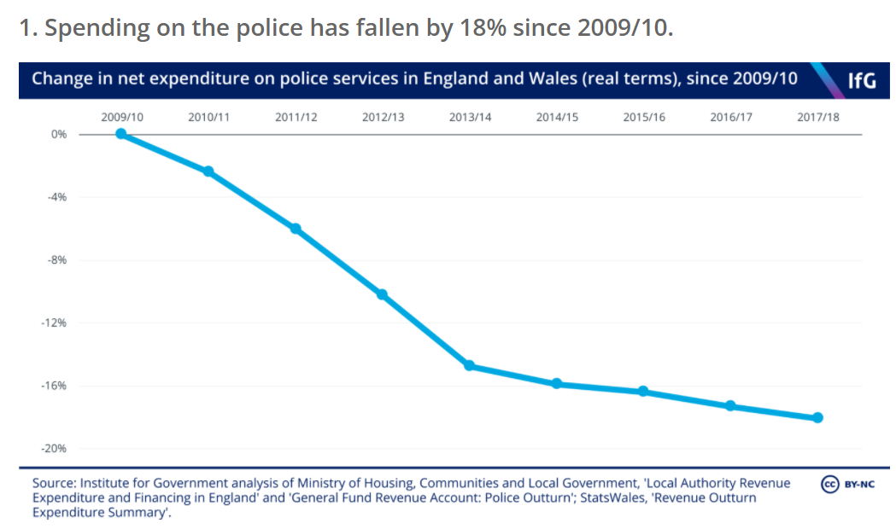

Figure 1 – Source: (Institute for Government, 2019, (A)

Furthermore, throughout different forces we are seeing a change in how operations are run. Therefore, looking at ways to reduce the demand, as well as reducing the high level of work that is being enforced on the police service. (NPCC, 2017) “Crime, accounts for less than a quarter of ‘demand’ through calls for service” (College of Policing 2015, as cited in NPCC, 2017).
Summary of research objectives
- Compare through research whether response policing is becoming more demanding over time either through calls, loss of officers or administration.
- Identify the key areas of response policing and to discover what areas are the most time consuming.
- To discover if front line policing is changing and therefore effecting demand, what are the considerations around future change.
- To find out what pressures front line officers face as well as the policies and procedures in place to provide support.

Literature review
Complex crimes are on the rise and therefore take a longer period of time to investigate. Thereby, causing more demand for officers with reduced numbers, however due to resourcing, violent crimes are being prioritised over complex. All crimes range in threat, risk and harm and due to the reduced numbers of officers, higher risk incidents get prioritised. However, administration can also be overwhelming with referrals to external services being required for calls that don’t involve crime such as missing people and mental health calls (Institute for Government, 2019, (B).

“A lack of data combined with changing trends in crime and crime-related work makes it hard to measure demand on the police. While the overall picture is unclear, there is enough evidence to suggest that some crimes – including complex and serious crimes – are placing increasing demands on the police” (Institute for Government, 2019, (C). From this, I can demonstrate that through this body of work I will be able to investigate and gather more research to support how police response and recourses are being challenged.

“The recruitment of an additional 20,000 police officers in England and Wales by March 2023” (Gov.uk, 2022). This statement has caused controversy within policing and Martin Hewitt who is a former Metropolitan Police assistant commissioner has an interesting response. Offenders being prosecuted is at an all-time low, statistics state just 7 per cent of reported offences lead to a charge. (Independent, 2020, (A) “Bringing in the 20,000 is not the answer to all the challenges we have around policing,” Mr Hewitt said, “it was “very difficult” for police to tell devastated victims that perpetrators would not be charged, and that years of rising demand and falling resources had damaged officers’ mental health”. (Mr Hewitt, as cited in, Independent, 2020)

An evaluation into a report in 2020 from The Independent stated that 999 calls were not being answered for more than two minutes. Furthermore due to cuts, demand on the police has increased and there are concerns around forces being overwhelmed and therefore causing huge pressures to the front line. As well as this, the answering target for 999 calls is a 10 second time frame. However, HMICFRS have evidence to suggest that 999 calls had increased in Wales and England by 11 per cent. Therefore, this answering time frame is being missed (Independent, 2020 (B).

Summary of research – Survey Method
Different research methods will be used throughout this dissertation such as questionnaires, journals, news articles and government figures. These methods will be used as I believe they will provide the best supporting evidence towards my title. Government figures will be key as they will show the different areas of demand and thereby providing statistics around my dissertation. Furthermore, journals and news articles provide additional information towards highlighted areas that will offer supporting evidence.

Summary of sampling framework
The intended participants throughout this dissertation will be aimed towards front line officers and the public. The reason for this is because they will be able to provide valuable evidence towards the main question for this dissertation. Front line officers deal with the demand and will reflect the pressures they face by answering the questions provided, and that is why they’re best suited for this research. Therefore, providing key statistics which will be presented in a graph format showing the comparisons between each chosen subject area. To add to this, the intention is to also develop a questionnaire towards the public around their views on what they think police demand and pressures are for front line officers. Thereby, showing an interesting comparison between front line officers and the public’s perception.

Ethical issues
Throughout my proposal I will ensure that there are no ethical issues by following the steps I have put in place. Firstly, by ensuring that the questionnaire is voluntary and that no one will be forced into taking part. Furthermore, my questionnaire will not be provided to any vulnerable people or victims of crime. Also, ensuring that none of the questions are offensive and by checking with my supervisor prior to handing out my questionnaire. Finally, I will act upon any feedback provided from this proposal to ensure that the topics I am researching into have been approved.

Timescale
Due to being a full-time response police officer while completing this degree my time is limited and therefore, I need to dedicate days to complete my degree. A table was developed which documents a rough guide on the days I intend to complete each research and sections of my dissertation.

Chapter 2: Literature Review:

Introduction
This chapter looks at the literature review of existing academic literature which shows the demand and different pressures impacting response policing. The research will display a critical analysis of different areas of study that have been reviewed and chosen to obtain evidence towards the criteria for this dissertation. The following research of literature will contain the cuts to Police throughout the United Kingdom. Following onto the specific types of incidents that the Police deal with. It will discuss as well as highlight the current statistics and signify why the gap in research should be further developed. Furthermore, critically examining how the impact of further demand increases additional pressures onto the front line. To add to this, the literature review will emphasis current theories and models that are applied to focus and stabilise or minimise demand. Information will be collected to show future objectives which are put in place to decrease upcoming pressures. Topics that are important to consider will be researched and for example will be as follows, cuts on the police force, types of demand that effect the police service such as mental health and concern for safety incidents. The research will also be supported by the use of graphs and charts to evidence the points identified. Thereby, providing critical analysis through literature research into gathering the known information to date, and the understanding of the problems and solutions in place. This review will contain many research topics that are supported by a range of sources to provide evidential support. The sources that have been utilised throughout this review have been obtained through the College of Policing, Google Scholar, and sources from the University of Wales Trinity Saint David’s online library.

Financial police cuts have been discussed over the years and have therefore been considered as a serious problem. The research conducted had found that there has been a significant drop in numbers in relation to policing personnel and funding within policing throughout England and Wales. As stated by Ellison in 2021 studies show that there has been a 19% drop in funding to be exact over the last decade and thereby causing 20,000 fewer response officers. Thereby, causing significant demand to resources across the frontline in England and Wales due to the lack of capacity to support this demand (Ellison, 2021). Further studies show that over the last five years, numbers of police officers have been decreasing at a vast rate. From March 2014, there was a drop of approximately 16,000 police officers from the start of 2010. Due to this decrease of police officers, statistics now show that for every 445 members of public there is one police officer to manage this significant number (College of Policing, 2015).

This graph in figure 2 shows an overall increasing in funding and budgeting provided to policing since the financial year ending March 2016 leading up to 2021-22. This is the overall funding and is sectioned into different areas as shown in the titles entered below the statistics (Gov, 2021).
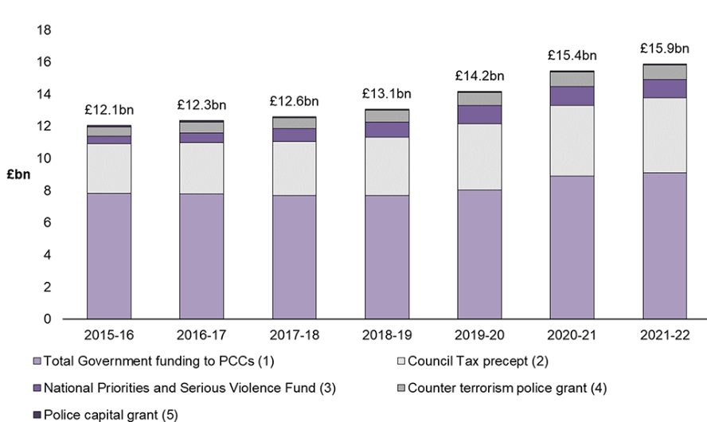
Figure 2: March 2016 to March 2022 Police government funding (Gov, 2021)

However, just because there has been a slight increase in funding doesn’t suggest it provides extra support in relation to demand. The current level of police funding is now seen to be at a matched level to March 2011 providing a 0.1% increase. During this research it shows that the figures have only just matched or slightly increased to what was in March 2011. Therefore, providing the researcher a question of, does the 2011 demand to Police correspond with the current demand to today’s date?

Therefore, it is important to understand how demand can be assessed, which leads onto the next area of research. Demand can be assessed through numbers of officers and the number of calls that are received that require deployment of an officer or officers. However, different aspects influence demand on policing, and these can be incorporated externally and internally within the force. To add to this, not all calls that Police officers attend occur through 999 or 101 calls. Incidents can happen by officers passing by, reports through social media as well as through intelligence information gathered. Although, depending on the type of incident, assessments are made through a threat, risk and harm model which then decides the need for a fast or slow response (Laufs, Bowers, Birks and Johnson, 2020). The threat, risk and harm model is utilised in many forces across the United Kingdom and enables call takers to assess the required response time for an incoming call. This model is known as The National Decision Model (2012) and provides users to establish threat, risk and harm through six key elements. These six key elements being, the code of ethics, information and intelligence gathering, risk assessing, considering powers, options, and taking action as well as reviewing (College of Policing, 2013).

Depending on the nature of the call, in turn will determine the response time to that incident. However, some calls are dealt with by other methods such as telephone, diverted to another organisation or through an appointment basis. Also, major complex incidents can lead to the need for greater resources of response or specialised resources such as firearms. No incident can be defined on how long it will take, some can be dealt with in minutes whereas others can lead to many hours. Thereby, leading to reduced resources across the force as so many resources are required to deal with that one specific incident (Ellison, 2021(2)).

The researcher found that police demand shows that majority of calls were non crime related. The figures show approximately 80 to 90 percent involved noncriminal behaviour complaints, public service assistance requests and disputes. However, figures also suggest approximately 80 percent of officers deal with protecting people from being victims of crime and crime preventing. Studies show through The College of Policing that recently public safety as well as welfare incidents are increasing and therefore causing greater demands to response policing. Therefore, causing a substantial altering in response to emergency calls, investigating crimes and crime detection being just a few of the changes. Community policing is now at the forefront as it is said to be reducing minor crime and thereby countering further serious crime. However, community policing requires more proactive patrols and therefore also involving a greater cost due to the need for more front-line resources (Boulton, 2017, p.70-73).

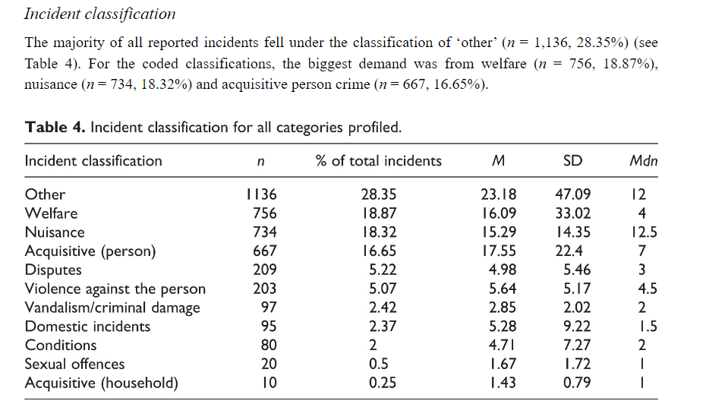
During this research, the below graph shows findings within Lancashire Constabulary in a study in 2013 with regards to number of incidents categorized through their control room. This clearly shows how other/welfare classifications are at the highest number of being reported to this force. A welfare check is conducted by police and is provided to ensure that individual is safe whether that being at their home address or within a public place (LeedsGov, n.d.).
Figure 3: Incident statistics from Lancashire Constabulary control room 2013 (Boulton, 2017, p.76(2))

Non-crime incidents are not captured on police records and therefore can provide inaccurate findings when it comes to police demand. For example, studies are showing that 83% of all calls that are recorded through the police control room are non-crime related incidents. To add to this, there is a significant increase on the reporting of mental health calls in which the police are dealing with. The Metropolitan Police have estimated that approximately 20% of mental health incidents account towards police time. Therefore, with this amount of increased demand for mental health incidents to front line officers is adding additional demand to front line policing. Furthermore, due to a mental health incident being classed as a non-crime incident it can affect the statistics towards police demand (College of Policing, 2015 (2)).
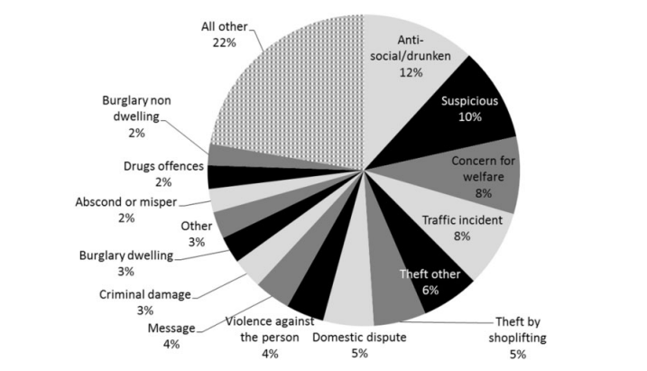
Figure 4: Incident types broken down into specified categories (Walley and Jennison-Phillips, 2018).

Again, as shown in figure 4 welfare incidents have incorporated towards a high percentage of calls as studies show above. A two-week exercise of data was collected resulting in detailed assessments of 535 incidents. Figure 4 above shows a breakdown of demand by incident type provided within a pie chart format.

The research gathered presents an existing theory around demand which shows that level capacity strategies are applied in some services which can be beneficial. Capacity strategies meaning the amount of staffing levels of front life officers at the time. Providing services to always be fixed rather than altered, thereby at times resources being under or over utilised. This can lead to stability of demand but during times of events planning for example, this can then lead to a disruption in total numbers and therefore effecting demand or requiring additional officers to maintain the demand, however this then comes at a cost (Walley and Adams, 2019, p.11-12).

One force has been able to use a software called ‘Qlick’ which is able to manage demand throughout the force. This software enables measurement of demand and cost, therefore providing an understanding of where resources are required or even not required. Studies on demand were obtained through 15 different forces who took part in a survey of the understanding towards demand to police forces. Walley and Adams identified studies that shown through the research gathered that one force struggled significantly through the summer of 2018, and therefore needed to request further assistant from another force to answer calls. The article states when capacity and demand were evaluated, it was shown across each force that there was not sufficient capacity to cope with the existing demand. Another interesting point shown that most forces could maintain demand if it was just fixated on crime. The police may not be considered the most appropriate recourse for incidents that are related to missing people as well as mental health incidents. It is highlighted that these areas of concern are very resource intense and that the police shouldn’t be the first point of contact (Walley and Adams, 2019, p.19-20(2)).

The research gathered presents that within Police Scotland three-quarters of incidents they deal with are not crime related. Research found that 73% of incidents in 2021 within Scotland led to no crime being documented. Links were shown to be incidents whereby people were suffering with mental health and therefore officers providing transport to hospitals. The article states that individuals suffering with mental health were not receiving the appropriate support. Therefore, contacting the Police which then provides officers dealing with these incidents for many hours, taking resources away from crime related incidents. (BBC News, 2022). The Guardian presented information from 2020 which shows that figures of mental health incidents from 23 English police forces risen by 41% from 2019. Wiltshire Police force specifically had a rising number of 248% compared to the previous year, leading to an increase of 2559 mental health incidents (The Guardian, 2020). This information provides clear statistics around how mental health incidents are on the rise and therefore effecting response policing and increasing general demand to officers.

Another article provided by the BBC News found that mental health incidents had risen over the past four years by over a quarter. Statistics shown in 2018 around a mental health report being recorded to the Police on an average of 56 incidents per hour bringing a total of 494,159 over the year (Jones, 2019).
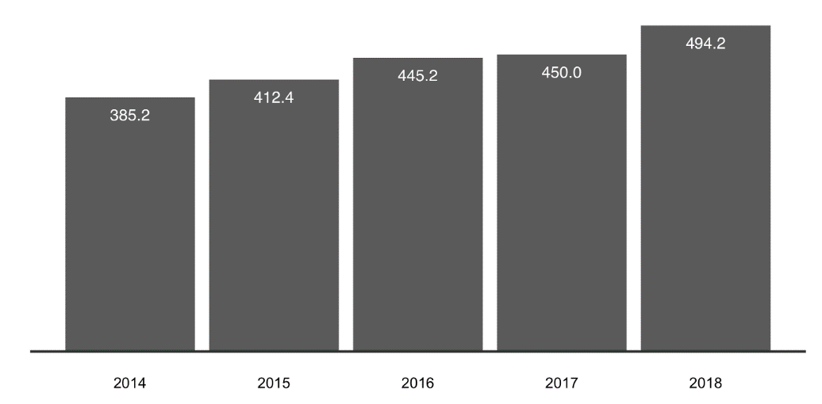
Figure 5: Statistics flagged as being mental health in thousands from 36 of 46 UK Police forces (Jones,2019)

Police have a vital role in attending incidents within a specific time frame. From the research gathered so far, we are able to see that the reoccurring themes show there is a significant demand in non-crime related incidents. The articles have been arranged into a thematic system to provide clarity around each key topic. Evidence shows through police cuts that due to the lower numbers of police staff it is therefore putting pressure on current front line officers, due to the fact of the high demand. “Police 999 response times almost double in seven years” (BBC News, 2019). The themes are reoccurring throughout each piece of research, mental health calls and concerns for safety calls are on the rise, thereby putting further pressure on police forces across the country. Studies show that police demand does not take into consideration mental health and concern for safety incidents and therefore show inaccurate readings when it comes to evidence.

Recent developments from research gathered shows that mental health incidents are rising due to the demand on the NHS since the pandemic. “NHS failings forcing police to respond to mental health incidents rather than crimes” (Dearden, 2018). Thereby, taking police officers away from dealing with crime related incidents and calls involving mental health can take up resources and time. This also applies pressure on front line officers as even though they have had appropriate training, dealing with these incidents can escalate significantly due to the presence of police. Although the police are usually deemed the least appropriate resource at the time to deal with these types of incidents, as this can cause sometimes worsen the situation. The sources from the articles show trends of mental health and concern for safety incidents on the rise. Significantly because it reflects and emphasises the further pressures on police staff dealing with these additional calls even when being at reduced numbers of staff due to the cuts.

Each figure shown within this literature review show the present statistics, similarities, and differences through each sector. The information gathered so far shows us that there is a gap in the research with regards to police demand through mental health, concern for safety and welfare checks. Throughout the literature, there is consistent evidence shown in each graph as shown within figures 3,4 and 5 that demand to front line policing is not being accurately reported. Considering this, researchers have become increasingly interested in demand around crimes, whereby the gap in research is identified in non-crime demand.

The research shows strengths within topics such as lack of capacity to support demand as well as high reports of non-crime incidents. The literature signifies that welfare/mental health incidents are increasing, thereby implementing more demand to front line officers. News articles have identified some areas of these concerns however there are weak areas of academic research. The questions in which need to be answered are, is there a rise in welfare/mental health incidents thereby causing further demand to response policing? Also, due to the reduced numbers of policing staff, it is therefore not allowing incidents to be dealt with in the time they’re given. Will an additional police unit need to be formed to deal with non-crime/mental health incidents to ease the pressure on response officers? Furthermore, what will demand to response officers look like in approximately two years’ time if nothing is implemented? Finally, when will the police get the correct funding they require to deal with the current and future demand?

To conclude, more critical analysis and evidence needs to be obtained to establish the demand towards the front line. Key attributes such as non-crime incidents and mental health calls are not taken into consideration when it comes to evaluating demand to response policing. Articles show within the literature that areas of demand are rising however there if little academic research around this area. The research objective was to establish and critically analyse if demand is rising within response policing. Therefore, by obtaining this secondary research it has provided information round loss of officers and call demand. Links have shown that non-crime incidents are rising and therefore causing a change in response demand. Therefore, evidence will be gathered now to assess the demand in these areas and whey up the pressures to police officers on the front line.

Chapter 3: Methodology:

Introduction
The previous section of this dissertation achieved the analysation of current literature around if response policing is becoming more demanding. The next section of this dissertation will look to gather evidence towards this title by conducting a research strategy. Objectives being, to gather information around pressures of being on the front line and understanding the views on police demand. As shown in the previous section, the gap in research around non-crime/welfare incidents is rising however not being documented when it comes to evaluating police demand. Therefore, providing a gap in the research criteria and enabling further evidence to be collected to identify this research question.

Research Strategy
The research method chosen for this dissertation is going to be evidence gathering through questionnaires. Questionnaires provide a wide range of responses, therefore providing different understandings as well as beliefs around the questions being asked. This method can provide patterns of similarities, allowing a final graph of readings to be created to identify the common connections (Harris and Brown, 2010 p,2). This method has been chosen as it will provide anonymous views from front line officers who are experiencing this current demand. Therefore, being the most credible source towards this research question. Multiple choice questions will be utilised to provide a range of answers to understand different views of users taking part in the questionnaire.

The questionnaire to be used will provide a summary of questions in which evidence will be gathered to reflect back towards the research title “A critical evaluation into the understanding if response policing is becoming more demanding and analysing the pressures of being on the front line”. Multiple choices will be offered so that a range of opinions can be gathered to obtain the best research possible. From gathering the information and research in my literature review, these questions will answer the gaps to the research. The gaps that have been identified are that non-crime incidents are no recorded when assessing police demand, as well as understanding the publics perception of demand to response policing. The target audience will be police officers from Gwent Police. An online survey will also be disseminated to the authors family and friends to provide an alternative view from a cross section of the public who are outside the police force. Target audience of officers is crucial as they are directly affected by the research title and will therefore provide the best credible evidence towards this research. Targeting the appropriate audience is crucial in obtaining accurate views and to provide valued answers. These answers are valuable towards research as these participants are experiencing these issues first hand. If the chosen target audience is not correct, it can provide inaccurate information and thereby not provide credible evaluation towards the research question (Questionpro, n.d.).

A question will be asked at the start of the questionnaire to determine how many years of service this person has completed if they are a police officer. This is so a range of different opinions from experienced and new officers can be evaluated. Different opinions will also be obtained from the public, as they are and who are being served and are therefore also affected by the demand. An inductive research approach will be utilised as more information needs to be obtained to answer this research question. By applying an inductive approach, it will allow assessment as well as investigation of information that is clearly yet to be identified from previous studies (Phair and Warren, 2021).
Data collection
The answers provided will be shown within charts which will show a clear summary of the responses given. This will assist in understanding of others’ opinions towards the research title. Graphs can provide evaluations of information in a simple format, therefore making it clear for the reader to understand. Furthermore, information can be placed in a more conscience style which provide clear summaries and can be used in several ways (Writer, 2020).

A qualitative approach is going to be utilised for data collection gathering throughout this research. Both qualitative and quantitative methods will be utilised. This decision has been made as the questions will reflect key words around response policing in which will provide the best evidence towards the research question. Quantitative approaches enhance understanding of the key topic, by identifying key patterns through meaningful explanations. This way a conceptual framework can be established to identify concerns around uncertainty. Open questions can be utilised to enable responses to be specific and therefore provide credible information to the research objective (Sofaer,1999).

Limitations & potential problems
One limitation will be that it could be difficult for police officers to fill out this questionnaire due to them dealing with calls and paperwork. However, due to this the information will make sure that the questionnaire isn’t extensive and to the point. Thereby, enabling individuals who take part to answer in an appropriate time and provide valuable evidence towards the dissertation title. Ensuring a questionnaire is concise and clear will provide clearer responses as well as less confusion for the part takers of the questionnaire. Also, explaining the reason behind the questionnaire will provide clarity around the reasoning for the research gathering and therefore provide accurate evidence. When discussing the questionnaire with participants, they will be reminded of the length of the questionnaire and encouraged to complete the questionnaire at the same time (Walliman, 2006, p,90). Another problem that could arise is biases from friends/family participants. Again these participants will be encouraged to provide honest answers and reply as if they are general members of the public.

Ethical considerations
Prior to the questionnaire being created ethical considerations have been measured. No personal details will be collected from the questionnaire. Providing a complete anonymous report, however ages will be obtained to get clearer statistics. A permission box will be located at the end of the questionnaire, enabling users to either give consent for their information they provide to be utilised in the research.

Conclusion
To conclude, the methodology will enable me to gather the critical research needed to answer the research question. I will be able to gather a range of different opinions, thereby broadening my view on the subject matter. This section has identified my chosen area of research gathering and has also explained how it will be evidenced using graphs. Therefore, I feel this is the best choice of methodology for my dissertation to obtain the information as it will answer the gap in research I have identified. The research that I gather will be analysed in the following section of my dissertation.

Chapter 4: Analysis of results:

This purpose of this chapter is so to show the data analysis gathered from the questionnaire results which will be studied and presented in detail. The objective of this research is to establish whether demand to response policing is increasing. Furthermore, identifying if the police are dealing with more non-crime incidents than crime.

The questionnaire results are set out in a qualitative method, ten questions were asked to participants. The questionnaire was provided to fifteen response police officers, each having different lengths of service. Each question was multiple choice and there were only ten questions to ensure that the questionnaire could be completed in a reasonable time. If a questionnaire is brief, it can allow participators to complete it in a short period of time and provide valuable evidence towards research gathering. Fatigue can occur when there are too many questions which can then provide inaccurate results when analysing answers from participants (Cape, n.d.).

Figure 6: The results show the length of service of each response police officer who took part in the questionnaire.

Thirty members of the public took part in my questionnaire which were uploaded onto Survey Monkey. By utilising this method, it provided links to family and friends, which enabled participators to complete the questionnaire in their own time and provide valuable responses towards evidence gathering. There are many positive aspects of Survey Monkey such as easy access and fast distribution to users (Varela et al., 2016).
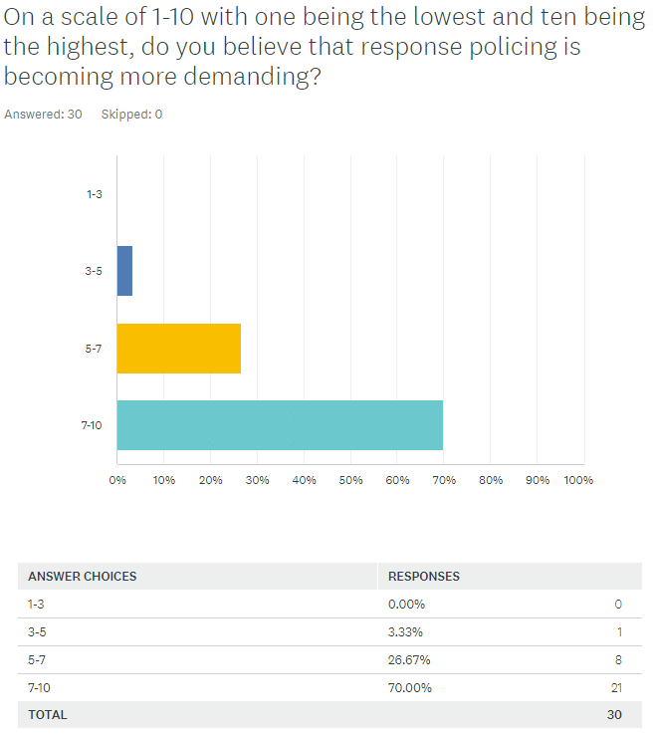
Figure 7: Q1 - Respondents on the left police, respondents on the right are the public.

From the statistics 80% of the police participants believe that response policing is under pressure. Similarly, 70 percent of the public surveyed believe the same to be true. Increased pressures of changing demand to policing as more intervention is now required for mental health, missing persons, and other statutory requirements (Bluelight, 2019). This information reflects a change of increasing non-crime incidents to response policing demand and therefore creating more demand for officers.

Figure 8: Q2 – Respondents above are police, respondents below are the public

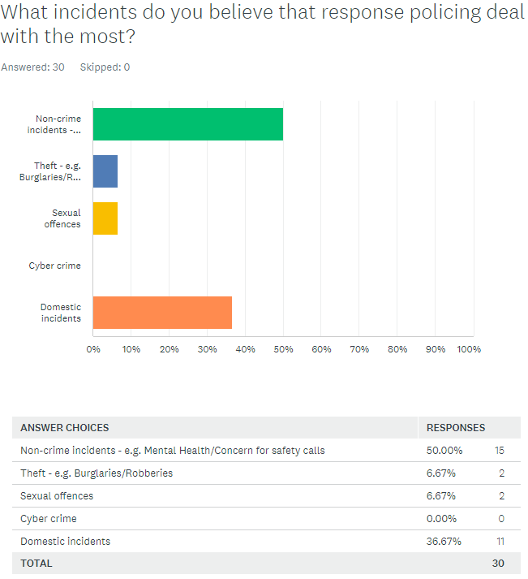
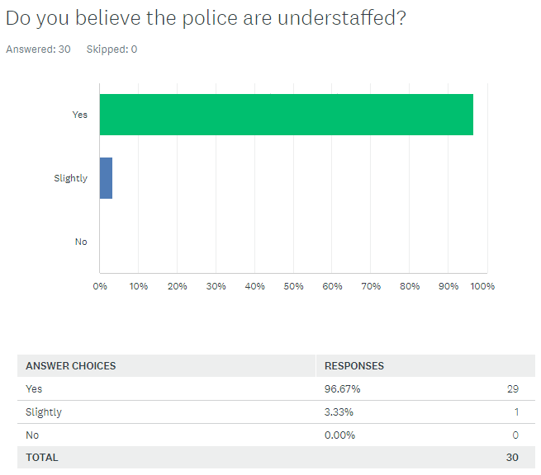
As shown in Figure 2 and 3 within the literature review, welfare incidents were the second most reported call into the Lancashire Constabulary control room in 2013. Mental health incidents are the most common provided answer within the questionnaire from members of the public and police as shown in the results, with domestic incidents being the second highest. As the statistics show, increasing evidence continues to be published around mental health incidents placing high demand on the police service. “The police have been swamped with half a million mental health crisis callouts in a year as overstretched NHS services struggled to cope with the pressure” (Andrews, 2020). Police systems data analysis is built for purposes like crime recording, however non-crime incidents are continuing to rise such as mental health incidents (Parliament, 2018).

Figure 9: Q3 – Respondents on the left police, respondents on the right are the public.
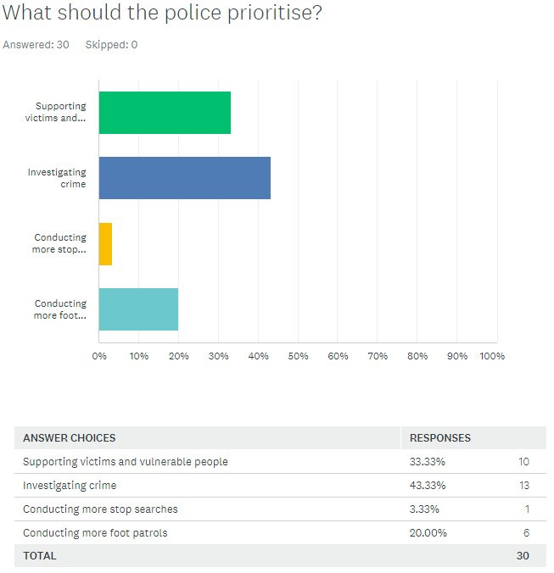
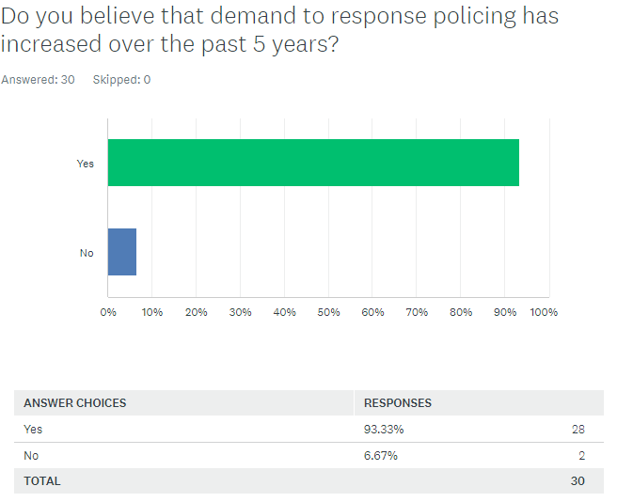
Figure 10: Q4 – Respondents on the left police, respondents on the right are the public

Figure 11: Q5 – Respondents on the left police, respondents on the right are the public.

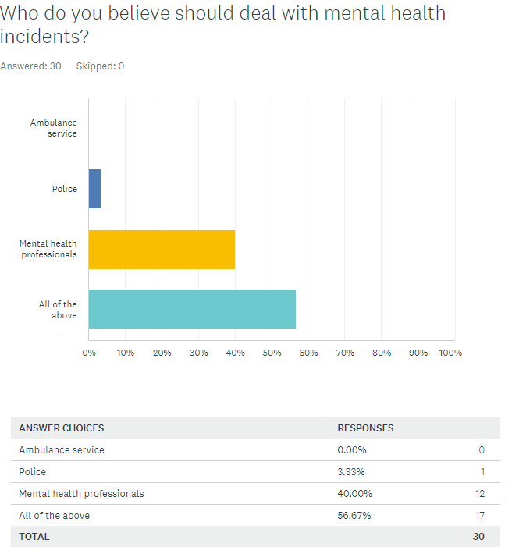
Figure 12: Q6 – Respondents on the left police, respondents on the right are the public.
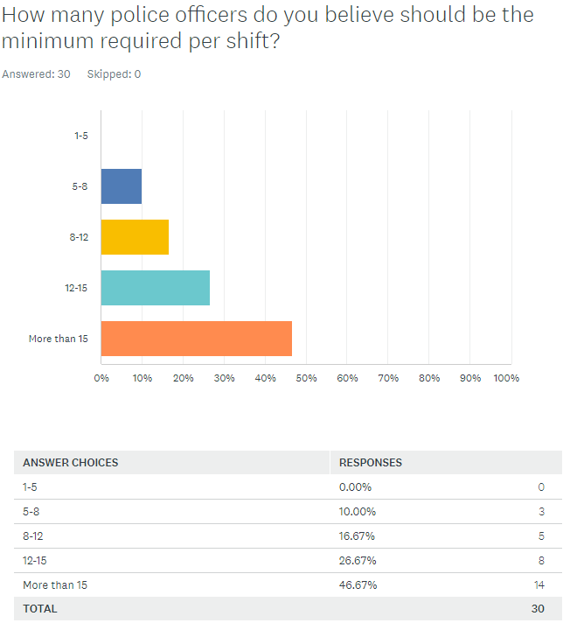
Mental health incidents being reported to the police are continuing to rise as shown in figure 4, chapter 2. The results above show interesting responses, especially that only one person throughout all participants believe the police should deal with mental health incidents. Also, Reports from Bedfordshire police suggest they spent more than 50,000 hours last year dealing with mental health incidents. Therefore, preventing them from dealing with crime incidents as the demand continues to rise (Evans, 2022).

Figure 13: Q7 – Respondents on the left police, respondents on the right are the public.
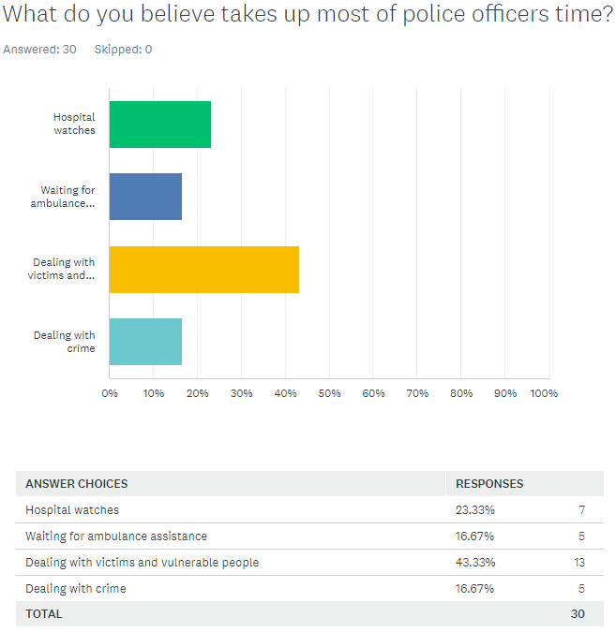
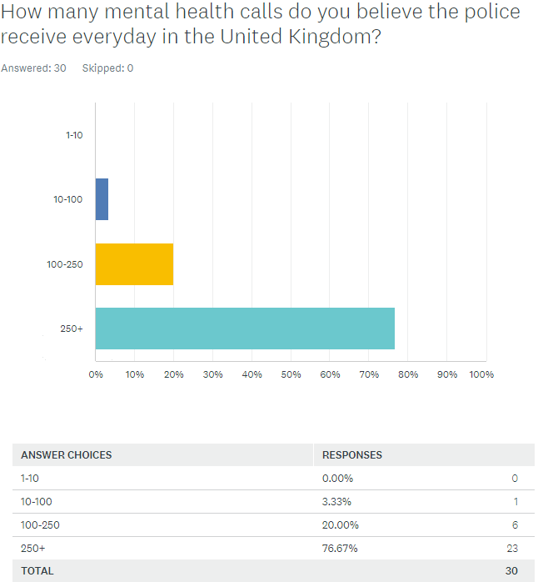
Figure 14: Q8 – Respondents on the left police, respondents on the right are the public.

Figure 15: Q9 – Respondents on the left police, respondents on the right are the public.
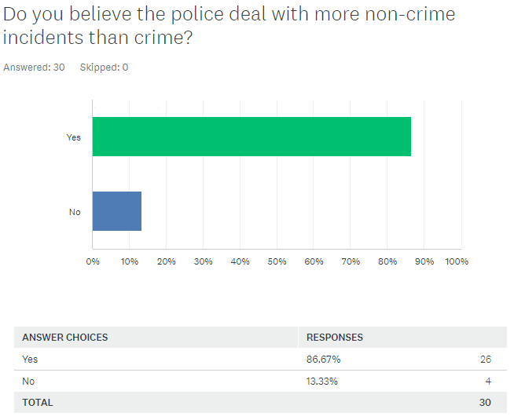
Figure 16: Q10 – Respondents on the left police, respondents on the right are the public.

Both answers from participants to question ten within the questionnaire are very similar, the police are typically known for enforcing the law, preventing crime, investigating crime and supporting victims. “The police and criminal justice systems are responsible for preventing criminal activity as well as punishing those who break the law” (BBC, n.d.). However, news articles are continuing to highlight the rise of non-crime incidents that the police are dealing with. “The reality is roughly 80% of police officers’ time is spent dealing with non-crime related incidents, and budget cuts have created pressures not only across policing, but across all public services” (Heath, 2020).

At the end of the questionnaire the last question was asked for participants to answer. This question was to provide consent for their information to be shared and viewed by others, all 45 participants provided consent. The information that would be shared would just be the responses, no personal information was obtained such as names or addresses. All the respondent’s answers are independent and are their own personal views on the questions asked and no ethical issues were fed back from participants.
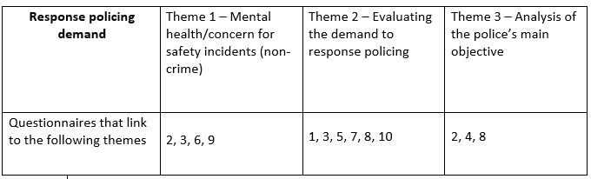
Themes

Figure 17: Themes identified from the research obtained through the questionnaire.

The research aimed to answer and understand the difference between members of the public and police officer views through several different questions. The themes above have been identified by analysing the research to place the linking material into their own sectors. The police and public answered this questionnaire which has provided a comparison of different views. When analysing research, it is important to understand that the findings translate a multitude of perspectives that cover a range of topics. Comparing both views, public and the police, we need to ensure that we weigh their opinions and perspectives in relation to their experience if they're a member of the police (Kornbluh, 2015).

The demand coming through to the police control rooms is more significant than what the public’s perception of what the police should be focusing on. Most of the public want more officers, enabling faster responses to calls and more engagement with communities (Muir, 2016). As shown within figure 13 a percentage of 46.67 was the most common answer, by members of the public when answering the minimum requirement of response officers per shift. This being at least 15 response officers, the second most common answer was between 12-15 which was at 26.67 percent answered by the public.

Conclusion
The findings throughout this chapter have revealed the opinions from members of the public and the police. There are some similarities to questions, and differences around what activities takes up the most of police officers time and what should be prioritised. Furthermore, the main findings show that non-crime incidents are dealt with more than crime, and that demand has increased over the past five years. Also, highlighting that the majority of participants believe the police are understaffed. The linked themes have been identified which correspond towards the demand to response policing. There is concerning evidence towards non-crime incidents rising, however in contrast most respondents in question four within the questionnaire have answered that the police should prioritise investigating crime.

The next chapter will explore the findings in more detail, providing a critical analysis and evaluation to reflect the research title.
Chapter 5: Findings and Conclusion

Introduction
This chapter will explore the findings and links within the themes that have been identified through the research proposal. The research question is aimed to identify whether response policing is becoming more demanding and to identify reasoning behind the answer. The research collated from the questionnaire responses has allowed the findings to be grouped into relevant themes which is explored further in this chapter. Ensuring the material provided relates to the research question provides relevance and engagement to the target audience. The information provided needs to be relevant to enable a clear summary of findings or themes that have been identified (Hargood, 2009).

The objective of the research was to show that the data supports non-crime incidents being at the forefront of response policing. Theme one shows that the data provided through four questions which is veering towards mental health and safety concerns rather than crime related incidents. Calls which involve a mental health concern are believed to be around 15% of the total UK’s policing incidents. Criticisms are held to the police on their dealings with mental health related incidents, however police officers are now expected to take a role in mental health care. Public service cuts are impacting police officer’s professional duties and therefore causing a rise in non-crime incidents (Lane, 2019). The objective of this research was to show the pressures on the front line, when understanding if demand to response policing is increasing. This objective has been achieved through the questionnaire results which links to the first identified theme. The first identified theme provides analyse towards response officers dealing with mental health and safety concern incidents more than crime. Furthermore, as shown in question two and three (See appendix B, Raw questionnaire for details) the public and police believe that response policing deal with more non-crime incidents than crime and that they’re also understaffed. However, when critically analysing these results back to the literature review, the analyses shows that secondary research has also shown links to the majority of police calls being non-crime related. “A key component of improving police awareness of their demand will be refining the understanding of “latent” and non-crime demand” (Langton, 2017).

Theme two links into the evaluation of demand to response policing. Six questions have been identified with linked themes such as staffing, perception of demand on a scale of 1-10 and what is believed to take up the most of police officer’s time. The data between each linked question is very interesting, providing further support towards research gathered in the literature review around lack of support towards demand for front line officers. Statistics show now by critically analysing the findings that most of the public believe that front line policing is understaffed, and that demand is increasing. Former police chiefs have suggested that resources are at a dangerously low level in some areas of the United Kingdom. As stated by Chief Constable Jon Apter "There are not enough boots on the ground, our officers are getting burnt out just trying to keep up with demand and something has to be done about it now" (Webber, 2019).

The objective from the questionnaire was to try and obtain critical answers from the public’s perception on what they believed affects response policing the most when assessing demand. Now, comparing the secondary research from the literature review to try and identify any links between the questionnaire results. Analysing the results from figure 9 from the questionnaire. The results show from this question that the majority of the police and public believe the police should prioritise investigating crime. However, as shown within the literature review in figure four, mental health incidents are continuing to be reported to the police with an approximate figure of 492,200 reports in just 2018. Research was conducted by the Police Foundation around public surveys across seven different police force areas. This was to analyse 28 focus groups opinions in establishing what the police should prioritise. The results show that the public believe the police should prioritise in tackling organised crime, sexual and violent crime and terrorism. However, suggesting that mental health and welfare incidents should be dealt with by other agencies (The Police Foundation, 2020). Although, when analysing the results from figure 11 the majority of the police believe that mental health professionals should deal with mental health incidents. Whereby, the majority of the public believe all services should deal with mental health and safety concern calls, that being the ambulance service, mental health professionals and police. Dyfed-Powys police chief constable Mr Collins provided a summary around the issues of conveying individuals with mental health and dealing with those concern for safety incidents. Individuals are being conveyed approximately 60 miles one way sometimes and getting delayed. This incorporates long round trips for response officers and await times for doctors can be from 10 to 12 hours (Fischer, 2019). As shown within the literature review, this further supports the effects to the police responding to emergency calls and investigating crime due to dealing with mental health incidents.

Critically analysing theme three provides some interesting data, specifically when evaluating figure 12. The results provide a mixed range of responses from the public when providing answers to what they believe takes up the most of police officers time. However, when focusing on the dealing with crime, police officers provided zero responses. Therefore, providing a police perception that dealing with crime is no longer taking up the most time with regards to response policing. Which therefore raises the question whether the police are dealing with more non-crime incidents than crime. This raises the question whether the police are dealing with more non-crime incidents than crime. Furthermore, secondary research suggested that Police were spending 40% of their time handling mental health incidents rather than fighting crime (Turner, 2019). The most common answer with 11 responses from police officers show that they believe dealing with victims and vulnerable people takes up the most time, while waiting for ambulance assistance being second. The question asked can be seen within Figure 14 of this study. Although, linking this critical analysis with figure 9, the public believe the police should prioritise investigating crime over supporting victims and vulnerable people. The latest rise towards demand on police services will cause concern towards the public and police officers. New figures should provide clarity towards the need for the government to make crime and policing a priority. Although there has been a slight increase of police officers, over a prolonged period the loss of skills and experience has provided a detrimental effect towards policing (Apter, 2019).

To conclude, this section has critically analysed the findings and themes identified from the results chapter. Each theme has been discussed in detail, portraying the key links between secondary information from the literature review and results obtained from the questionnaire. The next section will cover the final conclusion to summarise the dissertation as a whole and provided details around future research, recommendations and limitations that were identified.

Summary

The research objectives set at the start of the dissertation were as follows.

- Compare through research whether response policing is becoming more demanding over time either through calls, loss of officers or administration.
- Identify the key areas of response policing and to discover what areas are the most time consuming.
- To discover if front line policing is changing and therefore effecting demand, what are the considerations around future change.
- To find out what pressures front line officers face as well as the policies and procedures in place to provide support.

Throughout this research, evidence has shown that response policing has become more demanding regarding non-crime incidents as shown in Figure 4 and 8. Mental health incidents and concern for safety calls have been on the rise for many years which is placing more pressure and demand towards response policing. Furthermore, this has also reflected to the second objective, which has identified that non-crime incidents are the most time consuming. These incidents requiring more officers to attend these non-crime incidents and spending time waiting in hospitals. This has also provided a change in response policing, as it has now been identified through the research that non-crime incidents are being dealt with more than crime incidents as shown in Figure 16. To add to this, more pressure is being placed on response policing as they’re now dealing with additional incidents rather than being primally focused on preventing and investigating crime. These additional incidents been non-crime and concern for safety related incidents. Figure 5 shows the most common answer from members of the public and response officers that response policing has increased within the past five years. Due to a risk in non-crime incidents, response policing are now dealing with these incidents more than crime.

Further research
Future research has been identified from the information obtained within the findings chapter. One point of research that has been identified is to consult response police officers from different forces. This would provide a wide range of opinions in different areas of the United Kingdom. Which could then reflect similarities to the information that has already been gathered or a completely different analysis of views. Another point of further research could be to ask the same number of views from the police as was asked to the public. Due to work commitments and not being able to speak with other shifts, asking for 30 respondents to the questionnaire from officers was difficult to obtain. Whereas members of the public could answer the questionnaire in their free time which provided more responses to the evidence. Lastly, analysing how the media influences members of the public around policing. Social media is key attribute within society now and how it is presented can provide deceiving perceptions to facts. This can then provide divides between the public and the police as the information can provide an influence on them, but this can also depend on how that individual deems it to be fact or fiction (UKEssays, 2018).

Recommendations
The following recommendations have been identified from analysing the findings to develop further information. More questions could be identified to provide a wider range of responses and information towards the research question. The questions could also be asked to paramedics and mental health professionals to obtain their views on the research question. This would provide a wider response and interesting view of all departments involved in mental health incidents and concern for safety calls. Further investments towards mental health services to easy pressure on front line officers having to attend mental health incidents.

Limitations
All studies will be able to identify limitations and the limitations identified through this dissertation are as follows. One of the main limitations in which would have provided more evidence towards this research chapter was interviews. One of the main limitations to this research is time span for the delivery of the work. Due to work schedules in depth interviews were unable to be taken within the allocated time. In depth interviews with response officers and the public could provide a richer set of data for analysis. Interviewing can provide key data through verbal communication and obtaining further data, however if the interview is unstructured problems can arise (Fox, 2000). Another limitation consideration could be to obtain more information around non-crime incidents from a higher rank within the police force. Such as the Chief Constable of Gwent Police who could provide further in-depth statistics around how many non-crime incidents are reported within Gwent over a year. The size of this research project could be significantly expanded through obtaining data across every force within the United Kingdom. However, this was a limitation within this research project due to managing a workload and managing time.

Bibliography

BBC News. 2019. Police 999 response times almost double in seven years. Available at: https://www.bbc.co.uk/news/uk-england-manchester-47582743
BBC News. 2022. Three-quarters of Police Scotland incidents not crimes, report says. Available at: https://www.bbc.co.uk/news/uk-scotland-62001092?at_medium=RSS
BBC, n.d. The law. https://www.bbc.co.uk/bitesize/guides/z83wsg8/revision/5
Bluelight., (2019). POLICE DEMAND WE HAVE MET THE ENEMY AND HE IS US. https://bluelightonline.co.uk/police-demand/
Boulton, L. et al. (2017) ‘Calls for police service: Understanding the demand profile and the UK police response’, The Police Journal, 90(1), pp. 70–73. doi: 10.1177/0032258X16671032. Available at: Calls for police service: Understanding the demand profile and the UK police response - Laura Boulton, Michelle McManus, Lauren Metcalfe, David Brian, Ian Dawson, 2017 (sagepub.com)
Boulton, L. et al. (2017)(2) ‘Calls for police service: Understanding the demand profile and the UK police response’, The Police Journal, 90(1), pp. 76. doi: 10.1177/0032258X16671032. Available at: Calls for police service: Understanding the demand profile and the UK police response - Laura Boulton, Michelle McManus, Lauren Metcalfe, David Brian, Ian Dawson, 2017 (sagepub.com)
C. Hargood, (2009). Exploring the Importance of Themes in Narrative Systems. University of Southampton. Available at: https://eprints.soton.ac.uk/267749/
C. Turner, (2019). Police spend 40 per cent of time handling mental health incidents rather than fighting crime, says police federation chief. Available at: https://www.telegraph.co.uk/politics/2019/11/26/police-spend-40-per-cent-time-handling-mental-health-incidents/
C. Varela, J. R. Rodrguez, A. Andrs, and R. Roy, (2016). Advantages and disadvantages of using the website SurveyMonkey in a real study: Psychopathological profile in people with normal-weight, overweight and obesity i a community sample. https://www.researchgate.net/publication/316475533_Advantages_and_disadvantages_of_using_the_website_SurveyMonkey_in_a_real_study_Psychopathological_profile_in_people_with_normal-weight_overweight_and_obesity_i_a_community_sample
College of Policing. 2013. National Decision Model. Available at: https://www.college.police.uk/app/national-decision-model/national-decision-model?highlight=national%20decision%20model
College of Policing. 2015. Estimating demand on the Police service. Available at: https://assets.college.police.uk/s3fs-public/2021-03/demand-on-policing-report.pdf
College of Policing. 2015.(2) Estimating demand on the Police service. Available at: https://assets.college.police.uk/s3fs-public/2021-03/demand-on-policing-report.pdf
Dearden, L., 2018. NHS failings 'forcing police to respond to mental health incidents rather than crimes', report finds. Independent. Available at: https://www.independent.co.uk/news/uk/crime/nhs-mental-health-police-crime-uk-failings-funding-government-a8653121.html
Ellison, M. et al. 2021 ‘Understanding policing demand and deployment through the lens of the city and with the application of big data’, Urban Studies, 58(15), pp. 3157–3175. doi:10.1177/0042098020981007. Available at: Understanding policing demand and deployment through the lens of the city and with the application of big data - Mark Ellison, Jon Bannister, Won Do Lee, Muhammad Salman Haleem, 2021 (sagepub.com)
Ellison, M. et al. 2021(2) ‘Understanding policing demand and deployment through the lens of the city and with the application of big data’, Urban Studies, 58(15), pp. 3161. doi:10.1177/0042098020981007. Available at: Understanding policing demand and deployment through the lens of the city and with the application of big data - Mark Ellison, Jon Bannister, Won Do Lee, Muhammad Salman Haleem, 2021 (sagepub.com)
Fischer, G. (2019). 'Police officers taken off beat to deal with mental health calls'. BBC News. Available at: https://www.bbc.co.uk/news/uk-wales-49498208
Gov.uk, 2022. Police officer uplift, England and Wales, quarterly update to 31 March 2022. [online] Available at: https://www.gov.uk/government/statistics/police-officer-uplift-quarterly-update-to-march-2022/police-officer-uplift-england-and-wales-quarterly-update-to-31-march-2022
GOV.UK. 2021. Police funding for England and Wales 2015 to 2022. Available at: https://www.gov.uk/government/statistics/police-funding-for-england-and-wales-2015-to-2022/police-funding-for-england-and-wales-2015-to-2022
Guardian. 2020. Police 999 callouts to people suffering mental health crises soar. Available at: https://www.theguardian.com/society/2020/oct/18/police-999-callouts-to-people-suffering-mental-health-crises-soars
Harris, L. and Brown, G., 2010. Mixing interview and questionnaire methods: Practical problems in aligning data. Scholarworks.umass.edu. Available at: https://scholarworks.umass.edu/cgi/viewcontent.cgi?article=1227&context=pare
Instituteforgovernment, 2019(A). The Police - 10 key facts. [online] Available at: https://www.instituteforgovernment.org.uk/explainers/police-10-key-facts
Instituteforgovernment, 2019(B). The Police - 10 key facts. [online] Available at: https://www.instituteforgovernment.org.uk/explainers/police-10-key-facts
Instituteforgovernment, 2019(C). The Police - 10 key facts. [online] Available at: https://www.instituteforgovernment.org.uk/explainers/police-10-key-facts
J. Apter, (2019). Stats show need to prioritise crime and policing. Police Federation. Available at: https://www.polfed.org/news/latest-news/2019/stats-show-need-to-prioritise-crime-and-policing/
Jones, L., 2019. Police 'dealing with more mental health incidents'. BBC News. Available at: https://www.bbc.co.uk/news/uk-49317060
L. Andrews, (2020). Police are swamped with half a MILLION mental health crisis callouts in a year [Online]. Daily Mail Online. Available at: https://www.dailymail.co.uk/news/article-7983377/Police-swamped-half-MILLION-mental-health-crisis-callouts-year.html
Langton, S. (2017) When crime drops, the demands on the police don't necessarily fall, When crime drops, the demands on the police don’t necessarily fall. Available at: https://theconversation.com/when-crime-drops-the-demands-on-the-police-dont-necessarily-fall-79288
Laufs, J., Bowers, K., Birks, D. and Johnson, S., 2020. Understanding the concept of ‘demand’ in policing: a scoping review and resulting implications for demand management. [online] Taylor & Francis. Available at: https://www.tandfonline.com/doi/full/10.1080/10439463.2020.1791862
LeedsGov, n.d. Available at: https://www.leeds.gov.uk/one-minute-guides/police-welfare-checks
M. Evans, (2022). Police force losing hours to mental health calls and plans to bill the local authority. https://www.telegraph.co.uk/news/2022/07/16/police-force-losing-hours-mental-health-calls-plans-bill-local/
M. Kornbluh, (2015). Combatting Challenges to Establishing Trustworthiness in Qualitative Research. Available at: https://www.tandfonline.com/doi/full/10.1080/14780887.2015.1021941?needAccess=true
N. Fox, (2000). Using Interviews in a Research Project. Research Gate. Available at: https://www.researchgate.net/publication/253117832_Using_Interviews_in_a_Research_Project
Npcc.police.uk, 2017 (pp,16). Better understanding demand - Policing the future. [online] Available at: https://www.npcc.police.uk/2017%20FOI/CO/078%2017%20CCC%20April%202017%2024%20Better%20Understanding%20Demand%20Policing%20the%20Future.pdf
P. Cape, n.d. Questionnaire Sample Length: The Long and Short of Participant Engagement [Online]. https://www.questionpro.com/blog/questionnaire-sample-length/
Parliament., (2018). Policing for the future. https://publications.parliament.uk/pa/cm201719/cmselect/cmhaff/515/51509.htm
Paul Walley, Anna Jennison-Phillips, A Study of Non-Urgent Demand to Identify Opportunities for Demand Reduction, Policing: A Journal of Policy and Practice, Volume 14, Issue 2, June 2020, Pages 542–554, https://doi.org/10.1093/police/pay034
Phair, D. and Warren, K., 2021. Saunders' Research Onion: Explained Simply (+ Examples) - Grad Coach. Grad Coach. Available at: https://gradcoach.com/saunders-research-onion/
QuestionPro. n.d. Target Audience: What is and how to define it | QuestionPro. Available at: https://www.questionpro.com/blog/what-is-a-target-audience/#:~:text=What%20is%20a%20target%20audience,of%20certain%20products%20and%20services.
R. Lane, (2019). I'm a police officer not a social worker or mental health nurse: Online discourses of exclusion and resistance regarding mental health-related police work. Wiley online library. Available at: https://onlinelibrary.wiley.com/doi/full/10.1002/casp.2410?saml_referrer
R. Muir, (2016). Great expectations: what do the public want from the police?. The Police Foundation. Available at: https://www.police-foundation.org.uk/2016/09/great-expectations-what-do-the-public-want-from-the-police/
Sofaer, S., 1999. Qualitative Methods: What Are They and Why Use Them?. Ncbi.nlm.nih.gov. Available at: https://www.ncbi.nlm.nih.gov/pmc/articles/PMC1089055/pdf/hsresearch00022-0025.pdf
The Independent, 2020(A). Boris Johnson's promise of 20,000 officers isn't enough to solve crime problems, says Britain's most senior police chief. [online] Available at: https://www.independent.co.uk/news/uk/home-news/boris-johnson-police-officers-cuts-austerity-tory-crime-martin-hewitt-a9269481.html
The Independent, 2020(B). Police risk being 'overwhelmed' by rising 999 calls after budget cuts. Available at: https://www.independent.co.uk/news/uk/home-news/police-999-calls-emergency-rise-budget-cuts-a9611076.html
The Police Foundation. (2020). The public want the police to be more visible and to focus on core tasks, according to new research. The Police Foundation. Available at: https://www.police-foundation.org.uk/news/the-public-want-the-police-to-be-more-visible-and-to-focus-on-core-tasks-according-to-new-research/#:~:text=The%20report%20finds%20that%20the%20public%20want%20the,groups%20undertaken%20in%20seven%20different%20police%20force%20areas
UKEssays. November 2018. The relationship between Media and Police in Britain. [online]. Available from: https://www.ukessays.com/essays/criminology/the-relationship-between-media-and-police-in-britain-criminology-essay.php?vref=1
W. Heath, (2020). 80% of police officers time spent dealing with non-crime. https://www.thejusticegap.com/80-of-police-officers-time-spent-dealing-with-non-crime/
Walley, P. and Adams, M., 2019(2). An Evaluation of Demand Management Practices in UK Police Forces. Pp. 19-20. Open.ac.uk. Available at: https://www.open.ac.uk/centres/policing/sites/www.open.ac.uk.centres.policing/files/files/News/An%20Evaluation%20of%20Demand-Management-Practices-in-UK-Final-report.pdf
Walley, P. and Jennison-Phillips, A., 2018. A Study of Non-Urgent Demand to Identify Opportunities for Demand Reduction. Oxford Academic. Available at: https://academic.oup.com/policing/article/14/2/542/5045104?login=true
Walliman, N., 2006. Social Research Methods. Google Books. Available at: https://books.google.co.uk/books?id=eeuo9yZDDrcC&pg=PA36&source=gbs_toc_r&cad=3#v=onepage&q&f=false
Webber, A. (2019) Police lack resources to do their job, ex-chiefs warn. Available at: Police lack resources to do their job, ex-chiefs warn - Personnel Today
Writer, S., 2020. Why Are Graphs Important?. Reference.com. Available at: https://www.reference.com/world-view/graphs-important-3c19dcca7f97b2b9

Appendices

Appendix 1 – Ethics form

APPLICATION FOR ETHICAL APPROVAL

In order for research to result in benefit and minimise risk of harm, it must be conducted ethically. A researcher may not be covered by the University’s insurance if ethical approval has not been obtained prior to commencement.

The University follows the OECD Frascati manual definition of research activity: “creative work undertaken on a systematic basis in order to increase the stock of knowledge, including knowledge of man, culture and society, and the use of this stock of knowledge to devise new applications”. As such this covers activities undertaken by members of staff, postgraduate research students, and both taught postgraduate and undergraduate students working on dissertations/projects.

The individual undertaking the research activity is known as the “principal researcher”.

Ethical approval is not required for routine audits, performance reviews, quality assurance studies, testing within normal educational requirements, and literary or artistic criticism.

Please read the notes for guidance before completing ALL sections of the form.

This form must be completed and approved prior to undertaking any research activity. Please see Checklist for details of process for different categories of application.

Delete the Guidance Notes at the end of the form BEFORE submitting your application

SECTION A: About You (Principal Researcher)
Full Name: |  | Jamie Gough
Tick all boxes which apply: |  | Member of staff: | ☐ | Honorary research fellow: | ☐
Undergraduate Student | ☒ | Taught Postgraduate Student | ☐ | Postgraduate Research Student | ☐

Institute/Academic Discipline/Centre: | IMH
Campus: | Swansea
E-mail address: | 1920839@student.uwtsd.ac.uk
Contact Telephone Number:
For students:
Student Number: | 1920839
Programme of Study: | BSC Bachelor of Science (Honours)  DA6PPP-GW Professional Policing Practice
Director of Studies/Supervisor: | Deepak Patel

SECTION B: Approval for Research Activity
Has the research activity received approval in principle?  (please check the Guidance Notes as to the appropriate approval process for different levels of research by different categories of individual) |  | YES | ☒ | NO | ☐
 |  |  |  | Date
If Yes, please indicate source of approval (and date where known): Approval in principle must be obtained from the relevant source prior to seeking ethical approval | Research Degrees Committee |  | ☐
 | Institute Research Committee |  | ☐
 | Other (write in) |  | ☒ | Deepak Patel

SECTION C: Internal and External Ethical Guidance Materials
Please list the core ethical guidance documents that have been referred to during the completion of this form (including any discipline-specific codes of research ethics, and also any specific ethical guidance relating to the proposed methodology). Please tick to confirm that your research proposal adheres to these codes and guidelines.
UWTSD Research Ethics & Integrity Code of Practice | ☒
UWTSD Research Data Management Policy | ☒
 | ☐

SECTION D: External Collaborative Research Activity
Does the research activity involve collaborators outside of the University? |  | YES | ☐ | NO | ☒
If Yes, please provide the name of the external organisation and name and contact details for the main contact person and confirmation this person has consented to their personal data being shared.as part of this collaboration.
Institution
Contact person name
Contact person e-mail address

Has this individual consented to sharing their details on this form? |  | YES | ☐ | NO |  |  | ☒
Are you in receipt of a KESS scholarship? |  | YES | ☐ | NO |  |  | ☒
Is your research externally funded |  | YES | ☐ | NO |  |  | ☒
Are you specifically employed to undertake this research in either a paid or voluntary capacity? | Voluntary | YES | ☐ | NO |  | ☒
 | Employed | YES | ☐ | NO |  | ☒
Is the research being undertaken within an existing UWTSD Athrofa Professional Learning Partnership (APLP) | If YES then the permission question below does not need to be answered. | YES | ☐ | NO |  |  | ☒
Permission to undertake the research has been provided by the partner organisation | (If YES attach copy)  If NO the application cannot continue | YES | ☐ | NO |  |  | ☒

Where research activity is carried out in collaboration with an external organisation
Does this organisation have its own ethics approval system? | YES | ☐ | NO | ☒
If Yes, please attach a copy of any final approval (or interim approval) from the organisation

SECTION E: Details of Research Activity
Indicative title: | A critical evaluation into the understanding if response policing is becoming more demanding and analysing the pressures of being on the front line.
Proposed start date: |  | Proposed end date:
Introduction to the Research (maximum 300 words)
Ensure that you write for a Non-Specialist Audience when outlining your response to the three points below:
- Purpose of Research Activity
- Proposed Research Question
- Aims of Research Activity
- Objectives of Research Activity
Demonstrate, briefly, how Existing Research has informed the proposed activity and explain
- What the research activity will add to the body of knowledge
- How it addresses an area of importance.
Purpose of Research Activity

Response policing is the centralisation of all aspects of policing, it incorporates all types of crime, victims, suspects and much more. Being a response police officer for just over two years now, I want to document and express the demand and pressures around being on the front line. By evaluating the demand, it enables areas to be identified that are being overwhelmed and to incorporate measures to support these areas. Demand is being assessed by many forces due to the previous cuts in resourcing over the years. Critically, by recruitment being put on hold and other areas within the force being reduced in staffing, acceptability as well as value of work is now questioned.

Figure 1 – Source: (Institute for Government, 2019, (A)

Furthermore, throughout different forces we are seeing a change in how operations are run. Therefore, looking at ways to reduce the demand, as well as reducing the high level of work that is being enforced on the police service. (NPCC, 2017) “crime, accounts for less than a quarter of ‘demand’ through calls for service” (College of Policing 2015, as cited in NPCC, 2017)

(this box should expand as you type)
Research Question

Q1. What are the key factors that are putting strain on the UK police force?
Q2. To what extent are government actions benefitting modern day policing?
Q3. What are the key factors in which policing is changing and how these factors impacts front line situations?
Q4. What does the future look like for the demand within the police force?

(this box should expand as you type)
Aims of Research Activity
The research aims will be as follows –

To identify whether demand for response policing is becoming to overwhelming.
Be able to identify the pressures in which front line officers face.
Develop key statistics from sources to provide valuable evidence towards answering this dissertation.

(this box should expand as you type)
Objectives of Research Activity

- Compare through research whether response policing is becoming more demanding over time either through calls, loss of officers or administration.
- Identify the key areas of response policing and to discover what areas are the most time consuming.
- To discover if front line policing is changing and therefore effecting demand, what are the considerations around future change.
- To find out what pressures front line officers face as well as the policies and procedures in place to provide support.

(this box should expand as you type)
Proposed methods (maximum 600 words)
Provide a brief summary of all the methods that may be used in the research activity, making it clear what specific techniques may be used. If methods other than those listed in this section are deemed appropriate later, additional ethical approval for those methods will be needed.
Different research methods will be used throughout this dissertation such as questionnaires, journals, news articles and government figures. These methods will be used as I believe they will provide the best supporting evidence towards my title. Government figures will be key as they will show the different areas of demand and thereby providing statistics around my dissertation. Furthermore, journals and news articles provide additional information towards highlighted areas that will offer supporting evidence.

The intended participants throughout this dissertation will be towards front line officers and the public. The reason for this is because they will be able to provide valuable evidence towards the main question for this dissertation. Front line officers deal with the demand and will reflect the pressures they face by answering the questions provided, and that is why they’re best suited for my research. Therefore, providing key statistics which will be presented via a graph showing the comparisons between each chosen subject area. To add to this, I do intend to also develop a questionnaire towards the public around their views on what they think police demand and pressures are for front line officers. Thereby, showing an interesting comparison between front line officers and the public’s perception.

(this box should expand as you type)

Location of research activity
Identify all locations where research activity will take place.
Gwent
(this box should expand as you type)
Research activity outside of the UK
If research activity will take place overseas, you are responsible for ensuring that local ethical considerations are complied with and that the relevant permissions are sought. Specify any local guidelines (e.g. from local professional associations/learned societies/universities) that exist and whether these involve any ethical stipulations beyond those usual in the UK (provide details of any licenses or permissions required). Also specify whether there are any specific ethical issues raised by the local context in which the research activity is taking place, for example, particular cultural and/or legal sensitivities or vulnerabilities of participants.
N/A

(this box should expand as you type)
Use of documentation not in the public domain: Are any documents NOT publicly available? | NO | ☒
 | YES | ☐
If Yes, please provide details here of how you will gain access to specific documentation that is not in the public domain and that this is in accordance with prevailing data protection law of the country in question and England and Wales.

(this box should expand as you type)

SECTION F: Scope of Research Activity
Will the research activity include: | YES | NO
Use of a questionnaire or similar research instrument? | ☒ | ☐
Use of interviews? | ☐ | ☒
Use of diaries? | ☐ | ☒
Participant observation with their knowledge? | ☐ | ☒
Participant observation without their knowledge? | ☐ | ☒
Use of video or audio recording? | ☐ | ☒
Access to personal or confidential information without the participants’ specific consent? | ☐ | ☒
Administration of any questions, test stimuli, presentation that may be experienced as physically, mentally or emotionally harmful / offensive? | ☐ | ☒
Performance of any acts which may cause embarrassment or affect self-esteem? | ☐ | ☒
Investigation of participants involved in illegal activities? | ☐ | ☒
Use of procedures that involve deception? | ☐ | ☒
Administration of any substance, agent or placebo? | ☐ | ☒
Working with live vertebrate animals? | ☐ | ☒
Other primary data collection methods, please explain in this box  For example, ‘focus groups’. Please indicate the type of data collection method(s) in this box and tick the accompany box. | ☐ | ☒
Details of any other primary data collection method:  (this box should expand as you type) | ☐ | ☒
If NO to every question, then the research activity is (ethically) low risk and may be exempt from some of the following sections (please refer to Guidance Notes).

If YES to any question, then no research activity should be undertaken until full ethical approval has been obtained.

SECTION G: Intended Participants
Who are the intended participants: | YES | NO
Students or staff at the University? | ☒ | ☐
Adults (over the age of 18 and competent to give consent)? | ☒ | ☐
Vulnerable adults? | ☐ | ☒
Children and Young People under the age of 18? (Consent from Parent, Carer or Guardian will be required) | ☐ | ☒
Prisoners? | ☐ | ☒
Young offenders? | ☐ | ☒
Those who could be considered to have a particularly dependent relationship with the investigator or a gatekeeper? | ☐ | ☒
People engaged in illegal activities? | ☐ | ☒
Others (please identify specifically any group who may be unable to give consent) please indicate here and tick the appropriate box. | ☐ | ☒
Other – please indicate here:  (this box should expand as you type) | ☐ | ☒

Participant numbers and source
Provide an estimate of the expected number of participants. How will you identify participants and how will they be recruited?
How many participants are expected? | Approximately 15-20 participants.  (this box should expand as you type)
Who will the participants be? | The participants will range from colleagues who I work alongside, some also being students through PCDA or DHEP. To add to this, family and friends will also be asked for evidence providing member of the public views towards the aimed questions and will be the same questions to all participants.  (this box should expand as you type)
How will you identify the participants? | Participants will be identified through work, the ones I work along side as front line response officers. Friends and family will also be utilised; however none will be vulnerable and all participants will be over the age of 18.  No one will be forced to take part in the questionnaire as it will be a complete voluntary process.  (this box should expand as you type)

Information for participants: | YES | NO | N/A
Will you describe the main research procedures to participants in advance, so that they are informed about what to expect? | ☒ | ☐ | ☐
Will you tell participants that their participation is voluntary? | ☒ | ☐ | ☐
Will you obtain written consent for participation? | ☒ | ☐ | ☐
Will you explain to participants that refusal to participate in the research will not affect their treatment or education (if relevant)? | ☐ | ☐ | ☒
If the research is observational, will you ask participants for their consent to being observed? | ☐ | ☐ | ☒
Will you tell participants that they may withdraw from the research at any time and for any reason? | ☒ | ☐ | ☐
With questionnaires, will you give participants the option of omitting questions they do not want to answer? | ☒ | ☐ | ☐
Will you tell participants that their data will be treated with full confidentiality and that, if published, it will not be identifiable as theirs? | ☒ | ☐ | ☐
Will you debrief participants at the end of their participation, in a way appropriate to the type of research undertaken? | ☒ | ☐ | ☐
If NO to any of above questions, please give an explanation
(this box should expand as you type)

Information for participants: | YES | NO | N/A
Will participants be paid? | ☐ | ☒ | ☐
Is specialist electrical or other equipment to be used with participants? | ☐ | ☒ | ☐
Are there any financial or other interests to the investigator or University arising from this study? | ☐ | ☒ | ☐
Will the research activity involve deliberately misleading participants in any way, or the partial or full concealment of the specific study aims? | ☐ | ☒ | ☐
If YES to any question, please provide full details
(this box should expand as you type)

SECTION H: Anticipated Risks

Outline any anticipated risks that may adversely affect any of the participants, the researchers and/or the University, and the steps that will be taken to address them.

If you have completed a full risk assessment (for example as required by a laboratory, or external research collaborator) you may append that to this form.
Full risk assessment completed and appended? |  | Yes | ☐
 |  | No | ☒
Risks to participants
For example: emotional distress, financial disclosure, physical harm, transfer of personal data, sensitive organisational information
Risk to Participant:  No risks identified.  (this box should expand as you type) | How will you mitigate the Risk to Participant  (this box should expand as you type)
If research activity may include sensitive, embarrassing or upsetting topics (e.g. sexual activity, drug use) or issues likely to disclose information requiring further action (e.g. criminal activity), give details of the procedures to deal with these issues, including any support/advice (e.g. helpline numbers) to be offered to participants. Note that where applicable, consent procedures should make it clear that if something potentially or actually illegal is discovered in the course of a project, it may need to be disclosed to the proper authorities
(this box should expand as you type)
Risks to investigator
For example: personal safety, physical harm, emotional distress, risk of accusation of harm/impropriety, conflict of interest
Risk to Investigator:  No risks identified.  (this box should expand as you type) | How will you mitigate the Risk to Investigator:  (this box should expand as you type)
University/institutional risks
For example: adverse publicity, financial loss, data protection
Risk to University:  No risks identified.  (this box should expand as you type) | How will you mitigate the Risk to University:  (this box should expand as you type)

Disclosure and Barring Service
If the research activity involves children or vulnerable adults, a Disclosure and Barring Service (DBS) certificate must be obtained before any contact with such participants. | YES | NO | N/A
Does your research require you to hold a current DBS Certificate? | ☐ | ☐ | ☒

SECTION I: Feedback, Consent and Confidentiality
Feedback
What de-briefing and feedback will be provided to participants, how will this be done and when?
De-briefing will be provided to participants prior to taking the questionnaire. Explaining how a copy can be obtained of the results and the feedback if they wish to obtain this information. This will be done following all questionnaires being handed in and the final graph being complete to show the final results following the evidence.

(this box should expand as you type)
Informed consent
Describe the arrangements to inform potential participants, before providing consent, of what is involved in participating. Describe the arrangements for participants to provide full consent before data collection begins. If gaining consent in this way is inappropriate, explain how consent will be obtained and recorded in accordance with prevailing data protection legislation.
By completing this form I will acknowledge and act upon any ethical issues presented to me to ensure there are no ethical issues. All participants will be told this is a voluntary process and they do not have to complete the questionnaire if they do not wish to do so. The questionnaire will be explained prior to being filed out to all participants, to ensure there is no confusion and any questions that may have prior to taking part can be answered.

(this box should expand as you type)
Confidentiality / Anonymity
Set out how anonymity of participants and confidentiality will be ensured in any outputs. If anonymity is not being offered, explain why this is the case.
The only details obtained from the questionnaire will be age, length of service and job title. This will be obtained to identify the difference in answers if any from different age brackets ect. All completed questionnaires will be kept secure on my PC, and only viewed by myself to complete the final graph which again can be obtained for participants if they wish to obtain a copy. No names will be required for the questionnaire and it will remain completely anonymous apart from the details stated as above.

(this box should expand as you type)

SECTION J: Data Protection and Storage
In completing this section refer to the University’s Research Data Management Policy and the extensive resources on the University’s Research Data Management web pages (http://uwtsd.ac.uk/library/research-data-management/).
Does the research activity involve personal data (as defined by the General Data Protection Regulation 2016 “GDPR” and the Data Protection Act 2018 “DPA”)? | YES | NO
“Personal data” means any information relating to an identified or identifiable natural person (‘data subject’). An identifiable natural person is one who can be identified, directly or indirectly, in particular by reference to an identifier such as a name, an identification number, location data, an online identifier or to one or more factors specific to the physical, physiological, genetic, mental, economic, cultural or social identity of that natural person. | ☐ | X
If YES, provide a description of the data and explain why this data needs to be collected:
(this box should expand as you type)
Does it involve special category data (as defined by the GDPR)? | YES | NO
“Special category data” means sensitive personal data consisting of information as to the data subjects’ –  (a) racial or ethnic origin,  (b) political opinions,  (c ) religious beliefs or other beliefs of a similar nature,  (d) membership of a trade union (within the meaning of the Trade Union and Labour Relations (Consolidation) Act 1992),  (e) physical or mental health or condition,  (f) sexual life,  (g) genetics,  (h) biometric data (as used for ID purposes), | ☐ | x
If YES, provide a description of the special category data and explain why this data needs to be collected:
(this box should expand as you type)
Will the research activity involve storing personal data and/or special category data on one of the following: | YES | NO
Manual files (i.e. in paper form)? | ☐ | ☒
University computers? | ☐ | ☒
Private company computers? | ☐ | ☒
Home or other personal computers? | ☐ | ☒
Laptop computers/ CDs/ Portable disk-drives/ memory sticks? | ☐ | ☒
“Cloud” storage or websites? | ☐ | ☒
Other – specify: | ☐ | ☒
For all stored data, explain the measures in place to ensure the security of the data collected, data confidentiality, including details of password protection, encryption, anonymisation and pseudonymisation:
(this box should expand as you type)
All Data Storage
Will the research activity involve any of the following activities: | YES | NO
Electronic transfer of data in any form? | ☐ | ☒
Sharing of data with others at the University? | ☐ | ☒
Sharing of data with other organisations? | ☐ | ☒
Export of data outside the European Union or importing of data from outside the UK? | ☐ | ☒
Use of personal addresses, postcodes, faxes, emails or telephone numbers? | ☐ | ☒
Publication of data that might allow identification of individuals? | ☐ | ☒
Use of data management system? | ☐ | ☒
Data archiving? | ☐ | ☒
If YES to any question, please provide full details, explaining how this will be conducted in accordance with the GDPR and DPA (and/or any international equivalent):
(this box should expand as you type)
List all who will have access to the data generated by the research activity:
(this box should expand as you type)
List who will have control of, and act as custodian(s) for, data generated by the research activity:
(this box should expand as you type)
Give details of data storage arrangements, including security measures in place to protect the data, where data will be stored, how long for, and in what form. Will data be archived – if so how and if not why not.
(this box should expand as you type)
Please indicate if your data will be stored in the UWTSD Research Data Repository (see https://researchdata.uwtsd.ac.uk/ ). If so please explain. (Most relevant to academic staff)
(this box should expand as you type)
Confirm that you have read the UWTSD guidance on data management (see https://www.uwtsd.ac.uk/library/research-data-management/) | YES | ☒
 | NO | ☐
Confirm that you are aware that you need to keep all data until after your research has completed or the end of your funding | YES | ☒
 | NO | ☐

SECTION K: Declaration
The information which I have provided is correct and complete to the best of my knowledge. I have attempted to identify any risks and issues related to the research activity and acknowledge my obligations and the rights of the participants.

In submitting this application I hereby confirm that I undertake to ensure that the above named research activity will meet the University’s Research Ethics and Integrity Code of Practice which is published on the website: https://www.uwtsd.ac.uk/research/research-ethics/
Signature of applicant: | J.Gough | Date: 04.05.2022

For STUDENT Submissions:
Director of Studies/Supervisor: |  | Date:
Signature: |  | Date:

For STAFF Submissions:
Academic Director/ Assistant Dean: |  | Date:
Signature: |  | Date:

Checklist: Please complete the checklist below to ensure that you have completed the form according to the guidelines and attached any required documentation:
☒ | I have read the guidance notes supplied before completing the form.
☒ | I have completed ALL RELEVANT sections of the form in full.
☒ | I confirm that the research activity has received approval in principle
☒ | I have attached a copy of final/interim approval from external organisation (where appropriate)
☐ | I have attached a full risk assessment (and have NOT completed Section H of this form) (where appropriate) ONLY TICK IF YOU HAVE ATTACHED A FULL RISK ASSESSMENT
☒ | I understand that it is my responsibility to ensure that the above named research activity will meet the University’s Research Ethics and Integrity Code of Practice.
☒ | I understand that before commencing data collection all documents aimed at respondents (including information sheets, consent forms, questionnaires, interview schedules etc.) must be confirmed by the DoS/Supervisor, module tutor or Academic Director.
☒ | I have deleted the guidance notes before submitting the PG2 for consideration

RESEARCH STUDENTS AND STAFF ONLY
All communications relating to this application during its processing must be in writing and emailed to pgresearch@uwtsd.ac.uk , with the title ‘Ethical Approval’ followed by your name.
You will be informed of the outcome of your claim by email; therefore it is important that you check your University and personal email accounts regularly.

STUDENTS ON UNDERGRADUATE OR TAUGHT MASTERS PROGRAMMES should submit this form (and receive the outcome) via systems explained to you by the supervisor/module leader.

This form is available electronically from the Academic Office web pages: https://www.uwtsd.ac.uk/academic-office/appendices-and-forms/

Application Process

All staff research projects and all research students must submit the Ethical Approval Form to the University Research Ethics Committee via the Academic Office (pgresearch@uwtsd.ac.uk). Staff research directly in relation to personal study for taught undergraduate or Masters programmes should be submitted via the Institute procedures explained below.

Taught masters and taught undergraduate research Ethical Approval Forms are considered within Institutes. Institutes will provide details of the specific processes for this. Where the Ethical issues within any single ethical application are of particular concern the Institute will refer these to the University Research Ethics Committee. Any student activity that involves the collection of primary data needs to undergo Ethical approval, this includes assignment work as well as dissertations.

Appendix 2 – Questionnaire - Police

Dissertation questionnaire

Please circle your answers, do not circle more than one answer.
Participation confirmation –
Police officer – Length of service
0-12 months
1-3 years
3-10 years
10+ years
Response policing is the term widely used to describe the teams of police officers that respond to emergency and non-emergency calls from members of the public.

- On a scale of 1-10 with one being the lowest and ten being the highest, do you believe that response policing is becoming more demanding?
- 1-3
- 3-5
- 5-7
- 7-10

- What incidents do you believe that response policing deal with the most?
- Non-crime incidents – e.g. Mental health/Concern for safety calls.
- Theft – e.g. Burglaries/Robberies
- Sexual offences
- Cyber crime
- Domestic incidents

- Do you believe that the police are understaffed?
- Yes
- Slightly
- No

- What should the police prioritise?
- Supporting victims and vulnerable people
- Investigating crime
- Conducting more stop searches
- Conducting more foot patrols

- Do you believe demand to response policing has increased over the past five 5 years?
- Yes
- No

- Who do you believe should deal with mental health incidents?
- Ambulance service
- Police
- Mental health professionals
- All of the above

- How many police officers do you believe should be the minimum required per shift?
- 1-5
- 5-8
- 8-12
- 12-15
- More than 15

- What do you believe takes up most of police officers time?
- Hospital watches
- Waiting for ambulance assistance
- Dealing with victims and vulnerable people
- Dealing with crime

- How many mental health calls do you believe the police receive everyday in the United Kingdom?
- 1-10
- 10-100
- 100-250
- 250 +

- Do you believe the police deal with more non-crime incidents than crime?
- Yes
- No

Do you give consent for your answers and information to be utilised in research which may be seen by other people?
- Yes
- No

Appendix 3 – Survey Monkey – Public


