28/02/2024
Raluca-Cornelia Vasiu (2241085)
University of Wales Trinity Saint David
Group Presentation
Design thinking – Empathise in the Climate Change
Introduction
Climate change, which is mostly caused by people doing things like burning fossil fuels and cutting down trees, is a threat to our very existence. As temperatures rise around the world, ice caps melt, natural disasters happen more often and with more force, ecosystems are thrown off balance, and species is in danger. The effects are widespread and have an impact on health, water resources, and food stability. People need to move quickly to cut down on emissions, switch to renewable energy sources, and get used to the changes that are already happening. To fight this crisis and protect the future of our planet for future generations, the world needs to work together internationally, use sustainable practices, and raise public knowledge.

Main Findings
(What is empathize?)
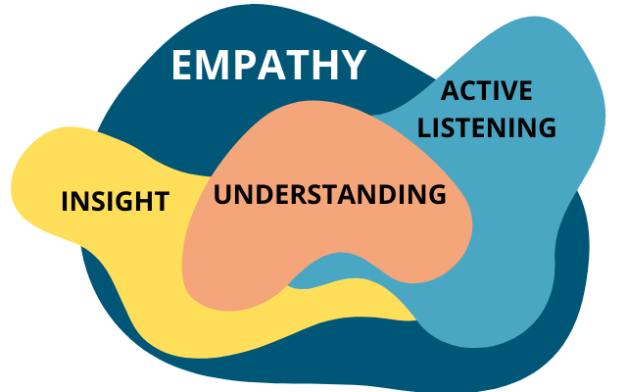
A person is said to "empathise" when they understand and share the feelings, thoughts, and points of view of others. When you use design thinking, empathising means really understanding the feelings, wants, and experiences of the people you are making a product or service for. Putting yourself in their shoes means carefully listening to their stories, watching how they act, and learning about the problems they are having and the things they want. By empathising, designers can really understand what users want and why they want it, which helps them make solutions that meet those goals.
(What is empathize in design thinking process?)
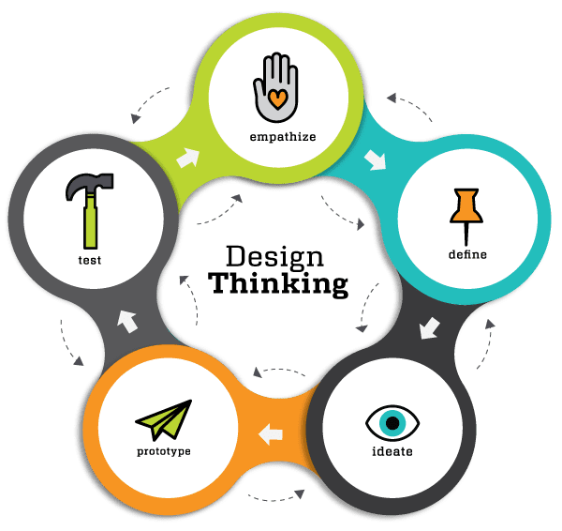
"Empathise" is the first step in the design thought process. It means being able to relate to and understand the people that a person are creating for in terms of their experiences, thoughts, and feelings. In this step, is to actively listen, observe, and put yourself in the users' place to really understand their needs, challenges, and goals. By putting themselves in the shoes of users, designers can learn useful things that can be used throughout the design process to make solutions that meet users' wants and give them meaningful experiences.

(Empathize design thinking in context of climate change)
When using design thinking to deal with climate change, "empathise" means knowing the different experiences, worries, and weaknesses of people and communities that are being affected by climate change. In this step, is needed to listen to their stories, see how climate change affects their daily lives, and understand how they feel and the problems they are facing.
Designers can learn a lot by putting themselves in the shoes of people who are touched by climate change. For example, learning about the real-life struggles of communities can help understand the problems they are facing because of climate change, like food shortages, extreme weather, or rising sea levels.
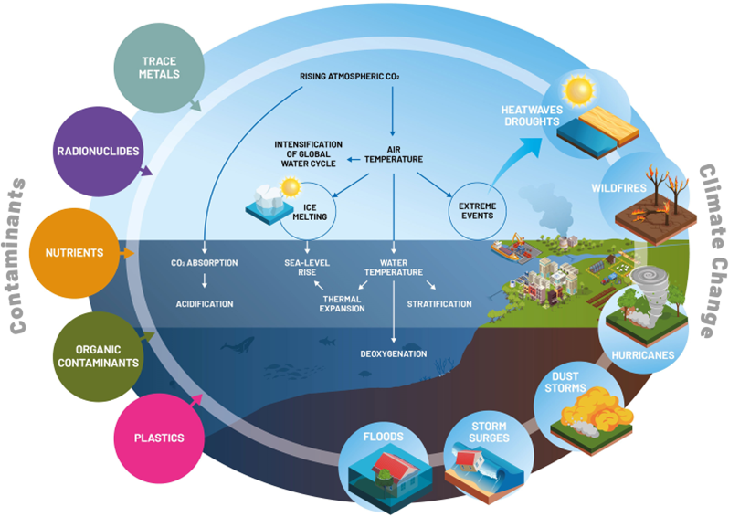
Also, the fact that empathy helps people figure out what the specific needs and goals of different groups are shows that it can help designers make solutions that work well for those problems.
Help people work together by understanding their concerns; this builds trust and teamwork, gets people in the community involved in the planning process, and makes sure that the final products are fair and respectful of different cultures.
Drive innovation shows that empathy leads to creativity and new ideas by revealing hidden needs and points of view that might not have been obvious otherwise. This can help find better and more creative ways to deal with climate change problems.

(How to prevent climate change?)
Climate change has many effects on the world. For example, global temperatures are rising, which makes heatwaves more common and stronger, which can cause illnesses and deaths from the heat. Climate change makes weather events like storms, floods, and droughts happen more often and with more force. These events can destroy a lot of property, force people to move, and even kill people.
When polar ice caps and glaciers melt, the sea level rises. This puts coastal towns at risk of flooding, erosion, and saltwater getting into freshwater sources. Agricultural output is affected by changes in temperature and rainfall patterns, which causes food and water shortages, especially in areas that are already weak.
People, communities, countries, and the world must all work together to stop the worst effects of climate change. Using less fossil fuels, switching to green energy sources, and becoming more energy efficient are some of the most important things that can be done to slow down climate change.
Protecting forests, wetlands, and other natural areas helps store carbon dioxide, protect wildlife, and make people more resistant to the effects of climate change. Building adaptable infrastructure, creating early warning systems, and encouraging sustainable farming practices are some of the things that can be done to help communities better deal with the effects of climate change.
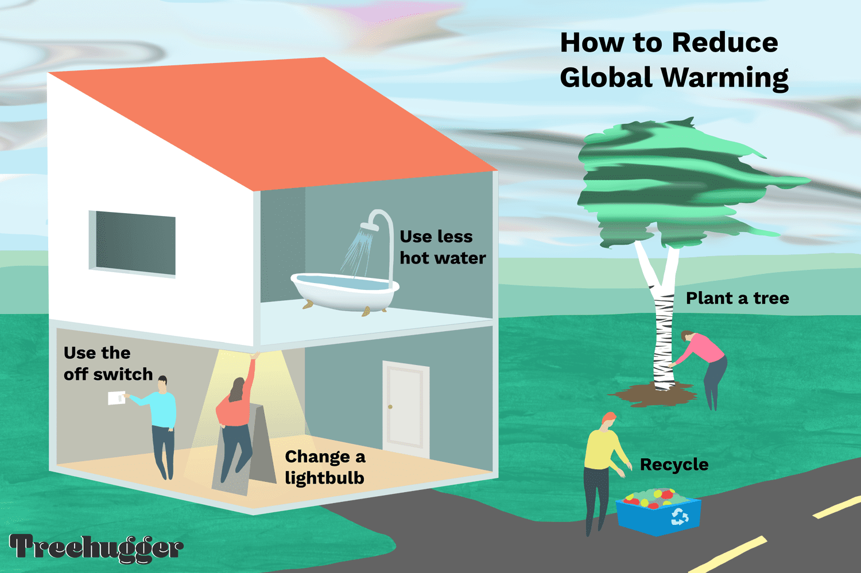
Supporting renewable energy projects, pushing public transportation, reducing waste, and encouraging sustainable ways of producing and consuming can help lower emissions and slow down climate change.

Conclusion
In conclusion rising temperatures, extreme weather events, melting ice caps, and dangers to ecosystems, food, and water security are just some of the ways that climate change affects the world. All levels of government need to work together to stop these affects. Reducing greenhouse gas emissions and switching to renewable energy are two important mitigation tactics that must be used to stop climate change from getting worse.
Communities can also deal with current and future effects by adapting to them through actions like restoring ecosystems and building adaptable infrastructure. International cooperation is very important for solving this world problem. The world can lessen the worst effects of climate change and make the future more stable and fairer for everyone by encouraging sustainability, safeguarding environments, and working together.

Reference list:

- Dam, R. and Siang, T.Y. (2018). Design Thinking: Getting Started with Empathy. The Interaction Design Foundation. Available at: https://www.interaction-design.org/literature/article/design-thinking-getting-started-with-empathy. [Accessed 26 Feb. 2024].
- Greater Good Magazine (2009). Empathy Definition | What Is Empathy. Greater Good. Available at: https://greatergood.berkeley.edu/topic/empathy/definition. [Accessed 26 Feb. 2024].
- Linkedin, (2024).Integrating Design Thinking into Climate Change Strategies: A Pathway to Innovation and Effectiveness. Available at: https://www.linkedin.com/pulse/integrating-design-thinking-climate-change-strategies-pathway-dkbrf/?trk=public_post_main-feed-card_feed-article-content [Accessed 27 Feb. 2024].
- Met office (2019). Causes of climate change. [online] Met Office. Available at: https://www.metoffice.gov.uk/weather/climate-change/causes-of-climate-change. [Accessed 26 Feb. 2024].
- Met Office (2023). Effects of climate change. [online] Met Office. Available at: https://www.metoffice.gov.uk/weather/climate-change/effects-of-climate-change. [Accessed 28 Feb. 2024].
- ‌Rusul Alrubail (2015). Teaching Empathy Through Design Thinking. Edutopia. Available at: https://www.edutopia.org/blog/teaching-empathy-through-design-thinking-rusul-alrubail. [Accessed 27 Feb. 2024].
- UNDP (2023). The Climate Dictionary: An everyday guide to climate change. [online] UNDP Climate Promise. Available at: https://climatepromise.undp.org/news-and-stories/climate-dictionary-everyday-guide-climate-change. [Accessed 28 Feb. 2024].

