

Module: Embedded Group Project
Module Code: ACDA5017

Automated Greenhouse

By: Damian Walczak (2015478) & Ethan Longley (2318473)

Date of submission: 08/07/2024
Abstract 5
Introduction 6
Aim 6
Objectives 8
Summary 9
Background Research & Literature Review 10
Greenhouse & Plant Properties 10
Moisture Sensors 10
Temperature sensors 12
Light sensors 14
Similar products 15
Microcontrollers 17
Development Methodology 18
Hardware 18
Software 18
Materials & Tools 18
Testing methods 19
Advantages 19
Disadvantages 20
Design and Implementation 21
Requirements 21
Justification 22
Circuit Design (Greenhouse) 22
Introduction 22
Window and Temperature control circuit 23
Main Schematic 23
Schematic Diagram for just greenhouse system 26
Flow chart of Greenhouse Temperature Control System 31
Watering System Circuit 33
Schematic Diagram for just watering system 33
Flowchart of Greenhouse Watering System 35
CAD Model 36
Simulation 37
Simulation for Greenhouse Temperature Control system 37
Introduction 37
Objectives 37
Components 37
Initialization 37
Main Function 37
Simulation Steps 39
Results 46
Conclusion 47
Simulation for Greenhouse Watering System 47
Introduction 47
Objectives 47
Simulation Steps 47
Conclusion 49
Evaluation 50
Evaluation of Results Against Research 50
Evaluation of Results Against Objectives 50
Evaluation of Results Against Aims 51
Future Implementation 52
Conclusion and Recommendations 54
Outcome 54
What worked and didn’t work 54
Deadlines 55
Recommendations for future 55
Reflection 57
What Did You Learn While Doing the Project? 57
REFERENCES & BIBLIOGRAPHY 58

Abstract
Throughout this document is a detailed report of the design and simulation of an automated greenhouse. The project of creating an automated greenhouse was determined by the group members for the purpose of a group project. During this, it was decided that Proteus was to be used for Circuit design and Simulation, MikroC PRO for PIC was to be used for compiling the programme for the Microcontroller and Onshape was to be used for the CAD. The simulation was a success and proves that the circuit design and programme used was suitable for purpose and allowed the group to achieve all aims and targets. A Gantt Chart was used to ensure all members of the group had evenly distributed work and to ensure that timescales were met.

Introduction
Many people enjoy the luxury of a garden and growing their own flowers and vegetables; however, this is not always as simple as it seems. With people having less time than others, some people having disabilities or even restrictions due to old age, being able to maintain their gardens can be a challenging task. With this in mind, we have decided to design a solution which is an Automated Greenhouse, with the aim of allowing the customer to maintain their plants effortlessly by using a variety of sensors and automated systems. Ethan

Aim
Automated greenhouses aim to maximize crop yield and improve the quality of produced fruits. By precisely controlling factors such as temperature, light, and soil conditions, these systems create an ideal environment for plant growth. This leads to higher productivity of the plants giving more fruits and improving their quality as controlling the environment reduces the occurrence of pests and diseases and stops them dying.
To control the temperature inside the greenhouse the aim is to control windows using a motor, the temperature sensor will detect the temperature and let the controller know what the reading is. Controller should decide on whether the temperature is too low or too high and should act to control that temperature. By opening and closing windows the greenhouse will keep or release heat. As optional heaters could be added to warm up greenhouse during cold winter days
At night-time windows should stay closed to prevent heat escaping during colder nights. Greenhouse should know when it's dark and bright to control windows.
Greenhouse will be able to water plants as soon as soil gets dry, this will be done by soil moisture sensor which will detect soil moisture and if needed controller will turn on the water pump to let more water in. This will prevent plants dying and making sure they will receive right amount of water.
To make sure the right components are selected some research needs to be done. The correct motor needs to be chosen to make sure the window can open and close, it also must have enough torque to lift that window, so the correct weight of window needs to be estimated.
To make sure the temperature is accurate the right temperature sensor and location placed needs to be considered to gain the most useful and reliable data. Light detecting sensor needs to be considered for detecting night or day.
A way of detecting soil moisture needs to be considered and correct sensor needs to be selected for reasonable readings, this then will be linked with water pump, so the pump needs to be powerful enough to push water through the pipes into the soil.
All inputs and outputs will require communication between each other and should be capable of working out some mathematical decisions based on data received from sensors, some details on correct microcontroller needs to be though to making sure it will be relevant for this kind of project. Damian

Objectives
To ensure that the aim is achieved, we plan to complete the below objectives.
- Research
  - This will ensure we understand the task ahead. Topics such as the sensors we plan to use, the main considerations when growing plants and vegetables and microcontrollers to control the automated side of the project. Another important topic to research is any comparable products; by researching this it will give us a good understanding of limitations others have faced when attempting to create their product as well as allowing us to determine whether our product will stand out amongst them.
- Development Methodology
  - Will allow to determine how we aim to develop the product and will highlight things, such as which software will be used for simulation, what tooling will be required for creating the product, what testing methods we plan to use as well as the advantages and disadvantages of our decisions.
- Design and Implementation
  - Using the decisions made in the development section, we will then determine a design for the product showing schematic drawings of the circuit as well as written programs to automate the product. Each aspect of the design process will be justified as to why we decided on each aspect rather than another. We will then go into detail regarding the implementation of the design and discuss how it was done, such as which compiling tool was used for the program and which software was used for the 3D modelling etc.
- Simulation
  - Using simulation software or a prototype, the designed product will be tested to determine whether there are any issues with the design that we haven't noticed, this will allow us to amend the design or the program to ensure that the product satisfies the aim. It will also prove that the methods we decided on are suitable and have allowed us to create a working product.
- Summarise
  - By summarising everything that we have done it will give a good overview of what we did well and areas we could have done better. It will also allow us to give an overview of whether the product finished as we expected or whether we were required to make changes throughout the project to accommodate unforeseen issues. Most importantly, this tells us if we achieved the project's overall aim. Ethan

Summary
In the following chapters, we will explore various aspects of automated greenhouses in detail. Chapter 1 introduces the topic, setting the stage for subsequent discussions. Chapter 2 delves into the research underlying automated greenhouse technologies. Chapter 3 outlines the development methodology used in creating these systems. Chapter 4 focuses on the design and implementation of key components, such as operable windows for temperature control, temperature sensors, soil moisture sensors, and water pumps for regulating water ingress. Chapter 5 presents simulations of the greenhouse operations, demonstrating their effectiveness. Chapter 6 evaluates the performance of the automated greenhouse system. Chapter 7 offers conclusions and recommendations based on the findings. Chapter 8 provides a reflection on the project and its outcomes. Finally, Chapter 9 summarizes the key points in an abstract. Damian

Background Research & Literature Review

Greenhouse & Plant Properties
To begin the research, it is important to understand the purpose of a greenhouse and why they are used as well as the requirements for growing plants. A greenhouse allows you to establish a customized microclimate, where you can manage the temperature and humidity for your plants. Whether you're aiming to grow vegetables all year-round, cultivate exotic plants, or start seedlings early in the season, greenhouses offer the flexible growing conditions necessary for success. A greenhouse stabilizes the growing environment by moderating the ambient temperature and shielding plants from extreme cold. [12] To summarise, it is very important for the greenhouse to be able to simulate different climates to allow a variety of different plants to grow. However, it is also important for different plants to be exposed to different temperatures, some plants can withstand higher temperatures than others, which is why it is crucial that the greenhouse is able to control temperature. Heat also causes the soil to dry, which could result in the plant to die. [13] Ethan

Moisture Sensors
The moisture sensor is an important aspect of the product, this will determine the moisture levels of the soil and will determine when more water is required for the plant. There are different types of moisture sensors to consider, therefor, detailed research will be carried out on each.
Resistive Moisture Sensor
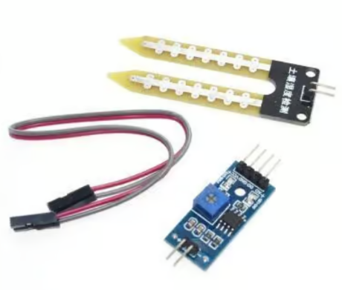
The below Moisture Sensor works by measuring the resistance within the soil. If the soil is dry, this would increase the resistance due to the lack of water in the soil allowing for electricity to conduct. With wetter soil, the electricity can conduct better meaning the resistance will decrease. This moisture sensor will typically have a supply voltage of 3.3v or 5v and can output its signal in either analogue or digital formats.

The sensor receives a known voltage (e.g., 5V) from the microcontroller or power source. It has a fixed resistor within the control module and the soil resistance acts as a variable resistor between the two probes. The voltage at the junction of these resistors is measured and changes with the soil resistance, reflecting the soil's moisture level.
The voltage divider circuit calculation will work as shown below.
V = 5v
R1 (Fixed) = 10Ω
R2 (Soil) = Variable
Using the equation;
$${}_{V_{out} = V ×\frac{R2}{R1 + R2}}^{}{}$$
For dry soil the resistance will increase therefor a value of 50Ω will be used.
$${}_{V_{out} = 5 ×\frac{50}{10 + 50} = 4.17v}^{}{}$$
For wetter soil, the resistance will decrease therefor a value of 5Ω will be used.
$${}_{V_{out} = 5 ×\frac{5}{10 + 5} = 1.67v}^{}{}$$
This will determine the output value for the signal which will then determine the moisture level of the soil. Using a microcontroller, this range of values can be used to determine the required moisture level at which the plant will require more water.
The pros and cons of this sensor includes;
Pros | Cons
Affordability | Less Accurate Than Other Types
Low Power Consumption | Susceptible to Interference from other conductive materials
Simplistic Design | Depth Restriction, unable to measure deeper pots.
[14]
Capacitive Moisture Sensor
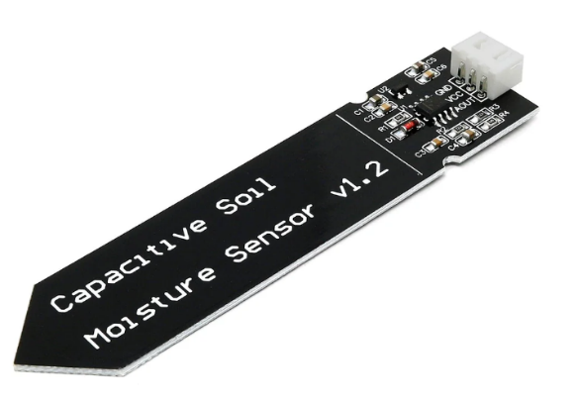
A Capacitive Moisture Sensor works off the principle of capacitance which is the ability to store electrical charge. This type of sensor usually consists of two electrodes which are then embedded in a non-conductive material. As the soil encounters the electrodes, it acts as a dielectric between them, this dielectric property affects the capacitance between the electrodes. The dielectric constant of the soil is higher when moist rather than dry. The capacitance varies depending on the soil's moisture level, converted into an output which can be analogue or digital.

Pros | Cons
High Sensitivity | Cost
Fast Response Times | Susceptible to Interference from other electricity sources
Low Power Consumption | Limited Depth Measurement
[15] [16]
Ethan

Temperature sensors
These sensors measure the ambient temperature and provide data to the control systems, which then adjust heating, cooling, and ventilation mechanisms accordingly. Sensors are strategically placed throughout the greenhouse to provide comprehensive data on the temperature distribution.
Types of Temperature Sensors
Temperature sensors come in various types, each with unique characteristics and suitable applications. The main types include:
Thermocouples
Thermocouples consist of two different metals joined at one end. They measure temperature by producing a voltage that varies with temperature. It is a sensor made to measure temperature. There are different types of thermocouples. Each type is made from different material and the temperature range is different [2]
Looking at all types of thermocouples, a wise choice would be Type T, its temperature range is between –200°C to 350°C and can be used in different environments. [3]
Resistance Temperature Detectors (RTDs):
RTDs measure temperature by correlating the resistance of the RTD element with temperature. Typically made from pure platinum, they provide highly accurate and stable measurements. [4]
Thermistors:
Thermistors are temperature-sensitive resistors, usually made from metallic oxides. Their resistance changes significantly with temperature. There are two types of thermistors: Negative Temperature Coefficient (NTC) and Positive Temperature Coefficient (PTC).
NTC thermistor works the way when the temperature increases, resistance decreases. temperature decreases, resistance increases. Then when the temperature decreases, resistance increases.
With PTC thermistor works the way when temperature increases, the resistance increases, and when temperature decreases, resistance decreases. [5]
Integrated sensors
The LM35 is a precision temperature sensor that provides an analogue output voltage directly proportional to the Celsius (Centigrade) temperature. It has a linear output with a slope of 10 mV/°C. This means for every degree Celsius change in temperature, the output voltage changes by 10 millivolts. The LM35 can measure temperatures in the range of -55°C to +150°C. Due to its low power consumption (less than 60 μA), the LM35 has minimal self-heating (less than 0.1°C in still air). The LM35 does not require any external calibration or trimming to provide accurate measurements. [11]
The best choice of plant temperature sensor would be thermocouple which can be inserted around the plant preferably out of direct sunlight to give reliable results. Alternatively, RTDs can be used. [1] They are relatively cheap and durable for all environmental conditions. Another great choice is LM35. LM35 is a reliable and accurate temperature sensor with a simple interface, making it suitable for a wide range of applications requiring precise temperature measurements such as greenhouse. Damian

Light sensors
Our use of light sensor will be to detect a day light to make sure windows are closed at night time.
Photoresistors (LDRs)
LDRs change their resistance based on the light intensity. They are commonly used in simple light sensing applications. Relatively cheap and simple to use. [8]
Phototransistors
Phototransistors detect light pulses and convert them into digital electrical signals. These are operated by light rather than electric current. [9]
Photovoltaic
Photovoltaic cells generate a voltage directly in response to light. They are like solar cells but are used primarily for sensing rather than power generation. [8]
Best choice for our project would be and LDR as its easy to use and cheap. Damian

Similar products
By understanding these existing solutions, we can identify best practices and areas for improvement in our own development methodology.
Priva Connext
Priva Connext is a comprehensive climate and process control system used in greenhouses to manage climate, water, and energy.
Key Features:
- Climate Control: Regulates temperature, humidity, and CO2 levels.
- Water Management: Integrates irrigation systems with nutrient dosing.
- Energy Management: Optimizes the use of energy for heating and lighting.
- Data Integration: Collects and analyzes data from various sensors to provide actionable insights.
Technologies Used:
- Sensors: Temperature, humidity, CO2, and light sensors.
- Software: Advanced algorithms for climate and process control.
- Connectivity: Remote monitoring and control via web and mobile applications.
[6]
Argus Controls
Argus Controls offers automated control systems for greenhouses and indoor growing facilities, focusing on environmental and fertigation control.
Key Features:
- Environmental Control: Manages temperature, humidity, CO2, and light.
- Monitoring: Real-time monitoring and data logging.
- Scalability: Suitable for both small and large-scale operations.
Technologies Used:
- Sensors: A wide range of environmental and soil sensors inluding wireless sensors.
- Control Systems: Programmable logic controllers (PLCs) and software for precise control.
- App on the phone to read data and control greenhouse.
- Automation: Automated responses based on sensor data.
[7]
When comparing different companies with their products, all systems provide comprehensive control of greenhouse climate, including temperature, humidity, CO2, and light. They use data to monitor and optimize the effectiveness of growing conditions. By learning from these leading products, we can implement best practices and innovative features to create a system that is both highly effective and user-friendly. Damian

Microcontrollers
Microcontrollers are small low-cost microcomputers which are used to perform specific tasks within embedded systems. Microcontrollers have a Central Processing Unit (CPU), Random Access Memory (RAM) and Read Only Memory (ROM) embedded within the chip. [17]
Below is a list of the advantages and disadvantages of using Microcontrollers.
Advantages | Disadvantages
Simple to use | Complex Structure
Small | Limited Number of Executions
Low Cost | Limited Processing Power
Able to be Reprogrammed | Limited Memory
Low Power Consumption | Limited Software Support
Real Time Processing
[18]
The Microcontroller controls the greenhouse system and ensures each function works when required. This will work by installing a programme into the ROM, and then receiving data from the Input terminals into the RAM. The Microcontrollers CPU will then retrieve data from both RAM and ROM and then determine the best output. For example, when the moisture sensor detects low levels of moisture, it will give a signal to the RAM to notify the CPU of the low moisture, the CPU will then access the programme in the ROM and determine that the plant requires more water, which will then send a signal through the output terminal to activate a watering procedure. [19]

Development Methodology
Before moving on to the design aspect of the project, it is important to highlight the methodology used to develop and create the product. Ethan

Hardware
Hardware is an important aspect of the project; this will allow for the product to work as expected. To begin, the components, this could vary from resistors to capacitors and even Diodes. These play an important role as they will be used to ensure the internal circuitry works and performs required.
Hardware will also include the power system; this will include the supply method. This could be a generator, supplying power to the product or even solar panels for a more environmentally friendly option.
Finally, the control systems, this would include PLCs and Microcontrollers. As discussed in the research, Microcontrollers will be the preferred hardware for this project. It will be used to control the functions of the product through its Input and Output terminals. Ethan

Software
We will use Proteus program for simulation and circuit design, and MikroC compiler for programming microcontroller.
Proteus is used for designing and simulating the hardware circuits. Proteus allows for virtual testing of the circuit designs, ensuring that the hardware components work together as intended before actual implementation.
MikroC Compiler is a powerful and user-friendly compiler for programming PIC microcontrollers. It supports a wide range of microcontrollers and provides built-in libraries for various peripherals and sensors. Damian

Materials & Tools
If a prototype were to be made, it will be important to highlight the required tooling and materials. With regards to tooling, not too much will be required, other than a hex key set and a terminal screwdriver. Other types of tooling used will include the programme compiler and the simulation software.
Materials for the prototype would include metal extrusion and clear acrylic plastic sheets for the frame and windows. This would replicate the glass of the greenhouse. As well as this, the materials would include each of the electrical components and Microcontrollers used for the circuit. Each of the materials would be highlighted in the bill of materials. Ethan

Testing methods
It's important to simulate and test the system to ensure functionality and performance.
Tests to include are
- Use Proteus to simulate the entire circuit, including sensor inputs and actuator outputs.
- Run the microcontroller code in a simulated environment to verify correct operation.
- Ensure that hardware and software components work together seamlessly.
Testing Methods:
- Test individual components, such as sensors and actuators, to ensure they function correctly.
  - Check that the motor operates in both directions to open and close windows.
  - Check that the pump operates when the soil is dry.
  - Check temperature sensor detects temperature.
  - Check soil moisture sensors detect moisture inside the soil.
- Test combined components to ensure they work together as intended.
  - Check if it's hot inside the windows open and when it's getting to ambient temperature windows will close.
  - Check when it is dark LDR detects change in light and sends signal to controller. Controller should decide when it's dark by saved data.
  - Check that the water pump will start working when soil is dry and stops when the plant has the right amount.
Damian

Advantages
The advantages of using this methodology for the automated greenhouse is that the Hardware itself is relatively cheap, therefor the internal circuitry would be low cost to purchase if the product was to be manufactured. As well as this, they are al easy to obtain.
For the software, it is all stuff which we as a group are familiar with and have experience using. This will prove to become an advantage when it comes to problem solving. The simulation software is also familiar to the group and will be great for simulating a wide variety of components with accurate results.
Testing for a prototype would then prove to be a greater advantage again, due to the physical test being carried out it will provide a greater and more accurate interpretation of how the product will perform in real time under more accurate conditions. Ethan

Disadvantages
While automated greenhouse systems offer numerous advantages, they also present certain challenges and disadvantages.
The setup cost for automated greenhouse systems can be significant due to the need for advanced sensors, actuators, control systems, and installation. To work around this problem, we will limit our greenhouse components to a minimum and make it cost effective with good and cheaper components.
Automated systems involve complex hardware and software that require regular maintenance and technical expertise. If something breaks down system won't function properly, and maintenance will be required. To work around this problem technical support should be available after product is released.
Automated systems involve complex hardware and software that require regular maintenance and technical expertise. To work around this problem components with higher IP ratings should be considered to prevent them being maintained that often. When selling this product, it should also be addressed how often maintenance needs to be undertaken
Automated systems may consume more energy as it's on constantly to make sure plants have perfect environment to grow healthy. To help work around this problem we can consider using lower power consumption components to minimize power consumption and possible program some kind of sleep mode so when plants are stable automatically shut down the system and turn it on automatically whenever plants will need it.
Damian

Design and Implementation

Requirements
Temperature Control: The system must regulate the greenhouse temperature by opening and closing windows using a stepper motor.
Soil Moisture Monitoring: The system must continuously monitor soil moisture levels using a soil moisture sensor.
Water control: The system must operate water pump when soil is getting dry and should only give enough of it for plants to grow.
Reliability: The system must operate reliably over long periods with minimal maintenance.
Ease of Use: The user interface must be intuitive and easy to use.
Energy Efficiency: The system should minimize energy consumption.
Night-time window control: At night-time windows should stay closed to prevent heat escaping during colder nights. Greenhouse should know when it's dark and bright to control windows.
Control unit: The system must communicate between each sensor and decide its action.
Drives: Stepper motor drive and relay drives are required as the microcontroller doesn't give enough voltage to make the motors or relays to operate.
Monitor: LCD screen can be supplied to show temperature inside the greenhouse and its operation.
Microswitch: To make sure window has been closed and open push button must be activated by the force of the window, if not detected error message should appear and it should be fixed before program continues.
The automated greenhouse system consists of the following main components:
- Stepper motor for window control
- Stepper motor drive to control stepper motor
- Soil moisture sensor
- Water pump
- Water pump relay, to control water pump. As water pump has 230V supply a relay is needed.
- Control unit (microcontroller)
- LM35 Temperature sensor
- LDR sensor
- LCD screen
- Microswitch
A stepper motor is used to precisely control the opening and closing of the greenhouse windows. Stepper motors are preferred due to their ability to move in discrete steps, allowing for accurate positioning.
A soil moisture sensor is placed in the soil to measure the water content.
A microcontroller PIC16F877A will processes the data from the soil moisture sensor, temperature sensor and LDR sensor and controls the stepper motor and water pump. Damian

Justification
Controlling the temperature within a greenhouse is crucial for optimal plant growth. Extreme temperatures can cause plant death or different illness. Automated window control using a stepper motor allows regulation of the internal temperature by adjusting the ventilation as needed.
Correct soil moisture is a critical for plant health. Overwatering or underwatering can lead to poor plant health and reduced yields. By continuously monitoring soil moisture levels and optimizing water usage, the system can ensure that plants receive the right amount of water, thereby help plants grow healthy.
Automating this process will reduce human intervention leading to freeing up time and not worrying about plants. This will also be great for beginners who have no knowledge on plants or someone who goes on holiday and needs their plants to be taken care of, the system will do that for them. Additionally, automation can lead to more efficient resource use, reducing water and energy consumption
Damian

Circuit Design (Greenhouse)

Introduction
Within this section, it will show and discuss the design and implementation of an automated greenhouse system with circuits for temperature and soil moisture control. The temperature control circuit monitors internal heat levels to automatically open and close windows, ensuring optimal growing conditions. The soil moisture circuit uses a sensor to detect dryness and activates a watering pump to maintain consistent soil hydration. Detailed circuit diagrams and descriptions illustrate the components and functionalities, showcasing a system that optimizes plant growth with minimal human intervention. Ethan

Window and Temperature control circuit
This section provides the detailed circuit design for a greenhouse system that monitors temperature and light levels, displays these readings on an LCD, and controls a window via a stepper motor. The system components include an LM35 temperature sensor, an LDR (Light Dependent Resistor), an LCD display, and a stepper motor, all interfaced with a PIC microcontroller.

Main Schematic
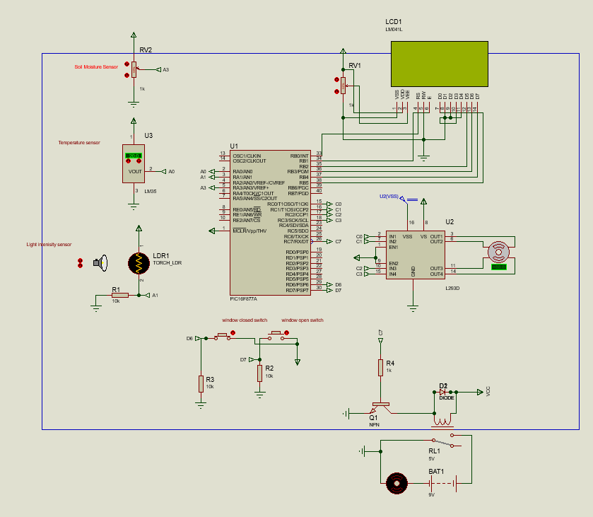

Components Used
- PIC Microcontroller: Central control unit.
- LM35 Temperature Sensor: Measures ambient temperature.
- LDR (Light Dependent Resistor): Measures ambient light intensity.
- LCD Display: Shows temperature readings and status messages.
- Stepper Motor: Controls the opening and closing of the window.
- Stepper Motor Drive: Controls operations of bipolar stepper motor
- Switches: For manual control and error detection.
- Power Supply: Provides necessary voltage and current to the circuit.
- Resistors
- Variable Resistor (Potentiometer): Acting as the moisture sensor.
- NPN Transistor: Acts as a switch that is controlled by the microcontroller. When the base of the transistor receives a signal from the microcontroller, it allows current to flow from the collector to the emitter, thereby activating the relay.
- Relay: A switch which will activate the watering pump when a voltage is sent through the PIC16F877A.
- Diode: Used as circuit protection from high voltages.
- Power Source

Pin layout of PIC16F877A Microcontroller:
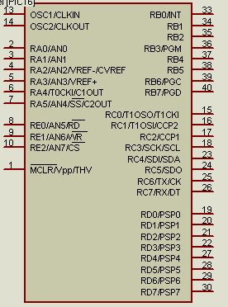
- A0 – Temperature sensor
- A1 – LDR sensor
- B0,B1,B2,B3,B4,B5,B6,B7 – LCD LM041L
- C0 – IN1 Stepper Drive (STEP1)
- C1 – IN2 Stepper Drive (STEP2)
- C2 – IN3 Stepper Drive (STEP3)
- C4 – IN4 Stepper Drive (STEP4)
- D6 – Window Closed Switch
- D7 – Window Open Switch
- Power Supply: Vpp connected to +5V
- RA3 - Moisture Sensor Input
- RC7 – Water Pump

Schematic Diagram for window and temperature control system.
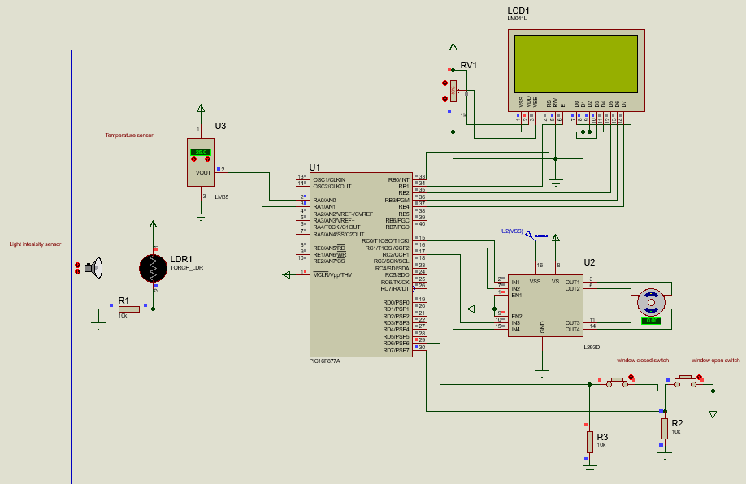

Stepper motor controller L293D:
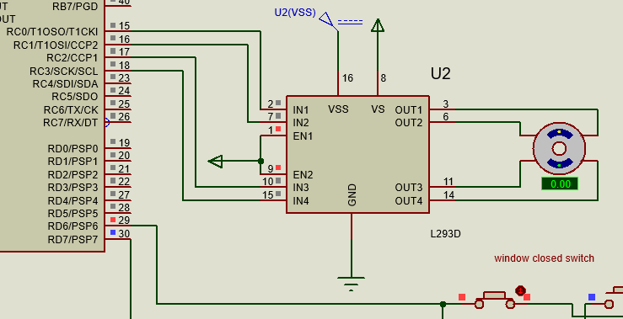
- OUT1 – Bipolar Stepper Motor
- OUT2 – Bipolar Stepper Motor
- OUT3 – Bipolar Stepper Motor
- OUT4 – Bipolar Stepper Motor
- C0 – IN1 Stepper Drive (STEP1)
- C1 – IN2 Stepper Drive (STEP2)
- C2 – IN3 Stepper Drive (STEP3)
- C4 – IN4 Stepper Drive (STEP4)
- GND – Ground
- VSS – Power to drive stepper drive 5V
- VS – Power to drive stepper motor 5V
- EN1 – Linked to EN2 and power

LCD Display:
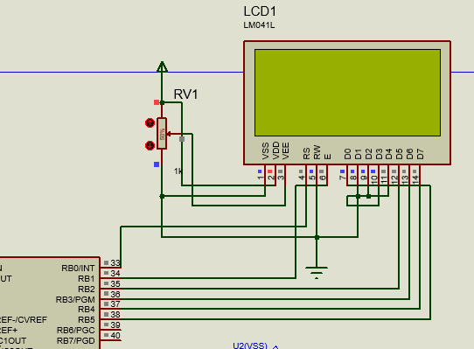
Data Lines:
- LCD_D4 to RB2
- LCD_D5 to RB3
- LCD_D6 to RB4
- LCD_D7 to RB5
Control Lines:
- RS to RB0
- EN to RB1
Power and Ground: Vdd and Vss of LCD connected to +5V and Ground.

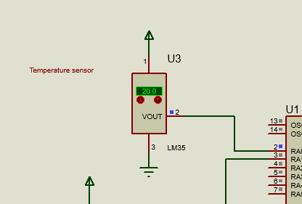
Temperature Sensor (LM35):

Vcc: Connected to +5V.
GND: Connected to Ground.
Output: Connected to AN0 (RA0) for analog-to-digital conversion
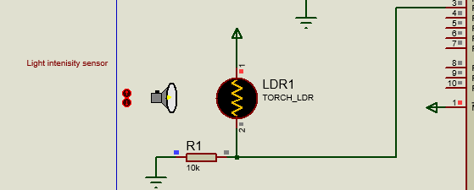
LDR

Voltage Divider: LDR in series with a fixed resistor.
Analog Input: Voltage divider output connected to AN1 (RA1).

Switches
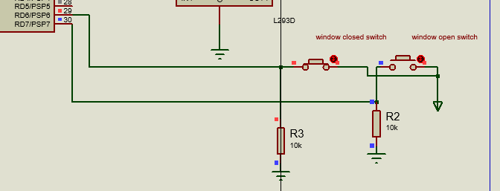Manual Control: Connected to RD6 and RD7 with pull-down resistors to detect the state of the window.

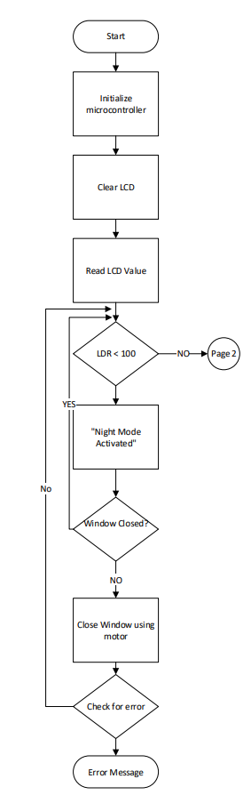
Flow chart of Greenhouse Temperature Control System

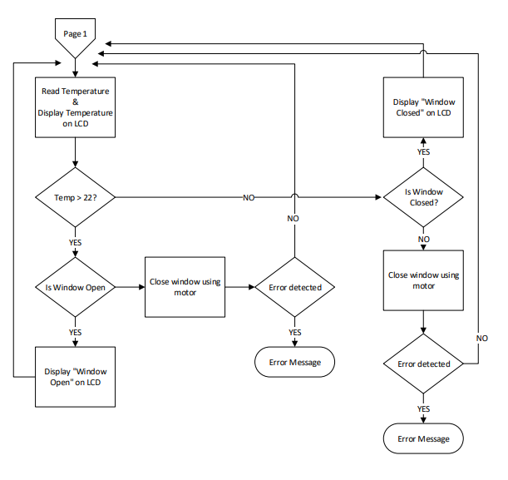
Damian

Watering System Circuit
The automated watering system is designed to automate the watering process in a greenhouse. It uses a PIC16F877A microcontroller to monitor soil moisture levels through an analogue input. When the soil is detected to be dry, the microcontroller activates an NPN transistor, which in turn energizes a relay. The relay, powered by a 5V battery, controls a pump to deliver water to the plants. Additional components like a moisture sensor which will be simulated as a variable resistor, a diode for protection against voltage spikes, and resistors for current regulation ensure the circuit operates reliably and efficiently.

Schematic Diagram for just watering system
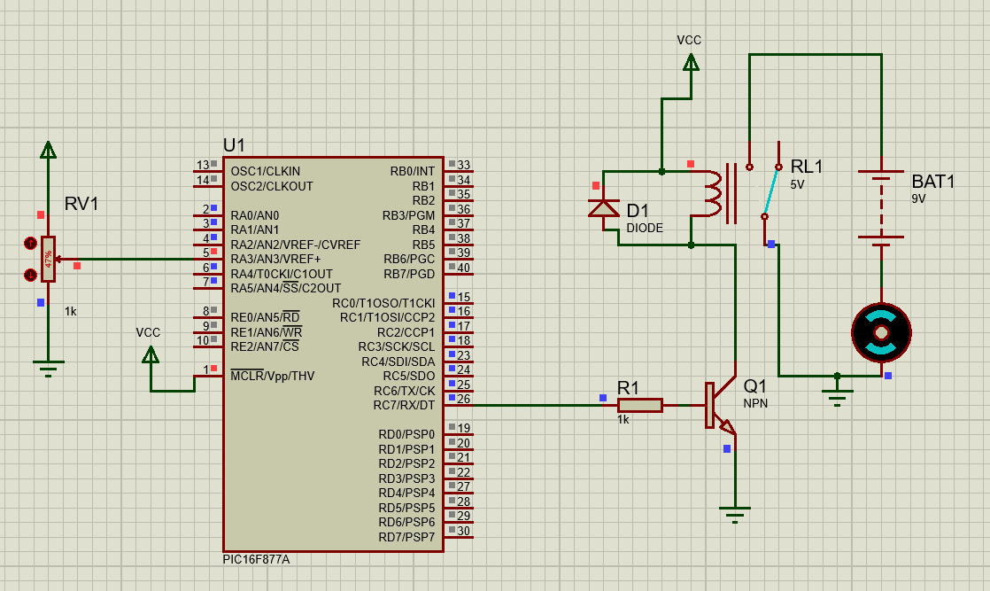

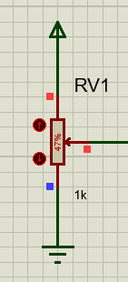
Moisture Sensor:

The potentiometer above is acting as the moisture sensor. As previously mentioned in the research, as the soil dries there is less conductivity within the soil meaning there is more resistance. By using the potentiometer to adjust the resistance it is acting as the soil going dry and then going moist again.
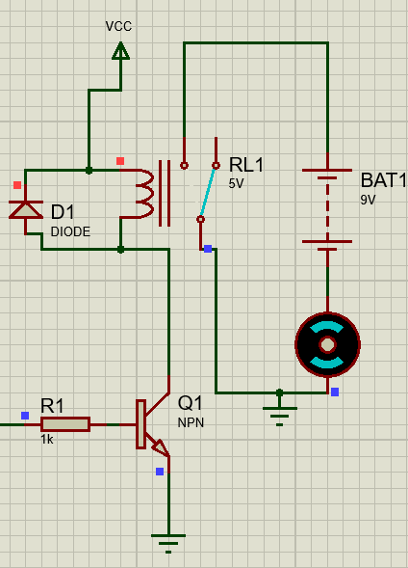
Water Pump:

The circuit shown is designed to control a water pump for automated irrigation. When the NPN transistor (Q1) receives a signal at its base, it switches on, allowing current to flow through the relay coil (RL1). This activates the relay, closing the normally open contacts and allowing the 9V battery (BAT1) to power the motor, which functions as a water pump. The diode (D1) across the relay coil protects against voltage spikes generated when the relay is de-energized, while the resistor (R1) limits the base current to the transistor, ensuring safe operation. This setup enables automatic watering based on the control signal received by the transistor.

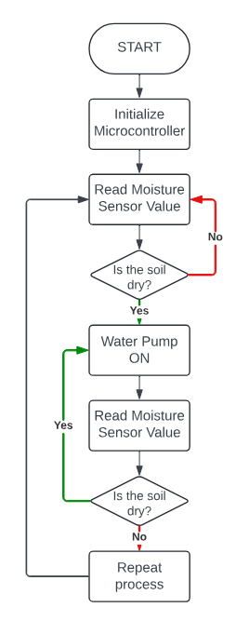
Flowchart of Greenhouse Watering System
Ethan

CAD Model
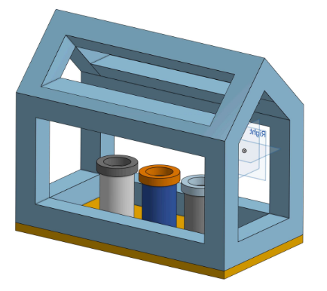
As a prototype, a CAD model was constructed, showing how a miniature version of the automated greenhouse will look.

Shown in the CAD drawing above is a miniature greenhouse with three plant pots inside. The Orange base is designed to be easily removed to access the plants inside and then reconnected. In the clear spaces between the frame will be the glass panels with the two roof panels being capable of opening and closing to help regulate the temperature. For a larger greenhouse, there will be more sections of the frame with more glass panels. For a prototype, this can be created using 3D Printed MJF Nylon parts to construct the base and the frame and then laser cut Acrylic for the window panels. For the real product, a metal frame will be used and real glass panels.
Ethan

Simulation

Simulation for Greenhouse Temperature Control system

Objectives
- To read temperature and light levels.
- To display the temperature on an LCD.
- To control a stepper motor to open/close a window based on the temperature and light levels.
- To handle errors and stop the motor if an issue is detected.

Components
- PIC Microcontroller: The central unit that controls the system.
- LM35 Temperature Sensor: Measures the temperature.
- LDR: Measures the light intensity.
- LCD Display: Shows temperature readings and status messages.
- Stepper Motor: Opens/closes the window.
- Switches: Used to manually control the window's state for error handling.

Initialization
Microcontroller Configuration:
- TRISA, TRISC, TRISD, and TRISB registers are set to configure input/output pins.
- ADC is initialized for analog-to-digital conversion.
- LCD is initialized and configured.

Main Function
The main loop continuously monitors light and temperature levels and controls the window accordingly.

Step-by-Step Operation:
LDR Reading:
- The LDR value is read to determine the light level.
- If the LDR value is below 100, night mode is activated, and the window is closed.
Temperature Reading:
- If it is not night, the LM35 temperature sensor is read.
- The temperature is displayed on the LCD.
Window Control Based on Temperature:
- If the temperature is above 22°C, the window is opened by rotating the stepper motor clockwise.
- If the temperature is 22°C or below, the window is closed by rotating the stepper motor counterclockwise.
Error Handling:
- The motor is monitored for errors at step 25 during window operation.
- If an error is detected, the motor is stopped, and an error message is displayed on the LCD.

Simulation Steps
Read LDR Value:
To make sure LDR is working I need to display it on the screen to show me the result, I want to know if its below 100 at night and above 100 at day light.
Provisional code is written to prove this for simulation purposes.
At dark:
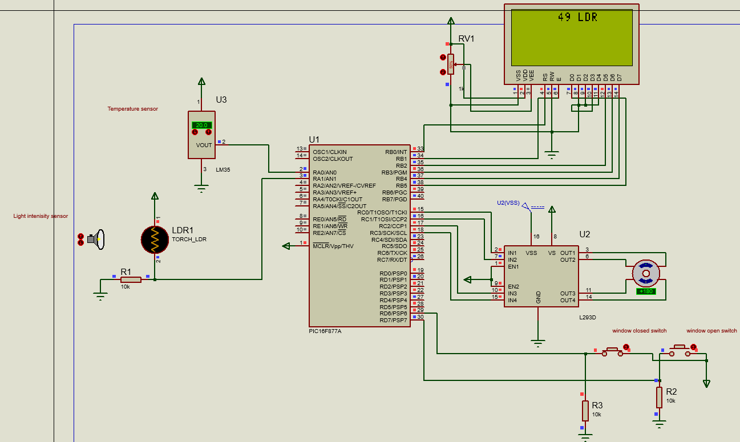

At day time:
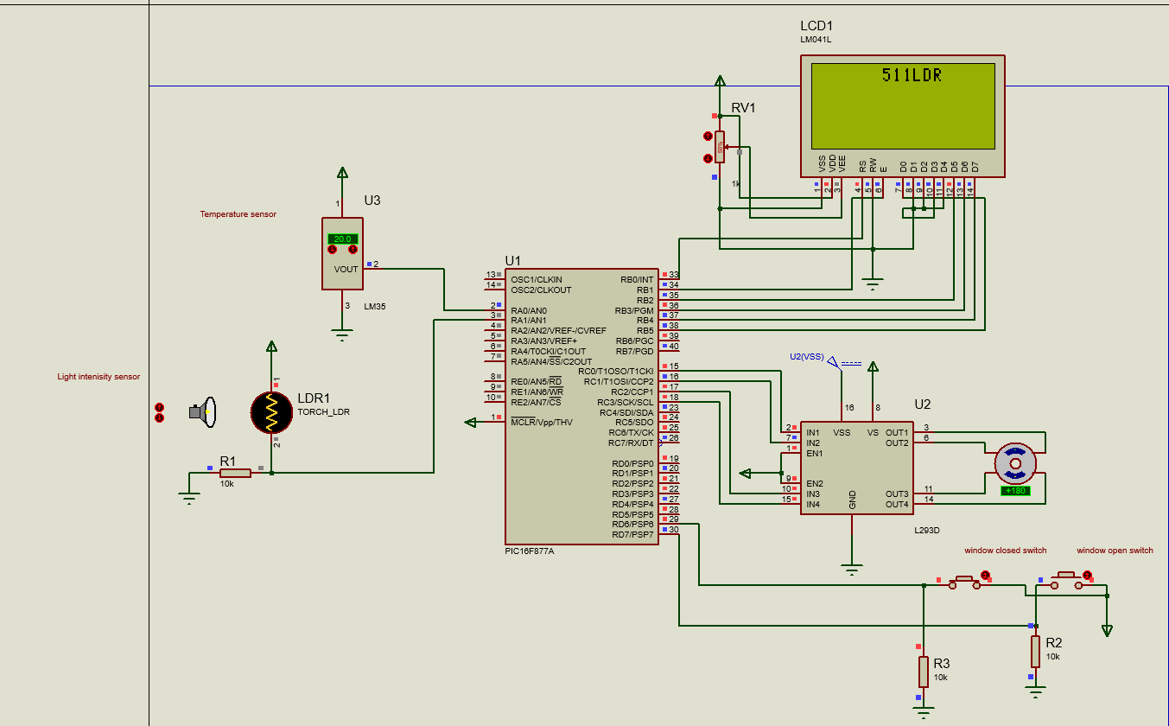System successfully converts data from analogue to digital and gives me a value of resistance. I can now test a night mode, so If the LDR value is less than 100, display "Night Mode Activated" on the LCD and close the window using the stepper motor if not closed already otherwise message will appear that windows are closed.

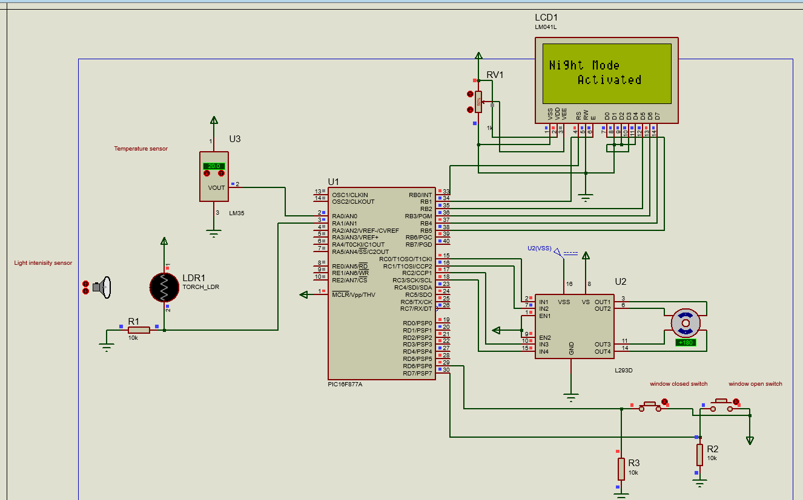
System successfully turns into night mode at dark, windows are closed so message closed windows appears.
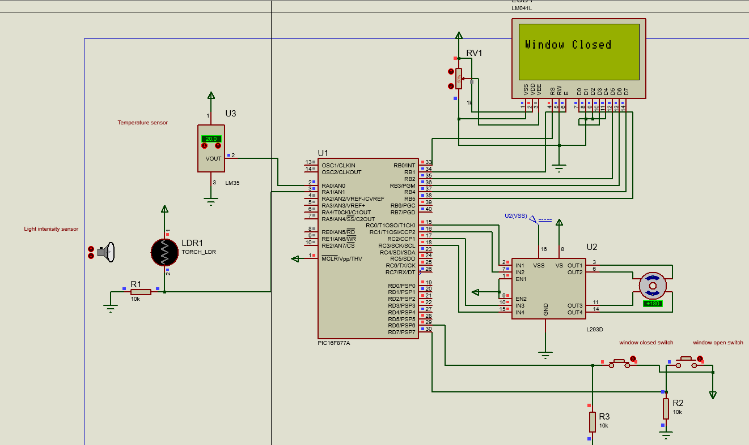For testing I will open window to check if motor starts working to close the window.
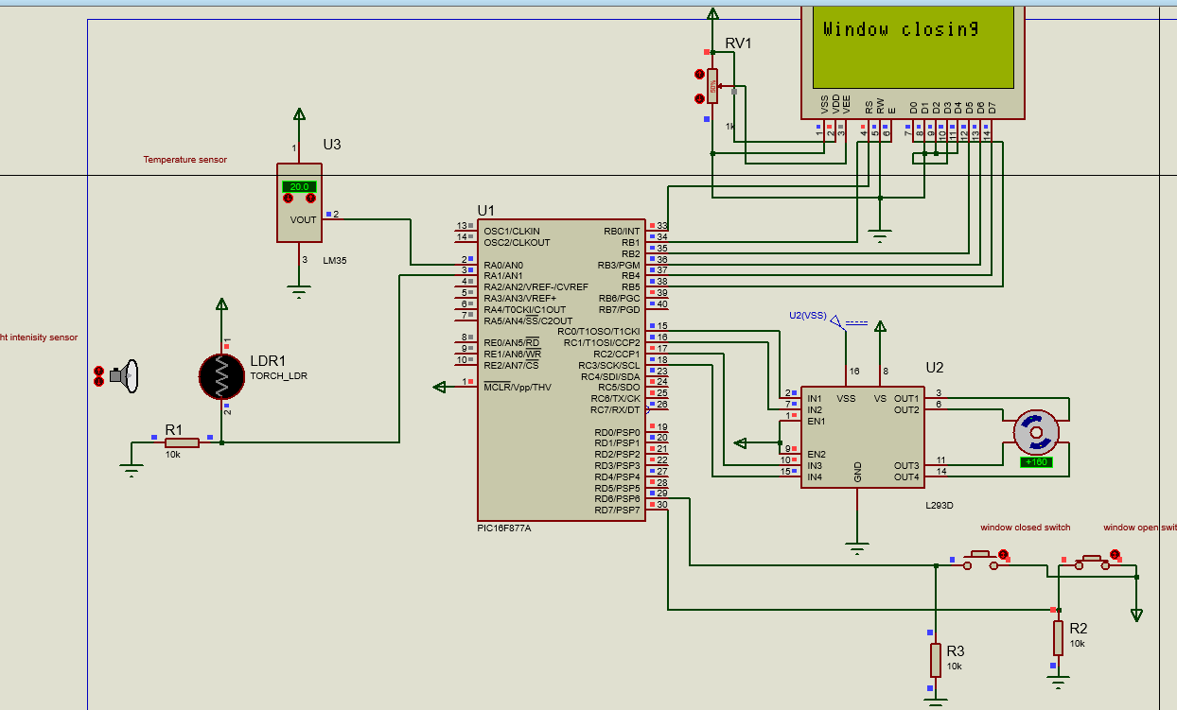Controller succesfully turns stepper motor to close the window and now its waiting for feedback from microswitches. If no feedback from switches it error message should appear.
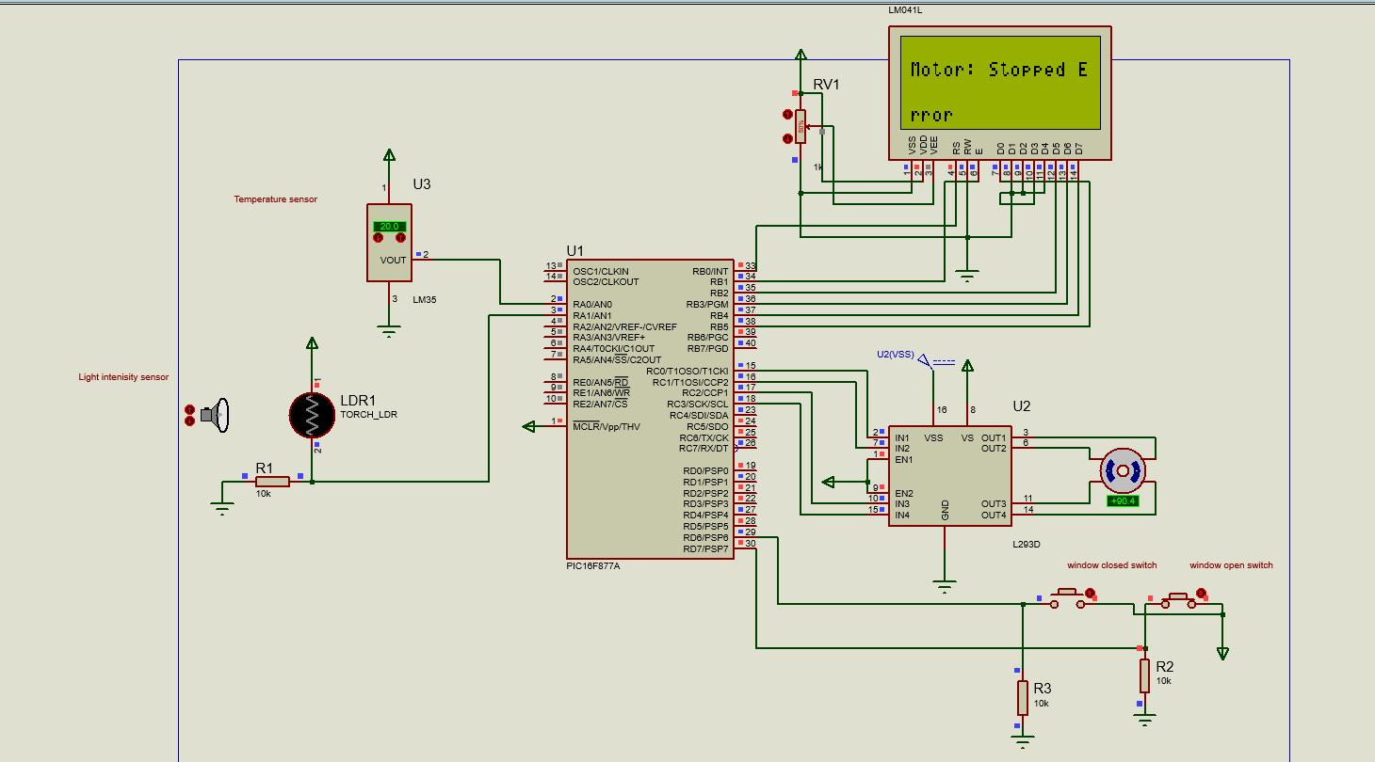Controller successfully stops the motor to prevent any damages on components and lets user know there is an error. Controller needs to be rebooted to retry. To exit night mode controller needs to detect a light and it will proceed to read a temperature.
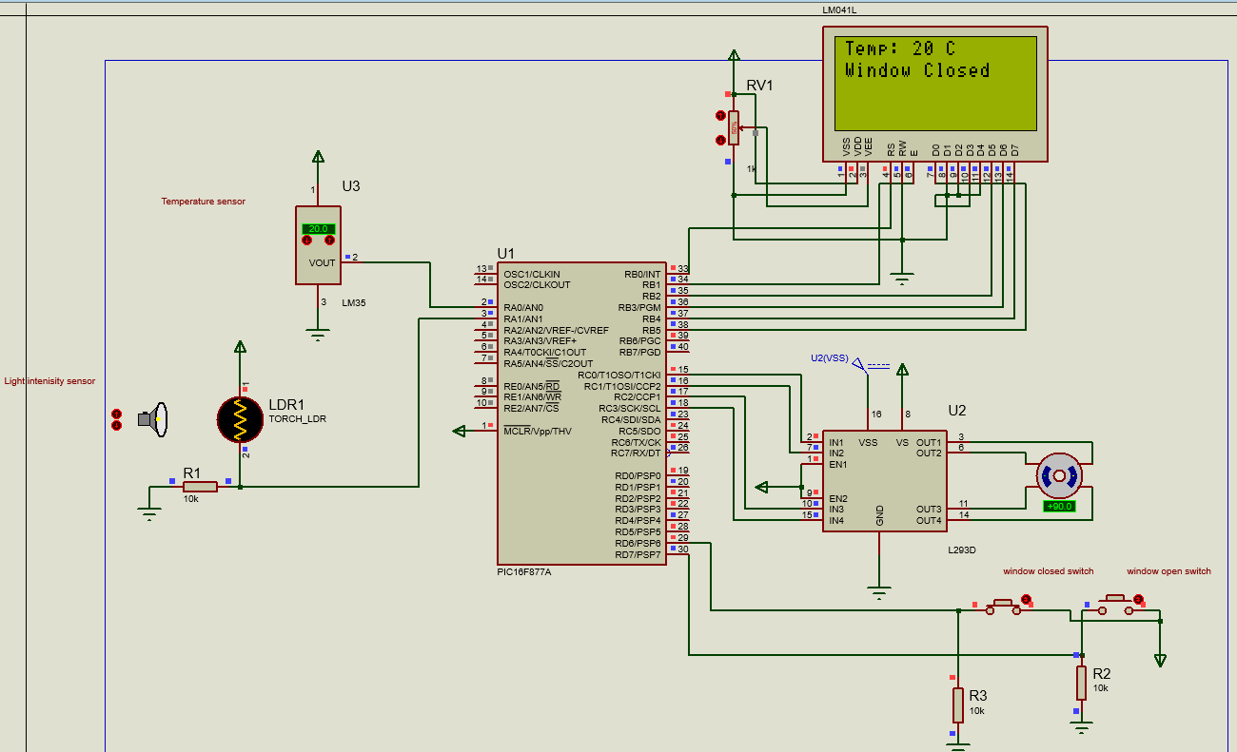Controller successfully enters main loop and displays a temperature and window status.
Read Temperature:
Controller must convert analogue signal from temperature sensor and converts it to degrees and display it on the screen. Window status must be displayed.
Testing below 22 degrees with windows closed.
Controller successfully displays correct value of temperature detected and displays status of window position. Now to make windows open controller should read temperature higher than 22 and open window using stepper motor, status of working motor should appear.
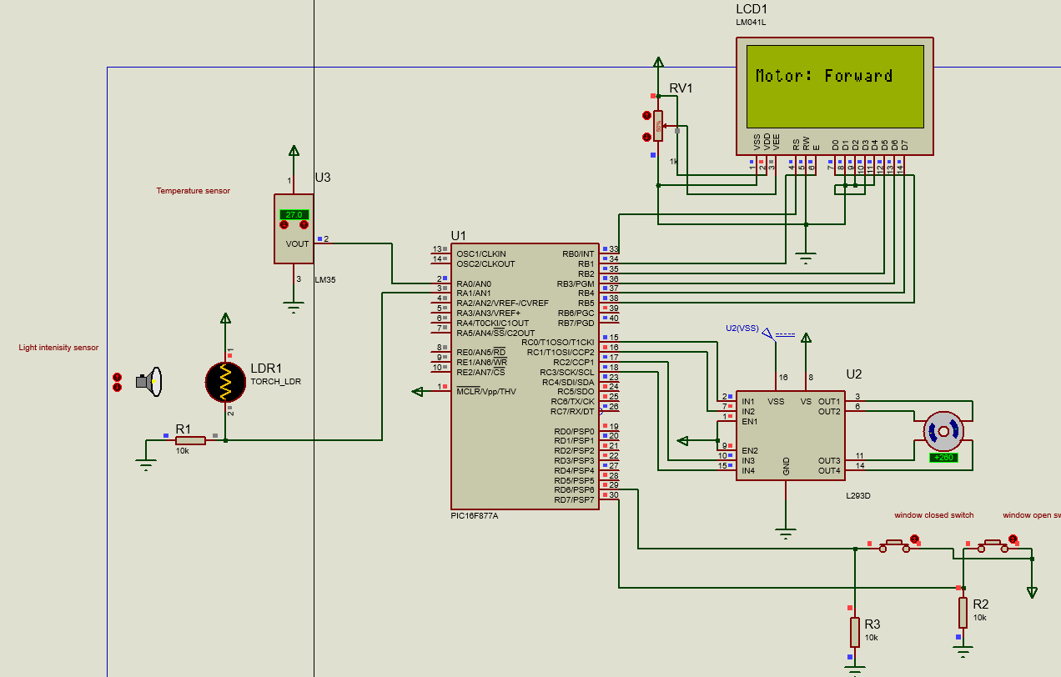Controller successfully turns motor forward and waits for switch reaction. If no reaction from microswitches error should appear to prevent damage to components.
Controller successfully stops the motor to prevent any damages on components and lets user know there is an error. Controller needs to be rebooted to retry.
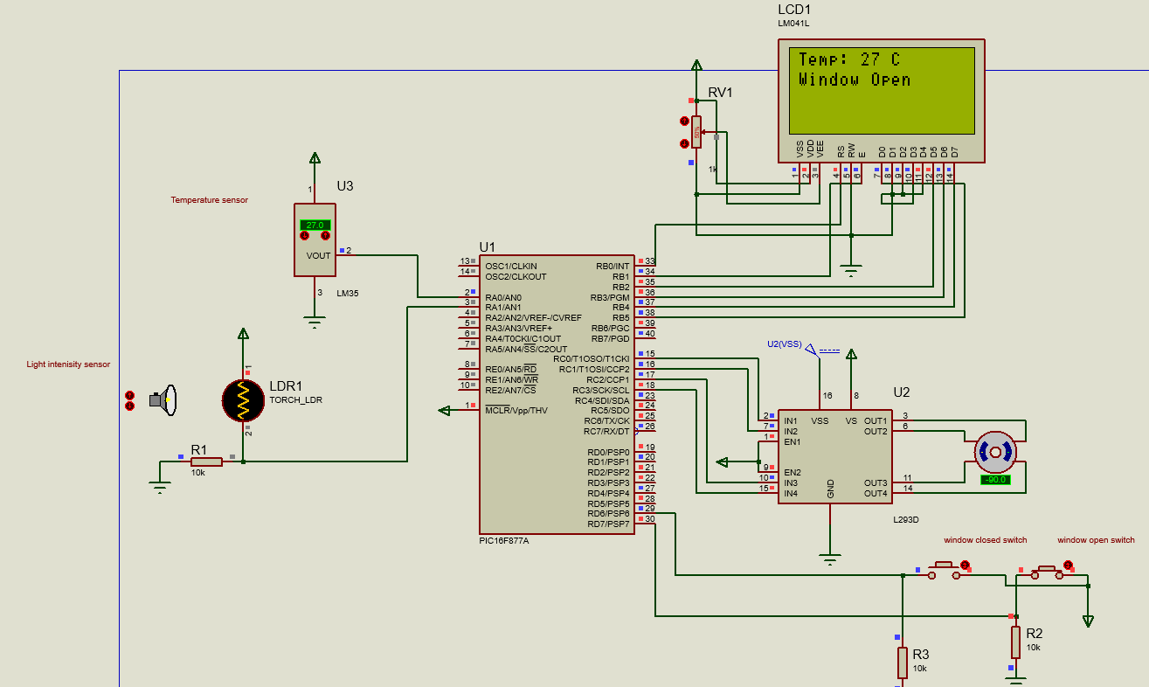Controller successfully stops the motor and display window status on lcd and current temperature. To test motor going reverse direction temperature must be below 22.
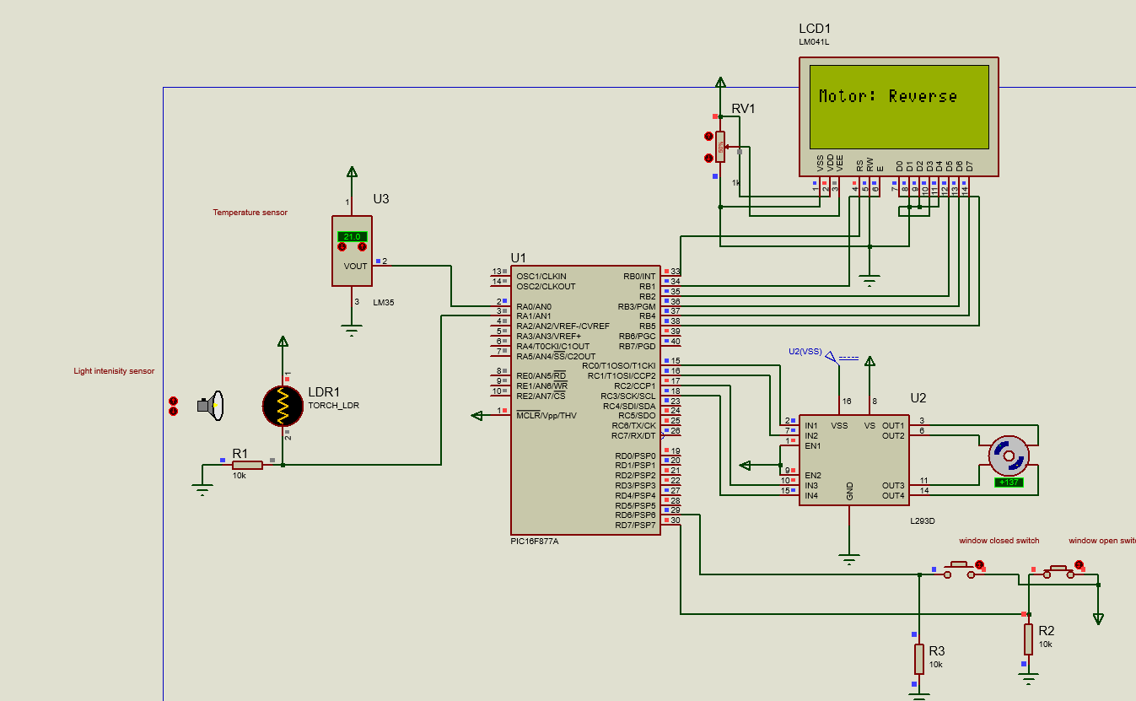Controller successfully turns counter clockwise and status of motor is displayed untiled microswitch has been pressed. Again, if it hasn't been pressed for a while error comes up same as in previous test. After window closed it should display on lcd and current temperature.
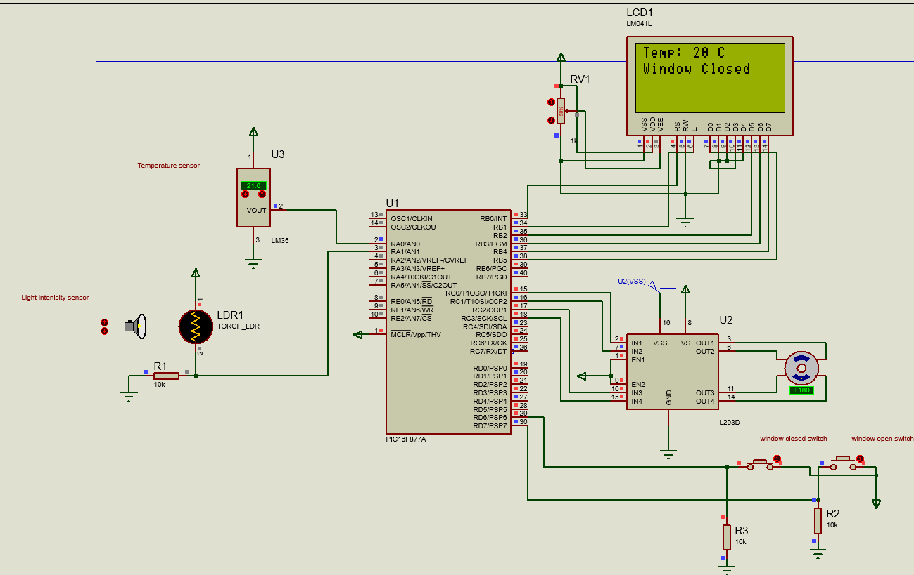
Controller successfully displays current temperature and status of window.

Results
- The Controller goes into night mode when its dark and restores normal operations at daytime.
- The system successfully reads temperature and light levels.
- The LCD displays accurate temperature readings up to 1 degree difference and status messages.
- The stepper motor correctly opens and closes the window based on the temperature and light conditions.
- The error handling mechanism effectively stops the motor and displays an error message if an issue is detected.

Conclusion
The simulation demonstrates that the microcontroller-based system can effectively monitor and respond to environmental conditions, controlling a window via a stepper motor based on temperature and light levels. The system also includes robust error handling to ensure safe operation. This simulation confirms the feasibility and reliability of the proposed design.
Damian

Simulation for Greenhouse Watering System

Objectives
- Ensure that change of resistance in Moisture sensor is detected by Microcontroller
- Ensure that water pump activates
- Ensure that water pump deactivates when resistance changes again.

Simulation Steps
The simulation will move through each stage of a day-to-day operation, ensuring that each step is simulated to prove the circuit and microcontroller reacts as expected to each scenario.
Phase 1
The first phase is ensuring that the microcontroller is active when power is received.
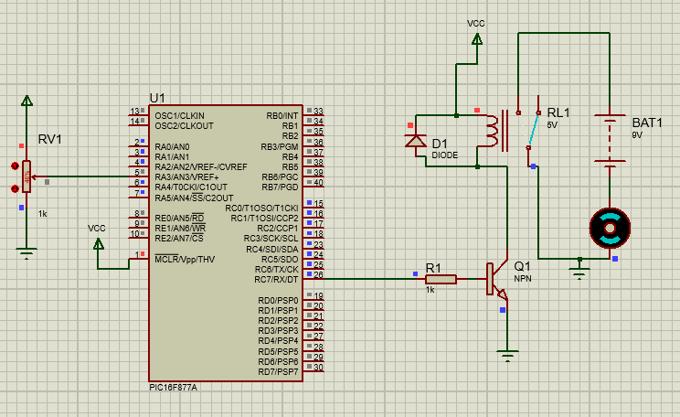As shown above, the microcontroller is active and is receiving power as expected.
Phase 2
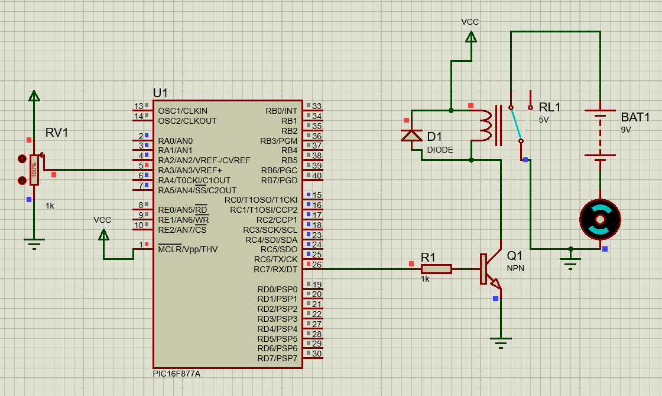
As the soil begins to dry, the resistance will increase, and the water pump will activate.
Once the potentiometer has been set to 100% resistance, the microcontroller has detected the change and activated the water pump. As shown the relay has now switched to close the circuit and supply power to the water pump.
Phase 3
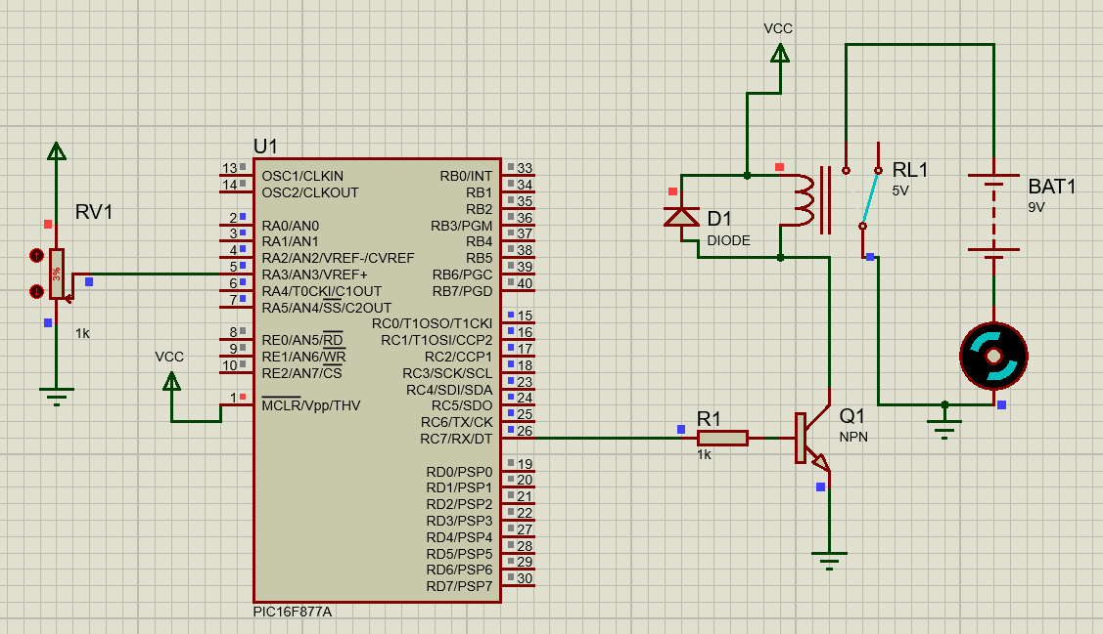
As the pump supplies the soil with water, the moisture sensor will decrease in resistance and the water pump should turn off.
As the potentiometer changes to a low resistance, the relay once again changes over to open the circuit and stop the water pump once again. This will be continuous as the soil becomes moist and then dry, ensuring that the plant is kept with regular water.

Conclusion
To conclude, the simulation was a success as the desired results happened. It was proven that the watering system reacted to change in moisture levels and provided the required output to correct the moisture levels.
Ethan

Evaluation

Evaluation of Results Against Research
Throughout the research section of this report, various sensors were researched to determine which would be the most suitable for the product. To begin, the moisture sensor was discussed, two different types. One being a resistive and the other being capacitive. Due to its low cost and simplicity, the resistive moisture sensor was used. It was also researched that the working principle of the resistive moisture sensor was that a higher voltage would indicate moister soil, this was useful as it allowed for a potentiometer to be used during the simulation. By varying the resistance would simulate the soil drying.
For the temperature sensor, an LM35 was decided upon due to it having better reliability and accuracy with the output changing by 10mV by every 1°C. By having an analogue to digital converter on this it allows for better readability and ensures a reliable method of temperature measurement for the greenhouse. A photoresistor (LDR) was then used for the light sensor, LDRs are far simpler to use than Phototransistors or any other light sensor. LDRs work by changing their resistance due to light intensity which is very similar to how the resistive moisture sensor works. From this, we can expect the voltage to alter depending on light levels and this changing the input to the microcontroller, this allowing the microcontroller to differentiate and give the required output. From the results, it is evident that as the LDR light levels change, the motor in the circuit activates to ensure that the windows open and close depending on the needs of the greenhouse.
Ethan

Evaluation of Results Against Objectives
Comparing the results to the objectives allows us to gauge whether the project was a success or not. At the beginning of the report, objectives were set out to be achieved throughout the duration of the report, ensuring that a clear goal is set. The first objective was research. research is crucial prior to beginning any project as it provides all relevant information regarding the topic and the project. Using the research, we were able to provide educated and effective solutions to issues and determine the most appropriate components to use within the circuits, overall allowing us to create an effective circuit.
The second objective was the development methodology, this was an opportunity for us to come together as a group and discuss the best methods to use to effectively develop the product and create it. With this in place it created a great structure for us to follow to create the product. With this in place we successfully structured the design of the product and considered each aspect of the product which assisted with a successful simulation. This followed into the design and implementation, with the research and development methodology considered, we were able to create an affective and appropriate design which worked and proved that our research was successful.
With the design created, it was then time to simulate the circuit design, this proving that our design was fit for purpose and able to perform tasks required of it. From the simulation, it was evident that the methodology and the design process was a success as it provided the results that we as a group set out to achieve. With both circuits being simulated and successfully working as they should. Finally concluding the project, each objective set at the beginning of the project was met successfully, proving that each method, software and design process used was a good decision and allowed us to complete the project to a high standard.
Ethan

Evaluation of Results Against Aims
The aim of the project was to develop an automated greenhouse system that maximizes crop yield and improves the quality of produced fruits by precisely controlling temperature, and soil conditions. Below is an evaluation of how the results align with these aims.
Aim: Control the temperature inside the greenhouse by using a motor to open and close windows, and optionally, a heater for cold winter days.
Result: The implemented system successfully controls the greenhouse temperature through a motorized window mechanism. The temperature sensor accurately detects the internal temperature and communicates with the controller. The controller effectively decides when to open or close the windows to maintain optimal temperature conditions. During cold nights, the windows remain closed to conserve heat, optional heaters are not included in this design but are kept for something to future improve. This has led to a stable and optimal growing environment, thereby improving plant productivity and quality.
The temperature control system meets the aim by maintaining an ideal temperature for plant growth, thereby enhancing crop yield and quality.
Aim: Ensure windows are closed at night time to prevent heat loss and open during the day as needed.
Result: The light-detecting sensor accurately differentiates between day and night. The controller responds appropriately by keeping windows closed at night and adjusting them during the day based on temperature requirements. This prevents heat loss during colder nights and allows for necessary ventilation during the day, contributing to an optimal growing environment.
The light detection and window control system effectively meets the aim of managing heat retention and ventilation based on day-night cycles.
Aim: Automatically water plants when soil moisture levels drop to ensure plants receive the right amount of water.
Result: The soil moisture sensor accurately detects moisture levels in the soil and communicates with the controller. When moisture levels drop below the desired threshold, the controller activates the water pump, ensuring that plants receive adequate water. This prevents plants from dying due to drought stress and ensures optimal growth conditions.
The soil moisture detection and irrigation system meet the aim by providing precise and timely watering, thus supporting plant health and productivity.

Aim: Select appropriate components (motor, sensors, microcontroller) and ensure effective communication and control among them.
Result: Extensive research was conducted to select the appropriate motor with sufficient torque to open and close the greenhouse windows. Accurate temperature, light, and soil moisture sensors were chosen and strategically placed for reliable data collection. The microcontroller selected is capable of processing inputs from all sensors and executing control actions accordingly. The system integrates well, with all components to maintain optimal greenhouse conditions.
The careful selection and integration of components meet the aim of creating a reliable and effective automated greenhouse system.
Damian
Future Implementation
Here are some potential future implementations:
- Integrate advanced data analytics and machine learning algorithms to predict and optimize plant growth conditions.
- Collect extensive data on temperature, humidity, light levels, soil moisture, and plant health over time.
- Add humidifiers and dehumidifiers to maintain optimal humidity levels, crucial for certain crops.
- Install sensors to monitor nutrient levels in the soil. And implement automated systems that can deliver liquid fertilizers to the plants when nutrient levels are low.
- Enhance the monitoring capabilities with a broader range of sensors. Monitor carbon dioxide levels to ensure they are within the optimal range for photosynthesis.
- Install solar panels to power the greenhouse, reducing reliance on external electricity sources.
- Implement energy storage systems such as batteries to store excess energy for use during low production periods.
Damian

Conclusion and Recommendations

Outcome
The outcome of the project is an overall success. From the beginning of the project, we as a group set out with the aim of designing and creating an automated greenhouse which is suitable for all to use, especially people with disabilities and the elderly.
We began with researching various aspects related to the topic of an automated greenhouse. By brainstorming ideas of what should be included within an automated greenhouse it allowed us to create a scope of areas to research which will benefit the remainder of the project. From this we decided on software and methods of developing the project, using the research to make successful simulations and drawings of what we had envisioned.
With each of these outcomes combined, we were able to successfully determine a suitable circuit for the greenhouse as well as create an effective programme which allowed the microcontroller to carry out the desired tasks at the desired times. Using CAD, we were able to create a prototype which could be used for real life simulation, including BOM for each of the circuits.
To conclude the final outcome of the project was a success, each of the aims and objectives we’re met, and a working simulation was created.
Ethan
What worked and didn’t work
What Worked:
The system's ability to maintain optimal temperature through motorized window control and optional heaters functioned effectively. The integration of temperature sensors and the controller's decision-making process ensured a stable growing environment.
The light-detecting sensor reliably distinguished between day and night, allowing the system to manage window positions accordingly. This feature helped conserve heat during the night and provided proper ventilation during the day.
The soil moisture sensors and the automated irrigation system successfully maintained appropriate soil moisture levels. This prevented drought stress and ensured consistent watering, which contributed to healthy plant growth.
The selected components, including the motor, sensors, and microcontroller, were well-suited for the project. Their seamless integration allowed for efficient communication and control, leading to a reliable automated system.
What Didn’t Work:
Initial challenges were encountered with sensor calibration. Ensuring that sensors provided accurate readings required multiple adjustments and iterations, particularly for the temperature and soil moisture sensors. Sensor value had to be calculated by specific value to get correct temperature. If our prototype will be built-in real-life position of sensor will also complicate things and gives us problems to obtain real value.
Occasional delays in communication between the sensors and the controller led to slight lags in response times.
Not enough time to build actual prototype in real life and test it.
On fan forward bug was found not displaying motor status and screen is blank. This must be fixed in future updates.
Damian

Deadlines
Throughout this project, we ensured that tasks had deadlines associated with them. This was achieved by using a Gantt Chart. The benefits of the Gantt Chart were that it allowed us as a group to see the progress being made and to distribute tasks amongst the group.
Throughout the use of the Gantt Chart, all tasks we’re completed on time if not ahead of schedule, proving that this method helped with efficiency within the group.
Ethan

Recommendations for future
Several recommendations can be made for future implementations. These recommendations focus on improving existing features, integrating advanced technologies, and ensuring sustainability and scalability.
Develop more precise calibration procedures. When built in real life regularly schedule recalibration to maintain accuracy and conduct thorough studies to determine the optimal placement of sensors within the greenhouse to ensure they provide the most accurate readings.
Integrate renewable energy sources such as solar panels and battery storage to provide backup power. This will ensure continuous operation during power outages and improve the system's sustainability. Install solar panels and wind turbines to provide renewable energy sources.
By implementing these recommendations, future iterations of the automated greenhouse system can achieve greater efficiency, reliability, and sustainability. These enhancements will ensure the system remains at the forefront of agricultural technology, providing significant benefits to growers and contributing to more sustainable farming practices.
Damian

Reflection

What Did You Learn While Doing the Project?
One of the critical insights gained was the significance of precision in sensor calibration. Accurate data is paramount for effective environmental control, and slight deviations can lead to suboptimal conditions. This highlighted the need for meticulous attention to detail and rigorous testing during the setup phase.
Tackling the various challenges during the project improved my problem-solving skills. I learned to approach problems methodically, analyse different solutions, and implement the most effective one. This experience made me more confident in my ability to handle complex tasks and find innovative solutions.
The need for precise calibration and accurate data collection taught me the importance of attention to detail. Small errors can have significant consequences in automated systems.
Managing deadlines and addressing unexpected issues during the project helped me develop the ability to work under pressure.
The project required integrating knowledge from various disciplines such as electronics, software development, and agricultural science. Implementing more rigorous planning and testing phases early in the project could have identified potential issues with sensor placement and calibration sooner.
In future projects, I will allocate more time for initial testing and validation of components and designing the system with scalability in mind from the outset could have prevented performance issues when expanding to larger setups. I will adopt a modular approach to system design, ensuring that components can be easily added or removed without affecting overall performance.
Damian

REFERENCES & BIBLIOGRAPHY
[1] “Measuring Greenhouse Temperature,” Greenhouse Product News. https://gpnmag.com/article/measuring-greenhouse-temperature-0/#:~:text=To%20measure%20the%20shoot%2Dtip (accessed May 28, 2024).

[2] “What is a thermocouple? How do they work?,” Process Parameters Ltd. https://www.processparameters.co.uk/what-is-a-thermocouple/#:~:text=A%20thermocouple%20is%20a%20device

[3] “Thermocouple Types | Watlow,” Watlow.com, 2022. https://www.watlow.com/resources-and-support/engineering-tools/reference-data/thermocouple-types

[4] “Understanding RTDs,” TE Connectivity. https://www.te.com/en/products/sensors/temperature-sensors/resources/understanding-rtds.html#:~:text=An%20RTD%20(Resistance%20Temperature%20Detector

[5] “THERMISTOR BASICS – Wavelength Electronics,” WAVELENGTH ELECTRONICS. https://www.teamwavelength.com/thermistor-basics/#:~:text=A%20thermistor%20is%20a%20resistance

[6] “Priva Connext | Most advanced greenhouse climate computer,” Priva. https://www.priva.com/horticulture/solutions/climate-and-process-computers/priva-connext (accessed May 28, 2024).

[7] “Cultivation optimization software for better consistency, repeatability, higher quality and greater yield.,” Argus Focus. https://argusfocus.com/ (accessed May 28, 2024).

[8] “Light Sensor | Analog Devices,” Analog.com, 2024. https://www.analog.com/en/resources/glossary/light-sensor.html#:~:text=Light%20sensors%20are%20a%20type

[9] T. Agarwal, “Phototransistor : Construction, Circuit Diagram & Its Applications,” ElProCus - Electronic Projects for Engineering Students, Nov. 29, 2018. https://www.elprocus.com/phototransistor-basics-circuit-diagram-advantages-applications/#:~:text=Phototransistors%20are%20used%20extensively%20to
[10] STMicroelectronics, “AN470 APPLICATION NOTE,” 2003. Accessed: Jun. 04, 2024. [Online]. Available: https://www.st.com/resource/en/application_note/an470-the-l297-stepper-motor-controller-stmicroelectronics.pdf

[11] “LM35 LM35 Precision Centigrade Temperature Sensors Calibrated Directly in Celsius (Centigrade) • Linear + 10-mV/°C Scale Factor • 0.5°C Ensured Accuracy (at 25°C) • Rated for Full −55°C to 150°C Range • Suitable for Remote Applications • Low-Cost Due to Wafer-Level Trimming • Operates From 4 V to 30 V • Less Than 60-μA Current Drain • Low Self-Heating, 0.08°C in Still Air • Non-Linearity Only ±¼°C Typical • Low-Impedance Output, 0.1 Ω for 1-mA Load 2 Applications • Power Supplies • Battery Management • HVAC • Appliances 3 Description.” Accessed: Jun. 04, 2024. [Online]. Available: https://www.ti.com/lit/ds/symlink/lm35.pdf?HQS=dis-dk-null-digikeymode-dsf-pf-null-wwe&ts=1717425784340&ref_url=https%253A%252F%252Fwww.ti.com%252Fgeneral%252Fdocs%252Fsuppproductinfo.tsp%253FdistId%253D10%2526gotoUrl%253Dhttps%253A%252F%252Fwww.ti.com%252Flit%252Fgpn%252Flm35

[12] J. Vernon, “Why do plants grow better in a greenhouse? - by Jean Vernon,” Hartley Botanic, Dec. 16, 2019. https://hartley-botanic.com/magazine/plants-grow-better-greenhouse/#:~:text=A%20greenhouse%20stabilises%20the%20growing

[13] M. Proctor, “Your plants get stressed when it gets hot,” Aug. 2012. Available: https://ucanr.edu/sites/MarinMG/files/152980.pdf

[14] KUNKUNE, “Soil Moisture Detection Sensor for Arduino - Kunkune,” kunkune.co.uk, 2019. https://kunkune.co.uk/shop/arduino-sensors/soil-moisture-detection-sensor-for-arduino/

[15] ThePIHut, “Capacitive Soil Moisture Sensor,” The Pi Hut, 2020. https://thepihut.com/products/capacitive-soil-moisture-sensor

[16] B. on Tech, “Tutorial 31 - Capacitive soil moisture sensor,” pFQaFnqpOtQ, 2020. https://arduino-tutorials.net/tutorial/capacitive-soil-moisture-sensor-arduino

[17] S. Yousif, “Microcontroller Design,” 2022. Available: https://www.uomus.edu.iq/img/lectures21/MUCLecture_2022_41025606.pdf

[18] Geeks for Geeks, “Advantages and Disadvantages of Microcontroller,” GeeksforGeeks, Dec. 14, 2020. https://www.geeksforgeeks.org/advantages-and-disadvantages-of-microcontroller/

[19] G. Gridling and B. Weiss, “Introduction to Microcontrollers,” 2007. Available: https://ti.tuwien.ac.at/ecs/teaching/courses/mclu/theory-material/Microcontroller.pdf

