Mikolaj Michalski (1900885)
1900885@student.uwtsd.ac.uk
Database design
The book store

Table of Contents
1. Introduction 2
2. Entity relationship diagram for database 2
3. The database 3
3.1. The tables 3
3.2. Forms used 7
3.3. Reports 15
3.4. SQL Code 18
3.4.1. Table Creation 18
3.4.2. Inputting data 19
3.4.3. Creating Relationships 19
4. User guide 19

Introduction
This report covers the database that has been created. The report covers the entity-relationship made to help in the creation of the database, as well as the tables that were created in the database. This report also covers the output of all reports and the forms that have been created in the database. Finally, the report covers the SQL code used in the database as well as a brief user guide on how to use it.

Entity relationship diagram for database
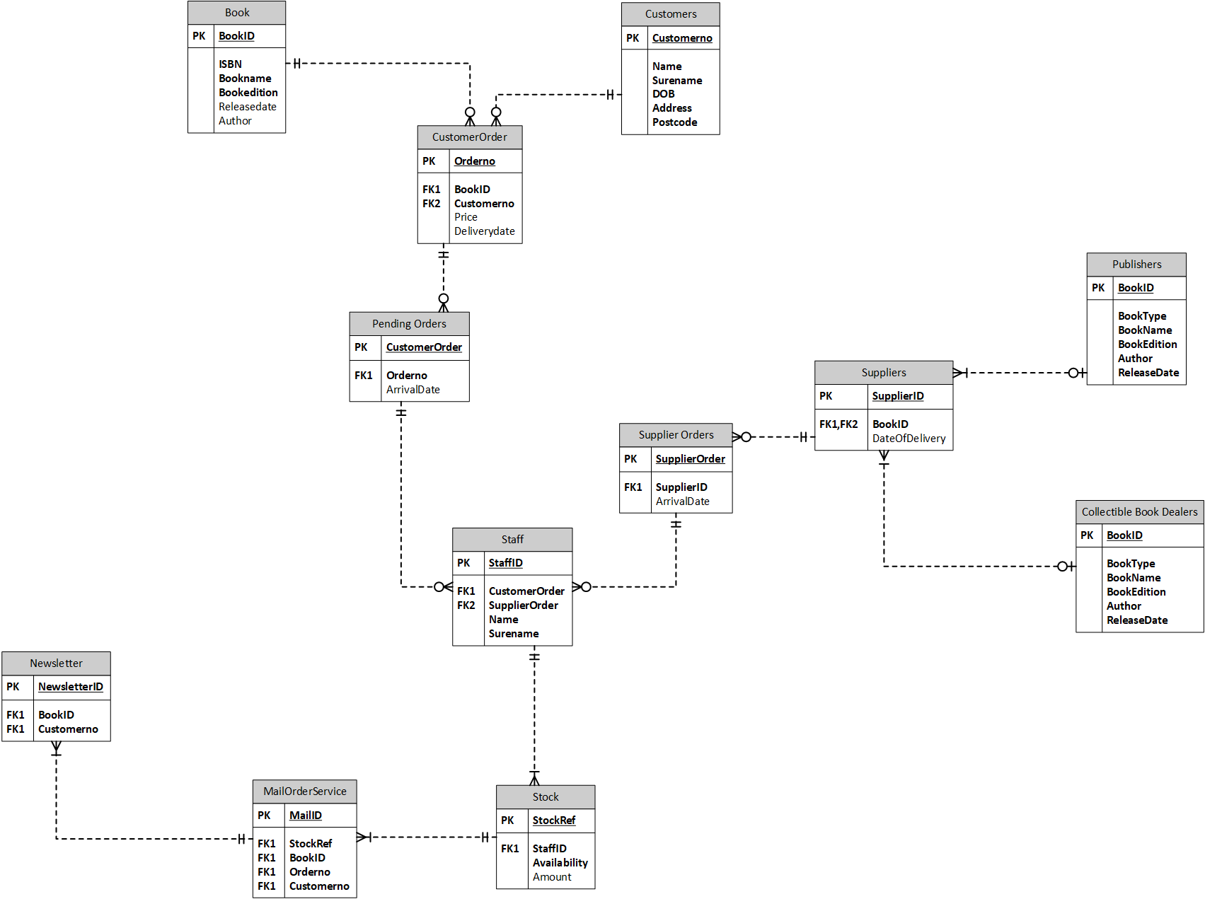
This is the entity-relationship diagram that was created before making the database. This was made to give an overview of how the database will connect with itself. This also helps with how the relationships will be created between each table. For example, the book and customers connecting to customer order. This shows that to create the customer order table both the book and customers table must be created beforehand. This is the second entity relationship that was created as the first one did not work correctly as part of a database. Instead of having 3 primary keys for the staff table, it was better to normalise the data into 2 separate tables that would then join into 1 table with 1 primary key.

The database

The tables
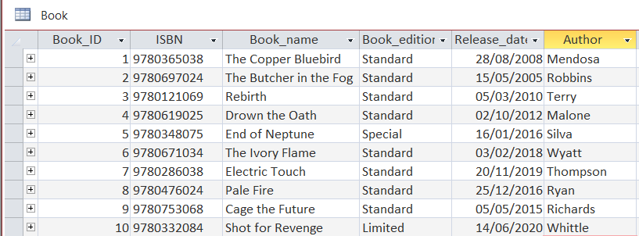
This is the book table; this is one of the primary tables that the information gets taken from. The primary key is “Book_ID”. This table gives information on the name, ISBN, edition of the book, release date and even the author.

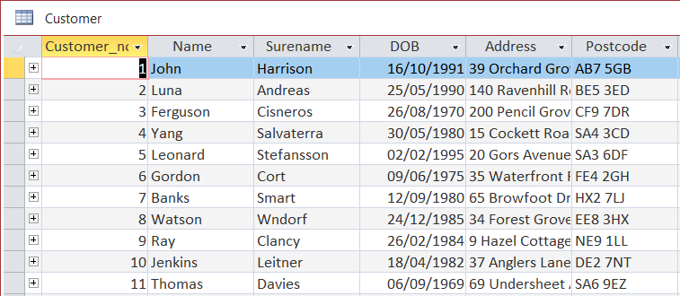
This is the Customer table where all the customer information is held together. It’s another primary table with the primary key being “Customer_no”. The customer number makes it much easier to find all information about a single customer in the database. The other fields contain the Name, Surname, DOB, Address and postcode of the customer.

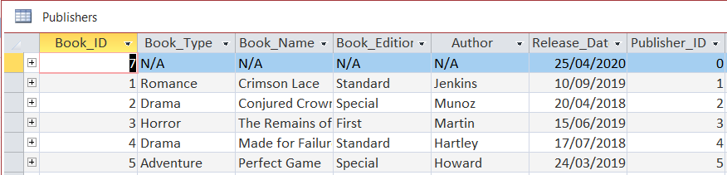
This is the 3rd primary table within the database that stores valuable information about the books. This is the table where the publisher’s books are saved so that the staff can see and place-specific orders on books that might be wanted by the customers. The primary key is the “Publisher_ID”, The publisher ID is not an auto-number as several books could be ordered from the same publisher etc. The other fields cover the following: Book_ID, type of book, the book name, the book edition, author, and release date. The book edition is important in this and the collectable book dealers table as these individual sell special and rare books that the library can then sell to the customers. One main thing can be seen in this table that there is a publisher ID of 0, this is in place for a very important reason. In the supplier table if the book is coming from the collectable book dealers’ section then the staff would input a 0 for publisher which is known as no publisher. This allows there to be a book dealer but no publisher and vice versa for the collectable book dealer section.

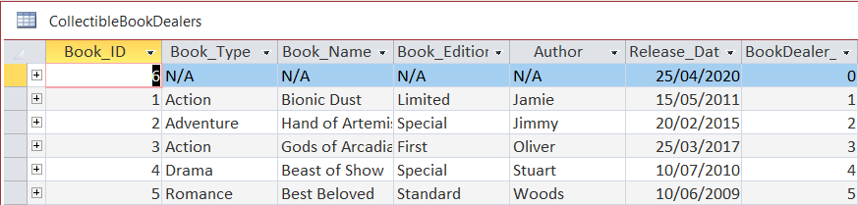
This is the last primary table in the database. This table is the same as the publisher table however, it’s the information gathered from the collectable book dealers and the books that they have for the library. The primary key is again “BookDealer_ID” This is done in the same way as the publishers’ table. This is made so if any books taken from publishers table without the use of book dealers can be recorded in the suppliers’ table with no issues. With the other fields covering the same information that the publisher table does.

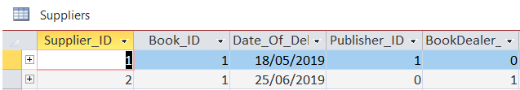
This is the supplier table that connects the publisher and collectable book dealer table together. The primary key is “Supplier_ID”. The other IDs that are connected work in the way mentioned previously. There are duplicate IDs if you were to try merge publisher and the book dealer table. This is why there is always an ISBN in place as well as the 2 fields implemented in this table. The 2 IDs publisher and bookdealer have the option of 0 to be used. The option 0 signifies a null field so it would display as no publisher etc. This is done so a direct supplier ID can be made as well as making a more specific order directly to the suppliers. Without this, there would be duplicate IDs that could cause several errors. Whereas now there are two Book_ID 1s in the table that both go to separate books due to the publisher and bookdealer ID. In a fully built system, this would work in a much more complex way however, this was the best way to simplify and explain it.

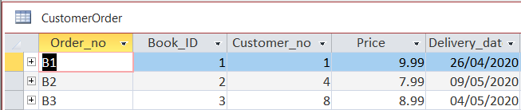
This is the table where the book and customer table connect. Its where the customer orders are made and stored. The primary key is “Order_No”. The information stored in this helps figure out what customer ordered what book and how much it all costs.

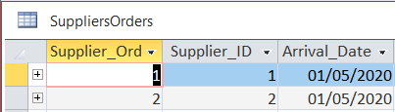
This table was created to hold the orders that are being made with the suppliers. These orders are important to the staff as this is one of their main ways of getting rare books into stock.

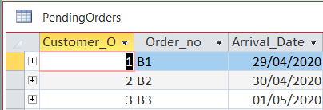
This table holds any current orders and places them in more of a priority list. The first order gets sent first etc. This would be in place unless the library would decide to offer better delivery options where users would pay for, such as next day delivery. The primary key is the “Customer_Order” field. This allows the order to be found much easier and shows its position in the queue.

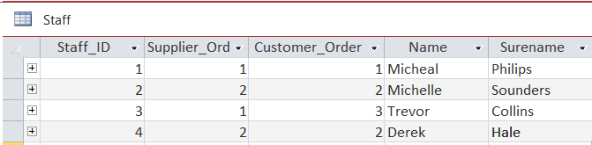
This is the middle table where all the information travels through. The staff have to process these orders and therefore they go through their information. Staff may either work on the same or different customer and supplier orders. The primary key is “Staff_ID” which holds the information for supplier and customer orders.

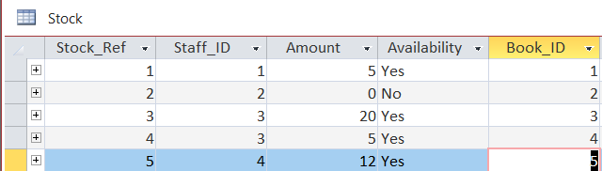
This table holds the information of the current book stock and whether its available or not. This reference is also later used for the mail service to inform the user whether the books in stock or not. As well as the newsletter to be sent with new book information. “Stock_Ref” is the primary key of this table.

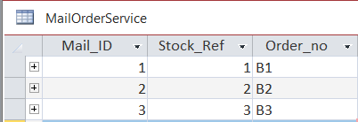
This table is where the mail information goes to. The order number for the customers’ orders is also held here so it can be sent over to them. The primary key is “Mail_ID” the stock reference is there in case there isn’t enough stock of the selected book for the customer.

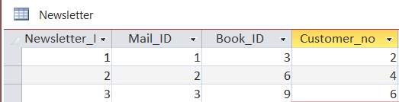
This is the final table in the database. The newsletter has the customer information and certain books get picked to be mailed over to the individuals. The Mail ID is connected to this as the mail team would be sending the information out to the customers. The primary key in this table is “Newletter_ID”.

Forms used
Main Menu Form
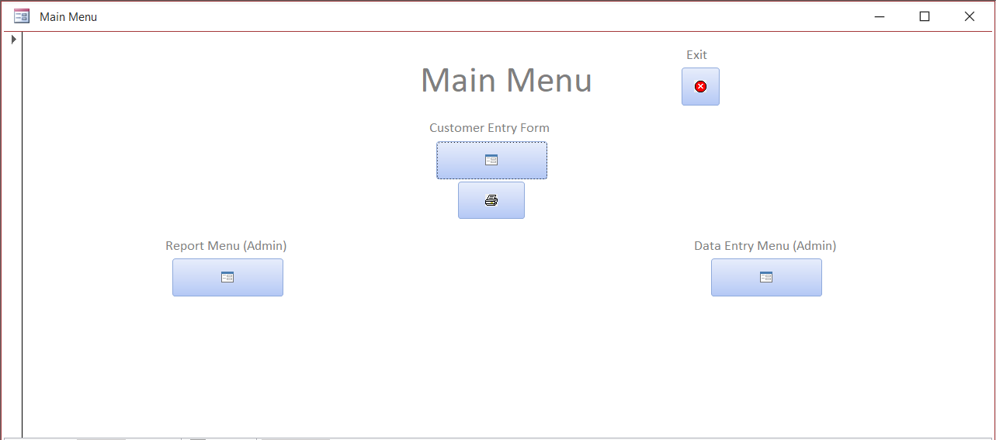
Report Menu Form
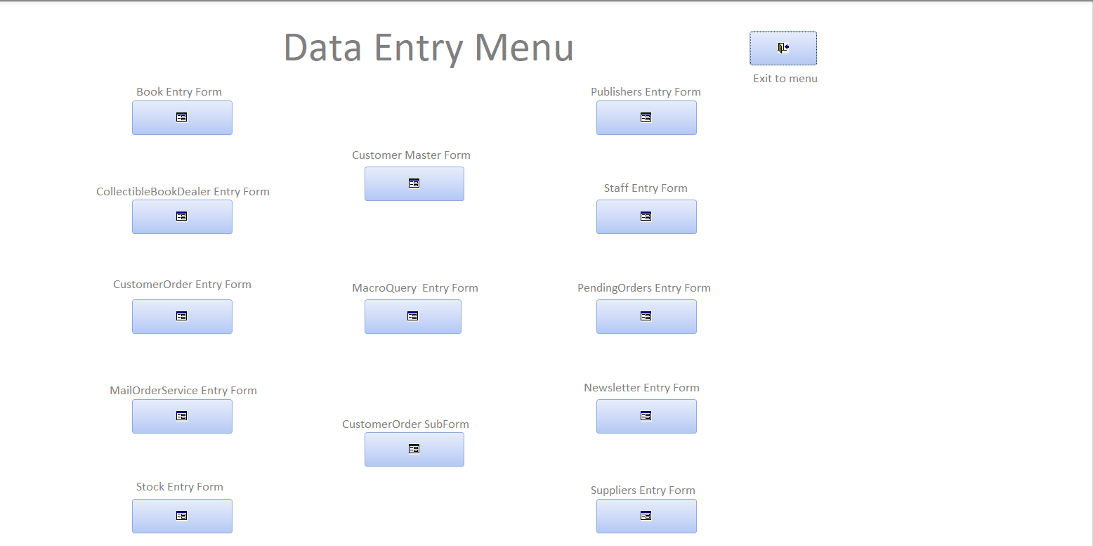

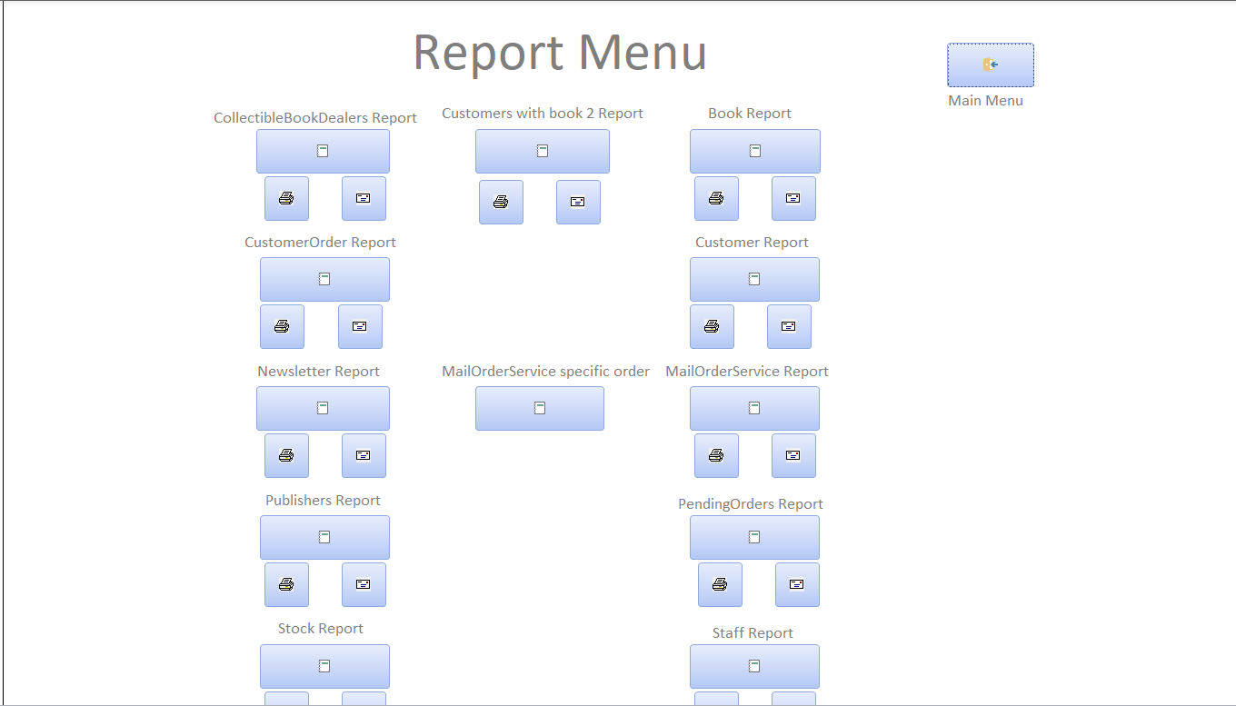
Data Entry Menu Form
These 3 forms have been made to make the database user friendly. These are the menus that allow you to navigate through the database. 2 of the forms are for admins while the main menu could even be used by a customer if they wanted to register and input their information. In each menu, there are buttons that connect to every other form within the database. The button automatically closes the form so that 1 window would be kept open at most times. The reports can be printed out to be checked in person, they can also be emailed to the desired place.
Customer Entry Form
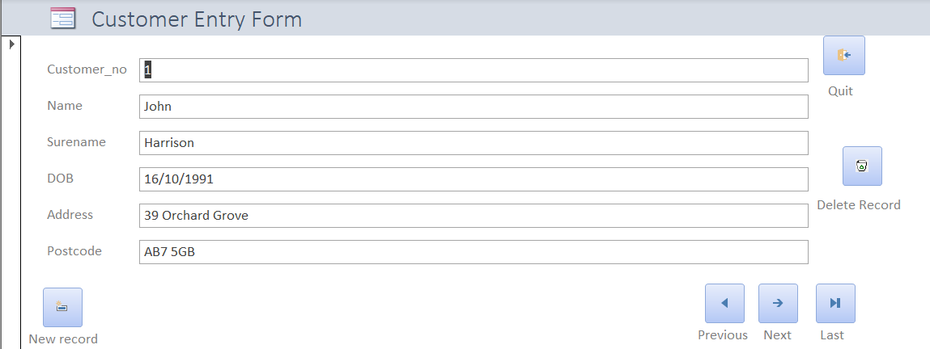
This customer entry form is on the front of the main menu to make it easier to get to. In this form, you have the buttons to do basically everything from making and deleting records to cycling through all the customer records in the database. The quit button was made to direct the user back to the main menu and close the form customer form so only 1 window is open.

The following forms have the same button layouts and are used to view and modify the forms in any desired way:
Book Entry Form
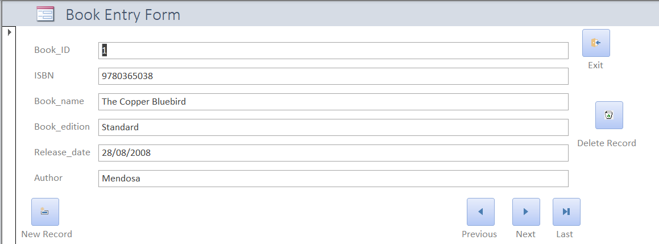

Publishers Entry Form
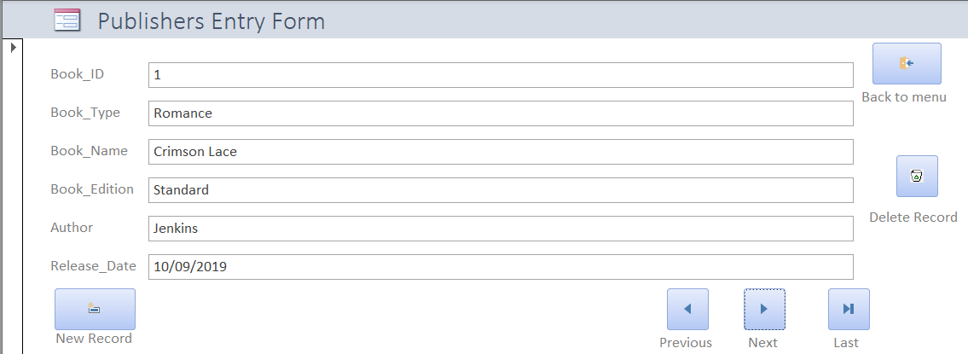

Collectible Book Dealers Entry Forms
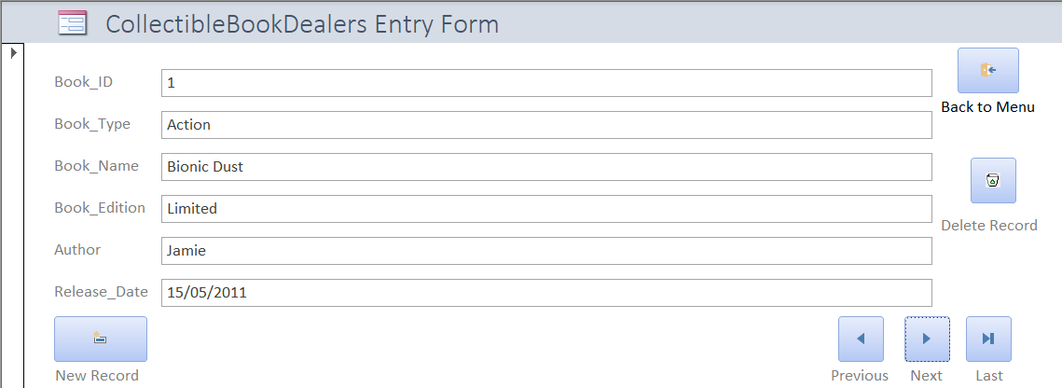

Staff Entry Form
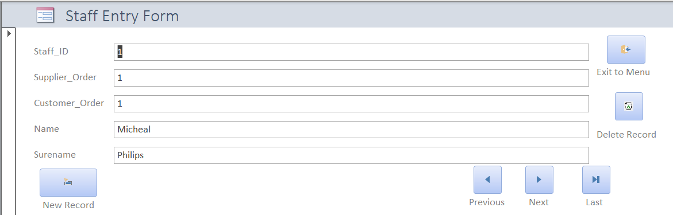

Customer Order Entry Form
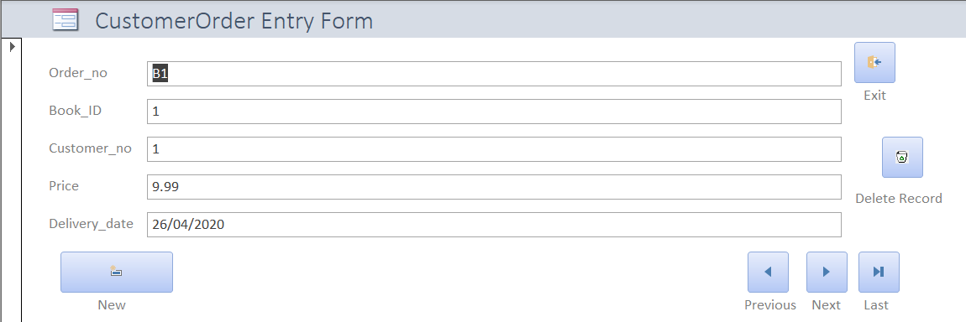

Pending Orders Entry Form
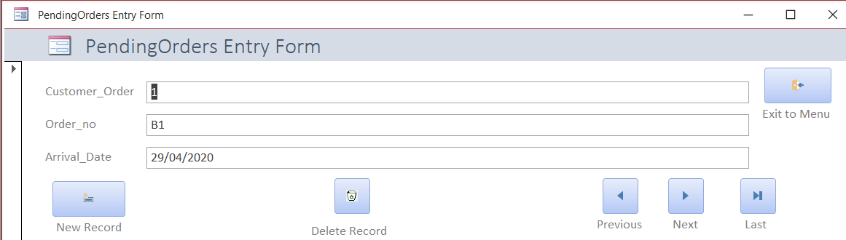

Mail Order Service Entry Form
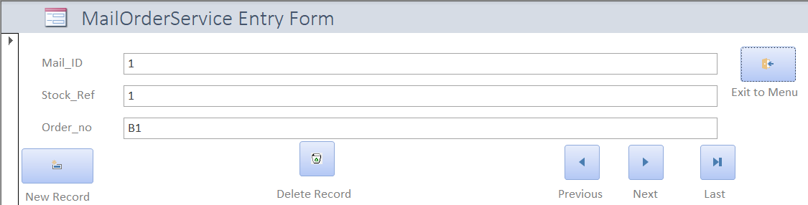

Newsletter Entry Form
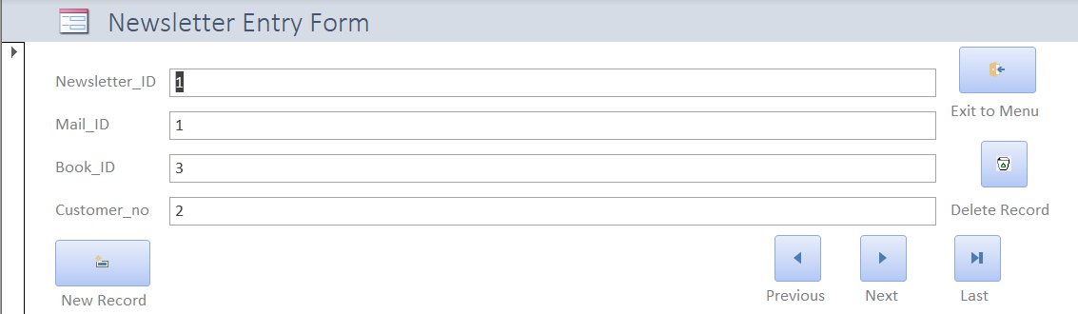

Stock Entry Form
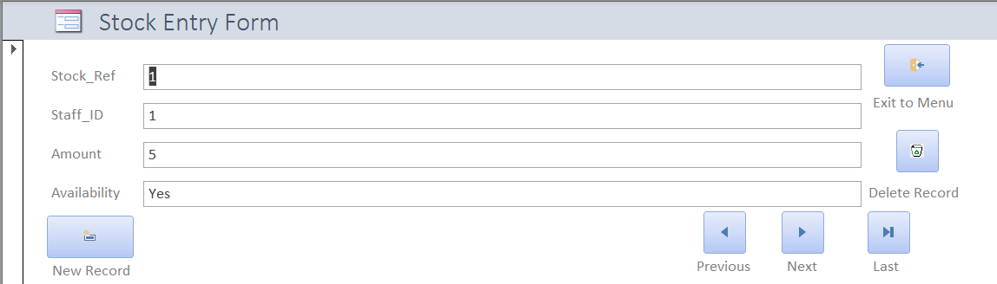

Suppliers Entry Form
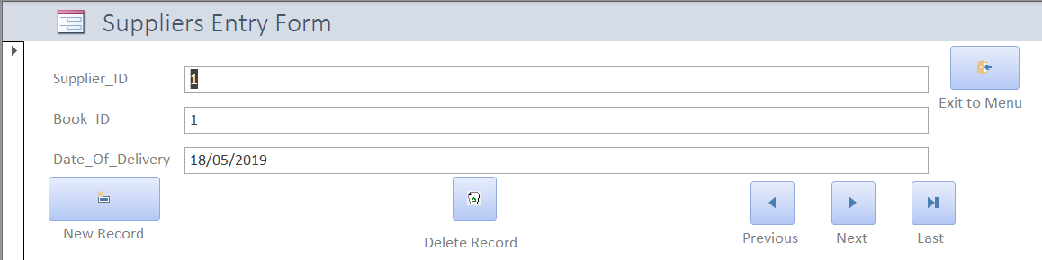

Suppliers Orders Entry Form
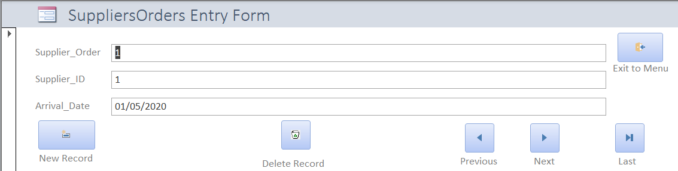

These entry forms are used to view and input the data that is in the tables. The user can also modify and delete them when necessary. These forms make inputting data easier than simply heading over to the tables and inputting them that way. This menu-driven format allows the database to be user friendly and much more efficient.

Customer Master Form
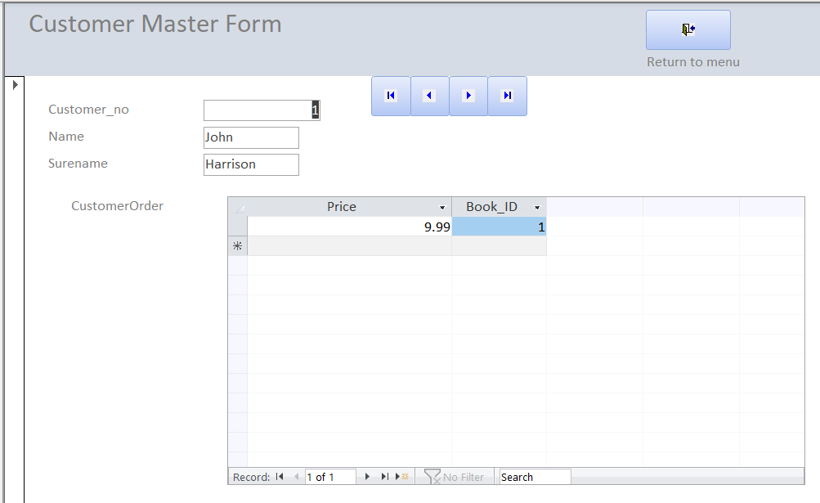
This form holds information about the customer as well as their order if they have any. The order will show the price of the book as well as its ID. In this form, the staff can enter and edit information about the users as well as find out if there are any orders for their customers.

Macro Query Entry Form
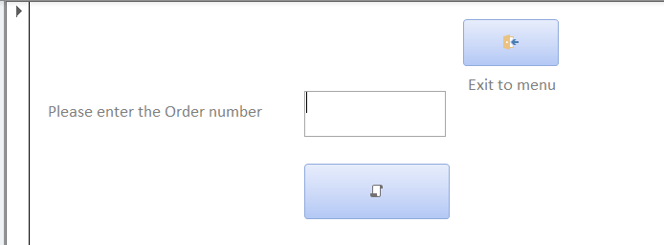
This is the macro query form that allows the staff to input specific order they want to see more information on. Upon searching the correct order number and running the macro it opens a report with the details of the order on screen for the user to read.

Customer Order Sub-form
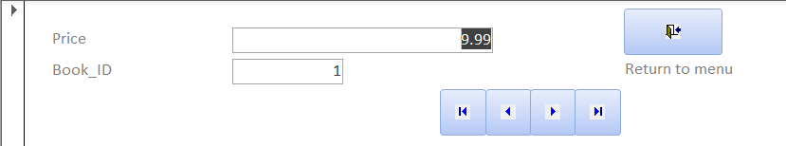
This is the Customer Order sub-form. This is the form that Is used within the master form to display the price and book that the users have. If a user is to order a new book the details of the book order will be sent here and would update to be displayed on the master form.

Reports
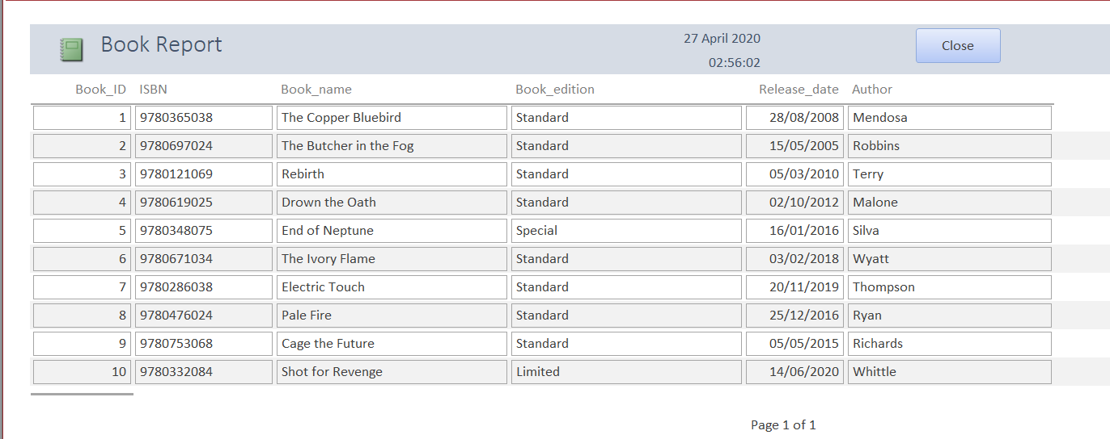
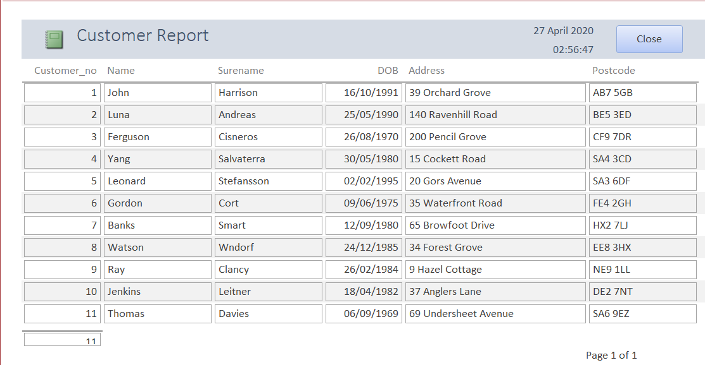
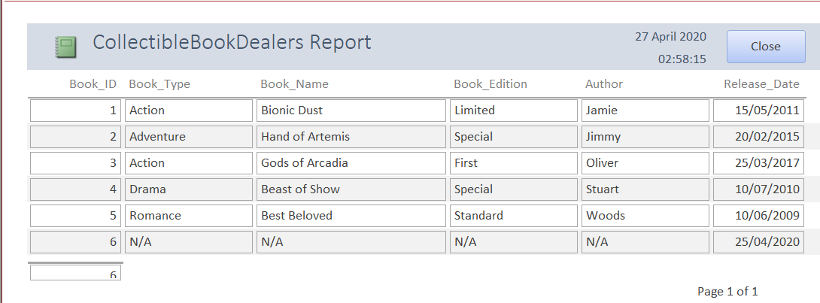
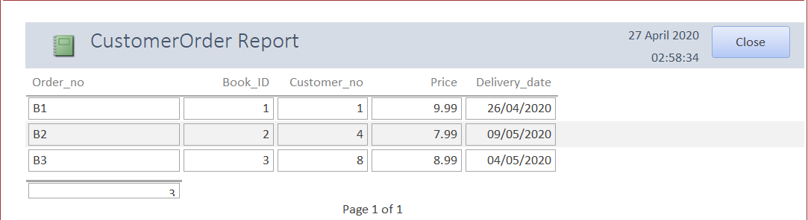
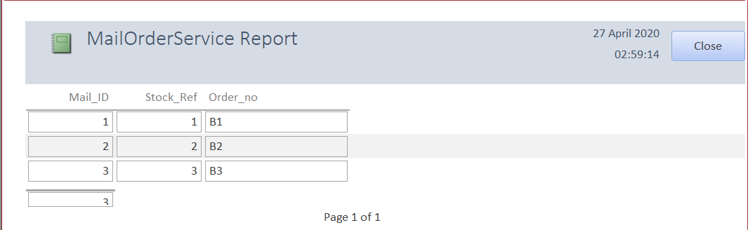
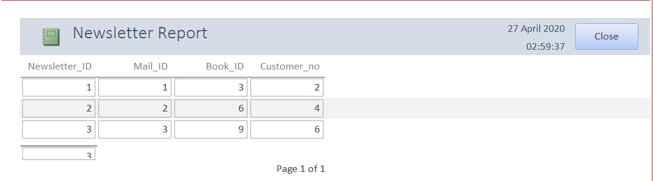
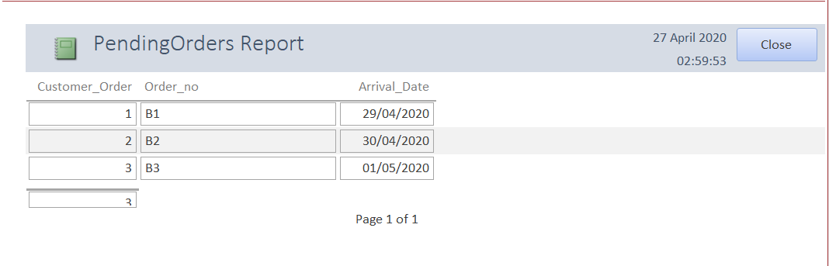
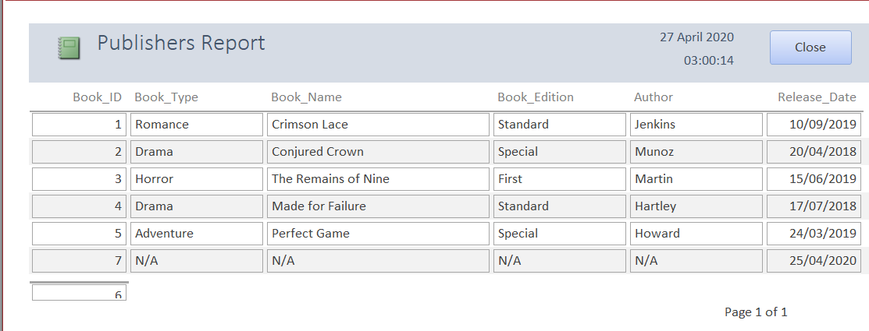
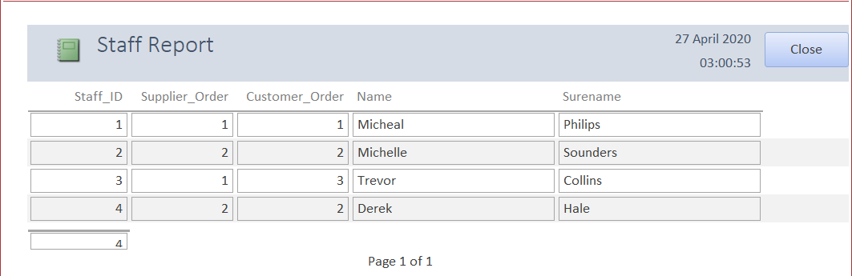
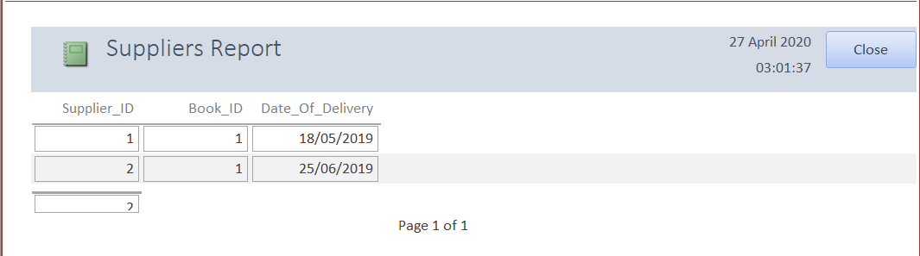
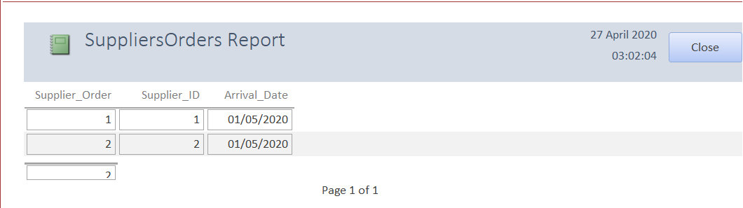
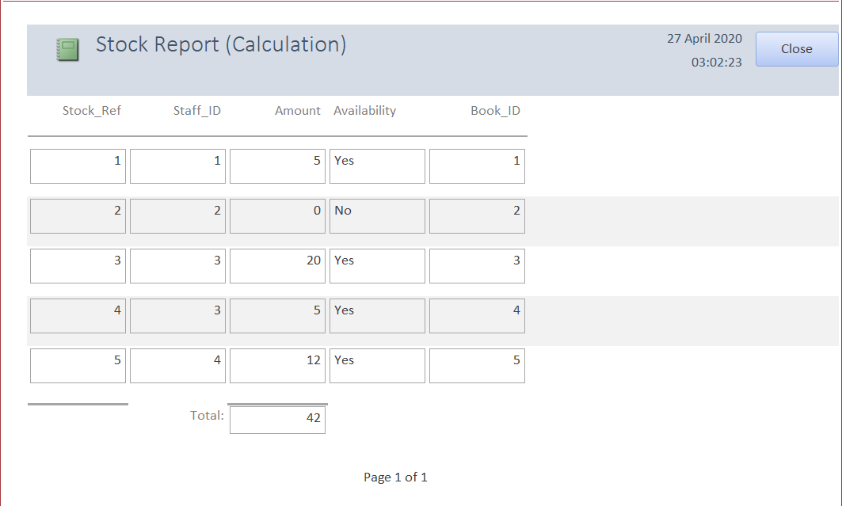
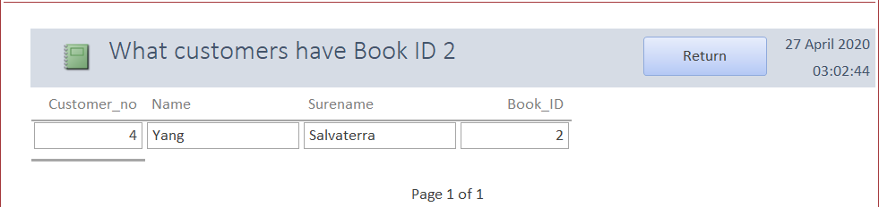
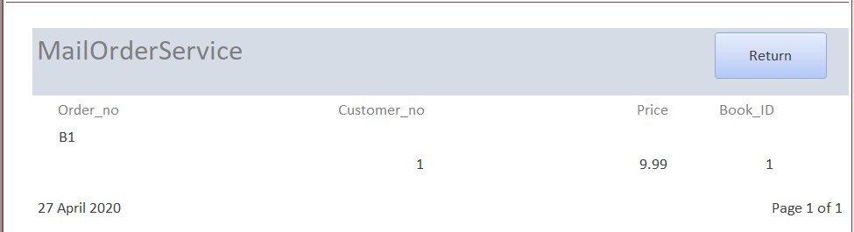

SQL Code

Table Creation
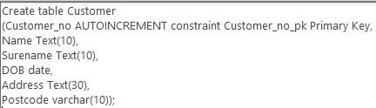
This is one of the types of SQL that was used within the database. This code is the way that the tables are created. The primary key is set using the constraint command. The “AUTOINCREMENT” command stands for an auto number so that the primary key will be unique and would not overlap in the table. The fields are created with different data types. In this specific table, it has the text, data, and varchar data types. When declaring the text field, you can select how many characters the user can enter into the field before the database stops them. This is used to stop any long unnecessary names that could be used simply to mess with the system. The date field will ask the user to enter a date in a specific format of “XX/XX/XXXX”. Finally, the varchar field allows the user to input number, letter, and special character into the field. Each table is created in a similar fashion just using different data types.

Inputting data
This is another type of SQL that was used in the database. This code was used to input actual details into the now created tables. The correct data types still apply when inputting this information.

Creating Relationships
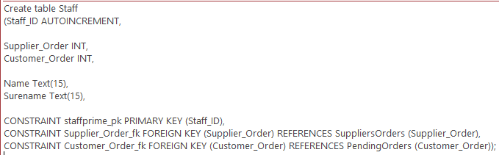This is the final type of SQL code that is used within the database. This format creates the table while creating the relationships linked with other tables. In this case, this would be used in any tables other than the primary tables of data for example customer etc. The constraint part calls the foreign key in a name you desire then references the table where the link is going to be made to.

User guide
This is the user guide to the database that has been created. The database is menu-driven. This means that the users can navigate through the whole system simply using the buttons that are there. Some buttons allow you to print reports as well as mail them. There are also some buttons that allow you to cycle through the records and everything is labelled to make it simple to use for anyone. Deleting records is also an option in case the user no longer exists within the system.

