
Strategic management for SMEs
[Document subtitle]


FAIZU EDU Adrian Petrea




BMSW6104: STRATEGIC MANAGEMENT FOR SME

Executive summary
The report based on the case study covers the strategic management of the organisation using the current direction of the organisation. Within this part, the Vision, Mission and goals of the organisation and their impact on the current businesses are discussed. Next, the report covers a thorough analysis of the current market strategies for Cafepod Coffee using frameworks namely PESTEL, SWOT and VRIN. In addition, the report also analysed the strategies that the organisation could take for their future growth. And lastly, the report covered the stakeholder analysis and their effects on the organisation including future recommendations for the organisation.

Table of Contents
Introduction 3
Current strategic direction- vision, mission, values 4
Business environmental scanning tool 5
Discussion about strategic growth strategies 9
Stakeholder analysis 15
Recommendation for future development 16
Conclusion 18
Reference List 19

Introduction
In strategic management, SME is the shortened form of the phrase small and medium-sized enterprises. Every country defines SMEs according to its own set of rules. In the UK, there are approximately 5.58 million business that is private and are owned by individuals among them 99.9% belongs to SMEs having less than 250 employees (merchantsavvy.co.uk, 2022). SMEs are the most important part of any growing economy. It contributes the major portion of the GDP of the UK. SMEs are the backbone of any economy; it helps them grow and achieve big numbers. Strategic management analysis of the SMEs will help us find problems they are currently facing and give us valuable insights to solve them so they can grow positively and rapidly. CafePod is an SME with less than 50 employees based in the UK. It was established in 2010 by Peter Grainger. Their head office is in Manfred Road, UK. CafePod is a speciality coffee company that makes various pods and coffee fillings. They have a large variety of coffee for their customers to choose from (cafepod.com, 2023). This report will be discussing the current strategic direction, Porter's generic strategy theory and further Stakeholder analysis will be discussed in this report.

Current strategic direction- vision, mission, values
About the Company: It was established in the year 2010, and the idea for CafePod came to light over pizza and beers in London. The founder Peter Grainger had a wild vision for changing how people take coffee daily. It has been a decade since their launch they are still passionately working towards making high-quality, great-tasting coffee that can be prepared at home easily. They make various kinds of speciality coffee that have great taste and also less in terms of price so that people of all levels could afford them very easily. CafePod made it possible that great coffee can be made at home very easily.
Vision: Having a clear vision is very important for a company so that it can plan the path towards it and achieve it. CafePods is in the very large food industry, among all the food segments only coffee amounts to £8.50 billion. From this market coffee pods make upto13% (CBI Ministry of Foreign Affairs, 2022). The vision of CafePods is to make high-quality coffee available to all sections of people at a very affordable price. They want to empower everyone at home with the tools they need and know-how so people could unleash their passion and creativity about coffee. Everyone likes their coffee in their way. Someone may like it in raw black form and others may like the cream. The vision of CafePod is to make every possible effort to make these people able to make coffee in their way.
Purpose, Mission: The purpose of any company is the reason for which the companies exist which also gives the value of the enterprise to its customer, shareholders, employees, and society (Fitzsimmons, Qin and Heffron, 2022). The purpose is the driving force for which the whole company works towards it. The purpose is the amalgamation of its mission, vision, and core values. The mission of any company describes what the company does in reality on the ground to make that purpose come true. The mission is more about their current products and services; the purpose is the larger goal that any company likes to accomplish in the long term. The mission of CafePod is to make custom-tailored coffee and pods that are developed for millions of customers who are at home but still want to enjoy high-quality coffee (cafepod.com, 2023). Their purpose is to become the biggest speciality coffee company and make consumers empowered with the know-how and tools to make the coffee of their choice at home.
Values and goals: They work in a very competitive market where there are big players like Nestle. Companies such as Nestle have a wide reach where they can sell their product. As a big company, they can’t cater to small needs and markets. This is exactly where small enterprises or companies like CafePod find their market. Small companies such as CafePod set their goal to achieve what big players could not. Big players also cannot focus on low-volume high-quality products because it will be less profitable for them, they can make more profit by selling a mass-market fit product that is liked by more people. They focus on selling numbers rather than taking care of their small unique customers. This is the perfect gap that becomes a goal for small companies like CafePod. Companies like CafePod have high-value standards, they rely heavily on innovation and products. CafePod also values its small base of customers who want quality coffee at home and their satisfaction.

Business environmental scanning tool
PESTLE analysis of CafePod
Political factors impact on CafePod: The major political factor for CafePod is their sourcing of raw materials, gathering raw materials has got the huge attention of the politicians from the source countries. For this reason, the company wants to know the norms of environmental and social. CafePod Coffee needs to maintain and ensure the following of many laws and regulations made by the British government to purchase coffee from other nations. For example, the organisation can only import non-roasted coffee beans to follow the legal implications (cbi, 2023).
Economic factors on CafePod: The economic factors of any nation are directly linked with the business of that nation, most developing countries have an economy that is emerging (Yadav et al. 2020). For Cafepod Coffee inflation is one of the factors that can affect the organisation most as already due to inflation the disposable income has fallen for the average UK citizen. In addition, the price of a cup of coffee is increased by at least 22% in 2022 (elementcoffee, 2022).
Social factor on CafePod: In this modern era now consumers are concerned about the nutritional consumption of particular drinks and coffee. Also, the accurate and sufficient information about nutritional energy on the label of their products has made CafePod in getting more developed as people can trust their products. Although it is also a threat to their selling of products as some individuals found their product is not safe for drinking due to the presence of caffeine in the large amount. With that being said the global trends for coffee pods are predicted to rise to 6.71 billion with a 4.8% CAGR (globenewswire, 2023).
Technical factors affecting CafePod: The best technical factor is that CafePod are using infinitely recyclable aluminium pods and also these are of high quality and can be reasonable ground (cafepod.com, 2023). Another technology that this company uses is they favour a longer, darker roast to the coffee beans which makes it bolder and also the more intense flavour is made (cafepod.com, 2023). CafePod blends from many nations from all over the world including the UK.
Legal factors affecting CafePod: There are many problems and legal issues within any nation which directly or indirectly affect the growth and productivity of these firms. CafePod must ensure the rights of their employee working inside them to achieve more success. As the right of their employee and their freedom of speech. The expansion of the firm is also possible by having the proper licence and having rules and regulations within the firm. Any SME working inside the UK has to ensure that they are flowing regulations set by the government such as there are set limits of a national living wage for every age group they change the minimum wage every year on 1 April (gov.uk, 2023).
Environmental factors affecting CafePod: The demand for these products is increasing and this has resulted in increasing productivity which ultimately leads to an increase in the use of vehicles for transportation. These are causing much pollution and harm the health of living beings. CafePods are focusing on the recyclable package which will help in the reduction of pollution and also use of renewable energy has saved many fossil fuels. As a company working inside the UK, they have to follow the environmental act set by the government and they have to collect their waste and separate recyclable materials then they have to dispose of them (legislation.gov, 2021).

VRIN Analysis of CafePod
Valuable: CafePod mostly produces coffee as they offer expresso blends while using coffee capsules which are made of food-grade recyclable plastic this product is more valuable. The most valuable aspect of a business is competition and this has helped CafePod in exploiting the available opportunities. CafePod can reduce threats from the external and internal environments which will further help them in increasing productivity. These competencies enhance the business growth and also help in expanding further. The CafePod brand image is unique and also contains good brand integrity, as it has been only achieved through continuous effort and the quality of the product offered by them (Muhammedrisaevna et al. 2021). CafePod has highly innovative in its product offering and these innovations are also used in marketing and also in other areas to increase productivity and growth.
Rare: CafePod Coffee has a unique strategy in case of pricing as good-tasting products and lower prices their coffee is soon to become one of the largest industries by maintaining quality. These things and qualities that are acquired by this company have made it rare as these are not easily available in the market. The great advantage of this firm is to provide the same taste in coffee while staying at home instead of going outside by providing them such goods to consumers (Tien et al. 2020). CafePod is now acquiring a global presence and also they are operating in various countries and regions. They also foster an organisational culture of solving problems between management and their employees. The calculated and guided risk given to the experts is followed by this company which has made it rare and also helps in enhancing the interest of consumers.
Inimitable: Using coffee capsules made with food-grade recyclable plastic is inimitable as their preparation practices are kept secret. The inimitable competition among the various industries has helped in adding value to the competitive advantage and also help them in long-term sustainability for any firm (Mahdi and Nassar, 2021). CafePod offers good and best-quality products and delivers them directly to consumers' houses which has also been a source of brand appeal. This high and continuous supply of these products to the home of consumers has made them repeat their orders.
Non-Substitutable: Their entire process of making their products are highly inimitable as this is an inimitable resource for the firm as they have high quality. These are only known to the upper authority of the management of the company. Products made by this organisation can not be substituted by others as they are kept highly confidential so that their uniqueness remains the same.
SWOT
SWOT is the short form of four key matrices namely strengths, weakness, opportunities, and threats which are used for business environmental scanning. SWOT was first originated in the early 1950s in the School of Harvard Business for analysis of case studies (Benzaghta, et al., 2021). Since then the SWOT was used in various ways to analyse the internal and external environments of any organisation to identify the big picture. SWOT is used along with the PESTEL framework analytic hierarchy process also known as Porter’s five forces to get more accurate results for strategic decisions (Benzaghta, et al., 2021).

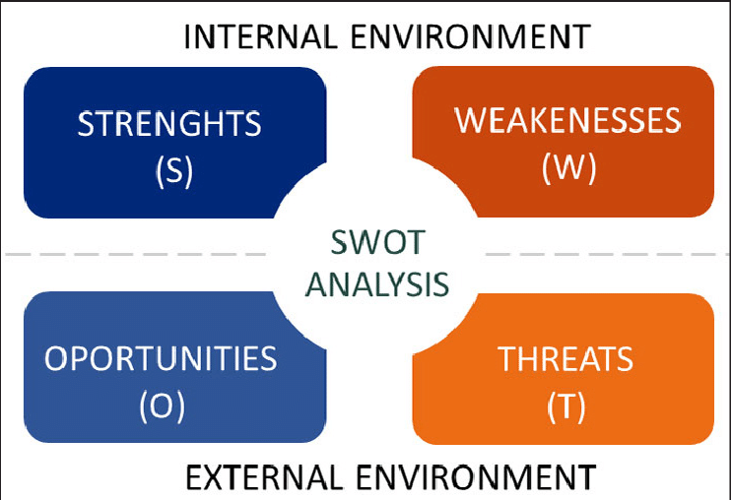
Figure 01: SWOT analysis matrix
(Source: Cañizares, and Bourotte, 2021)
Strengths
One of the most important factors in the SWOT matrix is strength which can be aligned with any business, may it be a small or large enterprise. CafePod is a small enterprise so it is very important to have their unique selling proposition of USP to stand out in a crowded market. The only thing they have is their understanding of their market segment and their products. CafePod has done extensive market research to find the best or hero product for them. This company has nearly 30 years of coffee blending and testing experience which helps them find great-testing coffee (cafepod.com, 2023). Their pods which can be operated by anyone at home are best sellers and their strength too. They deliver products online which is their strength too as they do not have to invest in infrastructure such as shops.
Weaknesses
As a small entity, they do not have much brand recognition such as their competitor Nescafe. Their competitor has a global reach and much more brand value and recognition in comparison to them. CafePod needs to work more on advertising and building its brand value. One more weakness they have is, as a small SME they have limited employees and can develop a limited type of products for their customers and can have a limited reach. They are in a very competitive market, it is very hard to stand out in a market where Nescafe is a market leader.
Opportunities
Opportunities are about cashing in on the lost market opportunities that the company could have explored but did not. CafePod has a strong presence in the online market but very little presence in the offline sector. The company can build strategic alliances and joint ventures with offline retailers such as Tesco, and Asda to advertise and sell their products (Arshad, and Yazdanifard, 2017). When more and more customers will come and see their products on stalls there they can experience them personally and buy them. The coffee market in the UK is in the billions so they can have their fair share out of that if they correctly market their product.
Threats
The biggest threat for CafePod is that they are in a crowded market with a giant market leader such as Nascafe. Although the market size of coffee is huge in the UK, it is about £8.50 billion they still have to make their way up (CBI Ministry of Foreign Affairs, 2022). People are now getting more health conscious and getting more inclined towards healthier alternative drinks. This is also a threat to coffee-based companies like CafePod. To compete with alternative drinks CafePod needs to bring some healthier drinks to their product lineup to cater for those customers and it will increase their sales too.

Discussion about strategic growth strategies
Porter’s generic strategy analysis:
Porter’s generic strategies consist of four main factors Cost leadership, Differentiation and Cost focus strategies. In the following study, we will deduce the factor that CafePod coffee should focus on without wasting the precious material of the organisation.

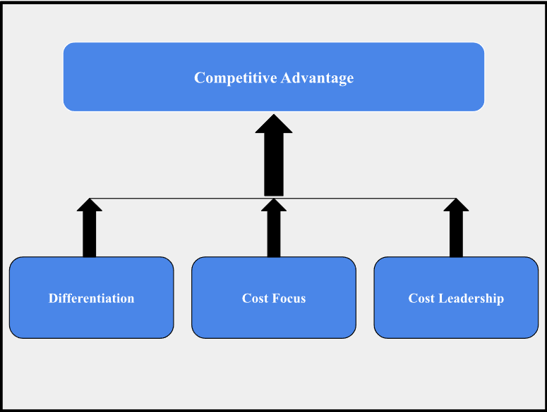
Figure 02: Porter’s Generic Strategies
(Source: Created by the learner)
Cost-leadership:
Cost leadership is an organisation's strategy to introduce price advantage by controlling the manufacturer's cost. Organisations implement this strategy using fixed manufacturing flow charts, improved machinery and standard procedures thus reducing waste and cost (BAL and ERKAN, 2019). In the case of cafe coffee pods the manufacturing process of the pods can reduce the price of the product to some extent, but for many coffee drinkers, the quality of the beans and flavour of the coffee is more important than the price. As long as cafe pod coffee is delivering coffee of good quality people are willing to pay a little more (MINTEL, 2018). With these facts in consideration, the Cost leadership strategy is not the correct approach for CafePod coffee.
Differentiation:
The process of developing a unique position in the industry through different activities is known as differentiation. According to studies conducted before, the organisation has to choose two competitive advantages. One organisation can only be a cost leader or a market differentiator (Ali and Anwar, 2021). In the case of CafePod Coffee's current strategy, the company is not driven by differentiation. Although the coffee pods just started to gain popularity the first product is more than three decades old (Perfect Daily Grind, 2020). Without any innovation in their services, CafePod Coffee cannot be considered the differentiator of the industry. With big players like Nestle on the competitor board, differentiation can bring one positive change towards the company's business.
Cost-Focus:
Cost focus strategy is when an organisation is trying to provide the product at a lower price than industry standards undercutting their competitor’s price and creating a competitive advantage. This strategy is usually used in conjunction with cost leadership or Differentiation strategies. According to research, all the companies follow the differentiator strategy since only one organisation can provide the lowest pricing (Islami, Mustafa and Latkovikj, 2020). Cafepod Coffee is one such organisation that is focusing on the cost by undercutting its competitors. Cafepod is providing 10 pieces coffee pod packs for 4 pounds (Cafepod, 2023) which is lower than the average price of coffee pods. This strategy combined with the CafePod differentiation strategy already made the company a growing giant in the coffee pods industry and focusing on this combination can be beneficial for the organisation’s future.
According to the data gathered and mentioned in the report so far, CafePod Coffee's cost-focus approach in conjunction with the differentiation strategy will be the best generic competitive strategy for the future of the organisation.

Ansoff Matrix
Through examining their product and market offers, firms can use the Ansoff Matrix, also known as a market expansion or product grid, to uncover growth potential. (Kyle, 2023). This also motivates business owners to find out the risk associated with different growth strategies. H. Igor Ansoff, a mathematician and business executive, provided the matrix in the Harvard Business Review in 1957. (Clarissia, 2020). It has four different quadrants, market development, market penetration, product development, and diversification. Among all of these factors market penetration, market development and product development of CafePod will be discussed for their strategic growth.
Market Penetration: Since it has helped so many industries grow by utilising their current resources and capabilities, Market Penetration techniques are thought to be the least risky of all of them. Market penetration involves an increase in sales with a company’s existing products in an already established market. In recent years, the UK coffee market has experienced tremendous growth. The market for coffee shops was predicted to grow to £3.5 billion in 2022 from £3 billion in 2021, a 16.4% increase. Sales of coffee shops are anticipated to continue growing positively and reach £4.5 billion by 2027. (Trish, 2023). CafePod is already available in both the channel online and offline modes such as Amazon, Cocado, Tesco, and Waitrose. They just need to do online marketing to boost their sales. Influencer marketing and Amazon AdWords could do wonders for them. This could boost their sales to new levels. They can also open test shops inside retail stores like Tesco where customers could come and taste their existing products and buy them if they like. They can also get valuable feedback to improve their products further.
Market development: Market development is where a company introduces their existing products to a new market. The UK has the largest consumer market for Fairtrade coffee. The consumers drink two cups of coffee per day. £2.9 billion is what consumers spend on drinks like tea, coffee and cocoa (Ridder, 2022). So the market has immense growth potential. Some people want to have high-quality coffee at their homes daily. CafePods also has the resource ready for expansion. All they need to do is explore new markets such as physical stalls near sports or movie complexes so that people could get to know them and try their products physically before buying. When they are assured about the quality then they can be potential new buyers.
Product Development: Product development is very important for any SME as their product is the main differentiating factor that makes the consumer choose them in the first place. Without the perfect product, they cannot survive in a competitive market. First, they need to find a gap in an existing market. After that, they need to heavily focus on consumer behaviour and how the taste of the consumer is changing. People are willing to pay higher for environmentally friendly products. CafePod already uses infinitely recyclable aluminium pods and reusable bean bags. They need to focus more on making their business sustainable.

Bowman’s Strategy Clock
Cliff Bowman and David Faulkner developed Bowman’s Strategy Clock, they built it by looking at Porter’s strategies and extended it for companies to follow. Their approach is based on the value-price perception of consumers. They rely on providing the consumers with what they are willing to pay for (Andreevic, 2020). It has eight strategic directions, which is shown using clock graphics generally. Each position on the clock is characterised by a unique combination of price and perceived value. These strategic options are Low Price, Low Added Value, Differentiation, Hybrid, Focused Differentiation, Monopoly Pricing, Risky High Margins, and loss of Market Share. Upon analysing Bowman’s Strategy Hybrid and Differentiation are the best strategy for CafePods.
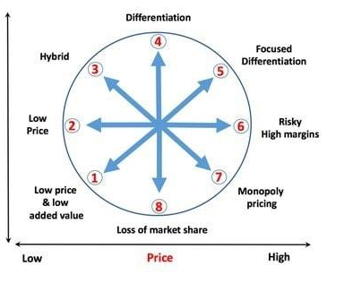
Figure 03: Bowman’s Strategy Clock
(Source: Arshad and Yazdanifard, 2017)
Hybrid: Hybrid is the best strategy for small enterprises like CafePod and small companies already work with tight profit margins. If it was a low-priced product that might have given them a high volume of sales but it could have decreased the perceived value of their product and the company too. Low perception about a company could hurt them in the long run. Also if they choose to price their product at extremely high value that also could hurt them as there are already established market leaders like Nescafe. CafePod can not price their product at very high prices, otherwise, people will simply avoid their product. Hybrid or moderate pricing is the best way forward for CafePod as it can compete with existing low-cost competitors with higher perceived value. At the same time, they can also compete with extremely high-value competitors with their low-priced higher-value products. They can also introduce a discount strategy to fight all the low-cost competitors. The value and quality are good and consumers can be assured that they are getting a reasonable price. This is the best combination for SMEs like CafePod.
Differentiation: The coffee market is very big and the options are endless. Only the coffee pods market is about 13% of the £8.50 billion coffee industry in the UK (CBI Ministry of Foreign Affairs, 2022). There are innumerable numbers of small competitors and also big market leaders like Nescafe who are driving the market with their products. Companies like CafePod are focused on specific segments where consumers want to make high-quality coffee at home. They do not want to go out every day for their coffee needs. Home coffee options were very less as the size is only 13% of the whole industry. CofePod makes high-quality coffee pods for those home users. They also provide know-how for their customers so they could have the coffee the way they like. Consumers need to have more options so that they can choose what tastes best for them. CafePod needs to invest more in research and development to make its product different from other competitors. They could make their product different by contributing to any social cause like sustainable farming for their coffee. They need to blend various coffee all over the world and create complex, well-rounded blends that are different in taste. They also need to make their product more sustainable as people often pay higher to have a sustainable product.

Stakeholder analysis
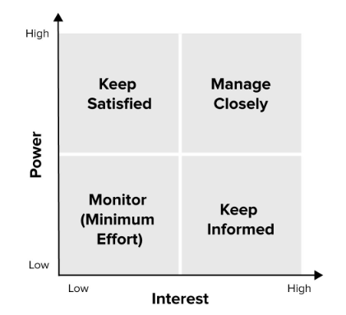
Figure 4: Stakeholder analysis diagram
(Source: inspired by Leeron and Cassie, 2022)
Stakeholder analysis is a tool of project management that is used to identify the stakeholders of any project and how they will be impacted by that particular project (Leeron and Cassie, 2022). With the help of this analysis, one can outline the important person they need to contact and communicate with regarding the development and scope of that particular project. The stakeholder analysis of CafePod includes keeping satisfied the customers, managing closely with suppliers, monitoring employees, and keeping informed of the local authority.
Keeping Satisfied: CafePod gives major priority to the customers as they believe consumers are the top stakeholders of their organisation. The interests of customers or these stakeholder groups are the high quality of their products and services as this is the only major reason behind the success of the firm (Leeron and Cassie, 2022). CafePod addresses these interests of their customers with great efficiency and they are always active in enhancing the experience of their consumers. They always work to keep their customers satisfied with their products and services and always enhance their products. This method helps CafePod in enhancing its products and customer experience, also they improved standards for their supply of required raw materials.
Managing closely: The suppliers of CafePod include coffee farmers, wholesale supply companies, and other vendors of the products. Any organisation are dependent on its suppliers to get growth and success which are essential for their firm (Taherdoost and Brard, 2019). Hence CafePod manages closely with their suppliers as their growth is dependent on them. Although the main CSR (Corporate Social Responsibility) interest of this group of stakeholders is the profitability of relations of their business from the chain of coffeehouses. Suppliers are an important aspect of any organisation therefore it is necessary to manage closely with them.
Monitoring: This generally refers to the tracking time and production steps, including other features as well. As the monitoring tools that are used to monitor employee is right and effective then this tool becomes employee-friendly, improving work efficiency, and helping the team in tracking (Trivedi and Patel, 2021). However, CafePod monitors their employee to achieve more success as the entire process is dependent on their employee and needs to make the employee feel happy. This will help any organisation in rewarding the strength of their employees and also helps in reducing and handling tackle distractions. Nobody in any organisation likes that their manager is standing just in front of them this tool can help managers reduce supervision of an employee.
Keeping Informed: The security of CafePod is dependent on the local authority as they protect them. Hence, they always keep the local authority informed about their decision and new policies which they have made or implemented. This is the primary responsibility of each organisation to keep their local authority always informed as their full protection is dependent on them. Raw materials and other required types of equipment that are used to be transported from one place to another place are also done with the help of a local authority. Hence growth and productivity also depend on the local authority.

Recommendation for future development
The above study has discussed several aspects of getting development of the company CafePod many theories and methods have also been discussed in this. Instead of that this study might have focused more on the various ways to gain more popularity for the company (Shepherd and Gruber, 2021). This will ultimately lead to attracting customers and it will increase the demand for their products. However, the method of preparing coffee pods usually tastes weaker than regular espresso the company might focus on this to gain more profitability. CafePod coffee tastes weaker than regular coffee shops. this can result in the consumers switching back to regular coffee tan espresso which can decrease the market size of the coffee and can affect café coffee pod greatly. The coffee pods market is already filled with many players and the tycoons like Nestle are also among them to get more development in this market. This is recondite to acquire more unique steps and provide faster delivery of their products to the consumers for getting more success (Gravier and Hawkins, 2019).
Although the café coffee pod has a great reputation among its clients still it is recondite to maintain good positive relations with them as they are only responsible for their success in this field. The organisation still requires compete for the place with the industry giants present at the top and which have already captured the entire market. The business of coffee is majorly dependent on trade done internationally, Asia, South America, and Africa are the major producers of coffee. Instead of that these drinks are most popular in the UK, Europe, and North America. Also, the trade relationship between the consumer and producer plays a great role in deciding the cost of the beverage which also impacts the sale (Hecht et al. 2020). Hence this is also recondite to this company to maintain good and positive relations with these countries that are supplying them with their raw materials. The company might focus more on marketing strategy to get desired development as it plays a valuable role in enhancing the growth and productivity of any firm.
Customer engagement is weak in this company hence, it is also renominated to introduce some rules and regulations for engaging customers and also maintaining good relations with them. This can be done by providing customers with coupons that can be used on the next order, or they also can provide some extra discounts to their consumers. Product development is also important for any SME as their product is the main differentiating factor that makes the consumer choose them in the first place (Plasek et al. 2019). Without having the perfect product, they cannot survive in a competitive market and this is necessary for this company to maintain the uniqueness of its products. Market development is where a company introduces its existing products to a new market and this needs to introduce several unique products of the company. The UK has the largest consumer market for Fairtrade coffee and CafePods also has the resource ready for expansion. All they need to explore new markets such as physical stalls near sports or movie complexes so that people could get to know them and try their products physically before buying.

Conclusion
Upon colluding all that have been cited in the assessment CafePod is a small enterprise working inside the UK. They have Nespresso-compatible pods as well as a large variety of ground and whole Bean coffee options on their website. They rely heavily on the subscription model but need to diversify their market. They can open physical stores where people could physically have a taste of the whole range of their products. Once people have a taste CafePod has a better chance of getting newer customers. They need to do more online promotion through social media influencers and AdWords so their company could have a reach among interested people. As a small SME, they have budget restraints so online marketing is best for them. They can target specific customers who have more potential of being a subscriber. Ansoff matrix shows that new product development should be at the centre of their focus. Bowman’s strategy shows that they need to price their product in the hybrid section so that they could have a high perceived value.

Reference List
Andreevic, H.A., (2020). Types of Strategies and Their Impact for Russian SMEs: The Case of the Coffeeshop Industry. pp. 18-19.
Arshad, A. and Yazdanifard, R., (2017). Investigative synopsis of Sony Inc.’s strategic management issues/failures and how to overcome them. International Journal of Management, Accounting and Economics, 4(9), pp.917-936.
Bal, H.Ç. and Erkan, Ç., (2019). Industry 4.0 and competitiveness. Procedia computer science, 158, pp.625-631.
Benzaghta, M.A., Elwalda, A., Mousa, M.M., Erkan, I. and Rahman, M., (2021). SWOT analysis applications: An integrative literature review. Journal of Global Business Insights, 6(1), pp.55-73.
CafePod (2023) HELPING PEOPLE MAKE GREAT COFFEE AT HOME Available at: https://www.cafepod.com/pages/our-story (Accessed: 11 April 2023)
CafePod, (2023). NESPRESSO® COMPATIBLE PODS Available at https://www.cafepod.com/collections/nespresso-pods (Accessed: 12 April 2023).
cafepod.com, (2023). WHY CAFEPOD? Available at: https://www.cafepod.com/ (Accessed on: 27 April 2023)
Cañizares, A.D. and Bourotte, C.L.M., (2021). Strategic diagnosis of geocommunication using SWOT analysis in the Varvite Geological Park, São Paulo, Brazil. Journal of the Geological Survey of Brazil, 4, pp.89-102.
CBI Ministry of Foreign Affairs, (2022) The United Kingdom’s market potential for coffee Available at: https://www.cbi.eu/market-information/coffee/uk/market-potential (Accessed 11 April 2023)
cbi, (2022). Entering the British coffee market Available at: https://www.cbi.eu/market-information/coffee/united-kingdom/market-entry#:~:text=You%20can%20only%20export%20green,longer%20apply%20to%20the%20UK. (Accessed: 28 April 2022)
Clarissia, S.M.S., (2020). A study on Ansoff Matrix Technique: As a growth strategy and an adaptive learning technique adopted in the leading brand of products. BIMS Journal of Management, p.26-29.
elementcoffee, (2022). Why Has The Cost Of Coffee Gone Up? Available at: https://www.elementcoffee.co.uk/post/why-has-the-cost-of-coffee-gone-up#:~:text=In%20early%202022%2C%20a%20study,drastically%20the%20industry%20is%20changing. (Accessed: 28 April 2023)
Fitzsimmons, A.B., Qin, Y.S. and Heffron, E.R., (2022) Purpose vs mission vs vision: persuasive appeals and components in corporate statements. Journal of Communication Management, 26(2), pp.207-219.
globenewswire, (2023). Coffee Pods Global Market Report 2023 Available at: https://www.globenewswire.com/news-release/2023/02/17/2610557/0/en/Coffee-Pods-Global-Market-Report-2023.html#:~:text=The%20global%20coffee%20pods%20market,(CAGR)%20of%204.8%25. (Accessed: 28 April 2023)
gov.uk, (2023). National Minimum Wage and National Living Wage rates Available at: https://www.gov.uk/national-minimum-wage-rates (Accessed: 28 April 2023)
Gravier, M. and Hawkins, T., (2019). The Knowledge Application and Utilization Framework Applied to Defense COTS: A Research Synthesis for Outsourced Innovation. European Journal of Innovation Management.
Hecht, A.A., Perez, C.L., Polascek, M., Thorndike, A.N., Franckle, R.L. and Moran, A.J., (2020). Influence of food and beverage companies on retailer marketing strategies and consumer behavior. International journal of environmental research and public health, 17(20), p.7381.
Islam, M.M., Akter, L., Pervez, A.K., Nabi, M.N., Uddin, M.M. and Arifin, Z., (2020). Application of combined SWOT and AHP for strategy development: evidence from pottery industry of Bangladesh. Asian Journal of Agriculture and rural Development, 10(1), pp.81-94.
Islami, X., Mustafa, N. and Topuzovska Latkovikj, M., (2020). Linking Porter’s generic strategies to firm performance. Future Business Journal, 6, pp.1-15.
Kyle, P (2023) Ansoff Matrix The Product/Market Expansion Grid Available at: https://corporatefinanceinstitute.com/resources/management/ansoff-matrix/ (Accessed: 12 April 2023)
Leeron and Cassie, (2022)., What Is A Stakeholder Analysis? Everything You Need To Know Available at: https://www.forbes.com/advisor/business/what-is-stakeholder-analysis/#:~:text=The%20purpose%20of%20a%20stakeholder%20analysis%20is%20to,each%20other%20or%20with%20the%20project%E2%80%99s%20core%20requirements. (Accessed on: 27th April 2022)
legislation.gov, (2021). Environment Act 2021 Available at: https://www.legislation.gov.uk/ukpga/2021/30/part/3/crossheading/managing-waste/enacted (Accessed: 28 April 2023)
Mahdi, O.R. and Nassar, I.A., (2021). The business model of sustainable competitive advantage through strategic leadership capabilities and knowledge management processes to overcome covid-19 pandemic. Sustainability, 13(17), p.9891.
merchantsavvy.co.uk, (2022)., UK Small Business Statistics Avabliable at: https://www.merchantsavvy.co.uk/uk-sme-data-stats-charts/ (Accessed: 28th April 2023)
MINTEL, (2018). ‘Latte levy’: UK coffee drinkers want to go green, but price is a barrier Available at: https://www.mintel.com/press-centre/latte-levy-uk-coffee-drinkers-want-to-go-green-but-price-is-a-barrier/ (Accessed: 11 April 2023)
Muhammedrisaevna, T.M., Shukrullaevich, A.F. and Bakhriddinovna, A.N., (2021). The logistics approach in managing a tourism company. ResearchJet Journal of Analysis and Inventions, 2(04), pp.231-236.
Perfect Daily Grind, (2020). A Brief History Of Coffee Pods Available at: https://perfectdailygrind.com/2020/08/a-brief-history-of-coffee-pods-nespresso-keurig-capsules/ (Accessed: 11 April 2023)
Plasek, B., Lakner, Z., Kasza, G. and Temesi, Á., (2019). Consumer evaluation of the role of functional food products in disease prevention and the characteristics of target groups. Nutrients, 12(1), p.69.
Rider, (2022)., Leading countries of origin for coffee imports into the United Kingdom (UK) in 2021 Available at: https://www.statista.com/statistics/653335/coffee-import-value-by-continent-region-in-united-kingdom-uk/ (Accessed: 28TH April 2023)
Shepherd, D.A. and Gruber, M., (2021). The lean startup framework: Closing the academic–practitioner divide. Entrepreneurship Theory and Practice, 45(5), pp.967-998.
Taherdoost, H. and Brard, A., (2019). Analyzing the process of supplier selection criteria and methods. Procedia Manufacturing, 32, pp.1024-1034.
Tien, N.H., Dana, L.P., Jose, R.J.S., Van Dat, N. and Duc, P.M., (2020). Analysis of McDonalds’ entry strategy into Vietnam market. International journal of advanced research and development, 5(3), pp.23-29.
Trish, C., (2023) UK Coffee Shops Market Report Available at: https://store.mintel.com/report/coffee-shops-uk-2022#:~:text=What%20is%20the%20market%20size,%C2%A33%20billion%20in%202021. (Accessed: 12 April 2023)
Trivedi, S. and Patel, N., (2021). Virtual Employee Monitoring: A Review on Tools, Opportunities, Challenges, and Decision Factors. Empirical Quests for Management Essences, 1(1), pp.86-99.
Yadav, G., Kumar, A., Luthra, S., Garza-Reyes, J.A., Kumar, V. and Batista, L., (2020). A framework to achieve sustainability in manufacturing organisations of developing economies using industry 4.0 technologies’ enablers. Computers in industry, 122, p.103280.

