Cristoffer Davies 1705493

A comparison report of a steel and concrete framed building – Materials, Construction and the Environmental impact
Construction Materials
DeWitt – Chesnut (Concrete)
World Trade Centre 3 (Steel)
Mr Allan Nantell M4X01314/M4X01349


Construction Materials – Steel and Concrete

Introduction
In this report, I will discuss the advantages and disadvantages of steel and concrete framed buildings. I will examine two real buildings – the steel-framed China World Trade Centre 3 (CWTC3) in Beijing and the concrete framed DeWitt-Chestnut Apartment Building (DeWitt) in Chicago. The purpose of this report will be to discuss how the materials used impact on design, construction and the buildings’ adaptability and their impact on the environment.

Concrete/Steel - Properties
Concrete has, for thousands of years, been used in constructing buildings and structures. More recently steel has been used increasingly in construction and Bhavikatti (2007) notes that it can provide accelerated schedules and that off-site fabrication can lead to a range of benefits.
According to Crow (2008) concrete is the most used material in the world. Civildigital.com (2018) notes that concrete is good at taking compressive loads but far less effective under tension. Thus, reinforcement is used to give concrete more strength under tensile load. According to Brtittanica.com (2017) concrete is very widely used in today’s construction industry because of its durability, strength and its ability to mould to any shape.
Wondris and Nutting (2017) note that steel is an alloy of iron and a small percentage of carbon. Wente and Nutting (2017) also explain that, depending upon the chemical composition, different types of steel can be produced. Mild steel, medium carbon steel and low alloy steel are generally used for steel structures. Emmitt and Gorse (2014) note that steel is strong both in tension and compression as well as being a ductile material which can be shaped in a variety of ways. According to Brittanica.com (2017) steel also has a high strength to weight ratio which once again is useful in the context of construction.

China World Trade Centre 3
Skyscrapercenter.com (2018) provides some basic information about CWTC3. It is a 330m steel framed skyscraper situated in Beijing, China. Its construction began in 2005 and was completed in 2010. The building is used for office and hotel space with some retail at the bottom. It was designed by Skidmore, Owings & Merrill LLP and its construction was managed by Arup Group Limited who are based in the UK. The building is located in the Beijing Central Business District.

Design
Kwok et al. (2005) outline some of the designs considered for CWTC3 explaining how the final design was developed. They note that: “Lateral stability under seismic load and wind load is the key issue for the design of such a tall building.”
Due to CWTC3’s location within an Earthquake zone, it is a requirement that the building was classified and constructed under the ‘Seismic Design Code of China’ which means that it must meet these seismic resistance requirements. Its location in Beijing characterizes it under class VIII which corresponds to a design ground acceleration of 0.20g with a 10% probability of exceedance in 50 years. The Chinese code includes three levels of seismic fortification, as described in table 1.
Table 1 seismic design criteria
Seismic Fortification Level | 1 | 2 | 3
Description | Minor (frequently occurred) | Moderate (seismic protection) | Severe (rarely occurred)
Design PGA | 0.07g | 0.20g | 0.40g
Probability of Exceedance | 50yr 63% | 50yr 10% | 50yr 2~3%
Fortification Criteria | No damage and remaining elastic | Damage allowed but repairable | No collapse

Kwok et al. (2005) explain that two of the important structural design elements, the perimeter tube and the central core were combined after separate development and they provide the figure below to illustrate the possibilities considered for the perimeter tube design:
Figure 1 - Schemes for perimeter tube (Kwok et al, 2005)

Kwok et al. (2005) note the following with regard to these options: Figure 1(a) is a steel diagrid frame and was potentially the most structurally efficient as it combines the lateral and vertical load transfer systems. The authors note that, “Different shapes of triangular unit were explored for best compromise between structural efficiency, build-ability and architectural design intent.”
Figures 1(b) and 1(c) show a diagonal hexigrid frame which were derived from the diagrid scheme by removing members. This improved the open window space and reduced the complexity so that construction efficiency would be improved. This hybrid system would have “achieved strength and stiffness from the axial stiffness of the inclined members and the flexural stiffness of the joints between the inclined members and the edge beam members.”
Figures 1(d) and 1(e) show a moment frame design and this was the scheme that provided the best exterior view for the ‘profitable floors’. In 1(d) an equal column grid spacing of 5m is shown but in 1(e) the spacing is 5.6m in the hotel zone and 4,2m in the office zone. “Belt trusses located in the mechanical levels of 6-8, 28-30 and 55-57 facilitated column shifts to cater for the reduction in the number of columns resulting from the gradual tapering of the building shape.” Kwok et al. (2005) also note that, at the bottom, V-shaped braced perimeter columns allowed for double column spacing for the entrance lobby.
Possible schemes for the central core are illustrated in Figure 2. 2(a) shows a concrete shear wall, 2(b) shows a pure steel braced frame and 2(c) shows a composite braced frame. They were all considered to be structurally feasible but the composite braced frame which is composed of composite columns and steel beams and braces was considered the most effective way to provide structural redundancy and safety margins under earthquake conditions whilst still being cost-effective.
Figure 2 - Schemes for the central core (Kwok et al., 2005)
The final design used a combination of the moment frame perimeter (figure 1(e)) and the braced frame core (figure 2(c)).

Construction
The construction of the elements noted in the preceding section are now discussed. Columns in the perimeter frame are rectangular but the columns in the core are L-shaped with multiple steel stanchions. These were quite complicated designs and their viability was verified using finite element analysis (Figure 3).
Figure 3 - Finite Element Model (Kwok et al., 2005)
The internal core was further strengthened at lower levels using composite steel plate walls (C-SPW) illustrated in figures 4 and 5. These provide enhanced resistance to lateral shear forces. This is significant in an area that is at risk of earthquakes. The C-SPWs also contribute to resisting wind loads on the building.
Figure 4 - FE Model for C-SPW (Kwok et al., 2005)

Figure 5 - Typical configuration of C-SPW (Kwok et al., 2005)

A structural steel floor system was used with a typical beam spacing between 8m and 16m. The vibration of the floor system could be disconcerting for occupants and, especially in the hotel areas, this has been reduced by increasing the depth of the concrete slab.
The soil under the tower did not have sufficient bearing capacity so that a pile foundation was used. The piles were 1200mm in diameter and 55m in length

Sustainability and Environmental Impact
One of the considerations in terms of sustainability of the building is, of course, how it meets the needs of the local conditions at the site. We have seen already that the soil conditions and the risk of earthquake have been taken into account in the design of the building. According to Mazzolani (2000) “Steel structures have been always considered as a suitable solution for constructions in high seismicity areas…” due to the strength and ductility of the material. Another factor is the ability to control the production process precisely to ensure that the quality and strength of the steel is predictable. According to Understandbuildingconstruction.com (2018) steel structures are very quick to build, particularly in terms of the on-site time since much of the construction is prepared off-site. This is a significant issue in many cases when buildings are being constructed in large cities.
On a more global level, Bujnak (2011), notes that the measurement of environmental impact of different construction materials is very difficult and complex. He considered three elements in terms of environmental impact – CO₂ emissions, energy consumption and resource depletion. He concludes that that there is little difference between concrete and steel in CO₂ emissions and energy consumption, but that concrete is significantly worse than steel in terms of resource depletion as shown in Figure 6.
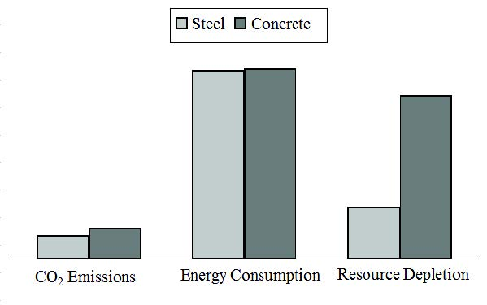
Figure 6 - Environmental impacts of steel and concrete (Bujnak, 2011)

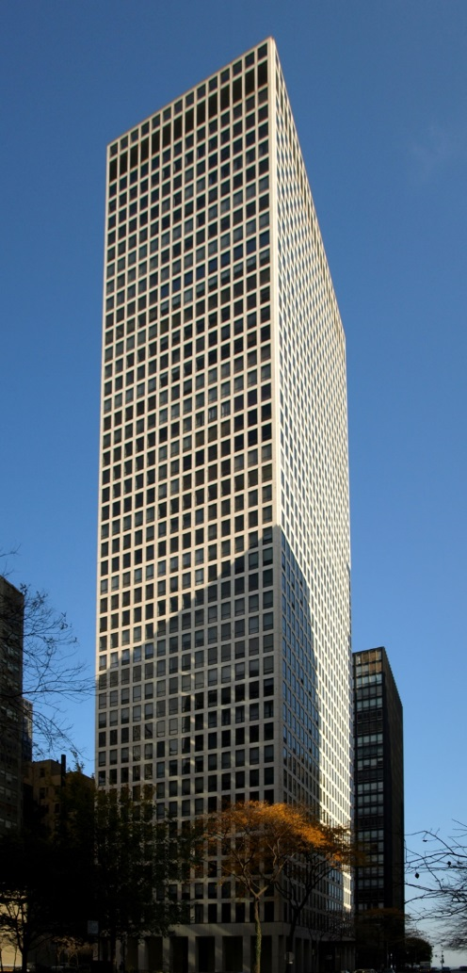
DeWitt-Chestnut Apartment Building
Figure 7 - DeWitt Apartments (Skyscraper Center, 2018)
The DeWitt-Chestnut Apartment Building is a 43 storey concrete framed residential skyscraper in Chicago, USA. It is a 120.4m tower that was constructed between 1963 and 1966. The company responsible for the design was Skidmore, Owings & Merrill. The lead architect was Fazlur Khan. The developers were Metropolitan Structures Inc. At the time of its construction this was a revolutionary design and influenced many buildings that were to follow including the World Trade Center in New York.

Design
According to Ali (2001), early applications of reinforced concrete to build towers were limited in terms of the achievable building height but as designers and engineers developed a better understanding of its properties a variety of structural designs led to far more possibilities. Ali further notes that Fazlur Khan has been credited with moving forward the design of tall buildings by introducing his ‘system charts for tall buildings’ (Figure 8, below)
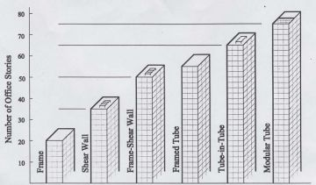
Figure 8 - System chart for tall buildings (Ali, 2001)

The framed tube system included in Khan’s system chart was used in the DeWitt apartment building and according to Moon (2018) was the first building to use the framed tube system in reinforced concrete.
As noted on som.com (Skidmore, Owings & Merrill website)
Closely spaced columns of reinforced concrete act with the spandrels to form an exterior tube and absorb all horizontal wind loads. This allows greater flexibility in the placement of interior columns, which creates more options for apartment layouts. The exterior columns are spaced at 5 feet, 6 inches on center and vary from 20-by-20 inches in the lower floors to 14-by-14 inches at the top of the building.
This further confirms the suitability of the design for residential purposes.

Construction
Ali (2001) notes that concrete is a good choice of construction material because of its ability to dampen vibrations. Concrete is also suitable in hotels and residential buildings as it has good sound absorption properties reducing sound transfer between units.
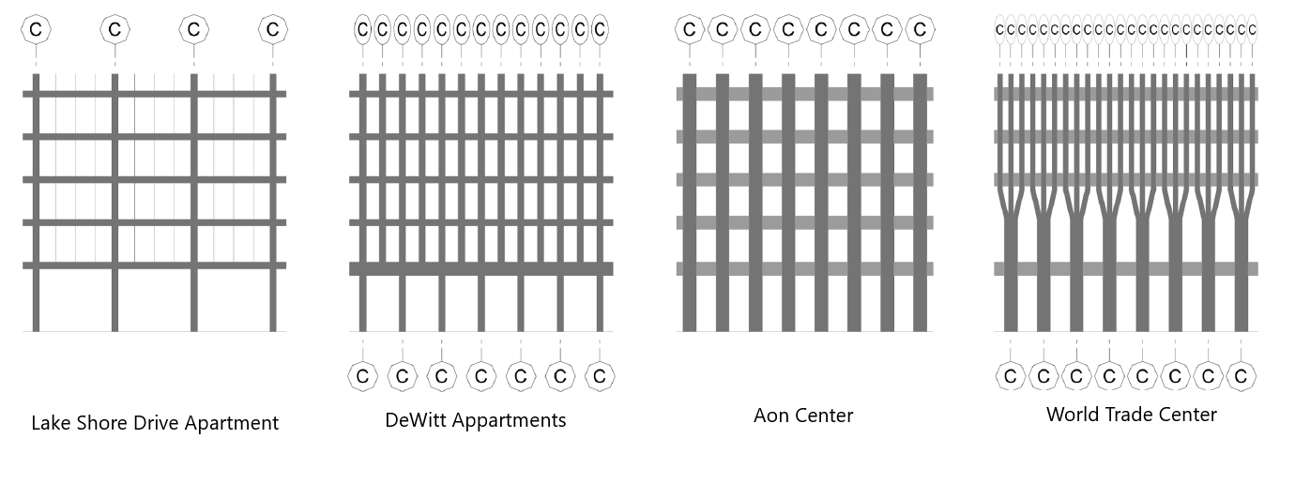
Moon (2018) considers the relationship between the frame structure and the building facade, in particular, the column spacing and the column width. The relationship between these two dimensions will determine the opening available between columns. For example, Moon (2018) notes that for the World Trade centre an extremely narrow spacing of 1m combined with the width of each column led to an opening of only 0.66m so that, at ground level, every three columns had to be merged. A similar scheme was adopted in the DeWitt apartment building as shown in the comparative diagram in Figure 9. The DeWitt Apartment arrangement is shown in the second diagram.
Figure 9 - Comparative diagrams - column structure (Moon, 2018)
These narrow opening can be problematic particularly for commercial buildings but as Moon (2018) points out that
…for residential tall buildngs whose floors are typically composed of many separate rooms, smaller perimeter openings of the framed tube system could well be integrated with the floor plans and corresponding façade design.

Sustainability and Environmental Impact
As noted above the building is suited to its residential purpose for several reasons – concrete has useful properties in terms of sound absorption and the column structure around the perimeter allows for increased flexibility inside the building. This suggests that the structure is very suitable for adapting the uses and applications of the internal areas. This is useful in terms of the long terms sustainability and viability of the building.
On a more global level we have already noted that concrete has less than ideal environmental impacts. However, Crow (2008) notes that statistics related to the huge global impact of concrete production are more to do with its widespread use than any inherent disadvantage compared to other materials. This suggests that other materials might not be any better were they to be used as commonly as concrete. Crow (2008) further notes that developments in concrete technology may well improve matters in the future – use of additives and mixing techniques will lead to higher strength concrete so that less of it is needed in any given structure.

Conclusion
The findings in this report suggest that there are, in many ways, several similarities between the two materials considered. Many of the same design principles have to be considered and many of the basic design patterns can be used for both materials.
There are some that argue that steel has some benefits in terms of construction – speed of construction and predictability due to offsite fabrication for example. In environmental terms it turns out that it is very difficult to make an absolute judgement as to which is more environmentally friendly. Technological developments in both cases are continually moving the goalposts, particularly in terms of sustainability and environmental considerations.
Perhaps, once again, we end up having to suggest that a very large number of considerations that are unique to each project will determine which material is best – horses for courses!

Word count excluding Reference List - 2197

References
Ali, M. (2001) ’Evolution of Concrete Skyscrapers: form Ingalls to Jin mao’, Electronic Journal of Structural Engineering, vol. 1, no. 1, pp 2-14.
Bhavikatti, S. (2009) Design of Steel Structures, New Delhi: I K International Publishing House Pvt. Ltd
Bujnak J., Environmental impact of steel and concrete as building materials on the global environment, Proceedings of post graduate course on Building efficiency 2011, Novi Pazar, Serbia, 14 and 15 February 2011, pp.02-34.
CivilDigital. (2019). Steel Structures Vs Concrete Structures | Complete Comparison of Steel & Concrete | CivilDigital |. [online] Available at: https://civildigital.com/steel-structures-vs-concrete-structures-complete-comparison-of-steel-concrete/ [Accessed 2 Jan. 2019].
Crow, J. (2008). The Concrete Conundrum. Chemistry World, [online] pp.62-66. Available at: http://www.rsc.org/images/construction_tcm18-114530.pdf [Accessed 31 Dec. 2018].
Emmitt, S. and Gorse, C. (2014). BARRY'S ADVANCED CONSTRUCTION OF BUILDINGS 3E. Chichester: Wiley.
Encyclopedia Britannica. (2018). Concrete | Definition, Composition, Uses, & Facts. [online] Available at: https://www.britannica.com/technology/concrete-building-material [Accessed 31 Dec. 2018].
Kwok, M. et al. (2005). The Structural Design of The Mega Tower, China World Trade Centre Phase 3, Beijing China. Paper presented to Tall Buildings from Engineering to Sustainability - Sixth International Conference on Tall Buildings, Hong Kong, 6 – 8 December, viewed 31 Dec 2018, https://www.researchgate.net/publication/269138571_THE_STRUCTURAL_DESIGN_OF_THE_MEGA_TOWER_CHINA_WORLD_TRADE_CENTRE_PHASE_3_BEIJING_CHINA
Mazzolani, F. (2000), Steel Structures in Seismic Zones in Mazzolani, F., Gioncu, V. (eds.) Seismic resistant steel structures (CISM courses and lectures ; no.420). Wien: Springer-Verlag.
Moon, K.S. (2018)’Dynamic Interrelationship between the Evolution of the Structural Systems and Façade Design in Tall Buildings’, International Journal of High-Rise Buildings, vol. 7, no. 1, pp 1-16.
Nutting, J. and Wondris, E. (2017). Steel - Testing of properties. [online] Encyclopedia Britannica. Available at: https://www.britannica.com/technology/steel/Testing-of-properties#ref81355 [Accessed 31 Dec. 2018].
Skyscrapercenter.com. (2018). China World Tower - The Skyscraper Center. [online] Available at: http://www.skyscrapercenter.com/building/china-world-tower/379 [Accessed 31 Dec. 2018].
SOM. (2019). Dewitt Chestnut Apartments. [online] Available at: https://www.som.com/projects/dewitt_chestnut_apartments [Accessed 1 Jan. 2019].
Understand Building Construction. (2018). Steel Frame Structures | Steel Framing | Steel Structures. [online] Available at: http://www.understandconstruction.com/steel-frame-structures.html [Accessed 31 Dec. 2018].
Wente, E. and Nutting, J. (2017). Steel | metallurgy. [online] Encyclopedia Britannica. Available at: https://www.britannica.com/technology/steel [Accessed 31 Dec. 2018].
Wondris, E. and Nutting, J. (2017). Steel | metallurgy. [online] Encyclopedia Britannica. Available at: https://www.britannica.com/technology/steel [Accessed 31 Dec. 2018].

