Design and Analysis of EM Systems

Electromagnetic Radiation

ACDC5009

BEng Embedded Electronic Systems

Zakir Basit

Table of Contents
Task 1 and 2 3
Abstract 3
Introduction 3
Methodology 4
Simulation 5
Discussion 9
Conclusion 10
Task 3 10
Introduction 10
Literature Review 10
Discussion 11
Conclusion 12
References 12

Task 1 and 2

Abstract
This report will detail the design process and provide simulation evidence for a rectangular waveguide system and a half-wave dipole antenna. It aims to reflect the application of electromagnetic theory and high-frequency simulation skills to analyse these fundamental microwave components based on specified parameters. The report includes background research informing the design choices (waveguide modes, cutoff frequencies, antenna resonance), the design methodology using parameters derived from student ID information (waveguide a=23mm, b=10.5mm; antenna λ=232mm), the implementation steps within the ANSYS HFSS simulation environment, and the results obtained from modal and frequency-domain analysis. The goal was to characterise waveguide behaviour under different dielectric conditions (vacuum and Teflon), comparing simulated cutoff frequencies (e.g., vacuum TE10 simulated fc ≈ 6.48 GHz vs theoretical fc ≈ 6.52 GHz; Teflon TE10 simulated fc ≈ 4.45 GHz vs theoretical fc ≈ 4.50 GHz) and field patterns, and to design and verify the performance, including resonance frequency (simulated f ≈ 2.64 GHz vs theoretical 1.293 GHz), return loss (S11), and radiation pattern, of a half-wave dipole antenna. The study validates the simulation approach against established electromagnetic principles for the designed components.

Introduction
Prior to commencing the design phase of the waveguide and antenna components, establishing a solid foundational understanding of the relevant principles of electromagnetic wave propagation and radiation was necessary. Research was therefore conducted on the inherent nature of guided waves within rectangular structures, the governing equations defining propagation modes and cutoff frequencies, the operational principles of resonant antennas like the half-wave dipole, and the overarching considerations of material properties (dielectric constant, conductivity).
Rectangular waveguides, as typically metallic pipes of rectangular cross-section, are simple structures used in efficient high-frequency electromagnetic energy transmission [1]. Discrete propagation modes (TE and TM) with matched transverse electric and magnetic field distribution and cut-off frequency of operation, minimum frequency denoted by the term cutoff frequency (fc), characterise the operation of such waveguides. Below cutoff frequency, propagation mode can't propagate effectively and gets attenuated [2]. The cutoff frequency is critically dependent on the waveguide's cross-sectional dimensions (width 'a' and height 'b') and the electromagnetic properties (permittivity ε, permeability μ) of the material filling the waveguide [1]. The dominant mode, typically TE10 for greater than b, has the lowest cutoff frequency and is typically the mode of operation preferred. Simulation software allows precise calculation and plotting of these modes and their cutoff frequencies, offering an advantage through the possibility of comparing theoretical predictions to calculated results. This programmability also allows for the easy investigation of how changing the dielectric material affects propagation characteristics, such as the lowering of cutoff frequencies when a dielectric like Teflon (εr ≈ 2.1) is introduced compared to vacuum (εr = 1) [1].
Antennas act as transducers between guided waves (in transmission lines or wave guides) and free space radiating waves. The half-wave dipole is a standard configuration of a resonant antenna widely used due to its simplicity and good behaviour [3]. It consists of a conductor of roughly half a wavelength (λ/2) long at the operational frequency. Effective radiation relies heavily on the achievement of resonance, when the input impedance of the antenna is real only, which enables a good matching to the feeding transmission line (commonly 50 Ω) [3]. The actual physical length is generally a little less than λ/2 due to end effects and the finite conductor radius; empirical correction factors (e.g., 0.95) are often employed for initial design [3]. The most important performance indicators are operating frequency (in terms of λ), the input impedance (in terms of the S11 parameter in simulation, as reflection loss), and the radiation pattern, which specifies how power is radiated in different directions (typically omnidirectional in the H-plane and figure-eight in the E-plane for a dipole) [3]. Simulation provides a very powerful tool to optimise the length to maximise the resonance at the target frequency and observe the resulting radiation characteristics.

Methodology
The precise waveguide dimensions and operational parameters for the antenna were determined from the provided Student ID form, resulting in:
- Waveguide Width (a) = 23 mm
- Waveguide Height (b) = 10.5 mm
- Waveguide Length (L) = 50 mm (fixed)
- Antenna Wavelength (λ) = 232 mm
- Antenna Conductor Radius (r) = 1 mm (fixed)
Waveguide Model: A rectangular box of dimensions a=23mm, b=10.5mm, L=50mm was modelled. The four sidewalls (parallel to the Z-axis, the direction of propagation) were assigned Perfect Electric Conductor (PEC) boundary conditions, simulating lossless metallic walls. The interior volume was assigned material properties of either 'vacuum' (εr=1, μr=1) for Task 1a or 'Teflon' (εr=2.1, μr=1) for Task 1b. Wave ports were established on the faces at Z=0 (Port 1) and Z=50mm (Port 2) to excite and analyse waveguide modes. Each port was configured to calculate the first 3 modes. An analysis setup was prepared for a frequency sweep from 2 GHz to 30 GHz to visualise behaviour across a broad range.
Dipole Antenna Model: A cylindrical conductor of radius r=1mm and length L ≈ 110.2 mm (0.95 * λ/2 where λ=232mm) was modelled. A very narrow gap (1mm) was made at the centre to leave room for the feed. The conductor material was assigned as PEC. A 50 Ω lumped port was established across the gap in the centre to serve as the excitation source. The entire antenna structure was placed inside an air-filled volume ('airbox') of sufficient size to contain the near fields. The outer boundaries of this airbox were assigned to a Radiation boundary condition to simulate an open, non-reflecting environment, as is required for accurate far-field pattern calculation. A setup for analysis was prepared for a frequency sweep around the theoretical operating frequency (f = c/λ ≈ 1.293 GHz), i.e., 1.0 GHz to 1.7 GHz.
Important parameters were computed using standard theoretical formulas prior to simulation:
- Waveguide Cutoff Frequency (fc): fc = (c / (2 * sqrt(εr * μr))) * sqrt((m/a)^2 + (n/b)^2) [2]. This was calculated for the first few TE and TM modes (m,n) for both vacuum (εr=1) and Teflon (εr=2.1), using a=0.023m and b=0.0105m.
- Dipole Length (L): L ≈ 0.95 * (λ/2) [3], giving L ≈ 110.2 mm where λ=232mm.
- Dipole Operating Frequency (f): f = c / λ [3], giving f ≈ 1.293 GHz where λ=232mm.

Simulation
Task 1 involved simulating the frequency sweep between 2 GHz and 30 GHz for both the vacuum (Task 1a) and Teflon (Task 1b) fillings. The main objective was to determine the waveguide structure propagation modes with a=23mm and b=10.5mm dimensions. Post-processing involved the examination of the modal solution data generated by the simulator to determine the modes present and their respective cutoff frequencies. For the case with vacuum fill (Task 1a), these simulated cutoff frequencies were then compared directly with the previously calculated theoretical values (TE10≈6.52 GHz, TE20≈13.04 GHz, TE01≈14.29 GHz). The output from the simulation is summarised graphically in the subsequent cutoff frequency plot.
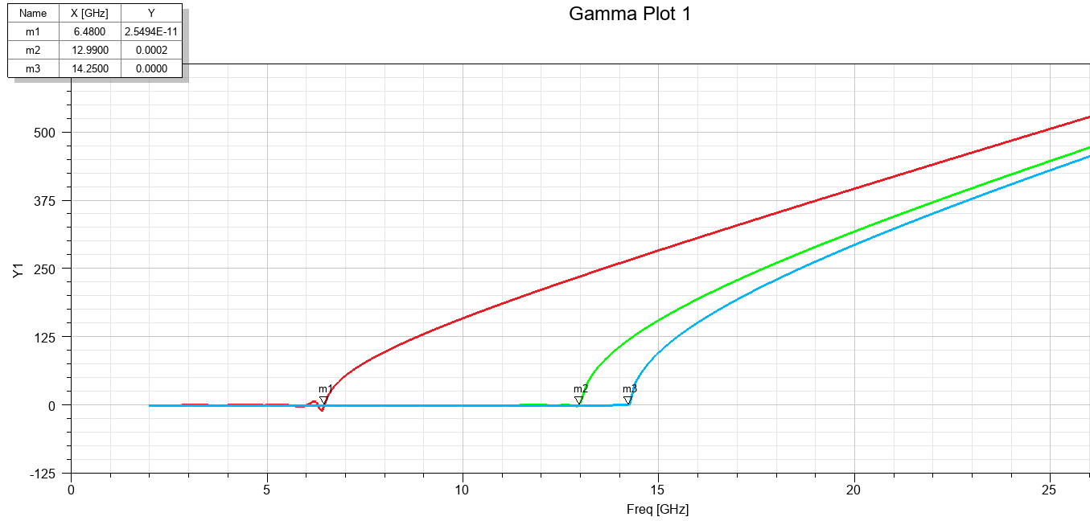
Figure 1: Simulated cutoff frequencies for three modes in the vacuum filled wave guide
The cutoff frequencies simulated for the three modes in vacuum were: TE10 = 6.48 GHz, TE20 = 12.90 GHz, and TE01 = 14.25GHz.
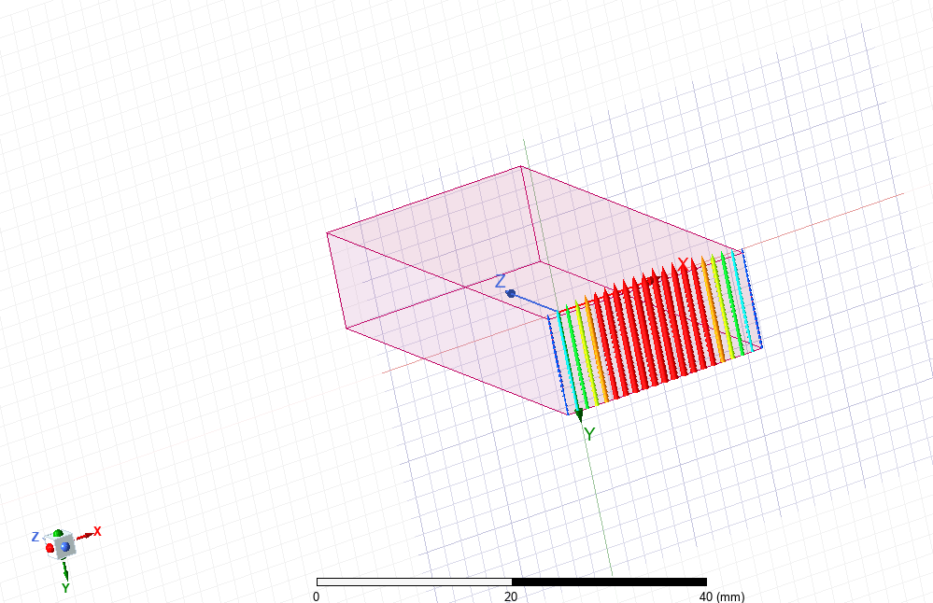
Figure 2: Port field display for port 1 showing the dominant mode distribution

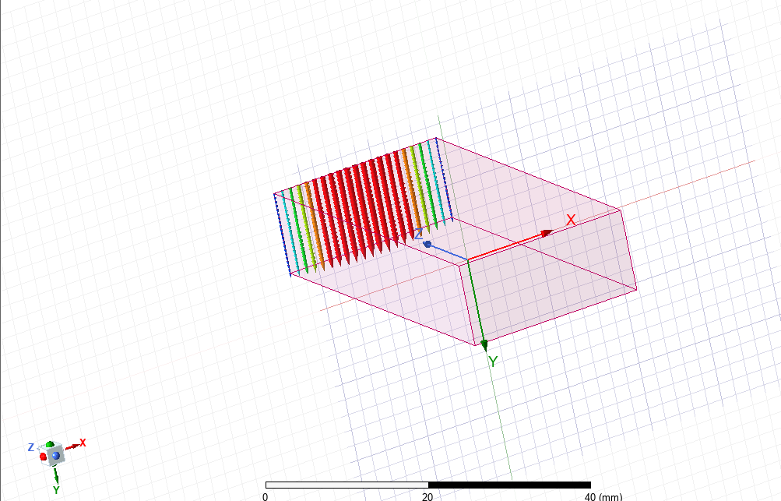
Figure 3: Port field display for port 2 showing the dominant mode distribution
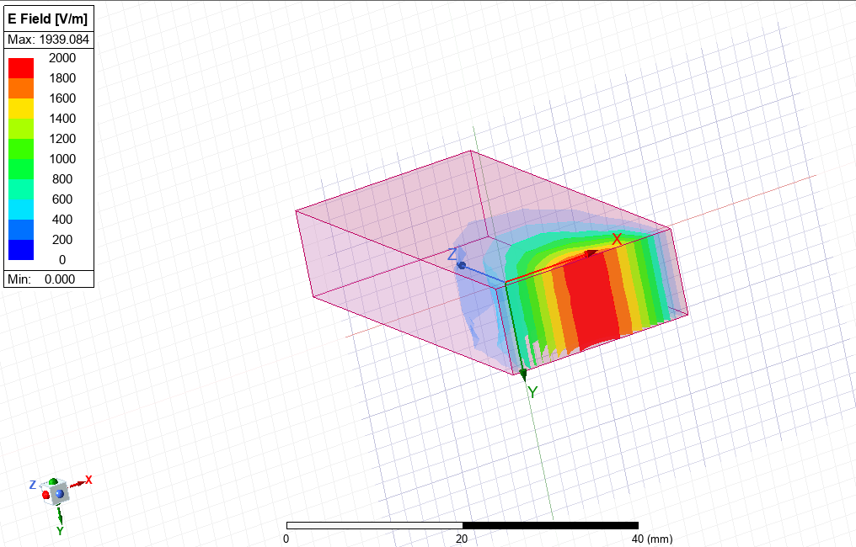
Figure 4: Electric and magnetic field distribution for the dominant mode
The same was done for the Teflon-filled wave guide (Task 1b). The theoretical cutoff frequencies (TE10≈4.50 GHz, TE20≈9.00 GHz, TE01≈9.86 GHz) were compared with the simulated ones, which are plotted below.
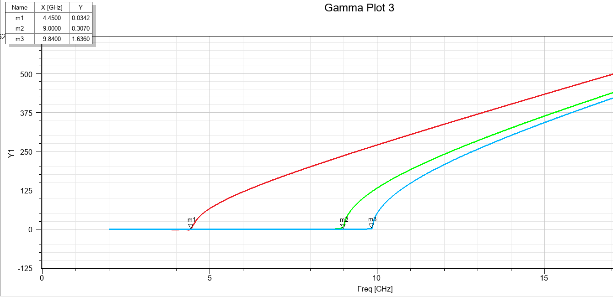
Figure 5: Simulated cutoff frequencies for three modes in the Teflon-filled wave guide
The cutoff frequencies simulated for the three modes in Teflon-filled wave were: TE10 = 4.45 GHz, TE20 = 9.00 GHz, and TE01 = 9.84 GHz.
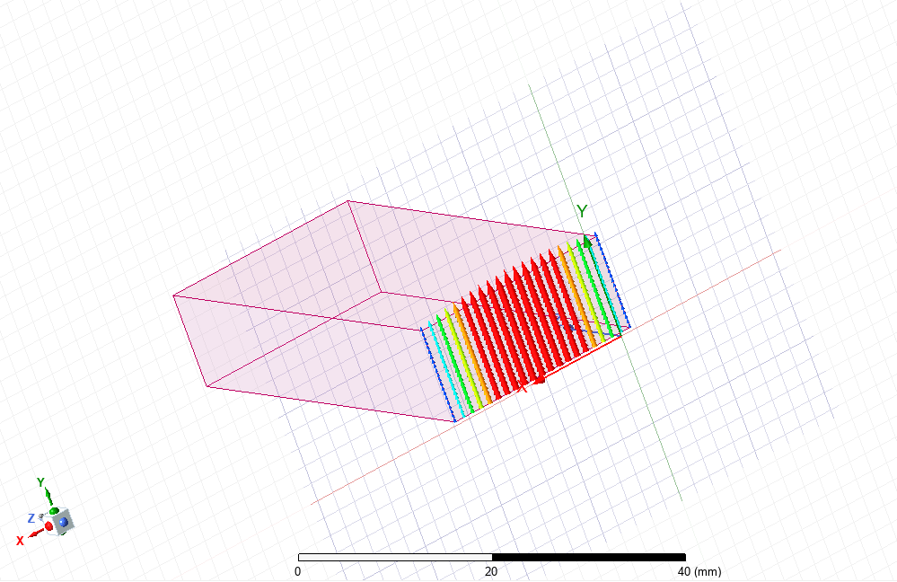
Figure 6: Port field display for port 1 (Teflon-filled wave) showing dominant mode distribution

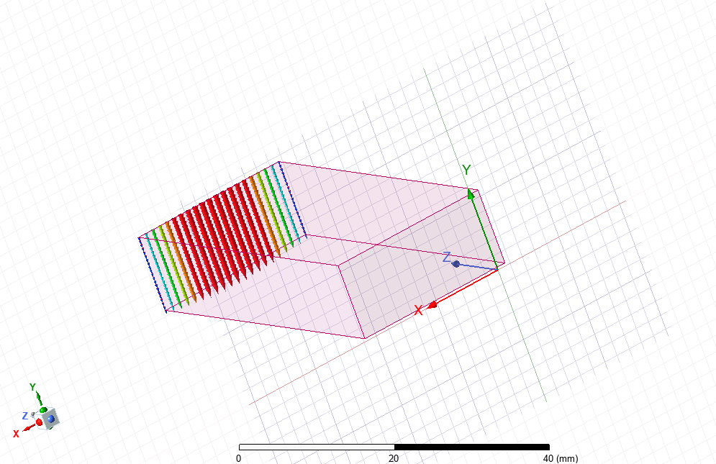
Figure 7: Port field display for port 2 (Teflon-filled wave) showing dominant mode distribution
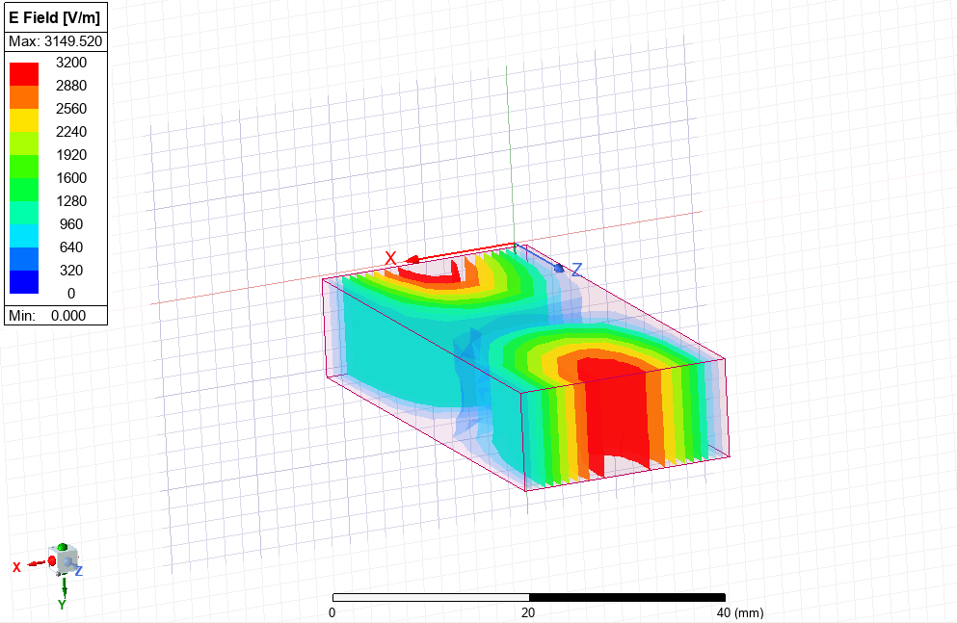
Figure 8: Electric and magnetic field distribution for the dominant mode (Teflon-filled wave)
Task 2 involved the simulation sweeping frequency from 1.0 GHz to 1.7 GHz. The S-parameter (S11) plot was generated to find the resonant frequence, where the return loss is minimal.
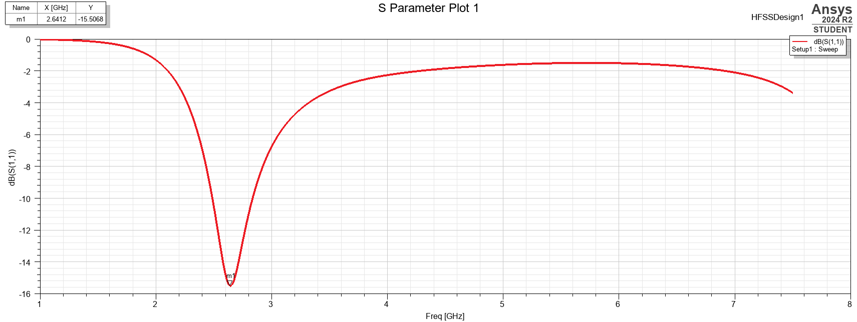
Figure 9: Simulated S11 plot for half-wave dipole antenna
From the plot, the resonant frequency was found to be approximately 2.64 GHz with a return loss of 15.5 dB.

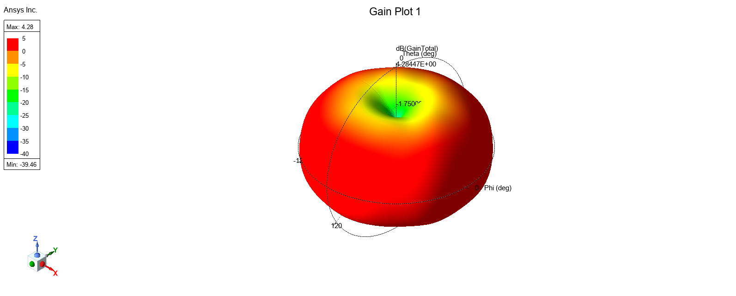
Figure 10: Simulated 3D radiation pattern of the half-wave dipole antenna at resonance

Discussion
The simulation results of the rectangular waveguide agree with electromagnetic theory. For the waveguide with a vacuum filling, simulated cutoff frequencies (TE10=6.48 GHz, TE20=12.90 GHz, TE01=14.25 GHz) aligned with theoretical values (6.52 GHz, 13.04 GHz, 14.29 GHz respectively). These minor discrepancies (<1%) arise from the fact that the used mesh in the simulation model does not have full resolution. As would be expected, the TE10 mode was the most common one with the lowest cutoff frequency. Port field displays and the internal field plots confirmed the expected spatial distribution of electric and magnetic fields for the calculated modes.
Introducing Teflon as the dielectric material significantly lowered the cutoff frequencies (simulated TE10=4.45 GHz, TE20=9.00 GHz, TE01=9.84 GHz) compared to the vacuum case. This reduction closely tracks the theoretical prediction, where fc is inversely proportional to the relative permittivity's square root (√εr ≈ √2.1 ≈ 1.45), thus giving fc(Teflon) ≈ fc(Vacuum)/1.45 (for example, 6.48 GHz / 1.45 ≈ 4.47 GHz, close enough to the simulated 4.45 GHz for TE10). The simulated values once again corresponded well with the theoretical predictions for Teflon (4.50 GHz, 9.00 GHz, 9.86 GHz). The field patterns observed qualitatively confirmed the expected distribution for the TE10 mode in the dielectric-filled guide.
For the half-wave dipole antenna (Task 2), the simulation was supposed to validate resonance at the theoretical operating frequency of 1.293 GHz (f=c/λ). The S11 plot indicated resonance at 2.64 GHz, which was significantly different from the theoretical value. Despite the frequency shift, the calculated return loss of -15.5 dB at resonance verifies that a good impedance match to the 50 Ω source had been attained at the calculated frequency. Moreover, the calculated radiation pattern had the typical toroidal (doughnut) pattern expected of a dipole, confirming its inherent radiation properties.

Conclusion
This report has illustrated the modelling, simulation, and analysis of a rectangular wave guide and half-wave dipole antenna based on ANSYS HFSS software. This project employed electromagnetic theory and simulation techniques in the characterisation of these fundamental elements from parameters derived from student ID information (a=23mm, b=10.5mm, λ=232mm). Wave guide simulations accurately confirmed near theoretical cutoff frequencies for the dominant (TE10) and higher-order modes for vacuum and Teflon-filled cases, demonstrating very clearly the theoretical impact of dielectric loading (fc reduced by ~1/sqrt(εr)). Simulation of the half-wave dipole antenna showed resonance at 2.64 GHz, which is significantly higher than the 1.293 GHz frequency derived theoretically using the initial length approximation. Despite this change in frequency, the simulation resonated with a good impedance match at resonance (S11 = -15.5 dB) and showed the typical toroidal radiation pattern of a dipole antenna.

Task 3

Introduction
The report discusses recent developments in radar technology as a response to the specific problem of UAV detection, or drone detection. Conventional radar, which has been designed for big aircraft, fails to work effectively against drones due to their unique features: low Radar Cross Section (RCS), low altitude often concealed by ground clutter, low speeds, and constructed from low-reflectivity materials [4]. This research considers advances enhancing drone detection by radar, using electromagnetic principles to this novel security issue. It further considers the societal and environmental impacts of deploying such technology and provides mechanisms for enhancing using new radar technology.

Literature Review
A comprehension of detection issues is at the heart before measuring solutions. Detection of small drones with standard radar is difficult due to physical constraints and system parameters set for large, fast, metallic targets. Unmanned aerial vehicles typically have an RCS much lower than aircraft (typically < 0.01 m²), and thus returns are readily mimicked by noise or clutter with standard algorithms [5]. They have a very low-altitude, low-velocity flight regime, which also makes them extremely difficult to distinguish, as they are masked in ground clutter (vehicles, topography, trees). Increased usage of non-metallic composites in unmanned aircraft manufacturing reduces the inherent radar reflectivity [4]. Hence, R&D is aimed at enhancing sensitivity, improving clutter rejection, and exploiting certain drone features. Significant technology directions include better antennas like Active Electronically Scanned Arrays (AESA), sophisticated signal processing like micro-Doppler processing, and investigation of diverse radar frequency bands, like millimetre-wave (mmWave), to improve performance against such difficult targets [5], [6].

Discussion
Current technology offers significant radar improvement for drone detection. AESA systems are most critical, providing dynamic electronic beam steering. This facilitates concurrent tracking of multiple targets and adaptive scanning prioritising resources to areas of interest or to individual detections, necessary for surveillance of airspace by large numbers of small, manoeuvrable drones [5]. High-level signal processing is also just as critical. Micro-Doppler analysis is an innovation, exploiting tiny frequency modulations from rotating drone propellers/rotors. This creates a distinctive signature, enabling detection and classification even when the drone body has minimal velocity relative to ground clutter, overcoming a major conventional Doppler processing limitation [6]. Moreover, the integration of machine learning and AI is rapidly advancing the technology. These algorithms classify advanced radar data, significantly improving classification accuracy between drones, birds, and clutter [7]. Frequency selection is also essential for operation: higher frequencies (Ku, Ka-band, mmWave) offer better resolution for small targets but have higher atmospheric attenuation; lower frequencies offer better foliage penetration but lower resolution [5]. Novel waveform design with complex pulses also enhances detection probability and interference immunity.
Widespread use of sophisticated drone detection radars raises serious societal and environmental concerns. On the positive side, these systems enhance security of critical infrastructure, airports, public events, and borders against unauthorised or malicious drones. On the negative side, spreading advanced surveillance technology raises legitimate privacy fears about overreach. This requires strong regulatory environments and ethics for system operation and data handling. On the environmental side, there are effects of higher energy usage from perpetually operating radar networks, possibly across large areas. Complex hardware manufacturing and disposing of it add to e-waste. Greater RF spectrum use requires effective management to prevent interference with the current systems, according to the international treaties [7].
More radar performance gains are possible. Constructing multi-static or networked radar systems from geographically distributed, cooperating transmitters and receivers is an attractive concept, which could provide significantly increased detection through spatial diversity, provide tolerant tracking, increase coverage, and enhance jam resistance [5]. Continued development and training of drone detection AI software with larger, more varied, realistic datasets (multiple drones, flight paths, clutter) is necessary to mitigate false alarms and maximise identification correctness. Research in new antenna materials, like metamaterials or digital arrays, could lead to more sensitive, smaller, lower-power sensors or new beamforming capabilities for specifically drone detection. Though complementary sensor data fusion (EO/IR, acoustic) adds system-level value, attacking the radar alone, further research in isolating fine, unique drone electromagnetic signatures beyond minimum micro-Doppler could reveal new detection/classification methods [6].

Conclusion
The report described inherent radar problems in drone detection and reviewed recent technological advancements that addressed them. Traditional radars are not effective due to drone characteristics (low RCS, low/slow speed, material). However, technologies like AESA, micro-Doppler processing, and AI-enabled integration have vastly improved detection and classification. Operating these systems heightens security at the cost of sensitive regard to societal privacy and environmental factors (energy, spectrum). Emerging innovations like networked radar, advanced AI, and new radar/antenna technologies promise future breakthroughs against the emerging drone menace. Sustained research, innovation, and effective deployment are needed to neutralise this complex security challenge while balancing technological capability with the higher social purpose.

References

[1] | D. M. Pozar, Microwave Engineering Fourth Edition, New Jersey: John Wiley and Sons, 2012.
[2] | C. A. Balanis, Advanced Engineering Electromagnetics Second Edition, New Jersey: John Wiley and Sons, 2012.
[3] | C. A. Balanis, Antenna Theory: Analysis and Design Fourth Edition, New Jersey: John Wiley and Sons, 2016.
[4] | M. Skolnik, Introduction to Radar Systems Third Edition, New York: McGraw-Hill, 2001.
[5] | W. A. G. Khawaja, “A Survey on Radar Techniques for Detection, Tracking, and Classification of Aerial Threats,” TechRxiv, 2022.
[6] | V. C. Chen, “Micro-Doppler effect in radar: phenomenon, model, and simulation study,” IEEE, 2006.
[7] | ITU, Radio Regulations, Geneva: ITU, 2020.

