

Comparative Leadership & Health System Response to COVID-19 in Spain, South Korea, and Canada
Student Name : ASHVINBHAI RAYMALBHAI CHAUDHARY
Student ID :2408901
Module code : LCHS7002
Module Title : Health Care System, Organisation and Leadership
Lecturer name : Shepherd Ziko
Table of Contents
1.0 Introduction 4
1.1 Background to COVID-19 and Global Health Leadership 4
1.2 Purpose and Scope of the Report 4
1.3 Structure of the Report 4
2.0 Health System Organisation & Centralisation/Decentralisation Analysis 4
2.1 Conceptual Foundations: Centralisation vs Decentralisation 4
2.2 Spain: System Structure & COVID-19 Response 6
2.3 South Korea: System Structure & COVID-19 Response 9
2.4 Canada: System Structure & COVID-19 Response 12
2.5 Comparative Analysis across the Three Countries 15
3.0 Leadership Analysis & Application of Leadership Theory 16
3.1 Conceptual Framework: Crisis Leadership in Health Systems 16
3.2 Leadership in Spain: Salvador Illa 17
3.3 Leadership in South Korea: Chung Sye-kyun and the KCDC 20
3.4 Leadership in Canada: Justin Trudeau 22
3.5 Comparative Leadership Analysis 24
4.0 Conclusion 26
4.1 Summary of Comparative Findings 26
4.2 Implications for Future Global Health Leadership 26
References List 27
Figure references 31

1.0 Introduction

1.1 Background to COVID-19 and Global Health Leadership
COVID-19 initiated a significant health crisis in the global community and put a great burden on the health system of all nations. The pandemic demonstrated that having a good leadership and organization is highly essential in the time of crisis. The speed with which governments can respond, how governments communicate with individuals and the way health systems are organized can alter pandemic outcomes. The realization of leadership and system organization can be used to explain why certain countries were more successful in dealing with COVID-19 than others (Haileamlak, 2021).

1.2 Purpose and Scope of the Report
The present report will compare the reaction of Spain, South Korea, and Canada to the COVID-19. It focuses on two major aspects such as whether each nation employed centralised or decentralised decision making or not, and the behaviour of the leaders during the crisis. The report analyses the impact of various systems and leadership styles on the outcome in the three countries by studying them (Wang et al., 2021).

1.3 Structure of the Report
The report is divided into four major parts. First, it illustrates how the response of every nation to COVID-19 was determined by health systems and decision making mechanism. Second, it examines leadership styles in Spain, South Korea and Canada. Third, it indicates the principal disparities between the countries.

2.0 Health System Organisation & Centralisation/Decentralisation Analysis

2.1 Conceptual Foundations: Centralisation vs Decentralisation
There are two methods of decision-making in a health system, namely centralisation and decentralisation. Centralisation implies that the nation government makes the majority of key decisions. All the rules, policies, and emergency actions are managed under a single authority. Instead, decentralisation implies that smaller entities like a region, state or province are empowered to make decisions. The local areas are in a position to select policies that suit the local situation (Sreeramareddy and Sathyanarayana, 2019).
Each of the two methods has advantages and disadvantages. Centralised systems are swift in nature as decisions are made at one point. They are also able to give uniform messages and national standards. Nevertheless, the centralisation might be excessive and the needs of the localities may be overlooked. Decentralised systems provide flexibility and enable responses that are able to suit the local populations, but they also result in mixed messages or delays or conflicts between the regions and the national government.
The organisation of a country is important during a pandemic. The rapid spreading virus requires prompt decisions, effective communication as well as effective coordination among various components of the health system. The centralised systems are usually better at the coordination, however, the decentralised systems are more flexible when the local areas can cooperate. The health system organization also determines the way the countries manage testing, tracing, hospital capacity, lockdown regulations, and vaccination. Governance influences speed, coordination and flexibility all of which determine the ability of countries to control infections and prevent deaths. These concepts enable them to draw comparisons on the COVID -19 response of Spain, South Korea, and Canada (Sustainability Directory, 2025).

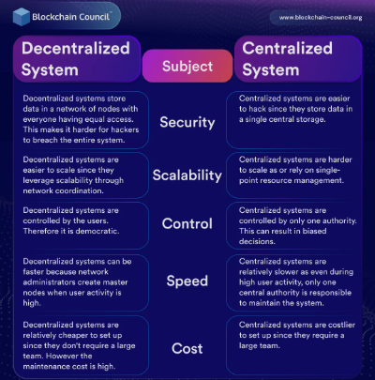
Figure: 1 (Abrol, 2022)

2.2 Spain: System Structure & COVID-19 Response
2.2.1 Overview of the Spanish Health System
The health system in Spain is decentralized. Health care delivery is primarily organized by 17 autonomous communities but the national Ministry of Health has the primary responsibility of establishing the overall policies. These areas are highly dominant of hospitals, primary care, and public health. Such a model used to be considered as effective to meet the local needs and enhance access to the services, before COVID-19 (European Observatory on Health Systems and Policies, 2024).
Decentralisation also implied that health services varied in each direction and it was at times difficult to liaise with the national government. Day-to-day operations are normally not controlled by the ministry of health, yet coordination is usually done by the ministry of health. This structure became an issue when COVID-19 came. Spain was forced to make rapid transition to a more centralised emergency model, which was the previous decentralised model. The overlap of national powers and regional powers turned out to be a significant problem in the time of the pandemic.
2.2.2 COVID-19 Governance: Centralised Actions
In Spain, the national government proclaimed state of emergency when COVID-19 was rapidly spreading in the country. Under this rule, the central authority assumed direct control of most of the things the regions used to operate such as when to lock down, close schools, movement restrictions as well as the provision of health messages. One of the most strict national lockdowns in Europe was in Spain. Citizens were not allowed to go outside unless it was necessary and the police would make sure that citizens were adhering to the guidelines (Jones and Giuffrida, 2020).
Centralised communication as well was introduced. The Minister of Health and other national officials updated every day and hence the information was the same at all places. This minimised confusion since everyone received the same message. Centralisation also allowed Spain to plan the national procurement of medical materials and ventilators in case of a high level of worldwide demand.
Nonetheless, there were certain limitations to this main strategy. Spain is a culturally and geographically diverse country and therefore, one national policy was not suitable to all regions. There were those places where the infection rates were higher, and action had to be stiffer, and those places where fewer cases were reported believed that the rules were excessive. The local decision-making was also hindered by centralisation as the regional governments were required to seek approval by Madrid. Centralisation was a way of bringing order, however, there was frustration and a sense that regions had lost their autonomy (Álvarez-Castillo et al., 2021).
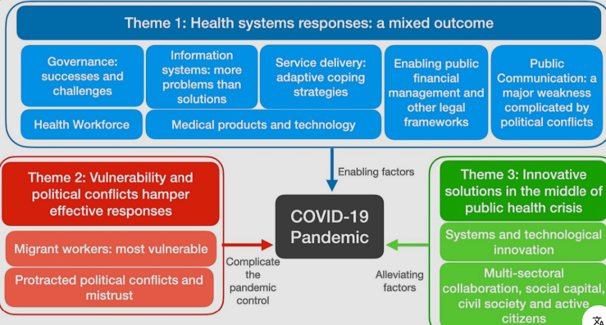
Figure: 2 (Tuangratananon et al., 2024)
2.2.3 COVID-19 Governance: Decentralised Actions
The first wave introduced the process of Spain starting to hand their power back to their regions. Every region had responsibilities of testing, tracing, and establishment of local rules. This allowed regions to customize the policies. There were areas that quickly added tests, and some had difficulties. They also decided on various options of closing bars, restaurants or schools.
There were good and bad aspects in this decentralised approach. On the one hand, local governments were able to respond more closely to the situation. Conversely, the differences among the regions were confusing. The regulations were more rigid with people of one region compared to the other. It is also because central and regional leaders argued when restrictions should be implemented or lifted which at times postponed critical decisions (Lawvs, 2023).
In Spain the outcome differed not everywhere. Other parts of the world such as Galicia, the Canary Islands dealt with the pandemic more effectively due to the fact that they possess more robust systems of public-health and are able to respond rapidly. Meanwhile Madrid and Catalonia had extremely high rates of infections and the pressure on the hospitals was huge. These variations demonstrate that decentralisation may be successful when a region is ready, but may result in lopsided results when it is not. The experience of Spain shows how difficult the many between central control and regional autonomy in times of a rapid-moving health crisis can be.

2.3 South Korea: System Structure & COVID-19 Response
2.3.1 Overview of the South Korean Health System
The health system of South Korea is highly centralized and the decisions that are made concerning public health are well controlled by the national government. The korea disease control and prevention agency (KCDC) and the Ministry of Health and Welfare play an important role in managing the outbreak of disease. The previous experience of South Korea with outbreaks, such as the MERS in 2015, resulted in significant changes. These modifications improved its emergency infrastructure, data systems and communication channels (Lee, 2003).

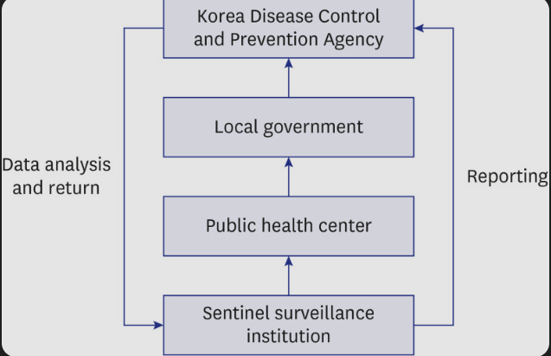
Figure:3 (Jang et al., 2025)
Due to this fact, South Korea entered the COVID-19 pandemic with firm leadership of the country, advanced technology of public health, and transparent emergency legislation. The central leaders were able to establish country-wide guidelines without necessarily consulting the locals, and this system of centrality also served to assist in responding quickly and in a synchronized manner to the pandemic within the country.
2.3.2 Centralised Pandemic Response Mechanisms
South Korea is a country that responds to COVID-19 very fast and centrally. The national government started to test and trace cases early before other nations realized the seriousness of the virus. Central authorities collaborated with the corporations to speed up a lot of test kits. This enabled the nation to experiment a lot, identify cases at an earlier stage, and isolate the infected individuals (Hong and Lim, 2023).
The digital tools that were used in centralised tracing include phone location data, credit card usage, CCTV footage, and special apps. These instruments aided in the identification of those individuals who were in close contact with infected individuals. Others were afraid of privacy, and the majority did not resist it since it served to manage the outbreak.
The entire country was to be under quarantine and travel restrictions. This retained policies everywhere. National authorities responded promptly when outbreaks occurred in certain locations such as Daegu early on through mass testing and assisting hospitals. The domestic communication was good. The government conducted frequent briefs, provided data publicly and issued directives. The information was trusted and people collaborated with the national policies.
The centralised form in South Korea was effective since the government was fast, articulate, and technologically savvy. The opponents claimed that centralised surveillance would reduce privacy and may be abused in the future. Nonetheless, in times of COVID-19, the quick central response was evident (Wilkinson and Richmond, 2023).
2.3.3 Strategic Local-Level Flexibility
Although South Korea is governed at the top, the local governments assisted in putting the national rules into practices. Local testing sites, quarantine centers and health teams are established at the offices of the city. They collaborated with national organizations but were partially free when dealing with outbreaks within their locality. Indicatively, a city may seal off certain social spots or increase testing in case of an increase in infections (Farha et al., 2025).
A balanced system was formed by the strong national leadership and the participation of locals. Everything remained the same in the hands of the national government and the local governments ensured that it met the needs of the location. Community health workers monitored individuals in home quarantine, brought supplies, and assisted at-risk individuals. This model was effective since individuals obeyed the regulations.
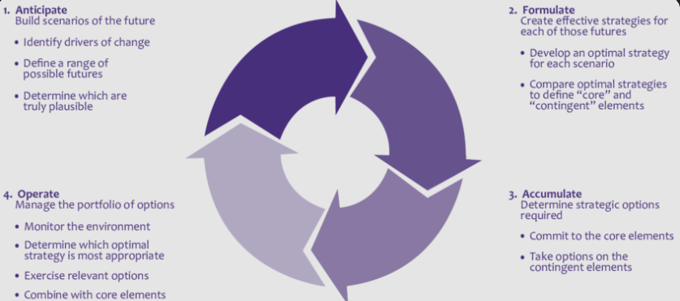
Figure: 4(Badanjak & Pandžić, 2021)

2.4 Canada: System Structure & COVID-19 Response
2.4.1 Overview of the Canadian Health System
The health system in Canada is headed by provinces and territories to a large extent. Every province or territory is in charge of health services, rules and regulations of health, and emergency treatment. The federal government provides funding, establishes policies on a national level and regulates borders, however, it does not dictate how the provinces operate their health systems. Canada has therefore 13 distinct provincial and territorial health systems (Government of Canada, 2023).
Decentralization previously allowed provinces to develop services that suited their citizens in terms of health. However, when dealing with a pandemic, it was more difficult to organize. The provinces were not moving at the same speed, they employed different rules and supplied information differently.
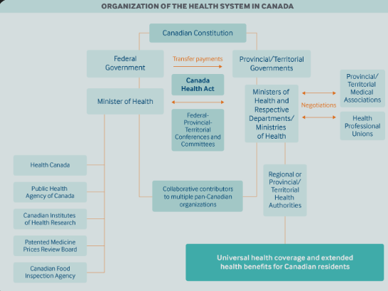
Figure: 5(Tikkanen et al., 2020)
2.4.2 Provincial Autonomy during COVID-19
Provincies had adopted other decisions when COVID -19 was initially spread. British Columbia was on the move, introducing additional contact tracing and testing. There were slow reactions and high outbreaks in Ontario and Quebec. Their differences were in the timing of school closure, mask-wearing, business restrictions and restrictions on gatherings. This tore the national response apart. Other provinces did the right things, and some had to deal with the long-term care outbreak, overcrowded hospitals, and lagging restrictions. Since it is the province that has the responsibility to enforce health issues, the federal government would not be able to institute a single rule regarding this matter. That slackened the capacity of Canada to be a single united system (Wilton et al., 2024).
The government was different in the manner in which information was disseminated. Different rules were given to people in various provinces, a factor that left them confused at times. There was no national system of buying protective gear, and at the beginning of the pandemic, provinces struggled to obtain them. Provincially-driven decision-making enabled them to amend what they had done, but led to inconsistent rules and delays, at least at the first wave.
2.4.3 Federal Coordination Efforts
Despite the federal government having limited powers, it still undertook some of the important actions. It regulated international boundaries, set travel restrictions, and national quarantine guidelines on travelers. Other emergency financial assistance provided by the federal government, like the Canada Emergency Response Benefit (CERB), was provided, and national vaccination deals were secured. Nevertheless, the constitution helped the federal government not to coerce the provinces into implementing certain health regulations. It was able to issue guidelines, but the provinces had the choice of whether to accept them. This occasionally created tension between the federal and the provincial. Overall, the efforts of the federal government assisted in facilitating the general response even though they were not able to coordinate all of the provinces completely (Allin et al., 2021).
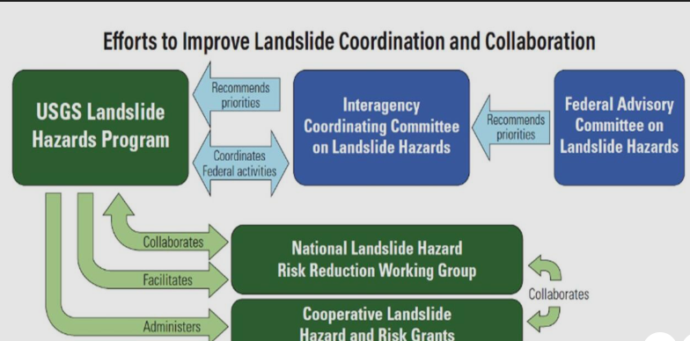
Figure: 6(Tuangratananon et al., 2024)

2.5 Comparative Analysis across the Three Countries
2.5.1 Centralised vs. Decentralised Strengths
The central government in South Korea made it easy to do things fast, maintain the same rules nationwide and leverage on technology. Since the national government was transparent, the policies were foreseeable and the people had an idea of what to expect. Spain used a mixed system. It is normally decentralised, however, in case of the emergency, it shifted to the central control. This started off very strong, but then the strain between the regions was such that the reaction was not as effective. The decentralisation system provided flexibility to Canada, but it also led to fragmentation. The provinces did not respond at the same rate and there was no unitary way of responding in the national scale (Navarro and Velasco, 2022).
2.5.2 Impact on Key Health Outcomes
South Korea underwent under testing and tracing and had minimal deaths. Cases and deaths were numerous in Spain particularly at the onset. In Canada, there were provinces that performed well and large waves in others. The decentralized system showed unequal outcomes in countries and more centralized countries responded faster. The same was the case with vaccination. South Korea organized the supply and distribution of vaccines in a short time. Canada with slow beginning improved. Once the systems were fixed, Spain performed well (Lim and Sohn, 2022).
2.5.3 Critical Evaluation of Governance Models
Success cannot be achieved simply through good governance. There is also culture, experience and trust. The system worked in South Korea as people had a lot of trust in technology and as well as the government which was a good leader. In Spain, the political fight weakened the response particularly when the various regions operated independently. In Canada, the regional system that the country had made coordination a challenge, although trust of people and federal government funds reduce the poor effects. Overall, the single central authority is the quickest and most convenient in terms of coordination, whereas the regional strategy is more effective when the regions collaborate and communicate with each other (Wilton et al., 2024).
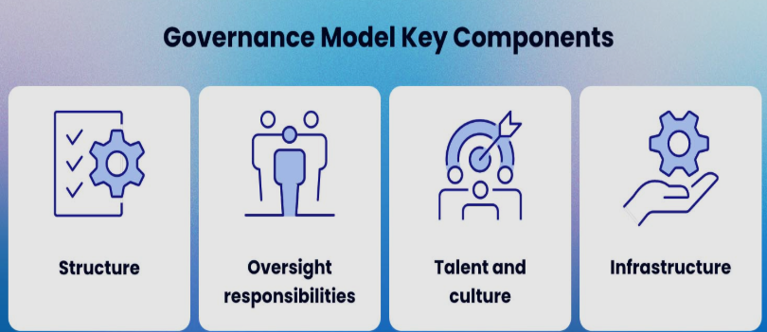
Figure: 8 (Jang et al., 2025)

3.0 Leadership Analysis & Application of Leadership Theory

3.1 Conceptual Framework: Crisis Leadership in Health Systems
Health crisis leadership refers to how leaders can lead a nation, an organization, or society in the case of an unexpected, abrupt crisis. COVID-19 was one such scenario where the leaders were forced to make fast decisions but they had a lot of unknowns. Various leadership theories describe the reason behind the success and failure of different leaders. Transformational leadership is aimed at the inspiration of people, a shared vision, and the encouragement of the masses to obey harsh regulations. Transactional leadership is based on explicit rules, rewards and punishments. Adaptive leadership refers to the speed of adapting to the emerging information and altering the strategies as the situation improves. Distributed leadership involves distributing leadership responsibilities between and among numerous individuals or levels rather than having a central leader. Systems leadership is concerned with the entire system and attempts to integrate all the components of the system (Cherry, 2024).
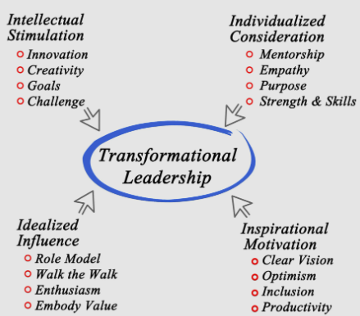
Figure: 9 (Ugochukwu, 2025)
Clear communication, trust, and openness are crucial especially in the case of a pandemic. Individuals have to have faith that they receive the truth and leaders are acting in their interest. Leaders ought to have their voices and express their facts, and maintain consistency. In case of a poor or misunderstood communication, the trust of people damages and adhering to the rules of health becomes more difficult.

3.2 Leadership in Spain: Salvador Illa
3.2.1 Dominant Leadership Style
The Minister of Health of Spain at the beginning of COVID-19 was Salvadriani. He had a preference to operate with the 17 self-governing regions in Spain. The system in Spain devolves power to the regions and therefore, Illa was not able to make decisions alone. He was forced to negotiate and discuss with regional leaders and this was the influence that influenced his leadership. He also acted reactively. Spain was struck at the first stroke and it was altered quickly. Illa was forced to take action when cases were on the increase. This is the reason why most of his decisions were reached when the number of infections had already grown (Reuters, 2021).
Adaptive leadership was also very high in his leadership. The COVID-19 was unforeseeable, and scientific knowledge evolved rapidly. Illa was forced to change the policies in Spain several times such as the rules of lockdown, the procedures of testing, and the travel restrictions. His actions were also influenced by political impediments. There are severe political distinctions between regions in Spain and such tension complicated the ability of Illa to implement unified actions. He even needed to think how regional presidents would respond even in situations when he was inclined to take quick action.
3.2.2 Examples of Crisis Decision-Making
Among the most crucial decisions made by the government of that time, the national lockdown in March 2020 by Salvador Illa deserves to be mentioned. This was among one of the most restrictive in Europe. Individuals could only go out to do necessary activities. This was decided at the point when the hospitals of Spain were overwhelmed particularly in Madrid and Catalonia. Illa centralised the health decisions usually dominated by the regional governments using emergency powers. This demonstrated his capacity to make decisive action in case of need despite the fact that Spain is normally decentralised (Mateos et al., 2020).
Another component of leadership that was exhibited by Illa was communication. He conducted frequent press conferences, was seen alongside scientific specialists, and attempted to unite the people together. He spoke soothingly and comfortingly. He never used dramatic words but he presented straightforward health advice. The national message was at times different with the regional message and this was confusing.
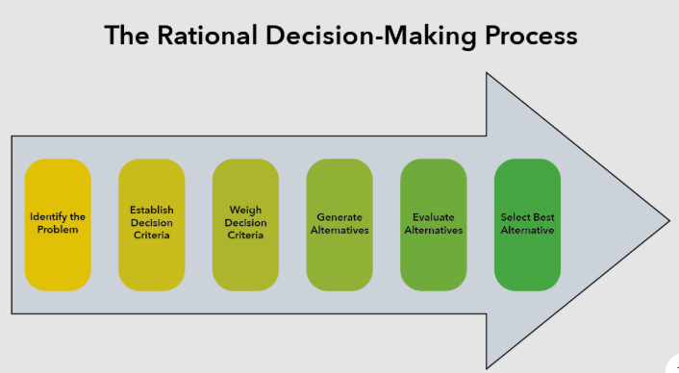
Figure: 10 (Fiveable, 2025)
3.2.3 Critical Evaluation
There were a number of strengths that Salvador Illa possessed. He remained on the spotlight throughout the crisis and this made people feel that they are being guided. He also made frequent appearances in press conferences and this demonstrated his commitment and delivery of one national message. Another example is that he listened to experts, which influence the rules of lockdown in Spain.
But there were weaknesses. The fact that Illa preferred to settle agreements was slow in response to the other countries. There were delays in negotiations with 17 regions in the case of contingency in case of an emergency. Opponents claimed that more vigorous measures taken at an earlier stage would have reduced the high rates of infections and deaths in Spain.

There was a large issue of political disintegration. The national government unrest with regional authorities did not help to implement the same rule also (Navarro and Velasco, 2022).
The death rate of COVID-19 in the first wave was one of the highest in Europe in Spain. A number of factors could have contributed to it such as increased numbers of people per square mile, high rates of international travel, and early diffusion in the community. The reaction was sluggish and organization problematic. Illa was unable to solve deeper-rooted challenges within the system owing to his limited leadership due to politics. Following the initial wave, Spain decentralized more authority, and each region received power unequally, which created an unequal result and a multiplier of issues among the regions.

3.3 Leadership in South Korea: Chung Sye-kyun and the KCDC
3.3.1 Dominant Leadership Style
The Prime Minister of South Korea at the beginning of the pandemic was Chung Sye-kyun. He was technocratic, data-driven, which is to say that he employed much science, professional expertise, and systemized systems rather than politics. He collaborated with the Korea Disease Control and Prevention Agency (KCDC) who had a solid power following the reforms following the MERS outbreak. This alliance assisted in the development of the swift and co-ordinated reaction of South Korea (Mao, 2024).
His leadership also revealed that he was capable of changing plans in a very short time. South Korea responded quickly when new information was received. The state added additional testing, found additional applications to monitor the expansion, and tightened restrictions on travelling. Chung never employed politicians alone in making decisions; he used experts.
He also undertook activities that transformed the mode of operation of the government. The government encouraged citizens to get involved, to adhere to health regulations, to use tracing applications, and to assist the nation. Leaders attempted to ensure that all people felt like it was a collective task. The government was extremely transparent and this made it retain the confidence of the people. Chung was good at speaking, informing people about the number of cases, the danger, and amendments to the rules (Hogan et al., 2021).
3.3.2 Crisis Decision-Making Examples
One highly significant instance of suitable crisis decision-making was the immediate initiation of mass testing. South Korea established drive-through testing and walk-in clinics at the beginning of the pandemic. This allowed individuals to be swabbed fast and reduced transmission. Chung supported KCDC to collaborate with the private companies in an effort to increase the speed of testing kits. This prompt measure was able to locate cases before they went viral.
The flexible leadership was also witnessed in policy changes. The government quickened the belt when small outbreaks occurred, such as in religious groups or nightclubs. It was provided that the KCDC had the authority to act immediately, and was supported politically by Chung. The press reports were provided daily with updates on rules and risks and new evidence. This made the people updated and reduced misinformation (Majumdar, 2022).
South Korea did not go into a nationwide lockdown as it prevented the virus in the initial stages. There was no blanket stay-home order but certain actions taken by the government. The actions enabled the businesses to continue their operations and contain the virus at the same time. This brought in great crisis leadership by the use of experts, national team work, and rapid responses.
3.3.3 Critical Evaluation
Chung Sye-kyun was an excellent leader in numerous aspects. He allowed the specialists in the decision making, thus leading to the people having trust in the government. He spoke freely and gave more detailed case and policy information, which made it less ambiguous and intimidating. He was quick and prevented major outbreaks. Collaboration with the KCDC came in handy. Individuals also contributed to it significantly since the leadership was stable and upright. But there were problems too. The application of surveillance tools caused people to be concerned about privacy. Others were not comfortable with the amount of data collected. The government was criticized in failing to safeguard privacy. Others were too concerned that there is a possibility of excessive reliance on central surveillance which may enable the governments of the future to assume too much (Holroyd et al., 2020).
Nevertheless, health was doing well in South Korea. The nation maintained low mortality rates, managed outbreaks and remained open in most regions without massive lock downs. The leadership of Chung was comparable to the top-down government and high level of trust of the people of the country.

3.4 Leadership in Canada: Justin Trudeau
3.4.1 Dominant Leadership Style
Canada Prime Minister Justin Trudeau demonstrated a caring changing style of leadership in the face of the COVID-19. He used to speak a lot about assisting human beings with their emotions and social needs. He talked much about protecting families, helping people in need and collaborating as a country. This assisted in calming down people and made them obey the rules (Farhan, 2021).
Trudeau also engaged in an act that demonstrated that he was concerned about fairness and well being. His addresses were based on togetherness and benevolence. He employed terms that were accessible to all, in an attempt to unite people. These qualities are reflective of transformational leadership where the leader is interested in inspiring and motivating as opposed to merely imposing rules. Nevertheless, the decentralized governmental system in Canada did not allow Trudeau to have direct influence on the health actions. Rules of lockdowns, schools, and community health were determined by provincial governments. This implied that Trudeau had a responsibility of coordinating, communicating and supporting nationally, as opposed to prescribing particular health policies (Armstrong and Armstrong, 1999).
3.4.2 Crisis Decision-Making Examples
At the start of the pandemic, Justin Trudeau held daily briefings. He approached individuals face to face, clarified new regulations and responded to inquiries. His nonchalant and encouraging manner was appreciated by people. Briefings made people more confident in the unstable periods.
One of the major decisions that Trudeau made was the introduction of the Canada Emergency Response Benefit or CERB. It was a money aid initiative on individuals who lost their jobs due to COVID-19. Millions of Canadians received revenue and it reduced economic harm of lockdowns. Trudeau was also able to establish wage subsidies to assist businesses to retain employees (Canada, 2020).
He was also involved in purchasing of vaccines. To provide supplies to the provinces, the federal government negotiated with a number of vaccine manufacturers. Although the initial rollout was not fast due to global shortages, Canada finally achieved high vaccination rates. Border restrictions were also handled by Trudeau. He introduced travel restrictions, the need to quarantine visitors in the hotel, and the testing regulations of individuals entering foreign countries.
3.4.3 Critical Evaluation
Justin Trudeau was a good leader in a number of ways. He was very kind and thus made people optimistic. After his utterances, many Canadians felt safe, particularly when the crisis went into effect. The wage help and CERB program prevented the collapse of finances by people. His government negotiated various deals in acquiring vaccines and this assisted them to implement a successful national vaccination campaign (Canada, 2020a).
Nevertheless, there were certain flaws in his leadership. Canada was behind other countries like South Korea. One of the reasons that the delay was caused was that provinces had own rules. Trudeau lacked the power to enforce national health regulations and thus every province made its decisions. This led to an uneven reaction, unequal rules and unequal outcomes. There were severe outbreaks in long-term care homes in some of the provinces. According to critics, these were supposed to have been addressed earlier.

3.5 Comparative Leadership Analysis
3.5.1 Differences in Crisis Leadership Approaches
The three countries, Spain, South Korea, and Canada demonstrated various styles of leading in the pandemic. In Spain, the government was centralized: the country was represented by Salvador Illa who was a decision-maker, however, he needed to continue negotiations with the regional governments. The leaders of South Korea trusted experts; Chung Sye-kyun and Korea Centers of Disease Control structured the response very meticulously. Canada was a caring attitude: Justin Trudeau provided emotional support and attempted to keep the country together, yet the power was constrained by the provinces (Garretsen et al., 2022).
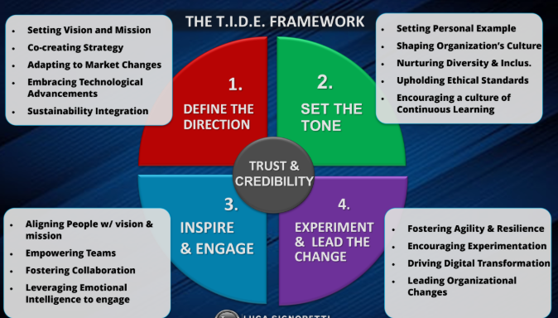
Figure: 11(Luca, 2023)
3.5.2 How Leadership Interacted with System Structure
The Korean leaders collaborated effectively with the central health system and therefore, the government and experts were able to move expeditiously. This assisted in the management of the pandemic. There were disagreements between the national and regional governments in Spain. Illa preferred centralising the decisions, however, because of the political struggles and the independent position of the locals, it took time.
3.5.3 Implications for Future Crisis Leadership
The comparison reveals that effective crisis leadership requires effective communication, trust, and correspondence between the action of leaders and the management of the system. The world is better off with leaders collaborating with professionals, making fast decisions, and remaining receptive. There must be clear co-ordination among various arms of the government particularly where power is decentralized. The cases of Spain, South Korea, and Canada demonstrate that it is essential to prepare the health systems and enhance the collaboration between governments and allow their leaders to adjust rapidly to the changing circumstances without neglecting to inform the population and involve them in the process (Jain, 2025).

4.0 Conclusion

4.1 Summary of Comparative Findings
The case of comparing Spain, South Korea and Canada depicts definite differences in the way they are governed and the one who governs. South Korea had a top-down regime that was managed by professionals. They took rapid, fact-based decisions and the entire nation synchronized well. Spain attempted to strike a balance between centralism and regionalism. That brought about fights and delay in decision making. Canada combined nurturing national leadership and powerful provinces. This caused the reply to be disproportional. These differences led to extremely divergent cases, mortality and trust rates in society. Concisely, the examples demonstrate that rapidity, coordination, and specific roles of each tier are significant components of a successful pandemic control (Chung, Choi and Cho, 2022).

4.2 Implications for Future Global Health Leadership
The global health leadership of the future should be well-coordinated centrally and not too rigid to allow every community to prompt its own response. National leaders are supposed to make specific objectives, distribute verifiable information, and allocate resources. The local leaders are then expected to make adjustments to suit local communities. Confidence and candor are important. Leaders should be truthful, confess when they are not sure and indicate why they take decisions. There should be increased emergency governance through legal capacities, common data systems, and joint plans between the levels of government in anticipation of the next crisis (Shayan et al., 2022).

References List
Allin, S., Fitzpatrick, T., Marchildon, G. and Quesnel-Vallée, A. (2021). The Federal Government and Canada’s COVID-19 Responses: From ‘We’re ready, we’re prepared’ to ‘Fires are burning’. Health Economics, Policy and Law, 17(1), pp.1–40. doi:https://doi.org/10.1017/s1744133121000220.
Álvarez-Castillo, J.-L., Hernández-Lloret, C.-M., González-González, H., Espino-Díaz, L. and Fernández-Caminero, G. (2021). Exploring the status of diversity in policies and practices of Spanish universities. An asymmetric dual model. Heliyon, 7(3), p.e06450. doi:https://doi.org/10.1016/j.heliyon.2021.e06450.
Armstrong, P. and Armstrong, H. (1999). Decentralised health care in Canada. BMJ, 318(7192), pp.1201–1204. doi:https://doi.org/10.1136/bmj.318.7192.1201.
Canada, D. of F. (2020a). Additional Details on the Canada Emergency Wage Subsidy. [online] www.canada.ca. Available at: https://www.canada.ca/en/department-finance/news/2020/04/additional-details-on-the-canada-emergency-wage-subsidy0.html.
Canada, D. of F. (2020b). Government introduces Canada Emergency Response Benefit to help workers and businesses. [online] gcnws. Available at: https://www.canada.ca/en/department-finance/news/2020/03/introduces-canada-emergency-response-benefit-to-help-workers-and-businesses.html.
Cherry, K. (2024). How transformational leadership can inspire others. [online] VeryWell Mind. Available at: https://www.verywellmind.com/what-is-transformational-leadership-2795313.
Chung, C.-S., Choi, H. and Cho, Y. (2022). Analysis of Digital Governance Transition in South Korea: Focusing on the Leadership of the President for Government Innovation. Journal of Open Innovation: Technology, Market, and Complexity, 8(1), p.2. doi:https://doi.org/10.3390/joitmc8010002.
European Observatory on Health Systems and Policies (2024). Spain: Health System Review 2024. [online] Who.int. Available at: https://eurohealthobservatory.who.int/publications/i/spain-health-system-review-2024.
Farha, F.F., Ali, M.A., Khan, F.A., Islam, I. and Shome, P. (2025). Combating COVID-19 Pandemic: Role of Local Government Institutions of developed and developing countries and assessing the activities of Ward 28 of Dhaka from this perspective. Journal of Urban Management. [online] doi:https://doi.org/10.1016/j.jum.2025.05.002.
Farhan, B. (2021). A new strategic leadership model for surviving and coping: Lessons from Canada’s leadership approach to COVID-19. Cogent Business & Management, 8(1), p.1883221. doi:https://doi.org/10.1080/23311975.2021.1883221.
Garretsen, H., Stoker, J.I., Soudis, D. and Wendt, H. (2022). The pandemic that shocked managers across the world: The impact of the COVID-19 crisis on leadership behavior. The Leadership Quarterly, 35(5), p.101630. doi:https://doi.org/10.1016/j.leaqua.2022.101630.
Government of Canada (2023). About Canada’s health care system. [online] Government of Canada. Available at: https://www.canada.ca/en/health-canada/services/canada-health-care-system.html.
Haileamlak, A. (2021). The Impact of COVID-19 on Health and Health Systems. Ethiopian Journal of Health Sciences, [online] 31(6), pp.1073–1074. Available at: https://www.ncbi.nlm.nih.gov/pmc/articles/PMC8968362/.
Hogan, K., Macedo, B., Macha, V., Barman, A. and Jiang, X. (2021). Contact Tracing Apps: Lessons Learned on Privacy, Autonomy, and the Need for Detailed and Thoughtful Implementation. JMIR Medical Informatics, 9(7), p.e27449. doi:https://doi.org/10.2196/27449.
Holroyd, T.A., Oloko, O.K., Salmon, D.A., Omer, S.B. and Limaye, R.J. (2020). Communicating Recommendations in Public Health Emergencies: The Role of Public Health Authorities. Health Security, 18(1), pp.21–28. doi:https://doi.org/10.1089/hs.2019.0073.
Hong, S.Y. and Lim, J.H. (2023). Why Is Success of South Korea’s Covid-19 Response Fading? International Journal of Social Determinants of Health and Health Services, 53(3), p.275519382311651. doi:https://doi.org/10.1177/27551938231165154.
Jain, H. (2025). Crisis Leadership Statistics – Insights On Decision-Making, Trust & Performance. [online] Kapable Blog. Available at: https://kapable.club/blog/statistics/statistics-on-crisis-leadership/.
Jones, S. and Giuffrida, A. (2020). Global report: Spain declares Covid state of emergency as Italians urged to stay home. [online] the Guardian. Available at: https://www.theguardian.com/world/2020/oct/25/global-report-spain-declares-covid-state-of-emergency-as-italians-urged-to-stay-home [Accessed 10 Dec. 2025].
Lawvs (2023). Legal Law Jobs | Lawvs. [online] Lawvs - Legal Law Jobs portal in Delhi. Available at: https://lawvs.com/articles/federalism-and-centre-state-conflicts-in-emergency-powers.
Lee, J.-C. (2003). Health Care Reform in South Korea: Success or Failure? American Journal of Public Health, 93(1), pp.48–51. doi:https://doi.org/10.2105/ajph.93.1.48.
Lim, S. and Sohn, M. (2022). How to cope with emerging viral diseases: Lessons from South Korea’s strategy for COVID-19, and collateral damage to cardiometabolic health. The Lancet Regional Health - Western Pacific, 30(100581), p.100581. doi:https://doi.org/10.1016/j.lanwpc.2022.100581.
Majumdar, S. (2022). How COVID-19 Restrictions Affected Religious Groups Around the World in 2020. [online] Pew Research Center’s Religion & Public Life Project. Available at: https://www.pewresearch.org/religion/2022/11/29/how-covid-19-restrictions-affected-religious-groups-around-the-world-in-2020/.
Mao, Y. (2024). Why do democracies respond differently to COVID-19? A comparison of the United States and South Korea. Frontiers in public health, 11. doi:https://doi.org/10.3389/fpubh.2023.1285552.
Mateos, R., Fernández, M., Franco, M. and Sánchez, M. (2020). COVID-19 in Spain. Coming back to the ‘New normality’ after two months of confinement. International Psychogeriatrics, pp.1–8. doi:https://doi.org/10.1017/s1041610220001155.
Navarro, C. and Velasco, F. (2022). From centralisation to new ways of multi-level coordination: Spain’s intergovernmental response to the COVID-19 pandemic. Local Government Studies, 48(2), pp.1–20. doi:https://doi.org/10.1080/03003930.2022.2042683.
Reuters (2021). Spain’s health minister quits amid pandemic to run for regional Catalan election | World News. [online] Hindustan Times. Available at: https://www.hindustantimes.com/world-news/spains-health-minister-quits-amid-pandemic-to-run-for-regional-catalan-election-101611580270915.html [Accessed 10 Dec. 2025].
Shayan, N.F., Kalejahi, N.M., Alavi, S. and Zahed, M.A. (2022). Sustainable Development Goals (SDGs) as a Framework for Corporate Social Responsibility (CSR). Sustainability, 14(3). doi:https://doi.org/10.3390/su14031222.
Sreeramareddy, C.T. and Sathyanarayana, T. (2019). Decentralised versus centralised governance of health services. Cochrane Database of Systematic Reviews, [online] 2019(9). doi:https://doi.org/10.1002/14651858.cd010830.pub2.
Sustainability Directory (2025). Centralized Vs Decentralized Systems → Term. [online] Climate → Sustainability Directory. Available at: https://climate.sustainability-directory.com/term/centralized-vs-decentralized-systems/ [Accessed 10 Dec. 2025].
Wang, C., Zhang, H., Gao, Y. and Deng, Q. (2021). Comparative Study of Government Response Measures and Epidemic Trends for COVID‐19 Global Pandemic. Risk Analysis, 42(1). doi:https://doi.org/10.1111/risa.13817.
Wilkinson, R.K. and Richmond, J.G. (2023). Exploring community level multi-agency communication and collaboration during the emergency response to the covid-19 pandemic. Public Health in Practice, [online] 6, p.100443. doi:https://doi.org/10.1016/j.puhip.2023.100443.
Wilton, J., JaludAbdulmenan, Chong, M., Becerra, A., MehazabeenNajmulHussain, Harrigan, S.P., Velásquez, A., Naveed, Z., Hind Sbihi, Smolina, K., Taylor, M., Adhikari, B., Zandy, M., SolmazSetayeshgar, Li, J., YounathanAbdia, MawuenaBinka, DronaRasali, Rose, C. and Coss, M. (2024). Cohort profile: the British Columbia COVID-19 Cohort (BCC19C)—a dynamic, linked population-based cohort. Frontiers in public health, [online] 12. doi:https://doi.org/10.3389/fpubh.2024.1248905.

Figure references
Abrol, A. (2022, January 20). Decentralized Vs. Centralized: A Detailed Comparison -. Blockchain Council. https://www.blockchain-council.org/blockchain/decentralized-vs-centralized/
Badanjak, D., & Pandžić, H. (2021). Distribution-Level Flexibility Markets—A Review of Trends, Research Projects, Key Stakeholders and Open Questions. Energies, 14(20), 6622. https://doi.org/10.3390/en14206622
Barao, J. (2024a, July 31). Why Governance Models Matter in Organizational Success. Azeus Convene. https://www.azeusconvene.com/articles/governance-model
Barao, J. (2024b, July 31). Why Governance Models Matter in Organizational Success. Azeus Convene. https://www.azeusconvene.com/articles/governance-model
Barao, J. (2024c, July 31). Why Governance Models Matter in Organizational Success. Azeus Convene. https://www.azeusconvene.com/articles/governance-model
Fiveable. (2025). Crisis Decision-Making Models. Fiveable. https://fiveable.me/crisis-management-and-communication/unit-6/crisis-decision-making-models/study-guide/VCxQEzmxxk2S4CSO
Jang, Y., Lee, H., & Park, H. (2025). Surveillance System for Infectious Disease Prevention and Management: Direction of Korea’s Infectious Disease Surveillance System. Journal of Korean Medical Science, 40(8). https://doi.org/10.3346/jkms.2025.40.e108
Luca. (2023, June 21). Introduction Leadership has undergone significant transformation in the past 15 years, adapting to technological advancements, market shifts, and evolving workforce dynamics. This article offers a concise analysis, capturing the essence of leadership’s 15-year evolution in one accessible read. Linkedin.com. https://www.linkedin.com/pulse/evolution-key-leadership-capabilities-comparative-15-luca
Tikkanen, R., Osborn, R., Mossialos, E., Djordjevic, A., & Wharton, G. (2020). Canada | Commonwealth Fund. Www.commonwealthfund.org; The Commonwealth Fund. https://www.commonwealthfund.org/international-health-policy-center/countries/canada
Tuangratananon, T., Rajatanavin, N., Khuntha, S., Rittimanomai, S., Asgari-Jirhandeh, N., & Tangcharoensathien, V. (2024). Governance, policy, and health systems responses to the COVID-19 pandemic in Thailand: a qualitative study. Frontiers in Public Health, 12, 1250192. https://doi.org/10.3389/fpubh.2024.1250192
Ugochukwu, C. (2025). Transformational Leadership Style: How to Inspire and Motivate. Simply Psychology. https://www.simplypsychology.org/what-is-transformational-leadership.html

