Problem Solving and Decision Making

Table of Contents
Introduction 4
Fishbone diagram 5
Reynolds’s problem: 6
What factors are responsible for this? 7
Symptoms of this problem: 7
Objective & problem consideration: 8
Problem-solving 8
Decision-making techniques: 9
Step in decision making 10
Reynolds’s solution development: 12
SWOT analysis: 13
PESTLE analysis 15
Change management 17
The benefit of change management of Reynolds 18
Resistance to change 18
Communication of change management & evaluation of the result 19
Conclusion: 20
References 21

Introduction
Today’s world is the world of information where more and more information required by management and decision maker for more convenient decision making for their organizational and other purposes. In this assignment, various part & parcel and influential factors of problem-solving are illustrated. This assignment initiated with an introductory paragraph and then illustrate about problem identification & solving procedure with implementation and following of the solutions. After describing these whole things this assignment concluded with a conclusion drawing with references for external sources.
Organizational background:
Reynolds is a renowned company who are running their business in their respective sector (Forbes.com, 2018). Reynolds is doing business from 1945(Reynoldsonline.com, 2018) and serving groceries and other product to the villages’ areas and has a vast product line. Though Reynolds’s overall activities are satisfactory, in some point they have some major problems and these causes this organization to in fall loss because of the unsatisfactory customer relationship. Their major problem with what this assignment deals with is ineffective and inefficient customer satisfactory service providing.

Fishbone diagram

Fishbone diagram is a diagram which illustrates how management or any person can define his core problems following the symptoms (Torrens and Barahona, 2013). The organization should define their core problems firstly and they should apply this procedure for their organizational betterment. And organization can use fishbone diagram in this regard and this will enable them to have a cause and effect result trough which they will be able to make a better decision for their organization.
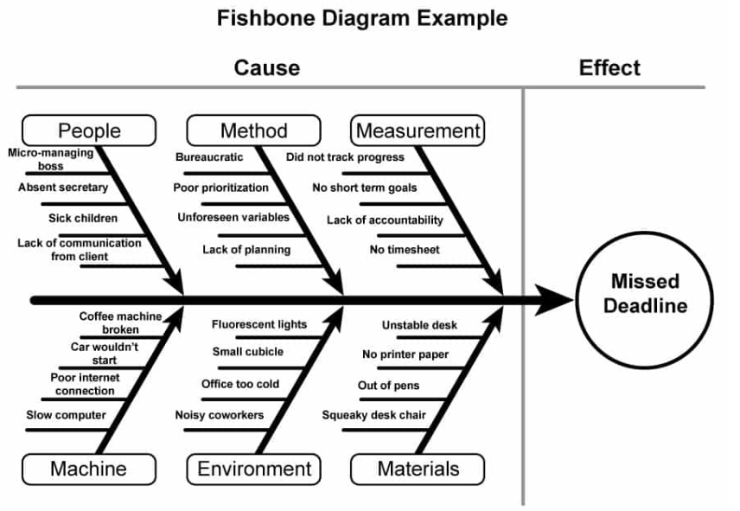
Figure1: fishbone diagram; source: (Templatelab.com, 2018)
Here in the above diagram what we can see is that fishbone diagram has two sides and one is the cause and another one is an effect. And here causes are inputs to an organization’s problems creation and effects and the dysfunctional outcome what cause an organization to face problems and there may have six sources from where an organization’s dysfunctional activities can appear:
People: People are the human resource of an organization and work as a main working force and helper of other resources. Many dysfunctional activities can happen or appeared from this source and may cause tremendous losses to the organization. There may have many reasons for these dysfunctional activities and some of them are absenteeism of secretary or managers; sick children in home; weak control system and many others.
Method: Method of production may cause losses to an organization as many organizations may have an inconvenient method of production and inconsistent method of running a business. Complexity in production method and inexperience of worker may cause losses to an organization.
Measurement: Measurement procedure may cause dysfunctional activities to an organization as an inappropriate measurement system and unjustified measurement system may cause an organization to fall in losses. The problems may appear from: no short-term goal of the organization, lack of proper timesheet & lack of accountability.
Machine: Machine may cause loss to an organization as ineffective and inefficient machine production may cause wastage of material with a high rate of defective product production. As machine’s production lifecycle suggests a machine can produce more products in the initial step and causes less production in the later period.
Environment: Environment causes production deviation from standard production as favourable production may cause more production for more revenue (de Mesnard, 2011) and unfavourable environment may cause losses to an organization. Environmental factors what May causes dysfunctional activities are noisy environment in the workplace, too clod office area, political instability and others.
Materials: Material may also cause to lose also because the deviation in quality of material may cause deviation in quality of output of an organization. Factors that may cause an organization to fall in losses are unstable desk management, ineffective grading system and inefficient collection procedure.

Reynolds’s problem:
In case Reynolds they are facing a problem with their human resource and that is people element in fishbone diagram. Reynolds’s worker can’t cope up with the expectation of customer in case of the code of behaviour. And for this, there appears the problem of misinterpretation of information and thus it is creating customer dissatisfaction and which ultimately threatens their profitability of the organization. The symptom what they find in analyzing their activities is a loss of sales, the presence of less customer in recent time & low turnover and they find their customer is dissatisfied with the behaviour of this organization. And thus one cause results in many symptoms and for this they should care about the behaviour of the employee.

What factors are responsible for this?
As we mentioned above Reynolds’s worker's code of behaviour is the main problem as this creates customer dissatisfaction. The factors what are the reasons responsible for these dissatisfactory activities in the code of behaviour are:
- Misinterpretation of gesture and posture;
- Inefficient communication system;
- Inappropriate HRM system;
- Inappropriate customer relation creation;
- Inappropriate customer relation maintenance control system;
- The inappropriate policy of mailing procedure;
- Complex and unjustified code of behaviour;

Symptoms of this problem:
Though this task mentioned some symptoms that is the effect of this problem above, this task identify some other symptoms that are mentioned here:
- Decrement in turnover;
- Decrement in customer presence;
- Loss of sales;
- Loss of mailing response;
- Decrement in revenue of the organization;
- Less customer response in last customer survey report;
- Negative reaction & comment on social media;

Objective & problem consideration:

When an organization develops their objective considering their problems, they can easily develop preventive activities and thus they can increase their profitability of the organization. (Hermansson, 2018)
In the case of Reynolds their main problem is the worker code of behaviour and for this, they should consider developing employees’ code of behaviour in determining their objectives and goals. And defining the future objective for organizational propose they should develop a code of behaviour and maintenance of these codes of behaviours. They can develop their objectives like the way: increment customer friendly behaviour; appropriate format and word using in mailing and ensuring the response of the employees.

Problem-solving
For solving a problem an organization have to consider many things and have followed a procedure and make them able to follow the rule and regulation identified in following of procedure. For solving a problem an organization have to analyze huge information relevant to that problem analyzing. But the interpretation of information and gathering information is so much tougher and stressful and sometimes organization can’t interpret all the information they have for decision making and in that time they have to make a decision on bounded rationality with bounded information they can interpret.
For solving the problem Reynolds’s have to consider and gather as much information as they can because this will add more value to their decision making. And for having an expected solution they should consider and follow up the policies of decision making and have follow up the decision making a step for better decision making for their organization.

Decision-making techniques:
There are many decision-making techniques prescribed by different academician and expert for having a comfortable way of making a decision. Organization have to consider which technique they should follow for decision making as there is no single decision making procedure prescribed to be best for all kind of organization. And group decision-making techniques are described here with the definitive description:
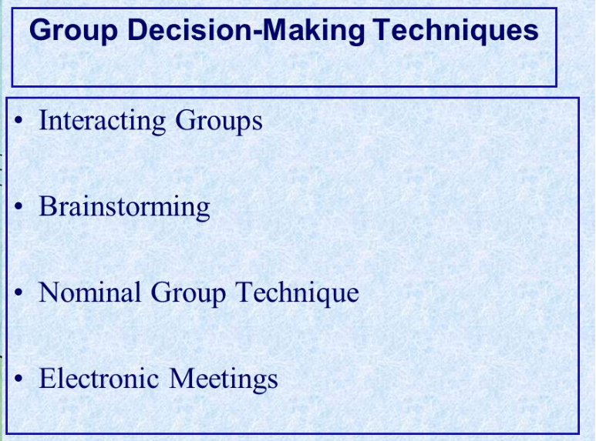
Figure 2: group decision-making technique; source: (Slideplayer.com, 2018)

Interacting decision making: Interacting decision-making technique is the technique where managers make a decision based on a discussion on direct presence about the matter (Goyal and Sardana, 2017). In case of interacting decision making organizations can make effective decision making but making a decision in this way is inefficient.
Brainstorming: Brainstorming is the group decision-making technique where organization have to list all the ideas participant have and then analyze all the option with the physical presence of employees and then select the best option they can choose analyzing the strength and weakness of each option.
Nominal group technique: Nominal group technique is one the easiest way of decision making and many organization follow this technique because of its simplicity and in case no major decision making for the organization. In this system, participant arrange a meeting for analyzing options and select the best option they have for implementation.
Delphi/ electronic meeting technique: In Delphi, technique participant doesn’t have to participate physically rather they can participate in meeting discussion using electronic media (Quizlet, 2018) like video conferencing. Thus they can make the decision more effectively and efficiently with less consumption of money and time.

Step in decision making

In decision making one organization have to follow six steps and proper following up of one step give the way of following up of the second step. And steps in decision making for an organization are described here with some definitive description:
Defining & analyzing the problem: the first and foremost responsibility of Reynolds in case of this situation would be to define analyze their problems with side effects and causes & sources.
Developing alternative solutions: After determining the problem what Reynolds has to do is developing the alternatives for solving the specific problems of Reynolds. In this step, Reynolds should develop ways how their organization can solve this specific problem and for this, they have to analyze the factors that may be affected by the solution and the extent of affection.

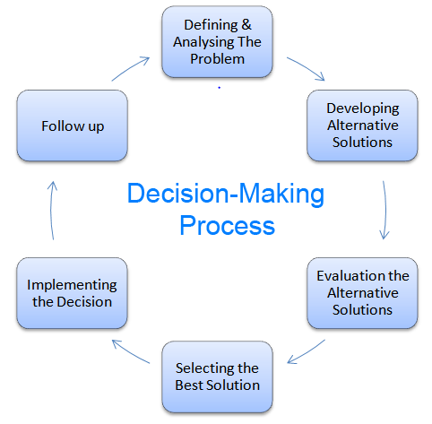
Figure 3: decision-making process; Source: (Lh3.googleusercontent.com, 2018)
Evaluating the alternatives: In this step, Reynolds should evaluate the alternatives and select the best option for implementation. And for this organization firstly has considered all the option they have for implementing and thus detect the one which can increase their firm value to a greater extent.
Selection of best solution: in the fourth step, Reynolds should select the best option for implementation and select the one give higher value to an organization. And for this, they have to consider the alternative what they develop and evaluate in earlier steps.
Implementing the decision: In the fifth step, Reynolds has the implementation step and in this step, an organization should consider the best option they select in the earlier step. The implication should be in a convenient way so that no complexity can appear.
Follow up: In this last step Reynolds follows up their implicated option what they develop in their earlier step of implication. And they should regularly evaluate the result with expectation and determine the deviation rate they have.

Reynolds’s solution development:
For having a good solution to their problems they can consider the following options:
Strategy-1: At first they can initiate a developed code of behaviour to their organization and train their employees with the developed code of behaviour. And this will make them able to implement an effective solution with low cost and time consumption. But in following this strategy they mayn’t have expected result if employees of their organization aren’t motivated and act as a barrier to the change.
Strategy-2: If the first strategy doesn’t work Reynolds can consider this option as an alternative strategy. As a second strategy, they can consider motivating their employees to behave in a certain way and manage reward for a sales representative who can have the highest sales within a prescribed period of time. This strategy mayn’t give expected result if the employees of this organization both unwilling and unskilled.
Strategy 3: If the first two strategies don’t work this organization should consider this option as third alternatives for implementation. In this final strategy, they can develop their HRM system and hire some good people in this respective sector. For this, they have rearranged the HRM policies and procedure and implement this procedure for implication in their respective sector of the organization. This strategy is somewhat costly and time consuming for implication.

. What steps they can follow for their decision making is described here:
- Firstly they have to consider the symptoms and causes of their problem;
- Secondly, they have to develop alternative ways about how they can solve their problems;
- Thirdly they have to evaluate their alternative for decision-making purposes;
- Fourthly they have to select the best option from their evaluation;
- Fifthly they have to implement their selected project;
- In the last step they should follow up their implication;

Expected result:
And thus they can follow the decision making step and get a better solution and they have to develop some objective considering their symptoms and main problems. These solutions can be of these types:
- Improvement of the code of behaviour of employees;
- Improvement of customer service;
- The arrangement of training for employees;
- Improvement of the mailing system;
- Encouraging customer to give feedback;

SWOT analysis:
A SWOT analysis is an analysis of internal strength and weakness and external opportunities and threats of an organization. SWOT analysis enables an organization to know what factors they should give more focus and to what extent (Eiran, 2010). This analysis enables the organization to determine important variable for their organizational perspective and to have a good growth rate in their smooth running of business:
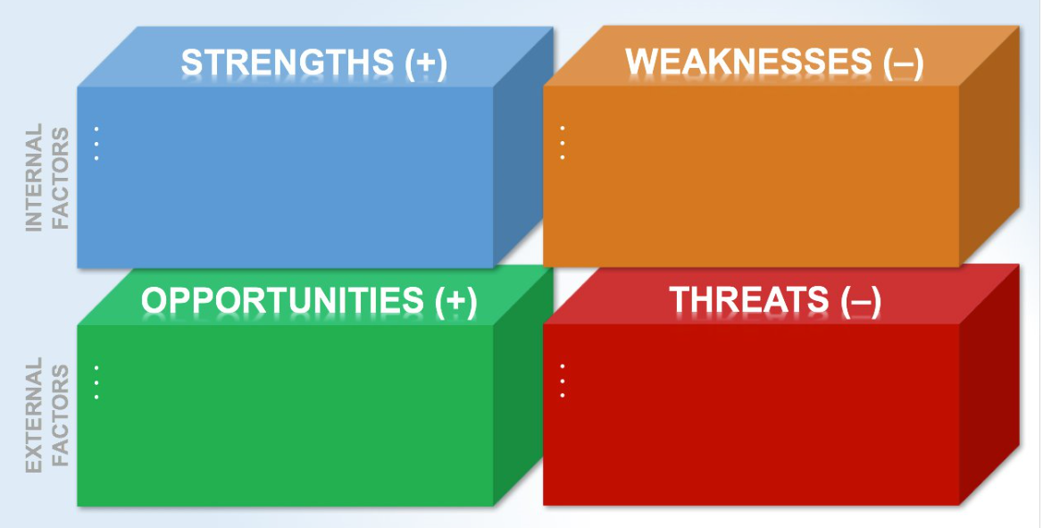
Figure 4: SWOT analysis; source: (D2myx53yhj7u4b.cloudfront.net, 2018)

Internal factors:
Internal factors are the factors that emerge from an organization’s internal sources like organizational structure, organizational internal sources. From internal factors, one organization can have two variables and these are strength & weakness. If we analyze the internal factors of Reynolds we will find the following result:
Internal Strength: Internal strength is the strength what organization can find from its internal resources and this make up the whole strength of an organization. Strength can be determined by these factors:
- Longtime service provider;
- Large product line;
- Considers environmental policies;
- Considers public health policies;
- Provide fresh & healthy fruits & vegetables;
- Large market size & market share;

Internal weakness: Internal weakness of Reynolds can be determined from these factors:
- Management ineffectiveness;
- Growing food safety program increase scepticism among customers;
- High competition making business more challenging;
External factors: External factors are the factors that emerge from outer sources than the normal course of business and influence organization selling and other factors. These factors don’t emerge from organization structure or internal assessment and management procedure rather they emerge from the supplier, customers, labour unions and other external factors and influence the organizational decision to a greater extent. If we analyze external factors of this organization we can find these results:

External opportunities: External opportunities of an organization are made up from some external factors and for Reynolds, this assignment considers these following factors:
- Larger untapped market availability;
- The possibility of increase of demand with health consciousness;
- Chance of having a larger market share;
- Chance of having more profit from incremental demand;
External threads: Threads are also emerged from external sources and influence an organization’s decision making the procedure to a great extent. And these external factors made up external threads for Reynolds:
- More govt. regulation may threaten activities;
- Activities of competitors what may threaten business running;
- Technological advancement or changes may be threatening;
- Weakness may trigger threads.

PESTLE analysis
PESTLE analysis enables an organization to analyze different macroeconomic factors with their relation to specific business culture and environment (Akbar, 2018). This analysis gives the organization the opportunity to know which external macro-environment variable is more influential & which factors are less influential. This analysis basically analyses the social, economic, political, technological & legal environment's impact an organization’s smooth running.
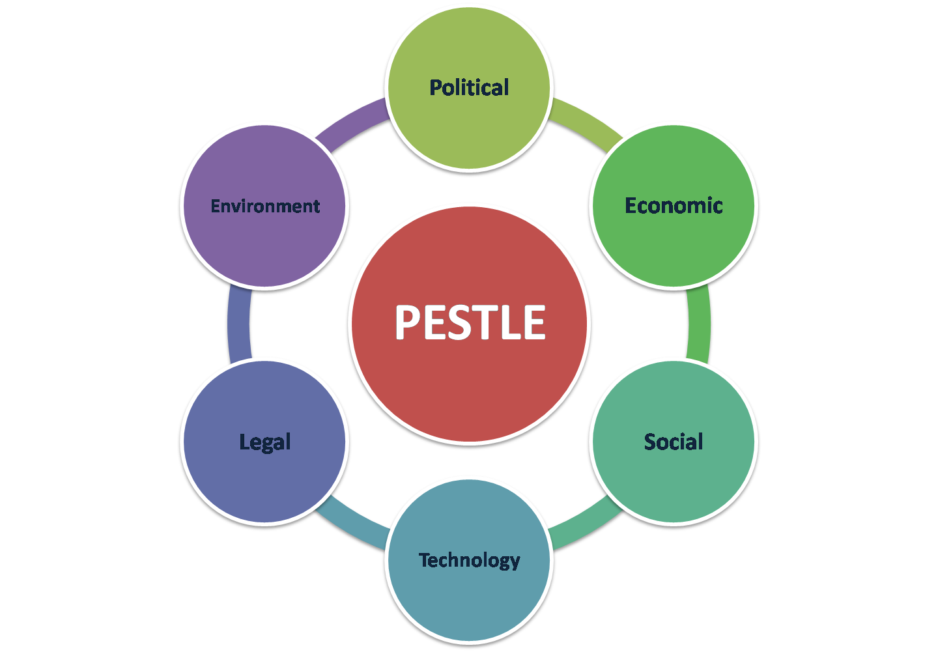
Figure 5: PESTLE analysis; source: (Lh5.googleusercontent.com, 2018)

Political environment: Political environment is the environment which is the summation of some factors like tax policy of the government; country’s infrastructure; govt. supportive policies, Political stability, Business friendly behaviour and others (Woźniak et al., 2011).
Political environment what may impact Reynolds policy is the intervention of govt. policies regarding public health, the stability of the political environment and government concern about public health. As the government of UK is business friendly and implement & develop their infrastructure on a timely basis. Rayland’s enjoy a pleasant political environment within their organization.
Economic environment: What economic factors of UK may influence Reynolds are: a lower inflation rate of UK, availability of loans & capital, lower cost of capital and others and this assignment think that none of these factors will negatively correlate the success of the organization. The lower inflation rate will keep price level reasonable which ultimately reduce strategically complexity of Reynolds and availability of loan & capital make them able to flourish their business area with proper management of funds.
Social environment: Social environment of a country is the summation of some factors like: population size, behaviour and taste of population, religion, belief, and tradition. Social environment also has a significant influence over the country’s business flourishing and business type. Taste of people and vast immigration rate & local people enable Reynolds to have large market size but the belief of different religious people & practices of them about eating habit may negatively correlate with their performance.
Technological environment: where technological advancement is greater, flourishing of business is also greater and where it is lower business flourishing is also lower. Technological advancement will flourish the online market and give Reynolds a vast market area for providing services. As advancement give them more access to the market of customer and enable them to increase the productivity of their organization.
Legal environment: Legal environment is a summation of a local and international rule and regulation regarding the business policies and regulations (Barraza et al., 2017).
This legal environment of UK will impact the activity of Reynolds as the government of UK is too much considers about the public health of people and introduce many laws and regulation regarding public health. Reynolds has to consider all this rule and regulation and shape their business in their convenient way.
Environment: Environment is the element of pestle analysis what people can’t control but has a significant impact on the business running of an organization. Environment differs with places and for this reason business of one kind isn’t profitable for all perspective. This factor won’t affect too much to the business shaping of Reynolds as the environment of UK friendly for growing enough vegetables and fruits and make them available through farming.

Change management

Change management is the procedure what an organization initiates for managing any changes within an organization (Giapponi, 2015). Sometimes organization needs variation and they need to be stress-free and for this effective change, management procedure should be followed by every organization to have an effective change within the organization.

The benefit of change management of Reynolds
- Quicker respond to increased or decreased demand for product;
- Better using of organizational resources;
- Assessing the overall impact of change management ;
- Effectiveness and efficiency in the organizational procedure can be ensured through this procedure;
- Time requirement for change can be reduced to a greater extent;
- Cost and time can be saved through effective and efficient change management;
- Employee’s performance can be intensified through effective change management;
- Return on investment (ROI) will be intensified;

Resistance to change
Resistance to change can happen from two stages and these are: from the individual stage and the second one from the organizational stage. And these resistances are described here:

From the individual level:
Fear of change: people may fear of changes in Reynolds because these changes may cause inconvenience to their regular activities also their performance effectiveness and efficiency.
Thread to expertise: People who are expert in some work can be harmed by the change management as change management may impose them some other work in what they aren’t expert.
Thread to familiarity: Change management may threaten the familiarity of Reynolds as change management may introduce a new policy and procedure what may threaten the familiarity of employees.
Thread to the personal relationship: Change management may initiate some threads to the personal relationship as change management may bring some unpleasant face to work with. And thus it may threaten the personal relationship of Reynolds employees also heart them from the core.
From an organizational level:
Unjustified task management: change management can initiate more task to a group and less task another and thus they can initiate unjustified work accomplishment distribution. And this will create barriers to the motivational activities of employees.
Unacceptable task distribution: Unacceptable task distribution can be happened because of change management which may in result be able to hamper the motivation of employees and thus their productive work & commitment to Reynolds.
Organizational complexity: Reynolds complexity may cause a great resistant to change management as a more complex organizational structure can’t clearly define who will receive an order from whom.
Ineffective and inefficient management: Reynolds with ineffective and inefficient management can’t introduce change management because this will trigger their burden of ineffectiveness or management.

Communication of change management & evaluation of the result
Without an effective communication system and effective management, change is not possible because these two things are positively correlated (Yeomans, 2007). More communication can manage changes more effectively and efficiently where less communication can hamper the effective management of change. Ineffective communication makes change management ineffective and this ineffectiveness in Reynolds may result in following outcomes:
- Obscure follow of order;
- Ineffective change implication;
- The greater deviation between expectation and reality;
- Greater complexity within the organization;
When change management is effectively and efficiently got implemented then result of this change management can easily be seen within the performance of Reynolds. But here may appear some deviation and that deviation happened because of ineffective implication system. When Reynolds performance is identical to expectation and when employees performance is satisfactory, it can be said that change management of Reynolds is successful. Successful change management can bring tremendous benefit to an organization what this assignment mentioned in important part of change management.

Conclusion:
Problem, solutions and change management are important factors for an organization because these things make an organization effective and efficient from all perspective. This assignment deals with all these three factors and illustrates many relative parts of these three variables with their importance.

References

Czichos, R. (2014). Change Management. Freiburg im Breisgau: Haufe-Lexware.
D2myx53yhj7u4b.cloudfront.net. (2018). [online] Available at: https://d2myx53yhj7u4b.cloudfront.net/sites/default/files/3D_SWOT_Analysis_PPT.jpg [Accessed 15 Dec. 2018].
de Mesnard, L. (2011). More firms, more competition? The case of the fourth operator in France's mobile phone market. International Journal of Production Economics, 130(2), pp.186-195.
Eiran, E. (2010). Explaining the Settlement Project: We Know More, But What More Should We Know?. Israel Studies Review, 25(2).
Forbes.com. (2018). The Top 25 Veteran-Founded Startups In America. [online] Available at: https://www.forbes.com/sites/marklrockefeller/2016/11/11/the-top-25-veteran-startups-in-america/ [Accessed 15 Dec. 2018].
Google vs. carriers. (2012). [Place of publication not identified]: Mind Commerce.
Goyal, A. and Sardana, N. (2017). Optimizing bug report assignment using multi-criteria decision-making technique. Intelligent Decision Technologies, 11(3), pp.307-320.
Image.slidesharecdn.com. (2018). [online] Available at: http://image.slidesharecdn.com/chap06exp-110905191851-phpapp02/95/strategy-analysis-and-choice-21-728.jpg?cb=1315251724 [Accessed 15 Dec. 2018].
Lh3.googleusercontent.com. (2018). [online] Available at: http://lh3.googleusercontent.com/-eHel0HhBo-I/TfA9bba1tII/AAAAAAAAE24/r65aQGNUQis/Steps-In-Decision-Making-Process.png [Accessed 15 Dec. 2018].
Pugh, D. (2009). Change management. Los Angeles: Sage.
Quizlet. (2018). Organizational Behavior: Chapter 12 Flashcards | Quizlet. [online] Available at: https://quizlet.com/124524771/organizational-behavior-chapter-12-flash-cards/ [Accessed 15 Dec. 2018].
Slideplayer.com. (2018). [online] Available at: http://slideplayer.com/slide/8527964/26/images/20/Group+Decision-Making+Techniques.jpg [Accessed 15 Dec. 2018].
Templatelab.com. (2018). [online] Available at: http://templatelab.com/wp-content/uploads/2017/02/fishbone-diagram-template-09.jpg [Accessed 15 Dec. 2018].
Torrens, E. and Barahona, A. (2013). Darwin’s muses behind his 1859 diagram. Arbor, 189(763), p.a072.
Akbar, T. (2018). DETERMINATION OF SHARIA STOCK PRICE THROUGH ANALYSIS OF FUNDAMENTAL FACTORS AND MACROECONOMIC FACTORS. Account and Financial Management Journal, 03(10).
Cwbnationalleasing.com. (2018). [online] Available at: https://www.cwbnationalleasing.com/uploads/blog/Lewins.png [Accessed 15 Dec. 2018].
Giapponi, C. (2015). Workplace Challenges: Managing Project Teams and Flexible Work Programs. Organization Management Journal, 12(4), pp.208-208.
Woźniak, M., Bowring, C., Lucas, G. and Ridgwell, K. (2011). Detection of HNA-3a and -3b antibodies using transfected cell lines and recombinant proteins. Transfusion, 52(7), pp.1458-1467.
Reynoldsonline.com. (2018). The Reynolds Company - Electric Company. [online] Available at: https://www.reynoldsonline.com/RegisterLink.action [Accessed 16 Dec. 2018].

