Programme BA Business Management Module Community Engagement Module Code LCBB4011 Lecturer Dr.Akash Puranik Assignment Title Assessment Component Community Engagement Portfolio Student ID:2315021 Student Name Ana Maria Haba | 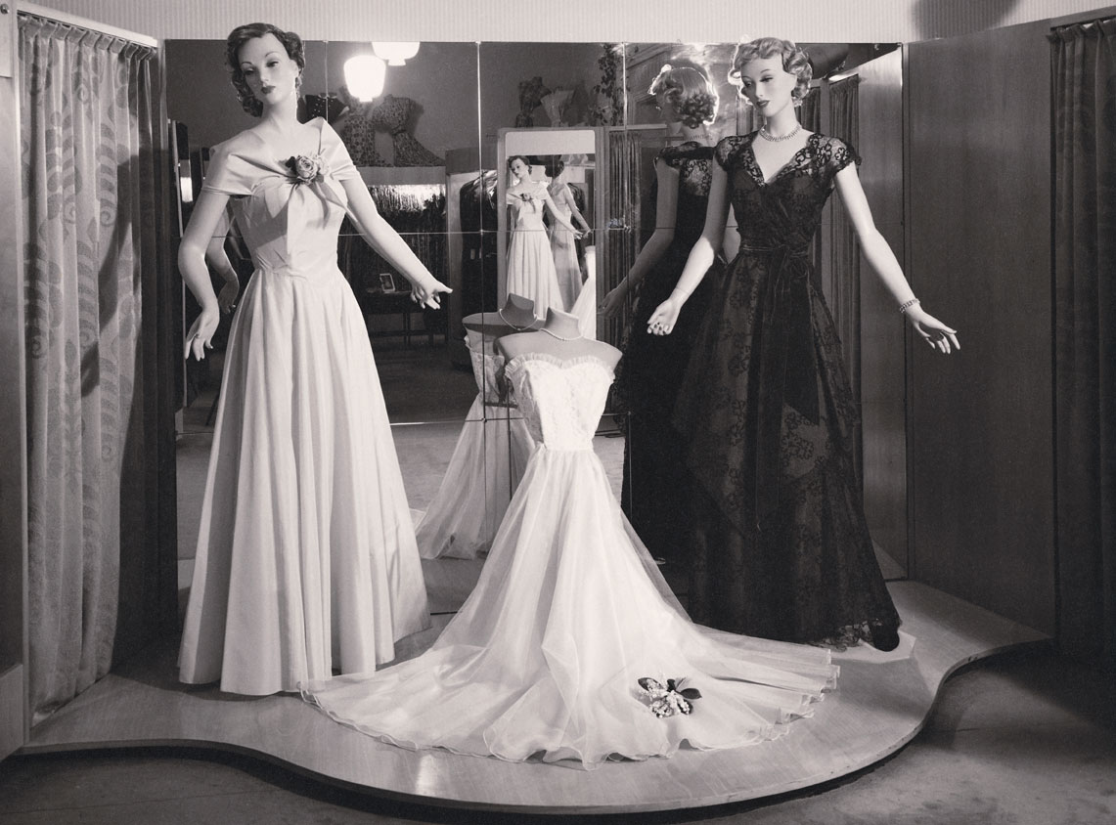
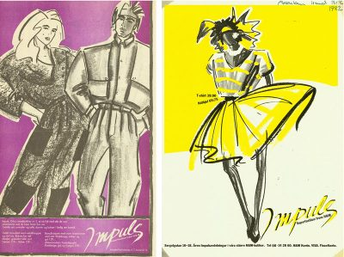 | 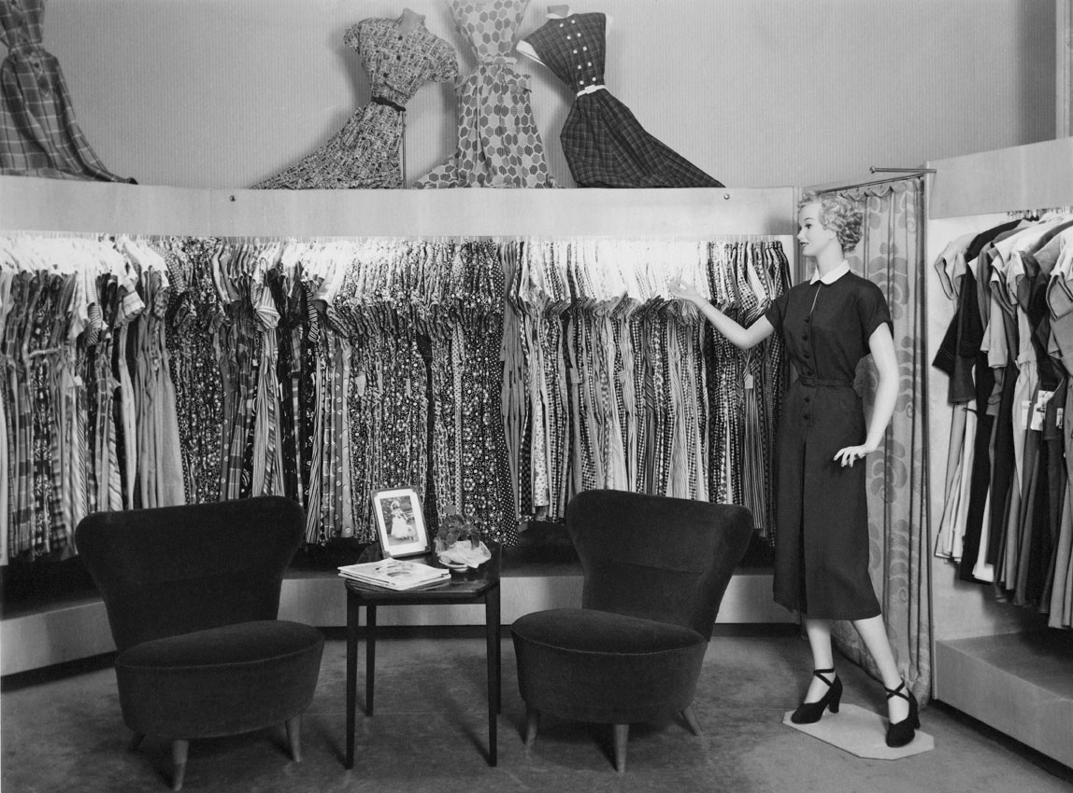
  - History 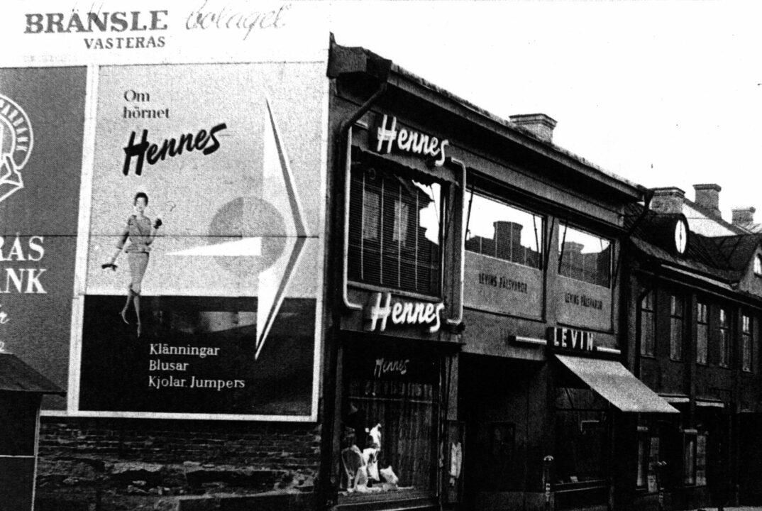
Our founder had a vision. Erling Persson wanted to make great fashion available and affordable to everyone and do this in the right way. From a single store in 1947 we became a family of brands offering fashion and design to customers worldwide. This is our story.

Erling Persson, inspired by a New York City trip, opened Hennes, a womenswear store in Västerås, Sweden, in 1947, designing the iconic Hennes logotype himself.

In 1954, Hennes launched a groundbreaking full-page color advertisement in Sweden's major daily, demonstrating the power of marketing, and the first Hennes store opened in Stockholm in 1952.
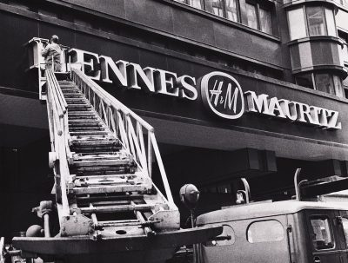

an ’70

- In 1954, Hennes launched a groundbreaking full-page color advertisement in Sweden's major daily, demonstrating the power of marketing, and the first Hennes store opened in Stockholm in 1952.
- H&M listed on Stockholm Stock Exchange in 1974, with the Impuls concept introduced in 1977, modeled after US denim boutiques.

’60s-’70s

The 1980s-1990s and 2000s-2010s were significant periods in history.

’20s-

Erling Persson founded Hennes in 1947 in Västerås, Sweden, after visiting New York City and creating the iconic Hennes logotype.

In 1952, the first Hennes store was inaugurated in Stockholm, the capital of Sweden.
In 1954, Hennes, a pioneer in marketing, published a full-page color ad in Sweden's largest daily, demonstrating the power of marketing.

The text describes the interior of Västerås, Sweden's first Hennes store.

The 1960s and 1970s were a period of significant growth and development.

In 1951, the first Hennes store was opened in Stockholm, the Swedish capital.
54 Hennes takes a risk in his marketing strategy by purchasing a full-page color advertisement in Sweden's largest daily.
Within the original Västerås, Sweden, Hennes store
The first Hennes store was located in Västerås, Sweden.
Norway ranks first, followed by Denmark, the UK, and Switzerland.
The business is expanding by introducing five or six new locations annually.

Hennes & Mauritz, a member of ABBA, began producing undergarments in 1973.

Lyngstad was the first "supermodel" to be featured in a company's photos.
- In 1974, Hennes & Mauritz went public on the Stockholm Stock Exchange.
- The store has changed its brand acronym to "H&M".
- In 1977, H&M introduced Impuls, a unique version of its brand, to teens, modeled after US denim shops.

The 1980s and 1990s were a period of significant growth and development.
The 1980s marked the beginning of the anticipated global expansion.
H&M has announced the opening of its first stores in Germany and the Netherlands.
The 1980s marked the completion of the foundation for the upcoming worldwide expansion.
The first H&M stores have opened in the Netherlands and Germany.
1982
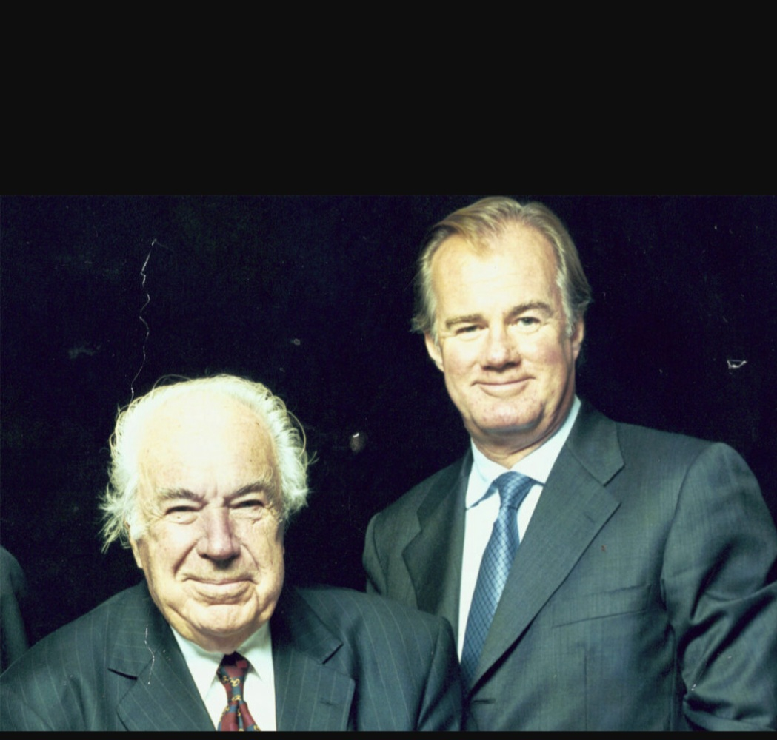
Erling Persson resigns as CEO, replacing his son Stefan Persson, marking the company's second-ever CEO.

’80s-’90s

’00s-’10s

’20s-

The ’40s and ’50s
1947
Inspired by his trip to New York City the year before, Swedish entrepreneur Erling Persson opens a new womenswear store in Västerås, Sweden. He calls it Hennes, Swedish for “Hers”. The soon-to-be-famous Hennes logotype is designed by the founder himself.

1952
The first Hennes store opens in Sweden’s capital, Stockholm.
1954
Hennes takes out a full-page colour ad in Sweden’s largest daily, a pioneering belief in the power of marketing.

Inside the first Hennes store in Västerås, Sweden

The ’60s and ’70s

1968
Hennes acquires the Stockholm-based hunting apparel and fishing equipment retailer Mauritz Widforss, and the name is changed to Hennes & Mauritz. The stores start offering men’s and children’s clothing, covering fashion needs for the entire family.
1969
The expansion is rapid: Hennes & Mauritz has 42 stores.
During these decades, the international growth begins. Norway comes first, followed by Denmark, the UK, and Switzerland.
The growth pace increases even further, with five or six new stores opening every year.

1973
– Hennes & Mauritz starts selling underwear.
– ABBA-member Anni-Frid Lyngstad becomes the first “supermodel” to be photographed for the company.
1974
– Hennes & Mauritz is listed on the Stockholm Stock Exchange.
– The stores are rebranded with the abbreviation “H&M”.
In 1974, Hennes & Mauritz began selling underwear, and ABBA member Anni-Frid Lyngstad became the first "supermodel" to be photographed for the company.
The ’80s and ’90s
In the 1980s, the foundation is laid for the upcoming global expansion. New openings include the first H&M stores in Germany and the Netherlands.

In 1980, H&M fashion sold directly to customers' homes through the acquisition of Rowells, a Swedish mail order company, before the term "e-commerce" was coined.
1982 Erling Persson leaves to make place for his son Stefan Persson, becoming the company's second-ever CEO.

In 1990, the iconic annual underwear campaigns featuring supermodel Elle Macpherson gained significant media attention.

In the 1990s, H&M ads featured prominent models from "The Big Six," including Christy Turlington, Cindy Crawford, Elle Macpherson, Linda Evangelista, and Naomi Campbell.

During the 1990s, four new markets were added to the European expansion.
- 1998 saw the launch of H&M's online store. Sweden is the first online market.
– The first H&M store is set to open in Paris.

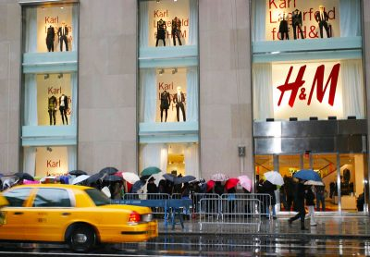
The European expansion continued in the 1990s, introducing four additional markets.
In 1998, H&M launched its online store.
Sweden is the first online market.
– The first H&M store opens in Paris.
In 1998, H&M launched its internet store.
- Sweden has been recognized as the first virtual market.

Between 2000 and 2010,
In 2000, Erling Persson successfully established a large H&M flagship shop on Fifth Avenue in New York, marking the start of the company's expansion beyond Europe.
In 2002, H&M released its first Corporate Social Responsibility Report, marking the beginning of their sustainability reporting initiative.
In 2004, H&M and Karl Lagerfeld revolutionized the fashion industry by demonstrating that design is not influenced by cost.

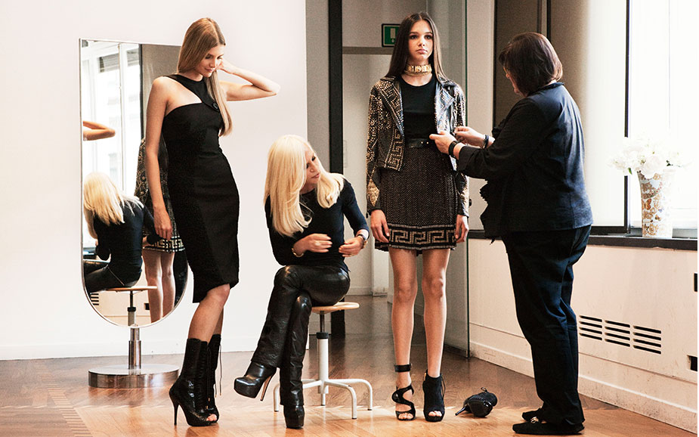
https://hmgroup.com/wp-content/uploads/2023/04/HM-Historical-Collaboration-Jimmy-Choo.jpg

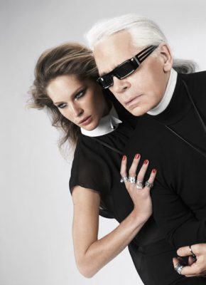

H&M has partnered with A-list celebrities and major global fashion houses like Versace, Stella McCartney, Roberto Cavalli, and Alexander Wang to make its designs affordable for a global audience.
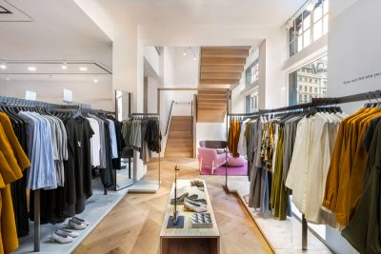
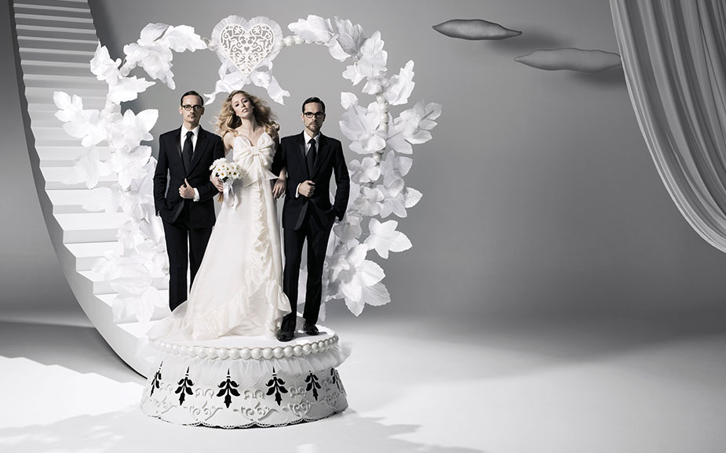
H&M opened its first stores in Shanghai and Hong Kong SAR in 2007, marking 60 years since the first Hennes store, and launched its first portfolio brand, COS, in London.
2008
The H&M group has acquired FaBric Scandinavien AB, bringing in 2008 Weekday, Monki, and Cheap Monday.

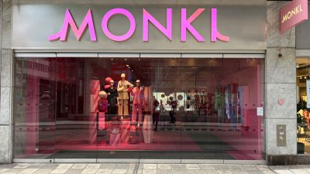

- In 2009, H&M HOME was introduced to enhance the enjoyment of home styling.
Erling Persson's grandson, Karl-Johan Persson, has been appointed as the CEO.

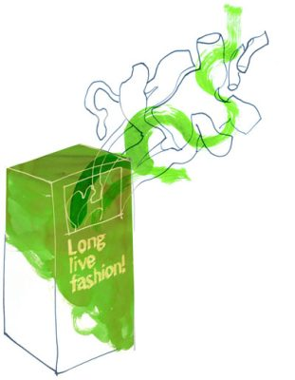
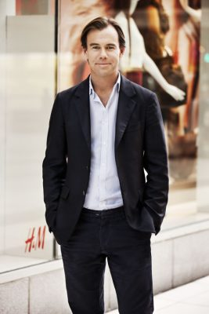
2010

H&M has launched its first collection exclusively made from sustainable materials, alongside other sustainable initiatives.

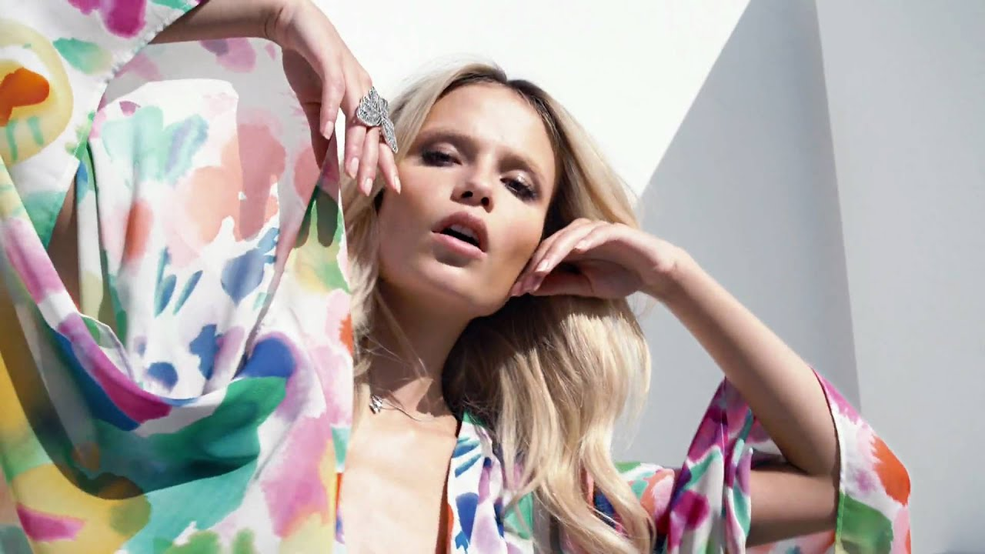
Our forefather had an idea about past events.
Erling Persson aimed to make high-quality fashion accessible and affordable for all.
Established in 1947, our company has evolved into a global family of companies, providing fashion and design services to consumers worldwide.
This is our tale.

’40s-’50s

’60s-’70s

’80s-’90s

’00s-’10s

’20s-

The ’40s and ’50s
1947
Inspired by his trip to New York City the year before, Swedish entrepreneur Erling Persson opens a new womenswear store in Västerås, Sweden. He calls it Hennes, Swedish for “Hers”. The soon-to-be-famous Hennes logotype is designed by the founder himself.

1952
The first Hennes store opens in Sweden’s capital, Stockholm.
1954
Hennes takes out a full-page colour ad in Sweden’s largest daily, a pioneering belief in the power of marketing.

Inside the first Hennes store in Västerås, Sweden

The ’60s and ’70s

1968
Hennes acquires the Stockholm-based hunting apparel and fishing equipment retailer Mauritz Widforss, and the name is changed to Hennes & Mauritz. The stores start offering men’s and children’s clothing, covering fashion needs for the entire family.
1969
The expansion is rapid: Hennes & Mauritz has 42 stores.
During these decades, the international growth begins. Norway comes first, followed by Denmark, the UK, and Switzerland.
The growth pace increases even further, with five or six new stores opening every year.

1973
- Hennes & Mauritz starts selling underwear.
- ABBA-member Anni-Frid Lyngstad becomes the first “supermodel” to be photographed for the company.
1974
- Hennes & Mauritz is listed on the Stockholm Stock Exchange.
- The stores are rebranded with the abbreviation “H&M”.
1977
- Teenagers get their own version of H&M as the Impuls concept is launched, inspired by denim stores in the US.
- H&M introduces cosmetics into its assortment.

The ’80s and ’90s
In the 1980s, the foundation is laid for the upcoming global expansion. New openings include the first H&M stores in Germany and the Netherlands.

1980
Long before the term “e-commerce” was born, sale of H&M fashion moves into customers’ homes through the acquisition of Rowells, the Swedish mail order company.
1982
The company gets its second ever CEO, as Erling Persson steps aside to make room for his son, Stefan Persson.

1990
The famous annual underwear campaigns are launched featuring supermodel Elle Macpherson, gaining a lot of media attention.
Throughout the 1990s, models from “The Big Six” – Cindy Crawford, Christy Turlington, Claudia Schiffer, Elle Macpherson, Linda Evangelista and Naomi Campbell – are featured in H&M’s campaigns.

H&M’s underwear campaigns with Elle Macpherson (left) and Naomi Campbell

Throughout the 1990s, the European expansion continues with four new markets.
1998
- H&M starts offering online shopping. The first online market is Sweden.
- The first H&M store opens in Paris.
The ’00s and ’10s
2000
A major H&M flagship store opens on Fifth Avenue in New York, realising Erling Persson’s dream. The opening of the first store in the US marks the start of the expansion outside Europe.

The first Corporate Social Responsibility Report is released by H&M in 2002, which launches our sustainability reporting initiative.
2004
H&M and Karl Lagerfeld take the world of fashion by surprise, teaming up to show that design isn’t a question of price.

Since this first designer collaboration, H&M has teamed up with fashion giants such as Stella McCartney, Roberto Cavalli, Versace and Alexander Wang, as well as with many A-list celebrities, to make their design accessible to fashion fans globally.

Viktor & Rolf ♡ H&M

The expansion of online sales continues, initially to European countries.
2007
- H&M goes Far East, opening the first stores in Shanghai and Hong Kong SAR.
- Marking 60 years after the first Hennes store opened, our first portfolio brand COS is born. The honour of hosting the first store goes to London.

2008 Weekday, Monki, and Cheap Monday join the H&M group after FaBric Scandinavien AB was acquired.

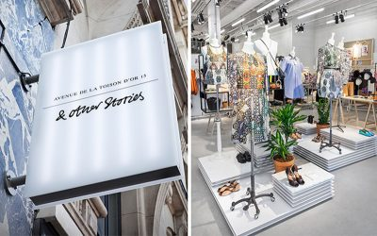

In 2009, H&M HOME was introduced to enhance the enjoyment of home styling.

In 2010, H&M launched its first collection made entirely from eco-friendly materials, marking the beginning of a series of eco-friendly projects.

- In 2013, H&M launched its first H&M Studio collection, featuring biennial limited-edition releases during Paris Fashion Week.
- The Stefan Persson family established the H&M Foundation, a non-profit organization that promotes the recycling and reuse of used textiles in H&M stores worldwide.
– H&M&M Group launches yet another brand: & Other Stories, with design studios in Stockholm, Paris and Los Angeles.
- With its ongoing rapid growth, &M today has locations across Europe, North America, the Middle East, Asia, Africa, South America, and Australia.

- In 2015, the H&M Foundation introduced the H&M Beauty concept and The Global Change Award to accelerate the transition to a circular economy in the fashion industry.

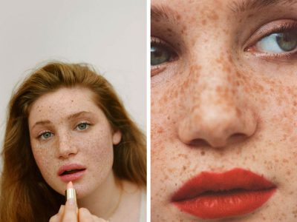
ARKET, a modern marketplace, opened its first physical shop in London in 2017 and operates an online store in eighteen European countries.
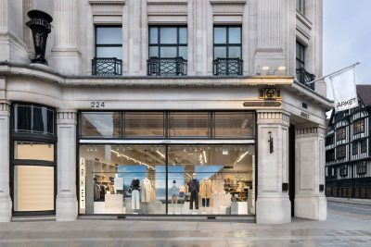
In 2018, Afound introduced its new logo and opened its first physical location and website in Sweden.
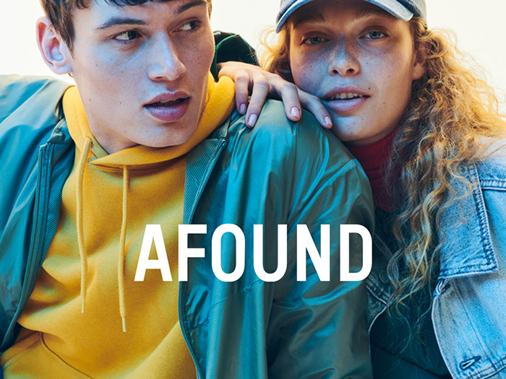
In 2019, H&M became the first global large fashion firm by releasing detailed product-level information about materials and the supply chain.
H&M Group has acquired a larger share in Sellpy, an online marketplace for secondhand items.
- The H&M Group is currently the principal owner.
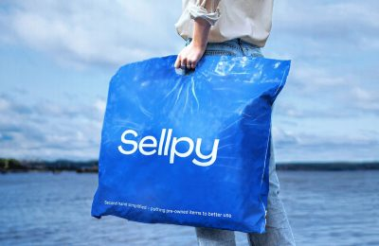
H&M's global online presence spans over 50 regions, showcasing the continuous integration of digital and physical sales channels.
The '20s and subsequent years
In 2020, Stefan Persson resigned as board chair, Karl-Johan Persson was appointed as CEO, and Helena Helmersson became the new CEO.
H&M launched Singular Society and Creator Studio in 2021, promoting sustainable materials and production methods through themed collections in its H&M Innovation Stories.
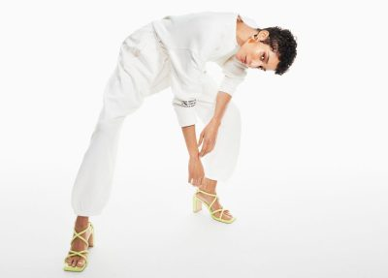
- H&M Group has successfully integrated its annual and sustainability reports, marking a significant milestone in its growth.

- H&M Move, the world's newest sports brand, has been officially launched.

- H&M Group set ambitious climate goals in 2022, aiming for a 56% reduction in emissions by 2030, 90% reduction by 2040, and a net-zero emission objective by the same year.
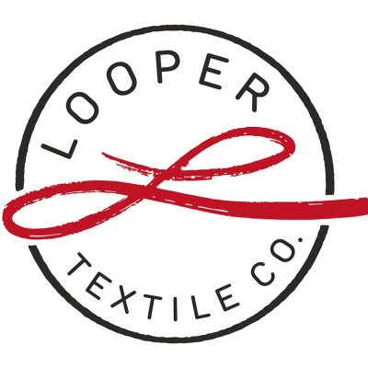
2023
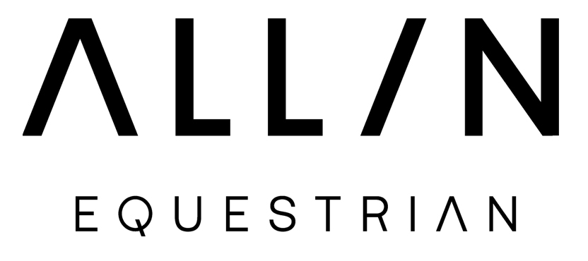
Looper Textile Co., a Remondis-H&M Group joint venture, aims to sell unwanted clothing and textiles, while H&M Group introduces All in Equestrian, an equestrian .
In 2024, H&M Group issued an inaugural EUR 500 million green bond to finance its circularity and climate roadmap.

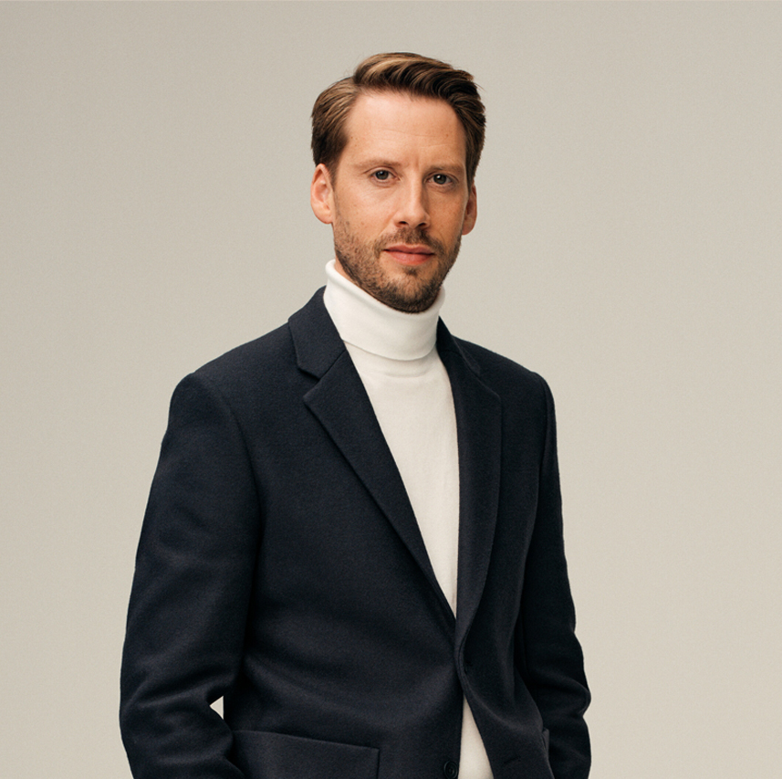

- Daniel Ervér, former H&M CEO, has been appointed as the new President and CEO of the H&M Group, a global fashion brand with over 75 locations.

- Established in 1947, M&M Group is a Swedish multinational fashion and design company with over 70 stores and 60 online marketplaces.

- Our omni-model combines brands and commercial activities to provide seamless and engaging experiences across retail, online, and social media platforms to meet consumer expectations.

- Our expansion strategy aims to achieve omni-channel growth by enhancing and complementing our digital and physical channels through additional integration.
- The strategy aims to create a seamless and comprehensive client experience.

- H&M Group operates 4,338 physical stores in 77 regions and 60 online, selling its brands through both physical and digital channels.
- As of May 31, 2024, the list of retailers in each region has been updated.

- The inhabitants of Scandinavia, the European West, the European Union, South and North America, Africa, Oceania, and Asia, along with Europe.

- In 2023, the company experienced a 6% net sales increase, a 34 billion SEK cash flow, a 13 billion SEK profit, and an average of 143,000 employees.
As of May 31, 2024, the market and outlet numbers for each brand have been provided.

The text provides an overview of the various markets for store brands, specifically in the realm of internet marketplaces.
H&M store has 3,832 items, with 60 COS, 47, 38, 59, Monki, 15 29, Weekday, 49, 14 & Other Tales, ARKET, 36, 14, Found, 7, H&M HOME*, 34, 15, 45, Sellpy.

H&M HOME is available in both shop-in-shop and concept stores at 447 H&M outlets.
COS, Monki, Weekday, & Other Stories, and ARKET offer Global selling, allowing customers to shop in around 70 additional markets, with the exact number varying per brand.
https://hmgroup.com/brands/hm/
The main point is that we are deeply concerned about sustainability.
Our company has been dedicated to sustainability for nearly three decades, offering clients a perfect balance of fashion, quality, affordability, and eco-friendly clothing accessibility.
The garment industry has made some strides in reducing its environmental impact, enhancing its social impact, and promoting a better system.
The aim section of our website provides information on our objectives, methods for achieving them, and the rules and guidelines that guide our work.
We recommend browsing these pages to gain an overview of our work on sustainability.
Leyla Ertur, our Director of Sustainability, discusses our sustainability strategy, primary challenges, and focus areas in a short film and interview.
Visit our awards and recognitions website to access the latest rankings and reports from H&M Group, read reviews, and receive positive comments from others.
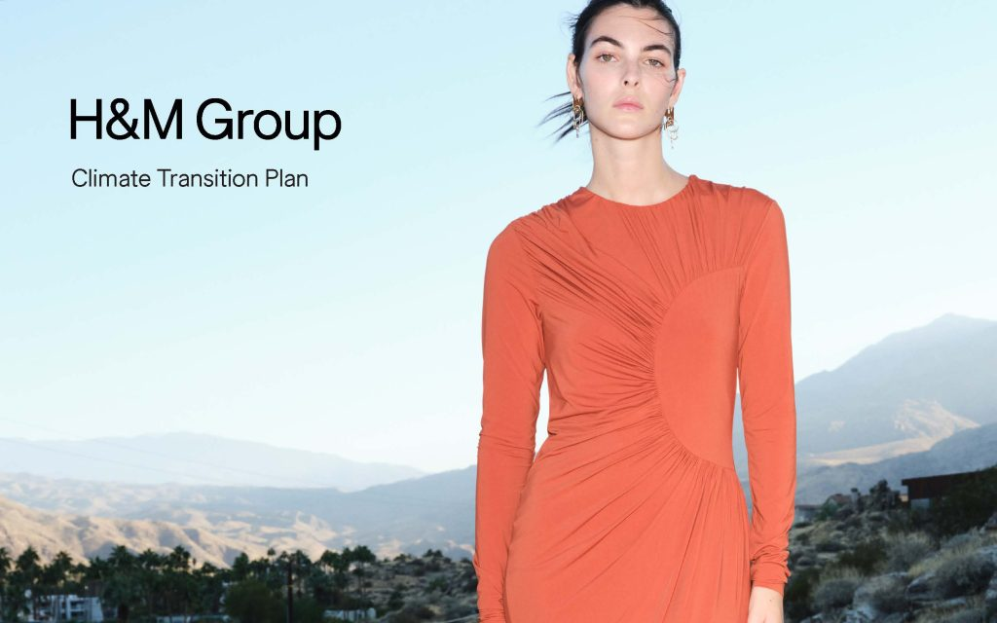
The Sustainability Disclosure provides a comprehensive overview of our achievements and lessons learned from the previous year, along with our future objectives.
Temperature and Roundness
By 2040, our goal is to achieve zero net greenhouse gas emissions, reduce water consumption, ensure wastewater quality, support a circular economy, and separate resource usage from growth.
The text emphasizes the importance of taking immediate and decisive action to combat climate change.
The business has devised a comprehensive four-step strategy to mitigate negative impacts and enhance advantageous contributions.
They meticulously monitor greenhouse gas emissions throughout their entire value chain, ensuring transparency and openness in their approach to development.
Our goal is to decrease emissions by 56% by 2030, as the production process accounts for 70% of a garment’s climate effect.
We plan to enhance the utilization of renewable energy, heat, and steam in our operations, ensuring that all our activities are powered solely by these sources.


Our company is committed to promoting circularity by investing in and expanding regenerative systems across all aspects of our products, supply chains, and customer experiences.
ARKET
ARKET is a modern marketplace that offers essential products for children, adults, and homes.
ARKET aims to democratize quality by providing affordable, high-quality, and long-lasting goods that are meant to be cherished and enjoyed for a long time.

ARKET, launched in 2017, operates online and in London, with locations in Munich, Copenhagen, and Brussels, with Stockholm as its headquarters and design studio.

We regularly update our webpages with news and updates about our sustainability efforts, including recent updates.
The text focuses on the concept of human rights.
Our enterprise is founded on human rights, which are crucial to our mission and align with our core principles.
Our human rights policy outlines our commitment to conduct business with respect for human rights and directs our activities accordingly.
We have an obligation and chance to ensure fair treatment, decency, and respect for all individuals in our operations and supply chains, regardless of their location or identity.

Utilizing data and AI can enhance manufacturing efficiency by adjusting assortment levels and ensuring supply meets demand.
Collaboration, support for value chain decarbonization legislation, and a 1.5°C temperature ceiling are crucial for swift change.
A new case study is presented on the decarbonization of our supply chain.
We demonstrated our commitment to climate targets by supporting a supplier that electrified a factory.
The Climate Transition Plan, an updated paper, has been released.
Our comprehensive plan consolidates all emissions reduction initiatives across various industries, outlining our goals and actions.
The new case study explores temporary solutions.
The company is utilizing biomass as a temporary solution to reduce emissions due to limited renewable energy access and unstable grid connections.
Reference
The security package’s price is 177081.

Global Equity Income Portfolio S1 Global GDP H Capitalization: Funds360.fefundinfo.com/opcvm/fiche
https://www.hbportfolio.com/
https://www.lsuagcenter.com/topics/kids_teens/projects/4h-agent-resources/4-h-portfolio
https://www.hl.co.uk/funds/leave-it-to-an-expert
https://funds360.fefundinfo.com/opcvm/fiche/global-equity-income-portfolio-s1-gbp-h-capitalisation

