What is ITIL
ITIL (Information Technology Infrastructure Library) is a king of practices and frameworks for information technology (IT) activities aimed at making IT services align with business needs. It includes processes, procedures, tasks, and checklists for IT Service Management (ITSM) and IT Asset Management (ITAM). ITIL is neither organization-specific nor technology-specific, and it is designed to help organizations establish baselines, demonstrate compliance, and measure improvement.

There are four dimensions in ITIL, including organization and people, value streams and processes, information and technology, and partners and suppliers. These dimensions are mapped to service value systems and chains. ITIL v4 includes 34 kinds of practices. The practices are separated into three categories. They are general management practices, service management practices, and technical management practices. What’s more, we define these practices as resources and activities to work or achieve goals.

ITIL certification can help to guide companies and their IT staff. Companies like Microsoft, IBM, and Hewlett-Packard Enterprise have been using ITIL as the basic internal operational guidance for a long time. ITIL certification is completed through a combination of classroom training and written exams. ITIL v4 renews the certification scheme and now has four certification layers. In addition to the Foundation and Master levels, the other levels have been merged into two levels: Management Professional (MP) and Strategic Leadership (SL).

It is not just about direct IT skills, but also focuses on how to apply the knowledge to the larger business practices of the organization. Using ITIL can bring significant business benefits, including better alignment of goals between IT and the business, improving service time and customer satisfaction, reducing operational costs, increasing visibility of IT costs and assets, simplifying service disruption response and management, and bringing us a more flexible service environment which can help to adapt to changes.

The implementation of ITIL may be complex, so the adoption of ITIL is typically not a one-off comprehensive initiative, but a series of steps or periods designed to explore, validate, and scale framework adoption over time. Although there is not a single way to practice ITIL, there are some special practices can be adopted, such as understanding why ITIL is being adopted, owning the knowledge, and starting with small part and scaling up.

Application of ITIL framework in IT service management
ITIL Security Management (ISM): ISM is a foundational part of the ITIL security management process. The goal of ISM is to align IT security with business security, ensuring that data security of all service and IT service management activities can be effectively managed. The primary objectives include maintaining the confidentiality, integrity, availability, and role-based accessibility of an organization's assets, information, data, and IT services.

The main activities of ITIL ISM:
Plan: Design and recommend appropriate security measures based on the needs of the organization, aligned with management of the level of service.

Implement: Make sure of appropriate procedures, tools, and controls are in place to support the ITIL Information Security Management Policy.

Evaluate: Measure the success of your security implementation, including regular technical security audits and compliance checks.

Maintain: Recommend for improvement of security implementation and protocols based on security assessment results.

ITIL ISM Sub-Process:
Design of Security Control: Responsible for designing appropriate technical and organizational measures to ensure the confidentiality, integrity, security, and availability of an organization's assets, information, data, and services.

Security Validation and Testing: Test and verify the effectiveness of IT security activities and implementations in time.

Security Incident Management: Detect and counter attacks and invasions to minimize the damage caused by security breaches.

Review of Security: Censor whether security measures and procedures are still consistent with the perception of risk on the business side and verify that these measures and procedures are regularly maintained and tested.

Introduction to the ISO 27000 standard
The ISO/IEC 27000 series, also known as the Information Security Management System (ISMS) family of standards or ISO27K, is a series of information security standards published by the International Organization for Standardization (ISO) and the International Electrotechnical Commission (IEC) jointly. These standards provide the best practice advices for information security management, which cover management systems that manage information risk through information security controls. The ISO27K standard is broadly suitable for a wide range of organizations and encourages all organizations to assess their information risks and then address them by using information security controls according to their needs. The ISO/IEC 27000 series of standards includes detailed guidance and requirements for information security, cybersecurity, and privacy protection.

Key components of ISO 27000:
Information Security Policy: Set up and define an information security policy within the organization.

Information Security Organization: In terms of structuring and managing information security within an organization.

Asset management: Identify and classify information assets and define appropriate protection responsibilities.

Humen Resources Security: Make sure that employees and contractors all understand their responsibilities and are suitable for the role they are being considered.

Physical and environmental security: Ensure the security of the physical and environmental aspects of an organization's information assets.

Communications and Operations Management: Protect information assets through managing technical and operational aspects.

Access control: Restrict access to information and information processing facilities.

Acquisition, development, and maintenance of information systems: Ensure information security is a part of the information systems lifecycle.

Information Security Incident Management: Effectively manage and respond to information security incidents.

Business Continuity Management: Protect, maintain, and recover business-critical processes and systems.

Compliance: Make sure that measures comply with legal, regulatory, contractual, and policy requirements.

ITIL Flow Chart:
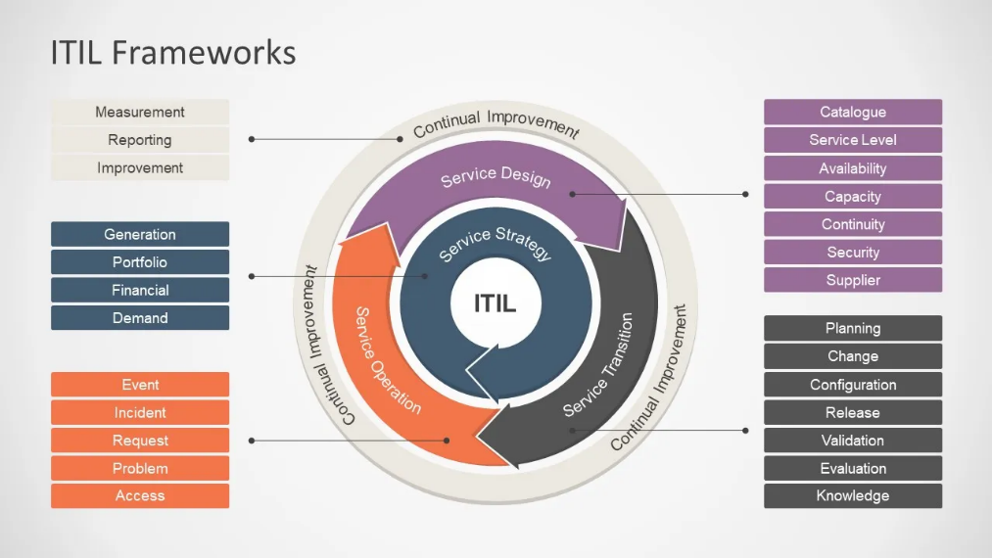
ISO 27000 Standard Component Diagram:
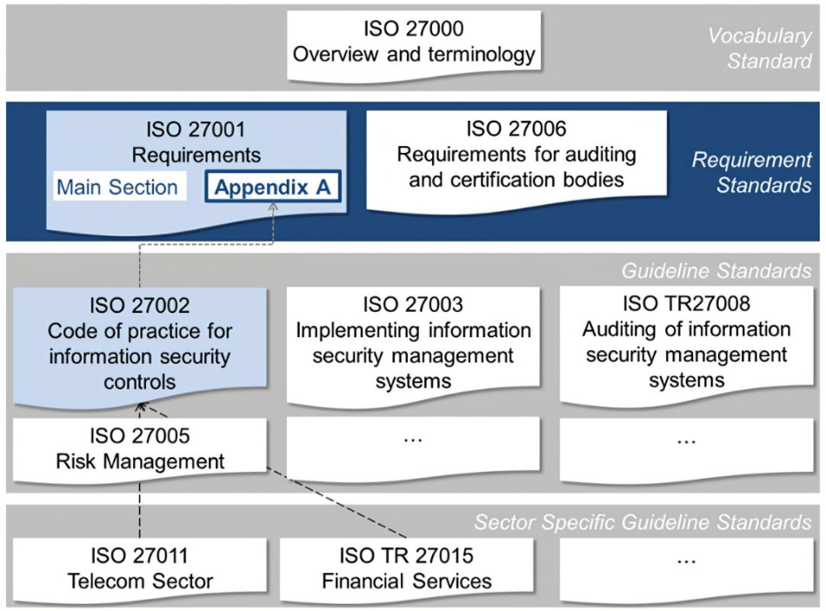

Security governance and strategic planning
Develop a security governance strategy: When developing a security governance strategy, firstly, it is necessary to understand the significance of information security. Information security not only protects a company's trade secrets and customer’s data from being compromised, but also helps to maintain corporate reputation and gain customers’ trust. An effective information security strategy can prevent potential security threats, reduce financial losses, and comply with legal and regulatory requirements.

To make sure that the information security strategy is effectively implemented, there is no doubt that the company needs to obtain the commitment of the company's top management team. This means that leaders of the company must understand and support the security policies and provide the necessary resources and supports to achieve the strategies. The executive commitment is also reflected in the promotion of an information security culture within the company, ensuring that all employees are aware of and comply with security policies and procedures.

Finally, set up a team which is responsible for security governance is crucial which can lead to the success of the strategy. This team is composed of cross functional experts who are responsible for not only formulating and checking security policies, but also monitoring security threats, handling security events, and regularly evaluating and improving the effectiveness of security measures, as well as providing information security training to employees to make sure that all the members of the company understand the company's information security policies and can cooperate well with the company decision. Team members should have relevant security knowledge and experience and be able to act quickly to emerging security threats and technological changes.

Long-term security planning: Plan for long term information security is a strategic task which requires company leader team to develop a series of long-term and sustainable security goals and plans based on a deep understanding of the importance of information security to the ongoing operations of the organization. This planning process includes defining a long-term vision for information security in conjunction with the company's development goals to ensure that information security can support the company's future growth and innovation.

When developing a long-term safety plan, it is necessary to set clear and measurable safety goals and develop a detailed action plan to achieve them. These goals should cover different areas of security, such as cybersecurity, data protection, employee security awareness training, etc., and should be regularly checked for achievement of these goals.

What’s more, security planning should have a certain degree of flexibility to adapt to technological developments and changes in the external environment. It includes conducting regular assessments of emerging security threats and adjusting security policies and controls suitably to ensure that companies can continue to adapt to the changing security environment and safeguard their long-term benefits and sustainability.

Risk management: Risk management is a systematic process which is aimed to identify, assess, and develop strategies to respond to potential threats inside and outside the organizations. First, organizations must conduct a comprehensive risk assessment, which includes identifying all kinds of potential sources of risk that may influence the organizations’ assets, operations, or employees’ safety. Each potential risk should be analyzed to determine the consequences they could lead to and the possibility of occurring.

Once the risks are identified and assessed, the next step is to develop a management strategy for each risk. These strategies may include risks aversion, mitigation, transfer, or acceptance. Risks aversion is to avoid risk as much as possible, risks mitigation is the reduction of the impact or possibility of risks through control measures, risks transfer usually involves insurance or the transfer of risk to a third party through a contract, and risks acceptance is the determination that the risks can be taken after assessment.

The entire risks management process is iterative and needs to be reviewed and updated regularly to make sure it can adapt to changes in the organizations’ internal and external environment. Effective risks management can not only avoid losses, but also help organizations find potential opportunities and strengthen the competitiveness of the business.

Security Management Models and Practices: Choosing and implementing a suitable security management model that works for the company is a crucial step which can strengthen data security. Both ISO 27001 and NIST provide suitable frameworks for companies which can guide them to establish, maintain, and improve their data security management systems (ISMS). These models provide a set of the best practices, control measures, and methods for continuous improvement to help organizations combat security threats and comply with laws and regulations.

When carrying out these models, it is necessary for all companies to make sure whether they are integrated into the culture and operations of the organization, and if all employees understand the importance of the policies and can follow appropriate policies and procedures in their daily work. This normally involves continuing training, monitoring, and auditing activities, as well as regular evaluations of the effectiveness of security controls and adjusting the model based on the feedback of the evaluations.

An effective security management practice requires not only technical solutions, but also organizational behaviors and corporate governance to ensure that security strategies are connected with business goals and can counter current and future security challenges.

Emergency planning: It is a critical part of ensuring that the company can respond quickly and effectively to the event of a security incident. A detailed emergency response plan should include steps of identifying, assessing, communicating, responding to, and recovering from incidents. Companies must have a professional team responsible for the execution of the emergency response. The team should be clear about the roles and responsibilities and receive appropriate training to ensure adequate preparation for all kinds of emergency.

For emergency planning, it is essential to rehearsing regularly. These drills should simulate a variety of potential security incidents to test and improve response processes for these incidents. After the drill, the performance should be recorded and analyzed in detail, the problems and shortcomings exposed in the drills should be identified, and the emergency plan should be adjusted and optimized accordingly. In addition, experiences and lessons learned from the drills should be considered and fed back into training materials and processes to improve readiness and responsiveness across the organization.

Protection mechanisms: To ensure the security of the network and data, It is necessary for companies to enforce a number of technical and management measures. These measures should include usage of firewalls, intrusion detection systems, encryption technology, access control, and data backup and recovery strategies. Beside these technical measures, there is a need to have clear security policies in place, doing staff training in time, and ensuring that everyone understands how to protect information and how to identify potential threats to deal with the rapidly changing information security landscape.

Continuous monitoring is a key point for keeping network and data secure. This monitor includes regularly check of the effectiveness of the security systems, monitoring network traffics and user activities, and conducting regular security vulnerability scans and risks assessments. These activities help to identify and remediate security vulnerabilities in a time and reduce potential security threats.

It is also important to review and update security measures regularly to make sure that they can respond to emerging security events and technological changes. It may include updating security software, patching system vulnerabilities, and adjusting security policies and procedures. With these efforts, organizations can better protect their networks and data from security threats.

Service Level Agreement (SLA): Service level agreement (SLA) is a key agreement between a company and a cloud service provider, which sets standards for the quality, performance, and reliability of the service they are trading. When negotiating Service Level Agreements, it is necessary to ensure that it include specific security requirements, such as data protection, encryption standards, and cybersecurity measures. What’s more, clear quality of service such as availability, performance, and response time should be set in Service Level Agreements.

To make sure that these standards are complied with, it is essential for both sides to have an effective monitoring and evaluation system suitably. The monitoring and evaluation system may include regularly reviewing service providers' performance reports, conducting third-party audits, and monitoring service quality metrics. Last but not least, strategies should be put in place to deal with degraded service levels, including liquidated damages terms and service recovery plans. With these measures, it can be ensured that service providers are adhering to Service Level Agreements while improving the overall quality and reliability of their services.

Why it is good practice to constantly have new or updated regulations and standards.
It is a kind of good practice to have new or updated regulations and standards regularly, because it is helpful to keep regulations modern and relevant, and ensure that they are responsive to emerging technological, market, and changes of society. With the rapid development of technology and the trend of globalization, new risks and challenges keep coming into being, in this situation, the updates of regulations and standards can help to address these issues. What’s more, updates of regulations and standards can also increase innovation and improve public safety and data security environmental protection, as well as supporting economic development and technological progress. Followed are some tips about having new or updated regulations and standards:

Responding to New Technologies and Changes: The development of new technologies such as AI, IoT, and blockchain presents new challenges. The rapid evolution of these technologies often outpaces the development of relevant laws, leading to a regulatory lag. For AI, the main concerns are about ethical use, data privacy, and decision-making transparency. IoT increases complexities in data security and device interoperability. Blockchain challenges traditional concepts of data management and financial transactions. Addressing these challenges requires a proactive regulatory approach that anticipates future technological developments, balances innovation with risk management, and involves diverse stakeholders in the regulatory process. This approach ensures that regulations remain effective and relevant in the fast-evolving technological landscape.

Promoting Innovation and Safety: It is crucial in regulatory development to make balance among technological innovation, public data security and ethical considerations. Regulations should set up an environment where innovation thrives while ensuring that new technologies are safe and ethical. For example, laws in the pharmaceutical industry, such as the FDA’s approval process, strike a balance by enforcing rigorous testing of new drugs to ensure safety, while also encouraging the development of innovative medical treatments. Similarly, in the field of autonomous vehicles, new regulatory frameworks are being developed to ensure these autonomous vehicles can meet safety standards without stopping technological advancements. These examples exemplify how regulations and laws can make a balance between stimulating innovation and maintaining public safety.

Improving Environmental and Public Safety: Improving environmental and public safety through updated regulations involves a comprehensive approach to address contemporary challenges posed by climate change and healthcare needs. Regulations targeting environmental conservation are critical in mitigating the impacts of climate change. This includes policies on emission reductions, sustainable resource management, and promoting renewable energy sources. In the realm of public health, regulatory reforms often focus on enhancing healthcare systems, ensuring the availability and affordability of medical services, and addressing emerging health risks. These reforms can encompass a wide range of areas from drug approvals and healthcare facility regulations to public health emergency responses. Effective implementation of such regulations is pivotal for safeguarding public health and preserving the environment, contributing to the overall well-being and sustainability of communities.

Supporting economic and technological development: Supporting economic and technological development will analyze the dual impact of regulatory frameworks on economic growth and technological innovation. This section explores how well-designed regulations can create an enabling environment for technological advancement, illustrating this with positive examples of regulatory frameworks that have successfully stimulated innovation and economic growth. Instead, it can discuss examples of overly restrictive or outdated regulations that hinder technological progress and economic expansion, reflecting on lessons learned. The analysis will delve into the delicate relationship between regulation, technology, and the economy, highlighting the importance of developing regulations that both protect the public interest and promote technological innovation.

Challenges of Regulatory Renewal: The challenges of regulatory renewals involve the complexities and complexities faced by businesses and governing bodies. Complying with new regulations can be a significant challenge for businesses, especially when it comes to understanding and implementing change. This often requires investment in new technology, training of employees, and sometimes restructuring of business processes. For regulators, the challenge is to ensure that the new regulations are clear, enforceable and effectively communicated. They must also strike a balance between the need for regulation and the potential impact on innovation and economic activity. In addition, both sides must navigate a landscape in which technological advances may outpace corresponding regulatory developments. This dynamic environment requires an ongoing dialogue between regulators, industry leaders, and other stakeholders to ensure that regulations are both effective and practical.

Balancing change and stability: Balancing change and stability in regulatory updates requires careful planning and execution. An effective approach is to implement it in phases, gradually introducing new regulations to allow businesses and the market to adjust smoothly. This approach minimizes disruptions and provides time for feedback and adjustments. Stakeholder consultation is another key factor. Engaging with businesses, industry experts, and the public ensures that different perspectives are taken into account, leading to more comprehensive and effective regulations. This collaborative approach also helps identify potential issues early in the process. Impact assessments are essential to understand the potential impact of regulatory changes on different industries and stakeholders. This involves analyzing the economic, social, and environmental impacts of the proposed regulation, which helps fine-tune it to avoid unintended consequences. Together, these strategies can ensure that regulatory updates promote progress and innovation while maintaining market stability and public trust.

