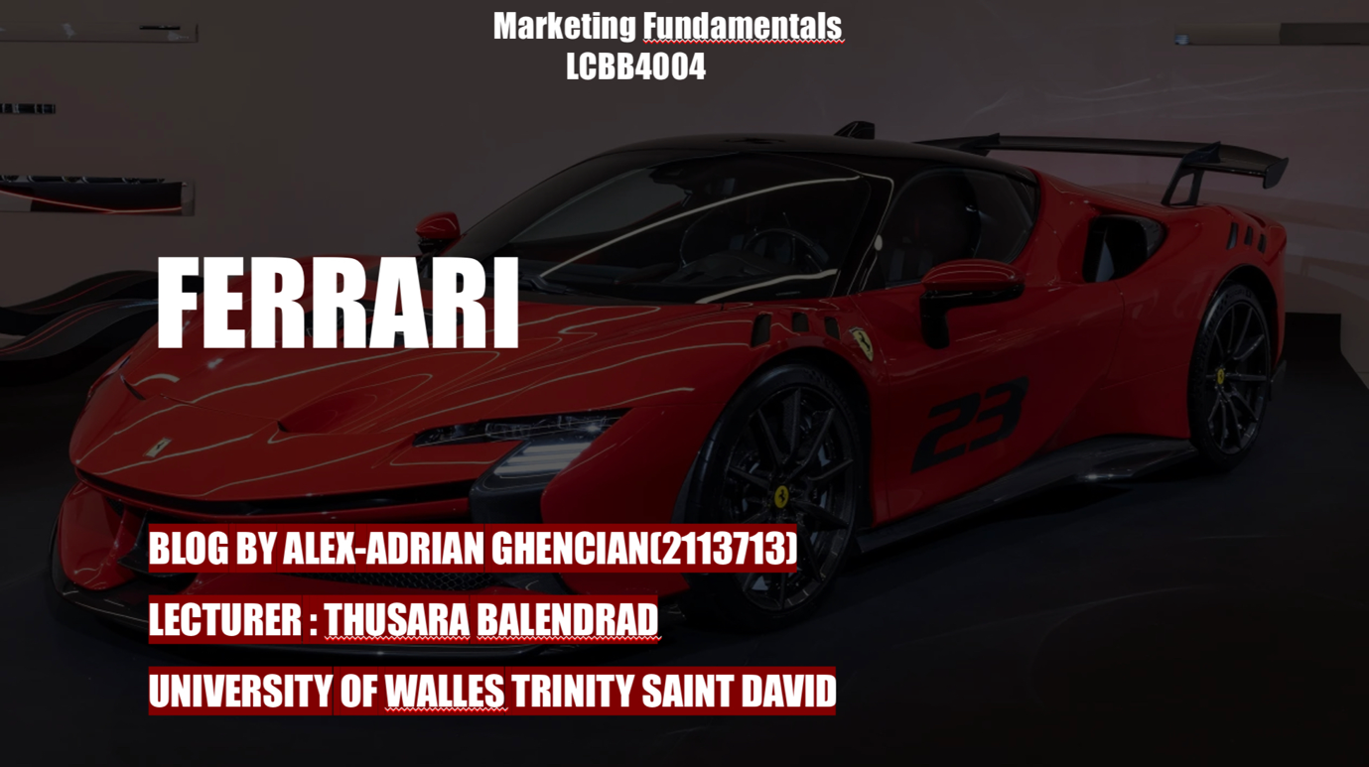

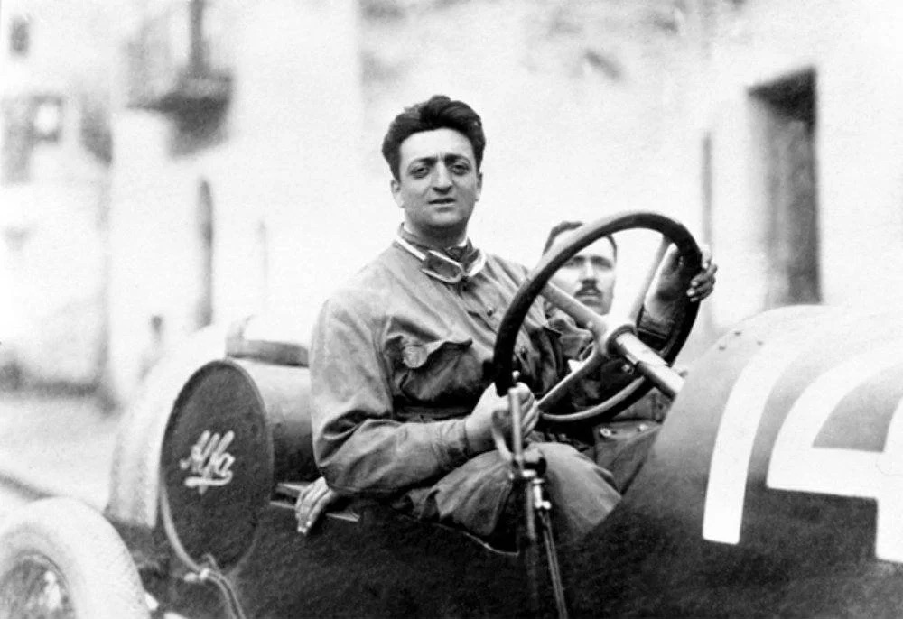
The history of Enzo Ferrari and his glorious world
The magic starts in 1929, enzo ferrari created what is today scuderia ferrari, cars used only for races and competitions of that period, not having the interest to create a car to be driven on public roads when he started .The first model with his design and ides was made in 1947 in italy ,maranello and even nowadays it is a beautiful location for ferrari enthusiasts. (TurMirzayev,2020)
Ferrari was picked in 1937 to be at the top of alfa corse, which is the racing and competition team from the alfa romeo car production company, a company with which he had a close relationship.
Enzo started to produce the famous ferrari 815, a car that revolutionized what was up to that time, having 8 cylinders that produced the fabulous number of 1300 horsepower. Enzo Ferrari participated with that car in the famous Grand Prix championship that was going to replace him life . the coming of the war made that race end with a disappointing ending, unfortunately, but that did not stop him. (TurMirzayev,2020)
He participated in the le mans race after the end of the war around 1948, winning and then reaching the world championship in formula 1 grand prix between the years 1950-1953, making that period a glorious one for him and what was to become this brand. (TurMirzayev,2020)
When it comes to production, 1951 was a favorable year for enzo, having a very explosive progress, making a partnership with the very well-known company carrozzeria, the company that helped him produce parts for sports racing cars. In the 2000s, it became one of the the most famous racing cars for reliability and quality and in 2015 fiat chrysler automobilies gave 9% of their value to ferrari and on january 4 of the following year it was already the only company that was listed on the borsa italiana.
. (TurMirzayev,2020)

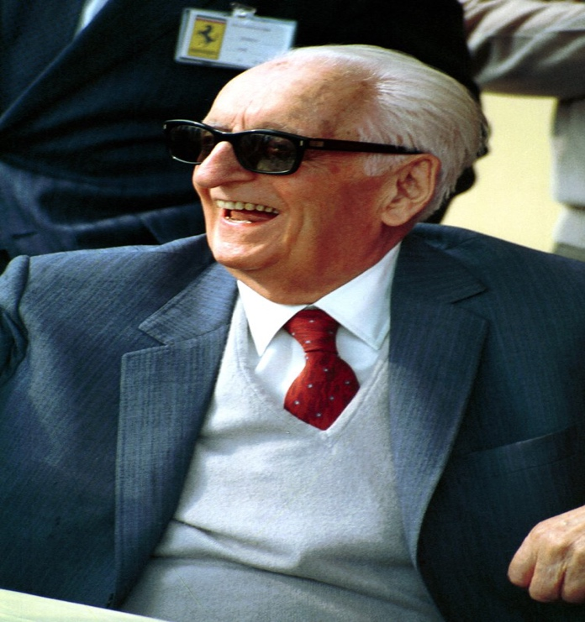
ENZO FERRARI
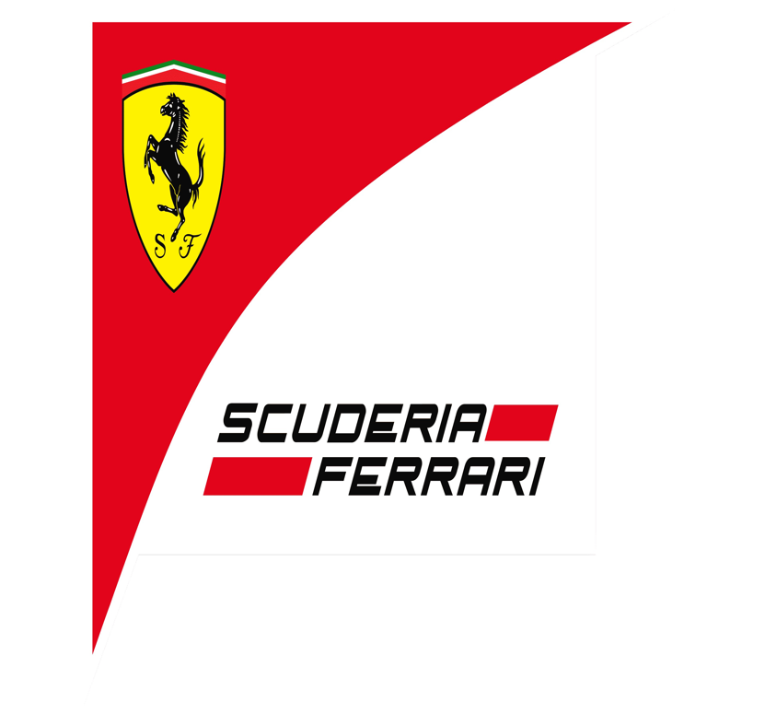
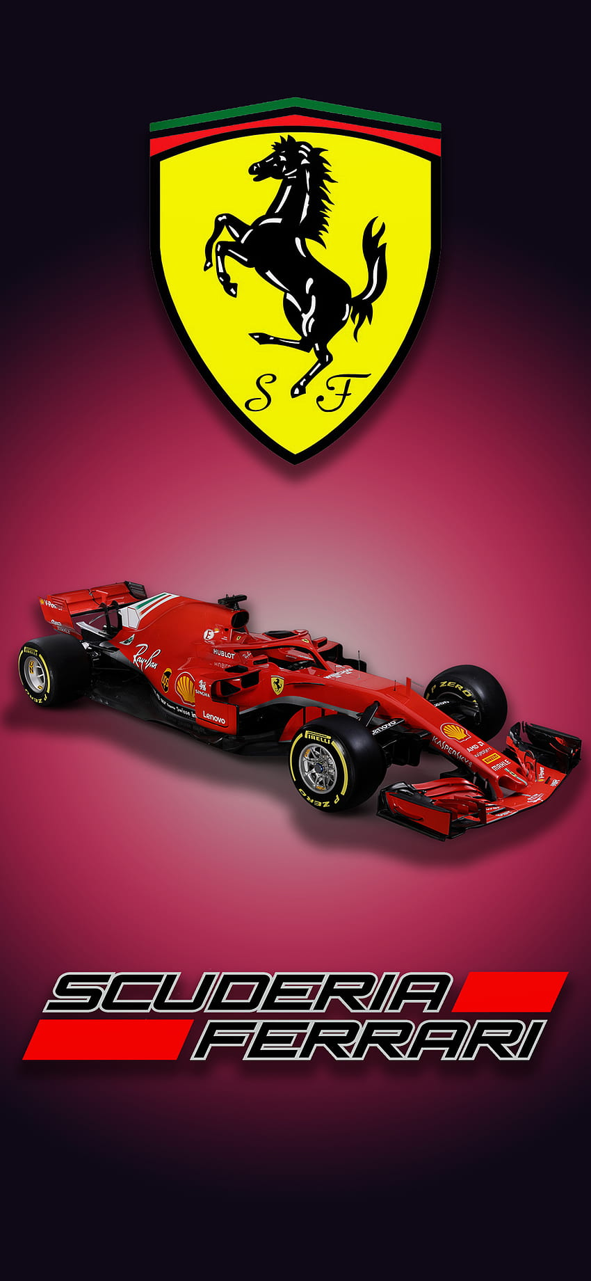
What we see on the Ferrari emblem is the "Prancing Horse" symbol of power and endurance with the aim of helping the Ferrari team successfully overcome the fascist regime in Italy. The founder of the company, Enzo, took over the coat of arms of Francesco Baracca, one one of the most famous pilots in the army during the war and he made the logo for his new racing team, reaching from military aviation to car racing. This fact made him very loved, respected and at the same time created some political advantages for this thing.
This shows us how a newly emerging company can make a logo very well known, borrowing a symbol loved by the people it belongs to. ( Mangattu,no date)
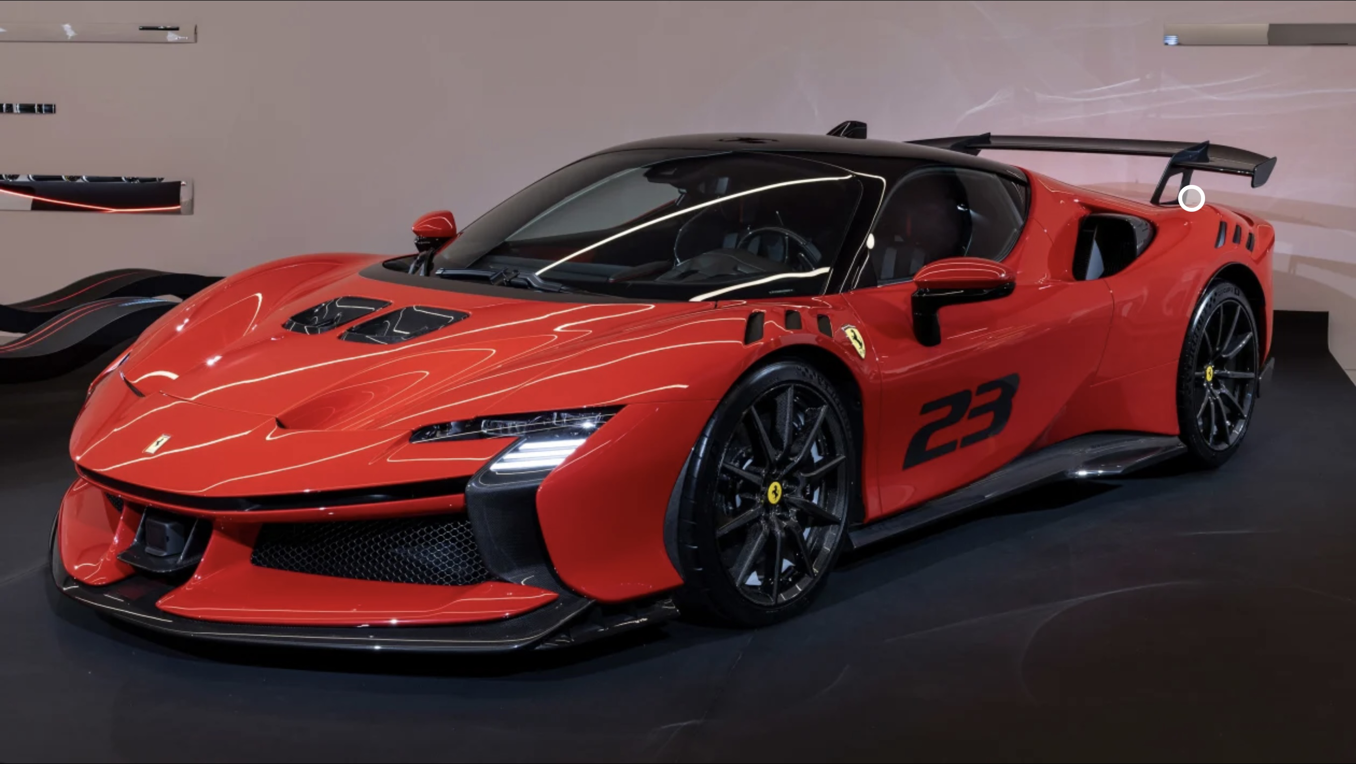
Mission and vision Ferrari
Vission statement
"Ferrari, Italian Excellence that makes the world dream".It can be seen about the vision of the company that they are very proud of the origin and the story that it has and remaining true to its heritage not detached from the origins created in the previous years when it comes to quality and innovation. Ferrari claims that it has inspired since it was created and made people want more from life so that they could one day be the owners of such a loved and respected brand as this.( DARBINYAN,2020)
Mission statement:
"We build cars, symbols of Italian excellence the world over, and we do so to win on both road and track. Unique creations that fuel the Prancing Horse legend and generate a "World of Dreams and Emotions".(DARBINYAN,2020)
With this, we could realize how important quality is for those at Ferrari, as well as the importance of the background that the company has. The influences and values make this prestigious company to be at the top even after decades, having as pride the logo created now many years with a history that strictly refers to Italian patrorism.(DARBINYAN,2020)

Segmenation
Segmentation is a process by which consumers can be grouped based on some well-defined criteria.The market segmentation is a very important aspect for Ferrari.(Mangattu,no date)
Demographic segmentation:
Ferrari is especially addressed to men who are over 30 years old with a high income that can be defined by Rich premium personalities or celebrities like movie stars, singers and even celebrities and athletes who have a very high social status, not for everyone.(Mangattu,no date)

Advantages
Market segmentation is in theory a marketing concept involving customer groups built to help the development and targeting of a so-called and desired segment of people in order to be able to reach exactly the right people. Therefore ,each customer is unique, companies do not have the power to satisfy each individual desire, and they cannot address everyone in the same way, each coming from a different background. A company that has managed to do segmentation can then outperform the competition by creating a unique way to produce or use services.(Fonseca,2011)

Disadvantages
For a company, segmentation involves financial costs and even development time until this criterion reaches the final part. The cost of production increases due to a product variation and a smaller production reaching other high costs for promotion and distribution due to the separate paths of promotion for each segment separately. Sometimes when the market segment changes, all the investments made for this end up being a loss and useless for the continuity of the company, attracting costs for the development of a new segmentation department and, on the other hand, large inventory must be kept by both the producer and distributor, so it can be left with unsoldproducts.(Chad,no date)
Targeting
Ferrari wants to target only the very rich buyers who have a very good status, including people who bring pride and worldwide performance, at the same time refusing many sales to public figures who in the past had scandals or damaged their image and created a bad one through bad behavior . He does this because he wants to maintain the clean image of the brand he has and at the same time make it exclusive.Not too long ago, Ferrari started targeting successful women, saying that one customer out of 20 is a woman, even having an impressive number of customers from the motorbike industry, and saw a very high interest in this niche. ( Mangattu,no date)

Advantages

When the company focuses on a specific target segment, it can allocate the optimal budget for production, the necessary time, and all efforts are more effective and efficient. This procedure helps the company not to waste resources to reach customers who will not be interested in the products that the company wants to promote or produce or to have a less interest about that. At the same time, the company can differentiate itself from competitors by offering customized products, desired services and experiences similar to the desired target.(Singh,2019)

Dissadvantages

This target can also be a disadvantage because, if the company focuses on a certain segment, it may not take all the resources found for the other segments or neglect the other segments that can create opportunities. Limited resources can be another problem because multiple targeting segments come vu a request for other resources so another investment time money and infrastructure. Businesses must very carefully evaluate their ability and the resources they can use and allocate them very efficiently in order not to end up with a loss.(Singh,2019)
Positioning
The company has always been very selective with potential clients because Ferrari doesn't want to see on the street that everyone is driving their own car. It's really a pretty serious check, doing some investigations about the potential client's past as well as what will be involved in order to do not affect the image of the company or of those who have already bought a masterpiece such as memorable characters or celebrities globally. Ferrari is proud to be one of the most admired car brands and identifies itself as a luxury vehicle manufacturer and applies a rather clever tactic making the owners should feel that they own a jewel that is hard to touch. (Magnatu,no date)
However, owning a Ferrari car is not enough to enter their family, having in addition a bunch of rules that oblige you to comply with what they impose, such as modifying the cars and especially the special limited edition models. Some examples would be: don't sell the model purchased sooner than 1 year, another very clear aspect is not to paint the car pink and besides that they are very strict with changing colors, but especially with the color pink.(Magnatu,no date)
Advantages

This segment called positioning helps the company to reach customers who can pay more money for the products it makes, even for the premium products in the respective range or the best quality services. This increased revenue strategy can bring much higher profits to the company and it is based on the so-called niche market where potential clients can pay a premium price for unique and high-quality services. (My,2023)
Also, customer loyalty can be implemented by reaching the products and or services made by the company much more easily. Loyal customers have the opportunity to make purchases much more often at a much higher price, being much easier to reach the products and services.(My,2023)

Disadvantages
However, this segmentation can also bring the following disadvantages that can affect a company. This strategy can limit the customer base because not everyone wants to pay a premium price for products and services, possibly causing the loss of new or current tailors migrating to other luxury companies that offer similar quality at a lower price. In these days where there are so many competitors, it is very difficult to make yourself noticed, leading to a very, very high allocation of resources, potentially causing significant losses to the company if it does not reach exactly where the team wanted. (My,2023)

Marketing Mix
Product Strategy

When it comes to Ferrari, they create some of the most beautiful and well-known or desired car models. The company focuses on a particular product instead of satisfying all the different requirements of the customers. The machines being made by hand in almost complete proportion make the eccentric buyers call them pieces of art. At the moment, some of the most famous models are the Ferrari 488 spider, Gtb, California, LaFerrari and many more. Each car is unique in its own way and it is very difficult to compete with such a car and with such a background, being encouraged by F1 Let Ferrari and Gran Turismo remain the same for the foreseeable future. In addition to street racing, they also focus on Formula 1 races with the Itlaia GT, 599XX or FXX K models.(Mirzayev,2020)

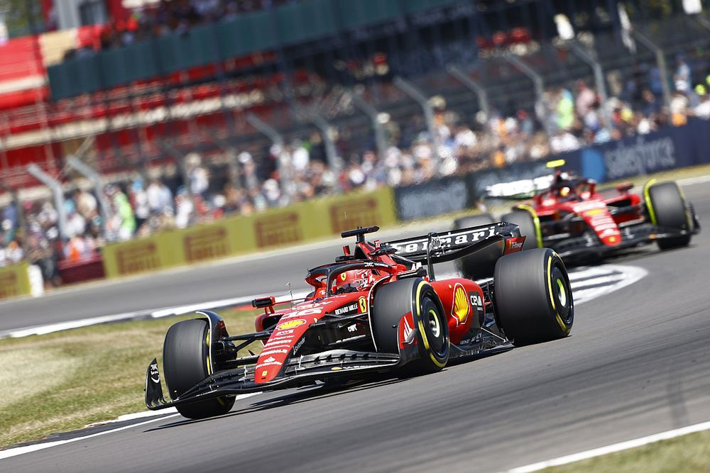

Price Strategy
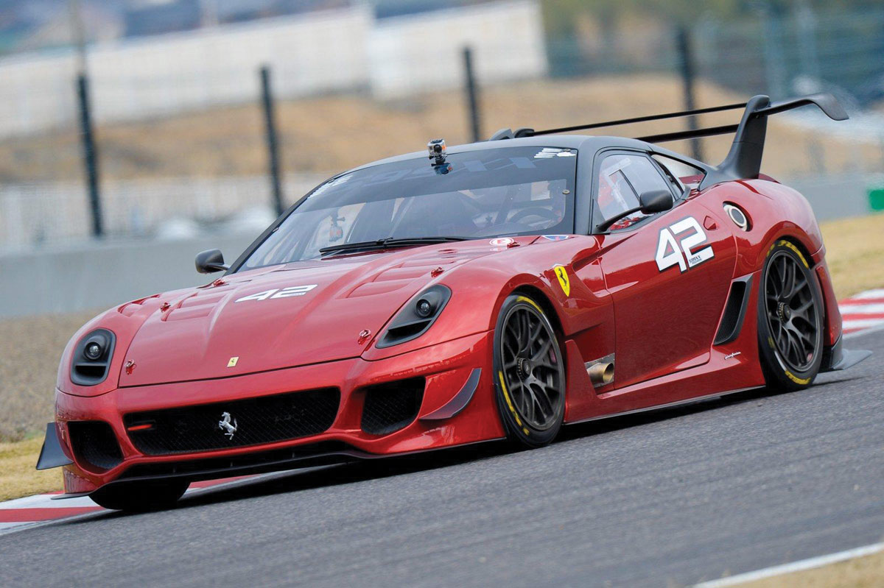
Ferrari is using price skimming as a strategy . In this area, the arranged price can be used immediately, being the most jovial element when we compare it with the others. This can show how endowed or special is the product to which we attribute it. For example, Ferrari is a super car that brings some of the latest technologies and one of the best qualities on the market when it comes to it, and at the same time it can put it at the top of super car sales. Making different market analyses, several strategies are made by Ferrari in order not to set an exorbitant price because it could affect sales and also not too low because the buyers could understand that premium materials are no longer used to create the model.(Mirzayev,2020)

Ferrari place and distribution

When we refer to the world map, we can find more than 50 authorized Ferrari dealers in Europe, North and South America and also in the middle east, these increasing from year to year. The fact that they also have online stores where you can configure and buy a supercar with home delivery or at the nearest dealership makes the job much easier for both them and the buyer. The distribution chain is not limited and this increases the advertisement being seen by the customers who come to buy a regular car. (Mirzayev,2020)
This sector has a great influence for this brand and strictly depends on the company to attract as many visitors as possible potential buyers both for the regular car and why not for the desired Ferrari. The fact that this car benefits from one of the best distribution systems makes this brand to be taken very seriously and not as an external care. By eliminating delays that in the long or short term could affect the relationship between the buyer and the company, Ferrari can double its income.(Mirzayev,2020)

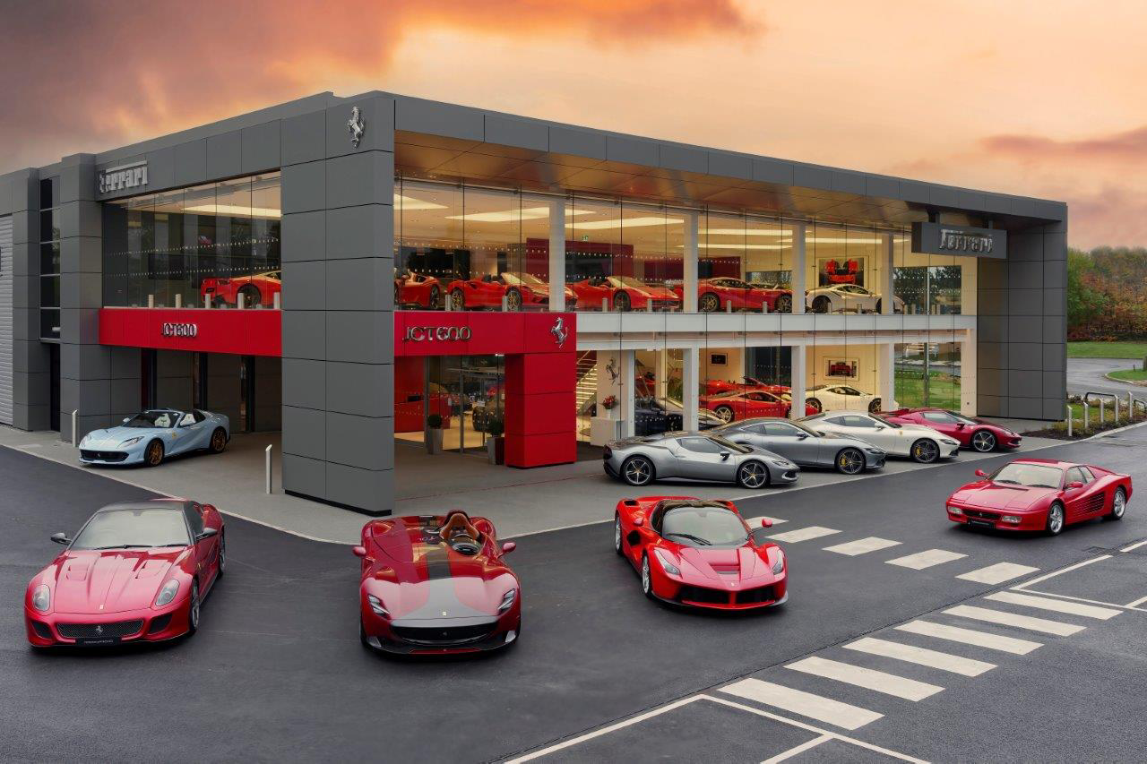

Ferrari Promoțional and Advertaising Strategy

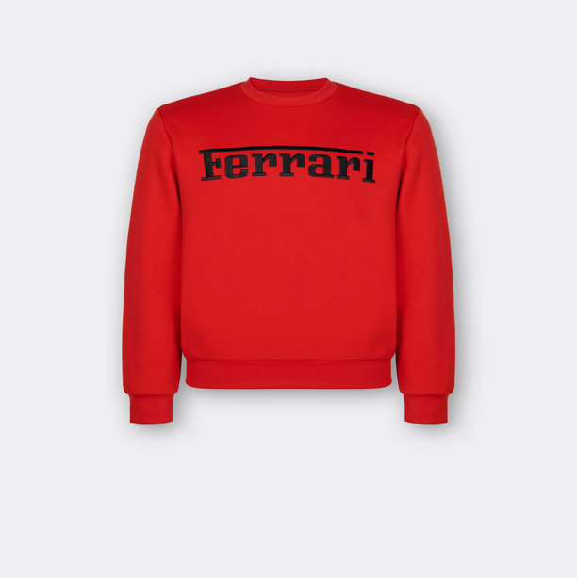
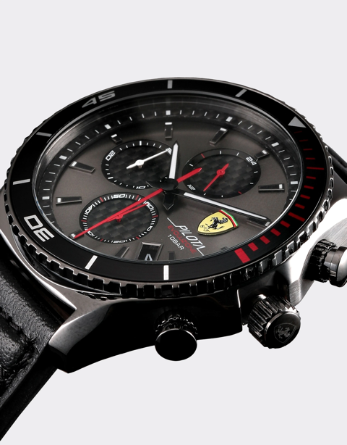
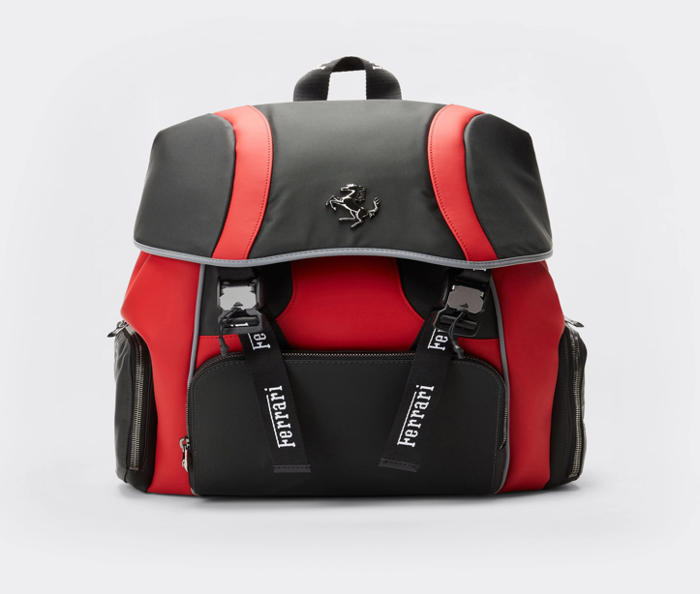
When it comes to Ferrari, it does not have to worry too much when it comes to advertising, being one of the most famous racing car teams participating in Formula 1, it is seen by more than 500 million people, making this brand known, including by children and those who have never seen one in real life. However, the history that has always been on the side of this brand, the very well-known manufacturer at that time, including in our days, when it has already exceeded 60 years of performance and year after year being regularly seen at car races that attract so much, cannot be neglected by many spectators. They are also known inclsuiv with accessories or clothes that wear their logo, these being much cheaper than a Ferrari or at least a tour with it. Watches, T-shirts, satchels, umbrellas are just some of these accessories that can be bought from the dealership even if you don't own a Ferrari. Including a roller-coaster named "Ferrari Rossa" in Abu Dhabi brings this brand to many people's lips and minds. Making an app for the phone that can be downloaded on any smartphone, bringing an interest to those who want to know more about this brand, at the same time making advertising much easier. "Search Marketing" and "Display Marketing" is one of the strategies they approach.(Mirzayev,2020)

References

Chand,S.(no date) Advantages and Disadvantages of Market Segmentation, Your Aricle Library. Available at: https://www.yourarticlelibrary.com/marketing/marketing-management/advantages-and-disadvantages-of-market-segmentation/27955 (Accessed: 25th July 2023)

Darbinyan,M.(2023) Marketing Strategy of Ferrari and Lamborghini, The Social Grabber. Available at: https://thesocialgrabber.com/marketing-strategy-and-swot-analysis-of-ferrari-and-lamborghini/ (Accessed: 25th July 2023)

Fonseca, J.(2011) ‘Why Does Segmentation Matter? Identify Market Segments Through a Mixed Methodology’ , Figures , pp. 1-3. Available at: https://www.researchgate.net/publication/234013895_Why_Does_Segmentation_Matter_Identifying_Market_Segments_Through_a_Mixed_Methodology ( Accessed: 25th July 2023)

Magnattu,S.(no date) ‘Marketing Management : “Ferrari S.p.A.”’ ,Marketing,Cosnumer Behavior ,pp.11-14. Available at: https://www.academia.edu/9547275/Marketing_Management_Ferari_S_p_A_ (Accessed: 26th July 2023)

Mirzayev, T.(2020) ‘The Ferrari’, Marketing in Global Context, pp.5-9. Available at: https://www.researchgate.net/publication/341976034_The_Ferrari (Accessed: 25th july 2023)

My,D.(ed.) (2023) ‘What is More For More Positioning Strategy? Advantages and disadvantages, hocMarketing.org. Available at: https://en.hocmarketing.org/what-is-more-for-more-positioning-strategy-advantages-and-disadv (Accessed:26th July 2023)

Singh, C.(2019) Marketing Targeting Concept, Process, Advantages and Disadvantages and Criteria , theintactone. Available at: https://theintactone.com/2023/05/12/market-targeting-concept-process-advantages-and-disadvantages-and-criteria/ (Accessed:26th July 2023)

