Police officer’s views of their response to county
Lines drug dealing

Gethin Evans
1920840

BSc (Hons) Professional Policing Practice
Word Count: 8,800

Acknowledgements

I want to start by expressing my gratitude to my dissertation tutor for all of her assistance and encouragement during this process. In addition, I want to thank all of the university and police personnel who assisted me during the training process. Additionally, I want to thank my wonderful colleagues who have been a terrific in supporting me when I've needed them.
Finally, I want to thank my family for being so kind and patient with me throughout this research while being under a lot of stress and strain.

Declaration

This work has not previously been accepted in substance for any degree and is not being concurrently submitted in candidature for any degree.
Signed: 1920840. Date: 19/12/2022
STATEMENT 1
This dissertation is being submitted in partial fulfilment of the requirements for the degree of BA.
Signed: 1920840. Date: 19/12/2022
STATEMENT 2
This dissertation is the result of my own independent work/investigation, except where otherwise stated. Other sources are acknowledged by footnotes giving explicit references. A bibliography is appended.
Signed: 1920840. Date: 19/12/2022
STATEMENT 3
I hereby give consent for my dissertation, if accepted, to be available for photocopying and for interlibrary loan, and for the title and summary to be made available to outside organisations.
Signed: 1920840. Date: 19/12/2022
STATEMENT 4
I hereby give consent for my dissertation, if accepted, to be available on the university’s IT system to those who have consent to use the system.
Signed: 1920840. Date: 19/12/2022

Abstract
Even though there is a substantial body of scholarly work on county lines as a whole, it is accurate to say that much of the research focuses on county lines crime in general and the exploitation it brings. Little literature focuses on police officers' perceptions of how they could handle drug sales over county lines.

To support officers better moving forward, this dissertation sought to understand officers' views on their response to county lines drug dealing. The researcher critically and in-depth analysed pertinent material on the connections between police officers and county lines. To acquire quantitative data, the researcher used online questionnaires to gather primary research. This primary research was then compared to secondary data to determine whether opinions agreed or disagreed with the findings. In order to help officers combat county lines drug dealing, recommendations were made once the research's findings were documented.

This study is important to the researcher as county lines evident this is a growing crime within South Wales police force area. This research has found that police officers are not feel adiquently trained or equipped to deal with county lines drug dealers. The researcher recommends an increase in officers to reduce the workload of officers, increase in communication between departments and officers to carry out secondment to specialist departments in order to train on how to respond to county lines drug dealing crimes.

Contents Table

Acknowledgements 2
Declaration 3
Abstract 4
1.Chapter One: Introduction 6
2. Literature Review 7
2. Chapter Two: Literature Review 9
3. Chapter Three: Methodology 18
3.1 Introduction 18
3.2 Research Approach 18
3.3 Ethical Considerations 21
3.4 Timeframe For Project 21
3.5 Conclusion 22
4. Chapter Four: Analysis of Results 23
4.1 Introduction 23
4.2 The Survey 23
4.2.1 Survey Creation 23
4.2.2 Participants 24
4.2.3 The Questions 24
4.3 The Results 24
4.4 Conclusion 35
5. Conclusion and Recommendation 36
5.1 Introduction 36
5.2 Findings 36
5.3 Achievement of the Obective 36
5.4. Main Findings. 37
5.5 Recommendations 38
5.6 Limitations 39
5.7 Conclusion 40
5.8 Self- Reflection 40
6. Bibliography 42
7. Appendices 55
7.1 Appendix One: Questionnaire 55
7.2 Appendix Two: Dissertation Proposal 58
7.3 Appendix Three: Ethics Form 65

Chapter One: Introduction

This dissertation will look at police officers views of their response to county lines drug dealing. It will discuss the potential reasons for the growing number of county lines gangs infiltrating not only South Wales police force area but many other forces in the United Kingdom (UK).
Literature suggests that although county lines is not a new crime and many warnings have been made regarding its potential to spread across the UK from major cities such as London and Birmingham, the warnings have been ignored by police, although this is now classed as a priority crime for many police forces.

This topic was chosen by the researcher as it is something that interests them due to the complexity of the criminality county lines and they have seen first-hand the violence and exploitation it can bring. Although the researcher highlights the importance of tackling county lines drug dealing it is a crime that they believe many officers avoid due to its complexity, understaffing and overstretched workloads.

Furthermore, county lines drug dealing has a direct or indirect impact on everyday policing throughout the UK. It would be beneficial to recognise and improve their responses to county lines drug dealing which may in turn bring down the high demand officers face, an improved response by officers towards county lines drug dealing will provide areas with target hardening protection making it less attractive for county gangs to infiltrate the area.

Chapter Two: Literature Review

The area chosen for this literature review is police response to county lines criminality and exploitation, which has been identified as an under-researched area. There are many studies regarding county lines themselves; however, there is little research that links police officers' responses to this growing violent crime; officers are frequently the first on the scene; however, officer's perspectives have not been recorded, which has been identified as a key area to explore.

In the early 21st century, most drug dealers were run by street gangs and drugs were dealt with within a concentrated area or transported to nearby locations (Andell, 2019). However, since around 2010, drug dealing has evolved into a phenomenon called County Lines (Her Majesty Inspectorate of Probation, 2021). The National Crime Agency (2021) describes county lines as organised criminality of persons who distribute illegal drugs across the United Kingdom by exploiting vulnerable people. Furthermore, Harding (2020) argues that policies of austerity, challenging legitimate routes for young persons to get out of poverty in the poorest parts of society, have made the temptation to participate in drug dealing greater. Which resulted in the local drug markets within larger cities becoming saturated (Windle and Briggs, 2015).
The drug markets within these cities became increasingly violent, increasing crime rates through homicides and serious assaults as gangs fought for their place within the 'drug market' (Whittaker et al., 2017). Furthermore, 'County Lines' offered drug gangs a solution to the resistance of inner-city drug dealing. Drug gangs face less resistance within rural parts of the United Kingdom as drug runners encounter less attention from the police and little resistance from local drug dealers (Shapiro and Daly, 2017). Additionally, successful police operations against known local drug dealers left the local drug market open for county lines gangs to exploit (Andell and Pitts, 2018).

To address this, local police forces have released media statements that stress that they will not tolerate county lines activity within their force areas and that their police forces should not be seen as 'soft targets' by outsiders (News Met, 2017). Additionally, police forces have conducted several high-profile crackdown operations; with these intelligence-led strikes, they have sought the mass arrest of suspected county lines drug dealers (Spincer, 2019). However, these tactics have been highly criticised by Innes (2010) and Coomber et al. (2017), who argue that it is a symbolic act from forces, rendering it typically ineffective and antithetical to the broader policing objectives. This has left county lines able to spread rapidly across England and Wales (Spicer, 2019). The National Crime Agency (NCA)(2017) noted that in 2015 only seven of the forty-four UK police forces reported county lines activity within their force areas. However, in 2018 all forty-four forces reported that county lines were present within their area (Grieson, 2019). The NCA (2017) reported that approximately 720 county lines gangs were operating within England and Wales. In 2020 this figure rose to over 2,000, with an estimated 283 gangs operating out of London alone (NCA, 2017). In addition to the increase in county lines activity, convictions of children aged between 10 to 17 for possession of a Class A drug with intent to supply (NCA, 2017) between 2012 and 2016 increased by 77% (Her Majesty Inspectorate of Probation, 2021). These statistics show that county drug gangs are exploiting children to carry out their drug running and dealing to protect themselves from being caught by police. Innes (2010) describes these tactics as sweeping up low-level local drug user-dealers. Moyle and Coomber (2018) argue that the current police drug dealing operations tackle low-level drug dealers who may not even be considered actual drug dealers to many people, while the high-ranking drug dealers are unchallenged. Additionally, Coomber et al. (2017, p. 12) argue that arresting these dealers may "repeal the protective effects of a dominant low-level indigenous dealing population' Moreover, police forces' current responses to county lines may be inadequate, creating an opportunity for more commercially orientated, violent dealers, to move into their force areas (Coomber et al. 2017, p. 12).

Olver and Cockbain (2021) conducted a study of eleven participants, six police officers from the West Midlands Police service, two policymakers from the Crown Prosecution Service and three non-governmental organisations; all participants had experience in tackling county lines. The results from this study expressed that no other legislation was needed; however, nine participants felt that legislation was not-understood well and expressed concerns that the Modern Slavery Act 2015 was being abused (Olver and Cockbain, 2021). Despite the criticisms, many participants saw the Act as a positive tool (Olver and Cockbain, 2021). Furthermore, participants reported many challenges when responding to county lines, such as; insufficient understanding and disjointed information-sharing. Also, members of the public may not identify themselves as victims or want help from police and other services (Cockbain, 2018).

Shuker (2013) claims victims of county lines drug dealing are not assisting police in their investigations or consider themselves as victims of crime; this has created friction between professionals' and safeguarding obligations of minors and vulnerable adults who are being exploited by county lines gangs (Brown, 2017). Additionally, despite this study being primarily a police sample, participants agreed that county lines are too complex an issue for the criminal justice system alone and emphasised that enforcement was not necessarily the most appropriate measure to tackle county lines, echoing the research of (Irwin-Rogers, 2019). Overall, only some participants felt they were adequately equipped to tackle county lines, with many participants reporting organisational barriers such as; budget cuts and limited resources. Furthermore, participants of this study needed clarification about who is leading responses to county lines. This problem has also been reported in current literature (Coliandris, 2015; Hudek, 2018). This study had limitations; for example, the sample comprises professionals from the criminal justice sector from one specific police force and only provides the view from one geographical area within the United Kingdom. Other forces may face different challenges. The study does not specify how much experience each person has with county lines crime. Also, the interviews were conducted in various environments and conditions, one over the phone and others in the workplace or cafe, which could cause the interviewee to become distracted. Additionally, any interview of this structure has a clear potential for self-report bias (Andres and Linden, 2005). Finally, it is acknowledged in the report that law enforcement draws more on their personal experience, whereas civilian participants appear to draw on their official organisational positions (Olver and Cockbain, 2021).

Due to the relatively new county lines phenomenon, little research is available to explore police officers’ effectiveness in tackling this crime (Spincer, 2019). Furthermore, the associated range of serious harm linked to county lines means it is now a key priority for police forces (Spincer, 2019). County lines and the police forces' desire to carry out a proactive and sufficient response were alluded to within The Government's drug strategy (HM Government, 2017). However, it has yet to be discovered how effective these responses will be and how they will be applied in real-world policing (Bacon, 2016). Furthermore, the inevitable response to this crackdown from county line dealers is yet to be seen (Collison, 1995).In addition, recent studies have highlighted that officers' interpretations guide their decision-making when responding to county line drug gangs on the ground (Brecon, 2016A). This stresses the importance of police research of their perspective, enabling others to understand their actions and decision-making beyond formal rules and policies (Ericson, 2007). To understand how and why police response to county lines is the way it is and how the phenomenon is constructed, more research into officers' perceptions of police responses to county lines is required.

In the United Kingdom, it needs to be clarified how to measure the success of police response to tackling county lines (National Audit Office, 2017); this brings even more confusion to professionals (Ford, 2018). Moreover, The Governments' intended response to tackling county lines encompasses prevention and enforcement using a multiagency response through; education, health, social services, housing, youth and victim services (Home Office, 2018a). Emerging research into good responses to county lines calls for multi-agency responses, emphasising community partnerships and a shared understanding of the risks and crimes involved (Hudek, 2018). Although, Atkinset et al (2007) acknowledges that multiagency work can be challenging in practice.

A further study was conducted by Blakeburn and Smith (2021) regarding the perspectives of the British Transport Police response to county lines. However, this study consisted of only four participants: a deputy assistant commissioner within the Metropolitan Police service, a representative from a charitable organisation, a senior officer and a police officer holding a supervisory rank within the British Transport Police. Furthermore, Blakeburn and Smith (2021) conducted their study using semi-structured research interviews, which accumulated approximately ten hours' worth of data. Clear themes that were identified as problems in tackling county lines within the study were; the complexity of information sharing between partner agencies, front-line policing awareness and capabilities and safeguarding persons involved in county lines and recognising the difference between vulnerable subjects and hardened criminals (Blakeburn and Smith, 2021). Moreover, county lines have been documented as cross-border crimes; it is argued that information sharing is critical in tackling county lines crimes (NCA, 2017). However, to truly eradicate county line activity, early intervention is required in the form of effective partnership information sharing and support (Waddell and Molloy, 2015). Furthermore, effective information sharing is essential in identifying risk and vulnerability by proactively preventing county lines and reactively (Home Office, 2018b). However, Blakeburn and Smith’s (2021) study highlights a concerning fact that police officers need to be trained and respond to county lines effectively due to staffing numbers. The Police Federation (2021) argues that COVID-19 has harmed police officers' well-being, reducing the number of operational officers. Furthermore, with the reduction in operating officers, there is potential for an increase in crime rates throughout the force, which could result in an easy target for organised crime groups (Police Federation, 2021). Research carried out by the Police Federation (2021) consisted of 12,471 responses from officers from forty-three forces across England and Wales. Of these responses, 371 were received from South Wales Police officers. Seventy-five percent of respondents indicated insufficient officers to deal with public demand (Police Federation, 2021).

The study by Blakeburn and Smitch (2021) has its restrictions; for example, the sample consists of only four participants, which presents a risk of introducing bias and narrow viewpoints into the findings; this is of particular concern as two of the four participants came from the British Transport Police. Furthermore, the sample size does not reflect the 43 police forces across England and Wales. Additionally, the study consists of approximately ten hours of data secured during each interview; however, it does not say whether each participant was asked the same questions, if each participant had an equal amount of time or if each interview was conducted in the same environments, this could cause inconsistency within the results. Moreover, it is noted that all police officers are of a senior rank, and constables who are first at the scene were omitted. Whose opinions are important when conducting safeguarding and answering county lines reported crime.

A further study by Spincer (2019) had the key research aim of how police officers interpret and respond to county lines. The study consisted of ten participants who were ranked from Police Constable to Detective Inspector; the participants participated in a semi-structured interview between forty-five to ninety-five minutes. The study used grounded theory methodology (Glaser and Strauss, 1967), acknowledging county lines as an under-researched phenomenon (Birk and Mills, 2015). The interviewers asked specific questions which were open-ended to allow participants to speak freely in their responses. The research showed that participants believed that the county lines drug supply model is complex and well organised to gain maximum profit; describing them as high-end superstores in the common market. As a response, Police forces' strategies which have been established to combat county lines, have been to encourage police officers to charge suspects under the Modern Slavery Act 2015. This type of conviction means drawing a stigma on county lines and the associated exploitation of vulnerable persons rather than the traditional 'badge of honour' associated with drug dealers (Swindon Advertiser, 2017). Police have arguably been given greater power to develop a strategic response to drug dealing, such as shutting down dealers' mobile phone lines, using the power of the Digital Economy Act 2017 (Spincer, 2019). The Home Secretary, Amber Rudd, argued that this "demonstrates this Government's determination to crack down on gangs and sends a very clear message that we will not tolerate this despicable criminal activity" (GOV.UK 2017). Additionally, officers highlighted harmful characteristics which are part of county lines, such as child exploitation and violence; police officers notably have acknowledged how difficult spotting child drug runners are; some dress in school uniform to avoid police attention. Moreover, officers noted 'punisher myths' that intimidate children and vulnerable adults into assisting in county lines activities (Coomber, 2006). Research undertaken by the Mayor of London in 2020 estimated that between January 2018 and April 2019, 4,013 youths in London were involved in county lines criminality. In this research, the largest group were teenagers aged between 15 to 19, who accounted for forty-nine percent of the participants in the study; this was followed by people aged between 20-25, who accounted for 29 percent (Busby, 2019).

County lines involve children and adults; therefore, it is argued that a multi-agency approach is critical (Her Majesty Inspectorate of Probation, 2021). The Police Youth Offending Team (YOT) reported that county lines gangs often used drug runners from their home cities, who would stay for days in rural areas; these youths are known to YOT and children services, recently local children with no previous welfare or criminal concerns are now being used as drug runners (Andell and Pitts, 2018). Moreover, police data indicated that knife crime goes hand in hand with county lines drug dealing. Within England and Wales, eighty-five percent of police forces reported the use of knives in county lines gang-related activity; seventy-four percent of forces reported the use of firearms (Her Majesty Inspectorate of Probation, 2021). However, this study only focuses on the forces in the South of England and does not reflect how Police officers throughout the United Kingdom view county lines and police response. Furthermore, the study uses police interviews conducted in 2017; therefore, the information is five years old and out of date; on the training and experience officers have on county lines. Additionally, the study does not provide any information regarding participants’ ethnical backgrounds and years of service, which could undermine the results. However, the study does acknowledge that although county lines are classed as a top priority in UK Police forces (Spiencer, 2019) it is under-researched (Birk and Mills 2015).

In conclusion, county lines have been able to sweep across England and Wales with little response from Police (Spincer, 2019), whilst police forces struggle to maintain their officer’s well-being and recruitment (Police Federation, 2019). It has prevented them from deterring the ever-growing county lines groups from entering their force areas (Andell and Pitts, 2018). Furthermore, the study by Olver and Cockbain (2021) highlighted that although new legislation assisted them in convicting county lines criminals, it is not well understood; therefore its use in real world policing is low, emphasising a lack of knowledge among front-line officers regarding county lines (Coliandris, 2015).

A study by Blakeburn and Smith (2021) noted that officers felt there needed to be more information sharing between agencies, also a lack of knowledge among frontline officers hindered their decision-making A further study conducted by Spincer (2019) demonstrated that officers understood that the county lines drug supply model is complexed and well-organised. The study also showed that officers were aware of the new legislation introduced to assist in fighting county lines.

Each study demonstrated limitations such as; sample size, sample quality and even how the study was conducted. Furthermore, the studies emphasised that front-line police officers’ views on their response to county lines is an under-researched area (Birk and Mills, 2015); highlighting the need for further research to assist police in their response to eradicate county lines.

3. Methodology

3.1 Introduction
This chapter discusses, justifies, and reviews the chosen project, the data collection methods and how data is interpreted. Resources that the project requires are detailed and ethical considerations are discussed. Additionally, the project timeline is detailed.

3.2 Research Approach
This study will consist of an online multiple-choice questionnaire. Although online data collection through questionnaires is relatively new among researchers, several benefits have already been identified (Lefever et al., 2007). This method was chosen because it has numerous benefits, such as data storage, anonymous results, creation efficiency, operation and ease of access (Lefeve , et al 2007). Mertler (2002) observes that online data collection is an efficient and convenient alternative to the more traditional method of gathering information from study participants. Likewise, by carrying out online questionnaires, the participants’ data is protected and simplifies the analysis process (Carbonaro and Bainbridge, 2000; Ilieva et al., 2002); however, whilst online questionnaires have their benefits, the researcher cannot always be sure that the correct audience participates.

Due to time restrictions placed on this study, the researcher developed a questionnaire consisting of twenty police officers of any rank to reduce gender bias females and males were equally represented. It is noted that the ethical backgrounds of participants were not considered and may affect the data collected. All officers in this study will have at least three years of service as a police officer, enabling only officers with experience to participate in the study. This was considered an essential factor to ensure participants in the study had enough knowledge and experience of county lines to provide constructive feedback. It is also acknowledged that there are numerous limitations, such as time; additionally, twenty participants are few. However, the study will provide a helpful insight into the experiences of police officers from the South Wales Police force but will not extend to the rest of the police in the UK.

Developing and using a questionnaire allows the researcher to ask very specific questions, which enables the study to benefit from more detailed research, avoiding unrelated information such as the age of the participants or the area within the South Wales Police force where they work. Research shows that questionnaires within research projects can quickly produce large quantities of data (Kelly et al, 2008) and reduce costs (Mertler, 2002). The researcher considered an interview method in collecting participants' data; however, this was not viable due to time constraints. There are some issues researchers need to be aware of when conducting online questionnaires for research (Lefever et al, 2007). Carbonaro and Bainbridge (2000) highlight that easy-access surveys are essential for online data collection. Additionally, researchers argue that using web surveys guarantee researchers a better response rate (Ilieva et al., 2002; Matz, 1999). However, Lefever et al. (2007) dispute this research and found this is only the accepted view among some researchers.

The primary research method used will be descriptive research. Descriptive research is a method used to describe occurrences as precisely as possible (Atmowardoyo, 2018). A descriptive research project enabled the use of empirical data that was critically analysed to evaluate the participant’s voice. Within this study, the researcher used both qualitative and quantitative data to analyse the results providing a numerical approach to discovering police officers’ understanding of their responses to county lines crime. It is agreed that qualitative research produces a more detailed description of the participant’s emotions and interpretations of studies (Denzin and Lincoln, 2011). Chalhoub-Deville and Deville (2008) argue that qualitative research achieves a deeper insight into the participant’s understanding of the study they are taking part in; this is reinforced by a study from Bachman (1998), which evidenced the same outcome. However, Silverman (2010) argues that qualitative research focuses too much on feelings rather than the actual studies themselves. A concerning fact about this study is the sample size when using qualitative research, as it does not provide generalisability (Harry and Lipsky, 2014; Thompson, 2011).

Carr's (1994) research found that quantitative research is likely to be used to generalise a group or population because it involves a larger sample selected at random (Carr, 1994). In addition, quantitative research is less time-consuming as it uses software to conduct research (Carrol and Bailey, 2016). However, despite the strength of qualitative research and its suitability for this research, it has its limitations (Rahman, 2017). Conversely, it is argued that qualitative research only takes a ‘snapshot’ of the study as it captures the views of the participants on the subject at that given time and not how it will become or how it has been (Schofield, 2007). Nevertheless, it is also argued that qualitative research does not capture the participant’s experiences and perspectives in highly controlled settings (Ary et al. 2013), as there is an apparent disconnect between the researchers and the participants when data is collected (Rahman, 2017).

3.3 Ethical Considerations
Ethical standards must conform to the University standards and the Code of Ethics (CoP, 2014). Ethical standards are required when a researcher surveys any human interaction, ensuring people are treated with honesty, integrity and respect (CoP, 2014). To officially conduct a survey, approval is required by the ethics committee to ensure that ethical standards are met; the university ethics committee has already approved this project. By complying with ethical standards, the well-being and health of the participants were prioritised and safeguarded (University of Kent, 2020). In addition, each participant will sign an ethics consent form; this form will give the participants information regarding how their details and data will be stored, how many people are included in the study and how the study will be formatted. To maintain an ethical approach to this study information and results were kept on password-protected devices. For this research, the participants had thirty days to complete the questionnaire, all completed the questionnaire in the allotted time.

3.4 Timeframe For Project
Within this research, the time scale for the whole project was extremely tight; as a result, a cross-sectional study design was used to manage the researcher’s time effectively and efficiently (Kesmodel, 2018). A cross-sectional study allows the researcher to share questionnaires simultaneously, unlike control studies, enabling research to be conducted more quickly (Wong et al, 2021).

3.5 Conclusion
This section discussed how ethical decisions are at the forefront of this project. The study consists of twenty officers who will participate in an online multiple-choice questionnaire for the researcher to establish what police officers think of their response to county lines drug dealing in the South Wales Police force area. However, it can provide insight into understanding the views of the participants. The primary limitation of this research is its size; twenty officers cannot represent the whole police force’s views.

4. Analysis Of Results

4.1 Introduction
This project aims to establish how officers feel about how county lines are dealt with in their police area. This chapter describes and discusses the survey results to establish the views of serving officers and the implications both personally and to the police force.
The literature review high lightened limited academic research on police officers’ views of their responses to county lines drug dealing activity. This need was addressed through the following research conducted with police officers within South Wales Police. To establish officers’ views on the current response to county lines drug dealing within their force area. All unanswered questions from the primary survey can be found in Appendix 7.1.

4.2 The Survey

4.2.1 Survey Creation
This research was conducted in the form of a multiple-choice, anonymous survey which consisted of twelve questions. This survey was created using Google forms software online, Google Forms is a survey tool that can be used to collect data and produce graphs of the data, which makes it user friendly.

4.2.2 Participants
This survey was shared with fifty police officers, however, only consisted of twenty-one police officers who responded, all who are the rank of police constable although this study was open to police officers of all ranks. The participants of this survey were selected at random though the South Wales Police email search tool and was conducted though a google forms online questionnaire, this ensured that the participants who responded remained anonymous.

4.2.3 The Questions
The questionnaire within this research consisted of twelve questions, seven of which were multiple choice and five were written responses of officer’s personal recommendations on how to improve officers’ response to county lines drug dealing. The questions within this research were pacifically chosen to expose weaknesses in officers’ responses to county lines drug dealing and how officers who are actively attempting to prevent this crime believe that it can be resolved whether it is a staffing issue or equipment or information sharing for example.

4.3 The Results
Question 1- Select your rank?
The first question within this research is for the police officers to select their ranks, this was in hope that officers of rank would respond to the survey and give a wider policing prospective of the police response to county lines drug dealing. However, all twenty-one of the officers who completed the survey were constables.
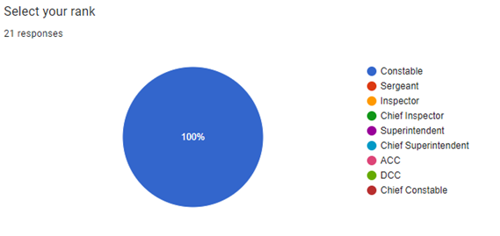

Question 2- Select your age
The second question within this research is for the officers age range. This result was expected as the results showed fifty-five percent of officers who completed the question were of the age range of twenty to thirty years old. Moreover, thirty percent of people who completed the question were between forty-one and fifty years old and fifteen percent were between fifty-one to sixty years old. However, only twenty of the twenty-one officers who completed this survey completed this question.
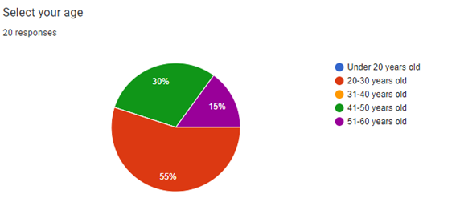
Question 3- Select your length of service
The third question within this research is for the officers to select their length of service. Furthermore, fifty-four-point four percent of the participants who responded to the online questionnaire the majority had between two and five years of service. The second highest response rate is with officers with over fifteen years’ experience with a response of thirty-three-point three percent. The other officers who participated either had between seven to two years’ experience of six to ten years’ experience this made up the other fifteen-point three percent of responses. These results illustrate the current experience within policing with a large gap between young officers and then officers with years of experience. However, a limitation within this research is it is unknown how many participants were male or female which may have an influence on the results. All the participants had thirty days to respond to the survey as this gave the researcher time to collect and analyse the results.
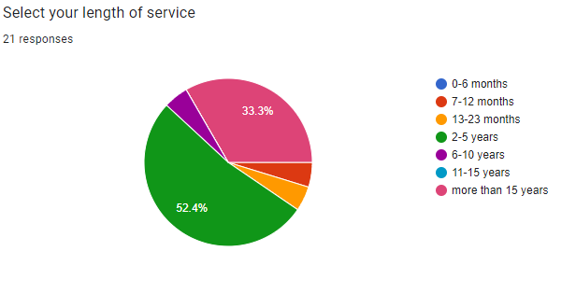

Question 4- Do you think police is current response to county lines drug dealing is working?
The fourth question within this research is do you think police is current repose to county lines drug dealing is working. Within this questionnaire nighty percent of officers believed that the police response is not working, however surprisingly twenty percent of participants did believe it was working. However, only twenty of the twenty-one officers who completed this survey completed this question. This is reflective of the views of Innes (2010) and Coomber et al (2017) who criticise police responses to county lines drug dealing and believe them to be ineffective, allowing county lines drug dealers to spread across England and Wales (Spicer, 2019).
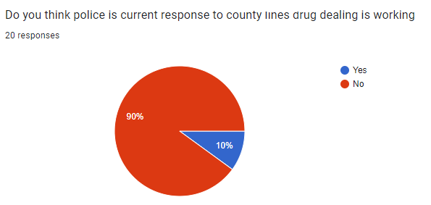
Question 5- If no, why?
The current response from officers within the study is that there is an increase in drug dealing within the South Wales Police force area with twelve of the participants agreeing with this, as previously pointed out in the literature review where Andell and Pitts (2018) where police are unable to detour the ever-growing county lines drug dealing gangs from their force areas. Moreover, four participants say that either policing priorities are elsewhere or that there are not enough resources to deal with the growing problem, this view was echoed in the literature review where the by the Police Federation (2021). However, only eighteen of the twenty-one of the participants which completed the questionnaire answered this question.
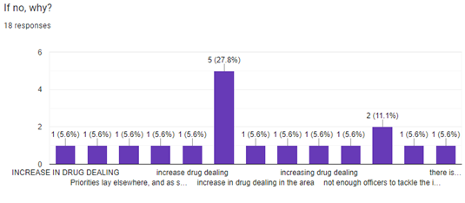

Question 6- What can police officers do to improve their response to county lines?
Many of the participants who responded to this question repeated their responses, which suggested that a reduction in workload, improved training, and increased proactiveness from cops would improve their reaction to county lines drug dealing. However, only nineteen of the twenty-one of the participants which completed the questionnaire answered this question. The participants responses to this question are similar to the criticisms in the literature review where Inners (2010) and Coomber et al (2019) clitorises police is current response with media statements not being enough to irradicate county lines drug dealing, this is clearly the viewpoints from serving officers.
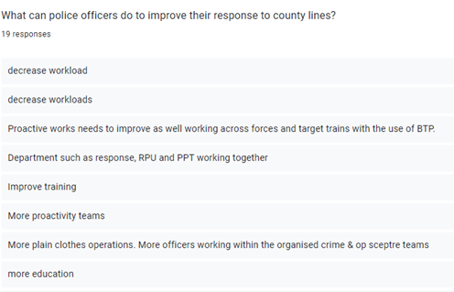
Question 7- Do you think police officers receive enough training to tackle county lines drug dealing?
Furthermore, a hundred percent of participants agreed that police officers do not receive enough training to tackle county lines drug dealing. This is a staggering result as it is meant to be a top priority for UK police forces (Spiencer, 2019). This response from officers is hardly surprising, from research discovered in the literature review Andell and Pitts (2018) study in 2018 were the only researchers highlighting the need for training officers although the study is now out of date.
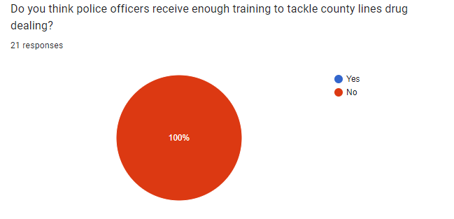
Question 8- What recommendations would you make to assist police officers in tackling county lines drug dealing?
The participants who answered this question appeared to be following the same theme within this questionnaire results with many repeating their answers that a decrease in workload, better education and more proactivity from officers would improve their response to county lines drug dealing. However, only nineteen of the twenty-one of the participants which completed the questionnaire answered this question
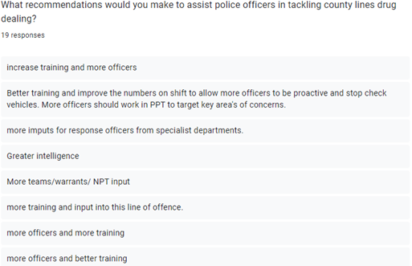

Question 9- Is there enough resources within South Wales police to tackle county lines drug dealing?
Moreover, a hundred percent of participants agreed, there was not enough resources within South Wales police to tackle county lines drug dealing. This was previously noted within the literature review as a growing concern raised by the Police Federation (2021).
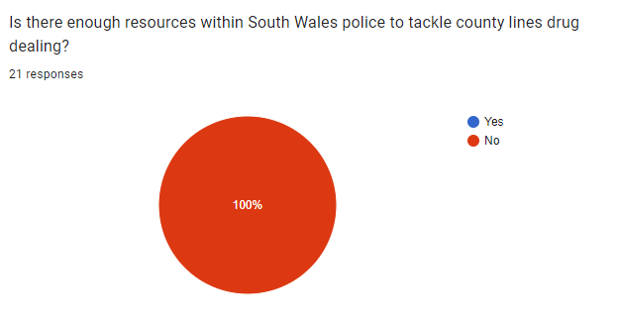

Question 10- Is there any equipment which will assist police officers in tackling county lines drug dealing?
The results from this question show thirteen of the participants who answered the question believe more equipment is required to tackle county lines in a more effective manner, surprisingly there is only one participant who believes that better information sharing will assist officers in tackling the growing problem. Moreover, four of the participants did not know if there was any equipment available to assist in tackling county lines, this could be down to poor education around the crime itself. However, only eighteen of the twenty-one of the participants which completed the questionnaire answered this question.
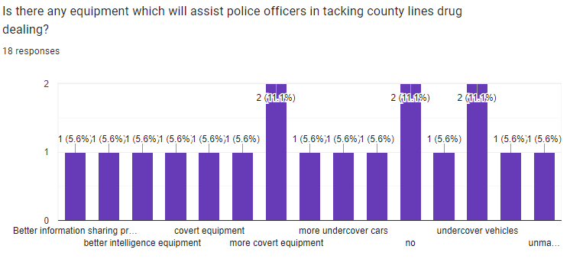

Question 11- What training have you received to assist you in tackling county lines drug dealing?
In-addition, officers who answered this question, have only had minimal training to tackle county lines, which may require improving as the general feedback from officers is that either they have not received any training or power points which are sent to them. Furthermore, given the severity of the problem South Wales Police face with county lines drug dealing criminality this cis clearly not enough. However, only nineteen of the twenty-one of the participants which completed the questionnaire answered this question. This is demonstrated in the previous chapters within this research, where officers interpretations guide their decision making withing county lines drug dealing instances (Brecon, 2016). Although, if officers are not adequately trained then their decision making could be counterproductive (Ericson, 2007).
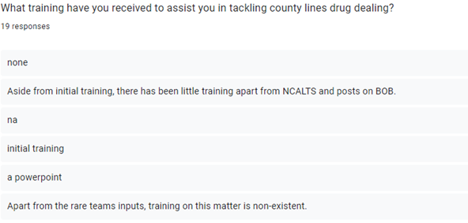
Question 12- Do you this police officers receive adequate training to tackle county lines drug dealing?
Finally, a hundred percent of participants agreed, police officers do not receive adequate training to tackle county lines drug dealing. This is highlighted in the study of Olver and Cockbain (2021) where new legislation has been introduced to tackle county lines drug dealing however due to the lack of knowledge among front-line officers it is having little effect (Coliandris, 2015).
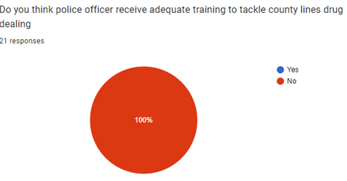

4.4 Conclusion
In conclusion, the present study identified that current police officers do not feel adequately trained or equipped to tackle county lines drug dealing, it is evident that officers feel that shortage of staff and increasing workload are factors in preventing them to become more proactive as shown within the study. This study has supported the secondary research conducted within the literature review. The results will be thoroughly examined in the following chapter to identify different trends, allowing for recommendations to be made following officers views on their response to county lines drug dealing.

5. Conclusion and Recommendation

5.1 Introduction
The previous sections of this dissertation have guided the research project through the introduction, research, planning and analysis phases of the research process, with the most recent chapter analysing the results from the primary data collected through both quantitative and qualitative research. As a result of the data collected, patterns emerged following the research conducted in the literature review and the results from the data collected from participating officers. This chapter will look in detail at these patterns. This chapter will also provide recommendations on how to improve police officers response to county lines drug dealing based on the research collected and expose the research’s limitations.

5.2 Findings
The previous section of this dissertation is the analysis of results from primary data collected during the research. Within this research topic there is very little research to compare how officers believe their response to county line drug related crime is working or not. Despite the lack of research, county drug related crime appears to be an area of concern not only from officers within South Wales Police but also other forces. This chapter aims to provide a detailed description of officer’s views on how to manage county lines drug dealing, and will provide recommendations to police forces in the United Kingdom to assist in tackling county lines drug dealing. In addition, this chapter will include a self-reflection of the project.

5.3 Achievement of the Objective
The research aim was to understand officers’ views on their response to county lines drug dealing. This study has completed the following objectives:
- Review the literature surrounding officers’ views on their response to county lines drug dealing.

- Identify and evaluate secondary data and recommendations to improve officers’ response to county lines drug dealing.

Objectives one and two were achieved by carrying out a literature review, focusing on understanding officers’ views on their response to county lines drug dealing. Previous studies lacked research in this are; thee current study aimed to bring this subject to the forefront of literature. also, it aimed to be developed further, rather than focusing on one primary force as in this study South Wales Police can be used to gain a wider viewpoint of officers across the United Kingdom.

5.4 Main Findings
During this dissertation, there have been multiple key findings. Firstly, there is a clear lack of training in police officers’ awareness of how to tackle county lines drug dealing. Furthermore, there is a shortage of police officers who are able to target these criminals either due to staff shortages, sickness or workload from other crimes. Moreover, the officer’s views and opinions are surprising when it is clear in the South Wales Police (2022) Commissioners delivery plan drugs and substance misuse is rated as the highest concern from people within the communities in South Wales. In addition to this, police officers within the research clearly identified areas in which officers could be better equipped in dealing with county lines drug dealing such as the use of covert equipment and a better sharing of intelligence across the force. Nevertheless, there is a fine balancing act between getting enough officers visible on the streets to prevent crime and increase target hardening and being able to tackle the problem within the force, which would be easier if officers were covert in their operations.

5.5 Recommendations
Whilst completing this study, a number of recommendations have been identified to assist police officers in their response to tackling county lines drug dealing activity. Furthermore, by exposing the issues officers believe are affecting their response to county lines drug dealing, it is hoped that solutions can be found to solve the issues.

The first recommendation is increasing officers’ training around identifying and understanding county lines drug dealing activity. This training will assist specialist teams who target county lines criminals in gathering and developing intelligence in tacking the gangs, whereas police officers who are on response may not have the time or staff numbers to tackle to serious crime.

Secondly, a better communication link between specialist teams such as the priority policing team who tackle county lines criminals specifically and response and neighbourhood officers who are constantly in the communities. By doing this it is hoped intelligence can be shared faster and easier which will make evidence gathering easier for officers no matter which department, there can also be knowledge and experience passed to younger officers in the service.

Finally, to create secondments in specialist team roles. This will force officers to share information and intelligence and will provide officers with a better understanding of the effective use of police powers when dealing with county lines drug dealing criminals, how they operate and how specialist teams can assist response in dealing with county lines criminals. The secondment will also provide opportunities for officers’ development within their roles as constables.

5.6 Limitations
This research has limitations and potential weaknesses which were outside the control of the researcher. It is the researcher’s responsibility to provide honest limitations of their presented study (Ross and Zaidi, 2019). This research was designed for constables from all ranks to participate; only constables responded, which did not provide a true and accurate reflection of the views of officers responses to county lines drug dealing; officers of higher rank may receive more training in this area allowing them to understand the problem better or they may be more statistically aware of the problem of county lines drug dealing within their force area.

A second limitation of this study is the sample size of the study; the study received a response of twenty-one officers over a three-week period of response collections as this research is on a time schedule. Twenty-one officer’s views cannot represent the views of all police officers within the United Kingdom. Furthermore, out of the officers who did respond to the survey fifty two percent had less than five years of service as a constable, although officers with less than three years of service were not meant to be included in this study due to their lack of knowledge as a constable, due to the response rate and time limit on this research it was opened to all officers to respond.

5.7 Conclusion
In conclusion, it is clear from reviewing both academic literature and the primary research, it reveals that police officers themselves do not believe they are doing enough to tackle county lines drug dealing. This confirms that the study’s theory is correct. Although this study had its limitations such as the number of participants who took part in the study, it is hoped with the researchers recommendations that police officers are able to improve their response to county lines drug dealing.

The dissertation has addressed and focused on the challenges on police officers response to county lines criminality. Throughout this investigation, gaps in the existing literature have been found and emphasized. In the near future, these gaps might be further investigated in order to improve current knowledge and raise awareness of the views of police officers in their responses in tackling county lines drug dealing. The dissertation has brought attention to the problems in the hopes that additional funding will be made available to officers to better combat county line drug dealing.

5.8 Self-Reflection
Throughout the study, the researchers gained a deep understanding of police officers views of their current response to tackle county lines drug dealing. The researcher has occasionally faced challenges with this work in terms of time management and self-study. The researcher's independent self-learning process taught them, the value of time management, and the importance of involvement with their dissertation tutor. By utilizing a number of tools to complete the dissertation questionnaire, such as Google Forms, the researcher has developed new abilities. The researchers wanted to uncover the numerous difficulties that police officers now experience while attempting to tackle county lines drug dealing. The researcher is optimistic that with the newfound knowledge brought about by this study, suggestions can be made to strengthen police officers' ability to combat county lines drug dealing gangs.

References

Andell, P. (2019) Thinking seriously about gangs: towards a critical realist approach. United Kingdom: Springer.

Andell, P and Pitts, J (2018) The end of the line? The impact of county lines drug distribution on youth crime in a target destination. Available at: https://www.youthandpolicy.org/articles/the-end-of-the-line/ (Accessed: 21st July 2022).

Andrees, B and Linden, V (2005) ‘Designing trafficking research from a labour market
perspective: the ilo experience’, International Migration, 43(2), pp. 55-73.

Ary, D., Jacobs, L., Sorensen, C and Walker, D (2013) Introduction to research in education. Cengage Learning,’ Journal of Correctional Education, pp. 9-22.

Atmowardoyo, H (2018) ‘Research methods in tefl studies: descriptive research, case study, error analysis, and r and d’, Journal of Language Teaching and Research, 9(1), pp. 197-204.

Atkinson, M., Jones, M and Lamont, E (2007) Multi-Agency Working and its Implications for Practice: A Review of the Literature. Available: https://www.nfer.ac.uk/media/2001/mad01.pdf (Accessed: 13 July 2022).

Bacon, M (2016) Taking care of business: police detectives, drug law enforcement and proactive investigation. Oxford: OUP.

Bachman, L (1998) Interfaces between second language acquisition and language testing research. Cambridge: Cambridge University Press.

Birk, M and Mills, J (2015) Grounded theory: a practical guide. 2nd ed. London: Sage.

Blakeburn, M and Smith, R (2021) ‘Exploring the role of the british transport police in responding to ‘county lines’ drug markets: enforcement and safeguarding perspectives’, The Police Journal, 94(2), pp. 239-256.

Brown, K (2017) ‘The governance of vulnerability: regulation, support and social divisions in action’, International Journal of Sociology and Social Policy, 37(12), pp. 667-682.

Busby M. (2019) County lines gangs linked to police cuts, says sadiq khan. Available at: https://www.theguardian.com/uk-news/2019/sep/19/county-lines-gangs-linked-to-police-cuts-says-sadiq-khan (Accessed: 13 July 2022).

Carbonaro, M and Bainbridge, J (2000) ‘Design and development of a process for web-based survey research,’ Alberta Journal of Educational Research, 46(4), pp. 392.

Carr, L (1994) ‘The strengths and weaknesses of quantitative and qualitative research: what method for nursing?,’ Journal of Advanced Nursing, 20(4), pp. 716-721.

Carroll, P and Bailey, A (2016) ‘Do decision rules matter? a descriptive study of english language proficiency assessment classifications for english-language learners and native english speakers in fifth grade,’ Language Testing, 33(1), pp. 23-52.

Cockbain, E (2018) Offender and Victim Networks in Human Trafficking. Routledge: Abingdon.

Coliandris, G (2015) ‘County lines and wicked problems: exploring the need for improved
policing approaches to vulnerability and early intervention’, Australasian Policing, 7(2), pp. 25-35.

Collins, J and Hussey, R (2009) Business Research: A Practical Guide for Undergraduate and Post Graduate Research. London: Macmillan International Higher Education.

Collison, M (1995) Police, drugs and community. London: Free Association Books.

College of Policing (2014a) Code of ethics. Available at: https://assets.publishing.service.gov.uk/government/uploads/system/uploads/attachment_data/file/341643/Code_of_Ethics_2014_Web_Accessible.pdf (Accessed: 25th May 2021).

Coomber, R (2006) Pusher myths: resituating the drug dealer. London: Free Association Books.

Coomber, R., Moyle, L., and Mahoney, M (2017) ‘Symbolic policing: situating targeted police operations/‘crackdowns’ on street-level drug markets’, Policing and Society, 29(1), pp. 1-17. DOI: 10.1080/10439463.2017.1323893.

Coomber, R and Moyle, L (2018) ‘The changing shape of street-level heroin and crack supply in england: commuting, holidaying and cuckooing drug dealers across “county lines”,
The British Journal of Criminology, 58(6), pp. 1323-1342. DOI.org/10.1093/bjc/azx068.

Denzin, N and Lincoln, Y (2011) The SAGE handbook of qualitative research. London: Sage Publishers.

Digital Economy Act 2017, c. 30. Available at: https://www.legislation.gov.uk/ukpga/2017/30/contents/enacted (Accessed: 20th July 2022).

Ericson, R (2007) ‘Rules in policing: five perspectives’, Theoretical criminology, 11(3), pp. 367-401.

Ford, S (2018) County Lines – a national summary and emerging best practice.
Available at: https://www.local.gov.uk/sites/default/files/documents/
County%20Lines%20National%20Summary%20-%20Simon%20Ford%20WEB.pdf (Accessed: 13 July 2022).

Glaser, B and Strauss, A (1967) The discovery of grounded theory. Chicago: Aldine.

GOV.UK (2017) Government takes action on county line drug gangs. Available at: https://www.gov.uk/government/news/government-takes-action-on-county-line-drug-gangs (Accessed: 18 July 2022).

Grierson, J (2019) Reports of county lines child exploitation likely to increase, say
police. Available at: https://www.theguardian.com/uk-news/2019/sep/16/county-lineschild-exploitation-police. (Accessed: 18 July 2022).

Hales, G and Hobbs, D (2010) ‘Drug markets in the community: a london borough case study’, Trends In Organized Crime, 13(1), pp. 13-30.

Harding, S (2020) County lines: exploitation and drug dealing among urban street gangs. Bristol University: Press/Policy Press.

Harry, B and Lipsky, M (2014) ‘Qualitative research on special education teacher preparation,’ Handbook Of Research On Special Education Teacher Preparation, pp. 473-488.

Her Majesty Inspectorate of Probation (2021) County Lines. Available at : https://www.justiceinspectorates.gov.uk/hmiprobation/wp-content/uploads/sites/5/2021/01/Academic-Insights-county-lines-.pdf (Accessed: 10 July 2022).

HM Government (2017) Drug strategy. London: Home Office.

Home Office (2018a) Serious Violence Strategy. Available at: https://assets.
publishing.service.gov.uk/government/uploads/system/uploads/attachment_data/file/698009/
serious-violence-strategy.pdf (Accessed: 13 July 2022).

Home Office (2018b) Criminal exploitation of children and vulnerable adults: county lines guidance. Available at: https://assets.publishing.service.gov.uk/government/uploads/system/uploads/attachment_data/file/863323/HOCountyLinesGuidance_-_Sept2018.pdf (Accessed: 13 July 2022).

Hudek, J (2018) County Lines Scoping Report. St Giles Trust and Missing People. Available at:
https://www.basw.co.uk/system/files/resources/County%20Lines%20Scoping%20Report%
20May%202018%20designed.pdf (Accessed: 13 July 2022).

Ilieva, J., Baron, S and Healey, H (2002) ‘Online surveys in marketing research: pros and cons,’ International Journal of Market Research, 44(3), pp. 362-380.

Innes, M. (2010) ‘Criminal Legacies: Community Impact Assessments and Defining “Success” and “Harm” in Police Homicide Investigations’, Journal of Contemporary Criminal Justice, 26(4), pp. 367-381.

Irwin-Rogers, K (2019) ‘Illicit drugs markets, consumer capitalism and the rise of social media: a toxic trap for young people’, Critical Criminology, 27, pp. 591-610.

Johnson, R and Onwuegbuzie, J (2007) ‘Mixed methods research: a research paradigm whose time has come’, Educational Researcher, 33 (7), pp. 14-26.

Kesmodel, U (2018) Cross‐sectional studies–what are they good for?, Acta Obstetricia et Gynecologica Scandinavica, 97(4), pp. 388-393.

Kelly, D., Harper, D and Landau, B (2008) ‘Questionnaire mode effects in interactive information retrieval experiments’, Information processing and management, 44(1), pp.122-141.

Lefever, S., Dal, M and Matthíasdóttir, A (2007) ‘Online data collection in academic research: advantages and limitations’, British Journal of Educational Technology, 38(4), pp. 574-582.

Matz, C. (1999) Administration of web versus paper surveys: mode effects and response rates. Carolina: University of North Carolina.

McLean, R. (2018) ‘An evolving gang model in contemporary scotland’, Deviant Behavior, 39 (3), pp. 309-321.

Mertler, C (2002) ‘Demonstrating the potential for web-based survey methodology with a case study,’ American Secondary Education, 30(2), pp. 49-62.

Modern Slavery Act 2015, c. 30. Available at: https://www.legislation.gov.uk/ukpga/2015/30/contents/enacted (Accessed: 20th July 2022).

National Audit Office (2017) Reducing modern slavery. Available at: https://www.nao.org.uk/wpcontent/uploads/2017/12/Reducing-Modern-Slavery.pdf (Accessed: 20th July 2022).

National Crime Agency (2017) County Lines Violence, Exploitation and Harm. London: National Crime Agency.

National Crime Agency (2020) County lines. Available at: https://www.nationalcrimeagency.gov.uk/what-we-do/crime-threats/drug-trafficking/county-lines?highlight=WyJjb3VudHkiLCInY291bnR5IiwiY291bnRpZXMiLCJsaW5lcyIsImxpbmUiLCJsaW5pbmciLCJsaW5lJyIsImxpbmVzJyIsImxpbmVzJy4iLCJsaW5lZCIsImNvdW50eSBsaW5lcyJd (Accessed at: 26 April 2021).

National Crime Agency (2021) Intelligence Assessment - County Lines Drug Supply, Vulnerability and Harm. London: National Crime Agency.

News.Met (2017) County line' drug dealers jailed. Available
from: http://news.met.police.uk/news/county-line-drug-dealers-jailed-269110 (Accessed at: 26 April 2021).
OECD (1993) Proposed standard practice for surveys of research and experimental development. 5th Ed. Paris: Frascati Manual.

Olver, K and Cockbain, E (2021) ‘Professionals' views on responding to county lines‐related criminal exploitation in the west midlands’, Child Abuse Review, 30(4), pp. 347-362.

Police Federation (2021) Conference puts roads policing under the spotlight. Available at: https://www.polfed.org/herts/news/2021/conference-puts-roads-policing-under-the-spotlight/ (Accessed: 13th July 2022).

Police Federation (2019) Officers bearing brunt of disorganised degree scheme. Available at: https://www.polfed.org/news/latest-news/2019/officers-bearing-brunt-of-disorganised-degree-scheme/ (Accessed: 29th November 2021).

Ross, T and Zaidi, B (2019) ‘Limited by our limitations,’ Perspectives On Medical Education (8)4, pp. 261-264.

Robinson, G., McLean, R and Densley, J (2019) ‘Working county lines: child criminal exploitation and illicit drug dealing in glasgow and merseyside’, International Journal of Offender Therapy and Comparative Criminology, 63(5), pp. 694-711.

Rohman, M (2017) ‘The advantages and disadvantages of using qualitative and quantitative approaches and methods in language "testing and assessment" research: a literature review’, Journal of Education and Learning, 6(1), pp. 102-112.

Schofield, J (2007) Increasing the generalizability of qualitative research. London: SAGE Publications.

Silverman, D (2010) Qualitative research. London: Sage Publisher.

Snyder, H (2019) ‘Literature review as a research methodology: an overview and guidelines’, Journal Of Business Research, 104, pp.333-339.

Shapiro, H and Daly, M (2017) Highways and byways, a snapshot of uk drug scenes. London: Drugwise.

Shuker, L (2013) Constructs of safety for children in care affected by sexual exploitation. in critical perspectives on child sexual exploitation and related trafficking. London: Palgrave Macmillan.

South Wales Police (2022) South wales police and crime plan 2022-2026. Available at: https://www.southwalescommissioner.org.uk/media/2330/2022-03-04-police-crime-plan-2226-final-eng.pdf (Accessed: 13th July 2022).

Spicer, J (2019) “That’s their brand, their business’: how police officers are interpreting county lines’, Policing and Society, 29(8), pp. 873–886. DOI:10.1080/10439463.2018.1445742.

Spicer, J., Moyle, L and Coomber, R (2019) ‘The variable and evolving nature of ‘cuckooing’ as a form of criminal exploitation in street level drug markets’, Trends in Organised Crime, pp. 1-23.

Stevens, A (2011) Drugs, crime and public health. 1st Ed. London: Routledge-Cavendish.

Swindon Advertiser (2017) ‘Cuckoo’ drug gang members jailed. Available at: http://www.swindonadvertiser.co.uk/news/15144911._Cuckoo__drug_gang_members_jailed/ (Accessed: 20th July 2022).

Torraco, R (2005) ‘Writing integrative literature reviews: guidelines and examples’, Human Resource Development Review, 4(3), pp.356-367.

Thomson, S (2011) ‘Qualitative research: validity’, JOAAG, 6(1), pp. 77-82.

University of Kent (2020) Research integrity: code of ethical practice for research. Available at: https://research.kent.ac.uk/ris-research-policy-support/wp-content/uploads/sites/2326/2021/03/Research-Integrity-Code-of-Ethical-Practice-in-Research.pdf (Accessed: 10th September 2022).

Waddell, S and Molloy, D (2015) Early intervention: a guide for frontline police officers and PCSOs: A Home Office Crime Prevention Panel project. Available at:
http://www.eif.org.uk/wp-content/uploads/2015/08/Police-Guide-FINAL-FINAL.pdf (Accessed: 20th July 2022).

Whittaker, A., Cheston, L., Tyrell, T., Higgins, M., Felix-Baptiste, C and Havard, T (2017) From postcodes to profits: how youth gangs have changed in waltham forest. London: South Bank University.

Windle, J and Briggs, D (2015) ‘It’s like working away for two weeks: the harms associated with young drug dealers commuting from a saturated london market’, Crime Prevention and Community Safety, 17(2), pp.105-119.

Wong, B., Lam, T., Lai, A., Wang, M, and Ho, S (2021) ‘Perceived benefits and harms of the covid-19 pandemic on family well-being and their sociodemographic disparities in hong kong: a cross-sectional study’, International journal of environmental research and public health, 18(3), pp.1217.

Yanchar, S and Williams, D (2006) ‘Reconsidering the compatibility thesis and eclecticism: five proposed guidelines for method use’, Educational researcher, 35(9), pp. 3-12.

7. Appendices

7.1 Appendix One: Questionnaire
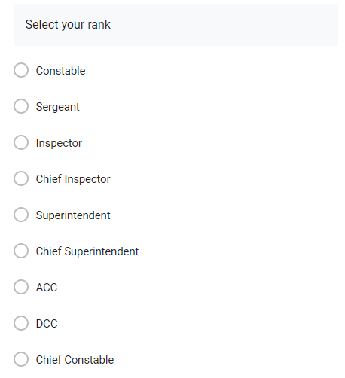





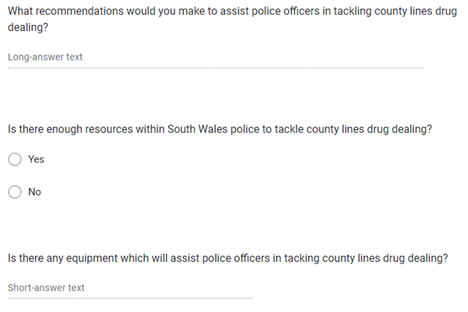

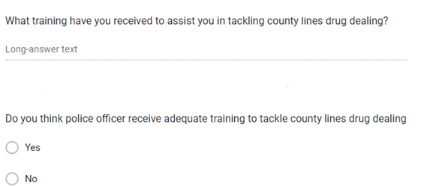

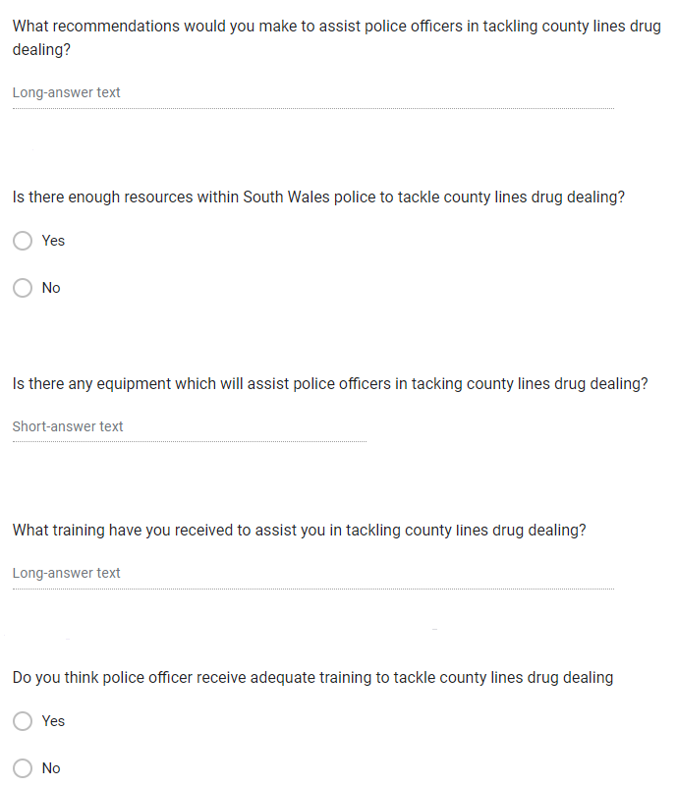

7.2 Appendix Two: Dissertation Proposal



UNDERGRADUATE DISSERTATION
RESEARCH PROPOSAL FORM

Please complete the following research proposal and submit it to Turnitin.
Please get rid of the red writing for your final submission.

NAME: Gethin Evans | STUDENT ID No.: 1920840
DRAFT RESEARCH TITLE QUESTION: Critical evaluation of police response to county lines criminality and exploitation

INTRODUCTION:

This dissertation will be completed as a research element of a Policing Practice Degree as part of the undergraduate degree at The University of Wales Trinity Saint David.

The area of research chosen is police response to county lines criminality and exploitation as this has been identified as an under researched area. There are many studies regarding county lines themselves, however, there is little research that truly links police officers’ responses to this growing violent crime, Officers are frequently the first on the scene, however, officer's perspectives have not been recorded, this has been identified as a key area to explore.

This research is necessary to establish whether police response to modern crimes such as; county lines is proportionate to deter individuals from committing these crimes which will in turn safeguard potentially vulnerable victims. The research also aims to highlight improvements police officers consider could increase safeguarding for vulnerable victims and target hardening measures that will prevent victimisation. This research is important as this is becoming a critical issue within South Wales Police force area, the exploitation and violence of these crimes are very harmful to not only the individuals involved but also impacts on the wider community.

The National Crime Agency’s, (2020) description of county lines is used to describe organised criminality of persons involved in distributing illegal drugs across the United Kingdom through the exploitation of vulnerable people. The County Lines drug supply model has been described as a drug-dealing phenomenon which is rapidly spreading across England and Wales (Spicer, 2019). This new form of drug dealing involves dealers from larger cities such as London and Manchester (NCA, 2017) migrating and exploiting vulnerable people from smaller towns to store, transport and sell drugs (Spicer, 2019).

Additionally, Spicer (2019) stresses that the county lines model is well organised and causes police forces significant challenges. Furthermore, Robinson, McLean and Densley (2019) argue that to truly eradicate county lines, policing policies need to focus less on prohibition and more on drug harm reduction. With county lines having implications on wider drug policy (Mclean, 2018), it is claimed that current drug laws are doing more harm than good (Stevens, 2011). It can be argued police forces have neglected to respond to warnings indicated by Hales and Hobbs, (2010) who reported that drugs are becoming more mobile. With the recent COVID -19 pandemic and police officers’ numbers falling (The Police Federation, 2021) this project will evaluate whether there are still enough officers available to tackle this growing crime.

SUMMARY OF RESEARCH –SURVEY METHOD:

OECD, (1993) defines research as systematic work that is undertaken to increase one’s knowledge. Collins and Hussey (2009) reason that effective methods for analysing, collecting, and presenting data are essential in academic writing.

The primary research method used will be descriptive research. Descriptive research is defined as a method of research used to describe occurrences as precise as possible (Atmowardoyo, 2018).

A questionnaire will be presented to approximately 20 police officers. The research study should provide quanitive data but also qualitative data which demonstates peoples voice for example data expressed in words.The reason descriptive research is best suited to my study as I will use empirical study to allow critical evaluation of what participents of the say. This is a small scale study of 20 participants. This number was chosen because it would enable enough data to be collected and analysed within the given time frame.

Throughout this research, both qualitative and quantitative data will be gathered which will provide a numerical approach to discovering police officers’ understanding of their responses to county lines crime. The qualitative data gathered will be analysed to provide in depth data to prove or disprove whether police officers believe their response to county lines is adequate and whether improvements can be made. By utilising both quantitive and qualitative data within the same research Strengths from both methodologies will be included. However, Yanchar and Williams (2006) argue that by using both methodologies there is “little regard for challenging issues pertaining to the nature of reality, knowledge, the good, and so on.” Although, Johnson et al, (2007, p. 11) argue “a researcher combines elements of qualitative and quantitative research approaches for the broad purposes of breadth and depth of understanding and corroboration”. Furthermore, using both research methods allows researchers to systematically examine both perspectives it enables readers of research reports to understand the research participants from the perspective of social science (Onwuegbuzie et al, 2011).

This method of research has been identified as the most appropriate due to the time constraints of the project. Questionnaires are a formal and controlled method of collecting data and will provide an accurate picture of county lines experiences within the police force. This method is conductible both face to face and electronically which mitigates the risks of contracting Covid 19. By carrying out an electronic survey if a future lockdown occurs or participants are concerned regarding catching Covid-19, this ensures minimum disruption to this research.

Secondary research conducted within this research will be in the form of a literature review. Snyder (2019) argues that literature reviews traditionally lack thoroughness and are conducted without a structured approach. He also argues that questionnaires can be questioned regarding its quality and trustworthiness. Furthermore, Torraco (2005) states that literature reviews can improve theory development within research, this can provide new conceptual models or theories. Additionally, Snyder (2019) claims literature reviews are essential for all research projects, in order to develop research questions and hypotheses it enables the researcher to justify their research. Moreover, literature reviews are essential for this research to establish what research has been completed previously and to develop a true understanding of the problem county lines causes across the whole of the United Kingdom and how effective the police response is to it.

SUMMARY OF SAMPLING FRAMEWORK:

The target sample for the research will be serving Police officers only. This sample is best for the research as it focuses on the prospective of current police officers views on their response to county lines. I will be using a general questionnaire which I will develop and tailor to gauge the perspectives of the police officers views. I believe this sample is best for my research as it will give a professional unbiased view of serving police officers who have an more of an insight and knowledge of the county lines problem they are facing and see first-hand what areas if any can be improved in their response and what methods are working to tackle the problem.

ETHICAL ISSUES:
Consideration has been given to the ethical issues with this line of research. No issues have been identified. All persons taking part in the research are above eighteen years old. The questionnaire will only be completed by police officers, these are all over the age of eighteen, this will prevent vulnerable people completing the research which would raise ethical issues.

Questionnaires will be used to gather quantitative data and a general overview of people’s thoughts on the subject. The questionnaires will be targeted to ensure participants remain anonymous and the questionnaire is fair throughout. However, it is accepted that the questionnaire may be rushed and will capture the participant’s views and feelings at that particular point in time.

Moreover, it is paramount for this research that consent will be given by all participants for their contribution to be used in this research and that the participants will remain confidential to protect their views.
TIME SCALE:

7.3 Ethics Form

APPLICATION FOR ETHICAL APPROVAL

In order for research to result in benefit and minimise risk of harm, it must be conducted ethically. A researcher may not be covered by the University’s insurance if ethical approval has not been obtained prior to commencement.

The University follows the OECD Frascati manual definition of research activity: “creative work undertaken on a systematic basis in order to increase the stock of knowledge, including knowledge of man, culture and society, and the use of this stock of knowledge to devise new applications”. As such this covers activities undertaken by members of staff, postgraduate research students, and both taught postgraduate and undergraduate students working on dissertations/projects.

The individual undertaking the research activity is known as the “principal researcher”.

Ethical approval is not required for routine audits, performance reviews, quality assurance studies, testing within normal educational requirements, and literary or artistic criticism.

Please read the notes for guidance before completing ALL sections of the form.

This form must be completed and approved prior to undertaking any research activity. Please see Checklist for details of process for different categories of application.

Delete the Guidance Notes at the end of the form BEFORE submitting your application

SECTION A: About You (Principal Researcher)
Full Name: |  | Gethin David Evans
Tick all boxes which apply: |  | Member of staff: | ☐ | Honorary research fellow: | ☐
Undergraduate Student | ☒ | Taught Postgraduate Student | ☐ | Postgraduate Research Student | ☐

Institute/Academic Discipline/Centre: | IMH
Campus: | Swansea
E-mail address: | 1920840@student.uwtsd.ac.uk
Contact Telephone Number: | N/A
For students:
Student Number: | 1920840
Programme of Study: | BSc (Hons) Professional Policing Practice
Director of Studies/Supervisor: | Jane Thomas

SECTION B: Approval for Research Activity
Has the research activity received approval in principle?  (please check the Guidance Notes as to the appropriate approval process for different levels of research by different categories of individual) |  | YES | ☒ | NO | ☐
 |  |  |  | Date
If Yes, please indicate source of approval (and date where known): Approval in principle must be obtained from the relevant source prior to seeking ethical approval | Research Degrees Committee |  | ☐
 | Institute Research Committee |  | ☐
 | Other (write in) |  | ☒ | Jane Thomas

SECTION C: Internal and External Ethical Guidance Materials
Please list the core ethical guidance documents that have been referred to during the completion of this form (including any discipline-specific codes of research ethics, and also any specific ethical guidance relating to the proposed methodology). Please tick to confirm that your research proposal adheres to these codes and guidelines.
UWTSD Research Ethics & Integrity Code of Practice | ☒
UWTSD Research Data Management Policy | ☒
 | ☐

SECTION D: External Collaborative Research Activity
Does the research activity involve collaborators outside of the University? |  | YES | ☐ | NO | ☒
If Yes, please provide the name of the external organisation and name and contact details for the main contact person and confirmation this person has consented to their personal data being shared.as part of this collaboration.
Institution
Contact person name
Contact person e-mail address

Has this individual consented to sharing their details on this form? |  | YES | ☐ | NO |  |  | ☐
Are you in receipt of a KESS scholarship? |  | YES | ☐ | NO |  |  | ☐
Is your research externally funded |  | YES | ☐ | NO |  |  | ☐
Are you specifically employed to undertake this research in either a paid or voluntary capacity? | Voluntary | YES | ☐ | NO |  | ☐
 | Employed | YES | ☐ | NO |  | ☐
Is the research being undertaken within an existing UWTSD Athrofa Professional Learning Partnership (APLP) | If YES then the permission question below does not need to be answered. | YES | ☐ | NO |  |  | ☐
Permission to undertake the research has been provided by the partner organisation | (If YES attach copy)  If NO the application cannot continue | YES | ☐ | NO |  |  | ☐

Where research activity is carried out in collaboration with an external organisation
Does this organisation have its own ethics approval system? | YES | ☐ | NO | ☐
If Yes, please attach a copy of any final approval (or interim approval) from the organisation

SECTION E: Details of Research Activity
Indicative title: | Critical evaluation of police response to county lines criminality and exploitation
Proposed start date: | 21/03/2022 | Proposed end date: | 02/01/2023
Introduction to the Research (maximum 300 words)
Ensure that you write for a Non-Specialist Audience when outlining your response to the three points below:
- Purpose of Research Activity
- Proposed Research Question
- Aims of Research Activity
- Objectives of Research Activity
Demonstrate, briefly, how Existing Research has informed the proposed activity and explain
- What the research activity will add to the body of knowledge
- How it addresses an area of importance.
Purpose of Research Activity

The purpose of my research activity is to evaluate the police response to county lines, both long and short term solutions, and how efficient those responses are. The research activity will educate the reader on how effective police responses are to a relatively new violent organised crime strategy. This is important in order to see if there is any improvements that can be made to the strategy and to establish its effectiveness in practice.

(this box should expand as you type)
Research Question
The key of my research are the questions I will be asking is do participants believe that South Wales Police response to county lines criminality is effective? And do they believe improvements can be made and if so how.

(this box should expand as you type)
Aims of Research Activity
This research aims to enable both police officers and the general public to understand police responses to county lines identify improvements that can be made that can will equip officers to respond to these incidents and whether there are any measurers that can be put in place to prevent people becoming victims of this crime.

(this box should expand as you type)
Objectives of Research Activity

Qualitative and quantitative date will be obtained by administering a questionnaire. This questionnaire will be conducted remotely and participants will be anonymous. All questions will be aimed for police officers views of South Wales Police is response to county lines and if any improvements can be made.

(this box should expand as you type)
Proposed methods (maximum 600 words)
Provide a brief summary of all the methods that may be used in the research activity, making it clear what specific techniques may be used. If methods other than those listed in this section are deemed appropriate later, additional ethical approval for those methods will be needed.
The research method, Chosen for this research is a questionnaire. This method has been chosen because it is the most suitable method to employ within the timeframe. This method is easy to administer and analyse. This survey also supports the ethical code to which I will be abiding by, as no personal information will be held about the participant’s and all participants will complete the survey on a deadline date and will be able to provide more accurate data.

(this box should expand as you type)

Location of research activity
Identify all locations where research activity will take place.
Swansea Central Police Headquarters- this research will be conducted electronically as well.

(this box should expand as you type)
Research activity outside of the UK
If research activity will take place overseas, you are responsible for ensuring that local ethical considerations are complied with and that the relevant permissions are sought. Specify any local guidelines (e.g. from local professional associations/learned societies/universities) that exist and whether these involve any ethical stipulations beyond those usual in the UK (provide details of any licenses or permissions required). Also specify whether there are any specific ethical issues raised by the local context in which the research activity is taking place, for example, particular cultural and/or legal sensitivities or vulnerabilities of participants.
Non Applicable

(this box should expand as you type)
Use of documentation not in the public domain: Are any documents NOT publicly available? | NO | ☒
 | YES | ☐
If Yes, please provide details here of how you will gain access to specific documentation that is not in the public domain and that this is in accordance with prevailing data protection law of the country in question and England and Wales.

(this box should expand as you type)

SECTION F: Scope of Research Activity
Will the research activity include: | YES | NO
Use of a questionnaire or similar research instrument? | ☒ | ☐
Use of interviews? | ☐ | ☒
Use of diaries? | ☐ | ☒
Participant observation with their knowledge? | ☐ | ☒
Participant observation without their knowledge? | ☐ | ☒
Use of video or audio recording? | ☐ | ☒
Access to personal or confidential information without the participants’ specific consent? | ☐ | ☒
Administration of any questions, test stimuli, presentation that may be experienced as physically, mentally or emotionally harmful / offensive? | ☐ | ☒
Performance of any acts which may cause embarrassment or affect self-esteem? | ☐ | ☒
Investigation of participants involved in illegal activities? | ☐ | ☒
Use of procedures that involve deception? | ☐ | ☒
Administration of any substance, agent or placebo? | ☐ | ☒
Working with live vertebrate animals? | ☐ | ☒
Other primary data collection methods, please explain in this box  For example, ‘focus groups’. Please indicate the type of data collection method(s) in this box and tick the accompany box. | ☐ | ☒
Details of any other primary data collection method:  (this box should expand as you type) | ☐ | ☒
If NO to every question, then the research activity is (ethically) low risk and may be exempt from some of the following sections (please refer to Guidance Notes).

If YES to any question, then no research activity should be undertaken until full ethical approval has been obtained.

SECTION G: Intended Participants
Who are the intended participants: | YES | NO
Students or staff at the University? | ☒ | ☐
Adults (over the age of 18 and competent to give consent)? | ☒ | ☐
Vulnerable adults? | ☐ | ☒
Children and Young People under the age of 18? (Consent from Parent, Carer or Guardian will be required) | ☐ | ☒
Prisoners? | ☐ | ☒
Young offenders? | ☐ | ☒
Those who could be considered to have a particularly dependent relationship with the investigator or a gatekeeper? | ☐ | ☒
People engaged in illegal activities? | ☐ | ☒
Others (please identify specifically any group who may be unable to give consent) please indicate here and tick the appropriate box. | ☐ | ☒
Other – please indicate here:  The intended participants of this research will be officers of; response, priority policing team and the neighbourhood policing department. This research will also include officers of rank in order to gain a wide perspective.  (this box should expand as you type) | ☐ | ☒

Participant numbers and source
Provide an estimate of the expected number of participants. How will you identify participants and how will they be recruited?
How many participants are expected? | There will be a minimum of Twenty participants included in this research. The true number of participants are currently unknown however it will be less than fifty.  (this box should expand as you type)
Who will the participants be? | The participants would be police officers.  (this box should expand as you type)
How will you identify the participants? | I will identify the participants though their involvement in regards to county lines. I seek advice and recommendations from officers of rank in daily briefings to select participants.  (this box should expand as you type)

Information for participants: | YES | NO | N/A
Will you describe the main research procedures to participants in advance, so that they are informed about what to expect? | ☒ | ☐ | ☐
Will you tell participants that their participation is voluntary? | ☒ | ☐ | ☐
Will you obtain written consent for participation? | ☒ | ☐ | ☐
Will you explain to participants that refusal to participate in the research will not affect their treatment or education (if relevant)? | ☒ | ☐ | ☐
If the research is observational, will you ask participants for their consent to being observed? | ☐ | ☐ | ☒
Will you tell participants that they may withdraw from the research at any time and for any reason? | ☒ | ☐ | ☐
With questionnaires, will you give participants the option of omitting questions they do not want to answer? | ☒ | ☐ | ☐
Will you tell participants that their data will be treated with full confidentiality and that, if published, it will not be identifiable as theirs? | ☒ | ☐ | ☐
Will you debrief participants at the end of their participation, in a way appropriate to the type of research undertaken? | ☒ | ☐ | ☐
If NO to any of above questions, please give an explanation
(this box should expand as you type)

Information for participants: | YES | NO | N/A
Will participants be paid? | ☐ | ☒ | ☐
Is specialist electrical or other equipment to be used with participants? | ☐ | ☒ | ☐
Are there any financial or other interests to the investigator or University arising from this study? | ☐ | ☒ | ☐
Will the research activity involve deliberately misleading participants in any way, or the partial or full concealment of the specific study aims? | ☐ | ☒ | ☐
If YES to any question, please provide full details
(this box should expand as you type)

SECTION H: Anticipated Risks

Outline any anticipated risks that may adversely affect any of the participants, the researchers and/or the University, and the steps that will be taken to address them.

If you have completed a full risk assessment (for example as required by a laboratory, or external research collaborator) you may append that to this form.
Full risk assessment completed and appended? |  | Yes | ☒
 |  | No | ☐
Risks to participants
For example: emotional distress, financial disclosure, physical harm, transfer of personal data, sensitive organisational information
Risk to Participant:  There will be no risks to participants  (this box should expand as you type) | How will you mitigate the Risk to Participant  There will be no risks to participants  (this box should expand as you type)
If research activity may include sensitive, embarrassing or upsetting topics (e.g. sexual activity, drug use) or issues likely to disclose information requiring further action (e.g. criminal activity), give details of the procedures to deal with these issues, including any support/advice (e.g. helpline numbers) to be offered to participants. Note that where applicable, consent procedures should make it clear that if something potentially or actually illegal is discovered in the course of a project, it may need to be disclosed to the proper authorities
This is non applicable to my research.

(this box should expand as you type)
Risks to investigator
For example: personal safety, physical harm, emotional distress, risk of accusation of harm/impropriety, conflict of interest
Risk to Investigator:  There will be no risks to investigator  (this box should expand as you type) | How will you mitigate the Risk to Investigator:  There will be no risks to investigator  (this box should expand as you type)
University/institutional risks
For example: adverse publicity, financial loss, data protection
Risk to University:  There will be no risks to university  (this box should expand as you type) | How will you mitigate the Risk to University:  There will be no risks to university  (this box should expand as you type)

Disclosure and Barring Service
If the research activity involves children or vulnerable adults, a Disclosure and Barring Service (DBS) certificate must be obtained before any contact with such participants. | YES | NO | N/A
Does your research require you to hold a current DBS Certificate? | ☐ | ☐ | ☒

SECTION I: Feedback, Consent and Confidentiality
Feedback
What de-briefing and feedback will be provided to participants, how will this be done and when?
I will write to the participants to inform them of the outcome of the study they participated in. I am also considering contributing to the federation magazine in order to produce a wider audience in relation to the feedback from the research.

(this box should expand as you type)
Informed consent
Describe the arrangements to inform potential participants, before providing consent, of what is involved in participating. Describe the arrangements for participants to provide full consent before data collection begins. If gaining consent in this way is inappropriate, explain how consent will be obtained and recorded in accordance with prevailing data protection legislation.
The questionnaire will be accompanied by information regarding the research and the rights of the participants.
By carrying out this questionnaire by doing this electronically then by responding they are giving their consent.

(this box should expand as you type)
Confidentiality / Anonymity
Set out how anonymity of participants and confidentiality will be ensured in any outputs. If anonymity is not being offered, explain why this is the case.
There will be no confidential information held. I will ensure all questions are equal and no one will be able to trace the participants who completed the research activity.

(this box should expand as you type)

SECTION J: Data Protection and Storage
In completing this section refer to the University’s Research Data Management Policy and the extensive resources on the University’s Research Data Management web pages (http://uwtsd.ac.uk/library/research-data-management/).
Does the research activity involve personal data (as defined by the General Data Protection Regulation 2016 “GDPR” and the Data Protection Act 2018 “DPA”)? | YES | NO
“Personal data” means any information relating to an identified or identifiable natural person (‘data subject’). An identifiable natural person is one who can be identified, directly or indirectly, in particular by reference to an identifier such as a name, an identification number, location data, an online identifier or to one or more factors specific to the physical, physiological, genetic, mental, economic, cultural or social identity of that natural person. | ☐ | X
If YES, provide a description of the data and explain why this data needs to be collected:
(this box should expand as you type)
Does it involve special category data (as defined by the GDPR)? | YES | NO
“Special category data” means sensitive personal data consisting of information as to the data subjects’ –  (a) racial or ethnic origin,  (b) political opinions,  (c ) religious beliefs or other beliefs of a similar nature,  (d) membership of a trade union (within the meaning of the Trade Union and Labour Relations (Consolidation) Act 1992),  (e) physical or mental health or condition,  (f) sexual life,  (g) genetics,  (h) biometric data (as used for ID purposes), | ☐ | X
If YES, provide a description of the special category data and explain why this data needs to be collected:
(this box should expand as you type)
Will the research activity involve storing personal data and/or special category data on one of the following: | YES | NO
Manual files (i.e. in paper form)? | ☐ | ☒
University computers? | ☐ | ☒
Private company computers? | ☐ | ☒
Home or other personal computers? | ☒ | ☐
Laptop computers/ CDs/ Portable disk-drives/ memory sticks? | ☐ | ☒
“Cloud” storage or websites? | ☐ | ☒
Other – specify: | ☐ | ☒
For all stored data, explain the measures in place to ensure the security of the data collected, data confidentiality, including details of password protection, encryption, anonymisation and pseudonymisation:
All data will be stored anonymously on a password protected personal computer.

(this box should expand as you type)
All Data Storage
Will the research activity involve any of the following activities: | YES | NO
Electronic transfer of data in any form? | ☒ | ☐
Sharing of data with others at the University? | ☐ | ☒
Sharing of data with other organisations? | ☐ | ☒
Export of data outside the European Union or importing of data from outside the UK? | ☐ | ☒
Use of personal addresses, postcodes, faxes, emails or telephone numbers? | ☐ | ☒
Publication of data that might allow identification of individuals? | ☐ | ☒
Use of data management system? | ☐ | ☒
Data archiving? | ☐ | ☒
If YES to any question, please provide full details, explaining how this will be conducted in accordance with the GDPR and DPA (and/or any international equivalent):
All data will be anonymised and stored on a password protected personal computer.

(this box should expand as you type)
List all who will have access to the data generated by the research activity:
Only I will have access to this data generated by the research.

(this box should expand as you type)
List who will have control of, and act as custodian(s) for, data generated by the research activity:
N/A

(this box should expand as you type)
Give details of data storage arrangements, including security measures in place to protect the data, where data will be stored, how long for, and in what form. Will data be archived – if so how and if not why not.
All anonymised data will be stored on a secure, password protected personal laptop. This will be destroyed on completion of the study.

(this box should expand as you type)
Please indicate if your data will be stored in the UWTSD Research Data Repository (see https://researchdata.uwtsd.ac.uk/ ). If so please explain. (Most relevant to academic staff)
N/A

(this box should expand as you type)
Confirm that you have read the UWTSD guidance on data management (see https://www.uwtsd.ac.uk/library/research-data-management/) | YES | ☒
 | NO | ☐
Confirm that you are aware that you need to keep all data until after your research has completed or the end of your funding | YES | ☒
 | NO | ☐

SECTION K: Declaration
The information which I have provided is correct and complete to the best of my knowledge. I have attempted to identify any risks and issues related to the research activity and acknowledge my obligations and the rights of the participants.

In submitting this application I hereby confirm that I undertake to ensure that the above named research activity will meet the University’s Research Ethics and Integrity Code of Practice which is published on the website: https://www.uwtsd.ac.uk/research/research-ethics/
Signature of applicant: | G. Evans | Date:  22/04/2022

For STUDENT Submissions:
Director of Studies/Supervisor: |  | Date:
Signature: |  | Date:

For STAFF Submissions:
Academic Director/ Assistant Dean: |  | Date:
Signature: |  | Date:

Checklist: Please complete the checklist below to ensure that you have completed the form according to the guidelines and attached any required documentation:
☒ | I have read the guidance notes supplied before completing the form.
☒ | I have completed ALL RELEVANT sections of the form in full.
☒ | I confirm that the research activity has received approval in principle
☒ | I have attached a copy of final/interim approval from external organisation (where appropriate)
☒ | I have attached a full risk assessment (and have NOT completed Section H of this form) (where appropriate) ONLY TICK IF YOU HAVE ATTACHED A FULL RISK ASSESSMENT
☒ | I understand that it is my responsibility to ensure that the above named research activity will meet the University’s Research Ethics and Integrity Code of Practice.
☒ | I understand that before commencing data collection all documents aimed at respondents (including information sheets, consent forms, questionnaires, interview schedules etc.) must be confirmed by the DoS/Supervisor, module tutor or Academic Director.
☒ | I have deleted the guidance notes before submitting the PG2 for consideration

RESEARCH STUDENTS AND STAFF ONLY
All communications relating to this application during its processing must be in writing and emailed to pgresearch@uwtsd.ac.uk , with the title ‘Ethical Approval’ followed by your name.
You will be informed of the outcome of your claim by email; therefore it is important that you check your University and personal email accounts regularly.

STUDENTS ON UNDERGRADUATE OR TAUGHT MASTERS PROGRAMMES should submit this form (and receive the outcome) via systems explained to you by the supervisor/module leader.

This form is available electronically from the Academic Office web pages: https://www.uwtsd.ac.uk/academic-office/appendices-and-forms/

Application Process

All staff research projects and all research students must submit the Ethical Approval Form to the University Research Ethics Committee via the Academic Office (pgresearch@uwtsd.ac.uk). Staff research directly in relation to personal study for taught undergraduate or Masters programmes should be submitted via the Institute procedures explained below.

Taught masters and taught undergraduate research Ethical Approval Forms are considered within Institutes. Institutes will provide details of the specific processes for this. Where the Ethical issues within any single ethical application are of particular concern the Institute will refer these to the University Research Ethics Committee. Any student activity that involves the collection of primary data needs to undergo Ethical approval, this includes assignment work as well as dissertations.

Notes for guidance in completion of this form

Section A: About You
Please complete all relevant sections

Section B: Approval for research activity
Research proposals must be approved in principle before applying for Ethical Approval. The proposal approval only becomes final when the ethical approval is received.

The process for proposal approval varies according the individual and programme of study:
- Research students, by application on form PG1 to the Research Degrees Committee
- Taught students by review of research proposal within Institutes (Institutes provide specific details of these processes)
- Staff, by agreement by the Academic Director/Assistant Dean

Section C: External Ethical Guidance materials
Many discipline areas are required to operate with the discipline specific codes of research ethics (for example health, psychology, education etc.), any such codes must be listed and you must tick to confirm that you have consulted with these.

Section D: External Collaborative Research Activity
Provide details of the external collaborative partners, where appropriate you might want to submit a copy of the external collaboration agreement with the Ethical Approval Form. If the partner requires the research to be subject to its own internal Ethical approval process then please provide details of that process and a copy of any final (or interim) approvals received from the organisation.

Section E: Details of Research Activity
Remember that the individuals reviewing this Ethical Approval Form may not have seen your research proposal, and also may not be experts in the specific area of your research. The information provided should therefore be jargon free and clearly stated.
Indicative Title: please use the same title as used on the research proposal.
Purpose: the Ethical approval process will want to ensure that the methods you propose are adequate and appropriate to address the research aims and objectives. Excessive additional data collection can be seen as unethical.
Proposed Methods: the Ethical approval process seeks to ensure that you understand the methods that are intended, and that the implementation of those methods will be appropriate and without unnecessary impact on respondents. This section must explain how the methods described will lead to the collection of necessary and sufficient data, but not excessive data. Please be specific.
Location: this needs to mention geographical location and also local situation (for example, within Local Authority Offices in Cardiff, using a private room but close to other individuals). If you are collecting data within an organisational setting then you need to explain the permissions that you have obtained to do this.
Research Activity outside of the UK: please complete this section in detail, and note any guidance you have received. Also describe your own familiarity (or not) with the location that you will be utilising.

Section F: Scope of Research Activity
Please tick ALL of the research activities that might be undertaken. If any additional types of activity are intended then please add an extra box and describe these.
If you have answered no to all questions in F then sections G and J do not need to be completed. Section H should be considered, and may be completed. Signatures are still required in section K.

Section G: Intended Participants
Please tick all categories that might apply.
Numbers & Source: if you are using a series of different methods or research activities please list numbers for each stage/phase. Be clear about how you will find respondents. Will you use intermediaries, and if so how? How will you ensure compliance with your sampling strategy?
Information for participants: all participants should be appropriately informed about the research, what is expected of them and what will happen to the information that they provide. The Ethical review process does not ask to see this documentation, but requires this to be reviewed and approved by the Director of Studies in the case of research students, the supervisor/module tutor in relation to students on taught programmes and the Academic Director/Assistant Dean in relation to staff research.

Section H: Anticipate Risks
All research carries some level of risk. The answers you provide to questions in this section will be reviewed to ensure that you have an appropriate understanding of the type of risks involved and how you can mitigate against these risks. If you have completed a full risk assessment, as required for example for laboratory work, field work, clinical tests, diving operations, or by a collaborative partner, you may append that to this form. In that case, please tick the box indicating this has been provided. You will not then be required to complete Section H.
Risk to participants Think very carefully about how your actions/questions/discussions might affect the people you are involving as participants. You might identify the risk as small but it would still be a risk. Many types of question have the potential to make respondents less content with their life / job; you need to recognise and try to ameliorate any such effects
If these are business owners, time with you may reduce profit.
In some locations physical risk is very real to both participants and yourself, please consider this.
Risk to you, the researcher Think about where you will meet people, if there are any dangers involved in the location. If you are meeting people as individuals think about using a public place. In general do not visit people in their own homes or remote locations. If you are talking to individuals about certain issues think about how their responses might affect you emotionally. What about the risk of collecting insufficient data?
Risk to the University When undertaking your research, you are acting as a member of the University (student or staff). Professionalism is important, so it is important to be well organised and well prepared. Punctuality, clarity etc. are all part of this. What will you do to ensure this? You must ensure you do not harm the good name of the University in any way and do nothing to undermine the reputation of the research it conducts and sponsors. Upholding high standards of conduct and integrity are vital in this regard. You must also conduct the research in such a way to minimise the potential for claims of negligence made against the University, its researchers and any collaborating individual or organisation. In this respect you should always comply with ethical, legal and professional frameworks, obligations and standards as required by statutory and regulatory authorities, as well as the university’s Research Integrity and Ethics Code of Practice. Research misconduct in this respect can take many forms, including:
- fabrication: making up results or other outputs (eg, artefacts) and presenting them as if they were real
- falsification: manipulating research processes or changing or omitting data without good cause
- plagiarism: using other people’s material without giving proper credit
- failure to meet ethical, legal and professional obligations: for example failure to declare competing interests; misrepresentation of involvement or authorship; misrepresentation of interests; breach of confidentiality; lack of informed consent; misuse of personal data; and abuse of research subjects or material
- improper dealing with allegations of misconduct: failing to address possible infringements such as attempts to cover up misconduct and reprisals against whistle-blowers

Adverse Outcomes. Think carefully about the possibilities, and cover here

Section I: Feedback, Consent and Confidentiality
Feedback to participants: outline your approach. Will interview transcripts be shared with respondents to check accuracy? Will summaries of questionnaire analysis be made available to respondents in some way? Will an overview report be provided? How and when?
Informed consent: Draft letter / e-mail / or heading (or footer) section of questionnaire must be approved by DoS/supervisor (if research student), supervisor/module tutor if taught student, or Academic Director / Assistant Dean if a member of staff.
Confidentiality/Anonymity. Explain clearly how you will ensure confidentiality and anonymity.

Section J: Data Protection and Storage
Before completing this section it is necessary to read the University’s Research Data Management information. The questions that follow are designed to ensure compliance with the Data Protection Act as well as established research protocols.

Many research activities will involve electronic transfer of data and use of data management systems in the summarisation and analysis of data. You will need to explain these in relation to compliance with the Data Protection Act.
Think carefully about who will have access to your data, this will include supervisors and examiners. Also that a thesis will be made available via the University library and the British Library system. If you are seeking an access bar for a period of time after completion then mention it here. If you will provide a copy of your findings, or intend to give a presentation, to a facilitating/ supporting/accessing organisation then explain that in this section. But also think about the general principle of data sharing, as explained in the Research Data Management information.
In terms of storage of data please ensure security, and also mitigate against loss of data.

Section K: Declaration
Ensure the appropriate countersignatures have been provided
Look carefully at the checklist and ensure that you comply with and tick all that are relevant to your research.

