Build & deploy a type 2 Hypervisor platform

Josh Lloyd (2205191)
[Company name] [Company address]
Table of Contents
Introduction 2
What Are hypervisors? 2
What kinds of hyper visors are there? 2
Comparison of Virtual box & VMWare 2
Conclusion 3
IP Addressing 3
So, what exactly are IP addresses? 4
Troubleshooting methods 4
Active methods 4
Passive methods 4
Hybrid methods 5
Evidence Tables: 5
Initial Set up 5
Firewall Configurations- 6
Ip configurations- 12
Final Ping connectivity 14
References 17

Introduction
In this assignment I have been tasked to research and deploy a network topology through the use of a hypervisor. I will first conduct research into two hypervisors and analyse and compare and choose my preferred on to work with to complete the task I will also conduct research into Ip addressing and troubleshooting techniques to combat any issues that arise during my deployment I will then finally document my progress with a timestamped screenshot followed by a short description of the task I am currently doing.

What Are hypervisors?
Computer system monitoring has been a fundamental part of maintaining system Security. The large majority of security features included within systems include security monitoring a few examples of this being. Intrusion detection, Firewalls, Antiviruses, Access control etc. In an ideal world a security monitoring system should include a complete view of the target its intendeds to monitor and the ability to protect the system itself.
The hypervisor was first proposed as an idea in the 1960s. The hypervisor or virtual machine monitor (VMM) allows a computing environment to run multiple independent operating systems simultaneously within a single physical computer, this allows for more effective use of the available computing resources such as storage space and bandwidth. The main reason hypervisor layers were introduced into server stacks is that the capacity of a server would be far too large to accommodate the work loads for it to be efficient. In turn virtualization is the best way forward into solving this problem as it allows for improvement in areas such as resources utilization and all the while simplifying and automation computing unit management. Even though this model was initially proposed to logically divide resources within a computing system it is now a hallmark in cloud computing and data centres in recent years.[1]

What kinds of hyper visors are there?
Hypervisors are typically described in two classes (type-1 & type-2). The type-1 hypervisor is executed on the hardware of the device, while type-2 hypervisors or executed through the OS. Type-2 hypervisors are the more modern approach and are widely used in computing environments and are also going to be the focus during this assignment.
There are many hypervisors currently on the market some notable ones are: XenServer; Microsoft-Hyper-V; Oracle VM-Server, VirtualBox and VMWare workstation these hypervisors are just a few of which represent the type-2 category. For the type 2 architecture the initial OS of the computing system is installed and then the hypervisor or (VMM), in turn then allows the users to run different guest OSs within their own environment.[2]
The two hypervisors I am going to be focusing on and comparing are Virtual box and VMWare as I feel they are the best choice in terms of completing this assignment as both offer great access and features.[2]

Comparison of Virtual box & VMWare
When it comes to hypervisors oracle virtual box is one of the most powerful virtualisations software’s available for operating systems with intel and AMD processors. The oracle software is a great solution as it is open source and provides unlimited use under the ‘general public licence’ version. VirtualBox provides users with the opportunity to create a large number of virtual machines on computers which run on x86 processors.
VirtualBox has a huge range of features and excellent performance for enterprise users, it can be used across multiple platforms such as windows, Linux, MAC, and Solaris operating systems. The one main advantage of virtual box is that it proves simple and fast data transfer between its virtual machines and since it is an open-source software it is often prone to fast troubleshooting and improving and adding new features.
VMWare is another popular hypervisor and offers many features just like VirtualBox, VMWare offers different products which are categorized into two levels: desktop and server applications. The desktop software that VMWare offers is compatible with multiple operating systems such as windows, Linux, and MAC.
In terms of desktop usage VMWare offers three types of software:
- VMWare workstation, which is used to install and run multiple copies of the same or different operating systems on the same computer.
- VMWare Fusion product, which is designed for users with MAC OS and provides the additional flexibility and compatibility with other applications.
- VMWare player, which is run by VMWare for users who do not have VMWare licenced products.[2]
The hypervisor software that VMWare uses for its servers are designed as bare-metal. Which means they can be ran directly on the server hardware without the need of a primary operating system. This server software includes multiple services offered by VMWare such as VMWare ESX server and VMWare ESXI server. VMWare servers are largely and primarily used on windows and Linux machines whilst VMWare workstation player is a free version of VMWare products and is used to run virtual machines on windows and Linux if I were to choose to use VMWare for this assignment this is most likely the version I would use due to it being free however this may cause limitations in features cause problems later down the line in completing the task given to me.[2]

Conclusion
From a test and analysis conducted by ([2]) the results indicate that both hypervisors perform the same although there Is a slight advantage in using Virtual box as it has slightly faster speeds and was just as efficient as VMWare when installing the OS and VirtualBox is a free and simple solution and is suitable for multiple applications and uses so therefore I will be choosing to use virtual box moving forward looking at this data as I believe it will provide me with the best features and be highly efficient.

IP Addressing
Data is communicated from one device to another via the use of internet protocols or (IP), these protocols create set of rules between applications and devices connected to the internet. This works a lot like how computers communicate in a network as they use routers to send data and messages over the internet as the router holds information on device location so it can receive the data and direct the message to the correct destination.

So, what exactly are IP addresses?
There are two types of IP addresses.
- IPv4 – This address type is a 32-bit address which use binary and octal systems, it identifies hosts within a network and have 2 to the power of 32 address available for use.
- IPv6 – This address type is a 128-bit address which are created using hexadecimal systems which can be assigned to an unlimited number of devices without fear of running out.[3]
IPv6 is the newer classification of IP addressing as it was created in order to solve the issue of running out of usable IP addresses as IPv4 being an older model can only hold a limited number of addresses even though that number is exceedingly high we would eventually run out of address in the future if we continued to use this format.
How are Ip addresses used?
To create a functional network each device must be uniquely identifiable. This is where Ip address come into use, The IP addresses can be assigned to a device either manually or automatically if creating your own network, you more than likely want to assign the Ip addresses yourself as you can keep track of the addresses by using and addressing table using this will greatly aid you in creating a network.[3]

Troubleshooting methods
With the advancement of network technologies so grows the room for error when creating new and configuring existing networks. When an issue appears sometimes network engineers may not know where the issue lays issues can arise from anywhere when creating a network some of not like congestion, link failure, router misconfiguration etc, to combat this networking professional have developed techniques to diagnose and correct these issues there are also useful tools which can assist in finding and correcting issues with your network more easily.
There are 3 different types of troubleshooting techniques:
- Active methods
- Passive methods
- Hybrid methods [4]

Active methods
Active methods are typically probing techniques which insert packets into the network to analyse and monitor the system on of these methods is a traditional non-tool-utilization techniques in which you use probing packets through the systems in the network to gather information and evaluate the measure to locate the issues within your network. This method can detect and locate network issues such as firewall rules, forwarding rules, congestion, strict priorities etc.
However this probing techniques has a weakness as it needs to send packets into the network to analyse and evaluate it, it can be rendered ineffective if some on the test packets are lost.[4]

Passive methods
Passive methods are more of a hand off approach when it comes to diagnosing issues in a network passive method just monito traffic in the network to detect and locate any issues within it of pf these methods are rule based techniques which uses rule matching to interpret monitored information in a useful way. Unlike the active methods rule based techniques do not require the implantation of test packets into the network but it does have drawbacks in comparison between accuracy and usage of time. If the set of data is large the accuracy of the diagnosis will be high, but it will take a large amount of time to process meaning it is not simple to implement in real-time.

Hybrid methods
Hybrid methods are a combination of both active and passive methods they utilize active probes and network traffic analysis to detect and locate issues.[4]

Evidence Tables:
 | Initial Set up
 | Device setup |  | 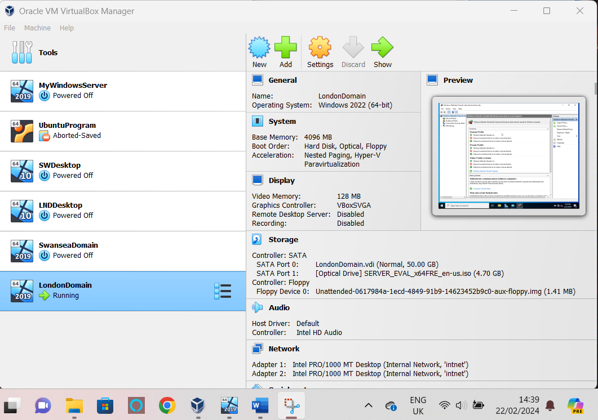 | Displays my first step into configuring the network requested clearly defining the servers by giving them appropriate names to clearly designate locations and IP addresses later on
 | Adapter Setup |  | 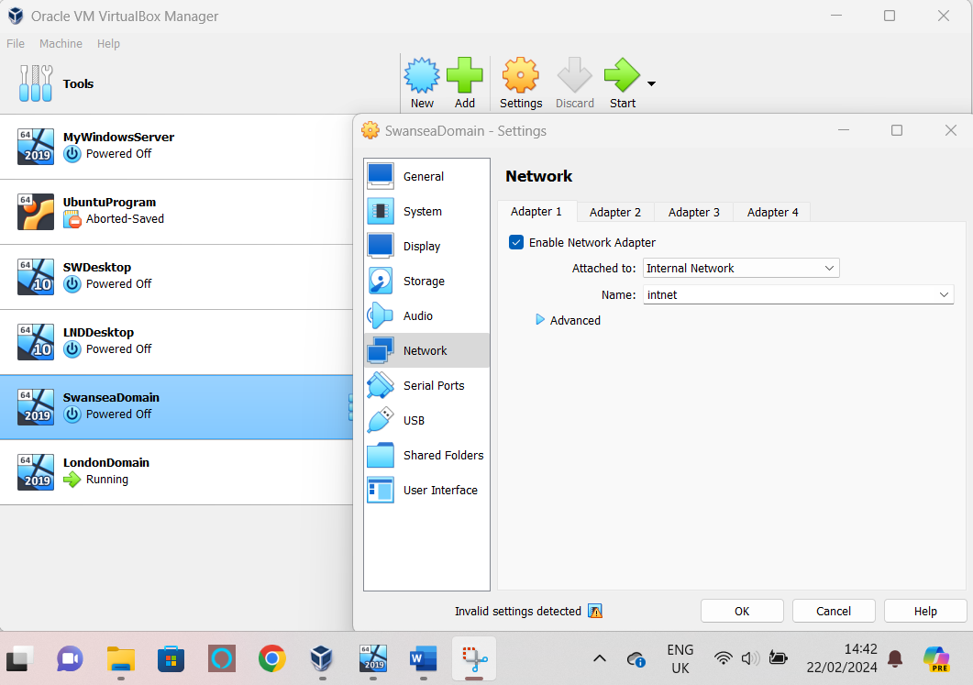 | Secondly, I configured all servers and desktops to an internal network so only these nodes can connect and communicate with each other and disallow others from connecting externally

Firewall Configurations-
Secondly I configure the firewall settings for all of the devices to accept ICMP and file echo requests so they can communicate with eachother I also set the IPsec settings to make ICMP files exempt from being vaught in the firewall ensureing that my pings will reach the destination when I test my connection.
London Domain Inbound & Outbound & IPsec |  | 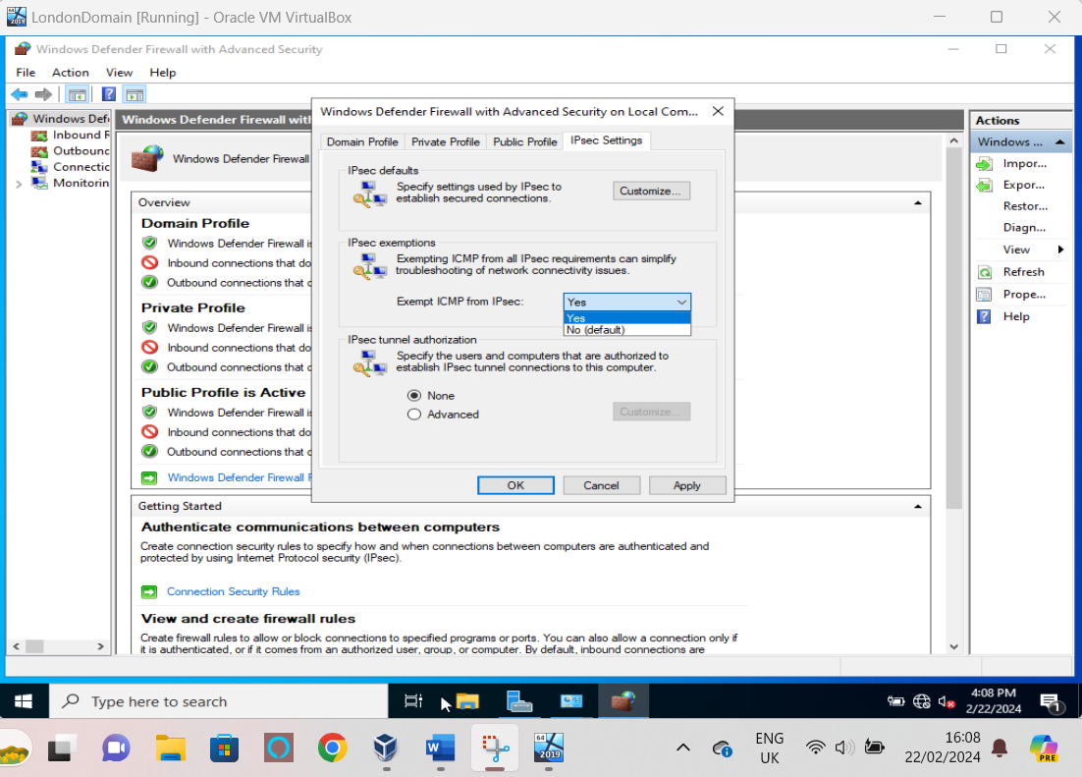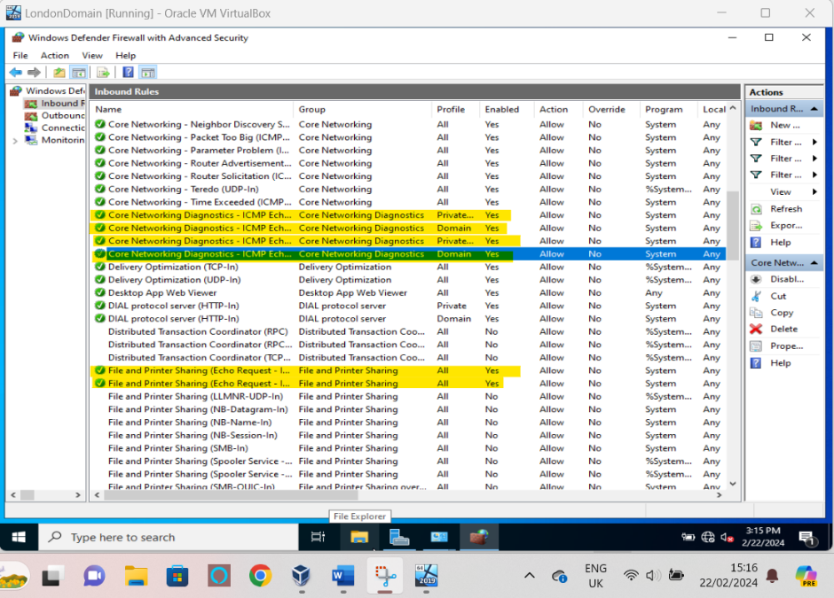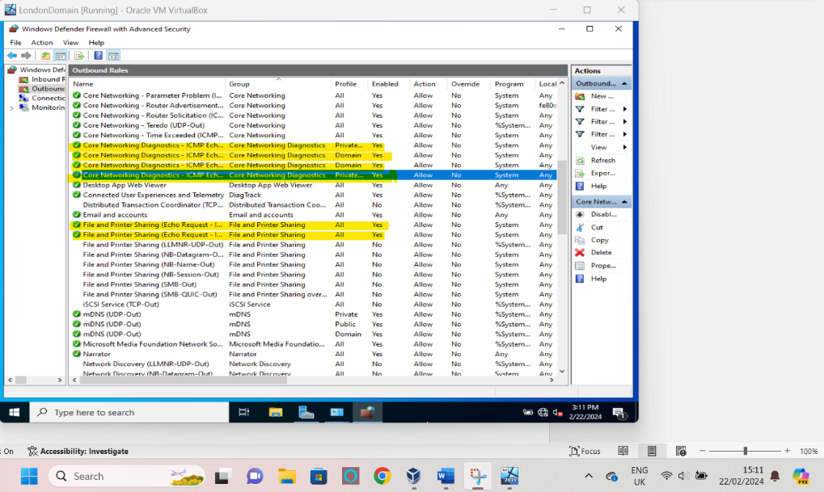
London Desktop Inbound & Outbound & IPsec |  | 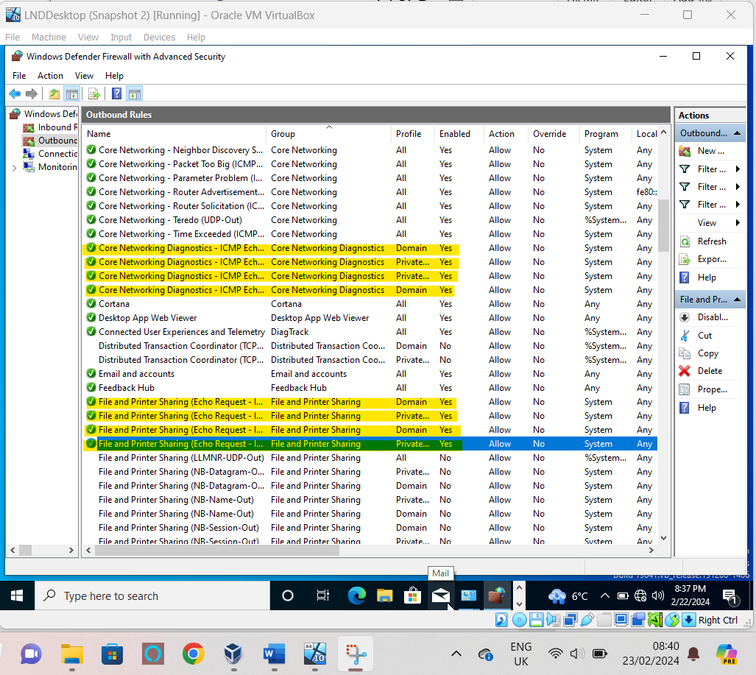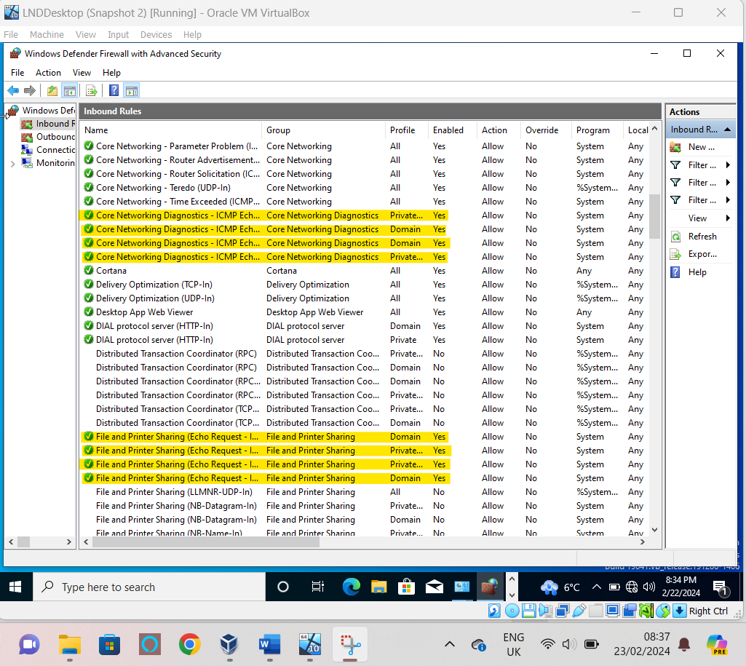  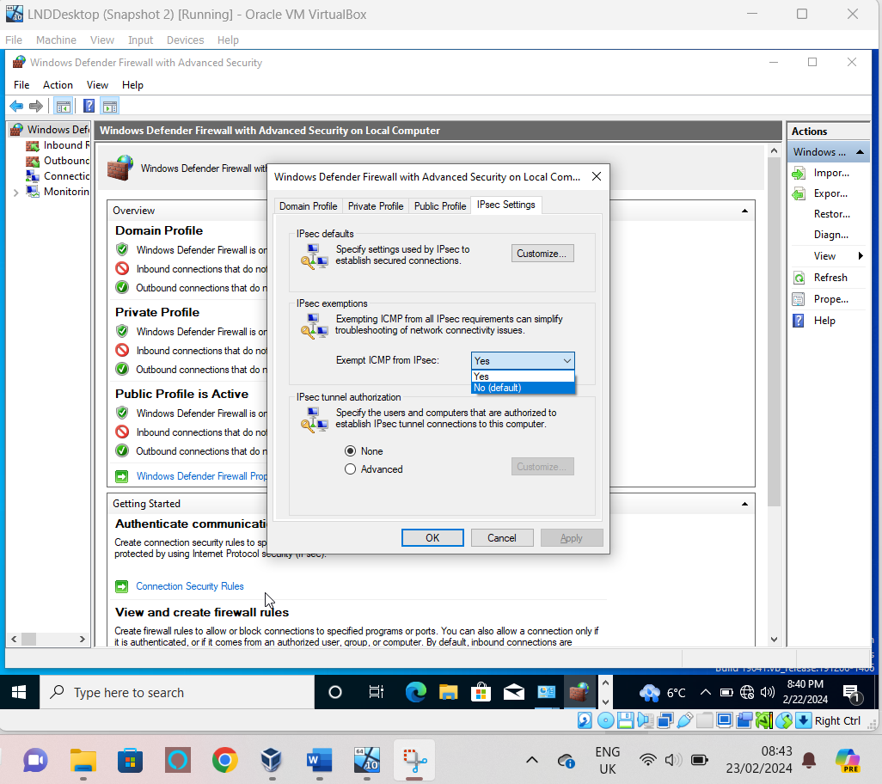
Swansea Domain Inbound & Outbound & IPsec |  | 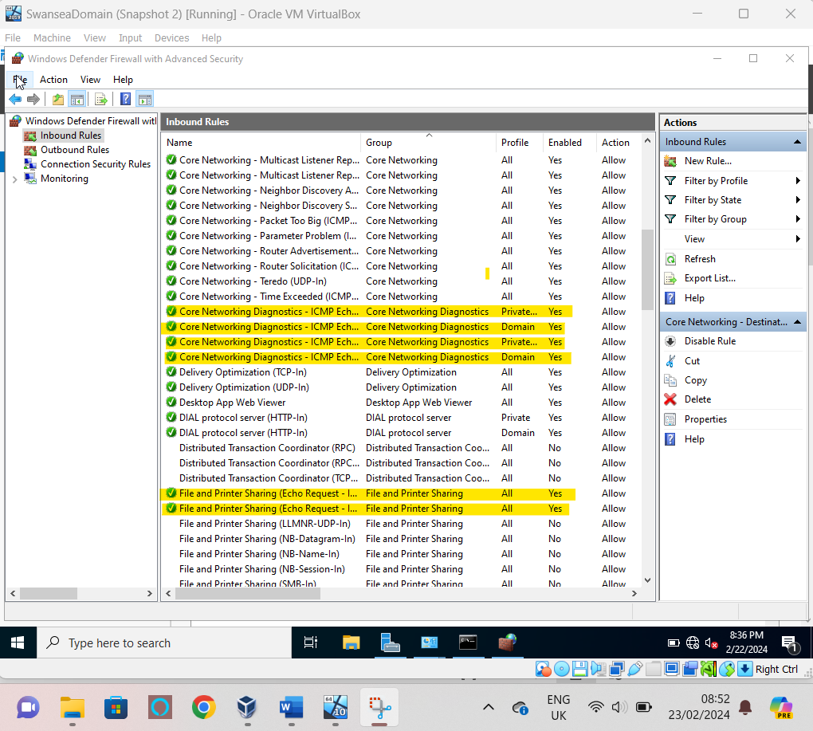  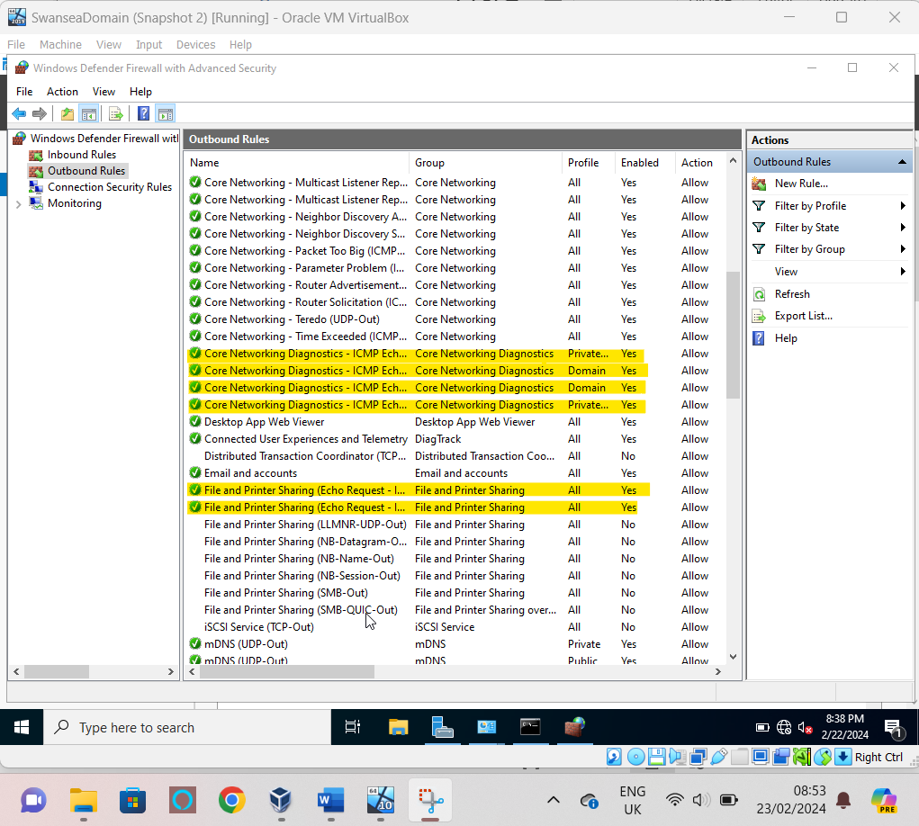  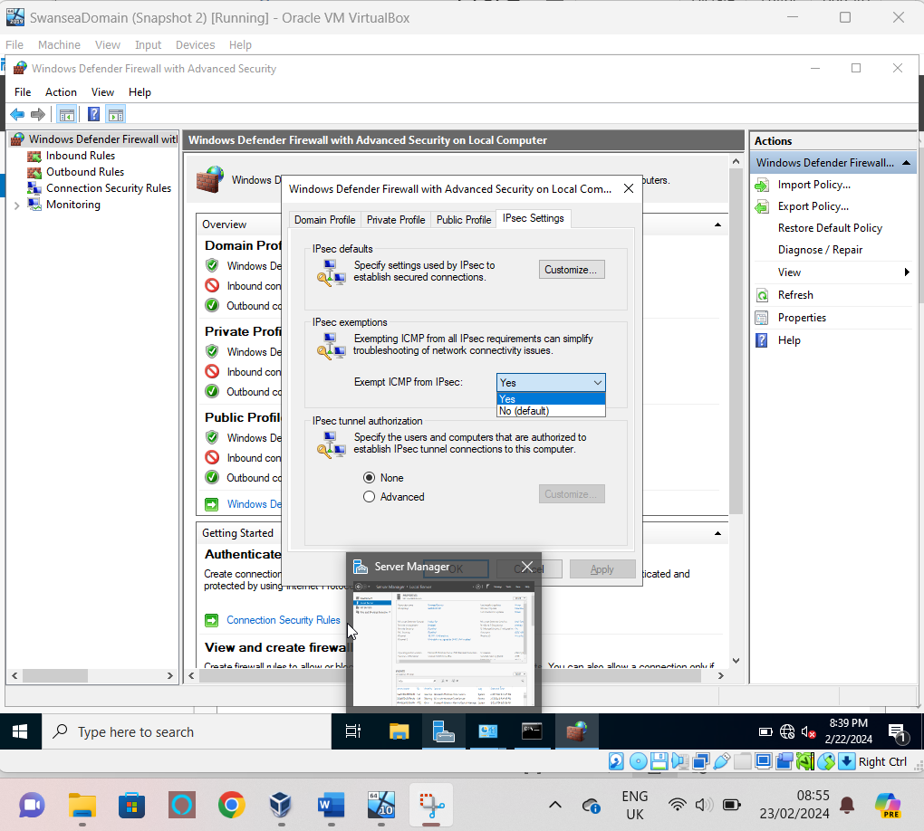
Swansea Desktop Inbound & Outbound & IPsec |  | 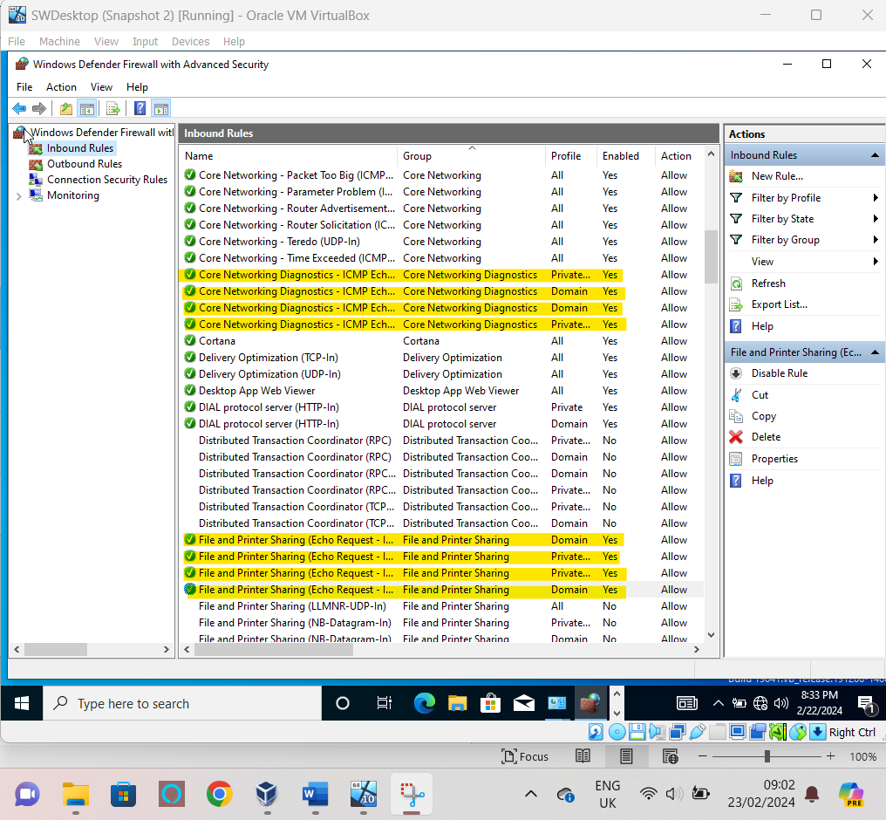  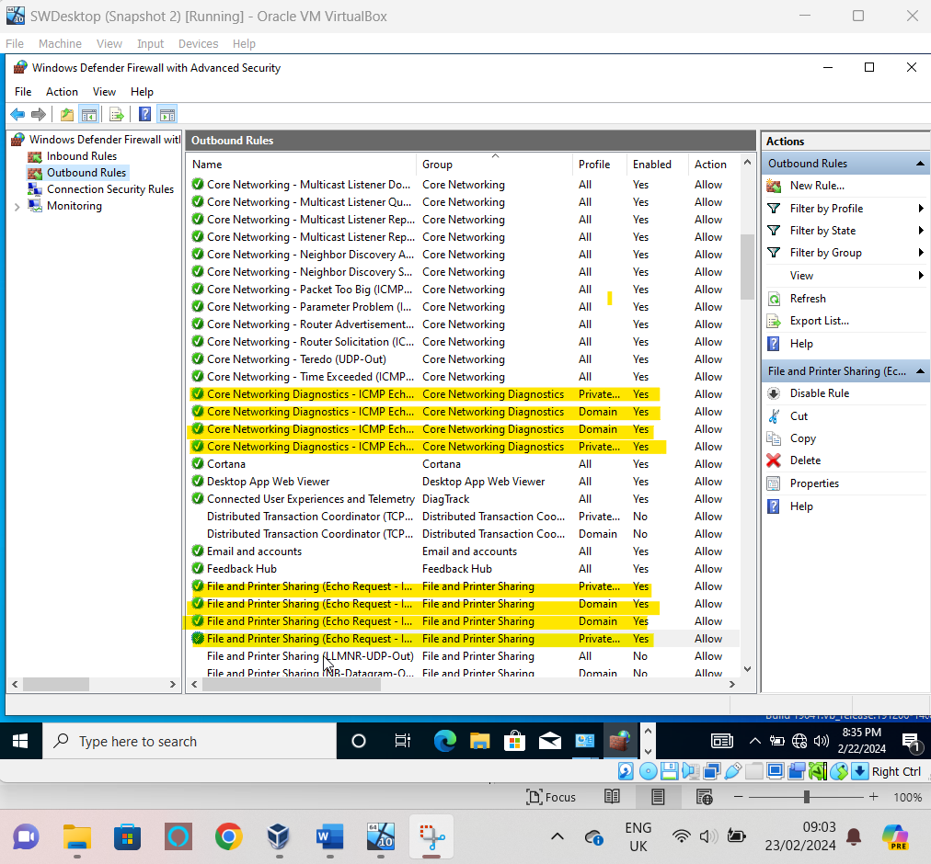  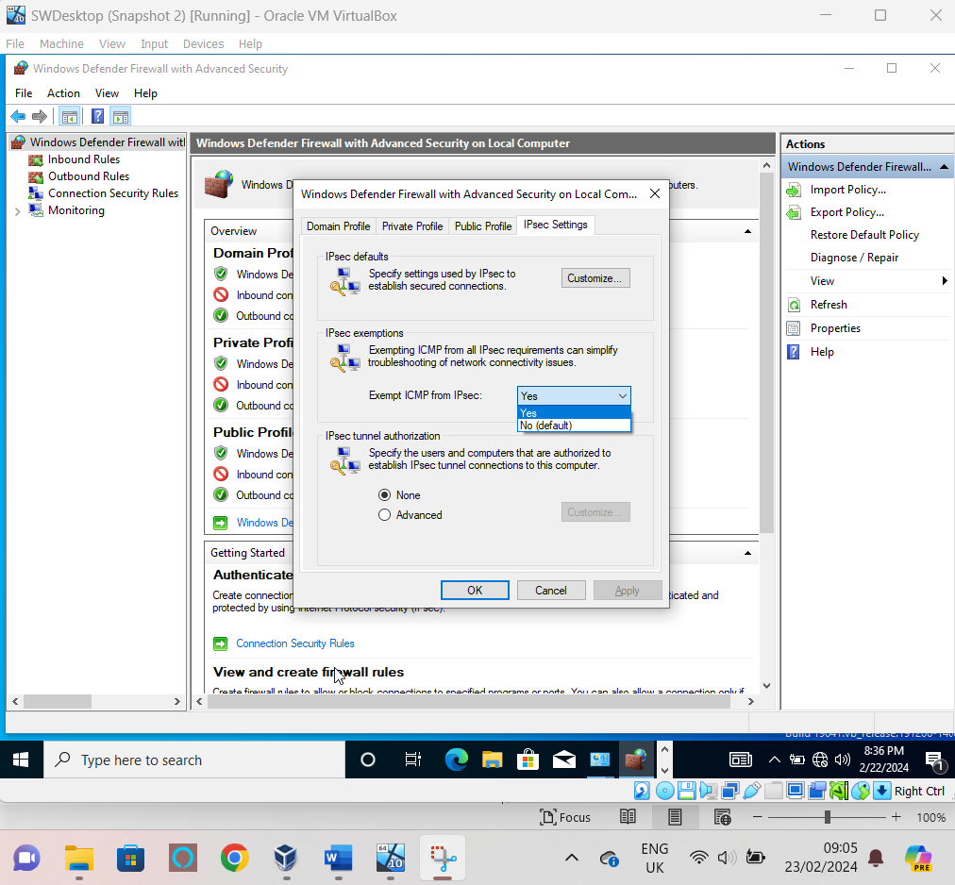

Ip configurations-

Thirdly I assigned the Ip addresses to the devices which were given to me in the brief for this topology to ensure connectivity I set the default gateway for all devices to their local server/desktop to ensure local communication.
London Server Ip | 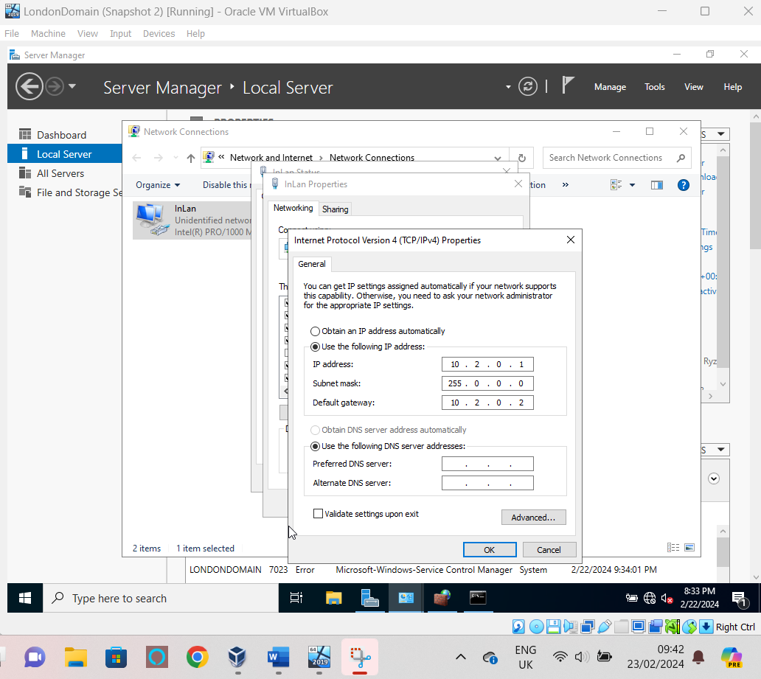
London Desktop Ip | 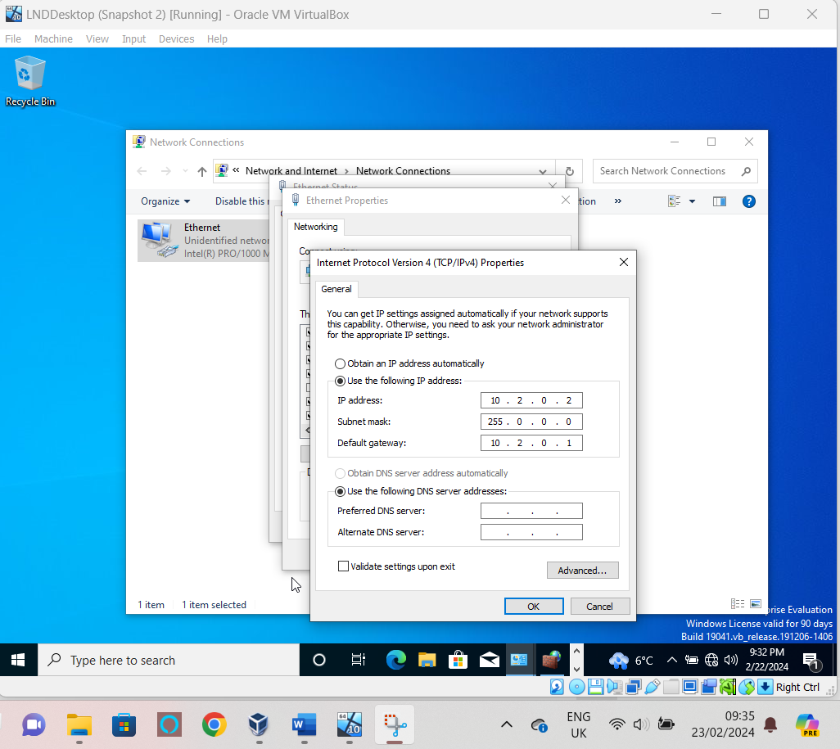
Swansea Server Ip | 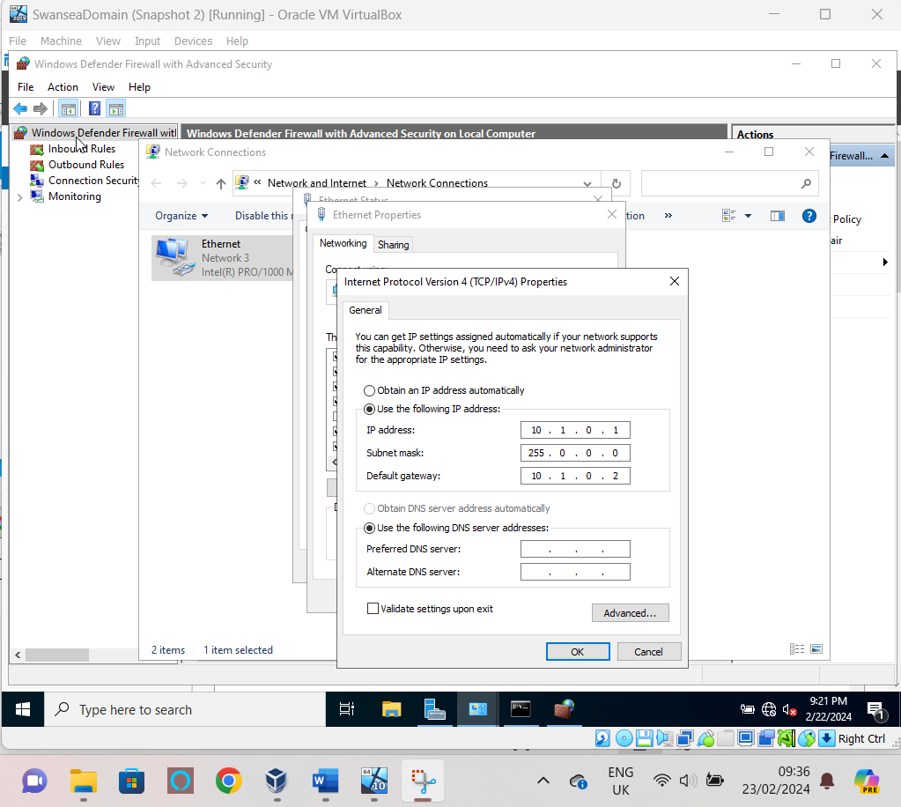
Swansea Desktop Ip | 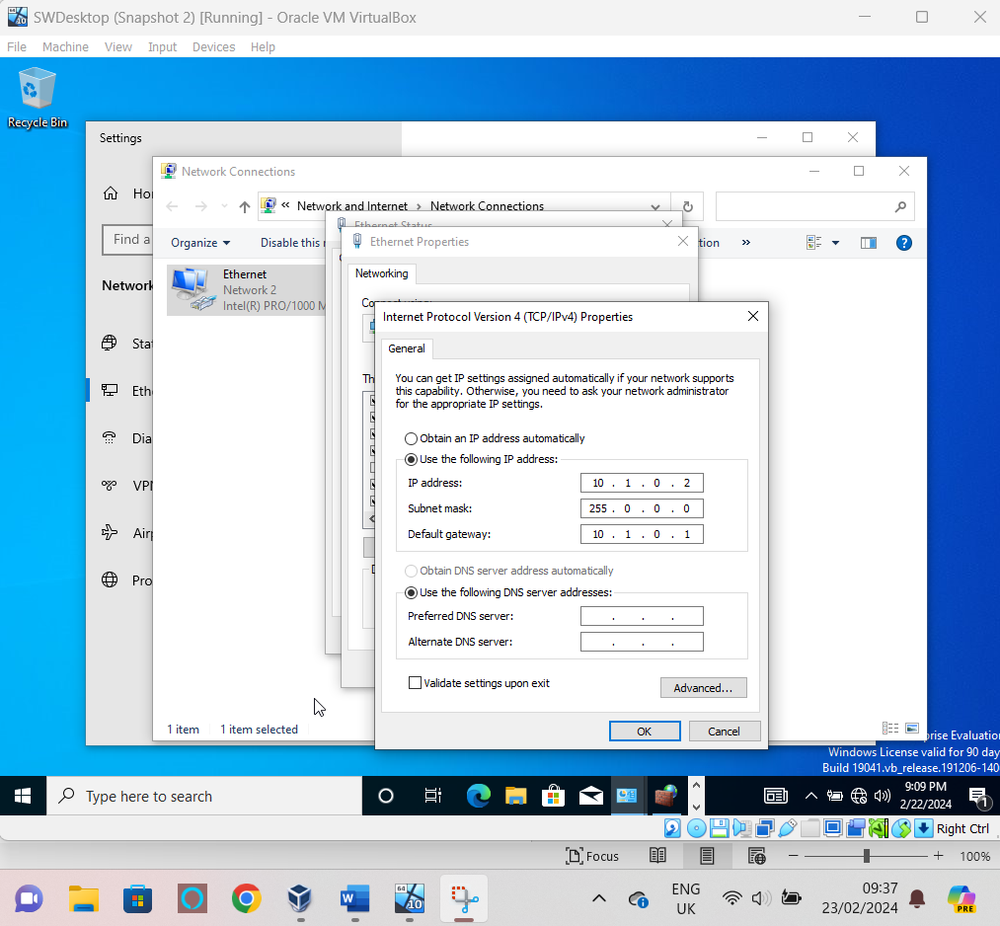

Final Ping connectivity

Finally, I conducted a connectivity check between the devise and managed to successfully ping each device which means all data being sent and received reaches it intended destinations meaning that the network is running with no problems. Initially I did encounter and issue with oracle resetting my Ip addresses but it was quickly resolved by replacing the addresses and retrying the connection which resulted in this final state.
London Server – London Desktop | 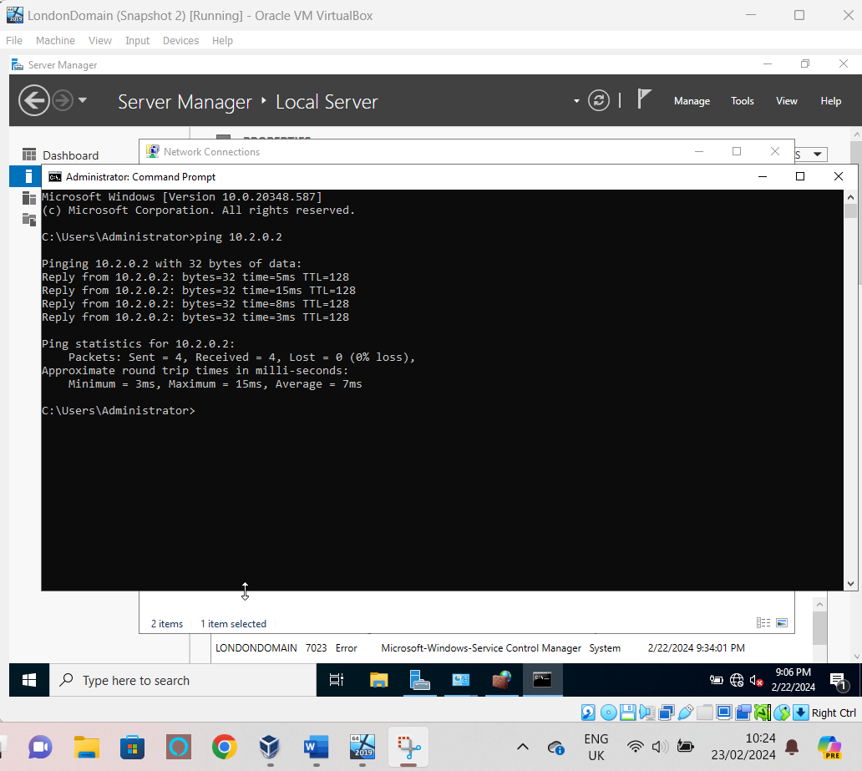
London Desktop – London Server | 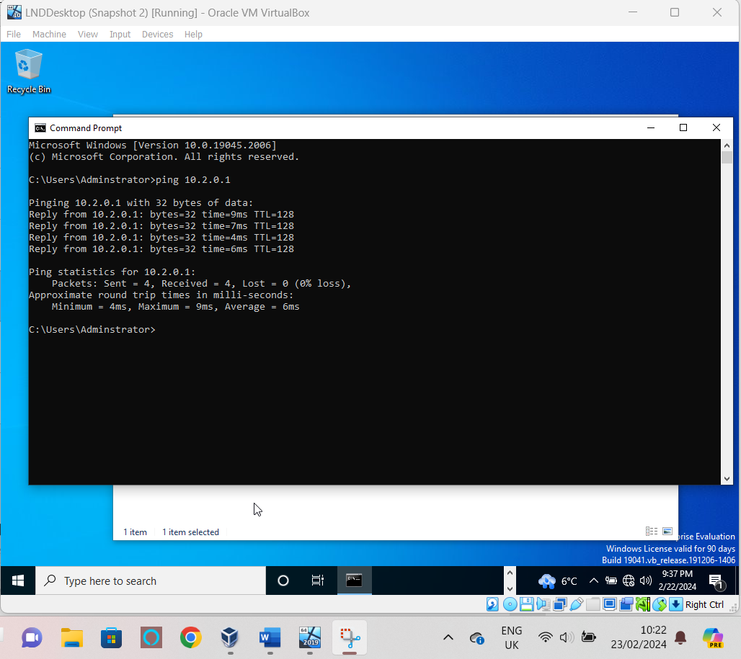
Swansea Server – Swansea Desktop | 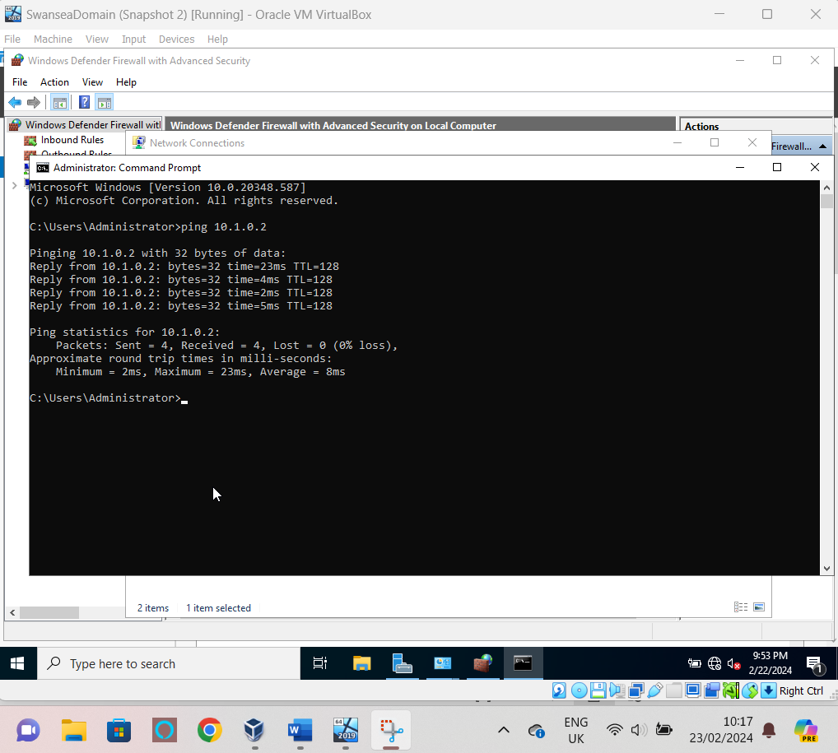
Swansea Desktop – Swansea Server | 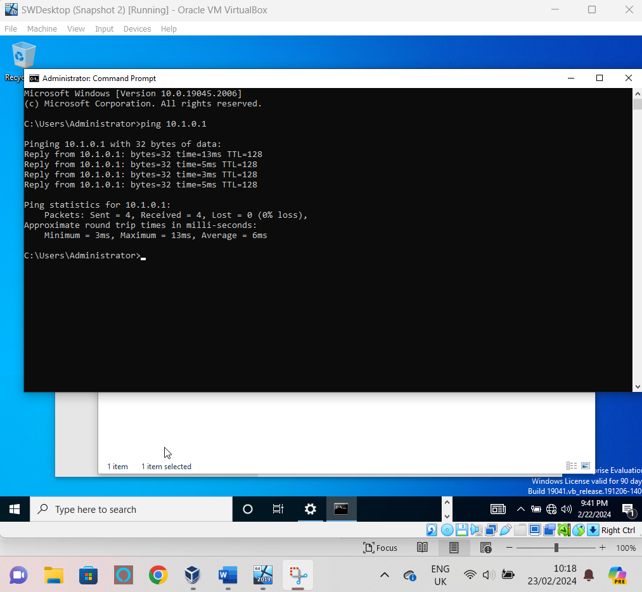
London Server – Swansea Server | 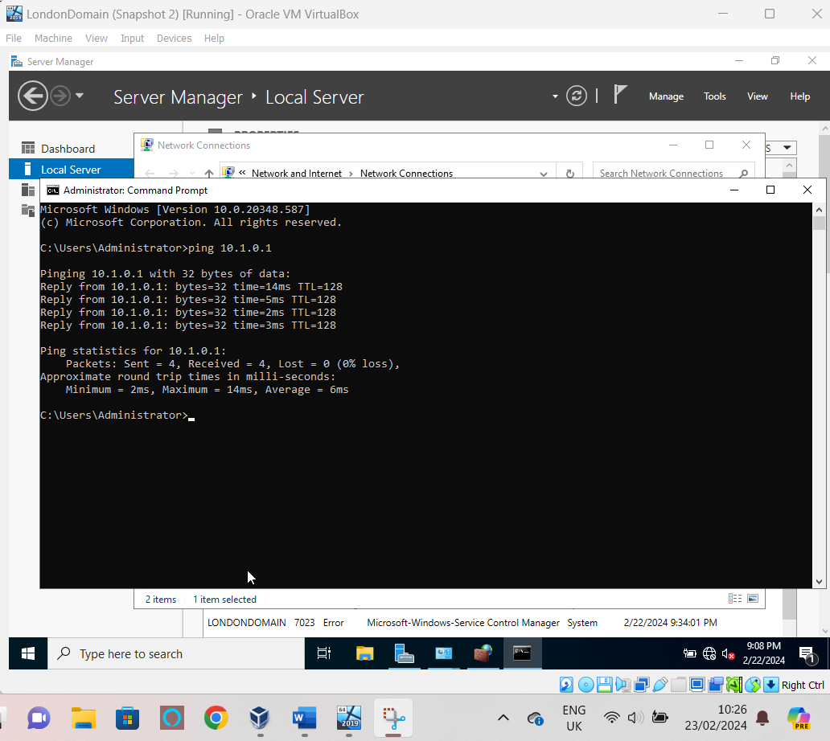
Swansea Server – London Server | 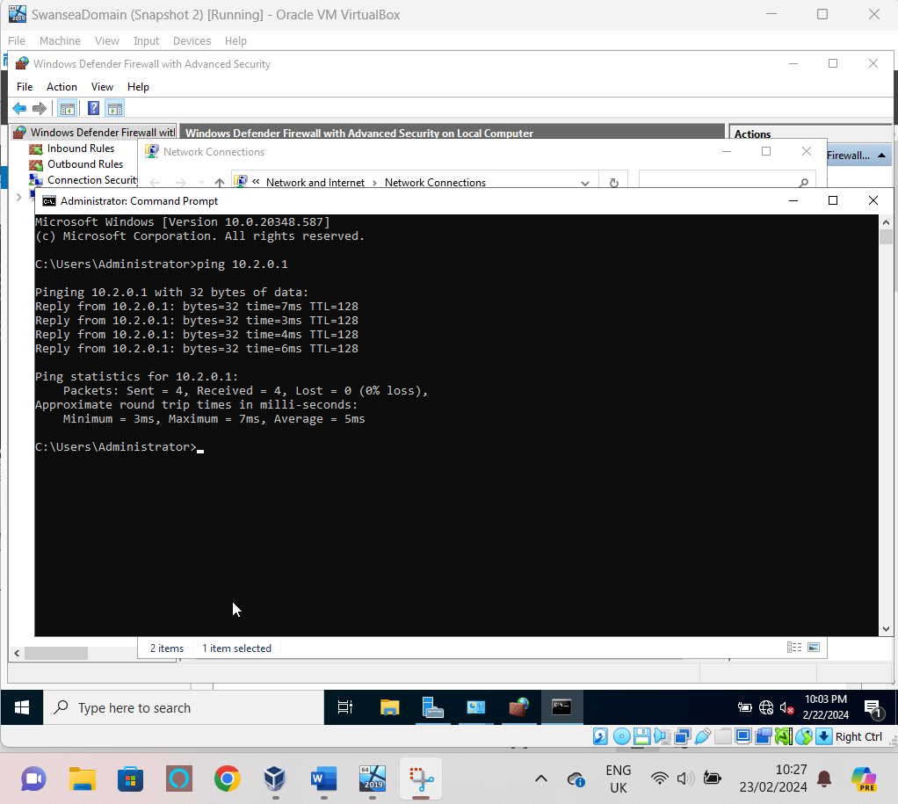

References

[1] E. Bauman, G. Ayoade and Z. Lin. E. Bauman, G. Ayoade and Z. Lin. A survey on hypervisor-based monitoring: Approaches, applications, and evolutions. A survey on hypervisor-based monitoring: Approaches, applications, and evolutions. 4848(1), pp. 1-33. pp. 1-33. 2015. . DOI: 10.1145/2775111.
[2] D. T. Vojnak, B. S. Ðorđević, V. V. Timčenko and S. M. Štrbac. D. T. Vojnak, B. S. Ðorđević, V. V. Timčenko and S. M. Štrbac. Performance comparison of the type-2 hypervisor VirtualBox and VMWare workstation. Performance comparison of the type-2 hypervisor VirtualBox and VMWare workstation. Presented at 2019 27th Telecommunications Forum (TELFOR). Presented at 2019 27th Telecommunications Forum (TELFOR). 2019, . DOI: 10.1109/TELFOR48224.2019.8971213.
[3] Deka Ganesh Chandra, Margaret Kathing and Das Prashanta Kumar. Deka Ganesh Chandra, Margaret Kathing and Das Prashanta Kumar. A comparative study on IPv4 and IPv6 | IEEE conference publication | IEEE xplore. A comparative study on IPv4 and IPv6 | IEEE conference publication | IEEE xplore. ; ; 2013. Available: https://ieeexplore.ieee.org/document/6524404.
[4] T. Van, T. Hai Anh, S. Sami and M. Abdelhamid. T. Van, T. Hai Anh, S. Sami and M. Abdelhamid. Network troubleshooting: Survey, taxonomy and challenges | IEEE conference publication | IEEE xplore. Network troubleshooting: Survey, taxonomy and challenges | IEEE conference publication | IEEE xplore. 2018. Available: https://ieeexplore.ieee.org/abstract/document/8585610?casa_token=SwKUs5BYaNQAAAAA:w6K_45ojTYs2KBOQGnve0v9iwLxGmhbc7Q8EFL-kAiAVYPbFKlpmfknfCVF9ILBTL9E4p1d64u6h.

