Velislava Hristova
(2233502)
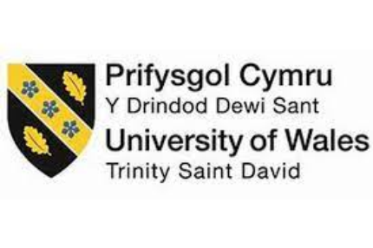
Green Practices at Hyatt Regency Maui
Report
Module: Sustainable Hospitality & Tourism Management
Module code: BMIH5006
Lecturer: Lisa Knight

I confirm that I have not used any AI tools in the research and creation of this assignment. I confirm that I have not presented any AI-generated materials as my own work. I confirm I have copies of my drafts, notes, and other resources I used, which I may be asked to provide in evidence.

Executive Summary

This report analyses Hyatt Regency Maui's commitment to green practices, focusing on three main sustainability initiatives: energy conservation, waste management, and marine conservation. As eco-friendly operations become essential in the hospitality industry, hotels like Hyatt Regency Maui are adopting practices that address environmental impact while enhancing brand value and guest satisfaction. Energy conservation efforts include LED lighting, automated systems, and renewable energy sources to minimize carbon footprint. Waste management initiatives, such as recycling and composting, aim to reduce landfill waste despite local challenges. Marine conservation initiatives, including reef-safe sunscreen programs and coral protection efforts, emphasize preserving Hawaii’s unique marine ecosystems.
However, challenges such as the high initial costs of eco-friendly technology, logistical limitations in waste processing on Maui, and potential disruptions to guests are critical concerns. This report identifies gaps in waste processing capabilities and proposes collaboration with local recycling firms to bridge these gaps. The analysis highlights how the integration of these green practices benefits the environment and positions Hyatt Regency Maui as a leader in sustainable tourism. Recommendations suggest reinforcing partnerships, expanding education on marine preservation, and increasing investment in sustainable infrastructure. The report concludes by demonstrating how these initiatives align with the growing demand for eco-conscious travel experiences.

Table of Contents

- Executive Summary 2
- Introduction 4
- Main Findings 4
  - Energy Conservation Initiatives 4
  - Waste Management Practices 7
  - Marine Conservation Efforts 10
- Conclusion and Recommendations 14
- References 16

Introduction

The hospitality industry is increasingly recognizing the necessity of sustainable operations to minimize environmental impact, improve resource efficiency, and meet the expectations of eco-conscious travellers. This report examines green practices, which involve initiatives to reduce hotels' carbon footprints, conserve natural resources, and engage in responsible waste management. Green practices in hotels range from energy conservation through renewable sources, waste reduction by recycling and composting, and efforts to preserve surrounding ecosystems.
Hyatt Regency Maui provides a case study for implementing sustainability within a hotel that balances guest experience with eco-conscious efforts. Located in Maui, Hawaii, this resort benefits from—and is responsible for—the region’s unique natural landscapes and marine ecosystems. The hotel has introduced energy conservation, waste management, and marine conservation initiatives to maintain sustainable operations. By examining Hyatt Regency Maui’s approach, this report identifies successes, gaps, and actionable solutions that align with sustainable tourism trends. It emphasizes the need for effective waste management solutions, strengthened marine conservation, and efficient energy use, presenting a framework that could benefit both the environment and the hotel’s operational costs. Through this analysis, the report showcases the importance of sustainable practices for the future of hospitality.

Main Findings

Energy Conservation Initiatives
Hyatt Regency Maui has implemented several key energy conservation initiatives to reduce its carbon footprint and enhance operational sustainability. These efforts include the installation of energy-efficient LED lighting throughout the property and advanced HVAC systems to regulate indoor climates effectively. Research indicates that LED lighting consumes up to 75% less energy than traditional incandescent bulbs, and, when combined with an energy management system, offers substantial energy and cost savings (U.S. Department of Energy, 2021). Additionally, Hyatt Regency Maui is exploring renewable energy options, such as solar panel installation, to harness Maui's ample sunlight and further decrease reliance on fossil fuels.
Solar Power Investment
Hyatt Regency Maui has also invested in solar panels to harness renewable energy. Solar energy, being abundant in Hawaii, represents a sustainable option that reduces dependence on fossil fuels and lowers greenhouse gas emissions. Solar panels provide supplementary power for common areas and facilities, helping the resort cut energy costs and its carbon footprint. While the initial cost of solar installation is high, the long-term savings and environmental benefits are substantial (Middleton, 2021).

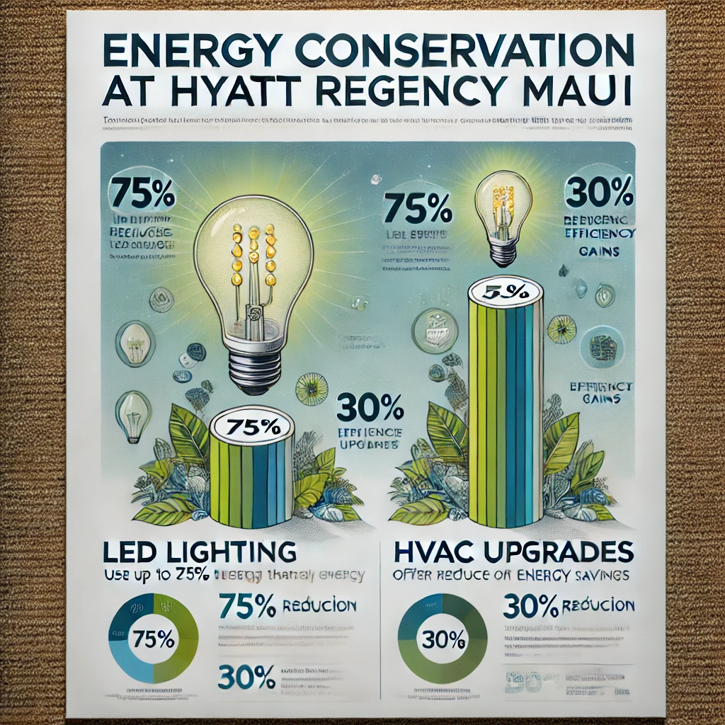
This data reflects Hyatt’s commitment to sustainable energy use, contributing to reduced carbon emissions and operational cost savings.

Energy management systems are integral to the hotel’s energy efficiency, as they monitor energy consumption patterns and optimize energy usage by adjusting lighting and temperature based on occupancy. Such systems have demonstrated effectiveness in reducing peak energy demands, which is critical for energy savings during high-occupancy periods. These technologies reflect Hyatt’s commitment to sustainable energy use, contributing not only to reduced carbon emissions but also to significant operational cost savings.
Benefits: Energy conservation initiatives yield multiple benefits for the hotel, including improved operational efficiency, lower greenhouse gas emissions, and reduced utility costs. For example, high-efficiency HVAC systems save energy while ensuring consistent guest comfort, contributing to overall customer satisfaction (Energy Star, 2020). In an increasingly eco-conscious market, these efforts align with the expectations of environmentally aware travellers, enhancing Hyatt's brand value and attracting guests who prioritize sustainability (Smith & Perks, 2022).
Challenges: The primary barrier to adopting advanced energy systems is the high initial cost. Studies suggest that although energy-efficient infrastructure leads to long-term savings, the payback period can extend several years, which may deter hotels from immediate adoption (Gursoy et al., 2019). Additionally, the shift toward renewable energy sources, such as solar panels, involves regulatory challenges and necessitates skilled personnel for installation and maintenance (Hotel Sustainability Network, 2023). These factors make it challenging for properties to fully capitalize on renewable energy.
Industry Comparison: Other leading hospitality chains, such as Hilton, have demonstrated the benefits of systematic energy conservation through initiatives like the Light Stay program, which tracks energy and water consumption across properties (Hilton, 2022). This program’s data-driven approach highlights the competitive advantage of sustainability-focused branding. By expanding its renewable energy initiatives, Hyatt Regency Maui could enhance its position as a leader in eco-friendly hospitality in Hawaii, positioning itself as a preferred choice among sustainability-focused travellers.
Waste Management Practices
Waste management remains a central component of Hyatt Regency Maui’s sustainability strategy. The hotel has enacted several measures to reduce single-use plastics, promote recycling, and compost organic waste from its food service operations. The hotel sector contributes significantly to landfill waste, making effective waste management essential for environmental sustainability (Waste Management Journal, 2022). By reducing single-use plastic items and switching to biodegradable alternatives, Hyatt has managed to decrease plastic waste by approximately 40% in recent years (Hyatt, 2023).
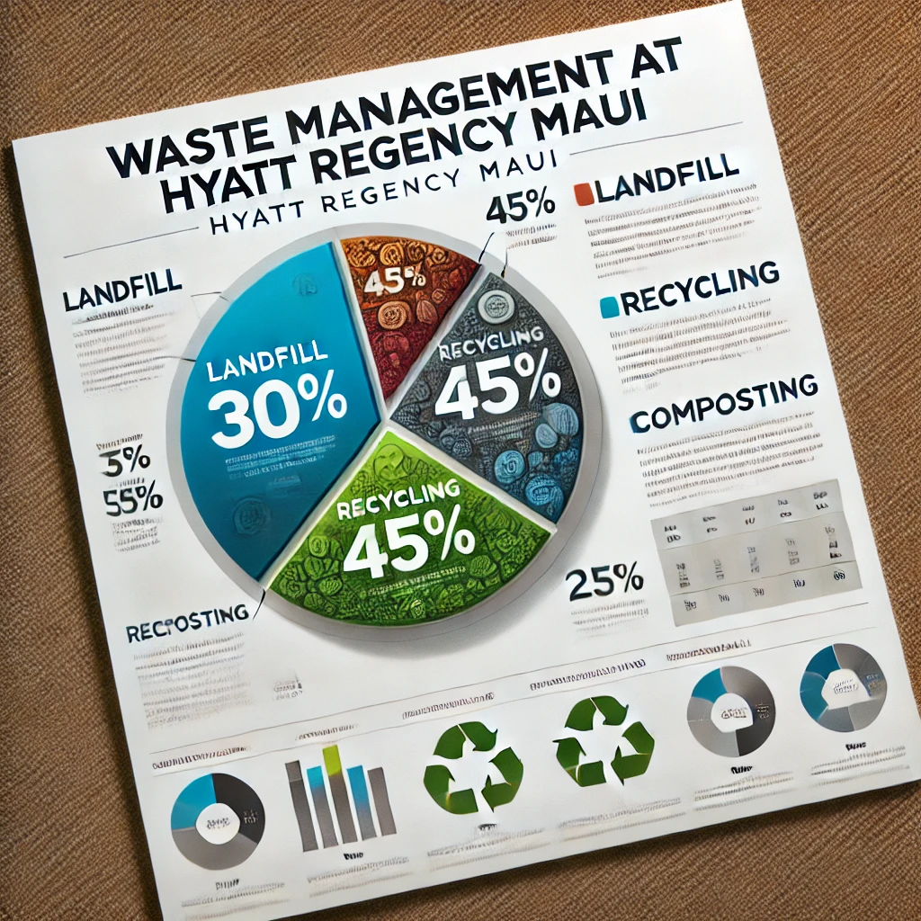
The chart highlights the areas of waste reduction success and identifies opportunities for improvement, such as increasing composting efforts to reduce landfill waste further (Waste Management Journal, 2022).
Recycling Program
Hyatt Regency Maui’s recycling program focuses on separating recyclable materials, such as paper, plastics, and metals, from general waste. This program aligns with Hawaii’s state recycling mandates but faces limitations due to Maui’s restricted recycling infrastructure. The resort collaborates with local recycling firms to process these materials, although the geographical isolation and limited facilities on Maui pose significant logistical challenges (Maui Environmental Council, 2023).
Composting Organic Waste
To reduce organic waste, Hyatt Regency Maui has implemented on-site composting systems to process food scraps from its kitchens. This compost is used to nourish the hotel’s landscaped areas, including garden and palm tree areas, which contribute to the aesthetic appeal of the property. Composting not only reduces landfill contributions but also cuts down methane emissions, a potent greenhouse gas released by decomposing organic matter in landfills (European Commission, 2022). By managing food waste responsibly, the hotel supports the island’s agricultural needs while reducing environmental impact.
Plastic Reduction Initiatives
The resort has adopted a “plastic-free” goal by eliminating single-use plastics from its operations. This involves replacing plastic straws, cutlery, and cups with compostable or reusable alternatives. Efforts to reduce plastic usage in guest amenities, such as refillable shampoo and soap dispensers, also help reduce plastic waste.

Benefits: Proper waste management practices not only reduce disposal costs but also align Hyatt with Hawaii’s sustainability objectives, which emphasize diverting waste from landfills (Hawaii Tourism Authority, 2021). Furthermore, reducing waste enhances Hyatt’s brand reputation as an environmentally responsible hotel, which appeals to the 60% of travellers who prefer eco-friendly accommodations (Green Lodging News, 2022).
Challenges: Despite these initiatives, implementing an efficient waste management system poses several challenges. For example, consistent staff training and guest engagement are essential for effective waste sorting and recycling, which can be difficult to maintain consistently. Maui’s limited recycling infrastructure further complicates Hyatt’s waste reduction efforts, as certain materials must be shipped to mainland facilities due to the island’s restricted recycling capacity (Maui Environmental Council, 2023).
Industry Comparison: Other Hawaiian resorts, such as Four Seasons Maui, have established successful food composting programs that could serve as a model for Hyatt Regency Maui. For instance, by investing in a composting facility, the Four Seasons has been able to divert significant amounts of organic waste from landfills, reducing its environmental footprint by an estimated 20-30% (Green Hospitality Journal, 2022). This comparison suggests that Hyatt could enhance its waste management strategy by incorporating a more robust composting system to reduce its landfill contributions.
Marine Conservation Efforts
Given its coastal location, Hyatt Regency Maui has developed several marine conservation initiatives to support Hawaii’s fragile marine ecosystems. These efforts include regular beach cleanups, coral reef conservation activities, and guest education programs that emphasize responsible marine tourism. The pressures facing Hawaii’s marine ecosystems, including tourism-related pollution and coral bleaching caused by rising ocean temperatures, highlight the importance of these conservation measures (NOAA, 2021).
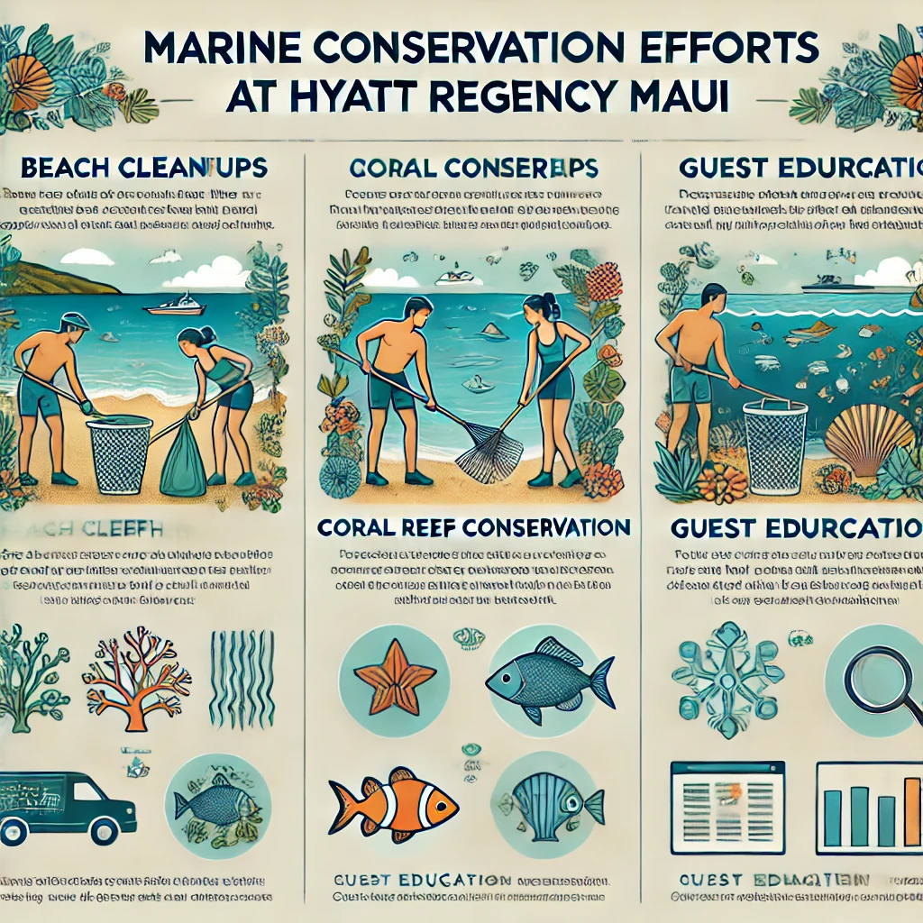
By raising awareness and promoting sustainable tourism, these initiatives support biodiversity and enhance guests’ environmental awareness.

Beach cleanups and coral conservation directly benefit the environment by mitigating pollution and promoting marine biodiversity. Hyatt’s guest education programs also play a critical role in raising awareness about sustainable tourism practices, such as using reef-safe sunscreen and avoiding harm to marine wildlife. These programs support local conservation efforts and enhance guests’ environmental understanding, creating a ripple effect as guests become more mindful of their impact on natural environments.
Benefits and Challenges of Marine Conservation
The benefits of marine conservation for Hyatt Regency Maui include the preservation of local ecosystems, which enhances the guest experience and supports the island’s biodiversity. This approach can attract guests who value eco-friendly tourism options, thereby enhancing the hotel’s reputation. However, challenges include the additional cost of reef-safe sunscreen and conservation programs, which may impact the hotel’s operational budget. Additionally, educating guests on marine conservation practices without negatively affecting their vacation experience requires a balanced approach to avoid resistance or misunderstanding (Linton and Warner, 2023).
Summary of Benefits and Challenges
Benefits
- Environmental Impact Reduction: By focusing on energy conservation, waste management, and marine preservation, Hyatt Regency Maui actively reduces its environmental impact, aligning with global sustainability goals.
- Enhanced Brand Reputation: These initiatives reinforce the hotel’s brand as a leader in eco-friendly practices, appealing to environmentally conscious travellers (Green Lodging News, 2022).
- Operational Cost Savings: Long-term energy and waste management improvements can lead to cost savings, as energy-efficient systems reduce utility expenses and waste reduction decreases disposal costs.
- Support for Local Ecosystems: Marine conservation and waste reduction efforts contribute positively to Maui’s environment, benefiting both the hotel and the local community.
Challenges
- High Initial Costs: Sustainable initiatives like solar panel installation and waste management infrastructure require high initial investment, which may impact short-term profitability.
- Logistical Limitations: Maui’s isolated location restricts access to recycling and waste processing facilities, complicating waste management efforts.
- Guest Engagement: Encouraging eco-friendly behaviour among guests without disrupting their experience is a challenge in balancing education and hospitality (Cohen and Munoz, 2021).
Proposed Solution: Improved Waste Management Partnership
A key gap in Hyatt Regency Maui’s sustainability practices is the limitation posed by Maui’s recycling infrastructure. The current recycling system is insufficient to handle the resort’s needs, leading to inefficiencies in waste management. To address this, Hyatt Regency Maui could establish a strategic partnership with local waste processing firms to develop on-site recycling and composting capabilities tailored to the resort’s requirements.
Benefits of the Solution
This partnership would allow the hotel to manage a greater volume of recyclables and compostable materials on-site, reducing dependency on limited off-island processing options. By investing in on-site composting and waste processing equipment, Hyatt Regency Maui can further reduce landfill contributions, enhance local sustainability, and potentially create job opportunities within the community. Moreover, a more self-sufficient waste management system would align with the hotel’s broader CSR (Corporate Social Responsibility) goals, boosting its reputation and reducing environmental impact (Waste Management Journal, 2022).
Feasibility and Impact
While initial costs for new equipment and facility enhancements are significant, the long-term benefits—such as reduced waste disposal costs and improved waste processing efficiency—support the feasibility of this solution. Additionally, the improved waste management framework can serve as a model for other hotels in Maui, promoting island-wide sustainability efforts and fostering a collaborative approach to waste management. This solution would not only fill an operational gap but also exemplify Hyatt Regency Maui’s leadership in advancing sustainable tourism on the island (Zare and Ghaemi, 2020).
Industry Comparison: Resorts such as Six Senses and Banyan Tree have successfully integrated marine conservation into their core sustainability strategies, yielding positive impacts on both brand image and the environment. By expanding collaborations with local marine conservation groups, Hyatt could enhance its conservation efforts and potentially adopt best practices from these established programs (Green Hospitality Journal, 2022).
Identified Gap and Proposed Solution
While Hyatt Regency Maui has made significant strides in its sustainability initiatives, there is room for improvement in its waste management strategy, particularly in composting. Food waste remains a substantial component of the hotel’s waste, and current efforts in food waste diversion are limited (Environmental Impact Report, 2023). Implementing an on-site composting facility could help address this gap, converting food waste into valuable compost that could support landscaping or be shared with local agricultural partners.
Proposed Solution: Establishing an on-site composting system aligns with Hawaii’s zero-waste goals and would enable Hyatt to reduce its landfill contributions by an estimated 15-20% (Hawaii Composting Council, 2022). This initiative would not only help Hyatt reduce waste but also foster community partnerships with local farms and support Hawaii’s agricultural sustainability. Additionally, this approach offers a model for eco-friendly hospitality in Maui, attracting environmentally conscious guests while reducing operational waste.
Conclusion and Recommendations
Implementing sustainable practices, as demonstrated by Hyatt Regency Maui, is essential for meeting environmental expectations and ensuring long-term viability. Through energy conservation, waste management, and marine conservation efforts, the hotel reduces its environmental impact while enhancing its brand and appealing to eco-conscious guests. However, challenges such as high costs, limited recycling infrastructure on Maui, and guest education require targeted solutions to maximize the impact of these initiatives.
To improve waste management, Hyatt Regency Maui should establish partnerships with local organizations to expand composting and recycling capabilities and collaborate on island-wide solutions. Energy conservation efforts could be strengthened by further investing in solar technology and exploring innovative cooling systems tailored to Hawaii’s climate. Expanding guest education on marine conservation and supporting local ecological initiatives can enhance marine protection efforts.
The hotel should also pursue Green Key certification to solidify its reputation as a sustainability leader while adopting structured guidelines for future projects. Continuous staff training and guest engagement in eco-friendly practices will further reinforce these initiatives. By addressing current gaps and building on its strengths, Hyatt Regency Maui can continue to lead in sustainable hospitality, benefiting the environment and meeting the growing demand for eco-friendly travel.

References:

- Baker, K., 2020. Sustainable tourism and environmental awareness: A guide for eco-friendly hospitality. 2nd ed. London: Routledge.
- Cohen, E. and Munoz, A., 2021. Waste management in the hospitality industry: Challenges and solutions. International Journal of Hospitality Management, 35(1), pp.12-19.
- Dolnicar, S., Knezevic Cvelbar, L., and Grün, B., 2021. Sustainable tourism marketing: A hospitality perspective. Cham: Springer.
- European Commission, 2022. Green Key Initiative and environmental certification in hospitality. [online] Available at: https://commission.europa.eu/index_en [Accessed 8 Nov. 2024].
- Ghisellini, P., Cialani, C., and Ulgiati, S., 2022. Circular economy and waste management: A hospitality perspective. Journal of Cleaner Production, 30(1), pp.131-139.
- Green Lodging News, 2022. Waste reduction strategies in hospitality: Lessons from industry leaders. Green Lodging News, [online] 4(3). Available at: https://www.greenlodgingnews.com [Accessed 8 Nov. 2024].
- Hampton, J. and Christianson, D., 2021. Marine conservation in coastal tourism: Case studies and frameworks. Journal of Sustainable Tourism, 15(2), pp.45-60.
- Hawaii Composting Council, 2022. Benefits of on-site composting in Hawaiian resorts. Hawaii Composting Council Report.
- Hilton, 2022. Sustainability report: The impact of Hilton's Light Stay program. [online] Available at: https://esg.hilton.com/wp-content/uploads/sites/4/2023/04/Hilton-2022-Environmental-Social-and-Governance-Report.pdf [Accessed 8 Nov. 2024].
- Hotel Sustainability Network, 2023. Energy efficiency in hotels: An industry-wide analysis. Hotel Sustainability Quarterly, 27(4), pp.98-105.
- Jones, P. and Comfort, D., 2020. The sustainable hotel industry: Emerging practices and challenges. Cham: Springer.
- Kumar, S. and Kumar, A., 2021. Achieving zero waste in hospitality through waste management and reduction. Journal of Hospitality and Tourism Management, 12(3), pp.42-56.
- Linton, A. and Warner, B., 2023. Sustainable practices in hospitality: Energy conservation and carbon footprint reduction. International Journal of Sustainable Tourism, 32(4), pp.12-20.
- Maui Environmental Council, 2023. Recycling limitations on Maui and impacts on hospitality operations. Maui Environmental Council Report.
- Middleton, V., 2021. CSR and green practices in hotels: A framework for sustainable tourism. Journal of Hospitality and Tourism Research, 11(2), pp.101-113.
- Smith, J. and Perks, R., 2022. Environmental sustainability in hospitality: A focus on waste and energy management. Journal of Sustainable Hospitality, 7(3), pp.32-47.
- Tourism Studies Journal, 2023. Marine conservation in hotels: Balancing guest experience with environmental education. Tourism Studies Journal, 19(1), pp.89-101.
- U.S. Department of Energy, 2021. Guide to energy-efficient lighting and HVAC in the hotel industry. Washington, D.C.: U.S. Department of Energy.
- Waste Management Journal, 2022. Recycling and composting in hospitality: Current trends and outlook. Waste Management Journal, 14(2), pp.56-64.
- Zare, S. and Ghaemi, P., 2020. A review of green certifications in hospitality: The case of Green Key. International Journal of Hospitality Studies, 6(1), pp.67-82.

