MDARZINS ID 1909722
Lab 4
Task 1
PC0 = 192.168.72.30
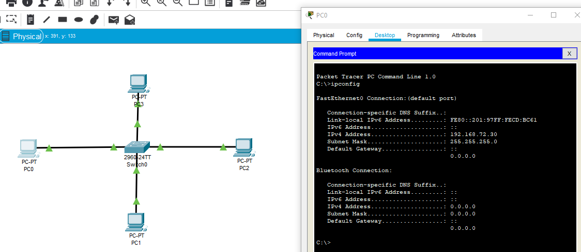
PC1 = 192.168.72.40
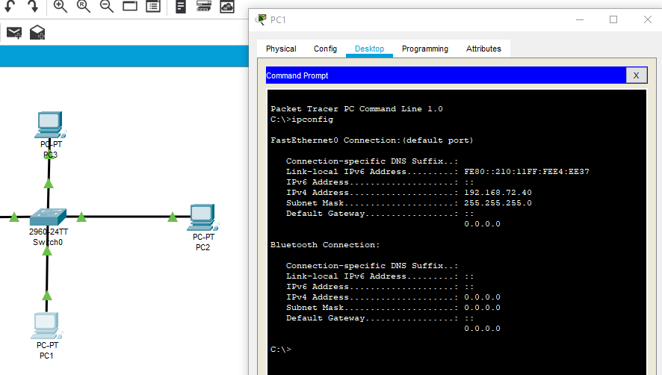
PC2 = 192.168.72.50
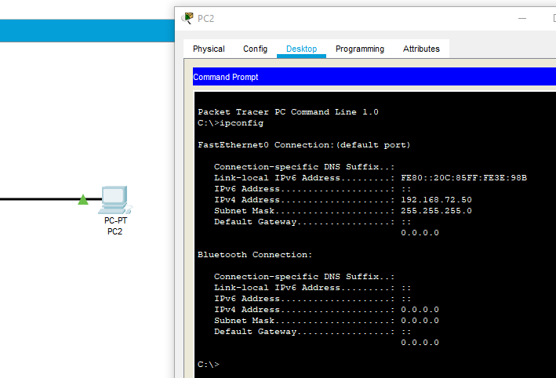
PC3 = 192.168.72.70

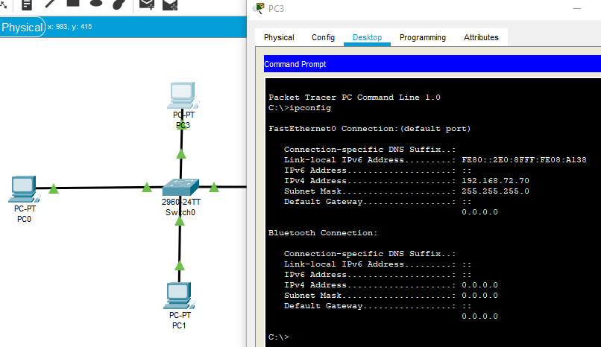
All with subnet mask = 255.255.255.0
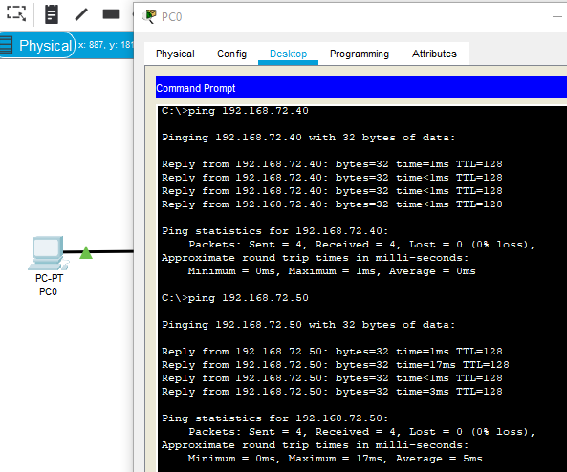
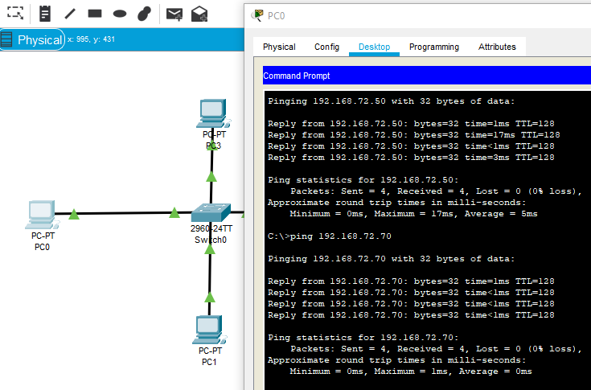
Ipconfig & ping to all PC’s successful.
Qu 2 Give HOST a name
Change HOST name
At Config tab change Hostname to SwTMyFirstSwitch
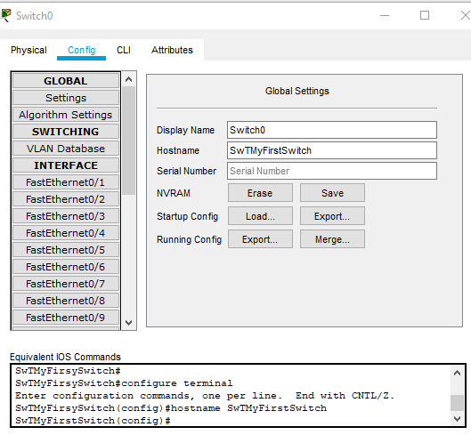

Qu. 3 Passwords
On Switch click select Command Line CLI
Place cursor in IOS Command Line Interface box and then press ENTER
At Switch>type enable then press ENTER
Switch (hatch) appears
Type config t and then press ENTER
NOTE: config t NOT required if HOSTNAME changed in Config box
Now Switch (config) hatch appears
Type Line console 0 and then press ENTER
Now Switch (config-line) hatch appears
Type password cisco123 and then press ENTER
At next line/hatch type login and then press ENTER
At next line/hatch type Exit and then press ENTER
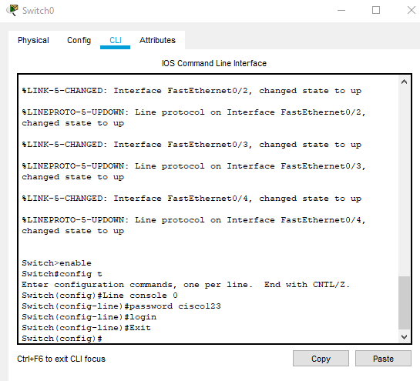

Config vty password
Same process as above, just change details to
Line vty 0 15
Password 1CiSc3
Login
Exit
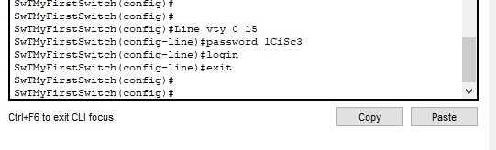
Enable privileged password
Type enable password cisco a nd press ENTER

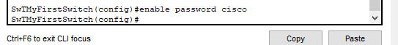
Once fully exited
Place cursor in IOS Command Line Interface box
Press ENTER
At User Access Verification Password
Type cisco123 ………….this will NOT be displayed

SwTMyFirstSwitch will be displayed
Type enable at the >prompt and press ENTER
You will be requested for a further password
Type cisco and press ENTER…this pw will NOT be displayed
Now you should see
SwTMyFirstSwitch in (hatch) mode
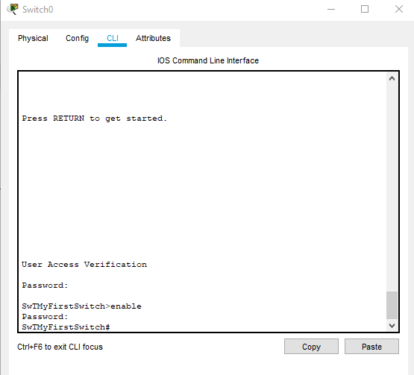

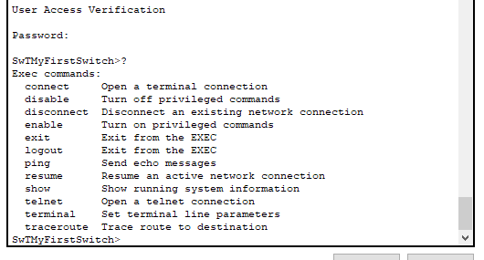
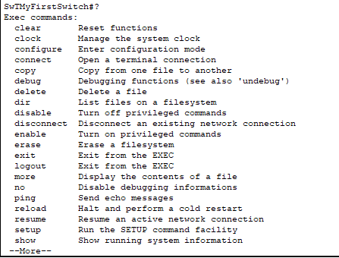
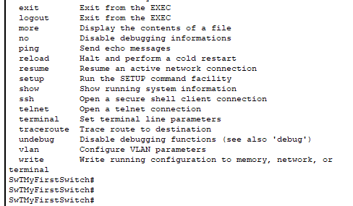
Observe running configurations
Type show running-config press ENTER

Privileged password is shown
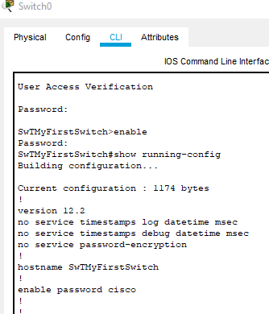

Remove privileged password
Privileged password now encrypted
Login in cisco123 then cisco
Enable
Config t
Type no enable password
Type enable secret cisco
Exit
Once out of (config) mode
Type show running-config
Password is now encrypted

Before = 1199 bytes After = 1228 bytes (with service pw encryption)
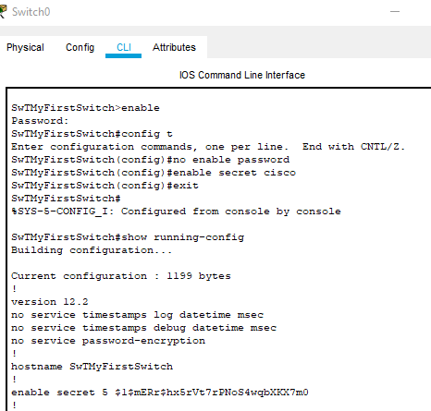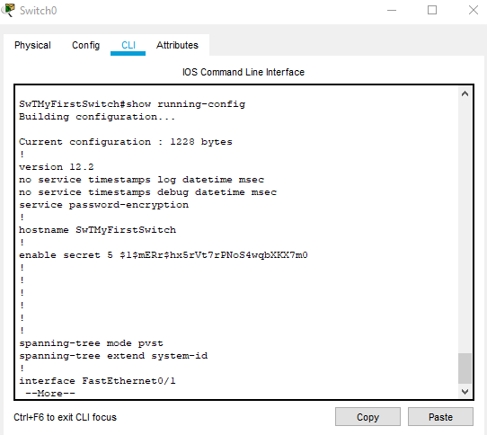
Do show running-config
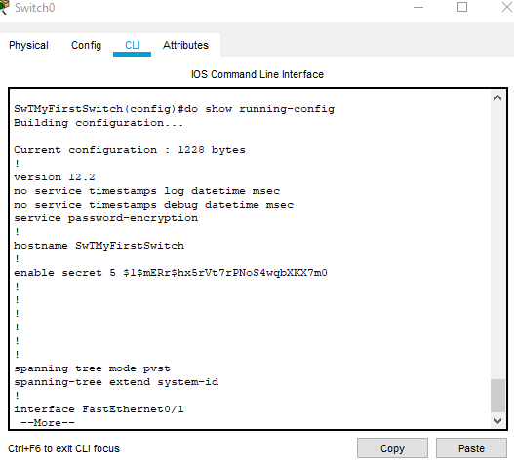
Do show interfaces
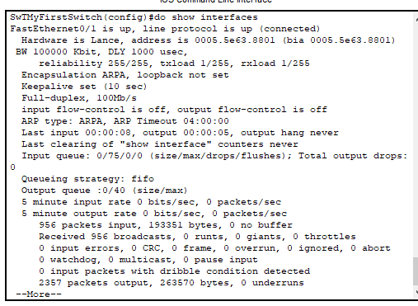
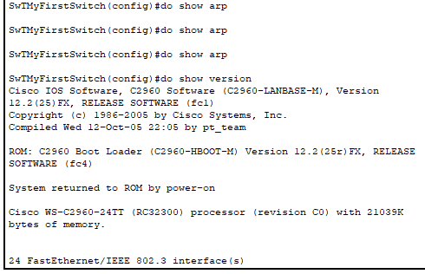
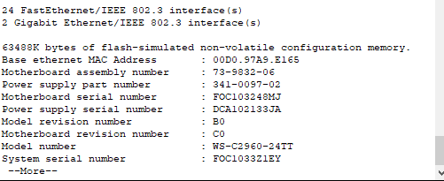
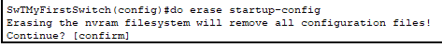
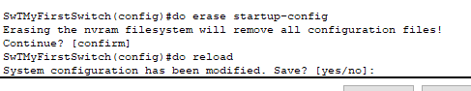

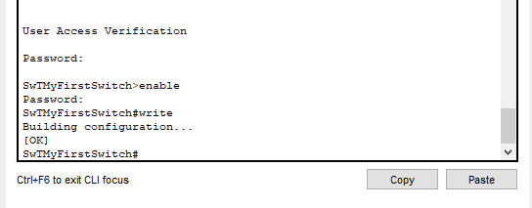

Lab 4
Task 2
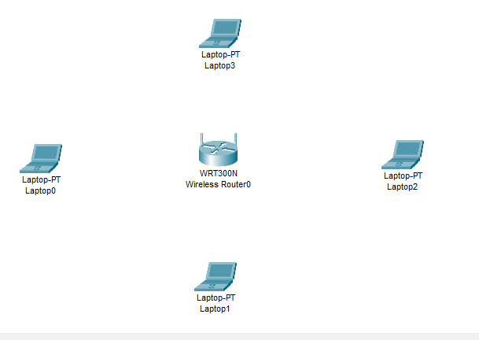
Wireless router
GUI
Setup tab
Scrolldown and change IP address to 192.168.10.1
Enable DHCP
Change Set Start IP to 192.168.10.20
Max users = 3
SAVE
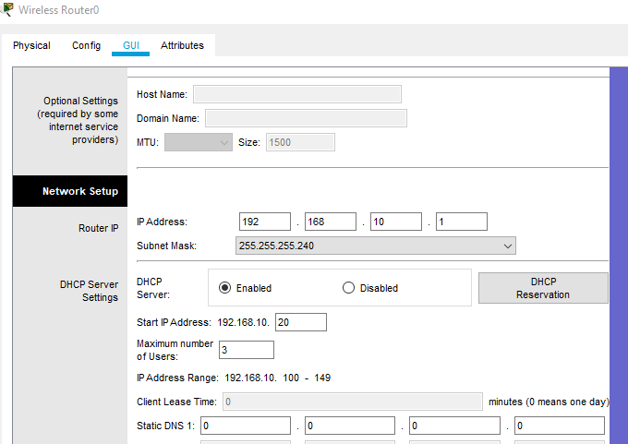
Next in Wireless Tab (basic settings)
Network mode = mixed
SSID = MyNetwork
Broadcast = enabled
SAVE
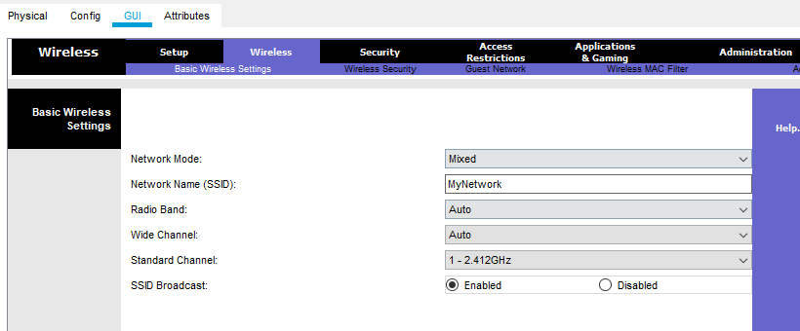
Still in Wireless tab (now Wireless security tab)
Change security mode = WPA2 Personal
Encryption = AES
Set PW = 123456789
SAVE
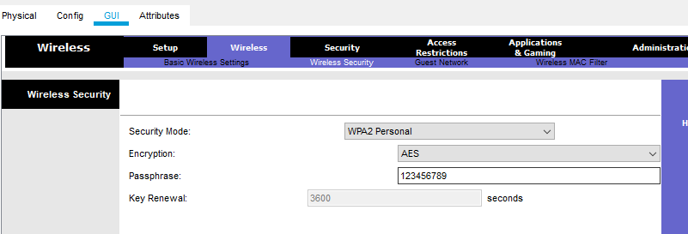
Now in ADMIN Mgmt tab
Change router PW = Cisco
Enable remote Mgmt
SAVE
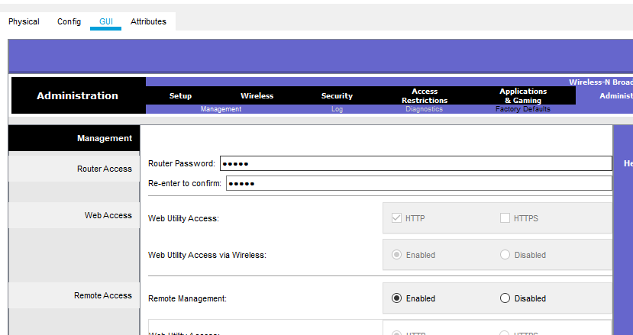
Back to main PT topology
Click on each laptop in turn to change to wireless cards WPC 300 N
Remembering to first turn off to remove & replace then turn back on.
Click on laptop and in Physical exchange cards
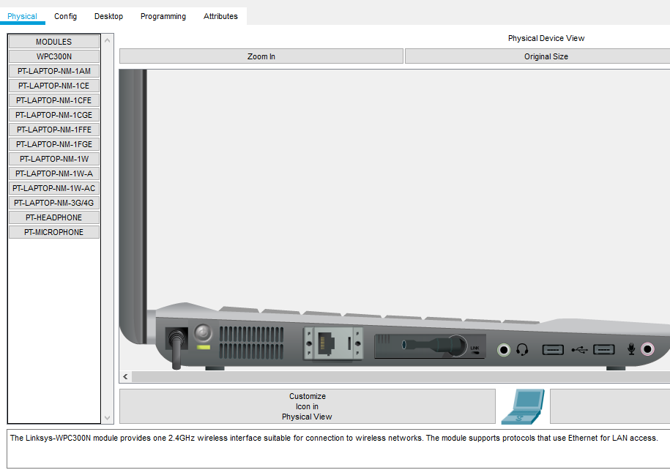
Now to Laptop 0
Click on laptop 0
Select Desktop tab, then PC wireless icon
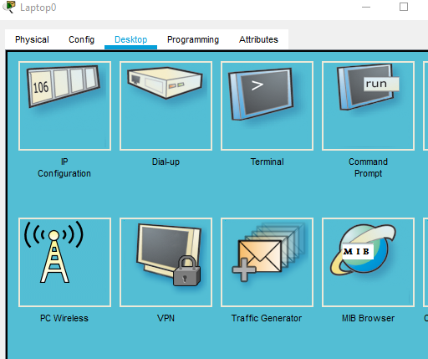
Select Connect tab
Refresh
Select MyNetwork
Connect
Next screen enter PW = 123456789
Press connect….nothing will be seen here…but topology will show ))))))))) link to router
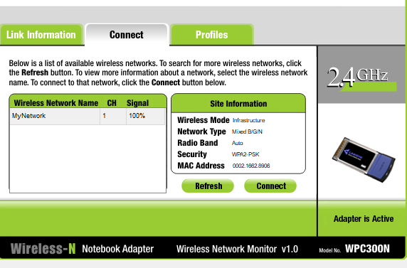
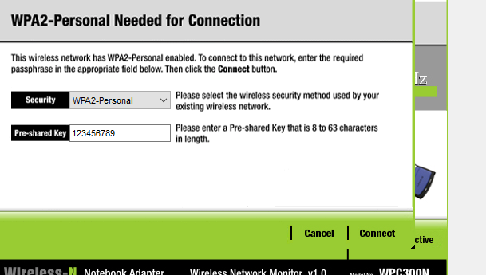
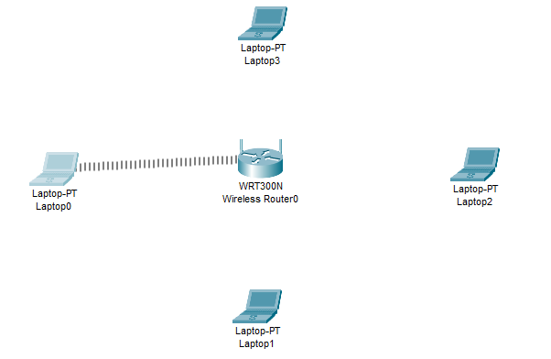
Repeat for laptops 1, 2 & 3 until all linked ))))))))))))))))) to router
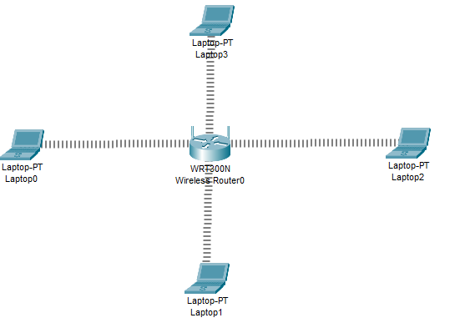
Laptop 0
IP address = 192.168.10.2
Subnet Mask = 255.255.255.240
Default gateway = 192.168.10.1
Ping successful
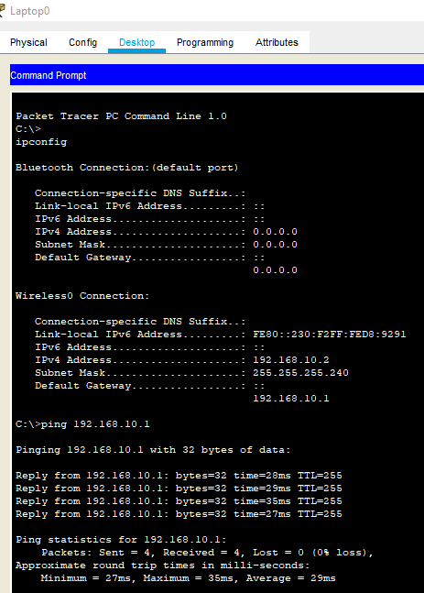

Laptop 1
IP Address = 192.168.10.3
Subnet Mask = 255.255.255.240
Default Gateway = 192.168.10.1
Ping successful
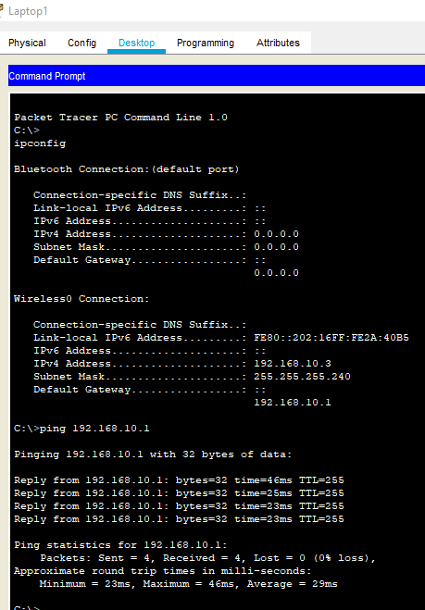

Laptop 2
IP address totally different = 169.254.45.38
Subnet mask = 255.255.0.0
No Default Gateway !!!
Ping Unsuccessful
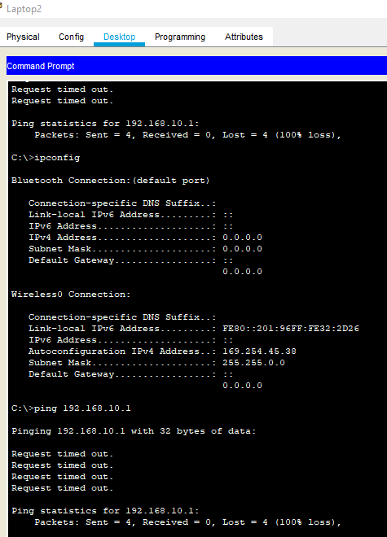

Laptop 3
IP address totally different = 169.254.119.210
Subnet mask = 255.255.0.0
No Default Gateway !!!
Ping Unsuccessful
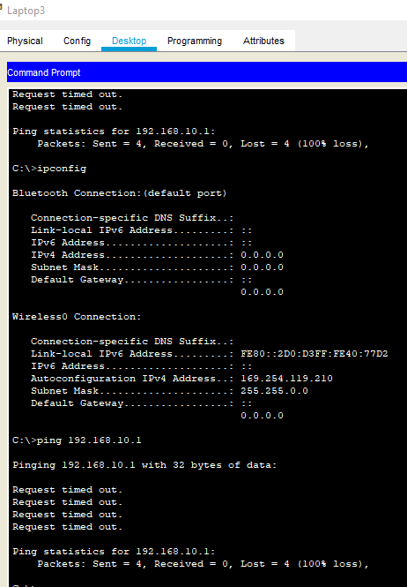

Unable to PING due to maximum number of USERs = 3 (Router + 2 laptops = max)
All laptops gained an IP address but only the first 2 laptops gained the DHCP (default gateway address).
Changed maximum users to 5 (from 3) to enable laptops 2 & 3 to become part of this Network, in Router setup & SAVE.
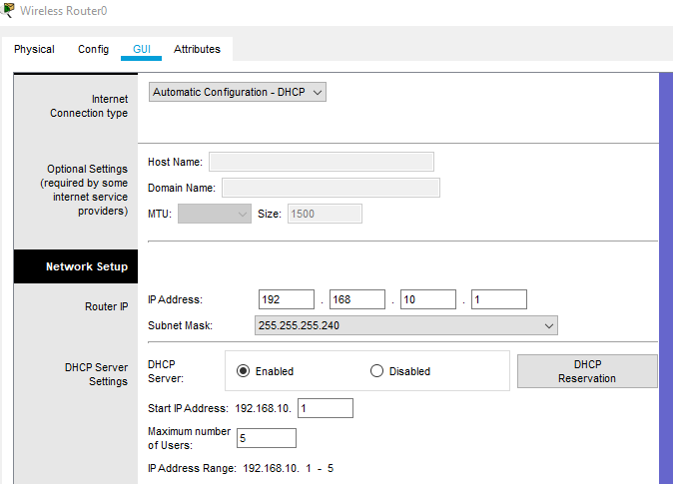
Laptop 2 now
IP Address = 192.168.10.5
Subnet Mask = 255.255.255.240
Default Gateway = 192.168.10.1
Ping successful

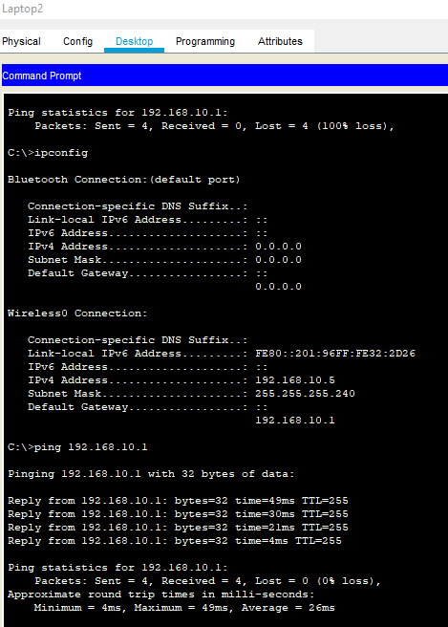
Laptop 3 now
IP Address = 192.168.10.4
Subnet Mask = 255.255.255.240
Default Gateway = 192.168.10.1
Ping successful
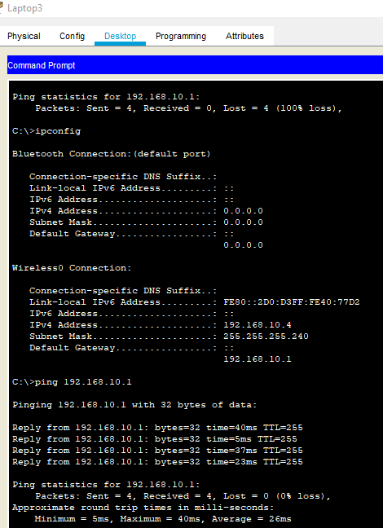

Use ipconfig /all to find MAC physical address
Laptop 0
Wireless MAC Address = 00 30 F2 D8 92 91
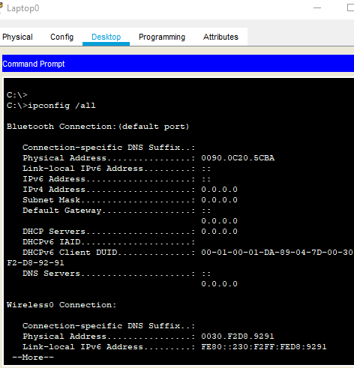
Laptop 1
Wireless MAC Address = 00 02 16 2A 40 B5
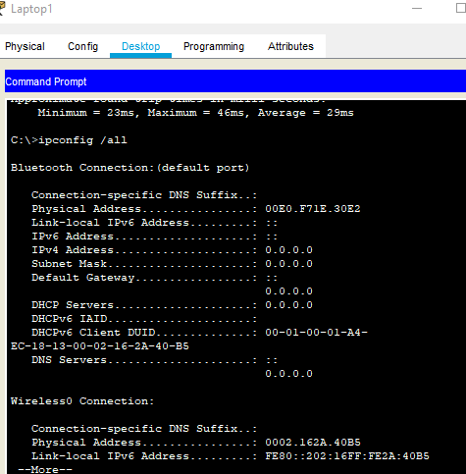

In Router / GUI / Wireless / Wireless MAC Filter tab
Click on Enable and then Prevent PC’s
Enter laptop 0 & 1 MAC address details and SAVE
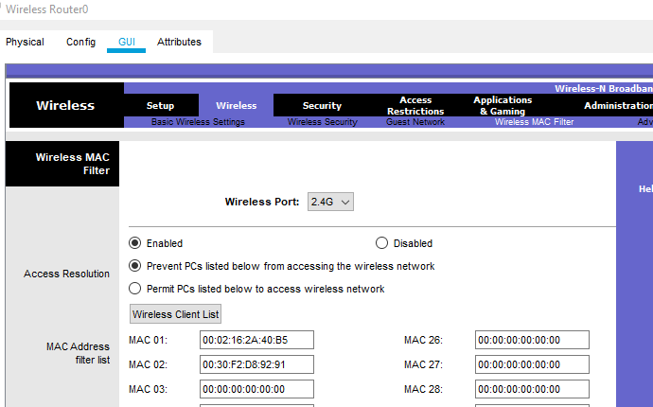
These laptops are NO longer connected to the network


