Assignment 1 – 28th April
Introduction
This essay will examine the negative externalities of tobacco product consumption in the United Kingdom, as well as the methods developed to fight these externalities. Any cost or benefit that a producer generates but does not personally bear or get is referred to as an externality. Externalities can be both positive and negative, and they can arise from either the manufacturing or consumption of goods and services. The costs and benefits can be applied to an individual or an organisation or to society as a whole (KENTON, 2022). This essay will investigate the effects of tobacco on public health and the burden this can create on the healthcare system in order to determine the degree of the implications of these externalities. It will also This paper will investigate how these solutions have influenced the industry and the general health of the populace.
The tobacco industry is one of the largest in the world, and it is currently tremendously profitable. The worldwide tobacco industry was worth USD 849.9 billion in 2021, and it is predicted to rise at a rate of 2.4% between 2022 and 2030. The enormous marketing operations carried out by the big corporations have also played an important role in supporting the sector. The tobacco industry is experiencing a trend of new product introductions, which entices customers to consume tobacco and so drive market growth (Grand View Research, 2022). The value of the tobacco industry highlights its significance across the world.
Within the UK, the tobacco industry is extremely profitable. The United Kingdom is home to two of the world's four largest tobacco firms, British American Tobacco (2nd) and Imperial Brands (4th). In recent years, the tobacco market in the United Kingdom has earned annual profits from operations of more than a billion pounds (Action on Smoking and Health, 2017). This demonstrates how profitable the tobacco industry is in the United Kingdom. This could be due to the high number of active smokers in the country. Despite the fact that smoking has declined in popularity over the previous decade, there are still millions of smokers in the UK. In the United Kingdom in 2021, 13.3% of persons aged 18 and older smoked cigarettes, equating to around 6.6 million people (Revie, 2022).

Market Externalities of the Tobacco Industry
The tobacco industry poses a significant threat to the health of the public. It does not only impact people who directly ingest tobacco products, but also people who live or interact with those that do. This can lead to a variety of serious health issues. The extent of the public health concern posed by cigarette smoking arises from two factors: the ubiquity of cigarette smoking and the numerous negative health impacts of smoking. Cigarette smoking causes chronic diseases that manifest later in life, such as lung cancer, as well as short-term health impacts. Cigarette smoke contains numerous chemical compounds. Inhaling cigarette smoke exposes the smoker to these chemicals (Institute of Medicine, 2015). This highlights the most serious externality of the tobacco industry. The dangers that it creates to public health. The Centre for Disease Control and Prevention note the increased risk of serious illness that comes alongside consuming tobacco products. Tobacco smoke contains a deadly combination of almost 7,000 chemicals. Many of them are poisonous. At least 70 have been linked to cancer in humans or animals. Smokers are 15 to 30 times more likely than non-smokers to develop lung cancer or pass away from it. Even smoking a few cigarettes each day or on occasion increases the risk of developing lung cancer (CDC, 2023). The risk of other diseases is also common among tobacco users. Smoking causes disease and incapacity, as well as injury to practically every organ in the body. Tobacco usage can lead to cancer, heart disease, stroke, and lung disease. Each year, second-hand smoke causes around 41,000 fatalities among those who don't smoke and 400 deaths among infants. In adults, second-hand smoke increases chances of lung cancer, and coronary heart disease (CDC, 2022). This highlights a portion of the potential illnesses and diseases that come from the use of tobacco products such as cigarettes. Unlike other products such as alcohol, smoking tobacco products does not only affect the user. The source from CDC highlights the dangers of second-hand smoke. The impacts of tobacco consumption are also shown by the World Health Organisation. The tobacco epidemic is one among the world's most serious public health issues. Tobacco kills as much as half of the people who use it. Every year, it kills almost 8 million people. Moreover, 7 million of the deaths are caused by direct tobacco use, whereas around 1.2 million are caused by non-smokers being exposed to second-hand smoke (World Health Organisation, 2022).
The cost of treating the health issues caused by tobacco products is another externality of the industry. Due to the volume of health issues that consuming tobacco results in, the costs incurred by health services is high. In the UK, this cost is placed on the NHS. Smoking-related sickness places a significant strain on NHS resources. Tobacco usage was responsible for 474,000 hospital admissions and 79,000 fatalities in 2015/16. Smoking is predicted to cost the NHS in England £2.6 billion each year. Tobacco dependence services are already available in primary care, as well as community and mental health care. By 2023/24, the NHS long-term plan promises to offer NHS-funded tobacco therapy to all hospitalised patients including pregnant women (NHS England, 2022). The number of hospitalisations caused by cigarette consumption over a year is highlighted above. This emphasises the enormous costs that the NHS will have to bear as a result. Smoking costs society £17.04 billion in England each year. Smokers are more likely to become ill when they reach working age, increasing their chances of missing work. Smokers are also more likely to die while still working, resulting in an additional economic loss. This amounts to £13.2 billion in total (Action on Smoking and Health, 2022). The ASH source above shows how smoking of tobacco products costs society annually. This is a cost that the tobacco industry does not suffer themselves, therefore it is seen as an externality.
Another externality caused by the tobacco industry is the environmental damage created in the production, transportation, and consumption of the products. The global tobacco industry costs the environment more than 600 million trees, 200 thousand hectares of land, 22 billion tonnes of water, and 84 million tonnes of CO2 every year. Tobacco products are the most polluted item on the earth. Every year, over 4.5 trillion cigarette filters are littered, damaging our oceans, rivers, city streets, parks, soil, and beaches (World Health Organisation, 2022). The costs that come with cleaning the waste are extremely high for governments and councils. Tobacco-related litter is the most frequent type of waste in England, accounting for 68% of all waste products. The vast majority of cigarette butts are made of single-use plastic. Cigarette filters that have been littered can stay in the environment for many years, releasing toxins into the air, land, and water, hurting plants and wildlife. Local governments spend approximately £40 million every year on cleaning (Brown, 2021). This highlights the significant cost that this externality of the tobacco industry has for society. Companies within the tobacco industry do not incur the cost of cleaning up this waste therefore it can be classed as an externality of the industry.
Solutions to the Market Externalities
Solution 1 – Anti-smoking Advertising Campaigns and Smoking Advertisement Ban
Many organisations called for the banning of advertising because of the harm that tobacco has on its users' health. The British Medical Journal published research in 1950 that revealed a connection between smoking and lung cancer. By 1962, the Royal College of Physicians had enough proof to call for an advertising ban. All television advertisements for cigarettes were outlawed on August 1st, 1965, thanks to the efforts of the Royal College (Steele, 2013). The source shows how health issues caused by smoking were discovered in the 1950s, however the laws around advertising cigarettes were not completely altered until the 21st century. After the cigarette Advertising and Promotion Act of 2002 went into effect, the majority of cigarette advertising and promotion was prohibited in the UK. The law originally prohibited billboard and print advertising, but it was later expanded to include a ban on sponsorship and direct marketing as well (UK Public General Acts, 2002).
In order to drive the numbers of active smokers in the UK down, anti-smoking campaigns were established. These campaigns designed to discourage the population from stopping smoking or for current smokers to stop. The most effective smoking cessation initiative in the UK was No Smoking Day. The programme, which was started in 1984, aims to foster a climate where smokers can quit. The first integrated mass media campaign targeting adult smokers in England aired on TV for three months between December 1994 and March 1995, costing slightly over £3 million (L Owen, 2006). These anti-smoking initiatives intended to educate the public about the dangers of using tobacco products. The ultimate goal of these programmes is to totally eradicate smoking in the United Kingdom. The government seeks to eliminate smoking by 2030. Through its services for tobacco control, public health, and assistance, councils may assist the government in achieving its goal of ending smoking in England by 2030. Currently, councils spend about £11 million on tobacco control and over £75 million on stop smoking services (Local Government Association, 2022).

Impact of this Solution
Anti-smoking campaigns have been stated to be effective in increasing the cessation of smokers. State-sponsored anti-smoking media programmes have the ability to reduce smoking among those exposed to the message. It was discovered that a combination of intense media and community initiatives can result in large decreases in adult tobacco usage. In California, the tobacco control programme was related with a 10-13% decrease in cigarette usage, with the media campaign accounting for 21% of the decrease (McALISTER, 2010). This shows how effective advertising campaigns have been in impacted the negative externalities. New official statistics show that the rate of smoking in England is continuing to plummet. Adult smoking in England has decreased from 14.9% to 14.4%, a decrease of about 175,000 people from the previous year. Rates are nearly a quarter lower than they were five years ago, when they were 19.3% (UK Government, 2018). While all of this decrease cannot be attributed to advertising campaigns, they have been found to be effective. A prospective, randomised controlled experiment was carried out in four television districts in central and northern England. Over an 18-month period, one region received no intervention, two regions received TV anti-smoking advertising, and one region received both TV anti-smoking advertising and locally sponsored anti-tobacco lobbying. After 18 months, 9.8% of smokers who were successfully re-interviewed had quit (McVey, 2000). This highlights that the anti-smoking policies and advertisement campaigns do have an impact on the number of smokers in the UK.
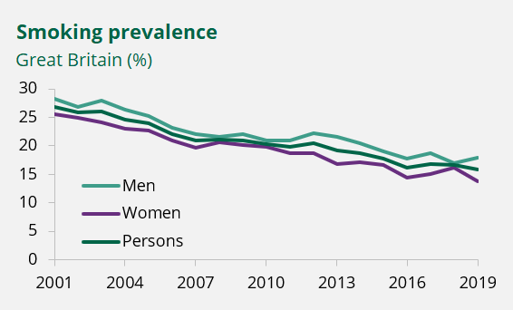
https://commonslibrary.parliament.uk/research-briefings/cbp-7648/
The graph above depicts the prevalence of smoking in the United Kingdom between 2001 and 2019. It demonstrates a decrease in the percentage of the population who uses tobacco products such as cigarettes. This lends credence to the hypothesis that anti-smoking initiatives have been successful in reducing the number of smokers in the UK.
Solution 2 – Increasing Tax on Tobacco
Another method that the UK has taken in order to combat the negative externalities, is the increasing of taxes on tobacco products, such as cigarettes. This is known as Tobacco Duty. The UK government places a tax on all purchases of tobacco products, as well as a tax on company’s importing tobacco to the country. Tobacco duty is a tax that is levied on tobacco goods. There are different processes in place for cigarettes, cigars, hand-rolling tobacco, heating tobacco, and other items. Cigarettes have been subject to a minimum charge of £347.86 per 1,000 since May 2017. Tobacco charges were frozen in 2022, although policy calls for them to be raised in line with inflation plus a fixed amount (Tax Payers Alliance, 2023). By increasing the cost of cigarettes, the government aims to lower the volume of purchases. The prices of tobacco products also further increases year on year. The Tobacco Duty Escalator of 2% above Retail Price Index inflation is applied to all tobacco goods under this policy. This year, the duty rate on hand-rolled tobacco will rise by 4%, to 6% above RPI inflation (HM Revenue & Customs, 2023).
Impact of this solution
The introduction of increasing taxes on tobacco has had a positive impact on the number of people that smoke in the UK. Cigarette prices in the United Kingdom grew by more than 200% between 1992 and 2011. Cigarette sales fell 51% during the same time period, while government revenue from tobacco taxes climbed by 44%. Adult smoking rates fell from 27% in 2000 to 20% in 2010 (Tobacco Free Kids, 2012). This shows that taxation has been an effective measure to combat the negative externalities of tobacco use.

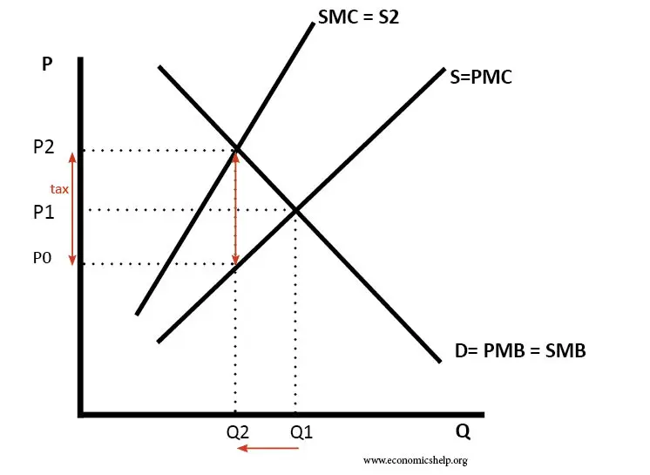
The graph above highlights the impact of increasing taxes on the number of smokers. The increase in tax leads to a fall in demand for cigarettes.
https://www.economicshelp.org/microessays/as/should-tax-cigarettes-increased/
Taxation has also created a positive externality out of the tobacco industry. Tobacco duties are charged on the purchase of cigarettes, hand-rolled tobacco, cigars, and other tobacco products. Tobacco charges are expected to rise to £10.4 billion in 2023-24. This amounts to 1.0 percent of total receipts and 0.4 percent of national income (Office for Budget Responsibility, 2023). The taxes raised by taxing tobacco products are useful in raising money for the UK government.

Emerging Alternatives to Smoking
Another factor which helps to combat the negative externalities of the tobacco industry is the emergence of e-cigarettes or vapes. Vaping exposes users to fewer and lower quantities of pollutants than smoking cigarettes. Vaping minimises your exposure to pollutants that can cause cancer, lung illness, and heart and circulation diseases such as heart attack and stroke (NHS, 2023). While this provides a safer alternative to smoking tobacco, it does not eliminate the health risks entirely. Despite this, the popularity of vaping is increasing.
https://www.ash.org.nz/vaping-and-harm-reduction
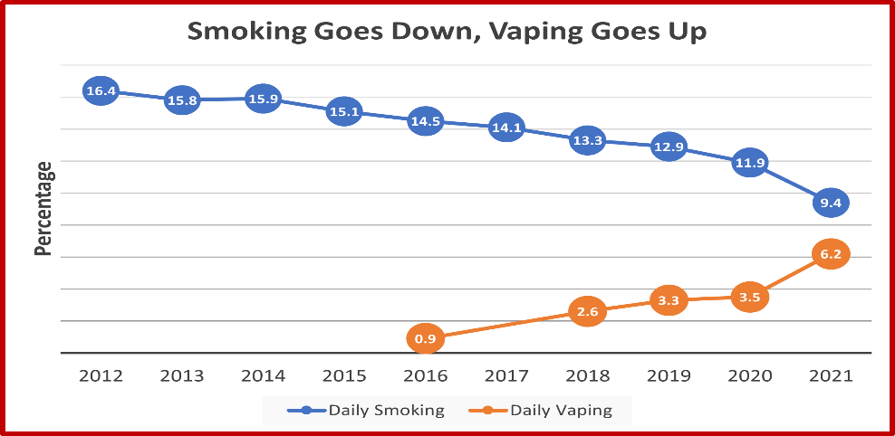

The graph above highlights how the increase in daily vaping has run alongside a drop in the daily smoking rate in New Zealand. This supports the idea that vaping, and e-cigarettes are useful in helping people stop smoking.
Conclusion
The tobacco industry is one of the largest and most profitable industries across the world. Companies within the industry record incomes within the billions of pounds per year and is continuing to grow. The industry is also successful within the UK, as there are millions of people that smoke regularly. Despite this, the number of smokers in Britain in on the decline. There are a number of negative externalities that come as a result of the tobacco industry. There are a number of health issues that arise from tobacco inhalation due to the harmful chemicals that exist within the smoke. Smoking can lead to lung cancer or coronary heart disease. This results in ten of thousands of smoking related deaths per year in the UK. In order to combat the high usage of cigarettes, the UK has banned advertising campaigns that promote smoking. There are also numerous campaigns that focus on anti-smoking and promoting the hazardous impacts smoking has on health. This has impacted the numbers of smokers in the UK as the total number of smokers is steadily decreasing, although there are also other causes that contribute to this. Another way in which the negative externalities are targeted in the UK is through taxation. This aims to reduce cigarette consumption by raising taxes on tobacco purchases and imports into the country. The goal of raising the price of tobacco products is to discourage people from acquiring them. This has also been effective in driving down the number of smokers, which in turn helps to combat the negative externalities of the industry. By having less smokers in the UK, the impacts that smoking has will also be lower. The taxation of tobacco also provides the UK with income in the billions of pounds. This can be seen as a positive externality of the tobacco industry. The emergence of vapes and e-cigarettes is also impacted the number of people that smoke. As vaping numbers rise, the number of active smokers is declining, however vaping does also come with health concerns. To summarise, the negative externalities of the cigarette industry outnumber the positives. While much has been done to combat the industry's negative aspects, much more needs to be done to entirely eradicate this problem.

