Hilton Hotel Group

Student Name: Gabriel Ivanof
Student ID: 2119317
Module No: BMIH5004
Tutor Name: Dale Clarke

Introduction :
The ability to support as well as maintain a process within a timespan to have a positive impact on society, environment while ensuring economic profits can be defined as sustainability. This report will discuss sustainability practiced in hospitality organization HILTON. Furthermore, it will provide a business overview of HILTON along with various business methodologies or approaches implemented. Further, this report discusses the organizational structure and future objectives. Moreover, the report describes various challenges faced by the organization and how will the organization handle such situations. The report also focuses on organizational strategic planning and its impact on the current performance of the business. In addition to this, the report includes HILTON's future of hospitality and how the profitability of the organization is affected by using green approaches. The report will include various sustainability aspects, which are important for organizational growth. Some of these aspects are, the role of finance in the business, how business is environmentally conscious, and more. With the help of various models, the report further discusses the importance of environmental sustainability and the impact caused by businesses.
HILTON is a multinational hospitality organization that was founded in the year of 1919 by Conrad HILTON. The organization is headquartered in Tyson, Virginia, United States. Further, the organizational business portfolio offers various hotel and resort services to its customers. The organization currently making further business progress under the leadership of Christopher J. Nassetta (stories.hilton.com, 2023).
The term hospitality refers to giving a warm welcome to travelers and offering them a place to settle like home. These services are provided to travelers in the form of various hotel and resort services. This helps to create a better experience for the customers it shows the hospitality services of the current place. Hotels provide services from basic to premium to their customers, this helps reduce customers' efforts by fulfilling their requirements and also enhances their experience. According to Milton Friedman, “It is the social responsibility of the organization to increase profits by providing various services to the customers and also accept basic society rules”. This statement states that the organization focuses on business profitability by covering various government and social policies (forbes.com, 2020).
Impact of Eco-friendly techniques on HILTON
Is this still relevant today:
The HILTON focuses on the adaptation of various sustainable practices, which helps the business organization to develop a positive customer perspective on the organizational operation. The increase in sustainable practices will help the organization to committed to its objective which is the reduction of environmental impact by using various sustainable practices. Using sustainable practices and promoting green will help the organization to reduce its operational costs and will help to reduce environmental impacts. This will ensure the sustainability of future generations, by saving various natural resources (Huang et al.,2022).

Buttler life cycle
Buttler life was introduced in the year 1980 by Richard Butler’s. This life cycle model is conducted to identify the tourism factor of an area (Zimik and Goenka, 2023). This model includes 6 stages in the model which are performed in steps to achieve a butler life cycle. The six stages of the life cycle are involvement, exploration, development, consolidation, stagnation, Rejuvenation, and decline. This cycle will provide meaningful and valuable data insights to the business organization. The tool will help the organization to identify tourist places and figures of attraction in a particular. Through this analysis, the organization can develop hotels in nearby the center of attraction which will make HILTON a central hub. This will the business to enhance profitability and provide future opportunities for business expansion in various geographical locations. The changing demand of the tourist industry can impact customer response over time. So by understanding the latest trends in tourism, the organization can adapt to situations where customer preferences over business organization changes.
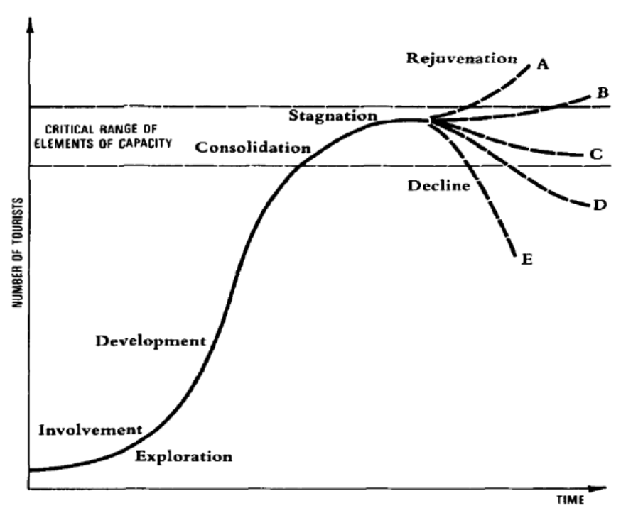
Figure 1Buttler's life cycle
(source: researchgate.net, 2020)

Triple Bottom Line
The triple bottom line is a framework that is used to maintain organizational commitment towards social and environmental factors as helps to enhance organizational profit. It is further analyzed based on the 3 p’s which are people, profit, and planet (forbes.com, 2019).

Figure 2 Triple Bottom Line model (Source: Created by the learner)
Planet
Various sustainable practices adopted by the organization-
Renewable energy :
The organization aims to increase the production of renewable energy, which is a pure and green form of energy. Renewable energy can be produced with the usage of various technological equipment such as solar panels, windmills, and more. The organization is using 100% renewable forms of electricity for nearly 1/3 of all the affiliated hotels under HILTON (hilton.com, 2020).
Organizing meetings and events to increase sustainable practices awareness
The organization has partnered with ClimeCO which provides a portfolio of carbon credits that helps the organization to identify carbon emissions from their hotels and can develop suitable strategies to reduce this.
Profits :
The graph below describes the revenue holdings of the business organization HILTON in us dollars. According to the graph, HILTON has successfully generated 8.77 billion us dollars in revenue, which upscaled the previous year year total revenue (5.79 billion). The overall reduction in revenue was caused by to global pandemic due to which HILTON had to shut down its properties to prevent the spreading of the virus (statista.com, 2023).
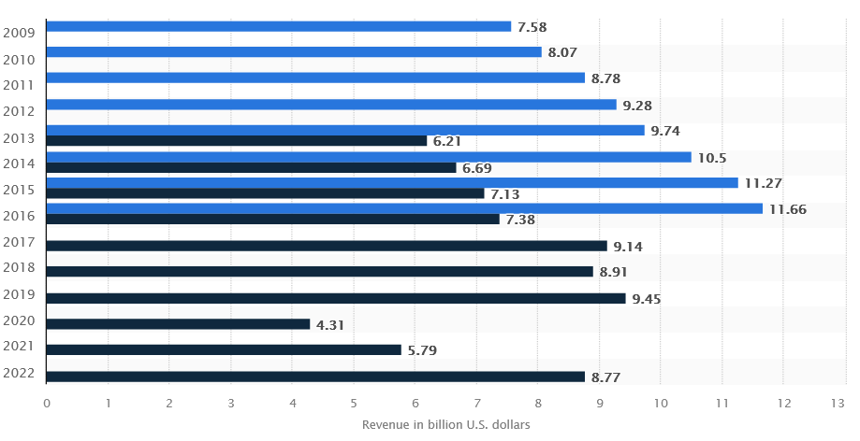
Figure 3: Revenue of HILTON Worldwide Holdings from 2009 to 2022
(Source: statista.com, 2023)
People :
Under this term, it includes the targeted potential audience on which the organization is focusing. HILTON is a multinational business organization which offers various hospitality services to its customers. The business organization's targeted audience is generally tourists, who are visiting various places to explore various other cultures and tourist places. The organization also welcomes various other clients who require hospitality services.

Does finance come first?
Finance plays a crucial role in any business organization. Without effective financial capital, the smooth working of the organization cannot take place. For any business organization to be sustainable and successful in the long term requires funds to improve services and maintain healthy competition with various other organizations that offer similar services. A major source of finance comes from the profit generated by the business organization. HILTON is a business organization that generates revenue by providing various hospitality services to potential clients. HILTON is a multinational business organization that requires high funds to maintain its functioning and perform various organizational operations. The picture below gives an understanding of the total number of hotels, brands, and properties present under the business organization HILTON.
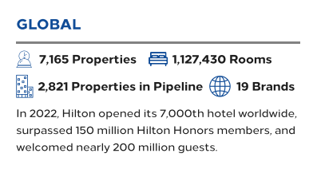
Figure 4 Global data of HILTON
(Source: hilton.com, 2022)
The graph below shows the overall market share of the Hiton organization worldwide. Various other competitors are also present, to compete with those HILTON requires finance to improve the quality of services provided to customers and improve in various other business sectors of HILTON (seekingalpha.com, 2022).

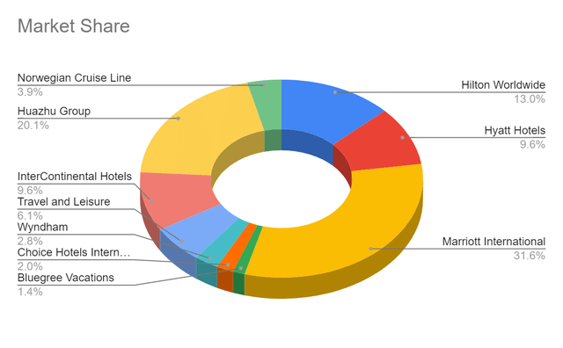
Figure 5 Market share distribution
(source: seekingalpha.com, 2022)
From the figure below, the operating revenue of HILTON can be understood in the years 2021 to 2022. operating revenue refers to the profitable revenue generated by the business organization from the primary business. Further from the figure it can be concluded that the operating revenue generated by the business organization in the year 2021 was $881 which got upscaled in the year 2022 to $1.73 billion (seekingalpha.com, 2022).
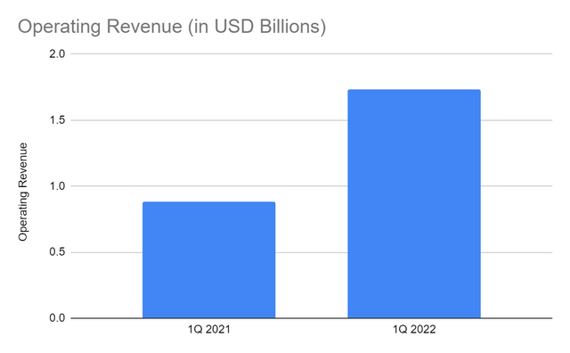
Figure 6 Operating revenue of HILTON
(Source: seekingalpha.com,2022)
Are businesses responsible for being environmentally sound or is it consumer driven?
Any business organization is equally responsible for the environment as the consumer. As one is selling those services and the other is buying that service. HILTON as a multinational company provides hospitality services to the customer and also are committed to the sustainability operation of the organization. The sustainability practice ensures a reduction in the environmental impact by the usage of various eco-friendly techniques. Further the graph below states the reduction in carbon emissions by the business organization. The gives briefly express the journey of the organization from -7% to -47% reduction in carbon emissions which are generated while performing various organizational operations (hilton.com, 2022).
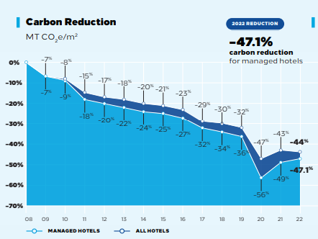
Figure 7 Carbon reduction by HILTON
(Source: hilton.com, 2022)
The graph below states the reduction in energy consumption over the years by the business organization. This will help the organization to develop a sustainable business as well as ensures the availability of resources for future generation by preventing wastage and saving.
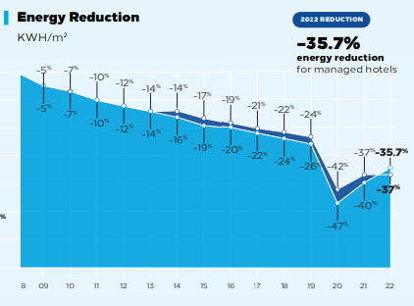
Figure 8 Reduction in energy consumption by HILTON
(Source: hilton.com, 2022)

Can the hospitality industry ever be truly green?
The hospitality industry is one of the biggest business industries worldwide. With the development of suitable strategies and Approaches the business organization can adapt to the green environment. HILTON is a business organization that provides hospitality services to clients. HILTON is committed to sustainability which ensures profitable development of the organization in the future, also it will reduce the operational cost of the organization. Further, HILTON is working on its operation approaches to develop a 100% sustainable business.
Various steps performed by the organization

Landfill reduction :
The business organization is committed to landfill waste reduction. The graph below discusses waste reduction from landfills produced by the HILTON. For managing hotels waste reduction reduced from -7% to -65.4% (hilton.com, 2022). This reduction will help the business organization to reduce harmful impacts on the environment. Further, these small changes in the strategies will help the organization to achieve its goal of being green.
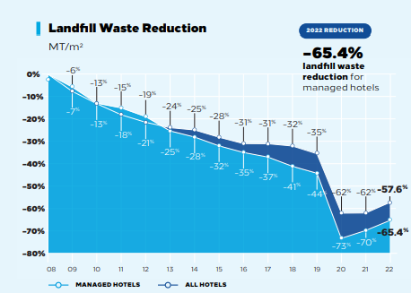
Figure 9 Reduction in landfill waste by HILTON
(Source: hilton.com, 2022)
Waste management
The HILTON is the first business organization to develop soap recycling strategies and set a commitment to send 0 soap to landfills. The organization is running one of the largest soap recycling programs which enrolls an 80% portfolio of the organization (hilton.com, 2022). Further, the organization decided to reduce single-use plastics which helps in reducing waste material generation. The organization will achieve this by organizing various events to create awareness among people.

Doxey's Irridex Model
The Doxey's Irridex Model was introduced in the year of 1975. This model was developed to understand local residents' behavior towards tourists.in simple terms, this model is used to analyze the local people's behavior towards tourism which can be positive or negative (DOXEY, 2015). This model is developed over factors like apathy, irritation, euphoria, and antagonism. The increase in the number of tourists will cause a change in local resident behavior, the term number of students and the behavior of local residents are inversely proportional to each other. Further, this model will help to analyze various local challenges and problems that can be faced by the organization. The decrease in tourism will negatively impact the financial growth of the business organization. This will also affect the local economy of that particular area, as hospitality services provided by the business organization play an important role and impact the gross domestic product rates of the country. Moreover, this will impact various other businesses like restaurants, local markets, and more. This business involves a good percentage of tourists who are potential buyers and helps the area to enhance its local economy.

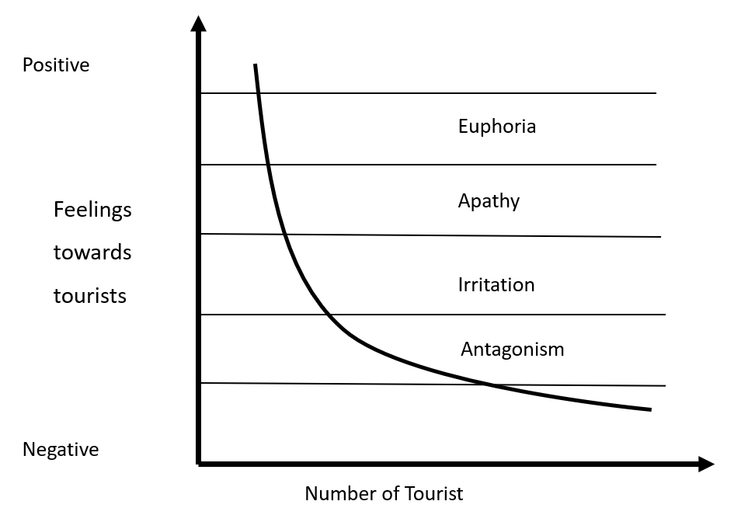
Figure 10: Doxey's Irridex Model
(Source: Created by learner, 2023)

Is financial resiliency key to sustainability
Financial resilience is the key to achieving sustainability in an organizational business. The organization requires financial funds to fulfill its commitment to the environment and social responsibility. Financial resiliency will enable the organization to allocate resources for sustainable practices without compromising the organizational operating strategies. The financial resiliency enabled HILTON to develop soap recycling strategies and reduction in landfill waste. Financial resilience allows businesses to random challenges that can occur in the future and cause sudden downturns and financial instability in the organizational business environment.

Conclusion:
In conclusion, this report provides a brief introduction to the HILTON hotel group. Further, the report discusses the vast portfolio of the business organization. Moreover, the report includes Milton Friedman's statement, that profitability is important for any business organization by taking acceptance over social and environmental factors.in addition to this business profitability with hospitality services is disused, as how this is relevant in the modern world. In addition to this, the importance of finance for any business organization is discussed. Later in the report, environmental responsibility is discussed for both the business and its consumers. With the help of a suitable model, the report provides information, on how sustainability is achieved by the organization with the help of financial resilience last suitable recommendation is mentioned which on adaption by the business organization can help the organization to achieve suitable business and growth in profitability.

Recommendation :
Usage of green energy
The organization can shift 100% usage of green energy which will reduce environmental impact and organizational achievement over the commitment. Further, the organization can invest in the development of green energy plants that will reduce carbon emissions so that it can achieve sustainability development goals (Erdogan et al., 2023).
Wastage reduction
The development of suitable strategies can help the business organization in waste management (Puntillo, 2023). In addition to this waste reduction can ultimately show an impact on future generations as it also decreases environmental impact.
Eco-friendly amenities
The business organization can adapt to eco-friendly practices by providing environmental amenities to clients. These amenities include refillable containers usage of digital technology can help the organization reduce paper usage for various bookings, forms, documentation, and more.

References:
DOXEY, S., Moore, MA (2015). An essay on Doxey’s (1975) Irridex; Ap’s (1992) Social Exchange Process; and Gursoy and Rurhterford’s (2004) Determinants of Community Support theories. Mphil document, University of Cape Coast, Ghana.
Erdogan, S., Pata, U.K. and Solarin, S.A., (2023). Towards carbon-neutral world: The effect of renewable energy investments and technologies in G7 countries. Renewable and Sustainable Energy Reviews, 186, p.113683.
forbes.com, (2019). What The 3Ps Of The Triple Bottom Line Really Mean [Online] Available at: https://www.forbes.com/sites/jeroenkraaijenbrink/2019/12/10/what-the-3ps-of-the-triple-bottom-line-really-mean/?sh=50201ec35143 [Accessed on 3 November 2023].
forbes.com, (2020). Milton Friedman On The Social Responsibility of Business, 50 Years Later [Online] Available at: https://www.forbes.com/advisor/investing/milton-friedman-social-responsibility-of-business/ [Accessed on 3 November 2023].
hilton.com, (2020). ENERGY & CARBON [Online] Available at: https://cr.hilton.com/wp-content/uploads/2020/04/Hilton-Energy-and-Carbon-Fact-Sheet.pdf [Accessed on 3 November 2023].
hilton.com, (2022). Travel with Purpose HILTON 2022 ENVIRONMENTAL, SOCIAL AND GOVERNANCE REPORT [Online] Available at: https://esg.hilton.com/wp-content/uploads/sites/4/2023/04/Hilton-2022-Environmental-Social-and-Governance-Report.pdf [Accessed on 3 November 2023].
Huang, W., Chau, K.Y., Kit, I.Y., Nureen, N., Irfan, M. and Dilanchiev, A.,(2022). Relating sustainable business development practices and information management in promoting digital green innovation: evidence from China. Frontiers in Psychology, 13, p.930138.
Puntillo, P., (2023). Circular economy business models: Towards achieving sustainable development goals in the waste management sector—Empirical evidence and theoretical implications. Corporate Social Responsibility and Environmental Management, 30(2), pp.941-954.
seekingalpha.com, (2022). Hilton Worldwide Has A High Capacity To Accommodate More Growth Prospects [Online] Available at: https://seekingalpha.com/article/4521113-hilton-worldwide-high-capacity-accommodate-growth [Accessed on 3 November 2023].
statista.com, (2023). Revenue of Hilton Worldwide Holdings from 2009 to 2022 [Online] Available at: https://www.statista.com/statistics/297760/revenue-of-hilton-worldwide-holdings-inc/ [Accessed on 3 November 2023].
stories.hilton.com, (2023). Executive Bios [Online] Available at: https://stories.hilton.com/executive-bios?_gl=1*188crlk*_gcl_au*MTI3OTQ5MzU4OC4xNjk3NTMzMzQ5 [Accessed on 3 November 2023].
Zimik, S. and Goenka, H.P., (2023). Investigating Tourism Industries Through the Lenses of Functional Management: A Concept Note. Available at SSRN 4393440.

