Assessment Component 1 BMHP5015
Nazma Begum 1912288

Introduction

This assignment reflects on my learning journey throughout this module which primarily focuses on developing professional identity and employability skills that I may need within the health and social care sector.
The module is structured into four key units which are Brand You, It's a Small World, Opportunity Knocks, and The Pursuit of Happiness. Each unit introduced essential concepts that shaped my understanding of personal branding, global health connections, career opportunities as well as wellbeing.
In this assignment I will critically reflect on the knowledge gained from each unit, supported by academic literature and evidence from online activities. Screen shots will demonstrate engagement in interactive learning. To structure my reflections, I will apply Kolb's Experimental Learning Cycle and Gibbs Reflective cycle provides systemic frameworks for analysing experiences and planning improvements. These models ensure that my reflections go beyond description to include evaluation and actionable steps for growth.
Finally, the conclusion will summarise the overall impact of the module on my personal and professional development it will explore what I have learned about myself, the strength's I have discovered and the areas I need to improve on.as well to enhance my employability and confidence in the health and social care environment. This process will help me create a clear roadmap for continuous learning and career progression.

Task 1 – Reflection on Unit 1: Brand You

Unit 1 emphasises the importance of personal branding in shaping professional identity. Personal branding refers to the strategic process of creating a unique image and reputation that differentiates an individual in the job market (Gorbatov et al, 2018) Through lectures and activities, I learned that personal branding is not limited to self-promotion but involves authenticity , consistency as well as value in creation.

Three concepts that stood out to me which were; Brand identity, Digital Footprint and Networking. Brand identity helped me articulate my strengths and align them with career aspirations (Szanto et al, 2025) Digital footprint highlighted the need for a professional and consistent online presence (Bonsu & Anim-Wright, 2024) Networking helps the individual interact with others which helps foster collaboration and knowledge can be expanded. (Gorbatov et al, 2018)

Applying Kolb's Experiential Learning Cycle, my concreate experience involved completing the LinkedIn profile activity. Reflective observation revealed gaps in my digital footprint.
Abstract concept occurred when I linked this to Gorbatov et al,s concept of personal branding. Active experimentation will involve updating my profile and engaging in networking opportunities.
Kolbs Experimental cycle is highly relevant for my module because it provides a structured way to turn experiences into actionable learning.

Heres how Kolb's model applied to this module it consists of four stages;

- Concrete experiences- Each unit involved a practical activity such as completing a online forum and discussing what certain things are portrayed to us. These hands-on tasks gave me real life experiences to reflect on. For Unit 1 I created a LinkedIn profile which was my concreate experience in personal branding.

- Reflective observation- After completing these activities I analyzed what worked for me andwhat did not work. I noticed gaps in my digital footprint and reflected on inequalities in global health systems.

- Abstract conceptualization- I connected my observation to academic theories and concepts introduced in this module such as Gorbatov et al.’s work on personal branding and Filser et al ‘s theory on opportunity. This stage helped me understand the broader significance of my experiences.

- Active experimentation- Finally I planned actionable steps based on my insights such as updating my CV engaging in networking in the classroom where we had to sit with someone we normally do not sit with and engage in conversation it was something I did which was out of my comfort zone.

By going through these stages Kolb's model ensured my reflections were not just descriptive but transformative helping me identify gaps, link theory into practice and create a road map for professional growth.

Gibbs reflective cycle applies to my module as well because it provides a cycle supported by deeper reflection by evaluating the strengths weaknesses of my current brand and planning improvement. The models consist of six stages which are as follows;

- Description- I describe what has happened in each unit such as completing online forum activities and quizzes. In unit two my classmates and I participated in global health discussion's. In unit four I completed wellbeing assessments.

- Feelings- I reflected on my own feelings during these experiences for instance I felt uneasy when interacting with people I do not normally sit with realizing the importance of confodence in personal branding.

- Evaluation- I assesed what worked well for me and what did not work so well. I identified that I need to create a LinkedIn profile and having weaknesses like an outdated CV or gaps in my digital footprint.

- Analysis- I linked my experiences to theory and literature For example I connected personal branding to Gorbatov et al’s research and opportunity recognition to Filsers et al ‘s theory, showing how academic concepts explain my observation's,
5.

- Conclusion- I summarize what I have learned about myself such as the importance of confidence, resilience, and proactive career planning. I also recognised areas I need to improve on like speaking more in class discissions and maintaining cultural competence at all times.

- Action plan- Finally I was able to plan actionable steps which I could take that were realistic and easily achievable such as updating CV engaging in networking, seeking mentorship, and implementing wellbeing strategies to enhance my overall ability to have employability skills and to have growth in my personality.

Gibbs model complements Kolb's cycle by adding emotional and evaluative dimensions making my reflections more holistic and something to strive and look forward to.

I know where I was lacking such as having an up-to-date CV. I also plan on telling friends and family of what job I am looking for so that they may help me be in touch with those who are working in the field I wish to pursue. I know now that me as a person is very important as I ar am my own brand I need to sell myself essentially when looking for work or building a business. Confidence plays a huge role in being the best to your full potential.

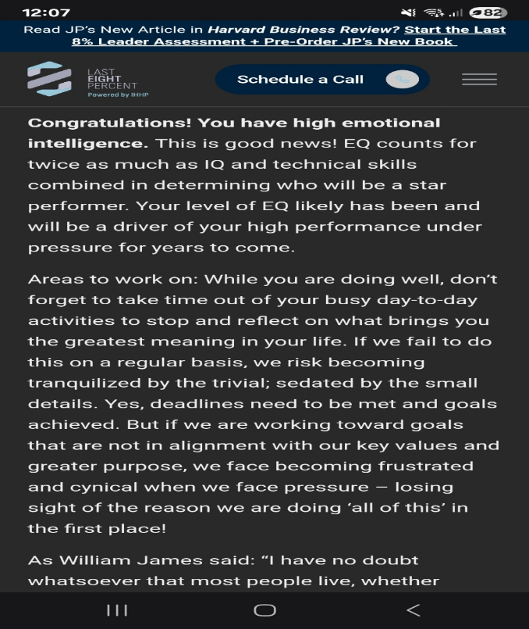
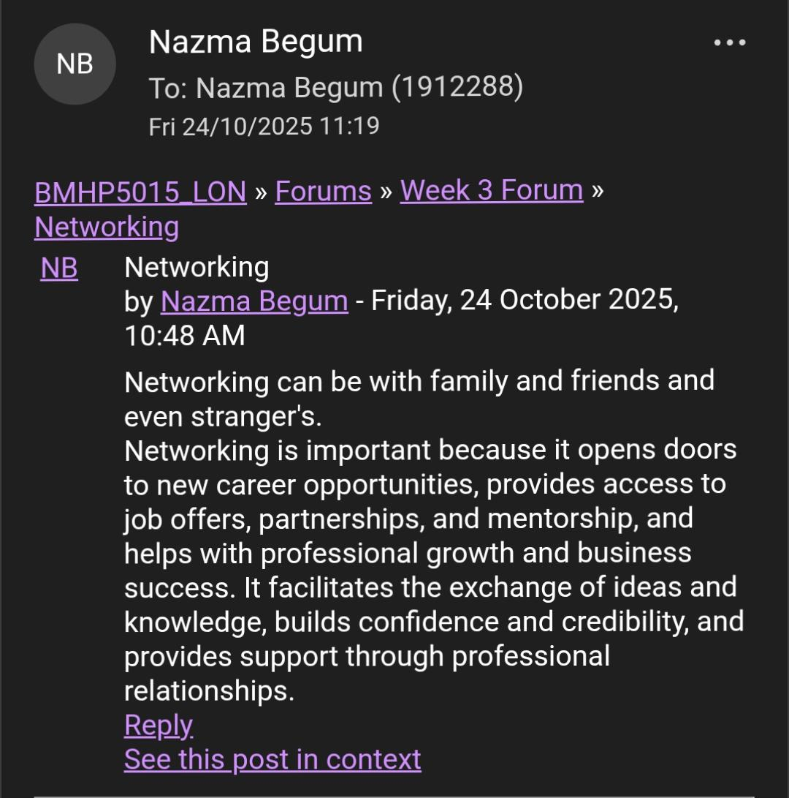

TASK 2- It's a small World

Unit 2 explored globalization and its impact on health and social care. I learned that health systems are interconnected, and global challenges such as the pandemics, aging populations, and workforce shortages require international cooperation
(Comas-Herrera, 2024).

Key topics include global Workforce Mobility, Social, Determinants of Health and Social and International Collaboration. These raised awareness of ethical recruitment and cultural competence (Ayalon, 2021). Reflecting on these topics, I realised that global health is not an abstract concept but a practical reality influencing local care and delivery.

Kolb's cycle applied here as my concrete experience involved participating in global health discussions. Reflective observation highlighted inequalities in health systems. Obstruct conceptualisation linked these observations to WHO’s emphasis on social connection for global health resilience. (WHO, 2025) Active experimentation will involve adopting culturally sensitive practices.

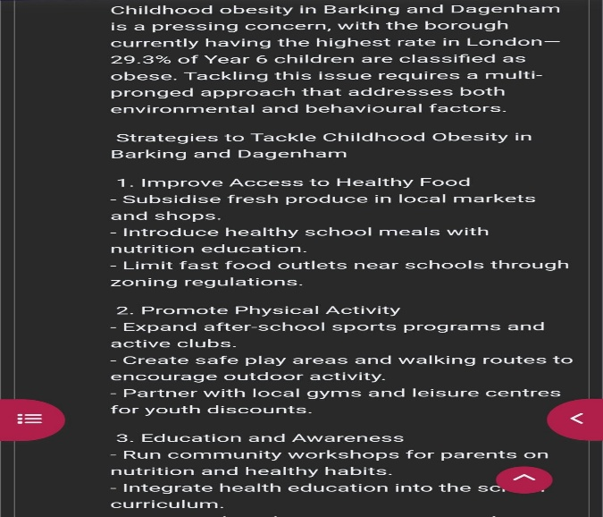
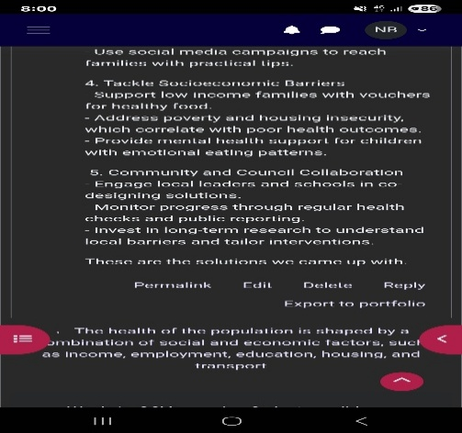

Task 3 – Reflection on Unit 3: Opportunity Knocks

Unit 3 focused on recognising and leveraging opportunities for personal growth. I learned that opportunities for personal and professional growth. I learned that opportunity recognition is a dynamic process involving awareness, evaluation and action (Filser et al, 2020)

Three concepts influenced my development: opportunity, Recognition, Professional learning and Career Development Strategies.
Activities such as career mapping and skills audits helped me identify areas for improvement and plan actionable steps.

Kolb’s cycle applied as my concrete experience involved completing a career mapping tool. Reflective observation revealed gaps in my skills, I noticed that and put a plan into place. Abstract conceptualisation connected this to Filser et al’s theory on opportunity recognition. Active experimentation will involve seeking mentorship and continuous learning. Gibbs cycle structured my reflection by evaluating what worked and what did not work so that I can plan how to improve.

SCREENSHOTS OF CAREER MAPPING TOOL SKILLS AUDIT RESULTS OPPORTUNITY IDENTIFICATION

Task 4 – The Pursuit of Happiness

Unit 4 examined wellbeing and happiness in health and social care. I learned that happiness is not merely an emotional state but a determinant of health and social productivity (Kubzanksy & Viswanatgh, 2019).

Key insights included Positive Psychology, Social Model of Health, and Global Wellbeing trends. Maslow's Hierarchy of needs (1943) highlights that self-actualization is merely achieved through one's own growth. And fulfilment. Unit four reinforced that wellbeing strategies such as resilience exercises help meet psychological and self-esteem needs, enabling me to thrive to my full potential professionally.
Kolb's Cycle applied as my concrete experience involved completing wellbeing self-assessments. Reflective observation revealed the importance of resilience.
When you reflect on what you may have done that did not produce the outcome that you desired you will effectively find ways to improve your performance so that you can achieve what you wish to in the work environment.

I have learnt alot about myself specially completing the online resilience assessment. Sometimes we are in denial with what we must do to improve our chances of success so doing these tests helps one see in plain sight what one must do to improve our chances of success.
Abstract conceptualisation linked this to Maslow's theory and positive psychology. Active experimentation will involve implementing wellbeing strategies in my daily routine. Gibbs cycle helped me analyse the impact of these activities and plan for my future wellbeing.

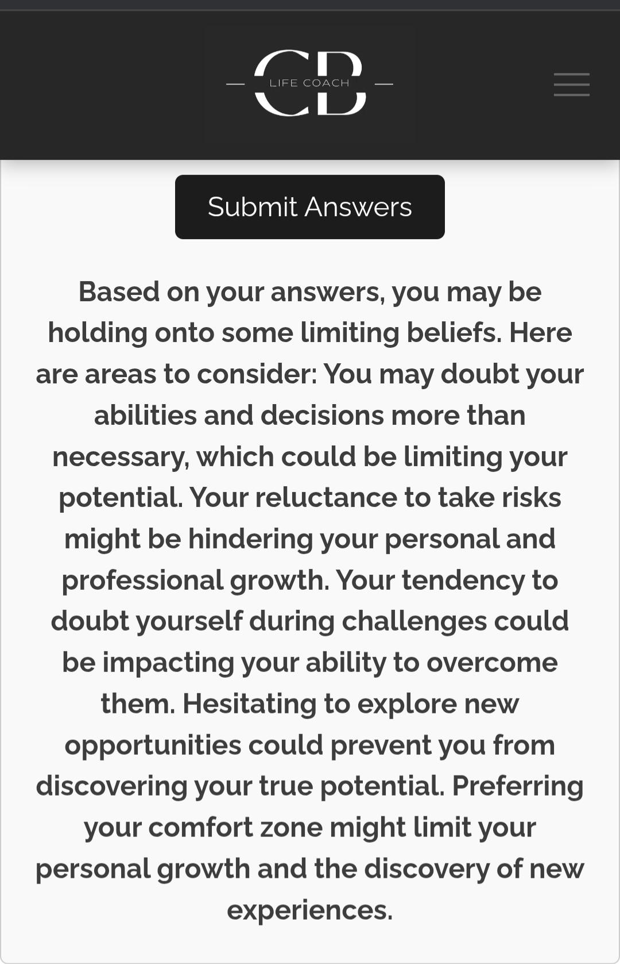

Conclusion

This module has taught me a lot about how I could significantly improve my employability skills in Health and social care. I now understand what is expected of me to thrive and flourish in the work environment.
Unit 1 has taught me the value of personal branding, while unit 2 expanded my awareness of global Health connections. Unit three encouraged pro active career planning, and Unit 4 highlighted the importance of wellbeing for having long term success which can be easily attained. Asa long as I know what my goals are long term and what steps I need to take to achieve this.

Interrogating Kolb's Experiential Learning Cycle and Gibbs’ Reflective Cycle allowed me to structure my reflections and plan actionable steps which I can easily manage so that I can achieve my goals.
Maslow's theory reinforced the importance of meeting psychological needs for professional growth. The knowledge and skills gained will enable me to present a strong professional identity engage in culturally competent practice, recognise opportunities and always maintain some form of resilience in an environment which may be challenging to me. I will also challenge myself to speak up more as I have so much to add but my self-esteem seems to always stop me in being able to do that.

References

- Ayalon, L. (2021) The global care network and its impact on sending and receiving countries. Ageing & Society, 42(10), pp.2244–2261.

- Bonsu, A.O. & Anim-Wright, K. (2024) Personal Branding: A Systematic Literature Review. International Journal of Marketing Studies, 16(1), pp.30–45.

- Comas-Herrera, A. (2024) Social care research: international cooperation is vital to prepare for future health shocks. BMJ, 387, q2145.

- Filser, M. et al. (2020) Opportunity Recognition: Conversational Foundations and Pathways Ahead. Entrepreneurship Research Journal, 13(1).

- Gorbatov, S., Khapova, S.N. & Lysova, E.I. (2018) Personal branding: Interdisciplinary systematic review and research agenda. Frontiers in Psychology, 9, p.2238.

- Helliwell, J.F., Layard, R. & Sachs, J.D. (2023) World Happiness Report. Columbia

- Kubzansky, L. & Viswanath, V. (2019) Pursuing Happiness and Health: Defining, Measuring, and Translating Wellbeing in Policy and Practice. Harvard T.H. Chan School of Public Health.

- Pshembayeva, E. Et al. (2022) Career success: Analysis and development of career opportunities in students. Frontiers in Education, 7, p.999541.

- Rahman, R. Et al. (2024) Systematic review of literature examining the application of a social model of health and wellbeing. European Journal of Public Health, 34(3), pp.467–472.

- Salo, P., Francisco, S. & Almqvist, A.O. (2024) Understanding professional learning in and for practice. Professional Development in Education, 50(3), pp.444–459.

- Szántó, P., Papp-Váry, Á. & Radácsi, L. (2025) Research Gap in Personal Branding: Understanding and Quantifying Personal Branding. Administrative Sciences

- World Health Organization (2025) Fostering social connection for global health. WHO Assembly Report.

