dissertation proposal

The impact of marketing strategy on organisational performance of KFC

Student name: SEBASTIANA FRASINESCU
Student ID: 2021070
Submission date: 30.08.2023
Supervisor name: TUSHARA BALENDRAN

Table of Contents
Table of Contents 2
INTRODOCTION 3
The rationale of the study 3
Research aim 4
Objectives of the research 4
Research questions 4
Literature review 4
Advantages and disadvantages of the Ansoff Matrix 8
Research methodology 11
Philosophie 12
Research approach 12
Research strategies 13
Type of investigation 13
Mono-method research 13
Time horizons 13
Data collection and analysis 14
Sampling 14
Data collection methods 14
Analysis of data 14
Research ethics 14
Planning 15

INTRODOCTION
Marketing concepts have always played a significant role in business strategy, but in recent years, marketing's impact on strategy has increased substantially. Today, marketing-rooted concepts dominate strategy more than ever. Customer satisfaction, the concept of getting close to customers, creating a customer-focused company, the profit impact of new product introductions, and an explosion of product variety are some of the concepts that currently dominate strategic planning. They supplement market share, market growth, and an abundance of other concepts that were once central to strategy. (Steven P, 1991)
Understanding your business, your customers, your markets, and your products are crucial to achieving strategic success. The days when strategists believed they could manage diversified enterprises like stock portfolios are long gone. With the benefit of the long run, it seems absurd to believe that it did not matter what products the company sold if it dominated its industry. (Steven P, 1991)
A marketing strategy is a long-term plan for obtaining a company's objectives by identifying client demands and developing a unique and sustainable competitive advantage. It includes everything from understanding who your consumers are to selecting which channels to utilise to get in touch with those people. (Steven P, 1991)
The idea of fast food is from early 19th century, at the beginning of the Industrial Age, when people were required to work 12 to 14 hours per day, there was little time for long meal breaks. In front of factories, the first refreshment bars and kiosks began to appear. Today, fast meals taken away from home are an integral part of our lifestyle.
Fast food is one of the fastest-growing culinary categories in the globe. It currently accounts for approximately half of restaurant revenues in developed nations and will continue to grow there and in many other developed countries over the next few years. The most rapid growth, however, is occurring in the developing world, where it is significantly changing the way people consume. People buying fast food because it is inexpensive, simple to prepare, and extensively advertised. This document aims to provide information about the fast-food industry, its trend, the reason for its emergence, and other factors that have contributed to its expansion. (Thornhill, A. 2009)

The rationale of the study
The marketing strategy can impact an organisational performance of KFC. In a competitive market, businesses work meticulously to ensure that their products and commodities reach their most enthusiastic customers in order to generate profit and achieve their organisational goals. (Adebusoye, A. 2022)
A considerable amount of strategic planning goes into determining how to deliver high-quality, premium products that satisfy consumer requirements and product objectives. Business strategies involving finance, production, human resources, and research and development all contribute to an appropriate balance of efforts aimed at achieving organisational objectives. (Adebusoye, A. 2022)
It is noted in the study that marketing strategies are attached to an organization's products, services, consumers, customers, and resources, and it is regarded as a crucial factor that promotes organisations' effectiveness, efficiency, and success. (Adebusoye, A. 2022)

Research aim
The main aim to of this research is to determine the impact of marketing strategy an organisational performance of KFC.

Objectives of the research
- To determine the current market strategies implemented by KFC in the UK using the Ansoff Matrix.
- To investigate the current directional development strategy that impacts on the organisational performance of KFC.
- To analyse the opportunities and changes of KFC, implementing marketing strategies.

Research questions
- What are the current marketing strategies implemented by KFC in the UK?
- What are the current directional development strategies that impact on the organisational performance of KFC?
- What are the opportunities and challenges of KFC implementing marketing strategies?

Literature review

A marketing strategy is an organization's plan to reach its target market to raise brand awareness and convincing consumers to purchase its products. Due to an increase in internet-related activities, many organisations have modified how they conduct business. A company can communicate with the public in a variety of ways, including through conventional methods, digital channels, and integrated marketing strategies. (Chartered Association of Business Schools. 2020)
A directional strategy keeps businesses focused in the most strategic manner possible, while continuing to expand revenue and the products and services offered to customers. They accomplish this by ensuring that individual departments collaborate towards corporate objectives rather than pursuing their own objectives. (Chartered Association of Business Schools. 2020)
What are the current market strategies implemented by KFC in the UK?
KFC initiated a revolution in the world of food lovers. They are constantly in search of new methods to provide their consumers with high-quality meals at low prices. It is the focus of KFC's worldwide marketing strategy. KFC focuses on maintaining its brand and the loyalty of its customers in every single day. (VAULT, K. 2022).
KFC utilises demographic segmentation to serve the vegetarian and non-vegetarian consumer segments of its target market. Its offerings are designed for children, young adults, nearly all age categories. (Kotler & Keller, 2016).
There is no doubt that KFC has an online and offline presence. KFC has over 27,000 locations in over 145 countries and territories. They have visited nearly every nation and territory. KFC's expansion beyond urban areas is evidence of this. After determining who the intended audience is, they modify their email campaigns accordingly. By increasing brand awareness and generating conversions, they increase the brand's income margin. (VAULT, K. 2022).
KFC uses two methods for content marketing. The first objective is to create unique chicken dishes and attract media attention. Second, develop original and engaging video content for free websites such as YouTube. Both are targeted to capture the audience's attention on their different social media channels. (Bloching, B. 2015).
KFC frequently launches limited time offers and promotions to generate interest in its products and encourage customer visits. These may include seasonal menu items, discounts, or promotions that coincide with popular events or holidays. KFC maintains consumer interest and increases sales thanks to limited time offers. (Kotler & Keller, 2016).
The most famous current promotion in KFC is TWISTER WRAP for £1.98. (KFC, 2023). The costumers can find more promotion using their KFC app or ordering online using different apps like JUST EAT, Deliveroo or Uber Eat. (KFC, 2023)
What are the current directional development strategies that impact on the organisational performance of KFC?
Kentucky Fried Chicken already an internationally recognised brand. Implementing effective marketing strategies can increase brand recognition and recall, resulting in increased consumer loyalty and confidence. (Kotler & Keller, 2016).
KFC has an extensive menu that accommodates a variety of flavours and preferences. These options can be highlighted by marketing strategies to appeal to a broader customer base and accommodate shifting dietary trends. (UK, K. 2022).
Innovation and New Products KFC can introduce and promote innovative and new products through marketing strategies. This can captivate consumers' interest, inquiry, and enthusiasm, thereby boosting sales and engagement. (KFC, 2023)
Digital Marketing and social media: With the expansion of digital platforms and social media, KFC can engage with consumers directly and reach a larger audience.
KFC could adapt its marketing strategies to local cultures and desire through localization. This can improve its resonance with diverse consumer groups worldwide.
Sustainability and Health Initiatives: If KFC promotes sustainable and healthier options, it can capitalise on the rising demand for environmentally conscious and health-oriented products. This can attract a new segment of consumers who are health conscious. (VAULT, K. 2022).
What are the opportunities and challenges of KFC implementing marketing strategies?
Brand Recognition and Loyalty: KFC is a globally recognisable brand, and effective marketing strategies can increase its visibility and enhance consumer loyalty (Kotler & Keller, 2016).
Diverse Menu Promotion: Marketing can assist KFC in promoting its diverse menu options, accordingly, appealing to a larger range of consumers with varying tastes and preferences (Kotler & Keller, 2016).
Innovation Promotion: Implementing marketing campaigns for new and innovative products can generate enthusiasm and attract customers' attention, thereby increasing sales and customer engagement (Kotler et al., 2017).
Digital Engagement: Utilising digital marketing and social media platforms allows KFC to communicate with a larger audience, allowing for interactive engagement and the possibility of viral campaigns (Hennig-Thurau et al., 2015).
Localization Strategies: Tailoring marketing efforts to local cultures and preferences can better resonate with diverse consumer groups and bolster customer relationships (Kotler et al., 2017).
Sustainability and Wellness Messaging: Promoting healthier alternatives and sustainable practises can capitalise on the increasing demand for responsible consumption and attract health-conscious consumers (Kotler & Keller, 2016).
The difficulties:
Intense Competition: The fast-food industry is highly competitive, requiring KFC to differentiate itself and perpetually innovate in order to distinguish out from rivals (Kotler & Keller, 2016).
Changing Consumer Preferences: Changing consumer preferences and trends necessitate adaptability for marketing strategies to remain relevant (Kotler & Keller, 2016).
Health Concerns and Criticism: Addressing health-related concerns associated with fast food while simultaneously promoting indulgent offerings presents a challenge for maintaining a positive brand image (Laroche et al., 2013).
Cultural Sensitivity: Operating in diverse markets necessitates careful consideration of cultural nuances to avoid misunderstandings or adverse reactions (Kotler et al., 2017).
Digital Saturation: The saturation of digital marketing channels necessitates that KFC create innovative and engaging content to captivate consumers' attention amidst the cacophony (Hennig-Thurau et al., 2015).
Franchise Consistency: Maintaining consistent messaging and branding across multiple franchise locations is difficult and requires effective coordination and communication (Kotler et al., 2017).
Crisis Management: The rapid dissemination of information through social media necessitates a robust crisis management strategy to address any negative incidents promptly and safeguard the brand's reputation (Laroche et al., 2013).

Advantages and disadvantages of the Ansoff Matrix
Kentucky Fried Chicken utilises the Ansoff matrix for its successful international expansion.
KFC has achieved success in its global operations and business because of its strategic growth decisions. In accordance with the internal and external organisational factors, these growth decisions and growth trajectories have varied across regions and time periods. However, KFC has utilised the Ansoff matrix successfully on multiple occasions to become one of the world's largest beverage companies. Listed below are some of KFC's most effective Ansoff matrix and category-based marketing strategies. (Shyam Future Tech. 2022)
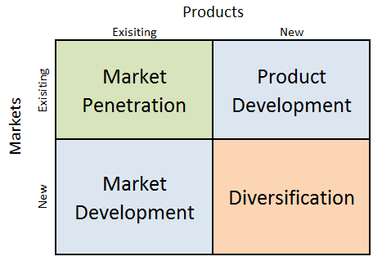
Figure 1 Ansoff matrix (Dudovskiy, J. 2019).

Market penetration is one of the strategies used by KFC for increasing the production and help the company to obtain more costumers in the same market. In the same market, competitive pricing would result from the management of overhead expenses. Increased attractiveness and competitive pricing within the same market will result in increased sales and consumption, and thus a greater market share. (Dudovskiy, J. 2019).
KFC will be able to reach a greater number of consumers in the same market using persuasive communication, marketing activities, and advertising.
Competitive pricing will provide the company with a competitive advantage and increase consumer engagement with its product. (Dudovskiy, J. 2019).Additionally, competitive pricing will increase KFC's sales and result in a greater market share.

Market development
By introducing existing products into new markets, KFC can increase its business growth with market development strategies. Different strategies will allow KFC to achieve this objective. KFC may also benefit business expansion through globalisation. International expansion will enable KFC to reach various groups of customers. (Shyam Future Tech, 2022)
In addition to understanding the potential cultural differences, the company will need to adapt its expansion strategy accordingly. The process of global expansion should consider cultural differences. (Shyam Future Tech, 2022)
Brand awareness is essential to help the business reach new consumer segments and increase its visibility. (Dudovskiy, J. 2019).
KFC introduced its own outfits line. The clothing will also feature popular slogans, such as 'It's Finger Lickin' Good' on a tracksuit and 'Bargain bucket' across the front of a headwear. (KFC, 2023). According to a KFC representative, the new collection is “a spicy new collection that’s tasty enough to eat". (KFC, 2022)
Product development
KFC can implement improvements and changes to existing products in order to provide consumers with new and improved options.
Before launching its entirety production of its own products, it is crucial for Kentucky Fried Chicken to fully understand the new product's development process, market response, and acceptability. (Adebusoye, A. 2022).
Diversification
Diversification refers to the growth and development of a business that results from the development of new products in new markets. (Dudovskiy, J. 2019). Diversification is essential because it enables companies such as KFC to remain competent, innovative, and competitive, thereby maintaining their relevance in the consumer markets.
Advantages
KFC can systematically evaluate its development options using the Ansoff Matrix. It encourages the business to consider a variety of strategies based on its existing products and markets. (Adebusoye, A. 2022).
The matrix presents four growth strategies — Market Penetration, Market Development, Product Development, and Diversification — allowing KFC to investigate a variety of expansion and growth strategies. (Shyam Future Tech. 2022)
The Ansoff Matrix helps KFC assess the level of risk associated with each option by categorising growth strategies. This allows the company to make educated judgements regarding the level of risk it is willing to assume.
When contemplating growth strategies, the matrix encourages KFC to apply its existing assets and resources, promoting a concentration on areas where the company has a competitive advantage. (Adebusoye, A. 2022).
Disadvantages
The Ansoff Matrix provides a framework for growth, but it may oversimplify KFC's complex strategic decisions. Not every growth strategy fits efficiently into the matrix's categories. External factors such as market dynamics, the competitive landscape, and technological disruptions are not considered by the matrix. KFC must evaluate these factors independently in order to make well-rounded decisions.
While the matrix assists in identifying growth opportunities, it does not provide specific instructions on how to implement selected strategies. KFC must create discrete strategies for implementing each strategy. (Shyam Future Tech. 2022)
The matrix does not specify how various development strategies can be combined or integrated. KFC must consider attentively how multiple strategies may interact and influence one another. (Adebusoye, A. 2022).
The Ansoff Matrix provides KFC with a simple and structured method for evaluating growth strategies, but it has limitations in terms of oversimplification, lack of external context, and implementation guidance. KFC should utilise the matrix as a starting point for strategic discussions and analysis but should supplement it with extensive market research and a thorough comprehension of its competitive landscape. (Shyam Future Tech. 2022).

Research methodology
Research methodology refers to the systematic approach and framework that researchers use to plan, conduct, and analyse studies. It describes the procedures, techniques, and strategies that govern the complete research procedure, from defining the research problem to drawing conclusions and interpreting collected data. A well-defined research methodology is crucial for assuring the validity, dependability, and credibility of research findings. (Bryman, A. 2016)
The first part describes the research's overall structure and methodology, including whether it is qualitative or quantitative.
In disciplines such as anthropology, sociology, psychology, education, and healthcare, qualitative research is frequently conducted. Complex social phenomena, human behaviour, and cultural contexts are explained with more detail. (Bryman, A. 2016)
Quantitative research can be used in topics where data can be measured and quantitatively analysed, such as the social sciences, economics, psychology, and natural sciences, quantitative research is used frequently. It provides a structured method for addressing research questions and valuable insights into patterns and relationships that may not be immediately apparent. (Bryman, A. 2016)
Quantitative research is also the method used to complete this research.
The research "onion" helps to find and to provide information for the study step by step. The “Onion” consists of six layers, each of which represents a step that a researcher must take to develop an effective approach. Each must be eliminated in order to get to the essence, which is data collection and analysis. (Saunders, 2019)
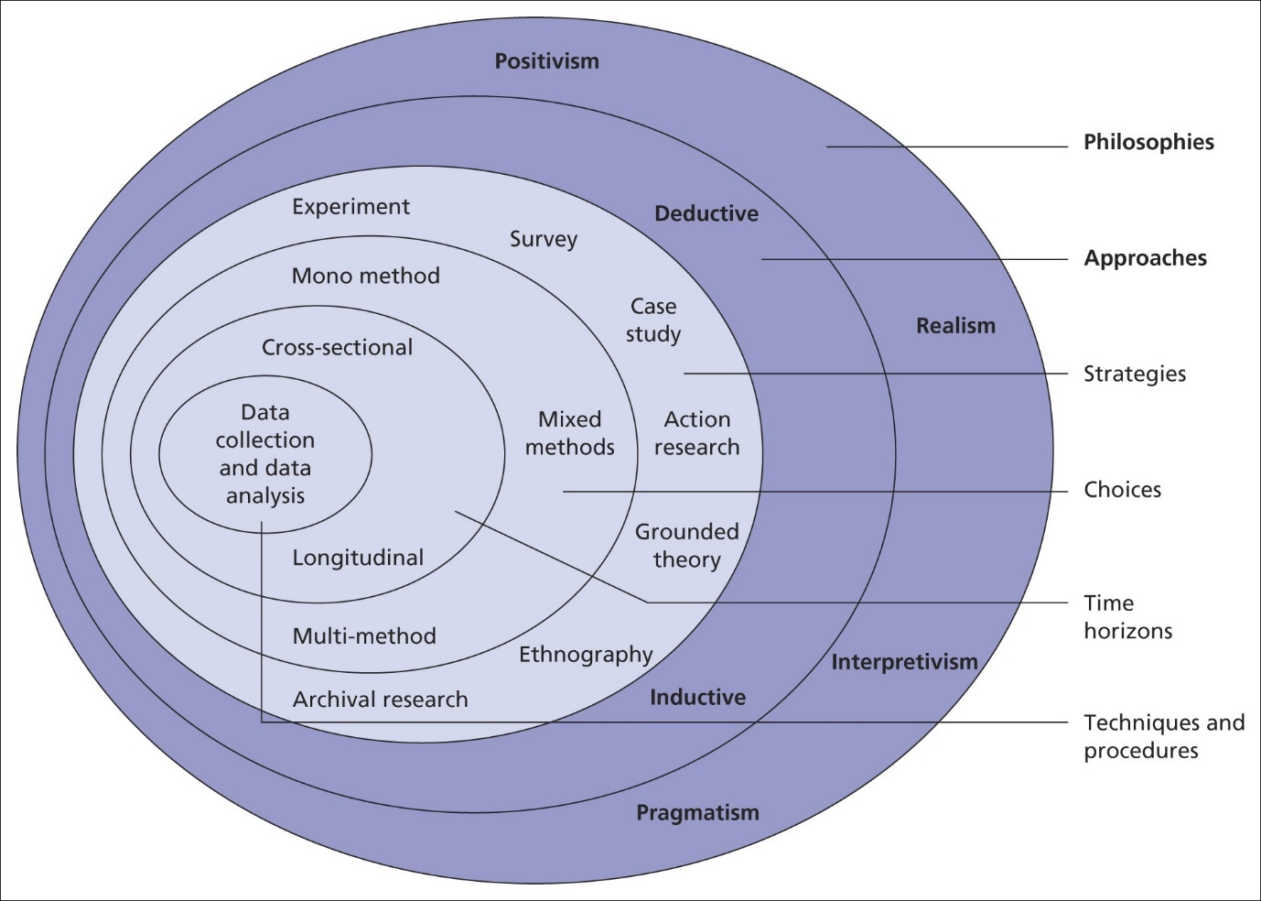
Figure 2 Research Onion (Saunders, 2019)

Philosophies
The concept of research philosophy related to the collection of beliefs, assumptions, and viewpoints that shape a researcher's methodology in carrying out research. The researcher's selection of research methodology, data gathering procedures, data processing, and interpretation of findings are influenced by it.
The field of research philosophy is often classified into three primary paradigms, namely positivism, interpretivism, and realism. Each of these paradigms has distinct underlying ontological, epistemological, and methodological assumptions about the fundamental nature of reality, the researcher's positionality, and the dynamics between the researcher and the researched. (Bryman, A. 2016)

Research approach
The research approach used in this study is positivism, which seeks to elucidate universal rules and generalisations that possess applicability across many situations. The approach places significant emphasis on the use of quantitative data, statistical analysis, and experimentation.
The task of the researcher entails maintaining a sense of detachment and objectivity, so minimising the potential impact of personal biases and influences. The process of doing research adheres to a structured and methodical approach. (Bryman, A. 2016). Some examples of research methodologies often used in academic studies include experimental research, surveys, and statistical analysis.
A deductive research technique tests an expansive theory or hypothesis using actual observations and data. A more extensive explanation of deductive research. A theory or hypothesis starts the deductive method. Research, expertise, and conceptual frameworks typically support this concept. Quantitative data is collected by surveys studies, or organised observations, which are all standard ways. The information obtained is in the form of numbers, so it can be evaluated quantitatively. (Bryman, A. 2016)

Research strategies
Surveys are a common way of collecting data from a large number of people to determine their ideas, attitudes, and perspectives on a topic. Surveys give quantitative data for statistical analysis to identify patterns, trends, and correlations. (Creswell, J. D. 2017).

Type of investigation
This study will be conducted using both primary and secondary research methods.
Primary research
Primary research, usually referred to as original research or field research, is the direct gathering of unique and direct data from primary sources in order to address particular study objectives or aims. Offers precise and current data that is directly relevant to the study aims. (Creswell, J. D. 2017). Enables researchers to exercise control over the process of data collecting, therefore assuring the quality and relevance of the acquired data. (Creswell, J. D. 2017).
In this case study the primary research conducted is the survey.

Secondary research
Secondary research, also called desk research or literature review, is the process of gathering and analysing data, information, and sources that have already been collected by others. Secondary research looks at and synthesises data that has already been published, gathered, or recorded. Primary research, on the other hand, involves getting new information directly. (Creswell, J. D. 2017).
The secondary research used in this case study is the literature review.

Mono-method research

Choices
Mono-method research, also called single-method research, is a type of research in which only one method is used to collect and analyse data. This means that the whole research study is based on a single way of collecting data, whether it's surveys interviews, observations, tests, or something else. Even though mono-method research is easy and focused. (Bryman, A. 2016)
In this case study, only quantitative data will be collected as part of the primary research.

Time horizons
The time horizons of the study are cross-sectional studies are a type of research methodology used in observational research to collect data from a group of people or cases at a single point in time. In a cross-sectional study, researchers receive information from subjects about various factors of interest without changing any variables. This approach is especially helpful for figuring out the frequency, distribution, and links between factors at a given time. (Bryman, A. 2016)

Data collection and analysis

Sampling
Sampling size
In this case study, the sample will have a size of approximately 50 respondents, which
currently includes KFC employees. The access to the sample size will be done via QR code.

Sampling type
In this case of study, the sample size will be conducted by currently employed, from bought gender male or female, age over 18 and different positions at work such as team members or management team.
Sampling method
The selection method for this case study is random sampling. The randomly sampling is a type of quantitative sampling that collects data from people who were chosen at random and were ready to take part in this case study. Thornhill, A. (2019).

Data collection methods
The online survey will be created using Microsoft Forms. English will be set as the default language for the survey. The survey will have a series of eight to ten closed-ended questions, including a range of question types, including 5-point Likert scale questions and multiple-choice questions. The designated duration for respondents to complete the survey is 15 minutes.

Analysis of data
The quantitative data obtained from the research will be subjected to analysis using Microsoft Excel software. This software will be used to generate tables and graphs for the purpose of data presentation.

Research ethics
Research ethics are the moral principles, norms, and standards that govern human and environmental research. To guarantee responsible and respectful research that respects the rights, well-being, and dignity of all stakeholders, ethical concerns are essential. (NIH Office of Extramural Research 2018)
To ensure study ethics, such as regulation, design, and execution, the researcher will not divulge any information to other parties and will keep all primary data private and confidential.

Planning
 | Week1 | Week2 | Week3 | Week4 | Week5 | Week6 | Week7 | Week8 | Week9 | Week10
*INTRODUCTION
*RATIONAL OF THE STUDY
*AIM
*RESEARCH OBJECTIVES
*RESEARCH QUESTIONS

*LITERATURE REVIEW

*RESEARCH

*METHODOLOGY

*SURVEY RESULTS

*MICROSOFT FORMS ANALYSIS-
ANALYSIS DATA

*CONCLUSION

*RECOMMENDATION

*FORMULATION OF DRAFT

*SUBMISSION

REFERENCES

Bryman, A. (2016). Social Research Methods. 5th ed. Oxford: Oxford University Press.
Chartered Association of Business Schools. (2020). Research Income for Business and Management 2020. [online] Available at: https://charteredabs.org/publications/research-income-for-business-and-management-2020/ [Accessed 2 Aug. 2023].
Creswell, J.W. and Plano Clark, V.L. (2017). Designing and conducting mixed methods research. Los Angeles: SAGE.
Dudovskiy, J. (2019). Apple Ansoff Matrix - Research-Methodology. [online] Research-Methodology. Available at: https://research-methodology.net/apple-ansoff-matrix-2/.
KFC (2019). KFC | KFC UK - Find a Restaurant and Order KFC Online. [online] KFC. Available at: https://www.kfc.co.uk/.
KFC (2023). KFC UK&I Shop. [online] KFC UK&I Shop. Available at: https://kfcshop.co.uk [Accessed 28 Aug. 2023].
KFC (2022). KFC to launch a clothing line and it includes a bag to fit a bucket of chicken. [online] The Sun. Available at: https://www.thesun.co.uk/money/19385916/kfc-to-launch--line-bag-bucket-chicken [Accessed 28 Aug. 2023].
Morakinyo Akinseye, E., Oludayo Onimole, S., Ayoade Ekundayo, O. and Busayo Adebusoye, A. (2022). Impact of Marketing Strategies on Organizational Growth: A Study of Selected Industries in Lagos State Nigeria. International Journal of Business and Economics Research, 11(1), p.1. doi:https://doi.org/10.11648/j.ijber.20221101.11.
NIH Office of Extramural Research (2018). Protecting Human Research Participants NIH Office of Extramural Research. [online] Available at: https://grants.nih.gov/sites/default/files/PHRP_Archived_Course_Materials_English.pdf.
Ruto, E., Gorton, M., Forbes, D., Proctor, T., Malhotra, N.K., Birks, D.F., Saunders, M., Lewis, P. and Thornhill, A. (2009). Marketing research : an applied approach. New York: Mcgraw-Hill.
Saunders, M., Lewis, P. and Thornhill, A. (2019). Research Methods for Business Students. 8th ed. United Kingdom : Pearson.
Shyam Future Tech. (2022). KFC’s Marketing Strategy - Actions that Led to KFC’s Success. [online] Available at: https://shyamfuture.com/blog/kfcs-marketing-strategy-actions-that-led-to-kfcs-success/ [Accessed 2 Aug. 2023].
UK, K. (2022). KFC • Find a Restaurant & Order KFC for Delivery Online. [online] www.kfc.co.uk. Available at: https://www.kfc.co.uk [Accessed 30 Jul. 2023].
VAULT, K. (2022). Yum. [online] portalsso.yum.com. Available at: https://thevault.kfc.com/content/front-house/induction-2/welcome-kfc/welcome-kfc [Accessed 14 Aug. 2023].
Adamkhankasi (2020). Ansoff Matrix of KFC. [online] Ansoff Matrix. Available at: https://ansoffs.com/ansoff-matrix-of-kfc/.
APA (2017). Ethical Principles of Psychologists and Code of Conduct. https://www.apa.org. [online] Available at: https://www.apa.org/ethics/code/index [Accessed 15 Aug. 2023].
Bryman, A. (2016). Social Research Methods. Oxford University Press.
Guba, E. G., & Lincoln, Y. S. (1994). Competing Paradigms in Qualitative Research. In N. K. Denzin & Y. S. Lincoln (Eds.), Handbook of Qualitative Research (pp. 105-117). Sage Publications.
Saunders, M., Lewis, P., & Thornhill, A. (2019). Research Methods for Business Students. Pearson Education.
Creswell, J. W., & Creswell, J. D. (2017). Research Design: Qualitative, Quantitative, and Mixed Methods Approaches. Sage Publications.
Denzin, N. K., & Lincoln, Y. S. (2018). The Sage Handbook of Qualitative Research. Sage Publications.
Merriam, S. B., & Tisdell, E. J. (2015). Qualitative Research: A Guide to Design and Implementation. John Wiley & Sons.Marketing the Pinball Way: Understanding How Social Media Change the Generation of Value for Consumers and Companies. Journal of Interactive Marketing, 29, 5-14.
Kotler, P., Keller, K. L., Ang, S. H., Leong, S. M., & Tan, C. T. (2017). Marketing Management: An Asian Perspective. Pearson.
Kotler, P., & Keller, K. L. (2016). Marketing Management (15th ed.). Pearson.
Laroche, M., Habibi, M. R., & Richard, M. O. (2013). To Be or Not to Be in Social Media: How Brand Loyalty is Affected by Social Media. International Journal of Information Management, 33(1), 76-82.

