
Manta Ray
Building
Contractors Ltd

Appraisal Report: _______________Bryn Bragl (Rhiw Cefn Gwlad), Bridgend

Number: _________________________________________________________001

Date: _______________________________________________02nd January 2026

Subject: ______Appraisal and Evaluation of the Bryn Bragle Energy Positive
Development for Consideration of Sustainable Solutions
within the Future of MantaRay Building Contractors Ltd.

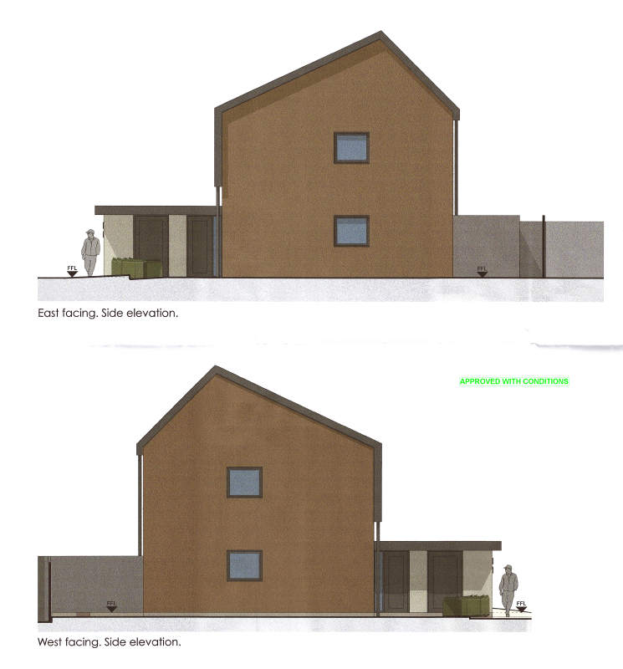

Contents
1.0 Executive Summary 3
2.0 Building Fabric 3
2.1 Structural Details 3
2.2 Material Innovations 3
2.3 Benefits to Efficiency 4
3.0 Environment 4
3.1 Environmental Response 4
3.2 Technological Integration (SOLCER & Tesla) 4
3.3 BedZED Development 4
4.0 Human Comfort 5
4.1 Challenges 6
4.2 Efficiency 6
5.0 Recommendations 7
5.1 Comparison with Other Developments 7
5.2 Energiesprong 8
6.0 Conclusion 9
7.0 Appendix 9
7.1 References 9
7.2 Additional Documents 11

Executive Summary
This appraisal evaluates the 2017 development (Bryn Bragl) in Bridgend, South Wales, as an example for our companies transition to more sustainable methods. The example was a project that collaborated between Wales & West Housing & Zenergy Design, the proposal outlines 14 homes designed to be more energy positive than traditional builds, they plan to generate more energy annually than the buildings consume. By making the most of a whole house systems approach which was rooted for in the Cardiff University ‘SOLCER’ (Smart Operation for a Low Carbon Energy Region), the project in a whole demonstrated that high – performing, carbon positive housing is a lot more of a viable option within this industry.

2.0 Building Fabric
The success of the example project is predicted on a “fabric first” approach, which prioritizes the thermal envelope of the building to reduce the energy demand first.

2.1 Structural Details
To achieve the thermal efficiency that they did on the Bryn Bragl development, they used a rigorous selection of high performing materials and construction detail techniques. The project included a large amount of high specification insulation material into the building fabrics; these serve to drastically reduce potential heat loss during the winter months. Complementing this, they focused on their airtightness standards for the new builds which were designed to reduce / prevent energy usage and waste through uncontrolled ventilation. Additionally, the installation of aluminium clad timber framed windows is an excellent design and provided an exceptional glazing solution, combining the external durability with the metal and the internal high performing natural insulation properties of timber.
2.2 Justification of Materials
The selection of high-performance fabric at the Bryn Bragl site is not just a design choice but specifically chosen to align with the Building Regulations Approved Document Part L in Wales, which has moved towards more stringent U-value requirements for the building envelope. By hitting an airtightness of 1.8M³ / (h.m²), this surpasses the standard UK requirements and effectively future proofed the targets against the foreseeable Welsh Government “Net Zero Carbon” targets for social housing. The fabric first approach is to avoid any performance gap which is often found in traditional constructed builds, where thermal bridging can lead to a large amount of heat loss.

2.2 Material Innovations
The aesthetics and functional design of the building elevations at the example demonstrate a well-blended strategy of traditional and pioneered materials. While the gable and rear elevations were designed to be constructed with conventional facing brick to keep the planning permission officers’ content and keep in turn with the local building types. The front elevations, however, consist of grey cladding that integrates solar panels directly facing the buildings surface with energy generation. The south facing roof covering consisted of PV panels rather than traditional bolt on systems, the PV systems are integrated into the main roof covering. This dual-purpose design is very efficient as it will save material costs by replacing normal interlocking tiles and reduce the weight and complexity of the construction all the while speeding the process up considerably.

2.3 Benefits to Efficiency
By reducing the heating demand due to the improved thermal efficiency, the required size and price of the mechanical heating system will be drastically reduced. This approach ensured that these ‘homes’ are now effectively ‘off grid’ from spring all the way through to the end of summer, running entirely on the PV panels and what is stored within the batteries.

3.0 Environment
The design of the example is not purely aesthetic; these are functional responses to the local South Wales climate and whatever technical opportunities of this generation’s energy creation possibilities.

3.1 Environmental Response
The planning involved within the site and orientation of this example reflect a design thought that is deeply responsive to both energy requirements and the characteristics of the south Wales landscape. To ensure maximum efficiency, these buildings are meticulously positioned with a primary south facing, 1 of the 2 faces of the mono pitch roofs, to capture enough solar gain to run as previously mentioned ‘off grid’ for the summer months. Additionally, the design of the site layout account for the misdirected and un-even topography of the local area, the site slopes from east to west, but the layout is strategically positioned and adjusted to maintain almost perfectly level access across the entire development all the while minimizing the physical and tangible deterioration of the local environment. This meticulously planned positioning was particularly crucial as it neighboured the Coed Y Morfa site of importance for Nature Conservation (SINC), this now ensure the preservation of the local wildlife and biodiversity before and after the construction period for years to come.

3.2 Technological Integration (SOLCER & Tesla)
The framework for the Bryn Bragl project is rooted in the SOLCER concept, a design that shifts the buildings’ role from a passive house consumer to an active energy producer. The design strictly follows the SOLCER framework which integrates solar collectors and PV systems which as previously mentioned built directly into the buildings structure.
To manage and hold this collected energy, it is stored in individual Tesla Power all battery packs with a 13.5Kwh capacity to store excess daytime solar energy. Each home has a Tesla battery within the fabric. This requirement for the large and significant battery storage directly influenced the internal layout of the dwellings and have specific space which had to be allocated to accommodate the infrastructure and control systems of each energy storage detail.

3.3 BedZED Development
While the SOLCER Cardiff concept and the Tesla Powerwall battery integrations represent the new age of energy positive construction methods, they are not without their drawbacks. A critical measurement of similar higher tech systems, such as the BedZED Development, show that the complex building management tools can lead to technology fatigue with the tenants if the interface is not in time and easy to navigate. Additionally, the 13.5Kwh battery must be given a cost benefit analysis against the operational carbon savings and eventual recycling/upfront cost. MantaRay should consider the long-term maintenance requirements compared to passive solutions such as increased thermal mass or natural ventilation used in certain Scandinavian models.
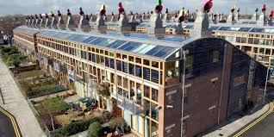
BedZED – the UK’s first major sustainable community – Bioregional (no date)

4.0 Human Comfort
This project replaces traditional gas fired central heating systems with all electric, integrated energy generators within the building. The core of the the building services strategy is the Pichler PKOM4 system, which serves as combined heat pump and MVHR unit. This works by extracting heat from exhaust air to warm any incoming fresh air while simultaneously providing adequate ventilation to the property where required and the domestic hot water requirements.
The main heating is managed by an exhaust air heat pump, which utilizes the residual warm air form the ‘wet’ rooms such as the kitchen and bathrooms as a consistent heat source. This unique method allows the unit to be fully operational all the while being far more efficient than standard air source units. Especially in the Welsh climate which is ever changing.
All of these different components are managed by a smart monitoring system, which automatically monitors electricity import/export, battery storage levels and internal humidity to ensure the home maintains peak performance without requiring constant manual configuration from the tenants.
Technology | Function | Control & Efficiency Method
Pichler PKOM4 | Combined Heat Pump & MVHR | Extracts heat from exhaust air to warm incoming fresh air - provides ventilation and domestic hot water.
Exhaust Air Heat Pump | Primary Heating | Uses the warm air from "wet" rooms (kitchens/baths) as a heat source, operating far more efficiently than standard air-source units.
Smart Monitoring | System Optimization | Systems monitor electricity import/export, battery status, and internal humidity to optimize performance automatically.

4.1 Challenges
Monitoring of the tenants showed that initially they struggled with electric towel rails and top up duct heaters, which lead to higher electrical usage in comparison to what was expected. These have been successfully mitigated by implementing 2-hour timers and refining control setting to make the technology to use more efficient and simpler to users.

4.2 Efficiency
The choice of the ‘Pichler PKOM4’ combined unit is very efficient as it utilizes a heat pump to recover energy from the wet rooms as previously mentioned which would otherwise be lost in a traditional extraction fan. However, if we were to do a pilot project, we must consider the ‘BS EN 13141-7’ standards for ventilation performance. There is evidence within the UK that shows that MVHR installations have been unsuccessful in certain regards, they indicate that the noise levels are high and the filter maintenance intervals are one of the main reasons that tenants disable their systems. We will have to ensure that the MVHR system we choose meets the required air change per hour required for health and that it does not come at the cost of acoustic comfort and or high maintenance issues.
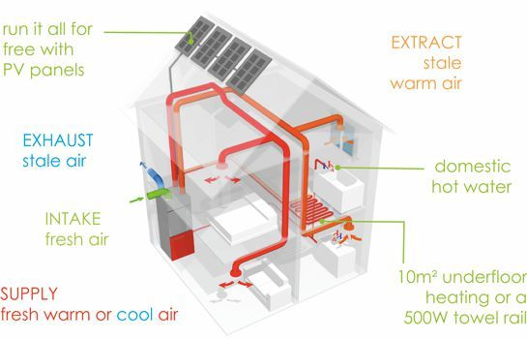
PKOM 4A Compact Service Unit (no date)

5.0 Recommendations

5.1 Comparison with Other Developments
The conclusions presented by the project at Bryn Bragl are reinforced by comparing its specific success to other projects also within the South Wales region.
The Solcer house in Stormy Down acted as the prototype for Bryn Bragl, proving that energy positive and efficient homes could be constructed cost effectively coming to circa £125,000. The Solcer house demonstrated the importance of utilizing local supply chains to reduce embodied carbon of the build itself.
Gwynfaen farm development offers a complimentary take, timber frame closed panels with blown wood fibre insulation to hit close to zero carbon usage.
All of these comparative project examples suggest that introducing off site manufacturing (OSM) and considering more sustainable materials for insulation is a highly viable option and could drastically impact the way social housing clients tender for the foreseeable future, and in turn change how we as a company operate.

5.2 Energiesprong
The “Energiesprong” model, pioneered in the Netherlands, is another positive argument for OSM, (Off Site Manufacturing). This method utilizes prefabricated insulated walls and roofing panels which include the PV integrations that can be retrofitted or fitting within a new build fabric, to hit net-zero status in days instead of months. At MantaRay, this would not only align with the ‘Well-being of future generations (Wales) act 2015’ by providing high performing sustainable homes and would reduce our on-site H&S risks and exposure to the unpredictable weather in Wales.
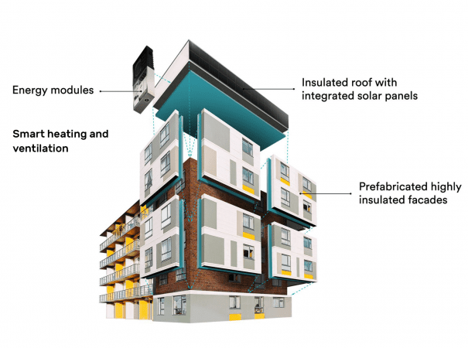
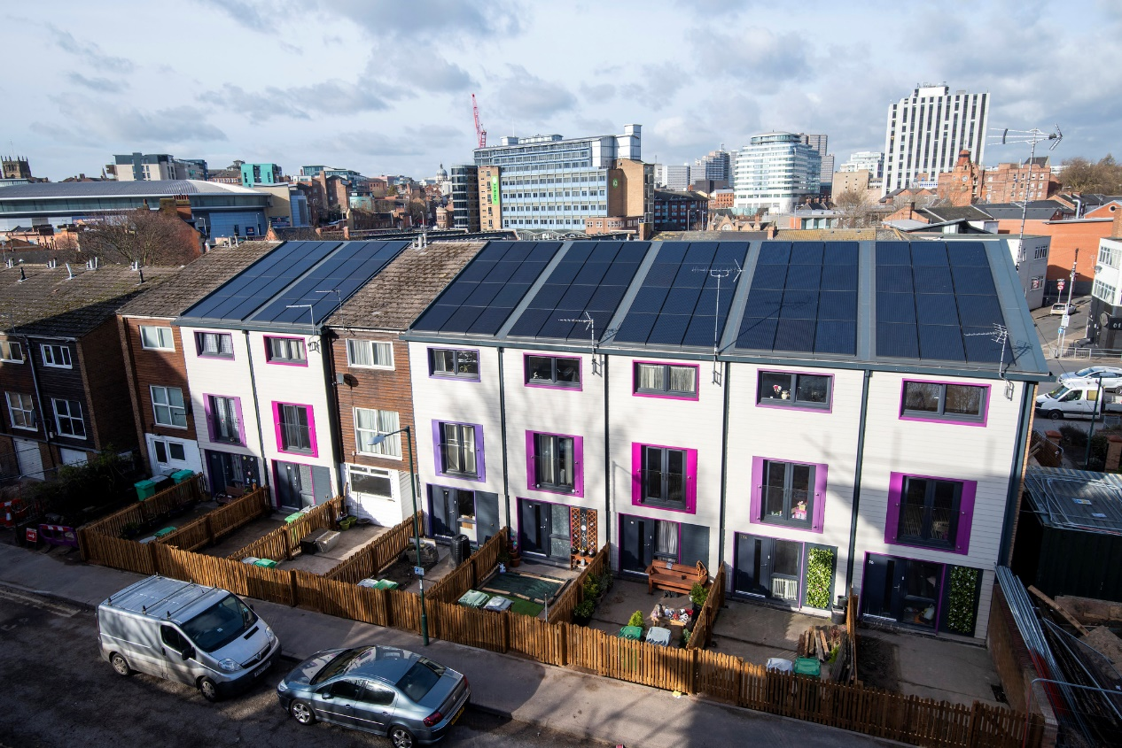
(Energiesproing, 2026)

6.0 Conclusion
In summary, the Bryn Bragl development is considered a very successful ‘experiment’ which has now provided concrete evidence that the construction of energy positive housing is not only a future goal but an achievable task in todays climate, using in simple terms, off the shelf construction tech. The project itself shows that by enforcing a fabric first approach with renewable generation, as developers we can create high performance homes which can significantly reduce the running costs for social housing examples.
For our company, it is understood that the potential performance gap is a risk. The measurable difference between how it they would be designed and the tenant’s pattern of usage. However, the recorded stats show a predicted drop in energy bills within the household, this shows that there is an attractive market for this model for social landlords such as the Welsh Government and local councils who we can offer a robust and fuel-efficient new build, at a good cost and meeting environmental targets.
Based on this appraisal, I recommend that our company (MantaRay Contracting) should begin a ‘pilot’ project which adopts all of the sustainable details demonstrated by the Bryn Bragl project. We will investigate the feasibility of integrating PV roofing panels and MVHR systems. By adopting these potentialities early, we can establish our position as a top contractor in sustainable Welsh new builds, this will ensure we stay competitive within this harsh industries future.

7.0 Appendix

7.1 References
Enfusion and RPA (2019) Prosperity for All: A low carbon Wales, Sustainability Appraisal (SA). https://www.gov.wales/sites/default/files/publications/2019-06/low-carbon-delivery-plan-sustainability-appraisal.pdf. Accessed on 2nd January 2026
TM54: Evaluating Operational Energy Performance of Buildings at the Design Stage | CIBSE (no date). https://www.cibse.org/knowledge-research/knowledge-portal/tm54-evaluating-operational-energy-performance-of-buildings-at-the-design-stage/. Accessed on 10th January 2026
The cost of ignoring poor housing (no date). https://bregroup.com/reports/the-cost-of-ignoring-poor-housing. Accessed on 2nd January 2026
Farmer, M. and Construction Leadership Council (2016) The Farmer Review of the UK Construction Labour Model. https://www.constructionleadershipcouncil.co.uk/wp-content/uploads/2016/10/Farmer-Review.pdf. Accessed on 10th January 2026
Welsh Government (2019) Prosperity for All: A low carbon Wales. https://www.gov.wales/sites/default/files/publications/2019-06/low-carbon-delivery-plan_1.pdf. Accessed on 10th January 2026
Future Wales: The National Plan 2040 | GOV.WALES (2021). https://www.gov.wales/future-wales-national-plan-2040-0. Accessed on 18th January 2026
Welsh Government (2025) Building Regulations Part L 2025 Review, Consultation Document. https://www.gov.wales/sites/default/files/consultations/2025-08/ad-l-consultation-document_0.pdf. Accessed on 12th January 2026
Passive House Plus (Sustainable building) issue 47 UK (2024). https://issuu.com/passivehouseplus/docs/ph_uk_issue_47_digital. Accessed on 12th January 2026
Committee on Climate Change et al. (2019) UK housing: Fit for the future? https://www.theccc.org.uk/wp-content/uploads/2019/02/UK-housing-Fit-for-the-future-CCC-2019.pdf. Accessed on 14th January 2026
British Gas Business (no date) Natural Renewable Electricity | British Gas business. https://www.britishgas.co.uk/business/gas-and-electricity/renewable-business-energy/natural-renewable-electricity?cid=CBSECMREGO2a&gclsrc=aw.ds&gad_source=1&gad_campaignid=21280227321&gbraid=0AAAAADtOEua2mAtYqR6Gm_CgnJuWmLd3d&gclid=Cj0KCQiAprLLBhCMARIsAEDhdPfTU3bRc1OA5Hx4yhdR2VkMc_MVFveaiLXwkcnkMDwCTYd5ntDo1yIaAkenEALw_wcB. Accessed on 14th January 2026
Sustainability Planning with IBM Planning Analytics (no date). https://www.google.com/aclk?sa=L&ai=DChsSEwjc457IgJWSAxVmpFAGHfwOHkAYACICCAEQAhoCZGc&ae=2&co=1&ase=2&gclid=Cj0KCQiAprLLBhCMARIsAEDhdPfIc9-r_EMMxeA_O2vh5YtfYLtHY2MoUf33q5FJ6CM-MMoEPbyWQQgaAn5cEALw_wcB&cce=2&category=acrcp_v1_71&sig=AOD64_1a2lusePVKPrIcEKPYTzPVfJmFPg&q&nis=4&adurl&ved=2ahUKEwjo9JDIgJWSAxVZUEEAHVxgDmIQ0Qx6BAg3EAE. Accessed on 13th January 2026.
Energiesprong UK | Home (no date). https://www.energiesprong.uk/. Accessed on 18th January 2026
PKOM 4A Compact Service Unit (no date). https://www.totalhome.co.uk/ventilation/?pid=594. Accessed on 18th January 2026.
BedZED – the UK’s first major sustainable community – Bioregional (no date). https://www.bioregional.com/projects-and-services/case-studies/bedzed-the-uks-first-large-scale-eco-village. Accessed on 18th January 2026

7.2 Additional Documents
Obtained from Bridgend Planning portal



