Problem
Analysis and Solution
Development

Module Name: Analysing and Solving Problems
Module Code: ACCA 4019
Student Name: John Tandazo
Student ID: 2442071
Group:2
Lecturer’s Name: Dr Redhwan Al-amri

Table of Contents
Introduction 2
Problem Scenario 2
1. Deconstruct the Problem 2
1.1 MoSCoW Technique Requirement 3
2.2 Variables Identification 4
2. Proposed Solution 5
FLOWCHART 5
3.2 Flowchart Explanation 6
4-Reflection and Justification 7
Abstract thinking 7
Sub-dividing 7
Justification of solution 8
Limitation 8
Assumption 8
References 9

Introduction
This document analyzes a problem at a local university that is failing to adequately manage classroom bookings. Classrooms are being assigned to overly large classes, classes overlap because two groups end up in the same room, and professors and students waste time rushing across campus between sessions. This report breaks down the problem into smaller issues, determines priorities, and proposes a clear, step-by-step solution. The tools used to address this are threefold: problem decomposition, a priority list created with MoSCoW, and a flowchart for designing a system that efficiently allocates classrooms, avoids scheduling conflicts, and minimizes unnecessary travel.

Problem Scenario
A local college is facing difficulties in managing its classroom allocations efficiently. Some rooms are overcrowded while others remain underused, leading to timetable clashes and wasted time as staff and students move between rooms. The college aims to optimise classroom allocation to make better use of available space and improve the overall learning experience.
You have been asked to develop a solution that achieves the following:
1. Efficient allocation of classrooms based on class sizes and room capacities.
2. Minimised time wasted by students and staff moving between classes.
3. Accurate timetabling to ensure all lessons start on time without scheduling conflicts.

Deconstruct the Problem
To solve a problem, it's important to break it down into smaller parts and understand each one. Chaos in university scheduling might seem like a single problem, but upon closer examination, it becomes clear that it's actually composed of several smaller, interrelated issues. This technique is known as decomposition, and it involves dividing a large, complex problem into smaller, more manageable parts. By focusing on each smaller problem, the risk of overlooking important aspects is reduced [1].
The Three Main Subproblems
When analysing the problem facing the university, three main issues can be identified:
1-Classrooms are not adequately sized for the classes.
2-Several classes are scheduled in the same classroom at the same time. This means two classes end up in the same room at the same time, which breaks one of the most basic rules the system must follow. [2].
3- Consecutive classes are located too far apart, causing delays. When rooms are too far apart, teachers and students end up rushing between buildings and sessions start late [3].
By breaking down the problem into these components, it becomes easier to manage and resolve. Each subproblem can be handled individually and then combined into a single, fully broken-down problem.

MoSCoW Technique Requirement
Before developing any solution, it is important to identify which requirements are essential and which are merely desirable. The MoSCoW technique is commonly used for this purpose, as it categorises requirements into four groups: Must Have (non-negotiable), Should Have (important but not critical at present), Could Have (useful extras), and Won’t Have (explicitly out of scope for the moment).
When different stakeholders are involved, such as administrators, lecturers, and students, priorities may vary. Using MoSCoW helps to establish clear priorities from the outset, ensuring that the most important requirements are addressed first. It also helps to avoid unnecessary work by focusing only on what is truly needed.
Furthermore, defining what will not be included is equally important, as it keeps the solution simple and prevents it from becoming overly complex [4].

M--Must Have | S--Should Have | C --Could Have | W –Will Not Have
Correct room size for each class | Readable timetable available before term | Departments request preferred rooms | AI-powered automatic assignment
One class per room at a time | Timetable changes automatically saved | Labs matched to courses automatically | Integration with other institutions
Short travel time between classes | Classes from same department in same building | Student feedback on room preferences | Real-time timetable changes without approval
Automatic alerts for schedule changes |  |  | Students choosing their own classroom
Minimum break between classes |  |  | Prediction of future enrolment numbers
 |  |  | Rooms assigned outside normal hours
 |  |  | History of rooms used in previous years
[5].

2.2 Variables Identification
The table splits everything into four groups, ranking each item from essential to non-essential. Must Have items are the five elements that simply must be present, because if any are missing, everything falls apart. Should Have items are three improvements for teachers and students. Could Have items are three extras that could be added later. And Will Not Have items are seven things deliberately left out.
Variables: | Description:
Room ID (string) | The unique name or code for each classroom.
Room Capacity (integer) | The maximum number of people the room can hold.
Class Size (integer) | The actual number of students enrolled in the session.
Room Location (string) | Where exactly on campus is it? (To avoid long walks).
Time Slot (datetime) | The specific day and time the class starts and ends.
Instructor ID (string) | The teacher's unique code (to prevent scheduling them in two places at once).
Room Availability | Is this room free at this time? Available or Not Available
Adjacency Score | How far apart two rooms are
Alert Status | Has the teacher been notified of any changes? Yes or No
Break Duration | The minimum rest time required between two sessions
This is the only information the system needs to function correctly [6].

Proposed Solution
Now that the key steps have been identified, what follows is establishing the order in which they must occur: where it begins and where it ends. This is done using a flowchart, which is a graphical representation of a process that facilitates understanding and arranges the steps logically, creating a path from beginning to end so that nothing important is omitted [7]. It is important to clarify that, while a flowchart helps structure and sequence the steps, it is not the technique that determines which steps are essential for the system to function, as that is the role of the MoSCoW technique. What the flowchart does is take those key steps and organise them in the correct sequence so that everyone can easily follow the solution [8].
The flowchart is presented below.

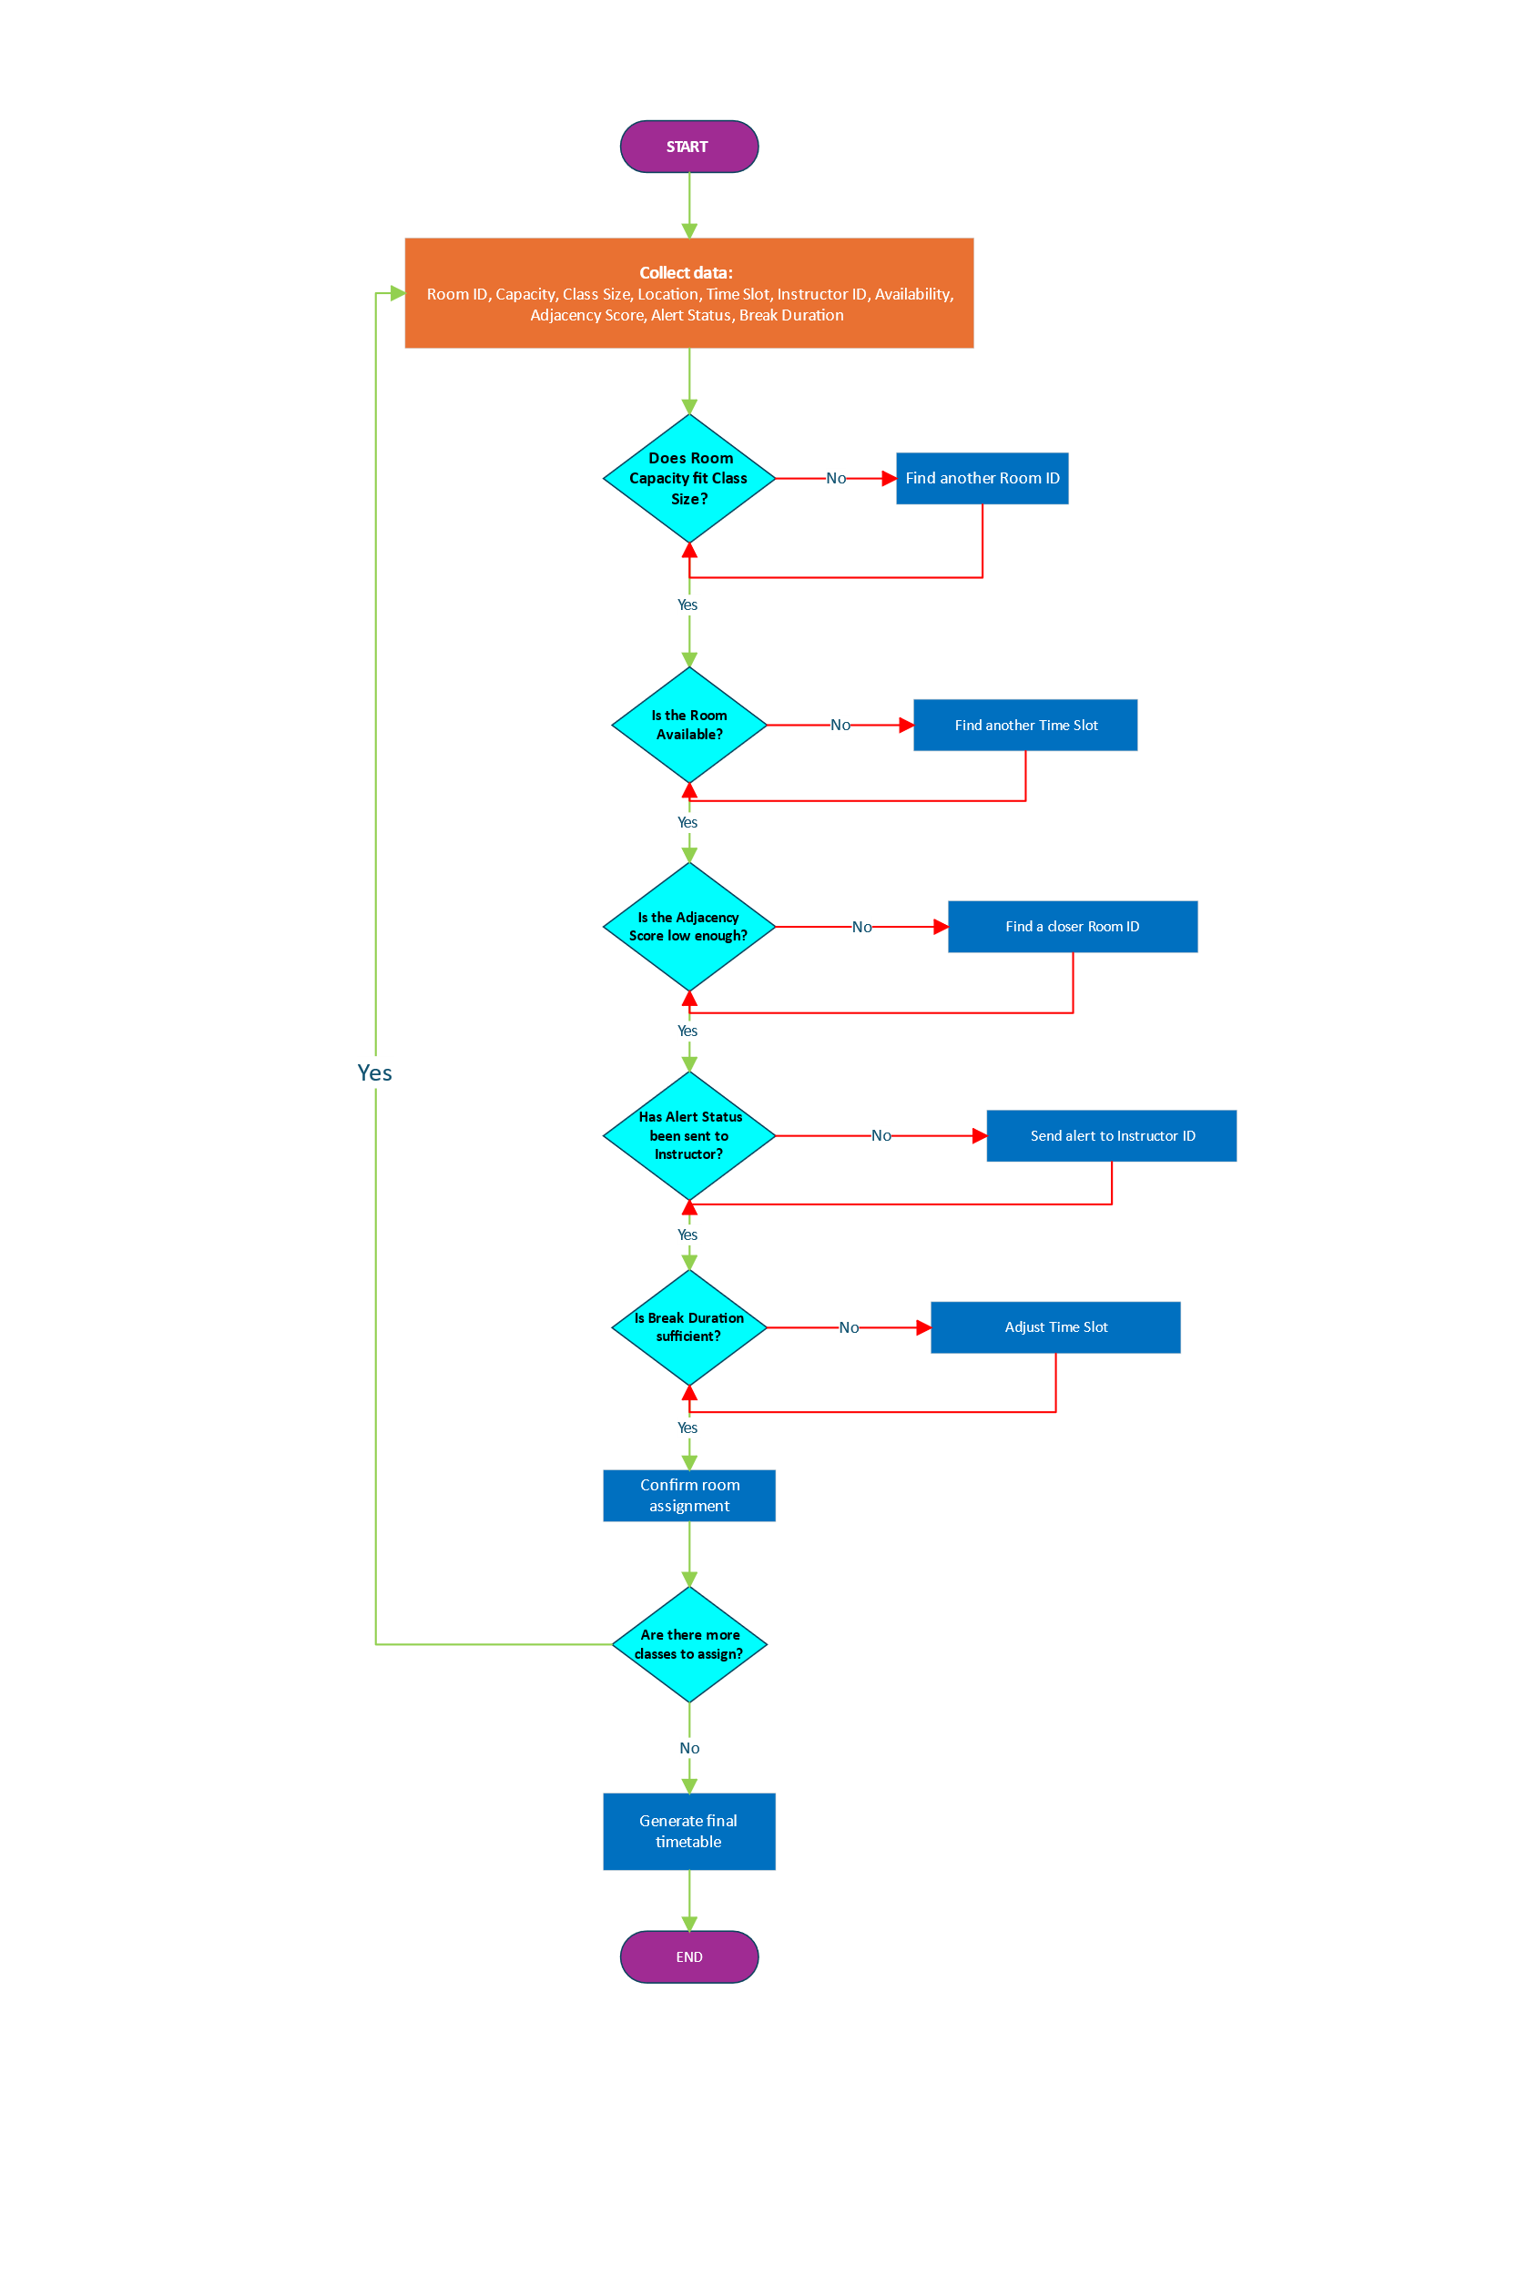
FLOWCHART

3.2 Flowchart Explanation
The process starts by collecting the ten variables the system needs to make decisions. Without this data, nothing can proceed.
The first check verifies whether the room is large enough for the class. If not, the system searches for another until it finds a suitable one.
Once a room fits, the system checks whether it is already booked. If it is, another time slot is tried.
If the room is free, the system checks the distance to the next session. If it is too far, a closer room is found so nobody wastes time travelling.
The system then checks whether the teacher has been notified. If not, an alert is sent immediately, as an unannounced change could send the teacher to the wrong room, losing valuable class time.
Next, the break between sessions is checked. If it is too short, the time slot is adjusted.
Once all five checks pass, the assignment is confirmed. If more classes remain, the process repeats. If not, the final timetable is generated. The flowchart makes the entire solution easy to follow, from the data collected at the start to the final timetable at the end. [9].

4-Reflection and Justification

Abstract thinking
When solving problems, especially those that are very extensive, we have to break the problem down and convert it into smaller problems in order to solve them one by one. When doing this, we must focus on what is significant and not on what is unimportant, because if we only think about the problem without analysing it in depth, we will end up doing things wrong and, worse, not doing anything at all. This is what was done with the classroom organisation problem at the college — the problem was analysed, broken down, and converted into three smaller problems. The MoSCoW technique was used to identify which steps are essential for the system to function, the variables were identified, and the process flowchart was used to establish the order of those variables. This demonstrates abstract thinking by focusing only on the significant details of the problem [10].

Sub-dividing
Instead of trying to tackle the classroom problem all at once, it was broken down into three smaller and more manageable parts:
1. Rooms not being the right size for the class
2. Two classes being assigned to the same room at the same time
3. Consecutive sessions being located too far apart
Breaking the problem down this way made it much easier to understand what needed to be solved and plan a clear solution for each part [11].

Justification of solution
The main problem was broken down into smaller parts, as these are much easier to solve and reduce the stress of tackling one enormous task. This allows for focusing on each part individually and finding simple solutions, rather than trying to solve everything at once.
Subsequently, the MoSCoW technique was used to categorize the requirements and identify which were essential and which were not, clarifying what the system needs to function. Once the key steps were identified, the variables were extracted, as the system needs data to make decisions. Finally, the process flowchart was used to establish the order and sequence of the variables. Without this, it would be impossible to know where to start or where to finish, and the system would not be able to function.

Limitation
The system can only work with the information it receives. If the data is incorrect (for example, if incorrect information such as a room capacity or a non-existent time slot was entered), the system will make mistakes without realising it. It also cannot manage classes that need to be divided into smaller groups, or rooms required outside of scheduled hours.

Assumption
A few things were taken for granted when designing this solution:
1. The data for all ten variables is assumed to be accurate and complete before the system runs. If any information is missing or wrong, the system cannot work properly.
2. Each teacher is assumed to be teaching only one class at a time.
3. The timetable is assumed to follow a regular weekly pattern without unexpected changes.
5-Conclusion
What this problem demonstrated is that it is better to break down large problems into smaller ones so they can be handled more easily. Trying to solve everything at once only leads to confusion and errors, and often results in nothing being done at all. By dividing the college problem into three smaller parts, it was much easier to understand what needed to be solved and how to do it. Using techniques such as MoSCoW helps identify what really matters, the variables give the system the data it needs, and the flowchart organises everything in a clear order. Any large problem, no matter how complicated it may seem, can always be solved step by step.

References

[1] | J. M. Wing, «Computational thinking,» Communications of the ACM, pp. 33-35, 01 March 2006.
[2] | J. K. A. H. Hamed Babaei, «A survey of approaches for university course timetabling problem,» Computers & Industrial Engineering, pp. 43-59, 2015.
[3] | P. A. E. H. Christos Gogos, «An improved multi-staged algorithmic process for the solution of the examination timetabling problem,» Annals of Operations Research, т. 194, pp. 203-221, 19 February 2010.
[4] | R. M. M. H. Q. A. A. Amjad Hudaib, «Requirements Prioritization Techniques Comparison,» Modern Applied Science, т. 12, № 2, p. 19, 2018.
[5] | N. A. H. T. S. K. Khadija Sania Ahmad, «Fuzzy_MoSCoW: A Fuzzy based MoSCoW Method,» в 2017 International Conference on Intelligent Computing, Instrumentation and Control Technologies (ICICICT), Kerala, India, 2017.
[6] | J. S. L. F. S. T. Ndudi O. Ezeamuzie, «Unleashing the Potential of Abstraction From Cloud of Computational Thinking: A Systematic Review of Literature,» Journal of Educational Computing Research, т. 60, № 4, 9 December 2021.
[7] | E. E. K. D. D. B. Anthony E. Zimmermann, «Effectiveness and Utility of Flowcharts on Learning in a Classroom Setting: A Mixed-Methods Study,» American Journal of Pharmaceutical Education, т. 88, p. 100591, 2024.
[8] | N. CHAPIN, «Flowcharting With the ANSI Standard: A Tutorial,» Communications of the ACM, т. 13, № 10, pp. 557-565, 1970.
[9] | P. C. S. T. Musarurwa David Chinofunga, «How can procedural flowcharts support the development of mathematics problem-solving skills?,» Mathematics Education Research Journal, т. 37, pp. 85-123, 2025.
[10] | A. S.-A. O. H. Aharon Gero, «Interrelations between systems thinking and abstract thinking:the case of high-school electronics students,» European Journal of Engineering Education, т. 46, № 5, pp. 735-749, 2021.
[11] | A. A. Y.-M. H. I. P. H. Ting-Ting Wu, «Identification of Problem-Solving Techniques in Computational Thinking Studies: Systematic Literature Review,» SAGE Open, 15 May 2024.

