Student Name: Victor Badaluta  Student ID: 2212187  Module Title: Foreign Languages & Cultural Awareness  Module Code: BMIH5003  Lecturer: Lisa Brasler  Date: 20.02.2024 | 
ASSIGNMENT 1: PORTFOLIO
(4 Components)

Component 1: Professional Reflection (500 words +/- 10%)

Weighting: 25%
I have been appointed as a Food and Beverage (F&B) employee at Sofitel London Gatwick Hotel UK. During my employment in a hotel, there was a scenario where a cultural misunderstanding occurred with a guest in our hotel. The guest was from South Korea and I could not understand his accent and gestures due to which some misunderstanding occurred. This misunderstanding occurred when I was involved in providing breakfast service to our visitors. This event occur in the hotel restaurant. When I reached out to the guest and asked him about what he would like to have for breakfast I was focused on providing the best services to our visitors. In this instance, I interacted with him in a very friendly and casual manner for which I used simple informal language. However, the guest did not find my gesture friendly for which in return rather than answering me in a friendly way he was angry towards me and wanted to leave the hotel without breakfast. The situation was then handled by the manager and he also instructed me to remain professional with the guests especially those whom I found are from other cultures.
After this incident, I realized that cultural misunderstanding can even occur from the way individuals communicate. Some cultures prefer to communicate formally and they do not like to be friendlier with others (Ting-Toomey and Dorjee, 2018). They don’t want any informal gestures in any professional place, especially in this case a hotel. The way I reached and communicated to the guest he might find it disrespectful as in Korea talking in a friendly way to elders are considered rude most of the time due to which he was on the verge of leaving the hotel angrily. To avoid such cultural misunderstandings in my future career I have to develop some specific skills and should behave professionally while interacting with guests. I need to develop cultural sensitivity and awareness first. I have to understand the communication and gesture styles of guests from different cultures so that I can communicate effectively with them.
To develop these skills I am planning to enrol in training programs that provide cultural awareness. The training will provide me understanding of different communication styles, etiquettes and gestures from different regions of the world. By developing a deep knowledge of the communication and gesture styles of individuals from different cultures I can develop my skills according to the guests’ preferences (Vetrinskaya and Dmitrenko, 2017). Enhancing language skills can also be an important element through which I can develop primary languages of hotels, common greeting phrases and gestures used in different areas of the world. It will show linguistic respect to our guests and can develop positive and comfortable interactions with others (Erazo et al., 2019).
Moreover, I also realize the need for active listening. As in most cultures, non-verbal communication is dominant over verbal communication (Van Der Veere, 2021). I will also work on my behavior according to which I will be focused on providing comfort to my guests. This will allow guests and visitors to enjoy their meals and feel respected and valued. This cultural misunderstanding is a valuable experience for me. After this, I joined training to develop cultural knowledge and improve my linguistics and gestures. After completing my training I am confident enough that I will never undergo any such situation in my future career. This training will also help me in providing the best experience for the guests which enhances the overall service quality of our hotel.
References:
Erazo, M.A.C., Ramírez, S.I.M., Encalada, M.A.R., Holguin, J.V. and Zou, J.H., 2019. English language skills required by the hospitality and tourism sector in El Oro, Ecuador. Theory and Practice in language Studies, 9(2), pp.156-167.
Ting-Toomey, S. and Dorjee, T., 2018. Communicating across cultures. Guilford Publications.
Van Der Veere, A., 2021. BODY LANGUAGE & BEHAVIOR CUSTOMS East & West: The non-verbal way of communication of different cultures. Arnaud van der Veere.
Vetrinskaya, V.V. and Dmitrenko, T.A., 2017. Developing students’ sociocultural competence in foreign language classes. Training language and culture, 1(2), pp.23-41.
Component 2: Training Plan (500 words +/- 10%)

Weighting: 25%

After having a cultural misunderstanding with a visitor in our hotel I have developed a training plan “Cultural Understanding Plan” for all the Sofitel London Gatwick Hotel UK employees. The training plan will develop cultural competency, ensure that all the guests at the hotel have the best experience and train the staff to avoid such mishaps in future. After the incident occurred I was worried that there was an immediate need to increase cultural sensitivity awareness, and language awareness and to adapt according to the diverse hotel environment. The training plan includes:
Need of plan
To develop an environment that is diverse and culturally aware. Improve communication skills of the staff to prevent cultural misunderstanding (Helmreich and Schaefer, 2018). The hotel will be arranging staff training to enhance customer satisfaction and improve the global reputation of the hotel to achieve a competitive advantage.
What training is required:
Cultural competency training
The training will provide knowledge to understand different cultural norms, the way they communicate and gesture styles. The training will encourage that language is the main element of interaction.
Training to develop language skills
The training will be focused on using basic greeting phrases while meeting with guests and using formal and polite language (Shepherd et al., 2019).
Active listening skills
The training will be given to understand non-verbal communication effectively. The training will be given to increase attentiveness among staff.
Multilingual communication etiquette
The training will be given to understand guest gestures and formalities appropriately. This will help recognize cultural practices.
Who will be trained?
Training will be obligatory for all the staff of the hotel including front-desk officers, housekeeping members, managers, and other restaurant staff. The hotel will hire external trainers who are specialized in cultural competency and language skill training.
Place of training
The training sessions will be conducted in the conference room of the hotel so that all the staff can easily adjust and participate in the learning process. The trainers can use multi-media presentations, use role-playing activities so that all the staff engage and learn efficiently (Prieß-Buchheit et al., 2020).
When training will be done
The training sessions of “Cultural Understanding Plan” will be spanned to one month schedule the sessions will include levels for every staff in the hotel. The sessions will be conducted at a time when there are fewer guests in the hotel. The staff will also incorporate fresh courses and updates for the continuous professional development of all employees.
This training aims to make our staff as cultural competency ambassador. After training the staff will ensure that all the guests feel respected in a diverse hotel environment. The staff remains committed to our aim to welcome, value and understand all guests apart from their inclusivity (Gagnon et al., 2020).
References:
Gagnon, K., Young, B., Bachman, T., Longbottom, T., Severin, R. and Walker, M.J., 2020. Doctor of physical therapy education in a hybrid learning environment: reimagining the possibilities and navigating a “new normal”. Physical Therapy, 100(8), pp.1268-1277.
Helmreich, R.L. and Schaefer, H.G., 2018. Team performance in the operating room. In Human error in medicine (pp. 225-254). CRC Press.
Prieß-Buchheit, J., Aro, A., Demirova, I., Lanzerath, D., Stoev, P. and Wilder, N., 2020. Rotatory role-playing and role-models to enhance the research integrity culture. Research Ideas and Outcomes, 6, p.e53921.
Shepherd, S.M., Willis-Esqueda, C., Newton, D., Sivasubramaniam, D. and Paradies, Y., 2019. The challenge of cultural competence in the workplace: perspectives of healthcare providers. BMC Health Services Research, 19(1), pp.1-11.
Component 3: Student Self-Reflection (500 words +/- 10%)

Weighting: 25%
Gibbs Reflective model on cultural awareness
Description
At the start, my knowledge related to the importance of cultural importance was not widely expanded. The training makes me understand its importance while acknowledging that visitors from different backgrounds have different needs. The incident that occurs with one of our guests appears to be the connecting force to develop deep understanding.
Feelings
Firstly I was confident that I can confidently communicate with diverse guests and can provide excellent services. But when the incident appeared and the guest was not happy with the service I lost my confidence. I have mixed feelings as I just realized at that time I don’t have cultural awareness skills. At that time I realised the importance of cultural awareness which created uneasiness for guests.
Evaluation
After reflecting on my skills I questioned my thoughts related to the importance of communication. It made me realise what can be friendly and polite for inclusive guests and what can be informal or rude. I also understood that if something is formal in one culture it can be informal in another (Greenhow and Lewin, 2019). After that, I was concerned about being more culturally aware and sensitive as I already work in the hospitality sector.
Analysis
The reflection and analysis helped me to consider the need for cultural awareness. Apart from communication style gestures, cultural and traditional norms, guest experiences and expectations are also to be fulfilled effectively (Ting-Toomey and Dorjee, 2018). It made me realise that if I am a good service provider in the hospitality sector I need to learn the importance of making guests feel respected and valued like at home. It is not just confined to fulfilling needs.
Conclusion
The above-mentioned experience enlightened the need and importance of cultural awareness as the main element in the hospitality sector. It is far beyond just learning languages it also includes developing a deep understanding of cultural diversity and individual ability to adapt according to culture. In globalized hotel sectors, cultural competency is not just training but an essential need to develop positive guest experience which in turn makes our hotel well-reputed.
Action plan
I now frequently address gaps in my hotel necessities and service-providing capabilities. I will be committed to training developing and to improve my skills in cultural competency. I will enrol myself in such courses and classes and seek feedback from teachers, colleagues and guests from diverse backgrounds on whether I have improved or not. The action plan aims to develop basic knowledge and skills that are important for to identify difficulties in multicultural interactions in the hotel business.
References:
Greenhow, C. and Lewin, C., 2019. Social media and education: Reconceptualizing the boundaries of formal and informal learning. In social media and education (pp. 6-30). Routledge.
Peterson, M., 2017. Living with difference in hyper-diverse areas: how important are encounters in semi-public spaces?. Social & Cultural Geography, 18(8), pp.1067-1085.
Ting-Toomey, S. and Dorjee, T., 2018. Communicating across cultures. Guilford Publications.
Component 4: Training Presentation (6 Slides)

Weighting: 25%
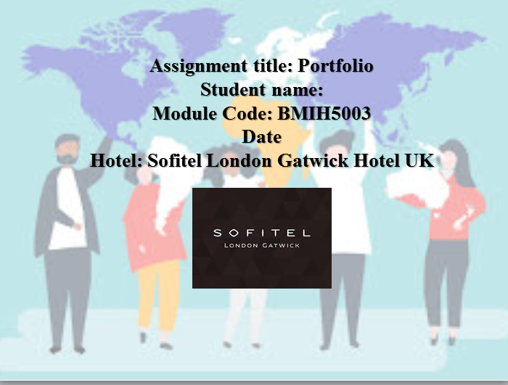
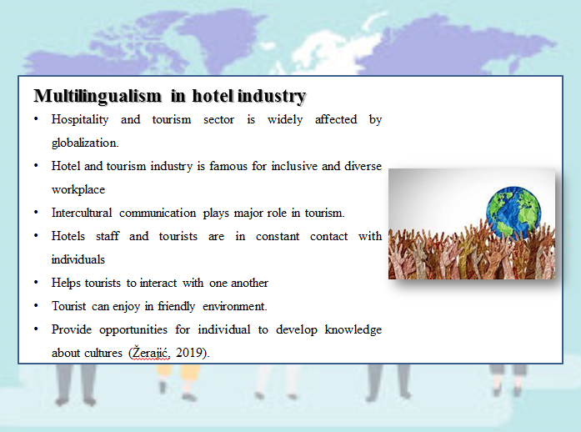
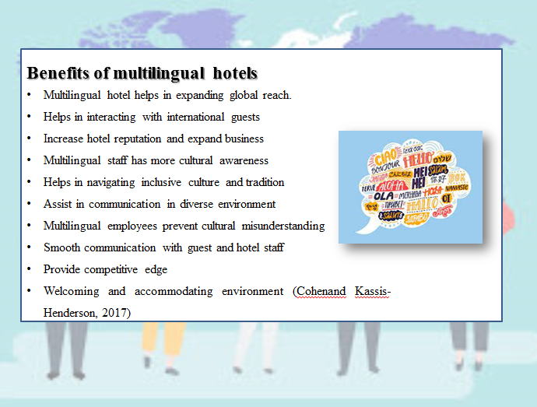

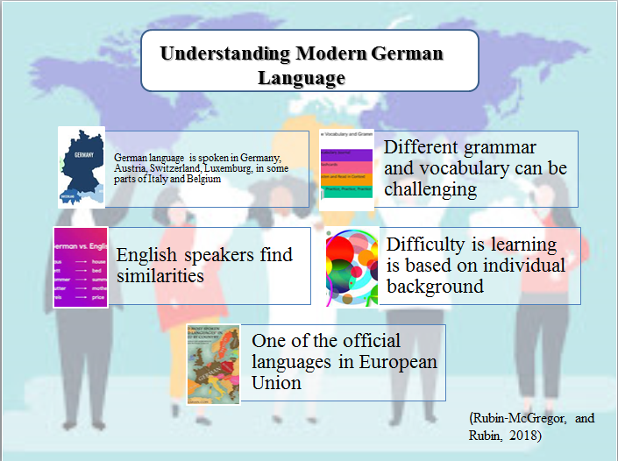

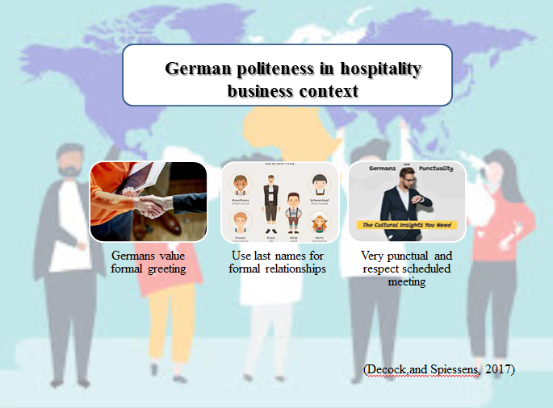
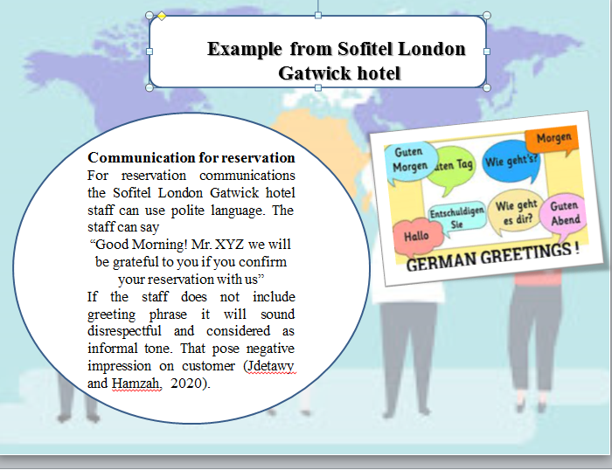
References
Cohen, L. and Kassis-Henderson, J., 2017. Revisiting culture and language in global management teams: Toward a multilingual turn. International Journal of Cross Cultural Management, 17(1), pp.7-22.
Decock, S. and Spiessens, A., 2017. Customer complaints and disagreements in a multilingual business environment. A discursive-pragmatic analysis. Intercultural pragmatics, 14(1), pp.77-115.
Jdetawy, L.F. and Hamzah, M.H., 2020. Linguistic etiquette: a review from a pragmatic perspective. Technium Soc. Sci. J., 14, p.695.
Rubin‐McGregor, J. and Rubin, B., 2018. Teaching the whole story: Examining the Shoah in intermediate German language courses. Die Unterrichtspraxis/Teaching German, 51(1), pp.31-52.
Žerajić, A., 2019, June. Intercultural management and the importance of foreign languages in modern hotel industry. In Tourism International Scientific Conference Vrnjačka Banja-TISC (Vol. 4, No. 1, pp. 360-377)

