Automation In the Agricultural Industry



Nathan Evans
Electrical and Electronic Engineering / Final Year Project
Submitted to: Gareth Jones
UWTSD – Waterfront Campus
29/04/25

DECLARATION

I, Nathan Evans declare that I am the sole author of this Project; that all references cited have been consulted; that I have conducted all work of which this is a record.

This work has not previously been accepted as part of any other degree submission.

Signed : N. Evans

Date : 29th April 2025

FORM OF CONSENT
I, Nathan Evans hereby consent that my Project, submitted in candidature for the BEng Electronic Engineering degree, if successful, may be made available for inter-library loan or photocopying (subject to the law of copyright), and that the title and abstract may be made available to outside organisations.

Signed : N. Evans

Date : 29th April 2025.

Automation In the Agricultural Industry

Contents Page:

The following report will demonstrate competence in the following areas.
1. Introduction
2. Literature review
2.1 Overview of the agricultural industry
2.2 Comparing Microcontrollers for Irrigation Systems
2.3 Technological Advancements in Sensor Integration
2.4 Drip Irrigation – Efficient water use
2.5 The impact of climate change on irrigation
2.6 Overcoming the Challenges of Excessive Irrigation
2.7 The Role of Sensors in Modern Irrigation Systems
2.8 Control Mechanisms in Automated Irrigation
2.9 Energy Efficiency and Sustainability in Irrigation Design
2.10 Machine Learning in Irrigation
2.11 User Experience and Interface Design
2.12 Literature Review Conclusion
3 System Overview
3.1 System Architecture
3.2 System Power and voltage regulation
3.3 Initial Issues with the pump
3.4 Fixing the Issue
3.5 Sensors and Signal Conditioning
3.6 Soil Moisture Sensor
3.7 Soil Sensor Working Principle
3.8 soil sensor justification
3.9 Sensor Summary
3.10 Rain Sensor
3.11 Rain Sensor choice justification
3.12 Sensor Summary
3.13 Microcontroller Unit (MCU): PIC18F45K50
3.14 PIC Conclusion
3.15 Motor Driver and Pump Control
3.16 Pump Justification
3.17 LCD Display – Simulation Only
3.18 Buzzer Feedback - Simulation Only
3.19 Operational Flow
3.20 System Advantages
4. Software Design
5. Results & Discussions
5.1 Current and Power Consumption of the system
5.2 Test 1: System with Pump in Action
5.3 Test 2: System With Soil Sensor in Wet Soil
5.4 Test 3: System in Lock Mode (Rain Detected)
5.5 Analysis and Interpretation
5.6 Current and Power Test Conclusion
5.7 System Response time
5.8 Pump Flow Rate
6. Conclusion
7. Future Improvements

- Introduction
Agriculture is a vital sector in many economies, providing food, employment, and raw materials. However, the increasing water demand, coupled with the challenges of climate change and inefficient irrigation methods, has strained water resources. Manual irrigation, is still widely practiced in many regions, often results in water wastage, inconsistent watering schedules, and poor crop health. [1]
With the ongoing advancement of sensor technologies, there is an opportunity for automation in the agricultural industry, to increase efficiency and sustainability. A big area to focus on is irrigation control. This is where automated system designs can respond to environmental conditions in real time, ensuring that crops receive the correct amount of water without manual input.
The project focuses on the design and implementation of an automatic irrigation system using the PIC18F45K50 (PIC) microcontroller. The system uses a resistive soil moisture sensor to detect when the soil is dry and activates a submersible pump to water the soil accordingly. To enhance intelligence and environmental awareness, a rain sensor is also integrated; if rainfall is detected, the system enters a locked state, preventing unnecessary watering.
The programme is implemented in embedded C, and the system is supported by additional peripherals, including a 20x4 LCD to communicate soil conditions to the user, a buzzer for alert notifications, and a L293D motor driver to amplify current for pump operation. The soil sensor output Is a clean analogue signal and the rain sensor output is processed through a voltage comparator, delivering a clean digital signal to the microcontroller.
The overall goal is to develop a cost effective, low power irrigation solution that minimizes water waste, reduces manual labour, and promotes sustainable agricultural practices for small scale and domestic farming applications.

- Literature review
2.1 Overview of the agricultural industry and Automated Irrigation Systems
The agricultural sector is experiencing changes driven by technological advancements that aim at increasing efficiency, productivity, and sustainability in farming specifically. These transformative changes have helped to push towards automation in agriculture, giving the sector considerable momentum. As agricultural practices evolve to meet the challenges posed by rapid global population increase, climate change, and dwindling natural resources, automated systems for irrigation and crop management are becoming a vital part to modern farming. The Global need for efficient water utilization faces more challenges such as, climate variability and increased drought occurrences. [2]. This has prompted researchers and engineers, to explore automated irrigation systems as viable solutions to enhancing agricultural productivity and sustainability.
Automated irrigation systems, are primarily reliant on a network of sensors and microcontrollers, they are designed to optimize water usage while minimizing the need for manual intervention. One of the primary challenges addressed by researchers in this field is how effective integration using real time sensor data to control things such as pumps and valves. Historically, platforms like Arduino have gained popularity for their accessibility and ease of use, however, microcontrollers such as the PIC18F45K50 are emerging as robust, power efficient alternatives that are particularly well suited for affordable, small scale irrigation projects. [3]
2.2 Comparing Microcontrollers for Irrigation Systems
Choosing the right microcontroller is essential for creating a reliable and energy efficient irrigation system. With various options available, it’s important to consider the project's size, budget, and complexity before making a decision.
Arduinos are a popular choice for beginners and is widely used in hobbyist irrigation projects. Its user friendly design, strong community support, and straightforward coding make it accessible. However, for larger or solar powered systems, its relatively high power consumption and limited features like memory and processing speed can become obstacles.[4] Show a similar project using an Arduino

In contrast, the PIC18F45K50, which has been used in this project, offers better energy efficiency and faster processing speeds, along with greater hardware control than basic Arduino boards. Its low power modes and solid interfacing capabilities make it perfect for practical applications where conserving energy and ensuring long lasting durability are crucial. While programming PIC microcontrollers may be a bit more complex, the advantages in efficiency and reliability are worth it for systems that need to perform consistently over time.

The ESP32 is another option, particularly if remote monitoring or Wi-Fi connectivity is a requirement. It's built for IoT applications, but it does consume more power during wireless use. For simpler irrigation systems that don’t require internet access, using an ESP32 can complicate things unnecessarily. [5] A notable project from Circuit Digest showcases the use of the ESP32 microcontroller alongside the Blynk app to create a smart irrigation system. This allows users to monitor and control their irrigation systems remotely using their smartphones. The system gathers data from soil moisture sensors and sends it to the Blynk cloud, enabling real-time decision-making and user interaction through an easy to use mobile interface.
In contrast, the irrigation system discussed in this report takes a different approach by using the PIC18F45K50 microcontroller, emphasizing a more self contained and offline first design. Unlike the ESP32 setup, which depends on internet connectivity and cloud data processing, the PIC system processes sensor data locally. This means it can control the water pump in real time without any user intervention, making it more reliable in areas with poor or unstable internet access. While the ESP32 offers benefits like enhanced connectivity, data logging, and user control, it also comes with downsides such as increased power consumption and complexity. The constant need for Wi-Fi and reliance on platforms like Blynk makes the ESP32 system vulnerable to interruptions due to network issues or app downtimes. Furthermore, using cloud based systems can raise security and privacy concerns, especially for users who might not have the technical skills to set up secure networks.
On the other hand, the PIC-based system makes the most of low power components and an energy efficient design, especially when integrated with a voltage regulator and possibly solar power. Its simpler logic control, based on local analogue and digital inputs, makes it a great fit for rugged environments or low-resource settings, like small farms in remote areas. [6]
Both systems highlight the benefits of automation in agriculture. The ESP32+Blynk project shines in user interaction and smart control, making it perfect for tech savvy individuals or modern farms equipped with IoT technology. Meanwhile, the PIC18F45K50 system offers a strong, scalable, and low maintenance solution, ideal for regions with limited connectivity or energy resources.
Other alternative microcontroller are Raspberry Pi boards. While they are powerful, they are generally excessive for basic irrigation tasks. They use significantly more power and require advanced operating system management. [7]They're better suited for more complex agricultural systems that involve data logging, advanced weather predictions, or machine learning.
Overall, options like Arduino and ESP32 offer great features for larger, more complex systems, PIC microcontrollers provide a solid balance of performance, reliability, and energy efficiency. This makes them particularly well suited for small to medium sized irrigation projects that prioritize sustainability.

2.3 Technological Advancements in Sensor Integration
A range of literature shows the technological advancements in automation systems for agriculture. An example of this would be a study outlined in bio conferences presented an automated irrigation system built around capacitive soil moisture sensors capable of measuring soil water content accurately, [8]. The basic framework of this design successfully initiated water flow when soil moisture fell below a predetermined threshold. However, a significant limitation of this approach lies in its failure to account for variable rainfall, which can lead to over irrigation. This shortcoming raises the possibility of detrimental consequences for crop health and water conservation.
In regions such as Great Britain, rainfall is inconsistent yet plentiful, meaning the integration of a rain detection mechanism within irrigation systems becomes paramount. The absence of such functionality not only threatens crop viability due to overwatering but also wastes valuable water resources in an era marked by heightened awareness of sustainability. This glaring limitation within existing models lays the groundwork for innovative solutions. By incorporating a rain detection feature linked to a PIC microcontroller, it becomes feasible to halt irrigation just before and during precipitation events, thereby optimizing resources and enhancing the overall efficacy of crop care.

2.4 Drip Irrigation – Efficient water use
Drip irrigation is a specialized form of micro irrigation that offers the most effective method for supplying water and nutrients to crops. This system provides water and nutrients directly to the root zone of each plant in precise quantities and at the optimal time, ensuring that every plant receives exactly what it requires for optimal growth. It is preferred by many farmers as is provides higher and more consistent quality in yields, alongside massive cost savings in water usage preventing water waste. Drip systems also assist in energy saving as they tend to operate on low pressure. India has emerged as a global leader in adopting drip irrigation systems. Drip irrigation delivers water directly to the root zones of plants in small, steady amounts. [9]

Many farmers across India have embraced affordable automated systems to manage how much water is delivered through their drip systems, adjusting flow based on soil moisture levels. These setups often include simple moisture sensors linked to timers or manual controls, enabling even small scale farmers to cut their water usage significantly, when compared to traditional flood irrigation methods.

The success of drip irrigation in India demonstrates how effective it can be to combine affordable technology, precise watering, and supportive policies to enhance agricultural productivity while conserving vital natural resources. This approach aligns with the goals of the project, showing that simple, cost effective automation can lead to meaningful advancements in sustainable agriculture, especially when water conservation is a top priority .[10]

2.5 The impact of climate change on irrigation
The increasing unpredictability of rainfall and rising global temperatures due to climate change have made traditional irrigation methods less reliable. In this challenging environment, the need for smart and efficient water management is more urgent than ever. [11]
Climate change is rapidly reshaping agriculture around the world, and one of the direct impacts is on the water resources and the demand for irrigation. As global temperatures rise, crops lose water more quickly through evapotranspiration, leading to a need for more frequent watering. [12] At the same time, changing rainfall patterns marked by unpredictable storms, shorter rainy seasons, and longer droughts make traditional irrigation schedules less reliable.
This unpredictability increases the worlds dependence on automated irrigation systems that can adjust on real time based on soil and weather conditions. In areas that experience little to no rain, smart irrigation has become an essential tool for ensuring crops can survive. These drylands take up 41% of the earths surface [13]. The challenges of water scarcity are expected to worsen in many these areas due to rising demand coupled with dwindling supplies from melting glaciers, lower groundwater levels, and reduced river flows particularly affecting developing nations. Integrating technology into irrigation practices can help address these issues. Smart systems that use weather forecasts, rain detection, and soil moisture sensors can optimize water use, reduce waste, and help maintain crop yields. Techniques like drip irrigation, moisture based triggers, and solar powered systems are becoming crucial for building a climate-resilient agricultural future.

2.6 Overcoming the Challenges of Excessive Irrigation
The constant battle to prevent over irrigation is one that continues with farmers around the globe. As mentioned previously, in a temperate climate such as Great Britain’s, it is essential to research the incorporation of rain sensors that can effectively lock the irrigation system during unpredictable weather conditions. This proactive measure is critical in preventing the ongoing issues of overwatering leading to water wastage and potential root rot in crops, increased pump costs, lowering the yield. These consequences are clear, and a rain sensor will help prevent.
Adopting complex solutions in favour of simplicity is a consistent theme among engineers. A publication based speeding up development without sacrificing quality, states that prioritizing high impact features, in this case, a rain sensor, allows for faster development speeds without compromising on quality. [14]. This aligns with the student-led initiative discussed previously, wherein the implementation of a straightforward rain sensor is pivotal to providing enhanced reliability in automated irrigation systems.
2.7 The Role of Sensors in Modern Irrigation Systems
In modern irrigation systems, sensors play a crucial role in monitoring environmental conditions and supplying real time data that control irrigation decisions. Among the types of sensors commonly used, resistive soil moisture sensors are particularly favoured due to their affordability and user friendly design. These sensors operate based on the electrical conductivity of soil moisture[15] however, they are prone to degradation over time, primarily due to corrosion. While resistive sensors are cheaper and easier to interface with microcontrollers, capacitive sensors afford greater durability and reliability in long-term applications, despite higher initial costs [16].
The advantages and disadvantages of resistive sensors highlight the continued relevance of cost effective analyses in the selection phase of irrigation technologies. For proof-of-concept projects, where budget constraints are significant, using resistive sensors often offers an affordable entry point to automated irrigation. In contrast, rain detection systems also frequently utilize resistive technology based on conductive tracks to detect moisture presence. These designs promote cost-section viability, though they too suffer from potential inefficiencies. Many engineers have developed solutions that address latency issues associated with resistive rain sensors, which may fail to respond quickly to minimal rainfall. This can be counteracted through sensor calibration. Through the use of a potentiometer, an engineer can set a threshold for the digital output allowing for fine tuned activation conditions. These methods work for proof of concept projects but may not be good enough for industrial scale over irrigation issues.
To counteract the delays caused by such sensors on an industrial scale, engineers often employ sensor fusion techniques, which integrate data from multiple sensors to optimize performance.[17] While this method yields enhanced accuracy, it also introduces complexity and elevated costs, making it less attractive for proof of concept irrigation projects. A simpler approach focusing on core functionalities such as the utilization of rain and soil sensors in tandem with a reliable microcontroller proves more advantageous for budget-conscious designs.

2.8 Control Mechanisms in Automated Irrigation
One of the key components of automated irrigation systems is how effectively they control the pumps that deliver water to the crops. However, connecting pumps directly to microcontrollers, like the PIC18F45K50, can be tricky because these microcontrollers often can’t provide enough power on their own. That’s where motor drivers come into play.
A popular choice for these systems is the L293D motor driver. This handy device boosts the current from the microcontroller, allowing the pumps to run smoothly and effectively, with the options of pulse width modulation for control speed and H-Bridge to control the rotation direction.[18]Through the use of L293D, it means crops get the water they need when they need it. In one project that looked into using the L293D for current application to a water pump. The motor driver demonstrated its efficiency and simplicity in this application, proving to be a reliable solution for managing water distribution in an automated system.[19]
By using the PIC18F45K50 microcontroller, this project takes advantage of its impressive features. This microcontroller is known for its powerful 8 bit processing capability, which means it can handle tasks efficiently without using up too much power. It also offers several input/output options, making it versatile for different applications.
One of the benefits about the PIC18F45K50 is that it can easily read signals from various sensors and respond quickly to control commands. This responsiveness significantly improves how well the irrigation system performs. Additionally, its modular design allows for straightforward integration of extra components like displays, alarms, and additional sensors without the hassle of complicated rewiring. This flexibility is key, as it makes the system adaptable to different farming environments and needs.[20]

2.9 Energy Efficiency and Sustainability in Irrigation Design
As the conversation around sustainable farming grows, there’s a rising focus on how to use energy more efficiently in automated systems. Many new designs aim to reduce energy use, especially during times when the systems aren't actively watering crops. By using smart techniques like low-power modes, sleep cycles, and watchdog timers, these systems can save energy and contribute to the greater goal of sustainability in agriculture, which includes lowering carbon footprints and reducing reliance on traditional energy sources.
In addition, many modern irrigation systems are beginning to take advantage of solar power, which allows them to operate off the grid. This shift highlights the importance of embracing sustainable solutions in agriculture today. Given that devices like the PIC microcontroller chosen, have low power needs, future versions of automated irrigation projects could easily incorporate solar energy, making them more independent from traditional power sources and promoting environmentally friendly practices.
In recent years, the introduction of Internet of Things (IoT) technologies has generated excitement about their potential in making agricultural practices more efficient and automated. For instance, a study by Dr. S. Velmurugan showcases an irrigation system that uses IoT and LoRa technology to monitor and send data remotely to cloud servers. This kind of technology allows farmers to control and keep an eye on their irrigation systems from anywhere. [21]
While IoT offers impressive capabilities for remote management, it’s important to be aware of the complexities, potential costs, and power requirements that come with these systems. For smaller projects with tight budgets, sticking to more affordable and straightforward local solutions is the best choice. These setups are easier to implement and use, making them more accessible.
As stated before during the discussion about sensor fusion, the project takes a more simplified approach to automatic irrigation. Focusing on creating a simple circuit and programme for irrigation that provides quick responses without relying on cloud-based solutions, which will complicate things.

2.10 Machine Learning in Irrigation
The advancement of machine learning and artificial intelligence introduces new possibilities for more adaptive irrigation systems. By harnessing historical weather data and soil moisture information, systems incorporating fuzzy logic algorithms can predict irrigation requirements with varying degrees of accuracy, effectively reducing water wastage. However, research indicates that the implementation of these advanced systems requires computational resources that often exceed the capabilities of basic embedded systems [22]. Consequently, many projects have focused on maintaining simpler, static threshold systems such as the one proposed in this literature review.
Despite the potential hurdles in implementing machine learning, it remains a promising area for future exploration. As technology advances, the possibility of integrating machine learning algorithms into agricultural systems becomes increasingly viable. However, the emphasis should remain on optimizing less complex methods, particularly by incorporating features such as rain detection to enhance existing irrigation practices.

2.11 User Experience and Interface Design
Another important factor in automated irrigation systems is how they interact with users essentially, the design of the user experience and interface. When systems display sensor readings and operational information on LCD screens, users are much more engaged and find the systems easier to use. In this project, an LCD interface has been included that lets users easily check on key information like soil conditions, rainfall status, and whether the irrigation is currently running. This clarity helps build trust and transparency, making it easier for people to feel confident in using the technology effectively.
This focus on user-friendly a design is a part of ensuring that anybody can interact with the system and get instant feedback in doing so. By presenting clear visual information about how the system is performing, it enable users no matter their technical skills to engage confidently with the irrigation system. To make the experience even better, the system hosts a simple sound feature in the form of a pizzo buzzer, that gives real-time alerts when irrigation starts. These enhancements help users stay informed and connected to their system, reinforcing their trust in the technology.

2.12 Literature Review Conclusion
In summary, although numerous automated irrigation systems contribute positively toward improving water management in agriculture, some still struggle with adaptability, user feedback, and long term sustainability. This project aims to bridge those gaps by harnessing the reliable capabilities of the PIC microcontroller, selecting low cost analogue/digital sensors, and implementing sound decision making logic to streamline the irrigation process.
The factors that make this systems approach stand out is how it tackles real world agricultural challenges with practical solutions, like adding rain detection features and creating easy to use interfaces. By focusing on thoughtful design and making it simple for users to interact with the system, its possible to develop irrigation solutions that are not only effective and sustainable but also accessible without needing expensive technology or complicated cloud setups.
As the demands of agriculture change, it’s crucial to innovate and adapt our automated irrigation technologies to keep pace with the shifting environment and the needs of users. Future versions of the project will build on these principles, ensuring that the student stays aligned with the realities farmers face every day.

3 System Overview
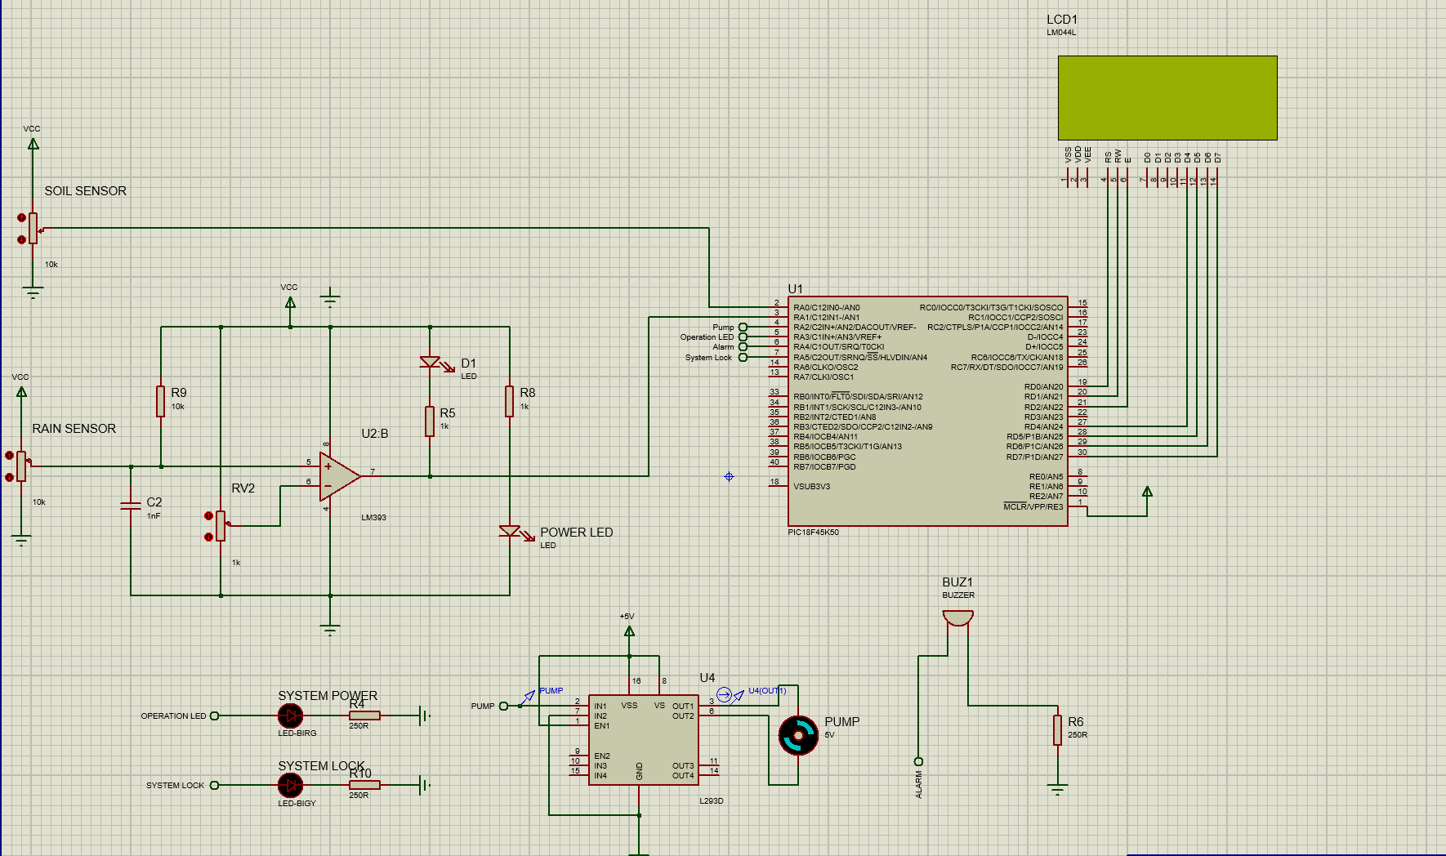
Figure 1 Proteus Simulation of project

Using the information gathered and presented in the literature review, the system is an automated irrigation solution designed to optimize water usage based on soil moisture and rainfall detection. It integrates multiple electronic components and sensors into a single embedded platform powered by the PIC18F45K50 microcontroller. The system aims to reduce water wastage, minimize manual intervention, and ensure the soil receives water only when necessary.
The system achieves this by reading the analogue output of a resistive soil moisture sensor and the digital output of a resistive rain sensor. The soil moisture sensor's analogue signal is processed directly through the PIC's built in ADC (Analog to Digital Converter), allowing for finer control and more nuanced irrigation decisions. The rain sensor is processed through a voltage comparator to deliver a clean digital signal. Based on these inputs, the system activates a submersible pump via an L293D motor driver and provides user feedback using an LCD display and a buzzer.
3.1 System Architecture
The system architecture can be divided into the following core modules:
- Sensing Modules: Includes the resistive soil moisture sensor (analogue output) and the resistive rain sensor (digital output via comparator).
- Processing Unit: PIC18F45K50 microcontroller that receives both analogue and digital signals and makes control decisions.
- Actuation Module: A submersible pump connected via an L293D motor driver is responsible for irrigating the soil.
- Output and User Feedback: Includes an LCD for displaying soil status and a buzzer to indicate operation modes or alert states.
- Power Supply Module: Supplies regulated power to all components, potentially with battery backup or solar panel integration in future versions.
- Each module communicates either through analogue readings or digital logic levels interpreted by the microcontroller, ensuring modularity and ease of debugging.

3.2 System Power and voltage regulation

To make the irrigation control system easy to use in various locations, the student chose to power it with a battery pack using four AA batteries. This setup provides about 9 volts (1.5V x 6), which is great, but since the main components such as the PIC, soil moisture sensor, rain sensor, and motor driver are designed to run safely at roughly 5 volts, the student added a voltage regulator to avoid any damage from too much power.

The student opted for a 7805 linear voltage regulator, a common, affordable, and reliable choice that converts higher voltages down to a steady 5V. In this system, the 9V from the AA batteries powers the 7805, which then supplies the stable 5V needed by the other components. To ensure everything runs smoothly and to protect against voltage spikes, they placed capacitors at both the input and output of the regulator. Using batteries has benefits. It makes the system portable and self sufficient, perfect for gardens, greenhouses, or remote farming areas. Plus, AA batteries are inexpensive, easy to replace, and widely available, simplifying maintenance and keeping costs low. The system is designed to draw little power when idle, so the batteries last longer between changes.
However, there’s a trade off: the 7805 regulator can waste a bit of energy as heat due to its design. But considering the system's low power needs, especially when the pump isn't running, this inefficiency is quite manageable for a low power project. Looking ahead, they might consider upgrading to a more efficient buck converter if they need to extend battery life even further.[23]
this power setup strikes a good balance between cost, ease of use, portability, and reliability, perfectly matching the project's aim to create a user friendly and energy efficient irrigation automation system.

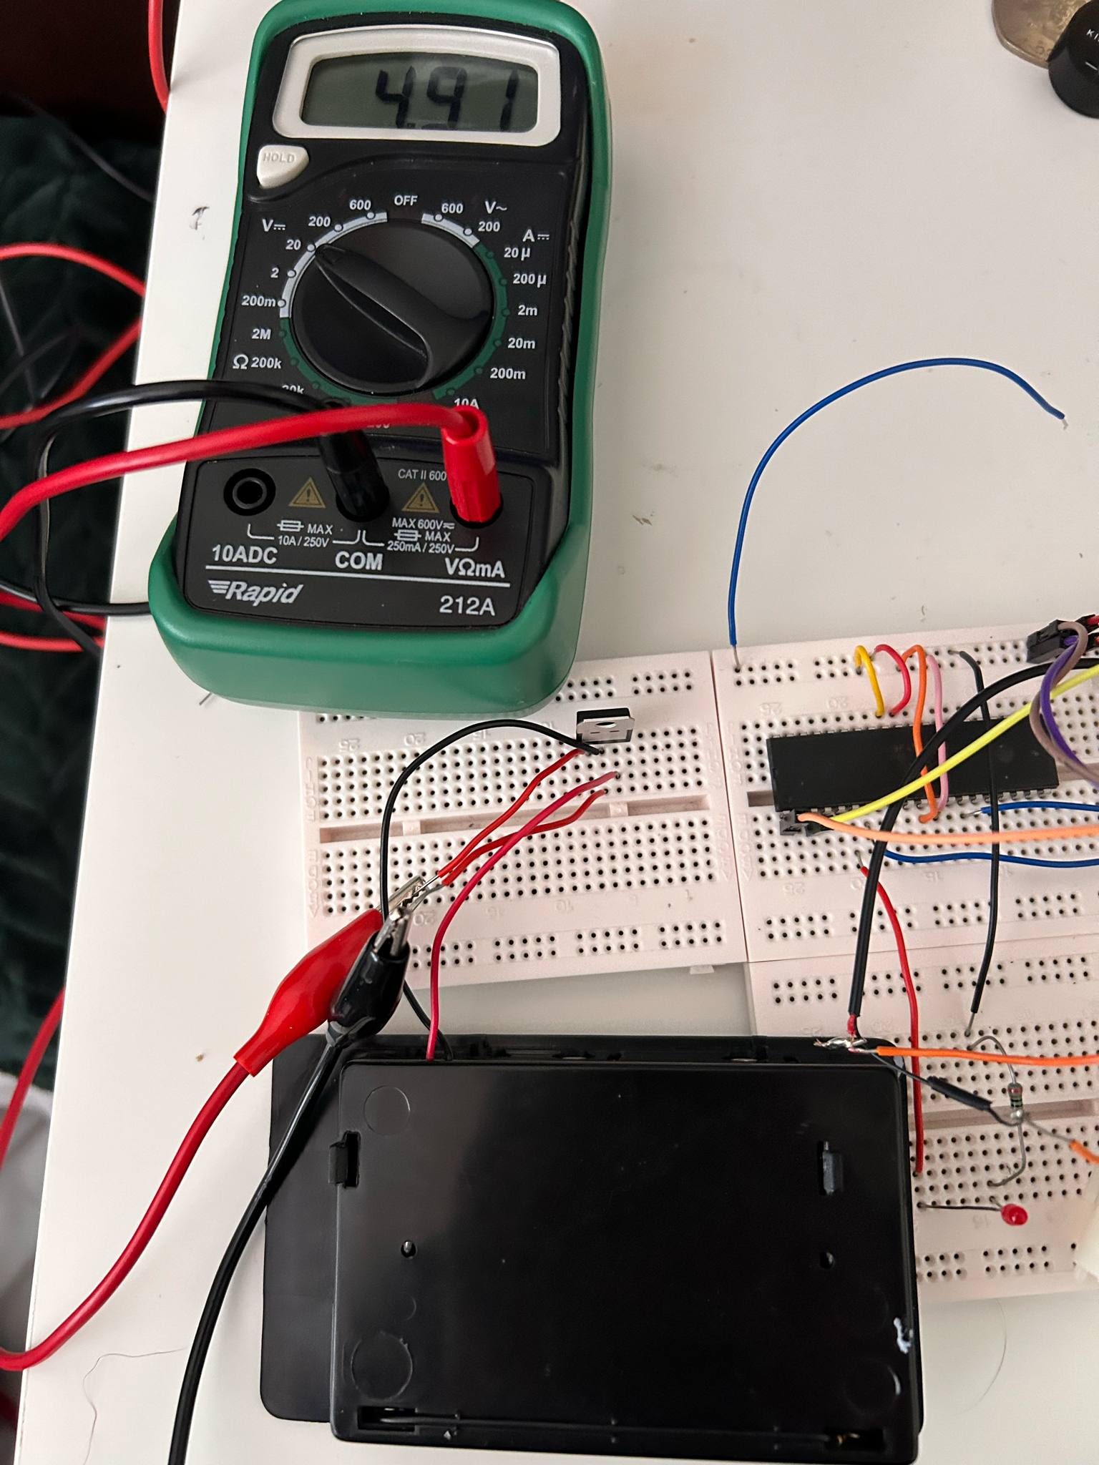
Figure 2 - 7805 output voltage from the battery pack

3.3 Initial Issues with the pump
After an initial test build of the circuit, it was found that the pump was activating, communicating with the PIC via the analogue output of the soil and rain sensor, put it was operation in a flickering type fashion. This could have lead to several issues that could potentially make the system redundant if not fixed. Inconsistent water flow was a side effect of this malfunction which has the potential to lead to underwatering of soil, having a direct impact on crop stability and health severely impacting the goals for the system.
A pump that operates erratically may consume more energy than necessary, leading to higher power usage. This inefficiency can negate the benefits of using an automated irrigation system and reduce the system's overall economic viability.
Flickering can also indicate that the pump is not receiving a stable power supply, which can cause mechanical stress and wear on the motor over time. This inconsistency can lead to overheating, reduced lifespan, and even premature failure of the pump.

3.4 Fixing the Issue
After through research, Connecting a 470 µF capacitor across pins 8 (the supply voltage pin) and the common ground of the L293D motor driver, significantly enhanced the stability of the power supply, ultimately preventing the pump from flickering. The capacitor acted as a reservoir of electrical charge, providing additional current during sudden bursts of demand when the motor driver is activated. This helps smooth out temporary voltage drops that can lead to flickering. Additionally, the pump can generate electrical noise and voltage spikes, especially during rapid changes in speed or direction, the capacitor filters out these fluctuations, aiding in stable operation. By positioning the capacitor close to the L293D, it also decouples the motor driver’s power supply from other parts of the circuit, minimizing the impact of transients that could cause supply voltage fluctuations. Overall, the capacitor enhances the performance and reliability of the motor driver by ensuring it receives a consistent voltage supply, which is essential for smooth and efficient motor operation. This addition not only helps reduce flickering but also improves the overall performance of your system. [24]

3.5 Sensors and Signal Conditioning
3.6 Soil Moisture Sensor
The system uses a resistive soil moisture sensor that operates on the principle that wet soil conducts electricity better than dry soil. As the moisture content increases, the resistance between the sensor’s probes decreases, producing a higher analogue voltage.
This analogue signal is fed directly into the PIC’s internal ADC. The ADC continuously samples the sensor output and converts it into a digital value that the microcontroller can process. A software-based threshold is implemented: if the ADC reading falls below a calibrated setpoint, the soil is considered "dry," triggering irrigation. If the reading is above the threshold, the soil is considered "moist," and no irrigation is necessary.
This method allows fine granularity rather than a simple dry/wet design, which is what a digital output from the sensor would produce. The system can distinguish varying moisture levels, offering more intelligent water management.
Calibration is achieved using trial readings across different soil types and conditions, ensuring reliability in different environments.
Specifications: | Soil Moisture Sensor Hygrometer Humidity Detection [25]  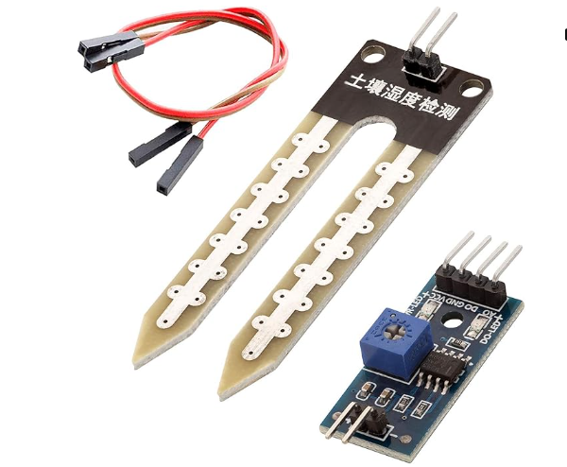 | HiLetgo 5pcs Capacitive Soil Moisture[26] 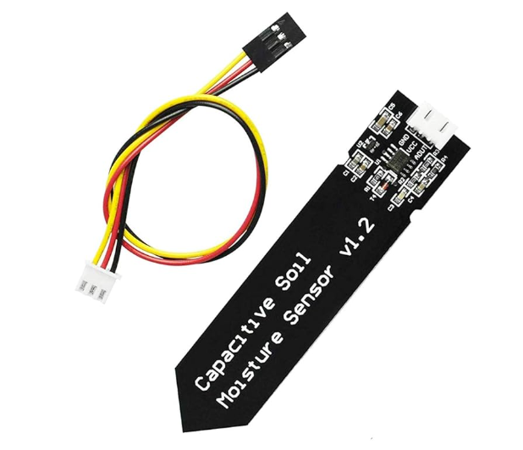 | Grove - Capacitive Soil Moisture Sensor[27]  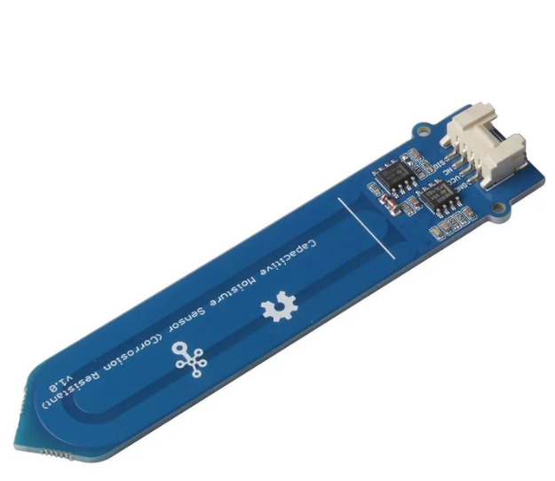 | Seeed 101020008 Grove - Moisture Sensor For Water, Soil and Plants[28]  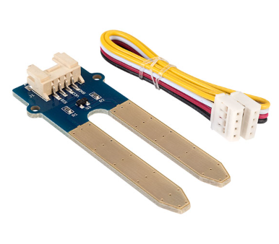
Sensing Method | Resistive sensing technique | Capacitive Sensing Method | Capacitive Sensing Method | Resistive sensing technique
Output signal | Analog – Digital | Analog | Analog | Analog
Operating Voltage | 3.3v – 5v | DC 3.3 – 5.5V | 3.3-5V | 3.3-5V
Figure 3 - Soil Sensor Comparison Table
3.7 Soil Sensor Working Principle

At its core, the sensor has two metal electrodes that are placed directly into the soil. These electrodes are made from conductive materials, typically stainless steel. When the soil is moist, water helps conduct electricity between the two electrodes. If the soil dries out, however, the resistance between the electrodes increases because there’s not enough water to facilitate conduction. The sensor then measures this electrical resistance. The resistance level is inversely related to the moisture content in the soil, lower resistance means there’s more moisture, while higher resistance indicates drier soil Usually, the sensor sends this resistance reading as an analogue voltage signal to a microcontroller or an analogue to digital converter (ADC). This circuit processes the resistance value to figure out how moist the soil is. The information about soil moisture can then be used to activate irrigation systems, alert farmers when it’s time to water, or even display the readings on a user friendly interface.

Resistive soil moisture sensors are simple and budget friendly, they can be influenced by soil salinity and might corrode over time. Despite these limitations, they’re still popular for basic irrigation and gardening needs because they provide valuable real time insights into soil moisture levels.

3 Sensor Choice Justification
3.8 soil sensor justification
The soil sensor highlighted in figure (2) was chosen as it sticks to the core values of the project discussed in the literature review. Whilst it can suffer from fast degradation, it has a list of features that permit its use for the project:
Cost-Effective: Resistive soil moisture sensors are typically less expensive than their capacitive counterparts. If you're working on a budget, this sensor presents a wallet-friendly option. Resistive sensors are straightforward to integrate with various microcontrollers, including the PIC18F45K50 you are using. The analogue output from the sensor can be easily read by the ADC, simplifying the wiring and coding processes.
The resistive design allows for quick setup and use, which is advantageous for prototyping. It's an established technology, and many resources and tutorials are available to support its implementation. These sensors provide real-time data on soil moisture levels, making it easy to gauge when irrigation is needed. This can help you implement timely watering schedules.
The sensor is readily available through various online retailers, which ensures you can acquire it quickly and easily when working on your project. Many hobbyists and professionals use resistive soil moisture sensors, which means you'll find lots of online guides, forums, and community support to assist with troubleshooting and optimization.
If your project's primary goal is to monitor soil moisture levels and automate irrigation without needing the advanced features of capacitive sensors, then a resistive sensor will serve your needs effectively.
3.9 Sensor Summary
While resistive sensors can have issues such as degradation over time and potentially less accuracy than capacitive ones, their simplicity, cost effectiveness, and ease of use can make them a suitable choice, especially for proof of concept projects or small scale applications.

Specifications: | Rain Sensor Module [29]  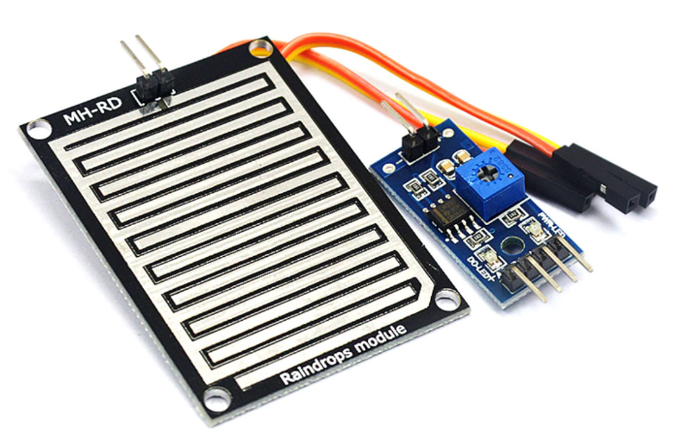 | Rain Drop Detection Module[30]  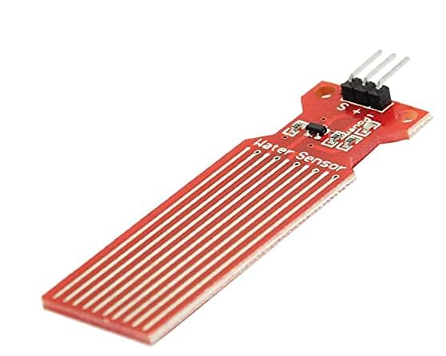 | Seeed 101020018 Grove[31]  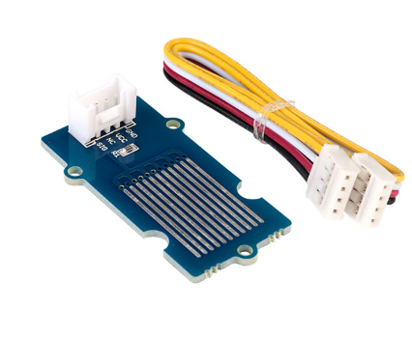
Sensing Method | Resistive sensing technique | Capacitive Sensing Method | Capacitive Sensing Method
Output signal | Analog & Digital | Analog | Analog
Operating Voltage | 3.3v – 5v DC | 3.3 – 5.5V DC | 3.3-5V
Figure 4 - Rain Sensor Comparison Table

3.10 Rain Sensor
The rain sensor is still a resistive type, composed of a grid of conductive traces that become conductive when wet. This signal is processed through a voltage comparator, outputting a clean digital HIGH when rain is detected. The rain sensor acts as a lock signal: if rain is detected, the system will not activate the irrigation pump, regardless of soil moisture readings. For the physical project, the rain sensor is attached to the master clear pin of the PIC, accommodating a simple but effective method to put the system in to ‘lock mode’. The master clear PIN acts as a locking mechanism when pulled low, and allows the system to resume operation when pulled high. The rain sensor outputs a clean digital signal, i.e (Low or High). In the proteus simulation, the rain sensor is attached to a I/O pin due to complications when attaching it to the Master clear pin. The system operates in the exact same way for the physical and simulated version of the project.
Both sensors are strategically located to provide accurate local measurements. The soil moisture output (analogue) allows nuanced control, while the rain sensor (digital) offers fast and reliable rain detection.

3.11 Rain Sensor choice justification
This rain sensor module is designed for straightforward integration into various projects. Its simple setup allows for quick installation and minimal coding effort when interfacing with your microcontroller.
The module provides a digital output, which makes it easy to connect to your microcontroller and read the sensor's status. You'll be able to determine quickly whether it’s raining, allowing your irrigation system to respond appropriately. The module is specifically designed for rain detection, which means it can accurately sense moisture with minimal false signals. This ensures that your irrigation system won't activate unnecessarily during rainfall, conserving water and preventing over-saturation of the soil. The small size of the module makes it easy to incorporate into your existing setup without taking up too much space. This is particularly useful if you have limited room or need a discreet installation.
The cost effectiveness of the rain sensor is a significant advantage, especially for budget conscious projects. This allows you to include reliable weather detection without significantly impacting your project’s overall budget. While it's designed for rain detection, this module can be used in various applications beyond just irrigation systems, making it a versatile addition to your toolkit. This could enhance your project's functionality or allow you to repurpose the sensor in future projects.
3.12 Sensor Summary
Support and Resources: Given the popularity of rain sensors, you'll likely find plenty of resources, guides, and community support available online. This can be beneficial for troubleshooting or optimizing how you incorporate the sensor into your project.

By including a rain sensor in the system, it can improve the systems efficiency, conserve water, and enhance overall functionality while keeping things simple and cost-effective.

3.13 Microcontroller Unit (MCU): PIC18F45K50
Microcontroller Selection: PIC18F45K50 for the Irrigation System
Choosing the right microcontroller is crucial for the effective and efficient operation of the portable irrigation system. Serving as the "brain" of the system, the microcontroller will manage data from various sensors, handle storage, and execute communication protocols. After thorough evaluation, the student selected the PIC18F45K50 as the ideal microcontroller for our project due to its versatile features, high performance, and cost effectiveness. Its combination of various analogue inputs for sensors and sufficient memory makes it an excellent choice for our soil irrigation application, ensuring efficient data transmission, reliable storage, and smooth communication.
Justifications for Choosing the PIC18F45K50:
- Analog-to-Digital Converter (ADC):
The PIC18F45K50 includes a 10-bit ADC with up to 13 channels, enabling precise readings from soil moisture sensors. This allows us to connect the moisture sensor to an analogue pin and accurately read its voltage output.
- Operating Voltage Compatibility:
It operates at either 3.3V or 5V, which is ideal for the soil moisture sensors such as the YL-69 used in the project, as well as for providing voltage to the irrigation pump.
- Multiple I/O Pins for Control:
The microcontroller provides ample input/output pins, which are essential for controlling various components of the system.
- Low Power Consumption:
With built-in power-saving modes, the PIC18F45K50 is optimized for battery-powered applications, making it suitable for the system.
- Expandable for Automation:
The flexibility of the microcontroller allows for future enhancements and automation features to be integrated.
- Potential Limitations:
The PIC18F45K50 lacks built in Wi-Fi or Bluetooth capabilities, which means that if the student intend to develop an IoT system in the future, we will need to incorporate external modules for Wi-Fi and Bluetooth

3.14 PIC Conclusion
In summary, the PIC18F45K50 is a robust choice for the irrigation system that utilizes an analogue soil moisture sensor. With sufficient ADC channels, a variety of I/O options, and power efficiency, it meets our needs for effective data management and automation

3.15 Motor Driver and Pump Control
The pump control system uses an L293D H-bridge motor driver, enabling the low-current GPIO output from the PIC to control the high-current submersible pump.
A digital HIGH output from the microcontroller enables the L293D to drive the pump
Electrical isolation and back-EMF protection are provided via the L293D’s internal diodes.
Specifications: | Low Noise DC 3-5V Mini Brushless Motor[32]  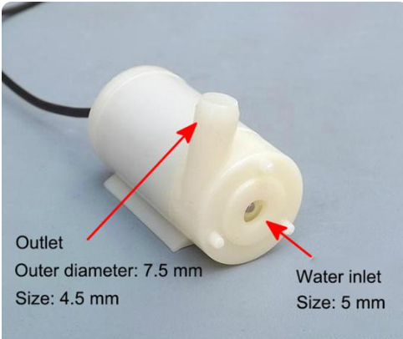 | Peristaltic Liquid Pump[33]  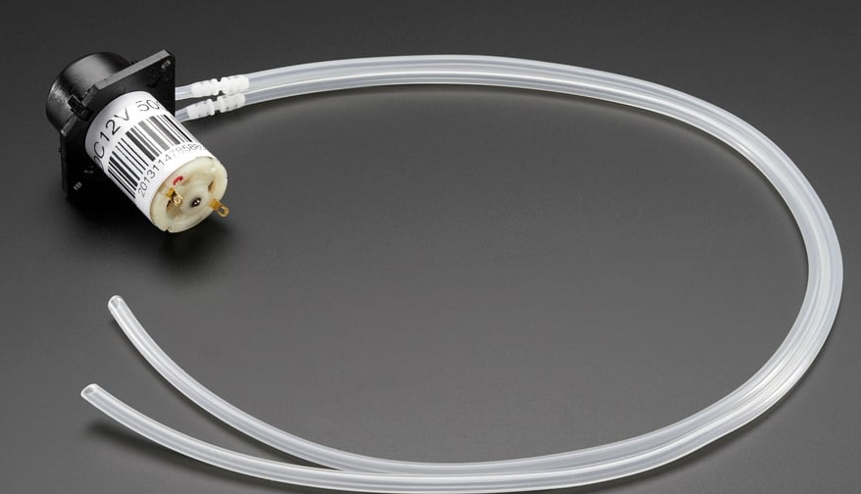 | 12V Water Pump Submersible [34]  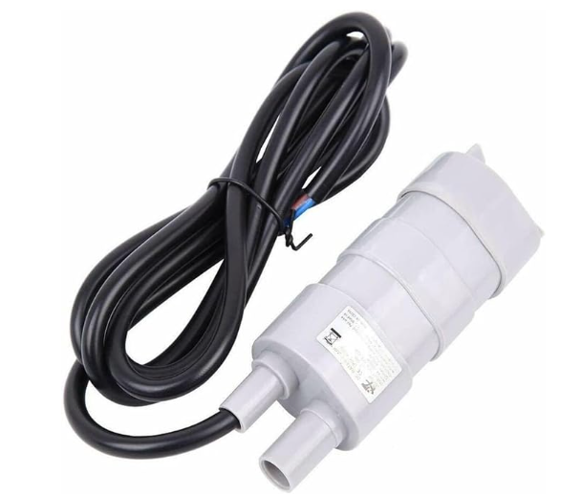
Motor Current | 100-200mA | 200-300mA | 3A
Flow Rate | 80-120Lp/Hour | 100mL/Min | 600 Lp/Hour
Operating Voltage | 3-5V | 12V | 12V
Figure 5 - Pump Comparison Table

3.16 Pump Justification
For the irrigation system project, a small 3-5V DC water pump was chosen, as it fits the system requirements for several reasons:
The pump operates on 3-5V, which matches the output of the 7805 voltage regulator already used in the system. This means there is no need any extra voltage converters, keeping the design simpler and more reliable.
This type of pump typically runs within a range of 100mA to 200mA, depending on the load. The system has been tested to draw about 0.19A (190mA) while in operation. This means the pump won’t strain the battery pack too much, allowing for longer use even with limited power sources.
With an operational wattage of around 0.95W, the pump helps keep the system energy efficient, which aligns perfectly with the goal set in the literature review of minimizing power use.
The small size of the pump makes it easy to integrate into a compact system or a small enclosure. It's perfect for prototype irrigation systems aimed at proof of concept designs or small agricultural projects.
Despite its size, this pump can typically deliver between 80 to 120 liters per hour, which is enough for watering the system design without having overwhelming flow during testing
These pumps are very budget friendly. This makes them ideal for purposes like prototyping, providing a good balance of performance and affordability, so students and engineers can build their systems without any issues.
Because of their low price and widespread availability, replacing the pump if it fails is straightforward. This not only minimizes downtime but also makes the overall system more maintainable in the long run.

3.17 LCD Display – Simulation Only
- An alphanumeric 20x4 LCD module is interfaced to the PIC to provide real-time system status:
- Soil status: "Dry" / "Moist" based on ADC readings.
- Rain status: "Rain Detected" / “System Lock”
- Pump status: "Pump on / Pump off
The LCD provides a solid user interface, providing information for users without the need for technical additions.

3.18 Buzzer Feedback - Simulation Only
- An active buzzer provides immediate audible feedback:
- Beep when irrigation starts.

3.19 Operational Flow
- The complete system operates in a continuous monitoring and control loop:
- Read ADC value from soil moisture sensor.
- Read digital input from rain sensor.
- If rain sensor is HIGH (rain detected), enter lock mode (no irrigation).
- If no rain detected and soil ADC value is below the dry threshold, activate pump.
- Continuously monitor for rain or moist soil conditions during irrigation.
- Once soil is moist/dry or rain is detected, deactivate pump.
- Update LCD display and issue buzzer alerts as needed.

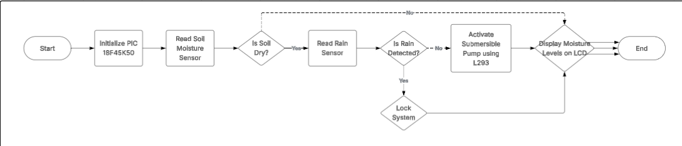
Figure 6 - System Flowchart

3.20 System Advantages
- The modular, hybrid analogue to digital design offers numerous advantages:
- High-resolution soil moisture measurement thanks to the use of analogue ADC readings.
- Reliable rain detection using simple digital comparator outputs.
- Real-time rain override ensures conservation of water.
- User-friendly feedback via LCD and buzzer.
- Low-power readiness for future solar powered upgrades.
- Scalable architecture for future sensor additions or remote communication.

- Software Design

The software for the automated irrigation system is developed using C programming language, compiled via the CCS C Compiler specifically targeting the PIC microcontroller. Development and initial validation were performed using Proteus for simulation, allowing for early stage debugging and system level validation before hardware prototyping.

The core objective of the software is to create a reliable, efficient, and responsive control system that can intelligently manage irrigation based on real time soil moisture levels (analogue input) and rain detection (digital input).
The provided C code is responsible for controlling a water pump based on soil moisture levels, using a soil moisture sensor connected to the analogue input of a PIC microcontroller.
Inside an infinite loop (while(TRUE), the code first selects the ADC channel 0 with set_ADC_channel(0) and introduces a small delay of 10 microseconds to stabilize the reading.
It then reads the soil moisture level using the read_ADC() function and stores the result in the variable Moisture_Sens_Thershold. The moisture level is displayed on an LCD screen using lcd_gotoxy(1,1) to set the cursor position and printf(lcd_putc, "Soil Moisture = %3u", Moisture_Sens_Thershold) to print the value.
The moisture value is also assigned to a variable named pump for easier reference. A conditional check follows: if the pump value is less than 100, indicating that the soil is dry, the microcontroller activates three output pins (PIN_A2, PIN_A3, and PIN_A4) by setting them high using output_high(), which turns on the pump, led and buzzer. The LCD then displays the message "Pump On" at a specific location (22,2).
If the pump value is 100 or higher, indicating that the soil has enough moisture, the code sets the same pins low using output_low() to turn off the pump, and the LCD displays "Pump Off." This control logic ensures that watering is automatically activated only when necessary based on the real time moisture level detected by the soil sensor.

- Results & Discussions

Achieving a functional system is important when trying to validate the performance, efficiency and reliability of the system. A list of technical tests was conducted. The primary tests were to assess the accuracy of the sensors, the response time of the system when activated and the behaviour of the pump when operational, current consumption, interaction between both soil and rain sensors.
The equipment used for testing purposes was as follows.
- 5v Power supply
- Breadboard
- Multimeter
During this section, the voltage output of the soil sensor was monitored across three different soil conditions. Those being: Dry, Damp and Wet. The main purpose behind these tests was to establish a correlation between the soil moisture content and the sensor output voltage. The collected data can then be utilised to optimize irrigation decisions and enhance water conservation.
To achieve these readings, the sensor was powered with a stable 5V supply and a multi meter set to 0-20V for accurate readings. As the system is given a 5V supply meaning this setting on the multi meter was deemed the best to read accurately. The ground clip (Black) was connected to the common ground of the circuit and the voltage clip (Red) was connected straight to the analogue output of the sensor.
The results were as follows:
Soil Moisture Level | Output Voltage (V)
1: Dry Soil | 4.89
2: Damp Soil | 3.62
3: Wet Soil | 2.80
Figure 7 - Output voltages of Soil Sensor in variable voltages

Test 1 - In dry soil conditions, the sensor recorded a voltage of 4.89 V. This high voltage reading confirms the sensor's sensitivity in detecting low moisture content. A voltage output close to the supply voltage typically indicates a lack of conductive moisture in the soil. This baseline voltage serves as a crucial reference point when determining irrigation requirements. The high reading of 4.89 V signifies that the soil has substantially depleted moisture reserves, signalling the need for immediate irrigation to restore adequate moisture levels conducive to healthy crop growth. When setting thresholds for automated irrigation, it is essential to define this reading as a critical trigger point, indicating that soil moisture is below optimal levels for plant health.

Test 2 - The damp soil measurement yielded a voltage reading of 3.62 V. This intermediate value indicates a moderate moisture condition in the soil, reflecting some retention of water without oversaturation. The reduction in voltage from the dry condition to the damp state illustrates the correlation between increasing soil moisture and decreasing voltage output, which aligns with the expected behaviour of resistive soil moisture sensors. This finding suggests that when soil moisture is at a damp level, irrigation should be cautiously managed to prevent overwatering. The 3.62 V reading could inform irrigation systems to delay activation, thereby conserving water and preventing potential negative impacts on root health due to excessive moisture.

Test 3 - Wet Soil Measurement
In wet soil conditions, the voltage dropped significantly to 2.80 V. This lower voltage output is indicative of high moisture content in the soil and reflects the sensor's ability to detect saturation. Such a reading is critical for effective water management, as it signifies that the soil is at or near field capacity, suggesting that further irrigation is unnecessary. Maintaining this threshold is vital for avoiding waterlogging, which can lead to detrimental conditions for crops, including root rot and decreased oxygen availability to plants. The low voltage value can be established as an upper boundary threshold that should trigger an irrigation lockout, safeguarding against unnecessary water application during periods of adequate moisture retention.

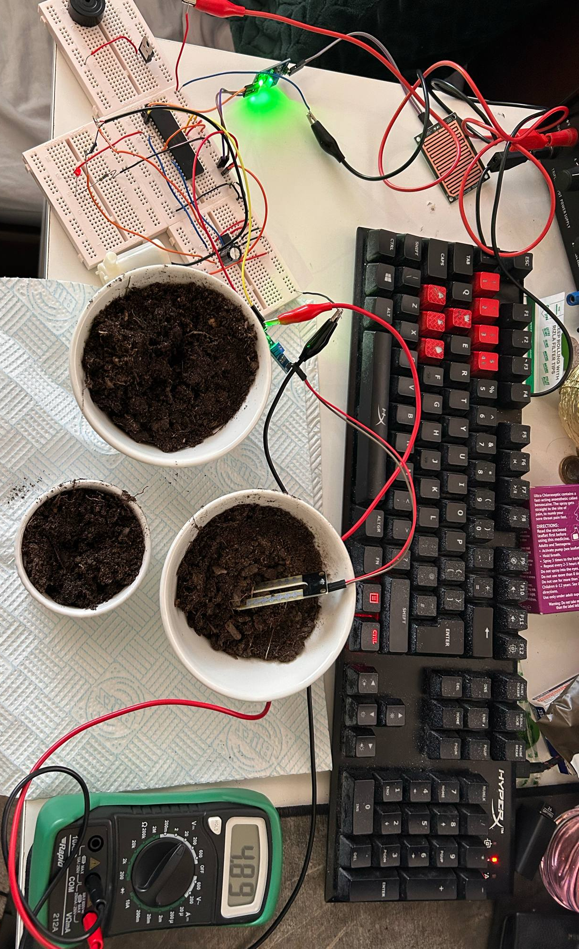
Figure 8 - Picture to show output voltage in Dry soil

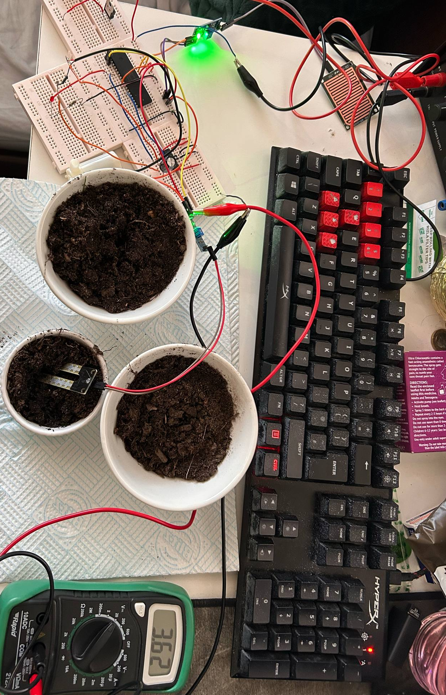
Figure 9 - Picture to show output voltage in damp soil
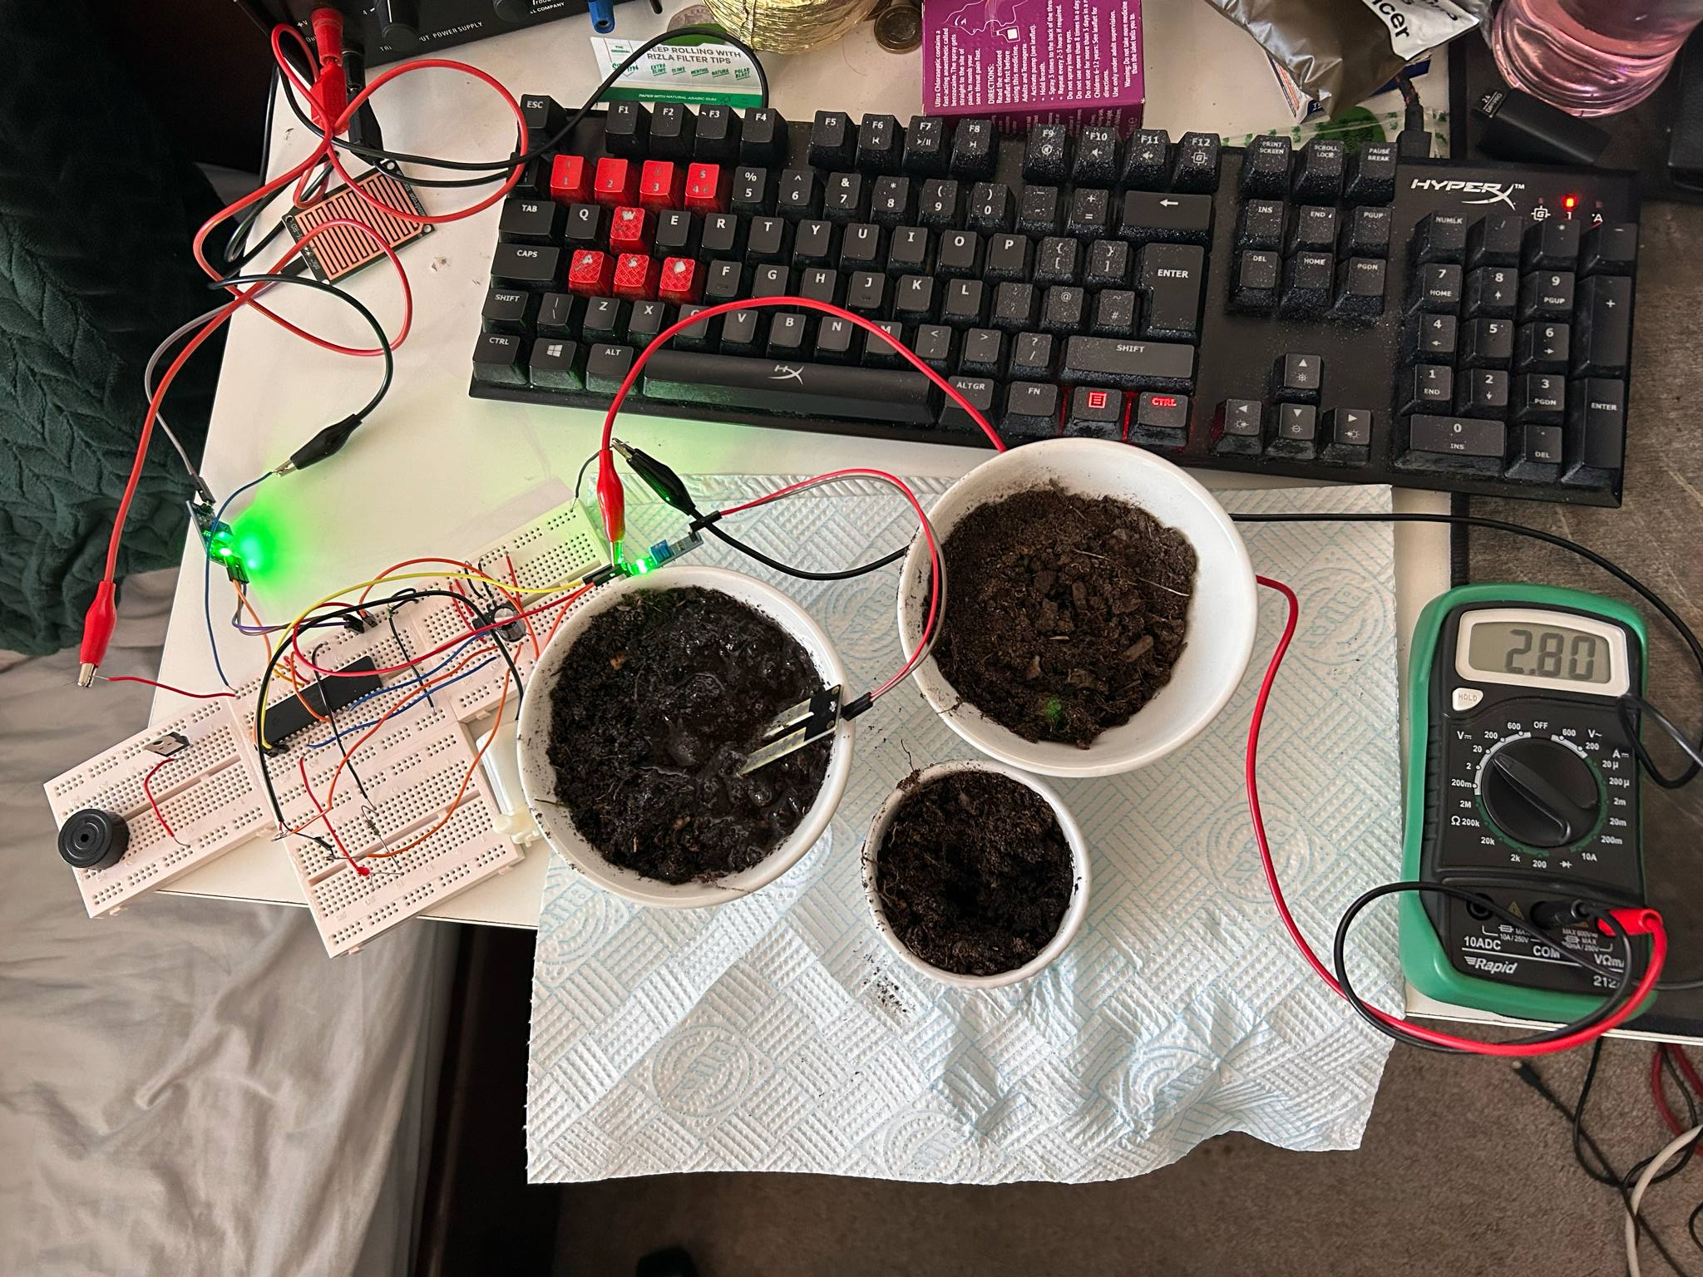
Figure 10 - Picture to show output voltage in wet soil

5.1 Current and Power Consumption of the system
To get a clearer picture of how energy-efficient our irrigation system really is, the student measured the current consumption during two important scenarios:
Test 1: System with Pump in Action
Test 2 System With Soil Sensor in Wet Soil
Test 3: System in Lock Mode
A digital multimeter was used for these measurements, setting it to the 10A DC range and connecting it in series with the system’s main power line to get accurate readings.

5.2 Test 1: System with Pump in Action Figure ()
In the first test, the pump was turned on as it was in dry soil. The multimeter showed a current draw of 0.19 Amps (190mA). This makes sense, as the pump needs more power to operate and that level of current is within the pumps operating range. While the system generally runs on low power during normal operations, it’s clear that activating the pump only slightly increases energy demand during irrigation. This information is vital for figuring out power supply needs, especially when powering the system via batteries.
Using Electric power formula the power was calculated for when the pump is activated:
P = V x I
P = 5V X 0.19A = 0.95W (950mW)

This indicates a good level of power consumption while the pump is operational meaning the system is energy efficient, thus meaning energy efficient. This archives one of the main targets for the system of keeping power consumption low, as seen in the literature review. This will also provide the entire system with a longer life span due to less heat being generated while in operation.

5.3 Test 2: System With Soil Sensor in Wet Soil Figure ()
During this second test, the system was assessed under the conditions of the soil being sufficiently wet. The soil sensor correctly detected high moisture levels and put the system into idle mode meaning the pump was no longer operational. The multi-meter showed a current of 0.04A (40mA) during this test. These results are significantly lower that test 1 and test 2.
Using Electric power formula the power was calculated for when the pump is activated:
P = V x I
P = 5V X 0.04A = 0.2W (200mW)

This power level while the system is in idle mode confirms that the system is highly energy efficient when the soil no longer needs to be irrigated. The low number of 0.2W is an extreme good results as it shows that the PIC and the sensors can run at low levels of power deeming the system as highly energy efficient when idle.
5.4 Test 3: System in Lock Mode (Rain Detected) Figure ()
In the second scenario, the rain sensor picked up some simulated rainfall, triggering the system to lock and preventing the pump from working. With the pump disabled. The multimeter reading dropped to 0.15 Amps (150mA). This reduced level of current consumption shows the energy-saving advantage of having a rain detection feature not only does it help conserve water by stopping unnecessary irrigation, but it also lowers the overall electrical load on the system.

Using Electric power formula, the power was calculated for when the pump is activated:
P = V x I
P = 5V X 0.15A = 0.75W (750mW)
When compared to the wattage produced when the pump is on, there is a loss of 0.2W(200mW). while the dip was not as low as expected before testing commenced, this shows that the system has a low idle power when there is rain detected, and it still remains energy efficient. This also protects the circuit from factors such as heat, thus enhancing its lifespan.

5.5 Analysis and Interpretation

The system's current consumption tests across three operational scenarios provide important insights into its energy efficiency and overall success.
In Test 1, where the water pump was actively irrigating dry soil, the current measured was 0.19A, resulting in a power consumption of 0.95W resulting in the highest power consumption of the three tests. This was expected, as the pump is the most energy demanding component in the system.
In Test 2, when the soil was sufficiently wet and the pump was inactive, the current dropped significantly to 0.04A, leading to a power consumption of 0.2W. This extremely low value indicates that when irrigation is unnecessary, the system runs on minimal energy, mainly powering only the microcontroller and sensors.
In Test 3, when the rain sensor locked the system due to simulated rainfall, the current measured was 0.15A, resulting in a slightly higher power consumption of 0.75W compared to the wet soil condition but still lower than when the pump was operating.

Comparing these three states reveals that the water pump is by far the largest consumer of energy in the system. When idle, the system's current requirements are significantly lower, which directly benefits energy conservation. The difference of 150mW between wet soil (0.2W) and rain lock (0.75W) can be linked to the additional circuitry required to process rain detection events. That being said, the system remains comfortably within a low power when operational.
5.6 Current and Power Test Conclusion
From an engineering perspective, these results confirm that the integration of environmental sensors not only improves the functional intelligence of the system but also supports energy saving goals outlined in the project literature review. Reduced current consumption during non irrigation periods increases system longevity, minimizes battery drain, and supports sustainability. All of these are essential factors for deploying automated irrigation solutions in real world environments. Furthermore, understanding the exact current and power profiles at each operational stage helps inform future improvements, such as implementing sleep modes, or using the consumption levels for solar implementation.

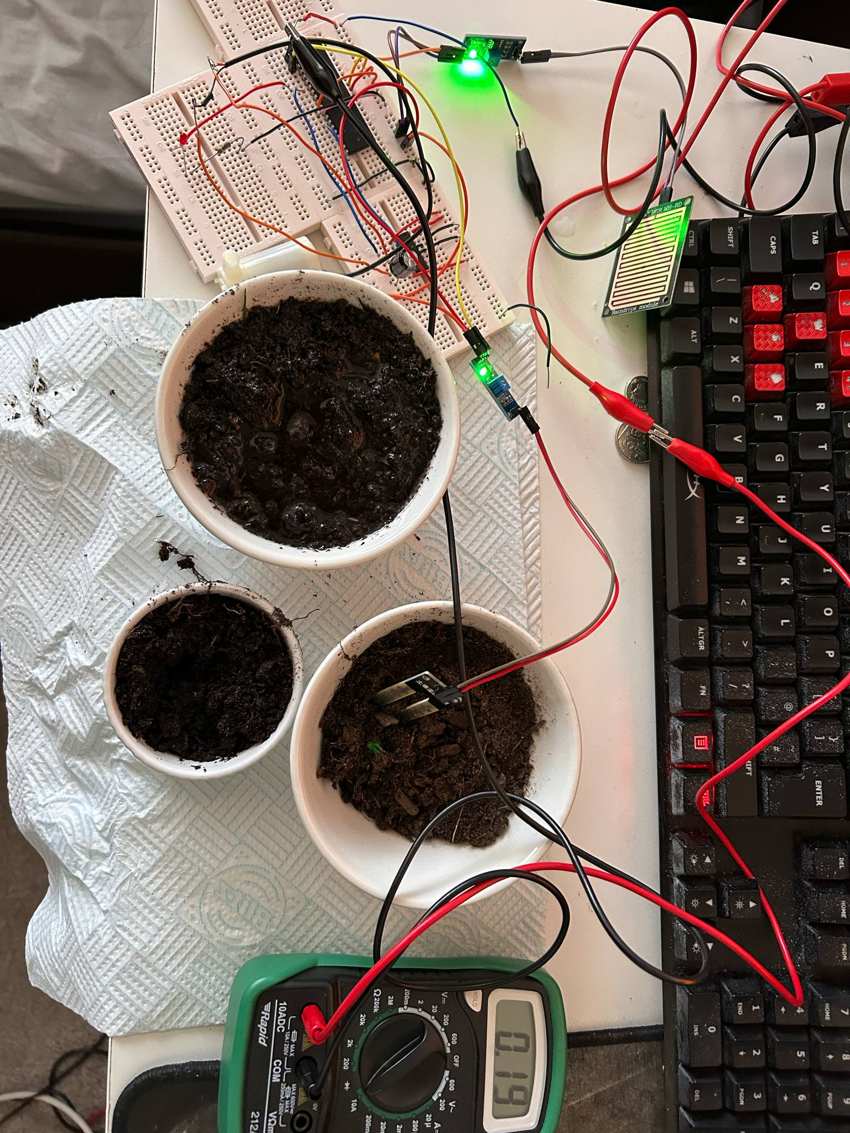
Figure 11 - Current Test (While pump is on in dry soil)

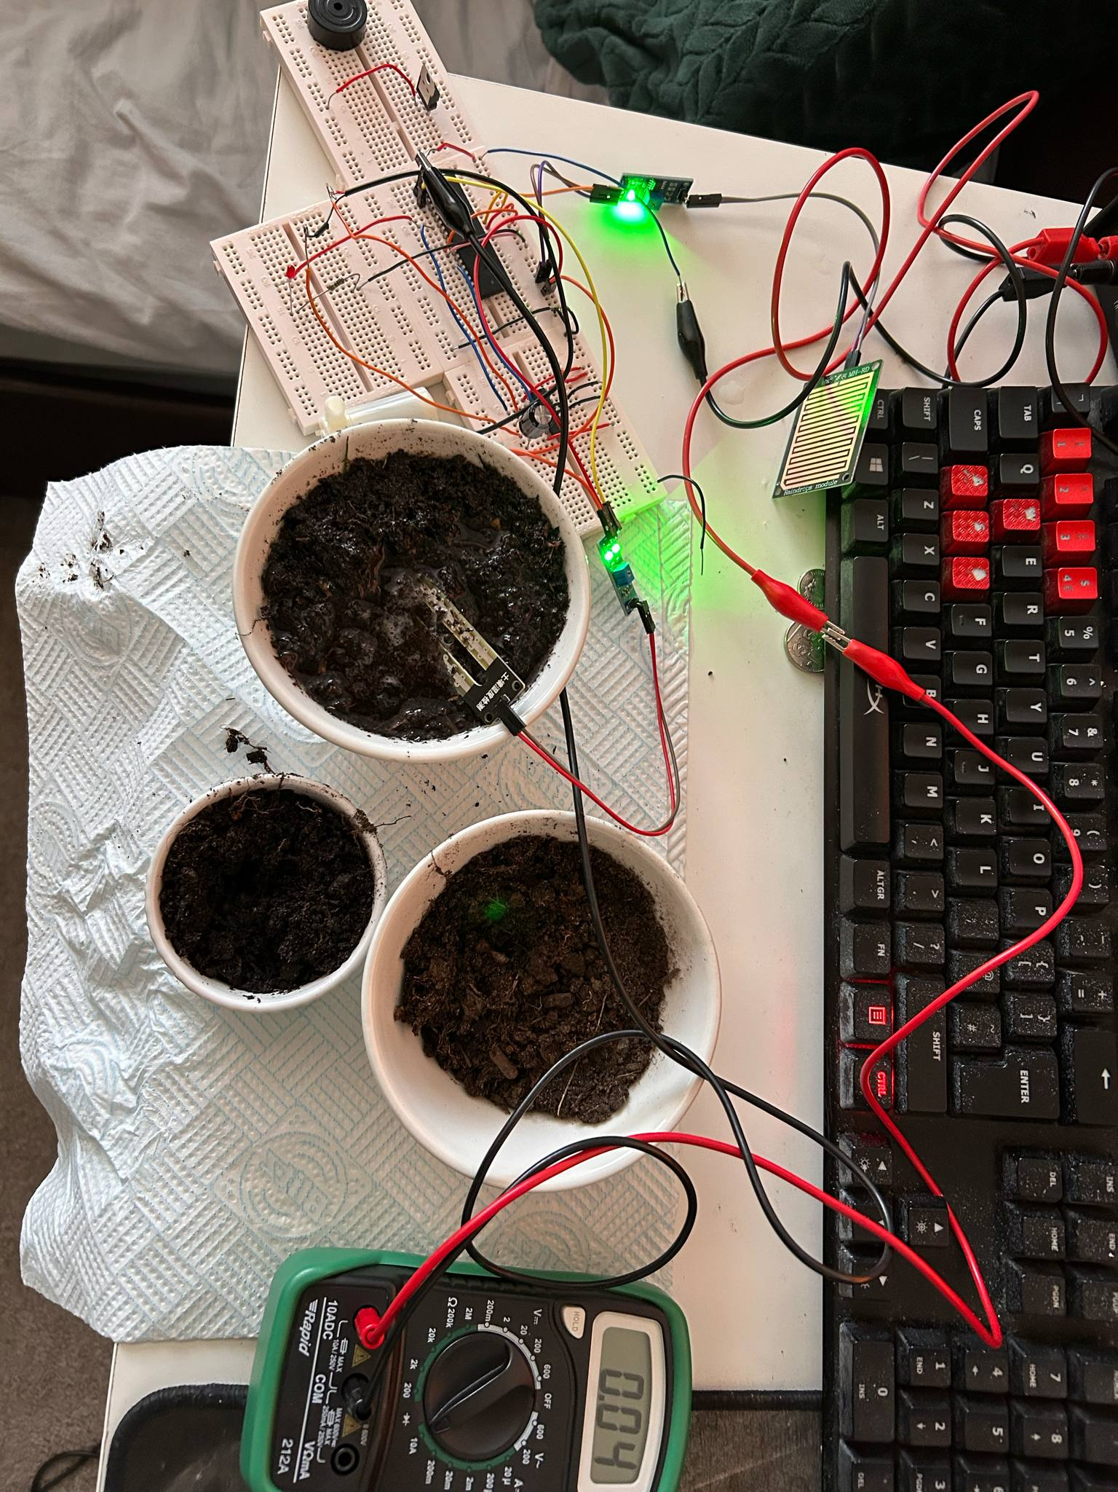
Figure 12 - Current Test (While Pump is off due to wet soil)

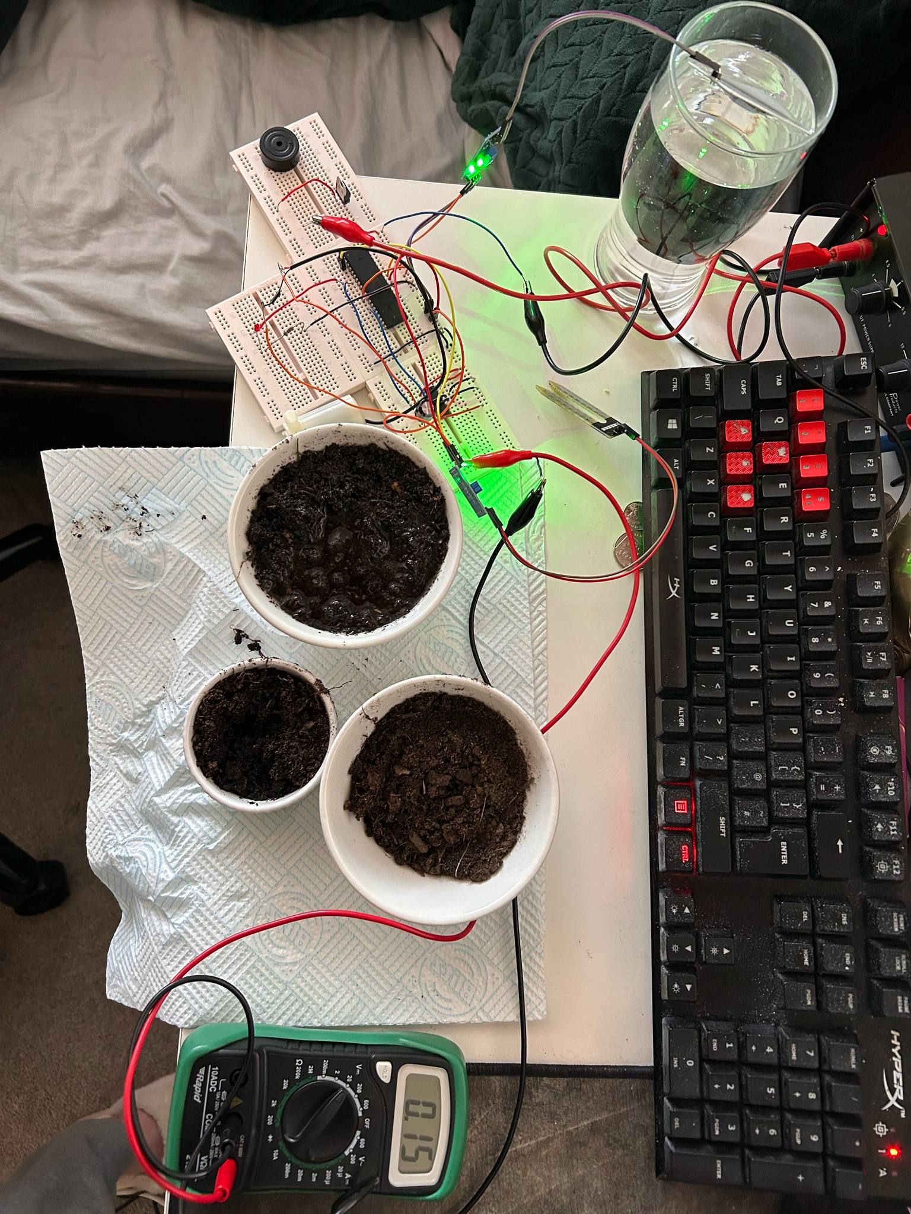
Figure 13 - Current When System is in lock mode

5.7 System Response time

From monitoring environmental conditions to activating the pump, the total delay in the system is usually under one second. This is quick enough to allow for real time adjustments, which is especially crucial during sudden rainstorms or rapid changes in soil moisture. However, in larger or industrial scale setups, there can be some communication delays particularly in wireless systems.
To summarize, the combination of fast digital comparators, efficient analogue to digital conversion by the PIC microcontroller, and a swift relay/motor driver setup gives the irrigation system an impressive response time. This ensures that the system is both highly responsive and effective, making it a reliable choice for efficient irrigation.

5.8 Pump Flow Rate
A good flow rate for the irrigation system is very important for many reasons. It ensures that water is spread evenly and efficiently to the soil, which is essential for crop growth and overall health. When the flow rate is consistent, it helps keep soil moisture at the right level, which can prevent problems like waterlogging. It also allows for timely watering, leading to better crop yields and higher quality produce. By delivering water efficiently, you can also reduce waste, helping to conserve. This also aligns with the project goal of water conservation. In short, maintaining the right flow rate doesn’t just meet the immediate watering needs of your crops. It also supports the long term yield intake.

6. Conclusion
To conclude, the student successfully developed and tested an energy efficient automated irrigation system that uses soil moisture and rain sensors to optimize watering. The system activates a small 5V water pump when it detects dry soil and automatically stops irrigation during rainfall, helping to conserve both water and energy.
Through careful testing with a multimeter, we found that the system consumes very little power just 0.95W when the pump is running and only 0.2W when it’s in idle mode. The battery operation, along with a 7805 voltage regulator, provided stable performance while keeping the system portable.

Each component, was chosen based on how well they worked together, their efficiency, and their affordability, all of which align with our goals of creating a sustainable and scalable irrigation solution.

Overall, this system has shown that with simple sensor integration, smart power management, and basic automation, we can greatly enhance small scale irrigation. There is potential for expanding this idea into larger systems or ones powered by renewable energy in the future!

7. Future Improvements
While the system performed well during testing, there are several improvements that could be implemented to further improve its performance and reliability.

First, adding a low-power sleep mode to the PIC18F45K50 microcontroller could significantly extend battery life when the system is idle. This means less frequent battery changes and improved efficiency. [35]

the 7805 voltage regulator could be replaced with a more efficient buck converter. This upgrade would reduce heat loss and improve overall energy efficiency, making the system even more sustainable.[36]

Additionally, sensor accuracy can enhanced by calibrating the soil moisture sensor for different types of soil. Alternatively, using capacitive sensors can help reduce long term corrosion, which is especially beneficial for longevity. For rain detection, employing a more sensitive rain sensor or combining multiple detection methods using methods such as sensor fusion, could improve the system's responsiveness during light rain for example. On the functionality side, incorporating wireless communication options like Wi-Fi would allow users to remotely monitor soil conditions and get updates on the system's status.
Finally, integrating solar charging could transform the system into a fully renewable solution, which is an essential feature for agricultural use in remote areas. With these upgrades, the project could evolve from a basic prototype into a commercially viable product that meets the needs of modern agriculture.

8 Code Appendix
#include <main.h>
#define LCD_ENABLE_PIN PIN_D2
#define LCD_RS_PIN PIN_D0
#define LCD_RW_PIN PIN_D1
#define LCD_DATA4 PIN_D4
#define LCD_DATA5 PIN_D5
#define LCD_DATA6 PIN_D6
#define LCD_DATA7 PIN_D7

#include <lcd.c>

unsigned int Moisture_Sens_Thershold;
unsigned int Rain_Sens_Threshold;
unsigned int Pump;

void main()
{

setup_adc_ports(sAN0 | sAN1, VSS_VDD);
setup_adc(ADC_CLOCK_INTERNAL | ADC_TAD_MUL_0);
lcd_init();

while(TRUE)
{

//Soil Moisture Sensor
{
set_ADC_channel(0); // Setting Pin A0
delay_us(10); // small delay
Moisture_Sens_Thershold = read_ADC(); // Moisture threashold is the value of the ADC

lcd_gotoxy(1,1);
printf(lcd_putc,"Soil Moisture = %3u", Moisture_Sens_Thershold);
pump = Moisture_Sens_Thershold;
if (Pump<100) // Below 100 Is the threshold

{

output_high(PIN_A2); // Output high to pump
output_high(PIN_A3); // Output high to LED
output_high(PIN_A4); // Output high to Buzzer

lcd_gotoxy(22,2);
printf(lcd_putc,"Pump On ");

}

else // When above threshold, turn everything off
{
output_low(PIN_A2);
output_low(PIN_A3);
output_low(PIN_A4);

lcd_gotoxy(22,2);
printf(lcd_putc,"Pump Off");
}
}

// Rain Sensor
{
set_ADC_channel(1); // Setting Pin A0
Rain_Sens_Threshold = read_ADC(); // Rain threashold is the value of the ADC

lcd_gotoxy(1,2);
printf(lcd_putc,"Rain Level = %3u", Rain_Sens_Threshold);
pump = Rain_Sens_Threshold;
if (Pump<100) // Below 100 Is the threshold

{
output_low(PIN_A2); // Output low to pump
output_low(PIN_A4); // Output low to Buzzer
output_low(PIN_A3); // Output low to LED
output_high(PIN_A5); // Output high to system lock LED

lcd_gotoxy(22,2);

printf(lcd_putc,"Rain! System lock ");
delay_ms(5000);
printf(lcd_putc,"\f");
}
else
{
output_low(PIN_A5);
}

}
}

}

Reference List
[1]
N. Prajapati, “The Pros and Cons of Manual vs. Automated Irrigation Systems | Titanium Excavation,” Titanium Excavation | Treasure Valley Wet Utility Contractor, Sep. 10, 2024. https://www.titaniumexcavation.com/the-pros-and-cons-of-manual-vs-automated-irrigation-systems/
‌
[2]
H. Shemer, S. Wald, and R. Semiat, “Challenges and Solutions for Global Water Scarcity,” Membranes, vol. 13, no. 6, p. 612, Jun. 2023, doi: https://doi.org/10.3390/membranes13060612.
‌
[3]
“PIC vs Arduino | Amazing 6 Comparisons of Microcontrollers,” EDUCBA, Aug. 15, 2020. https://www.educba.com/pic-vs-arduino/
‌
[4]
“Smart Irrigation System using Arduino | DHT11 | Moisture,” Arduino Project Hub, 2021. https://projecthub.arduino.cc/lakshyajhalani56/smart-irrigation-system-using-arduino-dht11-moisture-781740
‌[5]
Espressif, “ESP32 Overview | Espressif Systems,” www.espressif.com, 2023. https://www.espressif.com/en/products/socs/esp32
‌
[6]
“Arduino Smart Irrigation System Using ESP32 and Blynk App,” circuitdigest.com. https://circuitdigest.com/microcontroller-projects/smart-irrigation-system-using-esp32-and-blynk-app
‌

[7]
“What is a Raspberry Pi?,” Opensource.com, 2012. https://opensource.com/resources/raspberry-pi
‌

[8]
A. Margiwiyatno et al., “Use of Capacitive Sensors for Measuring Soil Water Content in Irrigation Systems: A Review,” BIO Web of Conferences, vol. 158, p. 01001, 2025, doi: https://doi.org/10.1051/bioconf/202515801001.
‌

[9]
“What is Drip Irrigation, Advantages, Techniques - Netafim India,” www.netafimindia.com. https://www.netafimindia.com/drip-irrigation/
‌
[10]
“Automat,” Automatworld.in, 2025. https://www.automatworld.in/global/blog-detail/drip-irrigation-systems-the-future-of-indian-farming
‌[11]
G. G. Haile et al., “Projected impacts of climate change on global irrigation water withdrawals,” Agricultural Water Management, vol. 305, p. 109144, Nov. 2024, doi: https://doi.org/10.1016/j.agwat.2024.109144.
‌ [12]
“Evapotranspiration - an overview | ScienceDirect Topics,” www.sciencedirect.com. https://www.sciencedirect.com/topics/agricultural-and-biological-sciences/evapotranspiration
‌

[13]
Z. Ahmed, D. Gui, G. Murtaza, L. Yunfei, and S. Ali, “An Overview of Smart Irrigation Management for Improving Water Productivity under Climate Change in Drylands,” Agronomy, vol. 13, no. 8, p. 2113, Aug. 2023, doi: https://doi.org/10.3390/agronomy13082113.
‌
[14]
K. Shields, “How to Speed Up Development Cycles Without Sacrificing Quality,” Designli.co, Mar. 28, 2025. https://designli.co/blog/how-to-speed-up-development-cycles-without-sacrificing-quality
‌
[15]
“Soil Moisture Sensor (Resistive) Guide,” Canada Robotix, Sep. 18, 2021. https://www.canadarobotix.com/blogs/how-to/soil-moisture-sensor-resistance?srsltid=AfmBOooKEzfAb2MzYp7PBbDqftECUIxVe0ZctSIsyDOB72Fmo52AS3DR
‌
[16]
Hackster.io, “Hackster.io,” Hackster.io, Jul. 12, 2018. https://www.hackster.io/devashish-gupta/capacitive-v-s-resistive-soil-moisture-sensor-e241f2
‌
[17]
G. M. Smith, “What is Sensor Fusion?,” Data Acquisition | Test and Measurement Solutions, May 15, 2024. https://dewesoft.com/blog/what-is-sensor-fusion
‌
[18]
“In-Depth: Control DC Motors with L293D Motor Driver IC & Arduino,” Last Minute Engineers, Dec. 21, 2018. https://lastminuteengineers.com/l293d-dc-motor-arduino-tutorial/
‌

[19]
“3.6 Controlling a Water Pump — SunFounder Newton Lab Kit for Raspberry Pi Pico 2 1.0 documentation,” Sunfounder.com, 2025. https://docs.sunfounder.com/projects/newton-lab-kit/en/latest/pyproject/py_pump.html
‌
[20] PIC18 Microcontroller Family shell sheet - Microchip https://ww1.microchip.com/downloads/en/DeviceDoc/30327b.pdf

[21]
Dr. S. Velmurugan, “An IOT Based Smart Irrigation System Using Soil Moisture and Weather Prediction,” papers.ssrn.com, May 02, 2020. https://papers.ssrn.com/sol3/papers.cfm?abstract_id=3597146
‌[22]
A. Sharma, A. Jain, P. Gupta, and V. Chowdary, “Machine Learning Applications for Precision Agriculture: A Comprehensive Review,” IEEE Access, vol. 9, no. 2169–3536, pp. 4843–4873, 2021, doi: https://doi.org/10.1109/access.2020.3048415.
‌
[23]
Jason, “Comprehensive Analysis and Applications of the 7805 Voltage Regulator IC,” Ic-components.com, 2015. https://www.ic-components.com/blog/comprehensive-analysis-and-applications-of-the-7805-voltage-regulator-ic.jsp#6.%20Heating%20Problem%20of%207805%20Voltage%20Regulator%20IC
‌
[24]
“Enhancing Pump Performance: The Power of Capacitors in Pumping Applications,” Southernpumping.com.au, 2025. https://southernpumping.com.au/news-and-articles/the-power-of-capacitors-in-pumping-applications
‌

[25] Soil Moisture Sensor Hygrometer Humidity Detection – Amazon Online Store https://www.amazon.co.uk/AZDelivery-Hygrometer-Moisture-Module-Arduino/dp/B07CNRJN8W/ref=asc_df_B07CNRJN8W?mcid=049aed14e40b3876911d79076f666403&tag=googshopuk-21&linkCode=df0&hvadid=697175004957&hvpos=&hvnetw=g&hvrand=7568535631045443490&hvpone=&hvptwo=&hvqmt=&hvdev=c&hvdvcmdl=&hvlocint=&hvlocphy=1007460&hvtargid=pla-653517438846&gad_source=1&th=1

[26]
“Amazon.com: HiLetgo 5pcs Capacitive Soil Moisture Sensor Module Wide Voltage 3.3~5.5V with Cable Wire for Arduino : Industrial & Scientific,” Amazon.com, 2025. https://www.amazon.com/HiLetgo-Capacitive-Moisture-Voltage-3-3-5-5V/dp/B07W83ZVFB?keywords=capacitive+soil+moisture+sensor+v2.0&qid=1670424686&sprefix=capacitive+soi (accessed Apr. 29, 2025).
‌[27]
“Grove - Capacitive Soil Moisture Sensor,” The Pi Hut, 2025. https://thepihut.com/products/grove-capacitive-soil-moisture-sensor (accessed Apr. 29, 2025).
‌[28]
Seeed 101020008 Grove - Moisture Sensor For Water, Soil and Plants – RapidOnline.com https://www.rapidonline.com/seeed-101020008-grove-moisture-sensor-for-water-soil-and-plants-75-0431?incVat=1&sitetype=1&utm_source=google&utm_medium=surfaces&utm_campaign=shopping%20feed&utm_content=surfaces%20across%20google&gad_source=1&gbraid=0AAAAAD-P5AVGAe-EVrVOxgRJrnYizNkLy&gclid=CjwKCAjwq7fABhB2EiwAwk-YbKXiNV32QyxTpBvXnIJ2UIKzqyayu5jgB83peVmXJEtWIr5NyeNoeBoCJNAQAvD_BwE
[29]
“Rain sensor module - Micro Miniatures,” Micro Miniatures, Aug. 02, 2022. https://www.microminiatures.co.uk/product/rain-sensor-module/?utm_source=chatgpt.com (accessed Apr. 29, 2025).
‌

[30]
Rain Drop Detection Module-
https://www.amazon.co.uk/UMTMedia%C2%AE-Sensor-Detection-Raindrop-Arduino/dp/B099895YRG/ref=asc_df_B099895YRG?mcid=e5b55ffb143c37d989b7657bc4676753&tag=googshopuk-21&linkCode=df0&hvadid=710833644442&hvpos=&hvnetw=g&hvrand=12087526395193751742&hvpone=&hvptwo=&hvqmt=&hvdev=c&hvdvcmdl=&hvlocint=&hvlocphy=9222198&hvtargid=pla-2391206394154&psc=1&gad_source=1

[31] Seeed 101020018 Grove -
https://www.rapidonline.com/seeed-101020018-grove-water-sensor-for-rainfall-leak-and-overflow-detection-75-0451?incVat=1&sitetype=1&utm_source=google&utm_medium=surfaces&utm_campaign=shopping%20feed&utm_content=surfaces%20across%20google&gad_source=1&gbraid=0AAAAAD-P5AVGAe-EVrVOxgRJrnYizNkLy&gclid=CjwKCAjwq7fABhB2EiwAwk-YbBqaQG-dVy4x__Ytxk89OeAU6nzH59Q20HmAP-_6EzNVV_wGsTjrZxoCKN8QAvD_BwE
[32] Low noise 3-5v submersible pump
https://www.joom.com/en/products/6649bc2e3734bd01246580a7?currency=GBP&utm_productid=6649bc2e3734bd01246580a7&utm_feed=main&utm_hash=224e361040e1f18a947859161b764aa3&variant_id=6649bc2f3734bd55246580a9&gsAttrs=eyJyZWdpb24iOiJHQiIsICJzcGVjaWFsUHJpY2VVc2VkIjpmYWxzZX0g&exp_price=NS44MSAg&country=GB&utm_source=twenga&utm_medium=partners&utm_audienceid=advertising_web_twenga_2d&customid=1d211f83e6bfa23534519c52c2096e35&gad_source=1&gbraid=0AAAAApN9tx0m0d1kmYwla4ZysMJW2Mn_Q
[33]
Adafruit Industries, “Peristaltic Liquid Pump with Silicone Tubing - 12V DC Power,” Adafruit.com, 2019. https://www.adafruit.com/product/1150
‌[34] 12V Water Pump Submersible High Flow
https://www.amazon.co.uk/Water-Submersible-Caravan-Camper-Motorhome/dp/B09Z7LLV9D/ref=asc_df_B09Z7LLV9D?mcid=79fe1f71d4213ddfa761a1fc3e51ca89&tag=googshopuk-21&linkCode=df0&hvadid=696352102719&hvpos=&hvnetw=g&hvrand=1631157820636557256&hvpone=&hvptwo=&hvqmt=&hvdev=c&hvdvcmdl=&hvlocint=&hvlocphy=1007460&hvtargid=pla-1728952717102&psc=1&gad_source=1

[35]
I. Tay, “8-bit PIC® MCU Low-Power Strategies - Developer Help,” Microchip.com, 2024. https://developerhelp.microchip.com/xwiki/bin/view/products/mcu-mpu/8bit-pic/low-power-overview/strategies/
‌[36]
“Buck Converters (Step-Down Converter),” Monolithicpower.com, 2024. https://www.monolithicpower.com/en/learning/mpscholar/power-electronics/dc-dc-converters/buck-converters?srsltid=AfmBOop0QpRmsMRWvswVoyclMMDGqVzV0Yn-Ip7njMjLlSFRkafW6Z2J (accessed Apr. 29, 2025).
‌

