Monsters have existed in myth for an extensive period of time. They have been viewed and represented in many ways throughout history and as time has moved on these perceptions and portrayals have altered. This has been particularly represented through classical mythology and modern-day representations. Some may believe that monsters are that of a mythical being and can be “human or animal or a combination of both”, whilst others suggest that they can be referred to as “extraordinary, alien and abnormal”. Monsters could also be described as anything that is not stereotypical as a hero. This would mean that anything that comes in-between the hero and his fate can be seen as having monstrous characteristics and can be therefore coined as a monster. These differing ideologies for the simple terminology of ‘monster’ impact how they are portrayed in classical myth and throughout history as a whole from prose to pottery. This essay will focus specifically on the difference of the portrayal during the archaic period and how it impacts modern day society. This means that the way that monsters are viewed over time is impacted drastically depending on the time whether it be modern day or in antiquity. The use of ancient mythology can therefore be used to make parallels and see correlations between the past and present in respect to mythology and the relationships that an audience has with monsters or what can be considered ‘fantastical creatures’.

Myth has always been a key element of both ancient Greek and Roman life. Without the myth that was portrayed in the classical period, the myth that we have today would cease to exist as well as key details from that specific time. These are most famously known in common culture through epics such as The Odyssey and through mythical series such as The Argonautics. Monsters always play a key role in these stories even though they are typically not the main characters. Despite this, without them it would mean that many of the tales would not be as fantastical and interesting as what they were then and continue to be today. Without these beasts the heroes that are known and loved today would have not had the same experiences and would therefore not have the same characteristics. This goes to show that the use of monsters in mythology is for both artistical purposes as well as character development as they completely change the story and what the hero has to achieve in order to complete his mission or find his fate. These monsters continually impact everyday life, whether it be through Hollywood Cinematography or in reference to crimes portrayed by the media. This can be seen as something taken from the archaic period because it is still used today. However, with this there are challenges when trying to represent these said monsters throughout mythology, whether it be in a literary sense or through an artistic approach.

When looking at monsters in the Graeco-Roman world there must be a clear indication on what is meant by a monster. Previously in this essay it was defined as anything considered to be abnormal and therefore the monster being considered may merely be that of a fantastical creature. This suggests that what is considered to be a monster may not always be the negative antagonist in a story, but merely a creature that is not human. A modern-day example of this could be Marvel’s ‘Incredible Hulk’ who from first glance is a hideous creature with immense power once he has transitioned from human form, however, he is also an avenger and as a result wants to help people and, in some instances, can be seen as a hero. This could help to explain the emergence of super-heroes in a modern-day capacity as they are typically abnormal, have a great deal of power, yet they do good deeds. As a result, their behaviours as creatures impact how they are perceived rather than their physical appearance. This contradicts the earlier mentioned criteria of defining a monster because it suggests that their actions define them over the way that they are artistically represented. This could lead to finding that monsters may have been represented more negatively in the classical period through art and their appearance making them seem worse than they actually were.

Homer’s Odyssey is a perfect example of the representation of monsters throughout Greek mythology. Throughout his journey, Odysseus encounters many fantastical beasts which can be coined as monsters. In Book Nine, he comes to the island of the cyclopes where he meets Polyphemus, the son of Poseidon. The cyclops traps Odysseus and his men in his cave causing them to attack him with a spear in order to be released and escape the island. This results with Polyphemus being blinded. Throughout Book Nine of the Odyssey, Polyphemus is portrayed as a “wondrous monster”. Homer suggests that the cyclops has great power and strength which is represented by him moving the large rock to blockade the entrance to his cave which “twenty stout four-wheeled wagons” would not be able to lift. This would have shown the audience who would have been listening to this oral poetry at the time just how much strength and power that Polyphemus would have held. The use of the example gives not only the audience of the contemporary but also a modern audience an idea of the scale and mass of the stone. This descriptive technique means that the way that this monster is represented has been done in such a way that it can be understood through differing periods. Because Homer is a very distinctive oral poet, we can assume that they would have done this with purpose meaning all types of audiences could engage with the works. However, this suggests that depicting monsters, particularly cyclopes through oral poetry is not a challenging concept. It could even be argued that the monster in this case is Poseidon when taking a modern approach to the definition as he continues to punish Odysseus for many years for what he did to Polyphemus. However, Poseidon does not take on the distinctive definition of a monster as he is a god, something that the word monster is not typically associated with as they are seen as a completely different species to those of the classical period. But this accelerates the differing beliefs of then and now because contemporaries of now may view gods and goddesses under a monstrous light because of how they use others to carry out their deeds and tasks rather than doing it themselves. However, this story should not just be used to demonstrate that of the classical period. Connor suggests that this similar story where a “hero loses his way and is held captive by hiding under the master’s own animals”. This heavily corresponds with The Odyssey because the men escape under the bellies of Polyphemus’ sheep once he is blinded so that he cannot find them.

However, when looking at Figure One, a monoscenic archaic image of pottery is displayed. It shows Odysseus and his men blinding Polyphemus at the point when Homer had built him up to be a creature of vulgarity and repulsiveness. Polyphemus has been painted black on the ceramic vessel whilst Odysseus has been left the more natural terracotta colour which shows a high contrast between the two characters. The darkness of Polyphemus could be seen as a display of evil when making a comparison on light and dark. The scene as a whole depicted on the vessel however does show Homer’s description meaning connections between the two pieces can be made. The spear is very easy to see as well as the cup which Polyphemus drank the wine causing his intoxication. Therefore, the artist is able to display elements of the book which are not actually taking place at the time of the scene. This means that the viewers of the artwork can clearly note what this display is rather than just generalising it to other stories of the time. One element that is clearly missing on this image is the flock of sheep which Polyphemus owns. This would accelerate the viewers imagination as the size of the sheep would add to the size of Polyphemus and how he was much large than the hero in this instance, Odysseus. However, as Figure One is merely a snippet of this vessel these animals may have been represented elsewhere and so this viewpoint is only valid when analysing the representation when considering just the picture, not the ceramic artwork as a whole. This suggests that there are artistic challenges such as space when representing these monsters. It is hard to display a whole scene on a vessel of such a small size and to do this would require great detail. It can be assumed that although these artists would have been of a high standard, they would not necessarily be able to transfer each element of the story onto their artwork. This would have been especially in regard to the literary works of Homer because of how descriptive the oral poet was and as a result not all of the key concepts would have been represented on the artwork.

Another great example of the typical mythical monster would be the Minotaur who is featured in the Argonautic series. The Minotaur was a half bull half man hybrid created from the offspring of his mother and a bull created by Daedalus. This alone gives him the original components of a monster as the minotaur is characterised as abnormal and a combination of both human and animal. It is suggested that whilst in the labyrinth he feasted on humans which also suggests monstrous behaviours. This is suggested when Minos orders seven men and seven women to be sent into the labyrinth as food for the minotaur. Theseus, one of the Argonauts and the hero in this tale, enters the labyrinth in an attempt to save the Athenians who had been sent for the Minotaur to feast on. He is able to kill the Minotaur and escape the labyrinth using string which shows him where he had entered originally. He kills the Minotaur, some believe with his own hands; however, it is a more popular to believe that Theseus used a spear. This is depicted in Figure 1, where upon the artwork on the vessel shows Theseus stabbing the Minotaur whilst surrounded by people who could be symbolic to the fourteen young Athenians sent into the labyrinth as tribute from Athens. Blood is pouring from the minotaur which shows the defeat. The artistic challenges faced here seem to be in regard to the faces of those whom are fighting one another. There is very little detail which represents the Minotaur and as a result he does not seem to be very monstrous. Although it is clear to see that he is a hybrid it cannot be definitively suggested that he is something to be feared as culture would commonly make us believe.

The way in which the minotaur is conceived could also be perceived as monstrous. Daedalus created a wooden cow which he put Pasiphae inside of, wheeled her to a meadow where she had sexual relations with a bull and it was “from this union that the Minotaur was born”. This suggests elements of bestiality throughout the myth which is seen as very disturbing in modern times. Although zoophilia would not have been acceptable throughout members of society in the archaic period it was very common throughout mythology. This can be seen when taking into account the myths which include Zeus seducing mortals whilst disguised in an animalistic form. This again enforces the view that the term monster cannot always be in regard to the appearance of the ‘monster’ but rather the actions that it carries out. Could this suggest the Pasiphae was really the monster and that the minotaur was merely a consequence of her crude encountering? This is a question which may need to be taken into consideration with the study of monsters in mythology as in this case the product of monstrous behaviour is what caused the creation of a monster. This could also influence the opinion that the use of the minotaur in this case was to give Theseus an obstacle to overcome making him a greater hero rather than because the minotaur was actually a monster.

In conclusion, the definition of a monster in Graeco-Roman mythology can be determined as many different things, whether that be of hybridity such as the Minotaur or whether it be any abnormal being with immense power i.e. Circe who is featured in Homer’s Odyssey. It cannot merely be reduced to one simple definition because of how the characteristics vary so greatly from one story to another, therefore, the easiest way to define this concept would be in regards to their actions and how they impact and excel the features of the hero who will have to overcome them. This can lead to artistic challenges such as detail as well as personal perception. Therefore, just because the author describes one thing, multiple artists will represent these descriptions in varying ways and styles. As a result, it may not always be a complete scene and the concept as a whole may have been lost in the transition from literary to physical formats. This suggests that although artistic challenges may hinder the portrayal of a monster, they allow a higher engagement from the viewer because parallels can be made on a personal level, rather than just in reference to the text or poetry.

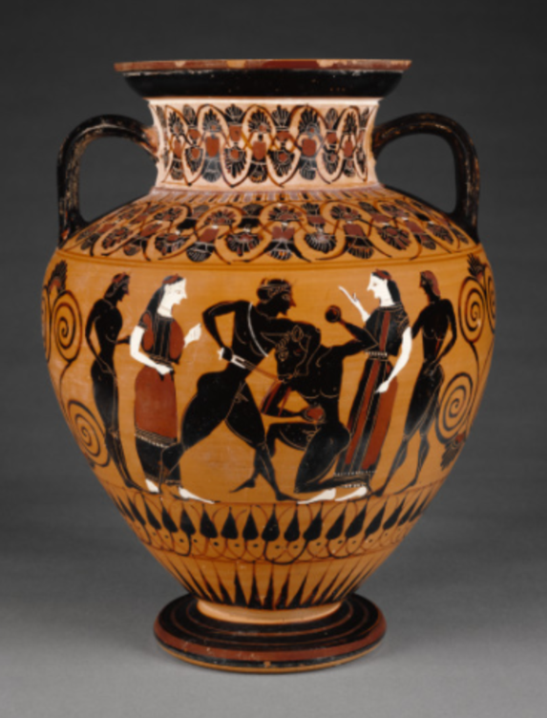
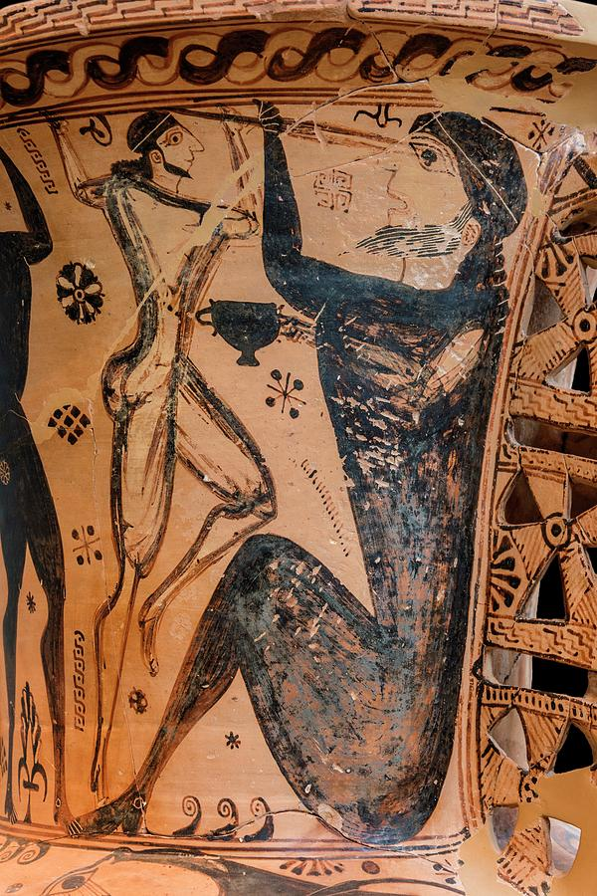

Figure 2: Attic Black-Figure Neck Amphora.
(Available from: http://www.getty.edu/art/collection/objects/11182/attributed-to-group-e-workshop-of-exekias-attic-black-figure-neck-amphora-greek-attic-about-550-bc/?dz=0.5000,0.6264,0.45

Figure 1: Odysseus Blinding the Cyclops.
(Available from: https://fineartamerica.com/featured/odysseus-blinding-the-cyclops-david-parkerscience-photo-library.html)

Bibliography
Apollodorus, Library and Epitome. Frazer, J. G (trans.). 1921. London: Harvard University Press.
Accessed: 30th May 2020
URL: http://www.perseus.tufts.edu/
Beetz, A. M. & Podberscek, A. L. (2009) Bestiality and Zoophilia, Sexual Relations with Animals. Oxford: Purdue University Press
Burt, M. E. & Ragozin, Z. E. (1900) Herakles The Hero of Thebes and other Heroes of the Myth. New York: Charles Scribner’s & Sons

Connor, S. (2014) ‘How did our legends really begin?’, The Independent, 29th July.
Available at: https://www.independent.co.uk/arts-entertainment/books/features/how-did-our-legends-really-begin-9634148.html

Evslin, B & Evslin, D & Hoopes, N (1967) Heroes and Monsters of Greek Myth. New York: Scholastic Inc.

Garcia, B. (2013) ‘Minotaur’, Ancient History Encyclopedia
Available at: https://www.ancient.eu/Minotaur/
(Accessed: 30th May 2020)

Gaster, T. H (2005) ‘Monsters’, The Encyclopedia of Religion, 9, pp. 6163-6166
Accessed: 25th May 2020
URL: https://go-gale-com.ezproxy.uwtsd.ac.uk/ps/i.do?p=GVRL&u=walamp&id=GALE%7CCX3424502106&v=2.1&it=r&sid=exlibris

Gould, C. (1886) Mythical Monsters. London: W H Allen & Co

Homer, The Odyssey. Murray, A. T (trans.). 1919. London: Harvard University Press.
Accessed: 22nd May 2020
URL: http://www.perseus.tufts.edu/

Kershaw, S. P (2007) A Brief Guide to the Greek Myths. London: Constable & Robinson Ltd

Lowe, D (2011) ‘Scylla, the Diver’s Daughter: Aeschrion, Hedyle, and Ovid’, Classical Philology, 106(3), pp. 260-264
Accessed: 22nd May 2020
DOI: 10.1086/661547

Morford, M. P. O & Lenardon, R. J (1999) Classical Mythology. New York: Oxford University Press

Murgatroyd, P (2007) Mythical Monsters in Classical Literature. London: Bloomsbury Publishing Plc

Parker, D (2018) Odysseus Blinding the Cyclops.
Available at: https://fineartamerica.com/
Accessed: 26th May 2020

Citation metadata

Connor, 2014
Gaster, 2005: 6163
Murgatroyd, 2007: 1
Kershaw, 2007: 1; Murgatroyd, 2007: 2
Hom. Od. 9.161
Hom. Od. 9.231
Kershaw, 2007: 398
Connor, 2014
Hom. Od. 9.409
Figure 1
Murgatroyd, 2007: 168; Hom. Od. 9.360
Hom. Od. 9.409
Kershaw, 2013: 277; Garcia, 2013
Apollod. 3.15.8
Garcia, 2013
Garcia, 2013
Beets & Podberscek, 2009: 3
Hom. Od. 10.133

