University of Wales Trinity Saint David
  - Wales Institute of Science and Art



Formula Student Concept Class Group Project

Group Design Project (ACHA5014)
BEng Automotive/Motorsport Engineering

Franklin Spencer Tim Attwood (2004876), Jared Davage (2103529), Toby Heathcote (2104144),
Jon Shallis (2113867), Van Watkins (2104732), Bleddyn Williams (2104564)
March 2023
Table of Figures and Tables 4
Figures 4
Tables 6
1. Introduction 7
1.1. Aims and Objectives 7
1.2. Timing Plan 9
1.3. Team Roles 9
1.4. Risks Identified. 10
1.4.1. Regulations, Health, and Safety 10
2. Aero Versus Non-Aero Car – Franklin 12
3. Powertrain - Franklin 13
3.1. Powertrain type 13
3.1.1. EV 13
3.1.2. ICE 15
3.1.3. EV vs ICE Comparison 16
3.2. Fuel Type 17
3.2.1. Octane Rating 17
3.2.2. 99 RON Petrol 18
3.2.3. E85 18
3.2.4. The Fuel That Will Be Used 19
3.3. Internal Combustion Engine Options 19
3.3.1. Possible Engines 20
3.3.2. Investigating the Triumph Tiger Sport 660 21
3.3.3. The Triumph 675 21
3.3.4. Naturally Aspirated Verses Forced Induction 22
3.4. Triumph 675 Long Block 23
3.4.1. Sourcing the Engine 23
3.4.2. Changes for E85 23
3.4.3. Engine Rotating Assembly 24
3.4.4. Cylinder Head Modification 25
3.4.5. Valvetrain Components 26
3.5. Air Induction System 27
3.5.1. Inlet Manifold 27
3.5.2. Air Flow Restrictor 31
3.5.3. Throttle Body 34
3.6. Exhaust System 34
3.7. Fuel System 35
3.7.1. Fuel Injectors 35
3.8. Engine Management 36
3.8.1. Factory ECU and Wiring 36
3.8.2. Triumph Race ECU and Wiring 36
3.8.3. Reprogrammable ECU and Custom Wiring 36
4. Transmission and Drive, Cooling, Exhaust and Rear Suspension - Toby 37
4.1. Introduction: 38
4.2. Final drive: 41
4.3. LSD: 42
4.4. Rear Suspension: 43
4.5. Cost of materials: 44
5. Chassis – Van 45
5.1. Introduction 45
5.2. Type of chassis: spaceframe vs monocoque 45
5.3. Chassis material 47
5.3.1. Advantages of using aluminium: 47
5.3.2. Disadvantages of using aluminium: 48
5.3.3. Advantages of using steel: 48
5.3.4. Disadvantages of using steel: 48
5.4. Chassis Construction 53
5.5. Conclusion 55
6. Chassis Design - Bleddyn 56
6.1. Concept Phase 56
6.2. Chassis Mk 1 56
6.3. Chassis FEA 59
6.3.1. FEA – Front Impact 59
6.3.2. FEA – Side Impact 60
7. Wheels and Tyres - Jared 63
7.1. Wheel and Tyre Selection. 63
7.2. Wheel and Tyre Size Benefits. 64
7.3. Tyre Data. 66
8. Braking System - Jared 68
8.1. Braking Calculations. 71
9. Suspension - Bleddyn 76
9.1. Bicycle model 76
9.2. Double A Arm Design 77
10. Cockpit and Driver Controls - Jon 79
10.1. Gear Shifter 79
10.2. Safety measures 80
10.3. Pedal Box 81
10.4. Steering 83
10.5. Ergonomics design 85
11. Conclusion 89
12. References. 91
13. Appendix 102

Table of Figures and Tables

Figures
Figure ‎3.1 - NetGain Hyper 9 motor (EVolve Electrics, 2023) 13
Figure ‎3.2 - Tesla Model S drivetrain (EV Europe, 2023) 13
Figure ‎3.3 - Hyper 9 motor power, torque, and efficiency graph (NetGain Motors, Inc., 2023b) 14
Figure ‎3.4 - Triumph Tiger Sport 660 (Bauer Media Group, 2023) 15
Figure ‎3.5 - Honda CBR650R (Hargreaves, 2019) 16
Figure ‎3.6 - Standard power graph for a Triumph 675 (Martin, 2020) 22
Figure ‎3.7 - Triumph Daytona 675 Engine for sale (eBay, 2023) 23
Figure ‎3.8 - Carrillo forged connecting rod for a Triumph 675 (JSD Machine Works, 2022) 25
Figure ‎3.9 - Triumph Daytona 675 Race Kits (Triumph Genuine Race Parts, 2012) 26
Figure ‎3.10 - Air flow restrictor location schematic (IMechE, p.83, 2022) 27
Figure ‎3.11 - Diagram showing an inlet manifold (Benvenuti et al. 2014) 28
Figure 12 - New inlet manifold CAD model 30
Figure 13 - Inlet manifold in suite with the engine model 30
Figure ‎3.12 - Intake restrictor design 1 and 2 (Mahank and Shelagowski, 2015, p.3) 31
Figure ‎3.13 - CFD study results of both designs showing pressure and speed (Mahank and Shelagowski, 2015, p.5) 32
Figure ‎3.14 - Graph showing the restrictor flow results from the CFD study and a flow bench test (Mahank and Shelagowski, 2015, p.4) 32
Figure ‎3.15 - CAD model of the air flow restrictor 33
Figure ‎3.16 - 50mm bore throttle body (AT Power Motorsport Product, 2013) 34
Figure ‎3.17 - Triumph Daytona race exhaust system (Triumph Genuine Race Parts, 2012) 34
Figure ‎3.18 - Matched set of 4 injectors 350cc/min (DW, 2023) 35
Figure 1 41
Figure ‎4.1- Spaceframe chassis 45
Figure ‎4.2 - Monocoque chassis with rear spaceframe 46
Figure ‎4.3- Real test data for rod bending 49
Figure ‎4.4- Properties of t45 compared to minimum/maximum property regulations and calculations 51
Figure ‎4.5- The displacement along a rod of 4130 steel 51
Figure ‎4.6- the strain measured along a rod of 4130 steel 52
Figure ‎4.7- the stress measured in a rod of 4130 steel 53
Figure ‎4.8- MIG welding 54
Figure ‎4.9- TIG welding 55
Figure ‎5.1 - Initial location of suspension mounts 57
Figure ‎5.2 - Formula Student Regulations 58
Figure ‎5.3 - Side impact structure dimensions 58
Figure ‎5.4 - FEA (Front Impact) 59
Figure ‎5.5 - Front Impact FOS 60
Figure ‎5.6 - FEA (Side Impact) 61
Figure ‎5.7 - FEA Side Impact (FOS) 61
Figure ‎5.8 - FEA - Front Torsion 62
Figure ‎5.9 - FEA - Rear Torsion 62
Figure ‎6.1 - BRAID Aluminium Wheel (BRAID, 2016) 63
Figure ‎6.2 - Rubber (viscoelastic) stress-strain hysteresis. (Holloway. C. n.d.) 65
Figure ‎6.3 - Tyre static spring rates graph 66
Figure ‎6.4 - Tyre static deflection graph (www.avontyres.com) 67
Figure ‎7.1 - AP Racing Aluminium Lug Mount Caliper-CP3696-6E0. 69
Figure ‎7.2 - AP Racing CP2623 Forged Aluminium Master Cylinder (apracing.com, n.d.) 70
Figure ‎7.3 - Braking Energy Absolute Against Time. 73
Figure ‎7.4 - Cumulative Braking Energy Against Time 74
Figure ‎7.5 - Brake Force vs Brake Energy. 75
Figure ‎8.1 - Force distribution using the Bicycle method. 76
Figure ‎8.2 - Suspension Geometry (Front View) 77
Figure ‎8.3 - Front View of Double wishbone assembly (GrabCad – Gordon Race Car, 2022) 78
Figure .1 - AP Racing Small diameter plastic reservoir with central outlet for direct fitment. 102
Figure .2 - Excel Braking Calculations Data Sheet 102
Figure .3 - Excel Braking Calculations Data Sheet 102

Tables
Table 1 - The Hyper 9 motor and Honda CBR650R specifications 17
Table 2 - Motorcycles engines fitting the specified criteria. 20
Table 3 - Engine decision matrix 21
Table 4 - Triumph 675 engine specification (MCS, 2009) 22
Table 5 - Spring rate measured with different camber and tyre pressures (www.avontyres.com, n.d.). 66
Table 6 - Braking calculation table 71
Table 7 - Advantages and disadvantages of the chosen pedal box 82
Table 8 - Cockpit dimensions data from subjects (Ahmad et al., 2021) 86

Introduction
The Formula Student concept class is a competition run by the Institute of Mechanical Engineers (IMechE); the competition engages students from all over the world to work as a team to design a race car. The teams have strict regulations to work to and need to design the whole vehicle with a budget of £45,000. The concept class differs from the standard formula student entry because the teams don’t manufacture anything but includes everything up to the point of purchasing components and building the car.

Aims and Objectives
- Develop a chassis system.
  - Decide upon an appropriate kind of chassis with justifications.
  - Decide upon an appropriate material for the chassis using real accurate data from an experiment, simulation, and designing a visual representation of the stresses acting on the material.
  - Choose a method of constructing the chassis.
- Develop a suspension system.
- Increase grip and handling by optimizing suspension geometry.
- Reduce unsprung weight for better suspension response.
- Improve adjustability to allow for fine-tuning of the car's handling characteristics.
It is essential to balance cost, efficiency and safety when making decisions on suspension components. Doing so will ensure that performance and safety requirements are met without compromising cost.
- Develop a braking system.
- Develop a safe and balanced braking system that can perform well in all conditions.
- Source brake parts from a company and give reason for not designing a brake system from scratch.
- Conduct testing and analysis of the chosen brake system to ensure that it performs adequately in all scenarios.
- Make sure, through analysis, that the brake system performs to the FSAE regulations for safety and performance.
- Consider cost, assembly, and maintenance.

- Develop a Wheel and Tyre Setup
- Find a reliable to company to source both wheels and tyres from.
- Select appropriate wheel and tyre size that comply with the FSAE regulations, to ensure it will a safe setup.
- Discuss advantages and disadvantages of the chosen wheel and tyre size combination.
- Conduct analysis of the chosen tyre setup and make decision on the appropriate tyre pressure, camber setup, spring rate, etc. with results.
- Consider the aerodynamic impact of the wheel design.

- Develop a power unit.
- Decide upon a suitable baseline power unit with good torque characteristics and cost justification.
- Select suitable engine components for use with the chosen fuel and modify the cylinder head to improve flow characteristics.
- Develop an inlet manifold integrating the air flow restrictor and a single throttle body.
- Select an engine management system to run the engine.

- Make an ergonomic and safe drivers’ cockpit and controls.
  - Throughout cockpit design, it is essential that parameters such as cost effectiveness, maintenance performance and safety must be accounted for. By following these parameters, and creating a cockpit in accordance with them, the performance of the car will be improved due to the impact on the driver.
  - Increase the driver's performance by designing an apparatus that was comfortable and safe.
  - Use a gear shifter that can compete and that is safe.
  - Find a pedal box that complies with the regulations and the ergonomics design.
  - A steering system that enhances drivers' performance which follows the rules.
  - In-depth analysis and research of safety structures, procedures and fire safety measures that follow closely the set rules.

Timing Plan
As part of the group project management, meetings are scheduled twice a week to provide a dedicated time for the team to engage in discussions, exchange feedback, and consider current progress and plans. By holding these meetings, the team can keep a form of communication between members and ideas a can be put forward for the next week ahead.
The meetings focus on reviewing the progress made so far, identifying potential bottlenecks, and evaluating the effectiveness of the current project plan so far, this is usually discussed with Abi. Additionally, its ideal for team members to work together on areas that cross over, such as rear suspension and axle setup.

Team Roles
- Jared
- Brake Setup
- Tyres
- Wheels
- Franklin
  - Powertrain
- Toby
  - Exhaust System
  - Transmission
  - Drivetrain
  - Cooling System
  - Rear Suspension
- Van
  - Chassis
  - Chassis Type
  - Chassis Material
  - Chassis Manufacturing
- Bleddyn
  - Chassis
  - Impact Structure
  - Front Suspension Geometry
  - Front Suspension Design
- Jon
  - Cockpit
  - Harness
  - Vehicle and driver equipment
  - Aerodynamics

Risks Identified.
The team considered potential risks related to members within the team, including disagreements with team members or even the project supervisor. Additionally, the team recognized the significant workload required, as another potential risk.
The team considered technical risks related to the design process and the potential loss of important files or issues with Solidworks designs. These risks are important due to their considerable impact on the result of the project and validation for real data.
The team also faced the risk of the car failing testing, or potentially getting disqualified due to the set regulations. These regulations had to be followed throughout with great care to ensure that the car was safe for the driver.

Regulations, Health, and Safety
It is important through the design of the vehicle that all health and safety factors are considered to make the car as safe as possible and that it applies to all regulations of the competition.
Some of these safety factors that apply to the regulations include:
- Material Safety- It is necessary for the material to meet the minimal requirements in the regulations to protect the driver from the forces acting on the car and so that the car does not reach its ultimate yield strength and cause the car to fail and fracture.
- Ergonomics – selecting the appropriate harness for the driver is very important, It must keep the driver in place in case the vehicle crashes. The regulations stated that the harness must be attached using one 8mm metric grade 8.8 bolt and steel backing plates with minimum thickness of 2mm. The edges of the test fixture supporting the sample must be a minimum of 125 mm from load application point (FSAE, 2022).
- Fire Safety - The firewall must be created from a hard, fire-resistant material such as aluminium or carbon fibre. Particularly, along the sides and the floor of the cockpit it must be entirely watertight and impenetrable. (Fsaeonline.com, 2022).
- Brake system – The brake system should provide a sufficient stopping force to safely bring the vehicle to stop in all conditions. It would also be ideal if the brake system is easily accessible for maintenance and repairs, such as repairing leaks or replacing fluid. The regulations state that the vehicle must come to a stop from 60km/h in less than 18 meters, so it is important that the chosen brake system can provide a sufficient stopping distance. (Fsaeonline.com, 2022).
- Tyre selection – it is important the correct tyres are used. The regulations state that wet and dry tyres can be used, as well as tyres from different manufacturers, but they must all the be the same on the same axle. It is also important that the tyres are meticulously maintained, this includes such things as tyres wear, operating temp, pressure, etc. (Fsaeonline.com, 2022).

Aero Versus Non-Aero Car – Franklin
When designing a car in formula student there are generally two body styles, aero and non-aero the decision in mainly due to the following factors:
- The Road Course – The track which is used to test these race cars is a short road course which has lots of corners and fairly short straights, generally the cars on the straights achieve a maximum speed of about 60 - 70mph and that speed is only maintained for about 3 - 5 seconds at which point they need to brake and turn into a corner. As aerodynamics require air speed to take effect it would require a much faster cornering course to take full potential of an aero car.
- OptimumLap Simulation – Running a simulation in OptimumLap allows you select a track and a vehicle to simulate its lap time, this was done on a short track with many corners and that of similar distance to the formula student road course at Silverstone. The vehicle selected was a formula student car and two tests were run, one with an aero body and one with a non-aero body, the simulated time for the aero car was 52.71s and the non-aero car was 53.83s. Although the non-aero car was nearly 1s slower the team believe that with a solid chassis and suspension design along with a high performing powertrain, this car will be able to outperform the aero car.
- Weight – Aero body panels are generally light weight if they are made from carbon fiber but carbon fiber is very expensive and given the budget may not be possible. Fiberglass is a good alternative, but it weighs 15% more than carbon fiber and the team fear it would be too heavy to compete.
- Cost – Materials and manufacturing is expensive for both carbon fiber and fiberglass which again could put the project over budget.
- Time – Aerodynamic development takes a lot of research and can require 1/1.5 people to work on aero design. Looking at previous formula student teams who have developed an aerodynamic body which is competitive often have upwards of 8 people in the team and they dedicate 2 to 3 people on designing the aerodynamic body work.
Given this is a team of 6 people everybody concluded that it was better to put more resources into other aspects of the car rather than expect one person to design and develop a competitive aero package. This combined with the cost and the OptimumLap simulation results meant the team decided to design a non-aero car.

Powertrain - Franklin
A powertrain is a group of components that generate and transmit mechanical power to the driven wheels of a vehicle. There are generally 3 methods of generating mechanical power; an internal combustion engine (ICE), an electric motor (EV), and a combination of both known as a hybrid.

Powertrain type
The decision needs to be made on what type of powertrain the vehicle will use, the choices given the regulations are, an electric motor, or an internal combustion engine. This is one of the first decisions that needs to be made because it will drastically affect the shape of the chassis and the type of drivetrain used. Since the road course the car will be tested on features lot of corners the maximum speed expected on the straights is about 60 – 70 mph meaning the car needs low end torque to accelerate the car through and out of the corners.

EV
The regulations say only electric motors are allowed to drive the wheels/axle and the power output from the electrical storage device must not exceed 80 KW. This dictates the maximum power and torque the motor will generate, even if the motor on paper is capable of much more than 80 KW it would have to be limited so it can only draw a maximum of 80 KW to comply with the regulations. This means there is no point looking for a 150 KW motor as it will be much heavier, and the driver will only be able to utilises 53% of that larger motor. Looking at the current range of electric motors that produce around 80 KW designed for vehicles there are two motors that stand out:
- The NetGain Hyper 9
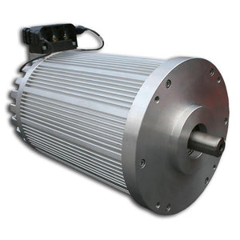
- The Tesla Model S 85D
Figure ‎3.1 - NetGain Hyper 9 motor (EVolve Electrics, 2023)
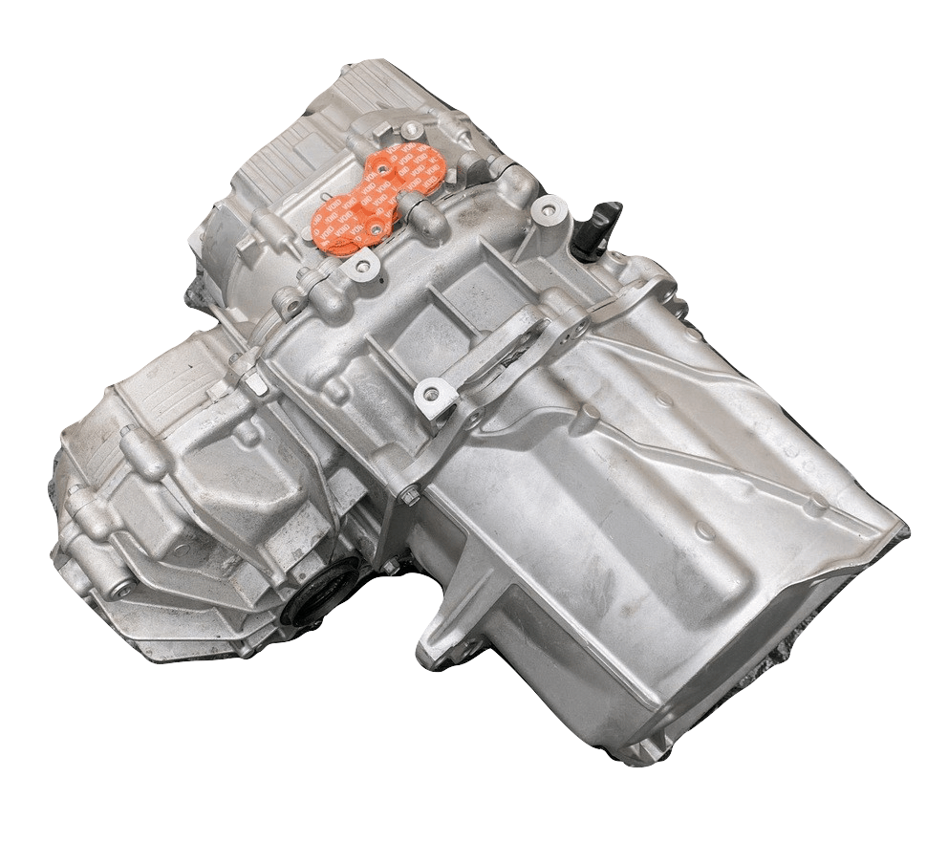
Figure ‎3.2 - Tesla Model S drivetrain (EV Europe, 2023)

NetGain Hyper 9 Motor
The NetGain Hyper 9 motor is a synchronous reluctance internal permanent magnet (SynRM) which “has stator winding like that of a conventional squirrel cage induction motor (SCIM) but its rotor is designed to provide the least possible magnetic resistance in one direction” (Bishop, 2020). NetGain (2023a) say the Hyper 9 motor is ideal for any light to mid-weight car with the motor combining the torque producing forces of permanent magnets with the high efficiency and cost-effective synchronous reluctance design producing 173 lb. Ft (235 Nm) peak torque from 0 RPM through to 2400 RPM. These torque characteristics are evident in the below graph, the blue line showing torque holds constant and flat until 2,400 RPM where it then starts to tail off making about 80 Nm at maximum speed.
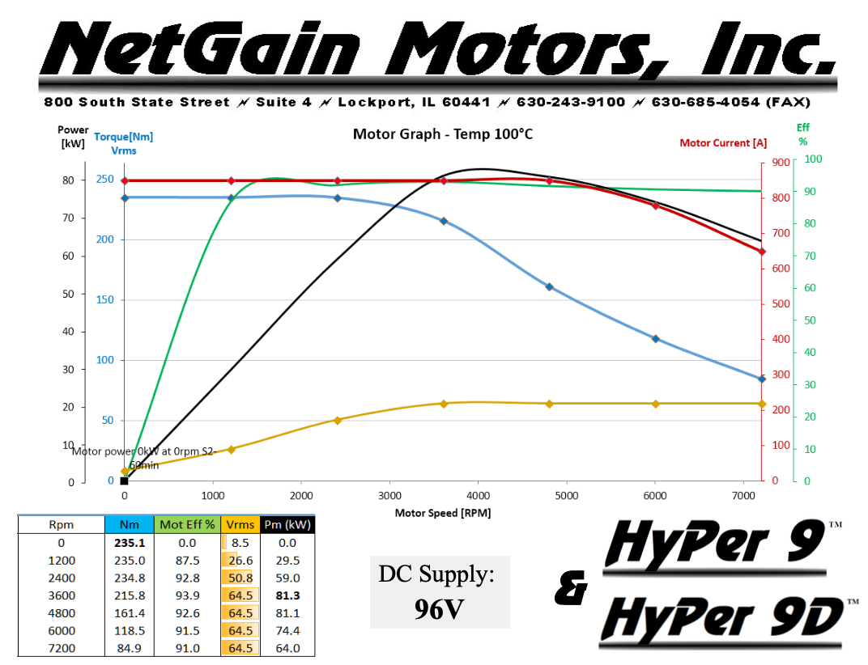
Figure ‎3.3 - Hyper 9 motor power, torque, and efficiency graph (NetGain Motors, Inc., 2023b)

Tesla Model S 85D Motor
Since the Tesla motors are designed and manufactured in house by Tesla, information and technical specifications are difficult to find. Electrogenic (2023) state the Model S 85D motor can spin up to 18,000 RPM running at 350V and officially generate 486 lb. Ft (660 NM) at 0 RPM and 375 KW at 6,150 RPM.

ICE
The regulations state “the engine(s) used to power the vehicle must be piston engine(s) using a four-stroke primary heat cycle with a displacement not exceeding 710 cm3 per cycle” (IMechE, 2022, p.80). In addition, there is an intake system restrictor which must be fitted and will limit the maximum power capability of whatever engine is chosen. Looking at larger capacity engines which generate more power and torque there are two options that stand out both of which are motorcycle engines:
The Triumph Tiger Sport 660
The Honda CBR650R

The Triumph Tiger Sport 660
The Triumph Tiger Sport 660 is a new motorcycle released in 2022 with a 4-stroke, 660cc, inline-3 engine. According to Wheelen (2021) produces 80 Hp and 47 lb. Ft with 90% of that torque being produced between 3,600 RPM and 9,750 RPM making the torque cure very flat which is ideal for a heavier vehicle such as the race car.
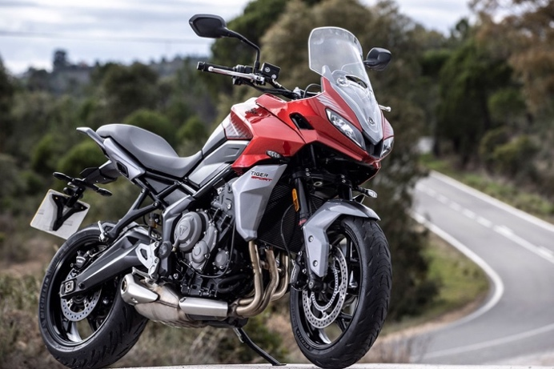
Figure ‎3.4 - Triumph Tiger Sport 660 (Bauer Media Group, 2023)

The Honda CBR650R
Unlike the Triumph, Honda (2022) say the CBR650 has a 649cc, inline-4 cylinder, 4-stroke engine and produces 93 Hp at 12,000 RPM and 47 lb. Ft at 8,000 RPM. Hargreaves (2019) says the engine used in the CBR650R is essentially a tuned and refined version of its predecessor the CBR650F making the same 47 lb. Ft as before but now makes peak torque 500 RPM later in the rev range at 8,500 RPM. The predecessor to the CBR650R, the CBR650F, was a very popular choice for formula student teams due its powerful and compact size with lot of aftermarket upgrades and parts.
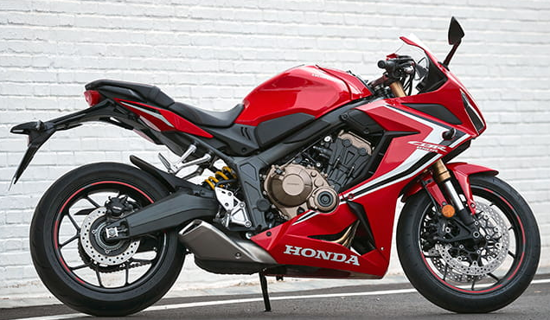
Figure ‎3.5 - Honda CBR650R (Hargreaves, 2019)

EV vs ICE Comparison
To compare the two options the specifications for both Hyper 9 electric motor and Honda CBR650R engine will be compared. The table below shows the specifications the team is interested in for making the final powertrain decision. Looking at the power and torque values it’s clear that the Hyper 9 motor outperforms the CBR650R particularly when it comes to torque with the CBR650R making only 28% of the torque capability of the Hyper 9 motor. The mass of the two options is remarkably similar, however it must be pointed out that the mass of the CBR650R is shown as a range for motorcycles engines of this capacity due to the exact mass not being able to be found. As the team is limited budget wise it critical to look at the prices and look at the power per cost value. It must be noted that a price range is shown for the CBR650R which was taken from eBay for a second-hand engine which runs. For the power to cost calculation a worst-case scenario was taken with the cost of the engine being £1,500. With the motor being 16 W/£ and the engine being 46 W/£ it’s clear that price wise the engine is a better performer and the same is true when looking at torque per cost value. The motor resulted at 0.039 Nm/£ and the engine at 0.041 Nm/£ so they are much more competitive when it comes to torque per cost but the CBR650R still come out on top.
Table 1 - The Hyper 9 motor and Honda CBR650R specifications
Criteria | NetGain Hyper 9 Motor (with inverter) | Honda CBR650R
Power | 120Hp (90KW) | 93HP (70KW) @ 12,000 RPM
Torque | 160lb.ft (220Nm) | 46lb.ft (62Nm) @ 9,500 RPM
Mass | 54.5Kg | 40 – 60Kg
Cost | £5,600 | £750 - £1,500
Power to Cost Ratio | 16 W/£ | 46 W/£
Torque to Cost Ratio | 0.039 Nm/£ | 0.041 Nm/£

- NetGain Hyper 9 Motor + inverter specifications (Fellten, 2023)
- Honda CBR650R Specs (Honda, 2022)

After comparing the two options the team collaboratively came to an agreement to run with an internal combustion engine due to the financial benefits and what would be weight saving benefit because the above mass for the motor does not include the mass of a battery pack.

Fuel Type
Choosing an internal combustion engine is one thing but now the type of fuel used to run the engine now needs to be chosen. Looking at the regulations the two types of fuels that can be used in an ICE are unleaded 99 RON petrol and E85.

Octane Rating
The EIA (2022) say the octane rating is a measure of how stable the fuel is, and the value is base off the pressure at which the fuel will spontaneously combust in an internal combustion engine. The higher the octane rating the more pressure the fuel air mix will need to combust, “these ratings are measured on a special octane rating engine known as a CFR engine” (Vizard, 1985, p.200). There are two common rating for octane:

Research Octane Rating (RON)
Vizard (1985) states the research octane rating is measured with certain parameters of the CFR engine, these include:
- Engine speed of 600 RPM
- Water jacket temperature of 212° F (100° C)
- Air inlet temperature of 150° F (65.5° C)

Motor Octane Rating (MON)
Vizard (1985) says the motor octane rating is measured with the same CFR engine but two of the parameters have different values:
- Engine speed of 900 RPM
- Water jacket temperature of 212° F (100° C)
- Air inlet temperature of 300° F (149° C)

(R+M)/2
This rating according to Vizard (1985), is the RON value plus the MON value divided by 2 giving the average of the two ratings.
It’s important to note that the octane value does not reflect the fuels energy and an engine with a compression ratio (CR) of 9:1 running 95 RON, or 99 RON would not have effect on the power it would make. Where octane really matters is when an engine has a high CR, an engine with a CR of 11:1 would require 99 RON as its cylinder pressure would rise above the combustion pressure that 95 RON can experience before combusting. With a higher CR come better efficiency and more power from an engine.

99 RON Petrol
The 99 RON petrol is not too dissimilar to the petrol brought at a fuel station; this fuel is made up of “multiple chemicals containing hydrogen and carbon, commonly known as hydrocarbons. The average petrol blend contains around 150 different hydrocarbons, including substances such as butane, isopentane and pentane” (Petro Online, 2021). The fuel used for the event is R Racing Fuel (2016) SUR racing gasoline who say their fuel is 99 RON and 88 MON meaning it has a (R+M)/2 values of 93.5 and provides protection against engine knock up to a compression ratio of 11:1.

E85
Sunoco (2017) E85 on the other hand is 15% petrol and 85% ethanol which is manufactured and distilled from plants in the same way alcohol for drinking is manufactured. With this fuel containing a large amount of ethanol “exerts a marked internal cooling effect due to the large amount of heat required to evaporate it” (Irving, 1962, p.10). The only octane rating provided by Sunoco (2017) is the combined octane number of 99 however, the DOE (2022) say E85 has about 27% less energy compared to petrol meaning more fuel will need to be used to generate the same amount of power as petrol.

The Fuel That Will Be Used
Given the higher-octane rating of E85 means whatever engine the team uses can have its compression ratio increased or a power added such as a turbo or supercharger could be integrated to help mitigate the power loss from the air flow restrictor as much as possible. E85 will also help the engine run slightly cooler resulting in less load on the cooling system and making a more drastic inlet temperature drop making the air denser. In addition, because E85 is made from 85% ethanol which is considers a biofuel it seen to be more sustainable.

Internal Combustion Engine Options
Given the team are after an engine with good low-end torque, the engine capacity needs to be as large as possible so only engines with a capacity of 640cc and above were considered. Furthermore, only new engines were looked at as they would require the least amount of work to run and create power.

Possible Engines
Below is a table showing all the motorcycle engines that have been considered for use in the vehicle.
Table 2 - Motorcycles engines fitting the specified criteria.
The 4 Engine Options
Criteria | Yamaha Tracer 7 | Suzuki SV650 | Honda CBR650R | Triumph Tiger Sport 660
Capacity (cc) | 689cc | 645 | 649 | 660
Cylinder Configuration | Inline 2 | V – Twin | Inline 4 | Inline 3
Compression Ratio | 11.5:1 | 11.2:1 | 11.6:1 | 11.95:1
Power (Hp) | 72 @ 8,750 RPM | 72 @ 8,500 RPM | 93 @ 12,000 RPM | 79 @ 10,250 RPM
Torque (lb. Ft) | 50 @ 6,500 RPM | 47 @ 6,800 RPM | 46 @ 9,500 RPM | 47 @ 6,250 RPM
Bike Mass (Kg) | 210 | 200 | 211 | 206

- Yamaha Tracer 7 Specs (Yamaha, 2022)
- Suzuki SV650 Specs (Suzuki, 2022)
- Honda CBR650R Specs (Honda, 2022)
- Triumph Tiger Sport 660 Specs (Triumph, 2022)

To decide on the best engine to use in the vehicle a decision matrix is utilised with the criteria in descending order on importance shown below:
Table 3 - Engine decision matrix
Engine Decision Matrix
Criteria | Yamaha Tracer 7 | Suzuki SV650 | Honda CBR650R | Triumph Tiger Sport 660
Torque | 4 | 3 | 2 | 3
Power | 2 | 2 | 4 | 3
Mass | 2 | 4 | 1 | 3
Compression Ratio | 2 | 1 | 3 | 4
Results | 10 | 10 | 10 | 13

Looking at the results it clear that the Triumph Tiger Sport 660 is the engine that should be used scoring 13 whereas all the other options scored 10.

Investigating the Triumph Tiger Sport 660
Looking to pursue the Triumph 660 engine more research needs to take place to see what potential the engine has in a race car application. Since the Triumph 660 was launched in 2022 there is limited knowledge on the engine itself especially when it comes to aftermarket parts. In addition, this being the concept class the team won’t be getting a physical engine meaning all the information will need to be researched, one of the most import aspects are the engines physical dimensions which will be needed for the design of the chassis. After contacting Triumph directly about general information on the engine including engine mounting point dimensions, they responded with approximate measurement of the engines overall size but were unable to provide mounting point measurements. They did however note that the 660 Tiger is based on the Triumph 675 and shares many features, also they said the 675 is quite popular with formula student teams.

The Triumph 675
The Triumph 675 engine was used in the Triumph Daytona 675 from 2006 – 2016 and the Triumph Street Triple from 2007 – 2017, the most powerful variant being the Daytona from 2013 – 2016. Meaning there’s a lot of resources and aftermarket involvement with this engine including Triumph race parts. These motorcycles however cannot be purchased new anymore which means one will need to be sourced second hand, however looking at the second-hand market for a complete engine rather than a complete motorcycle will financially save at least 75% which can then be allocated to improving the engine bought. This should equate to a better performing engine than what the team would have otherwise of ended up with. Below are the engine specifications and power graph:
Table 4 - Triumph 675 engine specification (MCS, 2009)
Standard Engine Specifications
Capacity (cc) | 675
Cylinder Configuration | Inline 3
Compression Ratio | 12.65:1
Power (Hp) | 126 @ 12,600 RPM
Torque (lb. Ft) | 54 @ 11,750 RPM

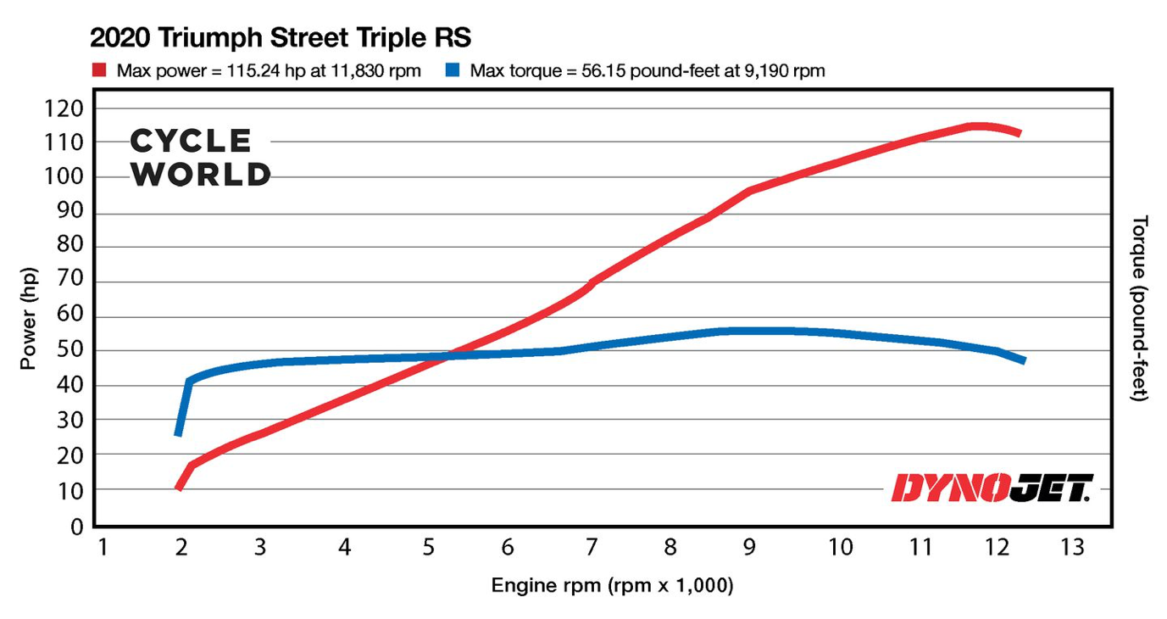
Figure ‎3.6 - Standard power graph for a Triumph 675 (Martin, 2020)
Looking at the specification table it makes similar torque to the 660 but has a huge increase in power producing 126 Hp whereas the 660 made 79 Hp. Better still the power graph shows the 675 makes about 45 lb. Ft from 2,000 RPM and sustains that up to the rev limiter peaking at about 55 lb. Ft at 9,000 RPM. This results in the final decision for the power unit, the team will use the Triumph 675 engine.

Naturally Aspirated Verses Forced Induction
The regulations do allow for a turbo or supercharger to be installed and they can help mitigate the power loss due to the air flow restrictor however, they add a lot of complexity and generate much more heat in the combustion change which can lead to engine failure. Looking at previous competition’s entries turbocharging particularly is common due to the efficiency of a turbo using wasted exhaust gases to spin a turbine whereas a supercharger has parasitic draw on the crankshaft requiring engine power to spin it. Previous teams seem to have at least 2 people working on the engine full time if they use a turbocharger, this is due to the complex sizing of the exhaust and inlet sides of the turbo to suit the engine. In addition, most forced induction engines use a charge cooler to remove some of the heat from the air that has been compressed and packing the cooler and pipe work in such a small car will be very changeling. Another element is cost, although the turbocharger itself may not be more than about £1000 the additional components needed quickly add up. Therefore, the team are going to run with a naturally aspirated (N/A) engine.

Triumph 675 Long Block

Sourcing the Engine
As mentioned, the vehicle will have to use a second-hand engine which will be sourced from places like eBay, Facebook marketplace, Triumph Specialist, owners’ groups, etc. An engine which has been removed from a crashed motorcycle but still runs is often a good source as the motorcycles cannot be used on the road again but mechanically the engines are often good to use. Another option is to purchase an ex-race engine which has been used in motorsport where the bike has been retyred from racing. Below is an example of a suitable engine listed on eBay:
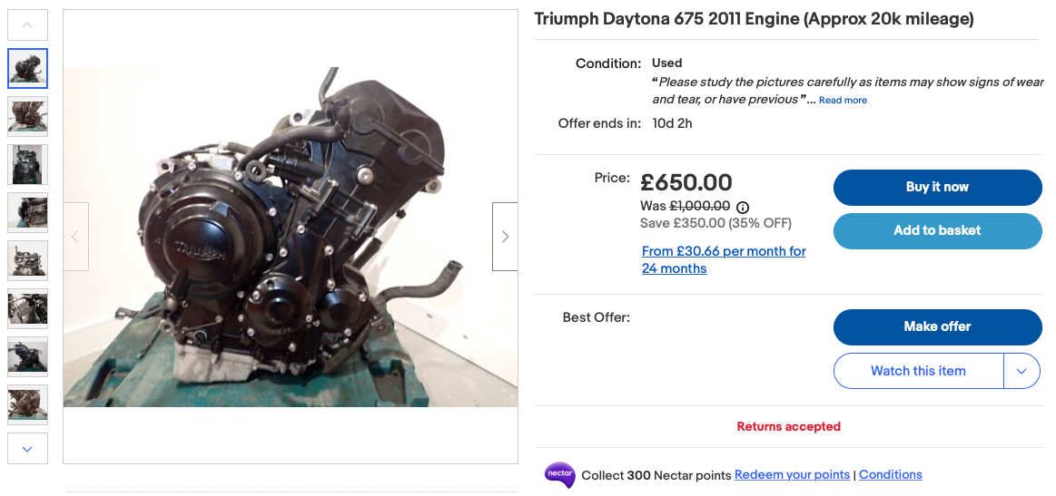
Figure ‎3.7 - Triumph Daytona 675 Engine for sale (eBay, 2023)

Changes for E85
To take advantage of E85 with the higher-octane value on a N/A engine the compression ratio needs to be increased, this done by reducing the size of the combustion chamber. To achieve a smaller combustion chamber volume the cylinder head needs to be shaved or the piston top needs to have domed top, sometime depending on the engine a combustion of both is used to achieve the desired compression ratio. Vizard (1985) has personally built an engine with more than 14.4:1 CR but Bob Griffiths at Bhp Developments has built engines more than 15:1 compression ratio running alcohol base fuels, very similar to ethanol. Looking online shows a large range of people running E85 on a N/A engine with varying compression ratios ranging from 14:1 to 16.5:1. The aim for this engine is to have a compression ratio of 15:1 which should still be safe for a quality, E85 fuel while extracting good performance.

Engine Rotating Assembly
The engine rotating assembly consist of the crankshaft, connecting rods and the pistons, all these components undergo huge stresses from the cylinder pressure during combustion. With the increased compression ratio comes increased cylinder pressure which can cause the OEM rotating assembly to fail resulting in a catastrophic failure of the engine. Its common practice to upgrade these parts to aftermarket forged components which are much stronger and can handle the increase cylinder pressures.

Crankshaft
The crankshaft in the triumph 675 is already a forged unit and should withstand the increases stresses without any issues.

Connecting Rods
The connecting rods in factory form are a cast construction and it is common to upgrade these to forged H-beam rods. They are the same length as the standard rods and with the standard forged crank they will not change the engines capacity. These should allow for increased cylinder pressures beyond what the team are expecting which will allow for a built in reliably factor.
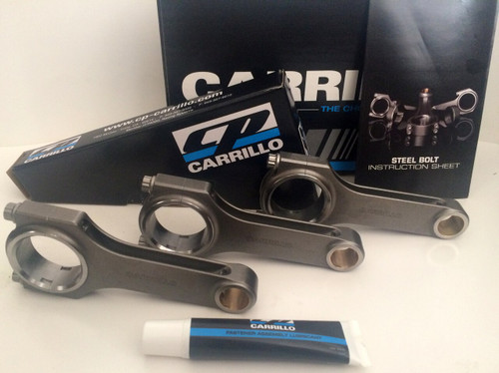
Figure ‎3.8 - Carrillo forged connecting rod for a Triumph 675 (JSD Machine Works, 2022)

Pistons
With the change to E85 and the desire for a compression ratio of 15:1 the engine will require custom pistons. Standard pistons are cast and can starts to break apart with high CR but even if could handle the pressure there is no way to increase the CR up to 15:1 with standard pistons. Happily Wiseco (2022) make custom pistons and have manufactured pistons for the Triumph 675 for customers in the past, Wiseco pistons are either forged or machined from a solid billet, they suggest the process and material they seem suit for the application.

Cylinder Head Modification
It’s clear the cylinder head on the Triumph 675 already flow very well due to the power the engine makes at high speed however Irving (1962) suggests improvements should be investigated into the following:
- Inlet and exhaust port shaping and polishing to improve flow characteristics.
- Head mating surface skimming to help achieve the desired compression ratio.
- Chamber CC’ing to ensure each cylinder will have the same compression ratio and volume.

Valvetrain Components
Valvetrain components include inlet and exhaust valves, valve springs, camshafts, and timing gear. Looking at valvetrain upgrades there are only two options on the market: the factory on road valvetrain parts or the Triumph race parts. The factory components will be designed for smooth and consistent running especially at low engine speed making the motorcycle easy to ride and control, in addition, there are emission standards the bike will need to pass for road use again limiting the full potential of the engine. The trade-off of emission control and rideability is less overall power and torque. Triumph race division have an upgraded camshaft which has a different cam profile and more duration but maintains the same valve lift as the standard unit.
- The standard inlet cam is 9.40 mm max lift and 258.98° duration. The Race Kit inlet cam is 9.40 mm max lift and 265° duration.
- The standard exhaust cam is 8.70 mm max lift and 247.08° duration. The Race Kit exhaust cam is 8.70 mm max lift and 260° duration.
(Triumph Designs Ltd., 2013, p.8)
There are also upgraded valves which can handle more heat from the combustion process and have better heat transfer properties. To accommodate the camshaft and valves there are mandatory upgraded items that need to be fitted such as valve springs, spring retainers and timing gear. All the valvetrain components would be taken from the bellow document:
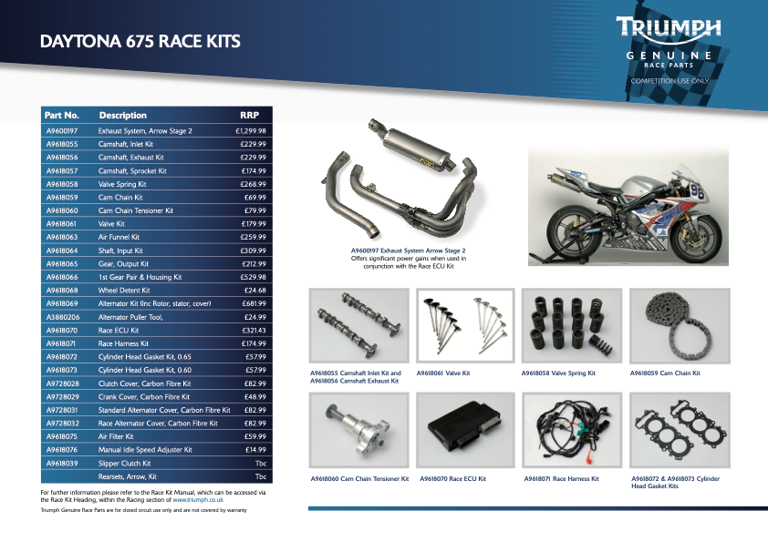
Figure ‎3.9 - Triumph Daytona 675 Race Kits (Triumph Genuine Race Parts, 2012)

Air Induction System
When running a N/A engine in the competition there must be an air flow restrictor to limit the power of the engines, the placement of the air flow restrictor is as follows:
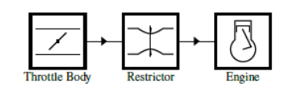
Figure ‎3.10 - Air flow restrictor location schematic (IMechE, p.83, 2022)
Due to the restrictor being after the throttle body it does not allow for individual throttles (ITBs) which the Triumph engine uses, therefore a custom inlet manifold integrating the air flow restrictor and a single larger throttle body needs to be designed.

Inlet Manifold

Design and Pulse Tuning
Inlet manifold design has a large impact on the overall power the engine produces but also how much and where peak torque is generated in the rev range. When designing an inlet manifold one can take advantage of pulse tuning which according to Heisler (1997) is taking advantage of the pressure waves in the inlet system which at high engine speeds can be exploited to increase intake pressure without the use of a compressor like a turbo or superchargers. The method is to time the point at which the air rushing through an open inlet port is stopped (i.e., the inlet port closes) and the momentum of the air hitting the close inlet valve creates a pressure spike. The aim is to get this positive pressure pulse to profligate through the inlet manifold and arrive at an open inlet port where it would then enter the cylinder. This result is slightly more air in the cylinder which with more fuel will generate more power. This is done by changing the length of the inlet manifold runners.
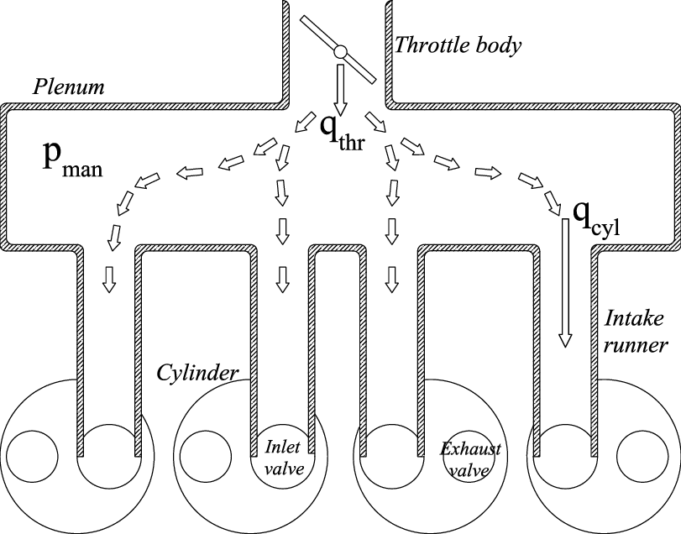
Figure ‎3.11 - Diagram showing an inlet manifold (Benvenuti et al. 2014)
The ideal length of an inlet runner to produce maximum torque at a given RPM can be calculated using the equation below:
L – Inlet runner length
CrR – Crankshaft rotation angle
RPM – Engine speed
$$\frac{2L}{330}= \frac{CrR}{360} x \frac{60}{RPM}$$
To calculate the CrR the below information is used in the following equations:
Inlet cam duration - 265°
Full lift - 106°
$$\frac{256°}{2}-\left(180°-106°\right)=54°$$
The angle from full lift to midway between BDC and the valve closing:
$$(180°-106°)+ \frac{54°}{2}=101°$$
$$CrR Angle=101°$$
Now the CrR angle can be substituted into the rearranged runner length equation with the desired engine speed peak torque would be produced:

$$L=\frac{330}{2} x \frac{101°}{360} x \frac{60}{8000}$$
$$L=0.347$$
From this it shows that runner length for producing peak torque at 8000 RPM is 347mm. 8000 RPM was chosen because the engine will not be able to rev highly and create power due to the air flow restrictor so this is where the team would like peak power to be.

CAD Model
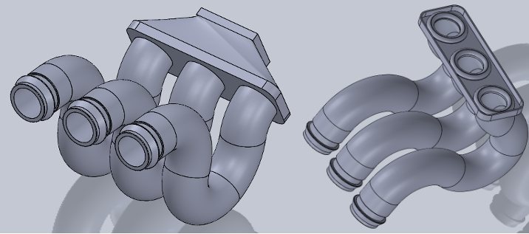
Figure 12 - New inlet manifold CAD model

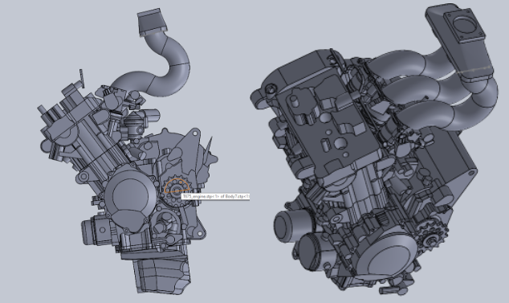
Figure 13 - Inlet manifold in suite with the engine model

Air Flow Restrictor

Restrictor Design
With an engine running E85 the air flow restrictor diameter must be 19mm, since the air flow restrictor is a well-documented component there are a few different designs which have been published. Instead of devolving one from scratch it is thought it would be more time efficient to use one of the designs already documented. The two air flow restrictor designs which are being investigated are designed by Mahank and Shelagowski:
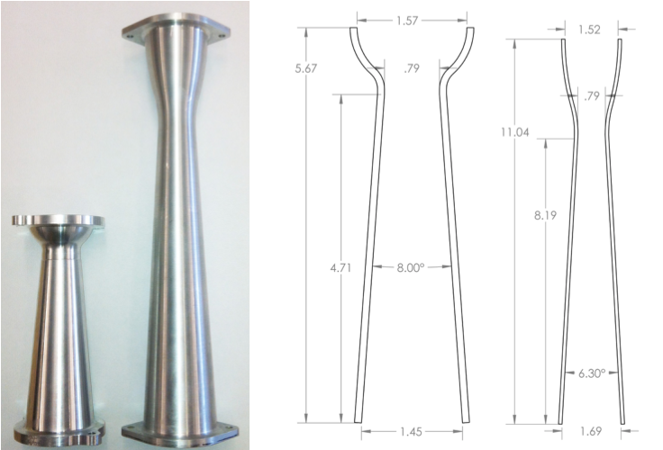
Figure ‎3.12 - Intake restrictor design 1 and 2 (Mahank and Shelagowski, 2015, p.3)
Looking at the technical drawing above it shows that the entrance and exit of the resistor is tapered, this is to help guide the air flow through the restriction diameter. The diameter of the restrictor for these designs is 20mm for running petrol and this is for SAE Formula Student however the regulations for the air flow restrictor are the same for both SAE and IMechE competitions.
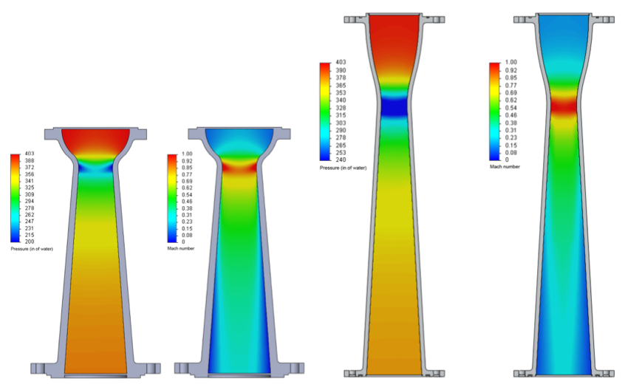
Figure ‎3.13 - CFD study results of both designs showing pressure and speed (Mahank and Shelagowski, 2015, p.5)
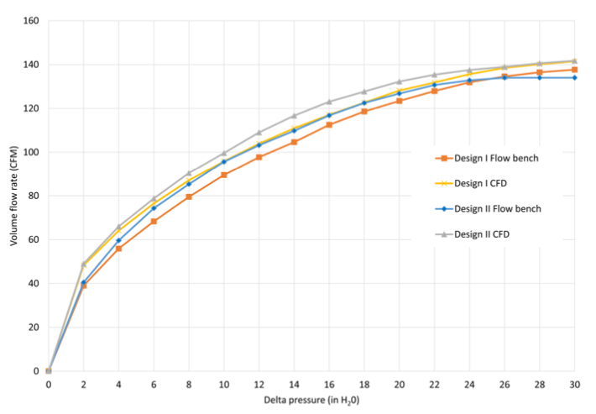
Figure ‎3.14 - Graph showing the restrictor flow results from the CFD study and a flow bench test (Mahank and Shelagowski, 2015, p.4)
Looking at the CFD study and the flow rate graph on the previous page shows that design 2 with a much longer and gradual taper flows better from 2 in H₂O through to 24 in H₂O but above 24 in H₂O design 1 flows slightly more. Looking at the area under the cure for the two designs shows that design 2 has much more potential when it comes to flow over a boarder range of air speeds.

CAD Model
The dimensions were taken from Mahank and Shelagowski design 2, but the diameter of the restrictor was made to be 19mm instead of 20mm to comply with the regulations, the inlet and outlet were also changed to 50mm. All the other measurements were adjusted to suit these new diameters so it should have the same flow characteristics but will inevitably flow slightly less due to the change from 20mm to 19mm. The bolt pattern on the inlet side is designed for the new throttle body and the outlet side has a different bolt pattern which goes to the manifold, they are different so the restrictor cannot be bolted on the wrong way.
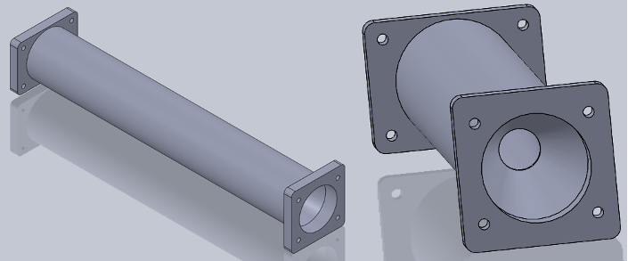
Figure ‎3.15 - CAD model of the air flow restrictor

Throttle Body
Since the air flow restrictor entrance has a diameter of 50mm, throttle body with a bore of 50mm is what’s needed. The throttle body selected is a AT Power Motorsport Products (2013) cable actuated throttle which is designed for N/A engines with a bore 50mm and come with a throttle position sensor.
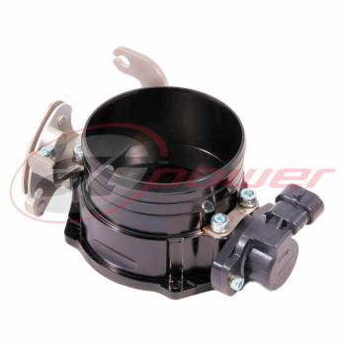
Figure ‎3.16 - 50mm bore throttle body (AT Power Motorsport Product, 2013)

Exhaust System
The exhaust system will use the Triumph race system but only for the 3 into 1 exhaust extractors, the extractors have already been tuned to produce maximum power. The 3 into 1 exhaust collector finishes in a 50.8mm outside diameter tube just below the clutch side of the engine ready for Toby to design the rest of the system and silencers.
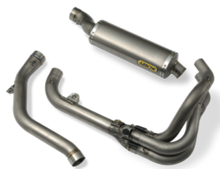
Figure ‎3.17 - Triumph Daytona race exhaust system (Triumph Genuine Race Parts, 2012)

Fuel System
On the Triumph 675 the fuel rail and fuel injectors are mounted to the ITBs which will be removed meaning the fuel injectors will need to be fitted to the new inlet manifold. In addition, with the running of E85 the injector size needs to increase due to E85 having less energy resulting in the need for more fuel.

Fuel Injectors
Since more fuel needs to be flowed for E85 the fuel injector size will need to change and is calculated below:
Stoichiometric air fuel ratio for E85 – 9.8:1 (Sunoco, 2017)
Full load air fuel ratio for E85 – 8.5:1 (Garret, 2020)
BSFC for E85 – 0.6 (Garret, 2020)
Target power – 128hp
$$Injector size=\frac{Max Hp x BSFC}{No. of Injectors x Duty Cycle}$$
$$Injector size=\frac{128x0.6}{3x0.8}$$
$$Injector size lbs/hr=32 x 10.5$$
$$Injector size=336 cc/min$$
A suitable set of injectors are these DW (2023) 350cc/min matched set of 4 injectors suitable for E85:
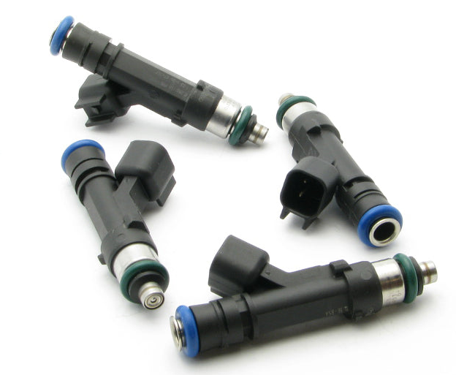
Figure ‎3.18 - Matched set of 4 injectors 350cc/min (DW, 2023)

Engine Management
To run the engine electronic fuel injection will be used which uses a computer known as an Electronic Control Unit (ECU) and there are 3 options.

Factory ECU and Wiring
The factory ECU on the motorcycle runs the engine perfectly for road use when the engine is in the motorcycle however, trying to run the engine out of the bike uncovers some issues. Since the bike is use on the road Triumph Design Ltd. (2014) has additional security systems, an anti-lock braking system and a traction control system that all communicate with the engine computer using the Controller Area Network (CAN). Getting this to all work outside the bike will be very difficult and it will still have a road tune in the ECU which will not account for running E85 with a new inlet manifold.

Triumph Race ECU and Wiring
The Triumph Genuine Race Parts (2012) ECU and wiring loom is designed for race and allow for several set tunes that can be loaded into the ECU and doesn’t have any security system but still communicates with via CAN to other system on the bike and there is no contingency for running E85.

Reprogrammable ECU and Custom Wiring
Using a reprogrammable ECU allows for real-time tuning and control over all the engine parameters, given the fact that the induction system, fuel system and the compression ratio has drastically changed this is critical. Using an aftermarket universal ECU also allows for any type of sensor to be used so the only original Triumph sensors that would be used are the crank position sensor, cam position sensor and the knock sensor. The wiring loom would also need to be custom made to suit the different types and location sensors that will be used.
Regulations: (IMechE (2023))

Transmission and Drive, Cooling, Exhaust and Rear Suspension - Toby
Cooling system:
- Only plain water can be used
- It has to have a rigid cover
- It has to be made of a material that can withstand 120 degrees Celsius
- Cooling system catch can is 10% volume or 100ml (whichever is bigger)
- Oil catch can is 10% volume or 900ml (whichever is bigger)
- Catch cans must be mounted to the chassis, behind the firewall and below driver shoulder level
- Must vent out the bottom of the chassis and exit outside the bodywork (3mm min hose)
Shields:
- Non perforated 2mm steel (for chains) or 3mm aluminium alloy (for belts)
- Width must be 3x the width of the chain / belt
- M6 grade 8.8 mounting bolts
Gearbox:
- Must have neutral gear
Exhaust:
- Driver not exposed to fumes
- No more than 450mm behind rear axle and 600mm above ground
- Have no exposed exhaust
- No application of fibrous / absorbent material to the exhaust (e.g. header wrap)

Introduction:
The areas I will be covering are: Rear suspension; Transmission and final drive; Exhaust; Cooling system.
Gear ratios: Choosing the right gear ratio is important as it will determine the top speed of the vehicle as well as the torque. With a higher gear ratio increasing acceleration / torque and lower gear ratio increasing the top speed.
Wheels and Tyres: Jared has chosen suitable wheels and tires for the formula student car. The size of the tyre is important is this will affect the torque / top speed and will need to be considered in the gear ratio calculation. As for one revolution of the wheel the car would have travelled further with a bigger diameter tyre. Wheels: 13” x 7” Tyres: 180/35/13.
Differential: A differential is very important as it allows the vehicle to turn smoothly without scrubbing as the outside wheel will need to move faster than the inside wheel. Go karts have a solid live axle but due to it not having suspension and the caster / camber angles, it lifts the kart up and so lifts the inside rear wheel up so there is no scrubbing. However as the formula student car will have suspension, it won’t be able to do this and will need a differential. It will also decrease tyre wear if we used an LSD.
Exhaust: After some research on materials, the best option to go with is 409 stainless steel as it has a higher corrosion resistance and will last longer than mild steel and it isn’t too expensive. It will also be easy to bend and weld. The Triumph 675 comes with its own 3-1 manifold so it is best that we use that and fabricate the end of it to direct the fumes away. The shape and diameter of the tube in the manifold will give the right balance of exhaust gas velocity and resistance (for less back pressure). It is also designed so the negative pressure waves that are reflected create good scavenging characteristics. In order to keep within the 110db noise limit a silencer might need to be added. Having the Triumph Off Road Can with baffle and catalytic converter would produce around 102DB at 6.5k RPM (this had wadding around the baffle). (675.cc exhaust and noise levels (2013)).
Cooling system: The Radiators should be put in a position so that they are exposed to a good air flow (e.g. in the wings or at the front of the car). Due to the engine being subjected to high RPMs for prolonged period of time it would be a good idea for a second radiator. Silicone hoses will be used as they are More flexible than rubber; there is a reduced risk of splitting over time and its able to withstand higher temperatures than rubber.
Rear suspension: The suspension system helps to keep the car stable and under control during high-speed turns and sudden changes in direction. The suspension system plays a key role in maintaining traction between the tires and the road surface. By keeping the tires in contact with the road and evenly distributing the weight of the car, the suspension system maximizes grip and minimizes the risk of losing traction and sliding off the track. A good suspension system can also provide a comfortable ride for the driver. The suspension system helps to absorb shocks and bumps in the road, smoothing out the ride and reducing the strain on the driver's body.

Exhaust Material | Life Expectancy | Cost | Corrosion and Rust Resistance | Other Notes
ALUMINISED STEEL: | 3-5 Years | Low | Aluminium coating gives the steel a good resistance | Very easy to work with (bending and welding)  Dull Finish
MILD STEEL: | 3-5 Years | Low | It will easily rust | Very easy to work with (bending and welding)  Dull Finish
INCONEL 718: | 10+ Years | Expensive | Contains Molybdenum which is corrosion and salt resistant | Nickle alloy which makes it heat resistant
Titanium Alloy: | 10+ Years | Expensive | Contains Molybdenum which is corrosion and salt resistant | Very hard to work with
316 stainless steel: | 10+ Years | Expensive | Contains Molybdenum which is corrosion and salt resistant | Similar to 304 stainless steel
304 STAINLESS STEEL: | 10+ Years | High | Really good corrosion resistance | 10% Nickle content, 20% Chromium content which makes it durable and it has a high temperature resistance  Polished Finish
439 STAINLESS STEEL: | 10+ Years | High | 0.5% Nickle resulting in less corrosion resistance than 304 but its still good | Polished Finish
409 STAINLESS STEEL: | 10 Years | Medium | Light corrosion resistance | Dull finish

Final drive:
The standard gearbox will be used. After some research into whether a belt or chain would be more suitable, I feel like a chain would be more suitable for the formula student car, especially with the engine and gearbox that we have gone for. This is because there is a sprocket already attached to the gearbox and then another one which would go onto the LSD. They are also cheaper, more common (for parts) and they are more efficient at lower power outputs.
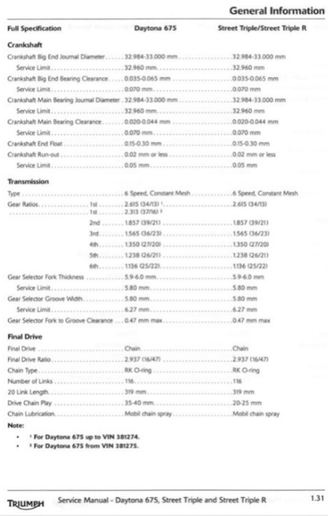
To work out the top speed (m/s): ((RPM / Gear ratio) x Tyre diameter (m) x Pi) / 60
Power = Angular Velocity x Torque
Figure 1
You can see the gear ratios of the bike in figure 1. The Final drive ratio is 2.937 (47/16). And the tyre size on the bike is 17” and the bike is about 190kg.

(MCN (2023))
Top speed & performance
Max power 128 bhp
Max torque 71 nm
Top speed 145 mph
Formula student: Tyre size 13”. A rough estimation for the formula student car is around 300kg.
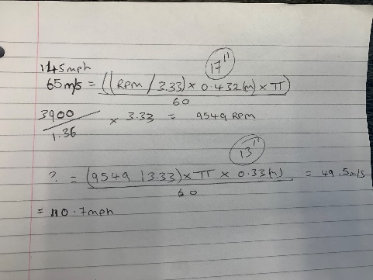
With the 13 inch wheels instead of the 17 inch wheels, that alone would reduce the top speed by about 35 mph. The formula student car is also about 110kg heavier and it will have a lot more drag and rolling resistance. However we cant reduce the gear ratio as we will still need all of this torque to be able to accelerate the car. The wheels are also smaller which would mean it can accelerate at a quicker rate. So with this into consideration its best to leave the final drive ratio at (47/16). This will give us a good baseline and then we can just put a bigger or smaller rear sprocket on after testing. This would just bolt off and on the differential and would just mean we would need to adjust the chain length.

LSD:
Limited slip differentials work by delivering the torque to the wheel with the most traction instead of the one with the least. There are 3 different types: A 1-way differential will only have a positive lock to limit slip during acceleration. A 2-way differential will limit slip during both acceleration and deceleration. A 1.5-way differential is a 2-way differential with a different lockup rate between acceleration and deceleration. (DSPORT (2015)).
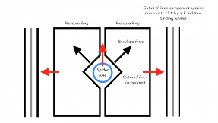
There are a few different types of LSD’s which I could choose from: (Low offset (2023) A.Mann) (Car throttle, engineering explained (2016))
- Clutch-type Limited Slip Differential is a type of LSD that uses a series of clutches to control the torque distribution between the wheels. The centrifugal force pushes the pressure rings up against the clutches. The more friction generated between them, the more torque is transferred to the drive shaft. The clutches can be engaged or disengaged based on the amount of torque being delivered to each wheel.
- Torsen / Helical differential uses gears to control the torque distribution. The gears can be locked or unlocked based on the amount of power being delivered to each wheel. Since there aren’t any clutch packs there is no way to alter the ratio. Since its all mechanical gears, they don’t need maintenance as there’s no wearing parts (e.g. clutches).
- Electronic Limited Slip Differential (eLSD): This type uses electronics to control the torque distribution. The electronics can be programmed to distribute torque based on a variety of factors, such as vehicle speed, wheel speed, and engine RPM.
- Torque vectoring differential: Its like an open differential with the pinion, ring, plant and sun gears, however, it has two separate clutch packs either side to distribute the torque using an electric motor to engage them. It is very expensive and complex.
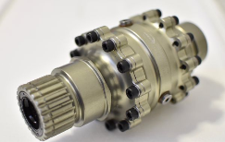
The differential that I have gone for is a Drexler adjustable preload FS differential. It is a clutch pack type differential with a sprocket attached to it so that it can be connected to the gearbox via a chain drive mechanism.
Drexler FS Differential Features: (MUR Motorsports (2017) Mr A.Giang)
- Original Version: Choice of three widths: 120mm, 140mm, or 160mm bearing distance
- Adjustable Version: Choice of two widths: 140mm and 160mm bearing distance
- Low weight: appx 2.6Kg
- Preload: Original= 20-25 Nm on delivery and ~10 Nm after run in; Adjustable=0-75Nm externally adjustable
- Includes 3 ramp settings for adjustability, making a total of 6 ramp setting options
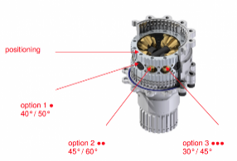
Drexler drive shafts will also be used. They slot into the differential have full articulation as well as lateral movement to allow for the hub moving closer / further away when it moves up and down.

Rear Suspension:
The rear of the car is going to use the same setup as the front, pushrod rod suspension (the spring compresses with upward movement of the wheel) with the damper and spring mount within the chassis. By using this setup, the wheel rate can be easily adjusted without changing the spring. Adjustment of wheel rate can also be altered through changing the bell crank arm length (it changes the motion ratio). Ride height can also be adjusted be changing the length of the pushrod, which is easily accessible. (VROOMO (2022)). Having a mechanism like this, instead of the Double wishbone system for example, will significantly reduce the unsprung mass of the vehicle as the weight of the coil over is now on the chassis. This will lead to better handling characteristics. Another advantage of a push rod suspension system is that it will have improved aerodynamics as the coil overs will be tucked away.
The Control Arms will be made out of Steel 4130 because its high strength, easily sourced and fairly cheap. It is also easy to work with in order to weld and bend.

Cost of materials:
- Exhaust - £500
- Oil catch can and cooler - £50 + £50
- Radiator - £100
- Chain and sprocket - £100
- Differential - £1680 (Drexler UK Distributor | Formula Student | Limited Slip Differential Supply (cmengineering.co.uk))
- Driveshafts - £500
- Hub and bearings – £1400 (Wheel Hubs - FSAE (rcvperformance.com))
- Rose bearings and steel 4130 for the suspension - £400

Chassis – Van

Introduction
The structural stability and support for the driver in the vehicle, and other aspects such as suspension and drivetrain of a formula student race car, comes from the chassis, acting as the vehicle’s foundation. Due to these reasons, the chassis is a crucial component in the design and manufacturing of a successful formula student race car, and with this comes the critical role of material selection and manufacturing decisions, to determine the performance and competitiveness of the car. The two main factors are that the chassis must be lightweight yet strong enough to withstand the different stresses acting on the car while racing. Therefore, the choice of materials and manufacturing methods used in the construction of the chassis will impact the vehicle’s speed, manoeuvrability, and overall performance. Consequently, Engineers must carefully approach the chassis’ selection and manufacturing to ensure that the final product meets the safety, performance, reliability standards and regulations necessary for successful competition. (Wright. (2001). Formula 1 technology. Society of Automotive Engineers.)

Type of chassis: spaceframe vs monocoque
The spaceframe chassis is one of two main chassis choices used in the construction of motorsport vehicles, the other being monocoque. The spaceframe chassis Is constructed from a series of tubes welded together to provide all the structural stability while attaching the suspension to the chassis itself, meaning the body panels provide no structural stability.
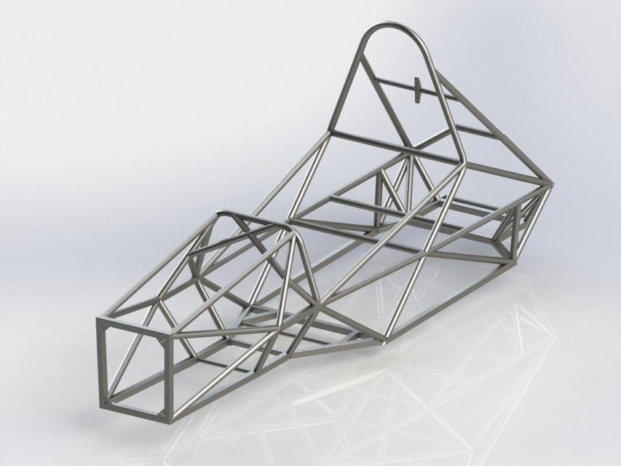
Figure ‎4.1- Spaceframe chassis

The design offers several advantages:
- The spaceframe is relatively simple to manufacture, as the manufacturer builds them using standard steel or aluminium tubing.
- It is modular, meaning individual components can be replaced or modified without replacing the entire chassis.
- It is lightweight, as the tubes used in the construction are thin and hollow.
(Brown, Robertson, A. J., & Serpento, S. T. (2002). Motor vehicle structures : concepts and fundamentals. Butterworth-Heinemann.)
However, there are also disadvantages to the spaceframe design. Due to its open lattice structure, it is not as rigid as the monocoque chassis and is, therefore, more prone to flexing and twisting. Unnecessary flexing and twisting can have a detrimental effect on handling, particularly at high speeds. In addition, the spaceframe design is less aerodynamically efficient than a monocoque due to having a less narrow shape, which can limit top speed and acceleration.
The monocoque chassis is the opposite of a spaceframe chassis, as instead of the tubular structure providing support and stability, the skin and body panels that the chassis holds together provide the necessary structural stability needed. Engineers construct Monocoque chassis from a single material, typically carbon fibre or aluminium. The monocoque design is inherently more rigid than a spaceframe due to its integral structure, which provides superior handling and stability.
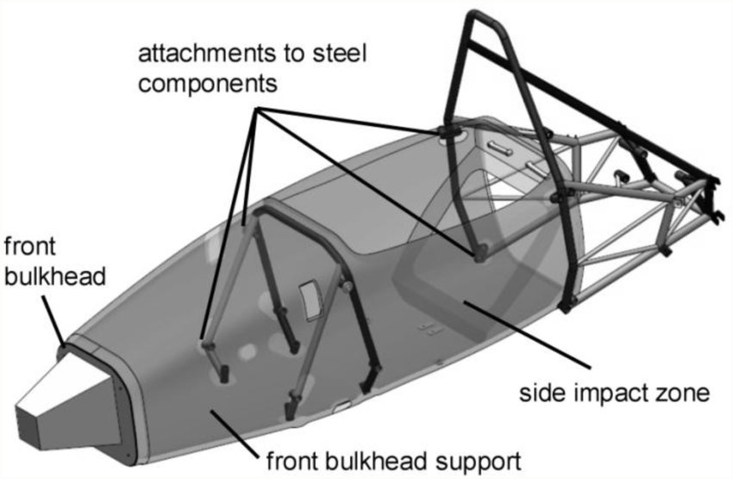
Figure ‎4.2 - Monocoque chassis with rear spaceframe
However, like the spaceframe chassis, the monocoque design has some disadvantages. It is more complex to manufacture than a spaceframe and typically requires substantially more expensive materials and manufacturing techniques (Brown, Robertson, A. J., & Serpento, S. T. (2002). Motor vehicle structures : concepts and fundamentals. Butterworth-Heinemann.). It is also less modular than a spaceframe, meaning replacing individual components is more complicated and would also result in more expenses; this is one of the main driving factors for engineers in formula students due to having smaller budgets relative to big motorsport teams who have much higher budgets.
In conclusion, while spaceframe and monocoque chassis have advantages and disadvantages, the monocoque design is generally favoured in motorsport due to its superior rigidity and aerodynamic performance. However, the choice of chassis design ultimately depends on the specific needs and requirements of the racing team. Considering the budget and experience of a formula student engineering team, the spaceframe chassis favours a minor team.

Chassis material
Aluminium is a popular material choice for motorsport chassis, especially in Formula Student racing. However, aluminium has several advantages and disadvantages:

Advantages of using aluminium:
- Lightweight: Aluminium is a lightweight material, a critical factor in motorsport. A lighter chassis means the car can accelerate faster and handle better, giving the driver an advantage over their competitors.
- High strength-to-weight ratio: Aluminium has a high strength-to-weight ratio, which means it is strong enough to withstand the stresses of racing while still being lightweight.
- Good stiffness: Aluminium has good stiffness, which means it can provide a rigid structure for the car without being too heavy.
- Good corrosion resistance: Aluminium is highly resistant to corrosion, which means it can withstand exposure to the elements without deteriorating. This is particularly important in racing, as the cars are often exposed to harsh conditions.
- Good thermal conductivity: Aluminium has high thermal conductivity, so it can quickly dissipate heat. This is important in racing, as the engines can get very hot and must be cooled quickly.

Disadvantages of using aluminium:
- Low ductility: Aluminium has a lower ductility than other materials, such as steel, which means that it is less able to deform without breaking. This can be a disadvantage in the event of a crash, as the chassis may not absorb the impact and other materials.
- Expensive: Aluminium is more expensive than other materials, such as steel, making it difficult for student racing teams with limited budgets.
- Challenging to weld: Aluminium is more difficult to weld than other materials, which can increase the complexity of chassis manufacturing.
- Susceptible to fatigue: Aluminium can be susceptible to fatigue, which can crack and fail over time. This can be a disadvantage in motorsport, as the chassis must withstand high stresses over an extended period.
(Milliken. (2003). Race car vehicle dynamics : problems, answers and experiments. SAE International)
Steel is another common material used in motorsport chassis, with several advantages and disadvantages.

Advantages of using steel:
- High strength: Steel is very strong, making it ideal for motorsport use. A steel chassis can withstand high stresses without deforming or breaking.
- High ductility: Steel has high ductility, meaning it can absorb much energy before breaking. This makes it a good material for crash protection.
- Accessible to weld: Steel is easier to weld than other materials, such as aluminium, making it easier to manufacture a chassis.
- Low cost: Steel is generally cheaper than other materials, such as carbon fibre, which can make it more accessible for student racing teams on a budget.
- Availability: Steel is widely available, which makes it easier to source and manufacture than other materials.

Disadvantages of using steel:
- Heavy: Steel is heavy, making the car slower and less manoeuvrable than lighter materials.
- Susceptible to corrosion: Steel is susceptible to corrosion, which means it needs to be adequately protected or coated to prevent rust.
- Poor thermal conductivity: Steel has a low thermal conductivity, meaning it is less effective at dissipating heat than other materials.
- Fatigue: Steel can be susceptible to fatigue, which means it can crack and fail over time if subjected to repeated stresses.
(Reimpell, Stoll, H., & Betzler, J. W. (2001). The automotive chassis : engineering principles : chassis and vehicle overall, wheel suspensions and types of drive, axle kinematics and elastokinematics, steering, springing, tyres, construction and calculations advice (2nd ed.). Butterworth Heinemann.)
Both materials have pros and cons when choosing steel and aluminium for a motorsport chassis, as listed above. However, steel seems more beneficial overall due to its higher strength, lower cost, and easier welding.
The main deciding factor in choosing materials is their bending load and comparing both. For example, the following table shows the results of an aluminium rod and a steel rod fixed on one end while weight is added to the other end and has the bending displacement measured for each increase in weight:
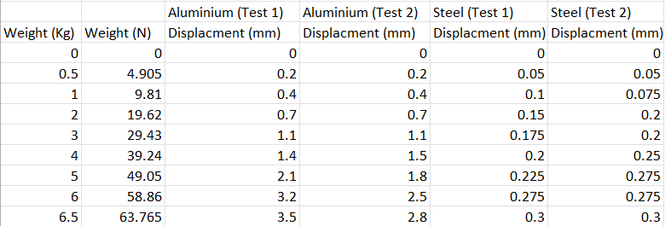
Figure ‎4.3- Real test data for rod bending
As figure above shows, aluminium bends much more significantly than steel, as the final displacement for steel is still less than the second weight for aluminium, showing the significant strength difference between the two materials. The main factor in deciding a material for the chassis is its resistance to bending; therefore, this test justifies the decision to construct the chassis from steel; however, student formula regulations require minimum and maximum properties of the chosen steel to be met for it to pass inspection. The specific regulations for chassis materials require that the chosen steel be unalloyed carbon steel, with a maximum carbon content of 0.3%, 1.7% manganese, and 0.6% of any other elements. The chosen material must also have the following minimum physical properties:
- Young’s modulus = 200GPa
- Yield strength = 305GPa
- Ultimate Yield strength = 365GPa
- Area/Moment of Inertia = 6695mm⁴
(Formula Student rules 2023, Imeche.org, fsuk-2023-rules---v1-1-(released-version---dec-22)7f18038e54216d0c8310ff0100d05193.pdf (imeche.org))
The chassis must meet these requirements to withstand the stresses of racing. The Young modulus is a measure of how stiff the material is, meaning its resistance to deformation, such as stretching or compression, making young’s modulus very important for the chassis; the stiffness will help maintain stability and control over the vehicle, especially while turning and crossing uneven road surfaces. So, the higher young’s modulus, the less likely it is to deform. Yield strength, however, measures how much stress a material can undergo before it begins to cause any deformation, determining the point at which the material and chassis will experience failure or fatigue. Similarly, Ultimate yield strength will determine how much stress the material/chassis can undergo before significant/permanent deformation is caused, resulting in breaking or fracturing, making it one of the essential requirements for the safety of the driver. The area/moment of inertia is the measure of the resistance of a material to bending under a load. Similarly, to young’s modulus, this determines the stiffness of the material and chassis, specifically its resistance to bending and torsion.
There are many types/grades of steel; however, the most considered type of steel used for chassis’, especially by formula student teams T45 steel:
T45 is a specific type of aerospace-grade steel often used to construct high-performance motorsport components, including roll cages and chassis. It has excellent strength and toughness properties, making it a popular choice for applications that require high levels of durability and resistance to impact. T45 is a stainless-steel alloy, known for its use in the aerospace department due to its ability to withstand high G forces without deforming (Smiths metal, T45 Steel | T45 Steel Tube (smithmetal.com)). T45 is also used in the current UWTSD MCR chassis, providing support that not only can t45 steel be used in motorsport applications and withstand motorsport racing forces and stresses. As previously mentioned, testing was done in the workshop to provide accurate data results figure 21 for the effect of bending on aluminium and steel. The steel rod used in the test was t45 steel.
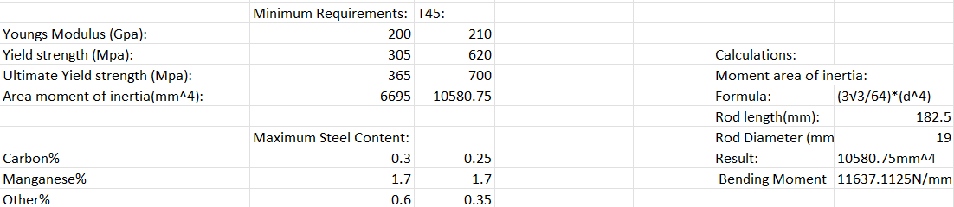
Figure ‎4.4- Properties of t45 compared to minimum/maximum property regulations and calculations
As shown above in figure above, T45 steel is well within the minimum requirement for young’s modulus, yield strength, ultimate yield strength, and moment of inertia. The moment of inertia was calculated by measuring the two parallel sides on the end of the hexagonal rod and replacing it in the formula; the rest of the data are typical values found for this specific material. (Carbon Manganese Steel Tube T45 (smithmetal.com)) (Dietsche, & Reif, K. (2018). Automotive handbook (10th edition, revised and extended.). Robert Bosch GmbH.). Figure 22 Also shows calculation done for the bending moment, by multiplying the mum load tested by the distance of the load from the fixed point. (Twigg. (1996). Science for motor vehicle engineers. Arnold.)
To show the effect of the bending on the steel rod, a solid works simulation was also made on a similar type of steel to show where the stresses act on the rod with the maximum force that was measured in the workshop experiment (63.765N), however, due to the properties being slightly different, the actual results of how much stress and strain is acting on the rod is not accurate to T45 steel.
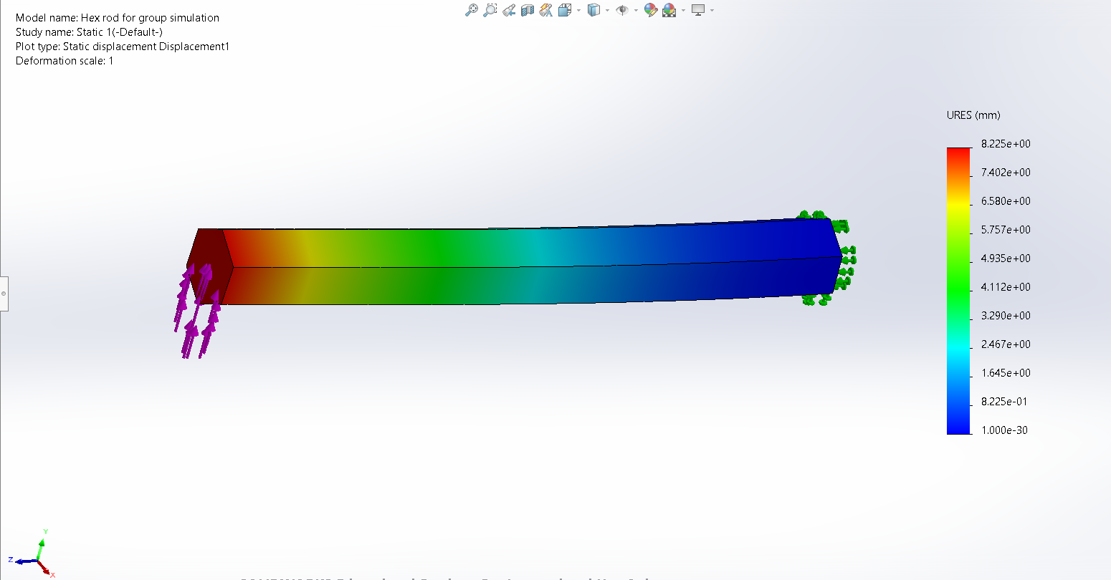
Figure ‎4.5- The displacement along a rod of 4130 steel
The figure above shows the displacement along the rod of the same shape and size as the rod used in the experiment. As shown in the simulation, on the fixed end (dark blue/right end), there is little to no displacement, however as it goes along the road towards the left end, the displacement begins to increase drastically in the centre until it reaches its max displacement (Red) when the force is being applied. The maximum displacement on the rod is 8.225e+00, which is equal to 8.225mm, which is significantly more than the steel measured in the workshop; however, the steel used in the simulation, 4130, has been known to be used in motorsport chassis in the past (The History of 4130 Cold Drawn Seamless Round Tube - A.E.D. Metal Products (aedmetals.com)), whereas the steel tested in the workshop had a maximum displacement of 0.3mm.
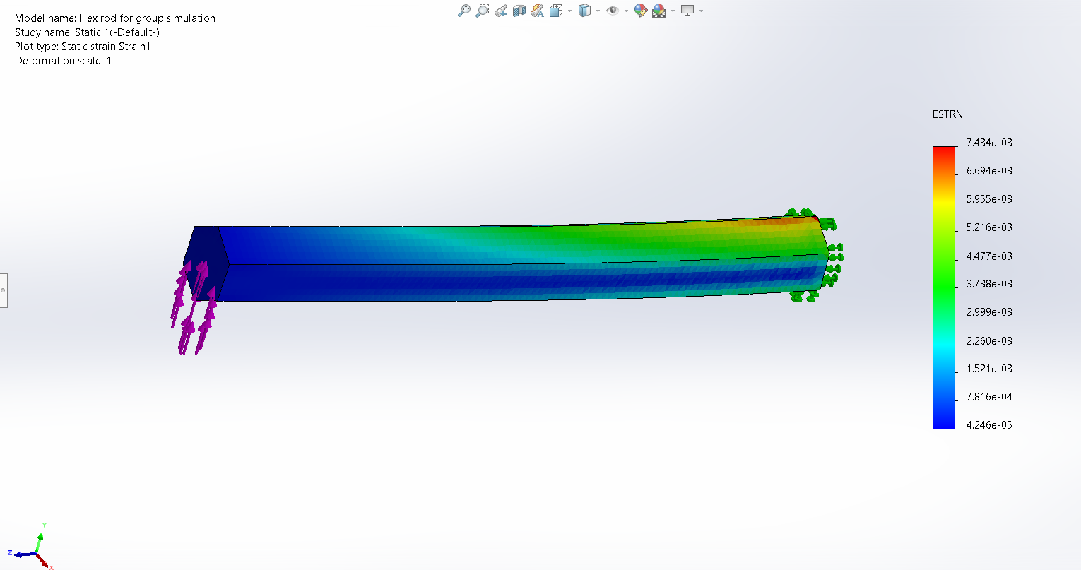
Figure ‎4.6- the strain measured along a rod of 4130 steel
As seen in the figure above, the strain pattern along the rod increases towards the fixed end, in the direction of the force (on the upside of the ride) where the material is being compressed. The material is being stretched and pulled toward the underside of the rod near the fixed end.
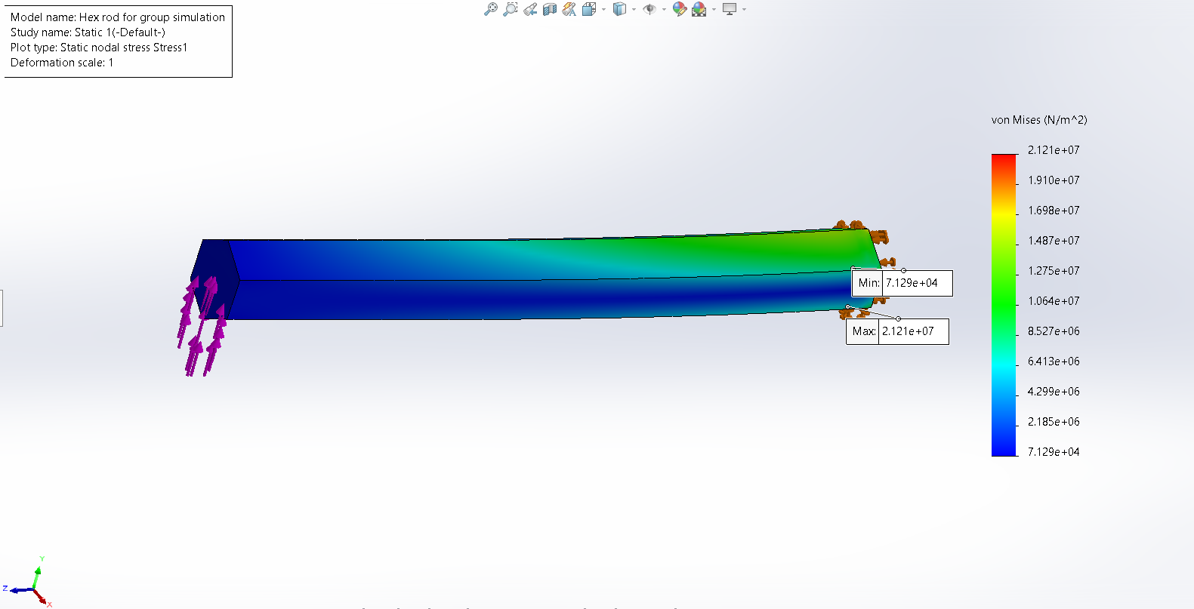
Figure ‎4.7- the stress measured in a rod of 4130 steel
Similarly, to figure showing the strain, the pattern seen in figure above shows an increase in deformation on the upside and underside towards the fixed end, showing where the limits of the steel are being tested under the same force as seen in the actual experiment.

Chassis Construction
A simple motorsport steel tubular spaceframe chassis can be constructed using various welding methods, including MIG (Metal Inert Gas) and TIG (Tungsten Inert Gas) welding.
MIG welding is a faster and easier welding method than TIG welding. This can be advantageous when constructing a simple motorsport chassis, allowing for a faster build time and can heavily benefit engineers when a chassis needs quick repairs, making it ideal for a formula student team. The fast-welding speed can also reduce the heat input into the materials (informed by workshop technicians), minimising distortion and warping of the chassis and body, which is essential for a small team with smaller budgets than big teams. Hence, there is unnecessary spending on new pieces of a body. Additionally, MIG welding produces strong welds with good mechanical properties, making them suitable for chassis construction. (Welding headquarters, What Is MIG Welding – Understanding It Thoroughly - Welding Headquarters)
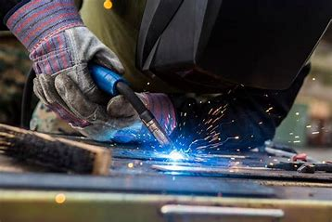
Figure ‎4.8- MIG welding

However, MIG welding also has some disadvantages. The process requires the use of a shielding gas, which can be expensive and may produce harmful fumes. MIG welding may also produce a larger heat-affected zone than TIG welding, which can affect the strength and integrity of the welded joints. This is particularly important in motorsport applications where the chassis may experience high loads and stresses as previously discussed. (Finch. (1997). Welder’s handbook : a complete guide to MIG, TIG, ARC & oxyacetylene welding ([2nd ed.], Completely rev. and updated ed.). HPBooks)
TIG welding, on the other hand, is a slower and more precise welding method. This allows for greater control over the welding process, producing high-quality welds with minimal distortion; however, due to being a slower task, the increased time results in TIG welding being more expensive than MIG welding. TIG welding also produces a smaller heat-affected zone compared to MIG welding, which can result in stronger and more durable welded joints. For this reason, TIG welding is often preferred in motorsport applications where precision and strength are critical, however unhelpful for quick welds.
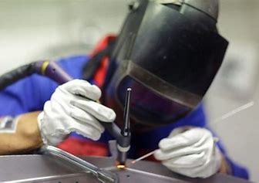
Figure ‎4.9- TIG welding
However, TIG welding also has some disadvantages. The process is more challenging and requires a higher skill level than MIG welding. This can increase the time and cost of constructing a motorsport chassis. Additionally, TIG welding may not be suitable for welding thicker materials or for larger-scale production due to its slow speed. (What is TIG Welding? | Advantages & Disadvantages (protigwelders.com))

Conclusion
After evaluating real data and simulation, the material the team decided upon was T45 steel, for its necessary physical properties that are well within the regulations and provide wider limits for the other departments to use heavier and faster equipment, as the material of the chassis can handle. The chassis will be made by welding the tubes together by MIG welding most of the chassis, and TIG welding near the hoops and cockpit of the chassis for driver safety.

Chassis Design - Bleddyn

Concept Phase
The aim of this department is to consider the aims of the team as well as the challenges that vehicle design will have to overcome in order to reach the optimum performance during the maiden year. Since there is no chassis predecessor to analyse and improve upon generalisation and predictions of mass, dynamics, component packaging and chassis rigidity will be taken to begin this project. As the group graduates its conception stage, more accurate figures and estimation of these challenges can be made. During this phase alterations to chassis are constant, and the performance gains significant. this is expected to change as the project develops and the performance gains become marginal but still significant in order to maximise performance.

Chassis Mk 1
Below is the first iteration of the vehicle chassis. This has taken the chassis selection by the material department of a steel space frame and became to localise loads, mass, and areas of rigidity in order to sustain performance under the predicted vehicle dynamics. Initially the chassis has a ground clearance of 50 mm and regulation minimum wheelbase of 1525mm. Since the majority of the loads the vehicle will experience is around corners and less so in a straight line, it is logical to have as small a wheelbase as possible to increase responsiveness in these conditions. The department used the general rule of Track Width = Wheelbase/1.2-1.5 to plot the initial track width. Since the goal was to make this vehicle as responsive as possible during cornering, a larger track width at the front in comparison to the rear was the desired approach to trackwidth design. The initial difference in length was present but minimal initially with the intention to alter this as more data became present during development. This estimation was made following research of previous competing vehicles with differences in length ranging from 20 to 50mm. Since the foundation of wheelbase and track width are established, preliminary suspension mounts and geometry can be defined as shown in figure.
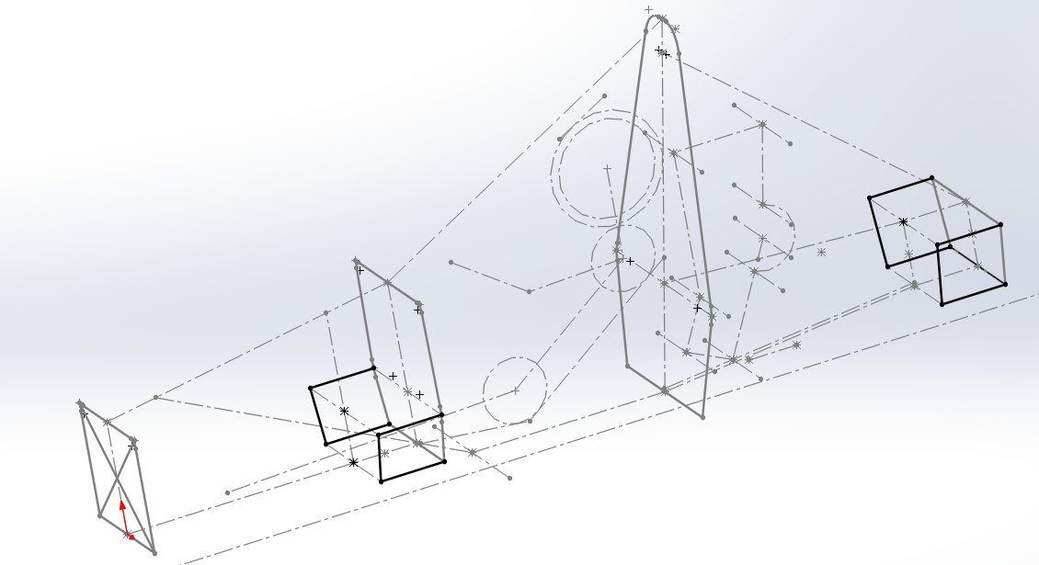
Figure ‎5.1 - Initial location of suspension mounts
These initial dimensions allow the design team to introduce a floor as well as ‘Percy’ to establish a ground clearance and initial design of chassis hoops that satisfy the IMECHI regulations.

The initial main hoop approach as to satisfy the regulations that state the clearance of 50mm from the top of the drivers helmet to the top of the main hoop as well as the main hoop being made up of one continuous piece of material. This would require the ,ain hoop to be designed with realistic bends as well as a thickness to meet the regulatory young’s modulus without triangulation of nodes. The initial design of the front bulkhead was to satisfy the regulatory dimensions of the impact actuator At least 100mm high and 200mm wide for a minimum distance of 200mm forward of the front bulkhead (IMECHI,2022), long enough to encase the drivers lower body while maintaining a level of comfortability, clearance for a pedal box as well as a basic aerodynamic profile (a smooth increase in frontal area). The next dimension to be established was the between the front bulkhead hoop and the main hoop, since ‘Percy’ had been introduces, this would be a simple dimension to plot since the consideration of the steering wheel and the room for manoeuvre the driver would need inside what would be the cockpit. The decision on width of the cockpit would also be determined by the area need for the driver to enter and exit the vehicle within a required time and effort. Therefore the last longitudinal dimension to establish would be between the main hoop and rear of the vehicle. This is expected to be a more dynamic dimension with changes due to be regular as packaging of vehicle components begin. However, adjustments must be vigilant as too much length will result in a larger wheelbase and deviation of the initial chassis design aims of achieving as small a wheelbase as possible. The lateral dimension of the rear of the vehicle are mostly established by the preliminary trackwidth, however, this may be impacted depending on the orientation of the engine and other powertrain components.
Since the boundaries of the vehicle are established, nodes and tubing can now be conceptualised. The front bulkhead (FBH) tubes are typically smaller than those found in the hoops and the supporting tubing smaller again. This would give great opportunity to shave some mass and reduce the overall mass of the vehicle as the development stage progresses and a more accurate representation of load and torsional stresses are established. Design of the side impact structure is very much governed by the regulations as shown below. As shown in the figure below the chassis satisfy those regulations.
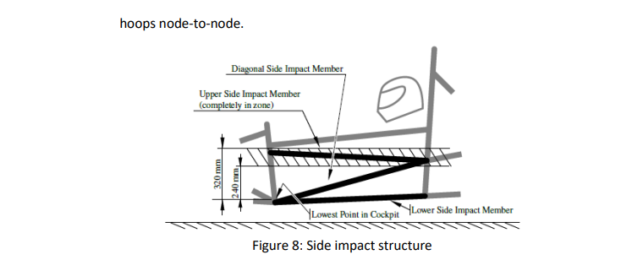
Figure ‎5.2 - Formula Student Regulations
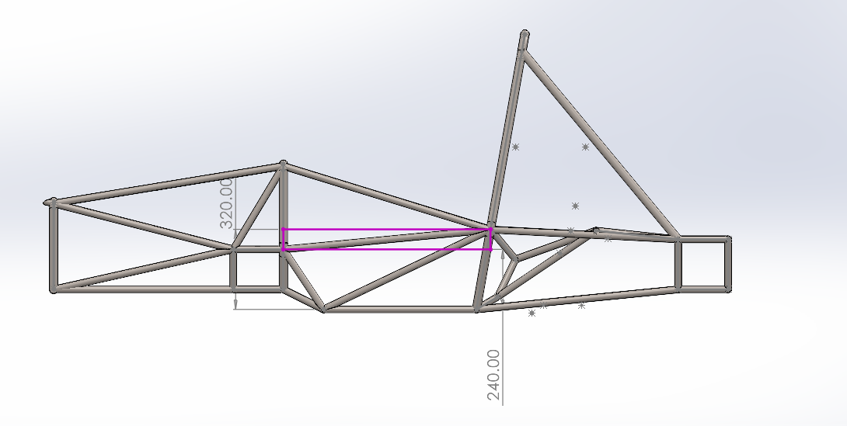
Figure ‎5.3 - Side impact structure dimensions
Therefore, the cockpit tubing is established first, then the FBH since there is the Impact Actuator having some ruling over the dimensions and finally the rear of the vehicle. Similarly to the geometry of the rear, the material and stiffness is subject to regular change later in the project with the introduction of differentials and drivetrain components. To counter the extra mass expected at the rear and subsequential impact to the vehicle dynamics the engine will be used as a stress member, bolted to support tubing attached to the main hoop. This will greatly increase the torsional rigidity of the chassis and lead to a noticeable increase in performance.
Following the decision by the materials department to use Steel 4130 an estimation of Cog, mass distribution and downforce distribution can be established to begin vehicle simulation.

Chassis FEA
Crash Worthiness is essential when designing a vehicle to compete at any level to ensure the safety of the driver as well as appropriate engineering methods are used when designing he vehicles chassis. To evaluate the crashworthiness of the vehicle Finite Element Analysis (FEA) was used to ensure the vehicle meets the standard set by the regulation as well as a factor of safety. FEA was carried out focusing on frontal impact, side impact, rear impact as well as the torsional stiffness of the chassis when experiencing bump on the front and rear suspension.

FEA – Front Impact
During the FEA parameters were set as if the vehicle was travelling at 540m/s² which is the top speed typically of a formula student car and is decelerating within 0.5milliseconds. this simulates the vehicle travelling at top speed then making impact with a barrier causing the vehicle to stop on impact. Results of this FEA are shown below.
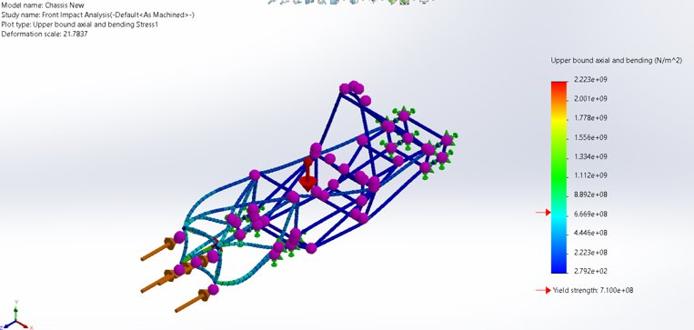
Figure ‎5.4 - FEA (Front Impact)
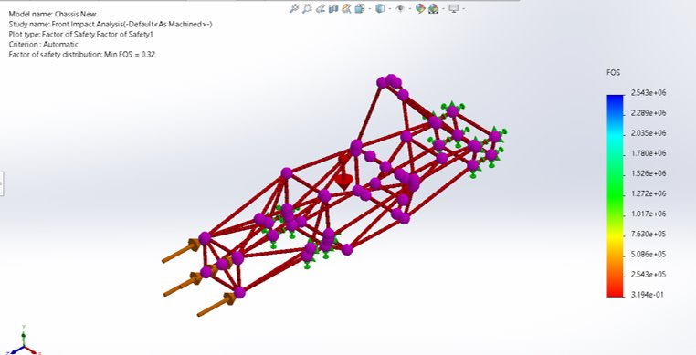
Figure ‎5.5 - Front Impact FOS
Clearly the vehicle achieves the young’s modulus required in the Imechi Regulations as well as the factor of safety chose by the chassis design department of 0.3.

FEA – Side Impact
Simulation of side impact was also important to prevent intrusion to the cockpit from the side of the vehicle, the force exerted was 1000N as shown in the figure below.
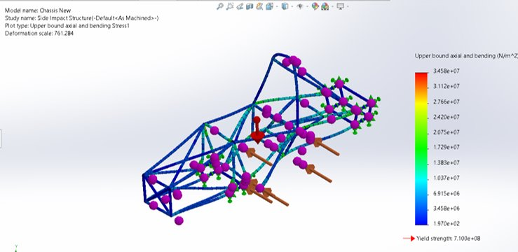
Figure ‎5.6 - FEA (Side Impact)
The highest amount of stress clearly is located at the main hoop; therefore, subsequent bracing could have been considered but as the figure below shows, the factor of safety is 21. Therefore, this chassis is capable of withstanding high loads without additional bracing.
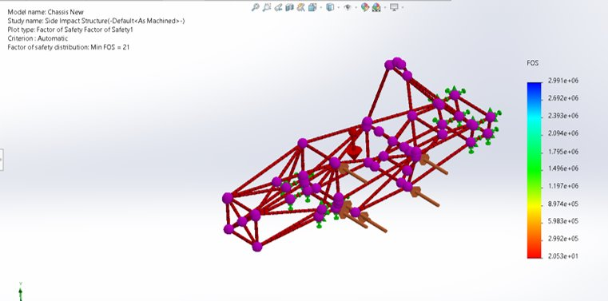
Figure ‎5.7 - FEA Side Impact (FOS)

Finally, the torsional rigidity of this vehicle was also sufficient and compliant with the regulations, the highest point of stress occurring in both scenarios at the top of the main hoop, a greater level of stress located there during torsion at the rear which is to be expected.

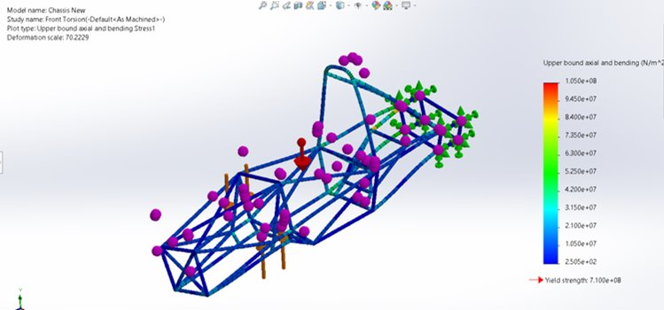
Figure ‎5.8 - FEA - Front Torsion
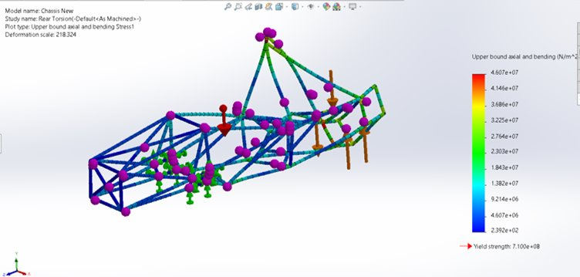
Figure ‎5.9 - FEA - Rear Torsion

Wheels and Tyres - Jared
Tyres and wheels are critical components of a vehicle's safety and performance. Tyres provide the necessary traction and handling, and their design is optimized for various purposes, such as racing tyres for dry and wet conditions. (Nationwide Vehicle Contracts, n.d.). The wheel choice of wheel can affect the cars handling characteristics on track, with smaller wheels limiting braking performance and larger wheels having a larger rotational inertia resulting in more energy to be transferred under braking. Although the use of larger wheels will unfortunately lead to higher braking temperatures. As the tyres are the only part of the vehicle in contact with the road, tyres and wheels play a crucial role in the vehicle's performance. By utilizing a larger contact patch and correct pressures in the tyres, the vehicles will be able to achieve the fastest time possible on track.

Wheel and Tyre Selection.
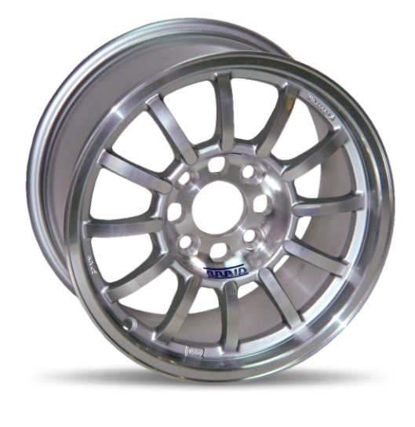
When deciding on a wheel and tyre setup, it is important to select appropriate wheels and tyres for the vehicle. The Winrace FSAE 13x7 aluminium wheel is chosen for its lightweight construction and high load rating of 600 kg, additionally, the 13x7 size provides an appropriate balance between grip and acceleration while allowing for a wider tyre contact patch as well as the wheel is made of forged aluminium, which makes it lightweight while maintaining high strength. (BRAID, 2016). For the best performance, selecting the appropriate tyre is a vital initial design consideration, with numerous size and compound options to choose from. Performance should be prioritized without sacrificing driveability, as the driver should feel confident and consistently achieve peak performance. (Jonathan Vogel, n.d.)
Figure ‎6.1 - BRAID Aluminium Wheel (BRAID, 2016)

Avon tyres are a good choice for a formula student vehicle due to their high grip levels, durability, and competitive pricing in comparison to other brands. Avon Tyres supply a range of tyres for formula student vehicles. They also supply a detailed tyre data package that includes spring rates, cornering force and self-aligning torque data. This data is shown below in section ‘Tyre Data’.

Wheel and Tyre Size Benefits.
A 7-inch wheel size compared to an 8-inch wheel size offers several benefits. The chosen wheel from BRAID features a 12 spoke design, which provides excellent rigidity and allows for efficient brake cooling. Due to the thicker and stronger design due to the 12 spoke design, the wheel is stiffer, which results in improved handling and reducing flex during hard cornering. (www.sheldonbrown.com, n.d.).
Lower Weight: The 13-inch wheel size offers several benefits. To start, wheel weighs only 3.85 kg which is relatively lightweight compared to other wheels available for formula student. Secondly, by using 13-inch wheels instead of 10-inch wheels, there will be more internal space for housing suspension or brake components. Although 10-inch wheels have a lower rotational inertia, the larger contact patch from the 13-inch wheels will improve handling and cornering. Also, the 7-inch wheel size is lighter than the 8-inch wheel size, reducing the unsprung mass and improving the vehicles acceleration and handling. Also, the BRAID wheel has a high load rating of 500 kg, meaning it can safely support the weight of the vehicle. (www.tyrebuyer.com, n.d.)
Improved Aerodynamics: A smaller tyre profile can reduce drag which means the vehicle can achieve a faster top speed. By using a smaller tyre less drag would be created as it moves through the air, which can reduce the overall aerodynamic drag of the vehicle. By using 13-inch wheels there are also many aerodynamic benefits. The smaller diameter of 13-inch wheels compared to larger sizes can help reduce aerodynamic drag. This is because the smaller wheels create less surface area for air to interact with, resulting in less turbulence and drag. (published, 2017)
Better Heat Management: The smaller tyre profile leads to less tyre-generated heat, which can be helpful in track-based driving conditions. The smaller size of the tyre can also help in dissipating heat more efficiently which will lead to a more balanced tyre temperature. This energy loss is stored in the tyre as heat and is commonly referred to as hysteresis loss or strain energy loss, as shown below. This happens when a viscoelastic material, like rubber in tyres, is compressed and then allowed to relax it accumulates more energy during the compression process than it releases during relaxation. (Holloway. C, n.d.)

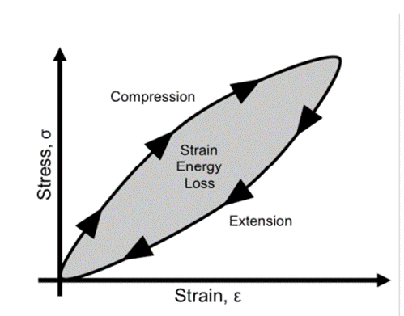
Figure ‎6.2 - Rubber (viscoelastic) stress-strain hysteresis. (Holloway. C. n.d.)

Cost-effectiveness: The Avon tyre and BRAID wheel is competitively priced and offers excellent value for money. This is important as we’re operating with a strict budget.
Smaller contact patch = lower braking force according to F = μN (where F is braking force, μ is coefficient of friction, and N is normal force). For instance, four 13-inch wheels with even weight distribution have a normal force of about 50 N (200 kg divided by 4 wheels = 50 kg per wheel), while four 18-inch wheels have a normal force of around 67 N. (courses.lumenlearning.com, n.d.) so smaller wheels can offer better acceleration and manoeuvrability due to their lower rotational inertia, but this does sacrifice the larger contact patch of the bigger wheels.

Tyre Data.
Tyre: | FSAE | Pressure | Camber (°)
Spec: | 14254S | Pressure | 0.0 | 0.5 | 1.0 | 1.5 | 2.0 | 2.5 | 3.0 | 3.5
Size: | 7.2/20.0-13 | 17psi | 173.07 | 180.78 | 174.92 | 166.84 | 166.16 | 163.35 | 156.27 | 155.13
Rim: | 7.0J x 13" | 19psi | 187.17 | 181.36 | 183.49 | 177.25 | 177.18 | 172.13 | 164.07 | 165.46
 |  | 21psi | 189.49 | 200.38 | 189.96 | 188.16 | 185.39 | 180.93 | 177.43 | 161.02
 |  | 23psi | 192.3 | 193.77 | 193.62 | 193.01 | 186.34 | 182.6 | 179.23 | 175.62
 |  |  | Spring Rate N/m
Table 5 - Spring rate measured with different camber and tyre pressures (www.avontyres.com, n.d.).

The above table displays various results of spring rate with different camber and tyre pressure combinations.
With increased camber at 2 degrees this reduces the contact patch, so to counteract that 19psi will be ran in the tyres. 19psi is a relatively low pressure that can help to improve grip and traction by increasing the contact patch between the tyre and the road surface. However, it's important to note that excessive camber can cause uneven tyre wear and reduce straight-line stability so it’s important that a sensible amount of camber is used. (Stevens, 2020).

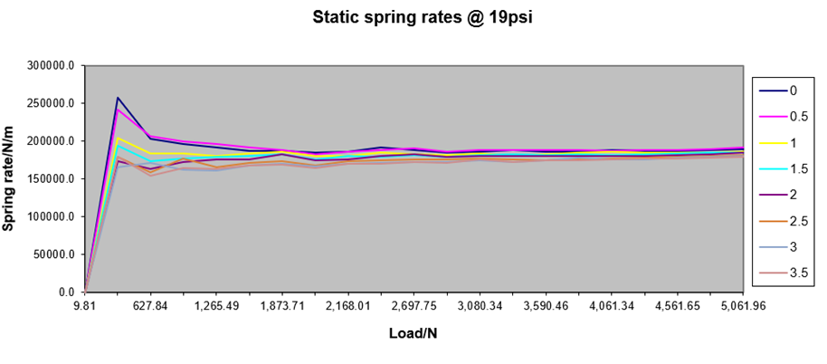
Figure ‎6.3 - Tyre static spring rates graph

This graph shows the static spring rates at 19psi with various degrees of camber, between 0 degrees and -3.5. from the graph it is evident that if the car were to run between 0 and -0.5 degrees of camber it would slightly increase the spring rate. Having a higher spring rate due to running this amount of camber would result in negative effects, such as increased vibration, which can be uncomfortable for the driver, this may also deteriorate parts faster over time. (Deo et al., 2007). Running more positive camber can also indirectly affect the tyre's spring rate by increasing the amount of contact patch with the road during cornering. This increased contact patch generates more cornering forces, which can compress the tyre's sidewall and tread, leading to an increase in the effective spring rate of the tyre. (Heisler, 2002)
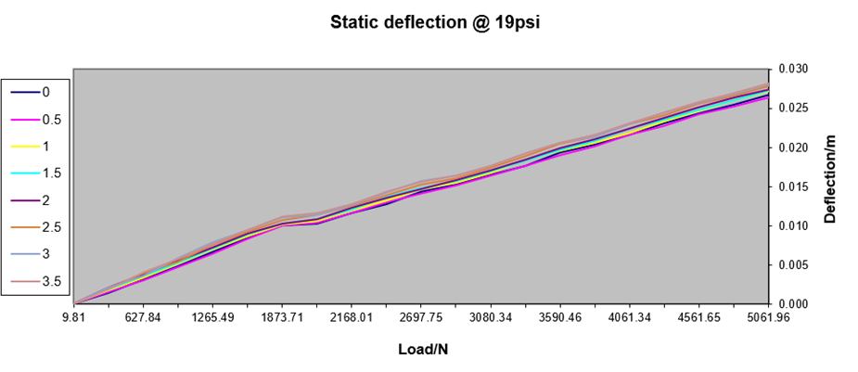
Figure ‎6.4 - Tyre static deflection graph (www.avontyres.com)
The graph above shows the static deflection at 19psi. evidently there’s not much change in deflection across increased loads using different camber setups. This is ideal because if a different camber setup is run later there will be no need to worry about increased deflection. At -2.5 degrees of negative camber the static deflection is higher in comparison to other degrees of camber although this will be with -1.5mm of different degrees of camber.
The amount of vertical load or compression that a tyre experiences when it is placed under a weight while not in motion is known as the static deflection. When the tyre experiences this it will compress and deform. (Gao et al., 2021)

Braking System - Jared
The braking system to be used will be an outboard braking setup. An Outboard braking system is a type of braking system where the brake calipers and rotors are mounted outside of the wheel hub and axle assembly. This type of braking system is simple and inexpensive to manufacture and maintain, hence why it is an ideal setup for the formula student vehicles. (Prajapati, S., & Kumar, A. 2019). Additionally, outboard braking systems can be easily accessed for maintenance and repair, which can be handy when it comes to replacing components when the vehicle is pitted.
The formula student competition regulations have rules regarding the braking system and stopping distance. These state that the vehicle must be able to come to a complete stop from a speed of 60 km/h (37 mph) within 18 meters (59 feet) on a dry surface. although, teams are encouraged to aim for a shorter stopping distance if possible. (Formula Student Rules 2022, n.d.)

5.1 Components.
AP racing will be used as the supplier for parts, by doing this it is more likely that the parts will fit together without running into issues with fitment by trying to make parts fit from different companies. The following parts are being used from AP racing:
- Discs – Grooved discs will be used as they have various advantages over drilled discs, including increased durability, longer lifespan, and improved brake performance which is ideal for the formula student vehicle. The grooves in the brake discs will also help to keep the brake pad surface clean and increase the number of brake faces. These brake faces are the leading edges of the grooves. This results higher braking efficiency braking and reduced wear on the brake pads. (apracing.com, n.d.)

- Pads – CP2195 pads will be used as they’re a direct fit for CP3696 Calipers. These pads are made from a mintex organic material, this organic material is a type of friction material used in brake pads. It is made from a blend of organic materials, such as rubber, Kevlar, and other fibres, mixed with resin and other binders. these pads also feature a high thermal stability, which means that they can withstand the high temperatures generated during hard braking without losing their braking performance. These pads also have an average friction Mµ of 0.32, which shows it can provide necessary stopping power. (apracing.com, n.d.).

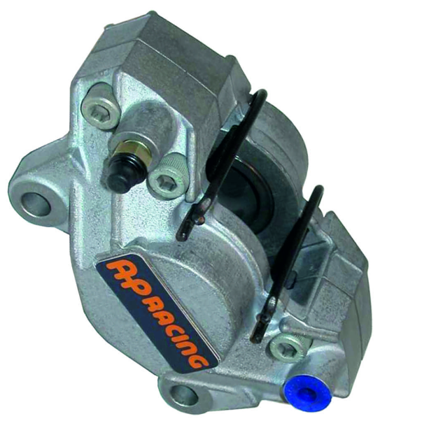
- Calipers – CP3696 Calipers will be used. This caliper is mounted by its lugs and features two pistons with a diameter of 41.3mm providing adequate braking force without adding unnecessary weight. It has a weight of 0.8kg and can run on disc sizes ranging from 240mm to 320mm. Compared to other brake calipers available from AP Racing, the CP3696 is mounted by its lugs rather than bolts, providing more secure and accurate installation and minimizes caliper. (apracing.com, n.d.)
Figure ‎7.1 - AP Racing Aluminium Lug Mount Caliper-CP3696-6E0.

- Fluid Reservoir – The small diameter plastic reservoir with central outlet is a lightweight reservoir supplied by AP racing. A benefit of this is that the small central outlet will improve fluid flow and prevent air bubbles, resulting in better braking performance as well as direct fitment to the master cylinder, removing the need for additional fittings or adapters, which would increase the cost. this reservoir will be used because the vehicle will have a small amount of pad wear meaning a large reservoir is not required. (Ltd, n.d.)
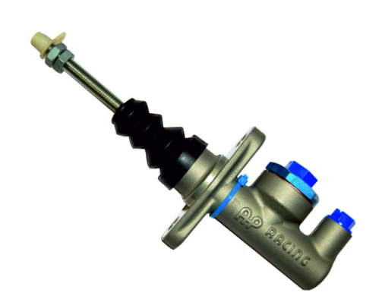
- Master Cylinder – The CP2623 is the best choice of master cylinder, in comparison to others available. this master cylinder is designed to be used with AP Racing's range of reservoirs, which is useful when it comes to the fitting location of the reservoir and results in more consistent brake pedal feel. This master is made from forged aluminium and cylinder features a hard anodized finish making it strong and resistant to corrosion. Another benefit of this master cylinder is that it has an adjustable pushrod which means it can be fine-tuned for ideal brake pedal feel as well as a precise setup. (apracing.com, n.d.)
Figure ‎7.2 - AP Racing CP2623 Forged Aluminium Master Cylinder (apracing.com, n.d.)

Braking Calculations.
To determine the braking details, calculations have been made within excel for the desired braking system.
Table 6 - Braking calculation table
Parameters | Calculations | Results
Weight kg | / | 200
Speed (kph) | / | 60
Speed m/s | / | 16.7
Kinetic Energy (MJ) | (0.5 * weight (kg) * velocity^2) / 1000000 | 0.03
Initial Velocity (m/s) | 60 (km/h) * 0.277778 | 16.66668
Final Velocity (m/s) | / | 0
Deceleration (m/s^2) | 1.4 (Tyre CoF) * 9.81 | 13.734
Stopping Distance (m) | (Initial Velocity) ^2/(2*Deceleration) | 10.11279388
Brake Force (N) | Deceleration * Vehicle Mass * Tyre CoF | 3845.52
Normal Force (N) | Vehicle Mass * 9.81 | 1962
Brake Torque (Nm) | Brake Rotor Diameter * Braking system Pressure | 34.72
Brake Rotor Diameter (m) | / | 0.248
Braking system Pressure (N/m^2) | / | 140
Wheel Diameter (m) | / | 0.3302
Wheel Circumference (m) | PI * Wheel Diameter | 1.037353894
Brake Rotor Circumference (m) | PI * Brake Rotor Diameter | 0.779114978
Wheel to Brake Rotor Ratio | Wheel Circumference / Brake Rotor Circumference | 0.751059964
Coefficient of Friction of Tyre | / | 1.4

The calculations above were made using the information gathered from the AP racing parts that will be used, as explained earlier. These values are important as they can show the characteristics of the braking system. They can also be used to calculate braking distance, brake force and brake torque, which are shown in graphs later.
As mentioned earlier, per regulations the vehicle must come to a complete stop in under 18 meters from 60km/h, from the results above it is evident that the vehicle comes to a complete stop at 10.1 meters, meaning this braking system is sufficient shows that it meets the requirements.
The following graphs show the characteristics of the brake system over a period of 7 minutes and 35 seconds. These graphs simulate the vehicle's performance on a theoretical track to illustrate the characteristics of the braking system. These results provide valuable information about the amount of energy dissipated through the chosen braking system.
It's a simulated track that would have a lot of turns at the start but gradually becomes more straight as time goes on. This is ideal as it is showing that the braking system is being tested under different driving conditions, which is a good way to evaluate its performance in a range driving of scenarios.

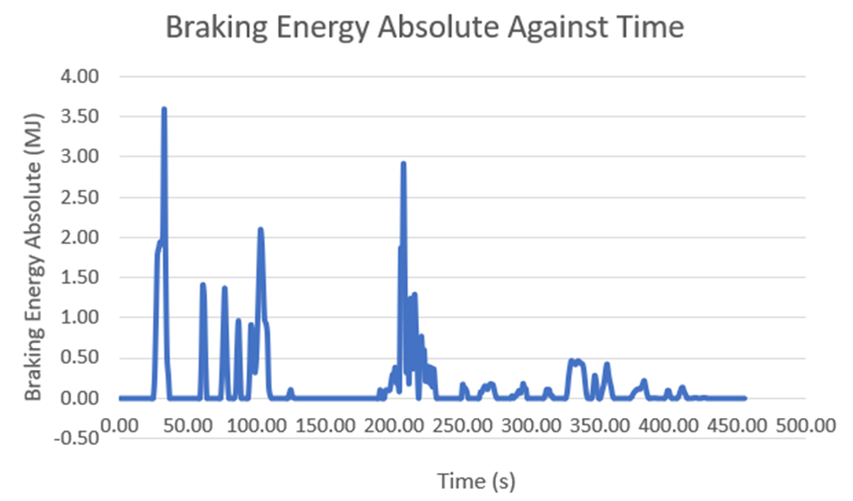
Figure ‎7.3 - Braking Energy Absolute Against Time.
The graph above displays Braking Energy Absolute against Time.
Braking Energy was calculated using the following formula:
0.5 * vehicle mass * speed^2 / 3.6^2 * deceleration over time / 9.81.
Absolute braking energy is the total amount of energy over time that is dissipated by a braking system when bringing a vehicle to a stop from a speed, without considering any energy losses due to factors such as rolling resistance, air resistance, or other external forces. (energyeducation.ca, n.d.)
It is evident from the graph that at the start of the test where speeds where higher and there were more corners, the amount of energy dissipated was higher than lower speeds. As well as another large spike around the 3-minute mark. Another factor to consider in this is that as the brakes wear down, they can become less effective at dissipating energy which results in more heat energy being lost.

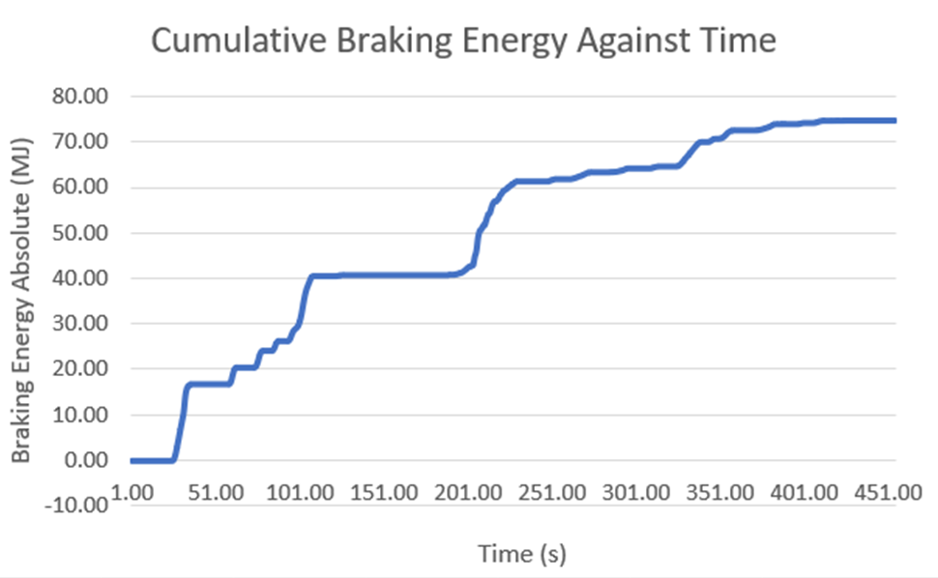
Figure ‎7.4 - Cumulative Braking Energy Against Time
The graph above display cumulative braking energy over time. This was calculated using the sum of each braking energy absolute value over the 7 minutes and 35 seconds.
This graph display shows a sharp increase in energy consumption during the first 40 to 50 seconds of testing, with a braking energy of 17 MJ reached within the first minute seconds. This initial spike in braking energy can be attributed to the high initial speeds of the vehicle, requiring greater deceleration to maintain control and bring the car down to ideal cornering speeds. As the test continues, the cumulative braking energy curve becomes more gradual, levelling off at around 75 MJ by the end of the test.
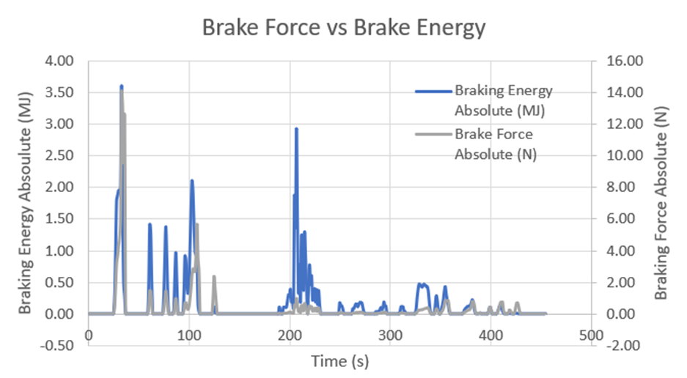
Figure ‎7.5 - Brake Force vs Brake Energy.
This graph compares brake force and brake energy.
As mentioned earlier, Braking Energy was calculated using the following formula:
0.5 * vehicle mass * speed^2 / 3.6^2 * deceleration over time / 9.81.
Braking force was calculated using the following formula:
Vehicle mass * Deceleration over time
It is evident from that graph that the first spike in the data is where the brakes were heavily applied from a high speed, from this spike we can see that the brakes weren’t applied for a long period of time, and the braking energy didn’t keep increasing.
Around 210 second in it is clear the data spikes again, this time it is the braking energy that is spiking, but the braking force is not. This shows the braking force remained relatively low and constant over that 20 second period, resulting in the brakes heating up and braking energy increasing.

Suspension - Bleddyn
During the suspension selection process there were two main candidates that had to be considered. Independent and dependent suspension systems are what is typically found on a vehicle. However, for racing applications and certainly in the formula student competitions, independent suspension systems is the preferred choice. Of these suspension systems the double wishbone assembly is the most common. This is the suspension set up that the department decided in due to its great adjustability, allowing maximisation on contact patch regardless of the vehicles mass, dimensions or tyre profile. However, to accomplish the desired geometry that would accomplish this maintenance of contact patch, usage of data and steady state models are required.

Bicycle model
The ideal approach to suspension design is to start from the contact patch, since the wheels and tyres department has decided on the use of 13’ x 7’ and the wheelbase, CG height, Distribution of mass and the assumed downforce distribution is calculated the bicycle model can be used to extract more data. From this model data regarding lateral acceleration, balance metrics, longitudinal wight transfer and slip rations can be calculated.
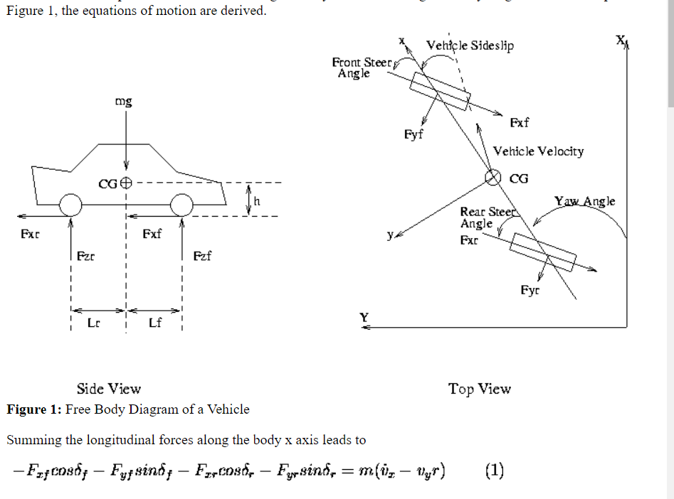
Figure ‎8.1 - Force distribution using the Bicycle method.
Following the extrapolation of data from this Bicycle method, as well as the additional inputs of suspended and non-suspended mass, the spring and tyre stiffness as well as the preliminary static camber and toe the use of the 4 wheel model is available. This model analyses the vehicle dynamics in greater detail when compared to the bicycle method. This allows data regarding lateral load transfer, roll and pitch angles as well as longitudinal and lateral acceleration to be evaluated. Following this understanding of the vehicle’s dynamics, decisions can be made regarding the correct springs and subsequent stiffness to achieve balance when under lateral load transfer. As well as this decisions regarding springs and tyres stiffness to provide the desired roll gradient.

Double A Arm Design
Following this understanding of vehicle dynamics under the initial assumptions of mass and load as week at the preliminary dimensions of wheelbase and track, CAD modelling of the upper and lower wishbones can begin to achieve maximum contact patch under these conditions.
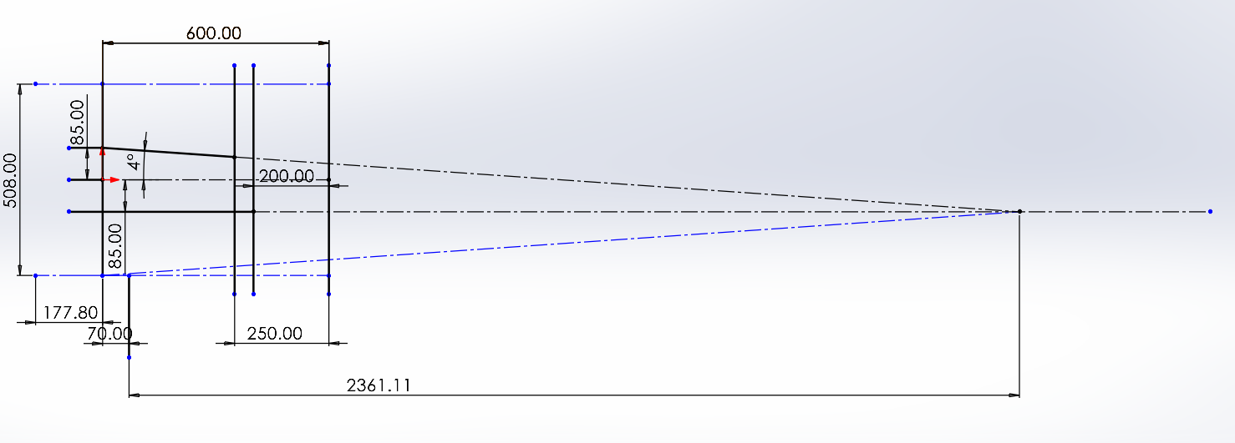
Figure ‎8.2 - Suspension Geometry (Front View)
The figure above shows the initial suspension design of the unequal double A-Arm setup. Using conditions that are already known from the Mk1 chassis.
- Wheelbase = 1200mm
- Wheel width = 177.80mm
- Suspension mount = 200mm
- Wheel Height = 508mm
As well as the choice of using a KPI of 9 degrees and an angle of elevation of 0 degrees at the lower control arm, calculations can then be made regarding the length of the lower and upper wishbone in the x axis. Following this calculation, the angle can be calculated from the top view of the vehicle.
This will affect the toe angles of the front wheels as well as some possible adjustments to the chassis to allow enough room to mount the upper and lower wishbones. As well as this CAD modelling can now begin in the suspension knuckle, both A Arms ad well as the push rod system.
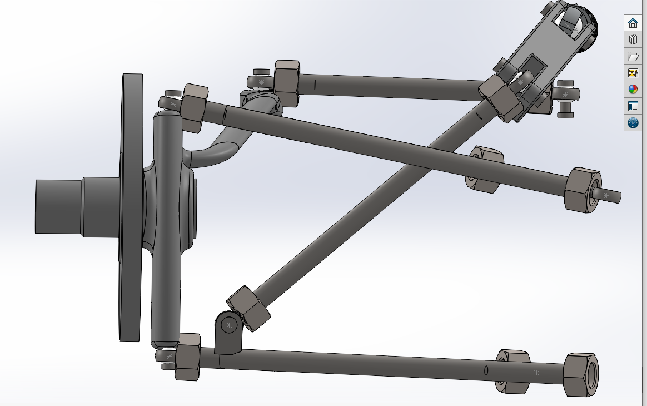
Figure ‎8.3 - Front View of Double wishbone assembly (GrabCad – Gordon Race Car, 2022)

Cockpit and Driver Controls - Jon
The cockpit of a Formula Student car is a critical component that impacts the driver's safety and performance around a track. The cockpit seats the driver of the car, and it is vital that it provides a comfortable and ergonomic seating position, good visibility, and easy access to controls (FSAE, 2022). Additionally, the cockpit protects the driver from impact using components such as crash structures on the rear, front and side that are designed with impact absorbing materials. Also, there is fire safety procedures in place such as a plumbed in fire extinguisher and a firewall. Throughout this project, it has been vital that research on previous Formula Student cockpits has been carried out. Throughout this review, the aim is to provide a comprehensive overview of the current state of knowledge on cockpit design for Formula Student.

Gear Shifter
The first component that was looked at was the shifter. The chosen shifter had been used previously by a team from the trinity college of engineering and research in Pune, Maharashtra, India. The shifter they used was a clutch less quick button shifter. However, for the car, it has been decided that paddles instead of buttons would be used. There were three potential systems that could have been used, electric, pneumatic, or hydraulic. However, with the aid of research, it was found that both pneumatic and hydraulic systems add great weight to the vehicle. Additionally, it was found that the fluids in a hydraulic system could catch on fire, limiting the safety of the system (Dabhade et al., 2020). The choice of system was electronic. This was due to factors such as its low cost, low weight, its reliability, and speed of function compared to the other two and the great comfort it provides for the driver (Dabhade et al., 2020). The methodology stated that the only time a clutch will be used is for the shift from neutral to first. From first to second, the upshift paddle will be used, and a signal will be sent to the MCU which will open the open and closed relays. These relays are placed in the circuits of the fuel injector and spark plug and when they are open, the power of both components is cut. The engine will then temporarily slow down as the shifting takes place and as there is no power or spark, the driver will not have to remove their foot off the accelerator (Dabhade et al., 2020). Further research was conducted to look at the reasons of choosing an electronic paddle shifter over a manual stick gear shifter. It was found that the difference in shift actuation speed between using a manual and paddle shifter was significant. While the average driver can actuate a shift within 500 milliseconds to 1 second, a paddle shifter can perform the same task but in a quarter of that time (Klein, 2020). The position of the paddles is on each side of the steering wheel, making the actuation an easy and safe task. The driver will use the paddle on the right to perform an upshift, and the left paddle to perform a downshift. This system was found most suitable for the car because of many reasons. The main one being the fact that it has a lot more benefits driving with a paddle shifter than a manual. It vastly increases the speed of actuation as mentioned above, and it also gives the driver more control over the car as it is possible to perfect a cornering shift with the paddles on the wheel.

Safety measures
It is vital that all relevant precautions are considered to ensure the driver's safety due to the high speeds and hazardous conditions on the racetrack. From the materials used in construction to the placement of controls, every aspect of the cockpit must be carefully considered and designed with safety in mind. Safety measures inside a cockpit include fire safety such as fire extinguishers and firewalls, drivers' protection such as harnesses, and crash protection such as side, front and rear impact structures. It was found in the regulations that there must be two dry/chemical extinguishers that are plumbed in and have a minimum firefighting agency capacity of 0.9kg. The fire extinguisher will be mounted in a fixed position within the cockpit, close to the driver's seat for easy access. It is connected to the car's electrical system and triggered by a switch on the dashboard or steering wheel. When triggered, it will release the firefighting agents to suppress the fire in the affected area.
The other fire safety aspect is the firewall. The firewall must be created from a hard, fire-resistant material such as aluminium or carbon fibre. Particularly, along the sides and the floor of the cockpit must be entirely watertight and impenetrable. This can be accomplished by building the firewall in a single piece that is at least 2mm thick, which will make it sturdy enough to survive any impacts or vibrations that may happen during the race (FSAE, 2022). Wiring, cable, and other pass-throughs are allowed if they are sealed with grommets to stop liquids from passing through (FSAE, 2022). Any line of sight between the driver compartment and should be blocked by the firewall. The firewall must cover any portion of the tallest driver below a plane that is 100 mm above the bottom of the helmet to guarantee that the driver is given the maximum amount of protection (FSAE, 2022). Moreover, many panels may be utilised to create the firewall, but they must overlap by a minimum of 5mm and be joined together by seals to prevent fluids from passing through (FSAE, 2022). Generally, a firewall for the vehicle should be manufactured from a fire-resistant material, designed to be as rigid as possible. The chosen material for the firewall was aluminium as it is more beneficial to the personal requirements of the car, especially the cost effectiveness.
The regulations stated that the harness must be attached using one 8mm metric grade 8.8 bolt and steel backing plates with minimum thickness of 2mm. The edges of the test fixture supporting the sample must be a minimum of 125 mm from load application point (FSAE, 2022). The width of shoulder harness test sample must not be any wider than the shoulder harness panel height. Harness loads must be tested with the worst case for the range of the angles specified for the driver's harness (FSAE, 2022). Using these regulations, it was found that a Schroth's Harness was most suitable. This harness weighs 2kg and the strap lengths are as follows; 850mm for the shoulder strap, 700mm for the lap strap and 780mm for the crotch strap (Raceparts, n.d).
There must be a crash structure for the rear, side, and front that comply with the regulations. These structures must be able to absorb a minimum of 4000J, the front and rear structures must be able to distribute the impact forces evenly across the vehicle and must be located with certain distance limits from the front and rear ends (FSAE, 2022). The front structure must be made from composite materials such as aluminium or steel. Static load tests must be undertaken for the front and rear structures (FSAE, 2022). It was found that an aluminium honeycomb was the best option for the front. It was previously used, and it can withstand 7350J of energy (UBC Formula SAE, 2022). The structure is hexagon patterned made from thin foil that shows strong absorption characteristics and great strength. It absorbs energy by collapsing at its base and folding in on itself, resulting in a small amount of energy being stored as it folds. As the load is applied it does not spring back to its original shape (UBC formula SAE, n.d). For the rear structure, a foam filled tube will be used. The choice of foam material was expanded polystyrene as it is cheap, lightweight, has good absorption characteristics and is easily shaped to fit the dimension regulations. The outside material is aluminium due to its strength, corrosion resistance, low weight and can be easily reconstructed to the right shape. The side structure is an aluminium sandwich panel with two aluminium skins with an aluminium honeycomb in between. The panel is mounted to the side of the frame with brackets designed to withstand impact forces and prevent the panel from separating from the frame.

Pedal Box
The pedal box used in the car was found online on a website that sells specific formula student components. We have chosen this pedal box as we feel it is the most suitable for our parameters, due to its lightweight, and limited maintenance. The pedal box chosen was a hydraulic clutch kit that cost £329.75 (RacingPedalBoxes, n.d).
A hydraulic clutch pedal box system works by using the fluid pressure to engage and disengage the clutch. This system has a master cylinder on the clutch pedal and a slave cylinder near it. When the clutch pedal is depressed, the master cylinder applies pressure to the fluid, which then moves the slave cylinder, causing the clutch to disengage. There was a choice of cylinder for the master cylinder, and it was between OEM and Willwood. It was found that the one that carries the best characteristics for racing is the Willwood cylinder.
Below is a table of the advantages and disadvantages of this box:
Table 7 - Advantages and disadvantages of the chosen pedal box
Advantages | Disadvantages
Soft pedal and long sturdiness | Pipes will rot
Versatile as it can be placed in anyplace | The correct fluid must be used
It is reliable | There is a risk of cylinder overflow
The pedal height can be automatically adjusted | Always must be compelled to check clutch fluid level
The cables are self-lubricated wherever the cables must be compelled to be greased from time to time. | Quite expensive
A soft pedal means that there is more comfort for the driver due to the pressure on the pedal being minimalised. The sturdiness characteristic means there is limited maintenance. Due to exposure to moisture, corrosive substances, and chemicals. Over time, this will cause the pipes to rot. The correct fluid must be used due to decreased performance if the wrong fluid is used. This can also lead to a cylinder overflow. To ensure this is measured, the team must be compelled to check the clutch fluid level which adds to the maintenance of the car.

The pedal ratio of this box is 5:1. The throttle pedal has an adjustable wire mechanism, with the pedal rotation angle and the wire stroke being adjustable. The brake pedal has a balance bar with a diameter of 7/16” - 20 to provide maximum stiffness. Each pedal has an anti-slip surface, and the box weighs 3.25kg (RacingPedalBoxes, n.d).
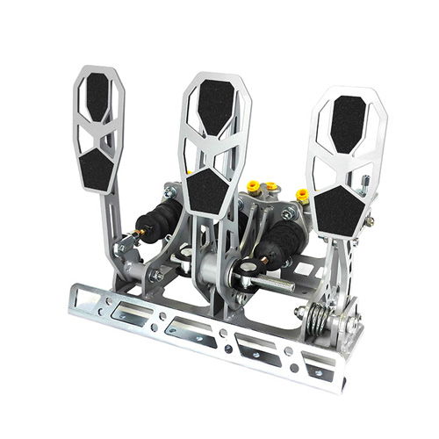
Figure ‎8.1- Hydraulic clutch pedql box (RacingPedalBoxes, n.d)

Steering
The regulations state that any system using cables or belts is prohibited. To overcome this, it was found that the most suitable system would be a mechanical steering rack. This system consists of a steering rack and pinion set, a steering column, a steering shaft, and an adjustable steering ratio. This system was chosen as maintenance can easily be performed, it is easy to adjust, and it is good for competitiveness. The regulations state that:
- The system must have positive steering stops that prevent the steering linkages from locking. These stops must be placed on the rack to prevent tyres and rims from encountering any other parts. The actuation of the steering wheel when standstill must also be possible.
- The steering system free play is limited to 7 degrees measured at the wheel.
- The wheel must be attached to the column with a quick disconnect, driver must be able to operate this while in the normal sitting position with gloves on.
- The wheel must be no more than 250mm rearward through the front hoop. This distance is measured horizontally, on the vehicle centreline, from rear surface of the front hoop to the forward most surface of the steering wheel with steering in any position.
- The rack must be mechanically attached to the chassis.
- Vehicles must have a wheelbase of at least 1525mm.
- The smaller track of the vehicle must be no less than 75 percent of the larger track.
- The track and centre of gravity of the vehicle must combine to provide adequate rollover stability (FSAE Rules, 2022).
The chosen rack was one found on the formula seven website. This website has been used throughout the project for other components, and it states that the chosen rack is suitable for the most demanding lightweight race cars (Formula Seven, n.d). To attach this rack, there were several steps to account for. The rack had to be positioned in line with the front wheels center line. Then using the appropriate brackets, the rack was attached to the chassis. The steering column was attached using suitable couplers. The rack chosen had a size of 450mm, with a weight of 940g. This rack has a travel distance from lock-to-lock of 72mm (Formula seven, n.d). This rack had options of any additional parts and it was decided that a hall effect sensor and steel spline couplers would be purchased with the rack.
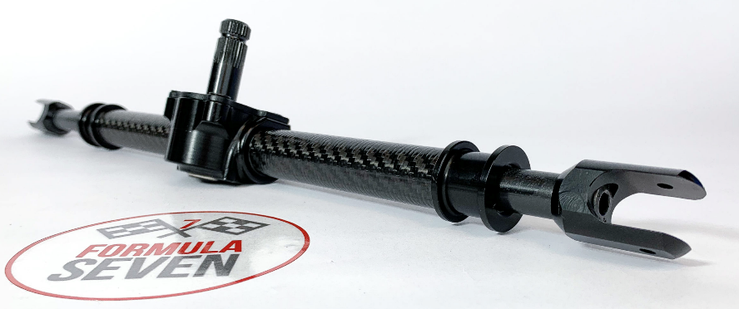
Figure 8.2- Steering rack (FomulaSeven, n.d)

It was essential that a steering wheel that was small, lightweight, and easy to control was found for this system. The sparco 383 wheel was chosen as it holds great characteristics that match the required parameters. This wheel has a diameter of 330mm meaning it is small (DemonTweeks, n.d). It has a flat-bottomed design which gives the driver an effortless way in and out of the cockpit. The wheel has a six-bolt mounting so it can be attached to the column using a quick release mechanism. The quick release system contains a hub attached to the column, and a mating adapter that is attached to the steering wheel. To detach the steering wheel, the driver must depress a lever which disengages the locking mechanism and allows the wheel to be lifted off the hub. To ensure that this system accommodates the shift system, additional components were required. These were mounting brackets to secure the shift paddles, as well as wiring and connectors to the interface with the vehicle's electronics.
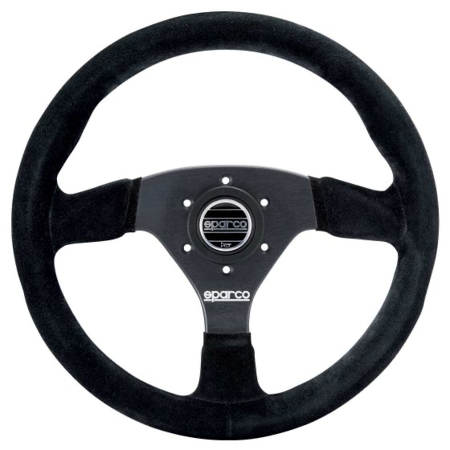
Figure 8.3 - Sparco383 wheel (DemonTweeks, n.d)

Ergonomics design
During this project, it was instrumental that the drivers' comfort and safety was heavily considered to increase the performance. Alongside the safety measures, the ergonomic design of the cockpit impacts the drivers' performance. Using background research, a design from Aligarh Muslim University was found. This design was for the 95th percentile male, and they found it to be the best fit for maximum comfort for the average male driver.
The rules stated that the driver must be:
- A minimum of 50.8mm from the straight line drawn from the top of the main hoop to the top of the front hoop.
- A minimum of 50.8mm from the straight line drawn from the top of the main hoop to the lower end of the main hoop bracing extend rearwards.
- The bottom 200mm circle will be placed on the seat bottom that the distance between the centre of the circle and the rearmost of the pedals is no less than 915mm (FSAE, 2022).

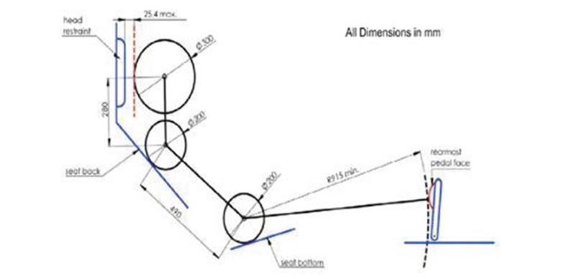
Figure 8.4- FSAE 95th percentile male template (Ahmad et al., 2021)
It was concluded that the distance between the neck point and the topmost point of the head is a straight line parallel to the vertical member (Ahmad et al., 2021). In the work performed by this team they listed dimensions such as the back-seat angle and the thigh angle, however some dimensions were made constant such as the pedal height (Ahmad et al., 2021). They performed an analysis of two seat angles of 55 and 70 degrees to find out what was most comfortable, and this was performed on subjects of different weight and height. Below is the data obtained by this team on the tests carried out:
Table 8 - Cockpit dimensions data from subjects (Ahmad et al., 2021)
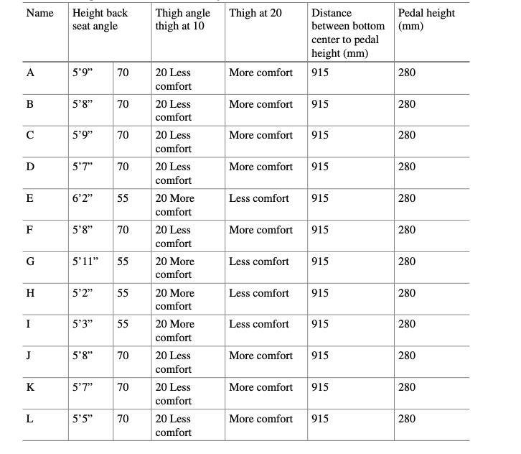
After carrying out these tests, the team was able to establish a maximum comfortable position for driving, and the best seat thigh angle which facilitates the knee according to the operation of the pedals (Ahmad et al., 2021).

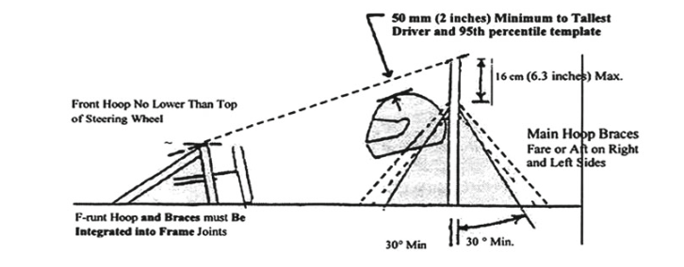
Figure 8.5- Demonstration of the rules of FSAE (Ahmad et al., 2021)
The design for the apparatus was made from wood and steel rods. It was found that this is the most suitable as:
- Wooden apparatus is cost-effective.
- It is customizable. Wood can be easily cut to fit the dimension requirements.
- Comfortable. It has good shock absorbing properties, that help to reduce discomfort and fatigue.
- Sustainable. Using wooden apparatus can help to reduce the environmental impact of the design process.

The team designed an apparatus that followed the guidelines of the FSAE rules. The length was fixed to 915mm (Ahmad et al., 2021). For the testing, the seat back angle, thigh angle, dash height and pedal assembly were adjustable for the subjects' preferences. The design used was the same materials as this team and using the results found by that team, it made more sense to use similar dimensions. However, there are differences such as the steering wheel being different, using a different pedal box kit, and a different shifter system etc. The design that was used for the vehicle had a fixed steering wheel position, however, this wheel has a quick release system so it can easily be removed and put back on.
This is how the apparatus looked:

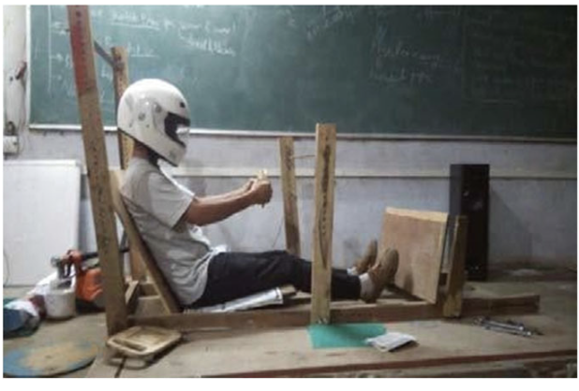
Figure 8.6- Ergonomic apparatus cockpit (Ahmad et al., 2021)

Conclusion
In conclusion, the team has worked effectively together to develop every aspect of the vehicle. The power unit whose base engine is a Triumph 675 inline-3-cylinder engine will run on a more sustainable fuel (E85) should deliver the low end torque the driver will be after in the corners. The engine should make peak power at about 8,000 RPM and will do so reliably thanks to is fully built and forged engine internals. The engine management system will take full control of the engine and ensure to delivers smooth and constant power when it up in the power band.
For the chassis after evaluating real data and simulation, the material the team decided upon was T45 steel, for its necessary physical properties that are well within the regulations and provide wider limits for the other departments to use heavier and faster equipment, as the material of the chassis can handle. The chassis will be made by welding the tubes together by MIG welding most of the chassis, and TIG welding near the hoops and cockpit of the chassis for driver safety.
The chosen outboard braking system for the Formula Student vehicle offers a simple and cost-effective solution that is easy to maintain and repair. The braking system is required to meet specific rules and regulations regarding stopping distance, and the selected components from AP Racing meet these requirements. The use of grooved discs, CP2195 pads, CP3696 calipers, a small diameter plastic reservoir, and CP2623 master cylinder, all from AP racing, provides a reliable and durable braking system that delivers the necessary stopping power for the vehicle. Additionally, the selection of AP Racing as the supplier ensures that the parts fit together seamlessly, without any issues with fitment. Overall, the chosen braking system components offer an excellent combination of performance, cost effectiveness, and ease of maintenance, making it an ideal setup for the Formula Student vehicle.
To conclude the wheel and tyre setup, these are important components for a vehicle's safety and performance. For a formula student vehicle, selecting appropriate wheels and tyres is essential for ideal performance and driveability. From the results it is clear that these tyres are an ideal choice as they perform well across various different pressures and camber changes, as shown in the graph. The Winrace FSAE 13x7 aluminium wheel and Avon tyres result in a good wheel and tyre combination due to their lightweight construction, high grip levels, durability, and competitive pricing. Smaller wheels offer benefits such as lower weight, improved aerodynamics, and better heat management as mentioned earlier, but may limit braking performance due to a smaller contact patch. Overall, selecting the right wheels and tyres can significantly impact a vehicle's performance on the track.
After conducting research on each sub-section, it was found and written up in this report what the best option for each is. With every decision there is a different possibility that could've been used, however every decision for the cockpit controls was looked at in extensive detail and discussed. The safety measures were the most discussed part. This was due to the amount of detail need to be put into this section, as not only does ensuring these measures are there keep the driver safe, but it also has a significant impact on the driver's performance around the track. How well the vehicle does, depends on the driver just as much as the team behind the making of the car.

References.
apracing.com. (n.d.). Aluminium Lug Mount - CP3696-6E0 | AP Racing. [online] Available at: https://apracing.com/race-car/brake-calipers/2-piston-range/aluminium-lug-mount-cp3696-6e0 [Accessed 12th Mar. 2023].

apracing.com. (n.d.). Brake Discs | AP Racing. [online] Available at: https://apracing.com/race-car/formula-student-sae/brake-discs. [Accessed 12th Mar. 2023].

‌apracing.com. (n.d.). Brake Pads | AP Racing. [online] Available at: https://apracing.com/race-car/formula-student-sae/brake-pads [Accessed 12th Mar. 2023].

‌apracing.com. (n.d.). CP2623 Type | AP Racing. [online] Available at: https://apracing.com/race-car/master-cylinders/flange-mounted-types/vertical-flange-types/cp2623-type [Accessed 12th Mar. 2023].

AT Power Motorsport Products Ltd. (2013) Single Throttle Body (50mm Bore) - (NA Engine)
Available at: https://www.atpower.com/products/single-throttle-body-50mm-bore-na-engine
(Accessed: 22/03/2023)

Bauer Media Group (2023) Triumph Tiger Sport 660 (2022 - on) Review
Available at: https://www.motorcyclenews.com/bike-reviews/triumph/tiger-660-sport/2022/
(Accessed: 21/03/2023)

Benvenuti, L. et al. (2014) A Cycle Accurate Nonlinear Hybrid Model of SI Engine for the Idle Speed Control
University of Roma: Roma, Italy

Bishop, T.H. (2020) Why permanent magnet motors and reluctance motors are finding increased industry application
Available at: https://www.plantservices.com/equipment/industrial-motors/article/11291709/why-permanent-magnet-motors-and-reluctance-motors-are-finding-increased-industry-application
(Accessed: 20/03/2023)

BRAID (2016). Winrace FSAE - BRAID. [online] BRAID. Available at: https://www.braid-wheels.com/en/winrace-fsae/P-1080?L2VuL3Byb2R1Y3RzLWZhbWlsaWVzL3N0dXJhY2UuaHRtbA== [Accessed 4th Mar. 2023].

‌courses.lumenlearning.com. (n.d.). 6.2 Friction | University Physics Volume 1. [online] Available at: https://courses.lumenlearning.com/suny-osuniversityphysics/chapter/6-2-friction/. [Accessed 14th Mar. 2023].

‌Deo, H., 7 ' Eateto Ehaia Niern, Suh, N. and Cross, E. (2007). Axiomatic Design of Customizable Automotive Suspension Systems. [online] Available at: https://core.ac.uk/download/pdf/4403459.pdf [Accessed 09th Mar. 2023].

Deatsch Werks – DW (2023) Matched set of 4 injectors 350cc/min
Available at: https://deatschwerks.com/collections/injectors/products/18u-00-0350-5
(Accessed: 25/03/2023)

eBay (2023) Triumph Daytona 675 2011 Engine (Approx 20k mileage)
Available at: https://www.ebay.co.uk/itm/155321925212?hash=item2429e87e5c:g:UH8AAOSw5gxjpCeZ&amdata=enc%3AAQAHAAAA8OCqC1D2F2sk4UPO0a1V1HPWjpqS4qWue5RjTCA5n8IF09NrEiDTSzxVY%2FehvNc3WeEMsLHxW9d4tFSHMLolZBKEh5nqmgGWcNC6DOqdgyAeAcKBWG6bL2Yl2UizYC%2BkbTY73gZfBcp%2BBYe5qDXaJ0AWT4%2BsIslEh8m%2FabcopVucteyfxswgPz9KhE89Lig3VevFPb40Tgenuq0wkamnYliYLurIjm7tB9ZF4PEw5i8eau8nH0dLtWIy0DbFdf9gj3lESZ8idWkHYEQkm5LM4izQXjaODQve2h%2FN3ZrZMEIrOI3aUhOZH26bcN7yLXOgAg%3D%3D%7Ctkp%3ABk9SR9zk_uHjYQ
(Accessed: 24/03/2023)

Electrogenic (2023) Choosing a Motor
Available at: https://www.electrogenic.co.uk/under-the-bonnet/technology/choosing-a-motor
(Accessed: 20/03/2023)

EV Europe (2023) Tesla Model S drivetrain – 220 KW
Available at: https://eveurope.eu/en/product/tesla-model-s-drive-train-220-kw/
(Accessed: 20/03/2023)

EVlove Electrics (2023) Hyper 9 IS Motor Kit
Available at: https://evolveelectrics.com/collections/motors/products/hyper-9-is-motor-kit
(Accessed: 20/03/2023)

Fellten (2023) Hyper 9 Motor and Controller and Accessories
Available at: https://shop.fellten.com/shop/hyper9kithv144v-hyper-9-motor-and-controller-and-accessories-hv-144-v-12959?category=1#attr=
(Accessed: 23/03/2023)

Formula Student Rules 2022. (n.d.). Available at: https://www.formulastudent.de/fileadmin/user_upload/all/2022/rules/FS-Rules_2022_v0.9.pdf. [Accessed 10th Mar. 2023].
Gao, X., Xiong, Y., Liu, W. and Zhuang, Y. (2021). Modelling and experimental study of tyre deformation characteristics under high-speed rolling condition. Polymer Testing, p.107052. [Accessed 10th Mar. 2023].
Garret (2020) How to Select A Turbo Part 2: Calculations
Available at: https://www.garrettmotion.com/news/newsroom/article/how-to-select-a-turbo-part-2-understanding-calculations-to-turbo-any-engine/
(Accessed: 25/03/2023)

Hargreaves, S. (2019) Honda CBR650R (2019) Review
Available at: https://www.bennetts.co.uk/bikesocial/reviews/bikes/honda/honda-cbr650r-2019-review
(Accessed: 21/03/2023)

Heisler, H. (2002). Tyres. Advanced Vehicle Technology, pp.270–310. [Accessed 09th Mar. 2023].
‌Holloway -Owner, C. (n.d.). White Paper: Influence of Temperature on Tyre Grip. [online] Available at: https://www.izzeracing.com/products/ewExternalFiles/Izze_Racing_White_Paper_Tyre_Temperature.pdf [Accessed 08th Mar. 2023].

Heisler, H. (1997) Advanced Engine Technology
The Society of Automotive Engineers: Warrendale, PA

‌Imeche.org. (2018). Formula Student - Institution of Mechanical Engineers. [online] Available at: https://www.imeche.org/events/formula-student. [Accessed 16th Feb. 2023].

Institute of Mechanical Engineers – IMechE (2022) Formula Student 2022 Rules
Available at: https://www.imeche.org/docs/default-source/1-oscar/formula-student/2022/rules/fsuk-2022-rules---v1-3-(t11-6-5-typo-correction).pdf?sfvrsn=2
(Accessed: 03/10/2022)

Irving, P.E. (1962) Automobile Engine Tuning
Temple Press Books: London

Jonathan Vogel. (n.d.). Tyre Modelling and Selection. [online] Available at: https://www.jovogel.com/tyre-modeling-and-selection [Accessed 05th Mar. 2023].

JSD Machine Works (2022) Triumph 675 Triple Carrillo Connecting Rods (Set of 3)
Available at: https://jsdmachineworks.com/triumph-675-triple-carrillo-connecting-rods-set-of-3/
(Accessed: 16/11/2022)

‌Ltd, F.S. (n.d.). CP4709 - Small Diameter Fluid Reservoirs. [online] Race & Rally. Available at: https://raceandrally.com/cp4709-small-diameter-fluid-reservoirs [Accessed 12th Mar. 2023].
‌Nationwide Vehicle Contracts. (n.d.). The Science of Tyres: How They Impact Car Performance. [online] Available at: https://www.nationwidevehiclecontracts.co.uk/blog/the-science-of-tyres-how-they-impact-car-performance [Accessed 10th Mar. 2023].

Mahank, T.A. and Shelagowski, L.M. (2015) CFR Formula SAE Intake Restrictor Design and Performance
Saginaw Valley State University: Saginaw County, MI

Martin, R. (2020) How Much Power Does The 2020 Triumph Street Triple RS Make?
Available at: https://www.cycleworld.com/story/bikes/how-much-power-does-the-2020-triumph-street-triple-rs-make/
(Accessed: 19/11/2022)

Motorcycle Specs – MCS (2009) Triumph Daytona 675
Available at: https://www.motorcyclespecs.co.za/model/triu/triumph_daytona_675%2009.htm
(Accessed: 15/01/2023)

NetGain Motors Inc. (2023a) Hyper 9 Motor Sales Sheet
Available at: https://www.go-ev.com/PDFs/HyPer_9_Sales_Sheet.pdf
(Accessed: 14/01/2023)

NetGain Motors Inc. (2023b) Hyper 9 Motor Graph
[Graph]
Available at: https://www.go-ev.com/PDFs/HyPer_9_96V_Performance.pdf
(Accessed: 14/01/2023)

Petro Online (2021) What is Petrol?
Available at: https://www.petro-online.com/news/measurement-and-testing/14/breaking-news/what-is-in-petrol/55119
(Accessed: 20/03/2023)

Prajapati, S., & Kumar, A. (2019). Design and Fabrication of Outboard Braking System for All Terrain Vehicle. 2019 IEEE Student Conference on Research and Development (SCOReD), 7-10. [Accessed 10th Mar. 2023].
published, O.B. (2017). What effect do tyres have on aerodynamics? [online] cyclingweekly.com. Available at: https://www.cyclingweekly.com/news/product-news/what-effect-do-tyres-have-on-aerodynamics-324578 [Accessed 5th Mar. 2023].
R Racing Fuel (2016) Product Information Sheet R SUR Racing Gasoline
Available at: https://www.imeche.org/docs/default-source/1-oscar/formula-student/r-sur-specification-030210.pdf?sfvrsn=2
(Accessed: 24/03/2023)

‌Stevens, M. (2020). What is Camber? (Positive vs Negative Camber Effects). [online] CarTreatments.com. Available at: https://cartreatments.com/what-is-camber/. [Accessed 09th Mar. 2023].

Sunoco (2017) Sunoco E85-R Technical Bulletin
Available at: https://www.imeche.org/docs/default-source/1-oscar/Get-involved/sunoco-e85-product-information.pdf?sfvrsn=0
(Accessed:24/03/2023)

Suzuki (2022) New V-Twin SV650 Engine Specification
Available at: https://bikes.suzuki.co.uk/bikes/street/sv650/
(Accessed: 19/10/2022)

Triumph (2022) Tiger Sport 660 Specification
Available at: https://www.triumphmotorcycles.co.uk/motorcycles/adventure/tiger-sport-660/specification
(Accessed:19/10/2022)

Triumph Designs Ltd. (2013) Motorcycle Race Kit Manual
Issue 1
Publication part number: A9900675
Triumph Designs Ltd: Hinckley

Triumph Designs Ltd. (2014) Daytona 675 Service Manual
Triumph Designs Ltd: Hinckley

Triumph Genuine Race Parts (2012) Daytona 675 Race Kits
Available at: http://www.triumph.lv/images/Daytona_Racing_Parts_Kit.pdf
(Accessed: 15/11/2022)

U.S. Department of Energy – DOE (2022) Ethanol Benefits and Considerations
Available at: https://afdc.energy.gov/fuels/ethanol_benefits.html
(Accessed: 25/03/2023)

U.S. Energy Information Administration - EIA (2022) What is octane?
Available at: https://www.eia.gov/energyexplained/gasoline/octane-in-depth.php
(Accessed: 24/03/2023)

Vizard, D. (1985) Tuning BL’s A-series Engine
Sparkford, Yeovil, Somerset BA22 7JJ, England: Haynes Publishing Group

Wheelen, D (2021) 2022 Triumph Tiger Sport 660 | First Ride Review
Available at: https://ridermagazine.com/2021/12/17/2022-triumph-tiger-sport-660-first-ride-review/
(Accessed: 20/03/2023)

Wiseco (2022) Custom Pistons
Available at: https://auto.wiseco.com/wiseco-custom-piston-order
(Accessed: 16/11/2022)

www.avontyres.com. (n.d.). SAE Formula Student. [online] Available at: https://www.avontyres.com/en-gb/tyre-care/motorsport-technical-data/tyre-applications/SAE-Formula-Student/. [Accessed 12th Mar. 2023].
‌www.fsae.com. (n.d.). Brake design: mu, pressure, pedal force, heat capacity and dissipation [Archive] - FSAE.com Forums. [online] Available at: http://www.fsae.com/forums/archive/index.php/t-12049.html?s=b94eb0d8ef2e59be1c6cdd5a0c908f5b [Accessed 14th Mar. 2023].
www.sheldonbrown.com. (n.d.). Wheel Stiffness Test. [online] Available at: https://www.sheldonbrown.com/rinard/wheel_index.html?utm_content=cmp-true [Accessed 14th Mar. 2023].
‌www.tyrebuyer.com. (n.d.). Impact of Wheel Weight on Your Vehicle | TyreBuyer.com. [online] Available at: https://www.tyrebuyer.com/education/impact-of-wheel-weight. [Accessed 06th Mar. 2023].

Yamaha (2022) 2022 Tracer 7 GT Technical Specifications
Available at: https://www.yamaha-motor.eu/gb/en/products/motorcycles/sport-touring/tracer-7-gt-2022/techspecs/
(Accessed: 19/10/2022)

energyeducation.ca. (n.d.). Braking - Energy Education. [online] Available at: https://energyeducation.ca/encyclopedia/Braking#:~:text=It%20involves%20the%20conversion%20of [Accessed 20th Mar. 2023].
Fsaeonline.com. (2022). Available at: https://www.fsaeonline.com/cdsweb/gen/DownloadDocument.aspx?DocumentID=d2404288-c121-4242-9944-90aa0b1d6a5f. [Accessed 20th Mar. 2023].
Gordon’s Race Car. Available at https://grabcad.com/library?page=1&time=all_time&sort=recent&softwares=solidworks&query=suspension
Bicycle Model – Available at http://code.eng.buffalo.edu/dat/sites/model/bicycle.html#:~:text=The%20non%2Dlinear%20bicycle%20model,traveling%20on%20a%20smooth%20road.
(Wright. (2001). Formula 1 technology. Society of Automotive Engineers.)
(Brown, Robertson, A. J., & Serpento, S. T. (2002). Motor vehicle structures : concepts and fundamentals. Butterworth-Heinemann.)
(Milliken. (2003). Race car vehicle dynamics : problems, answers and experiments. SAE International)
(Reimpell, Stoll, H., & Betzler, J. W. (2001). The automotive chassis : engineering principles : chassis and vehicle overall, wheel suspensions and types of drive, axle kinematics and elastokinematics, steering, springing, tyres, construction and calculations advice (2nd ed.). Butterworth Heinemann.)
(Smiths metal, T45 Steel | T45 Steel Tube (smithmetal.com)
(Carbon Manganese Steel Tube T45 (smithmetal.com))
Dietsche, & Reif, K. (2018). Automotive handbook (10th edition, revised and extended.). Robert Bosch GmbH
Twigg. (1996). Science for motor vehicle engineers. Arnold
The History of 4130 Cold Drawn Seamless Round Tube - A.E.D. Metal Products (aedmetals.com)
What Is MIG Welding – Understanding It Thoroughly - Welding Headquarters
Finch. (1997). Welder’s handbook : a complete guide to MIG, TIG, ARC & oxyacetylene welding ([2nd ed.], Completely rev. and updated ed.). HPBooks
675.cc (2013) – Exhaust and noise levels. Accessed on 26th March 2023. Available at: Exhausts and Noise Levels | 675.cc • Triumph 675 Forum
Low offset (2023) A.Mann – Different types of Limited Slip differentials. Accessed on 26th March 2023. Available at: Different Types of Limited Slip Differentials | Low Offset (low-offset.com)
DSPORT (2015) – Differentials 101: solving differential equations. Accessed on 26th March 2023. Available at: Differentials 101: Solving the Differential Equation (dsportmag.com)
Car throttle / Engineering Explained (2016) – Best kinds of differentials and what’s most suitable for you. Accessed on 26th March 2023. Available at: Engineering Explained: The Best Kinds Of Differential And What's Most Suitable For You (carthrottle.com)
MUR Motorsports (2017) Mr A.Giang – Differentials, What’s the difference. Accessed on 26th March 2023. Available at: MUR Blog - Differentials…What’s The Difference? (Pt. 2) : MUR Motorsports (unimelb.edu.au)
MCN (2023) - TRIUMPH STREET TRIPLE 675 (2013 - 2016) Review. Accessed on 26th March 2023. Available at: 2013-2016 Triumph Street Triple 675 review and used buying guide | MCN (motorcyclenews.com)
Institution of mechanical engineers (2023) – Rules 2022. Accessed on 26th march 2023. Available at: fsuk-2022-rules---v1-3-(t11-6-5-typo-correction).pdf (imeche.org)
Vroomo (2022) - FSAE Rear Suspension (A Brief Overview). Accessed on 26th March 2023. Available at: FSAE Rear Suspension (A Brief Overview) - VROOMO

(What is TIG Welding? | Advantages & Disadvantages (protigwelders.com)

Raceparts.com(n.d) Schroth formula student harness
Available at: https://race.parts/catalogue/content.aspx?node_id=628f78e6-498a-409f-b9e0-a5a800fc79ea
‌

‌

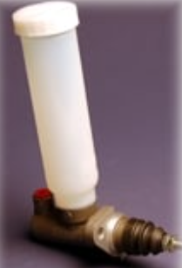
Appendix
Figure .1 - AP Racing Small diameter plastic reservoir with central outlet for direct fitment.

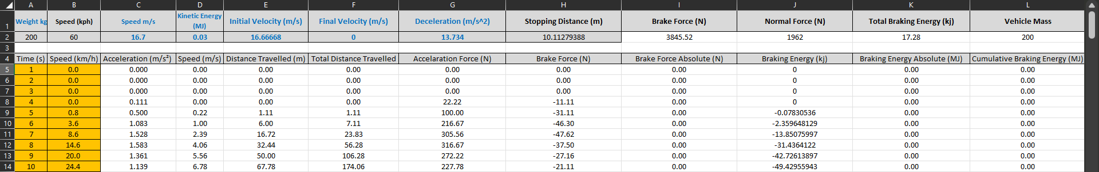
Figure .2 - Excel Braking Calculations Data Sheet
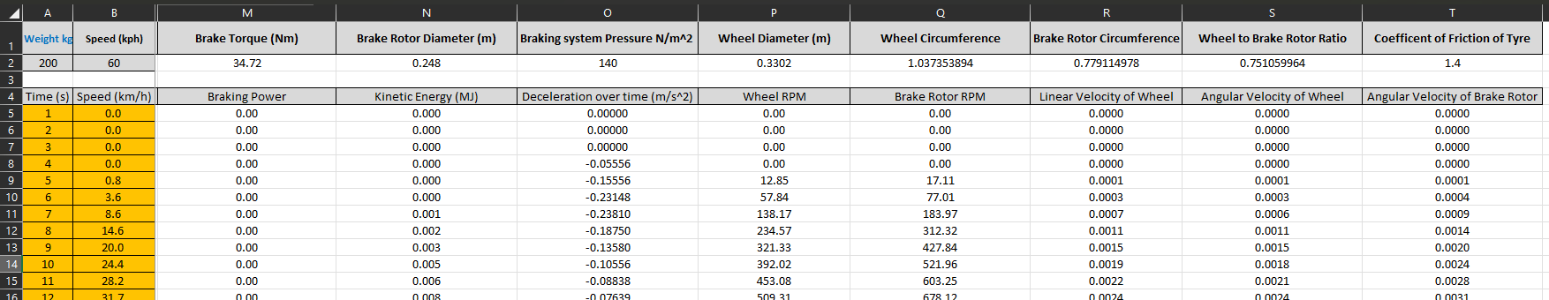
Figure .3 - Excel Braking Calculations Data Sheet

