Table of Contents
Poster 1
References 3



Student Name: Md Ranu Miah
Student ID: 2437168

Module Name: Marketing Management

Module Code: LCMB7024

Lecturer’s Name: Dr Laila Maazouz (London)

Poster – Marketing Strategy Pitch

Term 1

Poster
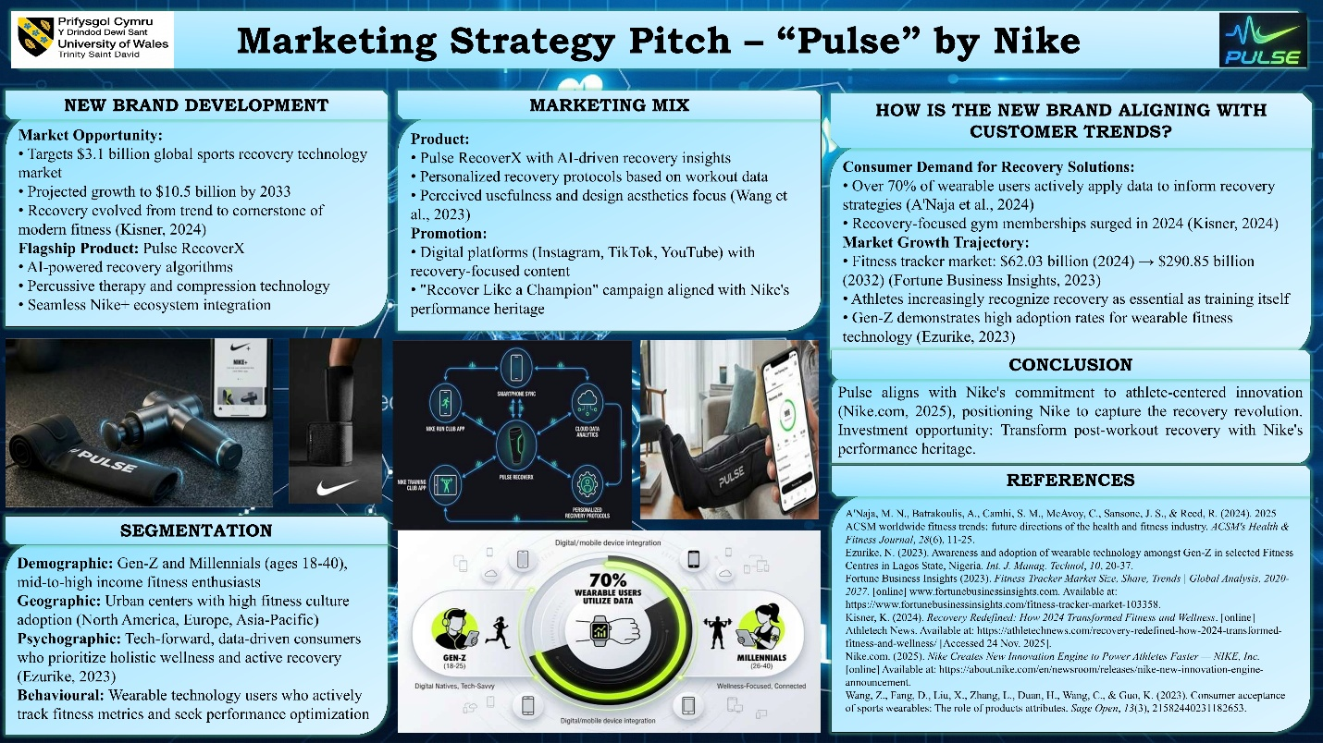
Nike introduces a new product, Pulse, a smart fitness recovery device that targets $3.1 billion sports recovery technology market in the world and would reach 10.5 billion billion in the year 2033 (Futuredatastats.com, 2024). Pulse RecoverX is our flagship product, and it responds to the underlying paradigm change recovery has turned into trend and staple of contemporary fitness (Kisner, 2024). Gen-Z and Millennials make up our target market and have high levels of embrace of wearable-based fitness technology products (Ezurike, 2023), with more than 70 percent of the wearable users currently utilizing the data to inform their recovery plans (A'Naja et al., 2024). The wider market in fitness trackers shows a spectacular growth of $62.03 billion to an expected of 290.85 billion by 2024 and 2032 respectively (Fortune Business Insights, 2023).
The points of differentiation offered by Pulse include AI-based recovery algorithms, built-in Nike+ systems, and professional-level technology previously only available to professional athletes. Our premium offering taps into the expanding consumer readiness to spend their money on recovery-based solutions: recovery-based gym memberships are rising in 2024 (Kisner, 2024). These features can be used to align the Pulse brand with the sport-related innovation that Nike is dedicated to ( Nike.com, 2025) as it focuses on perceived usefulness and design aesthetics, which were the most important drivers of adoption (Wang et al., 2023).
Investment prospective: Reclaim the revolution of performance with Nike performance heritage.

References
A'Naja, M. N., Batrakoulis, A., Camhi, S. M., McAvoy, C., Sansone, J. S.,&Reed, R. (2024). 2025 ACSM worldwide fitness trends: future directions of the health and fitness industry. ACSM's Health&Fitness Journal, 28(6), 11-25.
Ezurike, N. (2023). Awareness and adoption of wearable technology amongst Gen-Z in selected Fitness Centres in Lagos State, Nigeria. Int. J. Manag. Technol, 10, 20-37.
Fortune Business Insights (2023). Fitness Tracker Market Size, Share, Trends | Global Analysis, 2020-2027. [online] www.fortunebusinessinsights.com. Available at: https://www.fortunebusinessinsights.com/fitness-tracker-market-103358.
Futuredatastats.com. (2024). Sports Recovery Technology Market Size, Share and Industry Forecast. [online] Available at: https://www.futuredatastats.com/sports-recovery-technology-market.
Kisner, K. (2024). Recovery Redefined: How 2024 Transformed Fitness and Wellness. [online] Athletech News. Available at: https://athletechnews.com/recovery-redefined-how-2024-transformed-fitness-and-wellness/ [Accessed 24 Nov. 2025].
Nike.com. (2025). Nike Creates New Innovation Engine to Power Athletes Faster — NIKE, Inc. [online] Available at: https://about.nike.com/en/newsroom/releases/nike-new-innovation-engine-announcement.
Wang, Z., Fang, D., Liu, X., Zhang, L., Duan, H., Wang, C.,&Guo, K. (2023). Consumer acceptance of sports wearables: The role of products attributes. Sage Open, 13(3), 21582440231182653.

