Thomas Pritchard
1809125

ACDA5005 – Smart and Connected Devices I
Assignment 2
Rainfall Database Report

Lecturer: Gaynor Thomas

Contents
1. Introduction 1
2. Database 1
3. Website 1
3.1. Login 1
3.2. Import 3
3.3. Main Page 4
3.4. All Data 6
3.5. Log Out 8

Introduction

This report covers the features included in the RainfallDB website. Code excerpts have been included where appropriate, however the full commented code can be found within the original PHP files.

The database was created using MySQL via PHPMyAdmin. The website has been built using a combination of HTML, CSS, PHP, and SQL.

Database

The database contains two tables, one to hold the rainfall data and one to hold user details. The user table contains passwords which have been stored in a hash format to reduce the risk of password exposure should the database be accessed for malicious intent.

Data types and lengths have been chosen to hold relevant values for each field, whilst avoiding unnecessary overhead. Structures for each are below:

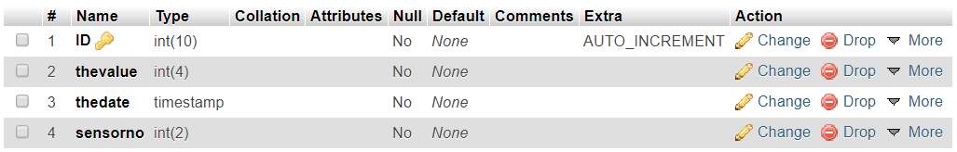
Structure of RainfallData table

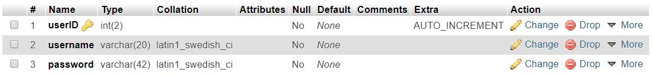
Structure of User table

Website

Login

Before accessing any data or other webpages, a user must log in successfully. This is achieved by all pages having access to a session cache which is interrogated on load, if a user is currently logged in (i.e. if(@$_SESSION["uname"]!="")) they are able to view the page, otherwise they are shown a splash screen (fig.1) which directs them to the login page.


Fig 1 – splash screen directing a non-authenticated visitor to the login page

On the login page the visitor is asked to sign in via the username and password fields (fig. 2 & 3).


Fig 2 – log in page

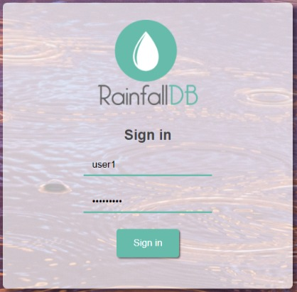
Fig 3 – login details entered

These details are then passed to a ‘Check Login’ php file which compares the username and password combo with the details stored in the database. As the password are stored in a hash format, this file uses PASSWORD('$pw') to compare the data. If a match is not found the user is shown a message and prompted to try again (fig 4), if a match is found then the user is ‘signed in’ by storing their username under a variable in the session cache. This is then used to authenticate against each page as mentioned above.

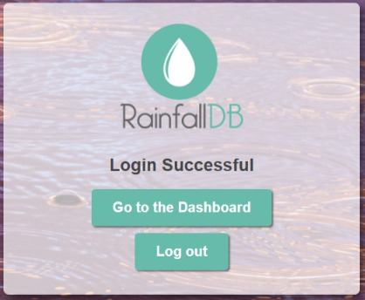
Fig 4 & 5 – Login successful and unsuccessful

Import
Once logged in the user has the option to import data by selecting the import option from the main menu. This runs PHP code which iterates through each .txt file using a for loop. It checks to see whether each file is empty, if it contains data it first reads this, stores it into an array and passes it to the database where it is appended to any existing rows, and increments a counter on completion. Each text file is wiped to ensure data is not duplicated on a second entry. A message is displayed for each file to let the user know the import has been successful, and a final message of completion is then shown (fig 6).

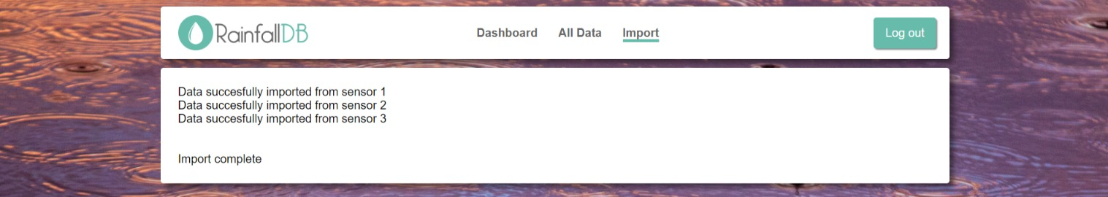
Fig 6 – page displaying successful data import

If all files are empty (i.e. the counter is still set to 0), the user is told there is ‘No new data to import’ (fig 7).


Fig 7 – Page confirming no data to import

Main Page

On the main page there are three sections – filters, quick stats and graphs.

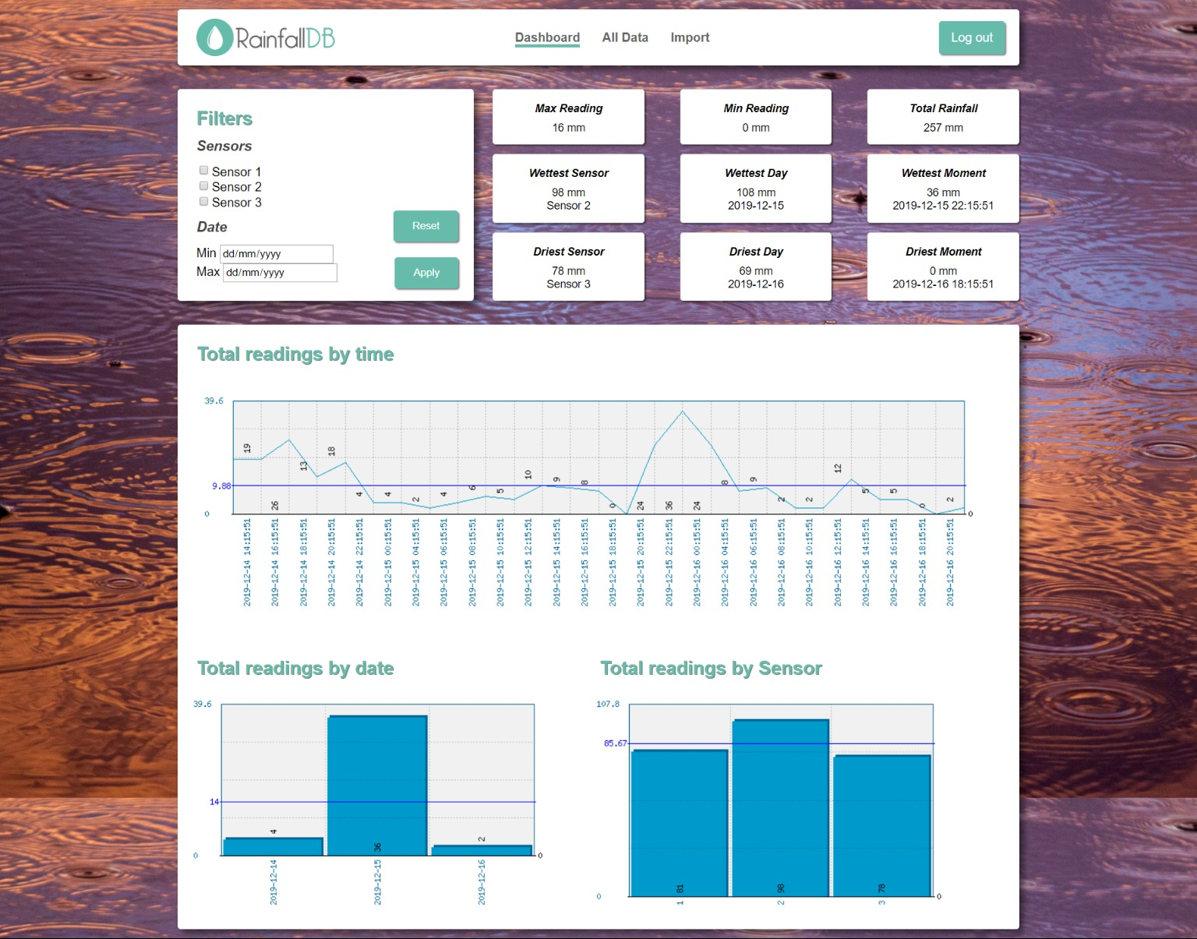
Fig 8 – main page with no filters applied

The user is able to filter by sensors with a checkbox list and dates using a date picker, there is also PHP in use to check whether these values have already been filled out and applied, and if so these are filled in so that the user can see what has been selected (e.g. if(isset($_POST['sensor1'])) echo "checked='checked'"). Once applied these are posted back to the current page to be used by the quick stats and graphs, the form can also be reset with a button which reloads the page.

From these filters, a section of PHP code using a variety of nested if statements generates an SQL query and stores this in a variable as a string. This string is also stored in the session cache to allow it to be utilised for the graphs which are generated in separate PHP files. An excerpt from this code to generate the sensor part of the query is below:

if(!empty($s1) OR !empty($s2) OR !empty($s3)){ //If any of sensors selected append the following to query
$iq ="WHERE (sensorno LIKE ";

if (!empty($s1) AND !empty($s2) AND !empty($s3)){
$iq .="'$s1' OR '$s2' OR '$s3') ";
}
else if (!empty($s1) AND !empty($s2)){
$iq .="'$s1' OR '$s2') ";
}
else if (!empty($s1) AND !empty($s3)){
$iq .="'$s1' OR '$s3') ";
}
else if (!empty($s2) AND !empty($s3)){
$iq .="'$s2' OR '$s3') ";
}
else if (!empty($s1)){
$iq .="'$s1') ";
}
else if (!empty($s2)){
$iq .="'$s2') ";
}
else{
$iq .="'$s3') ";
}
}

There are nine quick stats displayed in a flexbox layout, all making use of the query defined above to narrow down statistics based on user needs. The MIN(), MAX() and SUM() SQL functions are used to pull relevant data and fields from the database, utilising CAST(), GROUP BY, ORDER BY and LIMIT where appropriate. An excerpt used to return the wettest day is below, $iq contains the query defined by the above filters:

<div class="databox">
<span class="dbtitle">Wettest Day</span>
<? $query="SELECT SUM(thevalue) total, CAST(thedate AS DATE) date FROM rainfalldata ".$iq."GROUP BY date ORDER BY total DESC, date DESC LIMIT 1";
$result=mysqli_query($link,$query) or die;
while($r=mysqli_fetch_array($result))
{echo $r["total"]." mm<br/>";
echo $r["date"];}
?>
</div>

PHPMyGraph has been utilised to generate graphs based on data from the database, styled to fit in with the webpage and utilising any filters applied by the user above by pulling the query string from the session cache. There are three graphs to show readings over time, readings by date and readings by sensor using a combination of line and bar charts. These are generated on external PHP pages and then displayed on the main webpage as a .PNG.

The graphs are based on the filters applied so for example if a user wanted to view results over time for Sensor 1 and 2, they would see the below graph where each y value has been generated by summing the recording taken from sensor 1 & 2 at each time period. Similarly, the bar charts will show the sum of recordings taken on each day for any selected sensors, and the sum of recordings taken on each day by any selected dates.

All pages of the website are responsive and resize to fit on whichever device they are viewed on and with the main page the filters and stats box rearrange into a column format on smaller screen widths (fig 9).

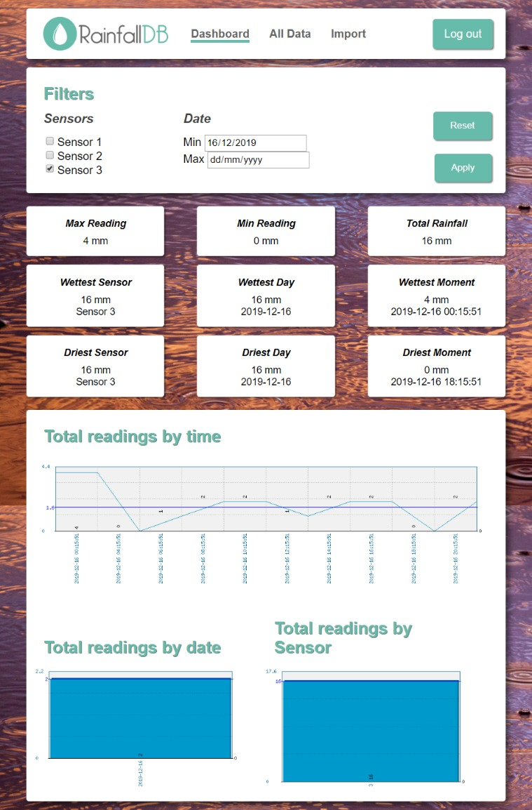
Fig 9 – main page displayed on a smaller screen

All Data

This page displays a different view of the data contained within the database, returning results in a table. This allows for a few extra filters to be applied: min and max values and an order option. The min and max values input is sanitised to remove characters that are not either a number or the + or - symbols to prevent rogue data being added to the query, an excerpt is shown below:

if(isset($_POST["valuesmin"])) {
$vmi=filter_var($_POST["valuesmin"],FILTER_SANITIZE_NUMBER_INT); //Sanitize input to only return number variable and + or -
$d++;
}

As on the main page, PHP is utilised within the form to retain any values already applied by the user, however a ‘human readable’ version is also generated and echoed above the table to make this clearer. Also similar to previously a section of PHP code using further nested if statements is used to generate the relevant SQL query, however this is not stored in the session cache as there is no need for the string outside of this webpage.

The user can combine any of the filter fields to generate a query, for example searching for results from Sensor 1 & 2 with a maximum value of 4 after 15/12/19 ordered by values high to low would generate the following query:

SELECT * FROM rainfalldata WHERE (sensorno LIKE '1' OR '2') AND (thevalue <= '4') AND (thedate >= '2019-12-15') ORDER BY thevalue DESC

The user would see (fig 10):

Showing all readings from sensors 1 & 2 with values equal to or below 4 recorded on or after 2019-12-15

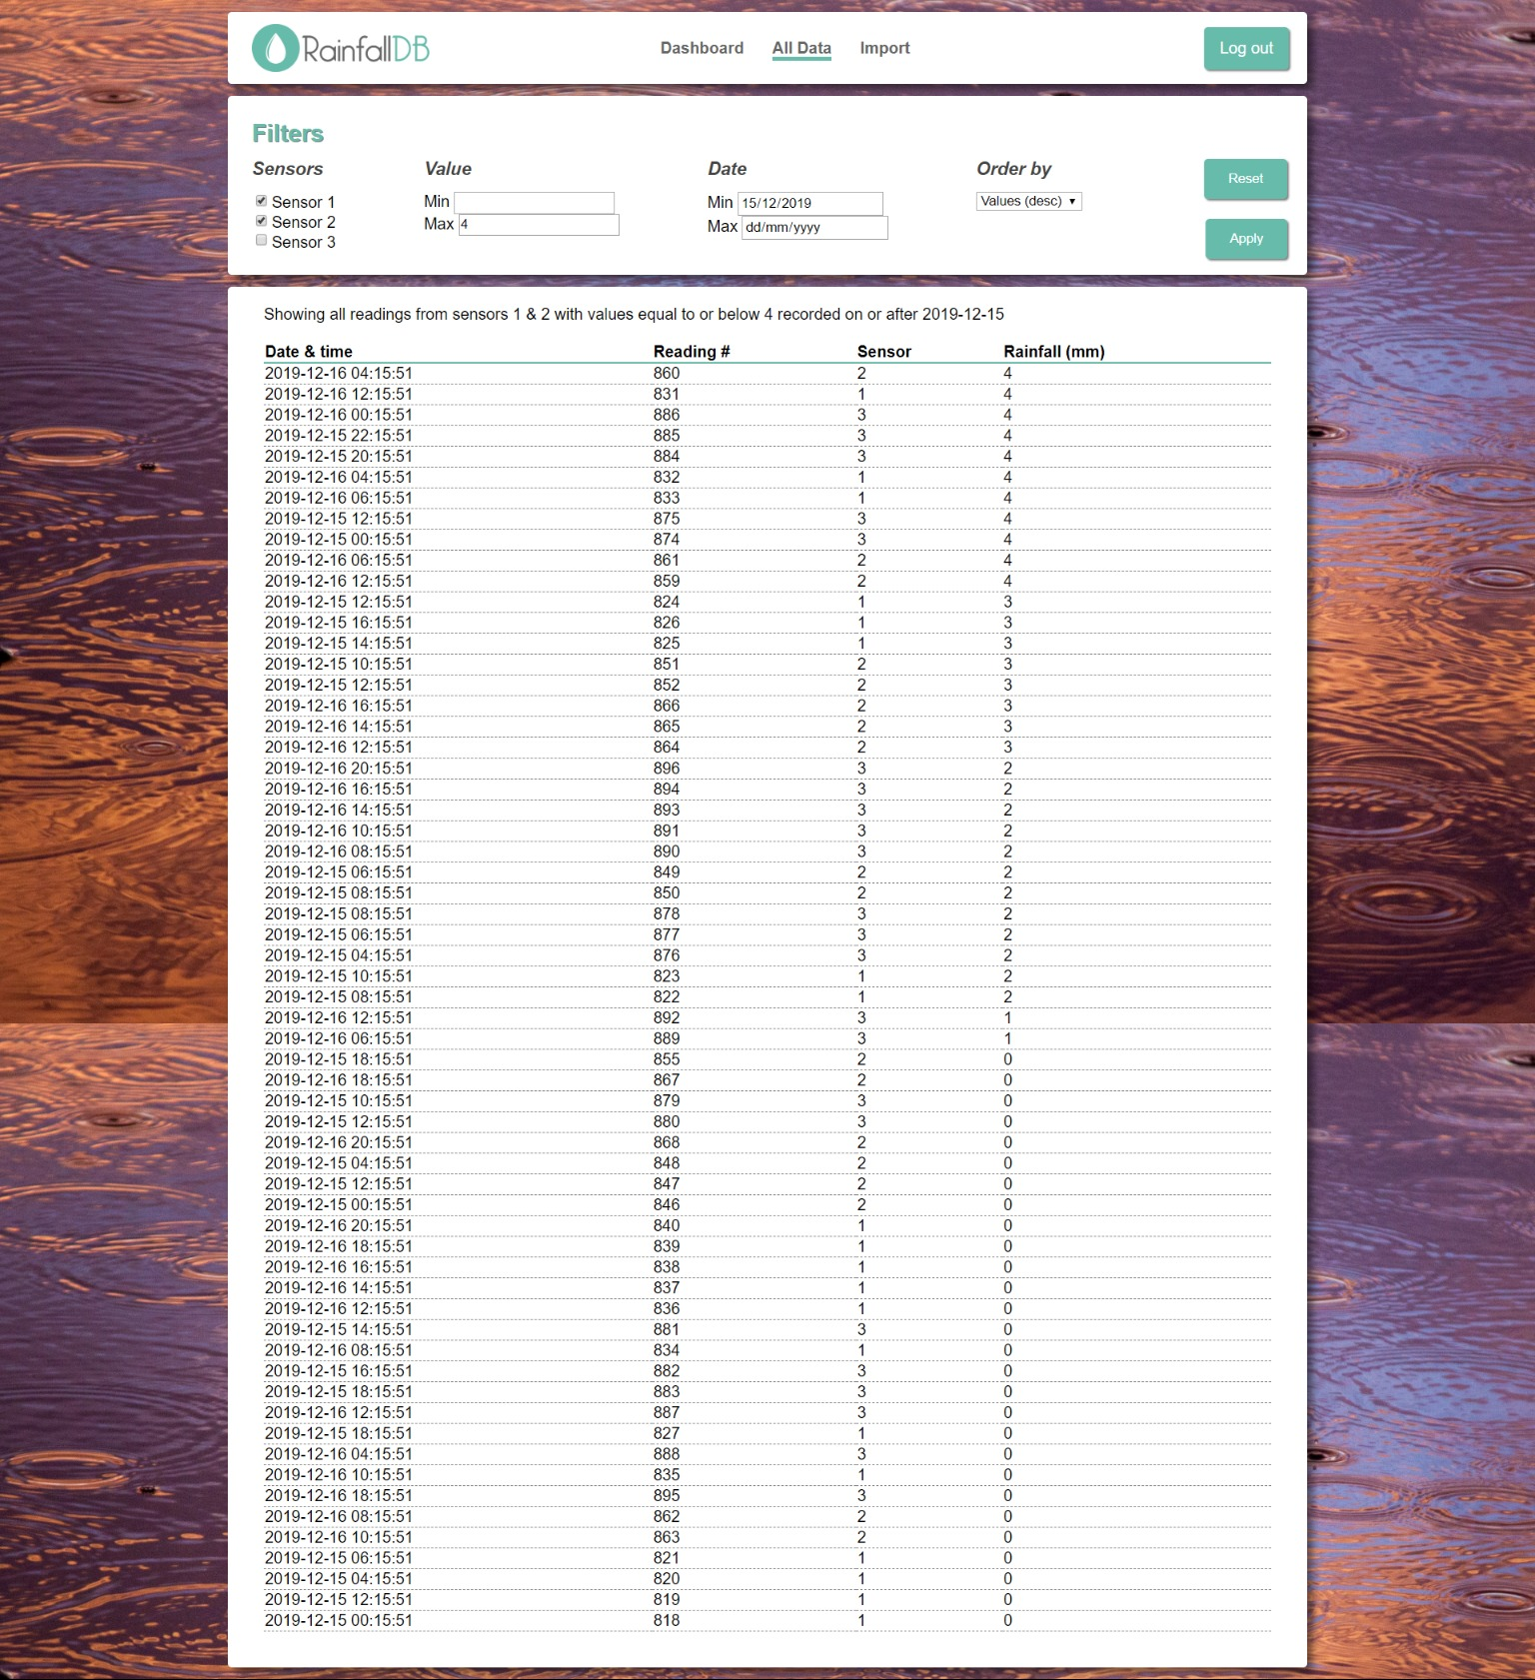
Fig 10 – all data page with filters applied

Data can be reset by using the button provided in the filters box which will refresh the page with no filters applied.

Results are displayed to the user in full in an easy to read table. Where there to be more data in the future, I would add page navigation here to prevent slow down and excessively long pages.

Log Out

Once the user has finished with their session, they can use the ‘Log Out’ button available in the top right of any page, which will run a PHP file clearing the session cache before returning the user to the login page.

