The impact of COVID-19 on SMEs:
An exploration of the impact of COVID-19 on Physiological needs of the owners of the Gym Sector in East London, UK

Abstract

Covid -19 has developed immense impact on different industrial sector globally due to different
restrictions and rules. The main purpose of this study is to evaluate the impact of covid-19
pandemic on the gym industry of the UK. The owner of gym and fitness centre of the UK has faced
challenging factor such as lack of clients for restriction and social distancing. This study has
focused on the effective strategies that are effective for mitigating the challenges faced by gym and
fitness industry of the UK. Supporting the owner gym and fitness companies in terms of
psychologically is an effective strategy that has been analysed in this study. The data has been
collected through mixed method which has utilised both primary and secondary method for
collection of information. This research has implemented epistemological philosophy and inductive
approach for completing the study and these techniques has helped the researchers to collect valid
and reliable findings. This can be found and summarized from this study that there has extend
impact of psychological support to gym and fitness owner of the UK to overcome the issues of the
covid-19.

Summary
Chapter 1: Introduction 5
1.1. Introduction 5
1.2. Background of the Research 5
1.3 Research Problem 6
1.4 Rationale of the Research 6
1.5 Research Aim 6
1.6 Research Objectives 6
1.7 Research Questions 7
1.8 Significance of the Research 7
1.8. Structure of the Research 8
Chapter 2: Literature Review 9
2.1 Concept of Covid-19 9
2.2 Impact of Covid-19 on SMEs 9
2.3 Impacts of Covid-19 on the gym sector of the UK 10
2.4 Theoretical aspects of physiological needs 11
2.5 Conceptual Framework 13
2.6 Conclusion 13
Chapter 3: Research Methodology 14
3.1. Introduction 14
3.2. Research Philosophy 14
3.3. Research Approach 14
3.4. Research Strategy/Design 15
3.5. Data Collection Techniques and Tools 15
3.6. Sampling, Sampling Techniques and Population 15
3.7. Data Analysis methods 16
3.8 Ethical consideration 16
Chapter 4: Findings and analysis 17
4.1 Introduction 17
4.2 Result 17
4.3 Primary data analysis 18
4.3.1 Critical contribution of the gym and fitness industry in the UK 21
4.3.2 Negative effect of covid -19 on the gym and fitness sector in the UK 21
4.3.3 Performance of the gym and fitness industry towards increasing consumers' behaviour 23
4.3.4 Strategic recommendations for repositioning of the fitness industry 24
4.4 Summary 25
Chapter 5: Conclusion and recommendation 25
5.1. Introduction 25
5.2. Linking of objectives 26
5.2.1 Linking with objective 1: “To critically analyse the concept of the COVID-19 pandemic and its subsequent impact on the SMEs” 26
5.2.2 Linking with objective 2: “To identify and analyse the various impacts of the COVID-19 pandemic on the physiological needs of the gym owners/managers” 26
5.2.3 Linking with objective 3: “To develop and present a framework for discerning the various impacts of the COVID-19 pandemic on the gym owners/managers” 27
5.2.4 Linking with objective 4: “To present recommendations regarding various physiological needs for the gym owners/managers for improving the performance levels of the gym and fitness industry” 27
5.3. Recommendation 27
5.4. Future Scope 28
5.5 Research Limitations 28
Bibliography 30

Chapter 1: Introduction

1.1. Introduction
The Gym industry specifically considered the various “small” and medium-sized enterprises in the UK has ensured the considerable decline in the pandemic. Growing lockdowns and the forcing closure of the diverse facilities across the globe have initiated the spread of being aware and fit and it has also been recorded that, whereas in the pre-covid era it was found that, 8.2% of the people thought gyms to be the most credible option, 6.8% people of UK have opined the same in the post-pandemic timeframe. Moreover, reports suggest that the gym and fitness sector in the UK stood at a valuation of almost 1.79 billion pounds, on the verge of growing by almost 32% in the same year.
This exponential growth in the sector has created various opportunities for gym owners and services’ providers in the fitness sector. However, the increasing demand had also created some physiological needs for the gym owners, especially for becoming capable of capitalising on the opportunity. For example, the need for additional funding, infrastructure, professional help, and others are being required by the gym owners for meeting the increasing need. This has limited the operational flow and accessibility of the people to a greater extent. The purpose of the paper is to find out the challenges that have considerably affected SMEs specifically that of the gym sector in the UK followed by the recommended strategies that have limited the growth and development of the same over a certain period.

1.2. Background of the Research
Due to the growing prominence of the pandemic, the growth and development of the Gym sector in the UK have considerably been declined over time as the ability to mitigate the changing demands has swiftly dismissed. Adding to this, the imposed restrictions have prevented access to the range of exercise facilities so that the physical activity level and mental health of the people in the country can be potentially maintained. Furthermore, the engagement in the physical activities has also ensured the intensity of the activities engaged in it and the psychological as well as behavioural health of people have significantly declined (Al-Fadly, 2020). The consumers' behaviour, as well as the requirements, have drastically changed with the changing trends of the market. Regular physical activities have also been potential to enhance the significant reduction of the risks specifically in the time of Covid and post covid scenarios.
For example, as per the “State of the Fitness Industry” reports of the “Leisure Database Company”, in the year 2022, researchers have implied that the gym and fitness sector is in “good shape”, taking into considerations regarding the impacts of the pandemic. The reports suggest that the gym and fitness centres in the UK, in the year 2022 were at more than seven thousand. Despite the severe impacts on the industry due to the lockdowns and travel restrictions implemented in the wake of the pandemic, the industry has been witnessing a resurgence due to changes in consumer behaviour. According to Omar, Ishak, and Jusoh, (2020), consumers in the UK have started perceiving gym and fitness services as necessities instead of luxuries, thus creating more demand for such services. This in turn has created more opportunities for the gym owners to capitalise on the growing demand, albeit by addressing some physiological needs like additional funding, customer acquisition and others.

1.3 Research Problem
This literature review was conducted by analysing research papers of different scholars and academics. But there exists some gap in this review. In the future, if any other pandemic happens how to overcome the situation is not discussed. How the industry can elevation itself in the market on a large scale is also not discussed. What might be the upcoming future of the economy is also not discussed.

1.4 Rationale of the Research
This research has intended that the impact of Covid 19 has been detrimental to the fitness industry to the extent that, it has completely transformed the industry in terms of its growth and development largely. The considerable shutdown of the service industry specifically that of the gym and fitness one has deciphered the considerable decline in terms of their operational flexibility. This has also caused the fitness industry of the UK to be losing brand loyalty and prominence. Therefore, the rationale of this research is to gauge the impact of the covid 19 pandemic on the fitness industry followed by a range of recommendations that can help them reposition their standards of operations to a greater extent (Juergensen, Guimón and Narula, 2020).

1.5 Research Aim
The aim of this research is to explore the impact of COVID-19 on Physiological needs of the owners of the Gym Sector in East London, UK

1.6 Research Objectives
- To critically analyse the concept of the COVID-19 pandemic and its subsequent impact on the SMEs
- To develop and present a framework for discerning the various impacts of the COVID-19 pandemic on the gym owners/managers
- To identify and analyse the various impacts of the COVID-19 pandemic on the physiological needs of the gym owners/managers
- To present recommendations regarding various physiological needs for the gym owners/managers for improving the performance levels of the gym and fitness industry

1.7 Research Questions
What are the impacts of the Covid-19 pandemic on the physiological needs of the gym owners in the fitness industry in the United Kingdom?

1.8 Significance of the Research
The research is significant as the covid 19 has been one of the most detrimental concepts for the globe. The entire gym and fitness industry of the UK has been confronting complexity regarding the growth and development of the sector. The detrimental impact of the covid 19 and the resultant restrictions and lockdowns have restricted the people from access to such utility sectors (Omar, Ishak, and Jusoh, 2020). Followed by this the consumer's behavioural approach has also evidently been changed. Therefore, to link these two concepts, the research is significant. Moreover, the research also tries to identify the physiological needs of the gym owners, especially in the wake of the Covid-19 pandemic, for being able to cope up with the rising demand for services. For example, the research will be instrumental in identifying the need for funding, customer acquisition, infrastructure, and others.

1.8. Structure of the Research

Figure 1.8. Structure of the Dissertation
Source: Researcher

1.9. Conclusion
The purpose of the chapter is to focus on the impact of the Covid 19 on the SMEs with the critical focus on the Gym and fitness industry to a greater extent. This paper has considered the challenges that the UK fitness industry has been faced with the key mitigation strategies.

Chapter 2: Literature Review

2.1 Concept of Covid-19
In early 2020 the world got introduced to an infectious disease named Covid-19. First, it was found in China. Then within a few months, it got spread around the world. SARS-CoV-2 is the virus responsible for this disease called Coronavirus Disease (COVID-19) which is also infectious in nature. Infectious means it can be spread from one person to another. This virus utilizes people`s coughs, sneezes, speaking, singing, or breathing to spread in the form of small liquid particles coming out of the nose and mouth (Rawaf et al., 2020). At the starting time, it was an epidemic. But when it started spreading like wildfire, WHO decided to declare this disease a pandemic in the month of March 2020. As a result, guidelines were made to restrict the spread of this virus. Consequently, people`s movement was obstructed which had a huge impact on their lifestyle. At that time, it was uncertain whether it will be possible to mitigate the virus or not. For this reason, lockdown guidelines were published (Al-Fadly et al., 2020). People started fearing going outside, at the same time they were also tired of staying home. As a result, this situation adversely affected their mental health. Moreover, this mental health issue was the reason behind the unintentional behaviour of people for fitness routine and going to the gym in public.

2.2 Impact of Covid-19 on SMEs
Because of Covid-19, every business got affected all over the world. MSME is not an exception to this, its economic life was also got affected by this infectious disease. The shift from normal life to covid life was very unexpected. This unexpected shift in demand, supply, product distribution, and consumer behaviour has hugely impacted and in many places destroyed the MSME all around the world. Consumers around the world were also victims of this pandemic. So, every business lost its many consumers (Moustakas et al., 2020). In addition to that, there were other problems like unavailability of raw materials and imports & export because of this economic failure. As lockdown was running at that time and people`s movement was restricted which created a mental issue causing diminishing the performance of employees. That was a situation where the economy was going down as a result many people lost their job which created more mental issues. The demand had fallen drastically. As a result, many companies were forced to pull out of the business (Omar et al., 2020). As the future of this disease was uncertain the SMEs started to invest their money more cautiously. But by doing this they were losing their opportunity to expand their business. Therefore, the demand for SME goods started falling. Here the big companies started taking over the market of the SMEs. Because of this during the pandemic period, SMEs got a huge loss at the same time the big companies flourished. Not only the SMEs which were owned by individuals but also all SMEs around the world got affected by this pandemic. The disease started spreading from one continent to another. When people of any country get infected by any pandemic it refers to a huge loss for the country`s economy. In this case, also the strong economic countries like China, USA, EU which are known for their big import and exports stopped their cross-border trading. As a result, a huge demand was created among the countries, but no solution was there as the import and export is stopped. But the most adverse impact of this was on MSME. Because they lost experienced consumers and good suppliers.
As a result, all businesses started to change their business strategies. They started investing in particular things thing which they believe can return them a good amount of capital. This also created a chance for innovation in the business strategy. Earlier the business of SMEs was restricted to their zonal areas. But in this pandemic, everything was changed forcing them to change their strategy. They decided to spread their business globally to sustain themselves in the market. They started to use the innovative business tool and innovative marketing strategies. Although every MSME sector was affected by this economic drawdown industrial sector was the only sector proven to be unaffected by this pandemic (Davillas et al., 2020). The demand for the industrial sector never goes down. This is the reason why this sector did not change its strategies much compared to other businesses. This is a fact of business that big business gives their work to small enterprises to do for them which is called subcontracting of work. This is the major source of income for the SME. At this time when every company was struggling with the uncertainty of the future, the SME had a huge chance of going through this tough situation. The SMEs did exactly the correct thing by adopting the correct measures to sustain themselves in the market.

2.3 Impacts of Covid-19 on the gym sector of the UK
Generally, the gym sector in the UK is a profit-making sector. But when the pandemic came even this sector`s profit was declined. It is evident that the percentage decline in its business is 39.5% in the year 2020-21. Though this sector had managed growth of 32% in the current year still its revenue is expected to decrease at a compound interest of 0.9% over the year 2020-21 which amounts to $1.8 billion. The routine of every individual around the world got changed because of this pandemic. Particularly the individuals engaged in fitness activities and gyms have changed their lifestyles dramatically (Dedryver et al., 2021). Some people quit doing fitness activities, some started gyms inside their homes to avoid the contamination from this disease. Which all together resulted in a loss of the gym industry.
As the routine of people has changed when the gym will reopen the possibility of people coming back in number as earlier is very less (Robinson et al., 2020). This suggests a future loss for this industry. But the gym industry also showed some innovation to sustain itself in the market and to satisfy customer needs. They started online sessions which is satisfactory for both the parties. Now people can stay at their homes and continue their gym sessions. At the same time, the gym industry can also elevate itself. By doing so many gym businesses got spread to more people because of their availability in online mode. That gave this sector a huge chance to reach more individuals. This is a way to get back its prior income before Covid-19. At the same time, it has a chance to flourish more than ever (Lu et al., 2020).

2.4 Theoretical aspects of physiological needs
Maslow presented a theory to define the hierarchy of needs. The theory presented the needs of an individual in the form of a pyramid. Here at the bottom of the pyramid, there is the basic needs. Going to the top the theory started filling high-level and intangible needs. According to the theory, a person starts from the bottom satisfying his/her basic needs (Tinson et al., 2020). One can only go to a higher level when the basic needs are satisfied. For example, these “needs”, like need for food, clothing, shelter, and others from the bottom right to the top are the “physiological” needs, the “safety” needs, belongingness needs, the “esteem” needs, and the “self-actualization” needs.
Physiological “needs” are the most elemental “needs” like food, clothing, and shelter. In this pandemic situation, most of the individuals got adversely affected economically. During this time many people struggled to manage their basic needs. So, in this situation when people cannot manage their basic needs, it is not possible to go to the gym and do fitness activities. Thus, this situation also affected the gym owners as their customers gone decreased in number (Žukauskas, Vveinhardt and Andriukaitienė, 2018).
Everyone is conscious of their safety. So, in the Covid situation, people do not want to risk their life by going to the gym and exposing themselves to infectious diseases (Gregurec et al., 2021). This safety needs could not have been satisfied by the gym owners. This results in a huge loss of the gym owners.
People care for their love and belongings more than themselves (Yue et al., 2020). If they go out to the gym and get infected with covid then it will be harmful to not only them but also to their loved ones. This was another reason for quitting the gym for many individuals which resulted in a loss for the gym owners.
Esteem need is also a factor in the loss of the gym industry. In this pandemic situation, many people who are economically stable managed gym equipment to not go to the gym with other people. This is also a cause of failure of this industry as their base got decreased.
Another major aspect of need is self-actualization needs. Many people who used to go to the local gym before the pandemic, started online gym classes during the pandemic (Razumovskaia et al., 2020). This benefited gym owners who spread their business globally, but the local gym owners got affected.

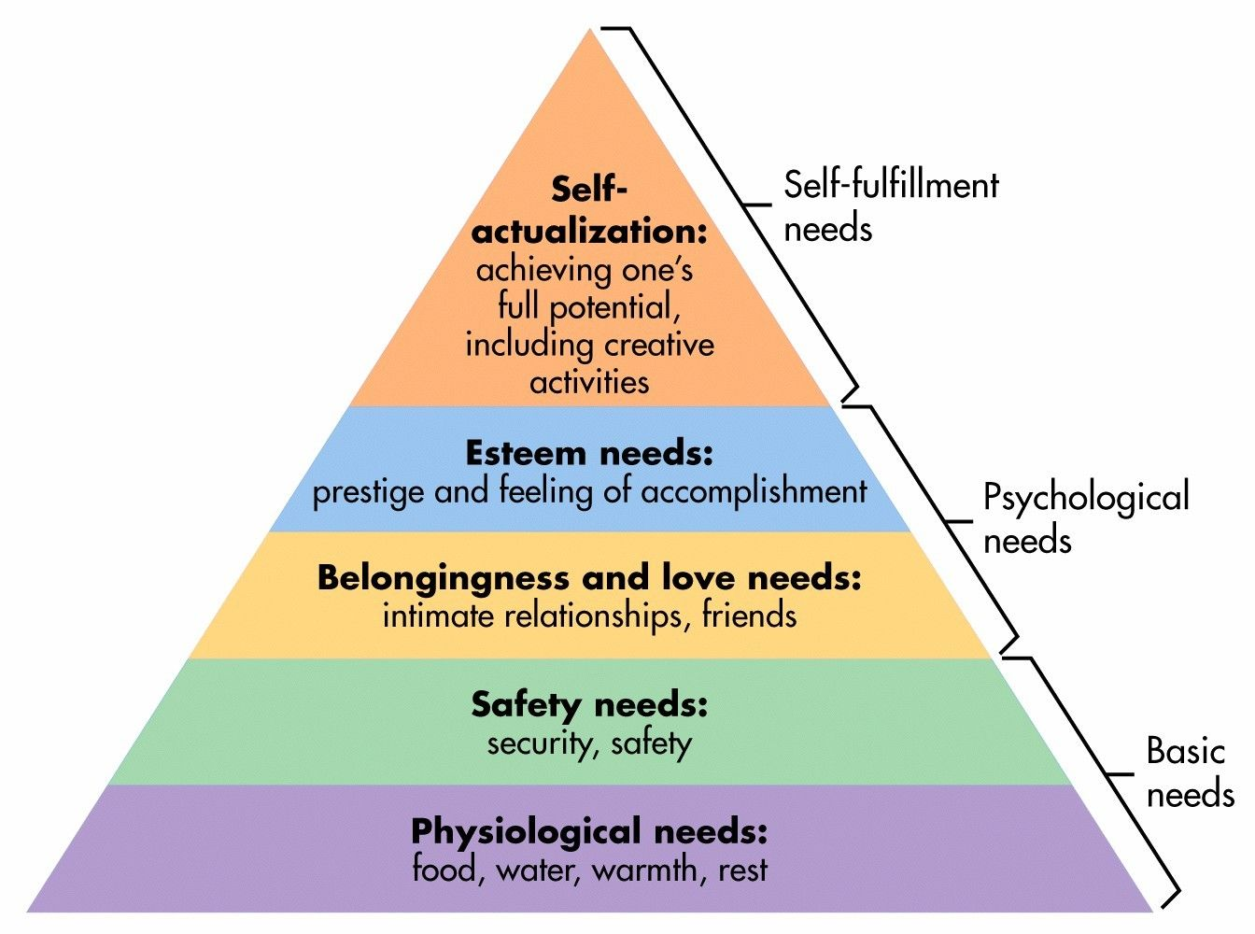
Figure 2.4: Maslow’s Hierarchy of Needs Pyramid
(Source: Tinson et al., 2020)

2.5 Conceptual Framework
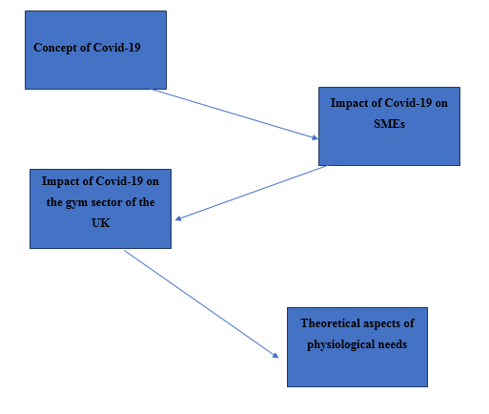

2.6 Conclusion
This chapter was focused on what was the various impacts of the Covid-19 pandemic on MSME and on the gym “industry” in the UK. The Covid-19 pandemic has impacted the whole universe in a different number of ways. Every sector is impacted in its own way. The review suggested that SMEs and the gym industry have struggled a lot to sustain themselves in the market. But it also created chances to use innovative ideas to sustain in the market and spread the business globally.

Chapter 3: Research Methodology

3.1. Introduction
This chapter focuses on discussing the range of methods that are utilized in the dissertation followed by the ways through which the study can be incorporated into the outcomes. This chapter includes a range of factors namely research approach, strategy, methods, design, philosophy, sampling techniques, and population, data collection and analysis tools and techniques, and ethical considerations along with the entire process through which the research can be effectively carried out. This portion of the study also incorporates the proper and effective strategies that can ensure the effective data collection methodology to be applied potentially in this study.

- Research Philosophy
- Research Paradigm
- Research approach
- Research Methods
- Research Strategies
- Sampling, Sampling Techniques and Population
- Data Collections Tools and Techniques
- Data Analysis Techniques
- Ethical Considerations

3.2. Research Philosophy
The research philosophy for this study has been used as epistemology. The philosophy has been potential to enhance the theory of knowledge to a great extent. In addition, the selected philosophy for this study has also increased the consciousness of the learning procedures for the personal as well as the professional growth of the audience through the research (Žukauskas, Vveinhardt and Andriukaitienė, 2018). The researcher used this philosophy for framing the research strategy and relating the concepts to the study object, which in this case happened to be the impacts of the pandemic on the physiological needs of the gym owners.

3.3. Research Approach
The research approach for this study has been used as inductive. This approach has been selected for this research because it incorporates as well as provides flexibility as well as information variety that supports the generation of the new theories. Along with this, this research approach also has the limitation of resource scarcity along with the positive benefit that there is no shortage or limitation of time in terms of leading this study to outcomes. The researcher chose the inductive approach as it allowed the researcher sufficient flexibility and the opportunity to closely attend to the study contexts and supporting the “generation” of new insights regarding the physiological needs of the gym owners in the wake of the Covid-19 pandemic.

3.4. Research Strategy/Design
The research strategy that has been considered for the study is the exploratory research strategy. The use of the explanatory research design helped the researcher in generalising the research findings to a great extent and explaining the various “casual” co-relations between the main variables and the key concepts (Oliva, 2019). Moreover, it helped the researcher in bringing new ideas and insights regarding the impact of the pandemic on the physiological needs of the gym owners, especially regarding the changes in consumer behaviour and changes in the micro and macro business environment.

3.5. Data Collection Techniques and Tools
The data collection tools and techniques that have been utilized in this study are the semi-structured interviews. This is because, the semi-structured interviews have a potential way to understand the unbiased responses from the respondents, has been utilized by the researcher at large. Besides, this being advantageous to the opening of respondents towards the sensitive issues has ensured the relevance of the future data for further research (Bloomfield and Fisher, 2019).

3.6. Sampling, Sampling Techniques and Population
The sampling method that has been followed in the research is random sampling. The use of the random sampling method ensured that all population groups were given an equal opportunity at representation. However, due to come constraints, the sample size had been kept at 10 (Braun, Clarke & Weate, 2016). With a key sample size of 10 participants for the semi-structured interviews, this research has been specifically dependent on the gyms in East London. The owners of the gyms being interviewed, out of the 10 owners the purposive sampling have ensured the researchers in the data extraction followed by the broader impact of the results on the common public.

3.7. Data Analysis methods
An exploration of the impact of covid 19 has utilized the qualitative and quantitative research and thus this paper has followed the primary data analysis and the thematic analysis to a greater extent. Along with this, Abraham Maslow's hierarchy theory has been incorporated into the entire research (Braun and Clarke, 2006). For the research on the impacts of Covid, the focus of the researcher has been on the primary as well as the secondary data sets that have been collected through either the semi-structured interviews or the secondary data that have been gained through the website’s journals and the books to a greater extent (Mishra, et al., 2019). The use of thematic analysis allowed the researcher in avoiding preconceptions and generating recurring themes and patterns in the study (Braun and Clarke, 2006). For example, the method of thematic analysis involves familiarisation with the key concepts, generating key themes, reviewing the themes, naming, and defining the themes and writing on the themes, for answering the research question.

3.8 Ethical consideration
The research made some ethical considerations while conducting the research. For example, the research made proper citations for the researchers, authors, and others from whose works the secondary data and key pieces of literature were collected (Braun, Clarke & Weate, 2016). Similarly, to avoid issues regarding IPR infringement and academic misconduct, the researcher adhered to the “Data Protection Act (2018)”. The researcher also avoided making any biases or manipulating the outcomes of the study.

Chapter 4: Findings and analysis

4.1 Introduction
Semi-structured interviews have the major significance in the primary qualitative research to achieve conversational outcomes from the responses of sample individuals. It represents a set of questions for analysing the outcomes regarding the topic through using open-ended questions. Open-ended questions help to describe the view of sample individuals without biases and any restrictions. It also provides the freedom to express the view of interview participants. Hence, the effectiveness of semi-structured interviews is high in research methods.

4.2 Result
This research uses 10 sample individuals for getting responses about the effect of the covid-19 on the UK gym sector. Therefore, sample individuals are selected by the random sampling process from the fitness sector in East London. Purposive sampling ensures 10 owners from the UK fitness and gym sector for the semi-structured interview in this research. Questions are formed from the basic aspects of this research such as the financial impact of covid on the UK economy, the effect of covid-19 on the gym sector, and many others (Omar et al., 2020). The 6 interview questions are formed based on the research needs hence, the interview transcript describes the responses of 3 participants on 4 questions according to their views.
Interview transcript
Semi-structured questions | Responses 1  (Participant 1) | Responses 2  (Participant 2) | Responses 3  (Participant 3)
What is the major impact of the covid on your gym business? | Major economic crisis is observed. | Economic and employee management issues are increased. | The business closed at the time of covid.
What is covid-19 teaching businesses about online marketing? | Online advertisement helps to increase customers in after covid situations. | We give training to employees regarding online sessions. | We give offers on social media such as coupons, discounts and doctor consultation facilities through the social media sites.
How come gym businesses give better results even in a crisis such as the pandemic? | Strategic business management | Better use of the online activities such as online advertisement to grab more customers | Making a suitable strategy is necessary for online trainers to advise people
Did you get the same number of customers in the post-covid market? | No, the numbers are reduced. | Customer number reduced from previous | Customer number increased
Table 4.1: Interview transcript
(Source: Learner)

4.3 Primary data analysis
Primary data analysing using thematic analysis such as making themes as per the research questions, help to align these with the responses of sample individuals. Secondary thematic analysis is also beneficial for evaluating the responses from secondary resources (Mishra, et al., 2019). Hence, responses from 10 sample individuals are critically analysed by supporting the literature from the secondary resources.

Interview questions
- Demographic questions.
- What is your name?
- What is your job role?
- What activities do you do?
- How long are you working here?
- What are your experiences here working as a manager/……?
- Questions related to Covid-19
- Can you tell me something about Covid-19
- What are the impacts of Covid-19 on business in general?
- Did Covid-19 impact your gym? If yes, can you tell me more about it with some examples, please.
- Questions related to Physiological needs and recommendations
- Do you think Covid-19 impact on people’s physiological needs? If yes, then what are they and how were they impacted?
- Were your physiological needs impacted by the Covid 19? If yes, can you tell something about it, please?
- What would be your recommendations to deal with impact of Covid -19 on people’s physiological needs?

Interpretation of survey questions: The survey questions have included three parts which
are related to demographic questions, questions related to covid-19, and questions about
recommendations and the need for psychological support. The responses of this survey have
provided enough data which are highly associated with the importance of psychological
support for humans during covid-19 and support of gym owners in the UK during a covid-19
pandemic. The demographic questions have been added regarding the personal information
the participants which are as name, duration of working experience, job role type in the
gym, and relationship with managers. Along with answering these demographic questions,
the participants answered questions regarding the situation during covid-19 in the UK. The
questions in the section on the impact of covid-19 have captured some essential questions.
These questions are regarding the impact of covid19 in general business over the world and
in the market of the UK.
One question was about the generation of information about the thoughts of the participants
regarding covid-219 and this is beneficial for understating the perception of participants.
Most of the participants have answered that this covid-19 has developed a negative impact on
the general business of the UK along with the whole world. Another question has been asked
to participants in this survey is regarding the impact of covid-19 on the performance of the
business industry of the UK. The participant&#39;s answered that during the pandemic this has
developed loss and a lower range of profit in the gym industry due to managing social
distance and personal interaction.
In the third section, the participants have been surveyed regarding the importance of
psychological support and the essence of this to human life. During covid-19 the human has
facade different psychological lowness and issues due to several crises. This is important for
humans to gain support psychological as this helps them to restore their power and self-
esteem. The participants responded with positive replies that this is essential for humans to
get psychological support to deal with issues and crises in life and during covid-19 there have
several issues. This is a major factor in mitigating and dealing with these issues the human
will need to gain psychological support.

The participants have answered mostly that they also must need psychological support
during the pandemic of covid-19 and in this question; they agreed that fact that this helps
humans to manage the issues. The participants have been asked to say some
recommendations to deal with issues and develop psychological strength. The gym owner of
the UK has faced an issue during this pandemic and analog with this sector other business
owner has facade issues regarding leakage of psychological strength. These survey questions
have helped the researchers to gather information regarding personal thoughts about the
importance of psychological support to a human and the importance of this support during the
pandemic in the UK. Through collecting the data of respondent participants, the researchers
have gained the ability to analyze the research information in terms of analyzing the research
topic of the impact of Covid -19 on the importance of psychological support for gym owners
of the UK.

As per the survey questions and answer to questions below interpretation is given

4.3.1 Critical contribution of the gym and fitness industry in the UK

The economic contribution of the gym and fitness industry is high, secondary resources help to describe the impact of the gym industry on the economic growth as this industry helps to maintain many other industries such as film, fashion, and many others. Therefore, this industry has the major contribution to employment and economic stability. However, the global pandemic reduced the effectiveness of the offline gym facilities due to the high level of covid pandemic threat and the anxiety among people due to the effect of super spreader SARS-CoV-2 (Moustakas et al., 2020). Semi-structured questions help to analyse the concern of UK gym owners (10 sample individuals) about the covid-19 effects has on their businesses. Questions regarding the profitability of the gym business are effective to analyse the economic benefits in the fitness sector. More than 6 participants gave positive responses regarding the high economic profit level in the gym businesses before starting the negative effect of the global pandemic. On the other hand, 2 participants stated that they observed lower profit levels from the gym business even in the pre-covid situation and both owners are from the start-up gym company in East London. Hence, most of the secondary resources and the primary responses reflect the high level of economic profit in the gym and fitness sector that helps to increase the economic stability and the employment in East London.

4.3.2 Negative effect of covid -19 on the gym and fitness sector in the UK
Global pandemic affects the economic segment due to lack of business propagation, supply issues and low market demand. Hence, different industries highly suffered from the negative impact of the covid-19 (Davillas et al., 2020). Primary data collection from the interview describes the impact of economic effects as well as other effects in the gym and fitness sector. As per the responses from semi-structured interviews, 40% of participants stated about major economic crises in their business during the global pandemic. On the other hand, 30% of gym owners stated that their gyms were totally closed due to pandemic effects such as lack of employees and the presence of restrictions. However, 30% of other participants also stated about the economic crisis and the employee issues during the pandemic which reduced the online training options also. Therefore, the pandemic impacts in different ways such as reduction of the financial stability, reduction the business operations from offline fitness sectors and increases complications due to lack of fitness coaches in gyms for online training also.
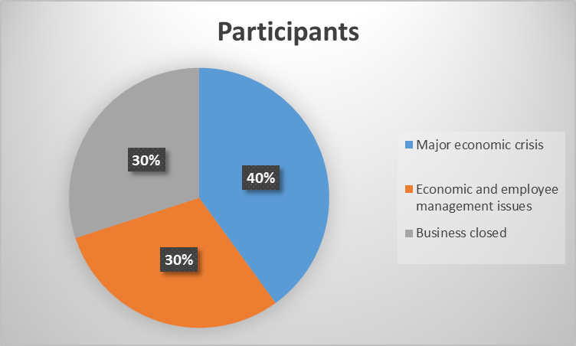

Figure 4.1: "What is the major impact of the covid on your gym business?"
(Source: Excel)
Responses from participants help to recognise real-life ideas from the UK gym and fitness sector. Hence, secondary data reflects many other issues such as supply failure impacts the transportation of gym materials for training which impacts the after-covid gym business in the UK. On the other hand, customer numbers are reduced as covid attached to people and that is responsible for the death of many people hence, overall customer numbers are reduced due to the hard effect of the global pandemic (Robinson et al., 2020). Therefore, the impact of the global pandemic is multidimensional which affects the startup gyms as well as long-run gyms too. Therefore, the outcomes from primary data analysis and secondary data sources that meet the objective of the research also give answers to research questions.

4.3.3 Performance of the gym and fitness industry towards increasing consumers' behaviour
Consumer behaviour analysing and strategic business activities are valuable for managing the profit level and increasing operational effectiveness. Hence, the questions based on the performance and the consumer behaviour management get both positive and negative responses (Lu et al., 2020). The question regarding learning from the risk of covid is most effective to understand the risk management strategies of gym owners for managing the business activities and reducing the issues strategically. As per responses from 30% of participants, online advertisement increased in their gyms for regulating the customer numbers in post-covid situations. On the other hand, 20% of participants focused on the employee training programs for regulating their online advertisements and online gym for stabilising the operations in this sector. However, 50% of participants have the view about the effectiveness of the online marketing such as using the social media channels for enhancing the customer numbers and regulating the business actions as per needs.
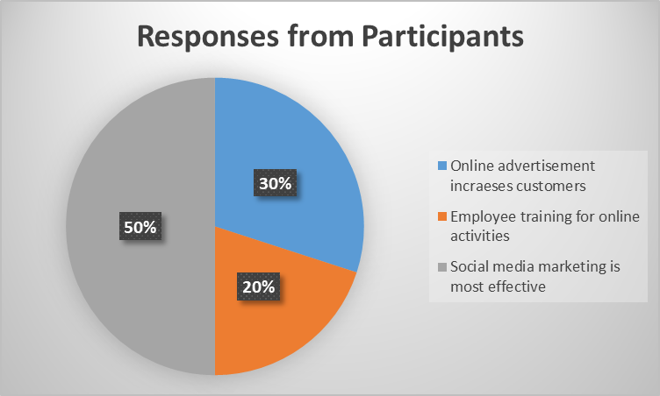

Figure 4.2: “What is covid-19 teaching businesses about online marketing?”
(Source: Excel)
Therefore, covid-19 impacts negatively on businesses hence, it helps to develop new business techniques and ideas such as online operations and skill development of employees for managing online-based marketing and online sessions for customers of all ages. Consumers focus on the governmental restrictions and the health assurance to reduce the chance of disease transmission and therefore, businesses also adopted the nature of operations from offline to online modes (Ong et al. 2021). Pandemic crisis helps to increase the leadership and the skills of employees as well as leaders in gum businesses to manage the operations strategically for increasing profits and reducing competition from the UK market.

4.3.4 Strategic recommendations for repositioning of the fitness industry
Repositioning is the most effective term in businesses to make changes in operational activities and enhance the business progress using the strategic planning. Hence, most businesses adopted the online-based operations even within gym businesses (Chakraborty et al. 2021). The question regarding the better outcomes even in the crisis period reflects the strategic business activities which help to make more profits and gain brand value during the crisis period. More than 20% of participants give responses regarding strategic business management using the support group for people in the crisis which help to enhance the customer loyalty to the business. On the other hand, 40% of business owners among participants stated the importance of online support groups and fitness coach facilities at huge discounts. Hence, community support and mental support to customers during the global pandemic enhance the brand value which can help to increase customer numbers and brand position in post-covid situations (Nyenhuis et al. 2020). However, 40% of participants stated the importance of online training sessions for physical and mental support of people with physical and mental issues. Hence, online-based supportive activities are valuable for gaining customer trust and customer loyalty.
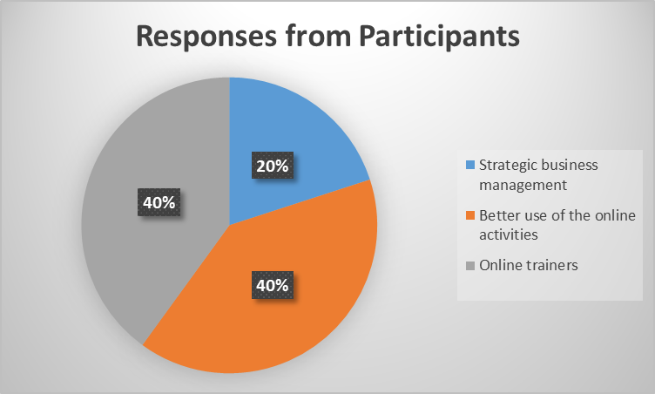

Figure 4.3: “How come gym businesses give better results even in a crisis such as the pandemic?”
(Source: Excel)
However, secondary data analysis is also effective to understand other types of recommendations for managing the future industry growth in the fitness sector. Hence, strategic business regulations using the online advertisement with other types of facilities are beneficial. Different types of discount-giving facilities, suitable monthly schemes, online coaching sessions, and collaborative physical and mental support through giving the facility of doctor consultation are valuable (Chakraborty et al. 2021). Hence, secondary data analysis and primary data-based analysis using semi-structured interviews reflect the importance of strategic business management in the fitness sector to regulate the growth through ensuring customer satisfaction, skill development of employees and managing the online operations for future profits. Therefore, these outcomes meet the objectives and ensure the answers to research questions regarding recommendations.

4.4 Summary
Primary data analysis from the semi-structured interview of 10 sample individuals is valuable for increasing the awareness of digital business progress. Strategic business management, online business activities, leadership and skill development are highly focused on the outcomes of the primary data analysis. Hence, secondary data collection and analysis have major significance to increase ideas regarding the impacts, strategic business activities, risk mitigation plans and online business activities. Consumer behaviour management is necessary to increase the brand value and the profit level in the post-covid situation and hence, customer need analysing is essential using the online activities. Online advertisements using social media channels have numerous benefits such as increasing customers, reducing competitive issues and ensuring future business growth after huge losses in the global pandemic. Performance of employees is reduced in the global pandemic due to excessive mental strength hence, training-giving strategies help to maintain sustainability and increase the performance of the business in the fitness industry. Innovative marketing strategies have the major benefit in the modern business perspective using the online mode of operations with giving facilities for costumes to expand the business and enhance sustainability.

Chapter 5: Conclusion and recommendation

5.1. Introduction
This research has the major focus on the impact of the global pandemic on the UK SMEs especially in the UK gym industry due to the high level of pandemic issues such as high level of health issues, lack of cash flow, restrictions, and lockdowns. The impact of the SARS-CoV-2 increased the economic instability globally and therefore, the global economy critically suffered from the effect of the pandemic due to lack of supply, health issues and cross-border restrictions. Physiological needs are under the basic requirement as per the description of the Maslow's Hierarchy of needs theory. Business issues due to lack of customers and the social distancing increase the financial crisis in the UK gym sector. Therefore, this study has critically focused on the impact of the global pandemic on the health and financial segment of the gym industry and the recommendations for reducing the negative effects in the post-pandemic era.

5.2. Linking of objectives

5.2.1 Linking with objective 1: “To critically analyse the concept of the COVID-19 pandemic and its subsequent impact on the SMEs”
Covid-19 pandemic is created issues in the daily lifestyle of the country’s overall world, and this has developed due to coronavirus. This spread of this virus has created the symptoms of fever, colds, and other organ failure in effected individual. The literature review part has highlighted the major impact of covid-19 pandemic on SMEs in the UK and this industry has a direct impact on the growth of economy of the UK. On the other hand, SARS-CoV-2 is responsible for spreading the Coronavirus Disease (COVID-19) through coughs, sneezes, nasal droplets, and breathing from one person to another. Therefore, physical distancing was the primary key to reducing the spreading of the super spreader virus. Moreover, the employment rate has been reduced in this subsequence of pandemic of covid-19. This unemployment has a major impact on higher poverty and increasing healthy habits among people. The SMEs has faced valuable contribution to the economic growth and mental pressure due to this restriction and lower performance of employees and economic instability. Furthermore, lockdowns and the governmental restrictions reduce the economic stability in the UK gym and fitness industry. Employee cuts are also common and hence, this outcome links with the first objective.

5.2.2 Linking with objective 2: “To identify and analyse the various impacts of the COVID-19 pandemic on the physiological needs of the gym owners/managers”
As per the description in the Literature Review section, the UK gym industry deals with the physical fitness as well as increasing mental effectiveness through increasing a healthy lifestyle as per instruction of gym owner or instructor. Hence, lockdown and social distancing were major aspects to reduce the effect of the global pandemic. Lockdowns and social distancing completely reduce clients from gyms and therefore, the UK gym industry was critically affected by economic failure due to lack of cash flow. Therefore, the outcomes in this research meet the second objective regarding pandemic effects on the fitness industry in the UK. This pandemic has created the psychological needs of the owner of gym owner, and this is important to support them psychologically for mitigating the issues of the pandemic. The restriction and regulation of this pandemic has created isolation situation of the owner of the gym and due to this reason, this is important to provide them psychological support for increasing their motivation and deal with the situation of pandemic.

5.2.3 Linking with objective 3: “To develop and present a framework for discerning the various impacts of the COVID-19 pandemic on the gym owners/managers”
Global economic issues have been observed due to high levels of health hazards, and lack of market demand for many products and services such as physical fitness through getting fitness training from the gym. On the other hand, supply issues enhance the complication regarding production, operational effectiveness, and more. Therefore, the overall global economy suffers from the effect of the global pandemic and the fitness industry is highly affected by the restrictions, demand for gyms, lack of trainers, and social distancing. Therefore, these sectional findings links with the third objective of this study. This is important for gym owner to use effective framework for analysing the psychological support to manage the crisis of the pandemic. This has been described in this research for reaching the 3rd objective of this study to understand the importance of psychological support for managing the impact of covid-19 pandemic.

5.2.4 Linking with objective 4: “To present recommendations regarding various physiological needs for the gym owners/managers for improving the performance levels of the gym and fitness industry”
This is important to provide the owner of gm industry of the UK to provide accurate and effective method of counselling and psychological support for maintain the performance of the industry. The number of customers in the post-pandemic era is reduced than the numbers of customers in pre-pandemic situations in the UK gym sector. Hence, strategic recommendations such as motivation for a healthy lifestyle, proper guidelines for enhancing physical fitness, and other facilities can be effective in regulating the profit level. However, many other factors must be focused on increasing the customer awareness such as giving the diet suggested by nutritionists in the gym, online gym training and more. Therefore, these findings link with the fourth objective of the study.

5.3. Recommendation
Different types of issues impact the gym industry during the global pandemic and hence, strategic business regulation has the major focus to expand the industry and manage the economic stability in the digital age. Online marketing facilities using social media are beneficial for increasing the attraction of customers after prolonged health issues among people (Lee, Hosanagar and Nair, 2018). Advertisements on social media can be effective for increasing awareness of "health-conscious people" regarding healthy habits. On the other hand, diverse types of facilities are also effective to increase customer attraction and the number of clients in gyms. Target audience maximisation is valuable for enhancing the profit level and reducing issues such as economic degradation, the resignation of employees, internal conflicts, and others. Therefore, different types of support systems such as giving the doctor consultation facility before starting the gym, dietician consultation for managing food habits and over telephone consultation for starting gym (Myers et al. 2020). However, many other facilities such as online training for physical exercises are the best way to encourage people and maintain the business flow of the gym by ensuring customer needs using the online platforms.
Hence, employees’ training is effective to increase their digital knowledge and the skills for regulating the digital activities, managing the online marketing and online customer support. On the other hand, Bhardwaj, Mishra, and Jain (2021), stated the importance of strategic leadership to enhance the ideas for managing the business progress through ensuring risk management ideas. Therefore, the leadership of gym owners and the skill of the staff are necessary for reducing the economic issues of the finesse industry in the UK. Collaborative business strategies are valuable for increasing the benefits of businesses under the strategic collaboration. Effective marketing strategies using the collaboration of the non-competitive companies are useful for-profit uplifting of both companies (Claro. and Ramos, 2018). For example, collaboration with nutrition supplement brands with the gym businesses is suitable to increase the marketing effect on both companies and enhance the profit level. Hence, proper business regulations through analysing the needs of clients are valuable in the UK gym sector.

5.4. Future Scope
Research outcomes help to make business strategies for profit uplift and growth in the UK gym industries as well as fitness SMEs. Therefore, it has the scope to give ideas to SME personnel and the gym owners to enhance profitability using online marketing, online physical training, providing dieticians with additional support and others. Business students might be benefited from the outcomes of this research. Future researchers can be benefited from the suggestions such as online marketing on social media, online customer support and collaborative marketing strategy for enhancing the customer segments to increase sustainability.

5.5 Research Limitations
This research follows an inductive approach for achieving generalized outcomes regarding
the impact of the covid-19 on the SMEs and the fitness industry. Hence, the deductive
research approach might be more effective to get specific outcomes regarding the strategic
gym management with the help of online marketing and collaborative facility-giving
strategies to attract more customers in the post-pandemic stage.

Despite the extensive reviews, the research has not been satisfactorily mitigated due to the research limitations. One of the most prominent research limitations of this research was the financial constraints that have allowed the researcher to considerably lower the range of responses in terms of the semi-structured interviews. Along with this, the second considerable constraint for this has been the time constraint for which the secondary data has been used was limited in terms of the utilization of the same for the research.

5.6. Conclusion
The conclusive statement of this research which focuses on the negative impact of the pandemic on the fitness sector in the UK. Economic issues, customer reduction and continuous losses are the major aspects of the research and the recommendations such as online marketing, collaboration, and online training are significant for increasing profit in the UK gym sector.

Bibliography

Rawaf, S., Allen, L. N., Stigler, F. L., Kringos, D., Quezada Yamamoto, H., & van Weel, C. (2020). Lessons on the COVID-19 pandemic, for and by primary care professionals worldwide. The European Journal of General Practice, 26(1), 129–133. https://doi.org/10.1080/13814788.2020.1820479

Belas, J., Gavurova, B., Dvorsky, J., Cepel, M., & Durana, P. (2021). The impact of the COVID-19 pandemic on selected areas of a management system in SMEs. Ekonomska Istraživanja, 1–24. https://doi.org/10.1080/1331677X.2021.2004187

Moustakas, L., Szumilewicz, A., Mayo, X., Thienemann, E., & Grant, A. (2020). Foresight for the Fitness Sector: Results from a European Delphi Study and Its Relevance in the Time of COVID-19. International Journal of Environmental Research and Public Health, 17(23), 8941–. https://doi.org/10.3390/ijerph17238941

Ahmad Raflis Che Omar, Suraiya Ishak, & Mohd Abdullah Jusoh. (2020). The impact of Covid-19 Movement Control Order on SMEs’ businesses and survival strategies. Geografia: Malaysian Journal of Society and Space, 16(2).

Davillas, A., & Jones, A. (2020). The COVID-19 pandemic and its impact on inequality of opportunity in psychological distress in the UK. IDEAS Working Paper Series from RePEc.

Dedryver, C. C., & Knai, C. (2021). “It”s Easily the Lowest I’ve Ever, Ever Got to’: A Qualitative Study of Young Adults’ Social Isolation during the COVID-19 Lockdowns in the UK. International Journal of Environmental Research and Public Health, 18(22), 11777–. https://doi.org/10.3390/ijerph182211777.

Lu, R., Wu, X., Wan, Z., Li, Y., Zuo, L., Qin, J., … Zhang, C. (2020). Development of a Novel Reverse Transcription Loop-Mediated Isothermal Amplification Method for Rapid Detection of SARS-CoV-2. Virologica Sinica, 35(3), 344–347. https://doi.org/10.1007/s12250-020-00218-1.

Tinson, A., & Clair, A. (2020). Better housing is crucial for our health and the COVID-19 recovery. The Health Foundation, 20(11), 1-25.

Gregurec, & Martina Tomičić Furjan. (2021). The Impact of COVID-19 on Sustainable Business Models in SMEs. Sustainability (Basel, Switzerland), 13(3), 1098–. https://doi.org/10.3390/su13031098.

Yue, J.-L., Yan, W., Sun, Y.-K., Yuan, K., Su, S.-Z., Han, Y., … Lu, L. (2020). Mental health services for infectious disease outbreaks including COVID-19: a rapid systematic review. Psychological Medicine, 50(15), 2498–2513. https://doi.org/10.1017/S0033291720003888.

Razumovskaia Elena, Larisa Yuzvovich, Elena Kniazeva, Mikhail Klimenko, & Valeriy Shelyakin. (2020). The Effectiveness of Russian Government Policy to Support SMEs in the COVID-19 Pandemic. Journal of Open Innovation, 6(4), 160–. https://doi.org/10.3390/joitmc6040160.

Žukauskas, Vveinhardt, J., & Andriukaitienė, R. (n.d.). Philosophy and Paradigm of Scientific Research. In Management Culture and Corporate Social Responsibility. IntechOpen. https://doi.org/10.5772/intechopen.70628, 121.

Oliva. R., (2019). Intervention as a research strategy. Journal of Operations Management, 65(7), 710–724. https://doi.org/10.1002/joom.1065, 65(7), pp.710-724.

Bloomfield, J., and Fisher, M.J., 2019. Quantitative research design. Journal of the Australasian Rehabilitation Nurses Association, 22(2), pp.27-30.
Mishra, Pandey, C. M., Singh, U., Keshri, A., & Sabaretnam, M. (2019). Selection of appropriate statistical methods for data analysis. Annals of Cardiac Anaesthesia., 22(3), p.297. https://doi.org/10.4103/aca.ACA_248_18.

Al-Fadly, A., 2020. Impact of COVID-19 on SMEs and employment. Entrepreneurship and sustainability issues, 8(2), p.629.
Juergensen, J., Guimón, J. and Narula, R., 2020. European SMEs amidst the COVID-19 crisis: assessing impact and policy responses. Journal of Industrial and Business Economics, 47(3), pp.499-510.
Omar, A.R.C., Ishak, S. and Jusoh, M.A., 2020. The impact of Covid-19 Movement Control Order on SMEs’ businesses and survival strategies. Geografia, 16(2).

Braun, V., Clarke, V. & Weate, P. (2016). Using thematic analysis in sport and exercise research. In B. Smith & A. C. Sparkes (Eds.), Routledge handbook of qualitative research in sport and exercise (pp. 191-205). London: Routledge

Braun, V. and Clarke, V., 2006. Using thematic analysis in psychology. Qualitative research in psychology, 3(2), pp.77-101.

Bhardwaj, A., Mishra, S., and Jain, T.K., 2021. Analysis of strategic leadership for organizational transformation and employee engagement. Materials Today: Proceedings, 37, pp.161-165.

Chakraborty, M., Batabyal, S., Jain, S. and Farheen, S., 2021. The Lockdown Effect on Fitness Industry: The Journey of Survival & Adaptability. Globsyn Management Journal, 15(1/2), pp.276-284.

Claro, D.P. and Ramos, C., 2018. Sales intrafirm networks and the performance impact of sales cross-functional collaboration with marketing and customer service. Journal of Personal Selling & Sales Management, 38(2), pp.172-190.

Lee, D., Hosanagar, K. and Nair, H.S., 2018. Advertising content and consumer engagement on social media: Evidence from Facebook. Management Science, 64(11), pp.5105-5131.

Li, F., Larimo, J. and Leonidou, L.C., 2021. Social media marketing strategy: definition, conceptualization, taxonomy, validation, and future agenda. Journal of the Academy of Marketing Science, 49(1), pp.51-70.

Malek, S.L., Sarin, S. and Jaworski, B.J., 2018. Sales management control systems: review, synthesis, and directions for future exploration. Journal of Personal Selling & Sales Management, 38(1), pp.30-55.
Moustakas, L., Szumilewicz, A., Mayo, X., Thienemann, E. and Grant, A., 2020. Foresight for the fitness sector: Results from a European Delphi study and its relevance in the time of COVID-19. International Journal of Environmental Research and Public Health, 17(23), p.8941.
Myers, K., Brown, M.B., Payne, S.C. and Rosney, D.M., 2020. The Reinvention of the Health and Fitness Industry During the Coronavirus Pandemic. CommonHealth, 1(3), pp.121-131.

Nyenhuis, S.M., Greiwe, J., Zeiger, J.S., Nanda, A. and Cooke, A., 2020. Exercise and fitness in the age of social distancing during the COVID-19 pandemic. The Journal of Allergy and Clinical Immunology: In Practice, 8(7), pp.2152-2155.

Ong, A.K.S., Prasetyo, Y.T., Picazo, K.L., Salvador, K.A., Miraja, B.A., Kurata, Y.B., Chuenyindee, T., Nadlifatin, R., Redi, A.A.N.P. and Young, M.N., 2021. Gym-goers preference analysis of fitness centers during the COVID-19 pandemic: A conjoint analysis approach for business sustainability. Sustainability, 13(18), p.10481.
Razumovskaia, E., Yuzvovich, L., Kniazeva, E., Klimenko, M. and Shelyakin, V., 2020. The effectiveness of Russian government policy to support SMEs in the COVID-19 pandemic. Journal of Open Innovation: Technology, Market, and Complexity, 6(4), p.160.
Robinson, J. and Kengatharan, N., 2020. Exploring the effect of Covid-19 on small and medium enterprises: Early evidence from Sri Lanka. Journal of Applied Economics & Business Research, 10(2), pp.115-124.

