

University of Wales Trinity Saint David
School of Engineering

Corrosion Under Insulation in piping (M7X01373)
Interim Report

George Wright
Student ID: 1804298
10th December 2020

Abstract
This interim report looks at the current work carried out to date in reducing the impact from CUI piping at oil and gas refineries. Aims, objectives and reasons for undertaking the project are reviewed with an updated project plan. In addition, a high-level research/literature review is discussed, a summary on experiment work carried out to date and next steps to be taken in the coming months.

List of Acronyms and Abbreviations
API – American Petroleum Institute
ASME – American Society of Mechanical Engineers
CS – Carbon Steel
CUI – Corrosion Under Insulation
EEMUA – The Engineering Equipment and Materials Users Association
MIC – Microbiologically Influenced Corrosion
RBI – Risk Based Inspection
UK – United Kingdom
SCC - Stress corrosion cracking
SS – Stainless Steel
TOW – Time of Wetness
TSA – Thermal Spray Aluminium

Table of Contents
Abstract ii
List of Acronyms and Abbreviations iii
1 Introduction 1
2 Project Plan and Schedule 3
3 Literature Review 4
3.1 Corrosion 4
3.1.1 Types of Corrosion 5
3.2 CUI at Ageing Oil Refineries – Mitigations, Detection & Maintenance 7
3.2.1 Mitigations against CUI 8
3.2.2 CUI Management 10
3.3 Independent Studies 11
4 Experiment Progress 12
4.1 Physical Experiment 12
4.1.1 Experiment Aim 13
4.1.2 Hypothesis 13
4.1.3 Apparatus 13
4.1.4 Experiment Method and Set-Up 14
5 Next Steps 16
5.1 Physical Experiment Completion and Data Analysis 16
5.2 Theoretical Experiment Data Analysis 17
6 References 18

Introduction
The petroleum industry remains an essential asset to the UK’s infrastructure and to many countries around the world. The industry however faces numerous changes and challenges in terms of environmental impact, fluctuating oil prices, extensive skill range needed, abiding to respective statutory and international law in addition to a persistent image problem (Sertin 2019). Moreover, the maintenance of oil refineries over time adds another challenge as they begin to age due to numerous mechanisms of material failure.

Oil refineries typically make small margins and high maintenance costs could therefore jeopardise making reasonable profits (EKT Interactive 2019). One area deemed high priority and producing a high maintenance cost is CUI due to its invisible nature and potential consequences. Although there are numerous mitigations against CUI, it is a high-cost problem to maintain and accounts for 40%-60% of maintenance costs to the refining and chemical industries (Caines et al, 2015). The below figure supports this showing the total cost ($MM) and unit down time (in days) from incidents by equipment type across the oil and gas industry:
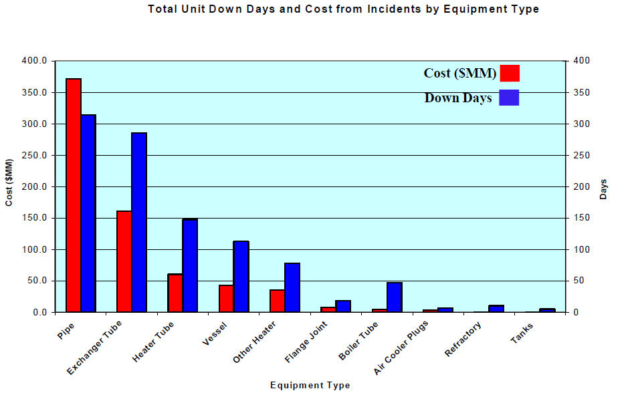
Figures 1: Oil and Gas Industry - Total Unit Down Days and Cost from Incidents by Equipment Type (ETEP 2012).
Figure 1 shows that CUI piping could cost between $150MM-$225MM which is more than any other equipment type failure and therefore highlighting CUI piping as a major issue in the oil and gas industry. Furthermore, Mohsin, Mokhtar and W Tse (2019) stated oil and gas industries now spend 10% of their maintenance and repair budget on CUI. From this industry experts have highlighted CUI as the highest priority type of corrosion (Caines et al, 2015) due to its continuous impact and is the reason why a refinery’s CUI management is crucial to address this issue.

CUI causes high maintenance costs due to the requirement to repair or replace equipment that has corroded under the insulation and if mitigated further or prevented will reduce costs. This is one benefit to the industry in addition to preventing loss of containment that ultimately makes profits. Other benefits are preventing environmental, health and safety risks that CUI poses with the final report detailing these with past outcomes. The benefits of this project could contribute to reducing the chances of these outcomes from happening and is the reason why CUI piping has been chosen.

Therefore, this project’s main aim is to look at reducing the impact of CUI piping in the oil and gas industry. To achieve this aim, research is carried out and experiments are set-up to analyse physical and theoretical data against literature to draw up an effective RBI program. Other project objectives are to understand what factors heavily impact CUI piping and to investigate if any areas on an oil and gas refinery are more susceptible to CUI. The last point is essential to understand to tackle high risk areas of CUI piping while trying to balance maintenance cost and resources available.

Project Plan and Schedule
To achieve the project’s main aim and objectives in a timely manner a plan was created using primavera to track work. The project plan lists milestones shown in figure 2 assigned with deadline dates. By doing this and updating the plan on a fortnight basis the workload can be managed should progress slip to ensure the project plan is delivered on time. The project was planned into four phases with figure 2 showing the baseline plan:
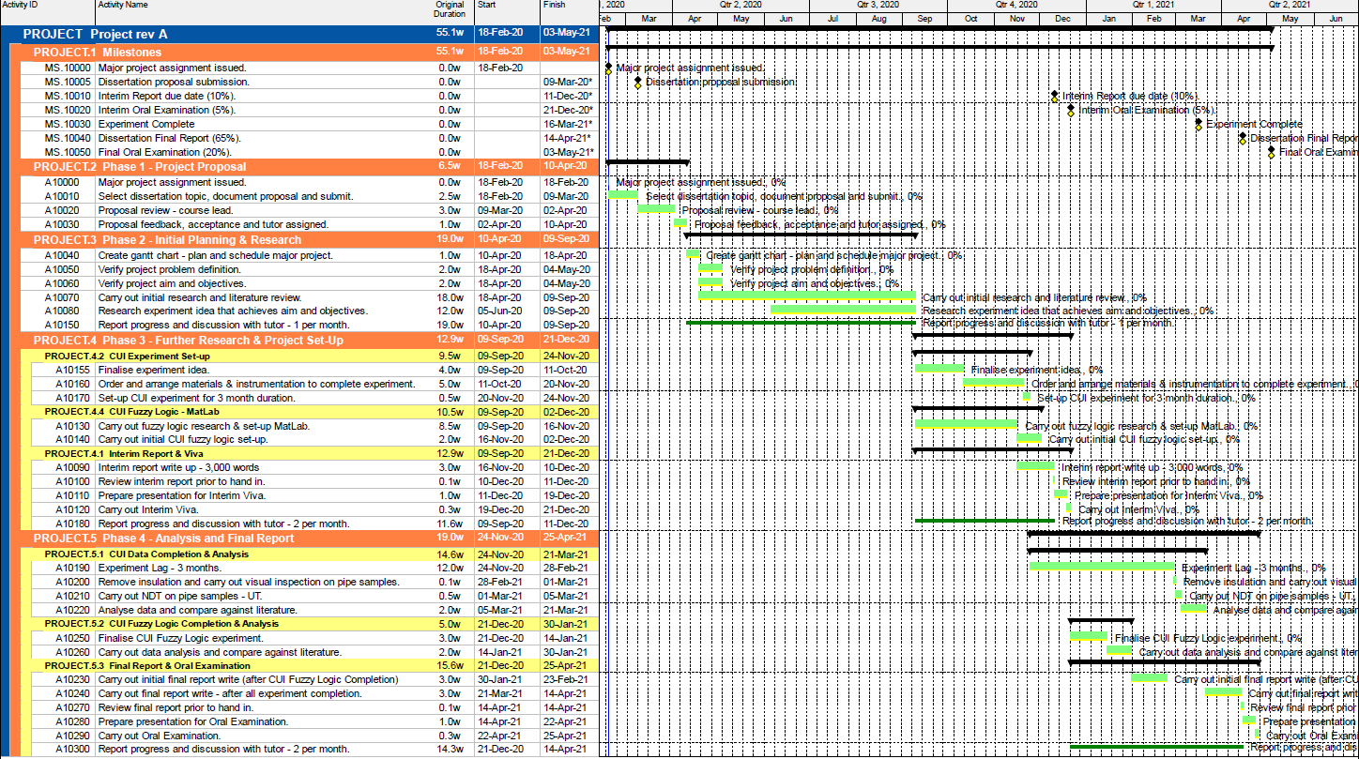
Figures 2: Baseline project plan set out.
Throughout the phases progress was reported and discussed with tutor. An update plan of the project is shown below in figure 3:
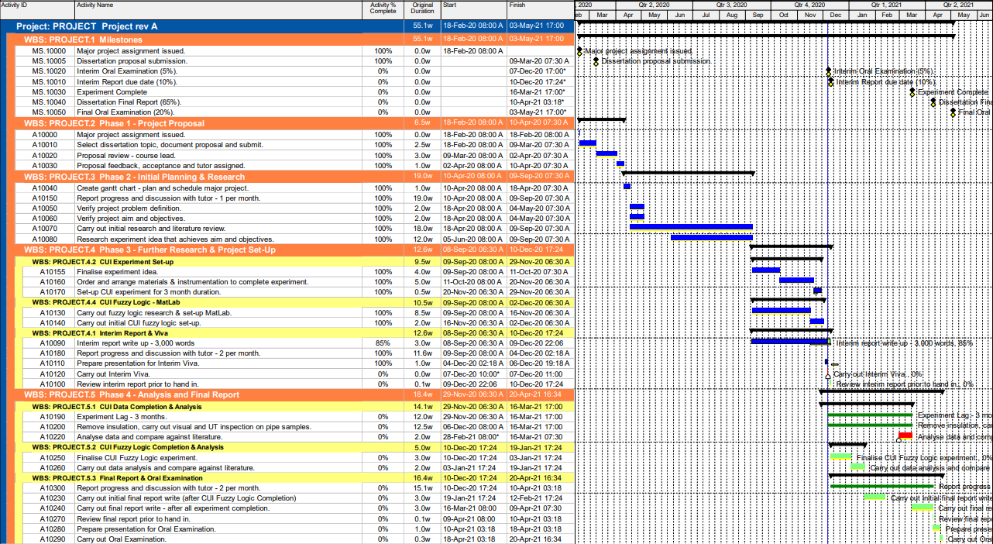
Figures 3: Project plan updated 6/12/20.
Currently the project is in phase three where the physical experiment has commenced and initial research/set-up to the fuzzy logic model has been completed. Final actions for carrying out interim report and viva will complete phase three and is on track to finish on time in mid- December which will lead the project to the final phase. In summary, the project plan is currently showing the project end date to finish on time.

Literature Review
To reach the projects main aim it was essential to carry out a literature review into several areas to understand the current issues and carry out critical appraisal on existing mitigations.

Corrosion
Environmental corrosion is the main reason why CUI piping occurs but comes in many forms. These various forms have been analysed and will be included in the final report including oxidation, microbial and others. One highlighted in this report is aqueous corrosion as it is generally accepted as the main cause of CUI across the oil and gas industry (Mohsin, Mokhtar and W Tse 2019) appearing in many forms (Caines et al, 2015). Electrolysis is the chemical reaction that causes the corrosion to happen as shown in figure 4:
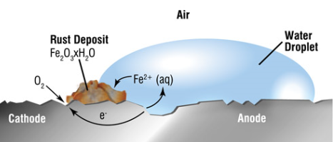
Figure 4: Aqueous corrosion – Iron, water, and oxygen (Wright 2019).
For aqueous corrosion to occur there must be a conductive electrolyte i.e., water to allow cations and anions to travel, a potential difference between two areas in the material (cathode and anode), a defined electron path and the presence of oxygen. A series of chemical reactions occur at the cathode and anode that results the latter being corroded leaving rust deposits (Edwards 2013) (Wright 2019).

Types of Corrosion

Uniform Attack
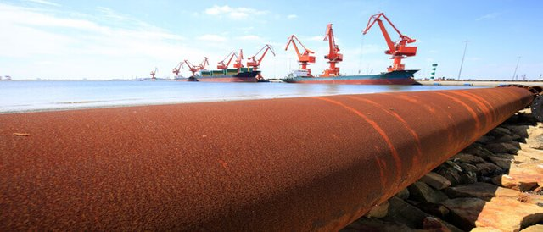
Figure 5: Uniform Attack Corrosion (Romero 2017).
Uniform attack is where corrosion happens uniformly across a component due to electrolysis with materials such as CS generally susceptible to this type due to its low passivity. In contrast to localised corrosion, uniform attack is predictable as the component degrades uniformly across all areas allowing measurements to be carried therefore making it a lower risk. However, this type does still pose risks if not recognised, like invisible nature of CUI, as sections of pipe can lead to thinning resulting in rupture (Caines et al, 2015) (Enegela 2020).

Localised Corrosion
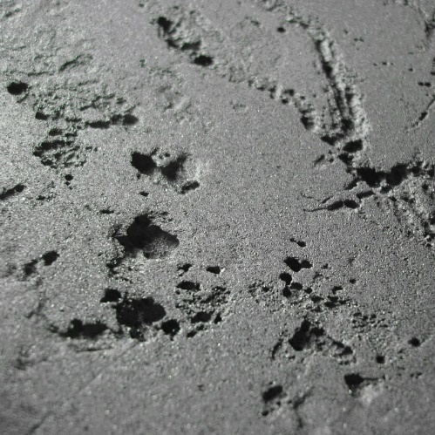
Figure 6: Localised Corrosion (Glister 2017).
Localised corrosion sees a component degrade over small, localised areas in contrast to uniform attack. Factors that influence this type of corrosion is salt particles and other contaminants from the corrosive environment in addition to materials having inclusions, coating breakdown and surface defects. This type of corrosion sees higher corrosion rates compared to others, is harder to predict, and usually result in pinhole leaks (Caines et al, 2015) (Enegela 2020).

Stress Corrosion Cracking
SCC occurs because of tensile strength being applied to a susceptible material in a corrosive environment as shown below (Shen et al 2019):
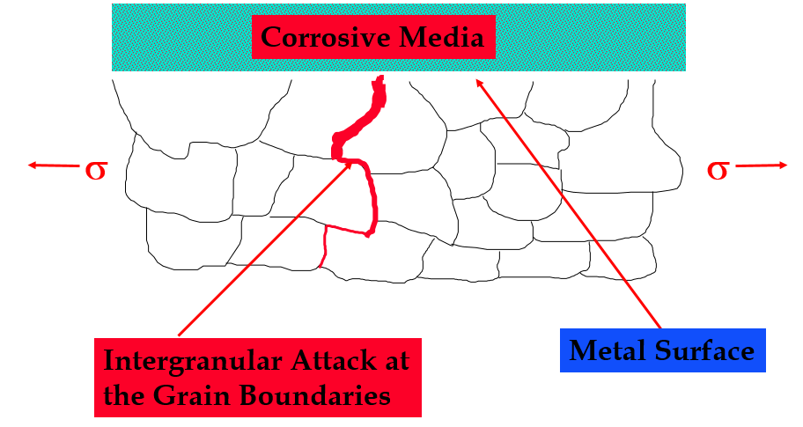
Figures 7: SCC (Holden 2019).
Metals are made up of grains where all the impurities of a metal lie at grain boundaries making it the weakest point (Cantwell et al 2014). Hence, SCC can occur where stress is applied on a metal in a corrosive environment causing intergranular attacks at the grain boundaries leading to a catastrophic failure (Holden 2019).

CUI at Ageing Oil Refineries – Mitigations, Detection & Maintenance
Many components in oil refineries are exposed to various environments that could affect the process in refining crude oil i.e., exchange of temperature. To mitigate the unwanted effect of heat transfer between components or systems to the environment insulation is used. Insulation has many other benefits and uses including personal protection against high temperatures (API 2014) (Caines et al, 2015). Insulated materials that are exposed to corrosion is known as CUI and it is this that presents a major issue to oil refineries as its not clearly visible. Figure 8 shows pipe insulated with annular space between the pipe and insulation:
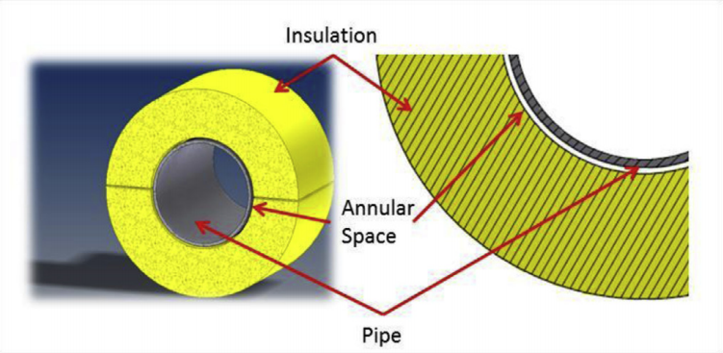
Figure 8: Pipe Insulation with the annular space between (Caines et al, 2015).
The annular space is created from the application of the insulation onto the pipe leaving space and crevices where any electrolyte can collect simulating various types of corrosion (Caines et al, 2015). There are several ways in which water or moisture can be collected in the annular space for example:
- Poor insulation installation or damage from foot traffic
- Steam tracing leaks
- External leaks from downstream/upstream pipe
- Internal leaks from pipe
Furthermore, there are number of environmental and process factors that are pivotal in accelerating CUI piping that are (Caines et al, 2015) (API 2014):
- Time of Wetness (TOW)
- Frequency of Wetness Exposed
- Internal/External temperature
- Chlorine content
- Microbial content
TOW is a critical factor to oil refineries that are ageing as there will be several components exposed to wetness for a long period of time. All environment factors generally cannot be controlled with external pipe temperature being a prominent factor in CUI. API (2014) states CUI is most severe between operating temperatures 77ºc and 110ºc but temperatures of -12ºc to 175ºc must be considered on a wider range. Thus, oil refineries try and mitigate the effect of CUI prior to pipe being installed. Where CUI is already occurring, the industry will try and have an effective RBI program to tackle areas at high risk to CUI.

Mitigations against CUI
The following factors are ways of mitigating CUI piping prior to installation:
- Types of Material
- Coatings
- Types of Insulation
It is essential to note these factors do not eliminate CUI piping as they heavily rely on quality assurance as well as having their disadvantages (Enegela 2020) and should be CUI risk assessed. However, in contrast to the environmental factors to CUI piping, these factors can be controlled to reduce CUI impact by careful selection in addition to utilising ASME/API Recommendations as per list below:
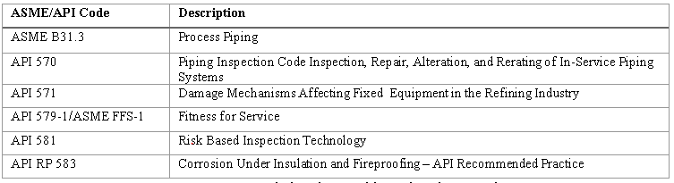
Table 1: Recommended codes used by Oil and Gas Industry.
Many oil and gas industries use recommendations set out from ASME and API for designing process piping, understanding mechanisms of failure, piping inspection, FFSA and RBI in addition to complying to international and statutory regulations. This major project focuses on piping CUI in the oil and gas industry thus the codes in table 1 will be referenced throughout.

Ageing refineries is a crucial factor to consider in these areas of mitigation where age and types of materials, coatings and insulation used need to be assessed as these influence CUI piping.

Types of Material
Oil and gas refineries generally use CS such as A106 grade B which is suitable for different processes in high temperature services (maximum 593ºc) including its high strength, toughness, and weldability (ASME 2016). Additionally, CS has some passivity to the environment as its composition includes Chromium providing an oxidized layer however it is not as effective as SS which has a higher Chromium content. SS is generally more expensive however, especially if all refinery pipe was made from SS, thus why refineries opt for a less expensive CS with a coating barrier to combat the corrosive environment (Metal Supermarkets 2016). Important to note other refinery processes and failure mechanisms will require different types of material based on their advantages and disadvantages.

Coatings
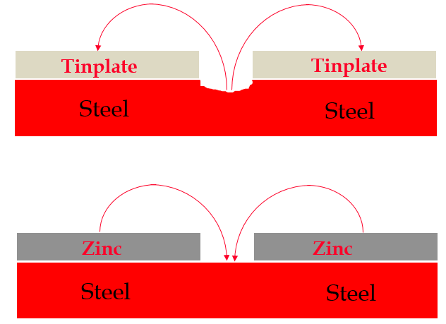
Figures 9: Illustrating substrate corrosion for steel using tinplate and coating corrosion for steel when using zinc (Holden 2019).
Oil and gas refineries are now beginning to coat materials using TSA due to its numerous advantages. TSA forms a strong adhesion to the substrate and under atmospheric conditions will oxidize providing an effective barrier between the corrosive atmosphere and component thus mitigating CUI to an extent.

Further advantages are a longer life duration of 20 years against 7 years of epoxy coats and as shown in figure 9 if the TSA coating is damaged over a small area the coat acts as the anode and therefore will corrode instead of the component. Nevertheless, the coating does have disadvantages including health and safety risks, generally costings, issues with NDT on welds and heavily relies on quality checks including surface preparation, contamination, and thickness checks to be effective (Holden 2019) Malek et al (2013).

Types of Insulation
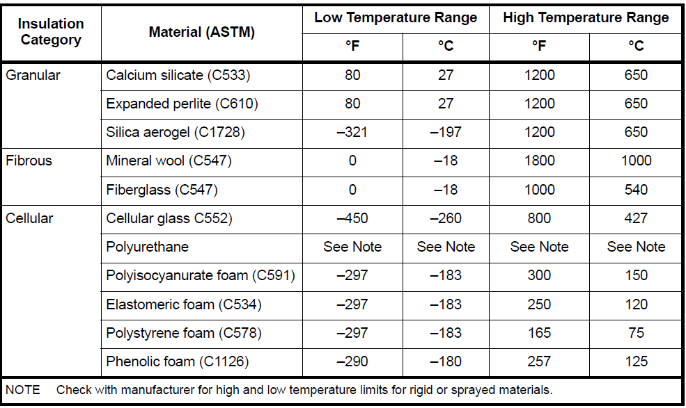
Table 2: Common Insulation Materials used in the oil and gas industry (API 2014).
Table 2 shows a range of insulation materials used in the oil and gas industry all having various advantages and disadvantages. However, materials that absorb water and chlorides are susceptible to CUI e.g., mineral wool, fiberglass, and calcium silicate and so should be avoided when combating CUI. In contrast, cellular type insulations have a high resistance to water absorption due to their closed cell structures e.g., perlite and elastomeric foam and therefore should be considered for use against CUI (API 2014).

However, the disadvantages of these type should be evaluated along with the process conditions required before selecting a material to combat CUI. API (2014) states it is hard to ensure insulation is leak tight and therefore all insulation types should always be inspected for CUI within a reasonable time frame. Insulation jacketing has been researched and will be analysed in the final report.

CUI Management
Enegela (2020) stresses the need to have an effective CUI management in place as shown in figure 10:
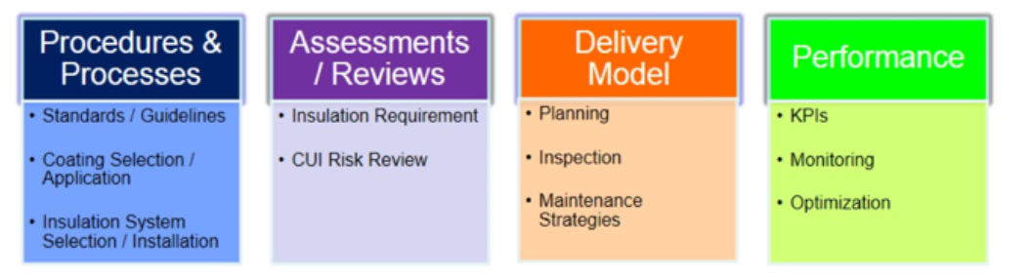
Figures 10: CUI Management Program (Enegela 2020).
API (2014) recommends having an RBI program including CUI piping to identify susceptible areas, prioritise inspection and to manage risk with a developed inspection plan. Understanding the pros and cons of NDT for inspection and monitoring is also considered in this step and will be included in the final report. Lastly, it is important to measure CUI management through KPI’s, monitor and optimise CUI management where possible to reduce the impact of CUI piping. Enegela (2020) highlights that the cost of insulation, coating and inspection repair can be an order of magnitude to the original cost and thus is essential to understand that high costs for an effective insulation or coating etc. could save money in the long run.

Independent Studies
Mohsin, Mokhtar and W Tse (2019) state the need for predicting CUI corrosion rates to construct a suitable inspection and maintenance plan for process pipes to reduce the effect of CUI. This would be advantageous in saving maintenance resource and cost to focus on areas where pipes require attention because of CUI. However, Mohsin, Mokhtar and W Tse (2019) further state data shortage on CUI due to oil and gas industries not disclosing any information only to leave API 581 as the suitable source for CUI corrosion rates for temperature ranges -12 ºC to 176 ºC.

The limitations on detecting CUI has led much research like Mohsin, Mokhtar and W Tse (2019) to find alternative methods in predicting CUI piping corrosion rates i.e., using fuzzy logic as shown in figures 11 and 12:
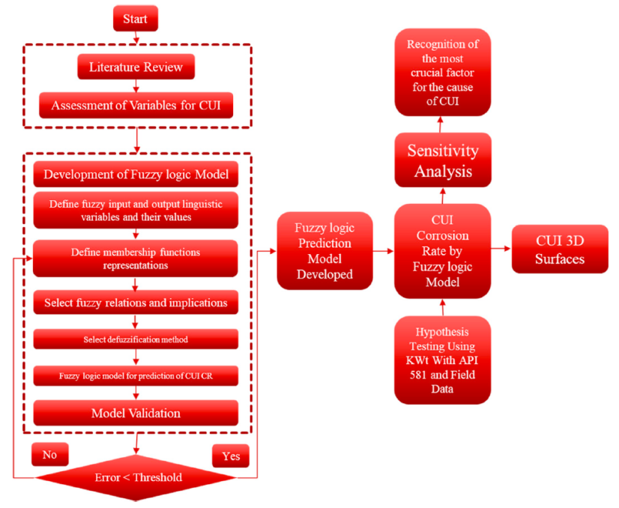
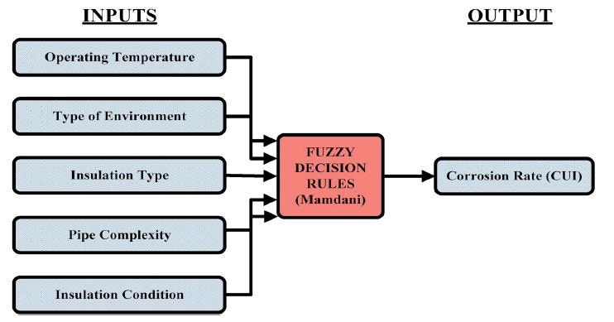
Figures 11 & 12 : Research Methodology, inputs, and outputs for predicting CUI (Mohsin, Mokhtar and W Tse 2019)
The model showed similarity in results against API 581 in addition to indicating type of insulation being the most prone factor for causing CUI. However, Mohsin, Mokhtar and W Tse (2019) did not factor chlorine content, TOW, or coatings in their fuzzy logic model for predicting CUI corrosion rates and if included could affect results.

Caines et al (2015) carried out traditional experiments in field testing and accelerating CUI using controlled measures particularly chlorine to predict CUI but results are to be determined. In addition, Caines et al (2015) did not factor insulation type or condition in their model. Lastly, Bai et al. (2017) showed chloride concentration increases CUI on coatings in isothermal conditions with 0.01%, 0.1% and 1% wt.% considered only. Understanding chlorine content on CUI piping would be particularly pivotal for oil refineries close to sea or offshore where the concentration would higher than what Bai et al. considered (~3.5 wt.%) in addition to factor this in Mohsin, Mokhtar and W Tse (2019) fuzzy logic model.

Experiment Progress

Physical Experiment
After carrying out a literature review an experiment was set up to investigate the role of salt spray on CUI using CS as understanding its affect could help reduce the impact of CUI piping in the industry, especially for those refineries that are near the coast. It was important to note that there are many factors that influence CUI corrosion rate and to investigate each factor would require a vast number of samples. Due to the coronavirus and limitations accessing samples and equipment, this was not feasible explaining why one factor is considered.

An assumption and exclusion in the experiment was that MIC does not have a sufficient impact on CUI piping and is one that cannot be controlled (Caines et al, 2015) however this will be reconsidered in the coming months. Another assumption was CUI would be insufficiently influenced by the humidity and that the salt spray applied would equal the daily average rainfall for a severe environment (4mm/day) based on a worst-case scenario. A limitation to the experiment was the time to run the experiment (4 months duration) due to managing time and meeting deadlines.

Experiment Aim
The aim of this experiment was to investigate and understand the role of salt spray (3.5 wt. %) on CUI piping against other CUI factors from literature. In addition, CUI corrosion rate (mm/year) along with type of corrosion will be determined to help build an effective RBI program to reduce the impact of CUI piping.

Hypothesis
CUI piping was expected to be accelerated by the salt spray with the insulated coated pipe to have the coating uniformly corroded and any corrosion on the CS to show pitting. Lastly, the uninsulated uncoated pipe was expected to be uniformly corroded.

Apparatus
A full list of materials and equipment used in the experiment is shown in the figure below:

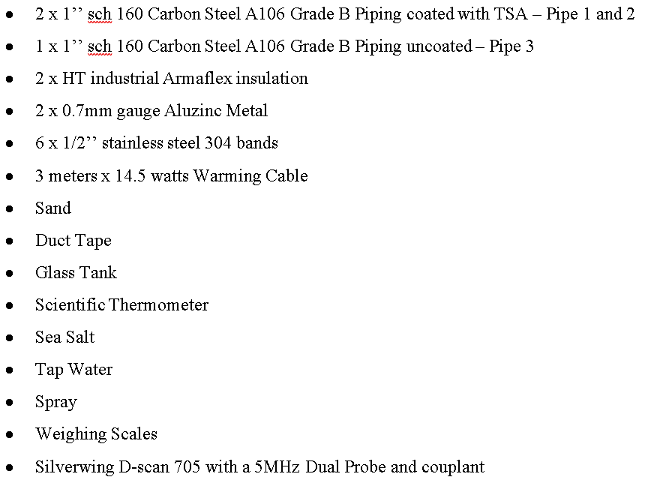
Figure 13: Experiment materials and Equipment.

Experiment Method and Set-Up
Using the materials available two 1’’ CS pipes were TSA painted and insulated using HT industrial Armaflex insulation (elastomeric foam) then jacketed with Aluzinc and held together with stainless steel 304 bands (pipes 1 & 2). This best represented the most common pipe material used along with the coat and insulation in the industry as shown below:
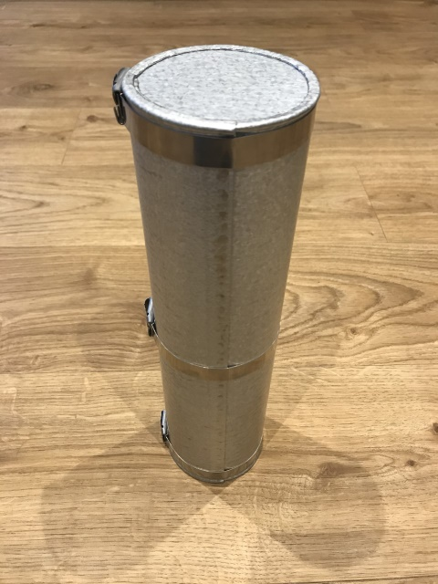
Figure 14: Pipe Sample - TSA CS pipe insulated
However, pipe 2 would have its jacketing and banding poorly applied and thus allowing easy access for salt spray to cause CUI. The other 1’’ pipe was left uninsulated and unpainted (pipe 3) to accelerate CUI with all three samples having the warming cable pulled through it. Utilising the duct tape all three pipes were filled with sand to ensure heat conducted from the warming cable through the sand to the pipe to approximately 40ºc. The warming cable along with the sand will act as a product flowing through the pipe. All three samples were then placed in a glass tank indoors to control the external pipe temperature and salt spray application. The final set up of the equipment is shown in figures 15 & 16:
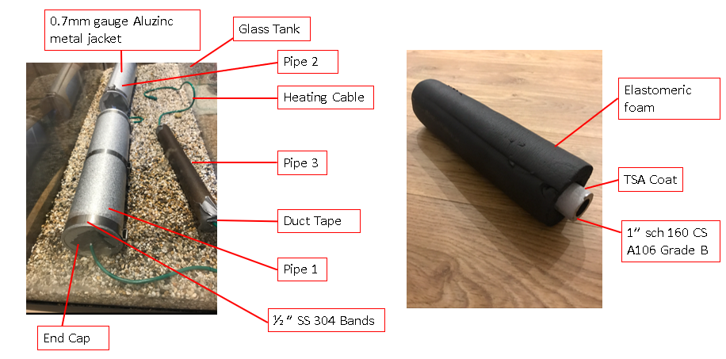
Figure 15 & 16: Experiment Set-up
Using a scientific thermometer, the pipe’s external temperature can be recorded daily to ensure no fluctuations occurred. It is important to note that the internal piping temperature cannot be controlled or measured in this experiment due to experiment access. Therefore, it is assumed that the external pipe temperature will equal to the internal pipe temperature. Furthermore, the heating cable would be left on throughout the experiment until inspection was due.

Mixing salt and water to get 3.5 wt.% using weighing scales each pipe would be exposed daily to approximately 4mm of seawater. The seawater mixture will act as salt spray and along with TOW are further factors that can be controlled in this experiment. A visual and ultrasonic inspection using a D-Scan would be carried out fortnightly on all samples and recorded for a period of four months to determine CUI corrosion rate (mm/year) and corrosion type. At each inspection five UT measurements will be carried out along each pipe sample with four further measurements at each location at right angles to each other to calculate average coating and material thickness losses.

The following table summarises controlled and uncontrolled variables in the experiment:
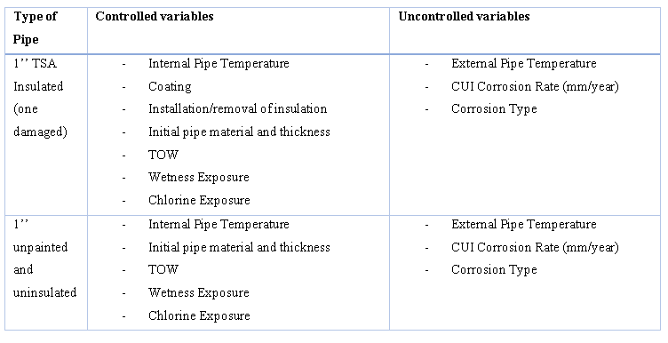
Table 3: Controlled and uncontrolled variables
Excluding the external pipe temperature, all variables are measured initially and throughout the experiment to allow data analysis to be completed at the end of the four-month period.

Next Steps
The final steps will be incorporated into a final report showing findings and recommending future work and considerations.

Physical Experiment Completion and Data Analysis
The next steps in the coming months are to record visual and UT inspections on all three samples. Once the experiment is complete types of corrosion along CUI corrosion rates (mm/year) can be determined and compared against literature such as the below figure :
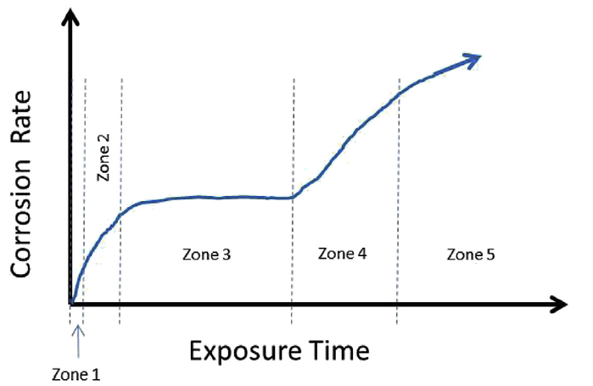
Figure 17: Types of zones – Corrosion Rate vs Exposure Time (Caines et al 2015).
Data error analysis using standard deviation and margin of error will be used to discuss limitations and improvements to be made in any future work. No additional resources or equipment is anticipated in the final months. After determining CUI piping corrosion rates, the data will be used to compare against literature and to recommend an RBI program to reduce the impact of CUI piping for oil refineries susceptible to salt spray.

Theoretical Experiment Data Analysis
In addition to the physical experiment, in the coming months a fuzzy logic model using MATLAB will be set-up and used to predict CUI piping corrosion rates (mm/year). This will be a similar model to Caines et al (2015) in determining CUI corrosion rates (mm/year) against API 581 data and analysing each factors contribution to CUI but with an additional factor that is of salt spray to produce graphs as shown below:

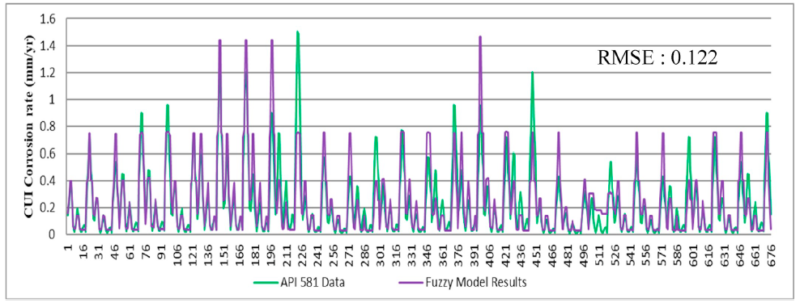
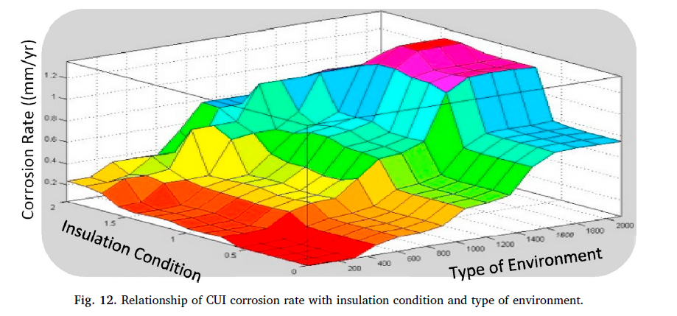
Figure 18 & 19: Fuzzy logic data compared against API and relationship of CUI corrosion rate with insulation condition & type of environment (Caines et al. 2015).
As shown in figure 19 relationships between different CUI factors can be made particuarly to the new factor to understand the role of salt spray on CUI piping. Theoretical data from this can be used and compared against literature and the experimental data obtained in this project. The data used from the therorectial experiment also make a contribution in reccomending an effective RBI program to reduce CUI piping impact.

References
API 2014. Corrosion Under Insulation And Fireproofing - API Recommended Practice 583. 1st ed. Washington: API Publishing Services, pp.7-76.
ASME 2016. Process Piping – ASME Code for Pressure Piping, B31. New York, pp. 156.
Bai X, Tang J, Gong J, and Lu X (2016). Corrosion performance of A1-A1₂O₃ cold sprayed coatings on mild carbon steel pipe under thermal insulation. Chinese Journal of Chemical Engineering, 25, pp.533-539.
Caines S, Khan F, Shirokoff J and Qiu W (2015). Experimental design to study corrosion under insulation in harsh marine environments. Journal of Loss Prevention in the Process Industries, 33, pp.39-51.
Cantwell P, Tang M, Dillon S, Luo J, Rohrer G and Harmer M (2014). Grain boundary complexions. Acta Materialia, 62, pp.1-48.
Edwards R (2013). Aqueous corrosion of steel. Corrosion Engineering Solutions, pp.1-3.
EKT Interactive (2019). Oil 101 – A Free Introduction to Oil and Gas. [image] Available at: https://www.ektinteractive.com/refining/refining-business-drivers/ [Accessed 4 Nov. 2019].
Enegela P 2020. Corrosion Under Insulation Assessment, Monitoring, And Management. NACE International Webcast – EEMUA.
Engineering Technical Excellence Program ETEP (2012). Metallurgy & Corrosion Overview.
Glister P 2017. Pitting Corrosion And Storage Tank Failure, Serious Storage Tank Corrosion. [online] Abfad Ltd. Available at: <https://www.abfad.co.uk/editorial/pitting-corrosion-and-storage-tank-failure/> [Accessed 10 November 2020].
Holden P (2019). Mechanisms of Material Failure - Corrosion. University of Wales Trinity Saint David Swansea.
Holden P (2019). Thermal Spraying and Powder Coating - Corrosion. University of Wales Trinity Saint David Swansea.
Malek M, Saad N, Abas S, Roselina N and Shah N (2013). Performance and Microstructure Analysis of 99.5% Aluminium Coating by Thermal Arc Spray Technique. Procedia Engineering, 68, pp.558-565.
Metal Supermarkets (2016). The Difference Between Carbon and Stainless Steel. [online] Metal Supermarkets. Available at: https://www.metalsupermarkets.com/difference-between-carbon-stainless-steel/. [Accessed 15 May 2019].
Mohsin K, Mokhtar A and W Tse P (2019). A fuzzy logic method: Predicting corrosion under insulation of piping systems with modelling of CUI 3D surfaces. International Journal of Pressure Vessels and Piping, 175, p.103929.
Sertin C (2019). Comment: The oil & gas industry is not dying, it is transforming. [online] Oil & Gas Middle East. Available at: https://www.oilandgasmiddleeast.com/drilling-production/34535-comment-the-oil-gas-industry-is-not-dying-it-is-transforming [Accessed 25 Oct. 2020].
Romero R 2017. Corrosion Damage Worldwide — Steemit. [online] Steemit.com. Available at: <https://steemit.com/steemstem/@robertoromero/corrosion-damage-worldwide> [Accessed 10 November 2020].
Shen S, Song X, Li Q, Li X, Zhu R and Yang G (2019). A study on stress corrosion cracking and hydrogen embrittlement of Jethete M152 martensitic stainless steel. Materials Science and Engineering: A, 740-741, pp.243-251.
Wright J (2019). Inhibiting Rust and Corrosion to Prevent Machine Failures. [image] Available at: https://www.machinerylubrication.com/Read/29116/inhibiting-rust-corrosion [Accessed 15 May 2019].

