Introduction
Within this project I was required to use a variety of different devices and system in order to develop a box sorting system based on the size of the box (Pallet, Small, Medium and Large) I was required to sort these boxes into different areas similar to that of a factory. For this I was required to use a PLC program in order to program to do so automatically.
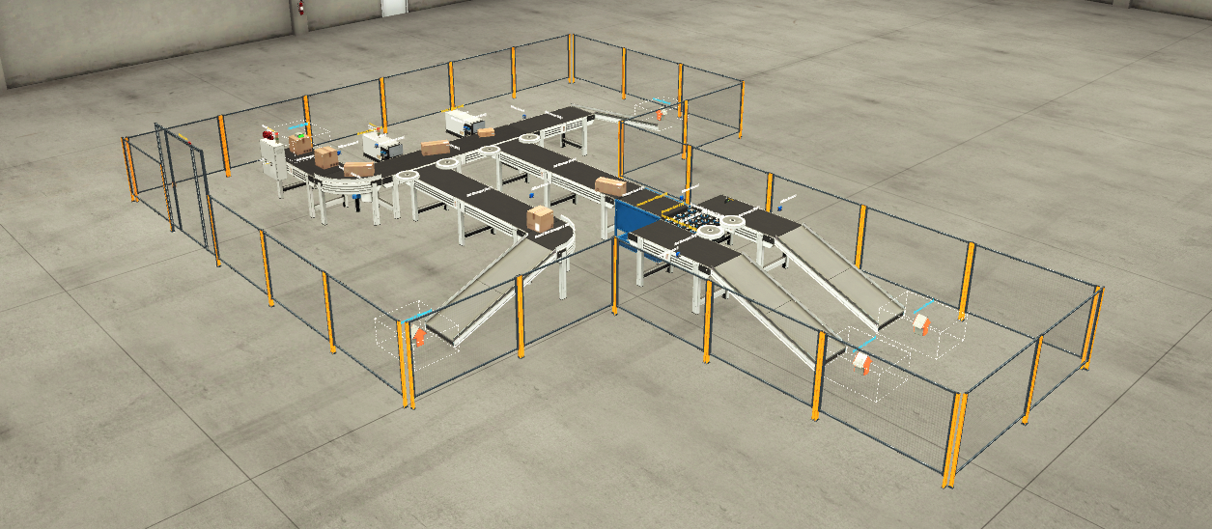
Task 1 – Provide a brief literature review of several PLCs currently used in industry and provide a table of Pros and Cons of each in your opinion.
PLCs are used in several different industries and can be used for many different purposes across a manufacturing sites which can preform many different tasks. They are essentially the brain of the system. They can be used to run conveyor belt systems, temperature controlling systems and energy management such as boiler systems. (Chaudhari, n.d.)
The 3 main types of PLC are Fixed, Modular and Distributed:
Fixed PLC – This is a single unit architecture that houses all the embedded hardware components in a single unit. This includes the CPU, input, output and power supply ETC.
Advantages | Disadvantages
Convenient for space -Small so do not take much room. | Processing power on the CPU is low, may struggle with complex tasks.
Are cheaper to purchase than other PLCs. | Has a fixed number of inputs and outputs.
Easy to mount/set up. | Suited best for basic applications

Modular PLC – A modular PLC is where the PLC has a different module for each of its hardware components. Each PLC has a mounting system which means it can be reconfigured for specific applications.
Advantages | Disadvantages
Larger memory | Large in size – Take up more room
Higher processing power | Harder to mount than a fixed PLC
Full customizable and easily expandable so good for complex applications. | Not cost effective for basic applications, expensive.

Distributed PLC – This is a high end PLC that has the ability to interconnect hardware components using high speed connection links.
Advantages | Disadvantages
Can control all PLC on plant Via network | Very high in cost – not suitable for basic tasks
Handle large complex tasks across a network | Very complex, high programming skills required
Large volumes of Input Output | Mounting system harder than a fixed PLC
(Phillips, 2019)

Task 2 – Utilising the components within FactoryIO, design a factory process capable of sorting a range of package sizes and weights (minimum 4 different types).
Full Factory
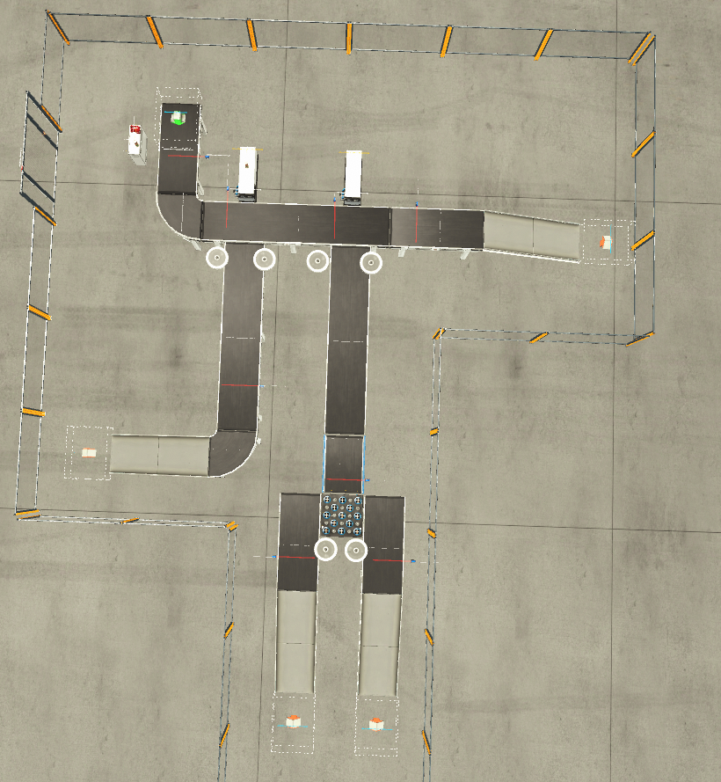
Large Box – This part was emitted then hits the sensor that actives pusher 1 it is then pushed onto its own track. It then falls down the chute conveyor and hits a remover.
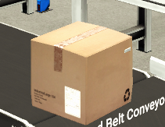
Medium Box – This part is emitted then hits the second sensor that activates pusher 2. It is then hit down to the weighting conveyor where it is hit and then weighed and sorted whether or not it is a medium or small box. It is then sorted accordingly.
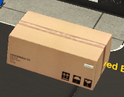
Small Box – This part is emitted then hits the second sensor that activates pusher 2. It is then hit down to the weighting conveyor where it is hit and then weighed and sorted whether or not it is a medium or small box. It is then sorted accordingly.
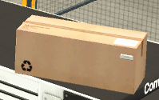
Palletising Box – This box is emitted and passes by both pushers and sensors until it goes down the chute conveyor and hits the remover.
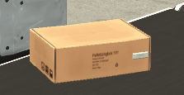

Control Box – The control box houses the start and stop buttons, one of the 2 stack lights and the siren for the factory. Once the start button is pressed the traffic light stack will activate and the siren will sound. Then the conveyors will turn on sequentially.
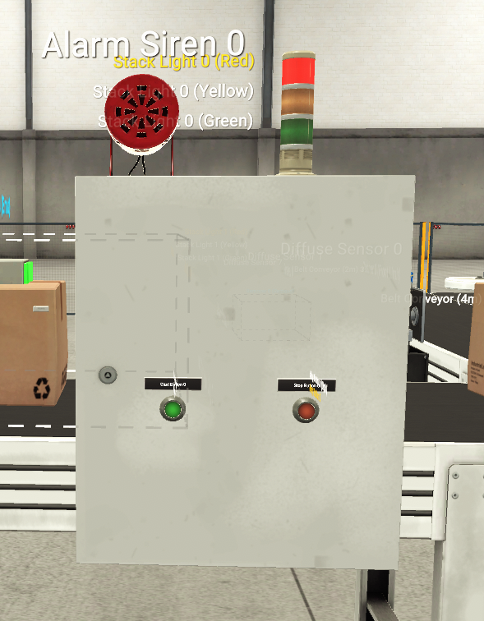
Emitter – The emitter is placed at the start of the system and provides the boxes to be sorted.
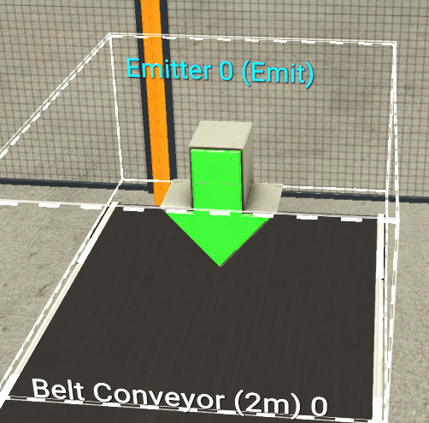

Diffuse Sensor – Each Diffuse sensor has a different purpose within this factory.
Sensor 0 to trigger large box pusher, large box counter and large box error counter.


Sensor 1 to trigger Medium/Small box pusher and the medium/small box error counter
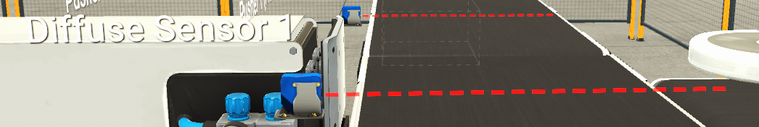
Sensor 2 to stop the weighing conveyor in order to take a measurement to sort the box and to -1 from the medium/small box error counter to show it has successfully gone through
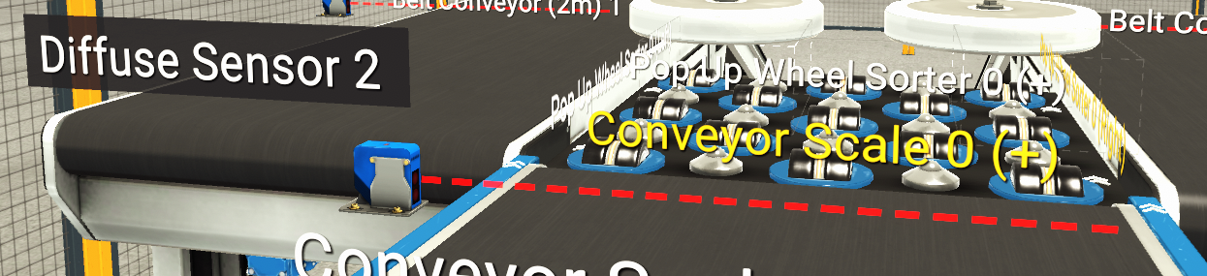
Sensor 3 to trigger the total counter for each box that passes.
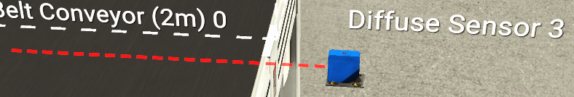

Sensor 4 to -1 from the large box error counter in order to register that the box has gone through.
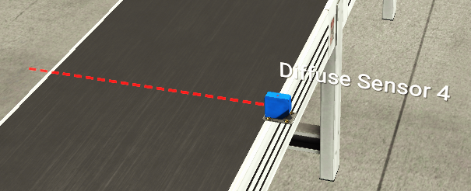
Sensor 5 to count the number of medium boxes

Sensor 6 to count the number of small boxes
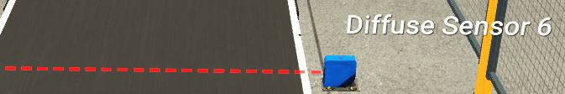
Sensor 7 to count the number of pallet boxes going through


Pusher
Pusher 1 is activated by sensor 0 to sort the large boxes and Pusher 2 is activated by sensor 1 to sort the medium and small boxes
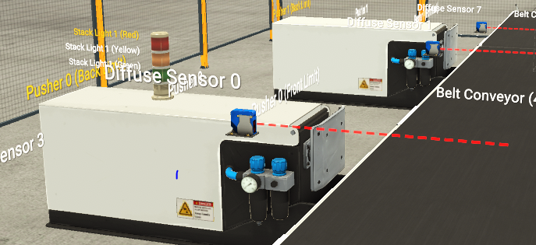
Wheel Aligner
Used in order to keep boxes on the conveyor and minimise them falling to ground.

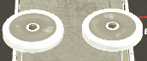
Conveyor Scale Weight
Once box hits sensor the conveyor stops and takes the weight of the box, it then displays on the digital display and activates the pop up sorter to go left or right.
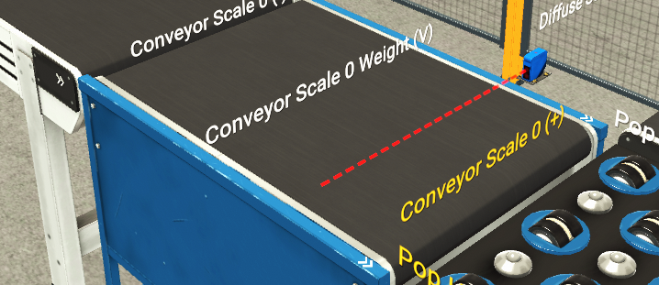

Pop Up Sorter
Once box hits sensor the conveyor stops and takes the weight of the box, it then displays on the digital display and activates the pop up sorter to go left or right.
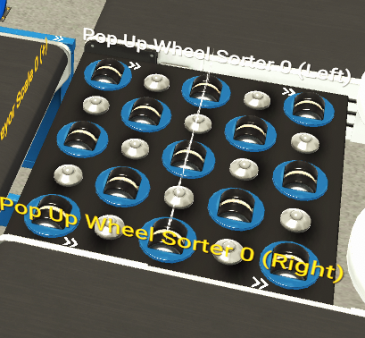
Digital Display
Once box hits sensor the conveyor stops and takes the weight of the box, it then displays on the digital display and activates the pop up sorter to go left or right.
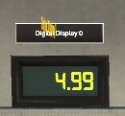

Chute Conveyor
At the end of the sorter the box slides down the chute into the remover which clears the box.
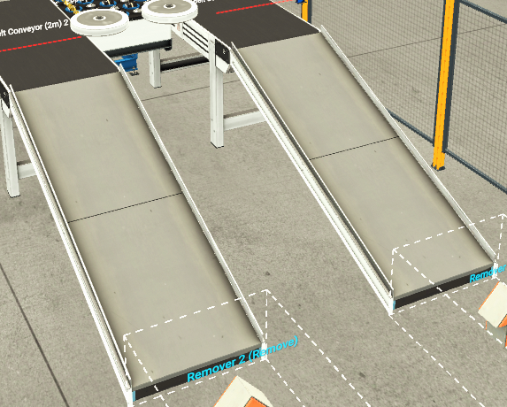
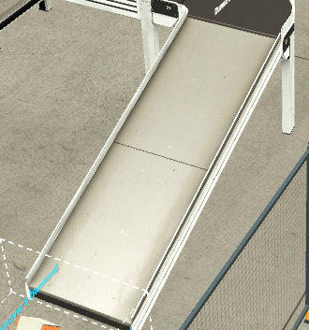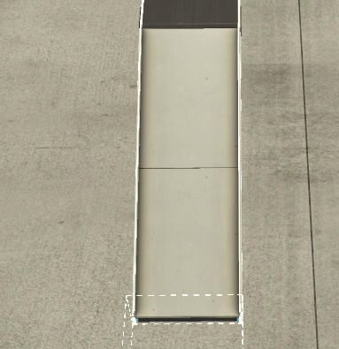

Remover
Clears the box from the factory.
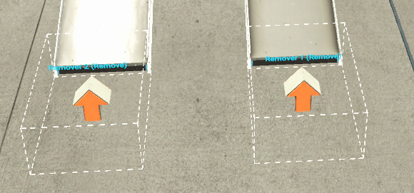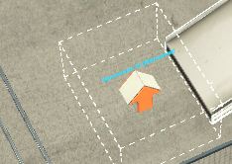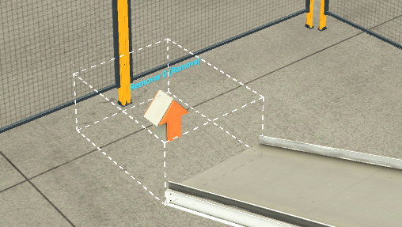

Task 3 – Write a ladder logic program to control your factory process
Network 1 is automatically generated and is used to so the PLC can communicate with the program.
Network 2 is used to start the system, once the start button is pressed the traffic light starts, the siren sounds and the system operates, once the stop button is pressed the system will stop.
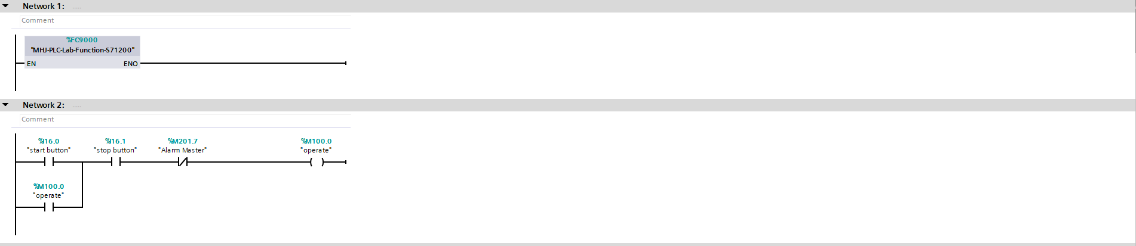
Network 3 is used to operate the conveyor belts. Once the system operates the conveyors activate sequentially.
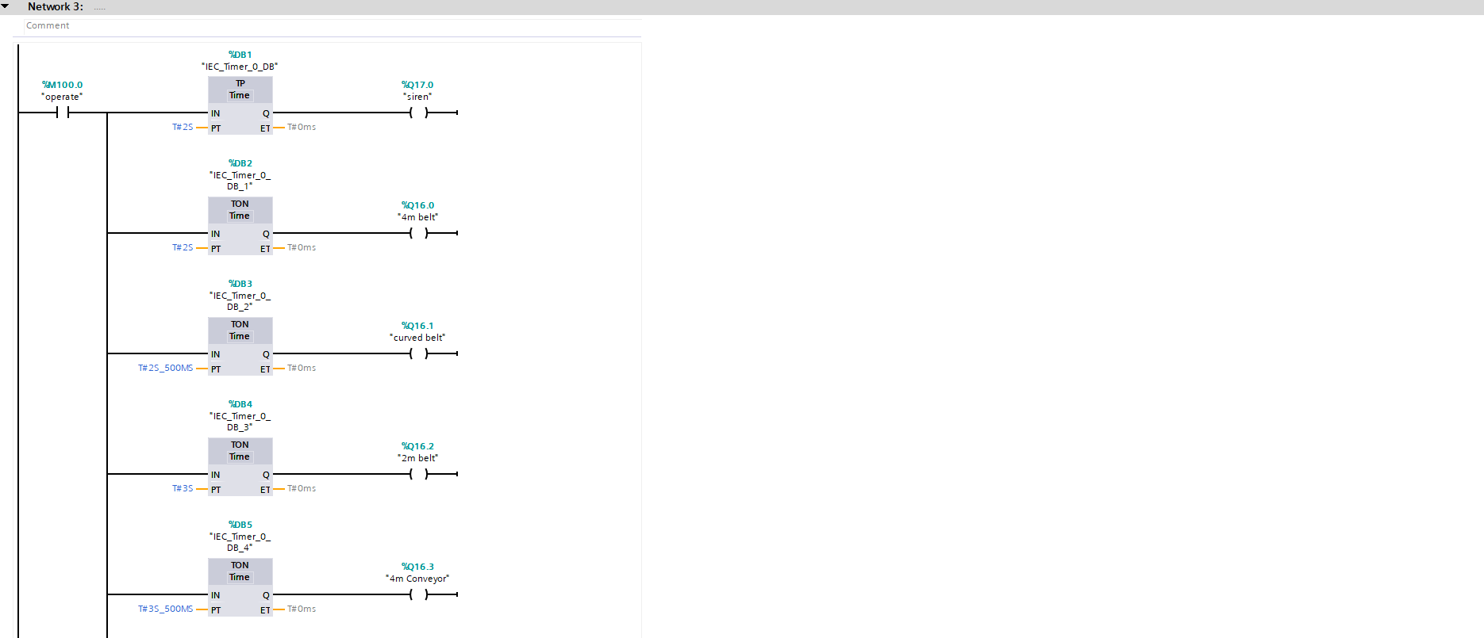
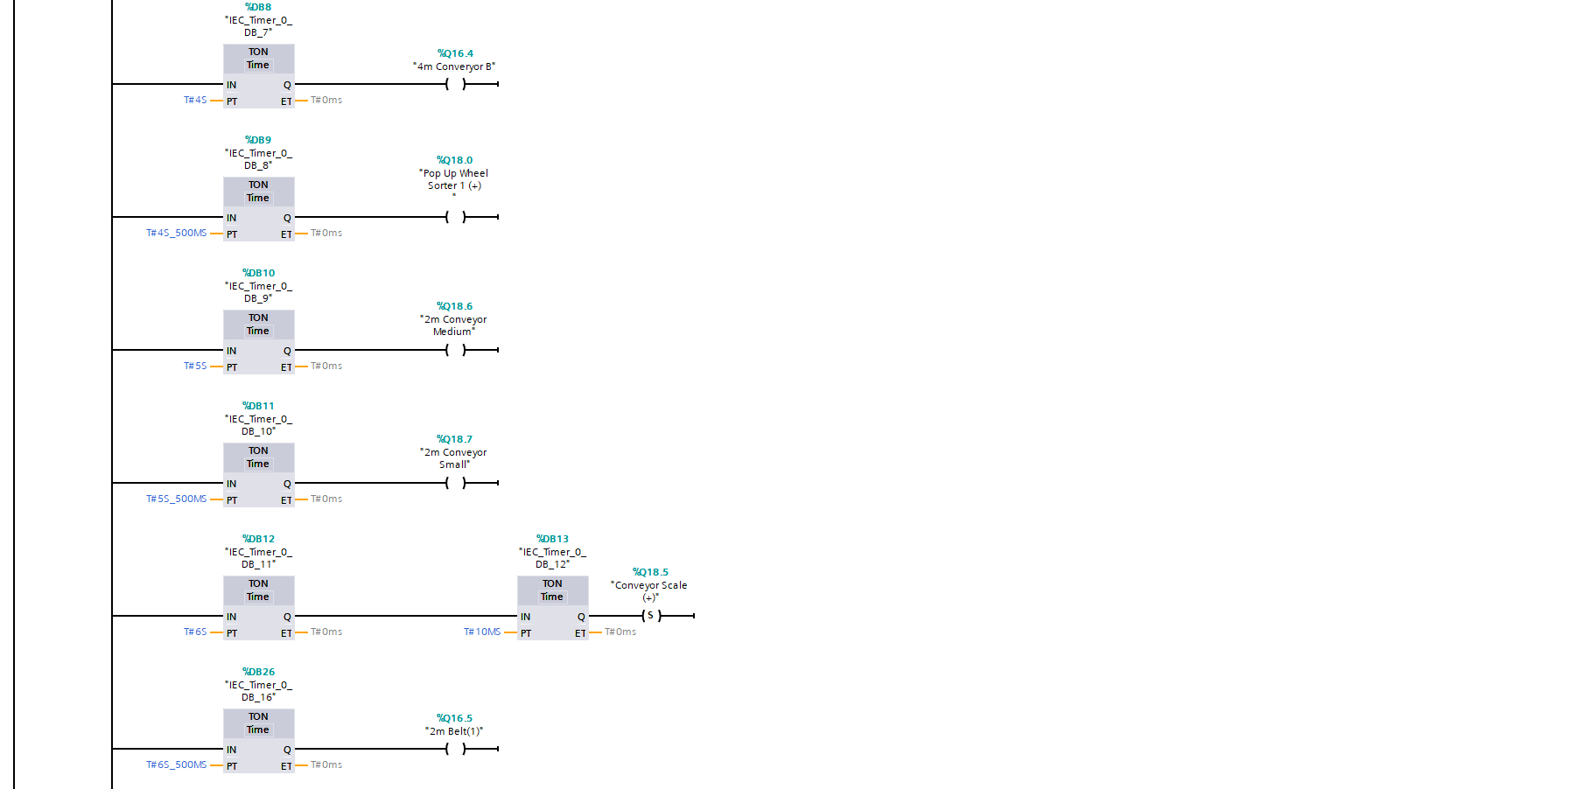
Network 4 is how the traffic lights work and in what order they activate.
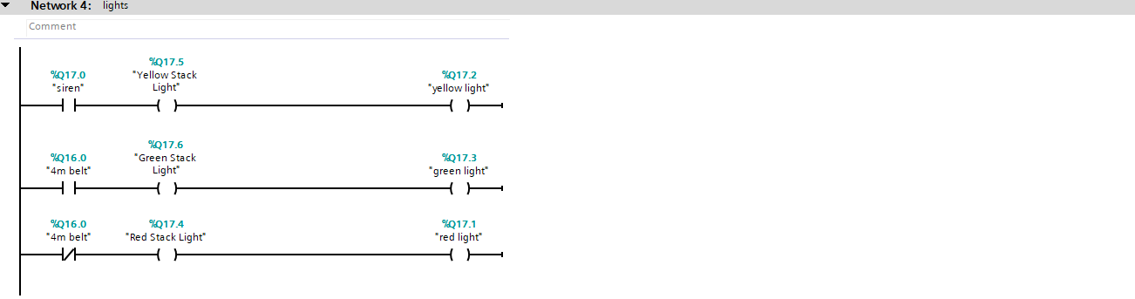
Network 5 & 6 link the alarms and warnings to the Root, Engineering and Warning Screens.
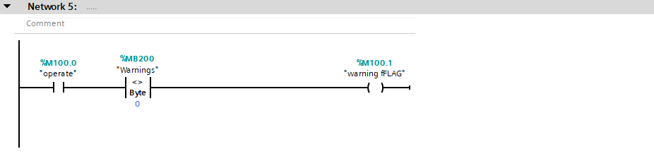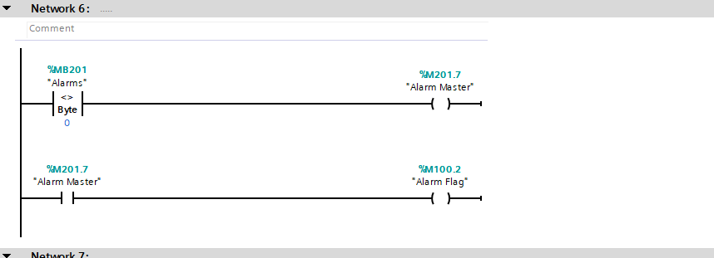

Network 7 is where the pusher is linked to be activated by the senor and push the large box onto the conveyor, and network 8 is used to activate pusher 2 and push the medium/small boxes onto the other conveyor.
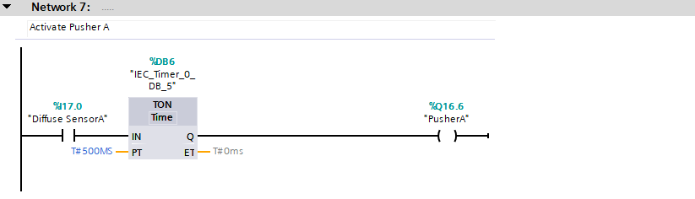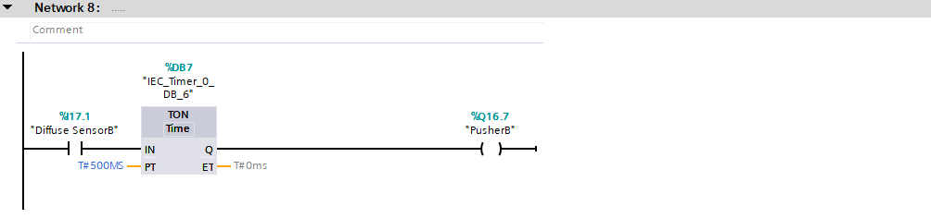
Network 9 is used in order to stop the small or medium box and the weighing scales conveyor, take a measurement and display it on the digital display.
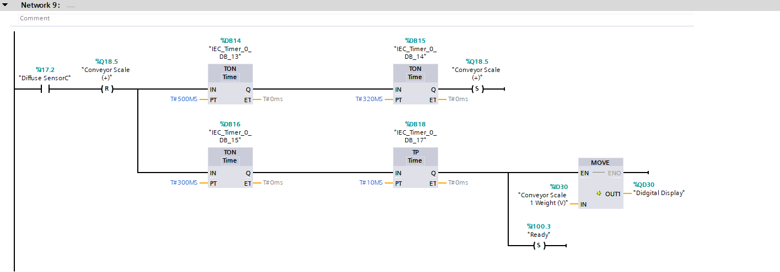

Network 10 activates the pop up sorter and allows the system to divert a box left or right based on if it is a small a medium sized box using its weight.
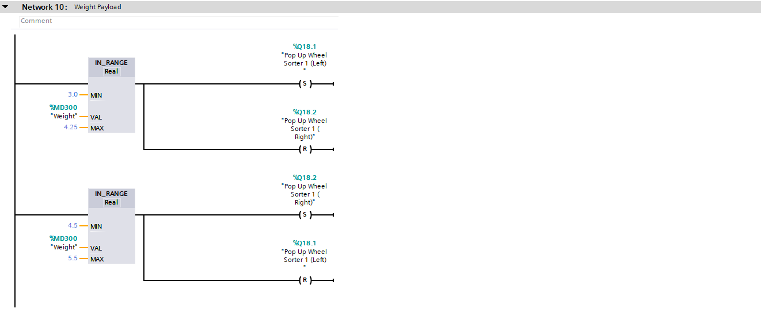
Network 11 reactivates the scale conveyor after the pop up sorter is configured ready to reset and weight the next box.
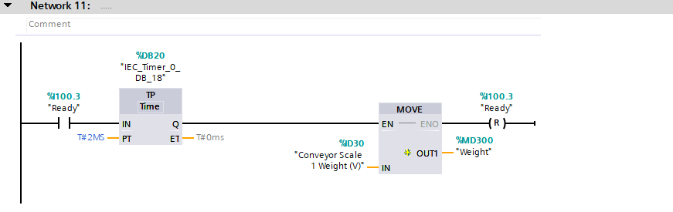

Network 12 was used in order to operate the counter on the root screen, as a box it the sensor the counter would add 1 and continue to count up
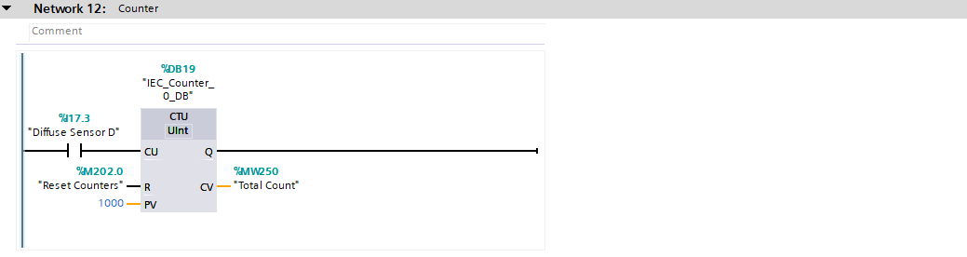
Network 13 was in place in order to reset the total count when the button was placed on the engineering screen
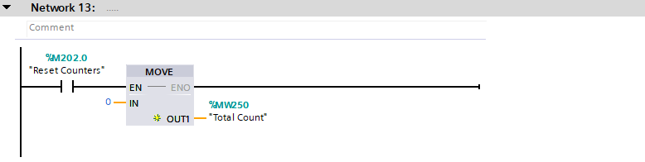

Network 14 & 15 is for the large box error counter, when the box hits the pusher A sensor 1 is added to the error counter, once the box hits sensor E the 1 is removed and box is delivered. If the box does not hit the senor the 1 stays in place, on the engineering screen I can set warning and alarm sensors. If the error counter hits its pre-set, e.g. 5, the warning light is activated, once it hits the alarm pre-set, e.g. 8, the system is stopped.
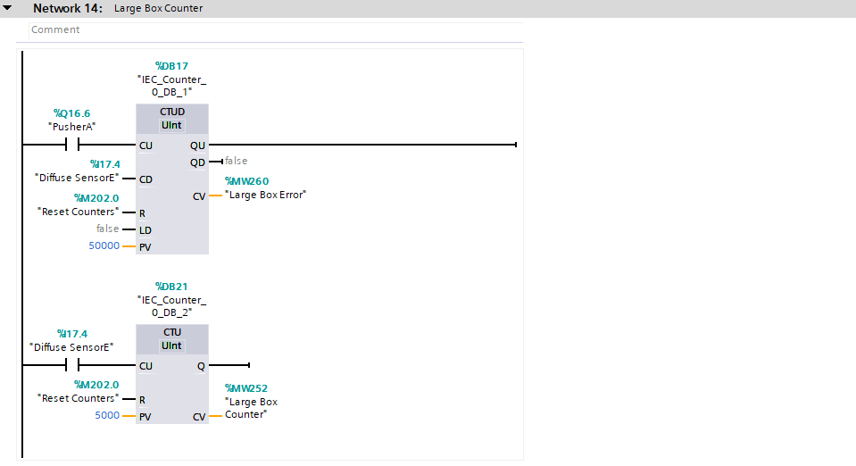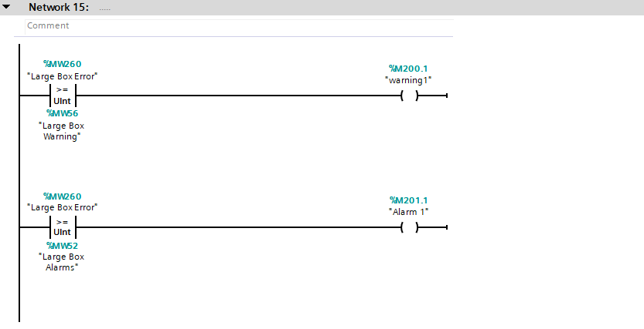

Network 16 & 17 is for the Medium/Small error counter, when the box hits the pusher B sensor, 1 is added to the error counter, once the box hits sensor E the 1 is removed and box is delivered. If the box does not hit the senor the 1 stays in place, on the engineering screen I can set warning and alarm sensors. If the error counter hits its pre-set, e.g. 5, the warning light is activated, once it hits the alarm pre-set, e.g. 8, the system is stopped.
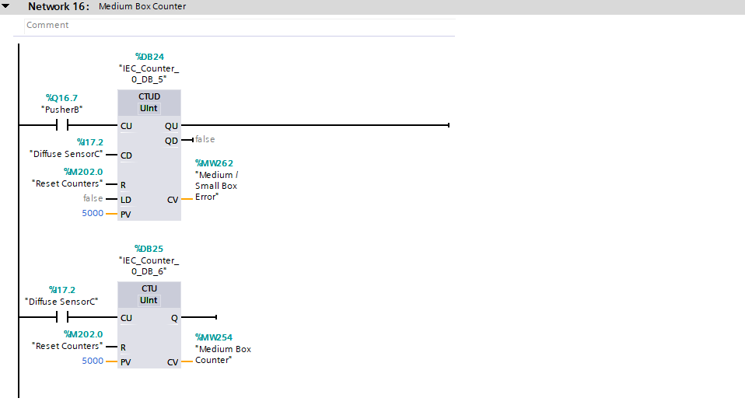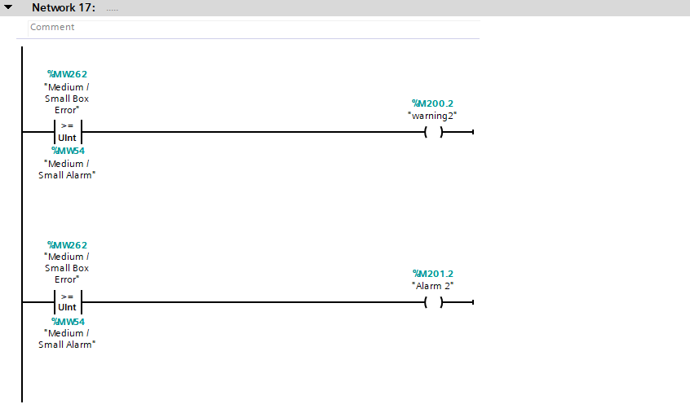

Network 18 & 19 is for the Medium/Small error counter, when the box hits the pusher B sensor, 1 is added to the error counter, once the box hits sensor E the 1 is removed and box is delivered. If the box does not hit the senor the 1 stays in place, on the engineering screen I can set warning and alarm sensors. If the error counter hits its pre-set, e.g. 5, the warning light is activated, once it hits the alarm pre-set, e.g. 8, the system is stopped.
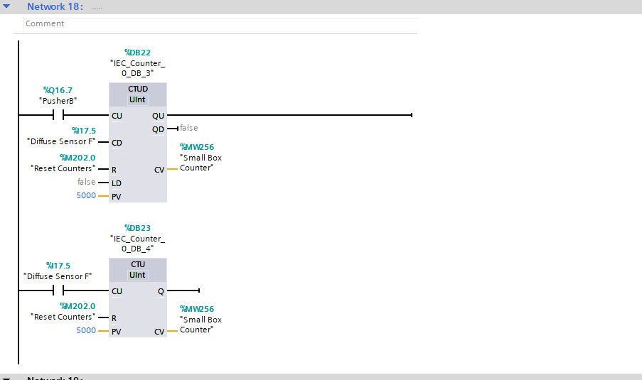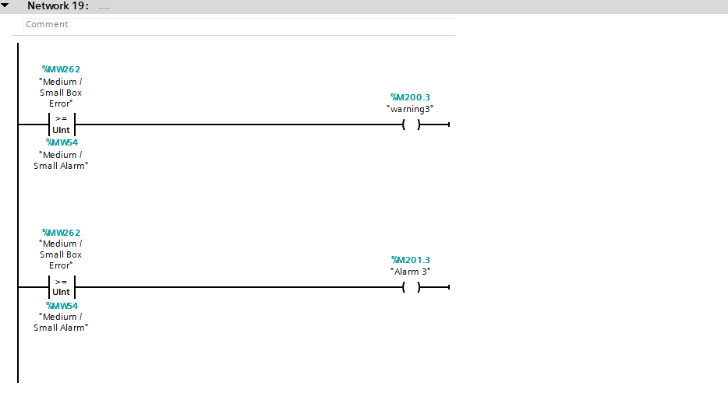

Network 20 this is the reset for the pallet box counter same as the networks above, once the reset button is pressed on the engineering screen the counter will reset.
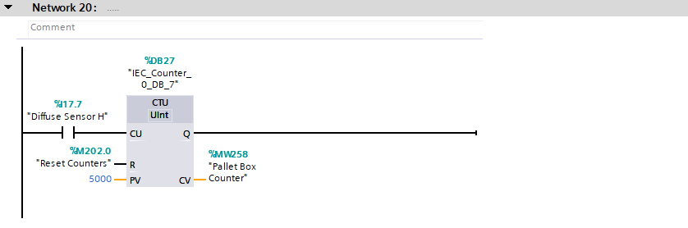

Task 4 – Incorporate a HMI device into your factory and program.
This Screenshot is from the driver section on factoryIO. I linked all devices to the PLC and then attached each device to a HMI tag, shown below. This allowed the siemens and factoryIO to register the devices and operate them when programmed in the network part.
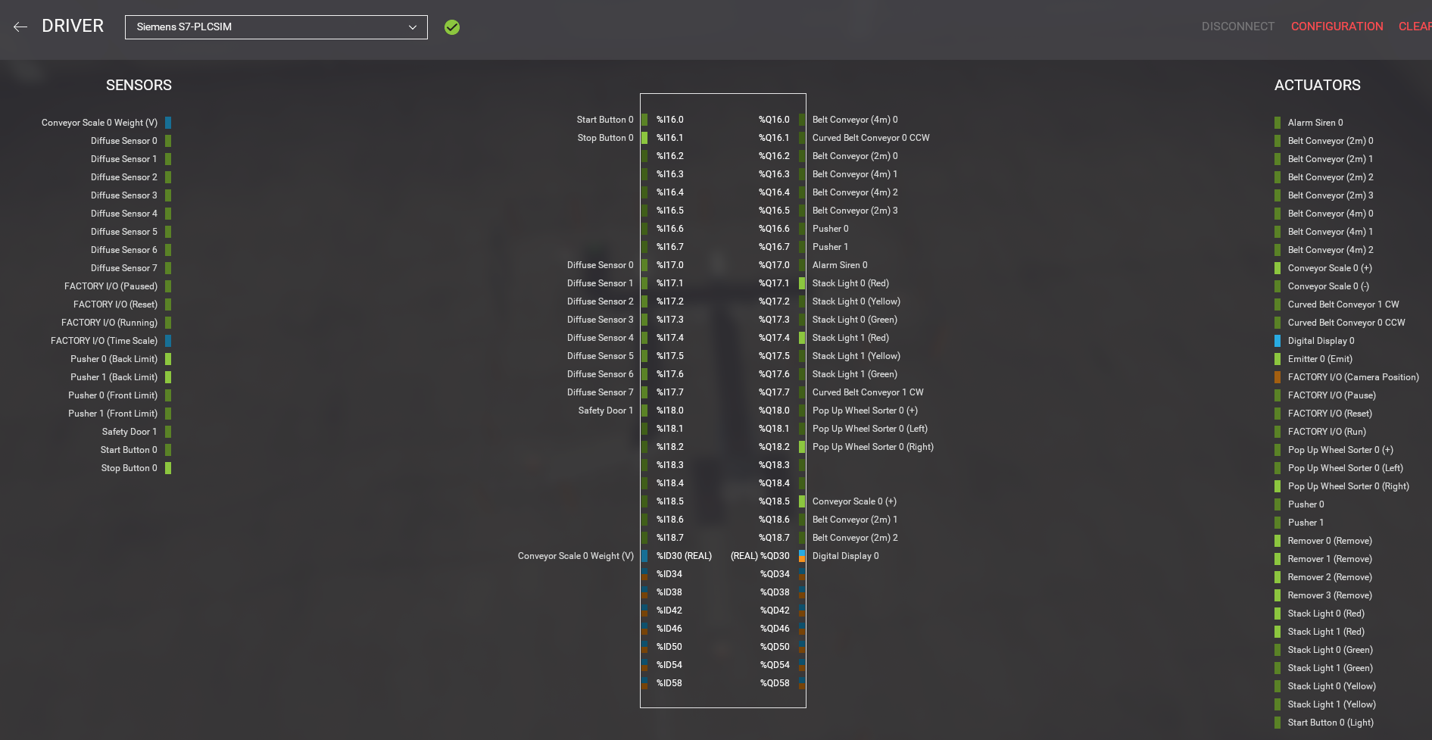

Below are the PLC tags for the factory, these were linked to factoryIO via the address number matching the location on the factoryIO driver section above. These were used in the network section of Siemens. They were able link everything together, the screens, networks and factory.
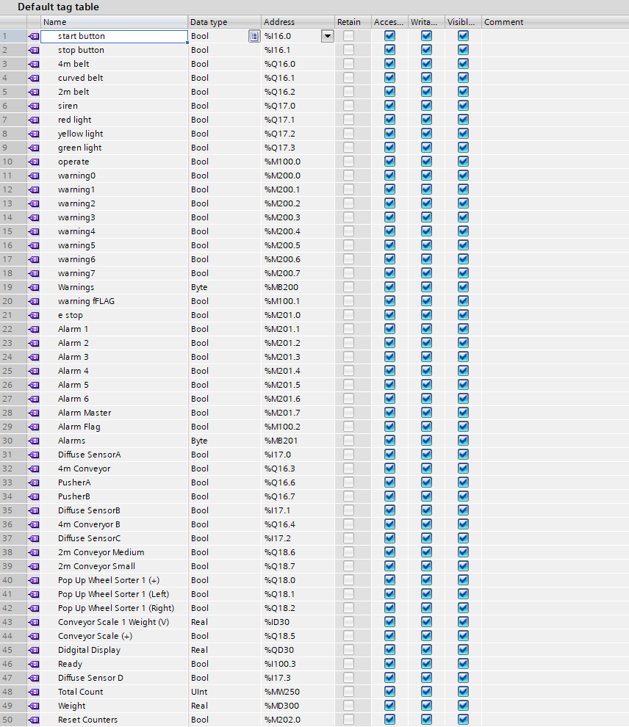
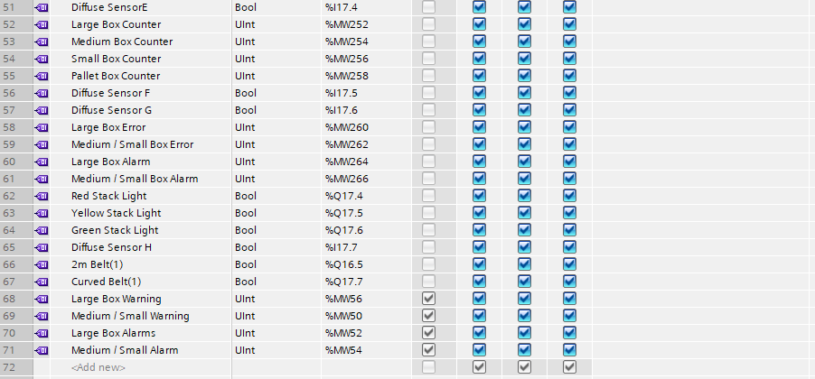

Task 5 – Design and incorporate several screens with navigation controls on to your HMI including Error/Warning and Engineering complete with their operation from the above brief.
Root Screen
This is the main screen for the factory. All aspects of the factory can be controlled by this screen. The operational buttons are used to stop and start the factory and are linked to the control box. There is also an emergency stop button which is used to stop the system and it cannot be reset until the Master Reset is pressed on the engineering screen. All counters are used in order to track the amount of boxes going through the system. The error counters could the amount of lost boxes, once these reach a pre set limit then the system will shut down. There is also a traffic light to indicate the systems status and 2 warning lights linked to the warning page. Lastly there is a navigation button in the top left in order to navigate screens.
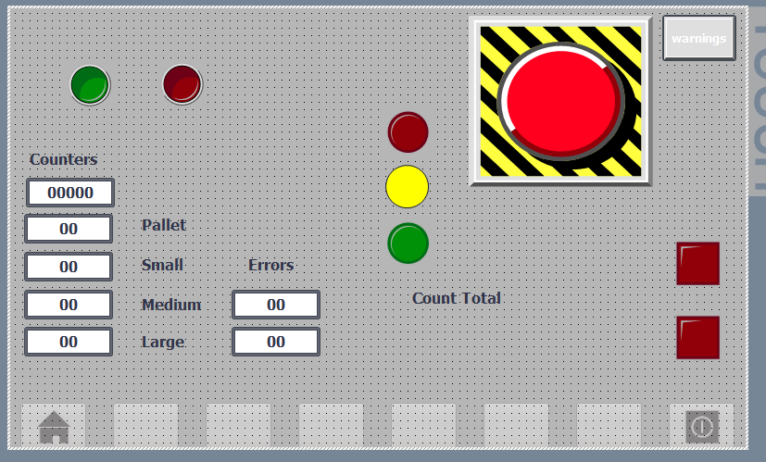

Warning Screen
The warning screen is to show which warnings and alarms are activated. A warning will allow the system to operate but activate a light where as an alarm will stop the system and the master reset will need to be pressed.
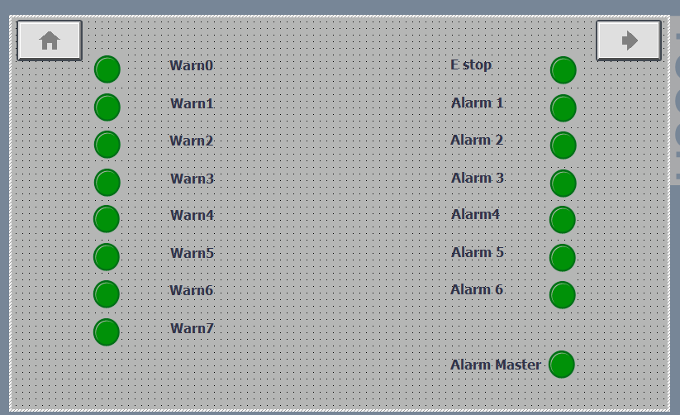

Engineering Screen
On this screen we can set the pre-sets for the error counters, we can set it so the system displays an alarm after 5 boxes are lost and alarm/shutdown once 8 boxes are lost for example. On this page is also the master reset and reset counter button previously discussed.
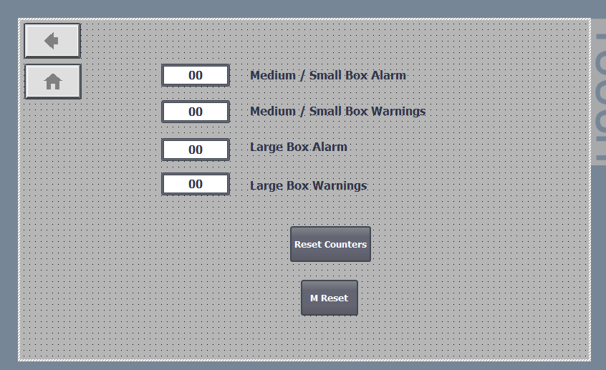

Conclusion
As can be seen above I have successfully completed this project and have the system sorting boxes automatically based on their sizes. I have included all aspects requires as well adding safety features to my plant in order to make it realistic. This has been accomplished to the best of my ability and has met my expectations for the plant.

Bibliography
Chaudhari, D. (n.d.). Top 43 Applications of PLC in Industry and in Daily Life. Retrieved from DipsLab.com: https://dipslab.com/plc-applications/
Phillips, R. (2019, November 13). What are the different types of PLC? Retrieved from Basic PLC: https://basicplc.com/different-types-of-plc/

