My dream zoo has become my worst nightmare: TV presenter Anna Ryder Richardson heartbroken after £100,000 court fine for accident at her animal park
by Anna Ryder Richardson
PUBLISHED: 01:08, 25 November 2012 | UPDATED: 11:58, 26 November 2012

This morning, like any other, I’ll walk around the grounds of my zoo, stopping to greet each of the animals, from the gibbons to the zebras, meerkats, lemurs and our pride and joy, two young rhinos named Zamba and Jambo.
Over the past five years since fulfilling a lifelong dream by buying Manor House Wildlife Park in Pembrokeshire, Wales, I’ve had a privileged existence. I spend my days tramping about in my wellies among these incredible creatures, covered in mud and looking as though I’ve been dragged through a hedge backwards, and I love it.
But this weekend, not even the animals can lift my spirits. After a court ruling last week, I have no idea whether my dream can continue.

Scroll down for video
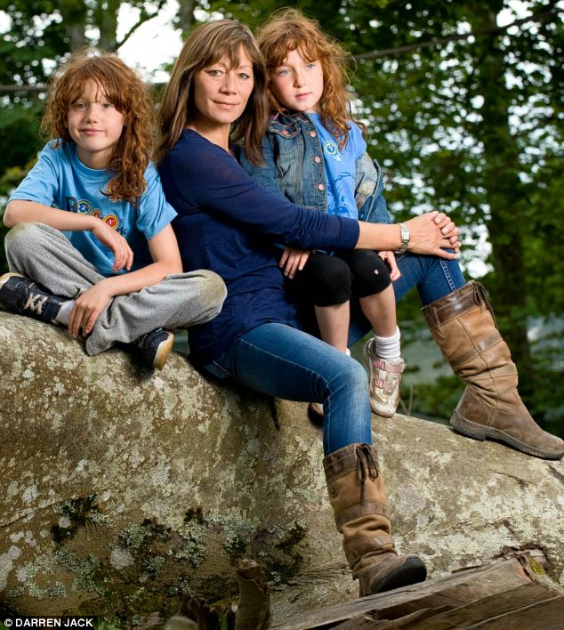
Anna Ryder Richardson, pictured with daughters Bibi, 7, and Dixie, 6, says that the past 14 months have been a time of incredible anguish for her family
In 2010 an apparently healthy tree in the park suddenly fell, and trapped beneath were a mother and her young son. They were both seriously injured.
Last Thursday, my husband Colin MacDougall and the company we run together were ordered to pay a fine of more than £100,000 for two breaches of health-and-safety legislation. Because Colin pleaded guilty – to charges which were not directly related to the incident – people have been left with the impression that we’ve admitted responsibility for the falling tree. The tree involved formed no part of the prosecution. In fact, it was a tragic accident we could not have foreseen.

More...
- My secret affair with Amy Winehouse, by Pete Doherty: Troubled rock star reveals the truth about their explosive romance
- Now, Halle Berry gets police escort as she takes daughter Nahla to the theatre... 24 hours after fight between ex Gabriel Aubry and Olivier Martinez
But the ruling was devastating for us. We were advised that the breaches would normally result in a fine of no more than £20,000. On this basis Colin accepted legal advice to plead guilty to avoid financial ruin.
We’ve poured every penny we have into the venture, even living in a tiny wooden hut in the park’s grounds to save funds.
Since that terrible day in August 2010, our thoughts have always been with the people involved, Emma Davies-Hughes and her three-year-old son Griff, who spent three days fighting for his life in intensive care.
First and foremost, we’re thankful that they survived, although they are still suffering the effects of their horrific injuries. The incident changed their lives for ever, and it will always haunt us.
Until now, we’ve not had the opportunity to give our version of events. We thought that chance would come in court during our trial, but the charges against me were thrown out because of a lack of evidence. As Colin pleaded guilty to the two health-and-safety breaches, the trial we were expecting did not happen.
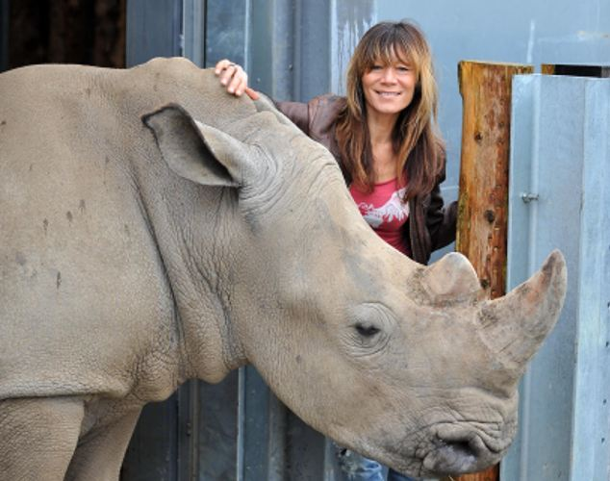
The TV presenter says she wanted to keep endangered rhinos not because of visitor numbers, but because she is passionate about conservation
The accident was the result of honey fungus, which attacks and kills the roots of trees and which was undetected by the tree surveyor we hired. It was claimed in court that we cut health-and-safety corners in an attempt to dodge the cost of properly addressing the issues we faced, which is deeply hurtful. It goes completely against everything we’ve attempted to do with the park from the start. In fact, it’s cheaper to chop a tree down than care for it.
This was never a money-making venture. It was the ultimate labour of love, which has turned into my worst nightmare.
I’ve lost count of the times I’ve been asked if I regret buying the zoo. The honest answer is that I never had any regrets until now. Over the past two years, I’ve had many nights where I’ve lain awake, consumed by guilt that I dragged my family here and put them through this ordeal.
In truth, my decision to buy the zoo in 2008 was the result of a crazy mid-life crisis. Before then, we had everything. As a TV presenter and property developer, I enjoyed a thriving career, as did Colin, who ran two highly successful restaurants in Glasgow. Our two beautiful daughters, Bibi, born in 2003, and Dixie, born the following year, completed our life together.
Yet since childhood, I’d longed to live in the countryside and when I heard someone talking about a wildlife park for sale in Wales, I knew it was something we just had to do.
Somehow, I persuaded Colin to agree to risk everything we had buying the dilapidated zoo in the tiny hamlet of St Florence, near Tenby, for £1 million. At that stage, every aspect of it was run-down and frankly hazardous, from the dangerous rides to the inadequate facilities for the animals, many of which displayed signs of anxiety. Remarkably, it was open to the public.
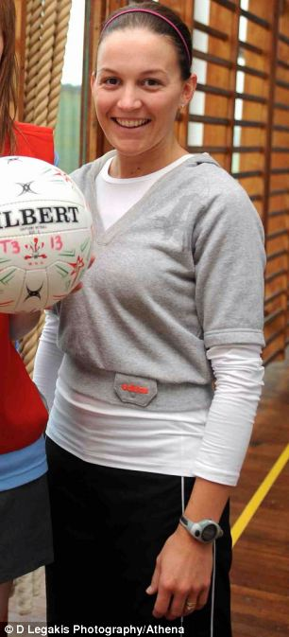
Emma Davies-Hughes from Llanelli west Wales, was injured with her son Griff
We instantly closed it and spent seven months completely renovating the entire park. After opening for just three months that year, we closed it again to focus on further work we knew needed to be done to transform it into our vision of a park that would help protect rapidly disappearing endangered species and teach young visitors about the importance of conservation.
Well aware of our lack of experience, we sought the advice of experts including Dr Jake Veasey, the director of animal care at Calgary Zoo in Canada, who became like a member of the family.
The work was extremely hard and I poured more than £1 million of the money I’d made from my media work into the renovations, which included new enclosures for many of the animals. The new home for Steve the gibbon was more impressive than our own accommodation.
At times, living in a cabin in the park made our family feel as if we are the most enclosed animals in the zoo, and Colin and I had our share of rows as a result of our drastic change in circumstances.
But what we sacrificed in privacy we gained in the joy of watching our daughters enjoying the freedom of life in the countryside and bonding with our 140 animals.
For Colin, the switch from bustling Glasgow to sleepy St Florence was a culture shock, but just like me, he came to love the outdoor life and every penny we made from the zoo was ploughed back into the business.
We have a full health-and-safety check every year. Last year, we passed a host of further tests by the European Association of Zoos and Aquaria to be allocated two endangered white rhinos, one of which is the first in Britain to be born through IVF. We wanted the rhinos not because they would increase visitor numbers, as was suggested in court, but because we are passionate about conservation.
Our zoo licence requires us to check our hundreds of trees daily to ensure they aren’t at risk of falling and endangering our staff, visitors, animals or fences. We have also had experts regularly checking the trees for any potential problems. The tree in question was assessed prior to it falling and deemed in need of monitoring, but we were totally unaware of the honey fungus. There was no recommendation for work to be done on the tree.
We firmly believe that although, as Colin admitted in court, we could have done more in terms of keeping records of our checks, we could not have known the tree would come down.
On August 24, 2010, Griff and his mother were petting the animals in the wallaby enclosure when the tree fell on them. Colin and I were on the scene within minutes, and I’ll never forget seeing the little boy trapped and suffering what I knew were very serious injuries. It was, without doubt, one of the most traumatic events of my life. Thankfully, a trained medic was on the site and treated Griff and his mother.
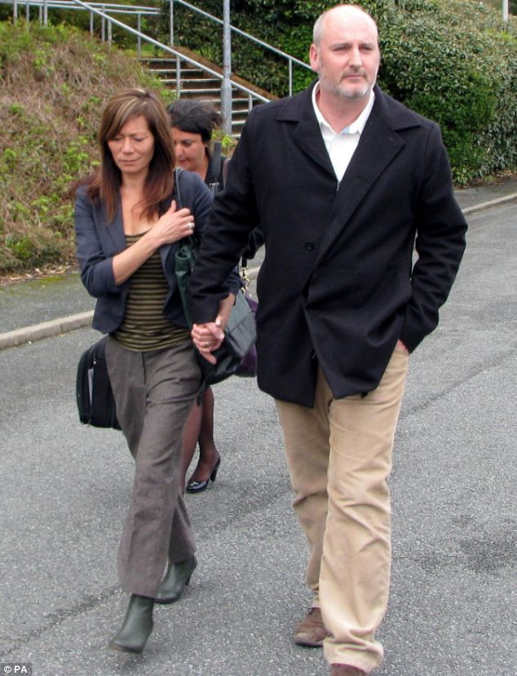
Anna Ryder Richardson, seen with her husband Colin MacDougall, says her decision to buy the zoo was the result of a crazy mid-life crisis
The relief we felt a few days later when we realised Griff would survive is indescribable.
We voluntarily closed the park for a day and a half and an independent tree expert carried out another assessment and declared us safe to reopen.
Then, 14 months ago, we learned we were to be prosecuted by Pembrokeshire County Council – although they had previously approved our tree-management programme – which came as a tremendous shock. We feel that their health-and-safety investigation was inadequate and we are currently in the process of making a formal complaint.
From the start, it was foreseeable that the family would bring a civil case against us, which is what our public liability insurance is for, but we were stunned when the council decided to bring three separate criminal cases against me, Colin and the company.
The criminal case has delayed the civil case, which means the family, who have behaved with remarkable dignity throughout their ordeal, have been unable to move on.
The past 14 months have been a time of incredible anguish for my family. Our daughters have been very upset by the news coverage of the case. I’ve been on bail for the entire period, which has had a dramatic impact on my career.
My earnings were what was keeping the business going, and without them, it’s been extremely tough. I’ve lost a lot of weight through the stress. Compounding this, my father died two days before our first appearance in court a fortnight ago.
When the charges against me were dropped, I held my emotions in check but when Colin’s charges were read out I was overwhelmed. I wept as the judge said the sentencing would be arranged so it wouldn’t clash with my father’s funeral.
When we discovered last Thursday that the fine was more than £100,000 we were absolutely horrified. The first £5,000 is due this month.
Through this entire experience, we’ve received many letters of support from people who have visited the park, letting us know how much they’ve enjoyed their experiences and commenting positively on the contrast from the sad state it was in before.
Pembrokeshire is stunningly beautiful and the people are wonderful but, after this experience, if I could pick up the park and run away, I would.
I’ve been trying to remember the inspiring feeling of watching the response of children to seeing animals many of them have never had the chance to see before, and the magic of being close to the animals whenever I like. At the moment, though, it’s difficult not to regret that I allowed myself to get so carried away with my dream.

- In a statement, Pembrokeshire County Council said: ‘The sentences reflect the fact that Manor House Wildlife Park and Colin MacDougall have failed, over a number of years, to manage the risks posed to the paying public and employees at the Park. Fundamental health- and-safety requirements were breached. The company and Mr MacDougall failed to follow advice contained in a specialist’s report on the trees upon which they should have acted. Being in that environment was unsafe and the company knew it but carried on entertaining thousands of visitors who were at risk.’
Read more: http://www.dailymail.co.uk/news/article-2238045/Anna-Ryder-Richardson-heartbroken-100k-court-fine-accident-animal-park.html#ixzz2E07jFI7F
Follow us: @MailOnline on Twitter | DailyMail on Facebook

