UNIVERSITY OF WALES TRINITY SAINT DAVID
LONDON CAMPUS
Assignment 2
Learning in the Digital Era
Video Link: If this finds you on Friday, expect unexpected money within an hour(‼️listen 1X)

Module Name: Learning in the Digital Era
Module Code: ACCA 4025

Student Name: Lorraine Kazondovi
Student ID: 2531577
Group: 1

Lecturer’s Name: Koushik Modak

Table of Contents
Introduction 2
Main Body 2
Conclusion 8
References 8

Introduction
This presentation is going to be about self-evaluation, where I’ll be discussing my strengths weaknesses and traits. Secondly, I will break down a professional development plan to improve my weaknesses. In conclusion, I will summarize the topic developing resilience, which I chose for the unit 4 topic task.

Main Body
This section will discuss the Gibbs Reflective Cycle and why it is important for one’s self-improvement. It will also discuss my strengths, weaknesses, traits and how I plan to improve my weaknesses.

Video Link: If this finds you on Friday, expect unexpected money within an hour(‼️listen 1X)
Slide 1 COVER PAGE
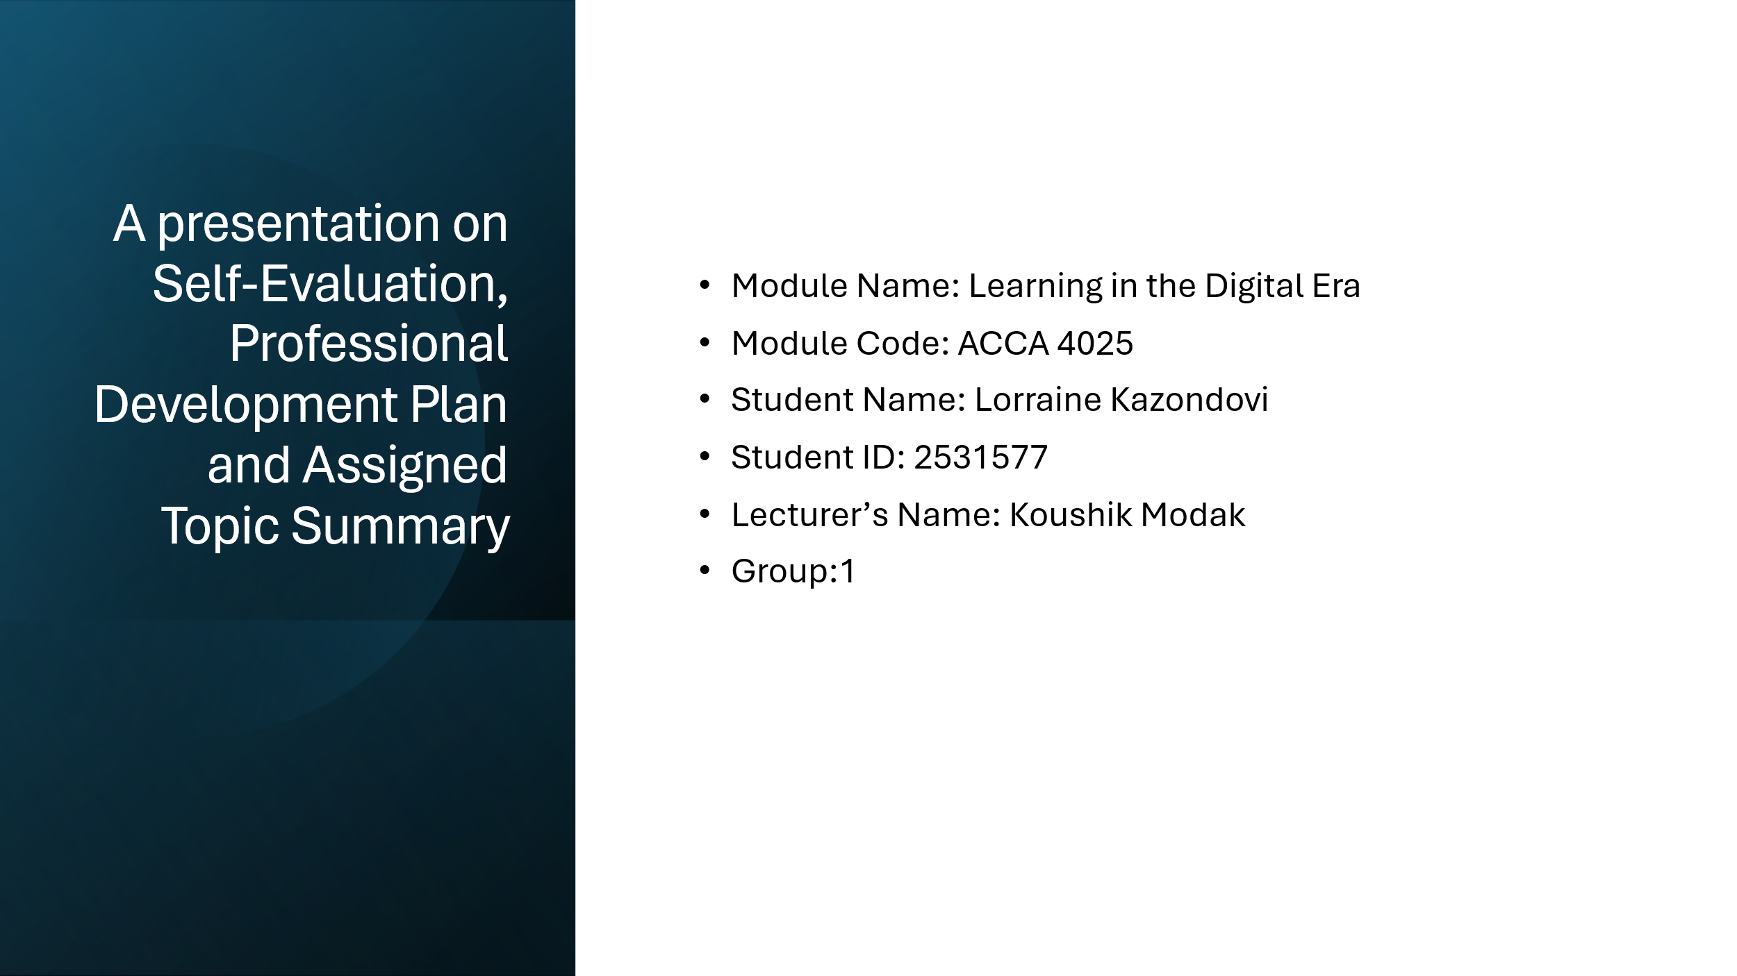

Slide 2 CONTENTS

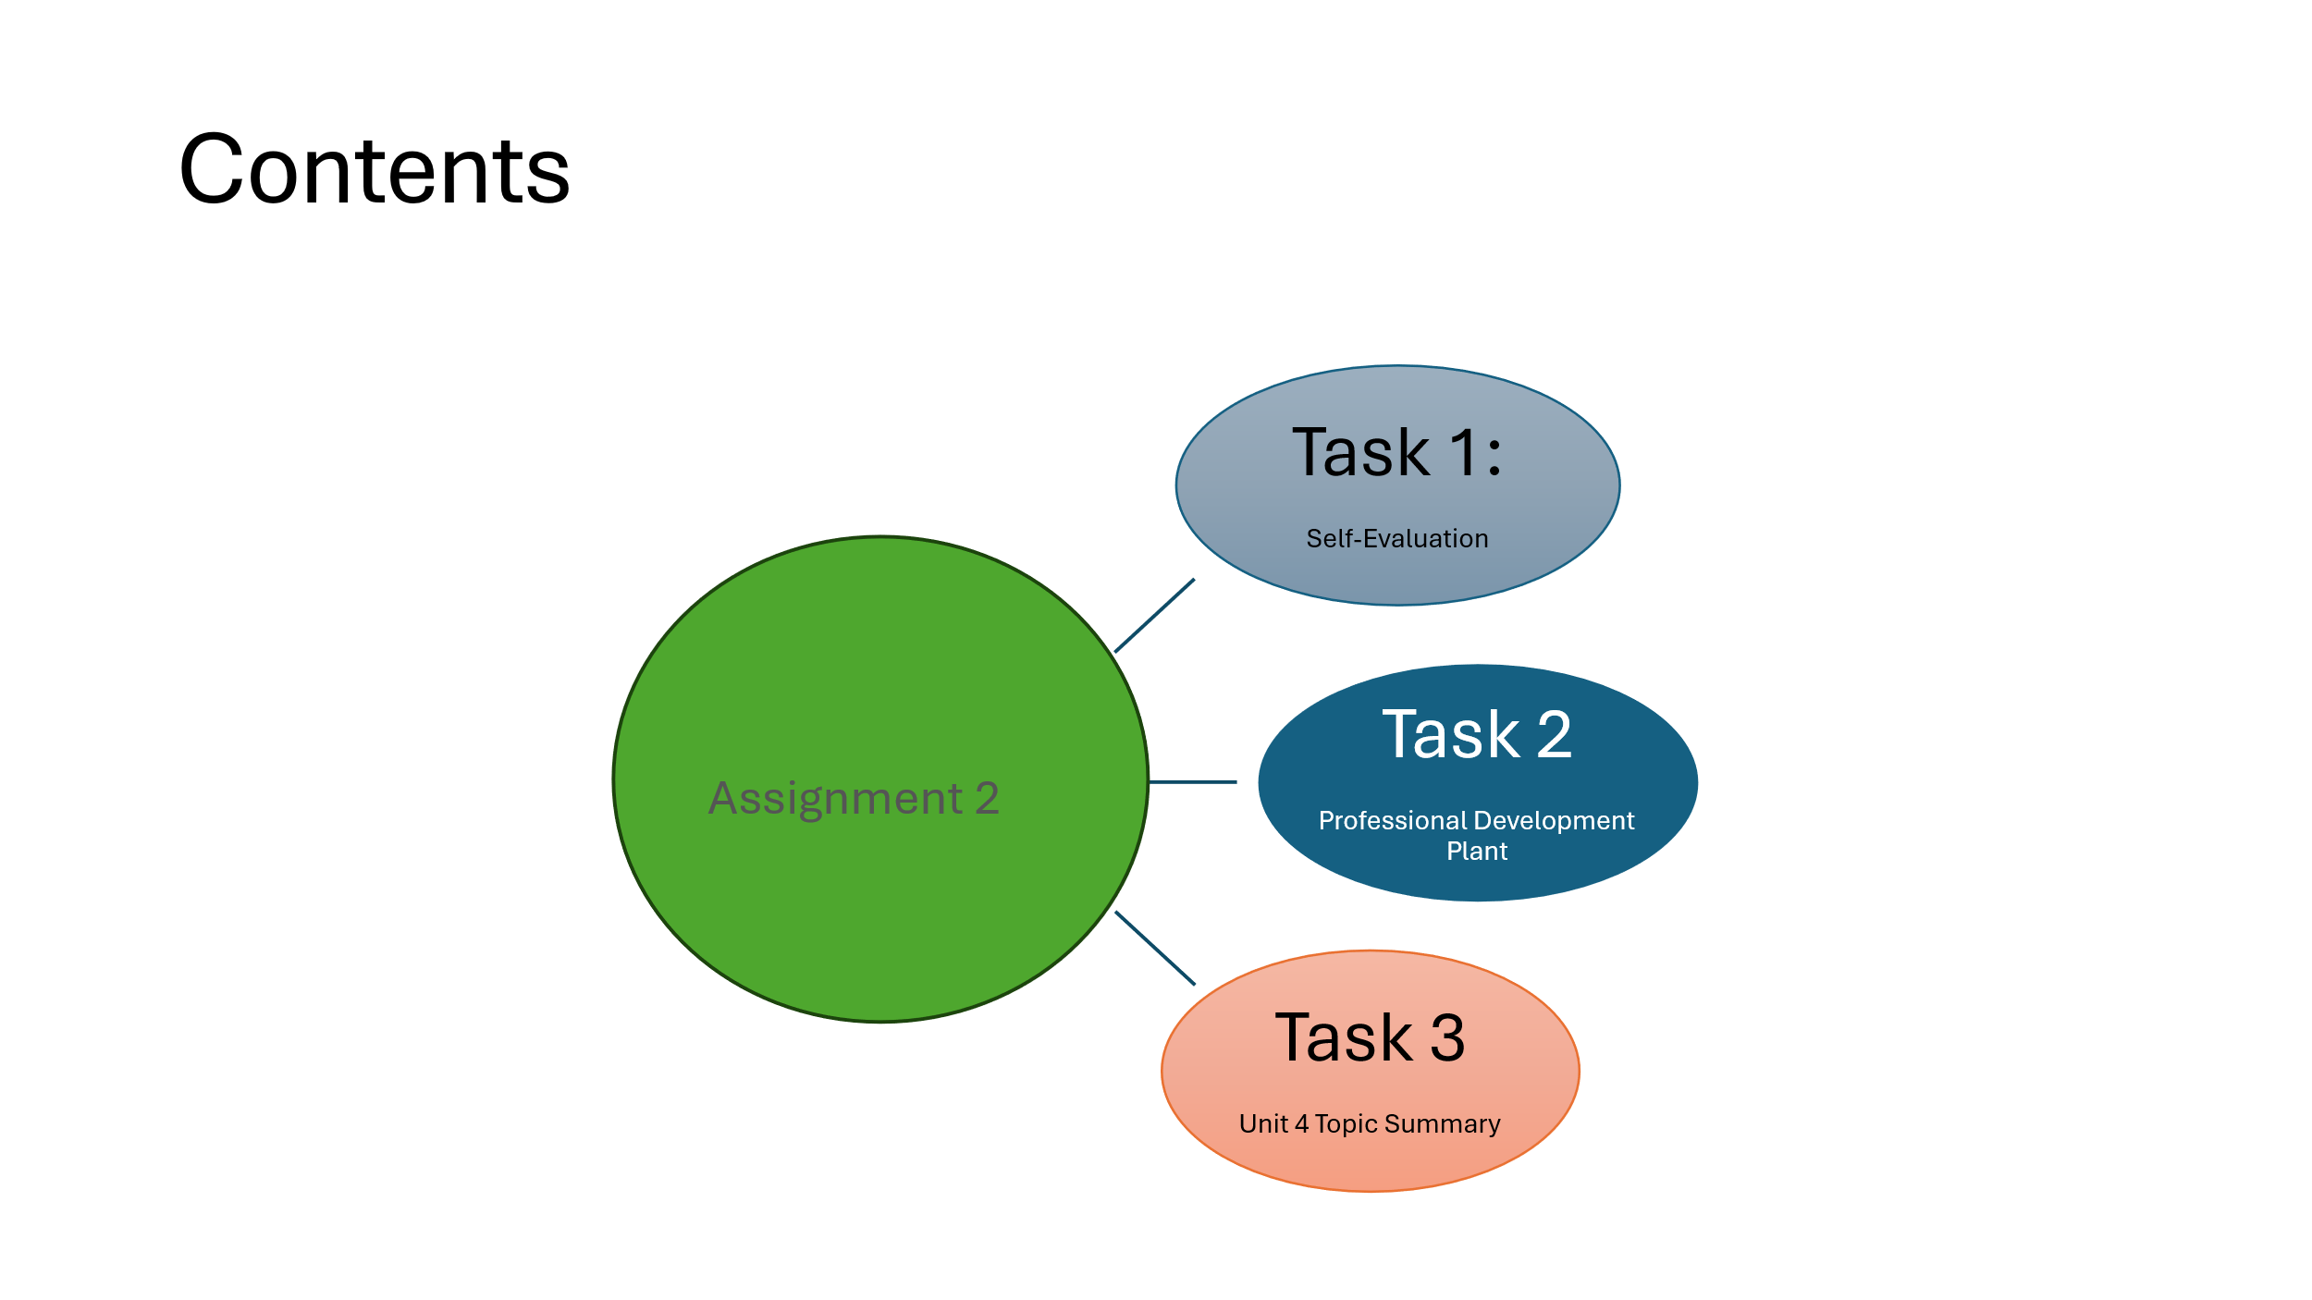

Slide 3 INTRODUCTION
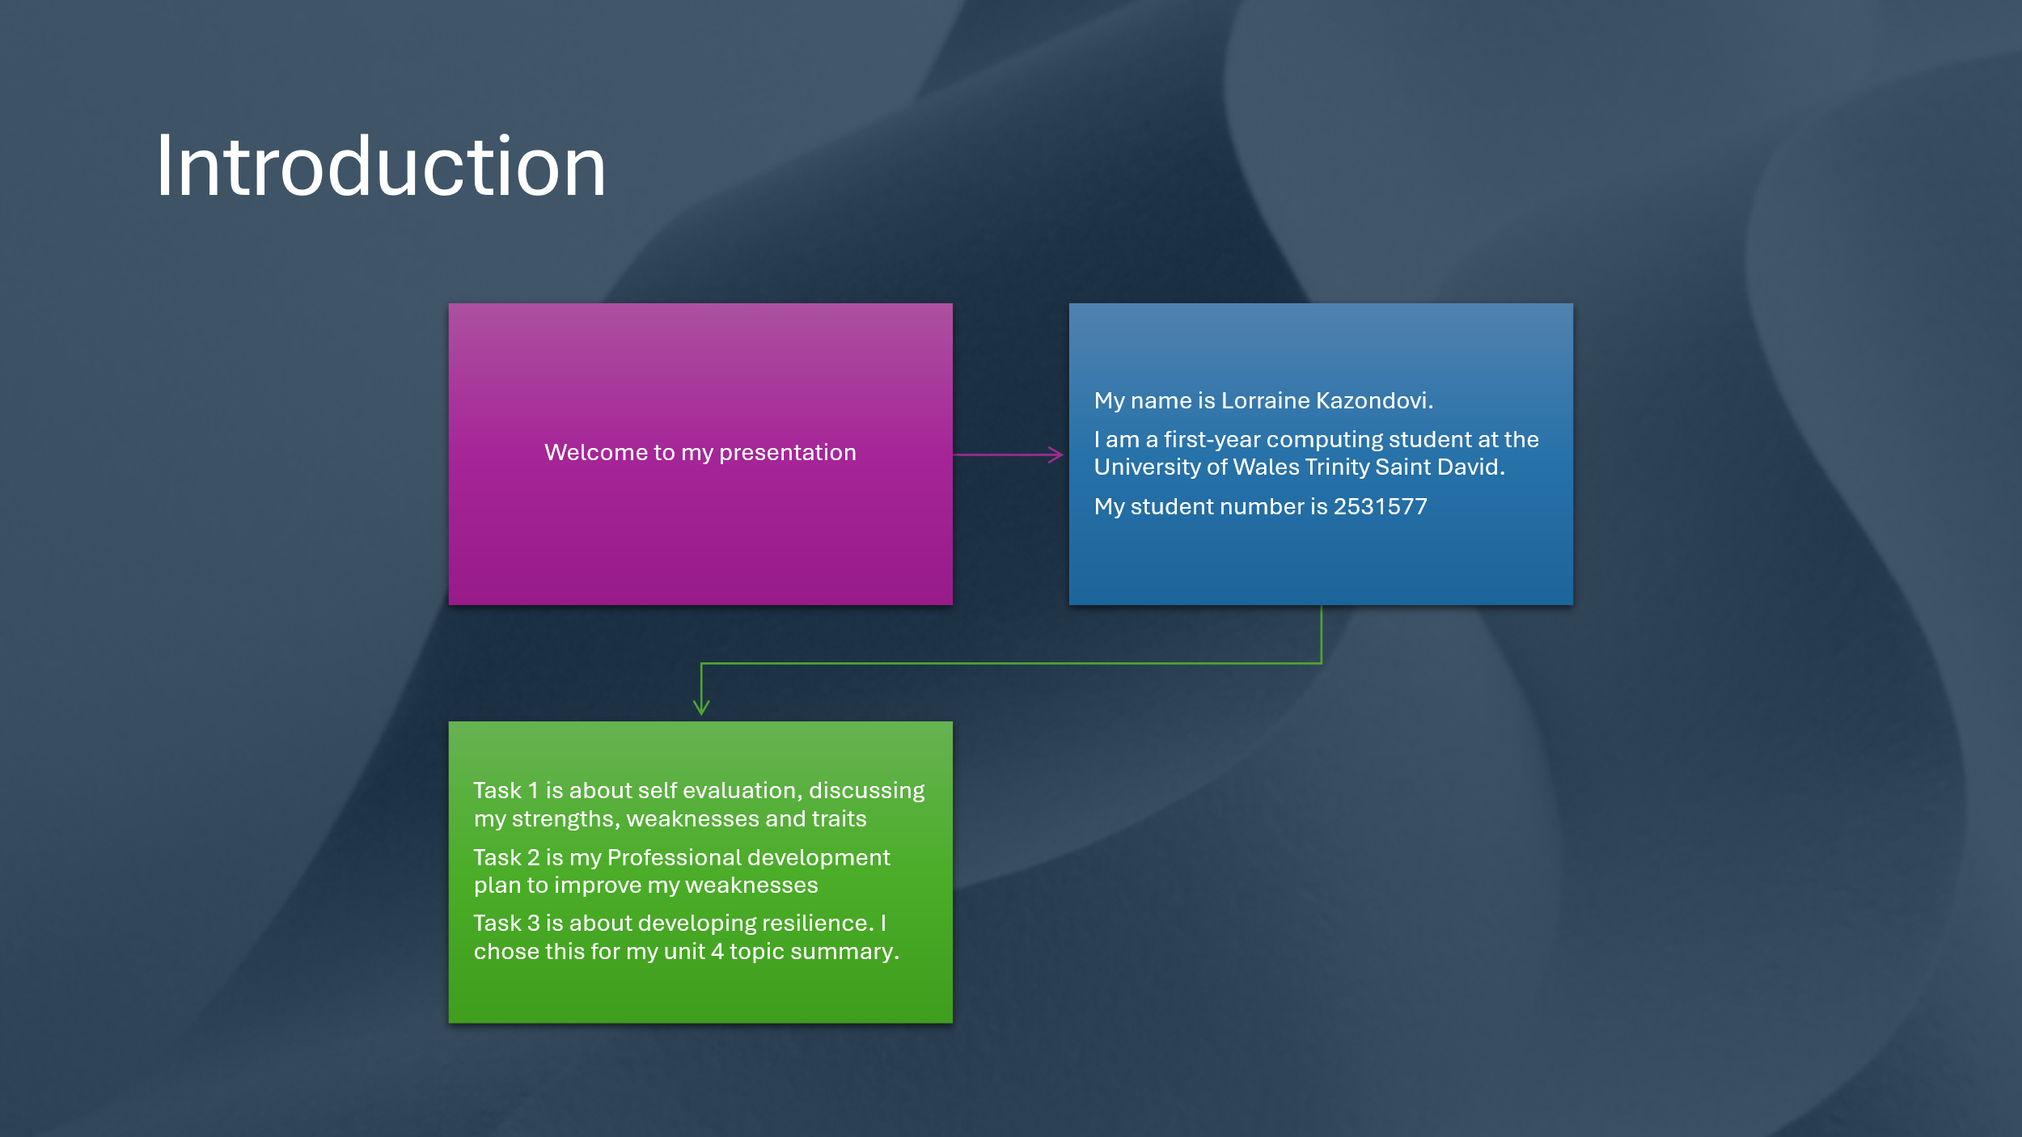

Slide 4 MAIN BODY
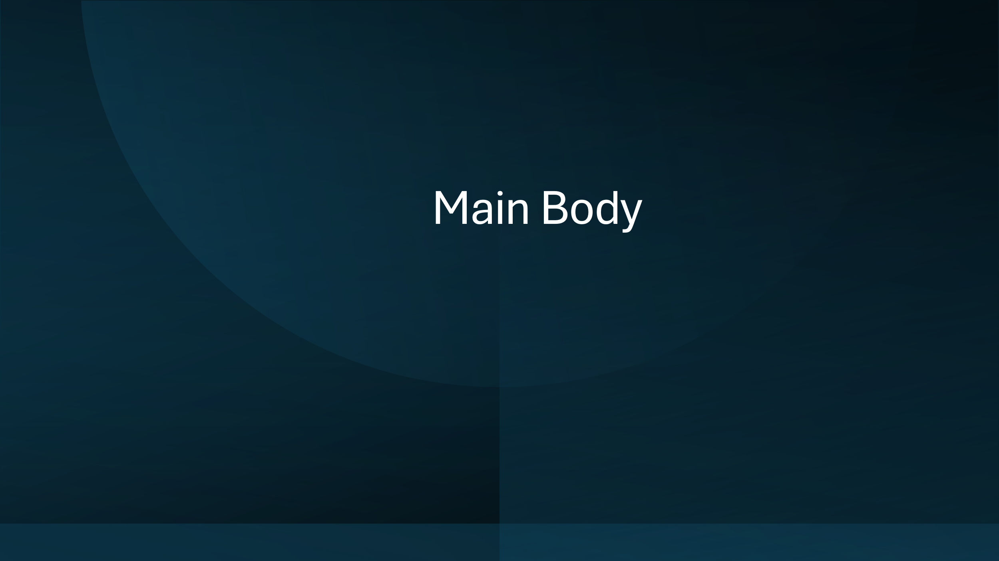

Slide 5 GIBB’s REFLECTIVE MODEL
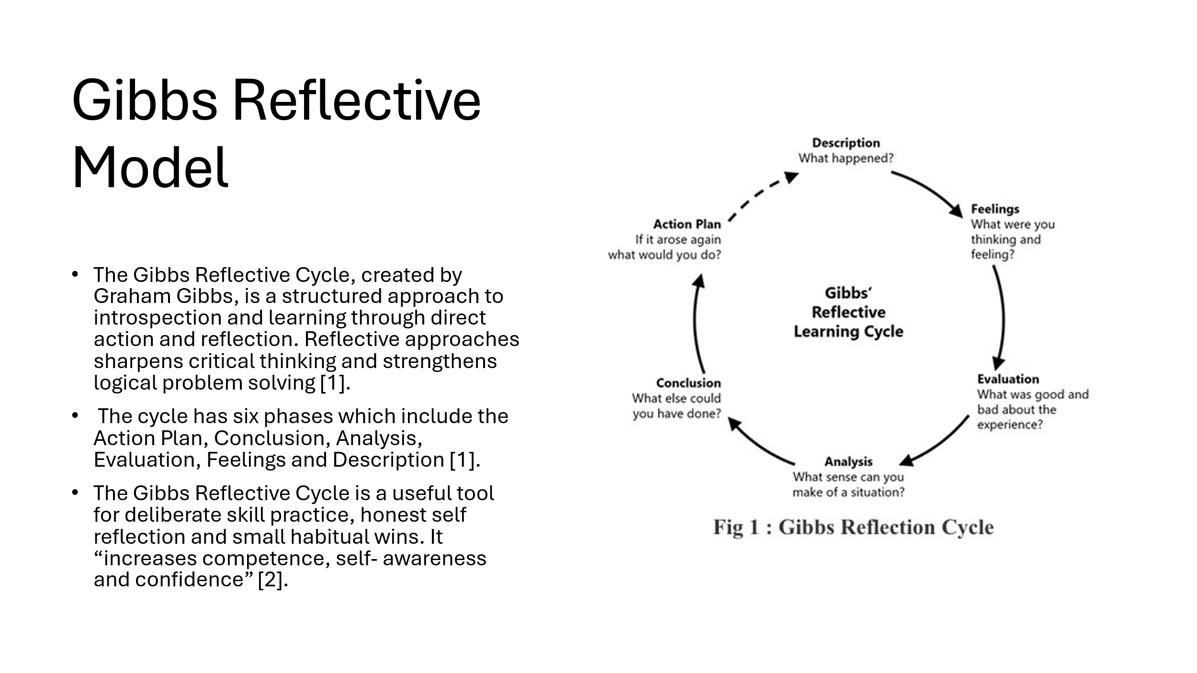
The Gibbs Reflective Cycle is a structured approach to introspection which helps with critical thinking and problem solving [1]. The cycle increases competence, self-awareness and confidence [2]. I plan to use the cycle as part of my professional development plan where I act after evaluating the emotions that contribute to my weaknesses.

Slide 6 TASK 1: SELF EVALUATION
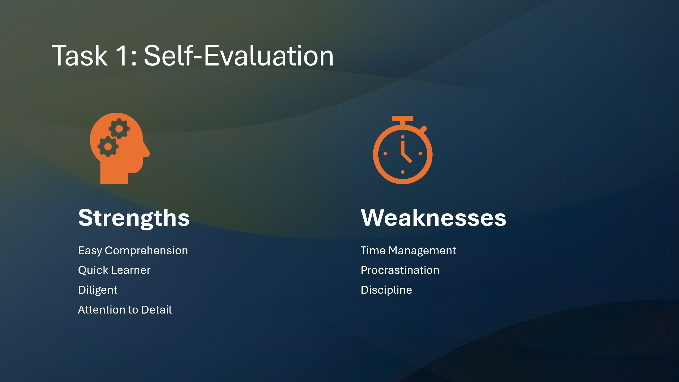
My individual SWOT analysis is as follows:
Strengths: grasping information quickly and highly adaptable
Weaknesses: Delayed starting and inconsistencies (procrastination)
Opportunities: Thriving in fast moving fields
Threats: Burnout cycles and reduced work quality

Slide 7 TRAITS GAINED FROM THE SELF EVALUATION
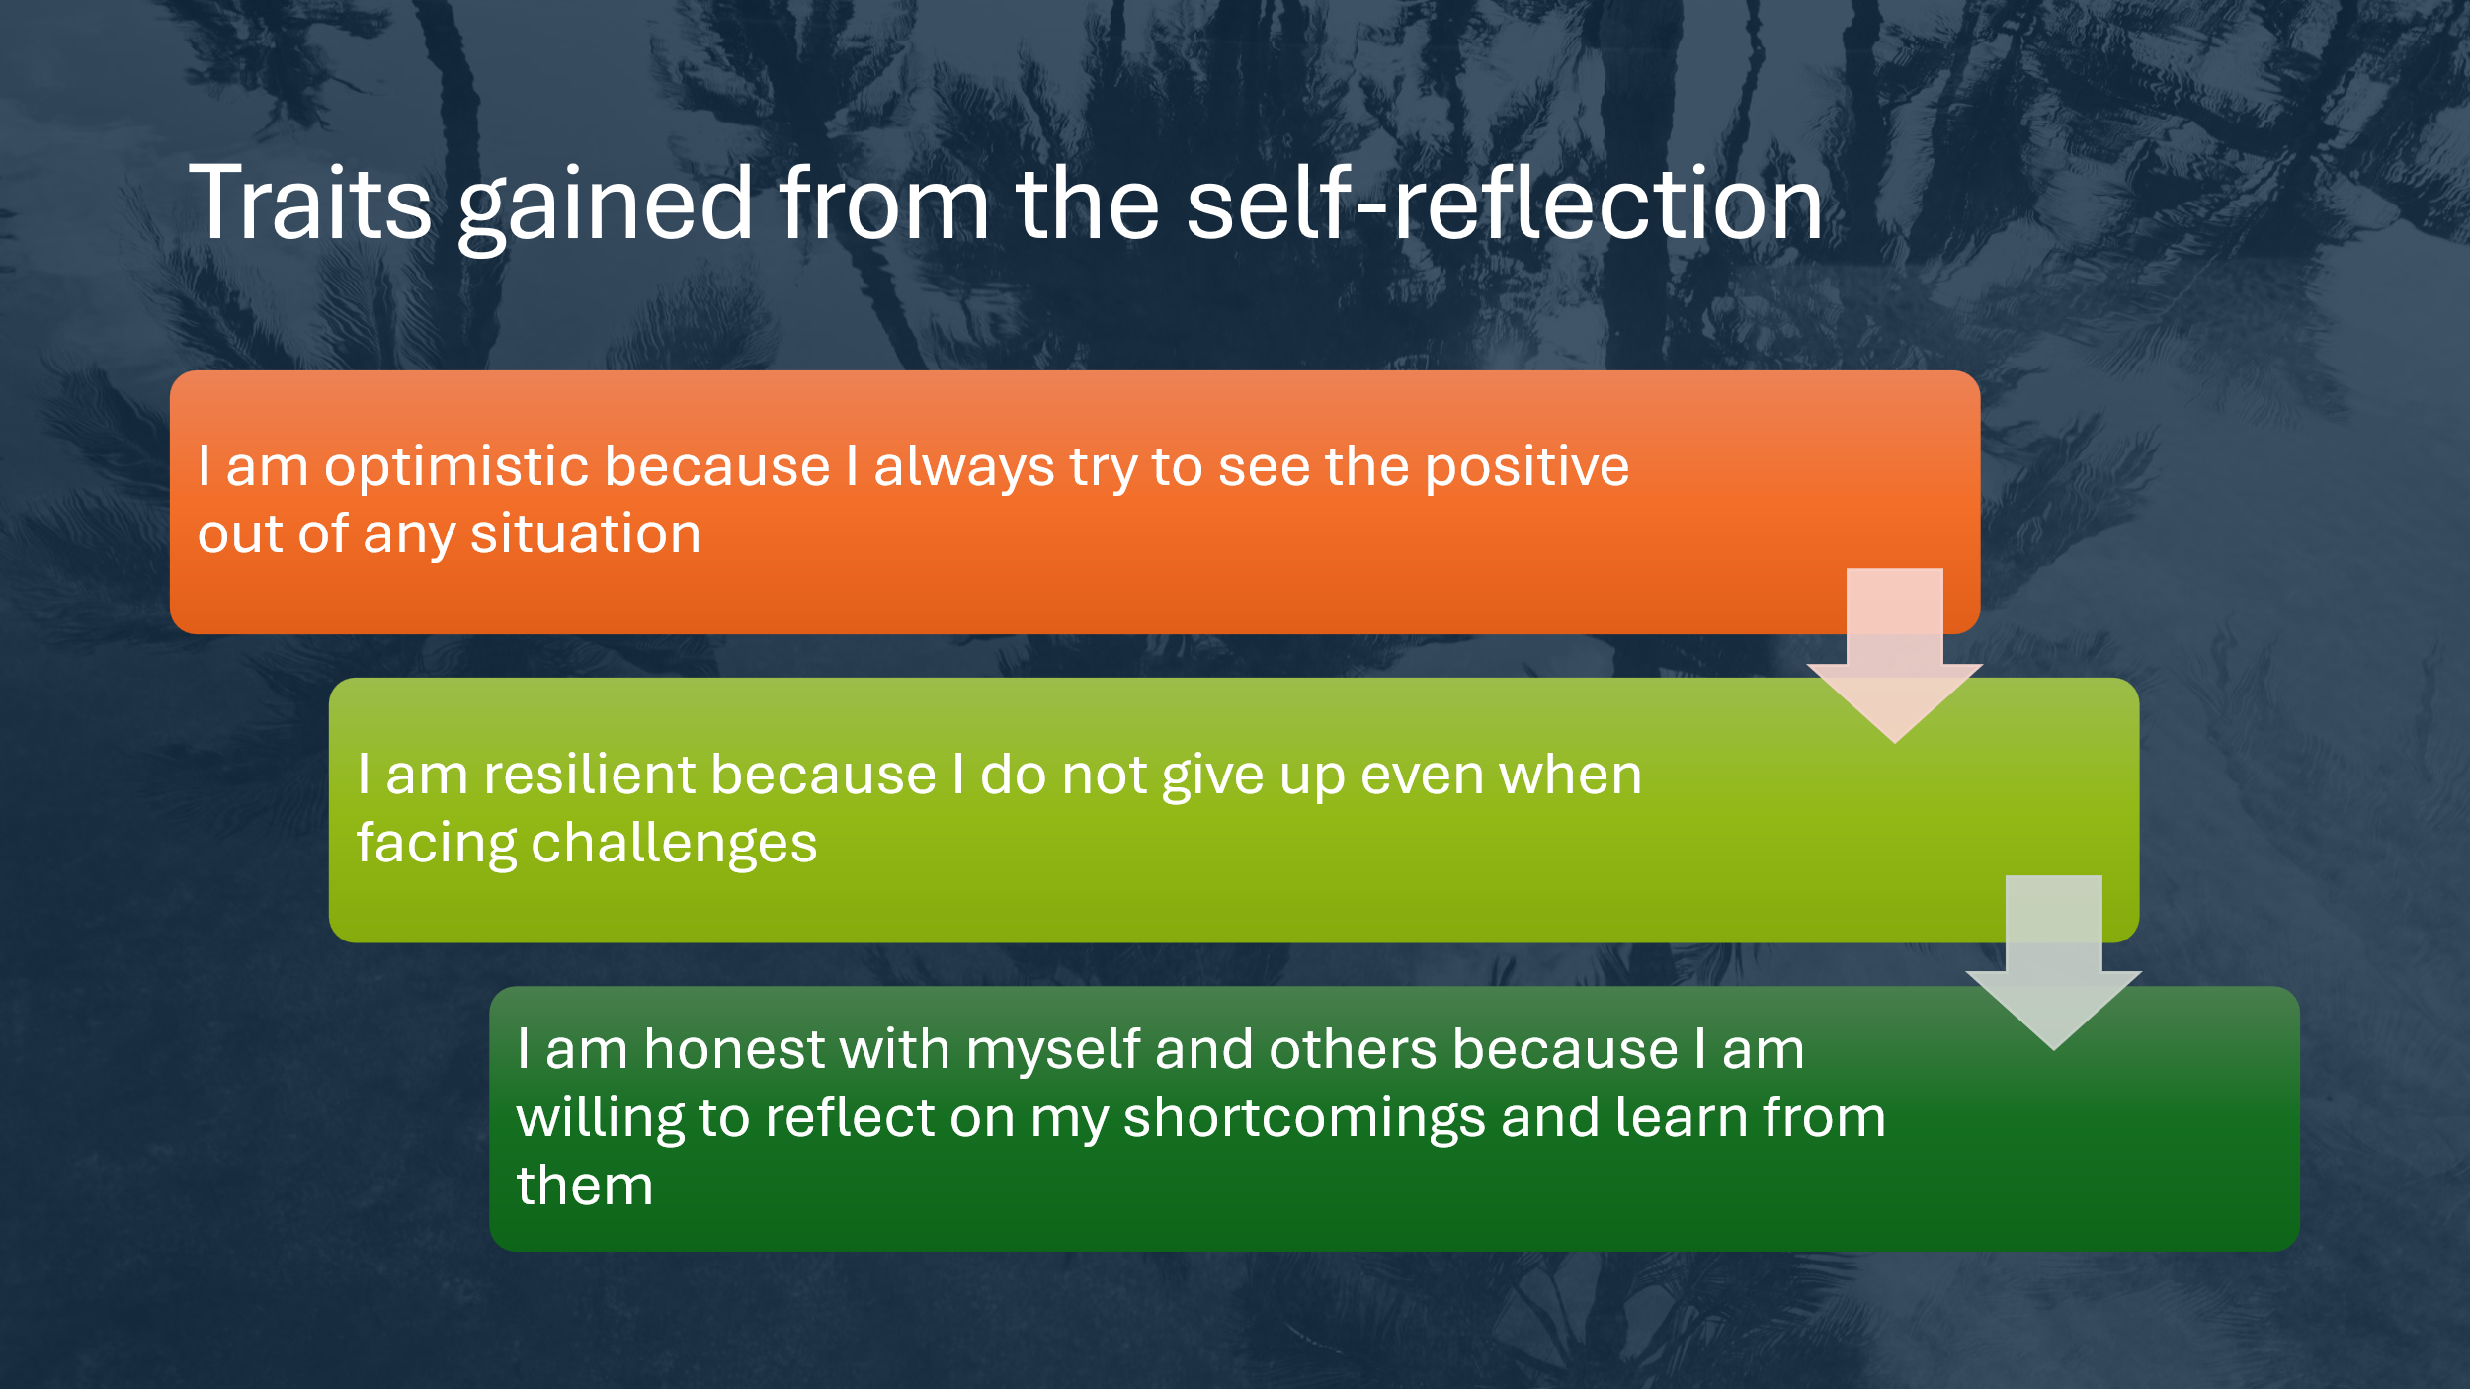
I have realized that despite my weaknesses, I possess important traits which have helped me excel in various areas of my life.

Slide 8 PROFESSIONAL DEVELOPMENT PLAN
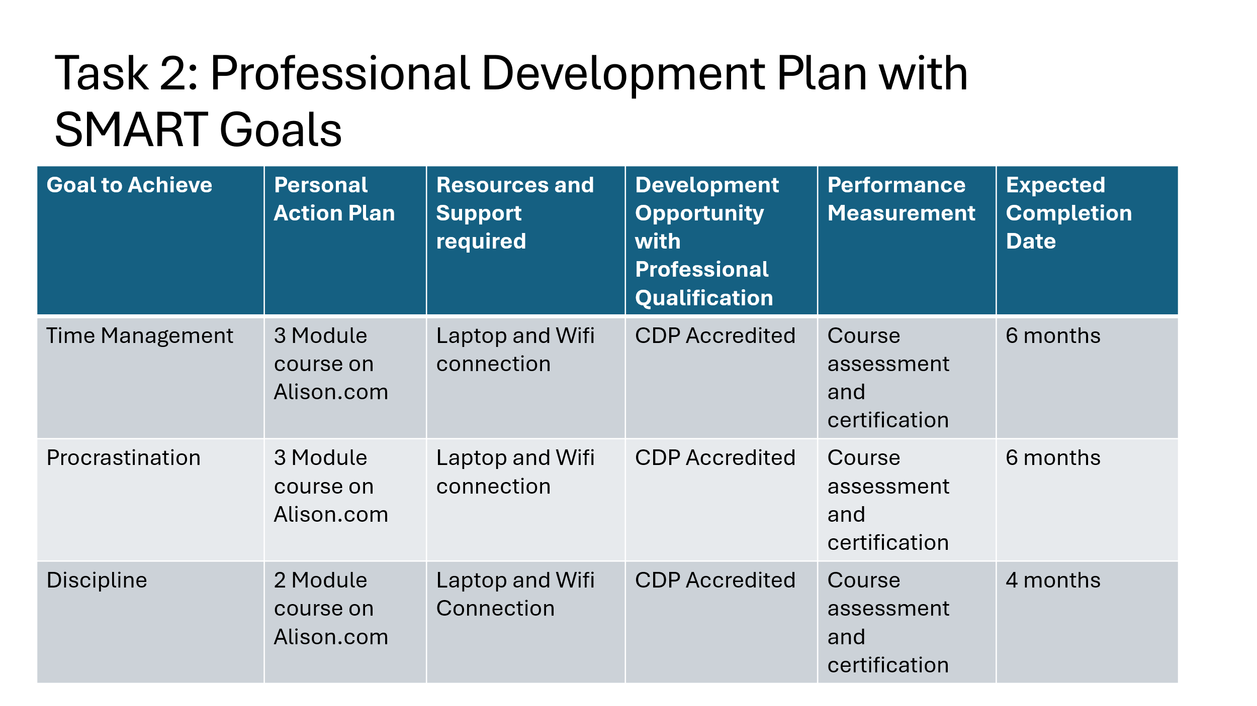
Alison.com is well known and respected learning website that is CDP accredited. It has numerous free courses and after completion you are awarded with a certificate. It is good platform to work on skills you’d like to improve.

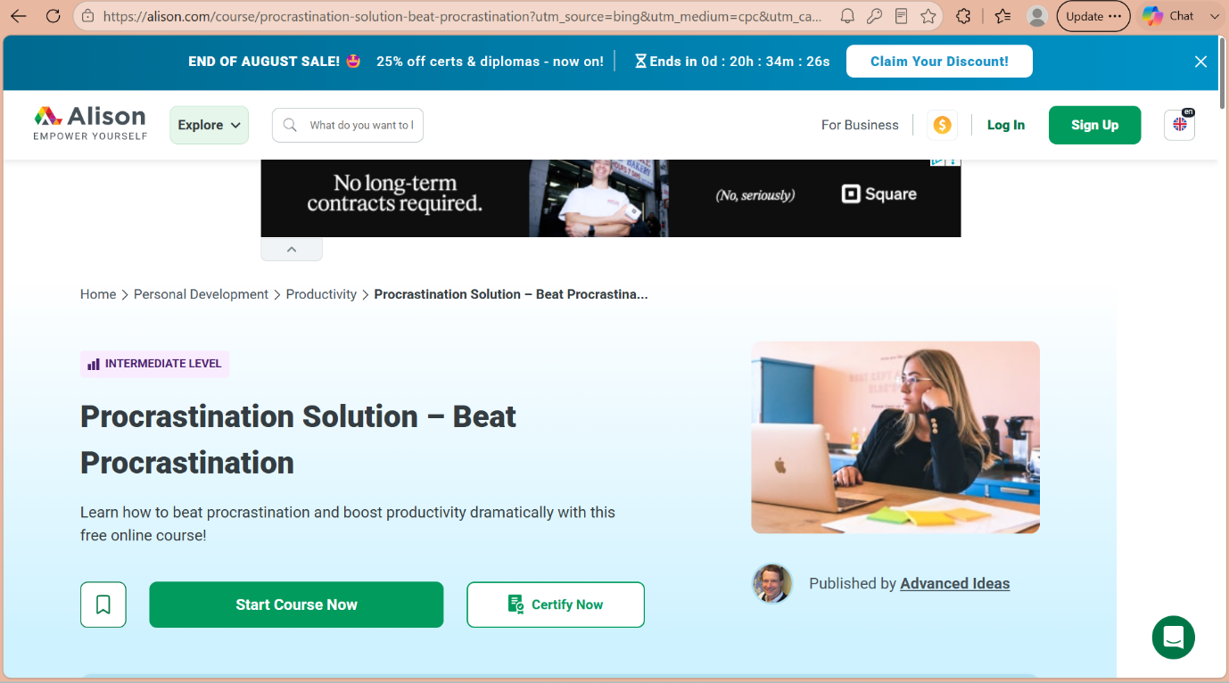
Alison.com is a free leaning platform

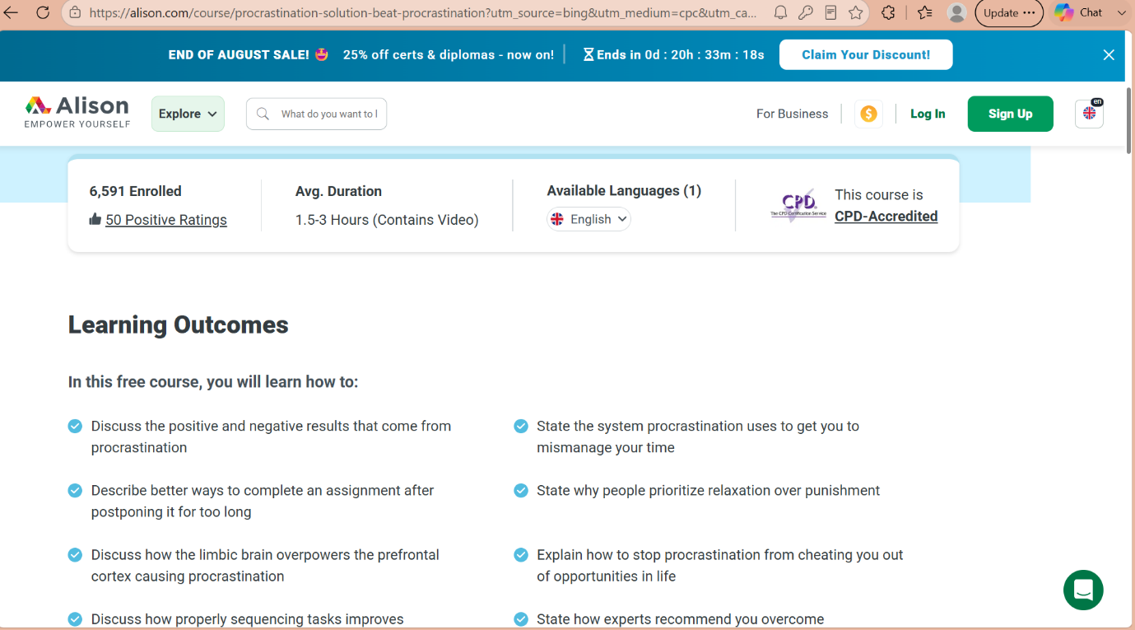
This course on procrastination has numerous learning outcomes
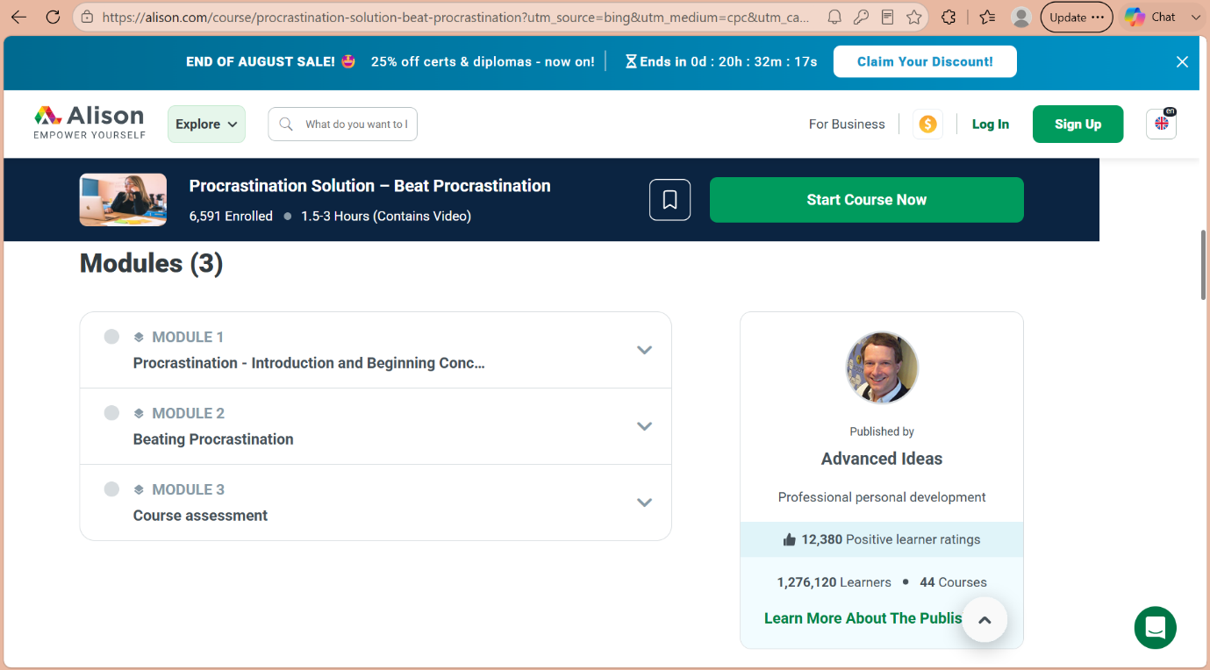
This course is based on 3 modules and is self-paced

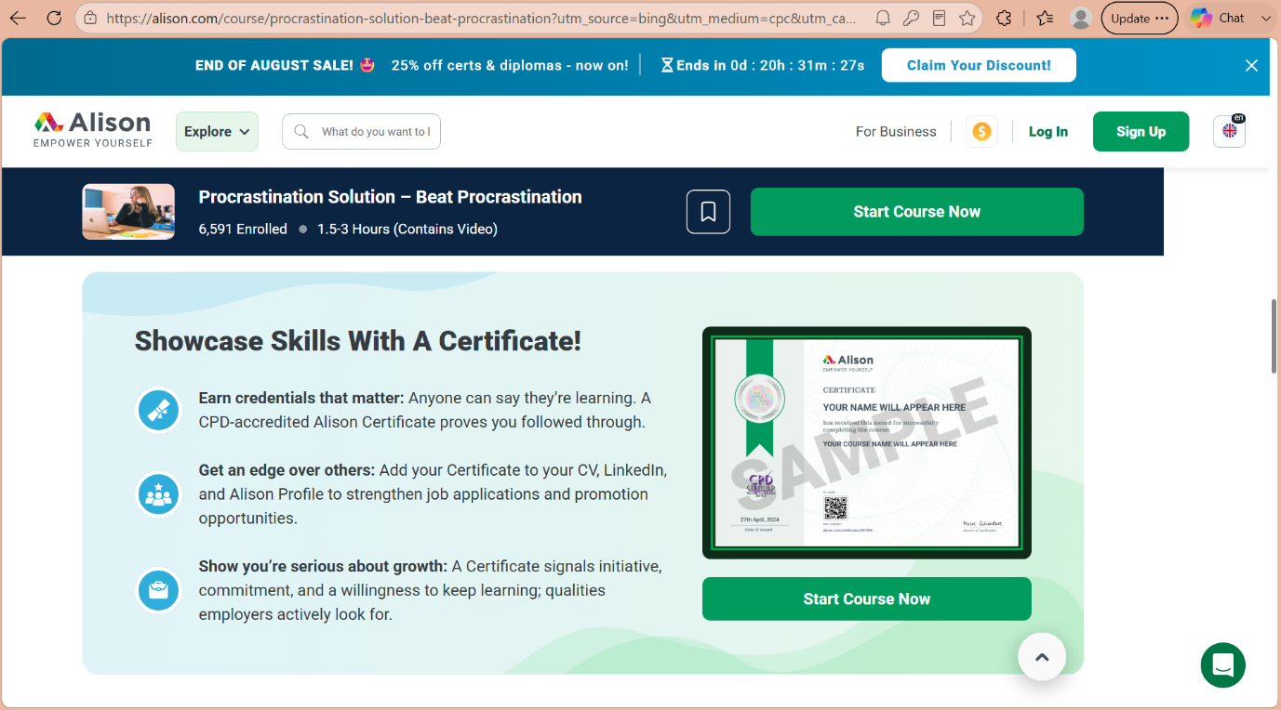
You can get a certificate as proof of completion

Slide 9 UNIT 4 TOPIC SUMMARY
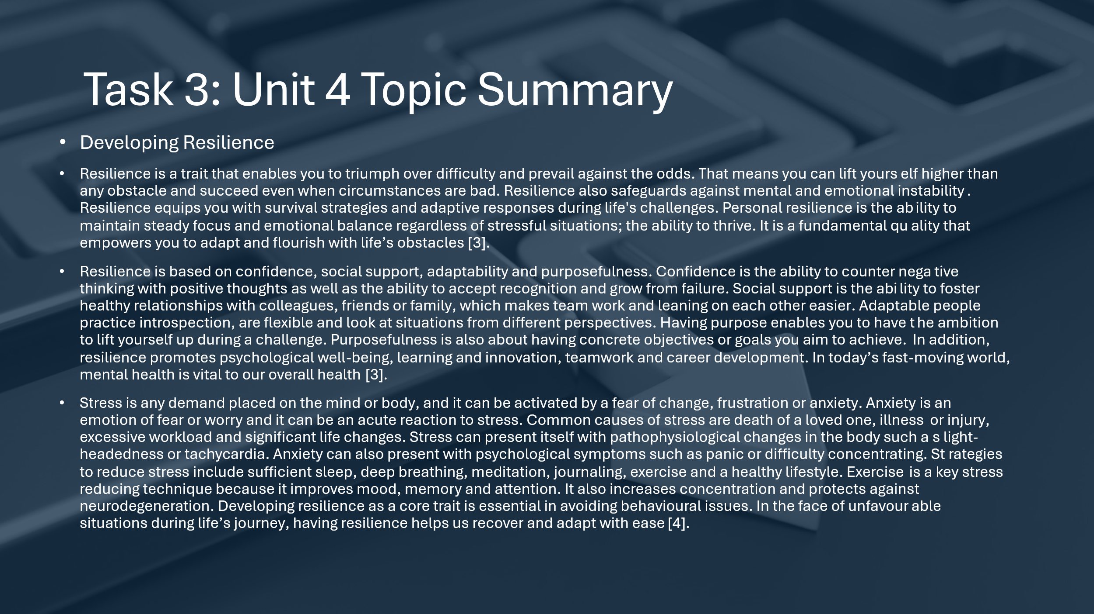
I chose the topic on developing resilience because it is a fundamental quality that empowers you to adapt and flourish despite life’s challenges [3]. Developing resilience as a core trait is essential to prevent behaviour problems. It also helps us bounce back easily during setbacks [4].

Slide 10 CONCLUSION
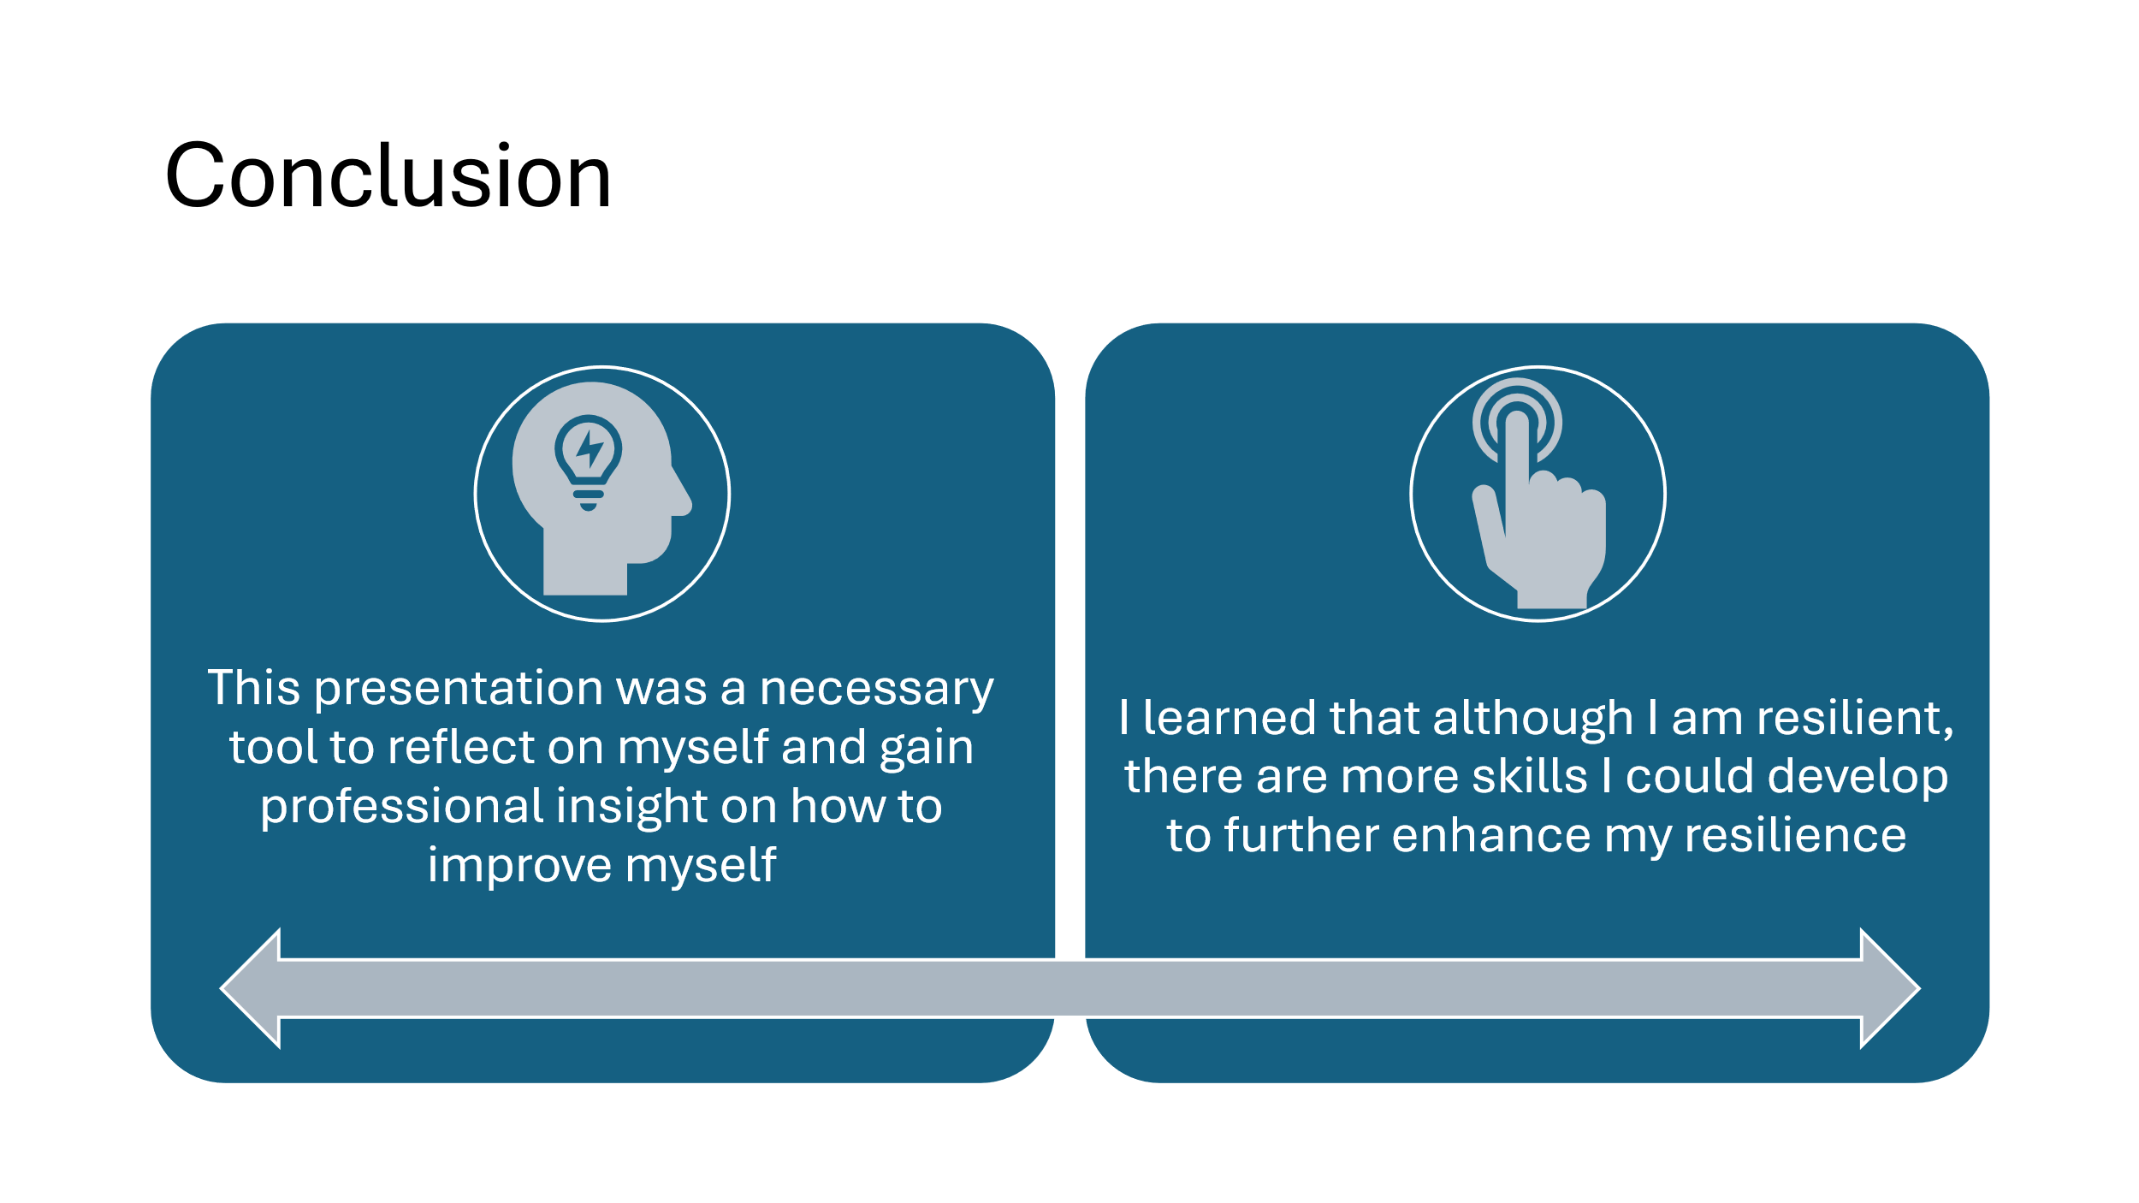
I learned that although I am a resilient person, I could still learn and practice to develop more resilience as well as improve on my strengths and weaknesses.

Slide 11
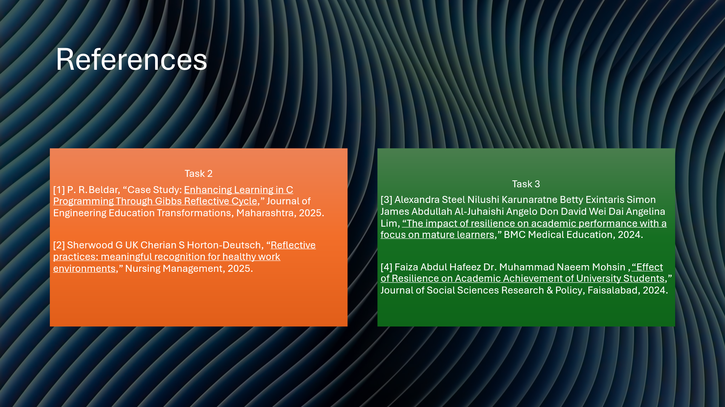

Conclusion
This presentation was a necessary tool to reflect on myself and gain professional information to enhance my abilities. Although, I possess a lot of positive traits, there is always room for improvement, because we never stop learning.

References

[1] | P. R. Beldar, “Case Study: Enhancing Learning in C Programming Through Gibbs Reflective Cycle,” Journal of Engineering Education Transformations, Maharashtra, 2025.
[2] | Sherwood G UK Cherian S Horton-Deutsch, “Reflective practices: meaningful recognition for healthy work environments,” Nursing Management, 2025.
[3] | Alexandra Steel Nilushi Karunaratne Betty Exintaris Simon James Abdullah Al-Juhaishi Angelo Don David Wei Dai Angelina Lim, “The impact of resilience on academic performance with a focus on mature learners,” BMC Medical Education, 2024.
[4] | Faiza Abdul Hafeez Dr. Muhammad Naeem Mohsin , “Effect of Resilience on Academic Achievement of University Students,” Journal of Social Sciences Research & Policy, Faisalabad, 2024.

