  Web aplication/website  Cloud computing Major Project (CSAC6000_LON) | Abstract  My project is a website for the country where I was born (Bulgaria). The site is not intended for commercial use. If a visitor chooses the country as a tourist destination, this website can assist them to learn more about it. The website's purpose is to provide visitors with concise information about Bulgaria's history, traditions, tourism sites, and some little-known facts. An additional alternative is enabling the visitor to attach images of places he/she has visited that have impressed him/her using only a login registration form.  ALEKSANDAR IVANOV ANDONOV  UWTSD STUDENT NUMBER 1813107

Declaration FORM AND FORM OF CONSENT
DECLARATION

I, Aleksandar I Andonov declare that I am the sole author of this Project; that all references cited have been consulted; that I have conducted all work of which this is a record, and that the finished work lies within the prescribed word limits.

This work has not previously been accepted as part of any other degree submission.

Signed: Aleksandar Ivanov Andonov

Date: 18.11.2021

FORM OF CONSENT

I Aleksandar I Andonov hereby consent that my Project, submitted in candidature for the B.Sc. Web Development degree, if successful, may be made available for inter-library loan or photocopying (subject to the law of copyright), and that the title and abstract may be made available to outside organisations.

Signed: Aleksandar Ivanov Andonov

Date: 18.11.2021


Contents
1.Acknowledgement 5
2.Introduction and background 6
2.1 Motivation 6
2.2 Aim 7
2.3 Objectives 8
3.Literature Review 8
3.1 Research on the problem domain 8
3.2 Web development 9
3.2.1 Front-end technology 11
3.2.2 Back-end technology 11
3.3 Web Tools 12
3.4 Different type of website 14
4.Methodology 15
4.1 Software Development Methodologies – SDLC (Software Development Life Cycle) 16
4.1.1 Iterative -Model 17
5.Analysis 20
5.1 Requirement Analysis is an important phase of SDLC. Let’s understand its concept with a Requirement Analysis example:[37],[38] 20
5.2 Feasibility Study 20
5.3 Functional and Non-Functional Requirements 21
5.3.1 Functional Requirements 21
5.3.2 Non- Functional Requirements 22
5.4 Unified Modelling Language (UML) diagrams 24
5.4.1 Structure and Behaviour diagrams 25
5.4.2 Use Case diagram 25
5.5 System Requirements 26
5.6 Risk Analysis 27
6.Design 28
6.1 Login System Entity relationship diagram (ERD) 29
6.1 User interface design (UI) 30
6.2 User experience design (UX) 31
7. Implementation 33
8. Testing 40
9.Evaluation 43
9.1 Personal Evaluation 43
9.2 System Evaluation 44
10. Further Enhancement 45
11. Conclusion 45
12. References 46
13. Appendices 53

List of Figures
Figure 1: Static vs Dynamic website…………………………………………….15
Figure 2: SDLC…………………………………………………………………………....16
Figure 3: Methodologies…………………………………………………………….17
Figure 4: Iterative Model…………………………………………………………….18
Figure 5: Iterative development………………………………………………….19
Figure 6: Functional & Non-Functional Requirements…………………24
Figure 7: Use Case diagram…………………………………………………………26
Figure 8: Web design………………………………………………………………….28
Figure 9: Login System……………………………………………………………….29
Figure 10: User interface…………………………………………………………….31
Figure 11: UX vs UI design……………………………………………………….….32
Figure 12: Home page…………………………………………………………………33
Figure 13: Home page…………………………………………………………………34
Figure 14: History page……………………………………………………………….34
Figure 15: Tourism……………………………………………..……………………….35
Figure 16: Personalities page………………………………………………………35
Figure 17: Traditions page……………………………………………………….….36
Figure 18: Bulgaria in the world………………………………………………….37
Figure 19: Video page…………………………………………………………………37
Figure 20: Gallery……………………………………………………………………….38
Figure 21: About us…………………………………………………………………….38
Figure 22: Login page………………………………………………………………….39
Figure 23: Register page………………………………………………………….….39
Figure 24: User’s page………………………………………………………….…….40

List of Tables
Table 1 – Testing…………………………………………………………………………40,41,42,43

1.Acknowledgement

I would like to express my gratitude to my supervisor, Md Sadeque Shaikh, for his valuable contribution to the assignment's success. Throughout the course of accomplishing the assignment, I was guided by several of his instructive recommendations and experience.

I would also like to thank all my colleagues who gave me help and encouragement.

Name: Aleksandar I Andonov
Signature. A.I. Andonov

2.Introduction and background
A website/web application's benefit is not limited to Internet advertising and providing information about the organization or enterprise. A well-designed online project that includes both textual and graphical information about products and services has a significant influence on potential, future, and present users. The web application/website is a unique technique of maintaining a continual relationship with the user as well as receiving feedback from them.

2.1 Motivation
Bulgaria is a country with a storied past. A beautiful country with access to the sea and a wonderful climate. Based on this, we can confidently predict that the country can be a fantastic tourist destination.
The purpose of this website is to popularise Bulgaria as much as possible and to dispel the notion that it is a communist state. A third-world country that is rarely known and avoided as a tourist destination. Of course, there are quite a few websites that provide information on the country and prominent tourist destinations, but my goal is to combine basic information about the country's history, traditions, and popular tourist places.
The problem that my project is attempting to answer is that Bulgaria is an unknown country for many people, or that those who know something or have heard something about it are mainly negatives.
Today, the availability of the Internet allows any user to find the information quickly and easily he is seeking for.
The website has evolved into a reflection of the advertised product. Many times, if a user is dissatisfied with the way the information is reflected and presented, he will not proceed to the next step, which is to buy, book, or complete another type of demand. The user nowadays does not want to waste time with irrelevant content or spend hours searching for it. The Internet is becoming increasingly popular as a source of vacation deals and information. The network's available data is the primary source for conducting preliminary research on the chosen topic.
In today's fast-paced and engaged environment, attractive design, valuable content, and simple navigation can persuade customers to take the little but critical step toward forming a favourable view. Therefore, the goal I am trying to achieve by creating the website is to provide brief information to visitors about the history of Bulgaria, the traditions, the tourist areas, and about some interesting facts that are little known, about what makes Bulgarians unique and how they have contributed to human progress.
The way visitors see the site and the sensations they have about it while browsing it is referred to as a nice interface. The website's design and vision have the ability to both attract and reject visitors. To be useful to users, a site must be adjusted to demographic and social variables including nationality, gender, age, consumer preferences, and technical audience equipment. It's critical to strike a balance without going overboard with graphic components because navigation becomes more difficult to utilise, and consumers have a harder time finding the information they're seeking for. The advantage of the website is that there are no age restrictions for users. My website does not cater to a specific demographic. My ambition is to attract more visitors, as well as active visitors who contribute photographs and videos.
The most crucial thing when we watch a single page is that it does not make us think. It must be guided intuitively. Everything should be provided such that we do nоt have to wonder where we are or how to find something. Links and buttons that are not clearly located are a needless source of question marks. He must be aware of it. The argument is that when we аre on the Internet, every question mark extremely detailed weight and distracts us from our initial search. And, in general, people dislike having to figure out how to accomplish things.
The fact that the site is not intuitive enough and is too difficult to understand can erode the user's trust even before it is acquired.
The site's goal is to make information highly clear and to make the most critical items that consumers need to be aware of easily accessible. Switching from one page to another, as well as easy orientation can help him focus his attention.
The home page is the most vital page of the website, particularly for tourists. It should provide consumers with a clear message as to why they should use the services of this website. The menu is the key feature of the home page, and it must be a connecting link. Each page of the site must include a link to the main page, and all pages must use the same navigation scheme.
People usually decide quickly whether they like a site or not, so it's critical to capture their interest as soon as they enter. A great method is to present the information with lots of images and additional data about the destination. [3]

2.2 Aim
- Build a website where visitors can learn about the country's history, places they may visit, and traditions.
- Online registration that allows you to upload attractive photos and videos.
- Make the website mobile friendly as well. This indicates that I want my mobile website to contain the same content and information as our desktop computer's page. Making my website responsive is one of the finest ways to pay attention to the mobile app and ensure that my website is simple and easy for people to use. Mobile phones are not going away, and they are certain to become more crucial with each passing year.
- Providing quality content on my website, regularly adding new information, establishing trust. One of the most important components in the success of information architecture is the capacity to give users the ability to locate information without having to browse or search, instead of moving directly to where they want to go.

2.3 Objectives
Objectives are the steps that lead to the achievement of a project's aim. They are the primary foundation of a project. They should be functional as well as long-lasting. As a result, the employment of specific software tools will assist me in achieving my aim.
- Manage database using PHP
- Design the website to make it responsive for different size devices using HTML and CSS also Bootstrap.
- Using JavaScript, I will create the website interactive and buttons working.
- Design database using MySQL

3.Literature Review
A literature review is a piece or section of a bigger research study that summarises the key points of existing knowledge on a certain issue. It contains key discoveries as well as theoretical and methodological contributions. Its ultimate purpose is to familiarise the reader with the existing literature on a certain issue, and it generally serves as the foundation for future study.

3.1 Research on the problem domain
The problem domain is sometimes referred to as the Scope of Analysis or the scope by analysts. We need to decide which User Stories or User Requirements are significant when gathering them.
The user-requirements, user- stories, and use-cases are thus the 'issue domain.' It's what you're hired to accomplish. It's not always what the client says... a software developer often has to go to tremendous lengths to figure out what the problem domain is.
Both of these domains confine the developer in software development. They may also overlap, for example, if the user specifies that the solution be implemented on specific commodity hardware and operating systems.
In software design, the problem vs. solution domain view serves a similar purpose as comprehending Functional Requirements vs. Non-Functional Requirements, but it distinguishes between requirements in a different way. Understanding needs, wrapping one's attention around them, and approaching them deliberately can all be aided by categorising them. It is crucial because Requirements Analysis is crucial. [1]
Creating a fantastic website may be characterized as an idea that is intended to have the greatest possible impact. My major goal while creating a website is to establish a connection with the intended audience. And, in my opinion, creating a website is not as simple as it appears. It is not always the case that a great idea results in a terrific website. Even the most basic of ideas may be used to make fantastic websites. To do so, I must consider every key part and intrinsic feature of a website.
In consideration of the above, arise various challenges to overcome when developing a website, such as: accessibility, compatibility, navigability, readability, and usability.
- Accessibility - The first problem in website development is to make the site as accessible as feasible. But what do we mean when we say, "web accessibility"? Website accessibility, on the other hand, can be defined as the activity of making websites accessible to people of varied backgrounds, skills, and disabilities. To construct an accessible website, we must design and develop it such that all users have equal access to the site's information, functionality, and features.
- Compatibility – ‘Compatibility’ is the next very important, but unfortunately one of the most overlooked aspects of website creation. Website compatibility, also known as 'browser compatibility,' focuses on making websites compatible across a variety of browser platforms. Web developers must create a schedule for browser testing that is both efficient and effective. To ensure that our website is compatible, we must test it on a variety of browsers, operating systems, and monitor resolutions, among other things.
- Navigability – People will abandon the website as fast as they arrived if it is difficult to navigate. In reality, the most significant feature of website design is navigability. The usability of a website is enhanced by a well-designed navigational structure. A website's users are a diverse group of individuals from various backgrounds and geographical places. Our website should be simple to navigate for all people, regardless of their affiliation. Visitors to the site should be able to quickly locate the information they want.
- Readability – 'Readability' is the fourth most essential factor to consider while creating a website. The process of providing the write-up in a style that makes it easier to read is referred to as readability. When building a good website, keep in mind that all users, regardless of their backgrounds or age groups, should be able to read it.
As a result, we need to select a typeface that is legible on screen and simple to read. The same may be said for the content arrangement and text colour. Create a content structure that allows people to quickly scan and skim over it.
- Usability - In practice, this is the sum of the other four major website-building problems outlined before. Getting people to visit our website is only half of the struggle. We must engage our readers on our website and urge them to return time and time again if we are to win this war. The success of a website is determined by how well it adheres to usability principles. In terms of usability, our website should be simple to navigate, and information should be easily accessible.[2]

3.2 Web development
Web development is the process of creating and maintaining websites; it is the work that goes on behind the scenes to make a website seem good, work quickly, and provide a good user experience. [4]
Web design, web content development, client-side/server-side scripting, and network security settings are all part of the web development process. A website can be as simple as a single page or as complicated as a whole web application. All of the steps involved in web development are what allow you to visit your website in a browser. Websites create a pathway between individuals seeking to contribute information and others seeking to absorb it. It allows you to reach out to potential clients all over the world. There are several reasons why a website is important.
- It functions similarly to a brochure, aiding in the promotion of business offers of any kind.
- It is a platform for information sharing, a platform for buying and selling different items and services
- It is a platform on which ideas can be presented to a large worldwide client base. [5]
An employee of the CERN research project in Geneva launched the world's first website in 1990. Only three years later, the Globe Wide Web launched with websites that could be accessed from anywhere in the world with an internet connection. Tim Berners-Lee and his colleagues at CERN, an international scientific organisation based in Geneva, Switzerland, began developing the World Wide Web in 1989. Servers and clients communicated via a protocol called HyperText Transfer Protocol (HTTP). They released a text-based Web browser in January 1992. [6]
The World Wide Web (WWW), also known as the Web, is the Internet's premier information retrieval service (the worldwide computer network). Linking linked material electronically, the Web provides consumers with easy access to a large number of documents. If the user clicks on the word or phrase in text, they will be taken to other papers that have extra information about it. Linked images, audio, animations and videos are included in hypermedia documents. When asked to do so, servers store and send documents to other computers on the network, whereas clients request documents from a server as the user requests them. User-friendly browser software allows users to examine the papers that have been retrieved.
Unified Resource Locator (URL) is the web address provided to a hypertext document defined in HyperText Markup Language (HTML) (URL).[6]
The original webpages were almost entirely composed of text with a few images thrown in for good measure. Websites have become increasingly complicated as the internet has been more commercialised and bandwidth has been expanded by internet service providers. However, as mobile internet use has increased, a tendency toward design minimalism has returned.
Today, there are over 1.3 billion websites worldwide, ranging from simple sites with a single URL, such as those produced with a homepage construction kit, to large, professionally created online businesses with thousands of subpages. Surprisingly, a major portion of the internet sites utilised worldwide cannot be accessible using public networks. In some circumstances, these are internal company intranets, while in others, this is “dark web” information that can only be accessed through specific browsers. As a result, the actual number of websites may have long since surpassed the 1.3 billion limit indicated above.[7]
In web development, there are many rules and practises to follow. Learn about web technologies that will help you achieve your objective if you want your website to appear and function the way you want it to look and function. JavaScript, CSS, and HTML are the three main languages required to create an app or website. Computers communicate using programming languages and multimedia packages called web technologies. Programming languages and tools used in web development are referred to as web development technologies. Programming languages are used to create software on every platform and operating system, although they differ in terms of style. Various types of coding languages exist... All of which is being divided into two main categories: front-end technology and back-end technology. [8],[9],[10]

3.2.1 Front-end technology
Front-end developers work on the client-facing (or user-facing) side of websites, applications, and software, or what users see. They create the visual features of the site, such as the layout, navigation, graphics, and other aesthetics. These developers' primary responsibility is to create interfaces that assist users in achieving their objectives.
To achieve all this, the front-end developer commonly writes in some of the following programming languages:
- HTML
- CSS
- JavaScript
- JQuery

3.2.2 Back-end technology
Users see the front-end, but they don't see the back-end. Back-end web developers work behind the scenes on the servers of websites, programs, and software to ensure that everything is working properly.
These programmers handle the code for security, content, and site structure in systems such as servers, operating systems, APIs, and databases.
- Java
- PHP
- MySQL
- C# [10],[11]

3.3 Web Tools
As the web world evolves, so do the technologies that make it up. A new website is launched every day, increasing the level of competition.
For the front-end and back-end of websites, as well as for other site functionality, developers operate multiple coding languages (such as design, interactivity, etc.) These various languages work together to create and maintain my website.[12]
I will discuss the fundamental tools for creating a project.
- HTML- (Hypertext Markup Language) is a text-based method of expressing the structure of material within an HTML file. This markup instructs a web browser on how to render text, images, and other multimedia on a webpage. HTML is a text file with certain syntax, file and name conventions that indicate to the computer and web server that the file is in HTML and should be read as such. A user can develop and design a simple webpage and then submit it to the internet by applying these HTML principles to a text file in nearly any text editor. [13],[66]
- CSS- "Cascading Style Sheet." The layout of Web pages is formatted using Cascading Style Sheets. While HTML is used to structure a web document (defining things like headings and paragraphs, as well as allowing you to integrate photos, video, and other media), CSS is used to design it—page layouts, colours, and fonts are all defined by CSS. CSS enables Web designers to establish a consistent look across multiple pages of a website. Instead of defining the style of each table and text block within the HTML of a page. [14],[15],[67]
- XAMPP- is (X) stands for Cross-platform, (A) Apache server, (M) MariaDB, (P) PHP, and (P) Perl. The Cross-platform generally implies that it can run on any computer with any operating system. Apache Friends developed XAMPP, which is open-source software. The Apache distributions for Apache server, MariaDB, PHP, and Perl are all included in the XAMPP software package. And it's essentially a local host or server. This local server runs on your own computer, whether it's a desktop or a laptop. XAMPP is used to test clients or websites before publishing them to a remote web server. On a local computer, the XAMPP server software provides a suitable environment for testing MYSQL, PHP, Apache, and Perl projects. [16]
- PHP- is a programming language established in 1994 by programmer Rasmus Lerdorf, who christened it "Personal Home Page Tools" after compiling a series of PERL scripts (PHP). In general, PHP's major purpose is to enable the creation of dynamic Web applications. PHP is a scripting language for web development, with PHP running on the webserver. The server application executes each PHP file, resulting in the development of content for a dynamic web page or pictures. PHP is compatible with a wide range of web servers, operating systems, and platforms, as well as relational database management systems.[17]
- JAVASCRIPT-JavaScript is an interpreted, lightweight programming language. It is intended for the development of network-centric applications. It works in tandem with and complements Java. Because JavaScript is interwoven with HTML, it is incredibly simple to use. It's free to use and cross-platform. JavaScript makes your website more interactive. This occurs in games, in reaction behaviour when buttons are touched or when data is entered on forms; in dynamic style; in animation, and so on.[18],[19]
- BOOTSTRAP- Bootstrap is a versatile toolkit that includes HTML, CSS, and JavaScript tools for creating and developing web pages and applications. Bootstrap gained a lot of traction after its open-source release in 2011, and for good reason. Bootstrap is popular among web designers and developers because it is versatile and simple to use. Its key advantages are that it is responsive by design, that it supports a wide range of browsers, that it provides a consistent design by employing reusable components, and that it is simple to use and understand. It comes with built-in support for jQuery plugins and a programmatic JavaScript API for rich extensibility via JavaScript. [20]
- MySQL- MySQL is an Oracle-developed relational database management system (RDBMS) based on structured query language (SQL). A database is a collection of data that is organised. It might be anything from a basic grocery list to a photo gallery or a repository for a corporate network's massive volumes of data. A relational database, in particular, is a digital storage that collects data and organises it using the relational model. Tables in this architecture are made up of rows and columns, and the relationships between data items are all logically structured. An RDBMS is a collection of software tools that are used to create, manage, and query a database.[22]
- VISUAL STUDIO CODE- Visual Studio Code blends the ease of use of a source code editor with the power of developer tools. It is compatible with Windows, macOS, and Linux. It has built-in support for JavaScript, TypeScript, and Node.js, as well as a robust environment of extensions for additional languages and runtimes (including C++, C#, Java, Python, PHP, and Go) (such as .NET and Unity). Visual Studio Code's heart is a lightning-fast source code editor that is ideal for day-to-day use.
For serious coding, you'll typically benefit from tools that comprehend more code than just blocks of text. IntelliSense code completion, sophisticated semantic code comprehension and navigation, and code refactoring are all included into Visual Studio Code. Using Visual Code, we have the option to install as many third-party extensions as we like. While most situation’s function "out of the box" with no setup, VS Code allows you, to tailor your experience to your specific requirements. Because VS Code is an open-source project. [21]
- LARAVEL-Laravel is an open-source PHP framework that is both sturdy and simple to use. It adheres to the model-view-controller design pattern. Laravel reuses existing components from other frameworks, which aids in the development of a web application. The resulting web application is more organized and pragmatic.
Laravel provides a comprehensive set of functions that include the fundamental aspects of PHP frameworks such as CodeIgniter and other programming languages such as Ruby on Rails.
Working with Core PHP and Advanced PHP is made easier using Laravel, combining many tools like Composer, Artisan, Features of Laravel, Modularity, Testability, Routing, Authentication, and others. [23],[24],[68]

3.4 Different type of website
Websites are classified into two types: static and dynamic.
Static websites are made up of a set number of web pages with hardcoded content and structure. As a consequence, regardless of who they are, where they're from, or whatever browser they're using, consumers view the same information.
Static website pages are often created by computer programmers using HTML to lay out the structure and CSS to add colour and other visual components. The majority of static web pages are created without the use of a database. [25]
A dynamic website is more functional than a static website, which is merely informative. It enables visitors to engage with the data shown on the page. Of course, this necessitates the use of more than simply HTML code.
Static websites rely solely on client-side HTML and CSS code, whereas dynamic websites employ client-side and server-side programming languages like JavaScript and PHP. A dynamic website can be modified by code that is performed in the browser and/or on the server when a user visits it. The ultimate result is the same as on a static website: an HTML page that can be seen in a web browser. [26],[27]



Figure 1-Static vs Dynamic Website [28]

4.Methodology
Research methodology is defined as a systematic approach to solving research problems by using various techniques to collect data, provide explanations for the collected data, and draw conclusions on the research data. [29]
The specific techniques or procedures that help us to identify, select, process, and analyse information on the subject are called research methodology.
Before starting any research project, we must decide which method to use. This will guide our research, help us choose the way we collect data, and help us analyse it.
Solving the difficulties encountered in the investigation is the main task of the design methodology. It is not only necessary to determine the research problem, but also to determine the best way to solve the problem. Research methodology teaches how to choose the best method, data or information, scientific methods, and problem-solving teaching techniques.[30]
The phrases "methods" and "methodology" are frequently confused in research, and the terms are occasionally used interchangeably. In the context of research, methods and methodology refer to two related but distinct concepts: methods are evidence-gathering procedures, whereas methodology, or research methodology, describes how investigators conduct research. Finally, the methodology gives the reason for the employment of certain approaches in the process, while the method includes the technical procedures or actions taken to do the research.[29]

4.1 Software Development Methodologies – SDLC (Software Development Life Cycle)
A software development life cycle (SDLC) is a set of steps that must be performed in order to complete a project. It is a detailed strategy that explains how to build, maintain, replace, and change or improve certain software. The life cycle is a mechanism for enhancing software quality and the development process as a whole. A development methodology is a method for creating software. [31]
SDLC is a process that consists of various stages: planning, analysis, design, development and testing, implementation/deployment, and maintenance.

Figure 2-SDLC [32]
There are a variety of methodologies available, each with its own set of laws, concepts, processes, and practises. Which approach we should use is largely dependent on the project kind. The goal of choosing a project management technique is to make the most efficient use of resources and time possible.
Project scope and requirements differ, hence the best methodology to use will differ as well. [33]
Here are a few of the most popular development methodologies as displayed on the figure 2.

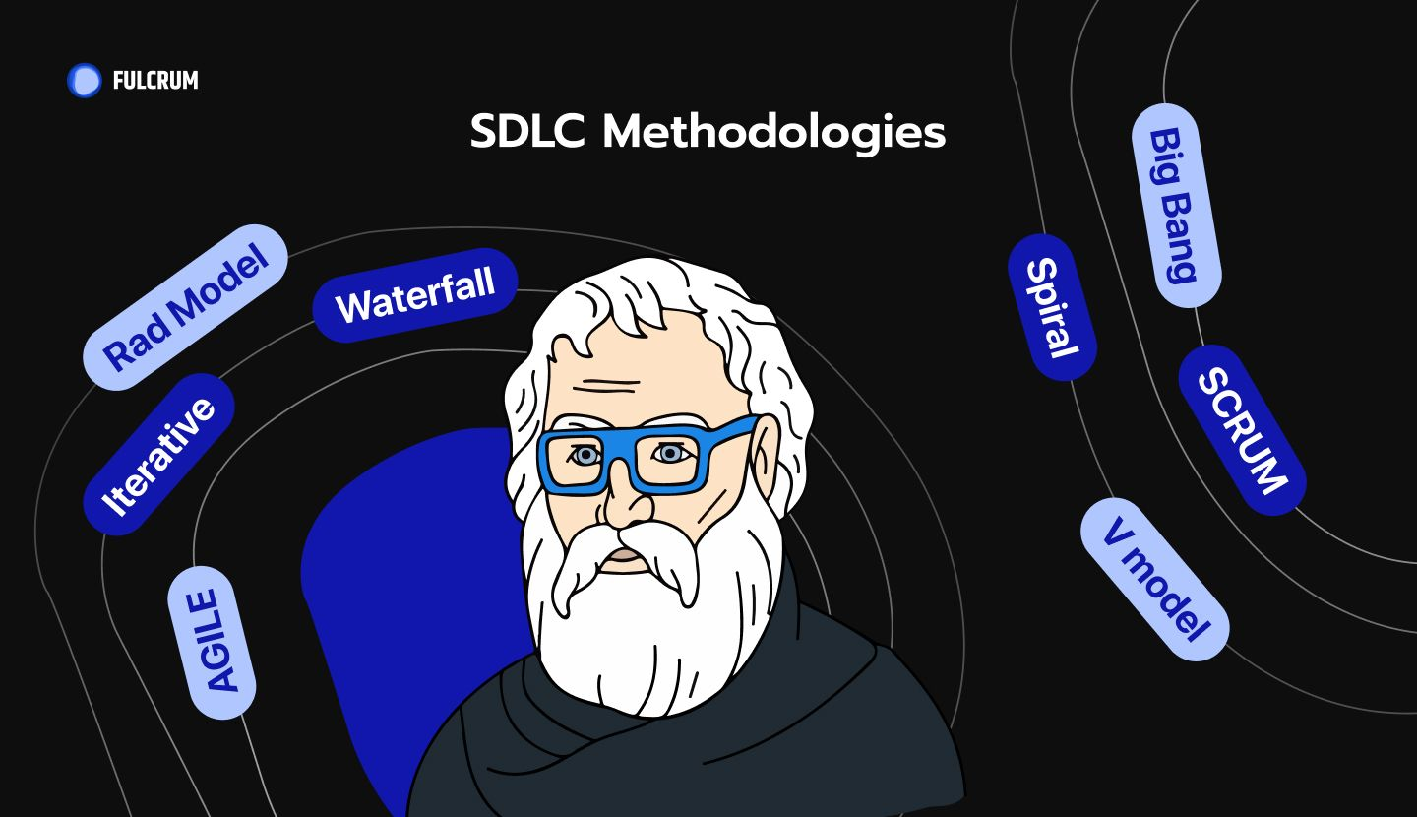
Figure 3 -Methodologies [34]

There is no ideal SDLC model, and it is difficult to choose one way above the others. However, in order to select the optimal alternative, you must be familiar with all SDLC models and assess the needs of all stakeholders. In my situation, while beginning a small project, I like to use the Iterative-Model.

4.1.1 Iterative -Model
An iterative development model is based on the systematic repetition of tiny software development cycles known as iterations. It aspires to produce the best product possible in the end. The process begins with the specification and implementation of a piece of software. The process is then repeated for each iteration to create a new version of the programme until the finished product is attained. As a result, the iterative model does not aim to begin with a complete specification of needs.
The iterative development process is cyclical; it does not follow a strict process. Once you are done with your initial planning, which does not necessarily have to be very well-defined, the rest of the steps for each iteration are carried out again and again with extensive testing in between until you reach the overall deployment stage.
Design changes are made, and new functional capabilities are added at each iteration. The primary idea behind this strategy is to build a system in modest increments - iteratively) over time - incremental.
Each recurrent cycle is tested for software and system integration at the beginning. At each phase, a decision is taken to determine whether the created outcome will be maintained or rejected for the following cycle. Because the programme is produced in smaller portions during each iteration, this is also known as incremental prototyping. [35]

Build 1
Testing
Implementation
Design and Development

Build 2
Implementation

Testing
Requirement
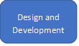
Build3
Implementation

Testing

Figure 4 - Iterative Model

Simply said, the SDLC iterative approach allows developers to access past cycles, which may be reviewed and updated as needed until the entire system is ready for deployment.
Let's go over the phases in the Iterative approach one by one.

- The first step in the iterative life cycle is planning, which involves identifying software needs as well as business and stakeholder requirements. At this point, it is not required to define project risks or worry about quality assurance needs because this phase will be repeated for your following iteration, ensuring that risks are overcome, and quality is maintained.
In my project, I want to create a website in the shortest amount of time possible. For the time being, I must include requirements: the main page, the website's content, and the navigation bar. After I've completed my initial planning for each requirement, which includes identifying overall project requirements, your target audience, website content, client requirements, and so on, I'll begin my first iteration, which will focus on the main page's basic template, website content, and navigation bar.
- Step two – Design
When compared to the other steps of iterative development, design does not play a significant role. The design team might, however, specify technical requirements for the software architecture in this step, such as language, services, and data layers, and so on. In the case of my website, the design team develops business rules, a database, data layers, languages, and so on at this stage of iterative software development.
- Step three – Implementation
When I finish the preceding steps, my next step will be to begin developing the code for my initial version of the software. To write the code, I adhere to the coding rules and employ various back end and front-end technologies such as compilers, interpreters, debuggers, and so on.
At this stage, I will create the technological architecture, database, and programmes for my first iteration module.
Keep in mind that occasionally implementation and testing are performed concurrently to verify that no problems remain. As a result, if I have written some section of the code improperly, I may rewrite it and move on to the next iteration after testing.
- Step four – Testing
Once my code for my first iteration module has been completed, it is necessary to test it for potential errors or issues that may have been neglected during the implementation process. I will undertake unit testing, which involves testing individual units of code; integration testing, which involves ensuring that units of code work properly when combined; and user acceptability testing, which involves assessing whether the systems meet the user requirements for that iteration.
- Step five – Evaluation
After I have completed all of my steps for each iteration, I will analyse the overall project. I will turn over the project to the client, who will check the finished output for efficiency and correctness.
So, according to my website, after testing, my audience or I as a developer may have encountered some issues with functionality, user interface (UI) design, user experience (UI) design, and so on. As a result, at this point, I will collect feedback and begin my next iteration from the very first step, planning. [35]

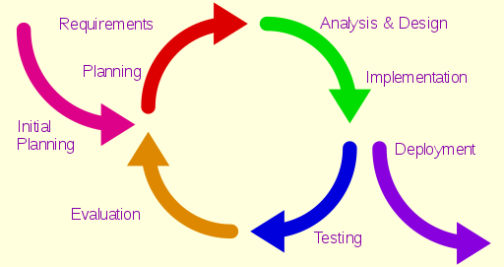
Figure 5 – Iterative development model [36]

5.Analysis
Analysis is a strategy for collecting, measuring, reporting, and analysing data for your website.
When building a website, you go through numerous stages. Analysing the competitive environment is both important and recommended. An analysis of the audience that reflects the target group is also performed. It is critical to define the project's working techniques and technologies. The planning of its key components is an important step. This include constructing the architecture of the web page and database, the interface, the functional aspects, automating the major operations, describing the priority concepts and goals, design analysis, and so on.

5.1 Requirement Analysis is an important phase of SDLC. Let’s understand its concept with a Requirement Analysis example:[37],[38]
Before creating any website its common practice to visualize the layout, the design and all the features you intend to incorporate. In addition, you think about how users will interact with each page and how the site should perform (behaviour, load time etc.). In software engineering, establishing a list of requirements for a program is referred to as developing the functional and non-functional requirements.
Website requirements are a list of necessary functions, capabilities, or characteristics related to your website and the plans for creating it. There are several types of requirements that may be defined during the process that come together to focus and prioritize the project plan.[39]
But here is another form of insight that you can leverage and is 100% unique to your website: your users’ perspective. Finding out how THEY got to your site, what THEY want from it, how THEY are experiencing it, what’s working or not working for THEM—this will give us the holistic insight we need to build a great experience for the people who visit our website day in and day out.[40]
Business requirements are gathered in this phase. This phase is the main focus of the project managers and stake holders. Meetings with managers, stake holders and users are held in order to determine the requirements like; Who is going to use the system? How will they use the system? What data should be input into the system? What data should be output by the system? These are general questions that get answered during a requirements gathering phase. After requirement gathering these requirements are analysed for their validity and the possibility of incorporating the requirements in the system to be development is also studied. [41]

5.2 Feasibility Study
Once the details of the software have been decided upon, a feasibility study needs to take place to determine the practicality of the proposed software. Here, all the requirements and components will be listed that are required for the finished piece of software to work. Feasibility checks usually consider five different factors:
- Economic: Can the software be created with the budget that you are working with?
- Legal: Will any legislation or standards interfere with or affect the development of this software?
- Operation Feasibility: Will the software we create successfully meet the requirements of our client or target audience?
- Technical: Can we create the proposed software using the technical equipment and skills that we have?
- Schedule: Can the software realistically be created to a high standard within the time frame we have been given?
The feasibility study will be completed with the help of a ‘Software Requirement Specification’ document, or SRS, which should have been drawn up in the planning stage of the development cycle.[42],[43],[44]

5.3 Functional and Non-Functional Requirements
When we begin a new project, we understand that upfront, well-defined requirements are vital to success. Defining criteria in advance helps us to properly manage client expectations and produce a smooth and seamless implementation process.
So, how can you make certain that our criteria are more precisely and clearly defined? Requirements are generally divided into two types: functional requirements and non-functional requirements. It is very important to understand the functional and non-functional requirements and the role they take part in the success of the project. [45]

5.3.1 Functional Requirements
What your website can accomplish and how it functions is referred to as its functionality. It includes everything from a user's activities to dynamic material and interactivity.
Having the correct functionality is critical to the success of a website, and it should be a part of the planning process. Before we write, design, or develop our website, you should have a good idea of what features it will have.
A real person's perspective and real-world events should be used to provide detailed information on how visitors will interact with the website or Web component. Furthermore, developing functional requirements to understand all aspects of the website's behaviour and user interactions will guarantee that all design components have been addressed and will enable for the creation of a decent website. [46],[47]
As an example, I will appear some common types of website functionality requirements. Of course, there are various, but this is dictated by the client's preferences.
- User authentication
- Account creation
- Search
- Upload images
- Contact form
- Blog
- Video library
- Mailing list sign up
- In-site search
- Shopping cart
- Location map

5.3.2 Non- Functional Requirements
A non-functional requirement, to put it simply, is a specification that outlines the system's operating capabilities and limitations that improve its functionality. A non-functional requirement is a characteristic that governs how a system functions. It improves the efficiency of apps or software while also demonstrating the system's excellence. Non-functional criteria might help us create a system that satisfies the demands of your end users if you understand how they work in an application. They define the software's quality attribute. Scalability, maintainability, performance, portability, security, and dependability are all examples of non-functional requirements. [48]
For the reason that the categories into which non-functional needs are classified are many and have some overlap, I will identify the most prevalent types that are associated with my project and business scope.
- Performance and scalability - Performance refers to how quickly a software system or a specific portion of it reacts to certain user inputs under given workload conditions. In most circumstances, this indicator describes how long a user must wait until the website loads, a transaction is completed, and so on, given the current number of users.
Scalability considers the most load that the device doesn’t always procedure now however may also procedure withinside the close to future. Although it’s difficult to make predictions in advance, it’s really well worth putting as a minimum a few load expectations.
- Portability and Compatibility - The portability refers to how a system or one of its components may be started in a different environment. Hardware, software, and other use platform specifications are frequently included. Simply said, it determines how successfully activities taken on one platform are replicated on another.
Compatibility refers to the ability of one system to coexist with another in the same environment. Installed software, for example, must be compatible with the operating system's firewall or antivirus protection.
- Reliability, Maintainability, Availability - Reliability. This quality feature indicates the likelihood that the system or its component will operate without failure for a certain amount of time under preset conditions.
Maintainability is the amount of time it takes to fix, alter, or adapt a solution or one of its components to improve performance or other attributes, or to adapt to a changing environment. It may be stated as a likelihood of repair over a period of time, similar to dependability.
Lastly, availability refers to the likelihood that a user will be able to use the system at any particular moment. While it may be described as a percentage of the time the system is available for operation during a certain time period, it can also be defined as a percentage of the time the system is available for operation during that time period.
- Security - This non-functional criterion ensures that any data stored within the system, or its components is safe from virus assaults and unauthorised access. We have to describe the login sequence and different user roles as system behaviour or user actions if we wanted to safeguard the admin panel from illegal access. As a result, the non-functional needs section will establish certain sorts of risks that will be addressed in greater depth in the functional requirements section. But if your security is based on certain standards and encryption techniques, these standards don't explicitly describe a system's behaviour, but rather serve as implementation instructions for engineers.
- Localization - This quality indicates how effectively a system or one of its elements fits into the context of the upcoming local market. Local languages, laws, currencies, cultures, spellings, and other factors all have a role in the setting. The longer a product is on the market, the greater success it should have with a certain target market.
- Usability - Usability relates to the ability to utilise a certain product, which includes features such as:
When an application's user interface is functional, users may easily navigate it. For example, if a user navigates an effective user interface for a streaming service, they will understand how the application organises its information and where to find pages such as settings.
Features serve the following purposes: Users with high usability can quickly discern what a feature is and what it can do.
Performance quality: When a device performs well, it signifies that the features of a system are working as expected by the creator. [49],[50]



Figure 6 - Functional &Non-functional Requirements [51]

5.4 Unified Modelling Language (UML) diagrams
The Unified Modeling Language (UML) is a standardised modelling language comprised of an integrated set of diagrams designed to assist system and software developers in specifying, visualising, constructing, and documenting software system artefacts, as well as business modelling and other non-software systems. The UML is a significant component in creating object-oriented software and the software development process. To express the design of software projects, the UML primarily use graphical notations. The advantage of UML supports project teams in communicating, exploring new designs, and validating the software's architectural design.
The first thing to note about the UML is that there are several diagrams (models) to become familiar with. This is due to the fact that a system may be viewed from a variety of perspectives. Many people will be involved in the creation of software. These are customer, analysts, designers, coders, and etc. Each of these individuals is interested in a different part of the system. A developer, for example, must grasp the system's design. A technical writer, on the other hand, is concerned in the overall behaviour of the system and must understand how the product works.

5.4.1 Structure and Behaviour diagrams
Structure diagrams illustrate the static structure of the system and its components at various abstraction and implementation levels, as well as how they are connected to one another. There are seven types of structure diagrams, which are as follows: class diagram, component diagram, deployment diagram, object diagram, package diagram, composite structure diagram and profile diagram.
From other hand behaviour diagrams, illustrate the dynamic behaviour of objects in a system, which may be represented as a sequence of changes to the system through time. There are seven different forms of behaviour diagrams: use case diagram, activity diagram, state machine diagram, sequence diagram, communication diagram, interaction overview diagram and timing diagram. [52]
I will present one of these diagrams for the reason that it's relevant to my project.

5.4.2 Use Case diagram
A use case diagram may describe the specifics of your system's users (also known as actors) and their interactions with the system using the Unified Modeling Language (UML). A use case is a set of activities or event steps that define the interactions between an actor's role and a system in order to accomplish a goal. A use case is a method for defining, clarifying, and arranging needs for a system. A use case is a collection of potential interactions between systems and users that describe the features to be implemented as well as the resolution of any faults that may occur.

5.4.2.1 Use case diagram elements
- Actors - Users who engage with a system are referred to as actors. An actor is any person, organization, or external system that interacts with our application or website. They must be external objects capable of producing or consuming data.
- System - A system is a predefined set of activities and interactions (functional and non – functional requirements) between actors and the system.
- Aim - The end result of the interaction between the participants. The diagram should show the actions and the alternatives used for the end goal. [53],[54]

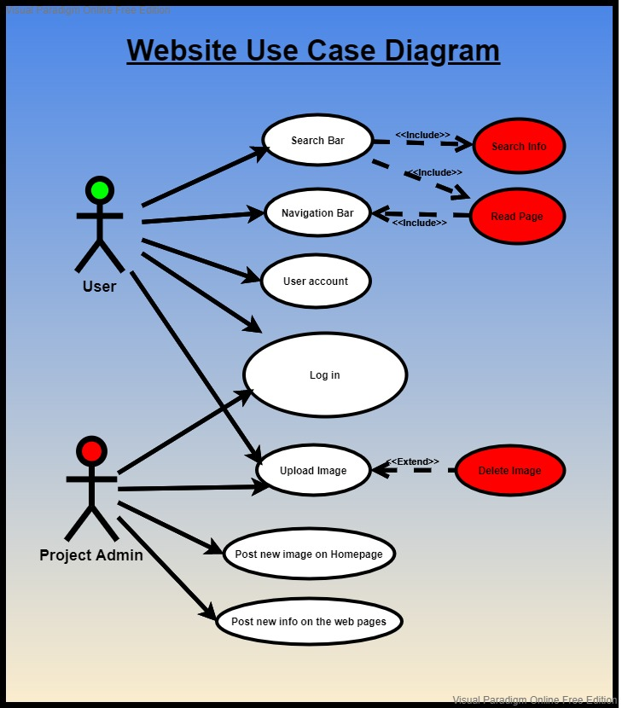
Figure 7 Use Case diagram

5.5 System Requirements
The system requirements are the parameters that our device must meet in order to employ certain hardware or software for this project.
Before we begin work on the project, we must ensure that the system requirements are compatible.
Processor - Intel(R) Core (TM) i5-3320M CPU @ 2.60GHz 2.60 GHz
Installed RAM - 8.00 GB (7.69 GB usable) Recommended: 16.00 GB
Graphics card details - Intel(R) HD Graphics 4000
Disk storage 225 GB - Recommended: 500GB
Operating system (OS) Windows, macOS - Recommended: Windows 10 Home, macOS Big Sur
System type 64-bit operating system, x64-based processor
Monitor Resolution: 1600X900 – Recommended:1920x1080
XAMPP Control Panel v3.3.0 PHP Version 8.0.10
Laravel - version 8
PHP - PHP 8.0.6 (cli)
Internet: Internet connection required for software activation

5.6 Risk Analysis
Using risk analysis at the start of a project in any program shows possible trouble areas. It is easier for developers and managers to reduce risks if they are aware of the dangerous zones. When creating a test strategy, it's important to consider the risks of testing the product as well as the likelihood of harm.
Any project comes with no warranties. Even the simplest operation might lead to unanticipated issues. Any event that has the potential to alter the project's result is a risk.
Any unpredictable occurrence or situation that might have an impact on our project is referred to be a risk. Not all dangers are bad. Some circumstances (such as finding a simpler way to do a task) or occurrences (such as decreasing pricing for software facilities) may be beneficial to our project. Risks are still unknown when we design our project since they haven't happened yet. However, some of the dangers that you plan for actually may occur, and we must deal with them.
Risk is defined as the probability of any unpleasant situation occurring. Risk analysis in software testing is the process of detecting and prioritising hazards in applications or software that we have produced. The ability of a programme to operate correctly on a platform other than the one for which it was created with little, or no modification is known as portability.
Some dangers are technological in nature, such as a component that may be difficult to utilise. Others are outside, such as market shifts or development deadlines.
The goal of a risk mitigation strategy is to eliminate or reduce the impact of the risk—events that have a negative influence on the project.
Since the project may be done by separate teams and the business requirement software applications and customer needs are different, and so on, the potential risks therefore may be varied. As a consequence of these differences, some of the potential project risks could be the following: the use of new hardware, new technology, code sequence, software update, availability of test resources, time spent on testing, a defect due to the project's complexity and size, time pressure from customers for implementation, and incomplete requirements.
After the risk has been identified the mitigation plan, which is a plan to reduce the impact of an unexpected event. The project team mitigates risks in various ways:
We should be familiar with the platform we are working on as well as the software testing tools, we will be using.
Analysing the risk involved with releasing substandard or untested software necessitates a good bit of information.
Regular backups could mitigate data loss.
We should be aware of the dangers that come with the software development process (difficult functionalities for development, the customer's changes requirements at the last moment).
Finally, risk analysis aims to assess the magnitude of the impact that will be felt if the event occurs, as well as to reduce future unfavourable unintended consequences.[55],[56]

6.Design
When I started the project, I was thinking about the last fantastic website I came on. Now, when I decided to establish a new website, I wondered why it was so successful. The website pleased me since it allowed me to do a task swiftly, effectively, and efficiently. User interface design is one of the most important methods for doing this (UI design).
The current web design process is the combination of art, technology, and psychology, and it develops over time as new trends arise. Frontend coding, website wire framing, layout design, colour combinations, font selection, graphic design, webpage interactions, UI, and user experience (UX), animations, and so on are all parts of web design. [57],[58]
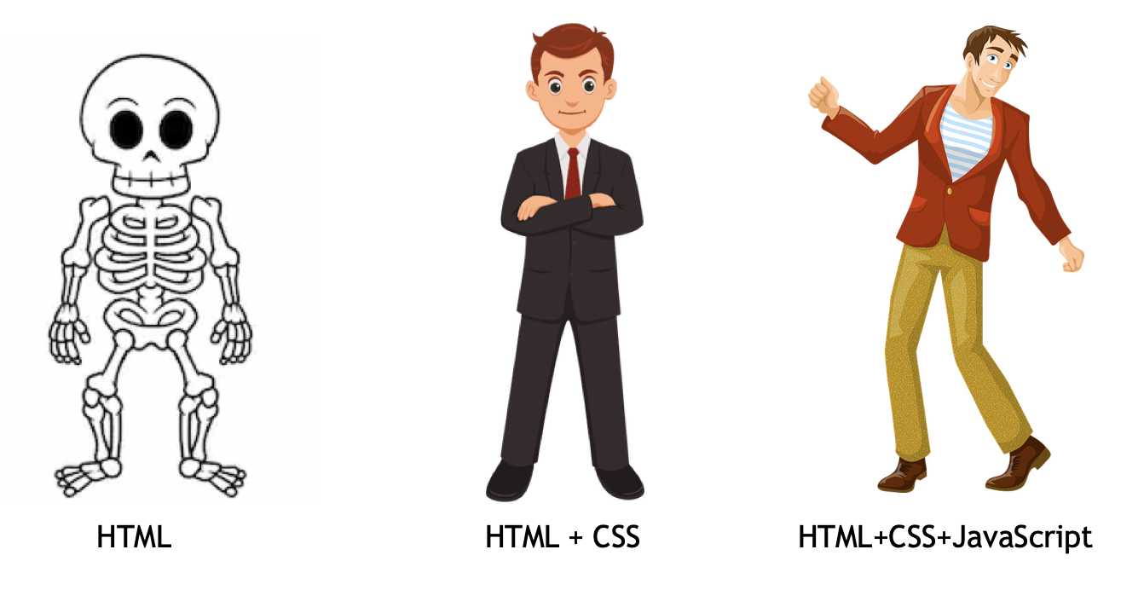Figure 8 - Web design [59]

6.1 Login System Entity relationship diagram (ERD)

The login system is designed to be simple and straightforward to use. If a user is new and wants to post a picture, the first step is to register. The registration has three fields to fill in: name, e-mail, and password. If the data is filled in correctly, they will be stored in the database, if there are no corrections it will be displayed as a message. After completing the registration procedure, the user may now log in using the same information that he supplied during the registration process. The user will be directed to a page where he may upload images. The procedure of uploading a photo has also been simplified. He must first fill out two fields: the photo's title and a description, following which he can select and upload images. After completing the photo uploading procedure, the user will be directed to a page where he may view the uploaded photo as well as all images posted by other users. Finally, once the user has completed his activity, he can log out of his account at any moment.
Login System ER Diagram
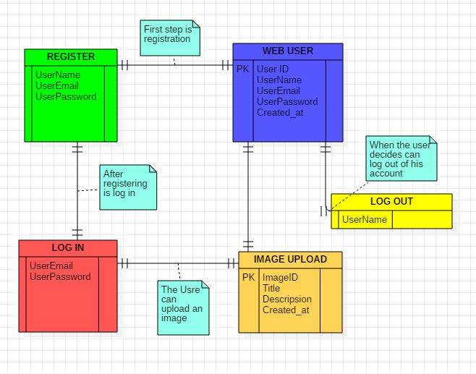Figure 9 - Login System

6.1 User interface design (UI)
User interface design is the aesthetic experience of computer interfaces, particularly visual touch points such as buttons, navigation menus, icons, and typography. The focus is on the interface's look and feel, as well as whether users have a pleasant and easy-to-use experience. In a nutshell, UI design is the process through which designers and developers construct user-friendly interfaces that connect your product or service to your clients.
A good website design is one that lets people explore quickly and effortlessly. Icons, menus, search bars, buttons, and other website components should be placed up cleanly to avoid causing user disruption. The sooner a visitor can complete his work on your website, the more satisfied he will be with your service. Arranging the pieces on the webpage to emphasise their importance is really beneficial. Larger and more colourful buttons or links, for example, will draw someone's attention and so serve as a signal that they are more significant.
The goal is to make website navigation as predictable as feasible. You never want a visitor to be confused about the purpose of a button or link, or where they are on your site.
Another key beneficial tactic is reducing the quantity of text on your website. Visitors to your website already have a limited attention span and forcing them to read big blocks of content isn't going to make matters any easier. Users should be able to quickly skim through and discover the areas and information they want.
Making a website intuitive is really powerful - in other words, when a person enters your website, he or she should not need instruction on what to do next. It is critical that you incorporate components that your users are already familiar with.
Most tasks on your website, whether it's to join up, make a purchase, or seek more information, should adhere to the three-click rule. It's exactly as it sounds you want to make sure your user can reach the objective in no more than three mouse clicks.
Remember that our website's visitors may have a range of disabilities, such as limited eyesight, hearing impairments, cognitive impairments, or movement impairments. Making certain that our website can appeal to a wide community will guarantee that you include everyone.
This might include employing basic, high-contrast designs wherever feasible, as well as minimising visual noise. Avoid using extraneous images or connections to pages that aren't entirely related to what your product or service provides. [60],[61],[62]

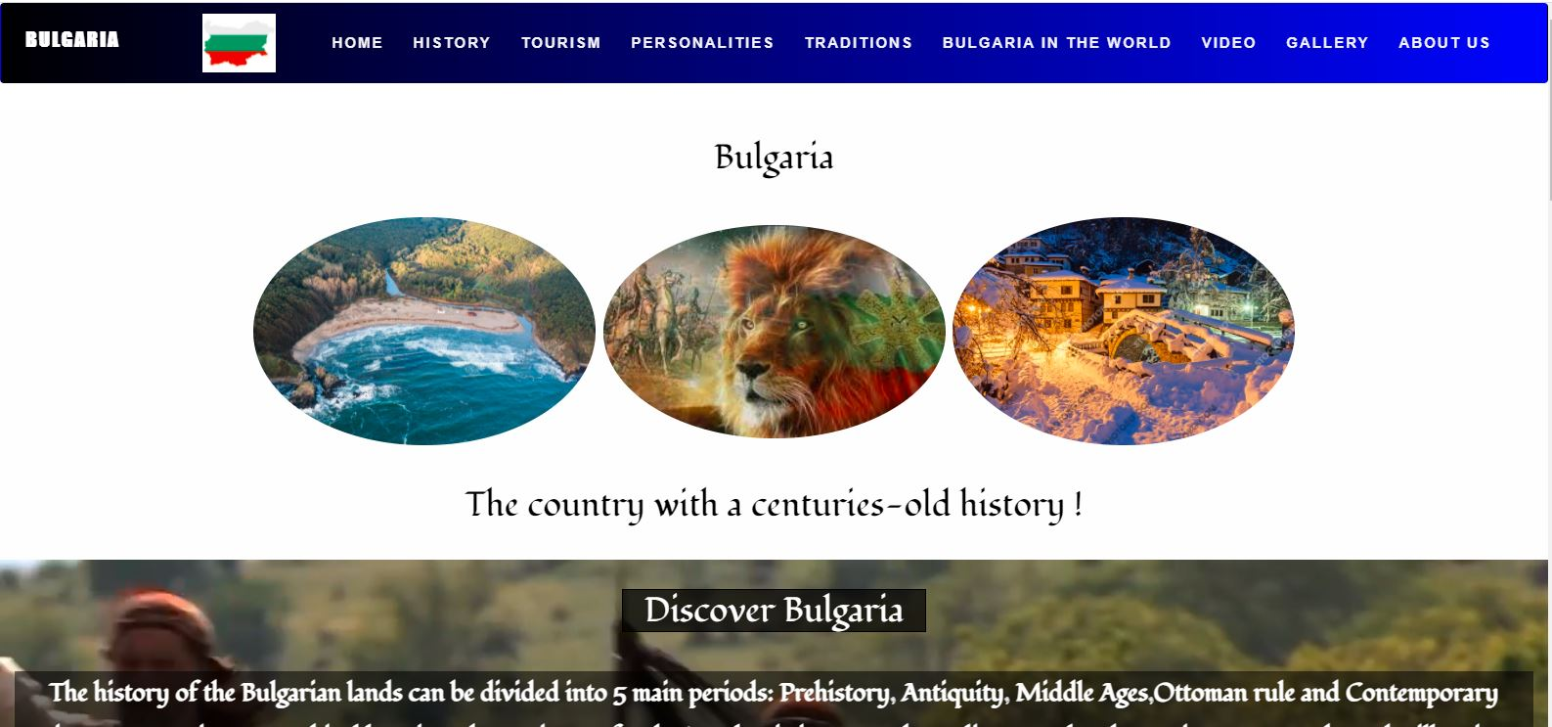
Figure 10 User interface

6.2 User experience design (UX)
The process of making a website more engaging, dynamic, and helpful is called user experience (UX) design. It is a method used by design teams to build products that give meaningful and relevant experiences to users. This includes features of branding, design, usability, and function, as well as the full process of obtaining and integrating the product.
Unlike UI development, UX development is more concerned with properly arranging all of the features and components in order to generate the user flow.

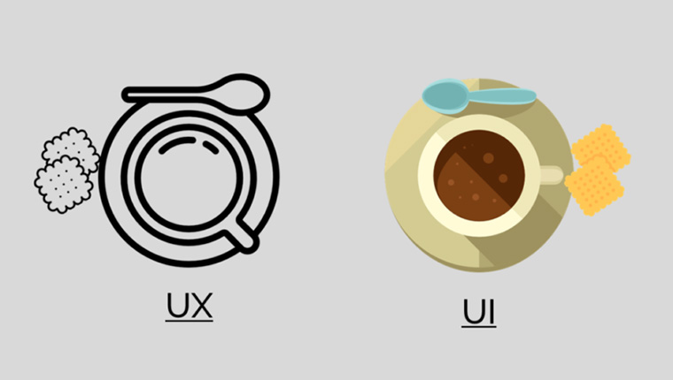
Figure 11 - UX vs UI design [63]
Nothing frustrates me more than a website that takes a long time to load. In fact, one of the most common reasons for people abandoning a website is poor page load time. Recommended is - it should take 4-5 seconds for your page to load.
Furthermore, the time it takes for your website to load can have an impact on your search engine rankings. Google uses a special algorithm to determine a website's ranking, and one of the elements considered is page load speed.
Context is a critical aspect of how people engage with your designs, according to one of the fundamental ideas supplied by the UX design method. In this case, context refers to paying attention to the devices that will be utilised to view your website.
Users nowadays prefer to use their phones to view websites rather than their PCs. As a result, mobile optimization is critical to the user experience.
Another fundamental aspect of UX design is hierarchy. A hierarchical approach to design, at its most basic level, is considering all of the functionality and content that your website will have, and then translating this into a framework in which each part of your website flows "naturally" from the previous.
One of the greatest methods to make a page simple to read is to correctly define the relationship between the items on the page: which elements are connected to each other, and which elements are parts of other elements. To put it another way, each page must have a distinct visual hierarchy.
A good user experience design should allow for easy adjustments to the design as needed.
For example, if you need to make changes to the programme or add a new feature, the approach should be simple and uncomplicated. It shouldn't interfere with other elements or lead to problems in the overall design.
The last concept of UX design is inextricably linked to user requirements. We will need to implement a continual, forces at work of usability testing to guarantee that our website meets the demands of our users.
The essential point to remember here is that a successful design process does not end with our "final project!"- when we publish it. Finally, our users will tell us if — and when — we have arrived at a "final version." [64],[65]

7. Implementation
The completion of a project is a significant milestone since it is the point at which the theoretical becomes a reality. The act of recognising and implementing a piece of code or a programming resource that has been written into the programme is referred to as implementation.
In this paragraph, I will explain how my project is being implemented.
Figure 12 and 13 introduces us to the website's main page. This introduces us to the project's substance and key idea. Figure 13 illustrates a search bar on the main page, and the idea is that if the user is curious and wants to learn more or simply look at the information supplied, he may do so right now.
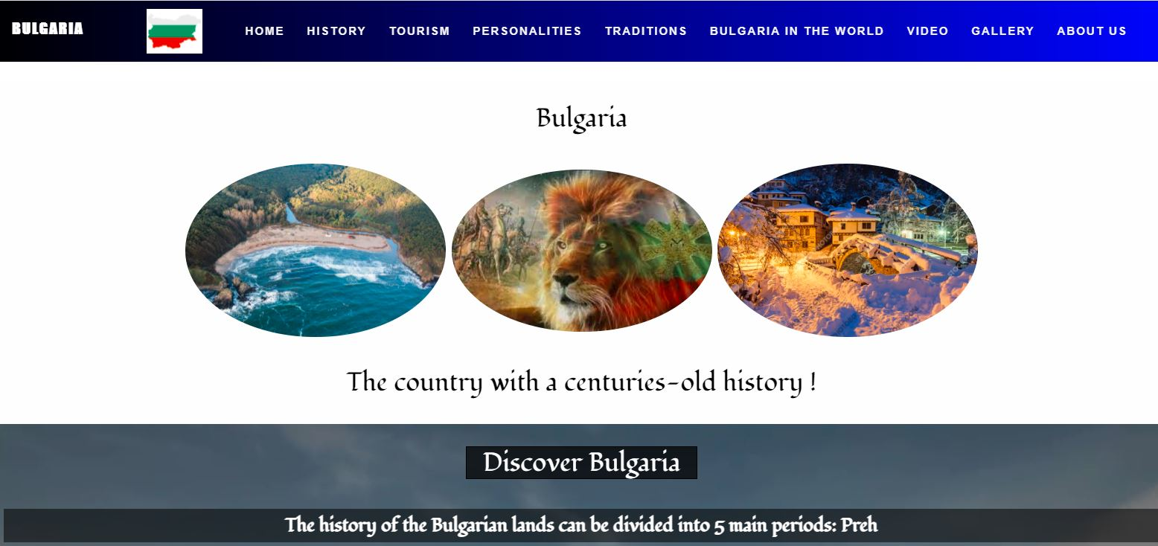
Figure 12-Home page

In addition to the search bar displayed in Figure 13, there is an active button labelled "Login in your page" that allows the user to create a profile.

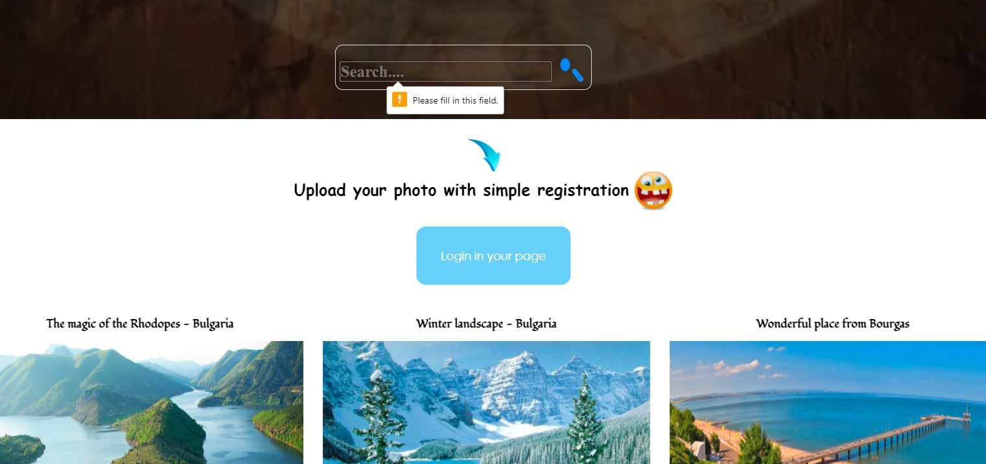
Figure 13-Home page

On page 14 of the following section, I illustrated a page on Bulgarian history. Of course, I can't cover all of history on one page, but I've chosen some of the most significant events in Bulgarian history.

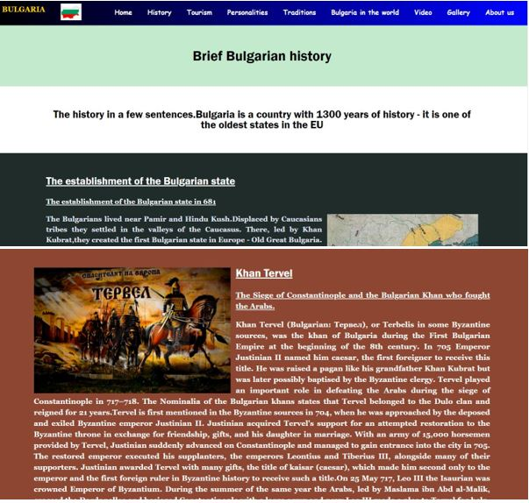
Figure 14-History page
We'll go on to the following page, which is about tourism. Here you will find information about some of Bulgaria's most popular tourist destinations. Of course, there are several more tourist attractions. Bulgaria is a country where visitors may enjoy the beautiful scenery and historical places at any time of year.

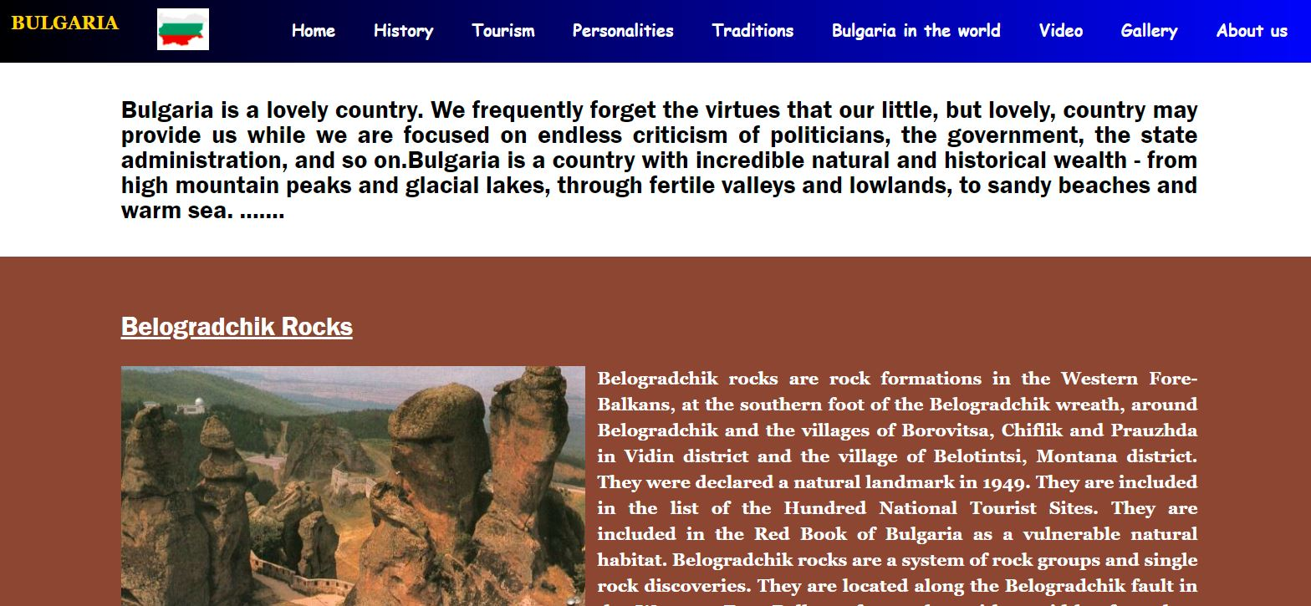
Figure 15-Tourism
On this page (Figure 16), I've focused on the heroic figures in Bulgarian history who have had a significant impact on and contributed to the events that have taken place over the years. These are people who have put "the cause of Bulgaria" above everything else and deserve to be respected.
"But this reward is enough for me - the people to saying: a pauper died for justice, for justice, and for freedom…" - Hristo Botev
"If I win, I win for the whole nation - if I lose, I lose only myself." – Vasil Levski

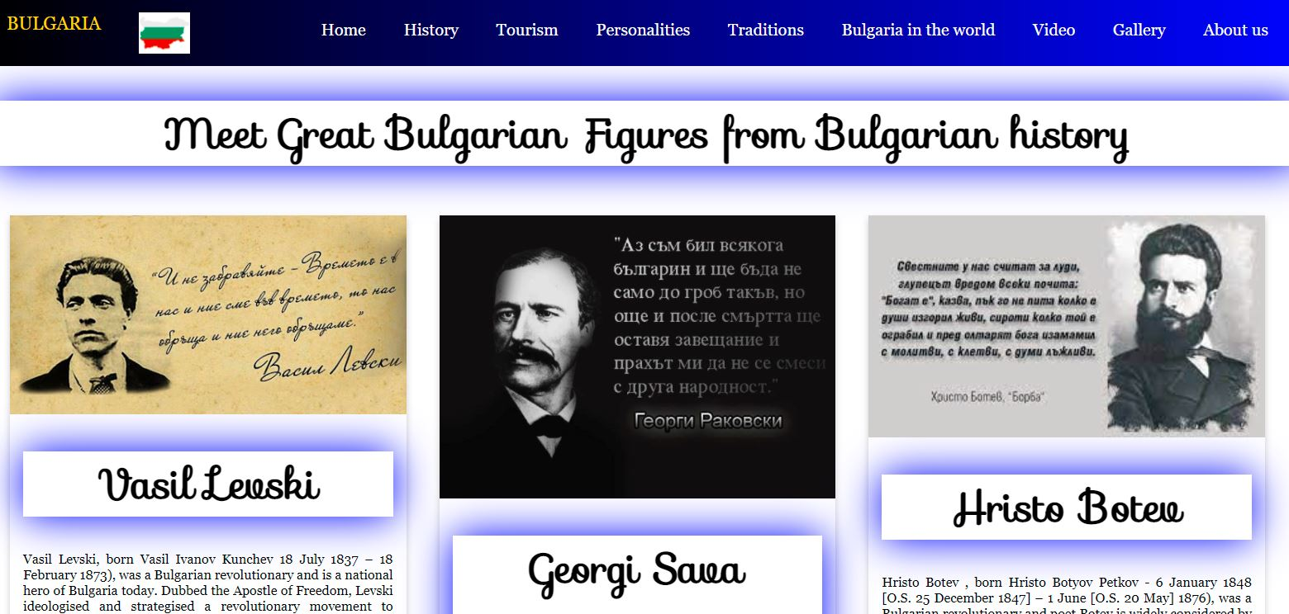
Figure 16-Personalities page

Bulgarians are one of Europe's oldest populations, and the traditions and rituals that they celebrate and keep until now are fascinating. I have highlighted some of the most appealing and fascinating traditions that are unique to our country.
This can be explored on the Traditions page.(Figure 17)

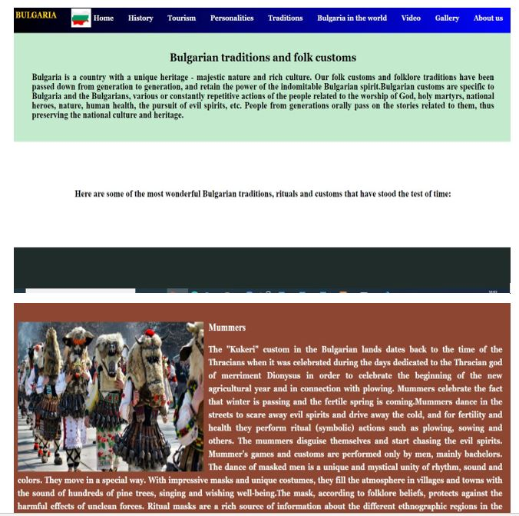
Figure 17-Traditions page

I decided to create this webpage(shown in Figure 18) because, although our small nation , we have demonstrated throughout the years that we play an essential role on the global stage and have given something worth it.

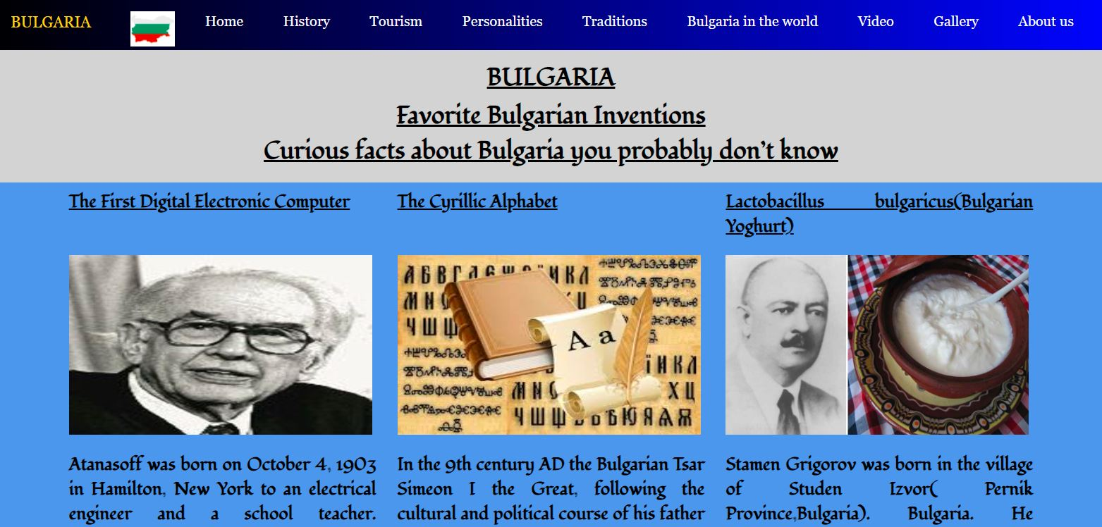
Figure 18-Bulgaria in the world

People nowadays are overworked and do not have time to read, research, and etc. For this reason, I have picked and selected several videos from which you may obtain an impression of Bulgaria and decide whether or not to visit it as a tourist destination.(Figure 19)

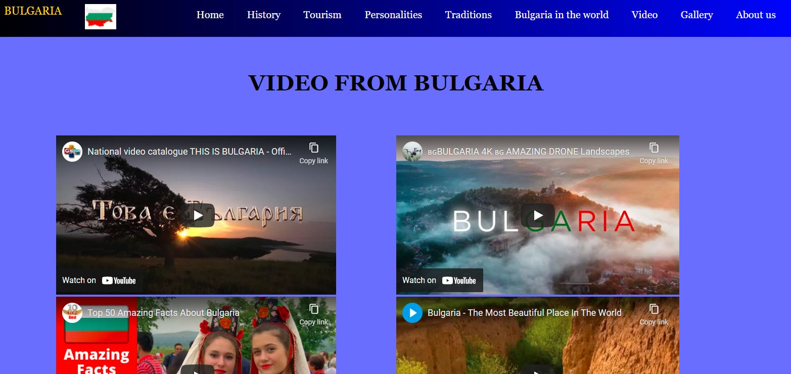
Figure 19-Video page
Figure 20 displays the "Galleries" page, where the user could add a photo and see all photographs uploaded by other users.

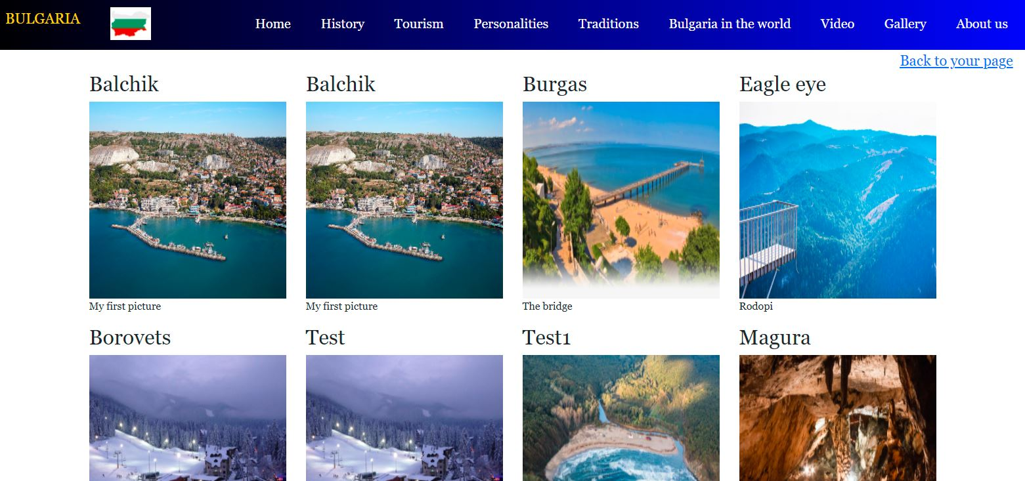
Figure 20-Gallery

The "About us" page provides information about the author and allows the user to contact the author if requested.

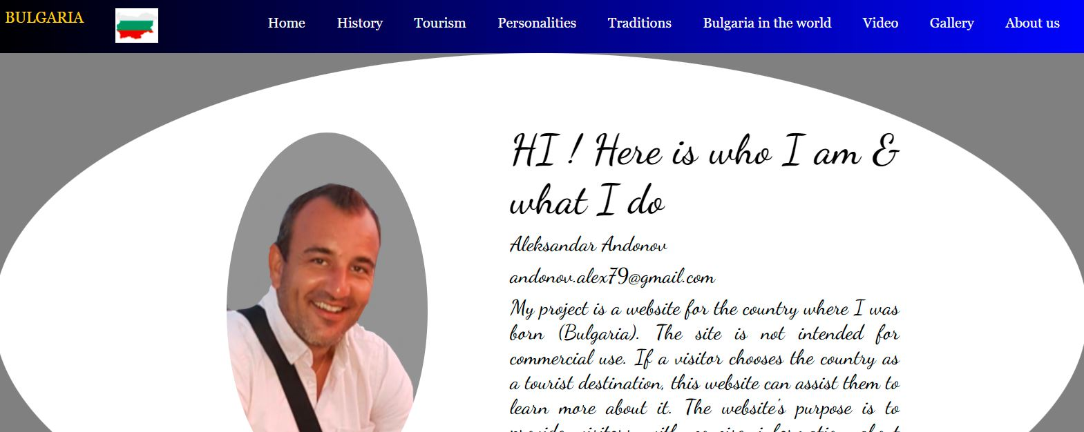
Figure 21-About us

The user can make his or her own account, log in, and then upload photographs in this section. In the Login page (Figure 22) email and password attributes, there are some stated restrictions, such as if the field is empty and a button is pushed, he will urge the user to enter the data like email and password
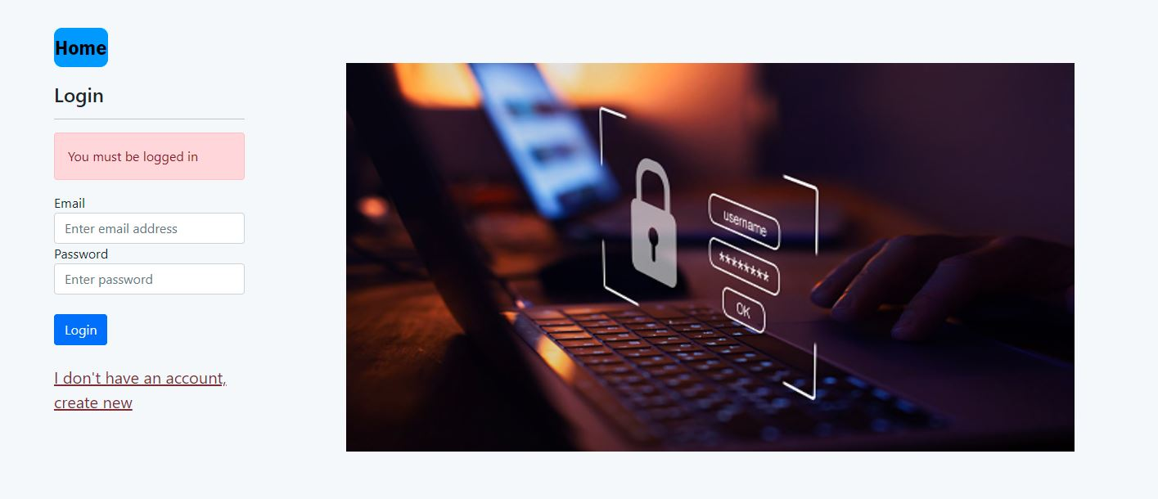
Figure 22-Login page

The same is applicable for the Registry page (Figure 23) attributes name, email, and password; if there are any concerns with the kind of input, the user will be prompted to supply the correct information.

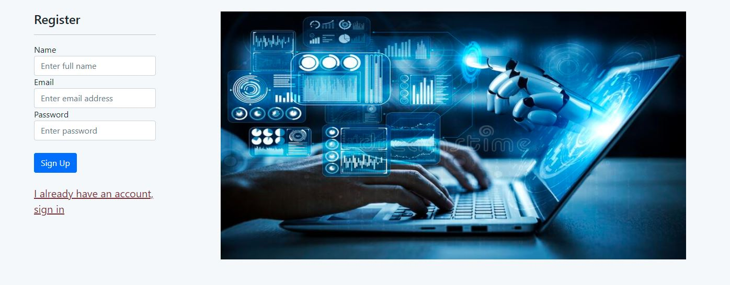
Figure 23-Register page

This is the page for the user. It displays the user's name and email address who created the account. The user must choose a photo, provide a title and description, and then submit the photo to the website.


Figure 24-User’s page

8. Testing
Before our website goes online and is accessible to the wider public, we test it for potential bugs. Web testing examines a website's operation, authentication, compatibility, and performance, among other things. In the table below we can see some of the checks that have been made.
Test | Input | Output
Checking Empty Fields  Validating | Screenshot of the form (Empty no details)  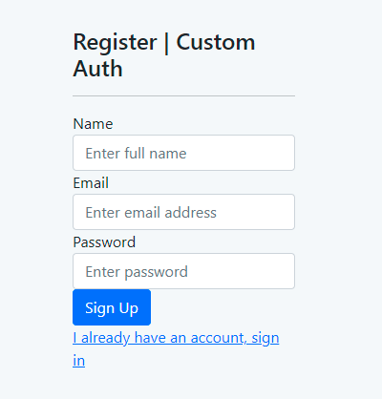 | Screenshot of the screen with the information – pass or failed  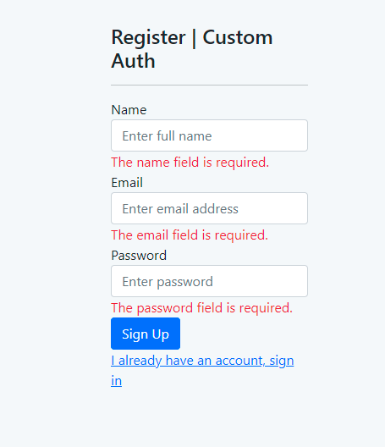
Registration or Login with filled information | Screenshot  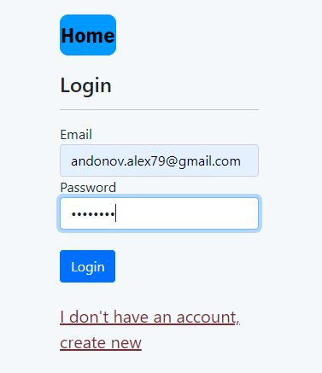 | Screenshot  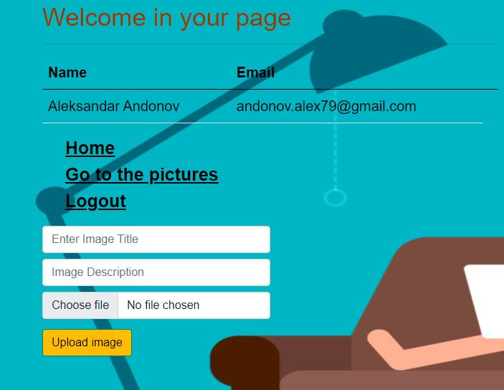
Validation and confirmation password | Screenshot | Screenshot  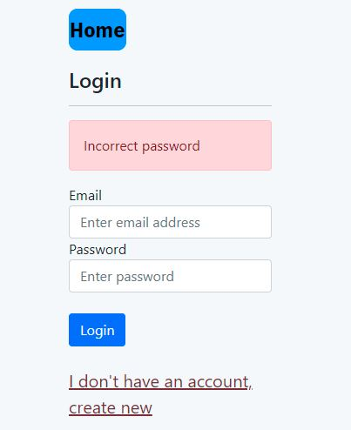
Test for Browsers -Google Chrome | Google Chrome  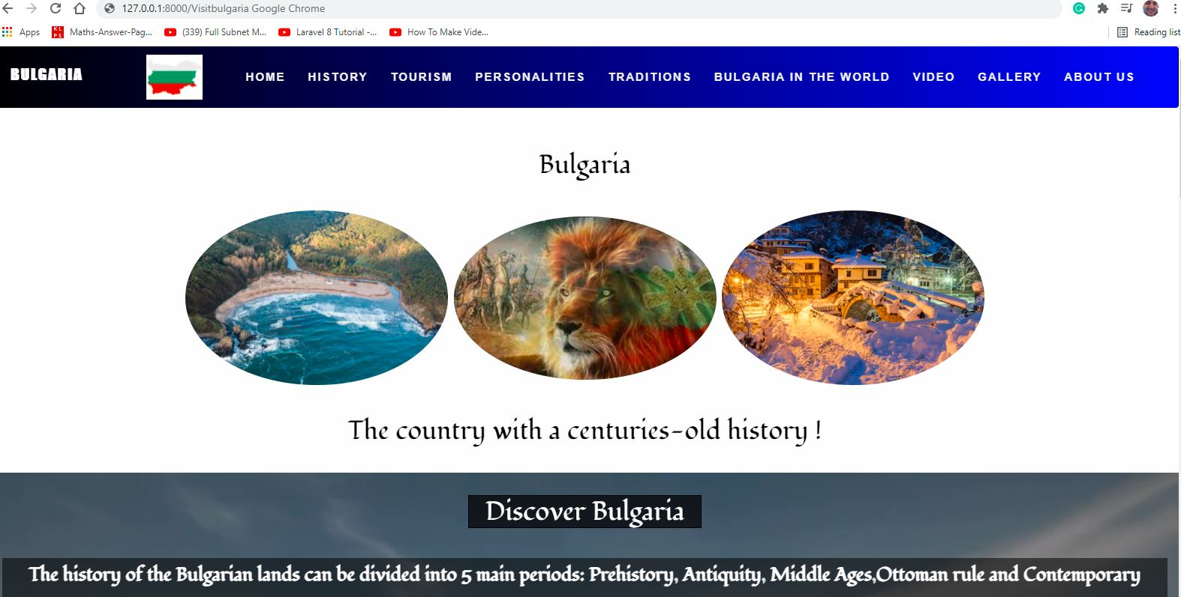
Test for Browsers -Firefox Browser | Firefox Browser  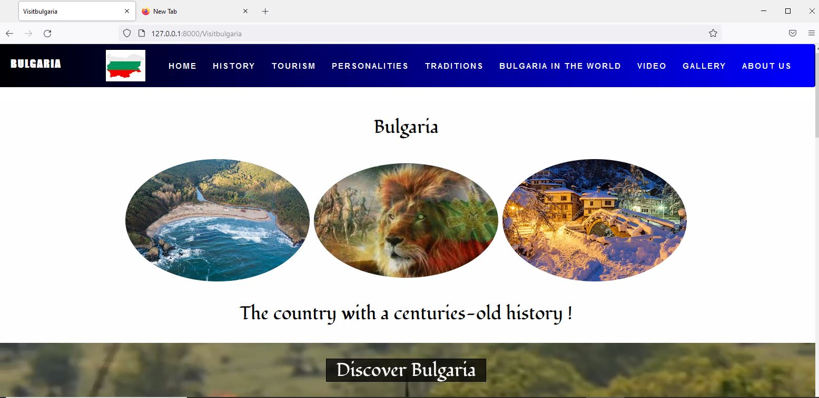

Table 1 -Testing

9.Evaluation
The evaluation is an important part of the project's development. It provides developmental feedback for the positive and effective impact on the users and creators of the project. The evaluation allows us to offer useful input on how far we have progressed toward our goals, how we have progressed toward them, what mistakes we have made, and what we can and should do to improve the project. To that purpose, let us split the evaluation into two categories: Personal evaluation and System evaluation.

9.1 Personal Evaluation
The project is a website for popularizing Bulgaria as a tourist destination and removing the negative perception of consumers about this beautiful country.
The website provides a brief historical overview, information about traditions, heroic personalities, popular tourist destinations, and on little knows facts, but with an important influence on the world stage. It is made with a very nice view. With simple navigation, the user has quick access to all pages, allowing him to easily receive the information he requires. It consists of nine pages – Home, History, Tourism, Personalities, Traditions, Bulgaria in the world, Video, Gallery and About us. Each page contains thematic information that can be understood immediately from the title of the page.
This website has two major functions: Login and Registration. Login enables the user to log in to their own created account in order to post images if the user wants to share his impressions of the destinations he has visited. Login in this application is performed by using an email address and a password.
The next feature is registration, which requires a name, e-mail address, and password. Once registered, the user will be able to log in to his page and upload as many photos as he wants. After entering his login details and entering the website, the user is sent to his page, where he can view the e-mail and names with which he registered. Another option is for the user to upload a photo from their own computer. Following the selection of an image, the user should input a title and description of the photo. The log-out option is available here, allowing the user to log out at any moment and navigate to other pages of the website.
The user has a search box on the main page that enable the user to look for more or additional information about the topics he is interested in.
When I began creating the website, I ran into a few issues with the design of the interface, the design of the navigation bar, and so on, but the major issue was with the features Login, Register, and Upload Photos. No images could be posted while registering and after login into the user page. The login and registration pages were not linked to the Navigation bar.
The website is linked to a suitable database for keeping the necessary data for user registration as well as all photographs posted by users.

9.2 System Evaluation
Several codes, "blade. files" and "CSS files" are created during the website creation process. The Blade and CSS files are used to create the depiction of website pages or distinct activity pages, and the codes are used to conduct internal actions and connections between the page and the activities in the pages. The website is composed of eight primary pages written in HTML, CSS, and JavaScript that represent the website. There is a search box on the main page (Home) that allows you to search for information. The navigation panel is situated at the top of the page and contains all pages, allowing for quick navigating from one page to the next. Another button on the “Home” page that takes the user to the login and registration area is "Login in your page."
In this part, the user can create his or her own account, log in, and then upload images. There are some specified restrictions in these email and password attributes (in the login page), which are if the field is empty and a button is pressed, he will advise the user to enter the data and will also display the error message when the right email format has not been input.
The same is relevant for the attributes name, email, and password (in the registry page); if there are any issues with the kind of input, the user will be notified to provide the right information. On the page "Gallery," which displays all of the images uploaded by users, there is a button that allows the user to easily return to his page and upload a photo again or log out of his or her account by clicking the "Logout" button.

10. Further Enhancement
At the beginning of the project, I had a clear purpose of why I was doing it, what I was going to do, and what the website would feature. My intention was for it to grow further than the scope of a university project. Now that it has reached the complete level, I am keen to create more functions.
The first thing I have to do (I even think it is mandatory) is to convert it into a mobile application. This would attract many more visitors considering that everyone nowadays uses mobile phones for absolutely everything. Other elements that might enhance the site include the creation of a blog where visitors can comment on the topics contained on the website, as well as the ability for the user to remove images that he has posted. A section for visitor comments can be put onto each page. Features like email verification, forgotten password recovery, and signing into the website using social media apps like Facebook and Google are essential and would significantly improve the site.

11. Conclusion
A website must be up to grade in various areas in order to be successful on the Internet. Not just in terms of the graphical presentation of the material, but also in terms of how applicable the website is and how logical its navigation is for the users. Efficiency, performance, and user pleasure all contribute to its usefulness. The accuracy and dependability of the services supplied by the site are factors that may persuade customers to use it again in the future. However, for the initial choice, the user's perception of the site is the most crucial. The visitor's degree of comfort when accessing the website is critical. The following parts are required: accurate and clear information content without the accumulation of redundant and confusing information content, general design, which must be in semantic unity in each of the site's pages for one reason or another, structure, and navigation.

12. References

[1]"Problem Domain", Wiki.c2.com, 2021. [Online]. Available: https://wiki.c2.com/?ProblemDomain. [Accessed: 16- Nov- 2021]
[2]"5 Biggest Challenges You Need to Face in Website Creation | StayOnSearch", Stayonsearch.com, 2021. [Online]. Available: https://www.stayonsearch.com/5-biggest-challenges-you-need-to-face-in-website-creation. [Accessed: 16- Nov- 2021]
[3] N. Ivanova, "DEPARTMENT OF COMPUTER SCIENCES SPECIALTY "INFORMATION BROKERAGE"", Fin.unibit.bg, 2013. [Online]. Available: https://fin.unibit.bg/images/pdf/bakalavri/d_r_2.pdf. [Accessed: 16- Nov- 2021]
[4]"What Is Web Development? Definition from OpenClassrooms", The OpenClassrooms Blog, 2018. [Online]. Available: https://blog.openclassrooms.com/en/2018/03/28/web-development-definition/. [Accessed: 16- Nov- 2021]
[5]"Web development Tutorial | A Complete Guide for Beginners | Edureka", Edureka, 2020. [Online]. Available: https://www.edureka.co/blog/web-development-tutorial/. [Accessed: 16- Nov- 2021]
[6]"World Wide Web (WWW) | History, Definition, & Facts", Encyclopedia Britannica, 2021. [Online]. Available: https://www.britannica.com/topic/World-Wide-Web. [Accessed: 16- Nov- 2021]
[7] J. Meloni, "SamsTeachYourself HTML, CSS and JavaScript All inOne", Doc-developpement-durable.org, 2021. [Online]. Available: https://www.doc-developpement-durable.org/file/Projets-informatiques/cours-&-manuels-informatiques/htm-html-xml-ccs/Sams%20Teach%20Yourself%20HTML,%20CSS,%20and%20JavaScript%20All%20in%20One.pdf. [Accessed: 16- Nov- 2021]
[8] M. Timotic, "9 Web Technologies Every Web Developer Must Know in 2021 - TMS", TMS, 2018. [Online]. Available: https://tms-outsource.com/blog/posts/web-technologies/. [Accessed: 16- Nov- 2021]
[9] C. Little, "An Introduction to Web Development Technologies | Tiller Digital", Tiller, 2019. [Online]. Available: https://tillerdigital.com/blog/an-introduction-to-web-development-technologies/. [Accessed: 16- Nov- 2021]
[10] A. Decker, "The Beginner's Guide to Website Development", Blog.hubspot.com, 2020. [Online]. Available: https://blog.hubspot.com/website/website-development. [Accessed: 16- Nov- 2021]
[11]"The Three Types of Web Developers (and What They Do) - MadCap Marketing + Creative", MadCap Marketing + Creative, 2021. [Online]. Available: https://madcapmarketing.com/the-three-types-of-web-developers-and-what-they-do/. [Accessed: 16- Nov- 2021]
[12] A. Sheldon, "Some Essential And Amazing Web Development Tools And Resources -2021", Valuecoders - Hire Dedicated Software Development Team, 2021. [Online]. Available: https://www.valuecoders.com/blog/technology-and-apps/web-development-tools-resources/. [Accessed: 16- Nov- 2021]
[13] B. Lutkevich, "What is HTML and How Does Hypertext Markup Language Work?", TheServerSide.com, 2020. [Online]. Available: https://www.theserverside.com/definition/HTML-Hypertext-Markup-Language. [Accessed: 16- Nov- 2021]
[14]"CSS (Cascading Style Sheet) Definition", Techterms.com, 2006. [Online]. Available: https://techterms.com/definition/css. [Accessed: 16- Nov- 2021]
[15] S. Morris, "The Ultimate Guide To CSS", Skillcrush, 2021. [Online]. Available: https://skillcrush.com/blog/css/. [Accessed: 16- Nov- 2021]
[16] P. Ganesan and P. Ganesan, "What is XAMPP and How to Install XAMPP on your Local Computer?", WPBlogX, 2021. [Online]. Available: https://wpblogx.com/what-is-xampp/. [Accessed: 16- Nov- 2021]
[17] Г. Христов, "Уеб дизайн, изработка на сайтове и SEO Варна", IGC уеб дизайн и софтуер, 2021. [Online]. Available: http://igcbg.com/bg/67/%D0%BF%D1%80%D0%BE%D0%B3%D1%80%D0%B0%D0%BC%D0%B8%D1%80%D0%B0%D0%BD%D0%B5/php-%D0%BF%D1%80%D0%BE%D0%B3%D1%80%D0%B0%D0%BC%D0%B8%D1%80%D0%B0%D0%BD%D0%B5.html. [Accessed: 16- Nov- 2021]
[18]"JavaScript - Overview", Tutorialspoint.com, 2021. [Online]. Available: https://www.tutorialspoint.com/javascript/javascript_overview.htm. [Accessed: 16- Nov- 2021]
[19]"JavaScript basics - Learn web development | MDN", Developer.mozilla.org, 2021. [Online]. Available: https://developer.mozilla.org/en-US/docs/Learn/Getting_started_with_the_web/JavaScript_basics. [Accessed: 16- Nov- 2021]
[20] T. Bacinger, "What is Bootstrap? A Short Bootstrap Tutorial on the What, Why, and How", Toptal Engineering Blog, 2021. [Online]. Available: https://www.toptal.com/front-end/what-is-bootstrap-a-short-tutorial-on-the-what-why-and-how. [Accessed: 16- Nov- 2021]
[21]"Why Visual Studio Code?", Code.visualstudio.com, 2021. [Online]. Available: https://code.visualstudio.com/docs/editor/whyvscode. [Accessed: 16- Nov- 2021]
[22]"Quickly Develop and Deploy Cloud Applications", Oracle.com, 2021. [Online]. Available: https://www.oracle.com/uk/mysql/. [Accessed: 16- Nov- 2021]
[23]"Laravel - Overview", Tutorialspoint.com, 2021. [Online]. Available: https://www.tutorialspoint.com/laravel/laravel_overview.htm. [Accessed: 16- Nov- 2021]
[24]"Installation - Laravel - The PHP Framework For Web Artisans", Laravel.com, 2021. [Online]. Available: https://laravel.com/docs/8.x/installation. [Accessed: 16- Nov- 2021]
[25] T. Greets, "Static and dynamic websites - what's the difference? - Mlytics", Mlytics, 2021. [Online]. Available: https://www.mlytics.com/blog/static-and-dynamic-websites-whats-the-difference/. [Accessed: 16- Nov- 2021]
[26]"Static vs Dynamic Website: What Is the Difference?", Amelia WordPress Booking Plugin, 2019. [Online]. Available: https://wpamelia.com/static-vs-dynamic-website/. [Accessed: 16- Nov- 2021]
[27] L. Lu, "The 8 Types of Websites and How to Design Them", 99designs, 2018. [Online]. Available: https://99designs.co.uk/blog/web-digital/types-of-websites/. [Accessed: 16- Nov- 2021]
[28] Rawat, "Difference Between Static and Dynamic Websites Explained | Newsdevi", NewsDevi, 2021. [Online]. Available: https://newsdevi.com/difference-between-dynamic-and-static-websites/. [Accessed: 16- Nov- 2021]
[29] I. Bouchrika, "How to Write Research Methodology: Overview, Tips, and Techniques", Research.com, 2021. [Online]. Available: https://research.com/research/how-to-write-research-methodology. [Accessed: 16- Nov- 2021]
[30] S. Mehta, "Types of Research Methodology in Research | Eduvoice", Eduvoice | The Voice of Education Industry, 2021. [Online]. Available: https://eduvoice.in/types-research-methodology/. [Accessed: 16- Nov- 2021]
[31]"SDLC Tutorial", Tutorialspoint.com, 2021. [Online]. Available: https://www.tutorialspoint.com/sdlc/index.htm. [Accessed: 16- Nov- 2021]
[32]"Software Development Life Cycle (SDLC) - Big water Consulting", Big water Consulting, 2019. [Online]. Available: https://bigwater.consulting/2019/04/08/software-development-life-cycle-sdlc/. [Accessed: 16- Nov- 2021]
[33]"7 Popular Project Management Methodologies And What They’re Best Suited For", Zenkit, 2018. [Online]. Available: https://zenkit.com/en/blog/7-popular-project-management-methodologies-and-what-theyre-best-suited-for/. [Accessed: 16- Nov- 2021]
[34] K. Khalimonchuk, "Software Development Methodologies & SDLC Models: Agile, Waterfall", Fulcrum Blog, 2021. [Online]. Available: https://fulcrum.rocks/blog/sdlc-models/. [Accessed: 16- Nov- 2021]
[35] M. Allan, "What Is Iterative Development – An Easy Guide For Beginners", Goodcore.co.uk, 2019. [Online]. Available: https://www.goodcore.co.uk/blog/iterative-development/. [Accessed: 16- Nov- 2021]
[36]"File:Iterative development model.svg - Wikimedia Commons", Commons.wikimedia.org, 2021. [Online]. Available: https://commons.wikimedia.org/wiki/File:Iterative_development_model.svg. [Accessed: 16- Nov- 2021]
[37] S. Halwai, "SDLC Requirement Analysis & Gathering - Techniques, Example", OpenXcell, 2021. [Online]. Available: https://www.openxcell.com/blog/sdlc-requirement-analysis/. [Accessed: 16- Nov- 2021]
[38] M. Rainford, "Developing Website Requirements - (Functional vs. Non-Functional) - New2HTML", New2HTML, 2021. [Online]. Available: http://www.new2html.com/website/developing-website-requirements-functional-vs-non-functional/. [Accessed: 16- Nov- 2021]
[39] A. Affairs, "Website Requirements | Usability.gov", Usability.gov, 2021. [Online]. Available: https://www.usability.gov/how-to-and-tools/methods/requirements.html. [Accessed: 16- Nov- 2021]
[40]"Website Analysis 101: Tools, SEO, and Examples [2021] | Hotjar", Hotjar.com, 2021. [Online]. Available: https://www.hotjar.com/website-analysis/. [Accessed: 16- Nov- 2021]
[41]"What are the Software Development Life Cycle (SDLC) phases?", Tryqa.com, 2020. [Online]. Available: http://tryqa.com/what-are-the-software-development-life-cycle-sdlc-phases/. [Accessed: 16- Nov- 2021]
[42] C. Oddy, "What Are The SDLC Stages? | KO2 Recruitment", KO2 Recruitment, 2021. [Online]. Available: https://www.ko2.co.uk/what-are-the-sdlc-stages/. [Accessed: 16- Nov- 2021]
[43]"Importance of Feasibility Study – System Analysis & Design", Assignment Help 4 Me, 2021. [Online]. Available: https://assignmenthelp4me.com/article-importance-of-feasibility-study-system-analysis-and-design-377.html. [Accessed: 16- Nov- 2021]
[44]"Types of Feasibility Study in Software Project Development - GeeksforGeeks", GeeksforGeeks, 2021. [Online]. Available: https://www.geeksforgeeks.org/types-of-feasibility-study-in-software-project-development/. [Accessed: 16- Nov- 2021]
[45] J. Software, "Functional vs Nonfunctional Requirements - Jama Software", Jama Software, 2021. [Online]. Available: https://www.jamasoftware.com/blog/requirements-management-functional-requirement-vs-non-functional-requirements/. [Accessed: 16- Nov- 2021]
[46] J. Uwujaren, "The Functional Specifications for Web Design", Small Business - Chron.com, 2021. [Online]. Available: https://smallbusiness.chron.com/functional-specifications-design-32364.html. [Accessed: 16- Nov- 2021]
[47]"How to define the functionality needs of your website", Blog.tbhcreative.com, 2019. [Online]. Available: https://blog.tbhcreative.com/2019/10/defining-website-functionality.html. [Accessed: 16- Nov- 2021]
[48]"Non-functional Requirements in Software Engineering - GeeksforGeeks", GeeksforGeeks, 2020. [Online]. Available: https://www.geeksforgeeks.org/non-functional-requirements-in-software-engineering/. [Accessed: 16- Nov- 2021]
[49]"Non-functional Requirements: Examples, Types, How to Approach", AltexSoft, 2021. [Online]. Available: https://www.altexsoft.com/blog/non-functional-requirements/. [Accessed: 16- Nov- 2021]
[50]"9 Nonfunctional Requirements Examples", Indeed.com, 2021. [Online]. Available: https://www.indeed.com/career-advice/career-development/non-functional-requirements-examples. [Accessed: 16- Nov- 2021]
[51]"What are Non-Functional Requirements exactly?", Modern Requirements, 2021. [Online]. Available: https://www.modernrequirements.com/blogs/pillar/what-are-non-functional-requirements/. [Accessed: 16- Nov- 2021]
[52]"What is Unified Modeling Language (UML)?", Visual-paradigm.com, 2021. [Online]. Available: https://www.visual-paradigm.com/guide/uml-unified-modeling-language/what-is-uml/. [Accessed: 16- Nov- 2021]
[53]"UML Use Case Diagram Tutorial", Lucidchart, 2021. [Online]. Available: https://www.lucidchart.com/pages/uml-use-case-diagram. [Accessed: 16- Nov- 2021]
[54]"Use Case Diagram Tutorial", Online.visual-paradigm.com, 2021. [Online]. Available: https://online.visual-paradigm.com/diagrams/tutorials/use-case-diagram-tutorial/. [Accessed: 16- Nov- 2021]
[55] A. Watt, "16. Risk Management Planning", Opentextbc.ca, 2021. [Online]. Available: https://opentextbc.ca/projectmanagement/chapter/chapter-16-risk-management-planning-project-management/. [Accessed: 16- Nov- 2021]
[56] A. Kalwan, "What is Risk Analysis in Software Testing and how to perform it? Edureka", Edureka, 2021. [Online]. Available: https://www.edureka.co/blog/risk-analysis-in-software-testing/#WhyuseRiskAnalysis?. [Accessed: 16- Nov- 2021]
[57]"User interface design: 4 rules you need to know - 99designs", 99designs, 2021. [Online]. Available: https://99designs.co.uk/blog/web-digital/user-interface-design/. [Accessed: 16- Nov- 2021]
[58] Tutorials, "Web Designing Tutorial with HTML5, CSS3, Javascript, Jquery and Bootstrap", Tutorial.techaltum.com, 2021. [Online]. Available: https://tutorial.techaltum.com/webdesigning.html. [Accessed: 16- Nov- 2021]
[59]"HTML Basics — The 10 Important Concepts", Medium, 2021. [Online]. Available: https://medium.com/@readizo.com/html-basics-the-10-important-concepts-afeedcbe8e7d. [Accessed: 16- Nov- 2021]
[60]"User interface design: 4 rules you need to know - 99designs", 99designs, 2021. [Online]. Available: https://99designs.co.uk/blog/web-digital/user-interface-design/. [Accessed: 16- Nov- 2021]
[61] Invozone.com, 2021. [Online]. Available: https://invozone.com/blog/a-comprehensive-guide-to-ui-ux-design/. [Accessed: 16- Nov- 2021]
[62] Invisionapp.com, 2021. [Online]. Available: https://www.invisionapp.com/defined/ux-design. [Accessed: 16- Nov- 2021]
[63]"Ingage", Ingage.media, 2021. [Online]. Available: https://www.ingage.media/web-design/ux-ui. [Accessed: 16- Nov- 2021]
[64]"The 7 principles of UX design—and how to use them - 99designs", 99designs, 2021. [Online]. Available: https://99designs.co.uk/blog/web-digital/ux-design-principles/. [Accessed: 16- Nov- 2021]
[65] Invozone.com, 2021. [Online]. Available: https://invozone.com/blog/a-comprehensive-guide-to-ui-ux-design/. [Accessed: 16- Nov- 2021]
[66] D. McMahon, HTML & CSS Crash Course: Learn html and css with easy to follow-step-by-step tutorials. 2021, p. 2.
[67] V. DeBolt, Integrated HTML and CSS: A Smarter, Faster Way to Learn. San Francisco London: Dan Brodnitz, 2021, p. 23.
[68] K. Dockins, Design Patterns in PHP and Laravel. Dolph, Arkansas USA: Apress, 2016, p. 22.
[69] Y. Xiang, Z. Wang and B. Zhang, Research on formulation method of complicated decision making problem based on domain knowledge Publisher: IEEE Cite This PDF. Long Beach, CA, USA: IEEE, 2018.
[70] M. Bowers, Pro CSS and HTML Design Patterns. New York: Apress, 2007.

13. Appendices
We use blade files for construction, code to read and display all files. CSS files are used to style HTML documents and to specify how HTML components should be presented.
Visitbulgaria.blade.php
<!DOCTYPE html>
<html lang="en">
<head>
<title>Visitbulgaria</title>
<meta charset="utf-8">
<meta name="viewport" content="width=device-width, initial-scale=1">
<link rel="stylesheet" href="https://maxcdn.bootstrapcdn.com/bootstrap/3.4.1/css/bootstrap.min.css">
<script src="https://ajax.googleapis.com/ajax/libs/jquery/3.5.1/jquery.min.js"></script>
<script src="https://maxcdn.bootstrapcdn.com/bootstrap/3.4.1/js/bootstrap.min.js"></script>
<link href="https://cdn.jsdelivr.net/npm/bootstrap@5.0.1/dist/css/bootstrap.min.css" rel="stylesheet" integrity="sha384-+0n0xVW2eSR5OomGNYDnhzAbDsOXxcvSN1TPprVMTNDbiYZCxYbOOl7+AMvyTG2x" crossorigin="anonymous">
<link rel="stylesheet" href="https://stackpath.bootstrapcdn.com/bootstrap/4.1.3/css/bootstrap.min.css" integrity="sha384-MCw98/SFnGE8fJT3GXwEOngsV7Zt27NXFoaoApmYm81iuXoPkFOJwJ8ERdknLPMO" crossorigin="anonymous">
<link rel="stylesheet" href="https://use.fontawesome.com/releases/v5.5.0/css/all.css" integrity="sha384-B4dIYHKNBt8Bc12p+WXckhzcICo0wtJAoU8YZTY5qE0Id1GSseTk6S+L3BlXeVIU" crossorigin="anonymous">
<link href="//maxcdn.bootstrapcdn.com/bootstrap/4.1.1/css/bootstrap.min.css" rel="stylesheet" id="bootstrap-css">
<link rel="stylesheet" href="https://fonts.googleapis.com/css?family=Rancho&effect=font-effect-shadow-multiple">
<link rel="stylesheet" href="https://maxcdn.bootstrapcdn.com/font-awesome/4.7.0/css/font-awesome.min.css">
<link rel="stylesheet" href="https://fonts.googleapis.com/css?family=Fondamento&display=swap" rel="stylesheet">
<link rel="stylesheet" href="style.css">
<link href="/css/main.css" rel="stylesheet">
</head>
<body>
<!-- Navbar -->
<header>
<div class="container-fluid p-0">
<nav class="navbar navbar-expand-lg my-navbar">
<a class="navbar-brand" href="#">BULGARIA </a>
<a class="nav-link" href="#"><img src="/img/Flag.jpg" class="img-responsive logo"></a>
<button class="navbar-toggler" type="button" data-toggle="collapse" data-target="#navbarSupportedContent" aria-controls="navbarSupportedContent" aria-expanded="false" aria-label="Toggle navigation">
<span class="navbar-toggler-icon"></span>
</button>

<div class="collapse navbar-collapse" id="navbarSupportedContent">
<ul class="navbar-nav m-auto">
<li class="nav-item active">
<a class="nav-link" href="#">Home</a>
</li>
<li class="nav-item ">
<a class="nav-link" href="{{ url('History')}}">History</a>
</li>
<li class="nav-item ">
<a class="nav-link" href="{{ url('Tourism')}}">Tourism</a>
</li>
<li class="nav-item dropdown">
<a class="nav-link" href="{{ url('Personalities')}}">Personalities</a>
<ul class="dropdown-menu mega-menu" aria-labelledby="navbarDropdown">

</ul>
</li>
<li class="nav-item ">
<a class="nav-link " href="{{ url('Traditions')}}">Traditions</a>
</li>

<li class="nav-item">
<a class="nav-link" href="{{ url('BGworld')}}">Bulgaria in the world</a>
</li>
<li class="nav-item">
<a class="nav-link" href="{{ url('Video')}}">Video</a>
</li>
<li class="nav-item ">
<a class="nav-link" href="{{ url('/image/gallery')}}">Gallery</a>
</li>
<li class="nav-item ">
<a class="nav-link" href="{{ url('About us')}}">About us</a>
</li>

</ul>
</div>
</nav>
</div>
</div>
</div>
</header>
<!--END Navbar-->
<!-- First Container -->
<div class="container-fluid bg-1 text-center">
<h3 class="margin">Bulgaria</h3>
<img src="/img/Black see.jpg" class="img-responsive img-circle margin" style="display:inline" alt="Black see" width="350" height="350">
<img src="/img/Lion.jpg" class="img-responsive img-circle margin" style="display:inline" alt="Lion" width="350" height="350">
<img src="/img/BGWinter.jpg" class="img-responsive img-circle margin" style="display:inline" alt="BGWinter" width="350" height="350">
<h3>The country with a centuries-old history !</h3>
</div>
<!-- Second Container -->
<div class="container-fluid bg-2 text-center">
<h3 class="margin">Discover Bulgaria </h3>
<!--<p>The history of the Bulgarian lands can be divided into 5 main periods: Prehistory, Antiquity, Middle Ages,
Ottoman rule and Contemporary History.Due to its geographical location, the territory of today's Bulgaria is among the earliest populated areas in Europe.
In the 3rd millennium BC. it is occupied by the Thracians, an Indo-European people believed to have come to the Balkans from the northeast.
They created their own states, which flourished during Hellenism. In the middle of the 1st century BC. the Thracians were subjugated by Ancient Rome.
Bulgaria, officially the Republic of Bulgaria, is a country in Southeast Europe. It lies on the eastern flank of the Balkans,
and is bordered by Romania to the north, Serbia and North Macedonia to the west, Greece and Turkey to the south,
and the Black Sea to the east. Bulgaria covers a territory of 110,994 square kilometres (42,855 sq mi),
and is the sixteenth-largest country in Europe. Sofia is the nation's capital and largest city;
other major cities are Plovdiv, Varna and Burgas. </p>-->
<p id="demo"></p>
<script demo="text/javascript">
var i = 0;
var p = document.getElementById('demo');
var txt = "The history of the Bulgarian lands can be divided into 5 main periods: Prehistory, Antiquity, Middle Ages,Ottoman rule and Contemporary History.Due to its geographical location, the territory of today's Bulgaria is among the earliest populated areas in Europe.In the 3rd millennium BC. it is occupied by the Thracians, an Indo-European people believed to have come to the Balkans from the northeast.They created their own states, which flourished during Hellenism. In the middle of the 1st century BC. the Thracians were subjugated by Ancient Rome.Bulgaria, officially the Republic of Bulgaria, is a country in Southeast Europe. It lies on the eastern flank of the Balkans, and is bordered by Romania to the north, Serbia and North Macedonia to the west, Greece and Turkey to the south, and the Black Sea to the east. Bulgaria covers a territory of 110,994 square kilometres (42,855 sq mi),and is the sixteenth-largest country in Europe. Sofia is the nation's capital and largest city;other major cities are Plovdiv, Varna and Burgas. ";
var speed = 90;
function demo() {

if (i < txt.length) {
p.innerHTML += txt.charAt(i);
i++;
setTimeout(demo, speed);

}else{
i = 0;
p.innerHTML = txt.charAt(i);
i++;
setTimeout(demo, speed);
}

}
demo();
</script>
<video class="video-bg" autoplay muted loop >
<source src="/img/Video.mp4" type="video/mp4">
Your browser does not support HTML5 video.
</video>
<div class="search_phase">
<form action="https://www.google.com/" method="GET" target="_blank">
<div class="col"><input type="text" placeholder="Search...." name="keywords" required=""></div>
<div class="col">
<button type="submit" name="keys_submit">
<div id="search-circle"></div>
<span></span>
</button>

</div>
</form>
</div>
<?php
$base="Bulgaria"; // Change base here
$search_URL="http://www.google.com/search?q="; // Google Search Query URL
if(isset($_GET['keys_submit'])){
echo $keywords=$_GET['keywords'];
header("location: ".$search_URL.$keywords.' '.$base );

}
?>
</div>
<audio autoplay muted loop>
<source src="/img/Petko.mp3" type="audio/mpeg">
</audio>
<!-- Third Container (Grid) -->
<div class="container-fluid bg-3 text-center">
<img src="/img/arrow.jpg" width="50" height="50" alt="arrow">
<h3 class="margin"><strong>Upload your photo with simple registration</strong> <img src="/img/smile.jpg" width="60" height="60" alt="arrow"></h3>
<form action ="{{url('/admin/dashboard')}}" method="GET">
</div>
<button class="btn">Login in your page </button>
</div>
</form>

<!--<a href="{{ url('Login')}}">Login in your page</a>-->
<div class="row">
<div class="col-sm-4">
<p>The magic of the Rhodopes - Bulgaria</p>
<img src="/img/rodopi.jpg" height="375" style="width:100%" alt="rodopi">
</div>
<div class="col-sm-4">
<p>Winter landscape - Bulgaria</p>
<img src="/img/winter.jpg" class="img-responsive margin" style="width:100%" alt="winter">
</div>
<div class="col-sm-4">
<p>Wonderful place from Bourgas</p>
<img src="/img/burgas.jpg" height="375" style="width:100%" alt="burgas">
</div>
<div class="col-sm-4">
<p>Wonderful place from Balchik</p>
<img src="/img/Balchik.jpg" height="375" style="width:100%" s alt="Balchik">
</div>
<div class="col-sm-4">
<p>Borovets Ski Resort</p>
<img src="/img/borovets.jpg" class="img-responsive margin" style="width:100%" s alt="borovets">
</div>
<div class="col-sm-4">
<p>Krushuna waterfalls</p>
<img src="/img/krushina.jpg" height="375" style="width:100%" s alt="krushina">
</div>

</div>
</div>
<!-- Footer -->
<footer class="container-fluid bg-4 text-center">
<p>From its start to the present, the website's goal has been to familiarise visitors with Bulgaria's history
and landmarks, as well as to enhance national pride by reviving forgotten
people from the recent and distant past.This website is not to be used with a commersial aim.
All the materials used do not have author rights. <a href="https:en.wikipedia.org/wiki/Bulgaria">https://en.wikipedia.org/wiki/Bulgaria</a></p>
</footer>
</body>
</html>

CSS FILES
Main.css(Home page)

body {
font: 18px Montserrat, sans-serif;
line-height: 1.8;
color:black;
}
p {
font-size: 18px;

}

.margin {margin-bottom: 40px; /*font-weight: bold;*/}
/*.h3{
font-weight: bold;*/

.bg-1 {
background-color: rgba(245, 245, 245, 0.055); /* Green */
color: #ffffff;
/*border: 2px solid black;*/
position: relative;
overflow: hidden;
max-height: 80vh;
margin-top: 5px;

}
.bg-1 h3{
font-family:'Fondamento', cursive;
font-size: 35px;
}

.bg-2 {
/*background-color: #474e5d; */
color: #ffffff;
font-size: 10vh;

/*background-image: url("/img/ciriliza.jpg");
background-repeat: no-repeat;
background-position: center;
background-size: cover;*/
/*text-shadow: 10px 10px 5px white;*/
position: relative;
overflow: hidden;
min-height: 110vh;

/*max-width: 100%;
height: auto;*/
}
.bg-2 p{
background-color: rgba(0, 0, 0, 0.541);
color: white;

font-weight: 900;
font-family: 'Fondamento', cursive;
font-weight: bold;
font-size: 25px;

}

.bg-2 h3{
font-family: 'Fondamento', cursive;
font-size: 35px;
border: 1px solid black;
margin-left: 40%;
margin-right: 40%;
background-color: rgba(0, 0, 0, 0.726);
color: white;

}

.video-bg{
position: absolute;
z-index: -1;
top: 0;
left: 0;
min-width: 100%;
min-height: 100%;
}

.bg-3 {
background-color: #ffffff; /* White */
color: #555555;
font-size: 25px;
}

.btn{
position: center;
top: 213%;
left: 51%;
transform: translate(-50%,-50%);
border: none;
outline: none;
font-family: Century Gothic;
background:lightskyblue;
border-radius: 15px;
padding: 5px 10px;
cursor: pointer;
font-size: large;
color: #ffffff;
width: 15%;
transition: 0.3s ease;
}
.btn:hover{
background: #00a3e8;
}

.bg-4 {
background-color: rgba(27, 121, 58, 0.514); /* Black Gray */
color: #fff;
background-image: linear-gradient(to right,blue ,white);
}
.bg-4 p{
font-family: 'Fondamento', cursive;
font-size: 25px;
}
.col-sm-4{
font-weight: 900;
font-family: 'Fondamento', cursive;
font-weight: bold;
font-size: 35px;
text-align: center;

}
.row{
padding-left: 1rem;
}
.container-fluid {

padding-top: 30px;
padding-bottom: 30px;
font-weight: bold;
font-family: Cursive;
color: black;
}

.my-navbar{
background-color: black;
/*position: fixed;*/
width: 100%;
background-image: linear-gradient(to right, black , blue);

}

.nav-item .nav-link{

color:rgba(255, 255, 255, 0.952);
font-size:15px;
font-family:arial;
letter-spacing: 2px;
margin: 0px 10px;
text-transform: uppercase;

}

.navbar-brand{
text-transform:uppercase;
font-family:impact;
font-size: 20px;
color:white;
letter-spacing: 2px;
}

.logo{
height: 60px;
margin-left: 50px;

}
/*.nav-item a.nav-link{
background-image: linear-gradient(to right, black , blue);
}*/

.col{
display: table-cell;
vertical-align: middle;
}

input, button
{
font-family: Nunito;
padding: 0px;
margin: 0px;
border: 0;
background-color:transparent;
}

.search_phase
{
width: 50%;
bottom: 10px;
margin-left: 350px;
padding-bottom: 0%;
padding-top: 0%;
position:absolute;
border-radius: 24px;
border: 2px solid #dfe1e5;
transform: scale(0.5);
}

input[type="text"]
{
width: 100%;
height: 100%;
font-size: 50px;
}
button
{
position: relative;
display: block;
width: 80px;
height: 90px;
cursor: pointer;
}

#search-circle
{
position: relative;
top: -8px;
left: 0;
width: 30px;
height: 40px;
margin-top: 0;
border-width: 15px;
border: 15px solid #4285f4;
background-color: red;
border-radius: 50%;
transition: 0.5s ease all;
}

button span
{
position: absolute;
top: 68px;
left: 43px;
display: block;
width: 30px;
height: 15px;
background-color: red;
border-radius: 10px;
transform: rotateZ(52deg);
transition: 0.5s ease all;
}

button span:before, button span:after
{
content: '';
position: absolute;
bottom: 0;
right: 0;
width: 45px;
height: 15px;
background-color: #4285f4;
border-radius: 10px;
transform: rotateZ(0);
transition: 0.5s ease all;
}
.bg-3 a{
font-size: 25px;
color:black;
}
.bg-3 h3{
font-size: 25px;
}

/*input{
height: 50px;
font-size: 0.3em;
width: 50%;
outline: none;
padding-left: 10px;
border: none;
border-radius: 15px;
transition: all .5s;
float: left;
position: absolute;
left: 8%;
bottom: 2.8%;

}

.icon{

height: 55px;
width: 55px;
background: red;
border-radius: 70%;
display: flex;
justify-content: center;
align-items: center;
font-size: 1.0em;
color: #fff;
cursor: pointer;
transform: translateX(-50px);
position:absolute;
left: 59%;
bottom: 2.5%;
}

.icon span{
transform: rotate(-45deg);
}

.active{
width: 60%;
}

input:hover{
box-shadow: 0 0 5px #fff,
0 0 10px #fff,
0 0 15px #fff;
}

/** {
box-sizing: border-box;

}

form.example input[type=text] {
padding: 3px;
font-size: 17px;
border: 1px solid grey;
float: left;
width: 10%;
background: #f1f1f1;
position: absolute;
left: 42%;
bottom: 3%;
transform: translate(-10%,-10%);

}

form.example button {
/*float: right;*/
/* width: 5%;
padding: 3px;
background: #2196F3;
color: white;
font-size: 17px;
border: 1px solid grey;
border-left: none;
cursor: pointer;
position: absolute;
left: 51%;
bottom: 3%;
transform: translate(-10%,-10%);
}

form.example button:hover {
background: #0b7dda;
}

form.example::after {
content: "";
clear: both;
display: table;
}*/

/*.search {

position: absolute;
top:50%;
left:35%;

}*/

We use this construction and code to read and display the second page “History”
History.blade.php
<!DOCTYPE html>
<html lang="en">
<head>
<meta charset="UTF-8">
<meta name="viewport" content="width=device-width, initial-scale=1.0">
<meta http-equiv="X-UA-Compatible" content="IE=edge">
<meta name="viewport" content="width=device-width, initial-scale=1.0">
<title>History</title>
<link rel="preconnect" href="https://fonts.gstatic.com/" crossorigin>
<link rel="stylesheet" href="https://fonts.googleapis.com/css?family=Tangerine">
<link rel="stylesheet" href="https://fonts.googleapis.com/css?family=Sofia">
<link href="/css/history.css" rel="stylesheet">
</head>

<body>
<div>
@include("header")
</div>

<header class="bg-light text-center">
<div class="container container--narrow">
<p1></p1>
<h1>Brief Bulgarian history</h1>
</div>
</header>

<section>
<div class="container">
<h1 class="text-center">The history in a few sentences.Bulgaria is a country with 1300 years
of history - it is one of the oldest states in the EU </h1>

</div>
</section>
<section class="bg-dark">
<div class="container">
<div class="split">
<div>
<h2>The establishment of the Bulgarian state</h2>
<p>The establishment of the Bulgarian state in 681</p>
<img src="/img/Asparuh.jpg" alt="Asparuh" id="hp" >
<p1>The Bulgarians lived near
Pamir and Hindu Kush.Displaced by Caucasians tribes they settled in the valleys of the Caucasus. There,
led by Khan Kubrat,they created the first Bulgarian state in Europe - Old Great Bulgaria. After the death of Kubrat Greater Bulgaria is
disintegrated under the blows of the Khazars. The eldest son Batbayan /Boyan / remained in her homelandhe soon obeyed the Khazars.
Kotrag, the second son, founded along the Volga Volga Bulgaria, which lasted until the beginning of the XII century. Kuber led part of
the Bulgarians to Pannonia,remained in Macedonia. Alcek reached Italy, Asparuh went to the mouth of the Danube andthere laid the foundations of
Bulgarian StateThe place where he built his fortified camp was called Ongle. In the spring of 680, the Byzantine emperor Constantine IV
Pogonat undertook a large military campaign against the proto-Bulgarians, but suffered a terrible defeat.
The following year, Khan Asparuh crossed the Danube with all his cavalry, allied with the Slavic tribes north of the Balkan Mountains
and entered Thrace. The existing population is mostly Slavic and belongs to the seven Slavic tribes and the north.
They are allies of Khan Asparuh. That is why he instructs them to take care of the defense of the borders.
The village of Pliska has been declared the capital.The borders of the new Bulgarian state stretch from the Black Sea
in the east to the Timok River in the west, from the Balkan Mountains in the south to the Dnieper River in the north.
The Byzantine emperor made peace with the Bulgarian ruler, legally recognizing the new state. In 681 a peace treaty was concluded.
For the first time, the Eastern Roman Empire recognized that a new state had emerged on its land, which still exists today - Bulgaria.
</p1>
</div>

</div>
</div>

</section>

<section class="bg-primary">
<div class="container">
<div class="split">
<div><img src="/img/Han Tervel.jpg" alt="Tervel"width="555" height="355" id="picture" ></div>
<div>
<h2>Khan Tervel</h2>
<p>The Siege of Constantinople and the Bulgarian Khan who fought the Arabs.</p>
<p1>
Khan Tervel (Bulgarian: Тервел), or Terbelis in some Byzantine sources, was the khan of Bulgaria during
the First Bulgarian Empire at the beginning of the 8th century. In 705 Emperor Justinian II named him caesar,
the first foreigner to receive this title. He was raised a pagan like his grandfather Khan Kubrat but was later possibly
baptised by the Byzantine clergy. Tervel played an important role in defeating the Arabs during the siege of Constantinople in 717–718.
The Nominalia of the Bulgarian khans states that Tervel belonged to the Dulo clan and reigned for 21 years.Tervel is first mentioned in the Byzantine sources in 704,
when he was approached by the deposed and exiled Byzantine emperor Justinian II. Justinian acquired Tervel's support for
an attempted restoration to the Byzantine throne in exchange for friendship, gifts, and his daughter in marriage.
With an army of 15,000 horsemen provided by Tervel, Justinian suddenly advanced on Constantinople and managed to gain
entrance into the city in 705. The restored emperor executed his supplanters, the emperors Leontius and Tiberius III,
alongside many of their supporters. Justinian awarded Tervel with many gifts, the title of kaisar (caesar), which made
him second only to the emperor and the first foreign ruler in Byzantine history to receive such a title.On 25 May 717, Leo III the Isaurian was crowned Emperor of Byzantium.
During the summer of the same year the Arabs, led by Maslama ibn Abd al-Malik, crossed the Dardanelles and besieged
Constantinople with a large army and navy.Leo III made a plea to Tervel for help, relying on the treaty of 716, and Tervel
agreed. The first clash between the Bulgarians and the Arabs ended with a Bulgarian victory. During the very first stages
of the siege the Bulgarians appeared in the Muslim rear and large part of their army was destroyed and the rest were trapped.
The Arabs built two trenches around their camp facing the Bulgarian army and the walls of the city. They persisted with
the siege despite the severe winter with 100 days of snowfall. In the spring, the Byzantine navy destroyed the Arab
fleets that had arrived with new provisions and equipment, while a Byzantine army defeated Arab reinforcements in Bithynia.
Finally, in early summer the Arabs engaged the Bulgarians in battle but suffered a crushing defeat. According to Theophanes
the Confessor, the Bulgarians slaughtered some 22,000 Arabs in the battle. Shortly after, the Arabs raised the siege.
The Byzantine-Bulgarian victory of 718 and the victory of the Frankish king Charles Martel in the battle of Tours (732)
stopped the Muslim advance in the interior of Europe.
</p1>
</div>
</div>
</div>
</section>

<section class="bg-dark">
<div class="container">
<div class="split">
<div><img src="/img/Boris.jpg" alt="Boris" id="picture" ></div>
<div>
<h2>Tzar Boris</h2>
<p>The christening of the Bulgarians</p>
<p1>
By the middle of the 9th century, Bulgaria was a powerful state, but it was not a lack of equality in relation to European
countries, which was exposed to international and cultural isolation. It was considered a barbaric state and a country of languages.
The need to communicate to the process of development of the European spiritual and material culture, built on Christianity, to impose the adoption of the new faith
Under the successor of Khan Presian - Boris (852 - 889) all important international contacts were with Christian states - Byzantium,
Rome, the Frankish Empire and later the Kingdom of Germany. The Bulgarians were a significant military force,
but they were outside the zone of Christian civilization. Consequently, most of the treaties with the Bulgarian state could be
violated and the attitude towards the Bulgarian rulers was as towards illegitimate representatives. In 852 Khan Boris faces this problem.
Christianization of the Slavic world and contradictions between Byzantium, Rome and the German kingdom. Bulgaria in
the system of international relations in Central and Southeastern Europe (852 - 863) Boris became the leader of
Bulgaria in a very complex and tense situation. At that time, the large Slavic masses in Central and
Southeastern Europe organized their own states (Great Moravia, the Croatian principality, the Serbian principality,
the Kotzel principality in Pannonia). Consequently, the rivalry between the Patriarchate of Constantinople
and papal Rome for religious, political and cultural supremacy over the still unbaptized Slavs intensified.This struggle
is also an expression of the political rivalry between Byzantium and the political forces of Western Europe - in particular the German kingdom
for influence over the Slavic states.
</p1>
</div>

<!-- <div>
<img src="/img/Simeon3.jpg" alt="Simeon3"width="555" height="355" id="hp" >
</div>-->
</div>
</div>
</section>
<section class="bg-primary">
<div class="container">
<div class="split">
<div>
<h2>Tzar Simeon I</h2>
<p>The Golden Century</p>
<img src="/img/Simeon3.jpg" alt="Simeon3"width="555" height="355" id="hp" >
<p1>Tsar Simeon I the Great was a Bulgarian ruler (king) who ruled the First Bulgarian State from 893 to 927.
Simeon's successful wars against Byzantium, the Magyars and the Serbs led to the largest territorial expansion of Bulgaria
in its entire history and made it the strongest state in the then Eastern Europe. His reign was also a period of cultural
prosperity, later called the Golden Age of Bulgarian culture.
Under his rule, Bulgaria's borders reached three seas - White, Adriatic and Black,
and contemporaries compared its capital Preslav with Constantinople. The Bulgarian Orthodox Church, established a
little earlier, became the first new patriarchate outside the Pentarchy, and Bulgarian Glagolitic and Cyrillic
translations of Christian texts spread throughout the Slavic world. The Cyrillic alphabet itself was created at
the Preslav Literary School in the 1990s. During his reign, Simeon replaced his original title of "prince" with "king".
Under Simeon, medieval Bulgaria reached its cultural heyday, becoming the literary and spiritual center of Slavic Europe.
In this regard, Simeon continued the policy of his father Boris to promote and spread Slavic culture and attract scholars
and writers to the country. In the Preslav and Ohrid literary schools, founded under Boris, the literary activity was
concentrated during the reign of Simeon, and during this period the new alphabet was created there - the Cyrillic
alphabet.
</p1>
</div>
</div>
</div>
</section>
<section class="bg-dark">
<div class="container">
<div class="split">
<div><img src="/img/Ivan Asen II.jpg" alt="Ivan Asen"width="555" height="455" id="picture" ></div>
<div>
<h2>Tzar Ivan Asen II</h2>
<p>Ivan Asen II - one of the greatest Bulgarian kings of Bulgaria </p>
<p1>
Ivan Asen II, also known as John Asen II or John Asan II (Bulgarian: Иван Асен II, was Emperor (Tsar) of Bulgaria
from 1218 to 1241. He was still a child when his father Ivan Asen I – one of the founders of the Second Bulgarian Empire – was killed
in 1196. His supporters tried to secure the throne for him after his uncle, Kaloyan, was murdered in 1207,
but Kaloyan's other nephew, Boril, overcame them. Ivan Asen fled from Bulgaria and settled in the Rus' principalities.
In 1211 he convened a church council in Tarnovo, the decisions of which were recorded in the so-called "Borilov Synod".
The boyar opposition supported the legal heirs, who in 1217 returned from exile, besieged Tarnovo, captured and
blinded Boril. Tsar Ivan Asen II came to power.Through skillful diplomacy, dynastic marriages, and a strong central
government, Ivan Assen II turned Bulgaria into a powerful state. He subdued the boyars who seceded during Boril's time.
In 1221 he concluded a treaty with the Hungarian King Andrew II and married his daughter Anna-Maria, receiving the Belgrade and Branichev regions.
Ivan Assen II directed his foreign policy south to the Epirus state of Theodore Comnenus. In order to secure peace with the
Bulgarians, the ruler of Epirus entered into an alliance with Ivan Assen II, cemented by the marriage of his brother
Manuel Comnenus to Princess Maria. In 1228, Tsar Ivan Asen II was invited to be the guardian of the minor emperor Baldwin II.
On this occasion, the ruler of Epirus Theodore Comnenus went to war against the Bulgarians as allies of the Latins.
The battle took place on March 9, 1230, at the fortress Klokotnitsa (to today's Haskovo). The Epirus troops were completely defeated and Ivan Assen II captured Theodore Comnenus. After this victory, the Bulgarian ruler conquered Thrace, Macedonia, Wallachia, and Albania. Bulgaria again went to three seas and regained the greatness of the time of Tsar Simeon.
Ivan Assen II also imposed his influence on Serbia through the marriage of one of his daughters with the Serbian prince Stefan Vladislav. After the victory at Klokotnitsa, he began to be called "King of Bulgarians and Greeks" and built in Tarnovo the church "St. Forty martyrs. He then became a donor to many churches and monasteries.
During the time of Ivan Assen II Bulgaria was in economic growth, gold, silver, and copper coins were minted, trade developed, as evidenced by the Dubrovnik Charter issued in 1230. Tarnovo became an economic and cultural center called the "Third Rome".
</p1>

</div>
</div>
</div>
</section>
<section class="bg-primary">
<div class="container">
<div class="split">
<div>
<h2>Ottoman rule (1396 - 1878)</h2>
<p>Bulgarian lands under Ottoman rule - 5 centuries</p>
<img src="/img/ottoman rule1.jpg" alt="ottoman rule1"width="555" height="355" id="hp" >
<p1>Bulgaria was the first of the Balkan countries to fall under Ottoman rule. All Bulgarian lands were finally conquered by 1396. But the Bulgarians do not accept the new government. As early as the beginning of the 15th century, they raised the first uprising against the Turks - in Northwestern Bulgaria, in 1404 or (according to other sources) 1408. However, it ended in failure.
The Ottoman rule destroyed a system of administrative, legal, fiscal, military, cultural and other institutions.
The church hierarchy, the state and the Bulgarian elite, which are the mainstay of the nation, have been destroyed.
The intelligentsia has been exterminated, scattered and degenerated, leaving society without organizers and leaders.
The demographic potential has been greatly reduced - some Bulgarians have been killed, many of them have been forced to
emigrate. Through various forms of anti-Ottoman resistance, Bulgarian society blunted exploitation, kept the historical
memory alive and kept the Bulgarian self-consciousness awake. The Ottoman conquest led to a mass psychological shock.
The invaders have an extremely good strategy - gradual conquest of individual territories, strengthening power in the
conquered lands, building a strong military organization, centralization of power, characteristic of the nomadic and semi-nomadic way of life. The main problem in the first decades of the Ottoman rule was the physical survival of the Bulgarians and their preservation as an ethnic group. In 1439, the Orthodox and Catholic Churches attempted a new anti-Ottoman coalition, but to no avail. The Bulgarians made a new attempt to reject foreign power during the crusades organized in 1443-1444 by the Polish-Hungarian King Wladyslaw III Jagiełło and the Hungarian voivode Janos Hunyadi. The army inflicted a heavy defeat on the Ottomans on November 3, 1443 near Nis. The severe winter forced the Crusaders to sign peace with the sultan. However, a larger operation is being considered. And in the autumn of 1444 the Crusaders reached Varna plain, where, however, they were defeated by the Ottomans on November 10, 1444. In the battle their 20-year-old leader Vladislav III Jagiello died and posthumously received the nickname Varnenchik. On June 29, 1453, Mehmed II the Conqueror conquered Constantinople, renamed it Istanbul and made it his capital.
The reasons for the relentless anti-Ottoman resistance lie in the constantly deteriorating situation of the Bulgarians. They cannot participate in the administrative-management mechanism, they are treated as a lawless social group - paradise. An important reason for resistance is ethnic and religious discrimination. According to Islam, one of the most important duties of a Muslim in an Islamic state is the "war for the faith" or the Holy War (Jihad). This policy of inequality was implemented in all institutions of the Ottoman state. A cruel form of assimilation is the "blood tax" (devshirme) - boys in childhood and adolescence are abducted, converted to Islam and specially trained to fill the army (janissary corps). This tax is often called Janissary. The gathering of children was approved by a special law and lasted until the end of the 16th century. accompanied by much cruelty and violence. An important reason for the resistance against foreign oppression is the policy of post-Muslimization of the Bulgarian population. The Islamization of the Bulgarians with varying intensity took place throughout the period of Ottoman rule. It takes three main forms - single, group and mass. Singles are the most dangerous for the nation because they lead to separation from the ethnic environment, gradual loss of language and conversion to Islam. The groups affect individual districts or villages in case of disobedience and / or non-fulfillment of their obligations. There were mass in the 16th century in Chirmen, Nikopol, the Aegean and Macedonia. Foreign political power, unbearable economic oppression, linguistic and religious differences, discriminatory policies, political and legal lawlessness provoke the struggle of Bulgarians against foreign oppression.
The resistance lasted throughout the period of foreign rule and covered the entire ethnic territory. During the first three centuries, the goals of the struggle were: protection of the nation, preservation of its demographic potential, counteraction to the system of exploitation by reducing the degree and struggle for political liberation.
From 1686 to 1689 3 major uprisings broke out, which were suppressed:
1686 - Second Tarnovo Uprising;
1688 - Chiprovtsi uprising;
1689 - Karposh Uprising.
Revival (18th - 19th century)
The revival in our lands began later, compared to Western Europe, as Bulgaria (and the Balkans in general) are under
Turkish rule. It is a process in which Bulgarians realize themselves as a people and begin to assert their rights and
aspirations to become equal to other European nations and to become a nation. During the Revival era, commodity-money
relations began to spread among the Bulgarian lands, and the aspirations and struggles of the Bulgarians for economic
and cultural progress and for ecclesiastical, educational and political freedom and independence intensified throughout
the Bulgarian national land. Traditionally, the beginning of the Revival is considered to be the writing of "Slavo-Bulgarian
History" by Paisii Hilendarski in 1762, although the turbulent processes of the Revival began to be noticed later,
after the successive Russo-Turkish War (1828 - 1829) and the Crimean War (1853). - 1856) when the material recovery of
the Bulgarians began, which raised their self-confidence, and the formal reforms imposed by Turkey on Europe facilitated
the aspirations for culture and mass education that began at the beginning of the century in the Asian Empire forced to
allow their development.
<img src="/img/Aprilsko.jpg" alt="Aprilsko"width="555" height="455" id="hp" >
Georgi Stoykov Rakovski is considered to be the founder of the modern Bulgarian national liberation movement against the Ottoman rule. In August 1841 he was the initiator of the Second Braille Revolt, which in February 1842 provided for the transfer of two detachments across the Danube - from Braila and Galati. Rakovski was discovered by the authorities and sentenced to death, but because he had a Greek passport, he was extradited, after which he managed to escape and hide. After the outbreak of the Crimean War (1853), Rakovski, together with a group of Bulgarians, established the Secret Society in Svishtov, which had the task of collecting money for the liberation and information about the Ottoman troops and passing it on to the Russian military command. The newly established Secret Society accepts as a flag of the future Bulgarian republic the tricolor - white, green and red.
Rakovski began preparations for a "general Bulgarian uprising" and established the First Bulgarian Legion in Belgrade in 1862. In the same year, it took part in the battles with the Turkish garrison at the Belgrade fortress of Kalemegdan.
This was followed by the detachments of Hadji Dimitar and Stefan Karadja in Moesia, of Ilio Voivoda in Macedonia and of Captain Petko Voivoda in the Aegean and Thrace, the creation by Vasil Levski of the Internal Revolutionary Organization (IRO) and the Bulgarian Revolutionary Central Committee (BRCC). The culmination of the national liberation movement against the Ottoman rule was the heroic April Uprising of 1876, which provoked the Russo-Turkish War of Liberation (1877-1878), which led to the formation of the Principality of Bulgaria.
Although the end of the Revival is traditionally considered to be 1878, when, with the San Stefano Peace Treaty, the free state of the Bulgarians was restored, this is to some extent true only for the Principality. In the unliberated lands, the Renaissance lasted until 1912, because after the Berlin Congress and even after the Union in 1885, Macedonia and most of Thrace remained under Turkish rule. The Bulgarian national revival there continued until their liberation in 1912 after the victorious Balkan War. Then the southwestern and southern Bulgarian lands were liberated, but were occupied by Serbia and Greece, and in Edirne Thrace the Turks carried out ethnic cleansing of 300,000 Bulgarians and thus a complex cross of the Bulgarian national development in these areas.
Third Bulgarian state (since 1878)
The third Bulgarian state began its existence on March 3, 1878, when the Russo-Turkish war ended in San Stefano. Initially, the territory covered the territories inhabited by Bulgarians from the Black Sea to Lake Ohrid and from the Danube to the Aegean Sea. Concerned by the new great state of the Balkans, the great powers accepted at a congress in Berlin Moesia and the Sofia field to establish themselves as a vassal and tributary of the Turkish Principality of Bulgaria. Within the Ottoman Empire remains the autonomous region of Eastern Rumelia with the administrative center of Plovdiv, which practically coincides in territory with today's Southern Bulgaria. Macedonia, Edirne and Aegean Thrace remained in the territory of the Ottoman Empire. On September 6, 1885 in Plovdiv the Union of Eastern Rumelia with the Principality of Bulgaria was announced. On September 22, 1908, Bulgaria declared its legal independence from the Ottoman Empire.
</p1>
</div>
</div>
</div>
</section>
<section class="bg-dark">
<div class="container">
<div class="split">
<div><img src="/img/Boris 3.jpg" alt="Boris3"width="555" height="500" id="picture" ></div>
<div>
<h2>Tzar Boris III</h2>
<p>Highly educated and pragmatic monarch and politician </p>
<p1>
The eldest son of Ferdinand I, Boris assumed the throne upon the abdication of his father in the wake of Bulgaria's defeat in World War I. Under the 1919 Treaty of Neuilly, Bulgaria was forced to, amongst other things, cede various territories, pay crippling war reparations, and greatly reduce the size of its military. That same year, Aleksandar Stamboliyski of the agrarian Bulgarian Agrarian National Union became prime minister. After Stamboliyski was overthrown in a coup in 1923, Boris recognized the new government of Aleksandar Tsankov,who harshly suppressed the Bulgarian Communist Party and led the nation through a brief border war with Greece. Tsankov was removed from power in 1926, and a series of prime ministers followed until 1934, when the corporatist Zveno movement staged a coup and outlawed all political parties. Boris opposed the Zveno government and overthrew them in 1935, eventually installing Georgi Kyoseivanov as prime minister. For the remainder of his reign, Boris would rule as a de facto absolute monarch, with his prime ministers largely submitting to his will. In the early days of the Second World War, Bulgaria was neutral, but powerful groups in the country swayed its politics towards Germany (with which Bulgaria had been allied in the First World War). As a result of peace treaties that ended the First World War (the Treaty of Versailles and the Treaty of Neuilly), Bulgaria, which had fought on the losing side, lost two important territories to neighboring countries: the Southern plain of Dobruja to Romania, and Western Thrace to Greece. The Bulgarians considered these treaties an insult and wanted the lands restored. When Adolf Hitler rose to power, he tried to win Bulgarian Tsar Boris III's allegiance. In the summer of 1940, after a year of war, Hitler hosted diplomatic talks between Bulgaria and Romania in Vienna. On 7 September, an agreement was signed for the return of Southern Dobruja to Bulgaria. The Bulgarian nation rejoiced. In March 1941, Boris allied himself with the Axis powers, thus recovering most of Macedonia and Aegean Thrace, as well as protecting his country from being crushed by the German Wehrmacht like neighboring Yugoslavia and Greece. For recovering these territories, Tsar Boris was called the Unifier (Bulgarian: Цар Обединител). Tsar Boris appeared on the cover of Time on 20 January 1941 wearing a full military uniform.
Despite this alliance, and the German presence in Sofia and along the railway line which passed through the Bulgarian capital to Greece, Boris was not willing to provide full and unconditional cooperation with Germany. He refused to send regular Bulgarian troops to fight the Soviet Union on the Eastern Front alongside Germany and the other Axis belligerents, and also refused to allow unofficial volunteers (such as Spain's Blue Division) to participate, although the German legation in Sofia received 1,500 requests from young Bulgarian men who wanted to fight against Bolshevism.
After the beginning of the Second World War, Boris III directed Bulgaria towards neutrality. With the help of Berlin and Moscow, Sofia managed to regain South Dobrudja from Bucharest through the 1940 Craiova Agreement.
In 1940, the king signed the Protection of the Nation Act, which deprived Jews of most civil rights and was essentially a copy of Germany's Nuremberg Laws.
In 1940, Boris III rejected Soviet proposals for a peace and friendship treaty, which included the possibility of future joint accession to the Rome-Berlin-Tokyo Axis. In January 1941, however, he and the government of Prof. Bogdan Filov agreed that Bulgaria should join the Tripartite Pact.
Handshake between Hitler and Boris III, 1941
In March-April 1941, German troops attacked Yugoslavia and Greece from Bulgarian territory, making de facto Bulgaria a conquering country. After the end of the hostilities, Bulgaria was given the opportunity to administer until the end of the war the lands known in history as Pomoravie, Vardar Macedonia and the Aegean. In connection with this, Tsar Boris III was called Tsar Unifier
In 1943, as part of the so-called final solution to the Jewish question, the Bulgarian authorities began the deportation of Jews from the "new lands", as well as some of the Jews from the old territories of the country. The first part of the plan to deport 20,000 Jews was carried out with the assistance of the state administration of the pro-German government of Bogdan Filov, during which 11,343 Jews from the newly acceded districts were sent to Treblinka, and those from Old Bulgaria were rescued after active intervention. by the Holy Synod of the Bulgarian Orthodox Church, as well as after a letter from the Deputy Speaker of the National Assembly Dimitar Peshev and the intervention of prominent intellectuals, oppositionists and others. Tsar Boris III stood up for the Bulgarian Jews and told the German leadership that his Jews had to work on public buildings and therefore could not deport them. German Foreign Minister Ribbentrop puts strong pressure on the king, but Boris III is adamant in his defense of the Jews
Tsar Boris III died unexpectedly of a heart attack after a short illness at 4:22 pm on August 28, 1943, shortly after returning from a visit to Hitler.
Rumors of the death of Boris III indicate that the tsar was poisoned by order of Hitler, who was greatly irritated after his last meeting with the Bulgarian ruler because of his refusal to hand over the Bulgarian Jews and send troops against the USSR.
</p1>
</div>
</div>
</div>
</section>
<footer class="container-fluid bg-4 text-center">
<p>If you want to learn a little more, you can visit the websites listed here:<a href="https:en.wikipedia.org/wiki/Bulgaria" >https://en.wikipedia.org/wiki/Bulgaria </a><br>
<a href="https://bulgarianhistory.org/" >https://bulgarianhistory.org/</a>
<a href="https://bg.wikipedia.org/wiki/%D0%98%D1%81%D1%82%D0%BE%D1%80%D0%B8%D1%8F_%D0%BD%D0%B0_%D0%91%D1%8A%D0%BB%D0%B3%D0%B0%D1%80%D0%B8%D1%8F" >https://bg.wikipedia.org/wiki/%D0%98%D1%81%D1%82%D0%BE%D1%80%D0%B8%D1%8F_%D0%BD%D0%B0_%D0%91%D1%8A%D0%BB%D0%B3%D0%B0%D1%80%D0%B8%D1%8F </a>
<a href="https://www.youtube.com/channel/UCKlT72Nk5Za6UCu3PJPctmg">https://www.youtube.com/channel/UCKlT72Nk5Za6UCu3PJPctmg</a>
</p>
</footer>
</body>
</html>

CSS FILES
History.css
body{
font-family:'Franklin Gothic Medium', 'Arial Narrow', Arial, sans-serif;
font-weight: 900;
font-size: 1.3125rem;
line-height: 1.5;
}
h1,
h2,
h3{
font-family: 'Franklin Gothic Medium';
font-weight: 900;
line-height: 1;

}

h2,
h3,
p{
margin-bottom: 1em;
text-decoration: underline;
}
.img{
display: block;
max-width: 100%;

}

.text-center{
text-align: center;
}
header,
section{
padding: 2em 0;
}
.container{
margin-inline: auto;
width:min(90% , 80.5rem);
}
.split>*{
flex-basis: 100%;
}

/*.split{
display: flex;

}*/

/*.split>*+*{
margin-left: 3em;
}*/

.container--narrow{
max-width: 55rem;
}

.bg-light{
background-color:rgba(35, 161, 35, 0.233);
padding: 2em 0;
text-align: center;
}
.bg-primary{
background-color:#824936;
color:white;
text-align: justify;
}
.bg-dark{
background-color: #222c2a;
color: lavender;
text-align: justify;
}
.bg-primary h2,p{
color:white;

}
.bg-dark h2{
color:white;
}
#hp{

float: right;
margin: 0 0 0 15px;
}
#picture{
float: left;
margin: 0 15px 0 0;
}
.bg-4 {
background-color: Black Gray ;
color: #fff;
background-image: linear-gradient(to right,white,Gray,white);
}
.bg-4 p,a{
font-family: 'Fondamento', cursive;
font-size: 20px;
color:#1B1212;
}
Tourism.blade.php
<!DOCTYPE html>
<html lang="en">
<head>
<meta charset="UTF-8">
<meta http-equiv="X-UA-Compatible" content="IE=edge">
<meta name="viewport" content="width=device-width, initial-scale=1.0">
<title>History</title>
<link rel="preconnect" href="https://fonts.gstatic.com/" crossorigin>
<link rel="stylesheet" href="https://fonts.googleapis.com/css?family=Tangerine">
<link rel="stylesheet" href="https://fonts.googleapis.com/css?family=Sofia">
<link href="/css/tourism.css" rel="stylesheet">
</head>

<body>

<div>
@include("header")
</div>
<header class="bg-light text-center">
<div class="container container--narrow">
<p1></p1>
<!-- <h1>Bulgaria is a country with incredible natural and historical wealth - from high mountain peaks
and glacial lakes, through fertile valleys and lowlands, to sandy beaches and warm sea.</h1>-->

<h1 id="demo"></h1>

<script demo="text/javascript">
var i = 0;
var p = document.getElementById('demo');
var txt = "Bulgaria is a lovely country. We frequently forget the virtues that our little, but lovely, country may provide us while we are focused on endless criticism of politicians, the government, the state administration, and so on.Bulgaria is a country with incredible natural and historical wealth - from high mountain peaks and glacial lakes, through fertile valleys and lowlands, to sandy beaches and warm sea. ........!";
var speed = 100;

function demo() {

if (i < txt.length) {
p.innerHTML += txt.charAt(i);
i++;
setTimeout(demo, speed);

}else{
i = 0;
p.innerHTML = txt.charAt(i);
i++;
setTimeout(demo, speed);
}

}
demo();
</script>
</div>
</header>

<!-- <section>
<div class="container">
<h2 class="text-center">Recommended places to visit. </h2>

</div>
</section> -->
</section>

<section class="bg-primary">
<div class="container">
<div class="split">

<div>
<h2>Belogradchik Rocks</h2>
<p></p>
<img src="/img/Skali.jpg" alt="Belogradchick"width="555" height="455" id="picture" >
<p1>
Belogradchik rocks are rock formations in the Western Fore-Balkans, at the southern foot of the Belogradchik wreath, around Belogradchik and the villages of Borovitsa, Chiflik and Prauzhda in Vidin district and the village of Belotintsi, Montana district. They were declared a natural landmark in 1949. They are included in the list of the Hundred National Tourist Sites. They are included in the Red Book of Bulgaria as a vulnerable natural habitat.
Belogradchik rocks are a system of rock groups and single rock discoveries. They are located along the Belogradchik fault in the Western Fore-Balkans for 30 km with a width of 3-5 km, included between Vedernik peak, located in the Vedernik mountain hill, and the surroundings of the village of Belotintsi. These are natural rock formations, in places up to 200 m high, formed over hundreds of millions of years. They consist of sedimentary rocks of sand and various, often large, rock fragments covered with calcareous sediments.
Water erosion, wind and temperature fluctuations have shaped various rock figures resembling mythical creatures, human silhouettes, animals and birds. Their reddish color is obtained from iron oxides and hydroxides, additional coloration of the rocks give the gray and cream limestones. Peaks, sheer rock walls, precipices, rock columns surround natural fortresses used by humans over the centuries. More than 100 caves have been formed in the sandstone and limestone. The vegetation on the rocks is poorly developed. The following species of higher plants are found: rock aurina, recumbent sandstone, northern periwinkle, deer bell, hornbeam, hornbeam, wall two-rowed, wall hole, forest fescue, large-flowered slender-legged, ciliate pearl, comfrey, plantain, common fat, marble fat, vanilla rock, lilac, etc.
</p1>
</div>
</div>
</div>
</section>

<section class="bg-dark">
<div class="container">
<div class="split">
<div>
<h2>Seven Rila Lakes</h2>
<p></p>
<img src="/img/Rilski ezera.jpg" alt="Rila Lakes" width="555" height="455" id="hp" >
<p1>The Seven Rila Lakes (Bulgarian: Седемте рилски езера, romanized: Sedemte rilski ezera, pronounced [sɛdɛmˈtɛ ˈriɫski ɛzɛˈra]) are a group of glacial lakes, situated in the northwestern Rila Mountain in Bulgaria. They are the most visited group of lakes in Bulgaria. The lakes are situated between 2,100 and 2,500 meters elevation above sea level.
Each lake carries a name associated with its most characteristic feature. The highest one is called Salzata ("The Tear") due to its clear waters that allow visibility in depth. The next one in height carries the name Okoto ("The Eye") after its almost perfectly oval form. Okoto is the deepest cirque lake in Bulgaria, with a depth of 37.5 m. Babreka ("The Kidney") is the lake with the steepest shores of the entire group. Bliznaka ("The Twin") is the largest one by area. Trilistnika ("The Trefoil") has an irregular shape and low shores. The shallowest lake is Ribnoto Ezero ("The Fish Lake") and the lowest one is Dolnoto Ezero ("The Lower Lake"), where the waters that flow out of the other lakes are gathered to form the Dzherman River.
The Seven Lakes are a tourist attraction in Bulgaria because of its natural environment. The lakes are located one above the other and are connected by small streams, which form tiny waterfalls and cascades. Tourist accommodation in the lakes' vicinity includes a chalet on the northeastern shore of The Fish Lake, at an elevation of 2,196 m. The most common time to visit the lakes is in summer, in July and August when the temperature is above 10 degrees Celsius and the risk of sudden storms is lower. During the rest of the year, the weather can be severe. The lakes usually freeze during October and do not melt before June. The ice cover can reach up to 2 meters.
</p1>
</div>

</div>
</div>

</section>

<section class="bg-primary">
<div class="container">
<div class="split">

<div>
<h2>Rila Monastery</h2>
<p></p>
<img src="/img/Rilski manastir.jpg" alt="Rislki manastir"width="555" height="455" id="picture" >
<p1>
The Monastery of Saint Ivan of Rila, better known as the Rila Monastery (Bulgarian: Рилски манастир, ) is the
largest and most famous Eastern Orthodox monastery in Bulgaria. It is situated in the southwestern Rila Mountains,
117 km (73 mi) south of the capital Sofia in the deep valley of the Rilska River ("Rila River") at an elevation
of 1,147 m (3,763 ft) above sea level, inside of Rila Monastery Nature Park. The monastery is named after its founder,
the hermit Ivan of Rila (876 - 946 AD), and houses around 60 monks.Founded in the 10th century,
the Rila Monastery is regarded as one of Bulgaria's most important cultural, historical, and architectural
monuments and is a key tourist attraction for both Bulgaria and Southern Europe.The complex acted as a depository of Bulgarian
language and culture in the ages of foreign rule. During the time of the Bulgarian National Revival (18th-19th century),
it was destroyed by fire in 1833 and then reconstructed between 1834 and 1862 with the help of wealthy Bulgarians from the
whole country, under the famous architect Alexi Rilets. The erection of the residential buildings began in 1816, while a
belfry was added to the Tower of Hrelyu in 1844. Neofit Rilski founded a school in the monastery during the period.
The monastery is known as being one of the hideouts of Bulgarian revolutionaries such as Vassil Levski, Gotse Delchev,
Peyo Yavorov, etc. The monastery complex, regarded as one of the foremost masterpieces of Bulgarian National Revival
architecture, was declared a national historical monument in 1976 and became a UNESCO World Heritage Site in 1983.
Since 1991 it has been entirely subordinate to the Holy Synod of the Bulgarian Orthodox Church.
</p1>
</div>
</div>
</div>
</section>

<section class="bg-dark">
<div class="container">
<div class="split">
<div>
<h2>EAGLE EYE</h2>
<p></p>
<img src="/img/Orlovo oko.jpg" alt="Orlovo oko" width="555" height="300" id="hp" >
<p1>The Eagle Eye - panoramic playground offers an indescribable experience - from the process of climbing to the top, which can happen either on foot or by jeep, to the opening views and unearthly beauty.
The site is located at an altitude of 1563 meters and is secured on the edge of the cliffs of Mount St. Elijah.
It reveals an incredible view of the Rhodopes, Pirin and partly of Rila.
It's a wonderful off-road experience that ends with stunning views and a scary but wonderful sky bridge.
Don't miss this if you are in the area!
</p1>
</div>

</div>
</div>

</section>

<section class="bg-primary">
<div class="container">
<div class="split">

<div>
<h2>The Devil Throat - cave</h2>
<p></p>
<img src="/img/Diavolsko.jpg" alt="Diavolsko"width="555" height="355" id="picture" >
<p1>
The Devil's Throat is an abyssal cave, which was formed as a result of the collapse of the earth's layers.
Its main part is occupied by a large hall, which houses the highest underground waterfall on the Balkan Peninsula.
The cave was formed by a river falling underground from a height of 42 m, forming a huge hall called the "Roaring Hall".
It is 110 m long, 40 m wide and 35 m high.The cave is entered through an artificial gallery with a length of 150 m,
through which you reach the base of the water flow. From here, 301 steps lead up along the underground waterfall through
the old entrance to the surface. Nearly 400 m from the entrance of the "Devil's Throat" the waters of the underground river
are lost in a siphon-gallery. The length of the siphon is more than 150 m, and after it in a 60-meter gallery the underground
river leaves the cave and comes to the surface again through a cave.
</p1>
</div>
</div>
</div>
</section>

<section class="bg-dark">
<div class="container">
<div class="split">

<div>
<h2>Magura Cave</h2>
<p></p>
<img src="/img/Magura.jpg" alt="Magura"width="555" height="455" id="hp" >
<p1>Magurata Cave is located in northwestern Bulgaria, 17 km from the town of Belogradchik,
in the limestone Rabishka mound (461 m above sea level). It is one of the largest and most beautiful caves
in Bulgaria. It consists of a main gallery and three side branches. The total length of the open galleries
is about 2500 m.The temperature in the cave is 12 degrees all year round. It is most visited by tourists in the summer.
According to geological studies, the formation of the Magura cave began about 15 million years ago. In one of the halls prehistoric
paintings were discovered, carved into the rock and painted with bat guano (fertilizer). The figures depict dancing female
silhouettes, dancing and hunting men, masked people, animals, stars, tools, plants. The drawings date from different
epochs - Epipaleolithic, Neolithic, Eneolithic, beginning of the Early Bronze Age. The Late Neolithic solar annual calendar
discovered there is the earliest solar calendar ever discovered in Europe. It is painted on the walls of the sanctuary hall and it
marks at least 5 holidays and 366 days.
</p1>

</div>

<!-- <div>
<img src="/img/Simeon3.jpg" alt="Simeon3"width="555" height="355" id="hp" >
</div>-->
</div>
</div>
</section>

<section class="bg-primary">
<div class="container">
<div class="split">

<div>
<h2>Thracian Tomb of Sveshtari</h2>
<p></p>
<img src="/img/sveshtari.jpg" alt="Sveshtari Tomb"width="555" height="455" id="picture" >
<p1>
The Thracian Tomb of Sveshtari (Bulgarian: Свещарска гробница, romanized: Sveštarska grobnica) is 2.5 km southwest of the village of Sveshtari, Razgrad Province, which is 42 km northeast of Razgrad, in northeast Bulgaria.The tomb is probably the grave of Dromichaetes (Ancient Greek: Δρομιχαίτης, romanized: Dromichaites; c. 300 – c. 280 BC) who was a king of the Getae on both sides of the lower Danube (present day Romania and Bulgaria) around 300 BC, and his wife, the daughter of King Lysimachus (Greek: Λυσίμαχος, Lysimachos; c. 360 BC – 281 BC) who was a general and diadochus (i.e. "successor") of Alexander the Great. The tomb is a UNESCO World Heritage Site.
Discovered and excavated in 1982 during excavations at Mound of the East Mound Necropolis of Sboryanovo (Ginina Mogila) - a tumulus of the early Hellenistic period, the Sveshtari tomb was built in the first quarter of the 3rd century BC. The tomb's construction reflects the fundamental structural principles of Thracian cult buildings. The tomb's architectural decor is considered to be unique, with polychrome half-human, half-plant caryatids and painted murals. The ten female figures carved in high relief on the walls of the central chamber and the decorations of the lunette in its vault are the only examples of this type found so far in the Thracian lands. It is an exceptional monument of the Getae, a Thracian people who were in contact with the Hellenistic and Hyperborean worlds, according to ancient geographers.
In 2012, archaeologists uncovered a significant treasure near the village. The treasure included a golden ring, 44 female figure depictions and 100 golden buttons, found in 150 tombs from the 4th century BC. It has been suggested that it is part of the site of the Getan city of Helis.

</p1>
</div>
</div>
</div>
</section>

<section class="bg-dark">
<div class="container">
<div class="split">
<div>
<h2>Tsarevets (fortress)</h2>
<p></p>
<img src="/img/Tzarevec.jpg" alt="Tzarevec" width="555" height="455" id="hp" >
<p1>Tsarevets (Bulgarian: Царевец, romanized: Tsarevets) is a medieval stronghold located on a hill with the
same name in Veliko Tarnovo in northern Bulgaria. Tsarevets is 206 metres (676 ft) above sea level. It served as the
Second Bulgarian Empire's primary fortress and strongest bulwark between 1185 and 1393, housing the royal and the patriarchal
palaces, and it is also a popular tourist attraction.The earliest evidence of human presence on the hill dates from the 2nd millennium BC. It was settled in the 4th century and a Byzantine city, tentatively identified with Zikideva, was constructed near the end of the 5th century, on the grounds of which the construction of the Bulgarian stronghold was begun in the 12th century. After the Vlach-Bulgarian Rebellion and the establishment of the Second Bulgarian Empire with its capital in Veliko Tarnovo, the fortress became the most important one in Bulgaria, often compared with Rome and Constantinople in magnificence. In 1393, the stronghold was besieged by Ottoman forces for three months before finally being conquered and burnt down on 17 July, which marked the fall of the Bulgarian Empire.
It has three entrances. The main entrance is located in the easternmost side of the hill. The castle complex is located in the centre, surrounded by an internal stone wall, two battle towers and two entrances - north and south. It consists of a throne hall, castle church and the king's chamber. The restoration of the fortress Tsarevets began in 1930 and was completed in 1981 in honour of the 1300 anniversary from the establishment of the Bulgarian state. Kings Petar, Asen, Kaloyan and Ivan Asen the second lived there. The castle was the biggest one in the 14th century.
Nowadays Tsarevets is famous for its Audio-Visual performance, which shows the majesty of the Fortress, bathed in wonderful colors in the evening sky. The show is created so that it visually and audibly recreates part of the history of Bulgaria, influencing the viewer in a unique way.

</p1>
</div>

</div>
</div>

</section>

<section class="bg-primary">
<div class="container">
<div class="split">

<div>
<h2>Summer resorts</h2>
<h2>Sozopol</h2>
<img src="/img/Sozopol.jpg" alt="Sozopol"width="555" height="455" id="picture" >
<p1> Sozopol is one of the oldest towns on Bulgarian Thrace's Black Sea coast. The first settlement on the site dates
back to the Bronze Age. Undersea explorations in the region of the port reveal relics of dwellings, ceramic pottery,
stone and bone tools from that era. Many anchors from the second and first millennium BC have been discovered in the town's bay, a proof of active shipping since ancient times.
Sozopol is located in southeastern Bulgaria. The town is located on a rocky peninsula in the southernmost part of
the Burgas Bay. Sozopol is the oldest town on the Bulgarian Black Sea coast. The settlement originated at the end of
the IV-III millennium BC. Later in 610 BC. A Hellenic colony called Apollonia Pontica was founded on the site of today's
Sozopol. In the IV century the city was known as Sozopolis and was under Byzantine rule. Today's city is a favorite
destination of Bulgarians and foreigners. The resort offers a variety of accommodation, restaurants, discos, as well as
excellent conditions for water sports.In the town you can see many archeological monuments: Architectural and archeological
reserve Ancient Sozopol, Thracian fortresses in the area of ​​Bakarlaka, Thracian tombs, Fortress walls;
Museums: Archaeological Museum, Alexander Mutafov House-Museum, Cell School in the village of Rosen.
Apollonia Arts Festival is held annually in Sozopol. Near the town are the resorts: Duni, Primorsko,
Kiten and campsites: "Garden", "Goldfish", "Kavatsi", "Veselie" and "Fig".
</p1>
</div>
</div>
</div>
</section>

<section class="bg-dark">
<div class="container">
<div class="split">

<div>
<h2>NESEBAR</h2>
<p></p>
<img src="/img/Nesebar.jpg" alt="Magura"width="555" height="595" id="hp" >
<p1>The city was founded more than 3200 years ago. Inhabited by the Thracians in the late Bronze Age, they called it
Melsambria, which meant "city of Melsas" - probably the name of the founder of the settlement.
After them the Dorians (ancient Greek tribe) arrived in the village at the end of the VI century BC. Under their rule the settlement
grew, a fortress wall was built, residential neighborhoods appeared. At the beginning of the 1st century AD. the city became part of
the Roman Empire. Then they began to call him Mesembria. The city continues to be an important economic and cultural center.
After the Roman Empire moved its capital to Constantinople and Christianity became the official religion, Christian temples
began to be built in Mesembria.The city became part of the First Bulgarian State in 812, when the Bulgarian ruler Khan Krum
conquered it. The Slavs who settled here began to call the town Nessebar. The city played an important role during the reign of
Tsar Kaloyan (1197-1207), Ivan Assen II (1218 - 1241), Constantine the Quiet (1257-1277).The city experienced great prosperity
during the reign of Tsar Ivan Alexander (1331 - 1371) - many new churches were built, cultural and spiritual activities developed.
Today the old and the new part of the city are separated by a narrow isthmus. The old town is located on a small peninsula.
Due to its exceptional cultural and historical richness, Nessebar has been declared a museum, tourist and resort complex of
international importance by Decree № 243 of the Council of Ministers of 18.07.1956.The ancient city with a thousand-year history
is located on a small rocky peninsula, 850 m long and 350 m wide, connected to the mainland by a narrow isthmus. Today,
valuable monuments from different eras of its existence are preserved: monumental fortress walls, basilicas, a unique water
supply system and imperial baths, picturesque medieval churches, Revival houses, windmills, narrow winding streets.
</p1>

</div>
</div>
</div>
</section>

<section class="bg-primary">
<div class="container">
<div class="split">

<div>
<h2>Golden sands</h2>
<p></p>
<img src="/img/Golden sands.jpg" alt="Golden sands"width="555" height="455" id="picture" >
<p1>
Golden Sands is one of the three major Bulgarian seaside resorts, located in the northern part of the Bulgarian Black Sea coast. It is located in the municipality of Varna, Primorski region, 17 km from the center of Varna.
It is located at the foot of Golden Sands Nature Park, a protected area by law. The beach, covered with golden sand, is 3.5 km long and up to 100 m wide.
Golden Sands is the most famous resort on the northern Black Sea coast. It is the second largest Bulgarian resort in terms of capacity and attendance. According to the National Statistical Institute, by 2020 the complex has 31,745 beds in 78 accommodation places and has a capacity of 3,525,936 beds × days, the number of nights spent is 1,163,058, and the number of overnight stays - 281,096 people.
The area around the resort is unique with its plant species and coastal vegetation. It is designated as a Nature Park. It preserves endangered and protected plant and animal species and has built five tourist routes that pass through old fountains, recreation areas, places with charming sea views. The cultural and historical heritage of the park covers a wide period - from antiquity to the late Middle Ages.
Apart from holiday tourism, the resort is also used for year-round spa treatment. Four of the mineral springs in Golden Sands with a total flow rate of 150 cubic meters per second are particularly useful.

</p1>
</div>
</div>
</div>
</section>

<section class="bg-dark">
<div class="container">
<div class="split">

<div>
<h2>Balchik</h2>
<p></p>
<img src="/img/Balchik2.jpg" alt="Balchik2"width="555" height="495" id="hp" >
<p1>
Balchik (Bulgarian: Балчик ) is a Black Sea coastal town and seaside resort in the Southern Dobruja area of northeastern Bulgaria. It is in Dobrich Province, 35 km southeast of Dobrich and 42 km northeast of Varna. It sprawls scenically along hilly terraces descending from the Dobruja plateau to the sea, and is often called "The White City" because of its white hills.
Founded as a Thracian settlement, it was later colonised by the Ionian ancient Greeks with the name Krounoi (Ancient Greek: Κρουνοί) (renamed as Dionysopolis (Ancient Greek: Διονυσόπολις), after the discovery of a statue of Dionysus in the sea).Later became a Greek-Byzantine and Bulgarian fortress. Under the Ottoman Empire, the town came to be known with its present name, which perhaps derived from a Gagauz word meaning "small town". Another opinion is that its actual name derived from that of a local noble - Balik.
After the liberation of Bulgaria in 1878, Balchik developed as centre of a rich agricultural region, wheat-exporting port, and district (okoliya) town, and later, as a major tourist destination with the beachfront resort of Albena to its south.
After the Second Balkan War, in 1913, the town was renamed Balcic and became part of the Kingdom of Romania. It was regained by Bulgaria during World War I (1916–1919), but Romania restored its authority when hostilities in the region ceased. In 1940, just before the outbreak of World War II in the region, Balchik was ceded by Romania to Bulgaria by the terms of the Craiova Treaty.
During Romania's administration, the Balchik Palace was the favourite summer residence of Queen Marie of Romania and her immediate family. The town is the site of Marie's Oriental villa, the place where her heart was kept, in accordance with her last wishes, until 1940 (when the Treaty of Craiova awarded the region back to Bulgaria). It was then moved to Bran Castle, in central Romania. Today, the Balchik Palace and the adjacent Balchik Botanical Garden are the town's most popular landmarks and a popular tourist sightseeing destination.
</p1>

</div>
</div>
</div>
</section>

<section class="bg-primary">
<div class="container">
<div class="split">

<div>
<h2>Winter resorts</h2>
<h2>Bansko</h2>
<img src="/img/Bansko.jpg" alt="Bansko"width="555" height="455" id="picture" >
<p1> Bansko is a town at the foot of the Pirin Mountains, which are part of Pirin National Park, in
southwest Bulgaria. It’s a gateway to numerous ski and snowboard slopes on Todorka Peak, including the
challenging Tomba run. Footpaths cross the park’s craggy alpine landscape, home to bears and wolves.
The park is also known for the high-altitude Vihren Peak, with forested ridges and striking glacial lakes.Bansko, once mainly a stockbreeding and travelling merchant community, has become an international centre for winter and summer tourism. The mountain peaks near the town, the numerous lakes and the old pine woods make it a recreation destination. Bulgaria's share in European winter tourism is steadily rising, and Bansko increasingly competes with resorts in France and Switzerland due to the comparatively lower costs. Improvements to the infrastructure and organisation of the ski area on Todorka have been made annually to accommodate the rising number of tourists. A gondola lift was built from town in 2003, replacing the minibus ride to the primary base area of Banderishka Poliana. As of 2010, the ski area has 75 km (47 mi) of ski runs, 14 lifts and drags, serving up to 24,500 persons per hour. The lift-served summit rises to an elevation of 2,600 m (8,500 ft) above sea level. The vertical drop is nearly 1,000 m (3,300 ft) to the base area at Banderishka Poliana, and over 1,600 m (5,200 ft) with the ski runs to town.
The nearby village of Banya, located only 5 km (3 mi) from the town, is known for its 27 thermal mineral springs.
</p1>
</div>
</div>
</div>
</section>
<section class="bg-dark">
<div class="container">
<div class="split">

<div>
<h2>Borovets</h2>
<p></p>
<img src="/img/borovets.jpg" alt="Borovets"width="555" height="455" id="hp" >
<p1>Borovets is a town on the northern slopes of Bulgaria’s Rila Mountains. It’s the gateway to numerous ski and
snowboard runs on Rila National Park’s craggy Musala Ridge. Cycle routes crisscross the alpine landscape. Footpaths lead
through rocky outcrops and valleys to the 7 high-altitude Musala Lakes, including glacial Icy Lake. Just north, kayaks
and other leisure boats ply the Iskar. The ski resort is at an altitude of 1350 m. 58 km of marked pistes cover the
generally north facing slopes up to an altitude of 2560 m, with many runs terminating near the village centre allowing
skiers to ski almost to their hotel door. The lift infrastructure of the resort is very well developed by drag lifts, baby tows, seat chain lifts, plus a gondola lift. 1 six-seat Gondola lift, 2 High Speed Quad Chair lifts, 1 Fixed Grip Quad Chair lift, 10 Surface ski lifts and 9 tow lifts. As for the 6 persons gondola lift, it takes you to the Yastrebets peak on 2363 m above sea level. The difference in altitude is approx. 1046 m and length of route is 4827 m. The gondola lift has a capacity of 1200 persons per hour. The journey takes around 20 minutes. The total capacity of all tow lifts of Borovets is 8150 persons per hour.
A 200-meter carpet lift takes the skiers from ski center Markudjik to the upper station of the gondola lift "Yastrebetz"; and the widened 10 km long Musala Pathway provides an easy way to return to the resort.

</p1>

</div>
</div>
</div>
</section>

<section class="bg-primary">
<div class="container">
<div class="split">

<div>
<h2>Pamporovo</h2>
<p></p>
<img src="/img/borovets.jpg" alt="Borovets"width="555" height="455" id="picture" >
<p1>
Borovets is a town on the northern slopes of Bulgaria’s Rila Mountains. It’s the gateway to numerous ski and
snowboard runs on Rila National Park’s craggy Musala Ridge. Cycle routes crisscross the alpine landscape. Footpaths lead
through rocky outcrops and valleys to the 7 high-altitude Musala Lakes, including glacial Icy Lake. Just north, kayaks
and other leisure boats ply the Iskar. The ski resort is at an altitude of 1350 m. 58 km of marked pistes cover the
generally north facing slopes up to an altitude of 2560 m, with many runs terminating near the village centre allowing
skiers to ski almost to their hotel door. The lift infrastructure of the resort is very well developed by drag lifts, baby tows, seat chain lifts, plus a gondola lift. 1 six-seat Gondola lift, 2 High Speed Quad Chair lifts, 1 Fixed Grip Quad Chair lift, 10 Surface ski lifts and 9 tow lifts. As for the 6 persons gondola lift, it takes you to the Yastrebets peak on 2363 m above sea level. The difference in altitude is approx. 1046 m and length of route is 4827 m. The gondola lift has a capacity of 1200 persons per hour. The journey takes around 20 minutes. The total capacity of all tow lifts of Borovets is 8150 persons per hour.
A 200-meter carpet lift takes the skiers from ski center Markudjik to the upper station of the gondola lift "Yastrebetz"; and the widened 10 km long Musala Pathway provides an easy way to return to the resort.

</p1>
</div>
</div>
</div>
</section>

<footer class="container-fluid bg-4 text-center">
<p>If you want to learn a little more, you can visit the websites listed here:<a href="https://bg.wikipedia.org/wiki/%D0%A2%D1%83%D1%80%D0%B8%D0%B7%D1%8A%D0%BC_%D0%B2_%D0%91%D1%8A%D0%BB%D0%B3%D0%B0%D1%80%D0%B8%D1%8F" >https://bg.wikipedia.org/wiki/%D0%A2%D1%83%D1%80%D0%B8%D0%B7%D1%8A%D0%BC_%D0%B2_%D0%91%D1%8A%D0%BB%D0%B3%D0%B0%D1%80%D0%B8%D1%8F </a><br>

</p>
</footer>
</body>
</html>

CSS FILES
Tourism.css
body{
font-family:'Franklin Gothic Medium', 'Arial Narrow', Arial, sans-serif;
font-weight: 900;
font-size: 1.3125rem;
line-height: 1.5;
}
h1,
h2,
h3{
font-family: 'Franklin Gothic Medium';
font-weight: 900;
line-height: 1;
}
h2,
h3,
p{
margin-bottom: 1em;
text-decoration: underline;
}
.img{
display: block;
max-width: 100%;

}

.text-center{
text-align: center;
}
header,
section{
padding: 2em 0;
}
.container{
margin-inline: auto;
width:min(90% , 80.5rem);
}
.split>*{
flex-basis: 100%;
}
/*.split{
display: flex;
}*/
/*.split>*+*{
margin-left: 3em;
}*/
.container--narrow,h1{
font-size: 30px;
text-align: justify;
}
.bg-light{
background-color:white;
padding: 1em 0;
text-align: center;
}
.bg-primary{
background-color:#824936;
color:white;
text-align: justify;
}
.bg-dark{
background-color: #222c2a;
color: lavender;
text-align: justify;
}
.bg-primary h2,p{
color:white;
}
.bg-dark h2{
color:white;
}
#hp{
float: right;
margin: 0 0 0 15px;
}
#picture{
float: left;
margin: 0 15px 0 0;
}
.bg-4 {
background-color: Black Gray ;
color: #fff;
background-image: linear-gradient(to right,white,#824936,white);
}
.bg-4 p,a{
font-family: 'Fondamento', cursive;
font-size: 20px;
color: black;
}
Personalities.blade.php
<!DOCTYPE html>
<html lang="en">
<head>
<meta charset="UTF-8">
<meta http-equiv="X-UA-Compatible" content="IE=edge">
<meta name="viewport" content="width=device-width, initial-scale=1.0">
<title>History</title>
<link rel="preconnect" href="https://fonts.gstatic.com/" crossorigin>
<link rel="stylesheet" href="https://fonts.googleapis.com/css?family=Tangerine">
<link rel="stylesheet" href="https://fonts.googleapis.com/css?family=Sofia">
<link href="/css/.css" rel="stylesheet">
</head>
<body>
<div>
@include("header")
</div>

<style>

*, *:before, *:after {
box-sizing: inherit;
}

.column {
float: left;
width: 30.3%;
margin-bottom: 16px;
padding: 0 20px;

}

@media screen and (max-width: 650px) {
.column {
width: 100%;
display: block;
}
}

.card {
box-shadow: 0 4px 8px 0 rgba(0, 0, 0, 0.2);
}

.container {
padding: 0 16px;
text-align: justify;

}

.container::after, .row::after {
content: "";
clear: both;
display: table;
}

.title {
color: grey;
}

.imgBox:hover
{
-moz-box-shadow: 0 0 50px blue;
-webkit-box-shadow: 0 0 50px blue;
box-shadow: 0 0 50px blue;
}

.container-fluid {
color:black;
font-size: 25px;
font-weight: bold;
text-decoration: underline;
text-shadow: 2px 2px rgba(0, 0, 0, 0.178);
text-align: center;

}

.img-circle{
border-radius: 50%;
display: block;
margin-left: auto;
margin-right: auto;
}
h2{
text-align: center;
font-family:"Sofia", sans-serif;
font-size:50px;
-moz-box-shadow: 0 0 50px blue;
-webkit-box-shadow: 0 0 50px blue;
box-shadow: 0 0 50px blue;

}
.bg-4,p{
font-size:20px;
}

</style>

<h2>Meet Great Bulgarian Figures from Bulgarian history</h2>
<p></p>
<br>

<div class="row">
<div class="column">
<div class="card">
<div class="imgBox">
<img src="/img/Levski.jpg" alt="Levski" style="width:100%">
</div>
<div class="container">
<h2>Vasil Levski</h2>
<p class="title"></p>
<p2>Vasil Levski, born Vasil Ivanov Kunchev 18 July 1837 – 18 February 1873), was a Bulgarian revolutionary and is a national
hero of Bulgaria today. Dubbed the Apostle of Freedom, Levski ideologised and strategised a revolutionary movement to
liberate Bulgaria from Ottoman rule. Levski founded the Internal Revolutionary Organisation, and sought to foment a
nationwide uprising through a network of secret regional committees.Born in the Sub-Balkan town of Karlovo to middle-class
parents, Levski became an Orthodox monk before emigrating to join the two Bulgarian Legions in Serbia and other Bulgarian
revolutionary groups. Abroad, he acquired the nickname Levski ("Lionlike"). After working as a teacher in Bulgarian lands,
he propagated his views and developed the concept of his Bulgaria-based revolutionary organisation, an innovative idea
that superseded the foreign-based detachment strategy of the past. In Romania, Levski helped institute the Bulgarian
Revolutionary Central Committee, composed of Bulgarian expatriates. During his tours of Bulgaria, Levski established a
wide network of insurrectionary committees. Ottoman authorities, however, captured him at an inn near Lovech and executed
him by hanging in Sofia.Levski looked beyond the act of liberation and envisioned a Bulgarian republic of ethnic and
religious equality, largely reflecting the liberal ideas of the French Revolution and contemporary Western society.
He said, "We will be free in complete liberty where the Bulgarian lives: in Bulgaria, Thrace, Macedonia; people of
whatever ethnicity live in this heaven of ours, they will be equal in rights to the Bulgarian in everything."
Levski held that all religious and ethnic groups live in a free Bulgaria enjoy equal rights. He is commemorated with
monuments in Bulgaria and Serbia, and numerous national institutions bear his name. In 2007, he topped a nationwide
television poll as the all-time greatest Bulgarian.<a href="https://en.wikipedia.org/wiki/Vasil_Levski">https://en.wikipedia.org/wiki/Vasil_Levski</a></p2>
<p2></p2>

</div>
</div>
</div>

<div class="column">
<div class="card">
<div class="imgBox">
<img src="/img/Rakovski.jpg" alt="Rakovski" style="width:100%">
</div>
<div class="container">
<h2>Georgi Sava Rakovski</h2>
<p class="title"></p>
<p2>Georgi Stoykov Rakovski (1821 – 9 October 1867), known also Georgi Sava Rakovski , born Sabi Stoykov Popovich
(Съби Стойков Попович), was a 19th-century Bulgarian revolutionary, freemason, writer and an important figure of the
Bulgarian National Revival and resistance against Ottoman rule.He was born in Kotel to a wealthy and patriotic family.
He attended monastery schools in his hometown and in Karlovo, and in 1837, went to study in the Greek Orthodox College
in Istanbul.[4] In 1841, he was sentenced to death whilst involved in revolutionary plans against the Turks, but thanks
to a Greek friend, managed to escape to France. A year-and-a-half later, he returned to Kotel, only to be arrested again
in 1845. Sent to Istanbul for seven years of solitary confinement, he was released in May 1848.He decided to remain in
Istanbul, where he worked as a lawyer and tradesman, and took part in campaigns for a Bulgarian national church.
Rakovski was soon arrested once more, this time due to his creation of a secret society of Bulgarians to assist the
Russians in the Crimean War. While being deported to Istanbul, he escaped, and gathered together a group of rebels.
In June 1854, he was transferred to Bulgaria.<a href="https://en.wikipedia.org/wiki/Georgi_Sava_Rakovski">https://en.wikipedia.org/wiki/Georgi_Sava_Rakovski</a></p2>

</div>
</div>
</div>

<div class="column">
<div class="card">
<div class="imgBox">
<img src="/img/Botev.jpg" alt="Botev" style="width:100%">
</div>
<div class="container">
<h2>Hristo Botev</h2>
<p class="title"></p>
<p2>Hristo Botev , born Hristo Botyov Petkov - 6 January 1848 [O.S. 25 December 1847] – 1 June [O.S. 20 May] 1876), was a
Bulgarian revolutionary and poet.Botev is widely considered by Bulgarians to be a symbolic historical figure and national
hero. His poetry is a prime example of the literature of the Bulgarian National Revival, though he is considered to be
ahead of his contemporaries in his political, philosophical, and aesthetic views.Botev was born in Kalofer
(some historians suggested that he was born in Karlovo and after several days was brought to Kalofer). His father,
Botyo Petkov (1815–1869), was a teacher and one of the most significant figures of the late period of the Bulgarian
National Revival towards the end of the Ottoman occupation. He had a strong influence on his son during the latter's youth.
In 1863, after completing his elementary education in Kalofer, Botev was sent by his father to a high school in Odessa. While there,
he was deeply impressed by the work of the liberal Russian poets of the day. He left high school in 1865 and spent the next two years
teaching in Odessa and Bessarabia. In the meantime he began creating his first poetic works and also established strong connections
with the Russian and Polish revolutionary movement. His political views soon started to take shape.
Botev returned to Kalofer at the beginning of 1867, where he temporarily replaced his ill father as a teacher.In May, during the
festivities celebrating Saints Cyril and Methodius (it was his father who first organized at the end of the school year such
festivities which today correspond to Bulgaria's national holiday on 24 May), he made a public speech against the Ottoman authorities
and the wealthy Bulgarians (whom he alleged were collaborating with the Ottomans). Botev was pressed into leaving the town as a result.
He initially decided he would return to Russia, but due to lack of money instead opted for Romania, at the time an asylum for many
Bulgarian exiles.<a href="https://en.wikipedia.org/wiki/Hristo_Botev">https://en.wikipedia.org/wiki/Hristo_Botev</a></p2>
<p2></p2>

</div>
</div>
</div>

<div class="column">
<div class="card">
<div class="imgBox">
<img src="/img/Petko.jpg" alt="Petko" style="width:100%">
</div>
<div class="container">
<h2>Captian Petko Voyvoda</h2>
<p class="title"></p>
<p2>Petko Kirkov , better known as Captain Petko Voyvoda (5 December 1844–7 February 1900) was a 19th-century Bulgarian
hajduk leader and freedom fighter who dedicated his life to the liberation of Bulgaria (and, particularly, the region of
Thrace).Petko was born in the Bulgarian village of Dogan Hisar, today Aisymi (Evros regional unit, Greece). He married a
Greek lady from Maronia in 1860. When a group of Turkish brigands attacked his wife, he fought and killed them all,
including the leader of the bashibuzuks, Mehmed Kesedji Bey.Beginning in 1861 Petko began fighting against the Ottomans in
the surrounding areas of Maroneia, Aisymi, Enos etc. He visited Italy in 1866, where he met Giuseppe Garibaldi, who became a close
friend. Petko lived in Garibaldi's home for a few months. Garibaldi helped Petko organize the well-known "Garibaldi Battalion" in the
Cretan Revolution of 1866–1869, consisting of 220 Italians and 67 Bulgarians, who fought the Ottomans on Crete under Petko's command.
For his service, Petko was assigned the military title of Kapetan (Captain).Petko Voyvoda's detachment, established in 1869, took
part in the Russo-Turkish War of 1877-78. His unit liberated Maroneia from the Turkish rule in December 1877, establishing a
Christian government there. He fought against the Turks for three months and saved the local population from Turkish oppression.
After that, he took part in the liberation of the Rhodopes together with Kraycho Voyvoda. As part of this effort, he led the defeat
of the 1878 Muslim insurgence in the Rhodopes organized by the British agent Saint Clair. With his son and new wife Rada Kravkova
from Kazanlak Petko lived in Varna after 1880 and died in that city in 1900. He founded the revolutionary committee called Strandzha
there in 1896.His revolutionary work has been commemorated with numerous monuments all around Bulgaria, as well as in his native
village in modern Greece and on the hill of Gianicolo in Rome, where a monument of Garibaldi also stands. The TV series Captain
Petko Voivode written by Nikolay Haytov and first aired in 1981 also popularized him as a national hero. There are several Bulgarian
patriotic songs dedicated to Petko and his comrades.<a href="https://en.wikipedia.org/wiki/Petko_Voyvoda">https://en.wikipedia.org/wiki/Petko_Voyvoda</a></p2>
<p2></p2>

</div>
</div>
</div>

<!---------------------------------->

<div class="column">
<div class="card">
<div class="imgBox">
<img src="/img/Raina-1.jpg" alt="Rayna" width="100%" height="450">
</div>
<div class="container">
<h2>Rayna Knyaginya</h2>
<p class="title"></p>
<p2>Rayna Popgeorgieva Futekova (Bulgarian: Райна Попгеоргиева Футекова), aka "Queen of the Bulgarians"
(Panagyurishte, Ottoman Empire, 6 January 1856 OS – Sofia, Kingdom of Bulgaria, 29 July 1917) was a Bulgarian teacher and
revolutionary born in Panagyurishte who is famous for having sewn the flag of the April Uprising of 1876.When she was 20
and working as a headteacher in the Panagyurishte girls' school, she was asked to sew the flag for the April Uprising by
Georgi Benkovski, which she accepted. The lion on the flag was drawn by Stoyan "Banenetsa" Karaleev after the pattern of
the lion printed on the cover of the Bulgarian Revolutionary Central Committee's organization chart and the letters were
drawn by Ivancho Zografa. Besides the Свобода или смърт inscription, the letters П and О (standing for Панагюрски окръг,
the Panagyurishte revolutionary district) were added at the bottom.
On 22 April, the day of the flag's sanctification by priests from neighboring villages, Rayna sewed tassels prepared during
the night to it. The flag's size is 2 by 1.5 m, it has two sides and is hemmed by a strip of gold lace.
On the day the uprising was proclaimed, she waved the flag together with Georgi Benkovski. After the uprising was brutally crushed by
Ottoman troops, she was captured by the Turks and subjected to severe suffering: she was beaten, raped,
and abused many times, left on bread and water for more than a month in Plovdiv Prison.After her time in the prison, she managed to
reach Moscow through Istanbul with a forged passport, where she studied medicine for three years and became a maternity nurse.
There she wrote her autobiography, the first book about the uprising, that was first published in Russian and then translated into Bulgarian in 1934.
Rayna Knyaginya was then invited by Kliment of Tarnovo to become a teacher in Tarnovo. She returned to Panagyurishte
three years later.<a href="https://en.wikipedia.org/wiki/Rayna_Knyaginya">https://en.wikipedia.org/wiki/Rayna_Knyaginya</a></p2>

</div>
</div>
</div>
<!---------------------------------->

<div class="column">
<div class="card">
<div class="imgBox">
<img src="/img/Benkovski.jpg" alt="Benkovski" style="width:100%">
</div>
<div class="container">
<h2>Georgi Benkovski</h2>
<p class="title"></p>
<p2>Georgi Benkovski (Bulgarian: Георги Бенковски) (1843 – 12 May 1876) was the pseudonym of Gavril Gruev Hlatev
(Гаврил Груев Хлътев), a Bulgarian revolutionary and leading figure in the organization and direction of the Bulgarian
anti-Ottoman April Uprising of 1876 and apostle of its 4th Revolutionary District.
Born around 1843 to the family of the small-time merchant and craftsman Gruyo Hlatev, Benkovski was a native of the bustling
sub-Balkan town of Koprivshtitsa and had two sisters, Kuna and Vasilya. For some ten years Benkovski lived in various cities
of the Orient, including Istanbul (Tsarigrad), İzmir (Smyrna) and Alexandria, engaging in various professions. During his
travels, Benkovski learned seven foreign languages to the level of basic competency: Arabic, Ottoman Turkish, Greek, Italian,
Polish, Romanian and Persian.Benkovski became involved in the revolutionary activities of the Bulgarian Revolutionary Central Committee after meeting
Stoyan Zaimov in Bucharest, Romania; he was also introduced to Vasil Levski and Hristo Botev's revolutionary and democratic
ideas. Benkovski was initially selected as Panayot Volov's assistant in the organization of the 4th Revolutionary District of the
April Uprising, but due to his fervour and leadership qualities Volov conceded the position of head apostle to Benkovski
voluntarily. Thanks to Benkovski's work, the insurrectional preparations developed best in this district.
When the April Uprising broke out prematurely in Koprivshtitsa on 2 May [O.S. 20 April] 1876, Benkovski was in nearby
Panagyurishte along with most other apostles. Upon hearing that fighting has broken out in Koprivshtitsa, Benkovski formed
an over-200-strong detachment and went to assist the insurrectionists. His detachment was known as "The Flying Band"
(Хвърковата чета, Hvarkovata cheta) because it toured the entire region tirelessly, mobilizing many insurgents and playing an
important part in the fighting.
In the wake of the uprising's suppression, Benkovski and the surviving members of the "band" (Stephen the Dalmatian, Zahari
Stoyanov and Father Kiril) headed to the Teteven Balkan Mountains. On 24 May [O.S. 12 May] 1876, the band's location was
betrayed by a local shepherd and the revolutionaries were ambushed by an Ottoman search party. Benkovski was shot dead in
the Kostina area near Ribaritsa while crossing a river bridge. He was subsequently beheaded; his head was sent to Botevgrad
and then to Sofia. The events were documented by Zahari Stoyanov and published in his Memoirs of the Bulgarian Uprisings;
the author was the only one of the four who managed to escape.
<a href="https://en.wikipedia.org/wiki/Georgi_Benkovski">https://en.wikipedia.org/wiki/Georgi_Benkovski</a></p2>
<p2></p2>

</div>
</div>
</div>
<!---------------------------------->

<div class="column">
<div class="card">
<div class="imgBox">
<img src="/img/Hristina.jpg" alt="Hristina" style="width:100%">
</div>
<div class="container">
<h2>Hristina Hranova</h2>
<p class="title"></p>
<p2>Apart from historians and journalists, few Bulgarians know about the heroic deeds of a worthy patriot, almost
forgotten by us, a courier and companion of the Apostle of Freedom Vasil Levski. She is a fighter on an equal footing with
men at Batak, Shipka, Sheynovo and Stara Zagora, a participant in the fighting of the Serbo-Bulgarian War and the first
practicing midwife after the Russo-Turkish War of Liberation. In addition, she is the first woman lifeguard in our country,
in Varna and in the world.Hristina Hranova Tsenkova is a volunteer in the Balkan Wars, who dedicated her life in the service of the Fatherland. She
was born in 1851 in the small mountain village of Klisura, Samokov region, as the last 18th child in the family.Her family
packed their belongings and moved from the village when she was 12 years old, escaping terrible crimes in her region and
hoped for a better life. He settled on the southern suburbs of Sofia, near what is now the chapel "St. Heptads."Christina
joined the resistance against the Turkish government while she was between the ages of 19 and 20. In the cold January days of
1872, she became a courier for the First (Sofia) Secret Revolutionary Committee, transporting letters to the Seventh (Lovchani)
Secret Committee.In 1876, Christina joined in preparation for the April armed uprising without fear or hesitation. She went to Batak and fought with the Batak people, against numerous ferocious hordes of Turkey.
A few days later he returned safely to Sofia. A bit later Hranova 's family learned that Serbia had declared war on Turkey.
She and her brothers secretly traveled to Serbia and participated in the Serbian War. Four of her brothers have died.
Less than a year later, Russia declared war on Turkey. She and the surviving brothers secretly left Sofia to join the
Russian army. A few weeks later, they managed to reach them and participate in the battles of Shipka, Sheinovo, and
Stara Zagora with other Bulgarian and Russians! All of Christina's brothers die in this war.After the war started a new page in her biography from here.
She was encouraged to study medicine in Kiev by Russian medics and the top officers. She worked as a maternity nurse in Sofia, Lom, Silistra, and Varna for more than 30 years.
After the Union of the Principality of Bulgaria with Eastern Rumelia in 1885, when Serbian troops attacked Bulgaria, Christina was
again on the battlefield and fought with the men at Dragoman, Gurguliat, and Slivnitsa. During the Balkan Wars, she was
again a volunteer and she wears a military overcoat to be useful at the front for Bulgaria, she is again a fighter and
a tireless and dedicated nurse and paramedic!Unfortunately, for her participation in the wars and her dedicated work,
Christina did not receive a pension. She was forced to live in hunger and misery. Only after 8 years, in 1918, she
was granted a miserable pension of BGN 60. At the same time she has nowhere to live - she is temporarily sheltered by
relatives and acquaintances. She died on November 14, 1918. She was buried by old comrades-in-arms in the Sofia cemetery,
but without a monument, which is why the grave of this heroic Bulgarian woman is unknown today!
<a href="https://www.youtube.com/watch?v=TcNlQ5af9RU">https://www.youtube.com/watch?v=TcNlQ5af9RU</a></p2>
<p2></p2>

</div>
</div>
</div>

<!---------------------------------->

<!---------------------------------->

<div class="column">
<div class="card">
<div class="imgBox">
<img src="/img/General Vazov.jpg" alt="Vazov" style="width:100%">
</div>
<div class="container">
<h2>Major-General Vladimir Vazov</h2>
<p class="title"></p>
<p2>Vladimir Minchev Vazov (Bulgarian: Владимир Минчев Вазов) (14 May 1868 – 20 May 1945) was a Bulgarian officer. He led the Bulgarian forces during the successful defensive operation at Dojran during the First World War.
Vladimir Vazov was born on 14 May 1868 to Mincho Vazov and Suba Hadjinikolova. His brothers were the writer Ivan Vazov, the officer Georgi Vazov and the politician Boris Vazov.
In 1886 Vladimir Vazov entered the Military School in Sofia. After he graduated in 1888 he was assigned as a second lieutenant to the 5th artillery regiment in Shumen.
On 18 May 1890 Vladimir was promoted to lieutenant and continued his specialization in Hessen, Germany. On 2 August 1894 he received the rank of captain and in 1896 was transferred to the 4th Artillery Regiment in Sofia and served as the commander of an artillery battery. During 1902 and 1903 he attended Artillery School in Tsarskoye Selo, Russia. On 31 December 1906 he was promoted to the rank of lieutenant colonel. In 1909 he was the commander of an artillery section in the 4th Artillery Regiment but was soon made a brigade commander.
During the Second conference of the Military Counsel of the Entente in Chantilly, it was decided to continue with the attempts at a breakthrough. The task for the Entente forces on the Macedonian front was to inflict major defeats on the Bulgarian army and effect a wide breakthrough in the Balkans in a relatively short time. The Allied command, which expected reinforcements, planned a major assault in the direction of Vardar and Doiran. In 1917 the 2nd (Bulgarian) Thracian Infantry Division was replaced at Doiran by the 9th Pleven Infantry division under the command of Colonel Vladimir Vazov.The battle for a breakthrough in the Bulgarian positions began on 22 April and continued intermittently until 9 May 1917.
The British infantry began its attack on the night of 24–25 April - 12 companies attacked the Bulgarian 2nd Brigade and after a bloody fight managed to take the "Nerezov", "Knyaz Boris" and "Pazardzhik" positions. After a Bulgarian counter-attack the British were repulsed with heavy casualties and by 8 pm had retreated. The British assaults on the right and central fronts were also repulsed with heavy casualties.
The British attacks in the next two days were defeated by constant Bulgarian fire and counter-attacks. Due to this fire the British withdrew to their initial positions on 27 April, the Bulgarians immediately started to reconstruct the destroyed fortifications.
Due to criticism by their high command, the British made new attempts at a breakthrough. On 8 May, after a long artillery barrage, they began another attack. The main assault started at 9 pm with five waves of British troops attacking the Bulgarian positions. After four attacks during the night of 8–9 May the British were defeated and suffered enormous casualties. A Times correspondent wrote that the British soldiers called the "Boris" point "the valley of death".
The artillery duel continued until 9 May but due to heavy casualties the British had to abandon all attacks. They lost 12,000 killed, wounded and captured of which more than 2,250 were buried by the Bulgarian defenders. The losses of the Bulgarian Infantry Division were only 2,000 of whom 900 died from
disease and wounds.Among the most notable moments of Vladimir Vazov’s life was his visit to England in 1936. The British legion celebrated the British victory in World War I. The British veterans invited one of their worthiest opponents on the battlefield. He was personally greeted by Lord Milne, who shook his hand with the words "It is a pleasure to meet the Bulgarian delegation, as even though we were enemies, you - like us - fought not only like brave men, but also like gentlemen." The British paid great honour to General Vazov as they lowered their national flags in his name. The chairman of the British legion Major Goldy said in his speech: “He is one of the few foreign officers whose name
features in our history”.
<a href="https://en.wikipedia.org/wiki/Vladimir_Vazov">https://en.wikipedia.org/wiki/Vladimir_Vazov</a></p2>
<p2></p2>

</div>
</div>
</div>

<!---------------------------------->
<!---------------------------------->

<div class="column">
<div class="card">
<div class="imgBox">
<img src="/img/genchvoivoda.jpg" alt="Gencho" width="100%" height="450">
</div>
<div class="container">
<h2>Gencho Voyvoda</h2>
<p class="title"></p>
<p2>Gencho Kargov, one of the earliest outlaws - avengers, is one of the most endearing characters to have battled
against the Turkish rulers.As is widely known, a lot of changes occurred in the organisation of the Ottoman state
following the riots in Kardzhali. Many villages lost their customary "privileges," and old tasks were substituted
with new ones.The Turks from the nearby villages went hunting in the Haina Balkan, and in the evenings they crept
about the Bulgarian cottages harassing the innocent peasants.One evening, Gencho Kargov spotted five Turkish hunters in his home. He entered and greeted them in Turkish. Because the Ottomans barred the Bulgarians from wearing green belts, one of them leapt to his feet and unbuckled his belt.
The Turks forced him to remove their shoes and wipe their feet. When the Turks grabbed his wife and tried to rape her, Gencho
took the axe and killed three of the uninvited visitors with a single swing. The others fled, leaving their weapons
behind. After what had happened, Gencho knew he would be murdered if he stayed in the village. He organized a small "band" of
outlaws to protect the Bulgarians in the villages.The little group had an influence in Sliven, Yambol, Karnobat, Nova Zagora,
Kazanlak, Tarnovo, and other places. They occasionally made it to the Plovdiv settlements. Where the Turks perpetrated
crimes against the Bulgarians, the little group came to their rescue.There are many instances where the little devoted group exacted vengeance and safeguarded the helpless Bulgarian populace. People sung songs honouring Gencho Voyvoda and his valiant crew.
For many years, the Bulgarian settlements of Tundzha Kurito have been free of the severe troubles.After the end of the
Russo-Turkish war he moved to Bessarabia and until the end of his life - 1883 he lived in the village of Dermendere.
<a href="https://www.youtube.com/watch?v=CeIxzn5UzkM">https://www.youtube.com/watch?v=CeIxzn5UzkM</a></p2>
<p2></p2>

</div>
</div>
</div>
</div>

<footer class="container-fluid bg-4 text-center">
<img src="/img/Shipka.jpg"class="img-circle"style="display:inline" width="255" height="200" alt="Shipka">
<img src="/img/Zname.jpg"class="img-circle" style="display:inline" width="255" height="200" alt="Zname">
<img src="/img/ciriliza.jpg"class="img-circle" style="display:inline" width="255" height="200" alt="ciriliza">
<p>If you want to learn a little more, you can visit the websites listed here:
<a href="https://bulgarianhistory.org/" >https://bulgarianhistory.org/</a><br>
<a href="https://www.youtube.com/channel/UCKlT72Nk5Za6UCu3PJPctmg">https://www.youtube.com/channel/UCKlT72Nk5Za6UCu3PJPctmg</a></p>
</footer>

<!-------- <footer class="container-fluid bg text-center">

<img src="/img/Shipka.jpg"class="img-circle"style="display:inline" width="255" height="200" alt="Shipka">
<img src="/img/Zname.jpg"class="img-circle" style="display:inline" width="255" height="200" alt="Zname">
<img src="/img/ciriliza.jpg"class="img-circle" style="display:inline" width="255" height="200" alt="ciriliza">
<p></p>

</footer>----->

</body>
</html>

Traditions.blade.php

<!DOCTYPE html>
<html lang="en">
<head>
<meta charset="UTF-8">
<meta http-equiv="X-UA-Compatible" content="IE=edge">
<meta name="viewport" content="width=device-width, initial-scale=1.0">
<title>History</title>

<link rel="preconnect" href="https://fonts.gstatic.com/" crossorigin>
<link rel="stylesheet" href="https://fonts.googleapis.com/css?family=Tangerine">
<link rel="stylesheet" href="https://fonts.googleapis.com/css?family=Sofia">

<script src="https://ajax.googleapis.com/ajax/libs/jquery/3.5.1/jquery.min.js"></script>
<link href="/css/traditions.css" rel="stylesheet">

</head>

<body>
<div>
@include("header")
</div>

<header class="bg-light text-center">
<div class="container container--narrow">
<p1>Bulgarian traditions and folk customs </p1>
<h1>Bulgaria is a country with a unique heritage - majestic nature and rich culture.
Our folk customs and folklore traditions have been passed down from generation to generation,
and retain the power of the indomitable Bulgarian spirit.Bulgarian customs are specific to Bulgaria and the Bulgarians,
various or constantly repetitive actions of the people related to the worship of God,
holy martyrs, national heroes, nature, human health, the pursuit of evil spirits, etc.
People from generations orally pass on the stories related to them, thus preserving the national culture and heritage.</h1>
</div>
</header>

<section>
<div class="container">
<h2 class="text-center">Here are some of the most wonderful Bulgarian traditions,
rituals and customs that have stood the test of time: </h2>
<!--
<div class="split">
<div><p>Here are some of the most wonderful Bulgarian traditions,
rituals and customs that have stood the test of time: </p>

</div>

<div><p>Here are some of the most wonderful Bulgarian traditions,
rituals and customs that have stood the test of time: </p>

</div> -->
</div>
</div>
</section>

<section class="bg-dark">
<div class="container">
<div class="split">
<div>
<h2>Ritual - Firefighting</h2>
<img src="/img/fire.jpg" alt="fire" id ="hp" >
<p>Firefighting is a dance with bare feet on embers. According to the tradition,
the firefighters play in the evening on the day of St. St. Constantine and Helena
(the night of June 3 and 4 in the old style). Preparations for the event begin at dawn with the "dressing"
of fireworks icons. A bright red cloth is placed, lined with old silver coins and decorated with flowers.
A procession is held around the village, and the icons are carried to the holy spring of St.
Constantine by three teenagers, after which a ritual washing of their handles is carried out.
Already during the day a place is being prepared on the square and the oldest firefighter - a man or a woman - lights a big fire,
which he maintains throughout the day. Usually this firefighter can no longer dance due to his advanced age.
At dusk, the embers are spread so that the coals are about 5 cm thick, forming a circle 2 m in diameter.
In this fiery disk, resembling the sun, the firefighters will dance, starting with the most experienced.
Their task is to make three rounds of embers, then cross it crosswise. This is only the beginning of the ritual
of firefighting, after which the real part begins.The dance itself is especially light and rhythmic. The player extends both hands up, forward or sideways and runs forward, backward or sideways.
Gradually, one by one, everyone began to dance barefoot on the "living fire" - (obtained by rubbing one tree into another).
In our country such fire, besides "living fire", is also called "new fire","Live fire" and "God's fire". This fire is a synthesis of the
notions of God's protection of the individuals - the firefighters, and of the magical happiness of the whole village, whose
inhabitants have gathered in an uplifted mood around it.</p>
</div>

</div>
</div>

</section>

<section class="bg-primary">
<div class="container">
<div class="split">
<img src="/img/kukery.jpg" alt="kukery"width="555" height="355" id = "kukery" >
<div>
<h2>Mummers </h2>
<p>The "Kukeri" custom in the Bulgarian lands dates back to the time of the Thracians when it was celebrated
during the days dedicated to the Thracian god of merriment Dionysus in order to celebrate the beginning of the new
agricultural year and in connection with plowing. Mummers celebrate the fact that winter is passing and the fertile
spring is coming.Mummers dance in the streets to scare away evil spirits and drive away the cold,
and for fertility and health they perform ritual (symbolic) actions such as plowing, sowing and others.
The mummers disguise themselves and start chasing the evil spirits.
Mummer's games and customs are performed only by men, mainly bachelors.
The dance of masked men is a unique and mystical unity of rhythm, sound and colors. They move in a special way.
With impressive masks and unique costumes, they fill the atmosphere in villages and towns with the sound of hundreds
of pine trees, singing and wishing well-being.The mask, according to folklore beliefs, protects against the harmful
effects of unclean forces. Ritual masks are a rich source of information about the different ethnographic regions
in the country (each region has its own costumes). The sound of the bells -"pines" hanging on the dancers' belts is said to
enhance the protective properties of the masks. Making masks can take more than a year, and creating them is
a real art. Most of the masks are made of wooden construction, covered with colorful ribbons, feathers, pieces
of fabric, sequins, mirrors and more. There are also those that look like different animals - a ram, a bull, a goat - all
of which look scary.At mummers' festivals, you can see women, children, and men dressed in a variety of costumes,
masks, and folk costumes, equipped with a variety of props, including animals. Often the groups play plays with different
participants - the king, the grandmother, the bear, the newlyweds, the priest, the donkey, and many others. Various folk
ensembles also take part in the festivals, so you can always enjoy the colorful Bulgarian costumes from different
ethnographic regions of the country.</p>
</div>
</div>
</div>
</section>

<section class="bg-dark">
<div class="container">
<div class="split">
<div>
<h2>Baba Marta</h2>
<img src="/img/baba Marta.jpg" alt="Marta" width="455" height="355" id ="hp" >
<p>The feast of Baba Marta in the Bulgarian traditions is a symbol of spring and brings a wish for health and
fertility at the beginning of the new cycle in nature. The tradition is related to the ancient pagan history
of the Balkan Peninsula, associated with all agricultural cults of nature. Some of the most specific
features of the March 1 ritual, and especially the tying of the twisted white and red woolen threads,
are the result of a centuries-old tradition that was inherent in Thracian (Paleo-Balkan) and Hellenic
customs.Baba Marta is a mythical character in Bulgarian folklore. In folk beliefs, presented in proverbs
and tales, her name is associated with the name of the month of March. There are three months that are
personified in the Bulgarian mythical notions - January, February and March. January and February are
presented as brothers with a fierce character - Big Sechko and Little Sechko. Baba Marta is considered
to be their sister, who is sometimes smiling and well-meaning, sometimes unpredictably evil.Martenitsa is a symbol of health,
longevity, fertility and abundance. It is made of twisted cotton or wool thread. The main colors are white and red.
White is a symbol of purity, innocence and joy. The bride's festive attire is white, the saints and angels are also dressed
in white. Red is the color of vitality, health and love fire. It is the light of the rising and setting sun, of the flowing
blood, of the fire. In the traditional Bulgarian wedding, the bride's veil is red. Red thread is tied to fruit trees, to a
child's hand to protect from evil and bring health.In the past, martenitsas were made by women in the family early before sunrise on March 1.
Now one buys them to give to those he loves.
Today, the martenitsa is worn on the left side of the heart, like a bracelet or necklace. According to a legend from
antiquity, the Bulgarians believed that with the onset of spring (according to folk beliefs, the beginning of spring marks
the first of March), some evil and bad force awoke.Martenitsa is the amulet of the then Bulgarian, which chases evil and
attracts good, it was considered the beginning of a new life (in Bulgarian symbolism red is associated with the masculine,
and white - with the feminine, their connection means the birth of a new life ).It is removed when the first stork is
seen and tied to a fruit tree. In some areas, they throw it into the river so that it can run on water and everything
bad can flow out.</p>
</div>

</div>
</div>

</section>

<section class="bg-primary">
<div class="container">
<div class="split">
<img src="/img/Bogoyvlenie.jpg" alt="Bogoyvlenie"width="555" height="355" id = "kukery" >
<div>
<h2>Epiphany(Yordanov day) </h2>
<p>Epiphany is one of the most ancient Christian holidays. It is celebrated on January 6 (Jordan's Day) according
to the Gregorian calendar and is dedicated to the birth of Jesus Christ and the accompanying events: the Circumcision of the
Lord and the Adoration of the Magi. Historically, the holiday has undergone significant changes in various Christian
traditions (in particular, the Nativity of Christ has separated from it) and today different Christian denominations
celebrate it differently.The Orthodox faith unites the feast of the Epiphany with the feast of the Baptism of the Lord,
accepting that at the baptism of Jesus on the Jordan River God appears in his triune nature: the Son - Christ, the Holy
Spirit - in the form of a dove landing on Christ, and the Voice of Heavenly Father. (Voice of God), who announces that Christ
is His Son.According to the Orthodox calendar, Jordan's Day marks the baptism of Jesus Christ by John the Baptist in the
Jordan River. At baptism, the heavens "open" and the Holy Spirit descends on Christ in the form of a dove, and a voice is
heard from heaven: "This is my beloved Son, in whom I am well pleased." Hence the name of the holiday.On this day, wherever
there is a pond, a ritual throwing of the cross is performed by the local priest. After the removal of the cross, a solemn
liturgy is celebrated, called the Great Blessing. On it the holy water in the temples is renewed. Everyone brings it home.
It protects from diseases and purifies the soul. Take care throughout the year for difficult moments in the family if someone
goes to bed sick. On Jordan's Day, three ritual breads are kneaded, kneading the rest of the old holy water. One is for
the home, the second is for the guests, and the third is left in front of the door of the house together with copper wine
for passers-by. The boxwood wrists from the previous Christmas are burned on an iron object, and the ashes are sprinkled
with holy water and buried under a fruit tree or rose bush. With the candle brought from the church, the lamp in the family
iconostasis is lit with a "new" fire. The new Christmas wrists are also laid there. The evening before Jordan's Day is the
third (and last) incense night. She must be lean.</p>
</div>
</div>
</div>
</section>

<section class="bg-dark">
<div class="container">
<div class="split">
<div>
<h2>Lazarus Day</h2>
<img src="/img/Lazarki.jpg" alt="lazarki" width="555" height="355" id ="hp" >
<img src="/img/Lazarki2.jpg" alt="lazarki" width="355" height="355" id ="hp" >
<p>Lazarus Day is a Christian holiday named after Saint Lazarus. The name Lazarus is a symbol of health and
longevity. Lazarus was a friend of Jesus Christ. When he died, four days after his death he was resurrected.
Lazarus Day is celebrated on the eighth day before Easter. Because Easter is determined by the lunar calendar, not the
solar calendar, Lazarus Day falls on a different date each year, but always on a Saturday.On this day the custom of Lazarus
is performed. The young women, called "lazars", pick flowers for the wreaths, which they will weave for the Feast of
Palm Sunday (the next day). The girls are dressed in traditional folk costumes. They go around the houses of the village,
sing ritual Lazarus songs and bless for health, happiness, and prosperity. The owner of the house gives them eggs, money,
fruits, and small gifts. In the past, on Lazarus' Day, the boys from the village asked for the hand of their chosen one.
Lazars are not just unmarried women, they are girls who enter virginity. It is customary for a girl to go to the Lazarus only once.
Future lazars gather earlier, even before Lent, and begin to prepare for Lazarus, ie. learn the songs they have to sing. These
songs are taught to them by the elders, whether maidens or brides, who went to "Lazarus".While the lazars play, the girls
lined up in a circle sing lazar songs around them. Both Christmas and Lazarus songs are set for each member of the family
and for each social status. There are songs about a girl, a boy, a boy, a girl, a child, a bride, a host, a housewife,
a shepherd, a plowman, etc.</p>
</div>

</div>
</div>
</section>

<section class="bg-primary">
<div class="container">
<div class="split">
<img src="/img/Surva.jpg" alt="Survaki"width="555" height="355" id = "kukery" >
<div>
<h2>Survaki </h2>
<p>Survakane is a Bulgarian folk custom performed on the Survaki holiday. It is known everywhere in the Bulgarian
ethnic territories, as well as among the Bulgarians living outside them.The custom consists in the ritual walking on a
certain territory (neighborhood, neighborhood, most often the whole village) by a group of survakars - children aged 4 - 12
years or bachelors. According to some recorders, in the more distant past the performers of the custom were men, but over
time, this was passed on to the children and the youngest. These survakars go from house to house, entering homes, where
they survak family members, livestock, barns, stables, etc., uttering spells-wishes for health and fertility. Survakane
itself consists of hitting the back of the survakane object with a specially prepared "survachka",which is made of twigs
and is decorated with various dried fruits, popcorn, wool, yarn, cookies and more For this survakane,
the hosts donate survakars with traditionally established gifts - most often these are food products: (bread, wine, dried fruits,
walnuts, bacon, etc.) and / or small change.It is interesting to note that this tradition is widespread in all territories
inhabited by Bulgarians, even outside Bulgaria. Survakane is also practiced by Bessarabian Bulgarians in Moldova and
Ukraine, who have reached as far as central Ukraine. They moved there as a result of the Russo-Turkish wars of the 17th
and 18th centuries, taking their traditions and language with them and successfully preserving them to this day.</p>

</div>
</div>
</div>

</section>

<footer class="container-fluid bg-4 text-center">
<img src="/img/Kuhnia.jpg"class="img-circle" width="255" height="255" alt="bulgarienflag">
<img src="/img/Roza.jpg"class="img-circle" width="255" height="255" alt="bulgarienflag">
<img src="/img/Koledari.jpg"class="img-circle" width="255" height="255" alt="bulgarienflag">
<p></p>
</footer>

</body>
</html>

CSS FILES
Traditions.css
body{
font-family:'Franklin Gothic Medium', 'Arial Narrow', Arial, sans-serif;
font-weight: 900;
font-size: 1.3125rem;
line-height: 1.5;
}
h1,
h2,
h3{
font-family: Copperplate;
font-weight: 900;
line-height: 1;
text-align: justify;
font-size: 25px;

}
h2,
h3,
p{
margin-bottom: 1em;
}
.img{
display: block;
max-width: 100%;

}

.text-center{
text-align: center;

}
header,
section{
padding: 5em 0;
}
.container{
margin-inline: auto;
width:min(100% , 90.5rem);
}
.split>*{
flex-basis: 100%;
}

/*.split{
display: flex;

}*/

/*.split>*+*{
margin-left: 3em;
}*/

.container--narrow,p1{
max-width: 100%;
font-size: 30px;
}

.bg-light{
background-color:rgba(35, 161, 35, 0.233);
padding: 2em 0;
text-align: center;
}
.bg-primary{
background-color:#824936;
color:white;
text-align: center;
}
.bg-dark{
background-color: #222c2a;
color: lavender;
text-align: justify;
}
.bg-primary h2,p{
color:white;
text-align: justify;

}
.bg-dark h2{
color:white;
}

#hp{

float: right;
margin: 0 0 0 15px;
}
#kukery{
float: left;
margin: 0 15px 0 0;
}
.bg-4 img{
margin-top: 3%;
width: 200px;
height: 200px;
border-radius: 50%;
position: center;
}

Bulgaria in the world.blade.php

<!DOCTYPE html>
<html lang="en">
<head>
<meta charset="UTF-8">
<meta name="viewport" content="width=device-width, initial-scale=1.0">
<meta http-equiv="X-UA-Compatible" content="ie=edge">
<link rel="stylesheet" href="https://maxcdn.bootstrapcdn.com/bootstrap/3.4.1/css/bootstrap.min.css">
<script src="https://ajax.googleapis.com/ajax/libs/jquery/3.5.1/jquery.min.js"></script>
<script src="https://maxcdn.bootstrapcdn.com/bootstrap/3.4.1/js/bootstrap.min.js"></script>
<title>Favorite Bulgarian Inventions</title>
<link rel="stylesheet" href="https://fonts.googleapis.com/css?family=Fondamento&display=swap" rel="stylesheet">
<link href="/css/BGworld.css" rel="stylesheet">
</head>
<body>

<div class="responsive-navbar">

<input type="checkbox" id="resnavbar-type">

<div class="res-menu">

<div class="navvalue">
<a href="#"><img src="/img/Flag.jpg" class="img-responsive logo"></a>
BULGARIA
</div>

</div>
<div class="res-navbtn">
<label for="resnavbar-type">
<span></span>
<span></span>
<span></span>
</label>
</div>
<div class="resnavbar-links">
<a href="{{ url('Visitbulgaria')}}">Home</a>
<a href="{{ url('History')}}">History</a>
<a href="{{ url('Tourism')}}">Tourism</a>
<a href="{{ url('Personalities')}}">Personalities</a>
<a href="{{ url('Traditions')}}">Traditions</a>
<a href="{{ url('BGworld')}}">Bulgaria in the world</a>
<a href="{{ url('Video')}}">Video</a>
<a href="{{ url('/image/gallery')}}">Gallery</a>
<a href="{{ url('About us')}}">About us</a>
</div>
</div>

<header class="bg-light">

<div class="container text-center">

<h3>BULGARIA</h3>
<p1>Favorite Bulgarian Inventions</p1><br>
<p1>Curious facts about Bulgaria you probably don’t know</p1>
<br><br>
</header>
<div class="container-fluid">
<div class="container overflow-hidden">
<div class="row gab100">

<div class="col-sm-3 col-lg-4">
<div class ="equal-col">
<p><strong>The First Digital Electronic Computer</strong></p>
<br>
<img src="/img/John A.jpg" alt="John A" width="430" height="255" >
<p>Atanasoff was born on October 4, 1903 in Hamilton,
New York to an electrical engineer and a school teacher.
Atanasoff's father, Ivan Atanasov was of Bulgarian origin,
born in 1876 in the village of Boyadzhik, close to Yambol, then in Ottoman Empire.Ivan Atanasov's parents were killed in
1876 in the Bulgarian war against the Turkish slavery when he was 1 year old. 12 years later in 1889 he immigrated in
United States with his uncle. In USA, they arrived in Ellis Island where his last name was changed to Atanasoff.
There he married a mathematics schoolteacher Iva Lucena Purdy, who was the mother of John Vincent Atanasoff.Atanasoff
invented the first electronic digital computer in the 1930s at Iowa State College (now known as Iowa State University).
Challenges to his claim were resolved in 1973 when the Honeywell v.Sperry Rand lawsuit ruled that
Atanasoff was the inventor of the computer. His special-purpose machine has come to be called the Atanasoff–Berry.
The basic concept was developed by Atanasov. Most of the electronic circuits of the ABC computer are the work of
Clifford Berry, and the mechanics were developed by Geert Weissman. The first scheme of the binary adder was designed
jointly by Atanasov and Berry. </p>
</div>
</div>
<div class="col-sm-3 col-lg-4">
<div class ="equal-col">

<p><strong>The Cyrillic Alphabet</strong></p>
<br>
<img src="/img/BG ciri.jpg" alt="BG ciri"width="430" height="255" >
<p>In the 9th century AD the Bulgarian Tsar Simeon I the Great,
following the cultural and political course of his father Boris I,
commissioned a new script, the Early Cyrillic alphabet, to be made at
the Preslav Literary School in the First Bulgarian Empire,
which would replace the Glagolitic script, produced earlier by Saints Cyril
and Methodius and the same disciples that created the new Slavic script in Bulgaria.In 886 Bulgaria adopted the
Glagolitic alphabet, created by St. Cyril and St. Methodius in the 860s. The Glagolitic alphabet was gradually replaced
by the Cyrillic alphabet, created in the Preslav Literary School at the beginning of the 10th century. It represents
the Greek alphabet with added simplified variants of the Glagolitic letters for those letters from the Glagolitic
alphabet that did not have Greek correspondences - these are the letters b, g, h, w, z, ѧ, ѫ, ъ, ь, ѣ, ю, ѩ, ѭ .
The oldest Bulgarian written monuments are from the end of the 10th and the beginning of the 11th century.As of 2019, around 250 million
people in Eurasia use Cyrillic as the official script for their national languages, with Russia accounting for about
half of them.With the accession of Bulgaria to the European Union on 1 January 2007, Cyrillic became the third official
script of the European Union, following the Latin and Greek alphabets.</p>
</div>
</div>
<div class="col-sm-6 col-lg-4">
<div class ="equal-col">
<p><strong>Lactobacillus bulgaricus(Bulgarian Yoghurt)</strong></p>
<img src="/img/Stamen G.jpg" alt="Stamen G" width="430" height="255" >

<p>Stamen Grigorov was born in the village of Studen Izvor( Pernik Province,Bulgaria).
Bulgaria. He completed his secondary education in natural sciences in Montpellier,
France and medical science in Geneva, Switzerland.
In 1905, at the age of 27, Grigorov made the discovery for which he is best known.
In the microbiological laboratory of Professor Léon Massol in Geneva, he discovered
that a certain strain of bacillus is the basis of yogurt.In recognition the strain was called
by the scientific community Lactobacillus bulgaricus.
In the 1950s, the state-owned yogurt company patented and promoted a specific blend
of bacterial strains to create an "official Bulgarian yoghurt".
This blend continues to be exported to yogurt producers in many countries.Apart from the discovery of Lactobacillus
bulgaricus, Stamen Grigorov contributed to the creation of a tuberculosis treatment in 1906, along with Albert
Calmette. This used penicillin fungi for the treatment of tuberculosis. Through his scientific experiments in-vitro
and in-vivo on lab animals and later on human patients, Grigorov demonstrated the healing effect of penicillin fungi
in the treatment of tuberculosis.</p>
</div><br>
</div>
<div class="col-sm-4 col-lg-4">
<div class ="equal-col">

<p><strong>Dimitar Paskov-Nivalin</strong></p>
<img src="/img/Dimitar Paskov.jpg" alt="John A" width="430" height="255">
<p>He was born on October 18, 1914 in the Bulgarian village of Gorno Brody, Greece. In 1927 the five-member family of
Spas Paskov moved to Peshtera, Bulgaria,Dimitar Paskov created the product in 1956 by extracting the
anticholinesterase ingredient from the leaves and flowers of the marshmallow. During this period,
nivaline is used in neurology, especially in the treatment of polio. Nivalin treats
children with paralysis and the disabled.In 1959, Dimitar Paskov extracted the anticholinesterase ingredient from the leaves and flowers of the snowdrop - an alkaloid called galantamine. Isolated in its pure form, this ingredient was named Nivalin. The discovery of the properties of the snowdrop happened by chance when the doctor noticed an improvement in a girl suffering from polio, who unwittingly drank the water from a cup of snowdrops, which her parents left on the table by the bed. Paskov's research on the snowdrop bulb began in 1950. In 1952 he went to Leningrad, where he did research with the drug on various paralyzes.
Upon his return to Bulgaria, he was accused of plagiarism, probably under Soviet pressure, in order to keep the discovery of Soviet intellectual property. However, Anichkov and Mikhail Mashkovski defended Paskov and acknowledged his contribution to the discovery of the drug.</p>
</div>
</div>
<div class="col-sm-4 col-lg-4">
<div class ="equal-col">
<p><strong>The Oldest Gold in the World</strong></p>
<img src="/img/GoldVarna.jpg" alt="GoldVarna" width="430" height="255">

<p>The oldest golden treasure in the world was found neither in Sumer, nor in Egypt, nor in pre-Columbus America,
but in Bulgaria, in an Eneolithic necropolis, found near Varna city in 1972.
Gold ornaments produced as early as 5-4 century BC, were found in the Varna necropolis.
Their total weight is 1.5 kg of pure gold. The ornaments are Thracian and found on the skeleton of a 45 year old man
who was buried ceremoniously, with golden treasures. Needless to say that this discovery caused enormous
interest worldwide, yet many people are unaware of its existence.The archeological site is one of the most remarkable
and significant monuments for the prehistory of the Balkans and Europe.
The site was discovered accidentally during the excavation of a canal near the port of Varna on an area of about 7500 m² were
found 294 (out of over 1000 total) graves from the Chalcolithic (Eneolithic), some of which are of great importance for
Bulgarian archeology.The gold objects found are over 3000 in number and their total weight exceeds 6 kg. Elsewhere,
no similar concentration of gold artifacts is known from the 5th.
millennium BC.</p>
</div>
</div>
<div class="col-sm-4">
<div class ="equal-col">
<p><strong>Gospels of Tsar Ivan Alexander</strong></p>
<img src="/img/Evangilie.jpg" alt="Evangilie" width="430" height="255">
<p>The Four Gospels of Tsar Ivan Alexander (the so-called London Gospel) are currently kept in the British Library.
It was copied in 1355-1356 by monk Simon for the Bulgarian Tsar Ivan Alexander.
It contains 268 parchment sheets with the text of the four canonical gospels.
Decorated with 367 multicolored miniatures, which makes it one of the most magnificent
Bulgarian written monuments from the Middle Ages.On November 3, 2017, the Four Gospels of Tsar Ivan Alexander were
included in the UNESCO International Register "Memory of the World"The gospels are very heavily illuminated by the
standards of the West European Late Middle Ages, following Byzantine traditions, going back to Early Byzantine luxury
manuscripts of the scriptures such as the Vienna Genesis. Most pages have small "frieze" images in a landscape format
taking the width of the written page. These are interspersed in the text, with between none and three per page,
the number and placement in the text depending on the story at that particular point. Other images are near-squares,
with the text wrapping round them, and there are larger or whole page miniatures at a few key points.</p>
</div>
</div>

<div class="col-sm-4">
<div class ="equal-col">
<p><strong>Ivan(John)Stefanov Nochev</strong></p>

<img src="/img/Apolo.jpg" alt="Apolo" width="430" height="255">
<p>Ivan (John) Stefanov Nochev is a Bulgarian aviation engineer who was involved
in inventing the engines of the Eagle module (Apollo 11 mission), with which US astronauts Neil Armstrong and Edwin Aldrin
land on the moon. Ivan Nochev was born on September 23, 1916 in Karlovo. Ivan Nochev has been fascinated by technology
since he was a child. He graduated from the local mechanical and technical school, did an internship at the Arsenal plant
in Kazanlak, and entered the State Aircraft Workshop in Bozhurishte. Later he founded the Airplane Workshop at Marino
Pole Airport - Karlovo.In 1951 Ivan Nochev left for Canada, where he worked in Canada. In 1956 he left for the United States.
He works for aerospace giant General Dynamics Corporation in the Conveyor division. In 1962, Dr.
John Nochev became an American citizen and founded his own company in the field of aerospace research - Lancea.
The jet engines invented with the participation of Ivan Nochev ensure the smooth landing of the "Eagle" module
with the astronauts on the moon, ensuring that the module is in a horizontal position when it is moonlit.
In addition, they ensure their successful return and docking with the spacecraft awaiting them in lunar orbit.
</p>
</div>
</div>

<div class="col-sm-4">
<div class ="equal-col">
<p><strong>Bulgarian carpets in Buckingham palace</strong></p>
<img src="/img/Carpet.jpg" alt="Carpet" width="430" height="255" >
<p>The British royal family, the visitors at 10 Downing Street, Churchill’s granddaughter, Queen Beatrix of the Netherlands,
legendary Mick Jagger, Harry Potter, dukes and counts from major families – all they step on unique Bulgarian carpets.
Thirty Bulgarian female weavers from the town of Kostandovo, 10 km from Velingrad, Southern Bulgaria, demonstrate amazing
skills that have opened to them the doors of the fussy European markets. The result is that many prestigious homes and
offices display Bulgarian carpets. Mind you, this is no mass production. The sophisticated hand-woven carpets made of
fine wool with pictures and family coats-of-arms woven into them in vivid colors are not unlike expensive Gobelin tapestry..
The factory is located in Kostandovo - a small town in the municipality of Rakitovo, which, however, has the largest loom in all of Europe, which can weave carpets up to 140 sq.m.
All carpets are woven by hand, from 100% real materials and dyes. Making a carpet takes several months.
</p>
</div>
</div>

<div class="col-sm-4">
<div class ="equal-col">
<p><strong>The ancient Bulgarian calendar</strong></p>

<img src="/img/Kalendar.jpg" alt="Kalendar" width="430" height="255">
<p>The ancient Bulgarian calendar is the most perfect in the world. This is officially recognized by UNESCO. Recent
research shows that the beginning of the calendar is in 5505 BC. With its 12-year cycle, the Bulgarian calendar is
the primary source of the Chinese one.The year in the Bulgarian calendar consisted of 365 days, of which 364 were
calendar days and 1 was separate. The calendar 364 days are divided into 4 seasons. Each season contained 91 days
spread over 13 weeks. The day after the winter solstice was called Idinazhden (One Day, One Day) and was a "separate"
day - it was not included in any month or week. The new year began one day after the winter solstice. The first
day of the new year was called "Day of the Sun" and always fell on Sunday (Sunday was the first day of the week).
The year contained 12 months, which according to most researchers bore the same names as the years of the 12-year
cycle - boar, sable, ox, tiger, rabbit, dragon, snake, horse, monkey, ram, rooster, dog.The Bulgarian calendar is
distinguished by its accuracy and practicality. Only in this calendar does each date always fall on the same day of
the week, and the addition of another zero day every 60 years compensates for the difference between the calendar
and the astronomical year.
</p>
</div>
</div>

</div>
</div>
</div>
</div>
<footer class="container-fluid text-center">
<img src="/img/bulgarianflag.jpg"class="img-circle" width="255" height="255" alt="bulgarienflag">
<p>This website is not to be used with a commersial aim.
All the materials used do not have author rights.The regard of this website
is to provide informasion about the country of Bulgaria.</p>
</footer>
</body>
</html>

CSS FILES
BGworld.css
/**{
margin:0;
padding: 0;
}*/
body{
/*background-image: url("/img/Books.jpg");
background-repeat: no-repeat;
background-position: center;
background-size:cover;*/
background:#6495ED;

}
.bg-light{
background-color:white ;

}

.row{
font-size: 25px;
font-family: 'Fondamento', cursive;
/*text-shadow: 4px 4px 4px white;*/
font-weight: bold;
color:black;
text-align: justify;
margin-top: 0.4em;
margin-bottom: 0.4em;
}

.gab100{
display: -webkit-box;
display: -webkit-flex;
display: -ms-flexbox;
display: flex;
flex-wrap: wrap;

}
.equal-col{
height: 100%;

}
.equal-col>*+*{
margin-top: 0.5em;
margin-bottom: 0.5em;

}
.container h3, p1 {
color:black;
text-align: center;
font-size: 35px;
font-weight: bold;
text-decoration: underline;
font-family: 'Fondamento', cursive;

}
.container{
width: 90%;
}

.col-sm-4 strong{
color:black;
font-size: 25px;
font-weight: bold;
text-decoration: underline;

}
.col-sm-3 strong{
color:black;
font-size: 25px;
font-weight: bold;
text-decoration: underline;

}
.col-sm-6 strong{
color:black;
font-size: 25px;
font-weight: bold;
text-decoration: underline;

}
.container-fluid {

color:black;
font-size: 18px;
font-weight: bold;
text-decoration: underline;

}

.logo {
height: 50px;
margin-left: 170px;
position: absolute;
}

* {
box-sizing: border-box;
}

body {
margin: 0px;
font-family: 'georgia';
}

.responsive-navbar {
width: 100%;
height: 80px;
/*background-color: #117DA9;*/
position: relative;
background-image: linear-gradient(to right, black , blue);
}

.responsive-navbar .res-menu {
display: inline-block;
}

.responsive-navbar > .res-menu > .navvalue {
display: inline-block;
font-size: 22px;
color: Gold;
padding: 25px;
}

.responsive-navbar > .res-navbtn {
display: none;
}

.responsive-navbar > .resnavbar-links {
display: inline;
float: right;
font-size: 18px;
}

.responsive-navbar > .resnavbar-links > a {
display: inline-block;
padding: 25px 50px 13px 2px;
text-decoration: none;
color:White;
font-size:20px
}

.responsive-navbar > .resnavbar-links > a:hover {

color:gold;
border-radius: 40%;
}

.responsive-navbar > #resnavbar-type {
display: none;
}

@media all and (max-width:650px) {
.responsive-navbar > .res-navbtn {
display: inline-block;
position: absolute;
right: 0px;
top: 0px;
}

.responsive-navbar > .res-navbtn > label {
display: inline-block;
width: 50px;
height: 50px;
padding: 12px;
}

.responsive-navbar > .res-navbtn > label:hover,.nav #resnavbar-type:checked ~ .res-navbtn > label {
background-color: gold;
}

.responsive-navbar > .res-navbtn > label > span {
display: block;
width: 25px;
height: 10px;
border-top: 2px solid white;
}

.responsive-navbar > .resnavbar-links {
position: absolute;
display: block;
width: 100%;
background-color: #1ba1d6;
height: 0px;
overflow-y: hidden;
top: 50px;
left: 0px;
}

.responsive-navbar > .resnavbar-links > a {
display: block;
width: 100%;
}

.responsive-navbar > #resnavbar-type:not(:checked) ~ .resnavbar-links {
height: 0px;
}

.responsive-navbar > #resnavbar-type:checked ~ .resnavbar-links {
height: 100vh;
overflow-y: auto;
outline:2px solid gold;
}
}

Video.blade.php

<!DOCTYPE html>
<html lang="en">
<head>
<meta charset="UTF-8">
<meta name="viewport" content="width=device-width, initial-scale=1.0">
<meta http-equiv="X-UA-Compatible" content="ie=edge">
<meta name="csrf-token" content="{{ csrf_token() }}">
<title>Video</title>
<link href="/css/video.css" rel="stylesheet">
</head>
<body>

<div>
@include("header")
</div>

<div class="container">
<div class="row">

<div class="container">
<h1> VIDEO FROM BULGARIA </h1>

<div class="row">
<div class="col">
<div class="feature-img"><br>
<!-- <img src="/img/boat.jpg" alt="boat" width="100%">
<img src="/img/play3.png" alt="play3" class="play-btn"onclick="playVideo('/img/Video.mp4')"> -->

<iframe width="560" height="315" src="https://www.youtube-nocookie.com/embed/CcyWiNAnNiI"
title="YouTube video player" frameborder="0" allow="accelerometer; autoplay;
clipboard-write; encrypted-media; gyroscope; picture-in-picture" allowfullscreen></iframe>

<iframe width="560" height="315" src="https://www.youtube-nocookie.com/embed/YHSCOXATmTs"
title="YouTube video player" frameborder="0" allow="accelerometer; autoplay; clipboard-write;
encrypted-media; gyroscope; picture-in-picture" allowfullscreen></iframe>

<iframe width="560" height="315" src="https://www.youtube-nocookie.com/embed/-QZ-KOgRYEM"
title="YouTube video player" frameborder="0" allow="accelerometer; autoplay; clipboard-write;
encrypted-media; gyroscope; picture-in-picture" allowfullscreen></iframe>
<iframe width="560" height="315" src="https://www.youtube-nocookie.com/embed/bLoVFLFFUHE"
title="YouTube video player" frameborder="0" allow="accelerometer; autoplay; clipboard-write;
encrypted-media; gyroscope; picture-in-picture" allowfullscreen></iframe>
</div>
</div>
<div class="col">
<div class="small-img-row">
<div class="small-img">
<!-- <img src="/img/Suny.jpg" alt="Suny" >
<img src="/img/play3.png" alt="play3" class="play-btn"onclick="playVideo('/img/mp4.mp4 ')">
</div>
<p> Video clip <br>Beautiful Bulgaria</p>
</div>
<div class="small-img-row">
<div class="small-img">
<img src="/img/Westrodopi.jpg" alt="Westrodopi" >
<img src="/img/play3.png" alt="play3" class="play-btn"onclick="playVideo('/img/Bulgaria.mp4')">
</div>
<p> Video clip<br>Beautiful Bulgaria</p>
</div>

<div class="small-img-row">
<div class="small-img">
<img src="/img/Shabla.jpg" alt="Shabla" >
<img src="/img/play3.png" alt="play3" class="play-btn"onclick="playVideo('/img/Mountains and fields.mp4')">
</div>
<p>Video clip<br>Beautiful Bulgaria</p>
</div> -->

<br>
<iframe width="560" height="315" src="https://www.youtube-nocookie.com/embed/B18tkJP2MuA"
title="YouTube video player" frameborder="0" allow="accelerometer; autoplay; clipboard-write;
encrypted-media; gyroscope; picture-in-picture" allowfullscreen></iframe>

<iframe width="560" height="315" src="https://www.youtube-nocookie.com/embed/ybl2aSulSJE"
title="YouTube video player" frameborder="0" allow="accelerometer; autoplay; clipboard-write;
encrypted-media; gyroscope; picture-in-picture" allowfullscreen></iframe>

<iframe width="560" height="315" src="https://www.youtube-nocookie.com/embed/bjTnHIbEjHw" title="YouTube video player" frameborder="0" allow="accelerometer; autoplay; clipboard-write; encrypted-media; gyroscope; picture-in-picture" allowfullscreen></iframe>
<iframe width="560" height="315" src="https://www.youtube-nocookie.com/embed/Ffb3PpAQ1ak"
title="YouTube video player" frameborder="0" allow="accelerometer; autoplay; clipboard-write;
encrypted-media; gyroscope; picture-in-picture" allowfullscreen></iframe>
</div>
</div>
</div>

<!--<div class="video-player" id="videoPlayer">
<video width="70%" id="myVideo"controls >

<source src="/img/mp4.mp4" type="video/mp4">
</video>
<img src="/img/close.png" class="close-btn" onclick="stopVideo()">

</div>-->
<!--<script>
var videoPlayer = document.getElementById("videoPlayer");
var myVideo = document.getElementById("myVideo");

function stopVideo(){
videoPlayer.style.display="none";
}

function playVideo(file){
myVideo.src = file;
videoPlayer.style.display = "block";
}

</script>-->

<br>
<footer class="container-fluid bg-4 text-center">
<img src="/img/bulgarianflag.jpg"class="img-circle" width="255" height="255" alt="bulgarienflag">
<p>From its start to the present, the website's goal has been to familiarise visitors with Bulgaria's history
and landmarks, as well as to enhance national pride by reviving forgotten
people from the recent and distant past. <a href="https://www.youtube.com/channel/UCKlT72Nk5Za6UCu3PJPctmg">https://www.youtube.com/channel/UCKlT72Nk5Za6UCu3PJPctmg</a></p>
</footer>

</body>
</html>

CSS FILES
Video.css
*{
margin:0;
padding: 0;
}
body{
background:rgba(0, 0, 255, 0.568);
}
.container{
width:100%;
margin:3px auto;

}
.container h1{
padding:60px 0;
color: black;
font-size: 44px;
text-align: center;
}
.row{
display: flex;
align-items: line;
flex-wrap:wrap;
}
.col{
flex-basis:50%;
min-width:250px;
}
.feature-img{
width: 70%;
margin: auto;
position:relative;
border-radius: 6px;
overflow: hidden;
}

/*.small-img-row{
display: flex;
background: burlywood;
margin: 20px 0;
align-items: center;
border-radius: 6px;
overflow: hidden;
width: 80%;
}*/
.small-img{
position: relative;
}
.small-img img{
width:150px;
}
/*.small-img-row p{
margin-left: 20px;
color: cornsilk;
line-height: 22px;
font-size: 15px;
}-->
.play-btn{
width: 60px;
position: absolute;
left: 50%;
top: 50%;
transform: translate(-50%,-50%);
cursor: pointer;
opacity: 0.5;

}*/
.small-img .play-btn{
width: 35px;
opacity: 0.5;
}
.video-player{
width: 80%;
position: absolute;
left: 180%;
top: 175%;
transform: translate(-200%,-130%);
display: none;
}
video:focus{
outline: none;
}
.close-btn{
position: absolute;
top: 20px;
right: 400px;
width: 35px;
cursor: pointer;
}
.bg-4 {
background-color: Black Gray ;

}
.bg-4 p{

margin-top: 3px;
background-color: Black Gray ;
background-image: linear-gradient(to right,white,rgba(0, 0, 255, 0.568),white);
font-family: 'Fondamento', cursive;
font-size: 25px;
padding-bottom: 35px;
text-align: center;
}
.bg-4 img{
margin-top: 3%;
border-radius: 50%;
margin-left: 38%;
}

Gallery.blade.php

<!DOCTYPE html>
<html lang="en">
<head>
<meta charset="UTF-8">
<meta http-equiv="X-UA-Compatible" content="IE=edge">
<meta name="viewport" content="width=device-width, initial-scale=1.0">
<meta name="csrf-token" content="{{ csrf_token() }}">
<link href="https://fonts.googleapis.com/css?family=Nunito" rel="stylesheet">
<link href="https://cdn.jsdelivr.net/npm/bootstrap@5.1.1/dist/css/bootstrap.min.css" rel="stylesheet" integrity="sha384-F3w7mX95PdgyTmZZMECAngseQB83DfGTowi0iMjiWaeVhAn4FJkqJByhZMI3AhiU" crossorigin="anonymous">
<title>Gallery</title>

<style>
.bg-4 {
background-color: Black Gray
color: #fff;
background-image: linear-gradient(to right,white,#6495ED,white);
}
.bg-4 p{
font-family: 'Fondamento', cursive;
font-size: 25px;
}

.header, span{
margin-left:87%;
font-size:22px;

border-radius: 15px;
padding: 8px 1px;
}
</style>
</head>
<body>
<div>
@include("header")
</div>

<span>

<a href="{{ url('/admin/dashboard')}}">Back to your page</a><br>

</span>

<div class="container">
<div class="row">
@if (is_array($images) || is_object($images))

@if(count($images) > 0)
@endif
@foreach($images as $image)
<div class="col-lg-3">
<h2>{{$image->title}} </h2>
<img src="{{asset('storage/uploads/'.$image->image)}}"height="300"width="300" alt="{{$image->title}}">
<p>{{$image->desc}}</p>
</div>
@endforeach

@else
<h2>No images</h2>
@endif

</div>
</div>
<footer class="container-fluid bg-4 text-center">
<p>The purpose of the website is to introduce Bulgaria's history and it's landmarks.It auso aims to
highlight national pride and Bulgaria's great culture. <a href="https:en.wikipedia.org/wiki/Bulgaria">https://en.wikipedia.org/wiki/Bulgaria</a></p>
</footer>
</body>
</html>

About us.blade.php

<!DOCTYPE html>
<html lang="en">
<head>
<meta charset="UTF-8">
<meta name="viewport" content="width=device-width, initial-scale=1.0">
<link href="https://fonts.googleapis.com/css2?family=Dancing+Script:wght@600&display=swap" rel="stylesheet">
<link href="/css/about us.css" rel="stylesheet">
<title>About Us Page</title>
</head>
<body>

<div>
@include("header")
</div>

<div class="container bg">
<div class="text">
<h1>HI ! Here is who I am & what I do</h1>
<p ><strong>Aleksandar Andonov</strong></p>
<p >andonov.alex79@gmail.com</p>
<p>
My project is a website for the country where I was born (Bulgaria). The site is not intended for commercial use.
If a visitor chooses the country as a tourist destination, this website can assist them to learn more about it. The website's
purpose is to provide visitors with concise information about Bulgaria's history, traditions, tourism sites, and some little curious
facts.
</p>

</div>
<div class="back">

<img src="/img/AZ.jpg" class="pict-responsive ">

<form action ="https://www.facebook.com/aleksandar.andonov1"method="GET">
</div>

<button class="btn">Read More</button>
</div>
</form>
</body>
</html>

CSS FILES
About us.css
body{

background: gray;
font-family: 'Dancing Script', cursive;

}
.container{
background: #ffffff;
height: 100%;
width: 100%;
position: absolute;

}

h1,
p{
margin-bottom: 0em;
margin-top: 1em;

}
h1{
margin-bottom: 0px;
}
p{
margin-top: 10px;

}

/*.back{
height: 55%;
width: 45%;

background: url("/img/AZ.jpg")no-repeat;
background-size: cover;
background-position:center;

}*/
.bg{
border-radius: 50%;

}
.pict-responsive{
border-radius: 50%;
margin-left: 3%;
display: block;
padding: 115px 290px;
height: 10%;
width: 55%;
}

.text{

width: 40%;
padding: 35px 35px;
position: absolute;
top: 45%;
left: 65%;
transform: translate(-50%,-50%);
font-size: 30px;
text-align: justify;
font-family: 'Dancing Script', cursive;
}
.btn{
position: absolute;
top: 91%;
left: 55%;
transform: translate(-50%,-50%);
border: none;
outline: none;
font-family: Century Gothic;
background: purple;
border-radius: 15px;
padding: 10px 20px;
cursor: pointer;
font-size: large;
color: #ffffff;
width: 15%;
transition: 0.3s ease;
}
.btn:hover{
background: #00a3e8;
}

Navigation bar header.
Header.blade.php

<!DOCTYPE html>
<html>
<head>
<meta charset="UTF-8">
<meta name="viewport" content="width=device-width, initial-scale=1.0">
<meta http-equiv="X-UA-Compatible" content="ie=edge">
<style>
* {
box-sizing: border-box;
}

body {

margin: 0px;
font-family: 'georgia';
}

.responsive-navbar {
width: 100%;
height: 80px;
/*background-color: #117DA9;*/
position: relative;
overflow: hidden;
background-image: linear-gradient(to right, black , blue);
}

.responsive-navbar .res-menu {
display: inline-block;
}

.responsive-navbar > .res-menu > .navvalue {
display: inline-block;
font-size: 22px;
color: Gold;
padding: 16px;
}

.responsive-navbar > .res-navbtn {
display: none;
}

.responsive-navbar > .resnavbar-links {
display: inline;
float: right;
font-size: 15px;
}

.responsive-navbar > .resnavbar-links > a {
display: inline-block;
padding: 25px 40px 13px 2px;
text-decoration: none;
color:White;
font-size:20px
}

.responsive-navbar > .resnavbar-links > a:hover {
background-color: while;
color:Gold;
}

.responsive-navbar > #resnavbar-type {
display: none;
}

@media all and (max-width:650px) {
.responsive-navbar > .res-navbtn {
display: inline-block;
position: absolute;
right: 0px;
top: 0px;
}

.responsive-navbar > .res-navbtn > label {
display: inline-block;
width: 50px;
height: 50px;
padding: 12px;
}

.responsive-navbar > .res-navbtn > label:hover,.nav #resnavbar-type:checked ~ .res-navbtn > label {
background-color: gold;
}

.responsive-navbar > .res-navbtn > label > span {
display: block;
width: 25px;
height: 10px;
border-top: 2px solid white;
}

.responsive-navbar > .resnavbar-links {
position: absolute;
display: block;
width: 100%;
background-color: #1ba1d6;
height: 0px;
overflow-y: hidden;
top: 50px;
left: 0px;
}

.responsive-navbar > .resnavbar-links > a {
display: block;
width: 100%;
}

.responsive-navbar > #resnavbar-type:not(:checked) ~ .resnavbar-links {
height: 0px;
}

.responsive-navbar > #resnavbar-type:checked ~ .resnavbar-links {
height: 100vh;
overflow-y: auto;
outline:2px solid gold;
}
}
.logo {
height: 50px;
margin-left: 30px;
margin-top: 15px;
position: absolute;

}
/*.resnavbar-links a.bb {

background-image: linear-gradient(to right, black , blue);

}*/

</style>
</head>
<body>
<div class="responsive-navbar">
<input type="checkbox" id="resnavbar-type">
<div class="res-menu">
<div class="navvalue">
BULGARIA
</div>
<a href="#"><img src="/img/Flag.jpg" class="img-responsive logo"></a>
</div>
<div class="res-navbtn">
<label for="resnavbar-type">
<span></span>
<span></span>
<span></span>
</label>
</div>

<div class="resnavbar-links">
<a href="{{ url('Visitbulgaria')}}">Home</a>
<a href="{{ url('History')}}">History</a>
<a href="{{ url('Tourism')}}">Tourism</a>
<a href="{{ url('Personalities')}}" data-toggle="dropdown">Personalities</a>
<a href="{{ url('Traditions')}}">Traditions</a>
<a href="{{ url('BGworld')}}">Bulgaria in the world</a>
<a href="{{ url('Video')}}">Video</a>
<a href="{{ url('/image/gallery')}}">Gallery</a>
<a href="{{ url('About us')}}">About us</a>

</div>
</div>

</body>
</html>

User’s page
Dashboard.blade.php

<!DOCTYPE html>
<html lang="en">
<head>
<meta charset="UTF-8">
<meta name="viewport" content="width=device-width, initial-scale=1.0">
<meta http-equiv="X-UA-Compatible" content="ie=edge">
<meta name="csrf-token" content="{{ csrf_token() }}">
<title>Dashboard</title>
<link href="https://cdn.jsdelivr.net/npm/bootstrap@5.1.1/dist/css/bootstrap.min.css" rel="stylesheet" integrity="sha384-F3w7mX95PdgyTmZZMECAngseQB83DfGTowi0iMjiWaeVhAn4FJkqJByhZMI3AhiU" crossorigin="anonymous">
<style>
body{
font-family: Arial, Helvetica, sans-serif;

}

.bg-img{
border: 10px solid black;
background-image: url('/img/welcome3.png');
background-size: 100% 100%;
min-height: 750px;
padding-top: 35px;
background-repeat: no-repeat;

}
.col-md-offset-3{
color:black;
font-size: 35px;
}
.table {
color:black;
font-size: 20px;
}
.bb,a{
color:black;
font-size: 25px;
font-weight: bold;

}
.form-control{
width:50%;
}
.btn{
color:black;
background-color:#FFBF00;
}
.col-md-6,h4{
font-size:35px;
color:#8B4000;

}

</style>
</head>
<body>
<div class="bg-img">
<div class="container">
<div class="row">
<div class="col-md-6 col-md-offset-3">
<h4>Welcome in your page</h4><hr>
<table class="table table-hover">
<thead>
<th>Name</th>
<th>Email</th>
<th></th>
</thead>
<tbody>
<tr>
<td>{{ $LoggedUserInfo['name'] }}</td>
<td>{{ $LoggedUserInfo['email'] }}</td>

</tr>
</tbody>
</table>

<ul class="bb">
<a href="{{ url('Visitbulgaria')}}">Home</a><br>

<a href="{{ url('/image/gallery')}}">Go to the pictures </a><br>
<td><a href="{{ route('auth.logout') }}">Logout</a></td>
</ul>

<form action="{{route('admin.dashboard')}}" enctype="multipart/form-data" method="POST">
@csrf
<input type="text" placeholder="Enter Image Title" name="title"class="mt-2 form-control" required>
<input type="text" placeholder="Image Description" name="desc"class="mt-2 form-control"required>
<input type="file" name="image"class="mt-2 form-control" required>
<input type="submit" class="mt-2 btn btn-success" value="Upload image"required>

</form>
</div>
</div>
</div>
</div>
</body>
</html>

Login.blade.php

<!DOCTYPE html>
<html lang="en">
<head>
<meta charset="UTF-8">
<meta name="viewport" content="width=device-width, initial-scale=1.0">
<meta http-equiv="X-UA-Compatible" content="ie=edge">
<meta name="csrf-token" content="{{ csrf_token() }}">
<title>Login</title>
<link rel="dns-prefetch" href="//fonts.gstatic.com">
<link href="https://fonts.googleapis.com/css?family=Nunito" rel="stylesheet">
<link href="https://cdn.jsdelivr.net/npm/bootstrap@5.1.1/dist/css/bootstrap.min.css" rel="stylesheet" integrity="sha384-F3w7mX95PdgyTmZZMECAngseQB83DfGTowi0iMjiWaeVhAn4FJkqJByhZMI3AhiU" crossorigin="anonymous">
<style>

body{

color: #212529;

background-color: #f5f8fa;
}
.col-md-5{
margin-left:100px;
}

.button ,a{
font-size:20px;
color:#722F37;
}
.navbar-brand{
font-family: 'Franklin Gothic Medium';
font-size:25px;
background: #0096FF;
border-radius: 10px;
padding: 10px 1px;
color:black;

}

</style>
</head>
<body>

<div class="container">
<div class="row">
<div class="col-md-7">

<div class="row" style="margin-top:50px" >
<div class="bb">
<a class="navbar-brand" href="{{ url('Visitbulgaria')}}">Home</a>
</div>
<div class="col-md-4 col-md-offset-4">
<br>
<h4>Login </h4><hr>

<form action="{{ route('auth.check') }}" method="post">
@if(Session::get('fail'))
<div class="alert alert-danger">
{{ Session::get('fail') }}
</div>
@endif

@csrf
<div class="form-group">
<label>Email</label>
<input type="text" class="form-control" name="email" placeholder="Enter email address" value="{{ old('email') }}">
<span class="text-danger">@error('email'){{ $message }} @enderror</span>
</div>
<div class="form-group">
<label>Password</label>
<input type="password" class="form-control" name="password" placeholder="Enter password">
<span class="text-danger">@error('password'){{ $message }} @enderror</span>
</div>
<br>
<button type="submit" class="btn btn-block btn-primary">Login</button>
<br>
<br>
<a href="{{ route('auth.register') }}">I don't have an account, create new</a>

</form>
</div>
<div class="col-md-5">
<img src="/img/login.jpg" height="475" style="width:300%" alt="rodopi">
</div>
</div>
</div>
</div>
</body>
</html>

Register.blade.php

<!DOCTYPE html>
<html lang="en">
<head>
<meta charset="UTF-8">
<meta name="viewport" content="width=device-width, initial-scale=1.0">
<meta http-equiv="X-UA-Compatible" content="ie=edge">
<meta name="csrf-token" content="{{ csrf_token() }}">
<title>Register</title>
<link href="https://cdn.jsdelivr.net/npm/bootstrap@5.1.1/dist/css/bootstrap.min.css" rel="stylesheet" integrity="sha384-F3w7mX95PdgyTmZZMECAngseQB83DfGTowi0iMjiWaeVhAn4FJkqJByhZMI3AhiU" crossorigin="anonymous">
<style>
body{

color: #212529;
text-align: left;
background-color: #f5f8fa;
}
.col-md-5{
margin-left:100px;
}
.button ,a{
font-size:20px;
color:#722F37;
}
</style>
</head>
<body>
<div class="container">
<div class="row">
<div class="col-md-7">
<div class="row" style="margin-top:45px">
<div class="col-md-4 col-md-offset-4">
<h4>Register </h4><hr>
<form action="{{ route('auth.save') }}" method="post">

@if(Session::get('success'))
<div class="alert alert-success">
{{ Session::get('success') }}
</div>
@endif

@if(Session::get('fail'))
<div class="alert alert-danger">
{{ Session::get('fail') }}
</div>
@endif

@csrf
<div class="form-group">
<label>Name</label>
<input type="text" class="form-control" name="name" placeholder="Enter full name" value="{{ old('name') }}">
<span class="text-danger">@error('name'){{ $message }} @enderror</span>
</div>
<div class="form-group">
<label>Email</label>
<input type="text" class="form-control" name="email" placeholder="Enter email address" value="{{ old('email') }}">
<span class="text-danger">@error('email'){{ $message }} @enderror</span>
</div>
<div class="form-group">
<label>Password</label>
<input type="password" class="form-control" name="password" placeholder="Enter password">
<span class="text-danger">@error('password'){{ $message }} @enderror</span>
<br>
</div>
<button type="submit" class="btn btn-block btn-primary">Sign Up</button>
<br>
<br>
<a href="{{ route('auth.login') }}">I already have an account, sign in</a>
</form>
</div>
<div class="col-md-5">
<img src="/img/register.jpg" height="475" style="width:300%" alt="rodopi">
</div>
</div>
</div>
</div>
</body>
</html>

Routes
Web Routes

Here is where you can register web routes for your application. These routes are loaded by the RouteServiceProvider within a group which contains the "web" middleware group.

<?php

use Illuminate\Support\Facades\Route;
use App\Http\Controllers\MainController;
use App\Models\Admin;
use App\Models\Image;

Route::get('/', function () {

return view('welcome');
});

Route::get(' Visitbulgaria', function () {

return view('Visitbulgaria');
});
Route::get('Video', function () {

return view('Video',['images'=>'image']);
});
Route::get('/admin/dashboard', function () {

return view('/admin/dashboard');
});
Route::get('BGworld', function () {

return view('BGworld');
});
Route::get('History', function () {

return view('History');
});
Route::get('Traditions', function () {

return view('Traditions');
});
Route::get('Tourism', function () {

return view('Tourism');
});
Route::get('header', function () {

return view('header');
});
Route::get('Personalities', function () {

return view('Personalities');
});
Route::get('About us', function () {

return view('About us');
});
Route::get('gallery', function () {

return view('gallery',['images'=>'image']);
});

Route::get('/', function () {
return view('welcome');
});

Route::post('/auth/save',[MainController::class, 'save'])->name('auth.save');
Route::post('/auth/check',[MainController::class, 'check'])->name('auth.check');
Route::get('/auth/logout',[MainController::class, 'logout'])->name('auth.logout');

Route::get('/admin/dashboard',[MainController::class, 'uploadForm'])->name('admin.dashboard');
Route::post('/admin/dashboard',[MainController::class, 'upload'])->name('admin.dashboard');
Route::get('/image/Video',[MainController::class, 'video'])->name('image.Video');
Route::get('/image/gallery',[MainController::class, 'gallery'])->name('image.gallery');

Route::group(['middleware'=>['AuthCheck']], function(){
Route::get('/auth/login',[MainController::class, 'login'])->name('auth.login');
Route::get('/auth/register',[MainController::class, 'register'])->name('auth.register');

Route::get('/admin/dashboard',[MainController::class, 'dashboard']);

});

Auth::routes();

Route::get('/home', [App\Http\Controllers\HomeController::class, 'index'])->name('home');

Auth::routes();

Route::get('/home', [App\Http\Controllers\HomeController::class, 'index'])->name('home');

Controllers
MainController
<?php
namespace App\Http\Controllers;

use Illuminate\Http\Request;
use Illuminate\Support\Facades\Auth;
use Illuminate\Support\Facades\Session;
use App\Models\Admin;
use App\Models\Image;
use Illuminate\Support\Facades\Hash;
class MainController extends Controller
{
function login(){
return view('auth.login');
}
function register(){
return view('auth.register');
}
function save(Request $request){

//Validate requests
$request->validate([
'name'=>'required',
'email'=>'required|email|unique:admins',
'password'=>'required|min:5|max:12'
]);

//Insert data into database
$admin = new Admin;
$admin->name = $request->name;
$admin->email = $request->email;
$admin->password = Hash::make($request->password);
$save = $admin->save();
if($save){
return back()->with('success','New User has been successfuly added to database');
}else{
return back()->with('fail','Something went wrong, try again later');
}
}
function check(Request $request){
//Validate requests
$request->validate([
'email'=>'required|email',
'password'=>'required|min:5|max:12'
]);

$userInfo = Admin::where('email','=', $request->email)->first();
if(!$userInfo){
return back()->with('fail','We do not recognize your email address');
}else{
//check password
if(Hash::check($request->password, $userInfo->password)){
$request->session()->put('LoggedUser', $userInfo->id);
return redirect('admin/dashboard');
}else{
return back()->with('fail','Incorrect password');
}
}
}
function logout(){
if(session()->has('LoggedUser')){
session()->pull('LoggedUser');
return redirect('/auth/login');
}
}
function dashboard(){
$data = ['LoggedUserInfo'=>Admin::where('id','=', session('LoggedUser'))->first()];
return view('admin.dashboard', $data);
}
public function uploadForm(){
return view('admin.dashboard');
}
public function upload(Request $request)
{
if(!$request->image||!$request->title||!$request->desc){
Session::flash('message','No field should be empty!');
Session::flash('alert-class','alert-error');
return back();
}
$image = $request->image;
$name = $image->getClientOriginalName();
$size = $image->getSize();
$ext = $image->getClientOriginalExtension();
$newImage = time().$name;
$path = "storage/uploads/";
$image->move($path,$newImage);

$img = new Image;
$img->title = $request->title;
$img->desc = $request->desc;
$img->image = $newImage;

$img->save();
Session::flash('message','The image has been uploaded succssefully!');
Session::flash('alert-class','alert-succsses');
return redirect('/image/gallery');
}

public function gallery(){

$images = Image::all();

return view('gallery', compact('images'));
return view('Video', compact('images'));
}

}

Database
2021_10_01_081011_create_admins_table
<?php
use Illuminate\Database\Migrations\Migration;
use Illuminate\Database\Schema\Blueprint;
use Illuminate\Support\Facades\Schema;

class CreateAdminsTable extends Migration
{
/**
* Run the migrations.
*
* @return void
*/
public function up()
{
Schema::create('admins', function (Blueprint $table) {
$table->id();
$table->text('name');
$table->text('email');
$table->text('password');
$table->timestamps();
});
}

/**
* Reverse the migrations.
*
* @return void
*/
public function down()
{
Schema::dropIfExists('admins');
}
}

Database
2021_10_06_114106_create_images_table
<?php
use Illuminate\Database\Migrations\Migration;
use Illuminate\Database\Schema\Blueprint;
use Illuminate\Support\Facades\Schema;

class CreateImagesTable extends Migration
{
/**
* Run the migrations.
*
* @return void
*/
public function up()
{
Schema::create('images', function (Blueprint $table) {
$table->id();
$table->string('title');
$table->string('desc');
$table->string('image');
$table->timestamps();
});
}

/**
* Reverse the migrations.
*
* @return void
*/
public function down()
{
Schema::dropIfExists('images');
}
}

