
Name: Mazhar Iqbal
Student ID: 2128405
Date: 07-06-2026
Word count: 839

Task 1 – Reading Task
Upload your photo of your A3 in-class notes here:
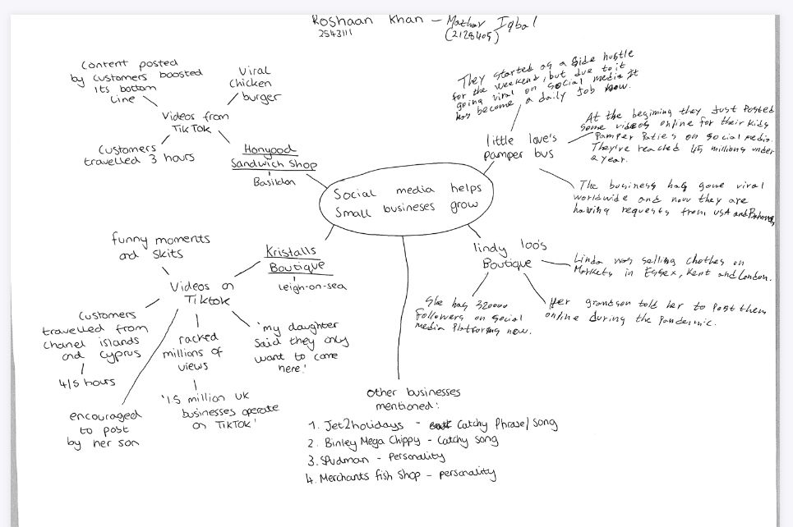

1. Answer these questions using the sentence starters below
a. What is the main idea of the text?
The main idea is social media like TikTok, Instagram and Facebook which are helping small businesses grow in sales and make them popular. These social media platforms are helping businesses to reach more people not only where they are based but also in other cities or countries. All these new social media platforms can make someone famous overnight by going viral, these businesses post photos and videos of their businesses online. Which reached a large amount of people from around the country and in some cases worldwide which increased sales in the business, and they gained popularity. Even small businesses can promote their items online for free now, which will reach thousands if not millions of people everywhere.

b. What are two key points?
One key point is when posts on social media can increase significantly the customers for businesses. In the text the Honeywood Sandwich Shop became popular when its own customers started posting videos and photos on social media, people started coming from far just to try their famous chicken burger. This is a perfect example how social media trend can help businesses in sales and popularity too.
Second is social media can help build a personal connection between customers directly. This is shown in the text how people would prefer buying from people rather than from advertisements. For example, Lindy Loo’s Boutique and Krystalls Boutique grew their followers by posting real videos of themselves which customers connected and enjoyed watching. Customers connected with owners and started follow them and supporting their businesses. This shows how social media can help create relationships and trust between businesses and customers.
c. What part of the text did you find most important? Why?
The most important part is that people buy from people, the last part of the text is the one I feel is important as it describes how social media has changed the marketing in the world regardless of the which business you do or the size of a business. This part explains why all the businesses in this text got success on social media. These businesses did not use the typical advertising method to promote their businesses and products but instead made real videos and shared experiences which helped them connect with the customers.
These days people use their social media a lot daily, when they watch someone’s video daily, they feel like they know them and they trust them. These then attracts them to buy from the people they “see daily”, the businesses mentioned in the article are examples of this. All those businesses got success and had increase in the sales because they had connected with people, some through videos and photos they posted and some which were posted by other customers.

d. Was anything unclear or difficult to understand?
I was not sure about how some posts online get viral than others, how does the algorithm work. Even though it doesn’t mention in the article, but I believe it should have explained that part too. There wasn’t much I couldn’t understand in the article as most of it was clear and very straightforward.
If another part could have explained how the videos of these business got viral, on some it makes sense as the customers were posting them. So that was maybe the amount of people liking them. The article mainly focuses on the positive things only, it only mentions in the challenges briefly.
e. How did your group help you understand the text better?
My group helped me by sharing their understanding on the different parts of the articles and with some examples we made in class which were very helpful to understand the text. All the different groups in class mentioned different things, which made us understand the main idea of the text which social media was helping these businesses gaining followers and following that increase in the sales. The discussions we had in the groups also helped me understand some parts of the text, as we were all focusing on different parts. So when we were all discussing our parts others were understanding the whole article easily, the group discussion was very helpful to me especially as sometimes I understand better when someone is speaking to me, rather than me reading it as if it too long it can get boring.
3. One sentence reflection
Question: What did you find challenging about this task?
The hardest part was definitely understanding the main idea of the text and then summarising it, I had to explain how these businesses got popular and had a significant growth in the sales. How some of them were posting themselves online and some business the existing customers were doing on their behalf, some started as a side hustle but ended up making it full time job.

