John Muir

In work, myself and a group of four children decided to discover the outdoor play ground which is surrounded by a field and woodland area. This outdoor area has many trees, bushes and plants.

To explore the area we looked around, we stopped and we listened. I asked the children to tell me if they hear any noises. Most of the children told me they could see and hear birds. We saw pigeons, magpies and robins.

Myself and the group of children decided to take practical action for the nature and wildlife. We came up with a few ideas, some children suggested that we make bird houses and some suggested we made bird feeders. We had a vote and majority of the children wanted to make bird feeders so this is what we did.

I started by researching different ways of making bird feeders, there was ideas such as using plastic bottles and wooden spoons with bird food in them. We decided against this idea as it meant we had to go shopping and buy the equipment which was not practical. We decided to put cheerio cereal on string and hang them on the trees, the children enjoyed doing this task and threading the cheerio’s on the string, they made one each to hang on the trees.

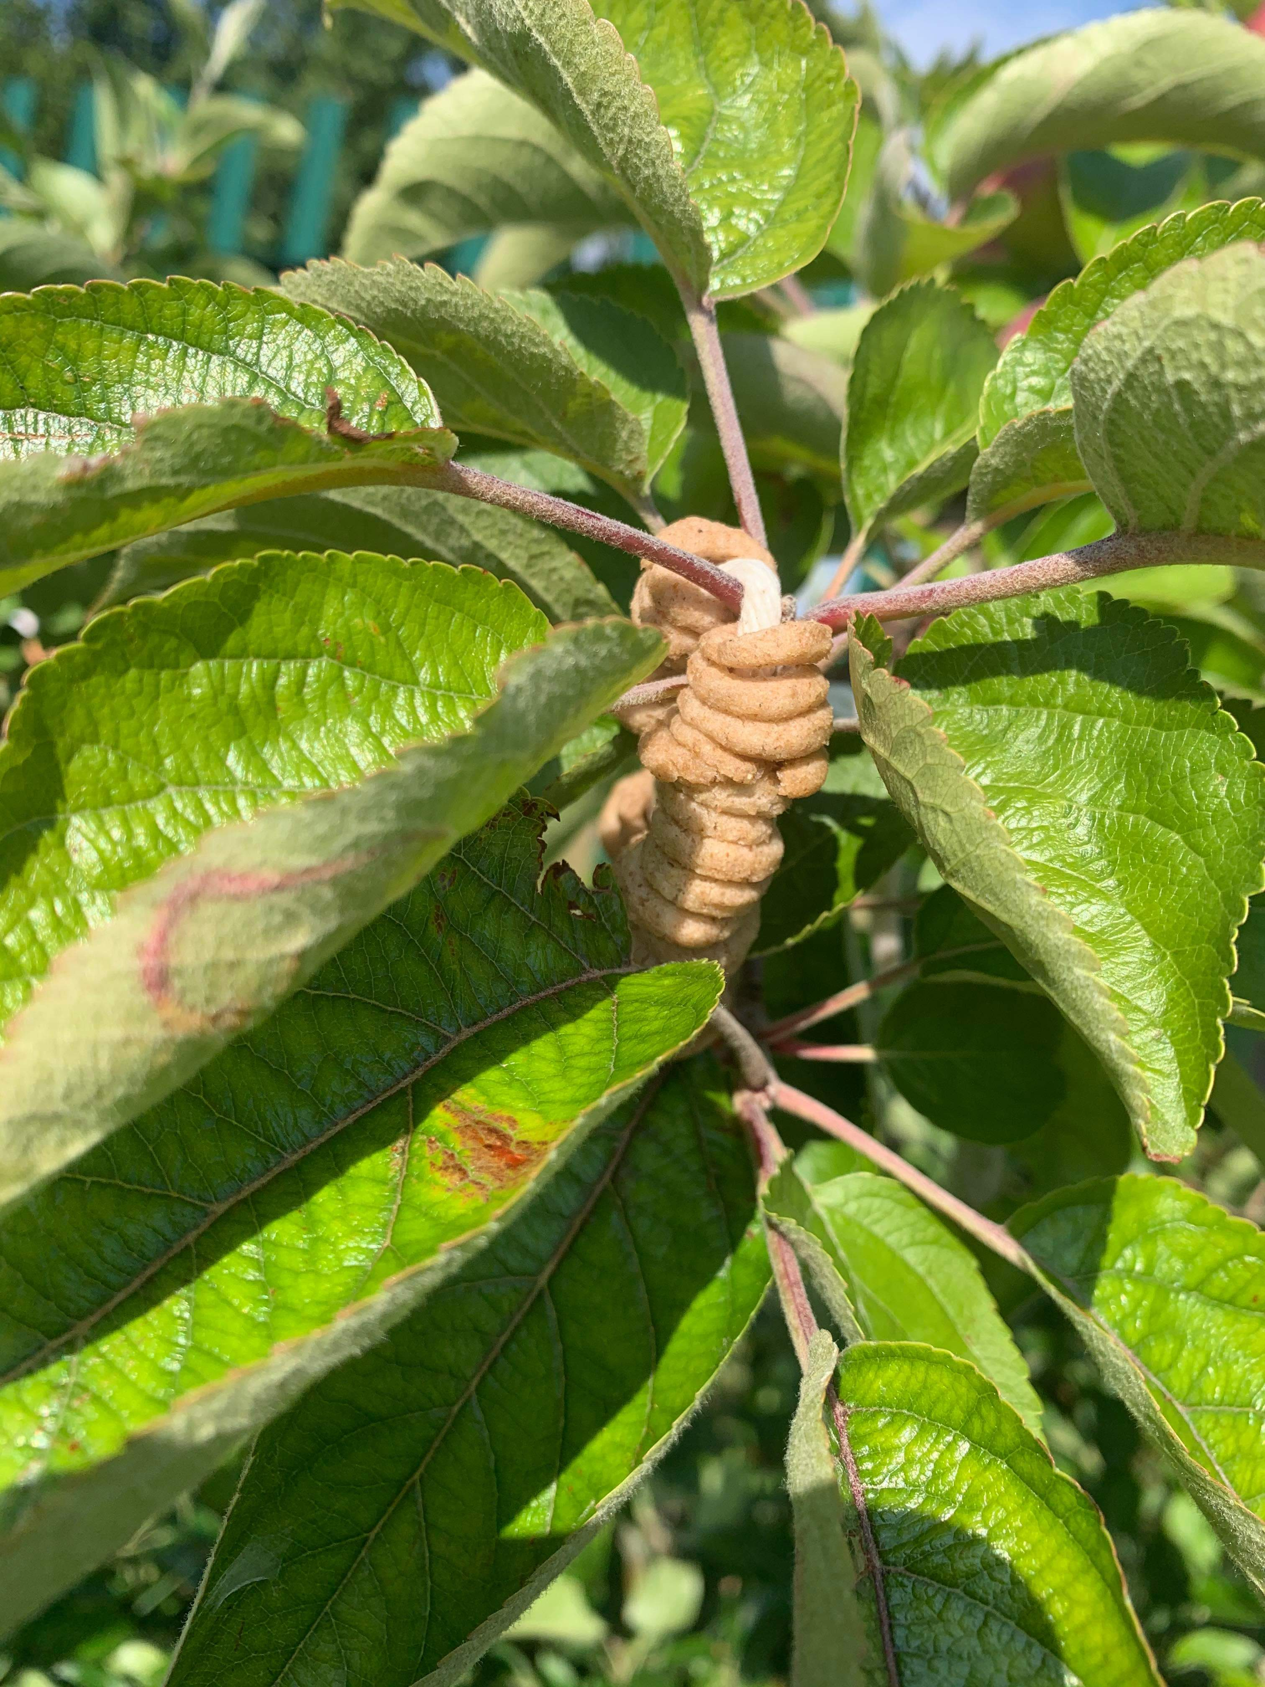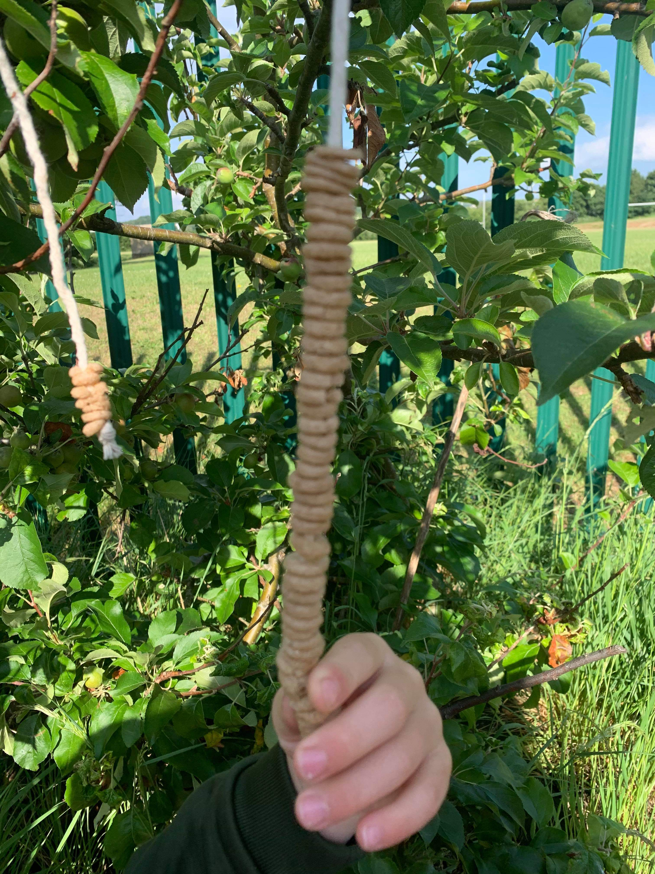

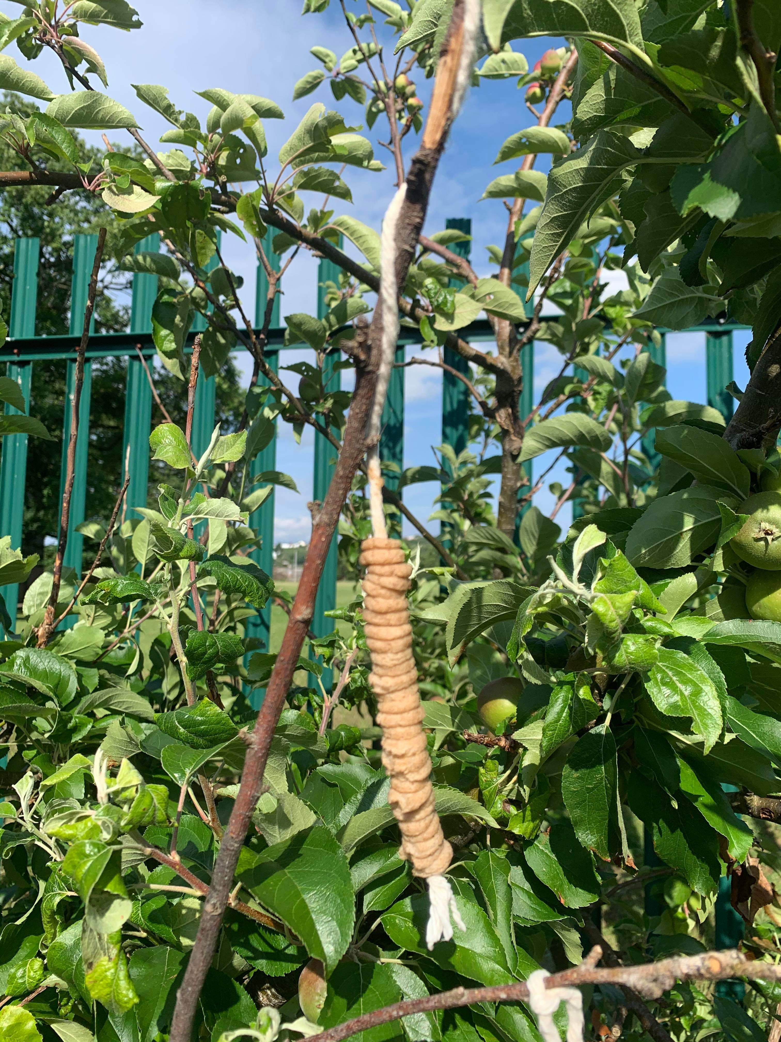

We also wrote a poem whilst making these bird feeders.

Feed the Birds Poem

We went out to the yard,
We all listened hard,
We heard the birds singing,
And we got thinking.
Maybe they were hungry,
Maybe they wanted some food?
We didn’t want to eat our lunch and the birds go hungry, that would be rude.
We made some bird feeders which string and cheerios, we worked hard,
Out in the yard.
Now we have to wait, for the bird to eat,
Then our mission to help will be complete.

