

Marketing Fundamentals

Name : Bianca Petronela Paunescu

Student ID : 2024896

Date : 10.01.2022

Internal and External Analysis
SWOT and PESTLE
NEXT PLC

Table of Contents

- About NEXT…………………………………………………..2
- COVID-19 ……….………..…………………………………..2
- COVID-19 – Impact on NEXT PLC…………………………..3
- Business Environment ……….………………………….…….3
- SWOT Analysis……………………….………….…………....5
- PESTLE Analysis……………………………………...……....6
- Conclusion……………………………………………………..10
- Reference list…………………………………………………..12

NEXT PLC is a clothing, footwear, accessories, and home products company based in the United Kingdom. In 1864, Joseph Hepworth, the founder of NEXT PLC, started his adventure in Leeds. In the United Kingdom and Ireland, there are now 597 stores. The headquarters of NEXT PLC are in Enderby, Leicestershire. In the retail industry, this is a well-known and top-ranking British multinational corporation, with over 500 stores in the UK. NEXT is committed to operating a responsible and prosperous company, with the goal of providing great service to all consumers, shareholders, employees, suppliers, the community, and the environment (The Org-NEXT).
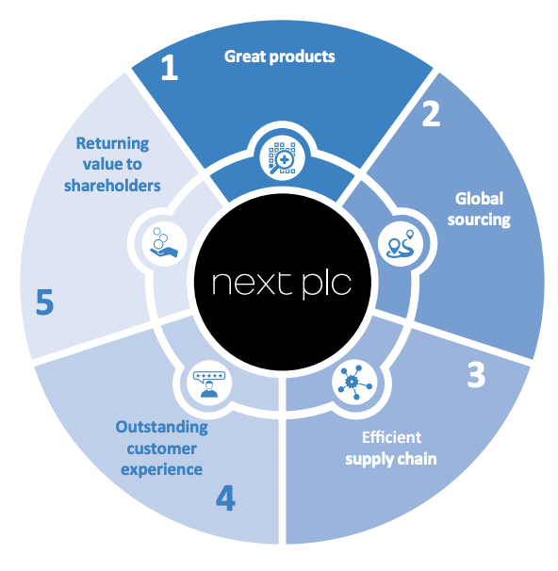
Common goals, principles, and standards are NEXT PLC's core values. Accountability, diversity, quality, cooperation, and leadership are all key values. NEXT delivers high-quality clothes and homeware that meets and exceeds the customers' expectations at costs that are within most people's reach. Customers can choose from a wide choice of NEXT and other branded products, all while enjoying a convenient shopping experience (NEXT, 2009).
The global impact of the COVID-19 epidemic has been enormous. Aside from the public health issue, economies have slowed dramatically, and customer behaviour has evolved dramatically, leaving many marketers unsure of what to do next. It is important for marketers to pay attention at the macro and micro trends that are reshaping the consumer landscape. Personal hygiene and personal space, social gatherings and family bonds, savings ratios, and consumer purchasing patterns were all affected by the epidemic. COVID-19 decreased productivity by making corporate operations more complicated (7 Macro factors that will shape the 2020s).
The government has imposed punitive sanctions all around the world since the textile industry does not fall within the definition of "vital" commodities and services. In India, Bangladesh, China, and Vietnam, contract cancellations and difficulty obtaining raw materials from China, a major supplier, have caused serious supply chain disruption and production activity suspension. One of the key difficulties affecting the local textile sector is the fall in the value of trade transactions with other parts of the world. Most textile and garment sectors are facing a rise in stockpiles as well as a decline in volume and value of trade due to deteriorating global demand (Baliyan and Diwan, 2021).
NEXT didn’t escape the pandemic either. The largest problem they faced was demand issues, and how to plan for a considerable drop in sales throughout the duration of the pandemic. As there was no prior experience with a similar situation, no one could say how much of an impact the Coronavirus will have had on retail and online sales. According to data from overseas sites, the difference between online and retail sales performance widened as movement limitations grew, with online scooping up a little amount of the business that couldn't be done in person. Certain product categories are likely to outperform others. So far, sales of homeware and childrenswear have been less affected than those of adult clothing companies, all of these being result of lockdown and people being forced to stay at home (Annual Reports & Accounts January, 2020).
Dealing with the crisis as the epidemic progressed, they put strategies in place to safeguard susceptible employees, compiling with varying levels of government restrictions, and deal with illness across the company. As part of the strategic planning, SWOT analysis (Strengths, Weaknesses, Opportunities, and Threats) and PESTLE analysis (Political, Economic, Social, Technological, Legal and Environmental) are two business analytical approaches that can be used in strategic planning.
Strategic management is to bring together and integrate the activities of a company's numerous functional departments to achieve long-term goals. The micro and macro aspects that play a role in the success or failure of a retail firm cannot be overlooked in any discussion of strategic planning.
1. Micro environment - tiny forces that affect a company's ability to serve its consumers.
2. Macro environment - sociocultural variables that have an impact on the microenvironment.
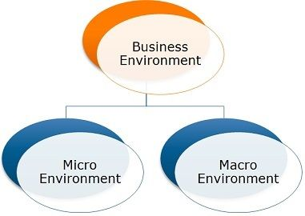

In retail, a micro environment refers to everything that is close by, including suppliers, consumers, competitors, and stakeholders. Any government or regulatory agency could be a stakeholder. The micro environment is usually contained within the company, and every retail store owner should be familiar with its components. The micro-environment has a direct impact on the day-to-day operations of the organisation. It is made up of numerous forces that are unique to a particular company and can have a short-term impact on daily operations and performance. These forces or factors include suppliers, shareholders, consumers, employees, competitors, and the media (Difference Between Micro and Macro Environment, 2019).
Suppliers: These are businesses that provide raw materials, machinery, and equipment to other businesses. Because they provide critical production inputs, their operations may have an impact on the company's strategy. If timely and adequate services are not delivered, the production process may be delayed, resulting in longer production times and less sales.
Customers: They are the final recipients of products or services. They are crucial to every company since they generate revenue by purchasing goods or services. As a result, a company's marketing strategy should be centred on retaining existing consumers but also attracting new ones by matching their needs and preferences. After-sales service and other value-added services are also crucial in growing a customer base.
Competitors: Business strategies can be directly influenced by corporate rivals or competitors. As a result, doing a competitive analysis of competitors is necessary in order to get a competitive advantage, which includes determining their USP (unique selling point) of products and services offered. A company can also stay competitive by providing better products or services than its competitors.
Individuals: Employees that are both skilled and specialists in their industries can assist organisations in achieving their objectives. Employing the right people and providing them with suitable training and growth opportunities can help businesses succeed.
Shareholders: Shareholders are those who invest in and own a piece of a firm. This is how they gain control of the business. They are entitled to a return on their investment in the end. As a result, companies must share earnings with them. Companies pay dividends to keep shareholders interested. As a result, striking the right balance between shareholder and corporate interests is crucial.
Media: Media channels have a significant impact on marketing tactics for businesses. Any company uses the media to advertise its goods and services. As a result, businesses must maintain a positive public image and a healthy relationship with the media. The company's terrible reputation could cost it a lot of money. Businesses increasingly have their own public relations (PR) department to handle media relations in an effective and helpful manner. Firms must also discover innovative approaches to reach out to their audience or customers, so they engage with the company.
In retail, a SWOT analysis is frequently used to examine micro and macro settings. Internal factors like strengths and weaknesses have an impact on a company, whilst external factors like opportunities and threats are out of the organization's control (Microenvironment vs. Macroenvironment, 2019).

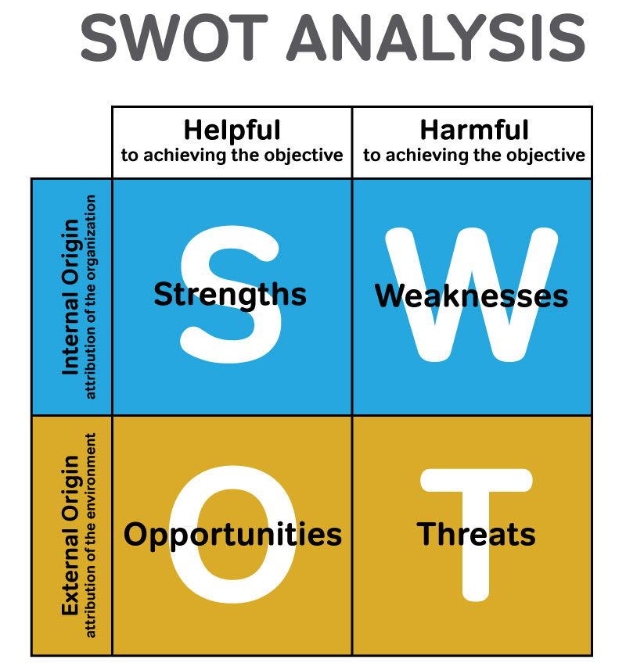
The company's versatility is a key strength, which is critical in the ever-changing retail sector. This can be seen in the company's efforts in next-day delivery services and online shopping networks (NEXT Corporate 2011.) NEXT was quick to note the growing popularity of online purchasing, and so decided to focus as much as possible on excellent online customer service. Given how important economic performance is for garment retailers, NEXT's success bodes well for the future. NEXT's corporate responsibility posture, which includes Annual Corporate Responsibility Reports describing the company's "social, environmental, and ethical performance," are signs of company’s transparency. NEXT is focused on establishing an environment in which workers are encouraged and valued, as this have proved to push employees to achieve higher levels of performance (Wolinski and Coates, 2005). Another factor which helps NEXT is having well established distribution channels and credit options, such as NEXT Credit. Also, having a strong third party relationship and being able to offer a complete Platform for other brands such as GAP, Victoria’s Secret, Ted Baker, Lipsy, F&F, etc. has proven to be one of NEXT’s opportunities.
While NEXT PLC has been mainly successful in the retail sector, the company's most danger is its fiercely competitive industry. Luxury products, such as the garments NEXT sells, are nevertheless vulnerable to alternative products. In the case of NEXT, products are standardised and can be easily duplicated by competitors. Customer loyalty to a company or brand is severely hurt in the clothing retail industry, which is mostly based on price competition. The reliance on rival prices by NEXT shows a confusing demand curve, which can be harmful to enterprises when profit margins are reduced. As a result, NEXT may be said to have limited control over its own earnings due to its inability to alter product pricing or demand. Retail apparel is a particularly dangerous company because of the disposable income consumers spend on such items and the seasonal cyclical effects. Now we can add COVID to the implications, with customers spending most of their time at home due to lockdowns or restrictions. Also, business disruptions around the world due to COVID-19 has impacted the company’s business as well (Business Model 1 Great products, 2019).
The general external environment that influences an organization's working style, decision-making process, strategy, and performance is referred to as the macro-environment. It has effects that are beyond an organization's control. PESTLE analysis is a macro-environmental method that considers a number of external variables or pressures, including political, economic, socio-cultural, technological, legal, and environmental factors. Organizations can control micro-environment factors but regulating macro-environment factors is nearly impossible. Customers, suppliers, competitors, and other internal elements make up the micro-environment, while political, social, and economic factors make up the macro-environment. PESTLE integrates macro-environmental components, and its application is based on the idea that understanding the effectiveness of an organisation or management solution requires first understanding the specific business environment (Buchanan and Gibb, 1998). The ability of an organisation to deliver value will be influenced by external and indirect qualities that describe the business environment. As a result, PESTLE analysis gives bigger picture of the external environment (Ward and Rivani, 2005).
Changes in the macroeconomic climate can have a direct influence on NEXT PLC and other retailers. Apart from opposing pressures, the PESTLE analysis reveals a great deal about NEXT PLC's operational challenges in the current macro environment. A thorough PESTLE study can assist a company in identifying the one opportunity that is right for them (Özbay, Özcan, İktisat, 2021).

Political Factors:

Political factors can have an impact on NEXT PLC's long-term profitability in a specific region or market. Because NEXT is a global retailer with locations in more than a dozen countries, it is subject to a wide range of political risks and systems. To prosper in such a dynamic retail market spanning multiple countries, it is critical to diversify the political environment's systematic risks. Before entering or investing in a particular market, NEXT PLC can carefully examine the following factors:
• The retail sector's relevance to the country's economic and political stability.
• The fear of a military invasion
• Corruption in the consumer services industry
• The impact of the Brexit transition period
• Government help for businesses during the COVID-19 pandemic
• Contract enforcement legal framework
• Intellectual property protection
• Consumer Services Pricing Regulations
• Taxation
• Retail work week regulations
• Mandatory employee benefits
• Product labelling and other retail standards
COVID-19 had an enormous impact on the Political behaviour, adding new factors to be considered:
• Obligation to wear a mask: The issued circular imposed the requirement to wear a mask in both open and closed spaces. As a result, there has been a huge surge in consumer demand for masks.
•Consumer behaviour has changed as a result of the regulation of keeping social distance in public transportation vehicles and other open and closed venues. These restrictions have had a significant impact on cafeterias, restaurants, and recreation centres. There has been a lot of takeaway service.

Economic Factors:
By examining country economic factors such as growth rate and inflation, as well as industry economic indicators such as retail industry growth rate, consumer spending, and so on, NEXT PLC can forecast the company's future performance. The following economic aspects should be considered by NEXT when conducting a PESTLE study:
• Economic system in operating countries
• Impact of the pandemic on retail customer spending power
• Intervention by the government in the free market
• Exchange rates and currency stability in the host country
• Financial market efficiency
• Infrastructure quality in the retail industry
• Labour costs and productivity
• Unemployment rate
•Innovative behaviour in E- Commerce
• Economy's educational level
• Inflation rate
• Interest rates

Social Factors
In any situation, a society's culture and way of life has an impact on an organization's culture. The common beliefs and attitudes of the population have an impact on how NEXT marketers create retail marketing messaging. The following social factors should be taken into account by the company's leadership.:
• Population demographics and skill level
•Internet empowering customers by providing choices
• The degree of education as well as the educational standard in NEXT’s industry
• Diversity and inclusivity in the workplace
• Hobbies and interests
New social factors appeared along with COVID-19’s impact:
• Establishment of social support groups
• Restrictions of home visits
• Restrictions of collective commemorations like funerals, weddings

Technological Factors
Diversity promotion is a must. Technology is impacting a wide range of sectors across the board. A company should not only do a technological analysis of the industry, but also assess the rate at which technology disrupts it. Slower speeds give a corporation more time to cope and stay profitable, whilst faster speeds give them less time. Understanding the following consequences of technology is part of technology analysis.:
•Digital marketing for boosting overseas business
• Recent technological advancements by competitors of NEXT
• Technology's impact on product offers

• Technology's impact on retail cost structures

• Technology's impact on the value chain structure in the consumer services sector

Environmental Factors

Environmental factors have a different impact on a company, depending on the country/state we are having our company in. An extremely important step a company should do before entering new markets is to analyse the environmental criteria that guide those markets:
• Weather
• Regulations on air and water pollution in the retail business
• Climate change
• Recycling
• Environmental laws
• Waste management
• Attitudes about renewable energy sources and support for them

• Attitudes toward "green" or environmentally friendly items

Covid also affected environmental changes such as mentioned below:
• Increase in medical waste
• Increase in water consumption
• Decrease in carbon emission
Legal Factors

The legislative structures and processes in place in several nations are insufficient to protect an organization's intellectual property rights. Before entering such markets, a company should carefully consider its options.
When entering a new market, NEXT leadership should evaluate antitrust regulations in the retail industry and across the country.
• Intellectual property, copyright, and patent law
• Discrimination law
• Consumer protection and e-commerce laws
• Employment law • Health and safety law
• Data Security
The mission to evolve is a never-ending task. Coronavirus is a real and imminent threat. The industry in which NEXT operates is still undergoing significant and long-term structural changes that show no signs of slowing down. The pandemic will expedite the transition to online shopping. The internet offers NEXT a once-in-a-lifetime opportunity to economically extend their brand in countries where they are a new participant by leveraging their online assets. They identified a way to profitably reach clients who are inadequately numerous in any specific town or city to justify the investment in a retail store through the online environment. The internet provides access to a large number of dispersed populations in a way that retailers never could.
Every function in the company is involved in this process of developing innovative approaches to serve customers, work with partners, and create value for shareholders. In order to adapt to a quickly changing world, their purchasing, sourcing, systems, marketing, warehouse, distribution, and store teams must all reinvent themselves. Their long-term viability will be determined by the delivery of new product lines, online systems, marketing tactics, warehouse capacity, business ideas, collaborations, and other factors. This demands a culture that embraces change, and it is not afraid to take risks, which is difficult to do amid a crisis.

Reference list:
- Annual Report & Accounts, (2021). Available at: https://www.nextplc.co.uk/~/media/Files/N/Next-PLC-V2/documents/2021/annual-report-and-accounts-jan21.pdf, [Accessed 5 Dec. 2021].

- Annual Reports & Accounts January (2020). Available at: https://www.nextplc.co.uk/~/media/Files/N/Next-PLC-V2/documents/2020/annual-report-and-accounts-jan20.pdf [Accessed 10 Dec 2021].

- Annual Report and Accounts, (2009). Available at: http://ir3.quartalflife.com/data/next/igb_html/pdf/1000001_e.pdf, [Accessed 5 Dec. 2021].

- Baliyan, R. and Diwan, P, (2021). A Shift in Paradigm for Apparel Industry Post Covid 19. Turkish Journal of Computer and Mathematics Education (TURCOMAT), Vol 12 (No 13):5203-5211.

- Buchanan, S. and Gibb, F. (1998). The information audit: An integrated strategic approach. International Journal of Information Management, 18(1).

- Business Model 1 Great products. (2019). Available at: https://www.nextplc.co.uk/~/media/Files/N/Next-PLC-V2/documents/2019/business-model.pdf, [Accessed 7 Dec. 2021].

- Gartner. 7 Macro Factors That Will Shape Business in the 2020s. Available at: https://www.gartner.com/smarterwithgartner/8-macro-factors-that-will-shape-the-2020s, [Accessed 10 Dec 2021].

- Lumenlearning.com. Microenvironment vs. Macroenvironment | Retail Management, (2019). Available at: https://courses.lumenlearning.com/wm-retailmanagement/chapter/microenvironment-vs-macroenvironment/. [Accessed 10 Dec. 2021]

- Miyazaki, A.D. and Fernandez, A. (2001). Consumer Perceptions of Privacy and Security Risks for Online Shopping. Journal of Consumer Affairs, 35(1), pp.27–44. Available at: https://onlinelibrary.wiley.com/doi/abs/10.1111/j.1745-6606.2001.tb00101.x [Accessed 172Dec 2021].

- Özbay, F., Özcan, A., İktisat, A. and Dergisi, F. THE EXAMINED OF THE INFLUENCE OF COVID-19 ON E-COMMERCE AND CONSUMER BEHAVIOUR: A STUDY ON TURKEY 1. Aydin Faculty of Economics Journal. Available at: https://dergipark.org.tr/en/download/article-file/1775574 [Accessed 12 Dec. 2021].

- StudiousGuy (2019). Difference Between Micro and Macro Environment. Available at: https://studiousguy.com/difference-between-micro-and-macro-environment/.

- THE ORG. NEXT. Available at: https://theorg.com/org/next-plc [Accessed 18 Dec. 2021].

- Ward, D. and Rivani, E. (2005). An Overview of Strategy Development Models and the Ward-Rivani Model.

- Wolinski, J. and Coates, G. (2005). AQA A2 business studies.

