Human Resource Management
Assessment-2



Presented By: - Professor Name: -
Apurva Jignesh Parmar (2211066) Mustafizur Rahman
Gladius David Kulothugan

Table of Contents
Introduction 3
Analysis of the labour market in the United Kingdom 3
The labour market of the United Kingdom (2021-2022) 4
Understanding the employment rate 6
Analysing the labour market 6
Changes in the labour market in the United Kingdom 8
Contemporary Employment Rate 9
Emerging changes in Human Resource Strategies in the post-Covid and post-Brexit phases 10
Assessing the recent situation of workplace and business activities 10
Reconfiguration of strategies by HRM post-Covid pandemic 11
Implementation of effective strategies in businesses 11
Significance of Recruitment 12
Significance of managing well-being 12
Conclusion 13
References 14

Introduction
The labour market generally refers to the point of supply and demand for labour. It is a significant cycle in which employees provide the supply and the employers demand effective labour practices. The labour market is one of the most crucial aspects behind the boost of any industry. Furthermore, it is intricately connected to markets specialised in capital, resources, goods, products and services. It is viewed at both macro and micro environmental and economic levels. In developed nations like China and the US, it has previously been unfeasible for numerous individuals to establish a profitable and steady working connection without such institutionalized backing. A prerequisite for the process of change management as described in the global labour protections is the unification of employment in the private and the public sectors into a matrix of labour market institutions, such as unemployment payments, re-employment programs, and education programs.

Understanding the significance of the subject, the following report will provide a detailed analysis of the contemporary situation of the labour market of the UK by closely analysing its trends, patterns and statistics. Furthermore, an analysis of the emerging changes taking place by the HRM post the Covid-19 will also be assessed to analyse the significance of HRM working conditions and relations.

Analysis of the labour market in the United Kingdom
It is important to understand the situation of the labour market before understanding the recommendations stemming from the HR services and actions in maintaining a successful organisational working post-Covid and Brexit conditions (House of Commons Library, 2022).
Increase in employment intentions - Understanding the key points from the labour market, the overall employment balance which significantly measures the distinction between recruiters to expand staff and employment levels with those expecting to decrease the employability levels in the last 3 months of 2022 remained almost positive in its outcome (+29) increase than the previous quarter (+34). There is a presence of effective employment intentions (CIPD, 2022).

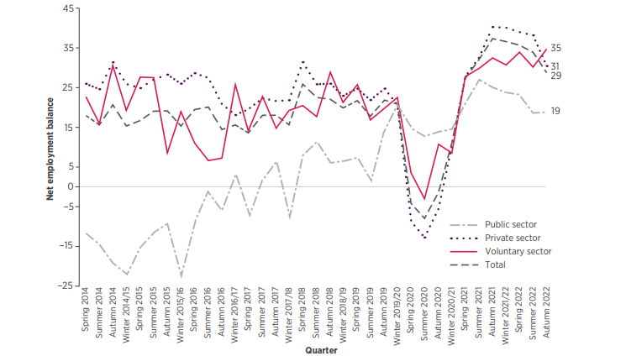
Fig 1: Overall Employment Balance (Survey by CIPD)
Source: (CIPD, 2022)
This situation remains positive in comparison to the pre-pandemic time series respectively. However, the overall employment balance diminished and disintegrated during the Autumn of 2021 (House of Commons Library, 2022). However, one striking factor understandable in the case of this situation is that employment situations have been soaring in the voluntary sector during this phase (CIPD, 2022). Furthermore, the private, as well as public sectors, have also seen positive growth in terms of labour recruitment. This suggests that the United Kingdom will witness overall growth in the trajectory of recruitment.

The rate of redundancy - Understanding the situation of the labour market, the rate of redundancy remained significantly low but is gradually increasing with time.
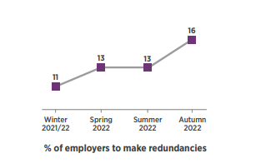
Fig 2: Survey results by CIPD assessing the percentage of employers to create redundancies
Source: (CIPD, 2022)

Furthermore, it has also been seen that employers are implementing policies to create redundancies in the last 3 months of 2022, which is an increase of 13% since the last quarter (CIPD, 2022).

The labour market of the United Kingdom (2021-2022)
Understanding the grave repercussions caused by the Covid-19 pandemic in the labour market, it can be assessed that in the period of August-October 2022, there was a major contribution of young people in every sector of the employability industry which resulted in a massive increase to 32.78 million (House of Commons Library, 2022).
Furthermore, assessing the employability rate of people aged between 16-64 witnessed an increase of 76.5% rise. It can also be seen that the levels of employability have increased since the last quarter (CIPD, 2022).
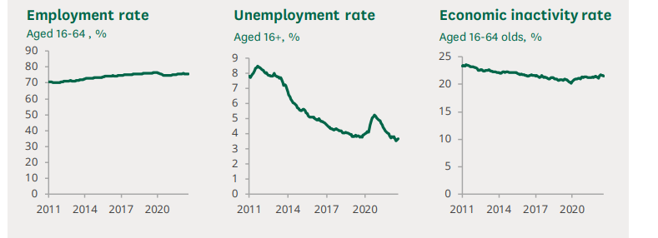
Fig 3: Statistics of UK Labour Market
Source: (House of Commons Library, 2022).

The rate of unemployment in the United Kingdom, on the other hand, was 3.7% and more than 1.27 million were unemployed (House of Commons Library, 2022). These people were mostly aged more than 16. Furthermore, more than 9 million people (aged between 16 to 64) were highly inactive economically and the overall rate of inactivity was 22% (House of Commons Library, 2022).

Understanding the employment rate
Assessing the statistics between August-October 2022, there was a steady employment rate where more than 32.78 million people in the United Kingdom were employed, especially between the ages 16 to 64 respectively. Furthermore, the rate of employment gradually increased from 2011 till the commencement of the pandemic caused due to Covid-19. However, the rate of employment increased exponentially at a soaring rate in 2020 with an increase of 77.8% respectively (House of Commons Library, 2022).
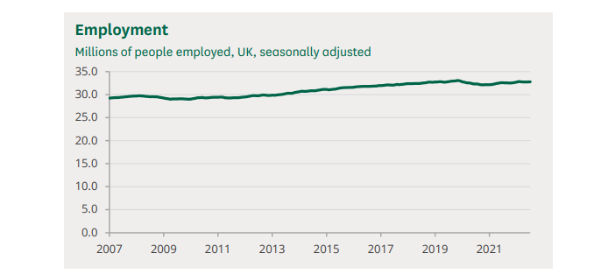
Fig 4: Employment rate in the UK
Source: (House of Commons Library, 2022).

However, after the commencement of the nationwide lockdown in March 2020, the employment rate fell significantly to 32.14 million (House of Commons Library, 2022). This situation gradually recovered between August-November 2022.

Analysing the labour market
Assessing the contemporary labour market of the UK, it can be clearly assessed that due to the low rates of unemployability and higher vacancy rates, it can be stated that the labour market of the UK is tight. This is because people in the UK, irrespective of any sector or industry, are inclined towards working, which also means that recruitment is getting more difficult with time.

Furthermore, these aspects have taken place because there has been significant growth in the number of inactive people in terms of economic stability since the commencement of the lockdown and pandemic. Furthermore, there has been a low migration rate in the case of the European Union which resulted in the disintegration of people in the labour market. Assessing the viewpoint of the Bank of England, there has been a steady decrease in the labour market or low participation or contribution of the same because of the increasing demand for labour which has seen a comparative increase than the supply of labour (Collings et al., 2021). However, in this case, the demand was still slow or absent. The rigid labour situation has exerted some upward tension on inflation, while contemporary spikes in wage growth are mostly related to substantial spikes in the cost of products and commodities on the international market.

The Bank of England forecasts that the labour economy will remain constrained all through the approaching quarters, but will steadily ease resulting in a rising rate of unemployment commencing in 2019 (CIPD, 2022). In light of the current constraint on average earnings caused by rising rates, it is anticipated that market consumption of goods and services would drop. Whether or if worker supply slows down alongside this demand, together with how persistently high industrial immobility is, will determine how swiftly the employment market dissolves.

Changes in the labour market in the United Kingdom
Because of the increasing rate of inflation witnessed in the nature of the labour market in the UK, this factor was attributable to the erosion of the value of pay scale and pay cheques. It has also been seen that labourers’ wages and scales were not improving in terms of how they should (CIPD, 2022). There has been strife between Ukraine and Russia and because of certain unprecedented geopolitical scenarios, dominated by Russia’s invasion of Ukraine have resulted in the rise of inflation which created this complexity (Collings et al., 2021).
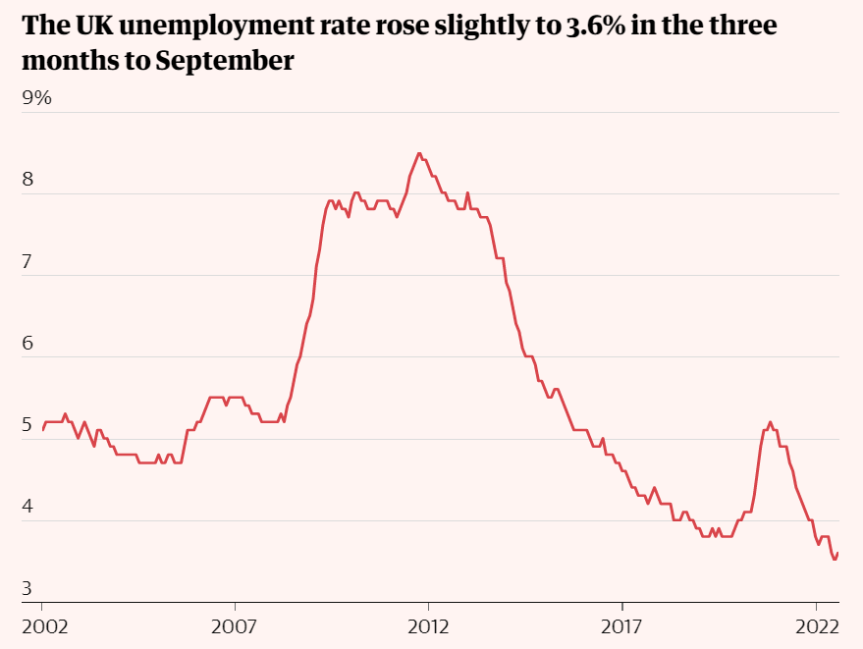
Fig 5: Assessing the labour market in the UK in current times
Source: (Guardian, 2022).

Assessing the rate of unemployment which has significantly reduced compared to a decade earlier, inactivity has begun to climb yet again and has become up 1.4 % from the position when Covid-19 first emerged in the UK around early 2020 (Guardian, 2022). The employment rate has declined by 1.1% indicating an opposite trend (Guardian, 2022).

The large determinant for the reduction in labour supply appeared to be a rise in the percentage of protracted unhealthy workers. The Office for National Statistics revealed that younger individuals were primarily to blame for the 0.2% spike in absenteeism in the three months preceding September. Typically, the decline has been particularly prominent among individuals over 50 (CIPD, 2022).

Contemporary Employment Rate
The rate of employment increased in the last 3 months of 2022, irrespective of a major blow in the rate of inflation and associated aspects. Furthermore, the last three months of 2022 have seen a boost in the number of full-time workers, which is still exceeding pre-pandemic levels. Since the commencement of 2022, there has been a steady reduction in the number of part-time employees; however, the last three months of 2022 witnessed an upsurge (Guardian, 2022).
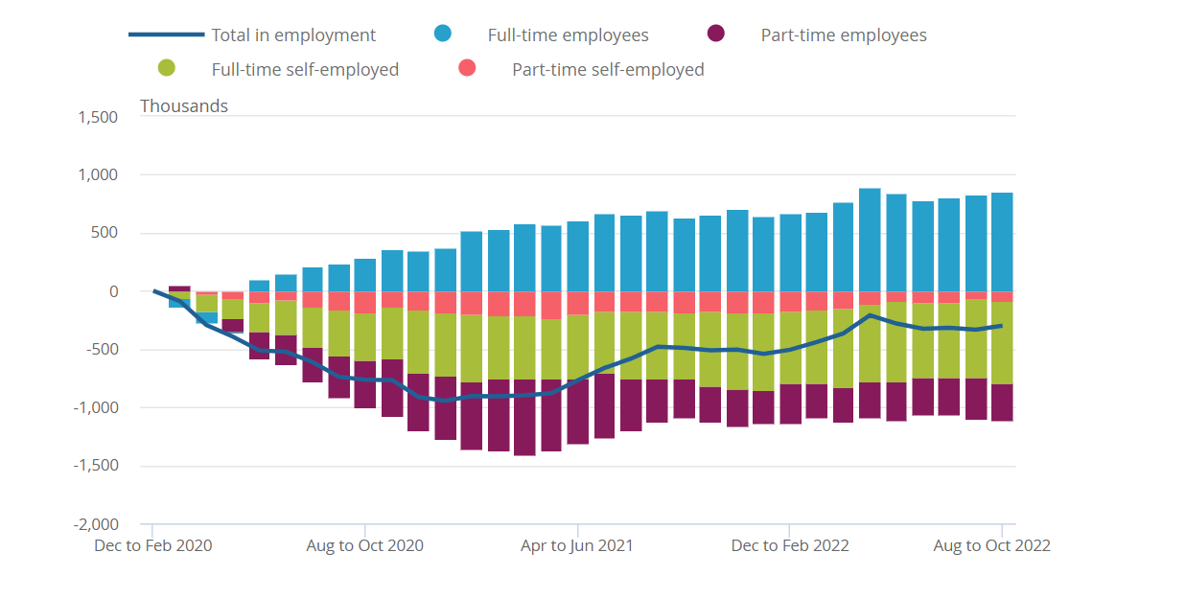

Fig 6: Employability Rate in the UK, 2022
Source: (ONS, 2022)
During the initial year of the coronavirus outbreak, the level of independent individuals decreased. During the last three-month period, part-time self-employment expanded while the number of full-time self-employed has remained relatively stable (ONS, 2022). The last three months of the contemporary year saw a significant boost in the number of individuals or groups' second jobs, up 44,670 to 1.543 million respectively (ONS, 2022).

Emerging changes in Human Resource Strategies in the post-Covid and post-Brexit phases

There is no doubt that human resource management (HRM) is one of the most integral aspects of reconfiguring significant efforts in maintaining the ethos of the organisation (Yawson, 2020). To meet the needs of an organisation, it is imperative for human resource managers to provide significant changes to cope with the repercussions brought down by the upsurge of the Covid-19 pandemic and related political disruptions caused due to Brexit changes and involvement. Human resource management, in every possible sector of the UK, effectively and efficiently responded to the changes in workplace settings and patterns by promoting the essence of the “new normal” (Aitken-fox et al., 2021). Furthermore, this new normal or normalising a hybrid situation of the promotion of onsite and remote working arrangements has been made possible because of the response to the pandemic which was indeed a significant input of the HRM in every organisation (Gardener et al., 2021; Venkatesh et al., 2021).

Assessing the recent situation of workplace and business activities
Assessing the input of the employees and understanding the efficacy of the Work-from-home culture (Alam, 2020; Deloitte, 2020), the overall situations for business organisations, irrespective of any given sector or organisation was outwardly challenging. Managers in business organisations were starting to define, allocate, and provide supervision in organisational activities and ensure a steady process in work management and stability, which was significantly witnessed during Brexit and post-Brexit environmental regulations (Carnevale and Hatak, 2020; Foss, 2021).

The primary objective of the organisation executives and managers was to ensure that the experiences of the employees are enhanced and at the same time, motivation and well-being facilities are provided (Alam, 2020; Deloitte, 2020). Furthermore, assessing the research supplied by (Collings et al., 2021; Deloitte, 2020), there have been situations in which there was a need to provide a well-designed job profile to assess how working progress or productivity of the employees are taken place and at the same time, assessing their measure of improvement and also assessing the consequences if these objectives are not met which is significantly rendered by the business organisations as a whole.

After the Covid-19 pandemic eased in the UK, there were certain implications. Employees engaging collaboratively on a project or activity started dispersing to respective locations because of the absence of real-time designing of work portfolios and there were no assessments of how work conditions should be performed in an optimal and homogeneous scenario (Alam, 2020). There has been an absence of smooth and efficient workflow conditions which needs a purview of the HRM strategies and techniques which will allow the organisations to undergo change management and ensure that there is a presence of effective work designs, optimal performance and work conditions respectively (Foss, 2021; Alam 2020; Lopes et al., 2014).

Reconfiguration of strategies by HRM post-Covid pandemic
Assessing the primary functions of human resource management in an organisation, the working conditions are all about the way business organisations recruit, manage, train and develop employees and workers (Hamaouche, 2021). This synergy has been substantially disrupted by the onset of the pandemic in the United Kingdom. Assessing the significance of this synergy, it is imperative for Human Resource Management to analyse the significance of reconsidering as well as reformulating the practices as well as strategies in enhancing the well-being of the employees and attracting them to provide effective technological competence with effective attitude to stimulate the effectiveness post-Covid crisis (Memon et al., 2021; Aiten-fox et al., 2021).

Implementation of effective strategies in businesses
Farndale et al., (2019) assert that the implementation of effective and strategic HRM will allow organisations in facilitating competitive advantage to ensure an increasing value by assessing the flow of productivity and talent among employees and workers and stimulating a positive culture which will reinforce flexibility as well as agility on long term practices. Recent research has placed great significance on addressing the need for HR reconfiguration and implementation of robust approaches in ensuring that there is a presence of Pay scale and benefits, Input of leadership skills and benefits, Training and development, Performance management as well as Employee relations and Layoff Practices (Dirani et al., 2020; Nilakent et al., 2013; Premeaux and Breaux, 2009; Wang et al., 2016).

Significance of Recruitment
Assessing the conditions of post-Brexit and post-Covid situations in the United Kingdom, it can be assessed that it is the obligation of HR to ensure that there is a presence of training mediums, in the light of recent changes, while recruiting new employees. Assessing the HR reconfiguration in this technique, it can be said that it is the responsibility of the HRM to ensure that there is a need for the development of IT Skills, proper training, and usage of technology platforms which will ensure a successful onsite and remote working conditions (Dwivedi et al., 2020; Dirani et al., 2020; Butler and Jaffe, 2021).

Significance of managing well-being
Assessing the significance of employee well-being at work, Yi-Feng Chen (2021), stated that maintaining and managing employee well-being at work is one of the primary attributes of an employer which promotes the contentment of a workplace which further accomplishes the potential of employees to achieve the organisations of any given business. The idea of work-from-home has placed a substantial boundary in assessing work life and normal life. Therefore, post the covid-19, it was imperative for HRM to deploy effective measures in assessing and managing the well-being of the employees holistically.

Szulc et al. (2021) proposed a comprehensive rearrangement of work while considering existing factors into account in order to increase well-being in the "normal way of life." Corporations must incorporate different family-friendly regulations that allow for an acceptable measure of discretion. To help ensure that individual well-being is situated at the forefront of the work process, it is essential to examine the way employment is structured. For instance, work responsibilities should not be excessively high in such a way that they drastically alter employees' ability to balance their private and professional lives, which might culminate in exhaustion and poor contentment. Alongside this, there ought to be professional standards and continuous check-ins to determine how well the workforce is doing. Again, it is crucial to formulate and implement regulations that restrict personnel from working long hours and extended weeks (Gardner et al., 2021; Venkatesh et al., 2021).

Conclusion
In assessing the significance of human resource management, it can be concluded that the present situation in the United Kingdom, pertaining to the labour market, has been gradually increasing because of the ease of the Covid-19 pandemic. However, in order to uphold dynamism and consistency, it is important for organisations to deploy human resource strategies and management which will allow for a holistic change in terms of optimisation of employee working conditions.

Through the following report, an understanding of the existing labour conditions has been assessed. Furthermore, the implementations of effective HRM Strategies have also been provided in relation to effective recruitment practices and HR implementation of well-being policies have also been examined for the effectiveness of business organisations in the United Kingdom.

References
Aitken-Fox, E., Coffey, J., Dayaram, K., McKenna, S. and Tian, A., 2021. The changing role of human resource management through crisis: From response to recovery, Call for Papers. Personnel Review.
Alam, M., 2020. Organisational processes and COVID-19 pandemic: implications for job design. Journal of Accounting & Organizational Change.
Butler, J. and Jaffe, S., 2021, May. Challenges and gratitude: A diary study of software engineers working from home during covid-19 pandemic. In 2021 IEEE/ACM 43rd International Conference on Software Engineering: Software Engineering in Practice (ICSE-SEIP) (pp. 362-363). IEEE.
Carnevale, J.B. and Hatak, I., 2020. Employee adjustment and well-being in the era of COVID-19: Implications for human resource management. Journal of business research, 116, pp.183-187.
CIPD, 2022. Labour Market Outlook. Autumn 2022. (ONLINE) Accessed on: December 22, 2022. Retrieved from: https://www.cipd.co.uk/Images/labour-market-outlook-autumn-2022_tcm18-112526.pdf
Collings, D.G., McMackin, J., Nyberg, A.J. and Wright, P.M., 2021. Strategic human resource management and COVID‐19: Emerging challenges and research opportunities. Journal of Management Studies.
Deloitte.,2020. Covid-19- A Lens on HR. (ONLINE) Accessed on: December 22, 2022. Retrieved from: https://www2.deloitte.com/content/dam/Deloitte/uk/Documents/human-capital/deloitte-uk-covid-work-workforce-and-workplace-key-considerations.pdf
Dirani, K.M., Abadi, M., Alizadeh, A., Barhate, B., Garza, R.C., Gunasekara, N., Ibrahim, G. and Majzun, Z., 2020. Leadership competencies and the essential role of human resource development in times of crisis: a response to Covid-19 pandemic. Human Resource Development International, 23(4), pp.380-394.
Dwivedi, Y.K., Hughes, D.L., Coombs, C., Constantiou, I., Duan, Y., Edwards, J.S., Gupta, B., Lal, B., Misra, S., Prashant, P. and Raman, R., 2020. Impact of COVID-19 pandemic on information management research and practice: Transforming education, work and life. International journal of information management, 55, p.102211.
Farndale, E., Horak, S., Phillips, J. and Beamond, M., 2019. Facing complexity, crisis, and risk: Opportunities and challenges in international human resource management. Thunderbird International Business Review, 61(3), pp.465-470.
Foss, N.J., 2021. The impact of the Covid‐19 pandemic on firms’ organizational designs. Journal of Management Studies, 58(1), p.270.
Gardner, D.M., Lauricella, T., Ryan, A.M., Wadlington, P. and Elizondo, F., 2021. Managing boundaries between work and non‐work domains: Personality and job characteristics and adopted style. Journal of Occupational and Organizational Psychology, 94(1), pp.132-159.
Hamouche, S., 2021. Human resource management and the COVID-19 crisis: Implications, challenges, opportunities, and future organizational directions. Journal of Management & Organization, 1, pp.1-16.
House of Commons Library, 2022. UK Labour Market Statistics. (ONLINE) Accessed on: December 22, 2022. Retrieved from:
https://researchbriefings.files.parliament.uk/documents/CBP-9366/CBP-9366.pdf
Lopes, S.A., Sarraguça, J.M.G., Lopes, J.A. and Duarte, M.E., 2015. A new approach to talent management in law firms: Integrating performance appraisal and assessment center data. International Journal of Productivity and Performance Management.
Memon, M.A., Ting, H., Ringle, C.M. and Muenjohn, N., 2021. Covid-19: The role of human resources management in time of uncertainty, Call for Papers. The Bottom Line.
Nilakant, V., Walker, B. and Rochford, K., 2013. Post-disaster management of human resources: Learning from an extended crisis.
ONS. GOV., 2022. Employment in the UK: December 2022. (ONLINE) Accessed on: December 22, 2022. Retrieved from:
https://www.ons.gov.uk/employmentandlabourmarket/peopleinwork/employmentandemployeetypes/bulletins/employmentintheuk/latest
Premeaux, S.F. and Breaux, D., 2007. Crisis management of human resources: lessons from hurricanes Katrina and Rita. People and Strategy, 30(3), p.39.
Szulc, J.M., Davies, J., Tomczak, M.T. and McGregor, F.L., 2021. AMO perspectives on the well-being of neurodivergent human capital. Employee Relations: The International Journal.
The Guardian, 2022. UK Labour Market is changing as inflation squeezes real pay. (ONLINE) Accessed on: December 22, 2022. Retrieved from: https://www.theguardian.com/business/2022/nov/15/uk-labour-market-inflation-real-pay-unemployment
Venkatesh, V., Ganster, D.C., Schuetz, S.W. and Sykes, T.A., 2021. Risks and rewards of conscientiousness during the COVID-19 pandemic. Journal of Applied Psychology, 106(5), p.643.
Wang, J., Anne, M. and McLean, G.N., 2016. Understanding crisis and crisis management: an Indian perspective. Human Resource Development International, 19(3), pp.192-208.
Yawson, R., 2020. Strategic flexibility analysis of HRD research and practice post COVID-19 pandemic. Human Resource Development International, 23(4), pp.406-417.
Yi-Feng Chen, N., Crant, J.M., Wang, N., Kou, Y., Qin, Y., Yu, J. and Sun, R., 2021. When there is a will there is a way: The role of proactive personality in combating COVID-19. Journal of Applied Psychology, 106(2), p.199.

