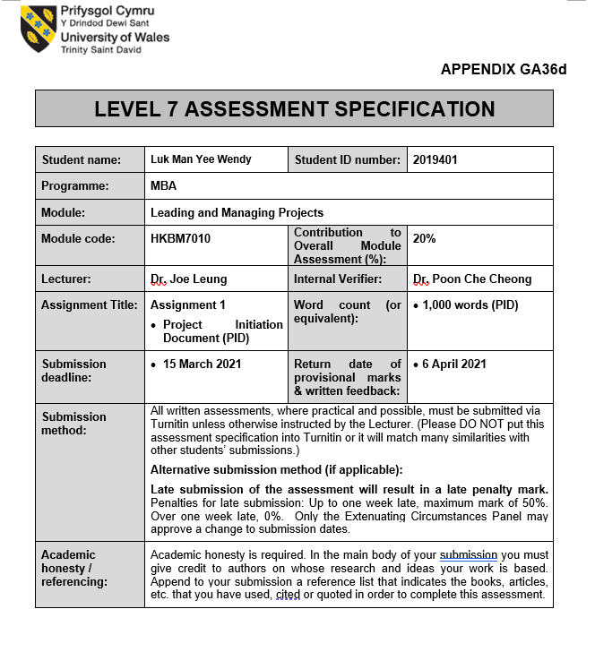

Background
Hung Fook Tong Holdings Ltd (HFT) is a chain of tea shops specializing in herbal tea, healthy food, and wellness drinks. The company was established since 1986 by the founders Tse Po Tat, Kwan Wang yung and Wong Pui Chu (Hung Fook Tong Holdings Ltd, 2015, p21). HFT was publicly listed in Hong Kong Stock Exchange since June 2014 with the stock code 1446 (Hung Fook Tong Holdings Ltd, 2015, p36). As of 31 December 2019, the company achieved of HKD 581.1 million and HKD 135 million for its retail and wholesale annual revenue respectively in Hong Kong. The main revenue contributor of HFT is derived from the retail business in Hong Kong which accounted for 74.9% of the Group revenue (Hung Fook Tong Holdings Ltd, 2015, p11).
Although HFT has achieved year-on-year revenue growth in the last five consecutive years, the success was mainly due to cost controls and product diversifications. Currently, HFT has wide range of products including homemade dishes, long shelf-life drinks, Chinese style soups, nourishing deluxe, dessert and tortoise herbal jellies (Hung Fook Tong, 2019). Besides these healthy products, the company also provide homemade snacks. Based on this varieties of products, it is recommended that HFT to focus on its core vision of “Naturally Made Wholeheartedly Good” to position itself in the wellness market industry (Hung Fook Tong Holdings Ltd, 2015, p5).

Project Aim and Objectives
The aim of this project is to propose suggestions to HFT to solidify its position in the wellness market industry. The impression of the company perceived by its customer group should be precisely positioned in the wellness market. To re-design the formula of the wellness drinks products by using low carbohydrates substitute the sugar ingredients while maintain the taste of the wellness drinks. This reformulation of healthy drink products can have a positive influence on public health. To extent the product line of Chinese style soups category by repackaging to pop canned soup. Pop canned soup has longer preserving at room temperature and greatly reduce the risk of breakage. It is ideal choice for contemporary lifestyle, where people can enjoy the convenience of having soups even when they are away from home. HFT has done well on product diversifications over the years. In February 2021, the company has launched two conceptual cafés in Hong Kong Island featuring handmade sandwiches and salad box in addition to its best-selling series of wellness drink products (Hung Fook Tong, 2021). It is suggested to expand the salad box products in the retail business for customer’s selection.

Project Deliverables
A project is successful when objectives are achieved to benefit the organization and met the expectations to the stakeholders. By implementing the project objectives, Hung Fook Tong can strengthen its leadership position in the wellness market and generate additional capital for the investors to secure long-term business growth. Alternatively, the success of the company has direct impact to the aspect of the employees. Increase employee motivation will lead to higher productivity and job security. Understand the needs and expectations for the customer group is crucial to HFT. Focus on providing diversified wellness solutions, customers will value the products and services that the company offer thus to increase customer satisfaction and the likelihood to retain customers.

Project Scope
This project is initiated for the purpose of solidifying the position for HFT in the wellness market through product diversification, improve customer orientation, and reformulation of the existing wellness drinks category. To extent the product line of the Chinese style soup series to pop canned soup, packaging materials will be sourced from steel can factory at the initial stage. The research and development team will evaluate the existing formula of the products can be fit to the new product design. To improve customer orientation, it is essential to investigate the trend of customers’ eating habits for salad products to determine the suitable locations for retail sales. Since the geographic restrictions of retail store may limit product varieties, it is vital to focus on market segmentation to target potential customers. Reformulation of the existing wellness drinks category will take longer time on research and development. In-depth analysis should be conducted to achieve the nutrient target and maintain the original taste.

Research Method and Information Sources
The research approach is based on secondary data collected from company annual reports, market research reports, and literature review. The company annual reports of HFT for the years 2015 to 2020 will be used to understand the financial performance of the retail and wholesale businesses in Hong Kong. Market research reports will be provided to analyze trends in the health and wellness market and the contemporary customers’ eating habits. The application of strategic model such as SWOT analysis, PESTEL analysis or BCG Matrix will be conducted to evaluate the findings and provide recommendations.
When implementing the project, a project team must be formed and lead by a project manager. A project manager is responsible for planning, organizing, executing, monitoring, and controlling throughout the entire process (Northeastern University Graduate Program, 2019). The project manager will assess what is the budget needed to execute the project and obtain the approval from the senior management team (PMTips, 2019). Other resources such as raw materials and packaging materials are to be outsourced from external suppliers. Quality standards and control measures should be established to ensure that all materials are suitable for their purpose. There are two stages of the project in which the extension of the product category and improve customer orientation target to complete within 6 to 9 months, whereas the reformulation of the wellness drink products targets to complete within 18 months.

Project Milestones
Below table is the key milestones of the project implementation suggested to HFT.
Key Milestones | Duration | Person in Charge
Project Kick-Off | 1 Day | Management Team
Project Team Formation | 1 Day | Project Manager
Budget Planning and Approval | 1 Month | Project Manager
Stage 1: Market Research and Analysis  Stage 2: Market Research and Analysis | 3 Months  9 Months | Research and Development Department, Project Manager
Stage 1: Sourcing Materials  Stage 2: Sourcing Materials | 1 Month  2 Month | Procurement Team
Stage 1: Quality Audit | 2 Weeks | Quality Control
Stage 1: Product release for trail run | 3 Months | Project Manager, Sales Department
Stage 2: Quality Audit | 2 Months | Quality Control
Stage 2: Product release for trail run | 3 Months | Project Manager, Sales Department

References

Aqua Green, (2020). Aqua Green LTD. Available at: https://www.aquagreenvalley.com/.
(Accessed: 10 March 2021).

BJ Bueno (2019). How to Create Strong Brand Positioning in Your Market – cultbranding.com. Cultbranding.com. Available at: https://cultbranding.com/ceo/create-strong-brand-positioning-strategy/.
(Accessed: 13 March 2021).

Dawar, N. and Bagga, C. (2015). A Better Way to Map Brand Strategy. Harvard Business Review. Available at: https://hbr.org/2015/06/a-better-way-to-map-brand-strategy. (Accessed: 13 March 2021).

Hung Fook Tong Group Holdings Limited. (2015) Annual Report 2015. Available at: https://www.hungfooktongholdings.com/html/ir_report.php (Accessed: 4 March 2021).

Hung Fook Tong Group Holdings Limited. (2016) Annual Report 2016. Available at: https://www.hungfooktongholdings.com/html/ir_report.php (Accessed: 4 March 2021).

Hung Fook Tong Group Holdings Limited. (2017) Annual Report 2017. Available at: https://www.hungfooktongholdings.com/html/ir_report.php (Accessed: 4 March 2021).

‌Hung Fook Tong Group Holdings Limited. (2018) Annual Report 2018. Available at: https://www.hungfooktongholdings.com/html/ir_report.php (Accessed: 4 March 2021).

Hung Fook Tong Group Holdings Limited. (2019) Annual Report 2019. Available at: https://www.hungfooktongholdings.com/html/ir_report.php (Accessed: 4 March 2021).

Hung Fook Tong Group Holdings Limited. (2020) Interim Report 2020. Available at: https://www.hungfooktongholdings.com/html/ir_report.php (Accessed: 4 March 2021).

Hung Fook Tong. (2021) ‘HFT Life’, HFT, 8th February. Available at: https://media-hungfooktong.todayir.com/202102241712191797972371_tc.pdf (Accessed: 5 March 2021).

Hung Fook Tong 鴻福堂網站. (2019). Product Details. Available at: https://www.hungfooktong.com/en/shop/ (Accessed: 4 March 2021).

Northeastern University Graduate Programs. (2019). What Does a Project Manager Do? Available at: https://www.northeastern.edu/graduate/blog/project-manager-responsibilities/#:~:text=In%20the%20broadest%20sense%2C%20project. (Accessed: 10 March 2021).

PMTips (2019). 3 Types of Essential Resources For Your Project. PM Tips. Available at: https://pmtips.net/article/3-types-of-essential-resources-for-your-project. (Accessed: 10 March 2021).

Welltodo. (2018). The Hong Kong Report: Wellness Trends, Growth and Market Opportunities. Available at: https://www.welltodoglobal.com/the-hong-kong-report-wellness-trends-growth-and-market-opportunities/ (Accessed 12 Mar. 2021).

Zachritz, M. (2020). Why The Resources You Choose for a Project Will Impact Its Success. Journyx | Premier Time Tracking and Resource Management Software for Projects, Billing, and Payroll. Available at: https://journyx.com/the-types-of-resources-you-choose-for-your-project-matter-for-its-success. (Accessed: 11 March 2021).

