Tena Brooke
1918218

Racial and ethnic differences in trends in dementia prevalence and risk factors in the United Kingdom.

Table of Contents
Chapter 1 2
Introducing the problem: 2
What is the rational for this topic? 3
Chapter 2: 4
Methodology 4
What are methods? 4
What is qualitative? 4
What is quantitative? 5
What are mixed methods? 5
What is a search strategy? 6
What is CASP? 6
Chapter 3: 7
Literature Review 7
What ethnic and racial groups are affected by dementia? 7
What are the risk factors of having a lack of prevalence? 9
Why is there a prevalence between this ethnic and racial group? 10
How have the trends in prevalence changed over the years? 11
Chapter 4: 13
Conclusion and recommendation 13
References 15

Chapter 1

Introducing the problem:
Dementia is derived from the Latin word demens, which means "out of one's mind." Although the term "dementia" has been around since the 13th century, it was only in the 18th century that it was first mentioned in the medical community (Assal, 2019). The National Institute on Aging (2021) defines dementia as a loss of cognitive functioning, reasoning, memorising, and thinking that interferes with a person's daily life and activities. Dementia sufferers can lose control of their emotions, intellect and personalities functioning as a result. Individuals often lose control of their motor activities and ability to plan (UCLA Health, 2015). Dementia is often used as an umbrella term and can be divided into five different categories. These are Alzheimer's disease (the most common type of dementia among the elderly). It is caused by changes in the brain, including as abnormal protein build-ups known as amyloid plaques and tau tangles (National Institute on Aging, 2021).

The causes of dementia have increased in the UK. Dementia was estimated to impact 800,00 people in the United Kingdom in 2014, according to Alzeheimer's Res*earch (2014), and this number is expected to rise in the future decades. Dementia has become a problem for ethnic groups, particularly African Americans and other minorities (BME). According to the Social Care Institute for Excellence (n.d), this is due to lack of awareness of vascular risk factors such as hypertension, diabetic, hypertension, and cardiovascular disease, which are frequent in African-Caribbean and South Asian UK populations. Even after controlling for modifiable risk factors like smoking, weight, and vascular health, the Lancet Regional Health Europe (2022) found that 1 in 10 cases of dementia were linked to ethnicity, and a similar number to socioeconomic deprivation. Similarly, The National Institute for Health Research (2020) believes that persons of colour are more prone to get dementia than White British people. When compared to the White British population (2%) of people diagnosed with dementia at a young age (under 65 years), minority ethnic communities (6%) had a higher proportion of those diagnosed with young onset dementia (under 65 years) (Knapp et al, 2007).

What is the rational for this topic?
As stated in the Prime Minister's challenge, dementia is a key government priority for research in the United Kingdom (Department of Health, 2012). Within the United Kingdom, there is an underlying issue of "lack of predominance among ethnic groups," such as Asian, Black, and minority communities (National Institute for Health, 2020). By focusing on and educating BME communities, the frequency of age-related disorders such as dementia will rise, perhaps posing significant problems for families and health and social care providers.

The aim of the study is to explore the following research question:
- What ethnic and racial groups are affected by dementia?
- What are the risk factors of having a lack of prevalence?
- Why is there a prevalence between this ethnic and racial group?
- How have the trends in prevalence changed over the years?

A literature review's objective is to illustrate and critically assess concepts, facts, and material relevant to the research subject (Hart, 2018). The study should highlight any gaps in the present literature and validate the need for more research to address and improve results (Hart, 2018). The purpose of this literature review is to investigate and comprehend the background or culture underlying the absence of dementia prevalence among BME people in the UK. Because this was an under-researched topic until recently, I will analyse prior and current literature on the subject. As a result, the goal of this study is to investigate the under-researched topic of low prevalence in BME to offer new ideas for increasing prevalence in this ethnic group.

Chapter 2:

Methodology

What are methods?
The tactics, procedures, or techniques used in the collecting of data or evidence for analysis to uncover new knowledge or get a better understanding of a topic are known as research methods. There are several sorts of research procedures that employ various data gathering tools (University of Newcastle, 2022).

What is qualitative?
According to Byrne (2001), qualitative research is important because it addresses "how" and "why" research questions and provides a better understanding of perceptions, phenomena, and context. Denzin and Lincoln (2005, p.2) states that qualitative research entails the systematic use and collection of a wide range of empirical materials, including case studies, personal experiences, introspective, life stories, interviews, observational, historical, interactional, and visual texts, to describe routine and problematic moments and meanings in people's lives. Qualitative research enables the researcher to identify difficulties from the perspective of study participants, as well as to comprehend the meaning and meanings that individuals place on behaviour, events, and objects. This is relevant for this study as it offers t a better understanding of their condition or handicap, their use of health services, or their social cultural norms. (Hutter et al.,2020). Empiricism is a philosophical approach based on the belief that all knowledge is gained by experience and that the mind is a "blank slate." Normally, when we interact with the environment through our five senses, we fill the page with thoughts derived from our experiences (Adhikari, 2019).

What is quantitative?
Quantitative research techniques require quantifying and analysing variables to acquire results. It is the use of specialised statistical approaches to numerical data to answer questions like who, how much, what, where when, and how many (Apuke, 2017). Furthermore, quantitative research comprises gathering data to quantify information and subject it to statistical analysis to support or refute competing knowledge statements (Leedy and Ormrod 2001; Williams, 2011)

What are mixed methods?
Teddie and Tashakkori (2003) defined mixed methods research as the third methodological trend. According to Gorard and Taylor (2004), the third alternative is 'mixed approaches,' which blends quantitative and qualitative methodologies. Mixed methods emerged as an explicit approach as an alternative to the dichotomy of qualitative and quantitative traditions in the later part of the twentieth century. According to the journal of Mixed Methods Research, mixed methodologies research is "research in which an investigator gathers, analyses, integrates, and draws inferences using both qualitative and quantitative techniques and methods in a single study or programme of inquiry" (Tashakkori and Creswell, 2007b, p.4). Mixed methods research studies statistical and thematic data techniques to enhance pragmatism. Mixed methods research studies statistical and thematic data techniques to enhance pragmatism. This is crucial for my research since the literature evaluated in this study examines a concept from several methods, making the findings more "practical" in terms of total outcomes and effect.

What is a search strategy?
A systematic review will be built around a well-constructed search strategy, which will be reported on in the methods sections of a study. The search approach will show most of the research and evaluate the eligibility to determine whether it should have an inclusion in your study. The objects that may have been missed depends on the quality of the search method (University of Michigan Library, 2022). Similarly, Pham et al., (2019) point out that a systematic search works best when the research or clinical question is well-defined and precise. Questions that are too wide or imprecise can't be addressed in a systematic fashion, and the outcome is usually an overwhelming quantity of search results. A question that is overly precise, on the other hand, can provide too few or even no search results (appendix, figure 1).

What is CASP?
In health-related qualitative evidence research, the Critical Evaluation Skills Programme (CASP) instrument is the most often utilised tool for quality appraisal. It's a general tool for evaluating the advantages and disadvantages of any qualitative research approach (appendix, figure 2). The tool asks the researcher to think on whether the study techniques were suitable and if the findings were well-presented and relevant (Critical Appraisal Skills Programme, 2018).

Chapter 3:

Literature Review

What ethnic and racial groups are affected by dementia?

According to Flier and Scheltens (2005), prevalence is defined as the proportion of a population who has illness at a given period. Dementia identification is a public health concern, according to the National Institute for Health (2018), particularly among ethnic minorities. It's crucial to figure out how to raise prevalence since there may be disparities in diagnosis and treatment.

The idea of race and culture is embodied by sensitivity and ambiguity Khan et al., 2015, p.12). As a result, there must be an awareness of the phrases since, as the English language evolves and changes, the terms we use to designate "ethnicity or ethnic group" can be naive and discriminatory. Demography, political science, sociology, history, geography, ethnology, and psychology are all classified as "ethnic group" (EG) or "ethnicity" (Katarzyna et al., 2018). As a result, an 'ethnic group' might be built on an individual's identity, interests, and choices. Our ethnicity and culture have an impact on who we are, how the rest of the world sees us, and how we act as a result (Khan et al., 2015, p.10). In this study, the terms 'BME' and 'BAME,' which stand for 'Black, minority ethnicity' or 'Black and Asian ethnicity minority,' will be used to designate groups that are in the minority in terms of numbers and ethnicity.

According to UK census categories, ethnicity was determined by self-report: English, Welsh, Scottish, Northern Irish, British, Irish, Gypsy or Irish Traveller, and any other White heritage; Other (any other stated ethnicity including mixed ethnicities); Black (including African, Caribbean, and any other Black, African, or Caribbean background); South Asian (including Indian, Pakistani, and Bangladeshi); and Unknown.

Individuals from the black ethnic group have a greater rate of dementia diagnosis, while those from the Asian ethnic group have a lower incidence than those from the white ethnic group, according to Pam et al., (2018). According to the study, black males are less likely than white men to be diagnosed with dementia, implying that the greater risk of dementia diagnosis recorded in the black ethnic group may understate the higher risk of dementia in this group. Rates amongst dementia and Asians are parallel to that of Whites. Dr Cooper identifies that “Perhaps British Asians do have a lower risk, or they may only be less likely to be diagnosed when they develop it” (UCL, 2018).

Khan et al., (2015) outlines that the growth of BME individuals from Europe and elsewhere in the world. Ethnic minority groups make up over 14% of the total UK population, many of whom are South Asian (Pakistan, India, and Bangladesh) (Blakemore et al.,2018). It is estimated that there are over 25 000 people from ethnic minority groups living with dementia in the UK (Mukadam, 2011). Dementia diagnosis rates may also differ among ethnic groups because of differences in the likelihood of people living with dementia receiving a diagnosis (Pham, 2018). The article criticises the lack of evidence relating to dementia diagnosis in the UK and instead highlights evidence relating to the prevalence of BME diagnosis. Despite the lack of evidence, the outcome is the same. There is a lack of diagnosis due to low levels of literacy, language barriers and a lack of appropriately translated and culturally adapted screening and diagnostic tools for this ethnic group and the low levels of awareness and stigma surrounding dementia make it more difficult for people to get the support they need. A similar idea is expressed by Khan et al., (2015, p.28) states that language barriers would make it difficult for individuals to communicate their needs to health professionals, which in turn poses an issue for correct care and diagnosis. UCLA (2018) insinuates that this is similar for verbal expression and word finding. In one culture the speed of communication might naturally be fast and not seem an issue for health professionals, whereas in another culture the speed of communication might be slower and identified as a risk but is the natural speed for speaking. Hence, this results in delays in diagnosis and accessing services are significant risks (House of Commons All-Party Parliamentary Group on Dementia, 2013).

What are the risk factors of having a lack of prevalence?

A 'risk factor,' according to the Alzheimer's Society (2021), is something that is known to raise a person's chances of having the disease.

The most prominent risk factor associated with a lack of prevalence is high death rates among BME people. Dementia and Alzheimer's disease accounted for 66,424 (12.5 percent) of all deaths in England and Wales in 2019, according to the Office for National Statistics (2019). Dementia diagnosis is influenced by age, and the age at which dementia is diagnosed differs by ethnicity (Khan et al., 2015). According to UCLA Health, persons of colour are more affected by early death (morality) than whites (2018).

This approach has been approved by the Office for National Statistics (2019). According to the evidence, in England and Wales in 2019, the White ethnic group had the highest age-standardised mortality rate (ASMR), with 718.3 deaths per 100,000 people. The White ethnic group had the highest number and proportion of deaths, with 47,093 deaths and 97.1 percent of deaths owing to this cause. The mortality rate for all other ethnic groups was less than 0.8 percent of all deaths. Due to a paucity of data, Black Africans had the lowest ASMR of any ethnic group (302.8 fatalities per 100,000 persons) (Kingsfund, 2021).

Flier and Scheltens (2005) point out that age is the most important risk factor for dementia in their article. Dementia was more common in women than in men, and it roughly doubled with every five years of age: 0.8 percent in the 65–69-year group and 28.5 percent in the 90+ year group. With this article, there are two big flaws. The first is that it refers to the general population rather than focused on BMEs, and the second is because the article is out of date.

Flier and Scheltens (2005), dementia can affect anyone under the age of 65, even though age is the most important risk factor. On the prevalence of dementia among younger persons, there are little statistics. A similar idea is expressed by Alzheimer’s society (2021), the article states dementia affects around 2 out of every 100 adults aged 65 to 69. As a person gets older, their risk increases, almost doubling every five years. This indicates that about 33 out of every 100 adults over the age of 90 suffer from dementia.

Why is there a prevalence between this ethnic and racial group?

Lebron (2013) describes culture as a social group's distinct feature; its members' shared values and conventions distinguish it from other social groups, and it is impacted by conscious beliefs.

Dementia is seen as abnormal and strange in different cultures. Several theories claim that cultural norms and family traditions have a significant role in how indigenous dementia patients are cared for. According to Connell and Gibson (1997), dementia is stigmatised in various cultures and should be kept concealed and discussed only within and beyond the family home. Family obligations, collective family support, and mental health perspective all play a role in the recognition of the dementing process and subsequent care (Braun & Browne, 1998 and Connell and Gibson,1997). Another important factor is the fear of being misunderstood or intimidated if individuals employ outside services or seek professional aid, as well as a lack of confidence in health care personnel (Kelacher et al.,1998; Morgan et al., 2015). Furthermore, it is a widely held belief that mental deterioration is an unavoidable part of ageing. It has been allowed as non-confrontational behaviour because of this worldview. When people are diagnosed with dementia in the early stages, they and their careers are typically hesitant to seek treatment since dementia is still associated with impaired capacity, worsen mental health, and loss of independence (Herrmann et al., 2018).

How have the trends in prevalence changed over the years?

Incidence is defined as the number of people who develop a specific disease or have a specific health-related incident within a given (The School of Public Health, 2022).

The research by Wolters et al.,(2020) examines the trends in dementia incidence between 1988 and 2015. The paper finds that the rate of dementia incidence has decreased by 13% every calendar decade. Both Flier and Scheltens (2005) and Wolters et al., (2020) contend that dementia incidence rates rose with age, similarly for women and men, ranging from roughly 4 per 1,000 person-years in those aged 65–69 years to 65 per 1,000 person-years in those aged 85–89 years.

However, the most effective study is used by Matthews et al., (2017) to develop a method for determining time trends in dementia incidence that is based on continuous monitoring of a specified and representative population utilising a standard strategy for case identification. They created IMPACT-BAM, which focuses on health states and the populations they influence, to produce reliable forecasts for dementia prevalence until 2040. The number of persons with dementia in England and Wales is expected to rise from 2016 to 871 700 (835 600 to 906 600) in 2020, according to projections on anticipated dementia prevalence up to 2040, assuming a 2.7 percent relative yearly drop in dementia incidence.

Overtime prevalence has increased due to more dementia awareness being reported but the number of dementia incidence will increase particularly with tends for age, but analysis of ethnic groups is not mentioned in the studies by Wolters et al., (2020) and Matthews et al., (2017).

Chapter 4:

Conclusion and recommendation
According to the National Institute for Excellence (Nice), around 460,000 individuals in England have dementia, with an additional 200,000 people thought to remain undiagnosed (Nice, 2020). To summarise, the frequency of dementia in the UK population is constantly rising. Dementia is more frequent in women and BME individuals, as stated by various literature studies. Age plays a role in dementia, but not exclusively, because ageing is inevitable. Improved dementia prevalence in groups, as well as increased education, are both protective against dementia (Public Health, 2015). According to Sea Brook and Milne (2009), promoting dementia awareness is the first step toward increasing incidence among ethnic minority groups in the UK. The recommendations put forward for BME individuals would be effective for the public.

Lester (1999) claims that phenomenology comprises multiple processes, including collecting "deep" information and opinions through reflexive, qualitative methods such as interviews, observations, and discussions with persons, according to the literature studies assessed. Even yet, there are several drawbacks to using an empirical phenomenological investigation. The use of acceptable techniques such as interviews has been noted as a risk since the depth of information gathered may be limited owing to time restrictions and the willingness of the participants (Lester,1999). The inclusion of quantitative data in the studies is crucial because it enables researchers to gain a better/ more accurate picture of the number of people in the UK who are afflicted by dementia, as well as providing statistics and projections for the future. The most effective research used a "mixed approaches" strategy.

Prince et al., (2016) expresses an essential viewpoint, stating that policymakers should plan future service supply based on current prevalence forecasts presented in various research. Investing in brain health promotion and dementia prevention initiatives, as well as tracking the epidemic's future path to see how successful these efforts are, should be added to the list of priorities. This might be accomplished in a variety of methods, including community building, coffee mornings with expert information that is shared, and an improve the quality of teaching in BME communities on dementia. Furthermore, trust must be created between general practitioners (GPs) and patients for therapeutic interactions to be effective (Croker et al., 2013).

References
Ahmadi-Abhari S, Guzman-Castillo M , Bandosz P, Shipley M J, Muniz-Terrera G, Singh-Manoux A (2017)Temporal trend in dementia incidence since 2002 and projections for prevalence in England and Wales to 2040: modelling study BMJ; 358

All- Party Parliamentary Group (2013) Dementia does not discriminate. Available at: https://www.alzheimers.org.uk/sites/default/files/migrate/downloads/appg_2013_bame_report.pdf (Accessed: 12 March 2022).

Alzheimer’s Society (2020). The Progression and Stages of Dementia. Available at: https://www.alzheimers.org.uk/sites/default/files/pdf/factsheet_the_progression_of_alzheimers_disease_and_other_dementias.pdf (Accessed: 10 March 2022)

Alzheimer’s Society (2021) Risk factors for dementia. Available at: https://www.alzheimers.org.uk/sites/default/files/pdf/factsheet_risk_factors_for_dementia.pdf(Accessed: 27 March 2021).

Apuke, Oberiri. (2017). Quantitative Research Methods : A Synopsis Approach. Arabian Journal of Business and Management Review (kuwait Chapter).. 6. 40-47. 10.12816/0040336.

Assal F. (2019). History of Dementia. Frontiers of neurology and neuroscience, 44, 118–126.

Blakemore, A., Kenning, C., Mirza, N., Daker-White, G., Panagioti, M., & Waheed, W. (2018). Dementia in UK South Asians: a scoping review of the literature. BMJ open, 8(4).

Braun, K.L and Browne C.V. (1998). Perceptions and of Dementia, Caregiving, and Help Seeking among Asian and Pacific Islander Americans. Health & Social Care Vol. 23 (4).

Connell, C and Gibson, G (1997) Racial, Ethnic, and Cultural Differences in Dementia Caregiving: Review and Analysis, The Gerontologist, (37), 3, p.355–364.

Critical Appraisal Skills Programme (2018). CASP (Qualitative) Checklist. Available at: https://casp-uk.net/wp-content/uploads/2018/01/CASP-Qualitative-Checklist-2018.pdf. (Accessed: 12 March 2022).

Dementia, U.K. (2007). A report to the Alzheimer’s Society on the prevalence and economic cost of dementia in the UK. Kings College London and the London School of Economics.

Denzin, K and Lincoln, S (2005) Introduction. The discipline and practice of qualitative research. In: Denzin NK, Lincoln YS, editors. The Sage handbook of qualitative research. Thousand Oaks: SAGE Publications; 2005 pp. 1–32

Department of Health (2015). Prime Minister’s Challenge on Dementia – Delivering Major Improvements in Dementia Care and Research, London: Department of Health; 2012.

Escudero, S. L. Z., Khan, O., Moriarty, J., Shah, A. (2015). Dementia, Culture and Ethnicity: Issues for All. United Kingdom: Jessica Kingsley Publishers.
Croker, E, Swancutt, R and Roberts, R (2013). Factors affecting patients’ trust and confidence in GPs: evidence from the English national GP patient survey BMJ Open.

Gorard, S., & Taylor, C. (2004). Combining methods in educational and social research. McGraw-Hill Education (UK).

Hart, C. (2018). Doing a Literature Review: Releasing the Research Imagination. India: SAGE Publications.

Herrmann et al (2018). A Systematic Review of Dementia-related Stigma Research: Can we move the dial? Am J Geriatr Psychiatry (26), 3.

Hutter, I., Bailey, A., Hennink, M. (2020). Qualitative Research Methods. United Kingdom: SAGE Publications.

Lebron, A. (2013) 'What is Culture?’, Merit Research Journal of Education and Review Vol. 1(6) pp. 126-13.

Leedy P.D. & Ormrod J.E. (2010) Practical Research: Planning and Design. (9th ed). Pearson Educational International

Lester, S. (1999) An introduction to phenomenological research. Available at: https://www.rgs.org/CMSPages/GetFile.aspx?nodeguid=7ad9b8d4-6a93-4269-94d2-585983364b51&lang=en-GB (Accessed 9th March 2022).

Matthews, F. E., Stephan, B. C., Robinson, L., Jagger, C., Barnes, L. E., Arthur, A., Brayne, C. (2016). ‘Cognitive Function and Ageing Studies (CFAS) Collaboration.’ A two decade dementia incidence comparison from the Cognitive Function and Ageing Studies I and II. Nature communications, 7, 11398.

Mukadam N, Cooper C, Livingston G. (2011). A systematic review of ethnicity and pathways to care in dementia. Int J Geriatr Psychiatry 26, p.12–20.

National Institute of Excellence (2020) NICE Impact dementia. Available at: https://www.nice.org.uk/Media/Default/About/what-we-do/Into-practice/measuring-uptake/dementia-impact-report/nice-impact-dementia.pdf(Accessed: 12 March 2022).

National Institute On Aging (2021).The Basics of Alzheimer disease and Dementia Available at: https://www.nia.nih.gov/health/what-is-dementia#:~:text=Dementia%20is%20the%20loss%20of,and%20their%20personalities%20may%20change.(Accessed: 10 March 2022)

Office for National Statistics (2020) Dementia and Alzheimer's disease deaths including comorbidities, England and Wales: 2019 registrations. Available at: https://www.ons.gov.uk/peoplepopulationandcommunity/birthsdeathsandmarriages/deaths/bulletins/dementiaandalzheimersdiseasedeathsincludingcomorbiditiesenglandandwales/2019registrations(Accessed: 12 March 2022).

Pham, T. M., Carpenter, J. R., Morris, T. P., Sharma, M., & Petersen, I. (2019). Ethnic Differences in the Prevalence of Type 2 Diabetes Diagnoses in the UK: Cross-Sectional Analysis of the Health Improvement Network Primary Care Database. Clinical epidemiology, 11, 1081–1088.

Pham, T., Petersen, I., Walters, K., Raine, R., Manthorpe, J., Mukadam, N and Cooper, C. (2018) ' Trends in dementia diagnosis rates in UK ethnic groups: analysis of UK primary care data', Clinical Epidemiology, pp. 949-960.

Prince, M., Ali, G. C., Guerchet, M., Prina, A. M., Albanese, E., & Wu, Y. T. (2016). Recent global trends in the prevalence and incidence of dementia, and survival with dementia. Alzheimer's research & therapy, 8(1), 23.

Prince, M., Knapp, M., Guerchet, M., McCrone, P., Prina, M., Comas-Herrera, A., Wittenberg, R., Adelaja, B., Hu, B., King, D., Rehill, A., & Salimkumar, D. (2014). Dementia UK: Second Edition - Overview. Alzheimer's Society.

Public Health England (2015) Prevalence of dementia in population groups by protected characteristics A systematic review of the literature. Available at: https://assets.publishing.service.gov.uk/government/uploads/system/uploads/attachment_data/file/465274/Dementia_Equalities_Literature_Review_Matrix_Report_-_Final_for_web_-_01102015.pdf (Accessed: 12 March 2022).

School Of Public Health (2022) Obesity Prevention Source. Available at: https://www.hsph.harvard.edu/obesity-prevention-source/prevalence-incidence/ (Accessed: 12 March 2022).

Seabrooke, V., & Milne, A. (2009). Early intervention in dementia care in an Asian community: Lessons from a dementia collaborative project. Quality In Ageing, 10(4), 29-36.

Shah, A., Khan, O., Escudero, S. L. Z., Moriarty, J. (2015). Dementia, Culture and Ethnicity: Issues for All. United Kingdom: Jessica Kingsley Publishers.

Social Care Institution for Excellence (2020). Black and minority ethnic (BME) communities and dementia. Available at: https://www.scie.org.uk/dementia/living-with dementia/bme/#:~:text=More%20than%2025%2C000%20older%20black,and%20South%20Asian%20UK%20populations.(Accessed: 4 March 2022)

Tashakkori, A., & Creswell, J. W. (2007). The new era of mixed methods. Journal of mixed methods research, 1(1), 3-7.

UCL (2018) Likelihood of dementia higher among black ethnic groups. Available at: https://www.ucl.ac.uk/news/2018/aug/likelihood-dementia-higher-among-black-ethnic-groups.(Accessed: 12 March 2022).

UCLA (2015) Dementia: Special Issues Related to Ethnic & Racial Minorities. Available at: https://www.youtube.com/watch?v=id4GsfxLq-Y.(Accessed: 12 March 2022).
University of Michigan Library (2022). Systematic Review. Available at: https://guides.lib.umich.edu/c.php?g=283340&p=2126706 (Accessed: 12 March 2022).

University of Newcastle Library Guides (2019) Research Methods: What are research methods? Available at: https://libguides.newcastle.edu.au/researchmethods(Accessed: 12 March 2022).

Wolters, F., Chibnik, L., Waziry,R., Anderson,R., Berr, C., Beiser, Bis,J., Blacker, DanielBos, D., Brayne, C., Dartigues, J., Sirwan K.L. Darweesh,. K, Davis-Plourde., Wolf, K., Debette, S., CaroleDufouil,. Fornage, F., Goudsmit, J., Grasset,L., VilmundurGudnason, Hadjichrysanthou, C., Helmer, C., M. Ikram, A., Ikram, M., Joas, E., Kern, S., H.Kuller, L., Launer, L., Lopez, O., Fiona E. Matthews, McKee, K., Meirelles, O., Mosley, T., Pase, M., M. Psaty, Claudia, B., L. Satizabal, Sudha Seshadri, IngmarSkoog, Stephan,B., Hanna Wetterberg.,Wong, MM., Zettergren, A., Hofman, A. (2020) Twenty-seven-year time trends in dementia incidence in Europe and the United States

Thesis Search Sheet:

My research question: |  | Racial and ethnic difference in trends in dementia prevalence and risks factors in the United Kingdom.
Places to search for information: |  | The University Library online  The library  Google
Date | Database / Search Engine Name |  | Search Terms | No of Results | Links to: title, aim, objective number? | Your Comments or notes
12.3.22 | Search publication on university online library |  | What is dementia | 3 | Links to title and aim and objectives | Journal articles defining dementia and the different types. When put into google, more results with similar idea that was presented in journal articles.
12.3.22 | Search publication on university online library |  | Define BME/ BAME | 4 | Links to title and aim and objectives | Proves umbrella meaning for BAME, identifies the limitation of using the phrase.
12.3.22 | Library category online |  | Dementia | 55 | Links to title and aim and objectives | Defines dementia  Does not identify how it effects ethnic groups.
16.3.22 | Google |  | What does prevalence mean? | About 2,780,000,000 results | Links to title and aim and objectives | Produced more results than expected, had to tunnel through to find appropriate (credited) result for study
19.3.22 | Google |  | What is the difference between prevalence of BME and white | About 8 results | Links to title and aim and objectives | The articles and Journal were trustworthy from government and National institute for excellence.
24.3.22 | Google |  | What ethnic and racial groups affected by dementia in UK journal article | 3,900,000  results | Links to title and aim and objectives | Most results were from the United Sates, difficult to find results from UK
24.3.22 | Google |  | Higher death rates for BME due to lack of prevalence with dementia | 317,000 results | Links to title and aim and objectives
25.3.22 | Google |  | What are the culture expectations relating to dementia? |  | Links to title and aim and objectives

Appendix 2:

2a: This highlights the use of quantitative data in the study. However, the CASP tool used focused on qualitative data. Some sections have been omitted as they were not relevant.

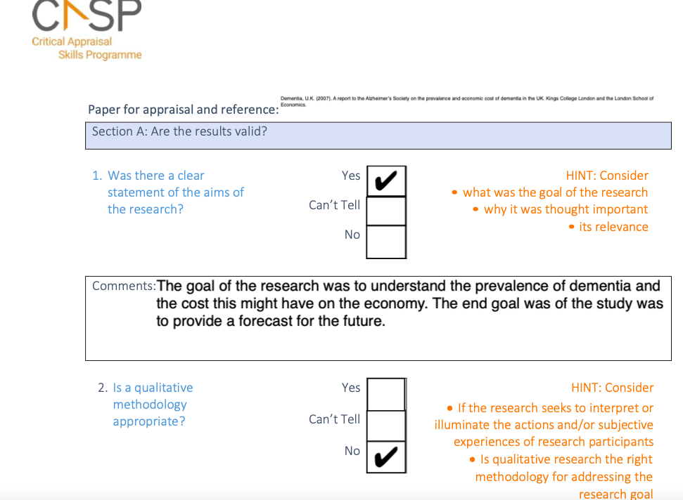

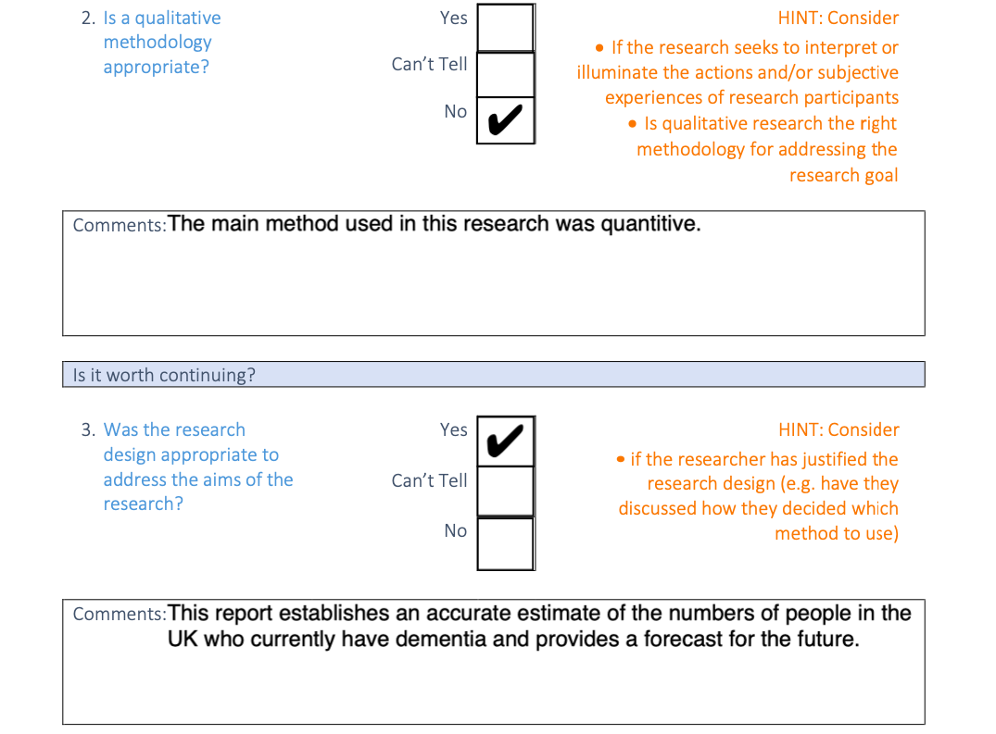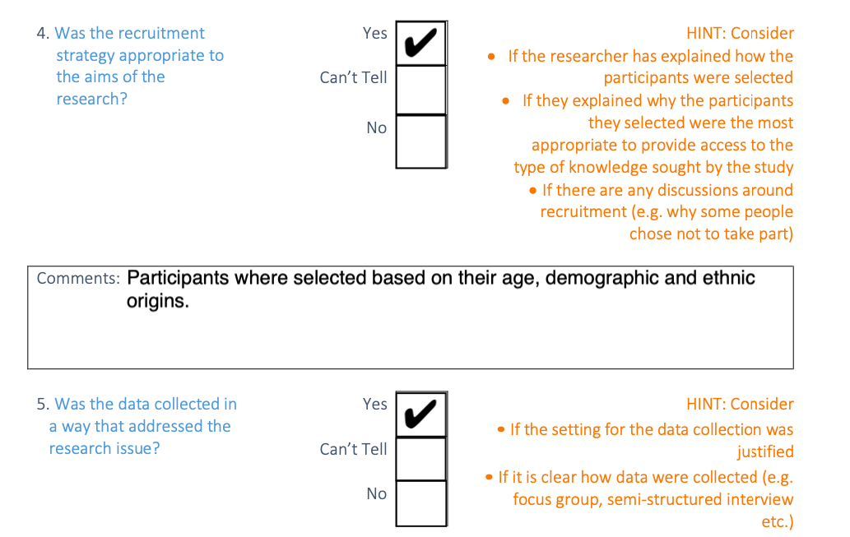

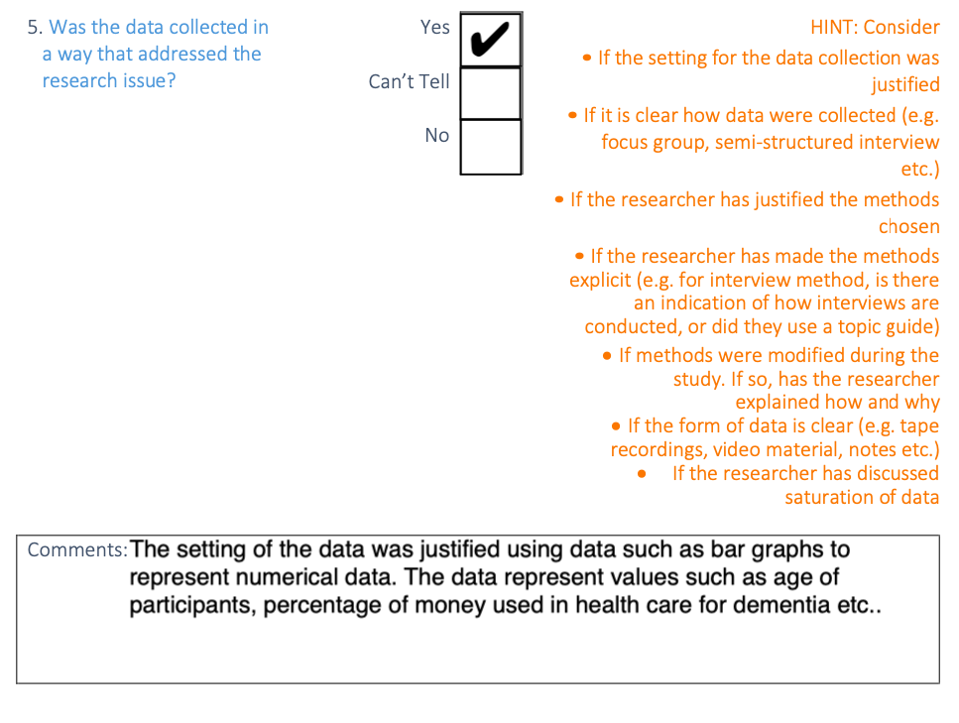

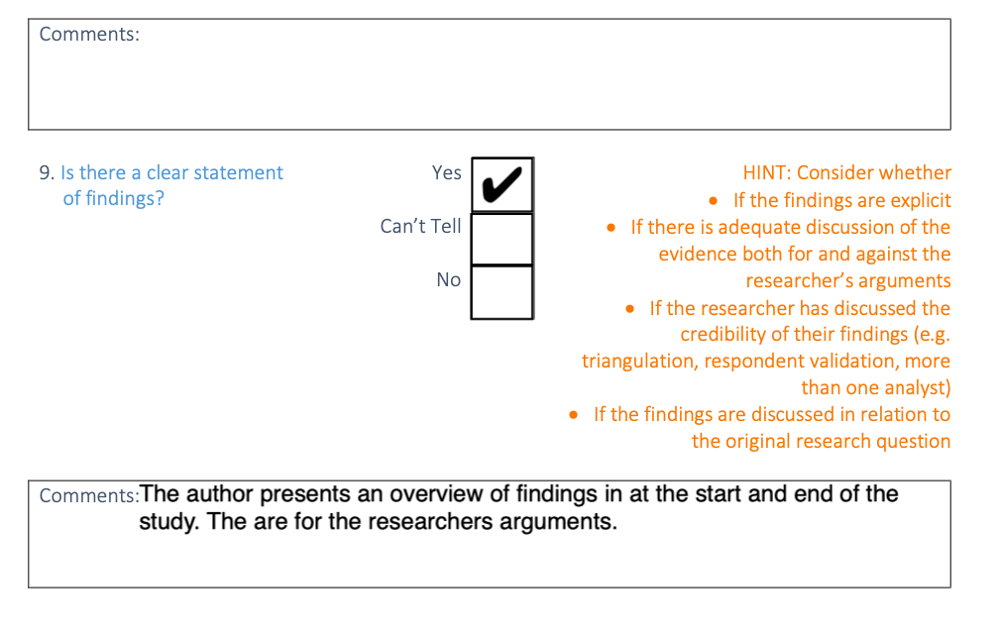

2b: This was the only relevant response for this qualitative study. The study had a variety of limitations. Such as lack of ethical approval. There was no justification on the reasoning for using a questionnaire to seek the information and it is not clear about the relevance of the data for future references.

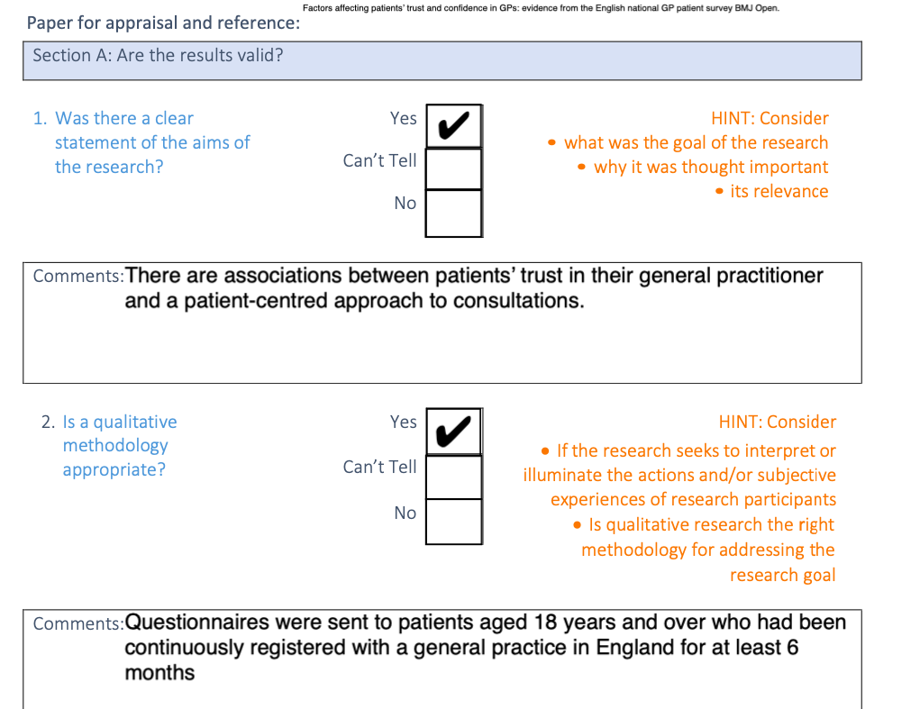

2C:



