Component 2 - Research Report
Student Name: NICOLETA BUSU
Student Number: 2025237
Lecturer Name: DR OLUWASEUN
BMSW4003_BIRM
Digital Skills and Research Methods.

Contents:
1. Introduction 3
2. Research design 3
2.1. Research Question 3
2.2. Method 4
2.3. Ethical Considerations 5
3. Results 5
4. Discussion 8
5. Conclusion 9
6. Reference List 10
7. Appendix A – A blank copy questionnaire. 10

Introduction
Digital technologies have transformed how students engage in interactive learning and study sessions. With the advent of modern technology, the availability of these digital technologies has become widespread. Students can effectively access these digital technologies to communicate, document and share their learning with their instructors and colleagues. In this research project, the author will contemplate some of the most widely used digital technologies students use at UWTSD. Microsoft Office, Microsoft Teams, OneDrive, Google Drive, WhatsApp, and Facebook, are some of the most prominent art forms of digital technologies that again provide significant assistance to university students in their studies. In this research project, the researcher will evaluate the effectiveness and adaptability of these technologies through a series of questions modelled as a survey. The report will outline the key research question and the vital goals and objectives of the research. Then the research paper will also highlight the critical methodological approach implemented in this research project. The researcher will also outline and reflect on the necessary ethical considerations to be maintained throughout the research project. Finally, thorough analyses and discussions of the findings will be conducted through the survey questionnaire.

Research design

Research Question
The key research question of the research project is:
What is the most effective state of digital technology used by the students at UWTSD?
Students at the university level are required to demonstrate a certain degree of competency and adaptability with different types of digital technologies, including Microsoft Word, Microsoft PowerPoint, Microsoft Access, Microsoft Excel, Outlook, OneDrive, Google Drive, Google docs, Google sheet, Microsoft teams, WhatsApp and many more. The research question is therefore dedicated to evaluating the most effective form of digital technology for the students at UWTSD. It is generally hypothesised that students at the graduate level must have a decent amount of competency in the application from Microsoft Office that including Microsoft Word, Microsoft Excel, Microsoft PowerPoint, Microsoft Teams and OneDrive. In this particular research project, the author will also include some other technologies that can help and assist the students in reaching out to their instructors and colleagues via communication platforms.

Method
Research philosophy can be identified as a belief through which a researcher explains how the data and information about a particular phenomenon should be collected, analysed and implemented. There are two dimensions of research philosophy in a specific research methodological approach. They are epistemology and doxology (Dul and Hak, 2007). Epistemology refers to what is mainly known to be accurate; on the other hand, doxology refers to what is generally believed to be accurate. And for this particular research project, the researcher will take a positivist philosophical approach. It generally follows the factual knowledge view, which is only gained through observation that includes reliable measurements. The role of the researcher will be limited to the collection of the data and interpretation of the result.
There are difficulty two types of the research approach. The first is an inductive approach, in which the reasoning from the researcher ships from specific observations made on several variables towards a generalised idea. The researcher will adopt a detective research approach by collecting data to test the current hypothesis in this research project. However, detective research takes the opposite direction, starting with a theory by trying different statistical analyses and comments on the theoretical concept. However, there are also many limitations of the deductive method. The conclusions made under deductive reasoning are only applicable should the premises of the inductive study are accurate and the terms are established (Wilson, 2014).
There are typically two types of research methods. The first is a qualitative research method, in which data collection and analysis are based on words and meanings (Cavana et al., 2001). Data collected from interviews, ethnography, literature reviews and focus groups are typically qualified in this research. On the other hand, quantitative research is the one which is generally expressed in terms of numbers, figures and graphs. Researcher uses this research method to confirm their theories and assumptions. There are different quantitative methods including observations, survey, close ended questions and direct experiments. In this particular research project, the researcher will follow a quantitative research method in which he has decided to employ a number of questionnaires-based survey on the intended participants (Easterby Smith et al., 2021)
The research will use primary source of data which will be collected through responses from a survey questionnaire. A questionnaire is known as a list of questions which a researcher uses with a view to gathering data from a group of respondents in regards to their own attitudes, opinions and experiences to a particular research problem (Jankowicz, 2013).
There are different types of sampling techniques. These are simple random, systematic, cluster, and stratified. For this research project, the researcher intended to use random sampling, also known as probability sampling. This can be identified as a particular sampling method which provides the process of randomisation in case of sample selection for a specific research project. Here, the sample will be used to represent the entire population to validate the hypothetical question of the researcher. The random sampling method is very convenient for conducting a limited scope questionnaire survey research. However, it can be easily influenced by its scope limitation and a handful number of risks of personal bias (Bell et al., 2022).

Ethical Considerations
To ensure the validity and acceptability of the research project, the researcher has also intended some ethical considerations. First, the respondents participating in the survey questionnaire will be issued complete anonymity. Also, the respondents will be coerced to participate in the research.
- Results
Fifteen respondents were chosen based on random sampling for the survey questionnaire. The questionnaire consisted of five different questions. In these questions, the respondents were asked to provide their opinion on a Likert five-scale chart ranging from how strongly they agreed to how strongly disagreed they felt about each statement.
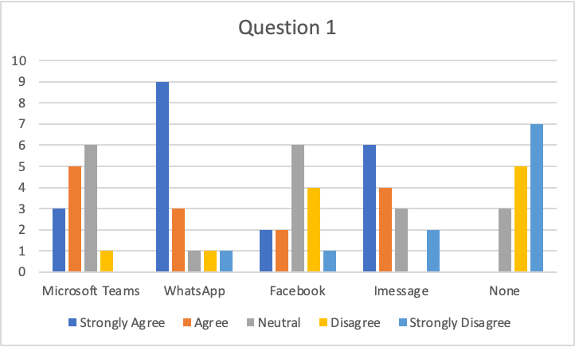
The first question was, which technology do you normally use to communicate at UWTSD? In response to this particular question, three respondents strongly agreed, five respondents agreed, six remained neutral, one respondent disagreed, and none of the respondents strongly opposed the case of Microsoft teams. In the case of WhatsApp, nine respondents strongly agreed, and another three agreed. In the case of Facebook, the highest number of respondents provided their opinion on the neutral option. In terms of iMessage, six respondents strongly agreed, and four agreed.
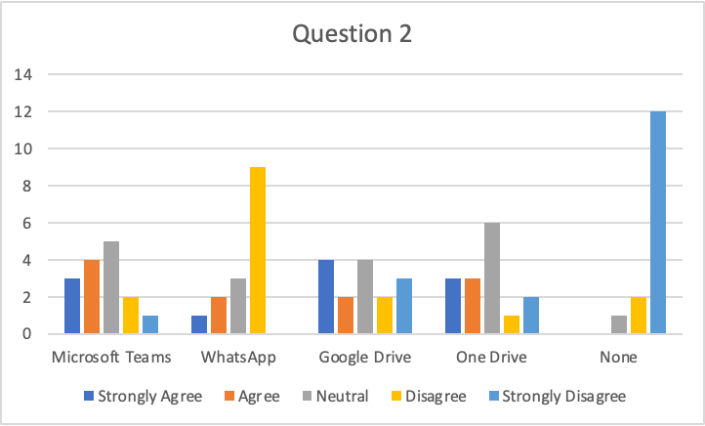
The second question was, which technology do you use to collaborate with your group members? Regarding Microsoft teams, three respondents strongly agreed, four agreed, five remained neutral, two disagreed, and one strongly disagreed. In the case of WhatsApp, nine respondents disagreed. In the case of Google Drive, four respondents strongly agreed, two agreed, four remained neutral, two disagreed, and three strongly disagreed. On the part of OneDrive, three respondents strongly agreed, another three agreed, six remained neutral, and the rest disagreed.
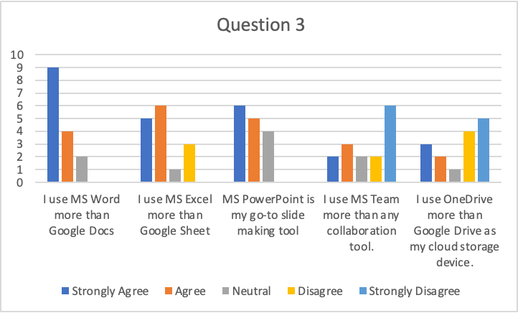
In question three, the respondents were asked to provide their opinions on some of the statements. When asked if they use MS Word more than Google Docs, nine respondents strongly agreed, and four agreed. When the respondents were asked if they use MS Excel more than Google Sheets, five strongly agreed, and six agreed. When the respondents were asked if MS PowerPoint is their go-to site meeting tool, six respondents strongly agreed and five agreed. When they were asked if they use MS team more than any other collaboration tool, two respondents agreed, three disagreed, two remained neutral, two disagreed and six respondents strongly disagreed. When asked if they use OneDrive more than Google Drive as their cloud storage device, three respondents strongly agreed, two agreed, one remained neutral, four disagreed, and five strongly disagreed.
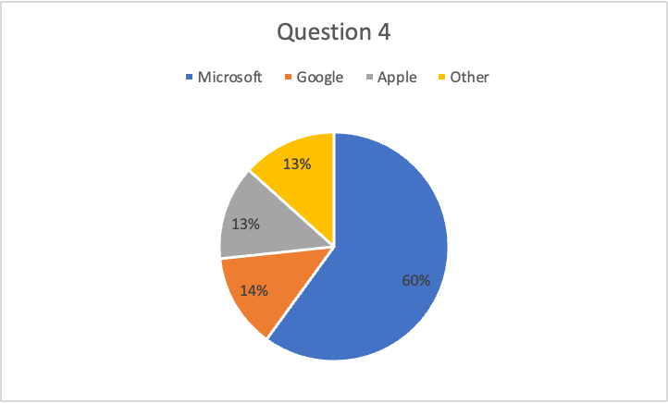
The fourth question asked the respondents which ecosystem they felt the most comfortable with for their academic studies. Based on the pie chart, it is evident that nine respondents chose Microsoft and the rest were evenly split between Google and Apple.
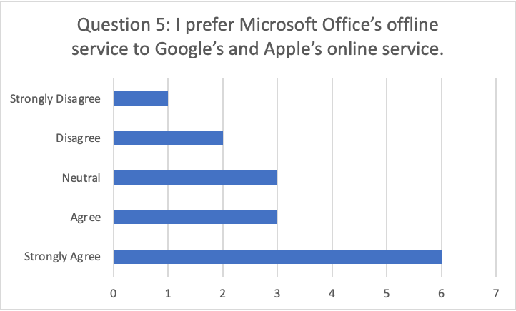
The final question asked the respondents if they prefer Microsoft offices of line services to Google and Apple's online services. In response to this particular question, six respondents strongly agreed with this statement, whereas three others remained in agreement with this statement.

Discussion
The findings of the questionnaire survey provided expected outcome except for one or two differentials. From the analyses of the answers to each question, it is apparent that Microsoft is clearly the winner in terms of digital technologies used effectively by students at UW TSD. Especially the three key software from Microsoft, including MS Word, MS Excel and MS PowerPoint, were clearly the favourites among the respondent students. When they were asked if they use MS Word more than Google Docs, 13 respondents out of 15 remained in agreement which is more than 85%. The same case applies to MS Excel over Google Sheets. More than 70% of respondents remained in agreement. When they were asked if PowerPoint was their go-to slide-making tool, none of the respondents was in this agreement response to this particular question. On the other hand, around 60% of the respondents felt that Microsoft was the digital technological ecosystem that they were most comfortable with when it came down to their completion of academic studies and assignments. Also, it is apparent from the results of the fifth question that, the meaning of the services from Microsoft office is available offline which helps a lot of students to write their essays, assignments, excel sheet or even presentation when they are not connected online. Additionally, this is clearly a preference of the students in their own choice of digital technology. However, there are some key differentials to the findings of the survey questionnaire, which did not go entirely according to the hypothesis of the researcher. It is clearly apparent that students do not find the storage system off Microsoft office for cloud storage devices over the same service as Google. Additionally, WhatsApp is clearly the favourite among the students when it comes to communicating with instructors, friends, classmates or group members. Finally, it also appears from the survey analysis that there was not a single student who was not active in at least one mode of digital technology for their communication and collaboration of academic studies.
The results obtained from the survey questionnaires mostly concur with the researcher's hypothesis. This is because the softer Microsoft office is unanimously used in academic and professional work environments. They ensure seamless transition and collaboration across cross-platform digital media, which other companies like Google and Apple do not provide in such an expensive way. Also, most computers and mobile phones come equipped with Microsoft office software. They also allow free access to almost every feature of Microsoft Word, Microsoft Excel and Microsoft PowerPoint, which are not available on any other platform. This is why it was evident that Microsoft office will be the most effective digital technological platform for students at UWTSD.
On the other hand, there were some interesting findings in the questionnaire survey result. Although Microsoft Office came back with features for online communication and collaborators, it did not provide ultimate satisfaction to the students since it is apparent that many students prefer chat messaging services like WhatsApp over Microsoft teams. Also, for online cloud storage devices, dance has revealed their preference for Google Drive over Microsoft OneDrive. It might be because Microsoft OneDrive is exclusively designed for desktops. In contrast, students can easily access Google Drive through their mobile phones, which allows them more accessibility and portability when sharing critical academic files and information.
- Conclusion
The research question of the project remains mostly valid since the students prefer Microsoft Office as their default software. They are comfortable with the ecosystem that Microsoft provides. The respondents also revealed that the offline feature is a lifesaver since they are required to write or edit an assignment on the go when there is little information connectivity available. However, on the part of communication and collaboration, Microsoft Office has split views among the respondents.

- Reference List
Bell, E., Harley, B. and Bryman, A., 2022. Business research methods. Oxford university press.
Cavana, R., Delahaye, B. and Sekeran, U., 2001. Applied business research: Qualitative and quantitative methods. John Wiley & Sons.
Dul, J. and Hak, T., 2007. Case study methodology in business research. Routledge.
Easterby-Smith, M., Jaspersen, L.J., Thorpe, R. and Valizade, D., 2021. Management and business research. Sage.
Jankowicz, A.D., 2013. Business research projects. Springer.
Wilson, J., 2014. Essentials of business research: A guide to doing your research project. Essentials of Business Research, pp.1-376.
- Appendix A – A blank copy questionnaire.
Questionnaire

1. Which technology you normally use to communicate at UWTSD?
 | Strongly Agree | Agree | Neutral | Disagree | Strongly Disagree
Microsoft Teams
WhatsApp
Facebook
IMessage
None
2. Which Technology you use to collaborate with your group members?
 | Strongly Agree | Agree | Neutral | Disagree | Strongly Disagree
Microsoft Teams
WhatsApp
Google Drive
One Drive
None
3. Provide your views on the following statements.
 | Strongly Agree | Agree | Neutral | Disagree | Strongly Disagree
I use MS Word more than Google Docs
I use MS Excel more than Google Sheet
MS PowerPoint is my go-to slide making tool
I use MS Team more than any collaboration tool.
I use OneDrive more than Google Drive as my cloud storage device.
4. Which ecosystem do you feel the most comfortable with for your academic studies?
a. Microsoft
b. Google
c. Apple
d. Other
5. I prefer Microsoft Office’s offline service to Google’s and Apple’s online service.
- Strongly Agree
- Agree
- Neutral
- Disagree
- Strongly Disagree

