LCMB7000: Human Resource Management (Assessment 2)

Contents
Introduction 3
Analysis 3
Outlining appropriate HR strategies for deploying in Retention of staffs in Amazon 3
Outlining HR strategies for deploying in learning and development in Amazon 6
Outlining HR strategies for deploying in compensation program of Amazon 8
Conclusion 10
References 11

Introduction
The recent trends of globalization has made the business periphery much more complex with global markets demands for Human resource allotment has been majorly diversified to be handled with their multifarious resourcing needs. With the advent of corporate globalization, human resource managers need to make a precise apprehension of the organizational cultural orientation to make them more assimilated to the various basic needs of HR. This can certainly make a corporate entity in global scale more competitive with higher job satisfaction of employees along with motivating them to perform well. The main essence of the HR functions is related to the productivity of resource or employees of international firm with assessing various areas of human resource that can enact for employee engagement to the firm (Boiko et al., 2021). Amazon one of the top-rated international tech leaders based in USA dealing in e-retail or commerce business have been putting eminent strategic thrust so that they can innovate through best of people management and engagement actions pertained within the firm. The HR strategy of the company is to maximize the employee engagement along with developing them as the HR associates like to closely operate with the employees at globalized corporate entity for making out the best of them. The following report will entitle over assessing critical appreciation of retention, learning and development and compensation as key areas for deploying HR strategies.

Analysis

Outlining appropriate HR strategies for deploying in Retention of staffs in Amazon
According to Zhukovska et al., (2021), retaining best of talents is a whole new challenge for maintaining an engaged workplace. It is therefore important to enact upon employee retention strategies as it can be seen that understanding employees regarding their demands and needs help them to make out the best of performing deeds for the benefit of the firm. For a company like Amazon, developing employee retention strategy is to follow their vision of keeping hold of best of talent pools who can be entrusted as prized assets of the firm and help in reduced employee turnover in challenging business environment (Ng, and Stuart, 2022). For Amazon, it can be seen that deploying retention strategies for best of team member values being shared and appreciated can be enrolled to achieve higher staff productivity. In this context some of the retention strategies are illustrated below:-
Hiring for cultural fit – It is necessary for Amazon that in terms of hiring process as part of employee retention program, they deploy a culturally fit model to the hired participants. One of their core strengths should be to put on cultural values among hired employees with more loyalty blended with team direction so that they can feel comfortable in reciprocating thoughts towards each other. It has been stated by Lee et al., (2021), in global corporate level, 80% of employee turnover is based on bad decision of employee hiring.
Persist upon hybrid workplace culture – In post Covid period, it can be seen that proclaiming on to a flexible workplace arrangement is best as it allows for an employee to work remotely as per his or her convenience. Amazon need to invest on hybrid model of working where they need to procure for 40% of employees fit to hybrid working circumstances assimilated in-group with working managers. This creation of virtual workforce can invariably create a win-win situation for Amazon while saving time and cost along with more inclusiveness to innovation and creativity.
Look upon employee well-being – It has been found by Lee et al., (2022), that looking upon employee well being is one of the core strategies to best of employee retention rate. Amazon going for a productive work ambience, need to entail for their warehouse employees in an ever-growing online demand portfolio by customers to maintain upon a safe working atmosphere with maintenance of their mental and physical health. In fact, in today’s working ambience, Amazon retention strategy is highly aligned to looking after reduced stress and flexible workplace atmosphere being pertained in global workforce continuity.
Appreciating employees – It can be seen that employee appreciation program act as one of the most exclusive intrinsic reward for employee pool of multinational organization for making them valued and create a sense of belongingness for the firm they work. Amazon needs to value employees by making meaningful ways of employee appreciation programs. For example, they can peer to peer recognition programs on weekly or monthly basis and provide on thank you notes that can appreciate employees based on their contribution and excelling activities for helping firm earn competitive growth (Venkat, and Khan, 2022).
Evaluating retention strategies through Herzberg Two Factor model
It has been found that employee exodus has been a growing challenge for any international business firm. Amazon as one of the tech leaders, known for innovation and creativity in e-commerce industry need to develop employee retention strategy in order to assess their employee motivation circumstances amplified through best of employee retention strategies and thereby yielding for better values imbibed in teamwork for achieving organization goals and mission in a competitive world (Ng, and Stuart, 2022).
The Herzberg Two Factor Theory can be ascertained for establishing relationship in between employee rate of retention for Amazon through driving different motivational factors as established through this theory. The theory proposes for two factors – motivators and hygiene factors.
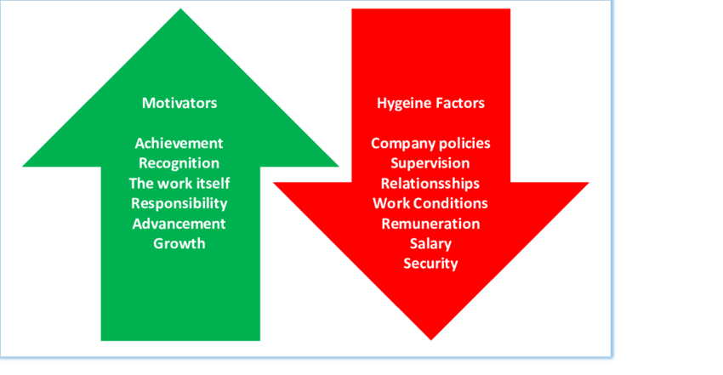
Fig: Herzberg Two-Factor Theory (Source: Thant, and Chang, 2021)
The hygiene factors implies for working conditions, peer relationships, quality of leader, job security and status of working. According to different hygiene factors, it can be implied that Amazon need to refer to improve on the physiological needs of employees so that there is less chance of employee dissatisfaction (Thant, and Chang, 2021). It can be seen that employees at Amazon for undertaking a thorough process of creativity and innovation implies for a stressful working condition. In this respect, the various hygiene factors that need to be implied by Amazon employers in this challenging and ever changing global HR demands can be asserted as involving employees to best of peer relation through best of communication channels that can relate to fruitful strategic decisions for Amazon in competitive arena. On the other hand, the factors of motivation exemplifies for job responsibility, satisfaction, recognition, sense of achievement and growth opportunities for employees. At Amazon, it can be seen that there is continuous necessity of responsive behaviour seek from employees with various prejudices of employee appreciation that boosts up their psychological needs to perform better within a team or group work (Bhatt et al., 2022).

Outlining HR strategies for deploying in learning and development in Amazon
One of the very essential parts of Human Resource (HR) strategies are the learning and development. Learning and development is required in every aspect of a business organisation. It is observed that employees of an organisation required training and learnings regarding the company rules, organisational history and working ethics. The training is a huge part for any organisation and through training the learning increases as well as the job satisfaction. Amazon Inc. has a strong organisation with an efficient Human Resource (HR) management department. They provide effective developmental training top their employees and they considered the training and developmental programme as their investments and not expenses. As a result, the employees of Amazon can provide highly advanced performance and they have highly competitive advantage. Amazon has the training programmes through which they teach their internal customers, that is their employees the skills which they require to perform their tasks with high efficiency. It is found through studies that employees need to be trained with Knowledge, Skills, and Abilities (KSAs). Employee development is an important factor for consideration for the Amazon Inc Human Resource (HR) management department. Training is required for the new workers and employees who are onboarding or when the employees are given with some new and different tasks or for the remediation and finally for the development of the employees.
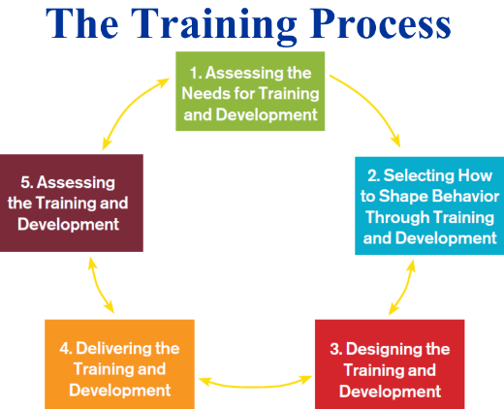
Figure: Five Steps of Training Process, talent management and development (Kartono and J., 2021)
Assessing the Needs for Training and Development: It is very important to find out the need or requirement for a training programme. To understand that the HR managers needs to understand the difference between what is happening in the organisation and what are their goals (Kartono and J., 2021).
Selecting How to Shape Behaviour through Training and Development: The aspect of shaping the behaviour of the employees through the training programmes depends on readiness of the employees. The level of ability of the employees, the level of confidence, the willingness or motivation level for learning and development, etc impacts the training and development process and its outcomes.
Designing the Training and Development: Learning is about bringing a permanent change in employee behaviour or their practices through providing them with experience or through training and practices. Training programmes are designed in a way so that the employees can learn and get developed. Therefore, the trainers need to design their training programmes based on the employee behaviours and their abilities. The planning for training is based on providing the best possible training at the minimum cost.
Delivering the Training and development: After the designing the next part is to deliver the training and development programme to the employees. To deliver the training the training processes may include written materials, lectures, projects, question and answer sessions, case studies, management games, interactive videos, etc. The different classroom learning, e-learning (which includes synchronous distance learning and asynchronous distance learning), simulations, etc.
Assessing the Training and Development: For the assessment of the training and learning process is done based on shaped behaviour, returns in terms of performance improvements, the four-level evaluation model can also be used, which includes, reaction, learning, behaviours, and results.
Therefore, for the development and efficiency of the employees there is a need for training process which will be developed based on different aspects as discussed above to develop the employees and the organisation in an integrated manner. The talent management in the Amazon Inc. is done is an effective manner as they have connection with the organisations which reach the underrepresented organisations and communities to find for the best talent who can be employees for technical and non-technical jobs of Amazon Inc. They have developed K-12 education for providing opportunities for the deprived but talented children and train them for future development, Tech U Program is the other programme to train the graduates for development and career opportunities, etc. Therefore, through such talent management and training the company is developing and all their individual employees are also developing.

Outlining HR strategies for deploying in compensation program of Amazon
The Human Resource (HR) departments must provide the employees with their required incentives and benefits. There are different types of incentives that are individual incentives and group incentives. The incentives and compensations can be bonus, commissions, merit pay, standard hour plans, etc. Bonus is a lump-sum portion of money which is given to the employees at the end of a certain time period after they reach certain goals or before any occasion or festival. Commission is the amount paid for making any successful sell of products or policies on any organisation. The merit pay is basically dedicated towards the best or the top most performers. The employees are often paid a compensation or incentive when they finish a given tsk within a given time period. The employee recognition by the organisation and paying the employees with incentives or compensations can motivate them to work hard for the development of the organisation to reach their goals (Samara, et al., 2021).
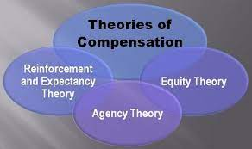
Figure: Theories of Compensation (Kang, et al., 2021)
Reinforcement and Expectancy Theory suggests that the employees and workers get the motivation to work better or maintain their high performance when they get rewarded for their extraordinarily good works (Kang, et al., 2021). The reward and the behaviour of the employees are connected and them to improve the behaviour there is a need to motivate through rewards.
Equity Theory suggests that the pray structure and the compensational structure should be based on equity. The employees observes that how the organisation with whom they are working are treating them. They prefer equity in rewards and payments. With inequity there can be decreased level of performance and productivity due to the dissatisfaction of the employees.
Agency Theory suggests that there needs to be a contract or understanding between the remuneration of the employees or the agency costs and the interests of the employers and the organisation. This contract can be based on two aspects that are, behaviour and outcome.
Amazon Inc. has developed their payment structure based on the performance of their customers. The company and their Human Resource (HR) department tries their best to develop their compensation policies and strategies in such a way that they match with the employee desires. Through the incentives and compensations, the employees get the inspiration to evaluate their performance and then improve their performances. The compensations can be beneficial in motivating the employees who are not much productive. There are also different disadvantages such as it is often found the there are employees who make use of unethical behaviours for achieving the desired rewards or compensation. The process of evaluating the performance of individuals is difficult as compared to the evaluation of the group performances. It is also found that compensation or incentive inequity can stimulate unhealthy competition among a group or employees or within the team of employees. Amazon Inc. provides group incentives to motivate the employees of a team to improve their team work. The collaborative work of the employees is encouraged through such group incentives. The employees understand the importance of maintaining good relationship in the work place through these incentives. Employees focus in integrated growth instead of individual development or personal profit. However, there are certain disadvantages that is all the members often do not put similar effort, some puts lesser effort they know that their teammates will fill in the gap which they are creating. The profits sharing plans, gainsharing plans, employee stock ownership plans, stock options, etc are some of the group compensations or incentives. The Dodd-Frank Wall Street Reform and Consumer Protection Act of 2010 was developed to minimise the inequity between deprived employees and the increase in compensation of the CEO or the executive officials (Ngxito, et al., 2021). The executive incentives are the other incentives which are incorporated in the Amazon Inc. to motivate their executives to make decisions which can be beneficial for the development of the organisation and their employees (Abdullah, et al., 2020). Amazon Inc. has other compensations such as workers’ compensation, employee insurance coverage, statutory benefits, etc.

Conclusion
The HR strategy of any company is to increase the engagement level of the employees along with developing them. The HR associates works closely and operate with the employees at global corporate organisation for making out the best of the employees and for the development of the organisation (Sitopu, et al., 2021). The human resource management is an essential task and therefore, the Amazon has developed their HR department is a way that they contribute to the development of the individual employees as well for the overall growth of their business. The entire project shows the importance of the human resource management for providing appropriate training to the employees and to keep them motivated to maintain high performance level.

References
Abdullah, P.Y., Zeebaree, S.R., Jacksi, K. and Zeabri, R.R., 2020. An hrm system for small and medium enterprises (sme) s based on cloud computing technology. International Journal of Research-GRANTHAALAYAH, 8(8), pp.56-64.
Barth-Obi, C., 2022. Crisis management: prevention, diagnosis, and intervention On basis of Amazon Inc (Doctoral dissertation, Private Higher Educational Establishment-Institute “Ukrainian-American Concordia University”).
Bhatt, N., Chitranshi, J. and Mehta, M., 2022. Testing Herzberg's two factor theory on millennials. Cardiometry, (22), pp.231-236.
Boiko, J., Volianska-Savchuk, L., Bazaliyska, N. and Zelena, M., 2021, September. Smart Recruiting as a Modern Tool for HR Hiring in the Context of Business Informatization. In 2021 11th International Conference on Advanced Computer Information Technologies (ACIT) (pp. 284-289). IEEE.
Kang, E. and Lee, H., 2021. Employee compensation strategy as sustainable competitive advantage for HR education practitioners. Sustainability, 13(3), p.1049.
Kartono, J., 2021. Influence of High-Performance Work Practices and Public Service Motivation toward Turnover Intention. Enrichment: Journal of Management, 12(1), pp.565-571.
Lee, C.C., Lim, H.S., Seo, D.J. and Kwak, D.H.A., 2022, April. Examining employee retention and motivation: the moderating effect of employee generation. In Evidence-based HRM: a Global Forum for Empirical Scholarship (No. ahead-of-print). Emerald Publishing Limited.
Lee, C.C., Quattropani, J., Seo, D. and Lim, H.S., 2021. The Moderating effects of employee generation on workplace retention during the Covid-19 pandemic. QRBD, 8, pp.41-58.
Ng, W. and Stuart, T.E., 2022. Acquired employees versus hired employees: Retained or turned over?. Strategic Management Journal, 43(5), pp.1025-1045.
Ngxito, N.C., Mntambo, V. and Lubbe, S., 2021. Compensation Structure and Employee Commitment: The Case of Academics at a Comprehensive Tertiary Institution. Journal of Public Administration, 56(3.1), pp.714-730.
PURI, M., 2022. THE EFFECT OF TRAINING AND DEVELOPMENT ON EMPLOYEE RETENTION (Doctoral dissertation).
Samara, G., Jamali, D. and Parada, M.J., 2021. Antecedents and outcomes of bifurcated compensation in family firms: A multilevel view. Human Resource Management Review, 31(1), p.100728.
Sitopu, Y.B., Sitinjak, K.A. and Marpaung, F.K., 2021. The Influence of Motivation, Work Discipline, and Compensation on Employee Performance. Golden Ratio of Human Resource Management, 1(2), pp.72-83.
Thant, Z.M. and Chang, Y., 2021. Determinants of public employee job satisfaction in Myanmar: Focus on Herzberg’s two factor theory. Public Organization Review, 21(1), pp.157-175.
Venkat, V.V. and Khan, S., 2022. Role of Competency Environment based Empirical Study and Education on Employees Retention and Psychological Analysis. International Journal of Early Childhood Special Education, 14(1).
Zhukovska, V., Piatnytska, G., Raksha, N., Lukashova, L. and Salimon, O., 2021. HR-manager: Prospects for Employment in the Labor Markets. In SHS Web of Conferences (Vol. 111, p. 01011). EDP Sciences.

