word count 2961
2307237

A Handbook for
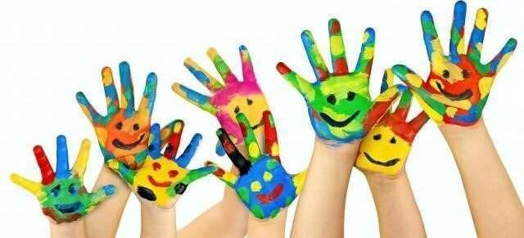

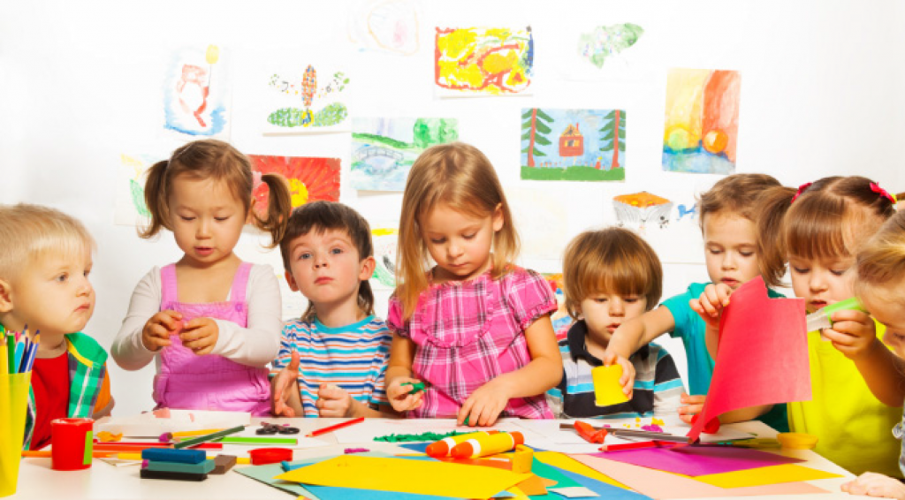

Early Years Transitions
Human Development
ECEY4004

Contents

- Introduction to Transition Page 3
- The Children’s Needs Page 5
- The Adults Role Page 8
- Partnerships Page 10
- Interventions Page 12
- The Proposed Outcomes Page 13
- Reference List Page 14

Introduction To Transition

As an early years practitioner we play a key role in supporting children’s development, so having a clear understanding of the their needs and of the developing child is necessary.
The purpose of this handbook is to help provide practitioners with information on how the child develops and theories behind the practice. Also I will explain the knowledge and skills needed to support children’s development whilst ensuring to plan a smooth process through transitions.
Transition is something that we all go through from birth, right in to adulthood. According to Bronfenbrenner (1979) a transition occurs when the environment around us changes.
Vogler (2008) suggest that there are three types of transitions ‘horizontal’, ‘vertical’ and ‘Education Associated transition. The three types of transition are explained as:
- Horizontal – An everyday transition that is part of a routine
- Vertical – A time related movement for example Nursery, Reception, Year 1
- Education Associated Transition – An everyday situation that can shape children’s pathways and experiences within or outside of school.
What is Transition?
Many Children start school from the age of 3 years old and stay in school up to the age of 18 years old. During this time, they will have gone through many transitions. The transition from home to school can be a scary time for children. Making the transition a positive experience and giving the children a feeling of belonging, as well as thinking about their wellbeing is key to their learning and to them becoming confident, sufficient contributors and informed citizens Welsh Government (2023). Children however, experience this when moving from setting to setting. According to Birth to 5 matters (no date) transition is a continual ongoing process for children and parents, who will go through a range of processes, adaptations, continuities, roles and identities during the transition process.
Children can experience many types of transitions as they develop, for example:
Developmental
- Communication, at first they start by smiling and listening, then they move on to talking.
- Physical, they first learn to crawl, then they learn to walk, which then moves on to being able to run.
Environment
- A new baby is a big transition as at first they was an only child with all the attention and now there is another child in the mix.
children can experience more than one transition at a time which can be quite complex. For example, they may move from a playgroup to nursery school and be transitioning into introducing a new baby into the family.
Effective Transition
Many children around the world go through the transition of school every year. Although it comes with anxiety for many children, parents or carers, many children see starting school as a positive experience Fabian H and A(2006.
A good practitioner will know the importance of a carefully planned transition whilst considering many different factors. This could include the child’s needs, respecting the parents, supporting their child’s learning and transitions. A successful transition is commitment from all practitioners involved in the process, developing effective communication and sharing information Welsh Government (2019).
- Allow time to settle – each child will adjust in their own time.
- Consider Circumstances – each family will have different needs and may require more support and parent/carer involvement will be differ to each child.
- Be inclusive – everyone should feel welcome and without judgement.

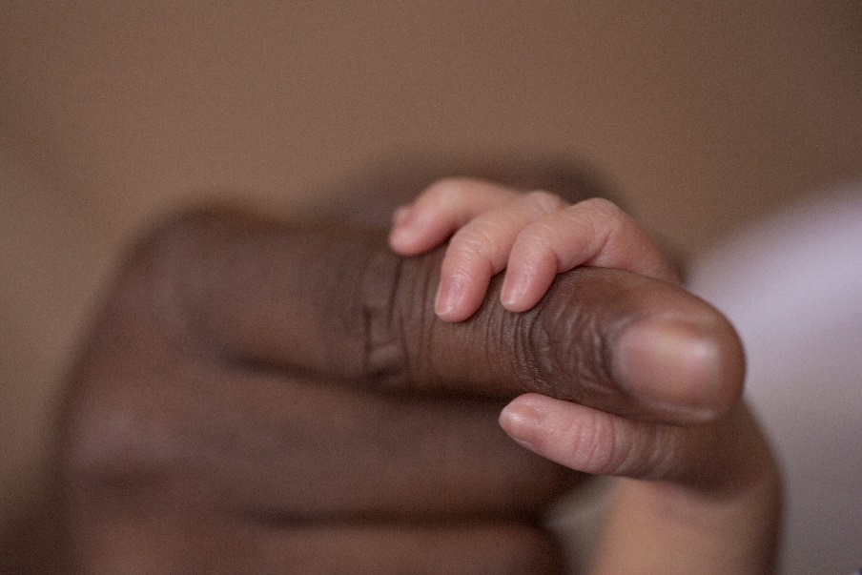

Needs of The Child

Every child is unique and each child reflects this in the way they learn. The physical and social environment in which children grow up play a key role in their development. Therefore require the need for caring, positive and nurturing interactions from the caregiver children in Wales (2023).
Every Child should feel included and cared for in a secure, loving environment. Every child should be able to form a safe and secure attachment with their keyworker, and no child should be excluded from or discriminated against due to family background, additional learning development, ethnicity, culture or religion. Setting up the childcare setting with familiar items around what the children already know and can do, makes the transition as smooth as possible makes it more of a positive experience for them.
Froebel believed that teachers should not teach but allow children to learn through play. Rousseau also supported this theory by suggesting that allowing children to learn naturally, they will grow and create their own society Linda pound (2008).
When a child babbles, cries or makes a gesture and an adult responds with eye contact, or a hug, neural connections are built and strengthened a child’s brain supports the development of communication and social skills are developed. These serve and return interactions shape the brains architecture. Harvard University (2023).

Play is an important part of transition process, children has the ‘right to play’ no matte of their religion, gender, language, background or culture, as governed by the United Nations Convention on the Rights of the Child. Play can be initiated by either the child or adult, which can be displayed by both the child and adults positively UNICEF (ND).
The Welsh Government introduced a new curriculum for Wales, based on the four purposes with the aim to support learner to become ambitious, enterprising, ethical, informed citizens and healthy, confident individuals.
Ambitious, Capable Learners:
- Can use digital technologies creatively to communicate, find and analyse information.
- Understands how to interpret data and apply mathematical concepts.
- Can question and enjoy solving problems.
- Can build up a body of knowledge and have the skills to connect and apply that knowledge in different contexts.

Enterprising, Creative Contributors:
- Can connect and apply their knowledge and skills to create ideas and products.
- Be able to identify and grasp opportunities.
- Take measured risks.
- Be able to express ideas and emotions through different media.

Ethical, Informed Citizens of Wales:
- Will show an understanding and exercise their human and democratic responsibilities and rights.
- Will be knowledgeable about their culture, community, society and the world, now and in the past.
- Will respect the needs and rights of others, as a member of a diverse society.
- Show their commitment to the sustainability of the planet.

Healthy, Confident Individuals:
- Are building their mental and emotional well-being by developing confidence, resilience and empathy.
- Can apply knowledge about the impact of diet and exercise on physical and mental health in their daily lives.
- Know how to find the information and support to keep safe and well.
- Form positive relationships based upon trust and mutual respect.
- Gain the skills and knowledge to manage everyday life as independently as they can.

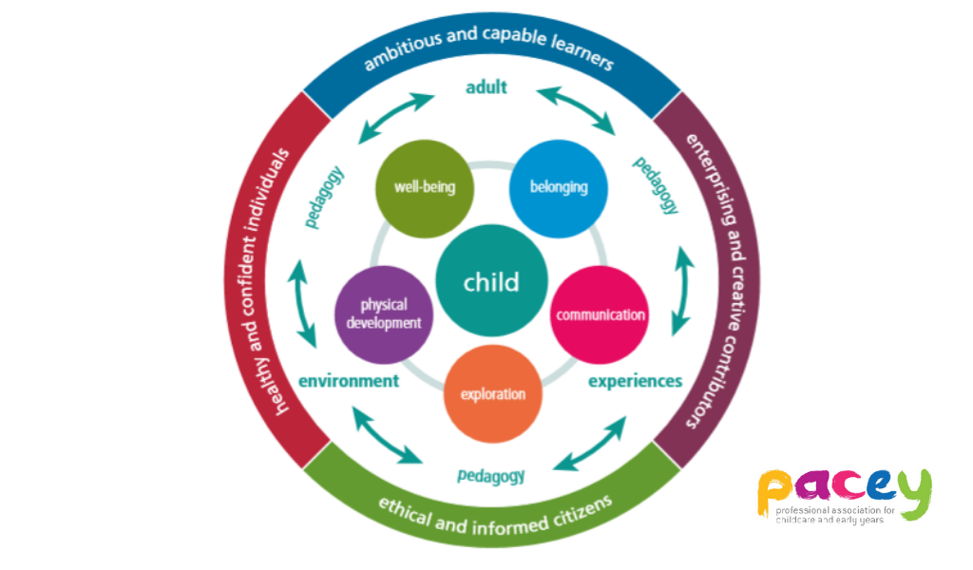

Every Child Deserves:
- Security
- Stability
- Consistency
- Emotional Support
- Love
- Education
- Structure
- Positive Role Models
Maslow’s hierarchy of needs suggested that there are 5 stages of basic needs. See the Maslow’s pyramid of hierarchy below. Not all stages are met due to illness, poverty, but that does not mean that a person cannot have their other needs met.
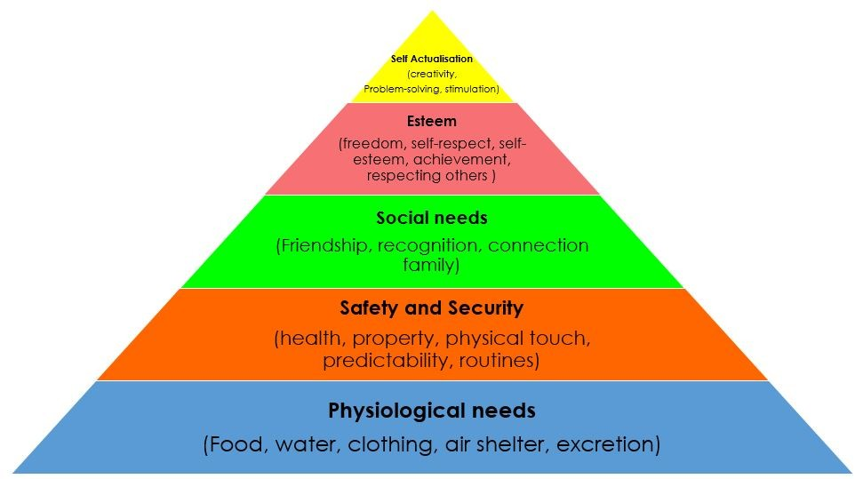
Physiological needs: basic things like food, water a home and a safe place to sleep. When the basic child’s needs are not met, the body cannot work. When met with the lack of safety and food it can cause ill health. When the 1st stage is met, then the 2nd stage can be looked at security: financial security, health and well-being needs met, once the first two stages have been satisfied, then we look to fulfil our other needs. The 3rd stage is social needs: having close friendships, family and love. Once a child has been able to meet their first two stages they are able to share and connect to others, without being able to connect and share with others, they may feel isolated, lonely, suffer with anxiety and depression, which can lead to a child’s basic needs not being met. The 4th stage is Esteem: a desire to be valued by others and self- esteem acceptance for themselves. When lacking in Esteem it makes it harder to believe in themselves and accept an adults validation, making it harder to fulfil their needs. The last stage is self-actualisation: A child has fulfilled all other stages and have reached their full potential, but is always looking to fulfil another need, meaning they are looking at ways they can reach other goals. As a key-worker having an awareness of the basic needs that a child needs, and ensuring their safeguarding and welfare needs are met. Maslow’s Hierarchy Of Needs Pyramid

Role of The Adult

To be able to fully support and facilitate transitions in the early years, practitioners must be aware of the skills and knowledge that is needed to be successful. The needs of the children must be met to encourage independence and confidence and enable them to settle into a new routine and their surroundings. As a practitioner they also have the responsibility for helping children when they move on to their next adventure, such as transitioning into a new classroom. Practitioner’s also have a responsibility to support the parent/carers through the transitioning process. Communication is a key element to a successful relationship between both the school and families.
How can a practitioner develop a mutual trust and form a positive relationship? Welsh Government (2022).
- Spend time getting to know the child and understand their likes and dislikes, suggesting that a form of attachment can be formed Bowlby (1951).
- Be aware of the culture, background, ability and circumstances of the child and family.
- Giving clear information to the parent/carers on the school’s process, using a various means of communication, recommended by Welsh Government (2018).
The Froebel’s approach Tovey, H (ND) was about allowing children to think for themselves, make choices and solve problems, allowing them to become independent individual with a strong community. In Froebel’s school children was able to play, create, and learn at their own pace. As where Bandura (1977) believed that children learned through watching behaviour, therefore contributing to their own learning. This can be a useful tool when thinking about the role of an adult.
A practitioner who is responsible for providing support, contact and communication to a child and their family within the setting. As a key workers approach is to help the teacher, child and family to develop a close, reciprocal relationship. Which goes back to Bowlby’s Theory (1951) on how babies become attached to their mother and what can happen when they become separated. Children do not become attached to their mum just because they feed them, but because they also feel secure and the mum supports the child’s social and emotional development. When a child is moved from the mum, in this situation they can often feel a sense of loss. The national minimum standards Wales (PACEY 2016) agreed with Bowlby’s theory and allocated a keyworker to a child, therefore it is important that the child and the key worker form a strong bond to help the child feel secure.
To begin the transition the practitioner and keyworker will arrange a visit into the school nursery, where they will meet with the child and parent/carers. The relevant paper work and an ‘all about me’ booklet will be completed during the first visit. This is when the transition process starts and the parent/carers are able to ask questions, meet the staff team and look around the setting and gain information on the daily routines. This also enables staff to identify background information such as cultural needs, any disability needs or any vulnerabilities of the child.
When the child starts the settling in process, keyworkers must remember the following within their role:
- Provide a warm welcome environment and be a good role model, value and respect the child and their families.
- Safeguarding and keeping sensitive information provided by the parent/carers confidential, giving reassurance and support.
- Maintain observations, assessments and planning.
- Meet the child’s physical, social and emotional needs.
- Keep the parent/carers up to date with informed information on their child’s development.
Ensuring these good practices will not only provide a smooth successful transition for the child and families but will also improve the outcomes for the child in the long term.

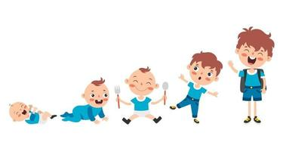

Partnerships

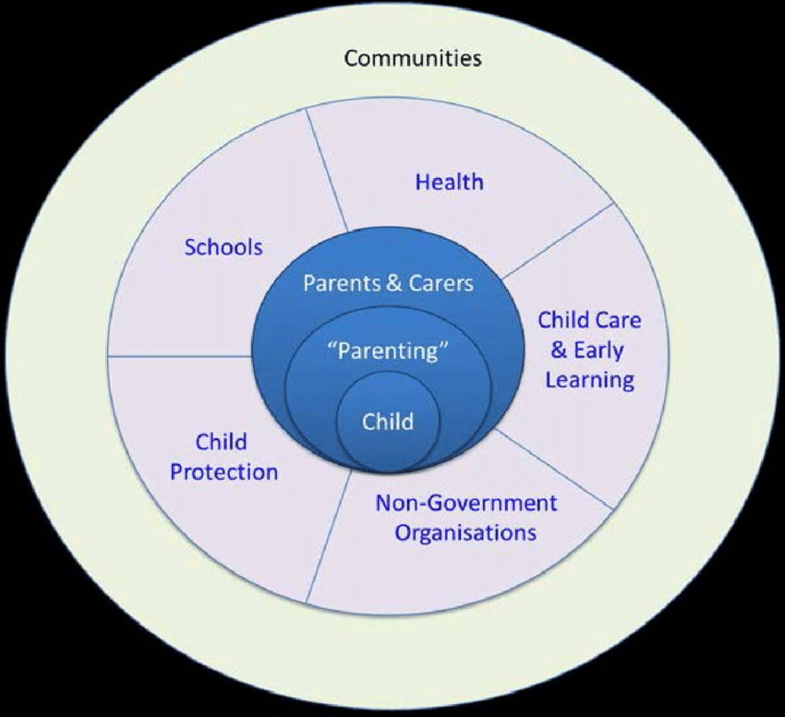

As practitioners we understand the importance of a strong partnership with parent/carers, do achieve the best lifelong learning outcome for children, having parent/carers involved in their learning journey.
Practitioner’s do this by sharing information in different ways, for example they may send home letters, post videos on the school website or update the outside information board.
As a keyworker it is your responsibility to ensure that parent/carers are involved from the day their child starts within your setting, and that they continue to be kept involved and informed on how their child is settling in and any progress they are making. Having daily or weekly chats and communicating with the parent/carers helps to build a strong foundation of trust. Any communication with parent/carers need to be flexible and mindful of any adaptions that you may need to accommodate, for example a parent first language may not be English, or they may have additional learning needs PACEY (ND).
As a practitioner you need to make sure you have parental permission when working with any multiagency, for example health visitor, speech and language therapist, educational phycologist’s and so on. Having a multiagency approach is important to being proactive and must come together to communicate to be able improve the child’s learning and life chance’s. If a practitioner feels that the child may have developmental delays, they can do assessments that will be able to help identify delays in their learning. Having access to these assessments, enables the keyworker to keep the parent/carers informed of any findings as well as ensuring all other multiagency who need to be involved are also informed. Each child with additional sensory development deserves the same rights to grow and learn as any other child.
As a practitioner/keyworker you need to adapt your communication through verbal and non-verbal strategies, responding appropriately and showing a genuine interest in what the child says or doing.

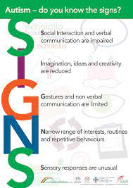

Interventions

It is key that the setting is welcoming, organised, consistent, professional and inclusive.
High quality childcare and support is essential for children to feel valued from practitioners in the early years. This view is held in theory practices of Froebel (Macblain, S 2022) and Montessori (Aubrey and Riley 2019).
All childcare settings must have a written statement of purpose which outlines all the practical aspects of the setting. Having a document allows the parents to make informed decisions about their child’s education. Care inspectorate Wales (2016).
The National minimum standards set out guidelines for correct practice, but settings can develop their own, and take inspiration from other practices internationally, for example the Te Whariki approach is that teaching should focus on the child’s interests and empowering the child in developing relationships in order to thrive Linda pound (2008).
In the Reggio Emilia (Sean Macblain 2022) approach to learning suggests their should be a daily routine, giving children time to play and discover opportunities to learn this is also found in the theory approach by Piaget, Vygotsky and Bruner (Sean Macblain 2022). Vygotsky also suggested that play was central to children learning, as it is through play they gain an understanding of relationships (Sean Macbalian 2022).
Whilst observing children through play, practitioners are able to assess the areas of learning and plan interventions suitable for the child.
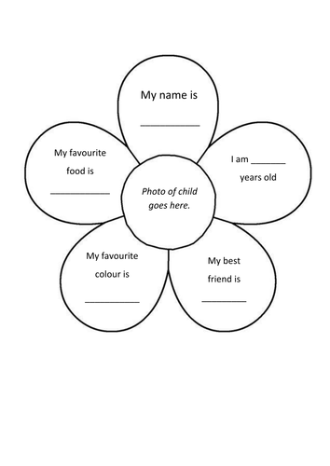
Having documented evidence of observations of the children can be a useful tool to help you begin to understand the child’s abilities and interests. In some school settings they may have a booklet ‘all about me’ that will move with the child, to pass on to their new teacher.
Play is an important role for a child, it helps them develop social skills for example playing with other children, it helps develop language and literacy skills for example being a critical thinker asking questions, and physical skills for example learning to kick and throw a ball. Having areas indoors and outdoors for children to play allows them to learn about themselves, others and the world around them. Play has become recognised as an important part of a child’s development of physical, emotional, social and creative skills Welsh government play policy (Dewis Cymru 2023).

Proposed Outcomes

The desired outcome is that all children are happy, confident and engaged learners. Each child is unique in their own way and develop at different paces, and will adapt to transitions and routine’s within a caring environment, that they feel safe in.
A good practitioner will play a key role in emphasising the importance of transition and how it should be planned.
The proposed outcome is that children and their parent/carer receive emotional support throughout all the transition stages, ensuring continuity with their care, learning and development support, making the transition a smooth, positive experience.
Positive interactions between the child and keyworker are important, as two individuals coming together to solve problems, this is called ‘sustained shared thinking’. This may involve children interacting together or a child and adult. Sustained shared thinking encourages children to think critically and supports positive learning according to Kathie Brodie sustained shared thinking in EYFS (ND).
Practitioner’s undergoing regular training to ensure that they understand the importance of attachment and of building a close relationships, and having strategies in place to manage behaviour.
The Welsh Government (2014) revised the curriculum based on the report by Professor Graham Donaldson, after a thorough independent review he advised the Welsh government that the then current curriculum was outdated and complicated. His recommendation was that the curriculum should have four main purposes, and have six areas of learning, these should be designed to help all children and young people to become: Ambitious capable learners, Enterprising, Ethically informed citizens and healthy confidential individuals.
Having a new curriculum for Wales means that education has come into the 21st century, which will improve the outcomes for all children in the identified areas. The transition processes and the role of the practitioner will all help in attaining these proposed outcomes.

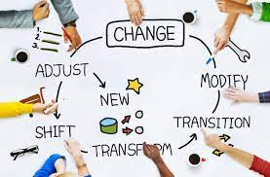

References

Anon, (2019). Available at: https://images.app.goo.gl/6T5CkEjzVsKnnyFX9 [Accessed 11 November 2023].
Anon, (2023a). Children In Wales: Early Years. [online] Available at: https://www.childreninwales.org.uk/professionals/our-work/early-years/ [Accessed 26 Novemeber 2023].
Anon, (2023b). Children’s play - Dewis Wales. [online] Available at: https://www.dewis.wales/childrens-play-cyp [Accessed 30 November 2023].
Autism: A Guide for Early Years Settings. (n.d.). Available at: https://autismwales.org/wp-content/uploads/2020/08/A-Guide-for-Early-Years-Settings_Eng.pdf [Accessed 26 November 2023].
Birth To 5 Matters (n.d.). Transitions – Birth To 5 Matters. [online] Birth to 5 Matters. Available at: https://birthto5matters.org.uk/transitions/ [Accessed 21 November 2023].
Brodie, K. (2012). Sustained Shared Thinking: Part 1. [online] Teach Early Years. Available at: https://www.teachearlyyears.com/cpd/view/sustained-shared-thinking-part-1 [Accessed 29 November 2023].
Brooker, L. (2008). Supporting transitions in the early years. Maidenhead ; New York: Mcgraw Hill.
Fabian, H. and Dunlop, A. (2006). Outcomes of Good Practice In Transition Processes For Children Entering Primary. [online] Unesco.org. Available at: https://unesdoc.unesco.org/ark:/48223/pf0000147463 [Accessed 26 November 2023].
Flying Start -Annex Transition Guidance. (2017). Available at: https://www.gov.wales/sites/default/files/publications/2019-07/flying-start-transition-guidance-for-professionals.pdf [Accessed 21 November 2023].
Image. (n.d.). Available at: https://www.google.com/url?sa=i&url=https%3A%2F%2Fwww.anyrgb.com%2Fen-clipart-yzueh&psig=AOvVaw1VSMUBWDEOZ_av54FpkBG_&ust=1700768764526000&source=images&cd=vfe&opi=89978449&ved=0CBIQjRxqFwoTCLCntMKv2IIDFQAAAAAdAAAAABAK [Accessed 25 November 2023].
GOV.UK (2022). Meeting the Needs of All Children - Help for Early Years Providers - GOV.UK. [online] help-for-early-years-providers.education.gov.uk. Available at: https://help-for-early-years-providers.education.gov.uk/get-help-to-improve-your-practice/meeting-the-needs-of-all-children [Accessed 12 Novemebr 2023].
GOV.WALES. (n.d.). Curriculum for Wales: overview. [online] Available at: https://www.gov.wales/curriculum-wales-overview#:~:text=The%20four%20purposes%20are%20the [Accessed 21 November 2023].
Harvard University (2023). Serve and Return. [online] Center on the Developing Child at Harvard University. Available at: https://developingchild.harvard.edu/science/key-concepts/serve-and-return/#:~:text=Serve%20and%20return%20interactions%20shape [Accessed 23 Noember. 2023].
Image. (2014). Available at: https://www.researchgate.net/figure/A-child-centred-approach-for-social-support-Sawyer-Gialamas-et-al-2014_fig2_309550444 [Accessed 23 November 2023].
Image. (n.d.). Available at: https://www.google.com/url?sa=i&url=https%3A%2F%2Fwww.playtheirway.org%2Four-philosophy%2Four-partners%2Funicef-uk%2F&psig=AOvVaw0JTBlAAmn8EK3H4F7TOdN2&ust=1700859019269000&source=images&cd=vfe&opi=89978449&ved=0CBIQjRxqFwoTCIiOs9__2oIDFQAAAAAdAAAAABAH [Accessed 23 November 2023].
Image. (n.d.). Available at: https://kinderly.co.uk/2022/06/07/a-new-curriculum-for-wales-2022-all-you-need-to-know/ [Accessed 23 November 2023].
Image. (n.d.). Available at: https://www.google.com/url?sa=i&url=https%3A%2F%2Fautismwales.org%2Fwp-content%2Fuploads%2F2020%2F08%2FA-Guide-for-Early-Years-Settings_Eng.pdf&psig=AOvVaw04wfHksqoiO8PbWiFCy7BG&ust=1701098859092000&source=images&cd=vfe&opi=89978449&ved= [Accessed 26 November 2023].
image. (2023). Available at: https://www.simplypsychology.org/bronfenbrenner.html.
imaginative minds ltd (n.d.). Available at: https://images.app.goo.gl/j6RUjMaNPc3roZhQ7 [Accessed 11 November 2023].
Lumen Learning (2019). Maslow’s Hierarchy of Needs | Introduction to Business. [online] Lumenlearning.com. Available at: https://courses.lumenlearning.com/wm-introductiontobusiness/chapter/maslows-hierarchy-of-needs/ [Accessed 30 November 2023].
Macblain, S. (2022). Learning Theories For Early Years Practice. 2nd ed. S.L.: Sage Publications.
Mickelburgh, J. (2019). Preparing for good transition from Reception to Year 1. [online] Early Years Foundation Stage Forum. Available at: https://eyfs.info/articles.html/teaching-and-learning/preparing-for-good-transition-from-reception-to-year-1-r248/ [Accessed 25 Novemeber 2023].
moodle.uwtsd.ac.uk. (n.d.). Early Years Learning Support Handbook. [online] Available at: https://moodle.uwtsd.ac.uk/course/view.php?id=9745§ion=5 [Accessed 23 November 2023].
moodle.uwtsd.ac.uk. (n.d.). Kirklees guidance for transitions in the Early Years. [online] Available at: https://moodle.uwtsd.ac.uk/course/view.php?id=9745§ion=5 [Accessed 23 November 2023].
National Minimum Standards for Regulated Childcare for children up to the age of 12 years. (2016). Available at: https://www.careinspectorate.wales/sites/default/files/2018-01/160411regchildcareen.pdf [Accessed 26 November 2023].
National Minimum Standards for. (2023). Available at: https://www.gov.wales/sites/default/files/publications/2023-11/national-minimum-standards-for-regulated-childcare_0.pdf [Accessed 25 November 2023].
PACEY (2016). Transitions and settling in. [online] Available at: https://www.pacey.org.uk/Pacey/media/Website-files/PACEY%20member%20practice%20guides%20(PDFs)/PG10-transitions-and-settling-in.pdf [Accessed 23 Novemebr 2023].
Pacey (2015). Working in partnership with parents - spotlight on. [online] Pacey.org.uk. Available at: https://www.pacey.org.uk/working-in-childcare/spotlight-on/partnerships-with-parents/ [Accessed 26 November 2023].
Pound, L. (2006). How children learn. London: Practical Pre-School Books.
Professional Association for Childcare and Early Years (2016). Supporting Members to Provide the Highest Standards of Care and Learning for Children. [online] p.7. Available at: https://www.pacey.org.uk/Pacey/media/Website-files/PACEY%20member%20practice%20guides%20(PDFs)/PG28-Theories-of-child-development.pdf [Accessed 30 November 2023].
Response to the Estyn thematic report on involving parents: Communication between schools and parents of school-aged children. (2018). Available at: https://www.gov.wales/sites/default/files/publications/2018-06/response-to-the-estyn-thematic-report-on-involving-parents-communication-between-schools-and-parents-of-school-aged-children.pdf [Accessed 25 November 2023].
Stoyanov, S. (2017). Theory of human motivation. [online] Miltan: Macat International Limited. Available at: ProQuest Ebook Central [Accessed 25 November 2023].
Successful Futures Looking at the Curriculum and Assessment Arrangements in Wales. (2014). Available at: https://www.gov.wales/sites/default/files/publications/2018-03/succesful-futures-a-summary-of-professor-graham-donaldsons-report.pdf [Accessed 30 Novemebr 2023].
The Basic Needs of The Child. (2020). Available at: https://images.app.goo.gl/o5gJA5qFpyj7nMAXA [Accessed 12 November 2023]. Image.
Tovey, H. (n.d.). Froebel’s Principles and Practice Today. [online] moodle.uwtsd.ac.uk. Available at: https://moodle.uwtsd.ac.uk/course/view.php?id=9745§ion=3 [Accessed 30 Novembe 2023].
Transition and Handover guidance Welsh Government guidance on the management and accountability of Transition and Handover processes in Healthcare Services, for children and young people as they grow older and move from using children’s to adults’ services. Consultation Document. (n.d.). Available at: https://www.gov.wales/sites/default/files/consultations/2020-01/consultation-document_1.pdf [Accessed 22 November 2023].
UNICEF (2023). UN Convention on the Rights of the Child (UNCRC). [online] Unicef. Available at: https://www.unicef.org.uk/what-we-do/un-convention-child-rights/ [Accessed 23 November 2023].
Vecteezy. (n.d.). Download A Kid In Different Ages for free. [online] Available at: https://www.vecteezy.com/vector-art/2405479-a-kid-in-different-ages [Accessed 21 November 2023]. Image.
Welsh Government (2020). Developing a vision for curriculum design - Hwb. [online] hwb.gov.wales. Available at: https://hwb.gov.wales/curriculum-for-wales/designing-your-curriculum/developing-a-vision-for-curriculum-design/#curriculum-design-and-the-four-purposes [Accessed 23 November 2023].
www.estyn.gov.wales. (2020). Working in partnership with parents and the community | Estyn. [online] Available at: https://www.estyn.gov.wales/effective-practice/working-partnership-parents-and-community [Accessed 25 November 2023].
www.google.com. (2020). Google Image Result. [online] Available at: https://images.app.goo.gl/o5gJA5qFpyj7nMAXA [Accessed 29 November 2023]. Image.
www.google.com. (n.d.). Title: Early Years: Planning The Transition from Play - TeachingTimes. [online] Available at: https://images.app.goo.gl/j6RUjMaNPc3roZhQ7 [Accessed 11 November 2023]. Image.
www.google.com. (2019). Title: Parent Guide to the Early Years Foundation Stage - Tops Day Nurseries. [online] Available at: https://images.app.goo.gl/6T5CkEjzVsKnnyFX9 [Accessed 11 November 2023].
www.open.edu. (n.d.). OLCreate: NNCO_TA Developing and managing relationships: 3 Children’s transitions. [online] Available at: https://www.open.edu/openlearncreate/mod/oucontent/view.php?id=79794§ion=3 [Accessed 23 November 2023].

