
University of Wales Trinity Saint David
School of Computing
Application Development
Kieran John Ayres (P149775)
23/10/2019
Database Management Systems/ACCA5014

Contents
Introduction 1
1. Security Measures 2
2. Transferring Data 4
3. Sorting Data 5
4. Order 6
5. Graph 6
Conclusion 8
References 9
Bibliography 9

Introduction
The focal point of this essay is to explain the technicalities of the implementation of the rainfall data website/application. This will be assisted with some sections of code along with screenshots of the website/application when active. These will focus on the features that the developer chose, these were split into the following sections; Security, Sorting Data, Order, Graph and then will be finished with a conclusion.

Project Initiation Document

Security Measures
Firstly, the assignment will discuss the necessary security measures taken. The PHP script/HTML file was connected to a database. Here is a screenshot of the fields in the “user” table in the database.
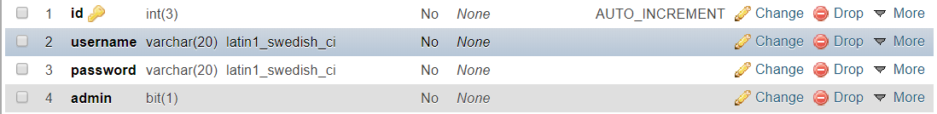
Figure 1
The first security measure that was implemented was a login. A screenshot can be seen below of the page “index.php”, this was a login page. This was so the user would have to login before being allowed access to view the website/application. However, a measure was taken to ensure someone couldn’t just direct themselves to the website without logging in. So, if for example, they were to try and view the data without logging in. Here is the code below for this. The code uses an if statement that would pass it would login, however, if not it would deny you access to the website.
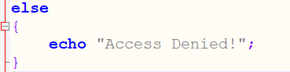
Figure 2

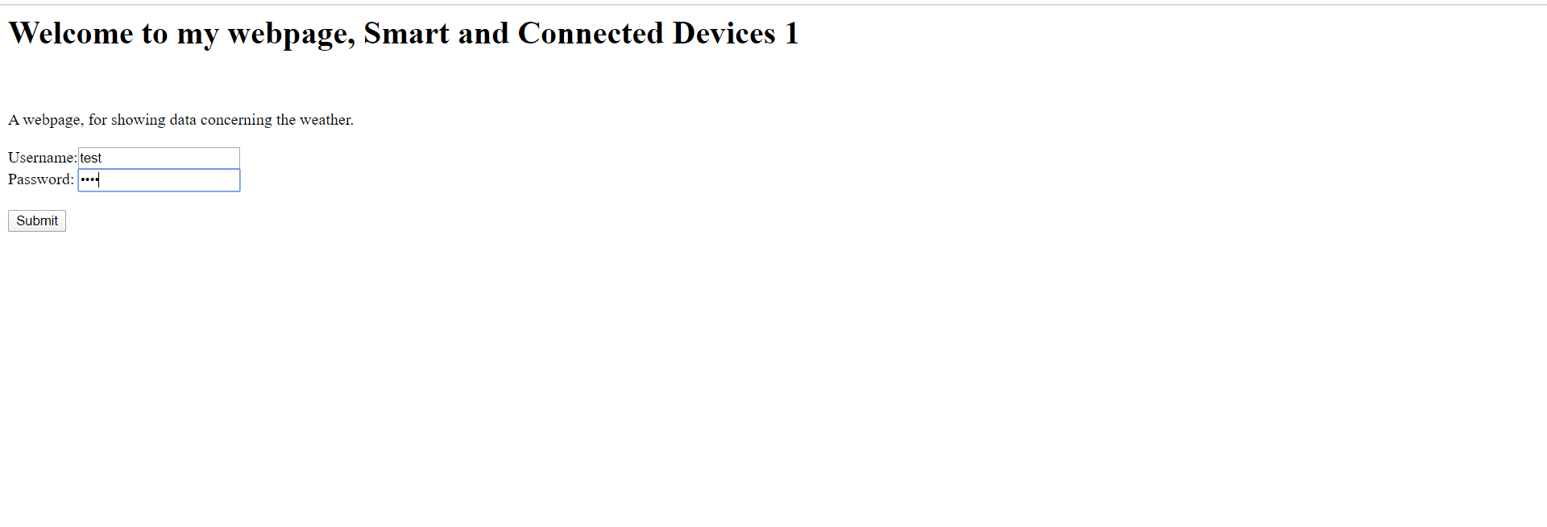
Figure 3
The variable types were essential to the security of the database. In particular, the datatype of the field “admin”. This was set as “Bit”. This is essentially, a Boolean however, SQL tends to work better with Bit [1] it was used so only the admin could have the option of doing a data transfer to the database. It was done by assigning the value of 1 to the admin, 1 being the value of “True”, meaning they would be granted access to this administrative right. There is a sample of the code below written to show this.
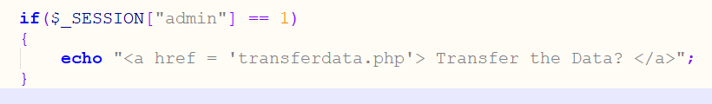
Figure 4

Transferring Data
The first thing that had to be done was to transfer the data from the flat text file into the database. This was so the developer could populate the database after it was set up so the data could have been worked with. A code snippet can be seen below. This was so the script would copy it in. This code was duplicated 3 times for the three different sensors with the number for the data for each sensor. This is shown under this snippet of code. Showing two examples, with each one representing a different sensor.
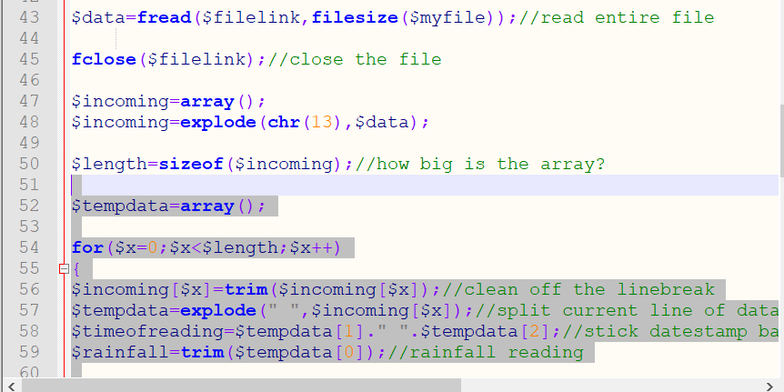
Figure 5
Figure 6

Sorting Data
The next section will focus on the next set of features that the developer decided to implement with the website/application.
Here is a screenshot of the rainfall data database structure:
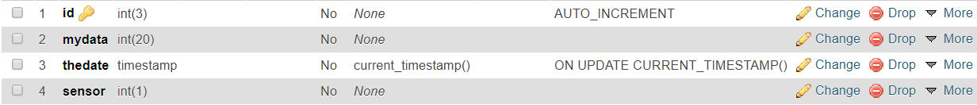
Figure 7
The developer chose to make pages to show the data like this because it gives more clarity to look at the columns filtered, the 1st data shown was from the column “mydata”. This was to show the recorded rainfall and then the second filter that was implemented was used to show only the date of the rainfall.
This is shown in the screenshot below:
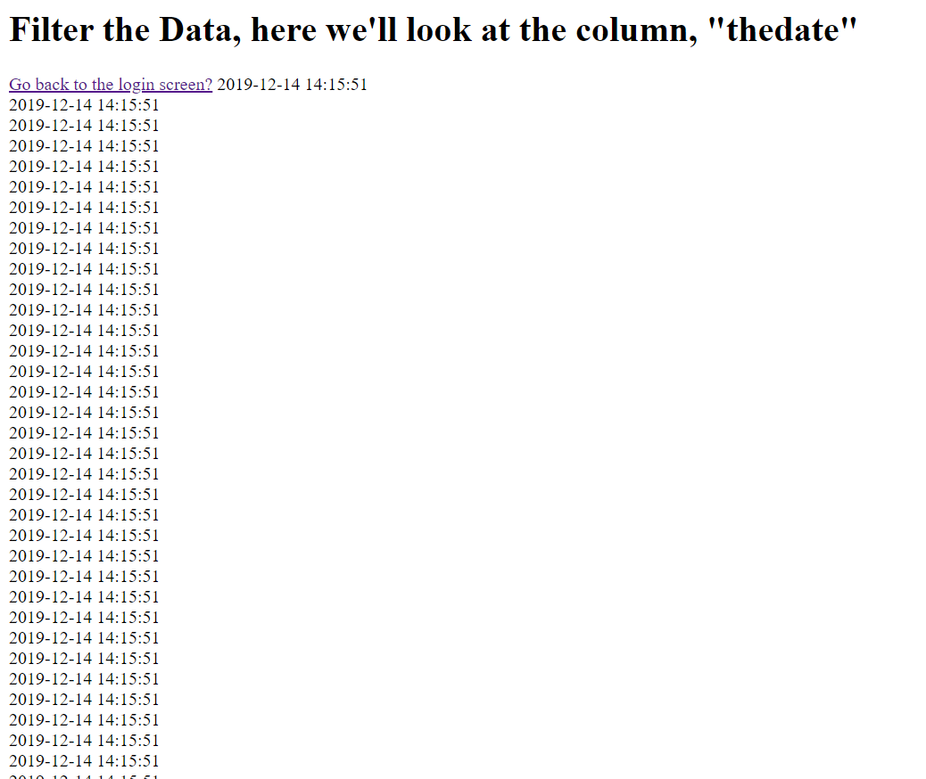
Figure 8

Order
The next feature is to show the data ordered, this can help the user see the data and further interpret it and make some more conclusions.
The query that was used to do this, was this, this is a query that orders the “mydata” column by ascending order. The result of this is shown under the query.
Figure 9
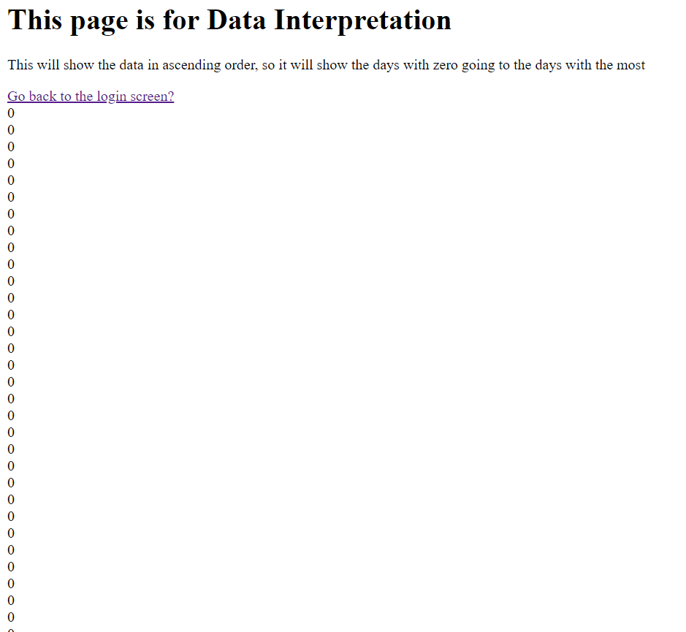
This one in particular was used because it can show the user how many times there was no rainfall. Or when how many occasions where there was the max rainfall.

Graph
The graph was a challenge as it required to add in the library file.
This is the graph that the developer chose, this graph may not represent the data in a way which is highly useful as it takes all the rainfall data, from the sensor, to the data to the date of the rainfall. To edit this, it would need a new query which specifies something other than just the generic data. This graph was added as a feature as it can allow the user to help interpret the data to make meaningful conclusions.
Currently, this is the graph which is ran using the following query:
Figure 10
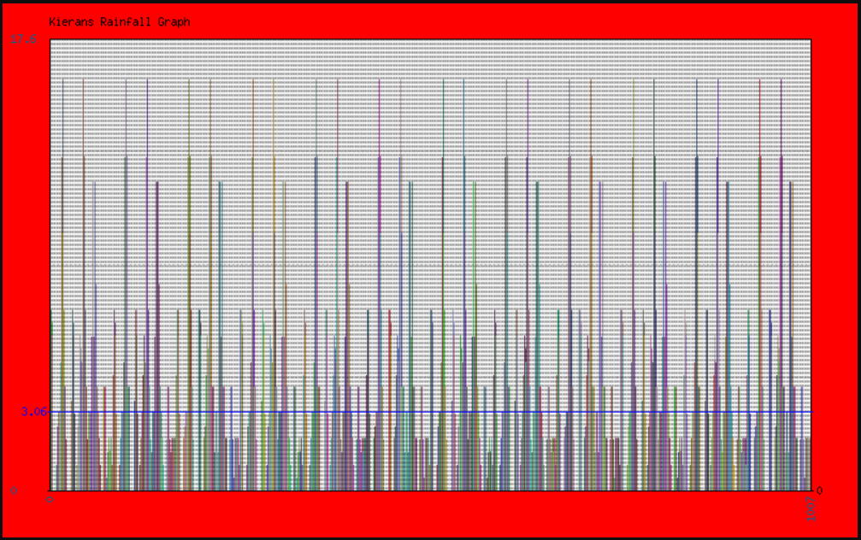
Figure 11

Conclusion
To conclude, from this assignment, the developer has learnt and encountered many new challenges, the main challenge that they encountered was using a language that they were relatively new to. They also learnt how to use the WAMP server software to assist in their development. Overall they found it a challenging process as some queries, if they were written wrong would need changing until they were working.

References

[1] | “SQL Server BIT,” SQLServerTUTORIAL.NET, [Online]. Available: https://www.sqlservertutorial.net/sql-server-basics/sql-server-bit/. [Accessed 27th February 2020].

Bibliography

[1] | “SQL Server BIT,” SQLServerTUTORIAL.NET, [Online]. Available: https://www.sqlservertutorial.net/sql-server-basics/sql-server-bit/. [Accessed 27th February 2020].

