DS 1 Template

My Screenshots/Photos
- Please add 4–6 screenshots or photos of your digital life.
- You can use your phone or laptop.
- For each screenshot, write one or two sentences explaining what it shows.

Screenshot/Photo 1
[Insert Photo/Screenshot below]
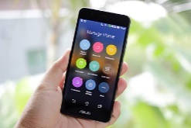
This screenshot shows the apps I use every day. I use my phone to communicate with friends and manage my daily tasks. I use my phone to call everyday and it makes it easy to talk to my friends. I want to improve how to be safe from scammers.

Screenshot/Photo 2
[Insert Photo/Screenshot below]

Laptops help you do your college work easily. It helps me in completing my assignment and college work. I even use to watch Netflix and movies on it. I want to improve my typing skills on the laptop. Laptops can be in handy when we need to create charts and tables.

Screenshot/Photo 3
[Insert Photo/Screenshot below]
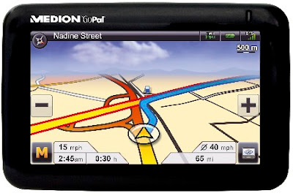
Sat navs help in finding routes for your destination. It helps in calculating the distance and finding the easiest route available. Sat navs really help in when driving a car. I want to improve how I can find the address quickly and easily.

Screenshot/Photo 4
[Insert Photo/Screenshot below]
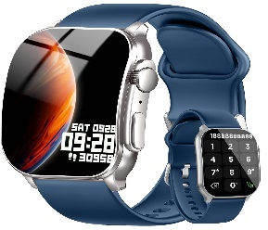
Smart watches are really helpful when phones are not around. It can help you track who called and check your messages when the phone is not around. It also helps you track your health records. I want to improve my health records using the smart watch.
It can also be used to speak to the people when phone is not around.

Screenshot/Photo 5
[Insert Photo/Screenshot below]
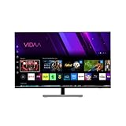
Smart tvs are really great invention to watch movies and videos. You can use to watch news. You can control it by adding more settings. It can also detect your voice and listen to commands. I want to learn how to use it and make my life better.

Screenshot/Photo 6
[Insert Photo/Screenshot below]
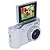
Digital cameras can help you click photos and make memories with your family. It can be gfreat when phones are not around. It helps you preserve memories in physical copies. I use it for travelling. I want to improve my skills by preserving more memories and taking more photos.

My Short Reflection
- Write 5–8 simple sentences about your digital life.
- You can use the sentence starters below if helpful.
- I use digital tools to … manage my work and communicate with my customers.
- I feel confident when I …use my phone and computer for work and everyday tasks.
- I want to improve …my computer skills and learn more about digital technology.
- I often use these tools: …my smartphone,social media,email,and Microsoft Word.
- I sometimes feel nervous about …learning new programs and technology.
- I hope this module will help me …improve my digital skills and become more confident.
- Digital skills are important for me because …I use them every day in my work and personal life.

Sentence starters
- I use digital tools to … manage my work and communicate with my customers.
- I feel confident when I …use my phone and computer for work and everyday tasks.
- I want to improve …my computer skills and learn more about digital technology.
- I often use these tools: …my smartphone,social media,email,and Microsoft Word.
- I sometimes feel nervous about …learning new programs and technology.
- I hope this module will help me …improve my digital skills and become more confident.
- Digital skills are important for me because …I use them every day in my work and personal life.
You can write more if you want.

Submission Checklist
Before you submit, please check:
​​​ ☒ I added 4–6 screenshots
☒ I wrote short sentences for each screenshot
☒ I wrote my short reflection
☒ My work is my own
☒ My file opens correctly
​​☒ My file opens correctly

