
BA INTERNATIONAL HOTEL MANAGEMENT FOREIGN LANGUAGES CULTURAL AWARENES code: M5X01923

Lecturer: Wai Wang

Student name: Elza Soares
Student Number:1815430

早餐信息 Breakfast information
国际早餐 International breakfast
营业时间上6点至上午10点 Business time 6am to 10am
35天秤座 如果您不预订房间 35 If you do not book a room
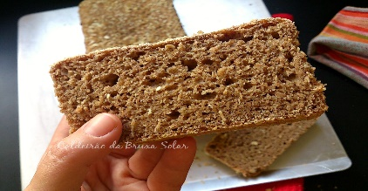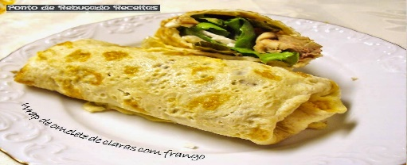
This Photo by Unknown Author is licensed under CC BY-NC

This Photo by Unknown Author is licensed under CC BY-NC
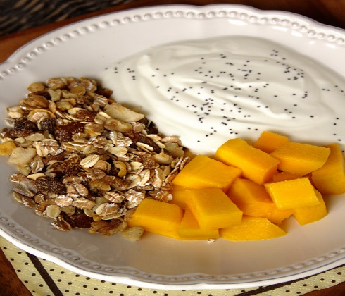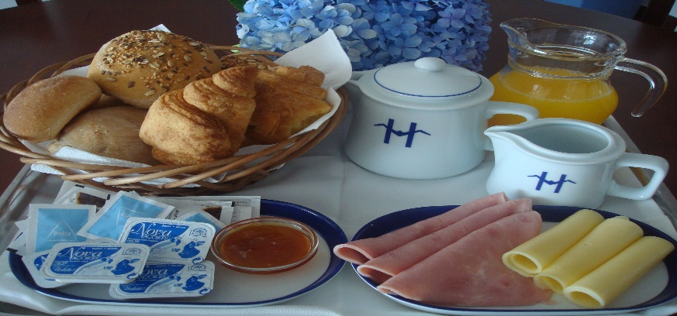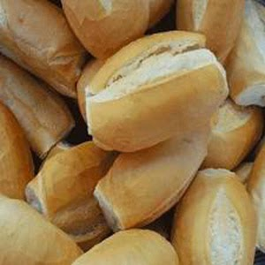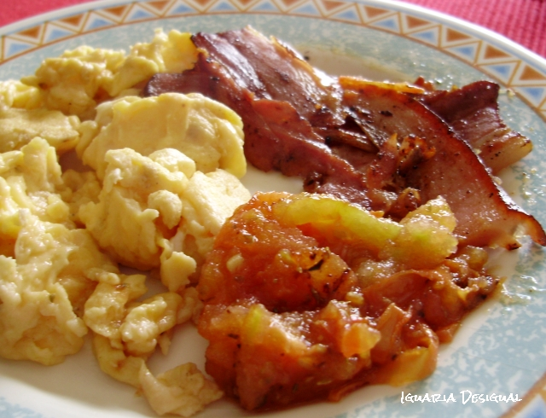
This Photo by Unknown Author is licensed under CC BY-SA-NC

