Bunyan, Oliver
C&P Engineering Services ltd

HND / BEng Electrical & Electronic Engineering

AC Response of an RLC network
Electrical Engineering / ACDA5001
Table of Contents
Abstract 2
Introduction 3
Method 5
Results 9
Discussion 14
Conclusion 16
References 17

Abstract

Within this report, a model of an RLC network has been built within proteus using unique component values. The phase difference was determined before Power factor correction and after power factor correction. Also, different power values were calculated, along with a graph of power factor against capacitor value. A phasor diagram was also demonstrated with different frequency values. It is discussed within also how the capacitor value to correct the power factor to $≥0.95$ relates to resonant frequency + maximum power transfer. It’s concluded that using a capacitor in an RLC network reduces reactive power and increases the efficiency of the power.

Introduction

This report aims to demonstrate how PFC (Power Factor Correction) on a load decreases the amount of power wasted to drive a load.

A power factor of 1 is when there is no power wasted, and the voltage and current are in phase with one another, this would be a perfect balance between the resistive components such as the capacitor and the reactive components such as an inductor. A power factor of 0.95 is deemed a good power factor and that’s what all companies shall be aiming for when driving loads to decrease power losses and decrease energy bills. The method of correcting for a trailing current by applying a leading current is known as power factor correction by adding a capacitor across a load. Companies are now being penalised for not having power factors above 0.95 or 0.9. [1]

This type of circuit is known as an RLC circuit where the capacitor being applied compensates for the reactive power that is due to the load. Capacitors mostly draw current that leads the voltage, therefore when the inductive load causes the current to lag the voltage the capacitors decrease the lag between the voltage and current. The capacitor can decrease the phase angle and bring the apparent power closer to the real power. It can also decrease the reactive power. A lot of industrial loads are inductive therefore they cause the voltage to lag the current. [1]

Apparent power is the amount of power delivered to a circuit, which is measured in VAr. [2]

Real power is the parts of the apparent power used by resistive elements, which is measured in W. [2]

Reactive power is the parts of the apparent power wasted by reactive elements, which is measured in VAr. [2]

Applying PFC can be beneficial in multiple ways, firstly the efficiency of energy will be increased in return decreasing the amount of power that needs to be consumed, this will have a positive impact on the climate due to less power consumption means fewer gas emissions used within plants that generate power. It also means that less current will be needed to power a load therefore the cable sizes do not need to be as big, saving companies a lot of money in the process. With PFC the voltage drop will also be decreased. [1]

If we had a purely resistive load the current and voltage would be in phase and have a perfect PF. If we had a purely inductive load the current will lag the voltage. If we had a pure capacitive load the current would lead the voltage, which would also equal power wasted. Therefore, using a capacitive load and an inductive load against each other is the correct thing to do to find a balance and make the load resistive equalling less power wasted. [3]

A phasor diagram demonstrates this clearly by showing the apparent power and the real power, the phase angle between them being smaller is what is needed for a better PF, which is what’s caused by using a capacitor.

Method

A parallel RLC circuit was built within the software Proteus with unique values. A graph was then plotted showing the Voltage of the load against the current of the circuit before we applied PFC (Power factor correction), which is done by adding a capacitor to the circuit.



Figure 1.1

As shown in figure 1.1, R1 (Source resistor) was 2.1Ω, R2 (Load resistor) 39Ω and L1 (Inductor) 0.167mH.
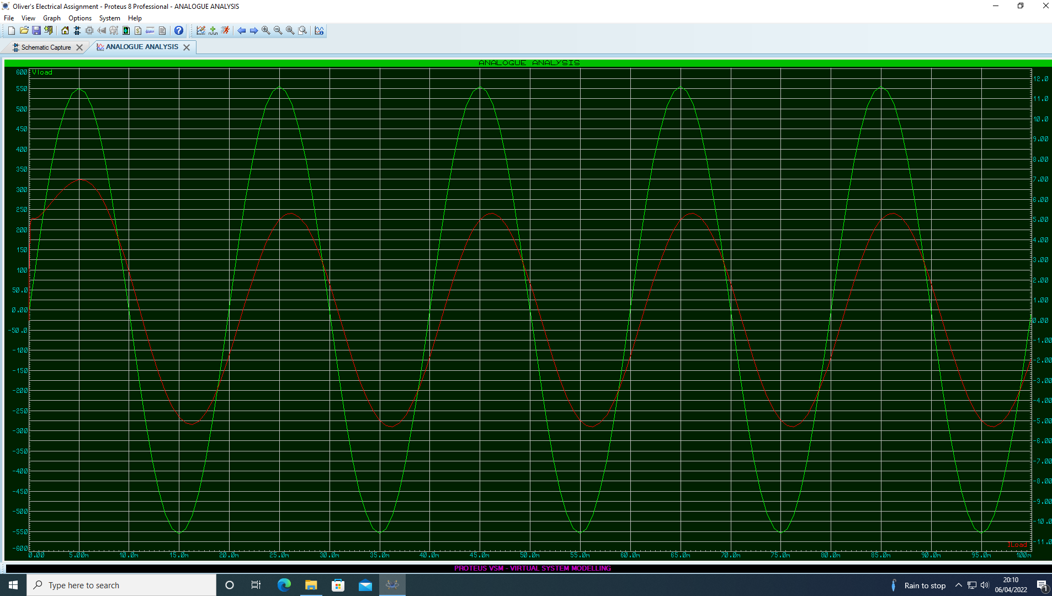

Figure 1.2

In figure 1.2 we have a graph with the Voltage load plotted against the circuit current from the circuit shown above in figure 1.1, this is what was used to determine the time difference between the two phases.

To determine the phase difference of each of the values, the time between the two phases was compared. This equation was then used to get the value of t.

$$t=time of Vload-time of Iload$$

$$T=Time of one full cycle$$

This Phase difference calculation was then used to find the phase difference between both phases:

$$θ=\frac{t}{T} x 360$$

The next task was to find the Reactive, Active and Apparent power by using some equations that gave values that allowed the powers to be calculated.

Using these two equations:

$$XL=2πFL$$

$$Z= \sqrt{R^{2}+{(X_{L}+X_{C})}^{2}}$$

Followed by this equation:

$$V=IZ$$

Rearranged to:

$I= \frac{V}{Z}$

Gave the values to calculate each of the powers using:

$$Apparant Power=V_{RMS} x I_{RMS}$$

$$Active Power=I^{2} x R$$

$$Reactive Power= I^{2} x X_{L}$$

The power factor could then be found using the active and apparent power values as shown below:

$$PF= \frac{Active Power}{Apparent Power}$$

Next the job was to find an appropriate capacitor value to correct the power factor of the load to $≥0.95$, numerous calculations were done to get to this capacitance value needed.

The calculations were started by using:

$$Z=R_{Src}+R_{Load}+j\left(X_{L}-X_{C}\right)$$

Followed by:

$I= \frac{V}{Z}$

The equation above would give us the resistive current (real part) and the reactive current (imaginary part).

The new Power factor would then equal to 0.95.

To find the new phase angle due to the PF (power factor) change this equation was used:

$$θ=\cos^{-1}{(PF)}$$

The new current then was to be found using:

$$I_{R}=Resistive Current$$

$$I_{L}=Reactive current$$

$\frac{I_{R}}{\cos{θ}}= I^{'}$

$I^{'}=New resistive current$

$$\left|I_{L}-I_{C}\right|= \sqrt{I^{'^{2}}-{IR}^{2}}=I^{'}2$$

$$I^{'}2=New reactive current$$

$I_{C}= I_{L}-I^{'}2$

$$I_{c}=Capacitor Current$$

With the capacitor current, capacitive reactance could be found using this equation:

$$X_{C}=\frac{V}{I_{c}}$$

Now that the capacitive reactance had been calculated the capacitance could be calculated using:

$$X_{c}= \frac{1}{2πFC }$$

The equation needed rearranging to this equation to then get the capacitance value which will give us a power factor of 0.95:

$$C=\frac{1}{2πFX_{c}}$$

Resonance of the circuit was also found by using the equation:

$$\frac{1}{2 x π x \sqrt{\frac{1}{\left(L x C\right)-\frac{R^{2}}{L^{2}}}}}$$

Results

The results I’d gathered from the method used were as below.

The phase difference calculated before PFC (power factor correction) was applied:

$$θ=50.4°$$

The results from the inductive reactance equation were:

$$X_{L}=52.465$$

And the Impedance value:

$$Z=66.647$$

I also calculated the impedance in Cartesian form:

$$Z=41.1+j52.465$$

The value of the Current was:

$$I=6.002 A$$

And the Current in Cartesian form is shown as:

$$I=3.701-J4.725$$

Due to knowing the current value, the Power values were calculated which came:

$$Apparant Power=2400.8 VA$$

$$Active Power=1480.587W$$

$$Reactive Power=1889.999 VAr$$

Next a new phase angle due to 0.95 PF was calculated:

$$θ=18.195°$$

And also, a new current:

$$I^{'}=3.896 A$$

Along with a new Reactive current:

$$I^{'}2=1.22 A$$

And then a new Capacitor current:

$$I_{c}=3.505 A$$

Capacitive Reactance value was then calculated to give:

$$X_{c}=114.12$$

Finally the Capacitance could be calculated giving:

$$C=27.89μF$$

A graph was made in excel which was comparing the power factor value against the capacitor value as shown in figure 2.1. This graph clearly demonstrates how the power factor is affected by using different capacitor values in the circuit built.
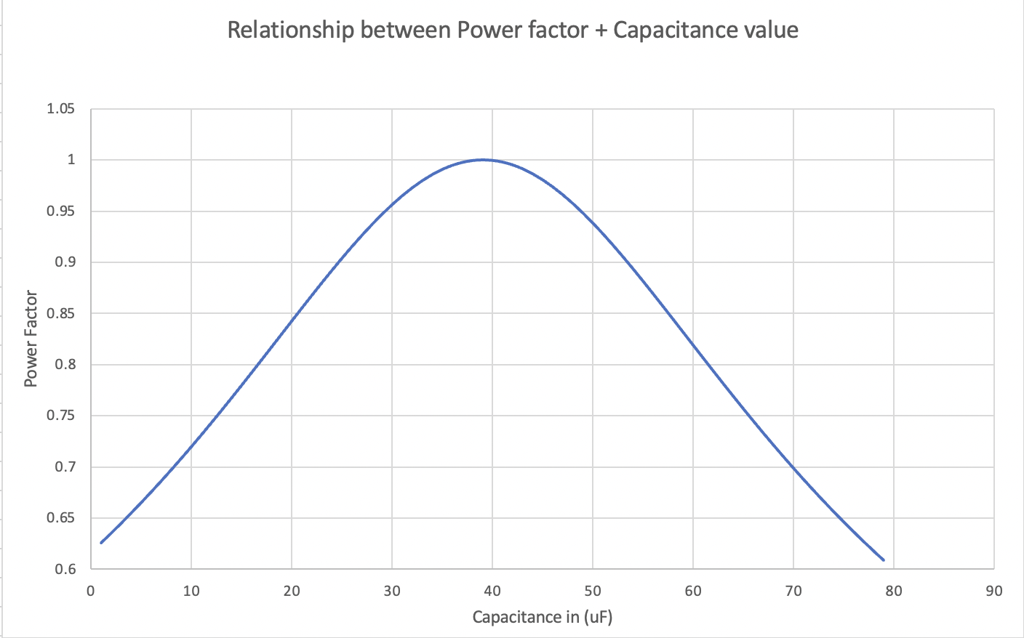

Figure 2.1

Phasor diagrams were also made using values in excel, which are showing the circuit at different frequencies levels. One phasor diagram at Resonance, one at 25Hz below resonance, One at 25Hz above resonance and one at 50Hz which is what we have in our circuit built.

The value calculated for resonance was at 63.527Hz

The phasor diagram for resonance was shown in figure 2.2.

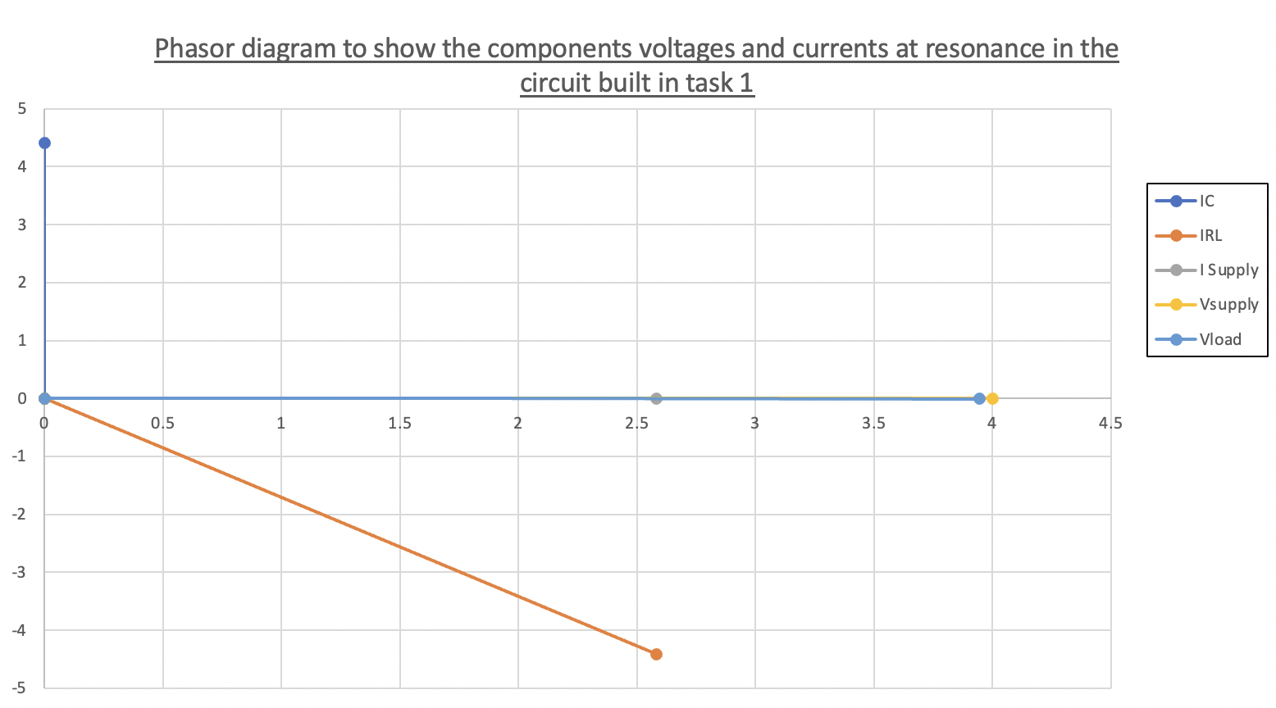
Figure 2.2

The phasor diagram for 25Hz below resonance was shown in figure 2.3.

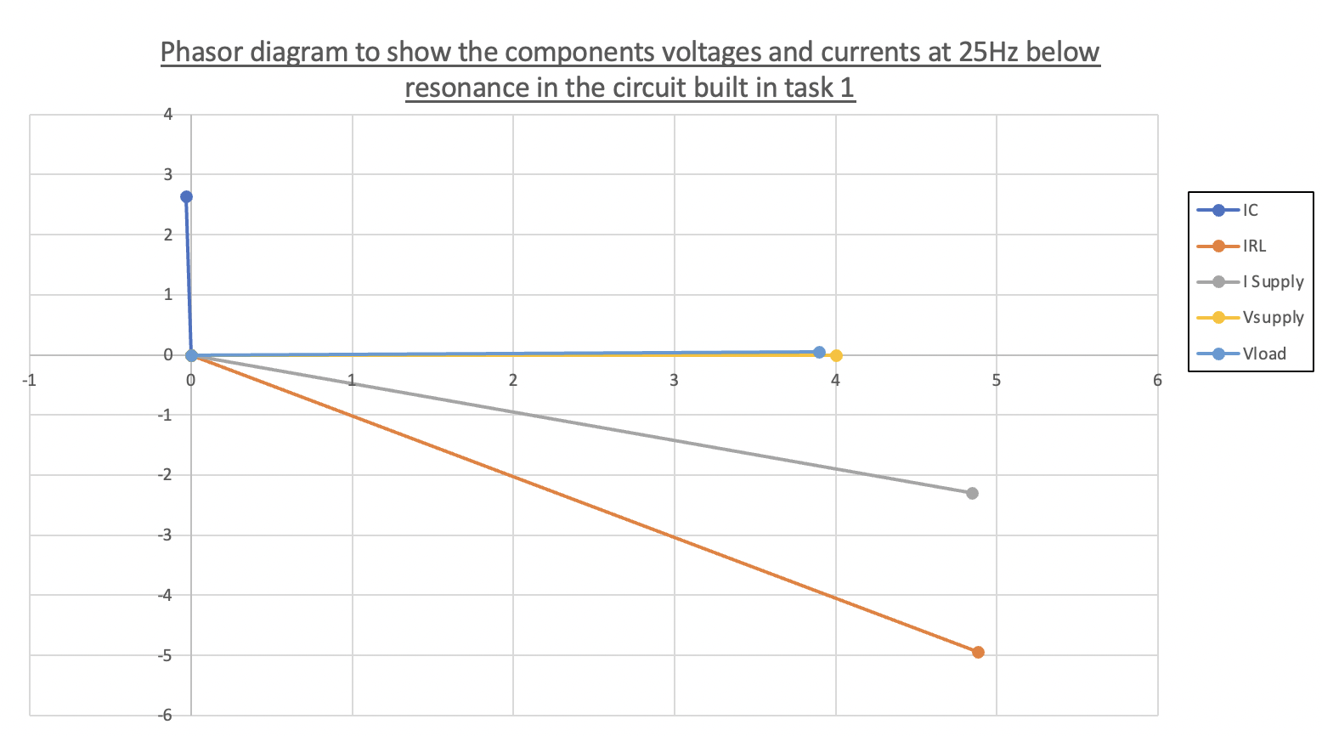
Figure 2.3

The phasor diagram at 25Hz above Resonance was shown in figure 2.4.

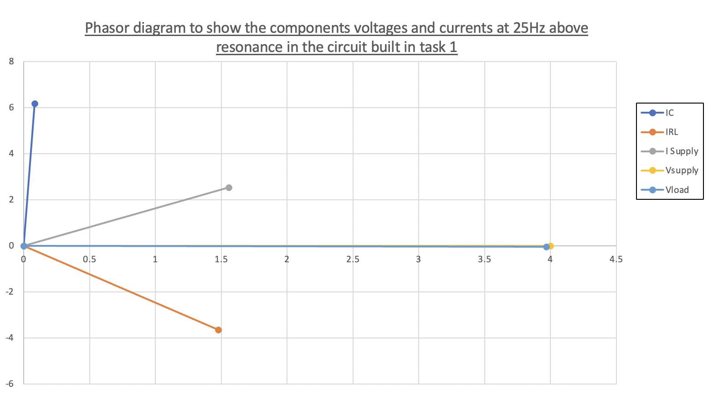
Figure 2.4

The phasor diagram at 50Hz was shown in figure 2.5.

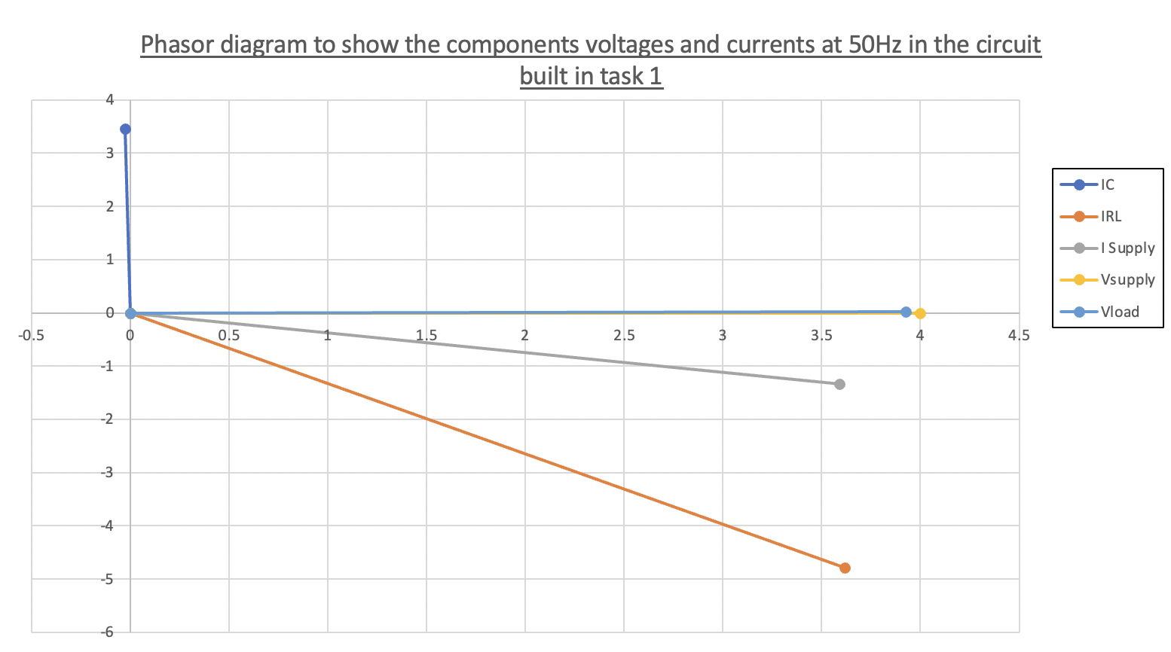

Figure 2.5

Discussion

When the phase angle was first calculated the result was $50.4°$, which showed that the current was going to be lagging the voltage by some bit. The apparent power calculated would be in the negative values as opposed to the positive as shown in the results section due to it lagging. We know the circuit is lagging due to it being a purely inductive circuit and no capacitor added yet to do the PFC. The impedance value to find the current was found taking into consideration the resistance of the source as well as the load.

Working with the new phase angle we could do calculations to find the capacitance needed to give us a power factor of $≥0.95$. The new phase angle was drastically smaller than the original phase angle sitting at $18.19°$, meaning the reactive power would be a lot smaller, and a lot less power wasted. With the change of PF, the reactive current was also decreased from what it was before PFC, which is what pulls the power down the imaginary axis on a phasor diagram. The effect of the capacitor pulling the current towards capacitance was what will cause the smaller phase angle and decreased reactive current + power.

When the power factor is 1 and at its resonance, the energy stored within the capacitor and the inductor oscillates between them both. They both transfer equal energy which causes the circuit to be purely resistive and no energy is lost. The energy is stored within the capacitor as electrostatic energy and is then transferred to the inductor to be stored as magnetic energy. [4]

In the graph shown in figure 2.1 it can be seen how the capacitor value increasing has a positive effect on the power factor up to the resonance. This is due to the circuit being purely inductive before the capacitor is applied, with the capacitor value increasing it pulls the inductive value closer to the capacitance until the capacitive reactance and inductive reactance are equal in magnitude. The impedance of the circuit would then purely just be the resistance. When the capacitor value continues to increase after resonance the power factor then decreases as the circuit becomes capacitive. [5]

With the phasor diagrams that are shown in figure 2.2 to figure 2.5 frequency influences the current of the circuit. As the frequency has an effect on the capacitive reactance and capacitive resistance, the impedance will change depending on the frequency. As shown in figure 3.1, current increases as frequency increases to resonance. After resonance, the current decreases, and the circuit changes from an inductive circuit to a capacitive circuit.

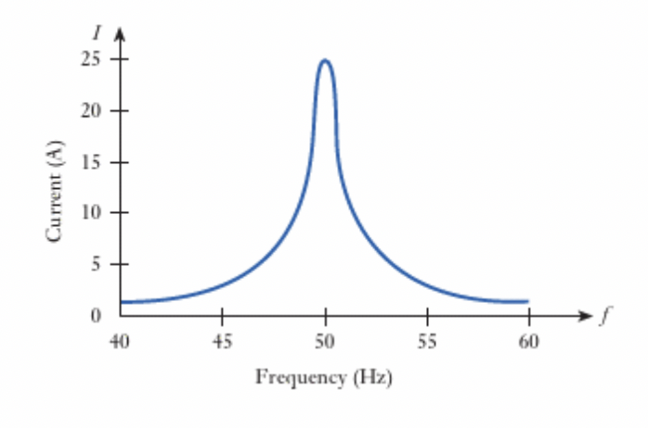

Figure 3.1 [6]

The capacitor value that was calculated to correct the power factor to $≥0.95$ relates to resonance and max power transfer. Due to the capacitor being added to the circuit the current is drawn closer to resonance as the capacitive value’s goal is to even out the inductive load and create a purely resistive load. It is important the right value was calculated to gain a PF of 0.95, which leaves the circuit close to resonance, if the value was too small the PF would’ve been smaller than what was needed, also if the capacitor value was way larger the PF would’ve been smaller than what was needed for resonance and the PF value would’ve started decreasing again. As for Max power transfer, if the capacitor value was too high, the circuit would become purely capacitive, where the phase angle would be increased, and the reactive power would also be increased. The capacitor value would influence the impedance of the circuit, when using an AC system, the max power transferred would be when the impedance of the source and the impedance of the load is equal to one another. If the capacitor value was not correct, the impedances would not be equal to each other, and the max power transfer would be a lot lower than it can be. [7]

Conclusion

The findings in the work within this report painted things more clearly as the theory has been backed up by evidence of using a real circuit and values. It clearly shows the importance of using the correct valued capacitor when trying to do PFC. When the capacitor value is either too much or too little can cause the PF to be lower due to the PF dropping again after resonance.

The importance of applying a capacitor to the load can be seen clearly within the results. With the load being purely inductive, the role of the capacitor is significant to pull the phase of the lagging current closer to the voltage. Vice versa would be if the load were to be purely capacitive, adding an inductor would be the correct thing to do to ensure maximum power.

With the PFC applied and max power transfer taken into consideration in AC circuits, it can be assured that the maximum power can be used to drive the load with no power wasted. It is crucial for companies to ensure that the PF of their loads within the business are suitable for the sake of their finances and the environment, among other things. This report has demonstrated that clearly with evidence to back the claims.

References

[1] | J. Ware, “Power Factor Correction (pfc),” Spring 2006.
[2] | S. mosey, “Power Factor Correction 2020,” UWTSD, 2020.
[3] | P. f. explained, “The engineering mindset,” [Online]. Available: https://theengineeringmindset.com/power-factor-explained/. [Accessed 10 04 2022].
[4] | J. K. a. I. S. E.Hughes, “Oscillation of energy at resonance,” in Hughes electrical & electronic technology, Harlow: Pearson, 2016, p. 309.
[5] | J. H. K. B. a. I. M. S. E. Hughes, “Frequency variation in a series RLC circuit,” in Hughes electrical & electronic technology, twelfth edition, Harlow: Pearso, 2016, p. 304.
[6] | J. H. K. B. a. I. M. S. E. Hughes, “Variation of current with frequency for circuit of Example 14.1,” in Hughes electrical & electronic technology, Twelfth edition, Harlow: Pearson, 2016, p. 308.
[7] | S. Mosey, “Max Power Transfer,” UWTSD, 2022.

