Student Id 1807243
Level 6: Psychopathology (ECAP6006)
Prepare and present a 15 minute PowerPoint rehabilitative proposal for an anxiety disorder of your choice. Your proposal should include the sub-headings – lay summary, background literature, proposed methodology, outcome measures and ethical considerations.
Project Theme:
This rehabilitative proposal has been created to offer sufferers of Social Anxiety Disorder (SAD) an effective treatment to facilitate their return independence, enabling improvements in their general health and wellbeing as well as meaningful participation in everyday life events, whether it be work, recreation, education or other everyday activities.
Project Title:
Rehabilitative treatment Proposal for the Anxiety Disorder ‘SAD,’ adopting a CBT approach using Exposure Therapy with both child and parent, (seeking to relieve anxiety symptoms by enabling adaptive behaviour of affected individuals).
Lay summary of the project:
Social Anxiety Disorder (SAD), also referred to as Social Phobia, is one of the most common anxiety disorders experienced by young people. This neurobehavioural trait is commonly characterised by reticence and fear in social situations (Craske et al., 2016). The defining characteristics of SAD as defined by DSM-5, (American Psychiatric Association, 2013) is anxiety in social situations, where fear of being scrutinized by others or fear of negative evaluation results in symptoms such as excessive blushing, sweating or trembling, leading to avoidance of social interactions and spaces with large gatherings (Beidelet al.,2007, Rao et al.,2007). With average onset of around 9 years of age (Burstain et al., 2011), there is a real need to introduce interventions to prevent persistence of the condition in adulthood, as evidence has shown where untreated, onset prior to 11 years of age can perpetuate through later years (Beesdo et a., 2007, Wittchen and Fehm, 2003) contributing to a plethora of negative psychological social consequences (Beidel, Turner & Morris, 1999) including depression, lowliness, friendship problems. SAD is also often associated with acceleration to comorbid conditions including major depression and drug abuse (Stein & Stein, 2008).
Evidence has shown that Exposure therapy (ET), following the Pavlovian Extinction Model, is one of the most effective treatments for SAD. Extinction therapy is a behavioural therapy technique which encourages individuals to ‘face their fears,’ seeking to reduce previously conditioned (negative) responses by repeatedly exposing individuals to aversive stimuli in a controlled environment with positive outcomes, until such time that the patients’ previous negative thoughts are no longer associated with their exposure in a given setting.
Exposure therapy is an key component of cognitive-behavioural therapy (CBT) to treat social anxiety disorder and other anxiety based disorders, and can take several forms, by exposure to the memory or image of a feared situation or object, in-vivo exposure (that is exposure to the feared situation or object in real life), or interoceptive exposure (exposure to bodily sensation). More recently virtual reality (VR) has enabled exposure to situations and objects virtually.
Behavioural therapy (a derivation of learning theory), is based on the premis that all behaviours are learned and as such are adaptable and as such reactions and responses can be ‘relearned.’ CBT aims to help affected individuals understand and identify their irrational thoughts along with self-destructive behavioural patterns in order to provide them with the necessary skills and techniques for debunking those irrational thoughts, relieving their symptoms by behaviour adaption.
This hypothetical rehabilitative proposal using CBT Exposure techniques for children and young people with SAD over a monitored 6 week period, along with guardian education has been created with the aim of improving their wellbeing and general health, thus assisting their return to a ‘normal’ childhood liberating them from a lifetime of illness and progression of mental health issues in later life (Beesdo et al., 2007, Black et al., 2015).
Background literature review:
Anxiety is often defined by a more prolonged state of tension, worry, and apprehension regarding uncertain, and potentially negative, future events. (Barlow, 2000) Fear and anxiety serve important evolutionary functions to keep us safe - fear allows us to combat/avoid immediate threats or danger, whereas anxiety increases vigilance and improves our ability to identify uncertain or potential threats. But, anxiety disorders can develop when anxiety or fear is excessive or occurs in the absence of true threat; immediate or future.
Cognitive/subjective level - negative mood, worry about possible future threats or danger, selfpreoccupation, and a sense of being unable to predict the future threat or to control it if it occurs. • Physiological level - creates a state of tension and chronic over-arousal, which may reflect risk assessment and readiness for dealing with danger should it occur. • Behavioural level - create a strong tendency to avoid situations where danger might be encountered, but without the immediate behavioural urge to flee, as there is with fear. (Barlow, 1998, 2002).

In recent years CBT approaches for SAD have followed generic components applicable to treatment of a range of anxiety disorders, such as promotion of relaxation and wellbeing practices, problem solving and identification and adaption of maladaptive thoughts and processes (Barrett et al., 2000, etc…). Whilst a generic approach has been proven to be effective in the adult population (Bennett et al., 2013) positive outcomes for young people with SAD are much less common, with twice as many children still clinically diagnosed with SAD 12 months post commencement of generic CBT ( Hudson, Keers et al ., 2015). 2.5% to 5% of children and adolescents meet criteria for anxiety disorders (Rapee, 2009). Historically, generic treatments have not focused on the behavioural nor cognitive causes of SAD. We know from historic twin studies that anxiety is a developmental disorder with a heritability of 30-40%, (Gross & Hen, 2004) affected by both genes and the environment, whilst the heritability of social phobias is around 51% its basis shared with neuroticism and extraversive traits (Stein et al., 2017) and modelling (observation of anxious behaviour of caregiver). Young sufferers of SAD are more likely than non-anxious youngsters to present with defects in social skills, have less friends, be less liked by peer-groups and are more likely to experience adverse social outcomes like victimization and rejection by other young people. These experiences perpetuate anxious emotions, avoidance and maladaptive practices. There is a high prevaleng of SAD in youngsters who have been abused, abandoned, , overly critized, overindulged and overprotected, Past interventions that have included social skills training have tended to me most effective (Scaini, Belotti, Ogliari and Battaglia (2016) with a 78 % improvements when combined with treatments relating to modifications in self focused and maladaptive cognitions relating to social interactions, simply helping children learn to manage their emotions and develop effective coping skills. Lifetime prevalence: 8-12%.( Ruscio et al., 2008) • More common in women than men. • Role or prior experiences: 92% of adults with social anxiety report to having experienced negative social events in childhood prior to becoming socially anxious.
Past approaches

To summarise, by combining exposure therapy along with education of parental/ guardians, parents can be more aware of how their own anxieties are affecting their children’s development of anxiety disorders. Encouraging parents to discuss when their own anxious actions could be dealt with better, will enable the child to realise that it is perfectly normal to feel anxiety from time to time and encourage them to discuss healthy options when faced with concerns about future social concerns.
Proposed methodology:
The interventions set out here will focus on children between 6-12 years. The initial two stages comprising the assessment process, identification of anxiety by school and/or GP and completion of the APA’s Severity Measure for Social Anxiety Disorder (Social Phobia) a 10-item measure that assesses the severity of symptoms of social anxiety (social phobia) in children and adolescents. The referral must be accompanied by parental agreement. This intervention will be open all genders, socioeconomic and ethnic statuses. All contributors must consent to participation (parent and child) and not participate in additional treatment for the duration of the treatment (in order for assessment of effectiveness of treatment at end of 6 week treatment period).
The treatment schedule is then determined dependent on the needs of the child formulating a set aim or focal point for treatment (Ward, Mann, et al., 2007) incentivising participation by putting the childs’ desired outcome at centre of rehabilitation process.
In this proposal, fear of being centre of attention, solo reading or presenting in class, fear of embarrassment, others noticing anxiety and criticism. Individual to meet with a CBT therapist for a weekly session for 6 weeks, each session lasting between 30-60 minutes. Initial consultation to identify anxiety triggers and unhelpful thoughts: With Therapists’ guidance, child compiles a CBT action list as follows:
Step One – Make A List of anxiety triggers.
- Step Two – List Unproductive Thoughts associated with anxiety tasks
- Step Three – Discuss and Create Replacement Thoughts and suggested actions.
- Step Four – Therapist concurs list with child and reiterates. Copy of list given to child to read over and to parent. Parent to be informed of treatment goals, and given roles to assist and practice for outcome aims.
- Step Five – Action…Phase four of treatment sees the introduction of appropriate measures to support the child in attaining their goals. In this proposal, exposure therapy, relaxation training and diaphragmatic breathing along with relapse prevention plans are instigated.
The final phases of treatment relate to evaluation of outcome and life post treatment. Has treatment been successful? Has the child been able to face their fears and is able to participate in peer group scenarios in the classroom? Identify which stimuli need further development put hypothetical action plans into place to overcome potential obstacles.
All interviews and interventions will be undertaken in the presence of the closest appropriate family member, to ensure child feels supported throughout the treatment stages. Follow-up assessment with be conducted 6 months post treatment.

Primary and secondary outcome measures:
The outcomes measures will explore recidivism in relation to the participants of the GLM interventions, comparing the outcome to the ‘actual recidivism figures’ (as presented through government documents via official statistics published by the Youth Justice Board (Blunt & Millard, 2020)
Recidivism will be calculated by new completion of APA’s Severity Measure for Social Anxiety Disorder (Social Phobia) at conclusion of intervention at 6 weeks.
For the purposes of these studies, a simple ‘yes’ or ‘no’ outcome score relating to recidivism was noted for each accrued charge. Recidivism will be measured four times in all and the FYO’s behaviour will be monitored using the results of the modified Criminal Sentiments Scale. (Simourd, 1997).
The data gathered will be evaluated to reveal the initial influence of the intervention (during and immediately after intervention completion at the 3- and 6-month stages) and any long-term effects (measured after 12 and 24 months respectively comparing participants results with similar offender groups without intervention measures. Consideration should be made for re offending patterns where records have yet to be updated or indeed where the reoffenders have not been caught (Spiranovic et al, 2015).
Main Ethical considerations:
The GLM intervention’s purpose is to maximise benefits to the recipient within an safeguarded framework, as such the integrity and professionalism of the individuals conducting the interviews and transmission and delivery of the intervention is paramount, with strict adherence to the British Psychological Society (BPS) (BPS Code of Human Research Ethics, 2017).

The BPS parameters indicate that the contributors to the study would be categorised as minimal risk as a result of their age and nature of their lawful behaviour. All interviewers should be fully trained professionals in line with the BSP Code of Ethics and Conduct guidelines (2017). However, for offender under 18 years parental or guardian consent must be adhered to. Guardian consent, it should be noted is not a precursor for permission for intervention should the young offender refuse to the intervention measures (Wolbransky, Goldstein, Giallella et al, 2013). All youth offenders are still children and as such treated accordingly.
The expected outputs from this project:

It is expected that post-completion of rehabilitation proposal, participants who fully engaged with the programme, implementing the recommended proposals, will present a departure from offending, will have a low risk of recidivism and positive attitudes against re-offending.

Whilst at present, there is not sufficient peer-reviewed proof to confirm explicitly the efficacy of the GLM, it is believed that the employment of strength-based endowing approaches, such as the GLM among YFOs, complements traditional and issue-oriented risk management methods, such as the RNR model.

A continually standardising dialogue between female offenders, researchers and practitioners is essential to a successful outcome in rehabilitation processes. To that end the GLM is ethically, clinically and etiologically relevant; as well as easily applied and particularly appropriate to this population demographic. More research on these adolescents would undoubtedly be appropriate and a reminder to clinicians that this young offender group would aim ultimately for improved and meaningful lives, not just empty promises of less destructive ones (Ward, et al., 2007).

Word Count: 2,585

CBT is one of the most effective treatments for GAD. There are several ways you may be offered self-help and CBT: you work through a CBT workbook or computer course in your own time. you work through a CBT workbook or computer course with the support of a therapist who you see every 1 or 2 weeks.

Treatment - Generalised anxiety disorder in adults - NHS

What is the new treatment for generalized anxiety disorder?
The FDA has approved a phase 2b study of an optimized form of LSD for the treatment of anxiety. The drug, called MM-120, is being developed by MindMed and is intended to treat generalized anxiety disorders and other mental conditions. MindMed is expected to begin clinical trials in 2022.13 Jul 2022

Anxiety disorder: Current treatments and what's on the horizon | MDLinx
mdlinx.com
https://www.mdlinx.com › article › anxiety-disorder-curr...

Search for: Wh
How do you live with GAD?
Making Lifestyle Changes and Healthy Habits
- Eating a healthy diet.
- Getting adequate exercise and maintaining a healthy weight.
- Avoiding smoking, alcohol, and drugs.
- Getting enough high-quality sleep.
- Spending time doing enjoyable and relaxing activities.
- Taking time to be alone and reflective.
- Being more socially engaged.

Living With Generalized Anxiety Disorder - Bridges to Recovery

Craske, M., Stein, M. B., & Hermann, R. (2016). Psychotherapy for generalized anxiety disorder in adults.
Ruscio, A. M., Brown, T. A., Chiu, W. T., Sareen, J., Stein, M. B., & Kessler, R. C. (2008). Social fears and social phobia in the USA: results from the National Comorbidity Survey Replication. Psychological medicine, 38(1), 15-28.
Stein, M. B., Chen, C. Y., Jain, S., Jensen, K. P., He, F., Heeringa, S. G., ... & Army STARRS Collaborators. (2017). Genetic risk variants for social anxiety. American Journal of Medical Genetics Part B: Neuropsychiatric Genetics, 174(2), 120-131.
Stein, M. B., & Stein, D. J. (2008). Social anxiety disorder. The lancet, 371(9618), 1115-1125.

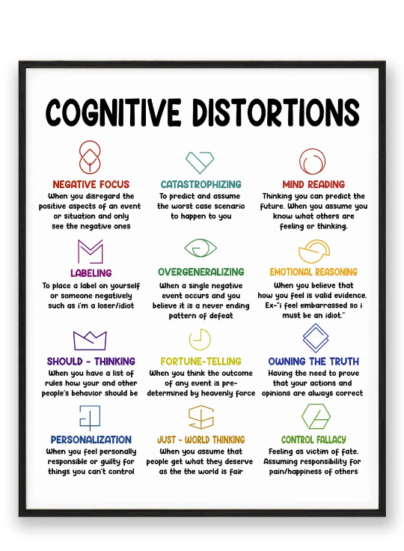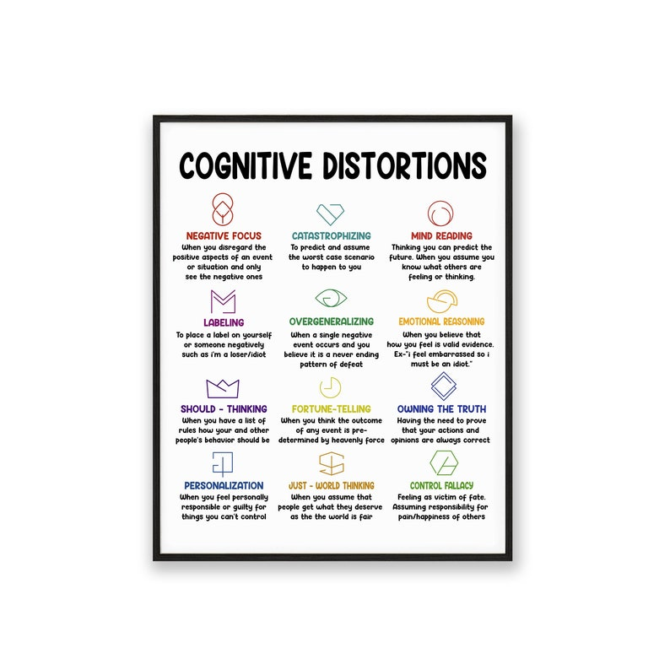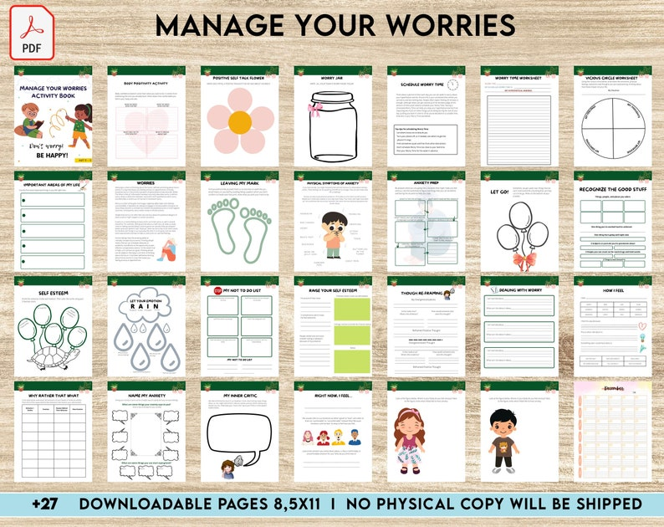

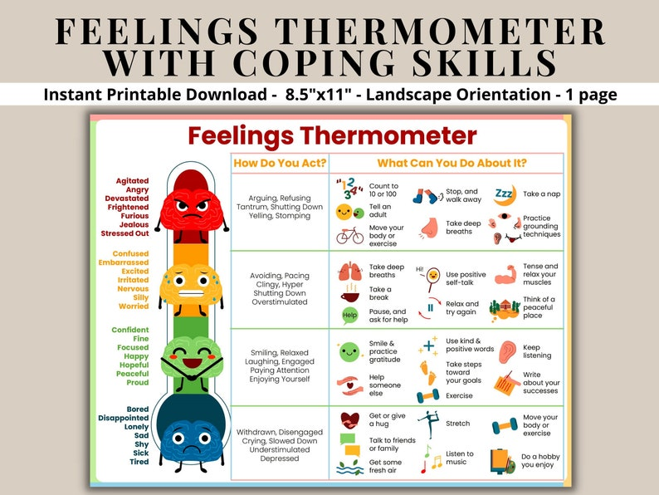
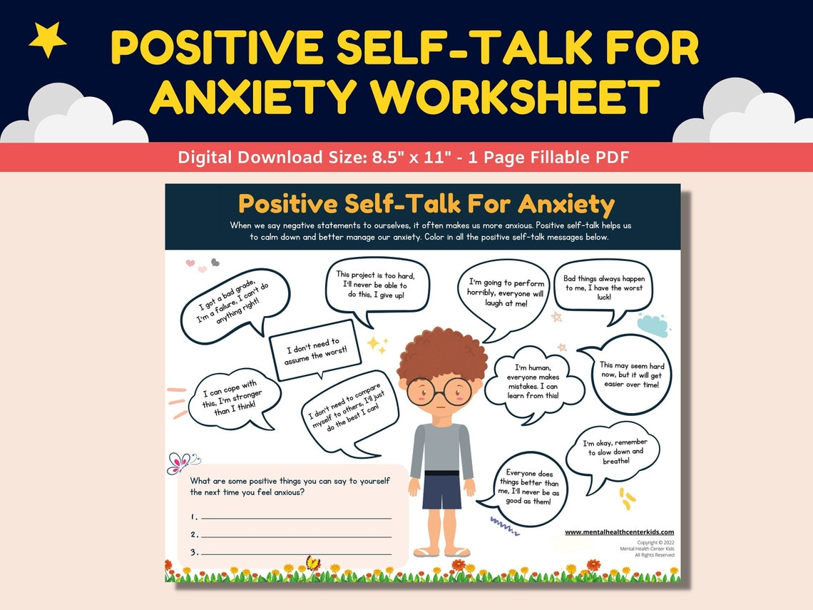

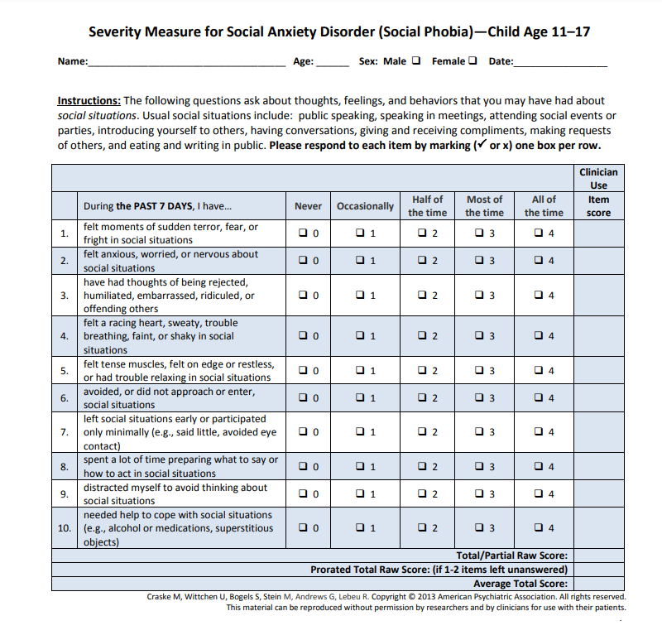

Instructions to Clinicians The Severity Measure for Social Anxiety Disorder (Social Phobia)—Child Age 11–17 is a 10-item measure that assesses the severity of symptoms of social anxiety (social phobia) in children and adolescents. The measure was designed to be completed by the child upon receiving a diagnosis of social anxiety disorder (or clinically significant social anxiety symptoms) and thereafter, prior to follow-up visits with the clinician. Each item asks the child receiving care to rate the severity of his or her social anxiety disorder (social phobia) during the past 7 days. Scoring and Interpretation Each item on the measure is rated on a 5-point scale (0=Never; 1=Occasionally; 2=Half of the time; 3=Most of the time, and 4=All of the time). The total score can range from 0 to 40, with higher scores indicating greater severity of social anxiety disorder (social phobia). The clinician is asked to review the score of each item on the measure during the clinical interview and indicate the raw score for each item in the section provided for “Clinician Use.” The raw scores on the 10 items should be summed to obtain a total raw score. In addition, the clinician is asked to calculate and use the average total score. The average total score reduces the overall score to a 5-point scale, which allows the clinician to think of the severity of the child’s social anxiety disorder (social phobia) in terms of none (0), mild (1), moderate (2), severe (3), or extreme (4). The use of the average total score was found to be reliable, easy to use, and clinically useful to the clinicians in the DSM-5 Field Trials. The average total score is calculated by dividing the raw total score by number of items in the measure (i.e., 10). Note: If 3 or more items are left unanswered, the total score on the measure should not be calculated. Therefore, the child should be encouraged to complete all of the items on the measure. If 1 or 2 items are left unanswered, you are asked to calculate a prorated score. The prorated score is calculated by summing the scores of items that were answered to get a partial raw score. Multiply the partial raw score by the total number of items on the Severity Measure for Social Anxiety Disorder (Social Phobia) (i.e., 10) and divide the value by the number of items that were actually answered (i.e., 8 or 9). The formula to prorate the partial raw score to Total Raw Score is: ___________(Raw sum x 10)______________ Number of items that were actually answered If the result is a fraction, round to the nearest whole number. Frequency of Use To track changes in the severity of the child’s social anxiety disorder (social phobia) over time, the measure may be completed at regular intervals as clinically indicated, depending on the stability of the child’s symptoms and treatment status. Consistently high scores on a particular domain may indicate significant and problematic areas for the child that might warrant further assessment, treatment, and follow-up. Your clinical judgment should guide your decision.

