

An investigation in to Piezoelectric Energy Harvesting and Potential Implementations

By Daniel lennon

Supervisor: Steve Mosey
Second Marker: Gareth Jones
Report submitted as requirement for the award of BEng Computer Systems and Electronics
April 2018
Level 6

DECLARATION

I, ............................................………………………………… declare that I am the sole author of this Project; that all references cited have been consulted; that I have conducted all work of which this is a record, and that the finished work lies within the prescribed word limits.

This work has not previously been accepted as part of any other degree submission.

Signed: .............................................

Date: ...............................................

FORM OF CONSENT

I ............................................………………………………… hereby consent that my Project, submitted in candidature for the BEng Computer Systems and Electronics degree, if successful, may be made available for inter-library loan or photocopying (subject to the law of copyright), and that the title and abstract may be made available to outside organisations.

Signed: .............................................

Date: ...............................................

2. Abstract.
The purpose of this project was to investigate, through the use of experimentation and research, the potential uses of a piezoelectric material as an energy harvesting device. Many different types of piezoelectric material exist but due to time and financial restrictions only lead zirconate titanate (PZT) transducers were tested. The proposed use of this type of transducer was to be incorporated in to a step set up, utilizing the energy released from a person’s footsteps to potentially power LED’s which would illuminate the step when being used and then fade off when stepped off of. Early on in this investigation it was discovered that the test setup developed would not provide enough power to complete the desired task. It was, however decided that testing should continue so that calculations could be made to determine how much energy could be generated in a larger, more task oriented environment and the microcontroller based LED set up was simulated to help determine the actual power needed to perform this task and show an understanding of the use of a microcontroller. Several other projects based around this type of energy harvesting technique have been reviewed and discussed in this paper and comparisons have been made based on the results provided by each one. Possible alternative uses for this type of energy harvesting will be discussed and the potential to incorporate additional harvesting methods in to a single, hybrid system is suggested.

Table of Contents
2. Abstract. 3
3. introduction. 6
4. background research and literature review. 8
4.1 Piezoelectric shoes. 8
4.2 Battery charging and device powering using piezoelectricity. 11
4.3 Existing products. 14
5. Materials used and experimentation methods. 16
5.1 Materials used. 16
5.2 Initial experimentations. 17
5.3 Development of a full-bridge wave rectifier. 18
5.4. Testing various circuit configurations. 19
6. Microcontroller based LED lights for steps. 24
6.1 Pulse Width Modulation. 24
6.2 PWM simulation. 24
6.3 Software code for PWM incorporation. 26
7. experimentation results. 28
7.1 initial results. 28
7.2 final results. 29
8. conclusions and recommendations. 34
9. reflection. 35
10. References. 36

3. introduction.
Energy harvesting has become an increasingly popular area of study in recent years. For this project the concept of using piezoelectric materials to generate a sufficient amount of usable energy was investigated. Piezoelectricity was first discovered in 1880 by Pierre and Jacques Curie two French physicists. They discovered that when pressure was applied to certain types of crystals, including quartz, topaz, cane sugar, Rochelle salt, and tourmaline the mechanical strain resulted in an electric potential being created. This effect became known as the direct piezoelectric effect. The following year a mathematician named Gabriel Lippman theorised that there should be an inverse effect meaning that if an electrical field was applied to the material it would deform in response. This theory was quickly tested and proven by the Curie brothers leading to the discovery of both the direct and indirect piezoelectric effect [1]. At this time, although an interesting discovery, there were not many practical applications as the amount of electrical potential generated was extremely small.
The first major practical implementation of this technology took place during World War I. In 1917 P. Langevin and his co-workers in France began to develop an ultrasonic submarine detector using the inverse piezoelectric effect. This was achieved after the war and sparked an increase in the research and development of piezoelectric materials [2].
With the increase of interest and research in the area, better synthetic materials were created which produced more useful levels of electrical potential than those found in organic materials. In society today because of our increasing development of low power consumption devices many areas of technology are now incorporating the use of piezoelectricity. It can be found in a multitude of industrial applications such as engine sensors, pressure sensors and sonar equipment. Its use can also be found in a variety of medical applications such as ultrasonic imaging and low power medical implantations. Even a wide variety of consumer electronics contain piezoelectric elements such as mobile phones, electric toothbrushes and speakers [3].
Although certainly a major part of some technologies, the power generated from piezoelectric transducers is still thought to be too small to be used as a main power supply for any but the smallest devices. This investigation aims to discover if, given the right application and implementation, multiple transducers used in conjunction with each other could potentially harvest enough energy to be used in a practical way. This will be achieved through connecting multiple transducers in different configurations to discover which way provides the highest energy output and then taking those results and determining in what situations the energy harvested could potentially be used.

4. Background research and literature review.
The concept of energy harvesting is not a new one, people have been harvesting environmental energy for as long as 5000 years with the first documented uses of water wheels and windmills dating back to around 4000 B.C [4]. These technologies continued to spread and improve over the centuries and in modern day the amount of energy that can be harvested from the wind through the use of windmills is increasing rapidly. According to statistics provided by Windeurope.org in 2016 almost 300 TWh where generated by wind power covering 10.4 % of the EU’s electricity demand for the year [5].
While wind and solar energy harvesting are the most dominant areas of expansion in this field, an increasing number of studies and investigations are being conducted in the area of kinetic energy harvesting, namely piezoelectric energy harvesting. In this following section some of these studies and investigations will be reviewed and compared in order to help obtain relevant information that could aid in the development of a successful system for converting ambient kinetic energy in to a usable form.

4.1 Piezoelectric shoes.
When research was started on the possible implementations of using piezoelectric materials as a power source, multiple reports and investigations on piezoelectric shoes were found. The first example of this was developed by the English inventor Trevor Baylis. Baylis is best known for inventing the wind-up radio in 1991. This invention was inspired by the aids epidemic spreading across Africa and the inability for those in the poorer most affected areas not having enough resources or electricity to properly communicate with, and educate each other. This invention didn’t spark much interest with society until it was featured on the TV show Tomorrows World in 1994 where it managed to gain financial backing and swiftly went in to production gaining Baylis the BBC Design Award for Best Product and Best Design in 1996 [6]. Following this invention, in 2001 he demonstrated his next invention, dubbed “Electric Shoes,”. By walking 100 miles across the Namib Desert whilst raising money for charity he tested his product, which allows the wearer to use his own walking power to charge a small battery for operating a radio transceiver or cell phone. This was achieved by placing piezoelectric elements in to the sole of the shoe and then using the energy created while walking to trickle charge a phone battery. Baylis and his partner for this expedition and experiment, John Grantham claimed that the shoes could generate between 100 and 150 mW of power per step. This was demonstrated at the end of their trek when Baylis used the phone he had been charging to contact British entrepreneur Richard Branson, head of the Virgin empire [7]. Although there was interest shown by both the US and UK militaries in commercializing this design, nothing has since happened.
Since Baylis’s demonstration of this technology there have been several other attempts at creating similar designs with reported levels of success. In 2014 a paper was submitted to the Indian Journal of Science and Technology titled Charging an Electronic Gadget using Piezoelectricity, written by J. John Livingston and M. Hemalatha from the School of Computing, SASTRA University, India. In this report different types of mechanical energy harvesters were discussed and their final design was shown. This design placed small piezo transducers in the heel and ball of a shoe and the voltages produced were converted from an AC Waveform to a DC output using a bridge rectifier and a smoothing capacitor connected to the mobile phone battery. In the report it is claimed that the experiment was successful although no actual data was recorded to demonstrate how much power was generated [8].
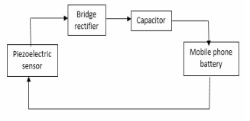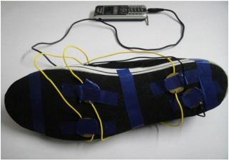
Figure 1. piezo shoe block diagram. Figure2. Shoe design.

In another report produced by Joses Paul P et al. from the Jeppiaar Engineering College
Chennai, India, a similar but more advanced approach was taken. The paper entitled ‘Project Power Shoe: Piezoelectric Wireless Power transfer – a mobile charging technique’ incorporates a similar use of the piezoelectric generators and rectification circuit but also includes wireless transmission of the electricity generated from the shoe to a mobile phone. This design consists of two units, Generation - transmission unit and receiver - charging unit. The Generation - Transmission unit side consists of the Piezo electric generator, a capacitance bank, an oscillator and a transmitter unit all integrated inside of the shoe. The receiver and charging unit consists of a capacitance bank, a rectification circuit and a charging circuit. This could be either designed independently of the mobile phone or embedded inside of it. The receiver receives the power which is converted to a DC supply using the rectification circuit and the output is then fed to the battery of the mobile phone through the charging circuit. Wireless power transfer has been an area of study since the beginning of the 20th century and in recent years with the increase in mobile technologies and reduced power consumption in these devices the research and development of such methods has greatly increased [9]. In this design the technique used for transferring the energy is called Evanescent Wave Coupling. This method Is an extension of the principles of electromagnetic induction. Electromagnetic induction works on the principle of a primary coil generating a predominant magnetic field and a secondary coil being in that field so that a current is induced within its coils. This causes a shorter range of transmission due to the amount of power required to produce the electromagnetic field [10].
As with the previous report this one claims to have been successful in its operation but again actual recorded data is not included within the report.

4.2 Battery charging and device powering using piezoelectricity.
Other reports that have been reviewed discuss charging batteries or powering devices using piezoelectric generators but through alternative methods rather than the use of footsteps as the two previous examples demonstrated. The next report reviewed was entitled the use of piezoelectric energy harvesting devices for charging batteries, was produced by Henry A. Sodano, Gyuhae Park, Donald J. Leo and Daniel J. Inman from the Centre for Intelligent Material Systems and Structures Virginia Polytechnic Institute and State University Blacksburg, VA. This report compares two different piezoelectric materials, monolithic piezoelectric (PZT) and Macro Fibre Composites (MFC), the later having recently been developed at the NASA’s Langley centre. The experiment used both types of materials subjected to vibrations comparable to those of a car’s engine, passed through a rectification circuit and smoothing capacitor to charge nickel metal hydride batteries ranging from 40mAh to 1000mAh and comparing the results. It was discovered that while the MFC had a voltage far larger than the PZT, the power produced was much less. This was because of the construction of the MFC which uses piezo fibres and interdigitated electrodes. Because MFC is constructed in this way the segments of piezoelectric material between each electrode can be considered individual, small power sources. These small power sources are connected to one another in series which creates a much larger voltage but does not increase the current produced. When two power sources are connected in series the voltages add but the current does not. The results recorded show that the MFC, unless subjected to a much higher signal than the PZT cannot sufficiently charge a battery. The PZT however when two signals were applied and used to charge the batteries showed usable results. The first signal was the resonance signal of the PZT at 50 Hz and the second was a random signal ranging from 0-500 Hz. The resonance signal was applied at 0.8 volts peak and the random signal was applied at 1.0 volts RMS.
The reason for a Lower voltage signal when at resonance was to avoid over straining the PZT.
Results showed that both at resonance and when subjected to the random signal, the batteries charged at reasonably similar rates. Below is a chart depicting the results obtain during this investigation highlighting the fact that PZT does have the potential to recharge a NiMH battery [11] .
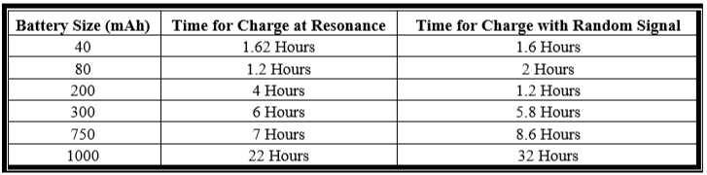
Figure 3. Battery charging results.
In a following report by the same authors, Comparison of Piezoelectric Energy Harvesting Devices for Recharging Batteries, the same experiments with PZT and MFC are performed with the introduction of a third component a bimorph Quick Pack (QP) actuator. As in the previous experiments the MFC produced a high voltage but extremely small amount of current and was subsequently unable to charge any of the batteries unless an unrealistically high excitation signal was used. The QP actuators piezoelectric element is not mentioned in the report but from additional research it is believed that PZT is the material used in its construction. As the MFC was unable to perform to the desired levels the following comparison chart presented in the report only compares the PZT and the QP.
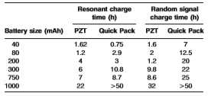
Figure 4. PZT vs QP battery charging results.

From these results in can be seen that the PZT performs better when subjected to the resonant and random signals [12]. These results and the results from the previous report offer encoraging information with regards to the capabilities of a piezoelectric generator to produce enough power to successfully power some kind of small electronic device.
In another report that was reviewed, the concept of using piezoelectric generators in the decleleration strips on roads was proposed. Shi Rui, Huang Lixiao and Yang Chenxiao claim, in their paper The Electricity Generation System Based on Piezoelectric Ceramic Applying on Road Deceleration Strip, that when 200 piezoelectric plates were placed in parallel with each other and subjected to the the equivilent pressure of a mid-size vehicle, this form of generator could produce around 0.002Wh [13]. In this report the authors investigate using the piezo elements in both a series and parellel configuration, claiming that for the highest possible power generation a parellel configuration worked best. These results again are encouraging as they also support the belief that this type of energy harvesting system can produce useable quantities of power.
In another report that was reviewed a broader view of energy harvesting techniques was discussed. In, a comparison of power harvesting techniques and related energy storage issues, Justin R. Farmer not only discusses piezoelectric energy but also thermoelectric, photovoltaic and electromagnetic energy harvesting. Also included within this report were the result obtained from several different experiments conducted attempting to discern viable ways of storing the energy produced from certain harvesting systems. Unlike the previous papers that have been reviewed, in this paper it is determined that, although a reasonable amount of energy can be produced from a piezo harvester, the ability to charge even the smallest batteries is a challenge that would need to be adressed before a more viable mobile energy harvester could be designed [14].

4.3 Existing products.
As previously mentioned the use of piezoelectric materials can be seen across many, varied areas of technology, one company that is already implementing a technology that reportedly incorporates piezoelecrtic materials in to energy harvesting floor tiles is a company named Pavgen. Pavgen is a british company that was founded in 2009 by Laurence Kemball-Cook a graduate in Industrial Technology and Design from Loughborough University. The actual technology used in the tiles is not available for pubic viewing but it is described as using electromagnic induction and piezoelectric materials to produce energy. the company has had several different instalations over the last few years demonstrating the technology, Bestival in 2011 was the first major event where the company demonstrated the tiles. The company claim to have recorded over 250,000 footsteps that produced enough power to charge over 1000 mobile phones. In 2012 for the London Olympics the company installed 12 floor tiles at Westham train station that powered 12 LED floodlights lighting the walk way to the stadium, this instalation gained the company quite a large amount of publicity and subsiquently gaining them a significant amount of investment [15], [16]. In 2015 the company was reported to be worth 17 million pounds [17]
From the reports that have been reviewed it can be seen that the study and development of energy harvesting techniques is continuing to grow and that these technologies are becoming more useful as the power consumption of devices is decreasing. Although these technologies are becoming a more popular area of study, the methods of storing the energy produced are still in need of improvement. From the results that have been seen it can be surmised that the use of piezoelectric generators for harvesting energy can and does work, the challenge is finding ways to implement this type of technology that will maximise the amount of usable energy that can be generated from the many, varied ways in which kineticenergy is wasted. The idea that several different types of harvesting techniques could be combined to create more efficient systems has been suggested and the research and development in to this area continues to grow. In 2014 at a conference sponsored by market research firm IDTechEx, held in Santa Clara, California, analiysts predicted that the energy-harvesting industry is projected to grow to US $2.6 billion by 2024 [18], this is further confirmation that this area of research and development is increasing in popularity and will continue to grow, hopefully to the point where the use and need for energy produced from non reusable sources such as fossil fuels will become obsolete.

5. Materials used and experimentation methods.
In this section the materials used for this investigation will be described and the reasons for using them will be explained. In addition, the different methods of testing the transducers will be explained and justified, leading to the final iteration of the test setup that was used to develop the final calculations of power that could potentially be produced from implementing a similar system on a much larger scale and in a more task oriented environment.

5.1 Materials used.
Although as previously mentioned there are many different types of piezoelectric materials available, for this investigation, mainly due to financial restrictions and availability, basic 27mm PZT piezo elements were used. These were purchased from CPC online at a price of approximately 35p per element.
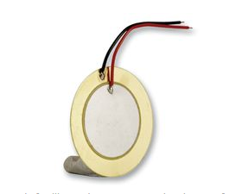
Figure 5. Piezoelectric element.
The only other components that were necessary for this investigation were diodes to build the rectification part of the circuit and different value capacitors for smoothing and as a way to measure the produced voltages for calculations.

5.2 Initial experimentations.
To begin with this investigation, it was decided that testing a single of the piezo elements was the first logical step. To do this a simple set up of the element connected to a voltmeter was used.
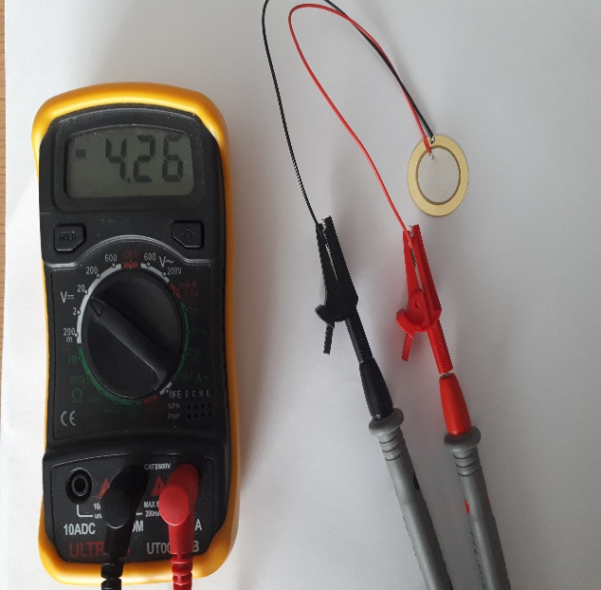
Figure 6. First setup of experiment.
The results seen when experimenting with this setup showed that just by tapping the element when placed on flat surface voltages of up to +/- 5v could be produced. From previous research of other projects and their results, higher voltages had been expected. Because of this the setup was adjusted slightly and the piezo element was placed slightly elevated from the surface so that when it was pressed the disc would flex slightly.
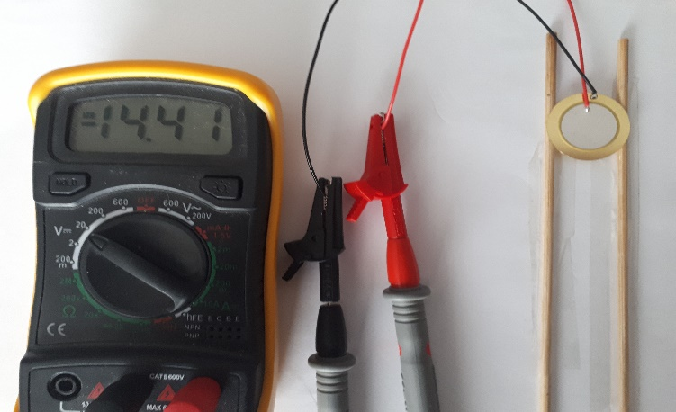
Figure 7. elevated element in first setup.

After this change in the setup, the voltages that were observed reached up to +/- 20v. this was more in line with the results observed in other experiments and what was expected. The next step in the expeimental process was to observe the voltages that could be obtain once a rectifier was attached to the piezo element.

5.3 Development of a full-bridge wave rectifier.
In order to convert the AC signal produced by the piezo element to a more usable DC voltage, a rectifier was built. A full wave bridge rectifier is designed using four diodes and a smoothing capacitor. When an AC signal is in the positive half of its cycle it passes through the two diodes D2 and D1, when it is in its negative half of the cycle it is directed through the other two diodes, D4 and D2 as shown in the following diagrams.
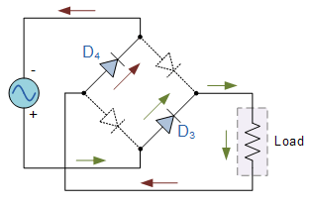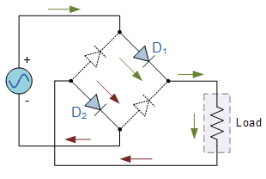
Figure 8. Negative half cycle. Figure 9. Positive half cycle.
The configuration of diodes in this way means that both the positive and negative cycles of the input signal, on the output of the diodes are of the same polarity.
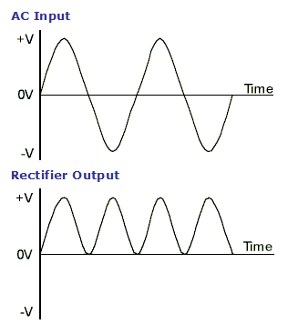
Figure 10. Example signals of input and output of rectifier
As can be seen in diagram 8, the output wave form of the rectifier is now positive but pulsating. To help fix this issue a smoothing capacitor is included in the circuit, this capacitor charges on each rising edge of the waveform and discharges on the falling edge creating a more DC like voltage.
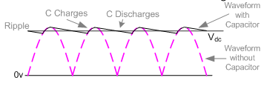
Figure 11. Effects of smoothing capacitor on wave form.
When designing the bridge rectifier, it was necessary to take in to consideration the voltage drops across the diodes. In either half cycle of the AC signal 2 of the diodes are in active use so the voltages lost across them must be considered. A typical diode has a forward voltage drop of between 0.6v up to 1.7v, when this was considered it was decided that this could potentially be too high so the idea to use Schottky diodes was decided upon. A Schottky diode has a much lower forward voltage drop, typically between 0.15v and .45v. This lower voltage drop helps to provides better system efficiency and a higher switching speed [19].

5.4. Testing various circuit configurations.
After building the rectifier it was attached to one of the piezo elements and using a multimeter the rectified voltages were observed.
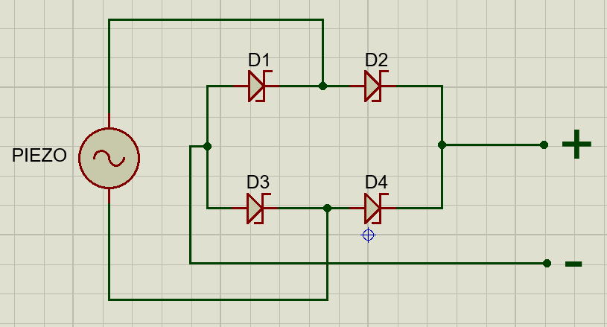
Figure 12. Single piezo with rectifier.
Once the circuit shown above had been built and the achievable voltages recorded, it was decided that the next step was to see how the circuit would react with two piezo elements connected both in series and then in parallel. Basic electronics principles dictate that when two or more power sources are connected in series, the voltages will add but the current will be that of the lowest value source. Conversely, if two or more sources are connected in parallel the current combines and the voltages will average out [20].
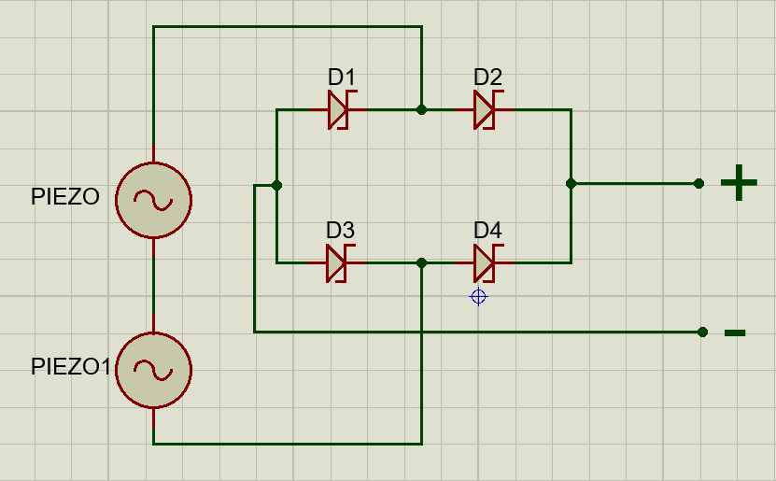
Figure 13. Series connection.
Figure 13 is a circuit diagram showing the way that the two piezo elements were connected in series for testing purposes. The voltage was measured in this set up and when compared to that of the single piezo element were not what had been expected (actual recorded result will follow in the results section of this report).
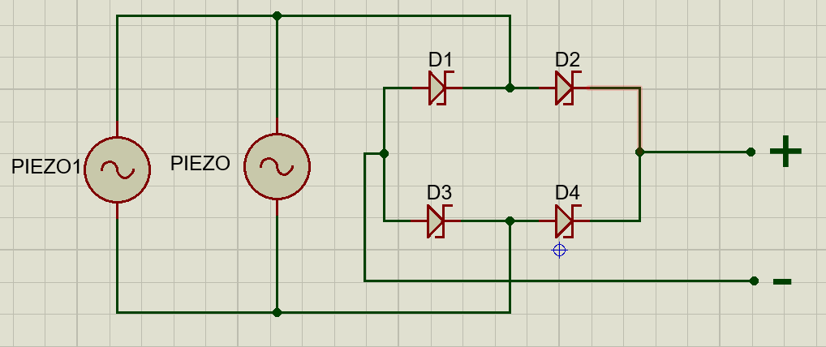
Figure 14. Parallel connection
Above is a circuit diagram showing the way that the two piezo elements were connected in parallel for testing purposes. The voltage and was measured in this set up and like the series connection, the observed voltage readings were not what had been expected
Both these tests were then performed on an arrangement of four elements after rectification in both parallel and series configurations and the results were recorded.
At this point, based on the testing that had been carried out and the results obtained from similar experiments, it was decided that the best configuration for the piezo elements was to be placed in parallel with each other. The main concern with using this configuration was the ability to keep all of the elements in phase with each other. If the signals were not in phase with each other they could have potentially cancelled each other out, wasting any potential energy being harvested. In order to ensure that each of the elements were in phase with each other, a way to make sure all of the piezo elements were depressed at exactly the same time needed to be devised. The way chosen to do this was with an arrangement like the one in the following diagram. 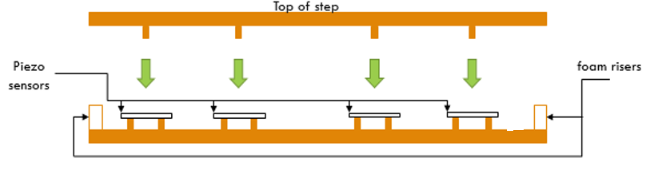
Figure 15. test setup.
In this arrangement each of the piezo elements were slightly raised in order to allow for a small amount of flexing and foam risers were attached at the sides to allow for the top of the step to rest just above the piezo elements. This setup was made with four piezo discs placed inside in order to check that they would all be depressed at the same time and were in phase with each other. This was done by attaching the piezo discs to an oscilloscope and observing the results.
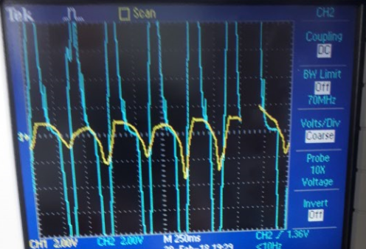
Figure 16. oscilloscope readings.
As can be seen in figure 16, although the voltages are different they are in phase with each other, because of this it was believed that it would be possible to go ahead with the arrangement of parallel piezo elements.
The final arrangement was designed to ensure that all the piezo elements were pressed simultaneously, that they were all positioned at the same height from the base of the step and that they were wired in parallel. To do this it was decided that a ceramic floor tile would work best as the base and lid of the design. This was chosen because it would allow for absolutely no flexing in the top when stepped upon. Pieces of Wood of varying thicknesses were originally tested but it was discovered that unless extremely thick and heavy, there would still be a small amount of flexibility in the wood which would mean that when stepped upon, the weight would not be evenly distributed between all of the piezo elements, limiting the overall effectiveness of the system.
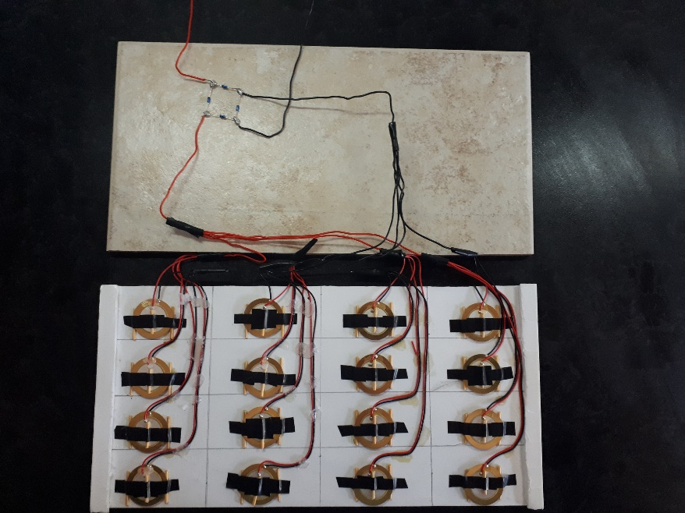
Figure 17. final setup.
The floor tile used measured 30cm by 15cm and contained 16 of the piezo elements in four rows of four. Each of the piezo discs are elevated by two small pieces of wood and the same sized piece of wood was placed across the centre of each of the elements to help maximize and uniform the flexing of each of the elements. Finally foam strips were attached to each side of the tile, just higher than the level of the pieces of wood that had been attached to the piezo elements. This allowed for the piezo discs to return to their natural state providing the widest possible voltage swings whilst reducing the risk of damaging them.
Once completed, before and after the rectifier was added the voltages were observed and recorded.

6. Microcontroller based LED lights for steps.
The proposed design for utilizing the power produced from the piezoelectric harvester was for lighting on stairs. The idea was that the piezoelectric harvesters built in to the steps would, during daylight hours, trickle charge some kind of battery or capacitance bank that would in turn power LED lighting fitted in to the back of each step during low light and night times. it was determined that the best and most economical way to implement this design would be using high luminosity LED’s in conjunction with a microprocessor with PWM capabilities.

6.1 Pulse Width Modulation.
Pulse Width Modulation (PWM) is a technique for getting analogue results using digital signals. Digital pulses can be used to create a square wave, a signal switched between on and off. This on-off pattern can simulate voltages in between fully on and off by changing the portion of time the signal spends on versus the time that the signal is off. The duration of time the signal is on is called the pulse width. To get varying analogue values, you change, or modulate, that pulse width. If you repeat this on off pattern fast enough with an LED the result appears as if the signal is a steady voltage between 0 and the nominal ‘on’ voltage, controlling the brightness of the LED [21]. For this project the purpose of using PWM is to create the effect of the LED lights fading out over a set period of time after a person steps off the step.
Due to time constraints, and the fact that the test setup could not produce enough power to operate the microcontroller or the LED’s, this portion of the design was only simulated to demonstrate the PWM capabilities, and calculations were made to approximate the power needed to perform the desired task.

6.2 PWM simulation.
For the purpose of demonstrating the capabilities of the PWM function, a basic circuit was simulated. The circuit consists of two LED’s and two buttons. The buttons represent the pressure switches that would be used to trigger the microcontroller to illuminate the LEDs and start the process of fading them out. Each button independently activates a single LED, this arrangement was to demonstrate how each step would light up and then fade over a pre-determined period of time. In this simulation the time it takes the LED to go from full illumination to off is 3 seconds. In a real-life situation there would be multiple LED’s connected in series to provide the same current to each of the individual lights and allowing for the fading effect to be uniform across each of the LED’s. The microcontroller that was used in this simulation was the PIC 12F1572, this was chosen because it worked with the CCS compiler that was being used to develop some of the program for the chip and it had enough pins to simulate two independent LED’s. if this design had physically been built, a different microcontroller would have been used, one that had higher current drive capabilities and many more input/output pins in order to facilitate the incorporation of many more step lights. There would also potentially need to be a separate supply for the LED’s as the current sourcing capabilities of the microprocessor could potentially not be high enough to sufficiently power, high luminosity LED’s.
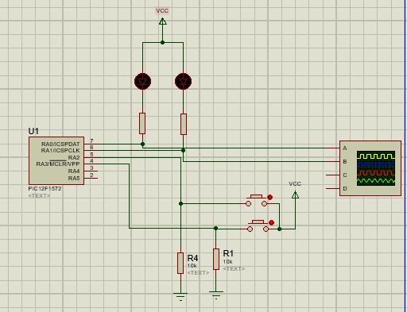
Figure 18. Circuit design to simulate PWM.
The circuit shown in figure 18 is the finished circuit used to demonstrate the PWM. In this circuit, the first button is connected to pin RA2, this operates the LED connected to pin RA0 and the button connected to RA3 operates the LED connected to pin RA1. A more complex circuit would need to be designed if this was to work for an entire set of steps but the basic principles of what was hoped could be achieved are demonstrated. Following is the main block of code written to simulate the PWM process.

6.3 Software code for PWM incorporation.

To simulate the desired fading effect of the LED’s the microcontroller needed to be programmed, two programs were used to do this Proteus and CCS. CCS was first used to develop the main header file for the PIC and then the rest of the code was developed and tested using the Proteus design shown in figure 18. The function of the microcontroller circuit once programmed was to simulate the step lighting function of the suggested design. Each button represents a separate step each connected to an LED. When the button, or step is pressed the LED will light up, when it is released the LED will fade in three seconds from full illumination to off. This was simulated and after several attempts was shown to perform the desired task. In this next section the blocks of code developed will be shown and the main functions explained.

This portion of the code declares all the variables used for this program. In these variable are the high and low values for the PWM and the decremental duty cycle value.


in this section of code, the interupt counter is initiated and the output pin values are set for the LED’s. At this point the LED’s would be set to low which is on.





The obove two sections of code initiate the duty cycle for the PWM on each LED. This decrements the on time for each pin in steps of 3 from 98 to 1 and then resets.

This final piece of code is the main function. This starts the timer and enables the interrupts that were set earlier in the code.

7. Experimentation results.
As previously mentioned, it was realised early on in the investigation that the power requirements to demonstrate a working prototype could not be achieved. It was however decided that the results obtained could be used to calculate an estimated amount of power that could be produced if the design was implemented on a much larger scale. In these calculations estimations based on the amount of foot traffic that the system could encounter have also been made as the final product, if it could be implemented would be intended for use in high traffic areas such as major train stations or busy shopping centres.

7.1 initial results.
Following are the voltage values recorded during the first stages of testing. Tests were performed on a single piezo element unrectified and then rectified, two in series and then in parallel both rectified and then four in series and then in parallel both rectified. Whilst every care was taken to apply the same amount of pressure each time, this could not be guaranteed as the tests were being done manually not with specifically calibrated machinery, so multiple tests were performed and the average values obtained were calculated and recorded.
 | Lowest voltage | Highest voltage | Average voltage
1 x  piezo | +/- 4V | +/- 20 V | +/- 12V
1 x piezo rec. | 4V | 19V | 11.5V
2 x piezo series rec. | 0.5V | 5V | 2.75V
2 x piezo parallel rec. | 8V | 24V | 16V
4 x piezo series rec. | 2V | 5V | 3.5V
4 x piezo parallel rec. | 20V | 30V | 25V

Each test was performed thirty times and the results were recorded and then averaged out to provide the above results. The tests performed did not all show the expected results. When the single piezo element was tested before and then after rectification it showed the expected voltage drop across the rectifier circuit of about 0.5V but the rest of the results were not as expected. When the two piezo sources were connected in series with each other it was expected that the voltages would combine leading to a higher voltage than that produced by a single element, this was not the case in fact when the two were combined in series the resulting voltage was significantly lower than that of a single element. Again, when the two elements were combine in parallel the result was not what had been expected. It was expected that the voltages would not combine and that they would average out when in fact the voltages recorded were much higher than with the single piezo element. When the number of piezo elements tested was raised to 4, although not the expected results, they were relatively consistent with the results recorded with two elements. The result showed that when in a series configuration the voltage produce was slightly higher than that of the two and when in the parallel configuration the voltages observed were quite significantly larger.

7.2 final results.
Given the results obtained it was believed that the best configuration was still a parallel one so the final set up was built consisting of sixteen piezo elements configured in parallel with each other. Once this set up was completed testing was under taken to measure the voltages that could be achieved. As this final setup had been designed to withstand a larger amount of force it was possible to place it on the floor and use the weight of a person stepping on and off to produce the resulting voltages. This test was, like the previous tests, repeated thirty times and each time the observed voltage was recorded and then the average was calculated. It was believed that these tests would be more accurate than the previous ones due to the fact that the amount of pressure applied to the step would be more consistent throughout the experiment as the weight of the person performing the tests did not change and the tiles rigidness allowed for more evenly distributed pressure. Readings were observed and recorded before and after rectification.
 | Lowest voltage | Highest voltage | Average voltage
Before rectification | 38V | 49V | 43.5V
After rectification | 35V | 48V | 41.5V

As can be seen from the above results the expected voltage drops across the rectification circuit occurred. Unlike the previous tests, the difference between the lowest and highest recorded voltages were much smaller. It is believed that the reason for this is the more accurate way in which these tests were performed and the more uniform depression of the piezo elements. At this point it was determined that an average voltage spike up to 41.5 volts could be produced when the ceramic tile was stepped on to and when stepped off of. Although these voltages seem quite high they are only momentary spikes and the current associated with these voltages was small, there for it was decided that capacitors of varying values should be attached to the end of the rectification circuit and the voltages accumulated across the capacitors after a pre-determined amount of time and steps should be recorded in order to calculate approximate power values. The values of the capacitors used were, 16V 470µF, 25V 100µF, 50V 10µF and 63V 47µF. The capacitors were attached to the circuit and the voltages across them were observed and recorded over a time period of fifty seconds and one step on and off each second. Each of the tests performed produced different results with the amount of accumulated voltage increasing with the voltage rating of the capacitors.
16V 470µF = 8.8V after 50 sec/steps.
25V 100µF = 21.6V after 50 sec/steps.
50V 10µF = 34.4V after 50 sec/steps.
63V 47µF = 36.5V after 50 sec/steps.

Form these results it can be seen that the highest voltage was accumulated across the 47µF capacitor. With this value calculations can be made to determine the power that was produced during the testing process.
This was done using the following equations.
Charge: $Q =CV$
Where C is the capacitance in farads, V is the voltage across the capacitor and Q is the charge measured in coulombs.
Energy stored in a capacitor:$W= 1/2 QV=1/2 CV^{2}$
Where W is the energy measured in Joules.
Power generated: $P=\frac{dW}{dt}$
Where P is the potential power in Watts and $dt$ is the dissipation time in seconds. From these equations the following calculations were made for the 63V 47µF capacitor.
$$1/2 \left(47×{10}^{-6}\right)×{36.5}^{2}= 0.0313J$$
From this we can approximate the power P in Watts over a set time period. For simplicity and convenience in further calculation the time period used was one second.
$P=\left(0.0313J\right)÷1sec. =0.0313 Ws=31.3mW$s
This is the amount of power that could be produced from fifty steps if taken at one step per second. This amount is very small but when put into the context of a much larger application the numbers can be more encouraging. The test set up that was used was only 30cm by 15 cm, the average size of a step in a train station could be assumed to be 200cm by 30cm. if this was the case, using the same piezo elements but fit to the size of the step, 211 piezo elements could be incorporated in to one step. This is 13.3 times larger than the test area so theoretically the power produced per second after fifty steps could be 13.3 times greater. This would give an approximate value of 406.9mWs. This again is not a large amount of power but in a real-life situation this equates to fifty people stepping on the same step and only that one step, once. If we think about this type of system being used in a busy train station there would not be only one step. If we say that there were twenty steps in a flight of stairs, which would not be uncommon in most busy stations, we can then say that if fifty people walked up a flight of twenty steps with each step able to generate 406.9mWs, twenty steps would generate 8138mWs or 8.13Ws. This is with fifty people walking up a flight of twenty steps, if we look at the average foot traffic at a busy train station then the values can become significantly larger. On Friday 1 December 2017, the Office for Rail and Road (ORR) published the estimates of station usage for all stations in Britain in 2016-2017 with Waterloo station being the busiest having 99,403,096 visitors over the year [22]. This equates to more than 250,000 visitors per day. If this many people were to walk up or down a single set of twenty steps with the piezo arrangement estimated earlier and using the numbers generated earlier, an estimated 40,650Ws or 40.65KWs could potentially be produced. If these numbers are even close to actual values that could be obtained it shows that a significant amount of power could be harvested if implemented in the right way. To put these values in to context, if 40,650Ws could be produced dividing this value by sixty would give 677.5W of usable power for one minute, divided by sixty again and this would provide 11.3W of usable power for one hour, generated by one flight of stairs, in one train station, in one day.
To compare and evaluate the amounts of energy that could be potentially be generated to those that would be required to power a system like the one suggested in this report, the estimated power consumption was calculated. It was decided that for a step the same size as the one used for the previous calculations, placing four bright white LED bulbs with viewing angles of at least 100 degrees, evenly spaced across the front of the step would provide a sufficient amount of light for the proposed design. An approximate power consumption for a low power LED bulb is around 4W. Using the approximate value generated in the previous calculations of 11.3Wh, the following calculations were made.
$11.3 ×60=678$
This gives 678 Watts per minute, dividing that by the number watts needed for the 4 LED bulbs per step gives the number of minutes each bulb could be lit continuously for.
$678 ÷16=42.4$
This number of minutes divided by 20 steps would give an approximate 2 minutes of full power for the entire set of lights for the flight of steps.

8. Conclusions and recommendations.
Using the calculations made and the values obtained from them, it can be seen that to use this harvesting system to provide enough energy to operate the proposed lighting system is not viable. That being said, the amount of energy that could potentially be generated is not insignificant. Taking in to account the piezo elements used in this experiment are far from the most efficient products available, their shape alone leads to lots of wasted space on the step set up, and the testing situation was far from as accurate as it could be, with larger more task oriented materials it is believed that better results could be achieved. Though the investigation did not achieve the desired results, it is firmly believed that under better test situations utilising better test equipment and materials, the results could have been greatly improved. The issue of storing the power produced is something that would need to be investigated in any further iterations of this investigation and potential ways of regulating the voltages and current would need to be devised. It is also believed that a harvesting system like this could potentially, with further investigation be combined with other types of energy harvesting systems such as photovoltaics, to create a system capable of generating more usable quantities of energy. For further work it would be suggested that a deeper understanding of different piezoelectric elements should be obtained and a better knowledge of the interaction between AC voltages when in parallel and series would be needed.
To summarise, this investigation is not considered a failure. Although the desired levels of power could not be obtained it can be seen that with a few, simple components what would have been completely wasted kinetic energy can be harvested and reused. The challenge now is to discover ways to optimize the energy that can be converted and find intuitive and unique ways in which the energy could be used. As electronics continue to develop and the power consumption of devices decreases, it is believed that this type of energy harvesting will continue to grow in its level of usability and practicality for implementation.

9. Reflection.
When thinking on the experience of this investigation it can be said that a greater deal of background research could have been done. A more complete understanding of the materials used and the processes undertaken to perform this investigation would have led to more accurate and thorough results. The amount of time devoted to the project should have been much larger and more realistic allowances for outside influences on the progress of the project should have been allowed for. If it was possible to start again a much more ridged and structured project plan would have been put in place and a greater appreciation of the influence of other assignments and their time constraints would be taken. It is believed that although this investigation could have been performed in a much more professional way, the desired result was, to some extent achieved. The reason for this line of investigation was the interest in harvesting ambient energy and the desire to work towards being able to create more sustainable forms of energy, in this it is believed that the goal was somewhat achieved. The ability to harvest the wasted energy is there and with more research and development it has the potential to become more and more usable. Further investigation in to ways of harvesting kinetic and other forms of wasted energy could be incredibly useful in leading our society in to an era where we are not consistently draining the natural resources of this planet and lead to self-sustainability for us all.

10. References.

[1] “This Month In Physics History.” [Online]. Available: https://www.aps.org/publications/apsnews/201403/physicshistory.cfm. [Accessed: 14-Apr-2018].
[2] “Piezo Systems: History of Piezoelectricity.” [Online]. Available: http://www.piezo.com/tech4history.html. [Accessed: 14-Apr-2018].
[3] “Top Uses of Piezoelectricity in Everyday Applications | APC International Ltd.” [Online]. Available: https://www.americanpiezo.com/blog/top-uses-of-piezoelectricity-in-everyday-applications/. [Accessed: 16-Apr-2018].
[4] M. Bellis, “The History of the Water Wheel.” [Online]. Available: https://www.thoughtco.com/history-of-waterwheel-4077881. [Accessed: 14-Apr-2018].
[5] I. Pineda, W. Pierre Tardieu, and L. Miró, “2016 European statistics Wind in power WindEurope Business Intelligence Aloys Nghiem (Installation highlights) Ariola Mbistrova (Financing highlights) Courtesy of Senvion Gmbh,” 2017.
[6] “Trevor Baylis | Lemelson-MIT Program.” [Online]. Available: http://lemelson.mit.edu/resources/trevor-baylis. [Accessed: 16-Apr-2018].
[7] “These Boots Were Made for Talking | WIRED.” [Online]. Available: https://www.wired.com/2000/06/these-boots-were-made-for-talking/. [Accessed: 16-Apr-2018].
[8] J. John Livingston and M. Hemalatha, “Charging an electronic gadget using piezoelectricity,” Indian J. Sci. Technol., vol. 7, no. 7, pp. 945–948, 2014.
[9] A. Kurs, A. Karalis, R. Moffatt, J. D. Joannopoulos, P. Fisher, and M. Soljači, “Wireless Power Transfer via Strongly Coupled Magnetic Resonances.”
[10] P. J. Paul, R. S. D. Tutu, W. K. Richards, and V. M. Jerome, “Project power shoe: Piezoelectric wireless power transfer - A mobile charging technique,” Proc. 5th IEEE Glob. Humanit. Technol. Conf. GHTC 2015, pp. 334–339, 2015.
[11] H. A. Sodano, D. J. Inman, and G. Park, “Comparison of Piezoelectric Energy Harvesting Devices for Recharging Batteries,” J. Intell. Mater. Syst. Struct. J. Intell. Mater. Syst. Struct. J. Intell. Mater. Syst. Struct., vol. 16, no. 1610, pp. 799–807, 2005.
[12] H. A. Sodano, G. Park, D. J. Leo, and D. J. Inman, “Use of piezoelectric energy harvesting devices for charging batteries,” Proc. SPIE - Int. Soc. Opt. Eng., vol. 5050, pp. 101–108, 2003.
[13] A. Rui, H. Lixiao, Y. Chenxiao, and S. Zhou, “The Electricity Generation System Based on Piezoelectric Ceramic Applying on Road Deceleration Strip.”
[14] J. R. Farmer, D. J. Inman, D. J. Leo, and N. Goulborne, “A comparison of power harvesting techniques and related energy storage issues,” 2007.
[15] “Pavegen – Permanent Installation Case Studies — Pavegen - The Next Step.” [Online]. Available: http://www.pavegen.com/permanent. [Accessed: 24-Apr-2018].
[16] “The Best New Green Energy Tech Could Be Right Underfoot | WIRED.” [Online]. Available: https://www.wired.com/2016/06/best-new-gren-energy-tech-right-underfoot/. [Accessed: 24-Apr-2018].
[17] “Pavegen Kicks Off Crowdcube Campaign To Power Up Its Kinetic Flooring Business | TechCrunch.” [Online]. Available: https://techcrunch.com/2015/05/25/pavegen-kicks-off-crowdcube-campaign-to-power-up-its-kinetic-flooring-business/. [Accessed: 24-Apr-2018].
[18] “Three Technologies for Harvesting Ambient Energy - IEEE Spectrum.” [Online]. Available: https://spectrum.ieee.org/consumer-electronics/gadgets/three-technologies-for-harvesting-ambient-energy. [Accessed: 18-Apr-2018].
[19] “What is a Schottky diode, Schottky barrier diodes, Schottky diode manufacturers - Future Electronics.” [Online]. Available: http://www.futureelectronics.com/en/diodes/schottky-diodes.aspx. [Accessed: 19-Apr-2018].
[20] “voltage - Connecting power sources in series or parallel? - Electrical Engineering Stack Exchange.” [Online]. Available: https://electronics.stackexchange.com/questions/225362/connecting-power-sources-in-series-or-parallel. [Accessed: 24-Apr-2018].
[21] “Pulse Width Modulation | DC Motor Drives | Electronics Textbook.” [Online]. Available: https://www.allaboutcircuits.com/textbook/semiconductors/chpt-11/pulse-width-modulation/. [Accessed: 20-Apr-2018].
[22] “ORR publishes top 10 busiest stations for 2016-17 – Network Rail.” [Online]. Available: https://www.networkrail.co.uk/orr-publishes-top-10-busiest-stations-2016-17/. [Accessed: 22-Apr-2018].

