

LOCATION: Swansea | LLEOLIAD: abertawe
LEVEL 5 | LEFEL 5
EXAMINATION PERIOD | CYFNOD ARHOLIADAU
may 2018 | mai 2018

MODULE CODE: M5X01136 & M5X00736
Circuit Design and Analysis
TIME: 2 HOURS
answer all questions

Equipment or materials required – Calculator
Adnoddau neu ddefnyddiau sydd eu hangen - Dim

ANSWER ALL QUESTIONS

  - Identify the circuit shown below in the diagram below
[1 Mark]
  - Explain the purpose of R1, R2, D1, D2, C1, C2 and Co. You may assume R1=R2, and the characteristics of Q1, Q2 and D1, D2 are matched.
[4 Marks]
  - Using a single diagram, define the bias points of a Class “A” amplifier, Class “B” amplifier and a Class “AB” amplifier. Describe the main attributes of these three classifications.
[6 Marks]
$$V_{cc}$$
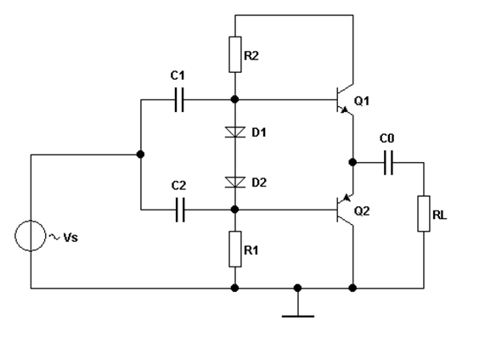
- The circuit shown is a Class AB push pull amplifier.

- R1 and R2 for a potential divider to bias the two transistor bases.
D1 and D2 provide an adjustment to the base bias of the transistors in order to forward bias the transistors into AB mode.
C1 and C2 provide ac coupling of the signal into the amplifier.
Because a single power rail supply is used the standing dc voltage on the Q1,Q2 node is approximately half of Vcc. In order to isolate this dc from the speaker Co is required, otherwise the speaker would be subjected to a relatively large dc bias and this would prevent correct speaker operation.

- Class A biasing refers to biasing the transistor into its linear region, class B refers to biasing the transistor at cut-off and class AB is a compromise bias point at the start of the linear region.
Class A is very inefficient but is comparatively linear. The transistors conduct even though there may be no input and hence waste energy.
Class B is more efficient as conduction only takes place during if an input signal is present but suffers from Cross-Over distortion as some of the input signal is used to forward bias the transistors and hence cause some distortion.
Class AB is a compromise between efficiency and distortion. The transistors are slightly forward biased in order to take the transistors into conduction at the start of the linear region.

- Draw a circuit of a simple passive Low- Pass RC Filter. Sketch and describe a fully labelled, typical frequency response curve for it. Identify the “cut-off” frequency and -3dB points on the graph, assume R = 10kΩ and C = 10nF.
[4 Marks]
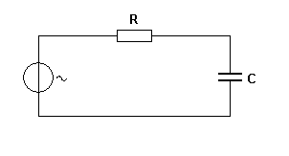
10nF
10k
Vin
Vout
0dB
-3 dB
f_{c}

$$f_{C }=\frac{1}{\left(2×π×R×C\right)}= \frac{1}{\left(2×π×10k×10×{10}^{-9}\right)}= 1591.549 Hz$$

The graph shows how the output of the filter is a maximum (100 % or 0 dBs) for low frequencies, however, as the input frequency reduces then the output voltage rises. At the cut-off frequency (f_{c} = 1591.549 Hz) the output has dropped to 70.7% of its maximum value i.e. -3dBs.

- The discharge equation for a series resistor/capacitor network is given by the equation below, where v_{c} is the voltage across the capacitor and Vs is the capacitor voltage before discharge.
$$V_{c}=V_{s}e^{{-t}/{RC}}$$
- Assuming the following: R=50k, C=20µF and Vs=10V, Calculate V_{c} after 3 sec.
[3 Marks]
- Sketch a labelled graph that would represent the discharge curve.
[2 Marks]
- R = 50k, C = 20μF, Supply voltage V_{S} = 10V , capacitor voltage = V_{C} and t = 3secs
And V_{C} = V_{S} . e ^{- ( t/RC )} )
τ = R x C = 50k x 20x10x10⁻⁶ = 1 seconds
Hence V_{C} = 10. e ^{- (3/1 )} )
Therefore V_{C} = 10. e ⁻ ⁽³ ⁾ ), = 10. (0.0498)
Hence V_{C} = 0.498 V

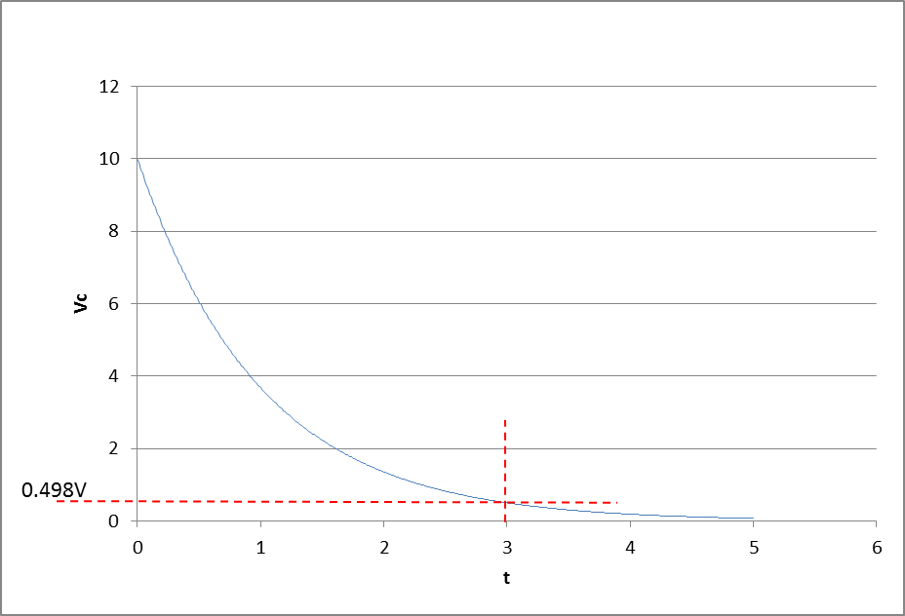

- For the transistor amplifier shown below, determine approximate values for the following dc bias voltages:
- Vb
[2 Marks]
- Ve
[2 Marks]
- Vc
[2 Marks]
- Determine approximate values for Rin, Rout and Av for the following bipolar amplifier. You may assume hfe = 100.
[6 Marks]

Assume Vbe 0.7 V
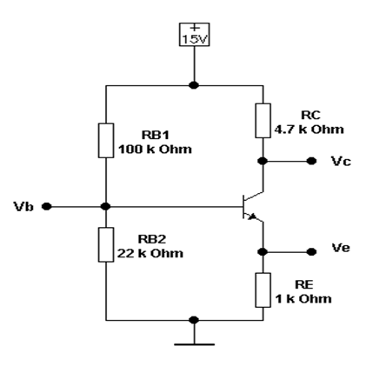
- $V_{b}=\left(\frac{R_{B2}}{R_{B1}+R_{B2}}\right)×15= \left(\frac{22k}{22k+100k}\right)×15= 2.7V approx$

Assume Vbe = 0.7V

- $V_{e}= V_{b }- V_{be }=2.7-0.7= 2V$

$$I_{e}=I_{c}=\frac{V_{e}}{R_{e}}=\frac{2}{1000}=2 mA$$

- $V_{c}=V_{cc}-\left(I_{c}×R_{c}\right)=15-\left(2mA×4.7k\right)=5.6V$

- Given hfe = 100

Rin = 82k // 18k // hfe . 1k
Hence ${{\frac{1}{Rin}=\frac{1}{82k}+\frac{1}{18k}+\frac{1}{100 × 1k }=12.195× 10}^{-6}+ 55.556× {10}^{-6 }+10×{10}^{-6}}^{}$

Hence ${\frac{1}{Rin}={\left(1.195+55.556+10 \right)×10}^{-6} =77.78×10 }^{-6}$

Therefore Rin = 12.86k approx.
Rout (by inspection) is approximately equal to Rc = 4.7k

Av = - Rc/Re (approx.) = - 4.7k/1k = -4.7 approx.

- Determine the output voltage (Vout) and output power for the two stage linear amplifier shown below if the input voltage (Vs) is 28mVpk-pk.
[8 Marks]
- Explain why the typical input and output capacitors for an AC amplifier are not shown on Thevenin Equivalent Circuits such as the one below for example.
[2 Marks]
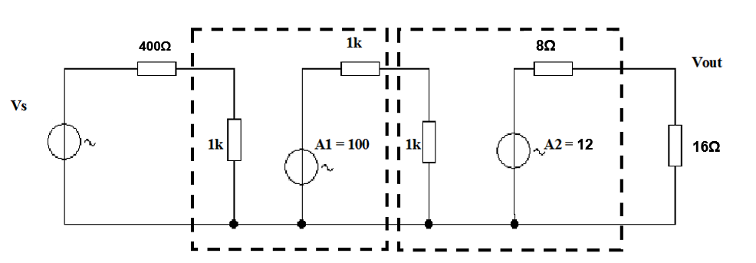
- A fully labelled diagram needs to be drawn.

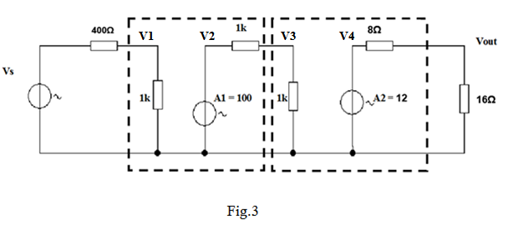

$$V1= \left(\frac{1k}{1.4k}\right)×28m V=20mV$$
$$V2= V1 x A1=20mV x 100 = 2V$$
$$V3= \left(\frac{1k}{2k}\right)×2 V=1V$$
$$V4= V2 x A2=1V x 12 = 12V$$
$$Vout= \left(\frac{1 6}{24}\right)×12 V=8Vpk-pk$$
$Vout$ rms =$\frac{\sqrt{2 } }{2}$ x ($8Vpk-pk)$= 5.66Vrms
Hence Pout = (5.66)² / 16 = 2W

- The capacitors are not shown because they are assumed to have zero reactance over the range of frequencies of interest.

Diwedd/End

